List of Contents

Introduction 4
So what do we mean when we say information products? 4
It's Easier Than You Think… 5
Chapter 1: Solving Problems Is Profitable 10
Solving problems is profitable. 10
Don’t ever be put off by the fact that the product may already exist. 11
Chapter 2: Power of Branding 15
Chapter 3: Find A USP 19
Chapter 4: Creating Digital Products 23
So how do you actually go about creating your information products? 24
Avoiding Doubts, Fears, and Writers Block 25
Chapter 5: Super Fast Product Creation Methods 29
The Interview 29
Record Your Own Tips and Advice 30
Turn Existing Content Into Products 30
Update/Republish Existing Information 31
Co-Create A Product 31
Help Finish Incomplete Projects 31
Purchase 'Private Label' Rights 31
Hands-On Video Or Camtasia Presentations 32
Create A Package Using Existing Products 32
Public Domain Information 32
Case Studies 32
Checklists and/or "Top 10" Lists 33
Sell Your Ideas 33
Hold A Contest 33
Templates, Forms, Etc. 33
Resources List 34
Directories and Guides 34
Capitalize on Trends and Fads 34
Chapter 6: Sort Your PST 38
Chapter 7: The Sell 45
Chapter 8: Mindset of Success 50
Conclusion 54
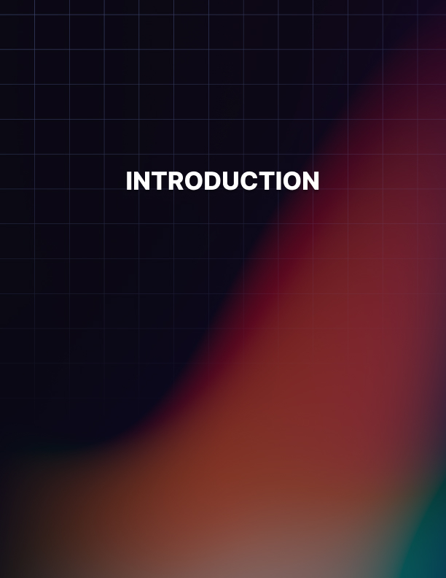

Introduction

Inside Digital Product School you will learn exactly how to create and sell your very own profitable products online.

Having your own digital products gives you the ability to generate a 6- figure online business from the comfort of your own home. Your digital products will sell for you online 24/7, 365 days a year on autopilot, when set up correctly. Bringing in passive income for years to come.

Isn’t that a dream? Passive income.

Look let’s be honest this is not going to happen by doing nothing. You will have to take action on this guide and implement what you learn, only then can you live the laptop lifestyle.

Selling information products are not only cheap to produce, they are also very easy to produce. Once you have done it once, you can literally rinse and repeat the same process. So, it’s definitely a skill worth learning.
Also, digital information products can be sold at scale, as what your selling is a digital download and not something you need to physically send to the customer. This provides you with massive advantages.

Selling information products online is a way to start your own business with very little to NO overheads.

Also, information products are very flexible. You can sell them at a profit, give them away as an incentive to get people to sign up for your list, sell them at a low price to showcase your skills and then offer higher priced products. There’s a whole world of ways to use information products to build an online business.

So what do we mean when we say information products?
Any product that gives people information, usually a solution to some sort of problem. People pay to get out of the hole they just fell in – not how to avoid holes. Solutions to problems always sell well.

For instance, a product could tell people how to train a dog, lose weight, design a website, cure bad breath, meet members of the opposite sex, put up shelves, apply makeup, or paint a portrait using oil paintings.
An information product can be made in video form, as an ebook, or as an audio recording. Some types of information products lend them- selves better to one form than another. For instance if you are telling people how to apply makeup you definitely need visuals, so a video would be best. An audio recording wouldn’t do the trick in this case and an ebook would need to have a lot of screenshots.

If you want to tell someone how to meet members of the opposite sex, however, an ebook or an audio recording would work well. And if you want to tell someone how to train a dog, an ebook with screenshots, or a video, would work equally well.

Find your subject, then decide on the best way to present it – ebook, audio, video etc.

It's Easier Than You Think…
Most people who are new to the Internet, or even some who have been around for a while, believe that they can't create their own ebooks (or CD’s, videos, etc.) because they can't write.

There are also a lot of 'so-called' gurus who will have you believe that it's more difficult than it actually is.

What I'd like to show you through this special guide is that you CAN create your own ebooks and other products. And you can do it fast!

Even if you've never written a word in your life! (If you’re new to the field, your main challenge may be getting recognized as an expert. But creating your own products will be easy once you learn the shortcuts and tips here!).

You see, it’s all about 'perspective.' The first time you see someone riding a bicycle, you immediately say “That’s not possible” or “I can’t do that.” And, maybe you’re right to some extent. You can’t ride a bicycle yet. But, that doesn’t mean you can’t ride a bicycle ever.

You just have to get on it, stumble a few times and before you know it, you’re balancing a metal frame on two wheels! Something that seemed impossible just a few days ago.

It’s the same with writing an ebook. In fact, it’s much easier than learning how to ride a bicycle.

The trick really is to just get started. Just start writing and let your thoughts flow. Don’t worry about spelling or grammar or sentence structure or formatting or any of that. Just get the information out of you. You can edit it later. If you edit while you write, you interrupt the flow of ideas.

You can also use a tape recorder and just talk freely into it. Imagine you’re talking to a friend and you’re giving her advice about X (where “X” is the subject you want to write about.) When you’re done, you can type it all out into your computer, or get someone to transcribe it.

What people should realize is that you don’t need to be an English major to write an ebook. Just write the way you talk to a friend. Then, have someone read it out loud and see if either of you can find any areas that sounds choppy or confusing. You can also get a college student to edit it for you, if you’re not comfortable doing your own editing. (Although, personally, I prefer to read an ebook that seems like the author is “talking to me” (it seems more interactive) instead of an ebook that uses perfect grammar, and structure but ends up being boring.

If it still seems like a daunting task to write the book, just break the ebook up into sections or chapters, and knock them out one at a time… kinda like writing short reports. (Break the task up into smaller pieces and tackle it that way.)

Anyone can write an ebook or create a digital information product. Once you have the content, you can turn that into different digital formats like audio’s, video’s and written text. You can do this!

Change your mindset, and say to yourself, I can do this! Ever heard of this quote:

“IF YOU THINK YOU CAN’T WRITE A BOOK, YOU’RE RIGHT!
IF YOU THINK YOU CAN WRITE A BOOK, YOU’RE RIGHT, TOO!”

It all comes down to you.

The point here is, what’s the WORST thing that could happen if you wrote a book and it wasn’t absolutely perfect? It’s an eye-opening experience to look at some of the e-books that are selling…right now…on the Internet. All you have to do is find one that, after you read it, you say, “MAN! Even I could do better than that!” But that book’s selling and yours isn’t because you’re waiting to get it perfect! Don’t get it perfect…get it out there!

Start saying to yourself, in your head…unless you want people to think you’re really crazy…I CAN write a book! I KNOW I can!

Know that your brain is already writing books for you each day. All you have to do is figure out how to get it down on paper…and that’s what this book is all about!

Get over that perfectionist stuff. It ain’t never gonna be perfect…just like that grammar, but it gets the point across, doesn’t it? Get your book as good as you can at the time, get it out there, see what happens and then test and tweak it until it sells. It’s NEVER going to be completely perfect, but it can be profitable!
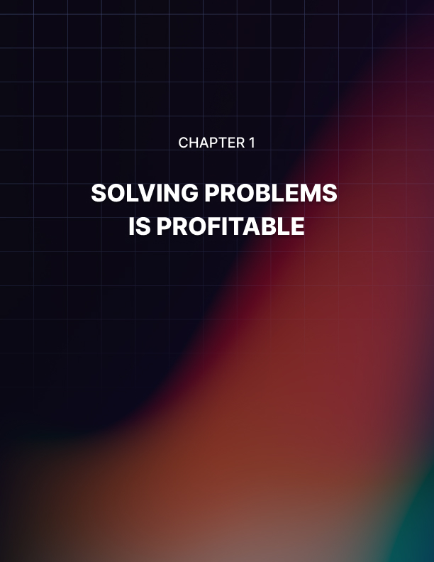

Chapter 1: Solving Problems Is Profitable

One of the biggest hurdles new internet marketers face is choosing what type of information product to create.

Since you most likely want to make a profit off of this, you need to create an information product that solves a problem or tells people how to do something.

Solving problems is profitable.
Also, you want to make sure that there’s a decent sized audience for this product, and you want to make sure that they have money to spend. So you wouldn’t want to create an information product that solves a really obscure problem that is only faced by a tiny group of people. And you wouldn’t want to create an information product that appeals to a crowd that has no money to spend, such as young teenagers or children.

Here is a list of evergreen product ideas where you will always find a hungry crowd. Provide these people with a genuinely helpful solution to their problem and you will have a grateful crowd that will come back again and again:

- Weight Loss
- Dog training
- Pet health
- Acne cures
- Curing romantic woes
- Saving money
- Debt Consolidation
- Avoiding foreclosure Fitness
- Parenting
- Fertility
- Making money online
- Driving targeted traffic to websites

This doesn’t mean that you should only stick to that list, by any means. If you have a skill and you can teach other people - for instance, as we mentioned earlier, applying makeup or painting a portrait or arts and crafts or home repairs - by all means create an information product around it.

You need to make your information product stand out, so you would want to develop a method that lets people learn how to do something quickly and easily, and emphasize that when promoting your product.

“Learn How to Paint Portraits Quickly And Easily!”
“Take Pictures Like A Pro - Learn How in Just Five Lessons!”
You get the idea.

If you’re searching for ideas, try to identify what potential customers need. You can do this by doing some basic Google searches and by visiting internet forums or blogs that are targeted to the area that you want to create a product for - dog training, weight loss, dating forums, etc.

Here’s one way to find out what people need - go to Google and type in the phrase “How To” in quotes.

Some product ideas there would be a weight loss product, or a quit smoking through hypnosis product, or, if you are religious, a product that helps people reconnect with their spirituality.

Or, a manual that gives people tips on creating a Google friendly site, if you know anything about SEO.

Don’t ever be put off by the fact that the product may already exist.

In fact, if there are NO other versions of the product - you should worry. That possibly means there is no market.

There is nothing new under the sun - but people who have an interest in an area tend to buy a LOT of products that address that interest.

If someone is a fanatic about dog training, they are likely going to buy more than one book on it. If someone is desperate for romance, they will snap up any product that looks like they offer a solution.

You need to create an excellent product that solves the problem, emphasize how good your product is when you are promoting it, highlight some common flaws that competing products have and how your product is better than the other products...and it won’t matter how many other competing products are out there. Really.

Another way to find out what people need is to go to Yahoo Answers and see what people are asking for help with.

When you go to www.answers.yahoo.com, you will see a list of categories on the left-hand side of the page. If you have an idea of what general type of information product that you want to create, you can click on the category that you are interested in and see what types of questions people are asking.

So, if you wanted to create a pet product, you would click on pets and you would see what kinds of questions people are asking about their pets.

If you wanted to narrow it down to horses or dogs or cats or some other type of animal, there is a list on the left of the page of different categories of pets, which you can also click on:

Just by seeing the common questions that crop up, you will be able to identify a need for information - and fill that need by creating an information product.

You can also find forums by going to a search engine such as Google or Yahoo and typing in, for example, “dog forum” or “chihuahua forum” or “DIY decorating forum” or “web design forum” or whatever your chosen topic is.

It’s important to make sure that there is actually a market out there that is seeking a product like yours.
And once you have done that, you can go on to the next step.
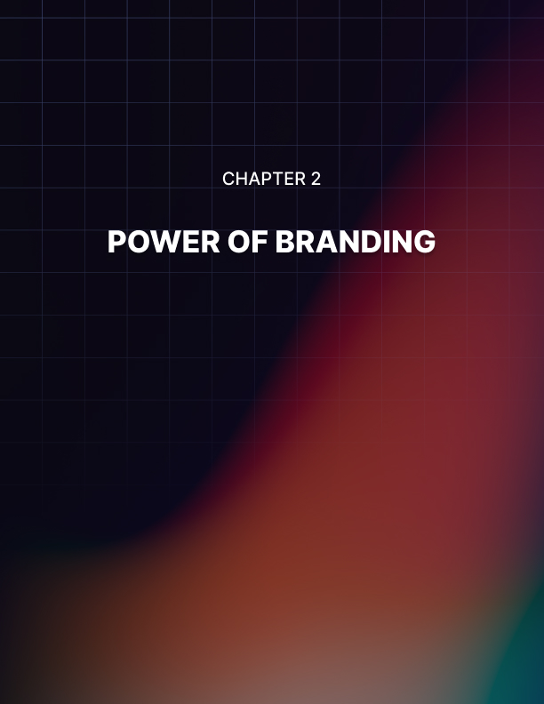

Chapter 2: Power of Branding

Once you have a general idea of what subject you want to write about in your information products, you should start thinking about branding yourself and your product line.

Creating a brand identity is a way to build customer loyalty and to ensure that when customers are looking for a solution, they think of you first.

Think of someone like Cesar Milano, and you automatically think “The Dog Whisperer”.

When you think of home decorating, what name pops into your head? Chances are pretty good that it’s Martha Stewart.

Think of cooking, and you’ve got a lot of different options… Emeril Lagasse… Rachael Ray… and yet even there, people have found ways to distinguish themselves. Extreme eating, adventures in dining -Anthony Bourdain! Southern cooking - Paula Deen!

If you’re from the UK you might think of Jamie Oliver when you think about School Dinners or Barbara Woodhouse when you think of dog training. If you think about money saving in the UK you think about Martin Lewis. When you arrive at his website the first thing you see is a picture of him. That tells you immediately you’ve come to the right place. Branding!

This branding allows them to build and build on their success.

Once you are known for producing an excellent product, people will come back to see what else you’ve got available, and when you create a list of satisfied customers and notify them that you’ve got something new, if you have established a brand for yourself, they are much more likely to want to purchase it.

You can, of course, choose to design a single product or a series of unrelated products, but you’re missing a great opportunity to build up buzz and repeatedly sell to the same customers when you do that.

To create a brand identity, it helps to have a consistent visual theme for your web endeavors - a similar design and color scheme for your website, your ebooks, your short reports, etc.

If you don’t have any design skills, no problem. You can go somewhere like elance.com, guru.com, rentacoder.com, or any other freelance website, and find a graphics designer to create a logo and website header for you that will represent your business.

You don’t have to get any fancier than that. People aren’t looking for fancy website design when they land at your website. They want to know that they’ve arrived at the right place - and will be instantly reassured when they see your familiar looking banner.

Then, they want the information that they came here to find - how to save money with coupons while shopping at grocery stores, how to litter train their cat, how to flatten their abs, etc.

And they want the site to be easy to navigate - they don’t want to have to hunt around to find what they are looking for.

So, all you need to help establish your brand identity is a custom designed banner and logo that visually tells the customer at a glance what you and your products are all about. You can adapt that logo and banner and use some version of it for all of your products.

Let’s take the coupon example, for instance.

You decide that you want to be the coupon queen. An obvious thing to do would be to get a crown logo designed; perhaps a crown sitting on top of a pile of coupons. From then one when anyone sees that logo and the phrase “The Coupon Queen” they know it’s one of your products.

You would want to include your brand name in your product title if possible. “The Coupon Queen’s tips for getting groceries FOR FREE!” or “The Coupon Queen’s 50 delicious low-cost recipes!”

Or, to use a more masculine example, say you are an expert fisherman and hunter and you want to create a series of information products that will teach people to fish and hunt.

You could create a brand identity like “The Good Ole Boy’s guide to Bass Fishing.” This could spin off a whole series of ebooks, instructional videos, product endorsements and so on.

The possibilities are only limited by your imagination.

Some of it sounds clichéd, and perhaps even tacky. But it works beyond your wildest dreams!


Chapter 3: Find A USP

Look, creating products is not that difficult, as I’m sure you’re aware of by now. But if you really want to make good money in this business and establish yourself as a respected expert, you have to be unique!

This is so important that it’s worth repeating several times.

Come up with a unique product or service, or as mentioned earlier, a unique twist/angle to an existing product. (Of course, the latter is much easier and quicker to do.)

If you're in a highly competitive niche, take existing ideas and products and find ways to improve on them considerably.

Look for an area within your field/niche that needs attention but isn't getting any. Look for 'holes' in your niche.

What are the main problems and frustrations of customers that other marketers and business owners aren't addressing?

Look for something that's highly needed but not being addressed by others. Do surveys, visit message boards and forums, etc.

Target a sub-niche (a smaller niche within a large niche) that isn't overflowing with competition, or one that isn't being addressed yet.

Example: When I first got into online marketing, the 'spam' laws were just beginning to come about. Marketers were just starting to get away from sending unsolicited email because they didn’t want to get in trouble. The online business was changing. New marketers were tip- toeing around the issue. They either got in trouble for sending unsolicited email, or were too afraid to even approach email marketing in fear of being labeled a 'spammer.'

I noticed the area that needed attention: permission email marketing. Email marketing was the easiest and cheapest way to build a business. But people were too afraid to use it. They needed a step-by-step guide to using email marketing the 'right way' - using opt-in methods so they wouldn't get in trouble.

So, that's what I wrote about. And, that's the book that put me on the map!

Find out what's missing from your market and fill that need. Study your market. Find the holes, and then find a way to fill them. If you don't think you have the skills needed, find someone who does and market that person's assets.

Example: think of celebrity agents. They don't have the acting/dancing/singing skills themselves. But it doesn't matter because they go out and find the talent, then they sell that talent!

A really powerful way to come up with unique ideas is to study other businesses that are NOT related to your market. If you’re in the online marketing field, look at the real estate business, the plumbing business or any other non-related business. If you look closely, with an open mind, you will find many creative and unique ideas that you can bring back to your own business and surprise your market! They will think you’re a creative genius. ;-)

Don’t hold back when you’re trying to come up with new and creative ideas. Let your brain take off – freely and unhindered. Think back to when you were 8 years old. Get back in touch with that “nothing is impossible” energy that children possess. That can be your greatest ally in business.

Every now and then I’ll come up with a completely original product idea, but usually it’s just stuff I see happening around me. I look at what’s already selling, what’s already (or is starting to become) popular.

I use my creativity to put new twists to existing "winning" ideas. That's the shortest route to success!

By giving it a twist, it sort of becomes a unique product. Just learn to pay attention. Keep one ear on the ground. Notice what’s getting the most shelf space in bookstores. Visit discussion groups in your niche. Get on mailing lists, etc.

In short, get out there and hang out among your customers and competitors (either online, offline, or both.) Do that and you’ll never run out of ideas to write about.

However, I’d strongly recommend that you give your product idea a little “twist.” Make it unique in some way so that it’s not the same ol’ product that everyone else is selling.
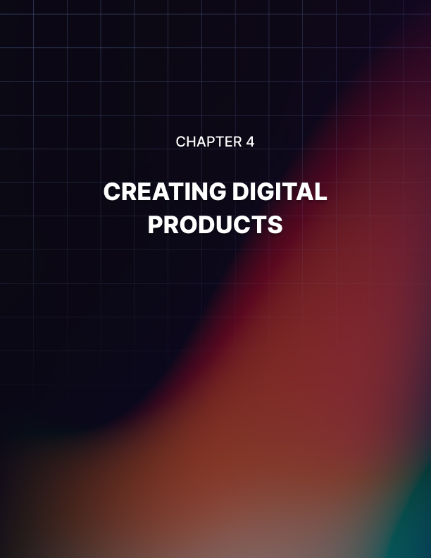

Chapter 4: Creating Digital Products

Now, we’re going to talk about what form your information product is going to take. There is a lot of talk these days about how video information products are hot and everyone prefers video. Don’t believe it.

Video is perfect for some types of information products and not so hot for others. And not everyone loves video.

There can be drawbacks to presenting information in video form. People have limited time and short attention spans these days, and it’s a lot easier to scan an ebook and get what information you need than it is to scan a video. Then again, some people claim the exact opposite.

It’s very hard however to fast forward an online video that is still loading to see if it contains the relevant information than it is to look at the contents page of an ebook.

So, your video must be well made and get to the point immediately, with no fluff or lengthy introductions, or you will anger people and get a lot of refund requests, and people will not be likely to order from you again.

In a written product, people are a little more forgiving, because they can page forward quickly to get to the information that they need.

If you are talking about how to design a web site, for instance, they may already know some of what you are discussing. In an ebook they can skip what they already know; in a video they can’t, because they don’t know where on the video to find the part of the video that they are looking for.

However, some information products do naturally lend themselves to ebook form or audio form.

If you can interview an expert, like an internet marketing guru, an audio form works quite well. If you have an information product that does not rely on visuals (like teaching someone how to paint a portrait), the audio form works quite well.

An audio recording is also a good option for people who are visually impaired.
Video can definitely jazz up an information product. Say you have a cookbook; anyone can write a cookbook, but if you show each step of the cookbook process, along with a picture of the cookbook at the end, you present a much more tantalizing picture.

If you want to show how to train a dog, it’s easy to say a technique, but to show a video of an unruly dog, and then you using the training techniques, and then that same dog behaving perfectly and obeying commands...is very powerful.

So how do you actually go about creating your information products?
It can be done very cheaply and easily.

For creating eBooks – You can use Microsoft Word, or you can download Open Office for free for both Windows and Mac, these both allow you to export your document in a PDF format.

For video creation – If you google “screen recording tool” you will find many free and paid versions of software that can help you create on- screen videos and edit them. Camtasia is one of the best ones I have used.

For audio creation – You can use a tool called Audacity. Which is a free open source audio software which will allow you to create products such as interviews etc.

There are many other software tools out there that can create you the digital format you are looking for. Many of them are free, some are paid, or have paid upgrades. Also a lot of the paid versions also come with free trials to test out.
Realistically speaking, the programs that cost money are going to have more features available then the free programs, but for the purposes of creating information products, the free products are more than sufficient.

When you create a written information product, like an ebook or short report, you are going to want to save it both in regular format and also in PDF, so that you can export it.

When you create a video or audio product, you may want to lead in with a short audio jingle - 5 seconds or so - or you may just want to start right in with the information product.

Video editing programs will allow you to add in titles and transition effects to your video, such as fading from one screenshot to another. Keep in mind that when you add in transition effects it can take longer for the product to download.

Don’t be nervous about making a perfect video; purchasers of information products don’t expect a Hollywood production. They have a problem; they want someone to tell them how to solve it, quickly and with no distractions. They’re not looking for fancy special effects.

One thing that is important in making your product look good is getting an attractive digital cover made.

They generally cost between $25-$97 - you definitely shouldn’t have to pay more than that - and you can find good cover designers on The Warrior Forum, elance.com, fiverr, guru.com and other freelance sites.

You will need to tell the designer the theme of your information product, what your author name is (you can use your real name, use a pseudonym, or use no name at all) and what the product title is.

You can also tell him what color scheme you want.

If you are creating an ebook he’ll create an ebook cover. If you’re creating a video he’ll create a CD cover. These are just photographs that you will have on the site that sells your product; you’re probably not going to mail out actual CDs because your costs would go through the roof.

Avoiding Doubts, Fears, and Writers Block
I’ve been creating ebooks and reports for a while so I don’t find myself doubting or fearing the future too much. But, that can happen from time to time, especially if you’re a beginning writer.

Here’s a simple remedy: do whatever it takes to shift your focus. That’s all there is to it.

Put the project aside for an hour (or even a day) if you have to. Go watch something funny on tv. Listen to your favorite music. Read a motivational book or article, play with the kids, or just go for a walk. It’s really not as difficult as we often make it out to be. Just change the track your “train of thought” is currently riding on. ;-)

Doubts and negative thoughts may enter your mind occasionally. Don’t fight it, just gently nudge your thoughts towards the positive and productive.

Then, go back to the project with a new, fresh attitude and perspective. It also helps to envision the end result just the way you want it to be.

For example, if you’d like your book to earn you $50,000 per year, keep seeing/visualizing that result consistently, as if it has already happened!

This process will burn the “success” image into your brain and pretty soon, doubt will be a thing of the past.

Once you get excited about the end results you'll achieve, get back on the computer and start writing! ;-)
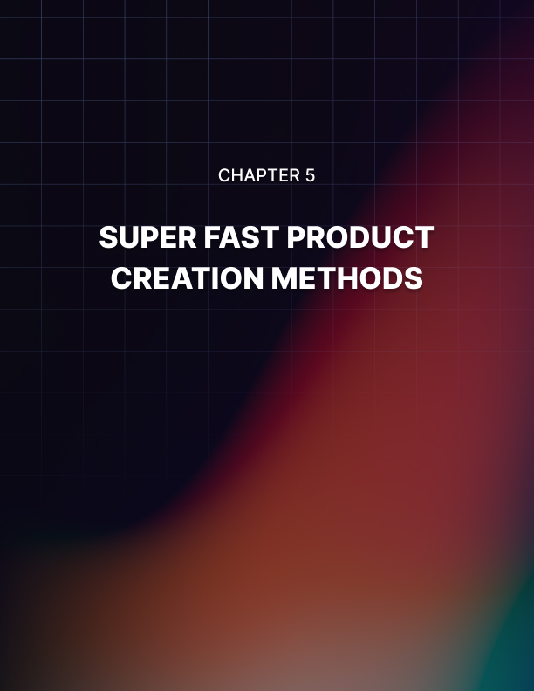

Chapter 5: Super Fast Product Creation Methods

The Interview
From experience I have found by far the fastest way to come up with a high-value product is to interview an expert on the subject which you want to write about.

You would entice the expert by reminding him of the free publicity he/she would get from your promoting the interview.

The more well-known the expert is, the more marketable the finished product will be.

You can also interview several experts and compile all the interviews into one product, in order to cover different angles and strategies on one subject.

Or, you could pick a general subject, break that up into subsections and then interview an expert for each sub-section. For example, if you're creating a product on 'Internet Business Success,' you could interview an expert on product creation, another on copywriting, and another on marketing strategies, and so on.

Your interview can include a set of specific questions, or just one question that requires a detailed answer.

You could also ask the expert to offer you a step-by-step plan that readers would be able to follow to get to their goal. (The easier you make it on the reader, the more likely he will be to buy your product.)

There are various formats you could choose to conduct and publish the interviews. You could simply send the questions to them via email and publish the answers into a report or ebook format. You could also choose to meet the expert one-on-one and record the interview, or you could conduct the interview over the phone and record it that way.

If you choose to record the interviews, your product package could then contain the audios as well as the typed up transcripts. Your pricing would also vary depending on which formats of your products you provide.

Record Your Own Tips and Advice
If you're an expert in a subject yourself, you could get a friend or partner to ask you preset questions and record/transcribe those.

You could also do a (free or paid) tele-seminar, record that and turn that into an instant product. Offer it as downloadable audios, an actual CD, or just the typed up transcripts.

A similar strategy can be used on live seminars. You can either videotape the seminar, make an audio recording of it, or both. You could just as easily invite other experts to join you in the seminar and turn that into an instant product.

Of course, these days, you can also do a webcast i.e. a seminar via the Internet, record that and turn that into a product.

Turn Existing Content Into Products
You can just as easily contact a bunch of experts and ask them to submit their best articles or reports on a particular subject. Then, compile them into a larger report or even an ebook.

Each expert gets to include their web links at the end of their content so they get free publicity from the submission.

You could further get instant exposure for your newly created product by giving all the experts who participated the first chance at selling the product to their own customers. (You can also use this strategy with interviews.)

The same idea can be used to borrow/reprint sections of ebooks, audios, or even existing videos. Contact the author and ask for permission to reprint the content in exchange for free publicity.

If you want to create a product for the 'copywriting' crowd, you could contact several copywriting experts and ask them to submit sales letters that they wrote for one of their products. You could compile all the submitted letters into one mega collection of "proven sales letters." You got an instant product!

You could take this idea further and ask each expert to break the letter apart and explain the specific techniques they used to create the letter. That added information could easily double or triple the value of your 'proven sales letters' package.

Update/Republish Existing Information
Find an ebook/manual that's at least a year old and ask the author/publisher to update the information. For example, you could approach the author of a "free classifieds" directory and offer to help update the information to include all the new resources that came about since the directory was last published.

You could also approach the author of a printed product and ask to convert his product into an audio CD…or visa versa.

How about taking an ebook on 'general gardening tips' and modifying it for the 'vegetable gardening' market.

Co-Create A Product
Another way to save time is to ask an expert to co-create a product with you. If it's an informational product, you could both write it together, and split the workload. The product would be finished in half the time.

The same can be done by involving several experts/authors. Each one would get assigned a portion of the work, say one chapter per author, if it's an informational product.

Help Finish Incomplete Projects
Most successful product creators, especially informational product creators, have at least one unfinished product. You can offer to help them finish it. The profits and exposure can be shared between the two of you.

This can be applied to ebooks, reports, manuals, manuscripts, even software/scripts or non-informational products.

Purchase 'Private Label' Rights
You could either search for owners who are already offering private label rights to their products, or approach authors and ask for it.

Private label rights offer you the right to insert 'your name' as the author of the product. You don't have to write a single word except type in your name and website info.
You could either pay for these rights with cash, or barter/trade using your own products and/or reprint rights.

Hands-On Video Or Camtasia Presentations
Another super easy way to create a high-value product is to create a "how-to" video or computer presentation simply by recording yourself (or an expert) while working on the project. For example, you could create a "how to" product that teaches others to use/learn the features of Microsoft Word by recording yourself using MS Word and explaining the features.

Most people prefer listening over reading, and watching over listening. They want 'easy.'

Create A Package Using Existing Products
Approach several product owners and ask them to donate their product to your project, in exchange for publicity and a cut of the profits. Once you have a bunch of products from different owners, package them together and sell the bundle for an attractive price.

Also, allow each owner/participant to promote the site to their own customers for a cut of the profits. It doesn't cost you a thing AND you get to build your own list fast!

Public Domain Information
This is another strategy/topic that's hot right now. Look for public domain information and republish, re-author, re-title and/or repackage it.

You could also go after out-of-print informational products and work out a deal with the original publishers/authors.

Case Studies
Ask several experts to offer a case study of their most recent project. For example, if you're writing about press releases, you would ask each contributor to give you a copy of their last 'successful' press release and explain the what/why/how of the reason for its success.
Compile the case studies into a guide that you can sell.

Checklists and/or "Top 10" Lists
Create (or ask an expert to put together) a simple checklist that one could use as a guide. For example, you could put together a 'travel checklist' which travelers could use to ensure that they have everything they need before they leave.

You could also use the same idea to create a "Top 10…" list for any subject. Example: "Top 10 Ways To Increase Your Website's Profits," etc.

Sell Your Ideas
Instead of creating the products yourself, you could put together a report that lists all of your creative ideas, so that others could use them to create their own products (kinda like this list).

You could even create a membership site where you share one (or a few) new idea(s) each month.

Hold A Contest
Example: If you'd like to write a report/ebook on 'creative landscape designs,' you could hold a contest and ask everyone to submit their best ideas/designs and allow you reprint rights to the submissions.

Then, compile all the submissions into one report/ebook.

Templates, Forms, Etc.
Create templates for others to use, compile a bunch of them together to create an instant product. Example: If you're a graphic designer, you could create ebook templates, header templates, website templates, etc. If you're a copywriter, you could offer several web copy templates that people could use to easily create their own sales letters, etc.

You could do the same thing with commonly used business letters, forms, etc.

Resources List
You could very easily compile a list of useful resources on certain subjects and turn that into a product. Example: a list of free advertising sites, article submission sites, free hosting or free web space sites, free clipart, free autoresponders, etc.

Directories and Guides
You could also create a directory of sites, resources, software or even businesses. For example, you could create a list of the best restaurants in your area and offer some information on each, as well as dining tips, and so on.

Capitalize on Trends and Fads
Here's an easy way to create a hot-seller… When the 'Lord of the Rings' craze hit the big screen, people started selling anything and everything that was even remotely tied to the movies in some way. And, the fans bought 'em all! The same happened with 'Sideways' and the wine craze, Atkins diet craze, and every other fad or trend that hit mainstream media.

What current hot trend or fad could you attach to your product? To be honest with you, your product doesn't even have to be an actual product. You could just as easily compile a bunch of powerful testimonials about someone else's hot product, add your affiliate links to it and pass the document around.

Allow others to pass it around freely as well. Pretty soon your little report of testimonials can start earning you commissions.

Yes, it can be that easy, IF you decide to make it that easy. Remember, don't let how 'most people' create products limit your creativity and options.


Chapter 6: Sort Your PST

You are probably thinking what is PST? It’s something I made up which stands for “Price”, “Sales-page” and "Testimonials.

Pricing is always a delicate issue, because if you charge too much people won’t buy, but if you charge too little, people might perceive that what you are selling has no value.

You should start out by looking at other information products that are similar to yours and examine their sales pages thoroughly to get an idea of what they offer and how much they charge for their product.

You don’t want to charge too much more than the other people in your field.
However you want to see what they have to offer versus what you have to offer.

If they are just selling a 20 page ebook on puppy training and you are selling a 100 page ebook on dog training from puppyhood through adulthood, along with a set of step by step videos...then of course you should charge significantly more.

The puppy ebook might sell for anywhere up to $17. The dog training ebook plus videos might sell for up to $67.

Or, you could offer the ebook at a cheaper price, say $37, and then offer the videos as an “upsell”. They might cost an additional $30 or so.

You may have noticed that the prices quoted here end in seven. There have been numerous internet marketing studies on this and oddly, prices ending in seven outsell other prices ending in the traditional .95 - $9.95, for instance.

That holds true even if the number ending in 5 is several dollars cheaper.

A product that sells for $19.97 has been shown (in some instances) to outsell a product that sells for $15.95.

Another thing to consider is whether you want to give the product away to start building a list. This method can work very well if you have back end products that you want to sell.
In the dog-training example, you could offer a free five-day course to teach people how to housebreak a dog, or how to handle a dog’s excessive barking.
Each day you would mail out the day’s lesson using an autoresponder service like Aweber, Getresponse, or Constant Contact.

In each email you would have a link at the top and at the bottom of the email, offering people a chance to click on the link and order your product. Then, you give a helpful, well-written lesson about your subject, again without giving away everything - just enough to show that you know your stuff.

If it’s a video or audio that you are selling, you could give away the first video or audio recording in the series to show the quality that the customer will be getting - in exchange for their name and email so you can use it to build a list.
Now, you need to start planning out the sales page for your product.

Again, one of the best things that you can do is study the sales pages of your competition.

You don’t want to copy them, of course; you want to see what they offer and make sure that you present a more compelling offer.

For instance if someone is selling an ebook about dog training you want to emphasize that your ebook comes with videos to actually demonstrate what you are talking about.

If someone is selling a video series about painting a landscape, you want to make one that is more thorough or that offers some type of free bonus like a video on how to paint a portrait.

You also want to get an idea of how sales pages are structured. Starting at the top, you will see that sales pages often have large, attention grabbing headlines. Many websites use this type of headline because – simply – it works.

The headline needs to be about the benefits that your product delivers. It needs to tell the customer what relief they can expect from buying your product.

It could say something like “Cure Your Dog’s Bad Habits Faster Than You Thought Possible!” or “Trim That Extra Tummy Flab In Weeks!” or “Supercharge Your Metabolism With These Superfoods!” Notice that sales pages do not have long unbroken blocks of text.

Under the headline you want a photograph, a paragraph or two about your product, and then a “sub-head”. You need to make it easy to read. The clip art in this book serves the same purpose – it breaks up chunks of text and makes it easier on the eye and easier to read.

You want a series of paragraphs and subheads. At some point a list of bullet points is also helpful. They should summarize your products benefits or highlight how it’s better than its competitors.

Example:
This product DOES NOT rely on:

- Expensive exercise equipment that’s impossible to put together!
- Fad diets that make you sick!
- Gross food supplements that taste horrible!
- Hours of torturous exercise!

This is good because it mentions negative points about your competitors and what they offer - subtly, of course, without naming names - and thus by contrast highlights the good things that you have to offer.

Customers have most likely tried many of those things before and have obviously failed or they wouldn’t still be dieting, so they will be eager to find a product that offers them something different.

You also want a clear “call to action” which tells the customer what to do, and you want it to be prominently displayed in several places on your sales page.
This is very important. If the customer can not easily figure out what to do next when they come to your sales page, they will hit the back button and you will likely lose them forever.

The call to action would say something like “To lose that excess tummy flab NOW, click here to place your secure order via paypal.”

You can also throw in a time element to make it more urgent, or a scarcity element. If you are using a time element you would say something like “For the first 48 hours, we are going to offer a free downloadable cookbook of low calorie recipes to each person who orders...” et cetera.

You must cut this off after 48 hours and remove that statement from the sales page when the bonus offer expires, because if you don’t, people will not take you seriously any more.

Remember, you are building brand loyalty here. You can’t do that if you show people that you make statements that aren’t true.

For scarcity, it helps if you have a physical object that you will mail to everyone who orders from you. It’s hard to claim that you have a limited number of ebooks to give away as bonuses because everyone knows that’s not true. You can give away an infinite number of ebooks.

You could also offer something like a free one-hour consultation with you, if the information product is appropriate to that type of offer.

You could offer it to the first 10 or 20 people who order.

And finally, on your sales page, you need to offer customer testimonials.

‘Wait’!, you say. How do I get testimonials? I haven’t even started selling the product yet!

Here’s what you do: you give away copies of the product to a few people in exchange for their honest review.

Most people are going to say something nice about your product. If you get a lot of criticism, then honestly, you should rethink your product and probably make some changes, especially if they all mention the same thing, such as “It wasn’t explained clearly enough.”

If you don’t know anyone personally who you feel will provide a good testimonial, you can go on an internet marketing forum and explain that you are creating a new product and would like to provide free copies to the first ten people who contact you, in exchange for their honest testimonial on it. (You can’t ask that they only say good things about it, but if you have created a quality product, rest assured that most if not all of the comments will be positive.)

Digitalpoint Forums and The Warrior Forum and WebmasterWorld have very active internet marketing communities. It’s worth joining just to learn about how to promote products online.

In fact before you ask for a testimonial it’s worth posting a few times, introducing yourself, and contributing to the conversation so that people can get to know you a little bit before you request a favor out of the blue.

Do this for a couple of weeks and you will learn a lot, make good connections, and when you do ask for those testimonials you will be much more likely to get a bunch of people responding favorably.
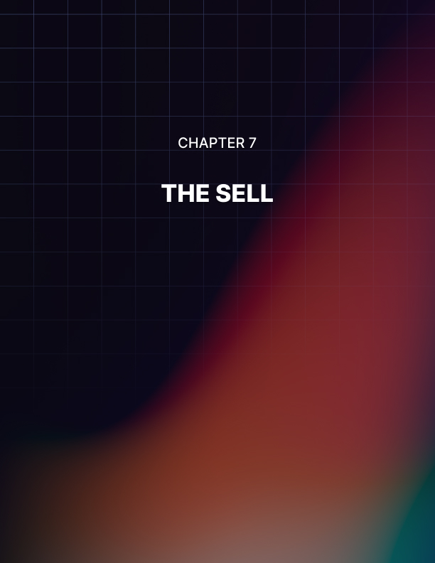

Chapter 7: The Sell

This is equally as important as creating your product. You can create the best, most useful product in the world but that doesn’t do you much good if you don’t know how to sell it, does it? Your product doesn’t make you any money sitting on your hard drive.

If you have an existing mailing list, tell them about your new product first! Offer them the best deal possible – a special offer that no one else will be getting. (You’ve gotta treat your own list the best.)

I would also offer an affiliate program to my customers so they can promote the product to others while they earn a commission.

If you don’t have your own list, the first thing you may want to do is, start sending out ‘joint venture’ offers to other businesses in your field. Offer them a nice-sized commission (at least 50%) and explain to them how they (as well as their customers) will benefit from the deal. I would send out at least one JV letter, per day.

If all you do is work on striking joint ventures with other marketers and business owners, you will not need any other marketing strategy to pull in amazing profits. Joint ventures are the best thing out there for us writers and marketers -- especially online!

You can also use highly-targeted ezine ads to get customers. (Here's a twist to this technique: instead of targeting customers, target affiliates who will help you sell the product! This strategy can grow your business very quickly!)

Another strategy that can work well for you (if you don't have an existing customer list) is to write short, focused articles and submit them to targeted ezines. Articles can be a great way to get viral advertising working for you.

There are hundreds of other strategies you can use. However, the ones listed above are some of the best and most effective ones around. You should always go for ‘quality’ traffic versus ‘quantity.’

There are numerous ways to sell an information product online and you may end up choosing to use many different methods.

Another way to do it is using Google Adwords pay per click. This is being mentioned only briefly here because learning how to do well with Google Adwords would fill another ebook entirely.

Adwords now named Google Ads are little ads that show up at the top of the search results. Bing Ads is also another pay per click service which is also very popular.

If you had a dog training ebook you would bid to have your adwords appear when people typed in relevant search phrases like “Dog Training” or “How To Teach My Dog To Sit”.

You have to constantly monitor your ad campaigns to see which ones are profitable and shut down the ones that are not showing enough return on investment.

You also have to make sure you set a daily spending limit, or your adwords bill could be in the thousands of dollars or pounds for an unprofitable ad campaign.

Some people make their living entirely by selling information products through adwords, so that is certainly an option. If you want to learn about adwords, read through all of Google’s own tutorials on the subject, and then buy some books on Adwords as well.

Another place to sell an information product is on The Warrior Forum, a popular internet marketing forum. Again, you need to join the forum, and then join the conversation there and post regularly for at least a few weeks. Then, you can go to the section of the site titled “Warrior Special Offers” and start out selling your information product there, if it is appropriate.

This works better if your product is related to internet marketing. Also, you need to offer the product at a price better than is offered to the general public, which is why it’s called a “special offers” section.

There are a number of rules regarding Warrior Special Offers; make sure to read them carefully. There is a small fee to post a Warrior Special Offer.

Another very popular way to sell your product is through Clickbank.Clickbank specializes in downloadable products. You have to apply to be a merchant on Clickbank and there is a one time setup fee. Then, you can encourage affiliates to sell your product for you, in exchange for a generous commission.
To entice affiliates you are going to have to offer a really large percentage of the product price, at least 50 percent and preferably 70 percent.

However, look at it this way. The affiliates will do all of the hard work for you, paying for adwords to drive traffic to your sales page, writing articles for article marketing directories that link to their pre sell page or to your sales page, creating presell pages that link to your sales page...and the more you pay them, the more incentive they have to work hard to sell your product.

Here are some tips to keep your affiliates happy and to attract good affiliates:

- Never undersell your affiliates. Do not offer your product for $25 if you have set the price they will promote it at $37.
- Offer good affiliate support. Offer them artwork to put on their sales page, showing your product; several different product pictures would be ideal. A picture of the ebook cover and a banner ad at the bare minimum, would be helpful.
- Offer them several custom written articles that they can then rewrite and submit to article directories.
- Offer them a free squeeze page that they can put their affiliate link on. Offer a cash bonus for every 100 copies of your product sold.
- Offer them unique bonuses they can give away to their audience if they purchase the product.
- Make sure that the terms and conditions of your affiliate offer are clear and specify what the affiliates can and can’t do: no misleading ads, etc.

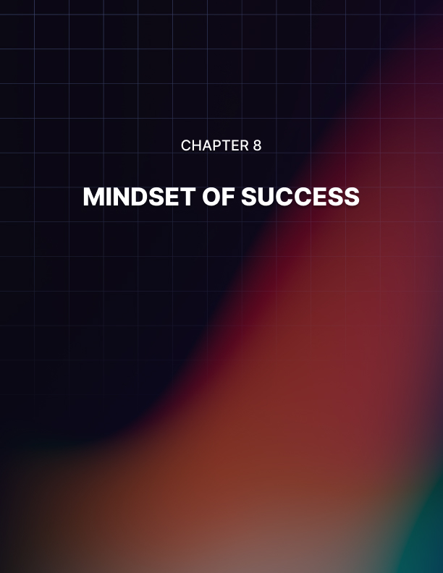

Chapter 8: Mindset of Success

The reason I've included this chapter on mindset is to help other people (like you) get started creating their own products. I know it can seem like a daunting task, but believe me when I say it is also the most profitable step you can take for your financial future!

There is a lot of information on the web on how to create your own products but not many of these sources provide a clear and concise step by step plan so that you can get your product out there and make money in the shortest time possible. This is all the information you need.

Stop buying more books about how to create digital products. The truth is you have this information in this guide, it’s time for you to take action.

I am confident if you follow the steps within this course and TAKE ACTION you will have your very own killer product that will bring in sales for years to come.

The hardest thing I've found and probably many other people find when they get started with any aspect of Internet Marketing is all of the hard work it involves.

I am not sure how you got interested in Internet Marketing but if you were like me you have probably been pulled in at some point, by all the websites out there that promise untold riches for 5 minutes work!

Don't get me wrong this is indeed possible, but in my experience not when you are getting started. It is indeed a reality if you have a list of 3,000 responsive buyers that you can send out an email that will make you thousands of dollars within a few days.

Although to start off you need to create that product and build that list and unfortunately that will require some good old-fashioned research, action and elbow grease!

So, you will need the correct mindset. Mindset is so important for your success.

Why is it this ebook can get handed to 2 people? One person does nothing, the ebook gathers digital dust on their hard drive. The other uses this exact information, takes massive action, learns, improves and gets better and creates a 6 or even 7 figure online business with digital products. They both had the same information, however the person who has success had the right mindset.

I will give you the answer to the number one question that stops people taking action or makes them give up in my experience.

I know this question comes up and can be very hard to overcome because I have asked myself the same question plenty of times when I was getting started with Internet Marketing.

Here is the question or questions I found myself asking when I was getting started:

- “Is this going to work?”
- “Is all this work worth it?”
- “Will my product sell?”

These are the three main questions that I found myself asking when I was creating my own product. Well take it from me the answer to all those questions is “Yes it really does work!”.

If you follow the steps within this course you will see that creating digital products to sell does not have some secret formula.

All you have to do is see things through to the end, have the ability to follow a series of steps and probably most importantly take action!

Whether it takes you 5 days or 5 weeks to follow these steps, see them through to the end and I guarantee you will achieve success online.

Once you create your own product and once that is pulling in money you can do the same thing over and over to build a digital product empire.


Conclusion

Every digital product can be made better. Your first goal should be to get your product out there in a good enough standard which provides value and helps solve people’s problems.

After that you should then start to make it better.

Most importantly, keep testing and tracking everything you do!

After you have the basics down, start testing everything to make it better. Test your headlines to see which one pulls better.

Test your offer, packaging, benefits, pricing… test everything! Don’t let anyone tell you what they “think” will work. Let your customers decide that for you.

Measure the response of everything you test to find out which is working better and producing more profits.

Don’t ever stop improving on what you have.

Each little improvement you make (after testing it out) can mean substantial additional profits for you. It’s the easiest way I know of to give yourself a raise without really doing too much extra work.

Finally, make your package unique, either through the offer, the packaging, or the product itself. Make yours stand out from the rest of the pack.

If you don’t do that, you’ll be lost among the other mediocre offers, and your customers will probably never find you.

(If you can’t think of a way to make your product/offer unique, just look at how other industries are doing it. You’ll get some great ideas just by watching other businesses that are completely unrelated to your field.)

Do the above and you’ll continue to get great results.

Creating information products to sell online is, I think, one of the most exciting and accessible businesses EVER.
You don’t have to have any qualifications, experience or expertise to start selling info products and the start up costs can be little more than zero.

This is important because it means you can try out different ways of selling and different types of info products without risking much cash.

If you’ve got a PC and internet connection and an interest in making money online then there’s really no excuse for not trying to profit from info products. It’s a fabulous business and never before in the entire history of man has the technological and sociological era been as ripe as it is now, for smart people to profit from info products with little or no start-up costs.

Go grab your piece of the money pie!

