Disclaimer

This eBook has been written for information purposes only. Every effort has been made to make this eBook as complete and accurate as possible. However, there may be mistakes in typography or content. Also, this eBook provides information only up to the publishing date. Therefore, this eBook should be used as a guide - not as the ultimate source.

The purpose of this eBook is to educate. The author and the publisher do not warrant that the information contained in this eBook is fully complete and shall not be responsible for any errors or omissions. The author and publisher shall have neither liability nor responsibility to any person or entity with respect to any loss or damage caused or alleged to be caused directly or indirectly by this ebook.

This eBook offers information and is designed for educational purposes only. You should not rely on this information as a substitute for, nor does it replace professional medical advice, diagnosis, or treatment.
Table of Contents

Introduction 4
Chapter 1: The Psychology of Staying Focused 9
How the Brain Chooses What to Focus On 9
What’s the Problem Here? 10
Notifications are Just as Distracting as Phone Calls 10
Chapter 2: Find Your Willpower 14
The Pareto Principle 14
Goal Setting and Objectives 14
Chapter 3: Create a Focus Haven 18
Chapter 4: Staying Focused In a Digital Age 23
The Distraction of Our Phones 23
Digital Minimalism 23
Chapter 5: You’re In Control of Your Time 27
Parkinson’s Law 27
Pomodoro Technique 27
Eat the Frog 29
Single Tasking vs. Multitasking: Which Is Better? 30
Chapter 6: Don’t Forget to Take a Break 33
Chapter 7: Fuel Up 36
How Sleep Improves Focus 36
Getting the Right Diet 37
Chapter 8: Make It a Habit 40
What is a Habit? 40
How to Create a Habit 41
Conclusion 44

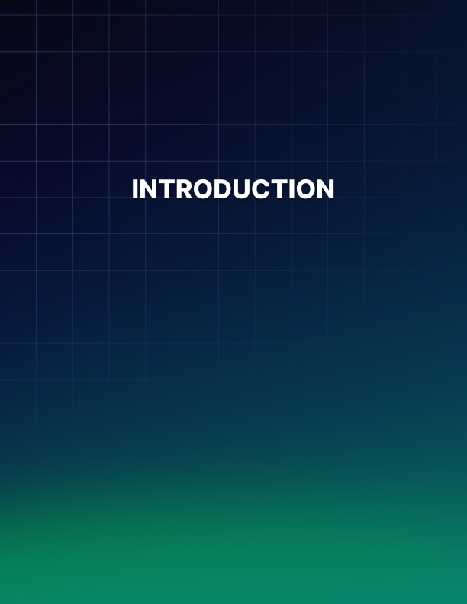

Introduction

Maintaining your focus in a noisy and distracted world can be tough. There is so much pulling our attention in every direction that it seems almost impossible to focus on the tasks that are truly important. From social media to text messages and calls and even people stopping by to talk, there is always something that can take our attention away from getting work done.

The result is that we feel like we are behind. When we spend most of our day checking notifications on Facebook or responding to unimportant emails, we find that there is very little time left to get projects and other work done. This can leave us feeling overwhelmed and may drive us to overwork ourselves, while feeling like we get nothing done.

This guidebook is here to change all that. The goal is to learn how to focus our attention and manage our time so we no longer have to stay at work late to finish projects or waste time away from our loved ones. Inside, we will learn that we are the ones in control over our time, not the clock, and that we can actually get things done based on a schedule of our own choosing.

As we work through this guidebook, we will learn the importance of setting goals, minimizing distractions, and even taking breaks. When it comes to focusing, we can work with some of the best time management techniques, including the Pomodoro Method and Eat the Frog to help us get more done. Slowly, by implementing some of these tips in one at a time, you can start to turn these ideas into habits and improve your focus when getting work done.

Stop letting this noisy and distracting world get the best of you.

Stop being a slave to the clock and feeling like nothing gets done. Take a look through this guidebook and see the exact steps you can use to reclaim your time and your focus!
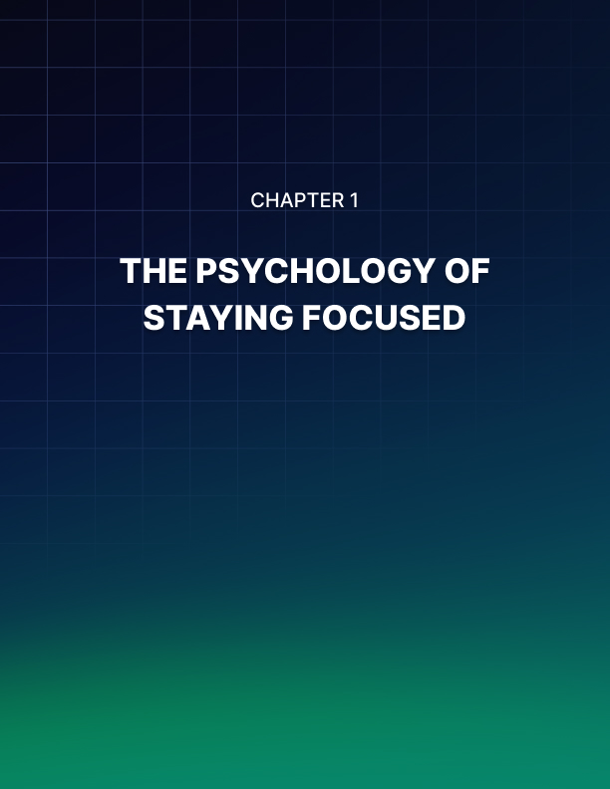

Chapter 1: The Psychology of Staying Focused

When we think about how many things are vying for our attention right now, the list seems endless. From a long to-do list to our phones, emails, family members and more, it seems almost impossible to keep up. While modern technology is amazing and has helped improve our world so much, there is the side effect of always getting our attention.

Think about your phone. It is common to see one notification after another popping up and distracting us from the things that we need to get done. All of a sudden we have wasted an hour and have a ton of work left to do. This continues to happen throughout the day and makes it impossible to get ahead.

You are not alone in this problem. The average office worker will find a distraction every three minutes. Research from the Human-Computer Interaction Institute at Carnegie Mellon University says that it can take almost 25 minutes to get back on task after a distraction. Basically, it is easy to lose focus and hard to get it back. We may not have a problem with too much work, but rather a problem with too many distractions.

How the Brain Chooses What to Focus On
During the day, your brain is always on and trying to gather and take in important information. This means that it has to sort through the noise and decide what it wants to focus on. This is called selective attention and there are two main forms that come with it:

Top-Down
This is also known as voluntary focus and it is one of the best types. With this focus, you pay attention to your goals. You look at the bigger picture and come up with a plan that helps you get there. You know that your phone and emails keep you from reaching these goals so you ignore them. You get stuff done on time, if not ahead of time.

Bottom-Up
This is more of a stimulus-driven focus. When a thought starts to creep up to you or a notification shows up on the phone and you get distracted, this is a sign that you work with bottom-up focus. You have to pay attention to what is going on around you, rather than the thing that deserves the most attention for you.

What’s the Problem Here?
The ultimate goal is to become a top-down thinker. This allows us to focus on what is important and avoid all the rest. Unfortunately, because of our natural instincts, we are often bottom-up focusers instead. Willpower and focus are finite resources, which means that the more you are distracted, the harder it is to get back on track. And since we are bottom-up focusers, every little thing is enough to distract us from our goals.

FOCUS
Since most of us can be easily distracted by little things like emails and notifications on our phones, we need to prepare for this. We need to be aware of it and limit the amount of distractions that we have during the day. Turning your phone off and staying away from social media, for example, can help keep the distractions down so your brain will not even realize they are there and you can focus on your work.

There is just too much that is adding to our focus problem and trying to draw our attention away from what is important. Those notifications, those emails, and those little things have a way of drawing us in, even if they are not that important at all.
We think we just give them a few moments of our attention, but it does not take long for them to take over and then we get nothing done during the day.

Notifications are Just as Distracting as Phone Calls
In the past, we would not know anyone was trying to contact us on our phones unless it rang. This was less frequent because most people had to have something important to talk about before they would go through the effort because it took some time for a phone conversation. Today, our phones often do not ring as much. But we may here a single beep or a vibration for a text or a Facebook message. And since these take just a few moments, we may get a lot of them during the day.

A study from three researchers at Florida State University suggest that getting one of these notifications, no matter how small they may be, could distract us as much as responding to a text message or a phone call, even if we do not respond to it. During this study, there were about 150 students who had to complete a test of sustained attentional performance. During this test, the subjects are given a series of single digits on a screen and a new digit will show up every second.

During this, the students are meant to tap on the keyboard each time the digit changes, unless the new digit is a 3. Each person did the test two times. The first time they did it without their devices there to interrupt them. The second time, they could have their phone and assistants to the test would text or place phone calls to these phones.

Through this, researchers found that the performance for that assessment suffered if the student received audible notification on their phone of any kind. Each type of phone distraction, whether it was a phone call or a text, was destructive to how well they did. It didn’t seem to matter if the student didn’t answer the phone or ignored the text. If they got the notification, they still knew they had that notification and their performance suffered.

This is telling to our focus and it is an example of how bottom-up thinking works. Something as small as a text notification is enough to send our focus out the window and can make our performance suffer. Recognizing this and finding methods to limit the impact it has on our work can be critical if you want to improve how well you do at work.
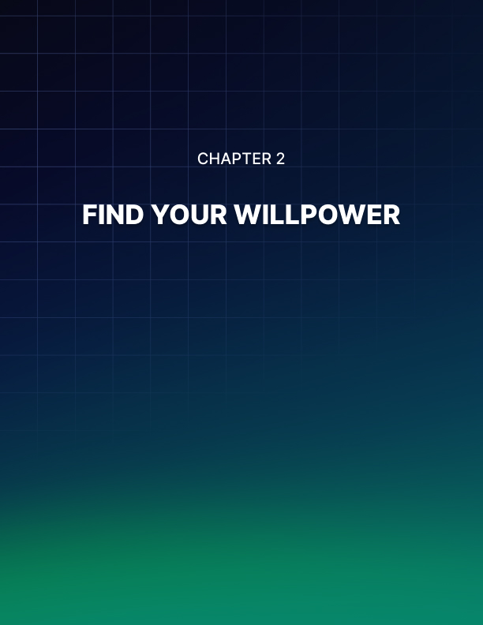

Chapter 2: Find Your Willpower

Even if you get easily distracted and you have bottom-up focus, there are steps that you can take to limit the effect of this. If you are tired of having your time eaten up by looking on social media or checking your phone each time it dings, and you do not want to work overtime in order to get the work done, then there are steps that you can take. This will not always be easy, but finding your willpower and what motivates you can make a difference.

Before we dive into some of the specifics on how to manage your focus, we need to look at how to find your willpower.

Understanding the Pareto Principle, and learning how to set clear goals for yourself can help make this happen.

The Pareto Principle
The Pareto Principle specifies that about 80% of the consequences in any situation will come from about 20% of the causes. This shows that there is an unequal relationship between the inputs and outputs. It often referred to as the 80/20 principle.

While this principle was originally applied to the relationship between wealth and population, it can be applied to many other areas including human resources, management, and manufacturing. It can also be applied on a more personal level. Time management is a common use of the Pareto Principle.

Many people tend to spread out their time rather than focusing on the tasks that are the most important. In this case, about 80% of your work-related output may come from 20% of your time at work.

Goal Setting and Objectives
To help you get more out of your time at work, you should set goals. This helps you to stay focused better and gives you something more to work towards. Your goal should not be, get more done. It needs to be more focused and specific to help you get results.

The best way to set a goal is to have. SMART Goal. These stand for specific, measurable, attainable, relevant, and time-bound. These can give you the specifics that you need for goals that will get you ahead. They can also be motivational so you keep working on them rather than giving up halfway.

You can set goals based on what works the best for you. Do you want to make it a goal to stop getting distracted at work? Then decide how much time you will allow yourself to check emails and phone calls and set that as the goal. If you have a big project at work, then use the SMART Goals idea to help you stay on track.

Let’s say you have a major project to get done at work and you are often getting things done at the last minute. This time we are going to use SMART goals. List out exactly what you want to get done in the goal. For this one, we want to get the project completely done by the deadline.

Then we will split it up into more manageable parts that are measurable, giving each part a due date that is attainable for our needs. The way that you split this up will depend on the exact project that you need to get done but having it in smaller and more manageable chunks can make life easier and gives you something to check off as you go. This alone can be motivational for many people.

Always remember to put a time-limit on any of the goals that you would like to reach. It is easy to just list out the items that you want to finish and then do nothing else with them. This is the fastest way for to get in trouble because you will keep putting them off. Set the goal with a time limit that is reasonable for that part of the project and stick with it so you no longer need to leave the work until the last minute.

Goal setting can help you use the Pareto Principle to its full advantage. When you are organized and can keep on track, it is amazing how quickly you can get work done and move on to something more important. No more wasting time at work or home, no more waiting until the last minute to get things done; you have clear goals that will help you succeed.


Chapter 3: Create a Focus Haven

The more distractions that go on around you, the easier it is to forgo your work to look at them. Your brain hears a ding or sees a notification about an email or a missed message, and it assumes that the information is important and needs to be answered right away. Of course, this is usually not the case and is just an easy way to distract yourself.

If you want to improve your focus, then you need to create a focus haven around where you plan to work. Cut out the noise and any distractions that often get in the way. Not sure what those distractions are? Take note for a few days and see what items and sounds tend to pull your attention away when you are supposed to be working.

An area that is void of all those distractions can make a big difference in how much work you get done. When you do not constantly hear your phone beep or vibrate, you will be amazed at how much you are able to get done during the day. You may even be able to get the work done early without the stress!

Some of the ways that you can create your focus haven includes:

Turn Off Social Media and Email
The first thing that you need to do when setting up your focus haven is turn off the emails and the social media. Social media is one of the biggest time wasters out there and it will not help you get anything done that you need. You should just turn it off as soon as you are ready to get some work done. If you need to, set up something on your emails to let anyone who sends you something know that you are working and can respond to them later. They can always come knock on your door if the matter is urgent.

Turn Off Your Phone
Our phones are connected to so many different things that it is a constant barrage of information and things that can distract us. From social media alerts, emails, phone calls, and texts, our phones are going off all the time. If possible, it is best to turn the phone off when you have some work to do. When you are all caught up, then you can turn the phone back on and look at some of the important emails and other parts.

If you have a job that you can’t completely turn off the phone, be a little creative. Have it set to only ring or send a message when it is someone important, and do not have it do this when any other message comes up.

Close the Door
When you leave your door open, you are inviting a lot of distractions to come in. You can easily hear all the noise and other commotion that goes on in other offices and down the hall and it does not take much before you notice something that gets you away from your work. Then there is always the chance that someone will see the open door and stop by to talk. A quick question can easily turn into socialization that eats up all your time.

When you need to get something done at the office, close the door. If possible, make it look like you are not even there. A closed door helps to muffle all the sounds that are around you in the office and makes it less likely that someone will knock on the door to talk. This can do wonders for helping you get some of your work done.

Turn on Some Classical Music
Classical music is the best for this. It is something that can help fill in the empty silence around you, or cut out the noise that may easily distract you, without being a distraction itself. Do not be tempted to add in some of your own music. While it can be fun to listen to your favorite band, it does not take long before that favorite song will get you distracted as you sing along. Plus, classical music has been shown to help improve focus! Use classical music to give just enough music and sound behind you to avoid more distractions in the workplace.

Organize
You may need to get a little bit of planning down to help with this one. Organization can prevent distractions and may stop you from having to search around the area to find the things that you need. When you have to stop and ask someone about a project or you need to search to find the items that you need, it can add a lot of time to a project and slow you down.

Being organized and ensuring that each thing has its own place will make a big difference in how productive you can be. And it eliminates any chances that your focus will go to something else when you should be working. You will know exactly where every item is and can just reach for it.

There are a few ways that you can work on this one. To start, take some time to organize your whole work area. Have items put close together that you often use with one another. Put them away and throw out anything that gets in the way or is trash that you no longer need to use. Then at night, when you try to create your to- do list, grab the items that you will need for the project and put them together in one area for each project you want to complete. You can then grab the items and use them as needed without as much searching around.

When you can make the space around you more tranquil and distraction free while you need to get stuff done, you can minimize the distractions and keep yourself hard at work. By turning off the phone and email and making it harder for others to know you are even there so they won’t stop by, you will find that it
Is easier to relax and focus.
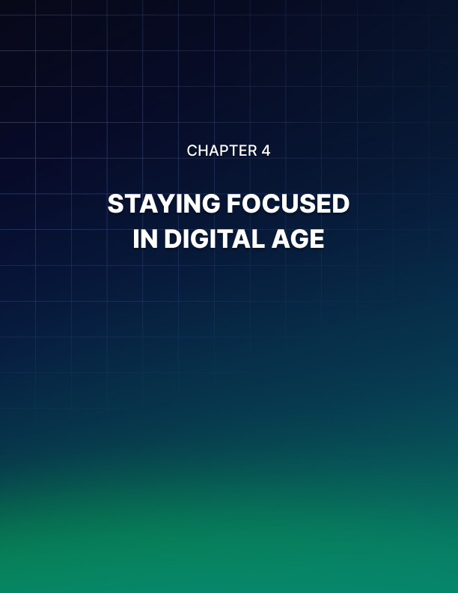

Chapter 4: Staying Focused In a Digital Age

The digital age has done a number on our focus. Even the most motivated of people can get instantly distracted when they see that little notification come up on Facebook or they notice another text or email has come up for their phone. This can make it difficult to stay focused and get anything done. And with more and more technology coming in all the time, it is just going to get worse.

The Distraction of Our Phones
Our phones are often our biggest distractions. They are no longer just a simple device to call someone on. They provide us with text messages, emails, social media alerts, and phone calls all in one. It is no wonder that they will provide us with hours of entertainment and distractions that make getting work done almost impossible.

With our phones going off all the time, staying focused will be hard. When we hear the ding or the vibration that alerts us that a text or an email or some other alert has occurred on our phones, we instantly want to pay attention. Even when we admit that the information is probably not that important and can wait, our focus has shifted and it will bother us until we check. This takes time away from work and can make it hard to get back on task, especially if this happens many times.

While our phones can be a really useful tool, they are one of the worst distractions when you want to get things done. If you are serious about helping your focus, then the first thing to work on is removing your phone. You may need to drop the phone off with someone else or turn it off so you can avoid all these distractions and keep yourself on task.

Digital Minimalism
At least when you are trying to get work done, you need to become a digital minimalist. This basically means that if the technology is not needed to get the work done, then it has to go. If you can do all the work without any technology, then turn it all off. Your goal is to see how much of the technology you can turn off or take out of the room and see how quickly your focus comes back into play.

Maybe you need to work on a report for a project. Spend half an hour or so online looking up information that you need, printing off the emails with relevant information, and gathering all the facts you need. After that half an hour, print everything off and then turn off the internet. If you are able to write out the report, then turn off the whole computer. If you need to type it up, go and physically turn off the Wi-Fi while you do your work.

This is important. Do not assume that you can keep yourself away from social media, searching online, emails, and everything else while you are on the computer. Some people can do this and may not need to turn everything else off. Others may be tempted to check things all the time. When you unplug the Wi-Fi, the only thing you can use is Word, or other similar software that does not need to be plugged in.

Don’t forget to turn off the other digital options around your office. Turn the phone off, the speakers off, and anything else that may connect you to the internet and any of the world outside your office door. You do not have time for that right now and it can all wait.

With all of it turned off, you have no more distractions. You can use the research you found earlier to help write your report and get stuff done. If you have a question or something you need to double check, do not turn the internet back on or reach for your phone. Make a little note on a post-it and look at it when all the work is done. You will be amazed at how quickly a report can get done when you focus all your attention on that rather than on every distraction that goes on around you.

Each thing is going to be a little bit different on how you do digital minimalism. If you are a social media expert, you will probably need to be on Facebook or something similar to get the work done. But you can turn off your email and phone during that time and make sure that you only spend time on social media and not on your own. With each project you work on, think of how many digital items you can turn off before you begin and see what a difference it will make.
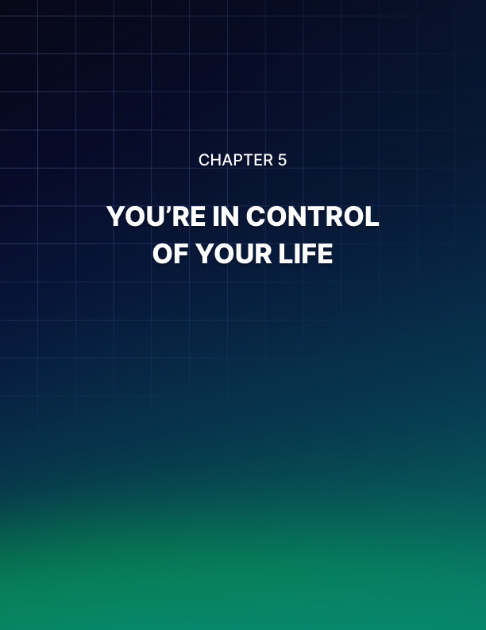

Chapter 5: You’re In Control of Your Time

One thing that many people forget about is that they are the ones in control over their time. They assume there are just not enough hours in the day to get all their work done and they feel overwhelmed when projects come due at the last minute. But with the right amount of focus and good time management techniques, you can easily learn how to take control of your time and get things done on schedule.

Parkinson’s Law
Parkinson’s Law is the idea that work expands so as to fill the time available for its completion. This simply means that the amount of time that you provide to yourself to finish a task is the exact amount of time that it takes to complete it. So, if you get three weeks to write an essay, then it takes that full three weeks to get it done. If you have a week to get the project done, then it will be done in a week.

While there are some exceptions to this (you can’t finish a 100 word document in an hour), the idea is that you can get the work done in the amount of time that is necessary. This is why it may take you three weeks to write an essay, but if you were given only a week, you would still be able to get it done in time.

If you set the timeline out too far, or make the goal too distant, it will take you that much time to get it accomplished. It does not matter how far out you set it, it will still take that long to get it all accomplished. If you want to make sure you get your work done in a timely manner, rather than at the last minute, then set the timeline sooner. Even if the deadline is three weeks, make your own goal to get it done in a week and see what a difference it makes. You may be surprised at how quickly you can get that project done!

Pomodoro Technique
The Pomodoro Technique is a good option to use if you need help staying focused on a task. If you find that small distractions get in your way, you often have to work past the point of being optimally productive, and you have open-ended work that could take an unlimited amount of time such as studying for an exam, then this technique can help you stay focused and get things done.

The basic idea is that you will set short bursts of time that you get work done. With the help of a timer, you get to work and try to accomplish as much as possible during that time. When the timer is done, you take a break. This lets you know that you have small bursts of time that you really focus, but then you will get a break, which may help you be more focused and get more done.

The core of this method is to work in 25-minute sprints. You can break down some smaller items into the same sprint if necessary and if they are small. And if you finish a project, then go ahead and work on the next thing on your to-do list. Never finish within the 25-minutes and then start to check your emails and get distracted. You can do that later but as long as the timer is ticking, you need to get work done.

Using this method is simple. It allows for working time and for some good breaks to give yourself a little rest. To work with this method:

- Get a to-do list and a timer. Fill out a list of the tasks that you need to get finished with the most important stuff on top.

- Set the timer for 25 minutes and then focus on a single task until the timer rings. Some bigger tasks may need a few of these 25 minute sprints to get done, but the point is to work on one thing at a time. If you have smaller tasks, group those together and do them in one sprint.

- When the session is done, mark off one pomodoro and then record what is done.

- Take a quick break to stretch and move around when that is done.

- When you have completed four of these cycles, it is time to take a break. Give yourself 15 to 30 minutes to move around and rest after all that hard work!

With these short bursts of intense concentration and focus, you will find you can get a lot more done. This short of a time period does not seem like much, but it can add up quickly and give you a chance to get ahead on your work.

Make sure to remember to take those breaks as you go along. It is easy to want to go full steam ahead and work more and more. And that is admirable that you want to get the work done. You may even be able to do a few sprints like this without the breaks. But this method is meant to help you get some intense focusing going on and your brain will need a break. Even half an hour after a few hours of hard work can make a world of difference.

Eat the Frog
Another method that you can use to help you get through all the work you need to accomplish during the day is known as Eat the Frog. This idea is that you will work on the most important task first and get it done right away in the morning. If it’s your job in the morning to eat a frog, then you should do it in the morning so it does not hang over your head all day. If you need to eat two frogs (or have two major things to get done during the day), then you should eat the biggest one first.

The idea here is not to just do the one task and then call it good for the rest of the day. But focusing on that one big task that needs to get done can help free your mind up. You do not have that big project pulling on your attention all day because that is the thing you focus on first. Once it is done, you have all that free focus to do other things. Plus, when you do the big thing first, the other smaller things seem easier and faster to do.

To use the Eat the Frog method, each morning you will:

- Identify your frog: This is going to be the task that is the hardest or the most important for the day.

- Eat it: This means that you get to work and get that task done right away. Do not put it off and try to do it later.

- Repeat it: Each day you will find the frog and then eat it right away.

Once you are done with that big task, you can work on some of the other tasks that you need to accomplish. But with that big task done, you no longer need to worry about it hanging over you or getting put off until the last minute.

This method may seem to have a weird name, but the idea is the same. You need to get the thing that is the hardest or the least enjoyable done right away in the morning. This way it is not hovering over you all day long. You can get it done and feel a sense of relief while you focus on getting all the other work done.

Single Tasking vs. Multitasking: Which Is Better?
All of the methods we discuss above ask you to do one task at a time. It does not matter how many tasks you need to get done, they all ask you to pick one at a time and focus on that until it is done. When that task is completed, you can move on to the next one and then the next one and so on.

This is because single tasking is often the best choice. We often assume that if we are doing a lot of tasks at once that we are being more efficient. This is wrong.
Multitasking often causes us to be more distracted and struggle with focus. We also do not complete tasks very well when we try to do a bunch of them.

With single tasking, we only focus on one thing at a time, avoiding all of the distractions from the other tasks that may get in our way. We can also do a better job on one task because we focus all of our attention on it until it is done, rather than splitting up our attention against two or more tasks. This often leads us to getting the work done faster too.

While it may seem like you are always running low on time when it comes to getting your work done, you have more control over your time than you could imagine.

With a good understanding of Parkinson’s Law and understanding some of the different time management techniques at your disposal, you will soon find that you have way more time in your day than you ever imagined.
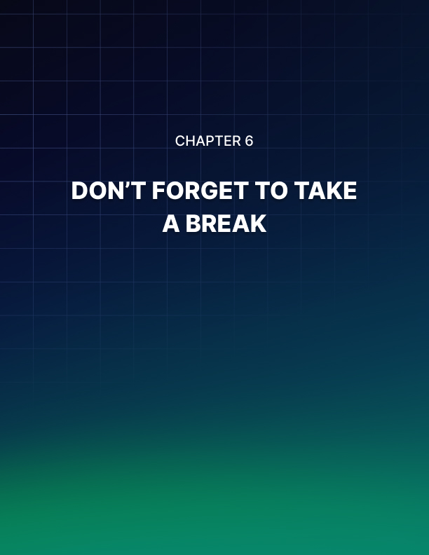

Chapter 6: Don’t Forget to Take a Break

It is easy to get excited about some of the methods we discussed in the last chapter and assume that you need to run full-steam ahead to get it all done. But it is also important to take a lot of breaks when you are doing any of these methods. Our brains are not designed to spend hours on end trying to get all the work done. And trying to force them to can make us tired and worn out. Before long the distractions will come.

That is why all of the methods we discussed above have breaks built in. When a task is done, you are supposed to take a break. When one of the sprints is done with the Pomodoro Method, you are supposed to take a break and an even longer one once four sprints are done. Breaks are great for aiding your focus and helping you stay on task.

Taking breaks from any mental work that you do is going to be helpful. It will make it easier to focus and can boost your productivity levels as well.

Some of the benefits of adding breaks into your day include:

Increases Your Productivity
Recent studies show that having some kind of break once an hour or so can help you be more productive than those who continued to work without a break. After some time, our brains are going to feel tired from all of the stimulation, making it hard to handle the task or see it as important any longer. When we take a break, we can come back to that job with some new energy and more focus.

Can Be Your Creative Fuel
Even if you really love the work that you do, you can’t keep on being creative and focused when your mind is tired. Even ten minutes to walk around your office or to go and grab a drink can help you calm down and just gives the brain a little rest.

This may bring about enough rest to help you think about the problem in a different way and find the solution that you want.

Physical Movement Keeps the Brain Sharp
When taking your break, it is a good idea to get up and move around as much as possible. Do a walk around the office or some jumping jacks. If you can get outside for a few minutes, give that a try. Physical activity, as well as fresh air and some sunshine, can do wonders for cleaning the fog that may come over you after working hard. While maintaining focus is good for getting work done, it does strain the brain and can make it wear out faster than normal. These healthy breaks that get the blood pumping through physical activity can be just the ticket that you need.

It is easy to fall into the trap that we need to sit down at our desks and focus all of our mind and attention on the tasks at hand for eight hours a day. This is going to wear you out quickly and can make your focus and productivity wane. Focus is necessary to get the work done, but regular breaks are just as important to keep the brain from burning out as you do your work.


Chapter 7: Fuel Up

Taking care of your body is an important piece of the puzzle when it comes to helping you focus. Without enough sleep and the right foods to provide important nutrition to the body, the brain is not able to focus or perform the way that it should. Both of these components need to be in place or you will struggle to get anything done during the day. The other techniques can do some amazing things for helping you stay on task and get more done during the day, but they need some assistance from the food you eat and the amount of sleep you get.

How Sleep Improves Focus
It is really easy to avoid getting the sleep that you need. You may not think it is a big deal to stay up late and miss out on a few hours of sleep, but this can do a lot of damage when it comes to your sleep. Getting enough sleep is a good thing because it helps us to think clearly, make smart decisions, and remember information.

When we fail to get enough sleep, it is going to cause impairments of the executive function. This is basically a set of abilities that we use to do well at work, in school, and in all parts of our life. A clear and alert brain, which we get when we sleep, allows us to focus, remember information, and be creative. None of this is possible when we do not get enough sleep.

Think about the last time you barely got any sleep. You may have had to stay up with the kids or worked on a big project. After just a few hours of sleep, you felt worn out and had trouble getting anything done, no matter how hard you tried. This can happen, though to a smaller degree, when. You miss out on a few hours of sleep each day.

If you find that your focus is just not coming into line the way that you want, it may be time to look at your sleep schedule. A routine sleep schedule, meaning you go to bed and get up at the same time each day, will make a big difference in how well you feel in the morning. Aim for at least eight hours of sleep as well. This gives your mind time to rest and clear out the mess so you can get to work with some of the best focus around.

Getting the Right Diet
Eating a healthy diet is a great way to help you maintain your focus. Foods full of bad fats and lots of sugars can hurt your brain power and actually makes it harder to focus. The right foods will make it easier to focus on any task that you need to get done during the day.

Food is the main food that will help to regulate your energy and your mood. Both of these are critical when it comes to your attention. Just like it is not a good idea to add some olive oil into the car to help it run, you should not put a ton of cookies, chocolate syrup, pop and other items into your body to help you run.

Food is really amazing in that it can affect your mental clarity, memory, mood, and the ability to focus. If you are still struggling with focusing and getting things done during the day, then it may be time to look at the foods that you eat.

When we have a soda or eat something with a lot of sugar, it can give us a temporary burst of energy. We may feel great for a little bit, but this energy is pretty fleeting. As soon as the sugar high is over, we have a big crash. From there, it is impossible to stay alert, much less have the focus that we need. Healthy foods help keep our energy levels steady so we can focus all day long.

There are many foods like green tea and blueberries that have claims about how they help your memory and can make you focus. But the most important thing is to focus on an overall healthier diet. Eating foods that fuel the body, rather than ones that will give you a temporary burst of energy and then makes that sugar crash hard to work with, can be the best for sustained focus.

Lots of lean proteins, healthy carbs, and fruits and vegetables are a good place to start. These will give your body all of the vitamins and minerals that it needs to stay sharp. Keep some healthy snack alternatives around the office too. You never know when all of that hard work is going to make you worn out and tired and having something that is easy to grab and will fuel your body can prevent you from eating something bad that takes away your focus.

If you want to get the good focus that helps you get work done in a timely manner, then you need to focus on fueling the body right. Adequate amounts of sleep at night and eating foods that not only stop the hunger pains, but also help you get all the vitamins and minerals you deserve can make all the difference.
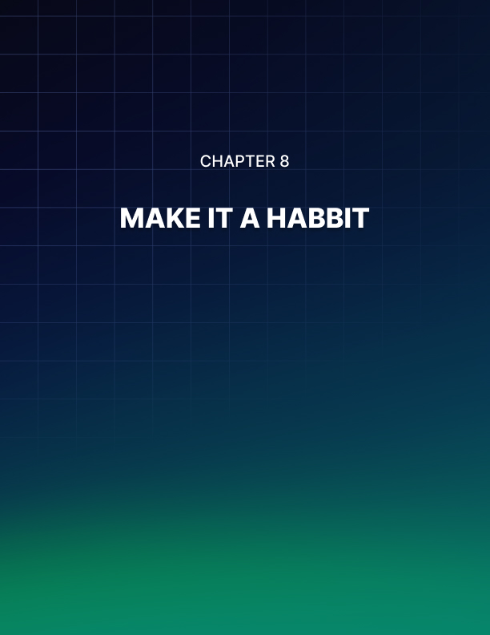

Chapter 8: Make It a Habit

All of the steps that we talked about above are great for helping you improve your focus. When you make clear goals about what you would like to accomplish and you get enough sleep and good food and you spend time using some of the time management techniques, you will find that it is easier to focus and you can get more done throughout the day.

But it is not always going to be easy. There will be times when you want to avoid doing the work or you would rather spend time on your phone. You may enjoy getting more work done during the first few days of trying out these different techniques. After a few days though, you may want to slip back into your old habits and not stick with it.

If you want to improve your focus and see results, you will need to not just read through some of the techniques above, you will need to turn them into habits that you are able to use day in and day out. When you get to bed and wake up each day for a month at the same time, you will make it a habit that is harder to break. If you get into the habit of Eating the Frog the moment you get into work, then it is just something you automatically start to do.

What is a Habit?
Your goal through all of this is to turn some of the actions that we discussed in this guidebook into habits. A habit is just a behavioral pattern that we develop by repeating it over and over again. It can often be used to help improve our performance of that pattern. When it is done enough, it is something that we can do without thinking about it.

This is a great thing for you because it will help you get more done, even without thinking about it. When you turn off your phone automatically when you enter your office, you have developed a habit that makes it easier to focus on your work and not get distracted. When you set up a to-do list and then sit down to work on sprints with the Pomodoro Method, you can get to work without feeling like it is hard to do.

Start with just one habit at a time. We gave a ton of suggestions through this guidebook that are meant to help you succeed. Taking them all on at once is an admirable goal, but one that will overwhelm you and can make it impossible to stay focused and on-task. Start with one or two that seem important to you. Maybe you make a goal during the first few weeks to get to bed half an hour earlier and that you want to try out the Pomodoro Method. From there you can see improvements and that may be enough to motivate you to try out a few other methods.

How to Create a Habit
Now that we have given you all of the tools that you need to take control over your time and gain more focus, it is time to turn those into a habit that you are able to use each day to get more done.

Some of the steps you can use to create new habits include:

- Focus on one habit at a time: If you spend a lot of time on your phone each day, maybe start by making it a habit to only check the phone once an hour. Then you can move on to making a focus haven in the office and then choosing one of the time management techniques. When you do one little thing at a time, it is easier to handle and can turn all of these into second nature while your focus improves.

- Start with a small habit: You do not need to dive in with the hardest habit to handle first. Start with something small.

- Be specific in your intent: You have to be specific and stick with the goal. Having a goal of just getting more done during the day just doesn’t cut it here. Have an action plan for how you will get everything done and be specific with your intent. If you are going to use the Eat the Frog method, know the day before which task you will complete for that and then sit down to do it right away in the morning with no distractions.

- Track your progress: The pomodoro method can be good for this since you are supposed to write down what you accomplish during each little sprint. At the end of a few weeks of doing it, compare notes and see how much more you are able to accomplish. You may be amazed at how much you can get done when you work on your focus and take control over your own time.

The process of creating a new habit is not that complicated. There are only a few steps to use. But following through with all of this is the part that is hard. The biggest obstacle to a new habit is just getting started. If you can get through the hard part and you can do the work for a few weeks, or up to a month, then it becomes a habit and you will find it is easier to just stick with it.


Conclusion

Maintaining our focus in this digital world is always hard. There are a lot of things that can catch our attention and may make it easy to get distracted and lose our focus on the task at hand. We may see a notification on social media, a text message, or even an email and feel the intense urge to check it out rather than doing our work. Each of these breaks can cost us valuable time when it comes to getting our work done.

In this guidebook, we took a look at how focus works with the brain and then explored a few of the different methods and techniques that you can use to help improve your own focus. This is not a process that will work overnight. It is easy to get distracted and avoiding the temptation of looking at your phone one more time or checking your email again is tough. But by slowly implementing some of the ideas in this guidebook and some of the techniques, you can slowly improve your focus and gain control over your time again.

