Table of Contents
Introduction 4
Mastering Clear Objectives 7
The Power of Clarity 7
SMART Criteria for Success 7
The OKR Framework: Aligning Your Team and Vision 9
The Power of Small Wins 10
Prioritizing Your Objectives: The Eisenhower Matrix 11
The Role of Flexibility in Goal Setting 11
Your Roadmap to Success 12
Crafting a Routine for Success 15
Understanding Your Habits 15
Aligning with Your Natural Rhythms 16
Building Effective Routines 17
The Battle Against Distractions 21
Understanding the Nature of Distractions 21
The Cost of Distraction 21
Strategies to Combat Distractions 22
Real-World Success Stories and the Role of Technology 24
Adapting Your Strategy and the Power of Deep Work 25
Sustaining Motivation Over the Long Haul 28
Strategies for Harnessing Motivation 28
Building Resilience and Overcoming Setbacks 30
Tools and Techniques to Sustain Motivation 32
Recap and Encouragement for the Future 36
The Power of Clear Objectives and Effective Routines 36
Managing Distractions and Sustaining Motivation 37
Embracing Continuous Growth and Looking Forward 38
Drawing Inspiration and Taking Action 39

Disclaimer
The information provided in this ebook is intended solely for educational and informational purposes. The author does not accept any responsibility for the outcomes that may arise from the application of the material within. While efforts have been made to ensure the accuracy and relevance of the content, the author cannot be held accountable for any errors or omissions, or for any consequences resulting from the use or misuse of the information provided. The responsibility for any actions taken based on the information in this ebook lies solely with the reader.



Introduction
Have you ever felt like you’re running on a treadmill, expending endless energy but getting nowhere? You’re not alone. In the fast-paced world of entrepreneurship, it’s easy to lose sight of your goals, drowning in a sea of distractions and competing priorities. But what if you could harness the power of self-discipline to transform your business and your life?
Imagine waking up each day with crystal-clear focus, tackling your most important tasks with unwavering determination, and watching your long-term goals materialize before your eyes. This isn’t just a pipe dream – it’s the reality for those who have mastered the art of self-discipline. And now, it’s within your reach.
In this book, you’ll discover the secrets that separate successful entrepreneurs from those who struggle to gain traction. You’ll learn how to cultivate the iron-clad willpower that propels you forward, even when motivation wanes. But this isn’t just another self-help book filled with feel-good platitudes. It’s a practical, no-nonsense guide that will revolutionize the way you approach your work and your life. From the moment you crack open these pages, you’ll be thrust into a world of possibility. You’ll uncover surprising truths about human behavior and motivation that will challenge your preconceptions and ignite your curiosity. Did you know that willpower is like a muscle that can be strengthened with practice? Or that the average person is interrupted every 11 minutes and takes 25 minutes to refocus on the original task? These are just a few of the eye-opening insights that await you.
But knowledge alone isn’t enough. That’s why this book is packed with actionable strategies and real-world examples that you can implement immediately. You’ll learn how to set clear, compelling objectives that align with your deepest values. You’ll discover how to craft a daily routine that maximizes your productivity and minimizes wasted time. You’ll master the art of overcoming distractions, both internal and external, allowing you to achieve laser-like focus on your most important tasks.
As you progress through these pages, you’ll feel a transformation taking place. The overwhelm and uncertainty that once plagued you will give way to a sense of clarity and purpose. You’ll find yourself tackling challenges with renewed energy and enthusiasm. And most importantly, you’ll start seeing tangible results in your business and personal life. But this book isn’t just about achieving short-term wins. It’s about setting you up for long-term success. You’ll learn how to sustain your motivation over the long haul, even when faced with setbacks and obstacles. You’ll discover strategies for staying resilient in the face of adversity, allowing you to bounce back stronger than ever.
What sets this book apart is its focus on practical, real-world application. You won’t find any fluff or filler here. Every concept, every strategy, every piece of advice has been battle-tested in the trenches of entrepreneurship. You’ll hear from successful business leaders who have used these techniques to overcome seemingly insurmountable challenges and achieve extraordinary success.
As you explore deeper into the book, you’ll uncover a treasure trove of tools and techniques designed to supercharge your productivity and focus. From the Pomodoro Technique to the Rule of Two-Minutes, you’ll have a full arsenal at your disposal to combat procrastination and maximize your efficiency. You’ll learn how to leverage technology to automate repetitive tasks, freeing up your mental energy for high-level strategic thinking.
But perhaps most importantly, you’ll gain a new perspective on what it means to be a successful entrepreneur. You’ll realize that true success isn’t just about making money or achieving fame. It’s about living a life of purpose, aligning your actions with your values, and making a positive impact on the world around you.



Mastering Clear Objectives
Imagine standing at the foot of a mountain, your eyes fixed on the distant peak. The journey ahead seems daunting, but you know that with the right approach, you can conquer it. This is precisely what setting clear objectives is all about in the world of entrepreneurship. It’s about transforming your grand vision into a series of manageable steps, each bringing you closer to your ultimate goal.
As an entrepreneur, you’re no stranger to big dreams and ambitious plans. But without clear, well-defined objectives, these dreams can remain frustratingly out of reach. In this chapter, we’ll explore how to turn your entrepreneurial aspirations into concrete, actionable goals that propel you forward.

The Power of Clarity
When your goals are vague or poorly defined, your mind struggles to focus and allocate resources effectively. It’s like trying to hit a target in the dark – you might get lucky, but your chances of success are slim. On the other hand, when you have crystal-clear objectives, your brain kicks into high gear. You become more focused, more motivated, and more resilient in the face of challenges. Clear objectives act as a roadmap, guiding your decisions and actions toward your desired outcome.
Consider the story of Sara Blakely, the founder of Spanx. When she started her company, she didn’t just have a vague idea of creating a successful business. Instead, she set a clear objective: to create footless pantyhose that didn’t show panty lines and made clothes fit better. This specific goal guided her product development, marketing strategies, and business decisions, ultimately leading to the creation of a billion-dollar company.

SMART Criteria for Success
One of the most effective tools for setting clear objectives is the SMART criteria. This acronym stands for Specific, Measurable, Achievable, Relevant, and Time-bound. Let’s break down each component and see how you can apply it to your entrepreneurial goals.
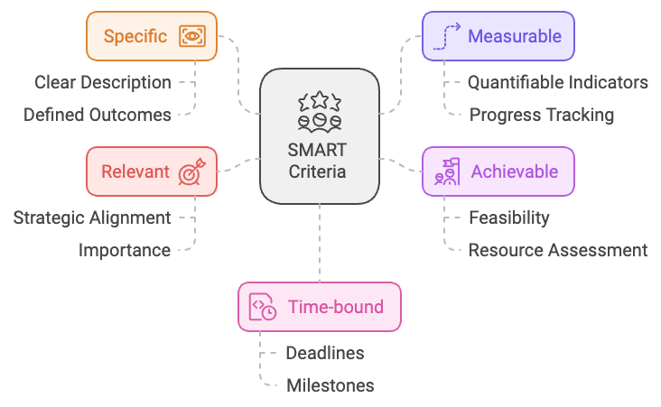
- Specific: Your objectives should be clear and unambiguous. Instead of saying, “I want to grow my business,” a specific objective might be, “I want to increase my company’s market share in the health food sector by 5%.”
- Measurable: You need a way to track your progress. This often involves attaching numbers or concrete outcomes to your objectives. For example, “I want to acquire 1,000 new customers in the next quarter.”
- Achievable: While it’s great to aim high, your objectives should be realistic given your resources and constraints. Setting unattainable goals can lead to frustration and demotivation.
- Relevant: Your objectives should align with your overall business strategy and long-term vision. Ask yourself, “Does this objective contribute to my ultimate goals?”
- Time-bound: Set a clear deadline for achieving your objective. This creates a sense of urgency and helps you prioritize your efforts.
Let’s put this into practice. Suppose you’re running a startup that develops mobile apps. A SMART objective might look like this: “To launch our new productivity app on both iOS and Android platforms, achieving 50,000 downloads within the first month of release, by September 30th of this year.”

The OKR Framework: Aligning Your Team and Vision
While SMART goals are excellent for individual objectives, when you’re leading a team or scaling your business, you might find the OKR (Objectives and Key Results) framework more suitable. This system, popularized by Google, helps align your team’s efforts with your company’s overall vision. Here’s how it works:
- Objectives: These are your ambitious, qualitative goals. They should be inspiring and challenging.
- Key Results: These are the quantitative metrics that measure your progress towards the objective. You should have 2-5 key results for each objective.
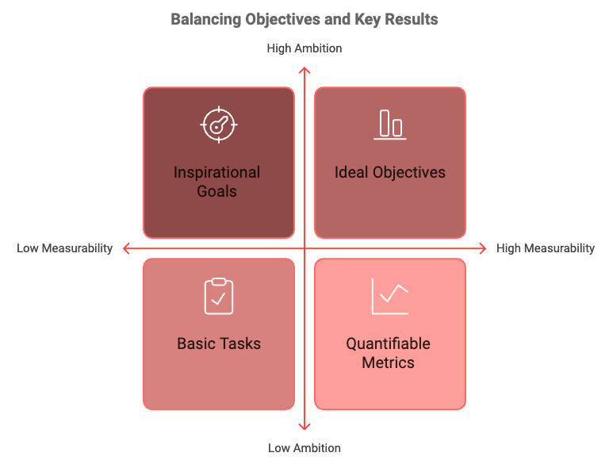
For example:
Objective: Become the leading eco-friendly packaging solution in the food industry.
Key Results:
- Increase market share from 15% to 25% by Q4.
- Achieve a Net Promoter Score of 8.5 or higher.
- Reduce production costs by 20% through improved manufacturing processes.
The beauty of OKRs is that they encourage you to set ambitious goals (the objectives) while providing clear metrics (the key results) to track your progress. This balance of aspiration and practicality can be incredibly motivating for you and your team.

The Power of Small Wins
Now that you’ve set clear objectives using SMART criteria or OKRs, you might feel overwhelmed by the scale of what you’re trying to achieve. This is where the art of breaking down big goals comes into play. Research has shown that the satisfaction of achieving small, frequent wins can be more motivating than the prospect of a single large achievement. By breaking your objectives into smaller, manageable tasks, you create opportunities for these motivating “small wins” along the way.
Let’s return to our app development example. Your objective of launching an app with 50,000 downloads in the first month can be broken down into smaller tasks like finalizing app features and design, developing MVP for iOS, conducting beta testing and gathering feedback, implementing improvements based on feedback, developing the Android version, preparing marketing materials, setting up app store listings, launching a marketing campaign, official launch, and monitoring and optimizing based on initial user feedback. Each of these tasks becomes a mini-objective, allowing you to celebrate progress and maintain momentum throughout the journey.

Prioritizing Your Objectives: The Eisenhower Matrix
As an entrepreneur, you likely have multiple objectives vying for your attention. The key to success is not just setting clear objectives, but also prioritizing them effectively. One powerful tool for this is the Eisenhower Matrix, named after President Dwight D. Eisenhower. This matrix categorizes tasks into four quadrants based on their urgency and importance:
- Urgent and Important: Do these tasks immediately.
- Important but Not Urgent: Schedule these tasks for later.
- Urgent but Not Important: Delegate these tasks if possible.
- Neither Urgent nor Important: Eliminate these tasks.
By categorizing your objectives and associated tasks in this way, you can ensure you’re always focusing on what truly matters for your business’s success.

The Role of Flexibility in Goal Setting
While setting clear objectives is crucial, it’s equally important to remain flexible. The business world is dynamic, and new opportunities or challenges may arise that require you to adjust your goals. Jeff Bezos, the founder of Amazon, is known for his ability to adapt Amazon’s objectives in response to changing market conditions. When Amazon started, the objective was to become “Earth’s biggest bookstore.” As opportunities arose, this objective evolved to “Earth’s most customer-centric company,” allowing Amazon to expand into various product categories and services.
To maintain this balance between clarity and flexibility, make it a habit to review your objectives regularly. Set aside time each week to assess your progress, and don’t be afraid to adjust your objectives if necessary. This might involve breaking down a goal into smaller steps if it’s proving too challenging, or setting more ambitious targets if you’re exceeding your initial expectations. During these reviews, ask yourself if you’re making progress towards your objectives, if these objectives are still relevant to your overall business strategy, if any new opportunities or challenges have arisen that require a shift in your objectives, and if you need to break down any objectives further or combine any for better efficiency.
Remember, the goal of setting clear objectives isn’t to create a rigid, unchangeable plan. Instead, it’s about providing yourself with a clear direction and a means of measuring progress, while remaining agile enough to adapt to the ever-changing landscape of entrepreneurship.
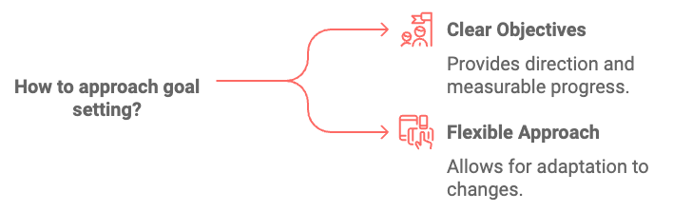

Your Roadmap to Success
Setting clear objectives is more than just a business practice – it’s a mindset that can transform your entrepreneurial journey. By applying the SMART criteria, utilizing the OKR framework, breaking down big goals, prioritizing effectively, and maintaining flexibility, you’re creating a roadmap that will guide you towards success. Remember, every great achievement in business started with a clear objective. Whether it’s Steve Jobs’ goal to “put a computer in the hands of everyday people,” or Elon Musk’s objective to “accelerate the world’s transition to sustainable energy,” these entrepreneurs understood the power of clarity in goal setting.
As you move forward in your entrepreneurial journey, challenge yourself to bring this level of clarity to your own objectives. With each goal you set and achieve, you’re not just building your business – you’re building your capacity for success. In the next chapter, we’ll explore how to craft a routine that supports these objectives, ensuring that your daily actions align with your long-term vision. Remember, setting clear objectives is just the first step. The real magic happens when you consistently take action towards achieving them.

Objective Type | Description | Example
SMART Goal | Specific, Measurable, Achievable, Relevant, Time-bound | Launch new app with 50,000 downloads in first month by September 30th
OKR | Objective with Key Results | Become leading eco-friendly packaging solution; Increase market share to 25%, NPS 8.5+, Reduce costs 20%
Eisenhower Matrix | Urgent & Important, Important but Not Urgent, Urgent but Not Important, Neither | Do immediately: Critical business decisions; Schedule: Long-term strategy planning; Delegate: Routine tasks; Eliminate: Time-wasting activities

Objective Achievement Rate = (Achieved Objectives / Total Objectives) * 100
This equation helps measure the effectiveness of your goal-setting and execution strategies.



Crafting a Routine for Success
The alarm blares, jolting you from sleep. You fumble for your phone, silence the noise, and stare at the ceiling. Another day begins. But what happens next? Do you leap out of bed, energized and ready to tackle your goals, or do you hit snooze, dreading the chaos that awaits?
For many entrepreneurs, the difference between success and struggle often lies not in grand strategies or breakthrough innovations, but in the small, daily actions that compound over time. This is where the power of routine comes into play. Routines are the unsung heroes of productivity, the scaffolding that supports your ambitions, the invisible force that propels you forward even when motivation wanes. By establishing effective routines, you’re not just organizing your day; you’re programming your mind and body for success.

Understanding Your Habits
Consider the case of Howard Schultz, the former CEO of Starbucks. Despite his demanding schedule, Schultz maintained a strict morning routine: waking up at 4:30 AM, working out, and sharing coffee with his wife before heading to the office. This routine, he claimed, set the tone for his entire day, allowing him to approach challenges with clarity and purpose. But why are routines so powerful? The answer lies in the concept of decision fatigue. Every decision you make throughout the day, no matter how small, depletes your mental energy. By establishing routines, you automate many of these decisions, conserving your mental resources for the critical choices that truly matter.
Before you can craft an effective routine, you need to understand your current habits and patterns. Take a moment to reflect on your typical day. What works well? What areas feel chaotic or unproductive? Be honest with yourself – this self-awareness is the foundation for positive change. To gain a clearer picture, try keeping a detailed log of your daily activities for one week. Note when you feel most energized and focused, as well as when you struggle. Identify patterns in your productivity, mood, and energy levels. Reflect on which activities contribute to your goals and which detract from them. This process might reveal surprising insights. Perhaps you’re most creative in the early morning hours but spend that time answering emails. Or maybe you consistently hit an energy slump in the afternoon, affecting your decision-making. Armed with this knowledge, you can begin to craft routines that align with your natural rhythms and optimize your productivity.

Aligning with Your Natural Rhythms
We all have unique biological clocks, known as circadian rhythms, that influence our energy levels, cognitive function, and mood throughout the day. Understanding and working with your natural rhythms can dramatically boost your productivity and well-being. Generally, there are three chronotypes: Morning Larks (peak performance in the early morning), Night Owls (most productive in the evening and at night), and Third Birds (fall somewhere between the two extremes). Identifying your chronotype can help you structure your day more effectively. If you’re a morning lark, tackle your most challenging tasks early in the day when your focus is sharpest. Night owls might find they’re more creative and productive in the evening hours.
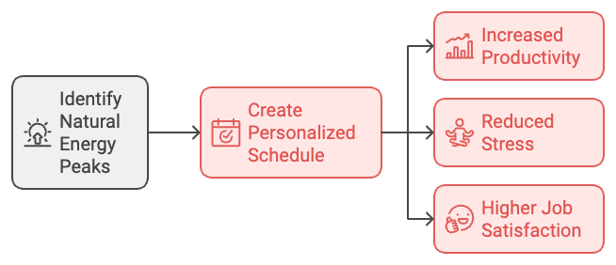
Remember, the goal isn’t to force yourself into a routine that doesn’t suit you. Instead, aim to create a schedule that harnesses your natural energy flows. This approach not only boosts productivity but also reduces stress and increases job satisfaction.

Building Effective Routines
For many successful entrepreneurs, the morning routine is the cornerstone of their day. It sets the tone, establishes momentum, and provides a sense of control before the demands of the world come flooding in. Here’s a framework for creating an effective morning routine: Wake up consistently, hydrate, move your body, practice mindfulness, fuel your body with a nutritious breakfast, and plan your day. Remember, this is just a template. Your ideal morning routine should reflect your personal goals, preferences, and lifestyle. Experiment with different activities and timings until you find what works best for you.
Once you’ve established a solid morning routine, it’s time to tackle the rest of your day. One powerful technique for maximizing productivity is time-blocking. This involves dividing your day into distinct chunks, each dedicated to specific tasks or types of work. This approach helps maintain focus, reduces context switching, and ensures you’re making progress on important projects rather than just reacting to incoming demands. To implement time-blocking effectively, start with your non-negotiables, group similar tasks, include buffer time, be realistic, and review and adjust regularly.

Time Block | Activity
8:00-10:00 AM | Deep work on challenging project
10:00-11:00 AM | Respond to emails and messages
11:00 AM-12:00 PM | Team meetings
12:00-1:00 PM | Lunch break
1:00-3:00 PM | Creative work or brainstorming
3:00-4:00 PM | Administrative tasks
4:00-5:00 PM | Review and plan for next day
Habit stacking is another powerful technique for building new routines. The concept is simple: you take a habit you already have and use it as a trigger for a new habit you want to develop. This approach leverages the neural pathways already established in your brain, making it easier to form new habits.
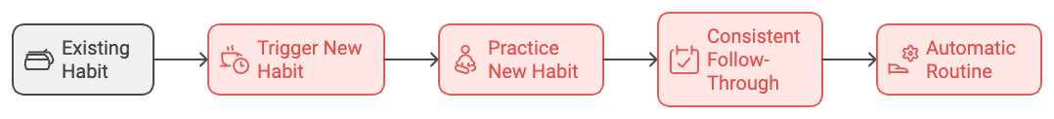
For instance, if you already have a habit of making coffee every morning, you could use this as a trigger for a new habit: “After I start the coffee machine, I will meditate for 10 minutes.” By linking new habits to existing ones, you’re more likely to follow through consistently. Over time, these small actions become automatic, forming the building blocks of your productive routine.
Numerous tools and apps can help you establish and maintain effective routines. Some worth considering include RescueTime for tracking how you spend your time, Todoist for task management, Habitica for gamifying habit-building, Forest for staying focused, and Any.do for combining to-do lists, calendars, and reminders. Remember, technology should serve as a tool to enhance your routines, not as a distraction. Choose apps that genuinely support your productivity goals and resist the temptation to overcomplicate your systems.
While morning routines often get the spotlight, evening routines are equally crucial for long-term success. A well-crafted evening routine helps you wind down, reflect on your day, and set yourself up for success tomorrow. Consider incorporating elements like reviewing your day, planning for tomorrow, implementing a digital sunset, practicing relaxation techniques, and maintaining a consistent bedtime. By establishing a calming evening routine, you’re not only improving your sleep quality but also setting the stage for a productive morning.
While routines are powerful, it’s crucial to strike a balance between structure and flexibility. Rigidity can lead to burnout and stifle creativity. Allow room in your routines for spontaneity, unexpected opportunities, and necessary adjustments. Consider building in “flex time” to your daily schedule – unstructured periods that can be used to catch up on tasks, explore new ideas, or simply take a break. This approach provides structure while maintaining the adaptability that’s crucial in the dynamic world of entrepreneurship.
Despite the best intentions, you may sometimes find yourself resisting your routines. This is normal – change can be uncomfortable, and old habits die hard. To overcome routine resistance, start small, be patient, celebrate small wins, be flexible, and remind yourself of the ‘why’ behind your routines. Regularly revisit your goals and the reasons you’re establishing these routines to stay motivated and committed.
Crafting effective routines is not a one-time task but an ongoing process of refinement and adaptation. As your goals evolve and circumstances change, so too should your routines. The key is to remain mindful of what’s working, what isn’t, and how your routines are supporting your larger objectives. Remember, the most powerful routines are those that align with your natural rhythms, support your goals, and bring a sense of structure and purpose to your day. They’re not about perfection, but about progress – each day moving you a step closer to your entrepreneurial dreams.
As you move forward, challenge yourself to implement at least one new routine element this week. It might be a morning meditation practice, an evening planning session, or a midday walk to clear your mind. Whatever you choose, commit to it for at least 21 days – the time it typically takes for a new habit to form. Your routines are the foundation upon which your success is built. By mastering them, you’re not just organizing your day – you’re sculpting your future, one habit at a time.



The Battle Against Distractions
In the fast-paced world of entrepreneurship, your ability to focus can make or break your success. Picture this: you’re in the zone, working on a crucial project that could revolutionize your business. Suddenly, your phone buzzes with a notification. You glance at it, telling yourself it’ll only take a second. Before you know it, you’ve fallen down a rabbit hole of emails, social media, and “urgent” but unimportant tasks. Sound familiar?
Distractions are the silent killers of productivity and creativity. They fragment your attention, derail your momentum, and rob you of your most valuable resource: time. In this chapter, we’ll explore the nature of distractions, their impact on your entrepreneurial journey, and proven strategies to combat them effectively.

Understanding the Nature of Distractions
Distractions come in many forms, but they generally fall into two categories: external and internal. External distractions originate from your environment, including technology interruptions, noise, visual distractions, and interruptions from colleagues or family members. Internal distractions, on the other hand, come from within, such as wandering thoughts, worries or anxieties, hunger or physical discomfort, and lack of clarity about tasks or goals. Both types of distractions can be equally detrimental to your productivity. The key is to recognize them for what they are and develop strategies to manage them effectively.

The Cost of Distraction
You might think that a quick glance at your phone or a brief conversation with a coworker is harmless. However, the true cost of these distractions is often much higher than you realize. According to a 2023 study by the University of California, it takes an average of 23 minutes and 15 seconds to fully regain your focus after an interruption. This means that even a 30-second distraction can cost you nearly half an hour of productive time. Moreover, constant task-switching, often triggered by distractions, can reduce your productivity by up to 40%. This phenomenon, known as “context switching,” forces your brain to constantly reorient itself, leading to mental fatigue and decreased efficiency. For entrepreneurs, these numbers translate to missed opportunities, delayed projects, and ultimately, a significant impact on the bottom line. In fact, a report from Atlassian estimates that distractions cost U.S. businesses an estimated $650 billion per year in lost productivity.

Strategies to Combat Distractions
Now that you understand the gravity of the distraction problem, let’s explore some proven techniques to help you maintain focus and boost your productivity. The Pomodoro Technique, developed by Francesco Cirillo in the late 1980s, is a time management method that uses a timer to break work into intervals, traditionally 25 minutes in length, separated by short breaks. This technique leverages the power of focused work sprints while providing regular breaks to recharge your mental energy. It’s particularly effective for combating both external and internal distractions, as it creates a sense of urgency and helps you maintain focus for manageable periods.
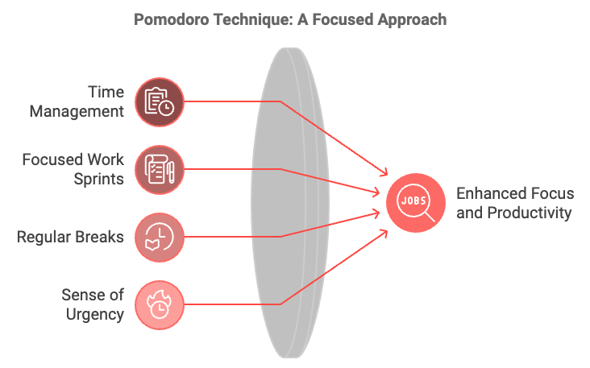
The Two-Minute Rule, originated by productivity consultant David Allen, states that if a task will take less than two minutes to complete, you should do it immediately. This rule is powerful for two reasons:
- It helps you quickly clear small tasks that might otherwise pile up and become distractions later.
- It prevents you from breaking your focus on larger, more important tasks for something that can be quickly addressed.
By implementing this rule, you can maintain a cleaner to-do list and reduce the mental clutter that often leads to distraction.
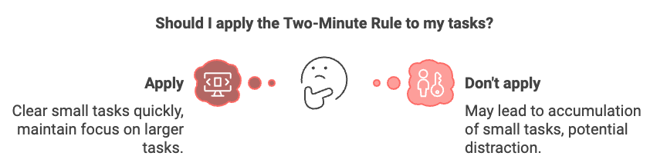
Creating a distraction-free workspace is crucial for maintaining focus. Your physical environment plays a significant role in your ability to concentrate. Consider decluttering your desk, using noise-canceling headphones, implementing a “Do Not Disturb” signal, keeping your phone out of sight, and using website blockers to avoid time-wasting websites during work hours. Remember, the goal is to create an environment that supports your focus, not one that constantly tests your willpower.
Mindfulness and meditation practices can significantly enhance your ability to focus and resist distractions. A 2023 study published in the Journal of Cognitive Enhancement found that just 10 minutes of daily meditation can improve focus and reduce mind-wandering. Try incorporating a short mindfulness practice into your daily routine, such as taking a few deep breaths before starting a task or using a guided meditation app during your lunch break.
The Eisenhower Matrix, introduced in Chapter 1, can be invaluable in managing distractions. By categorizing tasks based on their urgency and importance, you can more easily identify which “distractions” are actually important tasks in disguise. Use the matrix to prioritize your tasks at the start of each day or week to stay focused on what truly matters and resist the pull of less important distractions.
Task batching involves grouping similar tasks together and completing them in a single focused session. This strategy reduces the mental energy required for context switching and can significantly boost your productivity. For example, you might batch all your email responses into a single 30-minute block or handle all your social media updates in one sitting. By doing this, you’re not constantly flitting between different types of tasks, which can be a major source of distraction.

Real-World Success Stories and the Role of Technology
Successful entrepreneurs like Elon Musk and Jack Dorsey have mastered the art of focus and distraction management. Musk uses a technique called “timeboxing,” scheduling his day in five-minute blocks, while Dorsey assigns themes to each day of the week. These approaches help them maintain focus and reduce the mental load of constant task-switching.
While technology is often a source of distraction, it can also be a powerful ally in your battle for focus. Tools like RescueTime, Forest, Focusmate, and project management platforms like Trello or Asana can help you track your time, gamify focus, find accountability partners, and organize your tasks effectively. The key is to use technology intentionally, as a tool to enhance your focus rather than a source of distraction.

Adapting Your Strategy and the Power of Deep Work
As you implement these strategies, remember that managing distractions is not a one-size-fits-all process. Experiment, observe, and adapt your approach based on your personal distraction patterns and changing needs. Keep a distraction log for a week to identify your specific challenges and tailor your strategies accordingly.
The concept of “Deep Work,” coined by author Cal Newport, refers to the ability to focus without distraction on a cognitively demanding task. In today’s increasingly distracted world, the ability to engage in Deep Work can be a significant competitive advantage for entrepreneurs. By implementing the strategies discussed in this chapter, you’re not just avoiding distractions – you’re cultivating the ability to engage in high-value, focused work that truly moves the needle in your business.
As you move forward, challenge yourself to implement at least one new distraction-management strategy this week. Whether it’s trying the Pomodoro Technique, creating a more focused workspace, or starting a daily mindfulness practice, take action to reclaim your attention and boost your productivity. Remember, mastering the art of focus is not just about productivity – it’s about creating the space for your entrepreneurial vision to truly flourish.

Distraction Type | Example | Potential Solution
External - Technology | Phone notifications | Use “Do Not Disturb” mode
External - Environment | Office noise | Noise-canceling headphones
Internal - Mental | Wandering thoughts | Mindfulness meditation
Internal - Physical | Hunger | Regular, healthy snacks

Productivity Loss = Time Lost to Distraction + Time to Refocus
Where:
Time Lost to Distraction = Duration of distraction
Time to Refocus = 23.25 minutes (average refocus time)
Example:
For a 5-minute distraction:
Productivity Loss = 5 minutes + 23.25 minutes = 28.25 minutes

In the next chapter, we’ll explore how to sustain your motivation over the long haul, ensuring that you have the mental and emotional fuel to keep pushing forward, even when faced with challenges and setbacks.



Sustaining Motivation Over the Long Haul
The entrepreneurial journey is often likened to a marathon, not a sprint. It’s a path filled with highs and lows, victories and setbacks, moments of exhilaration and periods of doubt. In this ever-changing landscape, your ability to maintain motivation isn’t just beneficial—it’s essential for survival and success. Motivation is the fuel that drives your entrepreneurial engine. It’s what gets you out of bed in the morning, pushes you to tackle challenging tasks, and keeps you going when obstacles seem insurmountable. But like any fuel, it can run low if not properly managed and replenished.
Before we can effectively harness motivation, it’s crucial to understand its two primary forms: intrinsic and extrinsic motivation. Intrinsic motivation comes from within. It’s driven by personal interest, enjoyment, or alignment with your values. When you’re intrinsically motivated, you engage in an activity because it’s inherently satisfying or rewarding. For entrepreneurs, this might manifest as the passion for solving a particular problem, the joy of creating something new, or the satisfaction of building a successful business. Extrinsic motivation, on the other hand, comes from external factors. It’s driven by the desire to earn a reward or avoid a punishment. In the entrepreneurial context, extrinsic motivators might include financial success, recognition, or the avoidance of failure.

Strategies for Harnessing Motivation
Both types of motivation can be powerful drivers of action, but research suggests that intrinsic motivation tends to be more sustainable over the long term. A 2023 study published in the Journal of Business Venturing found that entrepreneurs who were primarily driven by intrinsic motivations reported higher levels of job satisfaction and were more likely to persist through challenging times. However, this doesn’t mean you should disregard extrinsic motivators entirely. The key is to find a balance and use both types of motivation strategically.
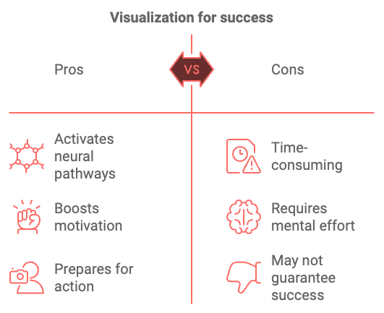
To tap into your intrinsic motivation, start by reconnecting with your ‘why.’ Why did you become an entrepreneur in the first place? What problems are you passionate about solving? What impact do you want to make in the world? Regularly revisiting these fundamental questions can help reignite your passion and remind you of the deeper purpose behind your work.
One effective technique for harnessing intrinsic motivation is goal visualization. This involves creating a vivid mental image of what success looks like for you.
But don’t just focus on the end result—imagine the process of getting there, the challenges you’ll overcome, and the growth you’ll experience along the way.
Neuroscience research has shown that this type of visualization activates many of the same neural pathways as actually performing the action, priming your brain for success and boosting your motivation.

Another powerful way to boost intrinsic motivation is through continuous learning and skill development. As you acquire new knowledge and skills, you’ll likely find increased enjoyment and satisfaction in your work. Set aside time each week for personal development, whether it’s reading industry publications, taking online courses, or attending workshops and conferences. While intrinsic motivation is often more sustainable, extrinsic motivators can provide powerful short-term boosts and help you push through particularly challenging periods. One effective way to leverage extrinsic motivation is through a well-designed reward system. Start by setting clear, measurable goals for yourself. These could be weekly, monthly, or quarterly targets. Then, assign specific rewards for achieving these goals. The key is to choose rewards that are meaningful to you personally. It could be something as simple as treating yourself to a nice dinner, taking a day off to pursue a hobby, or investing in a new piece of equipment for your business. Remember, the goal isn’t to rely solely on these external rewards, but to use them strategically to reinforce positive behaviors and provide extra motivation when needed.
One of the most powerful motivators is the sense of progress. As an entrepreneur, it’s easy to get caught up in the day-to-day grind and lose sight of how far you’ve come. That’s why implementing a robust progress tracking system is crucial for maintaining long-term motivation. Start by breaking down your long-term goals into smaller, measurable milestones.
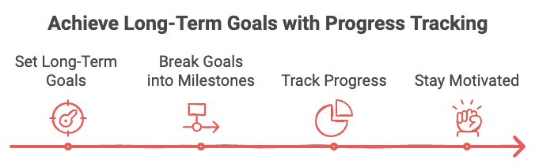
Use a tool like a Gantt chart or a project management software to visualize your progress over time. Regularly update and review your progress, celebrating small wins along the way. Consider implementing a “weekly win” ritual, where you take time each week to acknowledge and celebrate your achievements, no matter how small. This practice helps build momentum and creates a positive feedback loop, fueling your motivation to tackle the next challenge.

Building Resilience and Overcoming Setbacks
No entrepreneurial journey is without its setbacks. The ability to bounce back from failures and maintain motivation in the face of adversity is what separates successful entrepreneurs from those who give up. One key strategy for building resilience is to reframe your perspective on failure. Instead of viewing setbacks as insurmountable obstacles, try to see them as learning opportunities. After each setback, ask yourself: What can I learn from this experience? How can I use this knowledge to improve going forward? Developing a growth mindset, a concept popularized by psychologist Carol Dweck, can be incredibly powerful in this regard. With a growth mindset, you believe that your abilities and intelligence can be developed through effort, learning, and persistence. This perspective allows you to view challenges as opportunities for growth rather than threats to your capabilities.
Another crucial aspect of maintaining motivation during tough times is having a strong support network. Surround yourself with people who believe in you and your vision. This could include mentors, fellow entrepreneurs, or supportive friends and family members. Don’t be afraid to lean on this network when you’re feeling discouraged or overwhelmed. In the pursuit of entrepreneurial success, it’s easy to neglect self-care. However, maintaining your physical and mental well-being is crucial for sustaining long-term motivation. Burnout is a real threat for entrepreneurs, and it can quickly deplete your motivation and creativity. Make sure you’re getting enough sleep, eating a balanced diet, and engaging in regular physical activity. Exercise, in particular, has been shown to have a significant positive impact on motivation and cognitive function. A 2023 study published in the Journal of Applied Psychology found that employees who exercised regularly reported higher levels of motivation and job satisfaction compared to their sedentary counterparts.
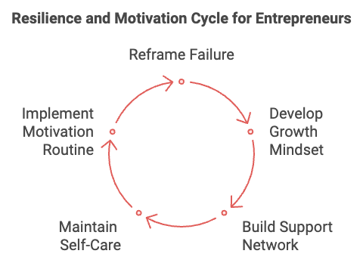
In addition to physical self-care, don’t neglect your mental and emotional well-being. Practices like meditation, journaling, or engaging in hobbies unrelated to your business can help reduce stress and recharge your motivational batteries. While we discussed the importance of routines in Chapter 2, it’s worth revisiting in the context of sustaining motivation. Consistent routines can help automate decision-making, reduce willpower depletion, and create a sense of progress and accomplishment. Consider implementing a “motivation routine” — a set of daily or weekly practices designed to boost your motivation. This could include activities like reviewing your goals, practicing gratitude, engaging in visualization exercises, or reading inspirational content.
Motivation can sometimes feel like an elusive, intangible force. However, B.J. Fogg, a behavior scientist at Stanford University, has developed a simple equation that can help us understand and influence motivation:
Motivation = Expectancy x Value / Impulsiveness x Delay
Here’s how to interpret and apply this equation:
- Expectancy: This is your belief in your ability to succeed. Increase expectancy by breaking large goals into smaller, achievable tasks and celebrating small wins.
- Value: This represents the perceived benefit of taking action. Boost value by regularly reminding yourself of your ‘why’ and the potential positive outcomes of your work.
- Impulsiveness: This factor represents distractions or competing priorities. Reduce impulsiveness by creating a distraction-free work environment and using techniques like the Pomodoro method.
- Delay: This is the time between action and reward. Minimize delay by setting up immediate rewards for completing tasks and visualizing long-term benefits.
By consciously working to increase expectancy and value while decreasing impulsiveness and delay, you can significantly boost your motivation.

Tools and Techniques to Sustain Motivation
With the advancement of technology, there are now countless apps and tools available to help you stay motivated. Here are a few worth considering:

App Name | Description
Habitica | Gamifies your tasks and habits, turning your goals into a role-playing game
Stickk | Allows you to make commitment contracts, putting real money on the line to motivate you to achieve your goals
Forest | Helps you stay focused by growing virtual trees while you work, which can translate into real trees being planted
Trello or Asana | Project management tools that help you visualize your progress and stay organized, boosting your sense of accomplishment

Remember, technology should serve as a tool to enhance your motivation, not as a distraction. Choose apps that align with your personal motivation style and business needs.
Entrepreneurship can often feel like a solitary journey, but it doesn’t have to be. Engaging with a community of like-minded individuals can provide a significant boost to your motivation. Consider joining entrepreneurial networks, attending industry events, or participating in mastermind groups. These communities can offer support, accountability, and fresh perspectives to help you stay motivated.
Sustaining motivation over the long haul is no small feat, but it’s a crucial skill for entrepreneurial success. By understanding the nuances of intrinsic and extrinsic motivation, leveraging progress tracking, building resilience, practicing self-care, and utilizing the right tools and communities, you can create a robust motivation toolkit to fuel your entrepreneurial journey. Remember, motivation isn’t a constant state—it’s normal for it to ebb and flow. The key is to have strategies in place to replenish your motivational reserves when they run low. Regularly revisit and refine your motivation strategies as your business evolves and your personal needs change.
As you move forward, challenge yourself to implement at least one new motivation strategy this week. Whether it’s starting a progress tracking system, joining an entrepreneurial community, or implementing a daily visualization practice, take action to nurture your entrepreneurial drive. Your motivation is the heartbeat of your entrepreneurial journey. By mastering the art of sustaining it, you’re not just increasing your chances of success—you’re ensuring that the path itself is rewarding and fulfilling. After all, true entrepreneurial success isn’t just about reaching the destination—it’s about enjoying and growing through the journey.



Recap and Encouragement for the Future
The entrepreneurial journey is a tapestry woven with threads of ambition, perseverance, and continuous growth. As we reach the culmination of our exploration into self-discipline and long-term success, it’s time to take a step back and reflect on the transformative strategies and insights we’ve uncovered. This final chapter serves as both a comprehensive recap and a springboard for your future endeavors. Let’s revisit the key principles that will propel you towards entrepreneurial excellence and provide you with the encouragement to keep pushing forward.

The Power of Clear Objectives and Effective Routines
At the heart of every successful entrepreneurial venture lies a set of clear, well-defined objectives. These objectives serve as your North Star, guiding your decisions and actions towards your ultimate goals. Remember the power of the SMART criteria we discussed in Chapter 1: Specific, Measurable, Achievable, Relevant, and Time-bound. Implementing the SMART framework ensures that your objectives are not just wishful thinking, but actionable targets that drive your business forward. Coupled with the OKR (Objectives and Key Results) system, you have a powerful toolkit for aligning your team’s efforts with your company’s vision. Don’t forget the importance of breaking down big goals into smaller, manageable tasks. This approach not only makes daunting objectives more approachable but also provides frequent opportunities for those motivating “small wins” that fuel your journey. As you move forward, make it a habit to regularly review and refine your objectives. The business landscape is ever-changing, and your goals should evolve alongside it. Stay flexible, but always keep your long-term vision in sight.
Your daily routines are the invisible force that propels you towards your goals, even on days when motivation runs low. As we explored in Chapter 2, effective routines are not about rigid schedules, but about creating a framework that supports your natural rhythms and optimizes your productivity. Remember the power of understanding your chronotype – whether you’re a Morning Lark, Night Owl, or Third Bird. By aligning your most challenging tasks with your peak energy periods, you can significantly boost your efficiency and output. The morning routine remains a cornerstone for many successful entrepreneurs. Whether it’s exercising, meditating, or planning your day, find a morning ritual that sets a positive tone for the hours ahead. But don’t neglect the importance of an evening routine. A well-crafted wind-down process can improve your sleep quality and set you up for success the next day. Time-blocking and habit stacking are powerful techniques to structure your day and build new, productive habits. Use these strategies to ensure you’re making progress on important projects and consistently reinforcing positive behaviors. As you refine your routines, remember to maintain a balance between structure and flexibility. Leave room for spontaneity and unexpected opportunities. The goal is to create a framework that supports your productivity without stifling your creativity or adaptability.

Managing Distractions and Sustaining Motivation
In our hyper-connected world, the ability to maintain focus is a superpower. As we discussed in Chapter 3, distractions are the silent killers of productivity, fragmenting your attention and derailing your momentum. Recall the two main categories of distractions: external distractions, which come from your environment, like notifications, noise, or interruptions from others; and internal distractions, which originate from within, such as wandering thoughts or lack of clarity about tasks. To combat these productivity thieves, we explored several powerful strategies: the Pomodoro Technique, the Two-Minute Rule, creating a distraction-free workspace, mindfulness and meditation, the Eisenhower Matrix, and task batching. Remember, managing distractions is an ongoing process. Be patient with yourself and continually refine your approach based on what works best for you.
Motivation is the fuel that keeps your entrepreneurial engine running. As we explored in Chapter 4, understanding and leveraging both intrinsic and extrinsic motivation is key to maintaining your drive over the long haul. Intrinsic motivation, driven by personal interest and enjoyment, tends to be more sustainable. Regularly reconnecting with your ‘why’ – the deeper purpose behind your entrepreneurial journey – can help reignite this internal fire. Extrinsic motivators, while often less sustainable, can provide powerful short-term boosts. A well-designed reward system can help you push through particularly challenging periods. Don’t underestimate the power of progress tracking. Regularly acknowledging your achievements, no matter how small, creates a positive feedback loop that fuels further motivation. Building resilience is crucial for maintaining motivation in the face of setbacks. Cultivate a growth mindset, viewing challenges as opportunities for learning and improvement rather than insurmountable obstacles.

Remember the motivation equation we discussed:
Motivation = Expectancy x Value / Impulsiveness x Delay

By working to increase expectancy and value while decreasing impulsiveness and delay, you can actively boost your motivation levels.

Embracing Continuous Growth and Looking Forward
As you stand at the threshold of your entrepreneurial future, armed with the strategies and insights from this book, remember that the journey of self-improvement and business growth is ongoing. The principles we’ve explored are not a one-time application, but a continuous process of refinement and adaptation. Embrace the mindset of a lifelong learner. The business world is constantly evolving, and staying ahead requires a commitment to continuous education. Set aside time each week for personal development, whether it’s reading industry publications, taking online courses, or attending workshops and conferences. Don’t underestimate the power of networking and community. Engaging with other entrepreneurs can provide fresh perspectives, emotional support, and potential collaboration opportunities. Consider joining entrepreneurial networks, attending industry events, or participating in mastermind groups.
As you implement the strategies we’ve discussed, be patient with yourself. Change takes time, and building new habits or shifting your mindset doesn’t happen overnight. Celebrate your progress, no matter how small, and don’t be discouraged by temporary setbacks. Remember to maintain a holistic approach to your entrepreneurial journey. While focusing on business growth is important, don’t neglect your physical and mental well-being. Regular exercise, a balanced diet, adequate sleep, and stress-management techniques like meditation are all crucial for sustaining your entrepreneurial drive over the long term.

Drawing Inspiration and Taking Action
Let’s take a moment to draw inspiration from entrepreneurs who have successfully applied these principles in their journey. Sara Blakely, the founder of Spanx, attributes much of her success to her unwavering focus and clear objectives. She started with a specific goal – to create footless pantyhose that didn’t show panty lines – and relentlessly pursued it, overcoming numerous obstacles along the way. Arianna Huffington, co-founder of The Huffington Post, emphasizes the importance of self-care routines in maintaining long-term success. After experiencing burnout, she made sleep and well-being a priority, even writing a book on the topic. Bill Gates is known for his “Think Weeks,” where he disconnects from daily distractions to focus deeply on reading, thinking, and strategizing. This practice has been crucial in helping him stay ahead in a rapidly changing tech landscape. Oprah Winfrey often speaks about the power of intrinsic motivation and staying connected to one’s purpose. Her ability to maintain enthusiasm and drive over decades in the public eye is a testament to the power of aligning one’s work with personal values and passions. These success stories remind us that the principles we’ve explored in this book are not just theoretical concepts, but practical tools that have been leveraged by some of the world’s most successful entrepreneurs.
As we conclude this book, it’s important to remember that while we’ve explored many powerful strategies and principles, your entrepreneurial journey is uniquely yours. The key is to take these concepts and adapt them to fit your personal style, goals, and circumstances. Don’t be afraid to experiment and iterate. What works for one entrepreneur may not work for another. Be willing to try different approaches, observe the results, and adjust accordingly. Your path to success may not be linear, and that’s okay. Each challenge you face and each obstacle you overcome is an opportunity for growth and learning. As you move forward, consider creating a personal development plan. Set aside time each quarter to review your progress, reassess your goals, and plan your next steps. This regular reflection can help you stay aligned with your long-term vision while making necessary adjustments along the way. Remember, success is not just about reaching a destination; it’s about who you become in the process. Embrace the challenges, celebrate the victories (big and small), and always keep learning and growing.
As we wrap up this journey together, I encourage you to take immediate action to implement what you’ve learned. Here are some concrete steps you can take:
- Review your current goals and apply the SMART criteria to refine them.
- Analyze your daily routine and identify one area where you can make an improvement.
- Implement one new strategy to manage distractions in your work environment.
- Create a motivation board or journal to help you stay connected with your ‘why’.
- Reach out to a fellow entrepreneur or join an online community for support and accountability.
Remember, the strategies and insights in this book are tools. Their true power lies in your commitment to consistently apply them. Every small step you take brings you closer to your entrepreneurial dreams. As you close this book and step back into your entrepreneurial journey, carry with you the knowledge that you have the power to shape your destiny. You have the tools to set clear objectives, craft effective routines, manage distractions, and sustain your motivation over the long haul. The path ahead may be challenging, but armed with these strategies and your unwavering determination, there’s no limit to what you can achieve. Your entrepreneurial journey is a testament to human potential – the ability to turn ideas into reality, to create value where none existed before, to make a positive impact on the world. Embrace this journey with all its ups and downs, knowing that each experience is shaping you into the successful entrepreneur you aspire to be. Go forth with confidence, resilience, and an unwavering commitment to your vision. The world is waiting for the unique value that only you can create. Your entrepreneurial success story is waiting to be written – and it begins now, with the very next action you take.

