Table of Contents

Introduction 4
Chapter 1: How Google AdSense Works? 7
1. You choose what and where AdSense ads will appear. 7
2. Advertisers bid on ad placement in real-time. 7
3. You get paid based on click throughs. 7
Chapter 2: Earning Money with Adsense 10
Chapter 3: How AdSense Can Help You Earn Extra Cash? 13
How Much Will I Earn? 14
How Does Google AdSense Work? 15
Chapter 4: Work As Much or As Little As You Want 18
The Money is More or Less Passive 18
You Can Do Something You Love – And Get Paid for It 19
Easy Learning Curve 19
This is a ZERO Startup Cost Business! 19
Rinse and Repeat 20
How You Get Paid 20
You Can Get Started Now 20
Where to Go From Here 21
Specifically, you need to learn: 21
Chapter 5: Google AdSense for Your Business 24
Chapter 6: Adsense For Advertisers 27
Chapter 7: Adsense – In and Out 31
1. You choose what and where AdSense ads will appear. 31
2. Advertisers bid on ad placement in real-time. 31
3. You get paid based on advertising placement. 31
AdSense Products 31
Benefits of AdSense 32
Control how Google represents your inventory 34
Manage how your ads are displayed 34
Powerful reporting tools 34
Chapter 8: Downside of Google AdSense 37
#1: Illegitimate Websites. 37
#2: Confusing Advertising Tunnels 37
#3: Your success depends on successful SEO 37
Chapter 9: Tips to Earn Money 40
Tips for AdSense Success 40
Chapter 10: Guaranteed Success? 43
Potential Issues Google AdSense 43
Chapter 11: Getting the Most Out of Google Adsense 46
Setting Up Your AdSense Account 46



Introduction

Google AdSense takes internet marketing to the next level. It is a helpful tool that allows website owners to select what types of ads are relevant for their target market, allowing only the most relevant ads to appear.

When relevant ads appear on your website, or ads that interest/speak to your specific target market, they are likely to click on those ads. And with Google AdSense, you earn money for every time an ad is clicked. It really is that easy!

In short, Google AdSense allows Internet marketers and website owners to work together to ensure the best possible results from results driven advertising. And do you want to know the best part about Google AdSense?... It’s FREE!

Rather than giving permission to advertisers of all varieties, Google Adsense puts the power in your hands to choose which ads make the most sense for you, your business and your target audience.

Google defines its AdSense program in the following way:

Google AdSense is a fast and easy way for website publishers of all sizes to display relevant Google ads on their website’s content pages and earn money. Because the ads are related to what your visitors are looking for on your site – or matched to the characteristics and interests of the visitors your content attracts – you’ll finally have a way to both monetize and enhance your content pages.

It’s also a way for website publishers to provide Google web and site search to their visitors, and to earn money by displaying Google ads on the search results pages.

Google further hails AdSense as ―The flexible, hassle-free way to earn revenue online. So, is what they say really true? Does it really work and more importantly, does it really work that well? The answer is, yes!

Google will pay you every time your site visitors click on an ad within your site. That means that you get paid whether they end up purchasing something from an advertiser or not. All they have to do is click in order for you to get paid!

In addition, you can not only choose which kinds of ads will appear on your site (as in relevant topics via keyword selection), but you also have the ability to integrate them seamlessly into your site by completely customizing the look of your Google AdSense ads. You have the ability to select a color scheme, size of the ads and placement specifications for the ads as well.

Google also makes it very easy to follow your AdSense success by providing you with easy to read, easy to manage reports that show you which ads are being clicked, how often they are clicked, and how much you are earning with your AdSense account.

From an outside perspective, Google AdSense is, in both theory and reality, a fantastic tool. So, it’s not just a self-proclaimed useful and effective way to gain revenue for your business... It really is!

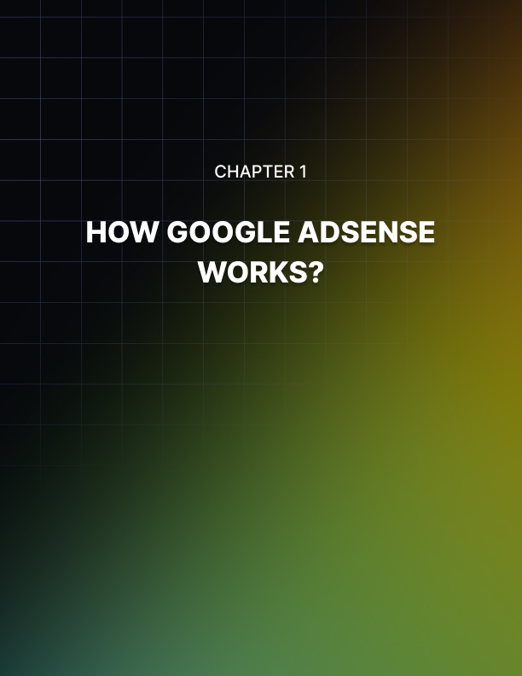

Chapter 1: How Google AdSense Works?

While Google AdSense is an extremely user-friendly tool, it can take some time to figure out exactly how it works. You will need to become familiar with all of its features, how they work and how they can best be used to benefit your particular business, your business goals and your business needs.

Let’s take a look at some of the most basic steps involved in Google AdSense to better understand how it works.

You choose what and where AdSense ads will appear.
You will carefully select and specify what kinds of ads you would like to show up on your site as well as where on your site they will be placed. Google will ask you for keywords about your business, products and/or services that will help generate a topic or topics of ads that are relevant to your business.

Advertisers bid on ad placement in real-time.
Advertising space online is valuable real estate. That is why many advertisers are willing to pay for quality placement. With Google AdSense, the highest bidder always wins the spot. In other words, you won’t find advertisers with questionable businesses paying too much for advertising space, so the bidding system helps separate the ―good advertisers from the ―bad ones.

You get paid based on click throughs.
Google bills those who win the bids and pay for advertising space. You then receive your payment based on the ads placed on your site and when/how often your site visitors are clicking on them.

Many people find it hard to believe that there is no fee for creating a Google AdSense account and allowing AdSense ads to be placed on your website. But the truth is, they only pay you when the ads are being clicked, so if you think about it, this method makes sense.

There is no need to pay them to advertise for other businesses. And in the same vein, they don’t pay you for simply placing the ads. There has to be positive activity in order for it to work on either end of the spectrum. The advertisers decide how much they are willing to pay for their ads (to be explored in Google AdWords) and you, as the one providing the advertising space, benefit from the ads’ effectiveness.

AdSense is also more than just advertising. With Google AdSense, you can choose to include one or all of their ― products as a way to increase your profit-earning potential through targeted advertising. For example, you can choose to place AdSense ads within your site (which are customizable and of course, targeted); you can also choose to include AdSense searches within your site (which help users and bring you a profit at the same time); or you can choose to place Google AdSense ads in your feeds. It’s up to you which, if not all, of these options you choose, but no matter how you look at it, Google AdSense just makes sense for business.

Remember, the more you take advantage of Google AdSense products, the more you will benefit from it.



Chapter 2: Earning Money with Adsense

Unlike the internet advertisements of old (largely banner ads, flashy boxes and annoying pop-ups), you earn money each and every time your site visitors click on a Google AdSense ad that is placed on or within your site.

They do not have to purchase something in order for you to earn a commission. All they have to do is click!

You no longer have to worry about busy, distracting, (sometimes obnoxious) internet ads crowding up your site. Instead, Google AdSense ads are text ads, which are proven to have a much higher click-thru rate than traditional banner ads. And in fact, there is much more to it. Google AdSense makes making money easy!

If you are considering creating a Google AdSense account, here are some tips for success:

Tip #1: Build a site with a professional look, tone and feel.
Your business depends on the effectiveness of your website, so make sure it’s the best it can be from look and feel to messaging and ease of use. It’s important to also note that Google does NOT accept sites that are created using free domains, so be sure to register a unique domain through a reputable service.

Tip #2: Your site should include valuable content.
Your site should include language that is not only relevant to your target market, your message should be enticing and provide valuable information. You want to convince your customers how valuable you are, not just hope they see it for themselves. On another note, Google will quickly recognize if your site is not legitimate, so be sure that your business is up and running to prove you are not just loading ads into your site to make money.

Tip #3: Work on driving traffic to your site.
Proper SEO techniques and keywords are absolutely critical when trying to top search engines. If you aren’t familiar with this process, be sure to learn more. It will serve you well moving forward. No matter what, driving traffic to your site is absolutely crucial for success.

Tip #4: Set up your Google AdSense account.
As previously noted, Google makes the entire process of setting up an AdSense account extremely user-friendly. They will walk you through the registration process and get you started with customizing and placing ads on your site in no time. They even offer valuable help tools and resources as you continue to grow and become more familiar with their products and services.

Tip #5: Network! Network! Network!
Nothing is better than word of mouth, so reach out to friends, family, peers, and colleagues to spread the word about your site. The more people who visit, the more people who will click on ads… and the more money you will make!

So what are you waiting for? Get out there and grow your business. Build a quality site that looks and sounds great. Create a Google AdSense account and watch the money roll through the door… and the mailbox! You’ll be happy you did.



Chapter 3: How AdSense Can Help You Earn Extra Cash?

Advertising can be an extremely cost-effective way to grow your business… if it’s done well. After all, its very purpose is to let others know about who you are and what you do.

The ultimate goal is to gain customers and increase revenue through attractive images, catchy slogans and hopefully, a quality product.

Whether you are a small business owner, Internet marketer, not-for-profit organization or large corporation, advertising is a very critical part of what you do.

There are many types of advertising to choose from, and depending on your business and your product, some advertising outlets may be more beneficial than others. From television to newspapers, billboards and radio, advertising opportunities have historically run the gamut from small and inexpensive, to large and exponentially costly.

The Internet, in all of its worldwide reaching glory, is the perfect place to advertise for almost any business, as you have the best chance of reaching the most people. And what’s more, you can target your market through multiple tactics, including Search Engine Optimization (SEO), keywords, and simply choosing when and where to place your ads. Much like you would choose which magazine to run your advertisement in, you can often choose which websites your ad will appear on, or which directories you will be listed in.

For Google customers, there are many options for advertising, including:

- Google AdWords for those looking to create ads/advertise
- Google AdSense for those looking to include targeted ads on their website(s) in order to earn money

Google’s advertising opportunities are perfect if you are looking to make money without investing a lot… if any cash up front. When a business chooses to place AdSense advertisements on their website, advertisers benefit from relevant and targeted placement, making sure their advertising only costs them money when it is actually working. What a novel idea, right? It makes so much sense, yet often, advertising does NOT work this way.

Google will only charge an advertiser when their ads are being clicked. Every time a web user clicks on a Google AdSense ad, the website owner who placed it there receives a commission and the advertiser is charged for the click. It’s one, big interconnected web of logical advertising that benefits everyone involved.

So, how is Google AdSense good for advertisers? It’s a simple advertising solution. It’s effective. It allows for maximum exposure to a targeted audience who are inherently ingratiate toward your product and/or service. And the bottom line is that it really does work! Most importantly, it helps us all increase sales and ultimately, make more money.

For advertisers, of course you pay for your ads (but an extremely low fee) but the benefit of increasing visibility and gaining new customers from those ads far outweighs the minimal cost. Afterall, that is the very purpose of your advertising in the first place, isn’t it? So take advantage of this extremely cost-effective advertising outlet and let Google AdSense help you along your journey to growing your business and your revenue stream!

How Much Will I Earn?
Of course the most pressing question that comes to mind when considering using Google AdSense is “How much money will I earn?” Well, according to Google, there's no precise answer, because your earnings will depend on a number of factors.

Factor #1: The type of ads on your pages.
AdSense allows you to display ads that are paid when users click them or when users view them. Advertisers (through Google) participate and compete in an auction and the [Google] system automatically selects [the ads that] will generate the most revenue for you…

Factor #2: The pricing of ads on your pages.
Google says it best, ― Not all ads are priced the same, so factors such as changing advertiser budgets, your specific content, and the ads your users choose to click will cause your earnings to vary even from day to day.”

Factor #3: How many AdSense products you use.
AdSense is more than just ads. You can earn money by choosing to display ads on your website, provide search functions generated by AdSense to your users, display ads in feeds and much, much more.

The only sure fire way to find out how much profit you will generate by using Google AdSense is to actually sign up for an account and put it to work. As we have said before, it is absolutely free, so why not try it?

The bottom line is that Google AdSense will give you a better chance at earning revenue through advertising than traditional ways of doing so, like drumming up advertisers yourself.

Imagine working in your spare time, doing something you love and getting paid for it. You can do all this from home from the comfort of your computer. Just 10 years ago, this wouldn’t have been possible. But today it is. It’s as easy as it sounds. You can do everything described above by creating a website and selling advertising through Google AdSense.

How Does Google AdSense Work?
Google AdSense is a program that allows you to easily put advertising on your website and get paid for it. You don’t need to negotiate with vendors, you don’t need to write any complex code, you don’t even need to create banner ads or write any advertisements.

Here’s how it works:
Someone comes to your website, on which you’ve put your Google AdSense advertisement. Google looks at your website and decides what kind of ads to serve. It basically ―reads your website, looks through their list of advertisers and picks out several that they believe would interest your visitor.

Your visitor comes to your website, browses your site and sees that ad. If they click on that ad, then Google gets paid by that advertiser for the click. They then collect a small commission and give you the rest of the money.

It’s a win-win for everyone because the visitor gets to see another site they’re interested in, Google gets paid, the advertiser gets targeted traffic and you get fast, easy cash in your bank account!
It’s Easy!
There’s a lot of stigma around working from home. Society has instilled the belief that it’s hard, that only a select handful of people can make money from home. That setting your own hours and being your own boss is the platinum dream to strive for, that few can actually achieve in reality.

It’s just not true! Working from home and making money from home can be a piece of cake – Especially with a tool like Google AdSense!

It’s Fast!
The moment you start getting traffic to your website is the moment you start getting paid. Most people don’t realize how easy it really is to start getting traffic to a website.

Once visitors start trickling in, you’ll quickly make your first dollar. After your first dollar online, you’ll make your first ten, then your first hundred, and in not too much time you'll have your first thousand.

What’s great about Google AdSense is that you start seeing progress immediately. Sure, you might start out making only a dollar, but it’s great to see that what you’re doing is working already.

Compare this to other online business models. For example, if you were selling ergonomic chairs online, you’d first have to stock merchandise, setup a merchant account and billing system, do your advertising – Then wait and wait and wait until someone is willing to make a $600 purchase.

Not so with AdSense – The moment anyone just clicks on a link, you get paid right then and there. Since you don’t have to wait until someone pulls out their credit card (which is a much higher commitment on their part) you’ll start getting paid almost immediately.



Chapter 4: Work As Much or As Little As You Want

Want to get paid more? Then work more. Want to just have a fun, profitable project on the side? Then work less!

What’s great about AdSense is that there’s no obligation whatsoever. It’s not like having an employer that’s asking you to get a certain amount of clicks per month – It’s entirely up to your own personal discretion how much or how little you want to make, how much or how little you want to work.

You set your own hours, your own dates, and your own vacations. Of course, the more you work the more you’ll make. The amount of work you want to do is completely up to you.

The Money is More or Less Passive
The money you make is more or less passive income – Meaning that once you put the work in, you’ll get paid whether you do more work or not.

It’s not 100% passive – If you have your website making $1,000 a month, that amount will gradually go down over the course of a year or two if you don’t put any new content up.

But could you take a 3 month vacation to France while continuing to get paid and not putting any work in? Absolutely! In fact, you could easily take a 3 month vacation without taking a hit on your income.

Could you build a business, get a day job and effectively be getting paid double – While putting just a couple of hours a week into maintaining your income? Of course!

The income you’ll make from AdSense is about 90% passive. You can leave it for a period of months and you could do almost no work on it and it will keep coming in. It takes just a little bit of work to maintain it at its current level or just a bit more work than that to have it continue to increase.

You Can Do Something You Love – And Get Paid for It
What are your passions or hobbies? If you could get paid for anything, what would it be?

One thing about AdSense is that you can make money promoting just about any kind of website. If your passion is fly fishing, you could easily create a fly fishing website, put AdSense on it and get paid for it.
If your passion is health, you can get paid for that as well. Even if it’s something obscure – Like how to raise a Rottweiler, you can get paid for that too.

Just about any topic you’re interested in, that others might be interested in as well, you can make money from through Google AdSense. In other words, you can make passive income from your own home doing what you love to do. Any topic that you’re passionate about, you can make money from.

Easy Learning Curve
Unlike many other internet businesses, Google AdSense has a very easy to follow learning curve.

A typical business’s learning curve could take you up to 6 months – Maybe even longer before you make any money. You have to learn how to sell, how to write marketing copy, how to collect money, how to get traffic, how to merchandise, how to manage, etc.

Fortunately, you won’t have to go through such a steep learning curve. With Google AdSense, you can start making money within your very first week.

The learning curve is very easy. Learning how to install Google’s code takes about 30 minutes. Getting traffic and getting paid might take you a week to learn. Apart from that, there’s very few skills you need to learn.

Then you’re off towards making however much you want to make!

This is a ZERO Startup Cost Business!
Most other internet businesses have huge startup costs. A typical internet business would cost $1,000+ to startup - sometimes as much as $10,000 and up. Initial merchandise, merchant accounts, shopping carts, etc all cost a fair amount of money to get started with.
With AdSense, your startup cost is quite literally zero. Web hosting and a domain name do cost money – About $10 each – But even those are optional if you choose to host your sites on a Blogger or Wordpress site.

For under $50, you can start making money online today. In no other time in history has this been possible. There’s literally no reason not to get started today.

Rinse and Repeat
There’s no limit to how many times you can rise and repeat the AdSense profit formula. Unlike, say, a chair business where you’d be starting competition with yourself, with Google AdSense you can literally start as many different websites as you want.

If you’ve started a successful Fly Fishing website making $500 a month, you could just as easily start a website about internet marketing and make another $500 a month.

However many times you choose to rinse and repeat it at your own discretion.

How You Get Paid
Google sends you a check once a month with the total amount of money you’ve earned from Google AdSense.

If you’ve been making $10 a day, at the end of the month Google will send you a check for $300.

You don’t need to fill out tax forms until you’ve made a certain amount of money. There’s no payment processing system you need to set up. Getting paid is fast, easy and intuitive.

You Can Get Started Now
With many businesses, you have to wait weeks or months before you can start earning your first dollars:
First, you have to incorporate, which could take up to a month. Then you need to get your merchant accounts and payment processors online, which could take another 2-4 weeks. Then you need to get your products ready, which could take weeks. The wait times pile up on and on while you’re shelling money out of your own pocket to cover expenses.

With Google AdSense, there’s no such wait times. All you need to do is start your website now and start getting some traffic.

The moment you start getting traffic is the moment you start getting paid. This could take as little as one week before you start seeing money come into your bank account!

Where to Go From Here
Now you know how easy, fast, cheap and profitable AdSense is. As I’ve mentioned, the learning curve is low – But there is a learning curve.

The first step is to make a decision now that you’re going to make this happen for yourself. It’s unfortunate that so many people get started on the path of making money from home only to never take action.

Don’t let that happen with you.

You can make money from home. It isn't difficult, but you do have to make a commitment. Follow through. Once you’ve made the decision, the next step is to educate yourself on the technical how-to’s of starting a Google AdSense website that makes money.

Specifically, you need to learn:
  - How to choose a profitable niche.
  - How to build a simple website.
  - How to create content that’s compelling.
  - How to install the Google AdSense ads.
  - How to get people to click on your AdSense ads.
  - How to get traffic to your website.

Once you’ve learned these 6 things – Which take literally about a week to learn – Then you’re ready to start making money from AdSense. Once you’ve had your first profitable website, it’s as easy and rinsing and repeating!

In this report, you’ve learned the basics of what Google AdSense is, how it works and why it’s both easier and faster than many other business models. Now it’s time to take the next steps and educate yourself further – And then take action on actually making money on the internet.

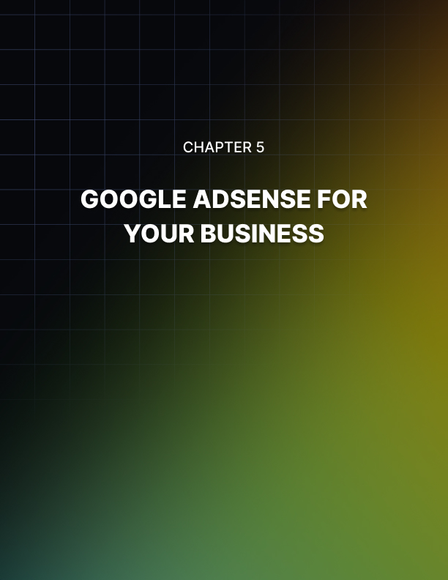

Chapter 5: Google AdSense for Your Business

Google AdSense is a great way to make money for your business. Not only is Google a more than reputable company, (arguably, one of the most well-known and trusted in the world) so you can trust their services, but the AdSense program is one of their most user-friendly and cost-effective offerings to date.

Have you ever clicked on an advertisement on the web? If you have, you are not alone. Millions of internet users ―navigate the web via click throughs, links and advertisements each and every second of every day. Across the world, this has become how we communicate, do business, shop, trade, exchange and enjoy.

Google AdSense is an extension of that reality and helps internet business owners and users alike generate an interconnected ―web of relevant information and helpful content that in the end will help you make more money.

And who doesn’t want to make more money?!

If Google AdSense seems like a fast, easy way to earn money, that’s because it is!

The folks at Google seem to not only understand the modern internet business landscape, they are one of the major driving forces behind it. From products and services for the everyday web browser, to advanced business tools for internet marketers, Google helps you make your internet dreams come true!

Google AdSense allows business owners and website managers to monetize their websites with an additional revenue stream… targeted advertisements that are seamlessly integrated into the site. You simply dictate your target market, enter keywords, and Google generates criteria for relevant advertisements that will be placed within your site. You can even choose to have the ads match your website color scheme and where the ads will be placed.

Once Google AdSense is implemented in your site, you will immediately begin earning money. How? Every time one of your site visitors clicks on an ad, you get paid. With AdSense, if you know your target market, understand who they are, what they want and then speak to those things, you are primed for success.

AdSense takes this concept one step further by paying you for acknowledging these things.

Unlike other internet advertisement opportunities, you get paid for click throughs. In other words, you will get paid every time someone clicks on an ad. They are not required to make a purchase from that particular advertiser in order for you to get paid. Refreshing, isn’t it?

So, if you are interested in making some additional revenue for your business, consider implementing Google AdSense. It’s fast, it’s easy and best of all, it makes ―cents!



Chapter 6: Adsense For Advertisers

Advertising can be an extremely cost- effective way to grow your business… if it’s done well. After all, its very purpose is to let others know about who you are and what you do. The ultimate goal is to gain customers and increase revenue through attractive images, catchy slogans and hopefully, a quality product.

Whether you are a small business owner, Internet market, not-for-profit organization or large corporation, advertising is critical.

There are many types of advertising to choose from, and depending on your business and your product, some advertising outlets may be more beneficial than others. From television to newspapers, billboards and radio, advertising opportunities have historically run the gamut from small and inexpensive, to large and exponentially costly.

The Internet, in all of its worldwide reaching glory, is the perfect place to advertise for almost any business, as you have the best chance of reaching the most people. And what’s more, you can target your market through multiple tactics, including Search Engine Optimization (SEO), keywords, and simply choosing when and where to place your ads. Much like you would choose which magazine to run your advertisement in, you can often choose which websites your ad will appear on, or which directories you will be listed in.

For Google customers, there are many options for advertising, including:

- Google AdWords for those looking to create ads/advertise
- Google AdSense for those looking to include targeted ads on their website(s) in order to earn money

The purpose of this report is to explore the benefits of AdSense and how you can not only earn a profit from using it, but how to make the most out of your AdSense account.

Google AdSense takes internet marketing to the next level. It is a helpful tool that allows website owners to select what types of ads are relevant for their target market, allowing only the most relevant ads to appear. When relevant ads appear on your website, or ads that interest/speak to your specific target market, they are likely to click on those ads. With Google AdSense, you earn money for every click. It’s that easy!

In short, Google AdSense allows Internet marketers and website owners to work together to ensure the best possible results from results driven advertising.

And the best part about Google AdSense? It’s FREE!

Rather than giving permission to advertisers of all varieties, Google Adsense puts the power in your hands to choose which ads make the most sense for you, your business and your target audience.

Google defines its AdSense program in the following way:

―Google AdSense is a fast and easy way for website publishers of all sizes to display relevant Google ads on their website’s content pages and earn money. Because the ads are related to what your visitors are looking for on your site – or matched to the characteristics and interests of the visitors your content attracts – you’ll finally have a way to both monetize and enhance your content pages.

It’s also a way for website publishers to provide Google web and site search to their visitors, and to earn money by displaying Google ads on the search results pages.

Google further hails AdSense as ― The flexible, hassle-free way to earn revenue online. Here’s how Google claims that you will benefit from AdSense: Get paid for displaying targeted Google ads on your site.

As we’ve already discussed, Google will pay you every time your site visitors click on an ad within your site ― Customize ads to match your site’s look and feel.

Not only can you choose which kinds of ads will appear on your site, you have the ability to integrate them seamlessly by selecting a color scheme, size and placement specifications. ― Track your success with online reports.

Google makes it very easy to follow your AdSense success by providing you with easy to read, easy to manage reports that show you which ads are being clicked, how often and how much you are earning with your AdSense account.

From an outside perspective, Google AdSense is, in both theory and reality, a fantastic tool. So, it’s not just a self-proclaimed useful and effective way to gain revenue for your business... It really is!



Chapter 7: Adsense – In and Out

While Google AdSense is an extremely user-friendly tool, it can take some time to figure out. You will need to become familiar with all of its features, how they work and how they can best be used to benefit your particular business, goals and needs.

Let’s review some of the most basic steps to understanding how it works.

You choose what and where AdSense ads will appear.
You will carefully select and specify what kinds of ads you would like to show up on your site as well as where on your site they will be placed.

Advertisers bid on ad placement in real-time.
Advertising space online is valuable real estate. That is why many advertisers are willing to pay for quality placement and with Google AdSense, the highest bidder always wins the spot.

You get paid based on advertising placement.
Google bills those who win and pay for advertising space. You then receive your payment based on the ads placed on your site.

Again, it is important to reiterate that there is no fee for creating a Google AdSense account and allowing AdSense ads to be placed on your website. The advertisers decide how much they are willing to pay for their ads (to be explored in Google AdWords) and you, as the one providing the advertising space, benefit from the ad placement.

AdSense Products
AdSense is more than just advertising. With Google AdSense, you can choose to include one or all of the following products to increase your profit-earning potential through targeted advertising:

- AdSense ads (which are customizable and of course, targeted)
- AdSense searches (These search boxes are meant to help users and can earn you money!)
- Display AdSense ads in feeds.

The more you take advantage of Google AdSense products, the more you will benefit from them!

Benefits of AdSense
There are many obvious benefits of AdSense and if it sounds too good to be true, we promise you, it’s not!

Here are a few of the benefits of AdSense according to Google:

The largest pool of advertisers
AdSense gives you access to Google's large advertiser pool without having to maintain individual relationships.

With AdSense, you don’t have to seek out advertisers who reluctantly and rarely purchase space. You have complete access to those who are not only willing, but seeking to advertise themselves.

The most advertisers means:

- More competition for your inventory
- More relevant ads
- Ads for all your online content

Not only can you choose relevant ad topics for your website, you can customize relevancy by each page/section of your website as well, ensuring the best possible chance for the highest number of click throughs.

The most robust targeting of any ad network
AdSense's innovative targeting options allow advertisers to more precisely reach their desired audiences on your site — meaning more revenue for you and a better experience for your users.

AdSense is mutually beneficial for both you and the advertisers, but you are also benefiting your users by helping them find additional products and services they need.

Contextual targeting
AdSense displays ads related to the content of your page.

This makes it more likely that your site visitors will click on these ads, making them lucrative for you and the advertiser.

Placement targeting
An advertiser can target your site based on demographics, vertical, geographic location, or URL. Targeting is critical for both your business and the advertisers who will compliment you.

Interest–based advertising
An advertiser can show ads based on your users' interests and previous interactions with that advertiser.

Again, targeting is key. And believe me, the internet is much smarter than we are!

Wide variety of ad formats
AdSense isn't just for websites. Earn additional revenue by displaying ads on these places:

- Site search results
- Mobile web pages
- Feeds
- Parked domains
- Mobile applications
- Videos
- Online games
- TV inventory

You can place Google AdSense ads just about anywhere you are willing. And remember, the more ads you allow, the more likely you are to make money. Just remember to keep it relevant and as always… targeting is key!

Flexible ad controls
Protect the value of your brand and ensure a positive user experience by choosing how ads are displayed on your site.

While you want to include multiple Google AdSense Ads to make it the most
beneficial, you will have to be careful not to over saturate your site. You don’t want to appear too ad driven, or “salesy”, as this can be a turn off for potential customers.

Control how Google represents your inventory
- Choose how advertisers can target your site
- Block advertisers by URL or category
- Block third-party ads or certified ad networks

You have the power to filter the ads placed on your site. Be sure to manage this wisely, keeping out any questionable ads or unrelated ads that may slip
through the cracks. While this isn’t likely, it can happen so just be sure to pay close attention.

Manage how your ads are displayed
- Choose which ad formats you accept.
- Customize your ads to match your site's look and feel.

Customizing is key, as you don’t want ads to appear out of place. However, be careful not to make the ads blend in too much, as they should still stand out in order to grab the attention of site visitors.

Powerful reporting tools
Detailed reports help you identify opportunities to make more money.

AdSense offers more than just advertisements. It is a powerful tool and also provides additional functionality that gives you important information regarding how to best benefit from it.

Performance reports
- Earnings by specific day or date range
- Earnings by page, domain, or ad unit
- Clicks, CTR, and eCPM

Google AdSense allows you to follow your earnings so you can clearly see just where and how your AdSense ads are being successful.

Google Analytics reports
- Earnings by user visits
- Earnings by user location, browser type, and referring source
- Traffic by AdSense impressions, clicks, and revenue

In addition to Google AdSense, Google Analytics is a remarkable complementary service that will let you know the trends of your website traffic as well as ad impressions and click throughs. This is a great and useful tool as well.

Additional monetization solutions
Google's suite of publisher monetization solutions support your ad sales business as it grows.

Google offers many additional, complementary services to enhance your Google AdSense account and overall experience.

- Monetize new media and platforms
- Optimize yield from multiple ad networks
- Manage your directly sold inventory



Chapter 8: Downside of Google AdSense

While it is true the AdSense can prove to be extremely profitable and
beneficial for website publishers and advertisers alike, it does (like anything else) have its down side.

#1: Illegitimate Websites.
Many online business owners are not business owners at all. They simply want to make easy money, through services and programs like Google AdSense. These so-called business owners put together less than legitimate websites that have one sole purpose to house advertisements that will turn a profit with every click-thru.

While this is not necessarily Google’s fault, it has become a problem and the web is full of these fake sites, making it even more difficult for hard-working business owners like yourself to prove that your business is not only trustworthy, but your advertisers can be trusted as well.

#2: Confusing Advertising Tunnels
Because almost anyone can create an AdSense account, they can advertise anything. While not all AdSense advertisements lead users through a web of confusion, some do. This less than honest approach to AdSense can not only be confusing, but frustrating and annoying for those of us trying to earn an honest living and truly help our customers.

#3: Your success depends on successful SEO
Search Engine Optimization (SEO) is important for your site and it is important for your ads. Why? Because SEO is how you get users to your site. Without it, how will they find you? And, so goes your traffic, so goes your click-thru rate. The higher the volume of traffic, the higher the click- thru rate for your site. One truly is dependent upon the other.

Even with these potential downfalls, Google AdSense can be an extremely lucrative venture for your business. You just have to make sure you are using it correctly and being careful not to fall into any of the traps mentioned here.



Chapter 9: Tips to Earn Money

Unlike the internet advertisements of old (largely banner ads), you earn money each and every time your site visitors click on a Google AdSense ad that is placed on or within your site. They do not have to purchase something in order for you to earn a commission.

As long as they click on one of your ads, Google will pay you.
You no longer have to worry about busy, distracting, (sometimes obnoxious) banner ads crowding up your site. Google AdSense ads are often text ads, which are proven to have a much higher click-thru rate than banner ads.

And in fact, there is much more to it. Google AdSense makes making money easy!

Tips for AdSense Success
Let’s break it down a bit more with these tips for AdSense success.

- Build a content driven site with a professional look, tone and feel.
It’s important to note that Google does NOT accept sites that are created using free domains, so be sure to register a unique domain through a reputable service.

- Your site should include valuable content.
Google will quickly recognize if your site is not legitimate, so be sure that your business is up and running to prove you are not just loading ads into your site to make money.

- Work on driving traffic to your site.
Proper SEO techniques and keywords are absolutely critical when trying to top search engines. If you aren’t familiar with this process, be sure to learn more. It will serve you well moving forward.

- Set up your Google AdSense account.
As previously noted, Google makes the entire process extremely user- friendly. They will walk you through the registration process and get you started with customizing and placing ads on your site in no time.

- Network! Network! Network!
Nothing is better than word of mouth, so reach out to friends, family, peers, and colleagues to spread the word about your site. The more people who visit, the more people who will click on ads… and the more money you will make!



Chapter 10: Guaranteed Success?

Google AdSense seems like a fast, easy way to earn money. Right? That’s because it is!

All you have to do is understand how it works. It’s like anything else. Your business can only be successful if you understand the ins and outs. If you know your target market, understand who they are and what they want and then speak to those things, you are primed for success!

The same goes for AdSense. All you have to do is understand what it is, how it works, and put it to work for you.

Potential Issues Google AdSense
While it is true that AdSense can prove to be extremely profitable and beneficial for website publishers and advertisers alike, it does (like anything else) have its down side.

Issue #1: Overcrowding the web with less than legitimate sites.
Many online ―business owners are not ―business owners at all. They are people who were mesmerized by the spell of the potential for easy money, through services and programs like Google AdSense.

These so-called ―business owners put together less than legitimate websites that have one sole purpose – to house advertisements that will turn a profit with every click-thru.

While this is not necessarily Google’s fault, it has become a problem and the web is full of these fake sites, making it even more difficult for hard-working business owners like yourself to prove that your business is not only trustworthy, but your advertisers can be trusted as well.

Issue #2: Confusing Links and Advertising Tunnels
Because almost anyone can create an AdSense account, they can ultimately advertise anything. That being said, some (not all) AdSense advertisements lead users through a web of confusion, leading them to third-party websites run by affiliates, rather than a website that was originally what the user was looking for.

This less than honest approach to AdSense can not only be confusing, but frustrating and annoying for those of us trying to earn an honest living and truly help our customers.

Issue #3: Your success depends on successful SEO
If you aren’t yet familiar with how to tackle Search Engine Optimization, you should get a move on. Not only is SEO important for your site, it is important for your ads. Why?

Because SEO is how you get users to your site. Without it, how will they find you? And, so goes your traffic, so goes your click-thru rate.

Remember - the higher the volume of traffic, the higher the click-thru rate. One truly is dependent upon the other.

Even with these potential issues, Google AdSense can be an extremely lucrative venture for your business. You just have to make sure you are using it correctly and be careful not to fall into any of the traps mentioned here.

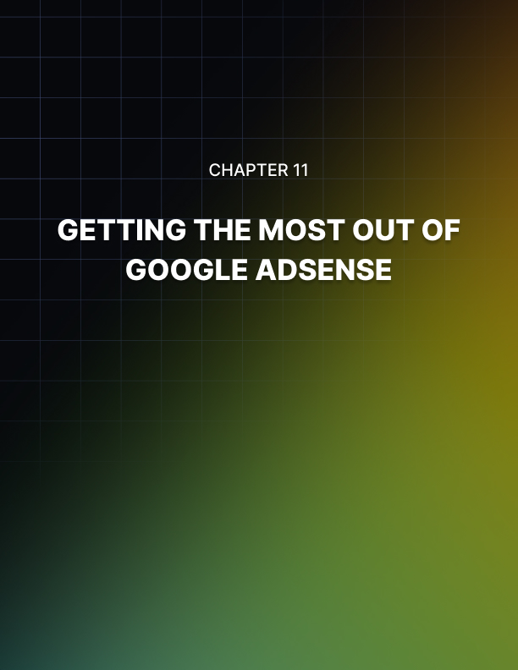

Chapter 11: Getting the Most Out of Google Adsense

Here are some guidelines that will let you know if you are approaching Google AdSense in the best way:

- If you are thinking about starting a business, but are unsure of how to attract potential advertisers.
- If you are a new business owner and looking to Google AdSense to help gain some initial revenue.
- If you are an established business owner looking to Google AdSense to help gain additional revenue.

Setting Up Your AdSense Account
Once you create your Google AdSense account, you will receive an email from the Google AdSense team. Let’s take a look at the message you will receive and discuss a few of the points contained in the email:

“Congratulations! Your Google AdSense application has been approved. You can now activate your account and get started with AdSense in minutes.“

We will now see Google take us through the process of setting up your account.

STEP 1: Sign in to your account.
Please visit https://www.google.com/adsense?hl=en_US and sign in using the email address and password that you submitted with your application. If you've forgotten your password, visit http://www.google.com/adsensepassword for assistance.

STEP 2: Generate and implement the AdSense code.
Click on the 'AdSense Setup' tab, then follow the guided steps to customize your code. When you've reached the final step, copy the code from the 'Your AdSense code' box and paste it into the HTML source of your site.

If you don't have access to edit the HTML source of your pages, contact your webmaster or hosting company.

In order for AdSense to work, you must build the unique AdSense code into your website. This is essential for the program to function.

Not sure how to add the code to the HTML source of your page? Our Code Implementation Guide can walk you through the process…

Once the code is implemented, Google ads will typically begin appearing within minutes. However, if Google hasn't yet crawled your site to determine its content, you may not notice relevant ads for up to 48 hours.

As soon as you start generating and running ads on your site, you will be able to track your results.

STEP 3: See the results.
After you've started running AdSense, you can see your earnings at any time by visiting the Reports tab in your account.

For a quick overview of your reports and the 5 steps to getting paid, view our Payments Guide.

In addition to walking you through the setup process, Google then goes on to provide you with helpful tips and links to ensure you understand Google AdSense to the fullest.

