List of Contents

Introduction 6
Chapter 1: Affiliate Marketing Explained 9
Advantages of Becoming an Affiliate Marketer 10
Shortcomings to Overcome 11
Chapter 2: The Nitty Gritty: How to Sell as an Affiliate 13
Where to Get Affiliate Links 14
Chapter 3: Creating a Website to Sell From 16
Finding Hosting 17
Chapter 4: Your Sales Page 19
The Value Proposition 19
Know Your Audience 20
Urgency 20
Readability 21
Narrative Structure 21
Standing Out 22
Chapter 5: The Go-To Market/Advertising Strategy 23
Finding a Route to Market 23
Promoting Via Social Media 24
Driving Sales With PPC 25
Chapter 6: Finding the Perfect Niche 27
Finding the Perfect Niche 27
More Considerations When Choosing Your Niche 29
The Single Most Important Factor 30
Chapter 7: Becoming a Thought Leader – The True Path to Riches 31
The Sales Funnel 32
Chapter 8: Selling Physical Products 34
Countless Other Options 35
Chapter 9: Scaling Up 37



Introduction

Becoming an affiliate marketer is in many ways the perfect business model. Here’s a way to earn money online, while you sleep, without even having to build a product!

This is the method that is most commonly promoted by internet marketing gurus, and that has reportedly helped them to live the lifestyles of their dreams, to buy their own private jets, and to generally enjoy the kind of lifestyle that was once the sole reserve of famous celebrities and extremely successful CEOs.

You may be wondering if this is all too good to be true. Can you really earn that much money while you sleep? By selling someone else’s product?

If that’s true, then why aren’t more people online billionaires?

Here’s the truth: it absolutely is possible to earn a huge amount of money online as an affiliate marketer. Plenty of people genuinely have made a huge amount of money by selling affiliate products online.

The problem? The methods that they share very often don’t reflect the best strategies that you should employ. Why? This often comes down to one of two things:

- They don’t want you to know the techniques they are actually using to get rich (newsflash: it’s selling those books to you!)
- They actually aren’t that successful. That’s because a large proportion of the people who are successful are already living on a sunny island somewhere and no longer need to sell eBooks!

The other thing to keep in mind, is that this is by no means a “sure thing.” There are no sure things when it comes to business, and there’s never a guarantee that any strategy you use will be effective.

But with all of that said, the intention of this book is to cut through the noise. To do away with the distracting nonsense and to instead focus on just what actually works. In other words: this book will explain to you how you actually sell a product successfully. That means teaching you the very strategies that were probably used to sell you this book!

That’s not a bad thing by the way: the very fact that you have been a customer means that you will have a great idea of what it is that appeals to someone when buying an ebook. You can get inside the minds of your customers.

What you’re really going to learn then is a set of tools and strategies: a number of different methods and concepts that you can apply when selling anything, that will help you to be highly successful.

You’ll still need to choose the right products and you will still need some luck. But you’ll also find that by applying these ideas, you’ll be able to increase your likelihood of selling anything.

In fact, you can consider the skills you will learn in this book to be what is known in business as a “force multiplier.” A force multiplier is anything that amplifies or exaggerates the success or the output that you might otherwise have achieved.

So, let's say you have a product that would normally shift 1,000 units. By applying the principles in this book, you will be able to sell 100,000 units… or maybe 500,000.

The key though, is to then find that product that would sell itself. That one breakthrough product that could sell hundreds of thousands of copies on its own. Then you apply these same principles and you sell millions of copies. That’s how you will succeed.

This comes down partly to luck, but you know what they say: you make your own luck!

That is to say, that by continuously trying and by setting yourself up to succeed, you will drastically increase your chances of success. If you start selling 30 products and use these principles on all of them… then either one of those products is going to be the huge breakthrough that you’re looking for, or the cumulative success of all 30 is going to help you to break through and succeed.
Either way… you’re on to a winner!

You’ll learn these principles and concepts but, on top of that, you can also think of this book as being a place where you can find all the basic how-tos and practical advice you need to get started as an affiliate marketer. Plus you’ll learn how to leverage the inherent advantages of this type of business model, and how to avoid the potential downfalls that come from selling a product that is not your own.

Ready to start making some huge sales? Want to get rich from a product without even having to own a product to sell? Then keep reading. You’re going to learn to do all those things.

I hope you’re excited, because this could be the start of something AWESOME.

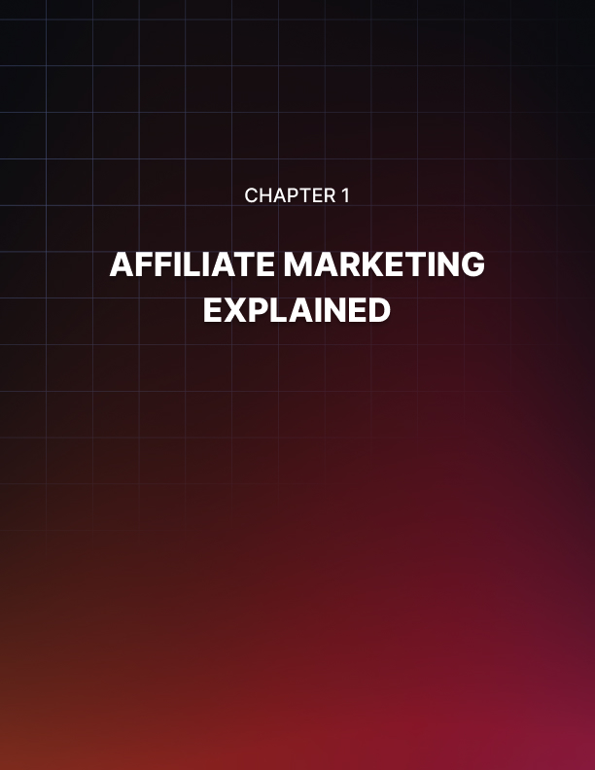

Chapter 1: Affiliate Marketing Explained

Before we look at advanced concepts and strategies, it first makes sense to go over what we mean by affiliate marketing exactly. What is affiliate marketing and why is it such a popular option for those looking to earn money online?

Essentially, affiliate marketing means selling for commission. This works online in just the same way as it does for a door-to-door salesman. That is to say that you will be selling a product that you did not create and do not own the rights to, but in return, you will get to keep some commission.

This is a powerful option for those who want to earn money online but don’t necessarily have the skills or the resources to build an ebook, an online course, or something else from scratch.

The big difference between being an affiliate marketer and a door-to-door salesman of course, is that the affiliate is someone who will be able to sell their products to the entire world. Thanks to the web, it’s possible to reach pretty much anyone, right in the comfort of their home! This makes affiliate marketing endlessly scalable – and with the right product and the right pitch, you can make a HUGE killing.

Online affiliate marketing can generally be split into two categories:

- Affiliate marketing for digital products (such as eBooks and online courses)
- Affiliate marketing for physical products (anything you might buy in a store)

We will talk about option number 2 toward the end of this book. But suffice to say that the majority of people who get into affiliate marketing will be focused on the first option.

Selling digital products has a huge number of impressive advantages after all! Firstly, selling digital products means that there is no storage and no delivery. That in turn means that a much bigger cut of the revenue will be split between you and the owner of the product!

Another advantage is that when you sell a digital product, there are no supplies and no materials. Moreover, the entire transaction is automated.

It’s for these reasons that affiliates can often stand to earn 70% or even 90% from promoting digital products!

You might at this point be wondering why anyone would be willing to give away such a large cut – the lion’s share – of their profits!

The answer is simple: if you’re an ebook owner and you are selling copies of your book to a wide audience, then the more copies you manage to shift, the more money you make. You are probably doing everything you can to try and convince people to find your book (and to help them find it in the first place). As such, you have likely saturated your current market.

Now here’s the thing: if you decide to also let affiliates sell your product, then you will be inviting those people to make you extra sales. This doesn’t detract at all from the sales you make – it’s all additional. So if you’re making $2,000 per month from your sales and you get an extra 10% of that, then this is an extra $200. It might not be a lot, but it’s effectively free money. With the ebook created, you no longer have to lift a finger!

What’s more, is that if you can attract the attention of 20 affiliates, then suddenly you’re earning an additional $4,000 per month! And if one of those affiliates is a superstar marketer, then you might be earning a whole lot more than that!

By offering higher commission on their products, product owners can attract more people to help them sell them. Thus, it is in their best interest to give away a big cut. This is a rare instance of a genuinely win/win scenario!

Advantages of Becoming an Affiliate Marketer
And it really can be a WIN with a capital W!

That’s because affiliate marketing removes many of the challenges and obstacles that you face when trying to sell something online. Some of these are obvious, others are not.

First of all, selling an affiliate product means you don’t need to create something new. This means that you can start earning money immediately. As soon as you are accepted as an affiliate, you can start making cash.

This is also very beneficial for anyone that is simply unable to make a product. Perhaps you have no idea how to make a course or an ebook, or maybe you just don’t have any valuable information to share. In this scenario, you could alternatively commission someone to make you a product, but that would potentially cost hundreds of dollars and months of waiting!

Of course, you would then get to keep 100% of the profit… but that wouldn’t necessarily translate to more cash! Why? Because when you keep 100% of $100, it’s less than keeping 90% of $150. In other words, you can simply find a product with a price and affiliate deal that suits your goals.

These benefits also mean that you could start promoting 20 different affiliate products in the time it would take you to sell just one of yours. The scalability is huge then, and this is something you really need to keep in mind when calculating the best business move.

But perhaps what’s even more beneficial about selling affiliate products, is that it allows you to sell products that have been proven. In other words, you can look and see which affiliate products are selling the best: how much have they made so far? How are they rated?

This way, you can now choose a product that is almost guaranteed to be a hit for you. You at least know that it has the potential to be a hit for you!

This is called “verifying the market” and it’s one of the best things you can do in ANY business. Otherwise, you are effectively taking a punt on an idea that may or may not resonate with your audience. Imagine spending hundreds of dollars and months of your life to create a digital product, only to then find that no one wants it!

Shortcomings to Overcome
With all that said… It is not my job to try and sell you on affiliate marketing. You’re already reading this book, so my only goal now is to give you honest and practical advice that can genuinely help you to make a killing. Rather than continuing to tell you how amazing affiliate marketing is then, I’m instead going to do something far more helpful and tell you about the downsides – so you can understand how best to mitigate and avoid them.

The biggest issue is that this is not your product. For all that affiliate marketing has amazing benefits, you ultimately are selling someone else’s creation. And unlike selling a “PLR” package (private label rights), you won’t have the opportunity to change it or to make edits as you see fit.

This means that you will be selling something that isn’t necessarily a reflection or extension of your own personality, views or styles. This is then significantly more difficult to sell.

This might sound vague, but as we will learn over the course of this post, your ability to sell often comes down to your ability to speak to the value proposition – to build trust and authority with your audience and to establish yourself as a thought leader. That’s significantly easier to do when you believe in the product 1,000,000% and when you actually created the product. This way, people will want to buy the product because they want more of what you have to offer. This is one of the biggest hurdles that you will need to overcome if you’re going to be successful as an affiliate.

And of course, it’s something we’re going to discuss in depth in this book.



Chapter 2: The Nitty Gritty: How to Sell as an Affiliate

Okay, enough promise and hype. It’s time to get real and to look at how you actually go about building this digital empire. How does affiliate marketing work on a technical level, and how do you profit from it?

Essentially, affiliate marketing works using cookies. Product creators are going to give you a share of their profits for every sale that you send their way. That means that they need to be able to track which sales are coming from you versus other sources. Cookies allow them to do this.

Cookies are small files that are stored by your browser when you visit a website. That same website can then look for those files subsequently, which they use in order to identify whether you have been to the site before. It’s thanks to cookies that you’re often already logged in when you visit a website.

When you become an affiliate, you’ll be given an affiliate link to promote. That link is unique to you, and doesn’t actually link directly to the product. Rather, it links to another website which is going to redirect visitors to the sales page so that they can make the purchase. Before they get redirected though, the cookie will first be stored on their computer so that the store can identify you as the person who sent them there. Simple!

This does though mean you need to be careful of a few things. One issue is that some people will try to bypass your affiliate link by simply typing the URL into their browser. Some marketers might also use this as a way to spy on your monetization methods and potentially use this to compete with you. For those reasons, some affiliates will choose to disguise the affiliate link by using a URL shortener.

Something else to think about, is that it’s important that you always announce the fact that you are getting commission on a link. You can actually get into trouble if you promote an affiliate link without declaring that you are earning commission from those sales. A simple pop-up box or notice at the top of the page will suffice: just don’t forget!

Here are three ways you can disguise your URL:

- Use a Redirect: One of the simplest and easiest ways is to use a redirect. This might mean setting up a web page that acts as an ‘intermediate’ page and then simply sends the visitors onward to the product or offer. That way, you can ensure that the cookies are stored on the user’s computer but they won’t be able to spy the destination URL without clicking.

- Masked URL: You can take redirecting one step further by making sure that the user never even sees the address of the destination site. You do this by using URL masking which is also known as a ‘stealth redirection’. Although the user is redirected, the URL will never change!

- Use a ‘Pretty Link’: A pretty link is a link that is shortened to be more attractive and shorter while of course also hiding the original URL. This works just the same as a redirect, except that you’ll be using a ready-made service like Tiny URL or Google’s link shortener.

Where to Get Affiliate Links
The best way to begin with affiliate marketing is to look for affiliate networks. These are sites that make it easy to find affiliate products by advertising them in a single place. These networks sell primarily digital products, which is what we are going to be looking at to begin with.

The popular options include:

- JVZoo
- Clickbank
- Commission Junction (CJ)

There are many others though and you can also find affiliate deals other ways:

- By contacting your favorite sellers and asking them if they’d consider offering an affiliate deal
- By Googling ‘affiliate programs’ and seeing what comes up
- By looking on marketing forums like Warrior Forum or BHW

Either way, the real magic comes down to selecting the right products from these platforms and that in turn often means – first of all – choosing the right niche.

The wrong niche is the one you think is perfect: the massive niche that everyone is interested in. These niches fail because they’re too crowded and no opportunities are left. You can succeed in fitness, in making money online or in dating… if you have a million-member list or you have a million dollars to pour into marketing.

We’re going to discuss how to find the right niche for you in an upcoming chapter. So we’ll come back to this.

In the meantime, some other things to think about include:

- The cost of the product – Is it likely to sell at that price? Does it offer good value?

- The commission you will earn per sale – Don’t be too won over by the commission you’re receiving as this doesn’t always translate to income! Number of sales, commission, and overall price must work together to get you the most profitable outcome.

- The value – This is the most important factor of all: how much value does this product offer? Does it sell itself? Is it speaking to a need that a lot of people share and that is emotive? Is it something you think you might want to read or enjoy?

- What’s included? – Some affiliate products will actually go as far as to include lots of extras to help you sell. That means they may have written adverts for you, created landing pages, and more. This essentially gives you a “business in a box.” All you need to do is publish what they’ve provided and start sending people there! This is really useful if you don’t know how to promote your product, but if you’re happy creating your own sales material then its usefulness may be more limited.

- Who is it for? – This is another big consideration and for a lot of different reasons. For instance, you need to think about whether your business appeals to a demographic that has available cash. If you are selling something to silver surfers then this can work well, as they actually have a large amount of disposable income in many cases. Tweens? Not so good!

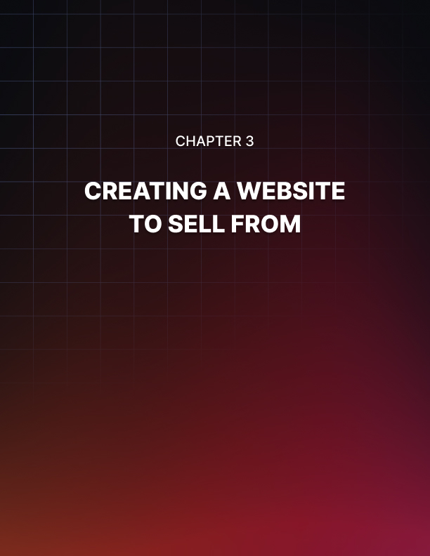

Chapter 3: Creating a Website to Sell From

Now you have the product and the link, it’s time to set about selling it. To do this, you are going to need a website and a sales page. Thankfully, it’s easier than ever to build both these things!

To build a website, by far the best strategy is to use the extremely powerful and popular tool: WordPress.

WordPress is a CMS, meaning a “content management system.” It is also essentially a template that allows you to create a website with minimal code, and then to import ready-made themes and plugins to extend its capabilities and customize its look. WordPress is used by a quarter of all websites on the net, and it powers some of the very biggest brands out there. This is important because it means you know that the tool is capable of creating a highly successful website. That in turn means that if you struggle to make your website successful later on, it’s not a case of it potentially being down to the way the website is structured. You know it must be fixable! Google knows and likes WordPress, and there is a huge amount of support out there if you need help changing settings or fixing the look.

What’s more, is that WordPress is completely free, and completely open source. It is different from a “website builder” in this sense, because it isn’t going to tie you into a lengthy contract that forces you to keep paying monthly. Nor will you be forced to display ads. Moreover, there is no limit to what you can build with WordPress, as you always have the option of editing the code itself (or hiring someone to do it for you).

In short, there is no good reason not to use WordPress, and choosing anything else will only introduce more risky variables and cause things to take longer. This is the mindset you need for successful affiliate marketing and for success in business in general: the aim is to succeed quickly. Take the path of least resistance. Start earning cash as soon as possible by focusing on the things that MATTER. Invest your time where you will see the most returns.

The best part of all this is that WordPress is extremely quick and easy to use. You’ll find instructions on how to set it up and make the basic changes you need all over the net, especially on YouTube.

Finding Hosting
Before you do that though, you’ll also need a hosting account. A hosting account means that you are paying a company to store your files on their server, which is going to in turn remain connected to the web. What that then means, is that when someone types your URL into their browser, your website will come up!

There are lots of factors to consider when choosing hosting:

- Price
- Amount of storage
- Bandwidth (the amount of data that you can transfer)
- Backup
- Features

Usually, you won’t need to spend more than $8-$20 per month, although a lot of hosting companies require you to pay the full amount upfront.

Some great options for hosting accounts include:

- Bluehost
- Dreamhost
- HostGator
- A2 Hosting

Choose one of these, then create an account and choose a URL (your web address). The URL should be something unique, easy to remember, but also related to the niche that you plan on selling in.

Once you’ve done this, you should be able to access a control panel. These will often now include a “one click” install for WordPress, and once you’ve followed those steps, you’ll be able to log into your account and start uploading content/changing the look and feel of your site. It’s really that easy!



Chapter 4: Your Sales Page

The website itself is where you are going to post content that brings people back to your website time and again. We’ll talk more about this in an upcoming chapter.

But the other thing you need to build and upload, is your sales page.

A sales page is essentially a single web page that has the job of promoting and selling your product. That means that you won’t feature anything else at all on this page: no other products, no adverts, and not even any links to your home page etc. The reason for this is that you don’t want anything to distract them from the product, or to pull their attention away from it.

Instead, this page will typically feature a long, narrow page of text that is focused purely on talking about the product and making the reader want to buy it. As the reader scrolls down, they will begin to feel more and more invested in the product having spent more time there, and they will grow more interested in what you’re selling.

You will then lace the page with “Buy Now” buttons, which will take them to the affiliate checkout.

The art is in writing this sales copy in such a way as to truly persuade the reader. So, how do you do that?

Here are some key tips for making a successful sales page.

The Value Proposition
The first and most important thing by far, is to make sure that you understand the product’s value proposition and how to leverage this for success.

Essentially, a value proposition is the thing that makes your product desirable. If the product is a good one, then this should have a strong, emotional pull.

The key is to understand how your product will make people’s lives better, and how best to communicate that to your specific audience. They should be able to picture themselves using their product, and get a feel for why it’s going to change things for the better.
The old saying to remember here is “you don’t sell hats, you sell warm heads.” Here, you are focusing on the value that the hat provides, not the hat itself.

Likewise, you don’t sell books on dating: you sell confidence, you sell great sex, and you sell the feeling of being able to walk into a room with an attractive partner on your arm!

You don’t sell books on business: you sell financial freedom, a feeling of being highly successful, and the freedom to create things that a person cares about.
You don’t sell courses on getting into shape! You sell energy, sex appeal, and raw physical power.

Look for the emotionally resonant words that tap into the reason someone might want your product. Then use them liberally!

Know Your Audience
When trying to find the value proposition, it’s also important to know your audience. That’s because the value proposition that will be most effective depends very much on the people reading your copy!

The biggest mistake is to try and appeal to everyone. Do this and you will end up with a bland product and a bland pitch that won’t make a big impact.

Instead, think about the precise kind of person that you want to address. Then think about how you can reach that person.

An exercise to better understand this, is to try and create a “buyer persona.” A buyer persona is a fictional biography you will write for your hypothetical ideal customer. By understanding them: where they spend time, what their other hobbies are, what their budget is like… you can better understand how to sell to them.

Urgency
In general, the aim is to sell via emotion. This is the KEY to understanding sales, which in turn is what will make you successful as an affiliate. People don’t buy things because they need them. Don’t buy things because it makes logical sense. People buy things because they feel this sense of urgency to do so. They do it because they’re excited about the prospect of something, they think it will make them feel good or be less stressed. And they’re worried they’ll miss out if they don’t.

This is why social proof (showing testimonials) can be powerful, because that suggests that lots of other people are enjoying this thing that they have yet to try. It’s also why you should try and get your audience to buy as quickly as possible once you have made the product sound as appealing as you can. You do this by using a limited-time discount, by saying that you will only be selling the product for a given period, or even by displaying a timer on your page.

Readability
Readability is also extremely important when it comes to selling a digital product from a landing page.
In short: if your website is currently a huge block of text, then this is going to put people off reading. Remember that attention spans are shorter on average than they have ever been and a lot of people are going to be pushed for time. Don’t make them work to understand your text!
Instead then, make sure to use big, bold headings that will display almost the entire message that you want to convey. It’s often said that someone should be able to read only your headings and still understand nearly everything on the page!
Likewise, you should ensure that your paragraphs aren’t too long and that they’re broken up and spaced out nicely. Use a big and clear font, and use lots of images throughout.

Narrative Structure
Another powerful trick is to use a narrative structure. There is a saying in marketing that “narrative is SEO for the human brain,” and this is extremely true.

When we see a story, we find it very difficult to move on without reading the whole thing. Moreover, we find it much easier to relate with what’s being said on an emotional level.

What you should do then, is to phrase your content in a way that will make people want to find out what happens and relate to you.

“I was once like you: a struggling actor who had no idea how to land an audition, let alone a gig!”

With that said, it’s also important to avoid being too clichéd. People have seen this trick a lot of times by now (it’s even common in television advertising) so try to find ways to make yours different and to make yours stand out.

Standing Out
Standing out is important in general, and this is one of the key things that people often misunderstand when it comes to the importance of selling online.
People are sick of seeing the same thing over and over again. If you want to sell, the most powerful thing you can do is to make your offering really unique and exciting. You don’t have power over the product itself, but you DO have the opportunity to market it in a really interesting way.

Why not create some bespoke art or even a video that will really convey the message of your product with your intended audience? Why not use this to make the offer you’re promoting really stand out?

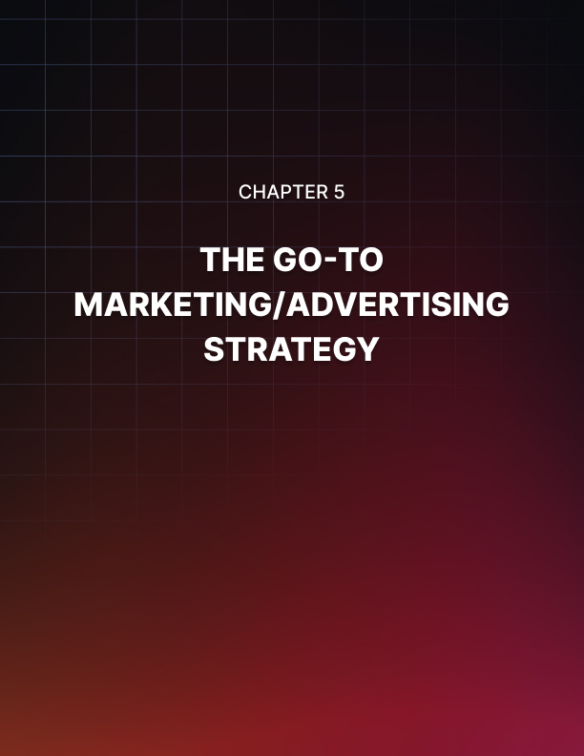

Chapter 5: The Go-To Market/Advertising Strategy

Once you have your product and a website to sell it from, you have a few options to start selling. The simplest is to send potential customers directly to your sales page. If you have designed it correctly, then this should lead to immediate conversions. People will land on your page, like what you have to say, and then buy from you!

Business, very often, is about finding a great product and then connecting that to the right audience.

Finding a Route to Market
One way to do this is to find your “route to market.”

This is a business term that basically means you’re going to identify a way in which you can reach the audience you want to sell to.

You might already have an audience that you built up before reading this book. Perhaps you’re already a successful blogger or YouTuber. That is now your route to market – your access to the people that will buy what you’re going to sell.

But if you don’t already have such an audience, the best strategy is just to find one that is sitting there waiting. In other words, don’t build an audience and then try and find a product to fit. Choose a product because you are aware of an audience that’s out there – or find the audience and then find the product.

A route to market could be any of the following things:

- A Facebook page
- A forum or online community
- A Subreddit
- A magazine
- A real-world club or class

What you might even find is that you already have connections or already have established authority.
If you are a prominent member of an online gardening community, then why wouldn’t you use that to your advantage by looking for a gardening product to sell? You already have the access and the trust and all that’s remaining is to introduce the solution to their problems.

I was once good friends with the editor of a magazine and that meant I knew that they would be willing to run the stories that I gave them. This provided me with a perfect and easy route to market. But to be honest, approaching any smaller magazine in an industry like that could have achieved a similar end – a captive audience that other people weren’t selling to.

Promoting Via Social Media
One of the best routes to market out there is social media.

Many of us think of social media as a tool we can use to promote our own brand by generating followers. But in fact, this is also a platform and a place where people congregate around a subject or a topic.

Some fantastic routes to market that exist on social media and social sharing sites that are completely free to use are:

- Facebook pages
- Google Plus communities
- SubReddits

But you might be protesting at this point already. You might be ready to say that you’ve tried this technique, you’ve posted your best content here, and you’ve not had any response.

There are a few reasons this may not have worked so far.

If you want to share products on a forum, then it is key that you first build up the trust and authority there. Post regularly, answer questions, help people out and generally make yourself popular there before you try and sell. If you sign up and then immediately try selling, then you’ll be banned or at least your post will be ignored.

It might not feel like ‘work’ but one of the best things you can do for your business is to hang out in these online communities, joke around and make yourself known as someone who isn’t just there to spam.

Another good tip is to think carefully about whether you’re actually providing value to this audience. The big mistake is to post articles and content that is simply there to promote your own products or that is just a rehash of posts that already exist.

You need to post things that are interesting, engaging and emotionally engaging. In other words, you don’t want to post an article on how to get abs in a week. Instead, you should aim to post articles about ‘cardio acceleration for incredible weight loss and body recomposition’. In other words, something new, something exciting. Clickbait but where the content actually lives up to the promise in the title.

Driving Sales With PPC
The other way to get direct sales is to set up a PPC campaign that will drive potential buyers directly to your website. This is a strategy that Tim Ferriss describes as “setting up a muse” in his book The Four Hour Workweek.

The great thing about this method is that it will allow you to earn money entirely passively and with the absolute minimum set up. You just find a product, set up a sales page, then send people there via adverts. The downside of course is that this does involve a little investment!

PPC ads are “Pay Per Click.” That means that you’re going to pay for the advertising only when the ad gets clicked. This amount will be determined by you – you decide how much you’re willing to pay as your maximum. However, because your ads will compete for space with other advertisers, the more money you pay, the more your ads will be seen. More competitive spaces of course cost more than less competitive ones.

The two biggest PPC platforms are:

- Meta Ads
- Google AdWords

Meta Ads let you show ads to Facebook and Instagram users based on their location, age, sex, interests, and more. Google AdWords lets you show ads based on what people are searching for – their “keywords.” If you advertise on a keyword like “buy hats online” then this of course will mean you attract people who want to buy hats.

The key to success on AdWords and Meta Ads, is to set your budget just right. Work out your CLV (customer lifetime value) by looking at what percentage of people who visit your site buy from you (your conversion rate) and how many times. Then find the average amount of profit for each sale.

So if you have 1,000 customers and 2 people buy from you averaging $600, then you can say that your CLV is $600 / 1,000. That’s a customer lifetime value of 60 cents.

As long as the amount you pay per click is lower than this, then you can almost guarantee that you will make a profit from your PPC campaign! As you reinvest more profits, you can grow and scale your business. And as you refine your sales page with better copy and refine your ads with better “targeting” (meaning they are showing to people who are likely to buy from you), you can increase the CLV as well!

This is the simple equation to an almost guaranteed marketing campaign!



Chapter 6: Finding the Perfect Niche

But let’s rewind for a moment. Because while creating a “muse” is a great way to generate passive income, the REAL success will come from becoming a big “name” in the industry. Imagine how much Tony Robbins would make if he started promoting an affiliate product! He’d probably generate millions of sales in a day. That’s what we want for you!

To get there, you start by creating a strong BRAND. And to do that you need to choose the right niche. This will also help you to select better products, with less competition but a big and hungry audience.

Finding the Perfect Niche
In internet marketing/blogging parlance, a niche is essentially a subject matter. This is the topic that you will be writing about and in turn, the industry that you will be promoting.

In the vast majority of cases, affiliate marketing will involve creating a blog with regular updates of some form or other. This means you’re going to need to write about this topic and find a large audience of people who are interested in reading about it.

But at the same time, this will also define the type of product you’re selling. If you write about fitness, then you’ll need to sell fitness-related products. If you write about music, then you’ll need to sell something to do with music, etc. Depending on your niche, you may find that products/services tend to gravitate more toward the high end or the low end.

And then there’s the fact that your niche will dictate the kind of person who comes to your site and thus their interest in buying online, their budget etc. Your niche will also dictate how much competition you’re going up against. And the type of marketing you have available to you. The list goes on…

For all these reasons, the niche you choose is one of THE biggest decisions for any affiliate marketing business and will have the greatest impact on your eventual success or failure. So how do you choose?

The Goldilocks Niche

- Some niches are too big.
- Some are too small.
- Others are juuuust right.

That third category of course is the type of niche that you want to find and the kind that will help you to get the very best results.

An example of a niche that is too big would be something like ‘bodybuilding’. Bodybuilding is a gigantic niche that incorporates a huge number of different sub-categories. There’s the sport of bodybuilding, there’s adding muscle, there’s just getting into shape… And this niche is pretty much stitched up thanks to the likes of Bodybuilding.com, Breaking Muscle, T-Nation, Men’s Health, Men’s Fitness etc. These sites have gigantic advertising budgets in the millions and they are competing with countless smaller sites that are all vying for the top spot on Google. If you try to compete with these, then you are going to have a very difficult time ranking for the most popular search terms. And if you pay for PPC, then you’ll need to offer up a huge CPC (cost per click) in order to get your ads anywhere that they will be visible.

On top of this, it will be much harder to sell affiliate products in this niche because your buyers will have tons of choice. Why would they buy a $50 ebook you recommend over the $20 hardcopy that is available at their local library? They’ve likely seen thousands of books on losing weight and they’re probably sick of them.

Meanwhile, a niche like ‘bird sewing patterns’ is just too niche. This is so specific that only a very small number of people are going to visit the site (people who like sewing and people who like birds). Likewise, those people will probably only be interested in your site for so long, while they choose a pattern to sew. So even if you land the very top spot on Google (which should be relatively more simple), you probably won’t sell all that many products. And there won’t be many products to choose from either, seeing as it’s such a slim niche.

So, that goldilocks niche is somewhere in-between. For example, instead of writing about bodybuilding, you could write about ‘Bodybuilding for students’. This is still a big niche but it’s also a lot more specific than bodybuilding generally and you’ll face a lot less competition. There simply aren’t that many ebooks out there that are aimed specifically at students who want to get buff and therefore you will face less competition. If someone is a student and trying to get strong, your book will be one of the few specifically catered to them and thus will have the edge over a general ‘bodybuilding’ book. In fact, there is a YouTube channel called ‘Student Aesthetics’ that has this very premise and it does very well.

Another great example of a real website that has landed on a great niche like this is ‘Nerd Fitness’. This is fitness aimed at nerds – and seeing as a lot of stereotypical nerds are out of shape, it’s an ideal combination.

If you were to look at sewing, then a great option could be ‘Easy Sewing Patterns’ or ‘Extreme Sewing’ (yes, that’s a thing). These are still very niche but not as niche as our previous example.

More Considerations When Choosing Your Niche
When choosing your niche, another thing to consider is the value proposition and the ‘emotional hook’. That is to say, that the very best niches for an affiliate marketer are the ones that promise something that the reader really wants. Bodybuilding is a great niche in this regard because it promises to help people get into shape. This is something that many of us will have a strong emotional reaction to – we all want to be stronger, fitter and more defined and we believe that we’ll be more attractive, more confident and happier as a result. Buying an ebook on fitness seems like a great first step to becoming hot and sexy and thus we’re very happy to spend $30, $50 or $100.

Now compare this to the ‘cat’ niche. This is a site all about cats and people who love cats. The thing is, no matter how much someone loves cats, a cat jumper isn’t going to change their life. That means you can’t charge much more than $5 or $10 for it (unless you’re selling a cashmere cat jumper to a very wealthy type of customer). This means you need a much higher turnover in order to make the same amount of profit. That in turn means it will take you a lot longer to start making the same kind of income – something to think about when choosing your niche.

Another question to ask is whether a niche is ‘evergreen’ or a trend. An evergreen niche is one that will always be relevant and the cat and fitness examples fit this bill. People will always want to be in shape and they will always like cats – meaning your site will never go out of date.

On the other hand, a trend would be something like the Paleo diet, or maybe One Punch Man. These things are very in vogue right now but may not always be. For a quick ‘in and out’ way to make money, that can be a tantalizing prospect.

Of course the ideal scenario is that you get involved in a trend or fad just before it gets big. If you can anticipate a trend like this, then you can potentially gain the upper hand before there’s much competition and then reap the benefits once millions of people start searching for that topic.

For example, if you’re willing to play the long game, then you could create a site about the Tokyo Olympics and start blogging right now so that you’ll be number one once that starts getting billions of searches.

Obviously, another consideration is what kind of products you can find in your given niche. If you find the perfect product that you absolutely love, then in some cases that alone can be enough reason for you to start blogging about that niche!

The Single Most Important Factor
But you know what the single most important factor is when it comes to choosing a niche? Your involvement with said niche.

If you don’t know anything about fitness, then you should not create a blog about fitness. If you have no particular interest in knitting, then stay away from that niche.

The only caveat to this rule is if you are working with a writer or an advisor who does love the subject.

There are countless reasons for this but the basic thing to keep in mind is that nothing trumps real passion. The best fitness sites are run by people who absolutely love fitness and who know the niche inside out. These people know precisely what competition is out there, they know how to teach a beginner and they know the advice that even the experts don’t know. What’s more, is that they can come up with new ideas and really innovate in the space.

Compare this with someone who starts a fitness site in a detached manner with no understanding. They’ll write generic articles based on what little information they do have and they’ll make a lot of mistakes/contribute nothing new to the niche.

As a result, no one will read their posts! Likewise, they won’t be able to identify the really good products that are likely to sell. And what’s more, is that there’s a very good chance you’ll simply become disinterested in the subject after a few months and leave your site to flounder.

So don’t let this happen: choose a niche that has at least some interest to you so that the passion will come across in your writing and drive you to keep on adding more and more great content.



Chapter 7: Becoming a Thought Leader – The True Path to Riches

The reason that your involvement and passion for the niche is so important is that you are going to need to do some content marketing and brand-building if you want to enjoy the very biggest success possible.

As we have touched on, this is how you get to the point where you can select nearly any product and then sell hundreds of thousands of copies.

But to get to this point, you need to consistently provide free value for your audience. This is important, because it is how you are going to build trust in your audience. It’s how you’re going to create fans, and it’s how you’re going to get to a point where your audience wants to come back to you time and time again to see what useful information you’ve put up.

Again, the way you get to this point is by posting about a topic that you genuinely love and find interesting.

And here’s the bad news: you can’t hire a writer. Sure, you can hire a writer, but doing that won’t work. Why? Because when you hire a writer, you hire someone who is very good at writing about something that they have no real interest in or passion for. It’s better to hire a personal trainer to write about fitness and then fix the grammar.

That’s because the personal trainer MIGHT actually have something new and interesting to say on the topic. If you get some random writer who knows nothing about fitness to write about abs, then the best they can do is to rehash something they’re read elsewhere. This simply doesn’t offer the reader anything new. It doesn’t incentivize them to come back.

And it doesn’t give them any reason to believe that the book you’re recommending can really change their fitness forever!

Conversely, say something really NEW and really EXCITING and they might just be interested in your recommendation.

The other bad news? You need to keep doing this. On multiple platforms. And you do this while having a consistent message and a “mission statement” that sets you apart from the crowd. And a logo that tells people what you’re all about and that people want to wear on t-shirts.

That’s how you build fans and not just followers. That’s how you create a movement. And that’s what ALL of those massively successful internet entrepreneurs standing in front of their jets did.

In fact, that’s what they’re doing by standing in front of those jets. They’re selling a vision, and they’re creating an army of followers who will buy any book they recommend.

Of course, there is a moral consideration here. With great power and all that! But I’ll save the preaching. It’s up to you to make sure that you keep up your end of the bargain by providing real value. After all, that will ultimately lead to even more loyal fans and even more sales.

So yeah, you had better be truly passionate about what you’re selling if you really want to succeed!

The Sales Funnel
Finally, consider that in many cases, the sales page will actually be the last stop on a “journey.” A sales funnel is a term used to describe a series of interactions you have with a potential buyer that will allow you to gradually convince them to buy from you.

The thing to remember here, is that most often, people don’t buy from strangers. If someone came up to you in the street and offered to sell you a product you would almost always say no! It’s just like we don’t give our number out to strangers in a bar before they have done some legwork to impress us.

In affiliate marketing, we can do this “legwork” by communicating with them in other ways. That might mean by giving away a free “report” or inviting them to an online seminar. It might mean getting them to sign up to a mailing list (use an autoresponder like MailChimp or Aweber).

This is how you convert a “cold lead” into a “warm lead.” They say that you should try and make five “touches” before attempting to sell. This way, the lead will know and trust you well enough to consider spending money on your brand.
Two of the very best strategies you can lead are to create a mailing list and to sell something that is extremely cheap.

The mailing list is a very popular strategy in the world of affiliate marketing. Usually, you will offer your subscribers something free (like a PDF report) in exchange for signing up. From here, you can then communicate with them directly in their inbox, which in turn helps to build rapport and trust. People are reluctant to give up their email addresses, so anyone that does is likely to be a receptive lead who you can later sell to. This is especially true seeing as many autoresponder tools will allow you to see who is opening your emails and who is the most engaged with your marketing!

You can then use a sales process via your emails to build hype for products before promoting them to your most receptive audience (while NOT bothering the people who clearly aren’t interested). You can do this with a sequence referred to as AIDA:

- Awareness
- Interest
- Desire
- Action

That’s four emails that first tease your product, then make it sound interesting, then make it sound amazing (while forcing the readers to wait), before giving them the change to buy.

The other trick – selling something very affordable – is a lesser known strategy. However, this is extremely effective because it allows you to demonstrate the value you’re capable of delivering, while at the same time making it easier to sell to the customer in future. If they had a good experience with you buying that $5 ebook, they are FAR more likely to impulsively buy that $50 affiliate product!

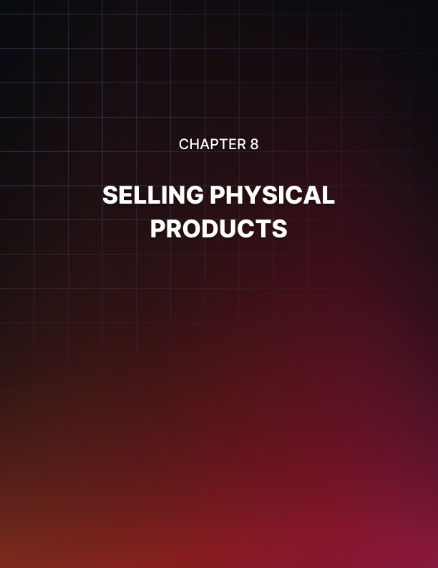

Chapter 8: Selling Physical Products

Finally, there is another option: selling physical products. At the start of this book, I mentioned that you could also sell physical items and that this had unique advantages and disadvantages versus selling physical products.

The advantage is that physical products appeal to more people. People like buying physical products because they get something tangible in exchange for their money. More people also understand physical products: there are a lot of people (like my grandad) who simply don’t have any need for digital products.

The downside is that physical products offer MUCH smaller commissions. The biggest affiliate platform of all is Amazon Associates. This platform has a lot of advantages: for instance, if someone follows one of your links to buy a product but ends up buying something else then you still get the profit! Amazon Associates also provides a lot of useful buttons and tools you can use to make sales.

But on the downside, Amazon Associates only offers somewhere in the region of 1-6% for their products. Most are at the lower end of that spectrum. Amazon also won’t pay you in foreign currency unless it’s by check (don’t even bother) and it has been well-known to simply change its affiliate policies overnight with no warning.

Is there money to be made here? Absolutely! Especially if you are selling products that are very expensive like computers, fitness equipment, or similar.
But in order to get to this point, you really need to have a website that is attracting hundreds of thousands of views per day. This is the only way to build the kind of success that you need in order to make it big.

Then you can write lots of blog posts around a range of different topics within your chosen niche. You’ll then use your domain authority in order to quickly rise to the top of the search engines for each of those posts, and by including some affiliate links to physical products, you can potentially earn a lot of money.

If you have 1,000 blog posts, each getting 10,000 hits a day and selling a computer that earns you $50 per sale… you can potentially earn a fair amount of cash.

Countless Other Options
That said, there are countless other options too.

For example, you might choose to sell an online course. These are excellent affiliate schemes that offer a lower percentage than most digital products, but will have better terms than Amazon. You can even find sites that will allow you to sell MBAs! This has the potential to earn you a huge amount of cash, and it’s a great feeling helping people to better themselves by extending their learning (a great example of a niche with a real mission statement and value proposition).

Remember too that you can always try contacting manufacturers and brands personally in order to discuss potential schemes. This way you can haggle for the best deal, while representing a brand that you believe in and that fewer other people are offering. If you’re already a big influencer, you’ll likely find this is more successful than if you’re a little-known nobody!

There are other business models that are slightly different but tangential to affiliate marketing too. For example, you could look into dropshipping. This will let you sell a product that will be stored and delivered by a third party manufacturer, but that will be marketed and branded as though it was yours! You can find companies happy to do this on sites like Alibaba, and it’s one of the best business models available for online entrepreneurs!



Chapter 9: Scaling Up

Whatever strategy you decide, eventually, you should be in a place where you have a funnel in place. That will mean that you have a blog or you are just posting on social media, and by doing that, you are getting more and more cold and warm links to your site.

You’re then collecting those emails, hitting them with a carefully crafted autoresponder sequence and then sending them over to your site where you are eventually converting them into buyers.

It’s a bit like a spider creating their web.

All you need to do now is to increase the volume of traffic – or flies – so that more and more get ensnared.

One way to do this is to reinvest your profits into advertising. If you have a system that works and a landing page that truly converts, then there is no reason not to do this.

As long as you pay less than you earn per visitor on average, then you can grow and grow your traffic and keep increasing your profits.

The other option? Repeat this whole process again, again and again, conquering different niches each time you do! That’s the wonderful thing about affiliate marketing: there is nothing to stop you from building as many revenue streams as you want! It is literally endlessly scalable.

The question here though, is whether you are going to set up a new website and a new brand to sell a new product in a largely anonymous manner, or whether you’re going to build on your success by promoting a second product from the same account.

As mentioned, this latter option is the TRUE way that you start to earn a lot of money. This is how you create an army of fans who will be excited to buy any product that you recommend. It’s how you become an internet marketing guru, and someone who is sought after by other product owners!

To get to this point, you need to continuously post high quality content. That might mean on YouTube, on your blog, or on social media – ideally on all three. You need to maintain your brand message, and you need to interact with your fans. Keep building that rapport, keep providing value, and only promote items that you’re truly a fan of.

You might be worried at this point. What if you don’t have a message to share? What if there isn’t a niche you’re an expert in? What if you don’t like writing or making YouTube videos?

And here’s the thing: you don’t have to be any of those things to begin with. Instead, you need to gradually become that amazing guru or marketer. The only way to do this is through practice.

And once again: that is why it is so important to enjoy the process. To really love the topic. To be passionate about what you are selling.

This is a skill that needs to be developed over time like any other. It most assuredly is NOT a get-rich- quick scheme. Yes, you can set up a muse and start earning some cash very quickly if you know how (and now you do). But in order to succeed at the very highest level, you need to become someone that people consider an authority in your niche, and who has something exciting and new to say.

That takes time.

But it’s great fun and the destination is more than worth the time you’ll put in to get there!

