List of Contents

Chapter 1: Introduction to AI for YouTube: Transforming Content Creation 5
Understanding AI in the YouTube Context 5
The Future of AI in YouTube Content Creation 6
Chapter 2: Automated Video Editing: Enhancing Efficiency and Quality 7
Evolution of Video Editing with AI 7
Overcoming Challenges and Learning Curves 9
Chapter 3: AI-Driven Content Recommendations: Keeping Viewers Engaged 12
The Power of Personalization 12
Future Trends in Content Recommendations 14
Chapter 4: Optimizing Thumbnails and Titles with Automation 17
The Significance of Thumbnails and Titles 17
Ensuring Ethical Practices 18
The Future of AI in Thumbnail and Title Optimization 19
Chapter 5: Automated Analytics: Understanding Your Audience for Growth 23
The Importance of Analytics in Content Creation 23
The Ethical Use of Analytics 25
The Future of AI in Analytics 25
Chapter 6: AI-Powered SEO Strategies: Boosting YouTube Visibility 29
The Role of SEO in YouTube Success 29
Ethical Considerations in AI-Driven SEO 31
The Future of AI in YouTube SEO 31
Chapter 7: Personalized Viewer Experiences: Chatbots and Interactive Content on YouTube 35
The Rise of Personalization 35
Challenges and Ethical Considerations 36
The Future of Personalized Viewer Experiences 37
Chapter 8: Smart Scheduling: Optimizing Posting Times with AI 41
The Imperative of Timing 41
Future Horizons: AI Evolution and Personalization 43
Chapter 9: Monetization Strategies with AI: Maximizing Revenue 47
The Landscape of Digital Monetization 47
Challenges and Ethical Considerations in AI-Driven Monetization 49
The Future of AI in Monetization 49
Chapter 10: Future Trends: Navigating the Evolving Landscape of AI on YouTube 54
AI-Driven Content Creation 54
Ethical Considerations and Regulation 56

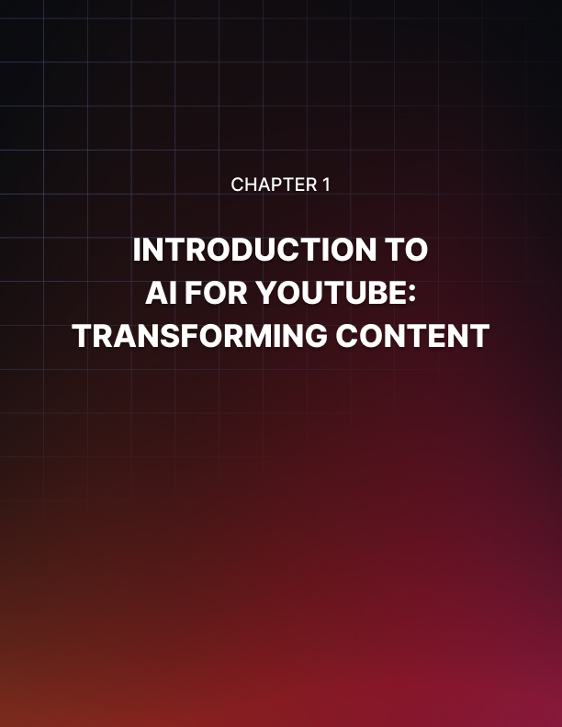

Chapter 1: Introduction to AI for YouTube: Transforming Content Creation

In the ever-evolving landscape of digital content creation, the integration of Artificial Intelligence (AI) has emerged as a revolutionary force, reshaping the way YouTube creators produce and share videos. This chapter delves into the foundational principles of AI and how its application is transforming content creation on YouTube, offering creators new tools and possibilities.

Understanding AI in the YouTube Context
To embark on this journey, it's crucial to grasp the essence of AI and its role within the YouTube ecosystem. Artificial Intelligence refers to the development of computer systems that can perform tasks that typically require human intelligence, such as visual perception, speech recognition, and decision-making. In the context of YouTube, AI becomes a creative ally for content creators, automating various processes to enhance efficiency and unleash innovative potential.

Automated Video Editing
One of the primary ways AI transforms content creation on YouTube is through automated video editing. AI-powered tools can analyze raw footage, identify key elements, and intelligently edit videos to create a polished final product. This not only saves creators valuable time but also ensures a professional and visually appealing outcome, even for those without extensive editing skills.

Enhancing Creativity with AI-driven Ideas
AI is not just a tool for efficiency; it's a source of inspiration. Creators can leverage AI algorithms that generate creative ideas for video content. By analyzing trends, user preferences, and historical data, these algorithms suggest topics, formats, and styles that are more likely to resonate with the target audience. This innovative approach helps creators stay ahead in the competitive landscape of YouTube.

AI and Personalized Content Recommendations
Understanding audience preferences is paramount for YouTube success. AI algorithms analyze user behavior, watch history, and engagement patterns to deliver personalized content recommendations. This not only keeps viewers engaged but also assists creators in tailoring their content to meet the specific interests of their audience, fostering stronger connections and increasing watch time.

AI-Enhanced Scriptwriting and Voiceovers
For creators who wear multiple hats in the content creation process, AI offers assistance in scriptwriting and voiceovers. Natural Language Processing (NLP) algorithms can generate scripts based on predefined topics or assist in refining existing content. Additionally, AI-driven voiceovers provide a convenient solution for creators seeking diverse narration styles without the need for external talent.

Navigating AI Tools and Platforms
As creators venture into the realm of AI for content creation, understanding the available tools and platforms becomes crucial. This chapter guides creators through popular AI-driven applications, providing insights into their functionalities and how they can be seamlessly integrated into the content creation workflow.

The Future of AI in YouTube Content Creation
Closing the chapter, a glimpse into the future sets the stage for what lies ahead. As AI continues to evolve, so will its impact on YouTube content creation. Creators can anticipate even more advanced features, from real-time audience feedback analysis to AI-generated virtual elements seamlessly integrated into videos.

In essence, Chapter 1 serves as a gateway to the transformative potential of AI in YouTube content creation. It introduces creators to the foundational concepts, practical applications, and future possibilities, setting the stage for a comprehensive exploration of how AI can elevate their content and redefine the landscape of digital storytelling.

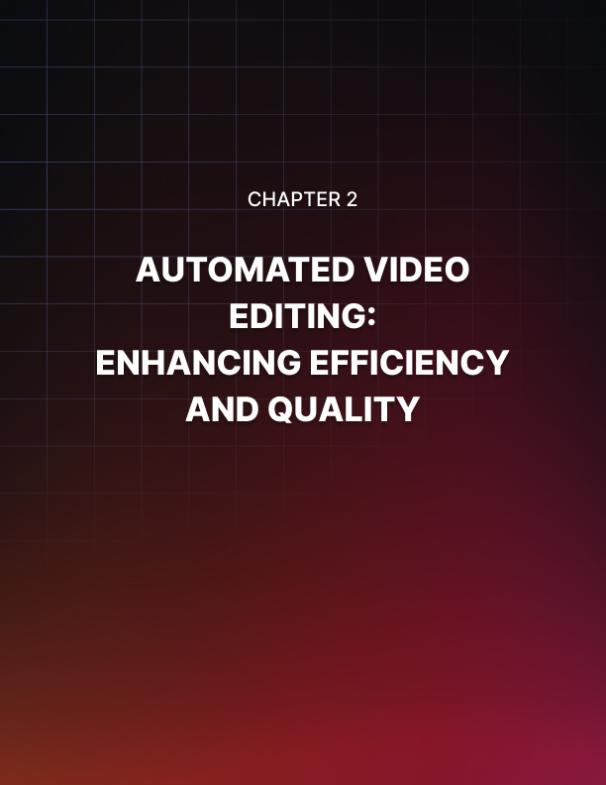

Chapter 2: Automated Video Editing: Enhancing Efficiency and Quality

In the dynamic world of YouTube content creation, the art of video editing plays a pivotal role in capturing audience attention and maintaining engagement. Chapter 2 explores the transformative impact of Artificial Intelligence (AI) on video editing, shedding light on how automated processes can elevate the efficiency and quality of content on the platform.

Evolution of Video Editing with AI
Traditionally, video editing has been a time-consuming and skill- intensive task, requiring creators to possess expertise in various editing software. With the advent of AI, the landscape has undergone a significant transformation. Automated video editing tools harness the power of machine learning algorithms to streamline the editing process, making it accessible to a broader audience.

Time-Saving Automation
One of the most significant advantages AI brings to video editing is time efficiency. Creators no longer need to spend hours manually sorting through footage, cutting clips, and adjusting transitions. AI algorithms can analyze raw video content, identify key moments, and automatically generate edited sequences, significantly reducing the time and effort invested in the editing phase.

Intelligent Scene Recognition
AI's scene recognition capabilities contribute to a more intelligent editing process. These algorithms can identify different scenes within a video, distinguishing between transitions, action sequences, and dialogue scenes. As a result, automated editing tools can apply appropriate effects, transitions, and pacing, ensuring a seamless and visually engaging final product.

Enhanced Visual Appeal
Automated video editing tools go beyond basic cutting and trimming. They leverage AI to enhance the visual appeal of videos. This includes color correction, stabilization, and even the application of artistic filters. By automatically refining visual elements, AI contributes to the overall quality and professionalism of the content, creating a more immersive viewing experience.

Dynamic Content Adaptation
AI-driven video editing adapts to the dynamic nature of content creation. Whether a creator is producing educational content, vlogs, or gaming videos, automated tools can customize the editing style to match the genre and tone of the content. This adaptability allows creators to maintain a consistent brand identity while catering to diverse audience preferences.

AI and Storytelling
At the heart of compelling content lies storytelling. AI is becoming a valuable ally in this aspect by analyzing narrative structures and suggesting edits that enhance the storytelling flow. Creators can leverage AI algorithms to ensure that their videos have a coherent and engaging narrative, holding the audience's attention from start to finish.

Collaborative Editing with AI
AI-driven video editing tools also facilitate collaborative workflows. Multiple creators or editors can work on a project simultaneously, with AI algorithms assisting in merging and harmonizing their contributions. This collaborative approach not only enhances efficiency but also encourages creative synergy among team members.

User-Friendly Interfaces
One of the key considerations for successful AI-driven video editing is user-friendliness. Chapter 2 explores how modern interfaces of these tools are designed with creators in mind. Intuitive controls, drag-and- drop functionalities, and real-time previews make AI-powered editing accessible to creators with varying levels of technical expertise.

Customization and Creative Control
While automation plays a crucial role, creators still retain creative control. AI-powered video editing tools provide customization options, allowing creators to fine-tune the automated suggestions according to their artistic vision. This balance between automation and creative control ensures that the final product aligns with the creator's unique style.

Overcoming Challenges and Learning Curves
As creators delve into the world of AI-driven video editing, they may encounter challenges and learning curves. This chapter addresses common concerns and provides insights into effectively navigating the transition from traditional editing methods to AI-powered workflows.

In conclusion, Chapter 2 serves as a comprehensive guide to the transformative influence of AI on video editing for YouTube. From time-saving automation to enhanced visual appeal and collaborative workflows, AI is reshaping the landscape of content creation.

Creators are empowered with tools that not only streamline their processes but also elevate the quality of their videos, fostering a new era of creativity on the platform.

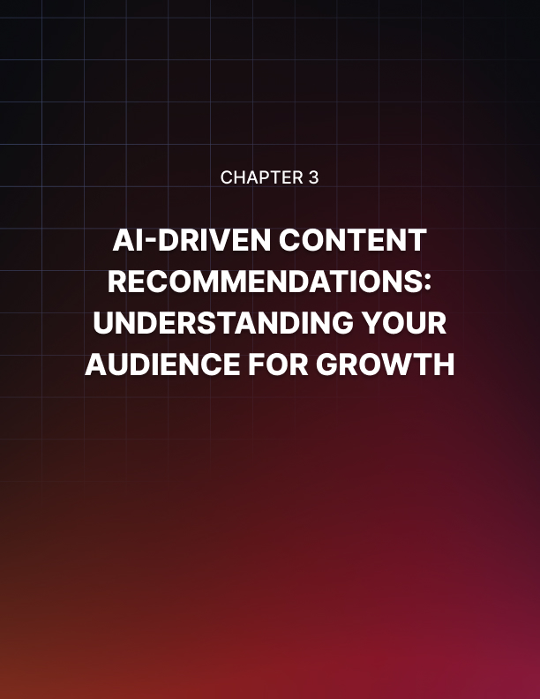

Chapter 3: AI-Driven Content Recommendations: Keeping Viewers Engaged

In the vast digital landscape of YouTube, content recommendation is a critical factor in viewer engagement and channel growth. Chapter 3 explores the transformative role of Artificial Intelligence (AI) in content recommendations, delving into how AI algorithms analyze viewer behavior, preferences, and trends to provide personalized and enticing suggestions.

The Power of Personalization
YouTube's success lies in its ability to deliver content tailored to individual viewer preferences. Traditional recommendation systems were often rule-based and lacked the sophistication needed to understand the nuances of user behavior. AI changes this paradigm by introducing personalized content recommendations that resonate with the unique tastes of each viewer.

Understanding User Behavior
At the core of AI-driven content recommendations is the analysis of user behavior. AI algorithms meticulously examine a viewer's watch history, the duration of views, likes, comments, and even the frequency of interaction with specific genres or topics. This granular understanding allows AI systems to create a comprehensive profile of each viewer's preferences and habits.

Machine Learning for Predictive Recommendations
Machine Learning (ML) algorithms play a pivotal role in predicting viewer preferences. By identifying patterns in vast datasets, these algorithms can predict what a viewer might enjoy based on their historical interactions. As viewers engage with content, the AI continuously refines its predictions, adapting to evolving preferences and ensuring a high likelihood of viewer satisfaction.

Dynamic Recommendation Engines
Unlike static recommendation systems, AI-powered engines are dynamic and responsive. They can adapt to real-time changes in viewer behavior, ensuring that recommendations remain relevant and engaging. This dynamic nature allows content creators to reach a broader audience, breaking away from traditional static recommendations that may not capture the evolving interests of viewers.

Enhancing Viewer Engagement
Personalized content recommendations contribute significantly to viewer engagement. When viewers encounter content that aligns with their interests, they are more likely to spend extended periods on the platform. This increased watch time not only benefits content creators but also enhances the overall user experience, fostering a positive feedback loop of engagement.

Diversifying Content Discovery
AI-driven recommendations contribute to the diversification of content discovery. Viewers are exposed to a broader range of content that aligns with their interests, introducing them to new creators, topics, and genres they might not have discovered through traditional browsing methods. This diversification enriches the content ecosystem on YouTube and promotes the discovery of niche and emerging creators.

The Role of Neural Networks
Neural networks, a subset of AI, play a crucial role in content recommendations. These networks can detect complex patterns and relationships within data, allowing them to understand the multidimensional aspects of viewer preferences. Neural networks excel at capturing the intricacies of user behavior, providing more accurate and nuanced recommendations.

Balancing Personalization and Serendipity
While personalization is key, AI algorithms also introduce an element of serendipity. This means that, alongside content tailored to a viewer's preferences, there is room for recommendations that might introduce new and unexpected content. This delicate balance ensures that viewers experience both the comfort of familiarity and the excitement of discovering something new.

Optimizing Content Discovery for Creators:

For content creators, understanding how AI-driven recommendations work is crucial for optimizing their content strategy. This chapter provides insights into how creators can leverage metadata, engagement metrics, and trending topics to align with AI algorithms, increasing the visibility of their content and reaching a broader audience.

Future Trends in Content Recommendations
Closing the chapter, a look into the future explores emerging trends in content recommendations. As AI continues to advance, we can anticipate even more sophisticated algorithms that seamlessly adapt to evolving viewer behaviors, providing recommendations that are increasingly accurate and personalized.

In essence, Chapter 3 serves as a guide to the intricate world of AI- driven content recommendations on YouTube. It explores how AI algorithms enhance viewer engagement, diversify content discovery, and empower creators to reach their target audience effectively. As the digital landscape evolves, understanding and harnessing the power of AI-driven recommendations become indispensable for content creators seeking to thrive on YouTube.



Chapter 4: Optimizing Thumbnails and Titles with Automation

In the visually immersive world of YouTube, the importance of thumbnails and titles cannot be overstated. Chapter 4 delves into the transformative role of Artificial Intelligence (AI) in optimizing these crucial elements of content creation. From designing eye-catching thumbnails to crafting compelling titles, AI-driven automation is reshaping how creators capture viewer attention and drive engagement.

The Significance of Thumbnails and Titles
Thumbnails and titles serve as the virtual storefront of YouTube videos. They are the first elements viewers encounter, influencing their decision to click and watch. Optimizing these components is essential for maximizing video visibility, attracting viewers, and ultimately growing a channel. AI introduces a new era of efficiency and creativity in this process.

Automated Thumbnail Design
Designing visually appealing thumbnails is an art, and AI is a powerful collaborator in this creative endeavor. Automated tools utilize image recognition and design principles to generate thumbnails that not only capture the essence of the video but also adhere to proven visual tactics that attract clicks. From color schemes to facial recognition, AI optimizes every aspect of thumbnail design.

A/B Testing and Thumbnail Optimization
AI-driven A/B testing is a game-changer for creators seeking the most effective thumbnails. By analyzing viewer responses to different thumbnail variations, AI algorithms can determine which designs yield higher click-through rates. This data-driven approach allows creators to refine their thumbnail strategies, ensuring they resonate with their target audience.

Title Optimization with Natural Language Processing (NLP)
Crafting compelling titles is an art that AI enhances through Natural Language Processing (NLP). These algorithms analyze language patterns, sentiment, and keywords to suggest titles that are not only attention-grabbing but also optimized for search. By understanding viewer behavior and preferences, AI helps creators tailor titles that align with trending topics and audience interests.

Dynamic Title and Thumbnail Pairing
AI's ability to analyze content and audience behavior extends to the dynamic pairing of titles and thumbnails. By considering the content of the video, viewer preferences, and trending topics, AI algorithms can suggest title and thumbnail combinations that maximize click- through rates. This dynamic approach ensures that creators stay relevant and engaging in a rapidly changing digital landscape.

Personalization and Viewer Segmentation
AI-driven personalization is not limited to content recommendations; it extends to thumbnails and titles. Creators can leverage AI algorithms to customize thumbnails and titles based on viewer segmentation. Different audience segments may respond differently to visual and textual cues, and AI ensures that creators can tailor their approach for maximum impact.

Brand Consistency and Recognition
Maintaining brand consistency is crucial for channel recognition. AI tools can assist creators in designing thumbnails that align with their brand identity. From color palettes to logo placement, AI ensures that each thumbnail contributes to a cohesive visual narrative, fostering brand recognition and trust among viewers.

Accessibility Considerations
AI-powered tools also contribute to making content more accessible. Thumbnails and titles can be optimized for readability and inclusivity. AI algorithms can analyze color contrasts, font sizes, and other visual elements to ensure that content is accessible to viewers with diverse needs and preferences.

Ensuring Ethical Practices
As creators embrace AI for thumbnail and title optimization, ethical considerations become paramount. This chapter explores how creators can ensure transparency, authenticity, and responsible AI usage in their content creation processes. Balancing the advantages of automation with ethical considerations is essential for maintaining viewer trust.

Data Privacy and Security
With the integration of AI in content creation, data privacy and security are critical aspects. This chapter guides creators on how to navigate the ethical use of viewer data, ensuring that AI algorithms are employed responsibly and transparently. Respecting viewer privacy is fundamental to building and maintaining a loyal audience.

The Future of AI in Thumbnail and Title Optimization
As AI continues to evolve, the future holds exciting possibilities for thumbnail and title optimization. Creators can anticipate even more sophisticated algorithms that adapt to evolving trends, cultural shifts, and viewer behaviors, ensuring that their content remains at the forefront of audience engagement.

In conclusion, Chapter 4 offers creators a comprehensive exploration of how AI is transforming the optimization of thumbnails and titles on YouTube. From automated design processes to data-driven strategies, AI empowers creators to enhance their visual storytelling and capture the attention of a global audience. As the digital landscape evolves, understanding and leveraging AI for thumbnail and title optimization becomes a strategic imperative for content creators seeking to thrive on YouTube.

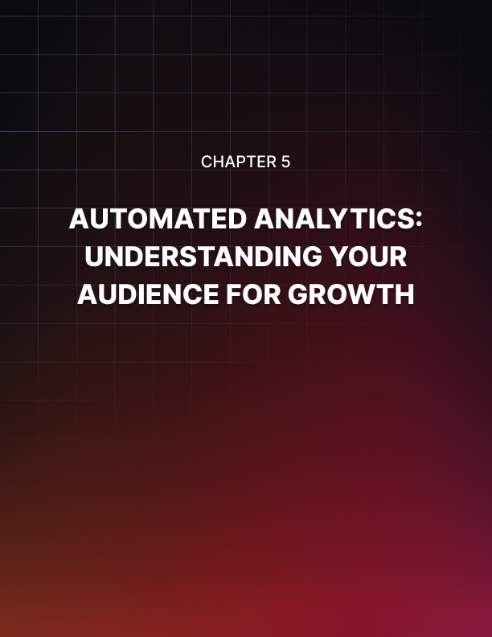

Chapter 5: Automated Analytics: Understanding Your Audience for Growth

In the dynamic world of YouTube content creation, understanding audience behavior and preferences is key to fostering growth and engagement. Chapter 5 explores the transformative role of Artificial Intelligence (AI) in automated analytics, providing creators with invaluable insights into viewer interactions, demographics, and content performance.

The Importance of Analytics in Content Creation
Analytics serve as the compass guiding content creators through the vast landscape of YouTube. They provide crucial insights into viewer behavior, helping creators tailor their content strategies for maximum impact. Traditionally, analyzing vast datasets required significant time and expertise, but AI-driven analytics streamline this process, making data-driven decision-making accessible to creators of all levels.

Automated Data Collection and Processing
AI automates the laborious task of data collection and processing. Creators no longer need to sift through endless spreadsheets to glean insights; AI algorithms do this in real-time. Automated analytics tools gather data on views, watch time, audience demographics, and engagement metrics, providing creators with a comprehensive understanding of their content's performance.

Predictive Analytics for Content Strategy
AI goes beyond historical data analysis; it introduces predictive analytics to help creators anticipate trends and optimize content strategies. By identifying patterns and correlations in viewer behavior, AI algorithms can predict which types of content are likely to perform well in the future. Creators can then adjust their strategies proactively, staying ahead of audience preferences.

Audience Segmentation and Personalization
Understanding that not all viewers are the same, AI enables audience segmentation and personalized analytics. Creators can gain insights into specific viewer segments, tailoring content and engagement strategies accordingly. This personalized approach enhances viewer satisfaction, fosters stronger connections, and contributes to audience growth.

Content Performance Metrics
AI-driven analytics offer a holistic view of content performance. Creators can delve into metrics such as click-through rates, average watch time, and audience retention. This granular understanding helps identify which aspects of a video resonate most with viewers, enabling creators to refine their content for better engagement and retention.

Real-time Feedback and Iterative Improvement
The immediacy of AI-driven analytics allows creators to receive real- time feedback on content performance. Whether launching a new series or experimenting with different formats, creators can quickly assess viewer responses and make iterative improvements. This iterative approach fosters a culture of continuous improvement, ensuring that creators stay responsive to audience preferences.

Optimizing Thumbnails and Titles with Analytics
Building on the insights from previous chapters, AI-driven analytics play a crucial role in optimizing thumbnails and titles. Creators can leverage data on click-through rates and viewer behavior to refine their visual and textual elements. This data-driven approach ensures that creators make informed decisions when crafting thumbnails and titles for maximum impact.

Understanding Viewer Demographics
AI analytics delve into the demographics of a creator's audience. Creators can gain insights into the age, gender, location, and interests of their viewers. This demographic understanding is invaluable for tailoring content that resonates with specific audience segments and expanding reach to new demographics.

AI and Trend Analysis
Trend analysis is a vital component of content creation, and AI excels in this arena. By analyzing global and niche trends, AI algorithms help creators identify topics and formats that are gaining popularity.
Creators can align their content with trending topics, enhancing discoverability and capturing the attention of a broader audience.

Strategic Collaboration with AI
Chapter 5 explores how creators can strategically collaborate with AI analytics tools. It provides insights into selecting the right analytics platforms, understanding the metrics that matter most, and interpreting data for actionable insights. Creators are empowered to make informed decisions that align with their content goals and audience expectations.

The Ethical Use of Analytics
As creators embrace AI-driven analytics, ethical considerations take center stage. This chapter addresses how creators can use analytics responsibly, respecting viewer privacy and maintaining transparency. Balancing the advantages of data-driven decision-making with ethical considerations is crucial for building and maintaining viewer trust.

The Future of AI in Analytics
Closing the chapter, a glimpse into the future explores emerging trends in AI analytics. Creators can anticipate even more sophisticated tools that leverage machine learning to provide nuanced insights. The future holds possibilities for AI to assist creators in strategic planning, audience engagement, and content optimization on an unprecedented scale.

In conclusion, Chapter 5 serves as a comprehensive guide to the transformative impact of AI-driven analytics in the realm of YouTube content creation. From automated data collection to predictive insights and real-time feedback, AI empowers creators to navigate the complexities of the digital landscape with agility and intelligence. As the digital ecosystem evolves, mastering the art of AI-driven analytics becomes a strategic imperative for content creators seeking sustained growth and success on YouTube.

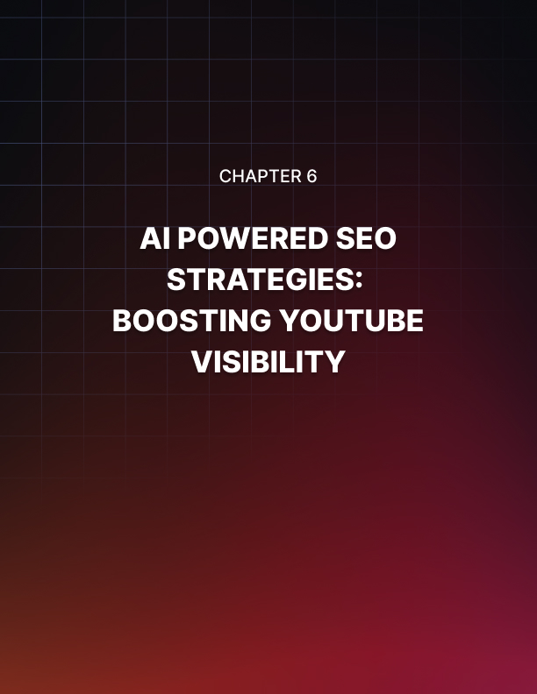

Chapter 6: AI-Powered SEO Strategies: Boosting YouTube Visibility

In the competitive landscape of YouTube, visibility is paramount for content creators seeking to reach a broader audience. Chapter 6 explores how Artificial Intelligence (AI) is reshaping Search Engine Optimization (SEO) strategies on the platform, providing creators with powerful tools to enhance their content's discoverability and maximize reach.

The Role of SEO in YouTube Success
SEO is the cornerstone of online visibility, and on YouTube, it is a crucial element for creators aiming to stand out amidst the vast array of content. Traditionally, SEO involved keyword optimization and metadata tweaking, but AI introduces a new era of sophistication, allowing creators to optimize their content more effectively and align with viewer search behavior.

Understanding Viewer Intent with AI
One of the significant advantages AI brings to YouTube SEO is its ability to understand viewer intent. AI algorithms analyze vast datasets to identify patterns in search queries, helping creators anticipate what viewers are searching for. This predictive insight allows creators to tailor their content to align with trending topics and meet audience expectations.

Keyword Generation and Optimization
AI contributes to the efficiency of keyword generation and optimization. By analyzing search trends, viewer behavior, and content relevance, AI algorithms suggest keywords that creators can seamlessly integrate into their titles, descriptions, and tags. This data-driven approach ensures that content is not only optimized for search algorithms but also resonates with the language viewers use.

Video Transcription and Closed Captions
AI's capabilities extend to video transcription and closed captions, providing creators with additional opportunities for SEO optimization. Transcripts and captions enhance the accessibility of content for viewers and contribute to better search visibility. AI algorithms can automatically generate accurate transcriptions, saving creators time and ensuring content is discoverable through a broader range of search queries.

Optimizing Thumbnails and Titles for SEO
Building on the insights from earlier chapters, this chapter explores how creators can leverage AI-driven SEO strategies to optimize thumbnails and titles. By aligning visual and textual elements with relevant keywords and search trends, creators can enhance the discoverability of their content, ensuring it appears prominently in search results and recommendations.

Competitor Analysis and Benchmarking
AI analytics tools facilitate competitor analysis, enabling creators to benchmark their SEO strategies against successful channels in their niche. By understanding what works for similar content creators, creators can refine their own SEO approaches, identifying opportunities for differentiation and improvement.

AI-Generated Content Suggestions
AI algorithms can also assist in generating content suggestions based on SEO considerations. By analyzing search trends and viewer preferences, AI tools can recommend topics that are likely to perform well in terms of search visibility. Creators can use these suggestions to diversify their content and tap into emerging trends.

Personalized SEO Strategies
As AI enables audience segmentation and personalization, creators can tailor their SEO strategies for different viewer segments.
Understanding the unique preferences and search behaviors of specific audience groups allows creators to optimize their content to better resonate with each segment, enhancing overall discoverability and engagement.

SEO Metrics and Performance Analysis
AI-driven analytics provide creators with in-depth insights into the performance of their SEO strategies. Creators can track metrics such as search rankings, click-through rates, and impressions to assess the effectiveness of their optimization efforts. This data-driven approach empowers creators to refine their SEO strategies continually.

Navigating Algorithm Changes with AI
The ever-evolving nature of search algorithms on YouTube requires creators to stay adaptable. AI tools can assist creators in navigating algorithm changes by providing real-time insights into how these changes impact content visibility. Creators can adjust their SEO strategies promptly to align with the evolving landscape.

Ethical Considerations in AI-Driven SEO
Chapter 6 emphasizes the ethical use of AI in SEO strategies. Creators are guided on how to leverage AI tools responsibly, respecting viewer privacy and maintaining transparency in their SEO practices.

Ethical considerations are paramount in building and maintaining viewer trust, a foundation for long-term success on YouTube.

The Future of AI in YouTube SEO
Closing the chapter, a glimpse into the future explores emerging trends in AI-driven SEO on YouTube. Creators can anticipate even more advanced algorithms that adapt to evolving search trends, providing nuanced insights and recommendations for optimization.

The future holds possibilities for AI to become an even more integral part of content creators' SEO toolkits.

In conclusion, Chapter 6 serves as a comprehensive guide to how AI is transforming SEO strategies on YouTube. From understanding viewer intent to optimizing content elements and navigating algorithm changes, creators can leverage AI to enhance the discoverability and visibility of their content. As the digital landscape evolves, mastering AI-driven SEO becomes a strategic imperative for content creators seeking sustained growth and success on YouTube.

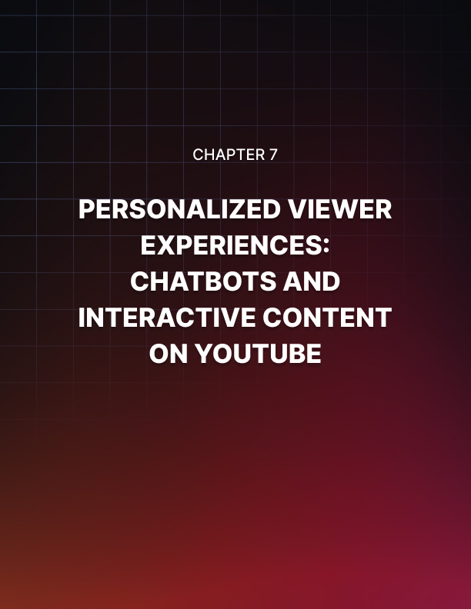

Chapter 7: Personalized Viewer Experiences: Chatbots and Interactive Content on YouTube

In the dynamic world of online content consumption, YouTube continues to be a powerhouse, attracting billions of users who collectively watch billions of hours of videos every day. As the platform evolves, content creators are constantly exploring innovative ways to engage their audiences. One of the most intriguing developments in this realm is the integration of chatbots and interactive content to create personalized viewer experiences.

The Rise of Personalization
YouTube, once a platform solely for passive consumption, has transformed into an interactive space where creators and viewers can engage in real-time. The rise of personalization has been instrumental in this transformation. Creators now understand that a one-size-fits-all approach may not be the most effective way to capture and retain their audience's attention.

Understanding Viewer Preferences
Personalization begins with understanding viewer preferences. Creators leverage data analytics and user insights to discern what their audience enjoys. From the type of content they watch to the time of day they are most active, this data serves as the foundation for crafting a personalized experience.

The Role of Algorithms
ouTube's recommendation algorithms play a pivotal role in suggesting videos based on a user's watch history and preferences. Creators have learned to work symbiotically with these algorithms, creating content that aligns with both their artistic vision and the expectations of their audience.

Chatbots: A New Dimension of Interaction
Enter the era of chatbots. These artificial intelligence-driven entities add a conversational layer to the viewing experience. Creators are now integrating chatbots into their content, allowing viewers to interact seamlessly through comments and receive personalized responses.

Real-Time Engagement
Chatbots enable real-time engagement, providing an immediate and interactive channel for viewers to express their thoughts, ask questions, or participate in polls. This direct connection fosters a sense of community, transforming the viewing experience from a passive one to an active and communal one.

Enhanced Accessibility
Creators are leveraging chatbots to enhance accessibility. Subscribers can receive updates, behind-the-scenes content, or even personalized shoutouts through automated messages. This not only adds a personal touch but also ensures that viewers feel a deeper connection to the content and the creator.

Interactive Content: Beyond Passive Watching
As technology advances, so does the desire for more immersive experiences. Interactive content takes the viewer from being a passive observer to an active participant.

Choose-Your-Adventure Videos
Choose-your-adventure videos have gained popularity, allowing viewers to make decisions that shape the direction of the narrative. Creators script multiple storylines, and viewers decide the characters' actions, creating a unique and personalized viewing experience for each individual.

Gamification and Challenges
Gamification elements, such as quizzes, challenges, and interactive games, are becoming staples in the content creation toolkit. Viewers not only watch but actively participate, making the experience more memorable and engaging.

Challenges and Ethical Considerations
While the integration of chatbots and interactive content enhances the viewer experience, it also raises important challenges and ethical considerations. Creators must strike a balance between personalization and privacy, ensuring that data is used responsibly and that the interactive elements do not compromise the well-being of the audience.

Privacy Concerns
Collecting and utilizing viewer data for personalization brings forth privacy concerns. Creators must be transparent about their data practices and prioritize user consent to build trust with their audience.

Ethical Use of AI
The deployment of AI-driven chatbots demands ethical considerations. Creators should be vigilant in preventing the misuse of these technologies, ensuring that the interactive elements contribute positively to the viewer experience without crossing ethical boundaries.

The Future of Personalized Viewer Experiences
As technology continues to advance, the future of personalized viewer experiences on YouTube holds limitless possibilities. Creators will undoubtedly explore new ways to engage their audience, leveraging emerging technologies to create immersive and personalized content.

Emerging Technologies
From virtual reality to augmented reality, the integration of emerging technologies will redefine the landscape of personalized viewer experiences. Creators will have the tools to transport their audience into entirely new dimensions, breaking the barriers between content and consumer.

Collaborative Creation
The future may see a shift towards more collaborative content creation, where viewers actively contribute to the development of the narrative. Platforms may evolve to support real-time collaboration, blurring the lines between creator and audience.

In conclusion, the marriage of chatbots, interactive content, and personalization is reshaping the way we experience content on YouTube. Creators who embrace these technologies are not only keeping pace with the evolution of the platform but also forging deeper connections with their audience. As we step into the future, the boundaries of personalized viewer experiences are bound to expand, offering a rich and diverse landscape for creators and viewers alike.

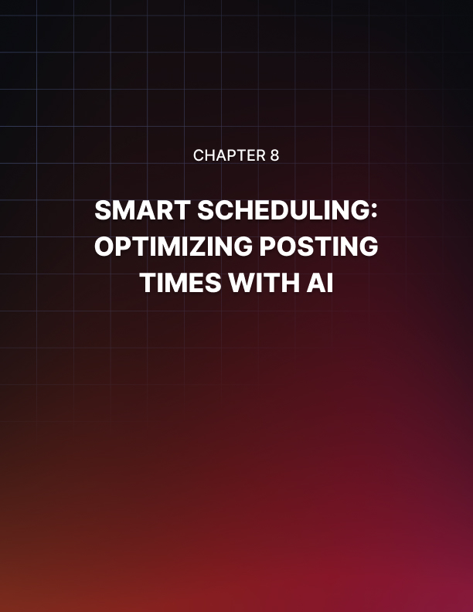

Chapter 8: Smart Scheduling: Optimizing Posting Times with AI

In the ever-evolving landscape of content creation, timing is often as crucial as the content itself. With the influx of videos on platforms like YouTube, creators are realizing the significance of strategic scheduling. Enter the era of Smart Scheduling, where artificial intelligence (AI) is harnessed to optimize posting times and maximize audience reach.

The Imperative of Timing
Understanding when to release content can significantly impact its visibility, engagement, and overall success. Smart Scheduling acknowledges that not all hours are created equal, and the timing of a post can make the difference between it being lost in the digital noise or rising to the top of a viewer's feed.

Viewer Habits and Preferences
Smart Scheduling begins with a deep understanding of viewer habits and preferences. Creators are leveraging data analytics to identify peak hours when their target audience is most active. This data- driven approach allows for a more strategic and tailored posting strategy.

Time Zones and Global Audiences
In the interconnected world of online content, creators often have global audiences spanning multiple time zones. Smart Scheduling takes into account the geographical distribution of the audience, ensuring that content is released at times when it is most likely to reach viewers across the globe.

AI-Powered Insights
The heart of Smart Scheduling lies in the integration of artificial intelligence to analyze vast datasets and extract actionable insights. Creators are turning to AI algorithms to predict optimal posting times based on historical data, user behavior, and trends.

Machine Learning Algorithms
Machine learning algorithms are at the forefront of Smart Scheduling. These algorithms analyze patterns in viewer engagement, identifying correlations between posting times and content performance. As more data is fed into the system, the algorithms continuously refine their predictions, adapting to evolving viewer behaviors.

Predictive Analytics
Predictive analytics play a crucial role in anticipating future trends. Creators can leverage AI to forecast optimal posting times, allowing them to stay ahead of the curve and capitalize on emerging opportunities in the digital landscape.

Dynamic Adaptation to Trends
The digital realm is dynamic, with trends evolving rapidly. Smart Scheduling goes beyond fixed posting times and embraces flexibility. Creators use AI to monitor real-time trends, adapting their posting schedules to align with what is currently capturing the attention of their audience.

Virality and Trend Surfing
Smart Scheduling allows creators to ride the waves of virality by identifying trends early on. By strategically aligning content releases with emerging trends, creators increase the likelihood of their videos being discovered and shared, amplifying their reach.

Seasonal and Event-Based Optimization
AI enables creators to optimize posting times based on seasons, holidays, and major events. Whether it's tailoring content for a festive season or aligning with a cultural moment, Smart Scheduling ensures that creators remain agile in their approach.

The Human Touch in Smart Scheduling
While AI plays a central role in optimizing posting times, the human touch remains indispensable. Creators bring their intuition, creativity, and understanding of their audience's preferences to complement the analytical power of AI.

Content Alignment
Smart Scheduling is most effective when it aligns with the nature of the content. Creators strike a balance between data-driven insights and the thematic relevance of their videos, ensuring that the timing enhances the viewer's overall experience.

Engaging with the Audience
Creators actively engage with their audience to gather real-time feedback and preferences. This two-way communication informs Smart Scheduling decisions, allowing creators to respond to audience expectations and desires.

Future Horizons: AI Evolution and Personalization
As AI continues to evolve, the future of Smart Scheduling holds exciting prospects. Creators anticipate even more personalized and granular insights, allowing them to tailor their posting times not only based on broad trends but also individual viewer preferences.

Personalized Posting Times
Future iterations of Smart Scheduling may delve into personalized posting times for individual subscribers. By considering each viewer's habits and engagement patterns, creators can deliver content at times when it is most likely to capture their attention.

Integration with Other AI Tools
Smart Scheduling is poised to integrate seamlessly with other AI- driven tools. From content creation to audience engagement, a holistic AI ecosystem will empower creators to streamline their workflows and enhance every facet of their online presence.

In conclusion, Smart Scheduling represents a paradigm shift in content creation, where the optimization of posting times is elevated to a science. The synergy between AI-driven insights and human creativity is shaping a new era where content not only speaks to its audience but does so at precisely the right moment. As creators continue to refine their strategies, Smart Scheduling stands as a testament to the ever-evolving nature of the digital landscape.

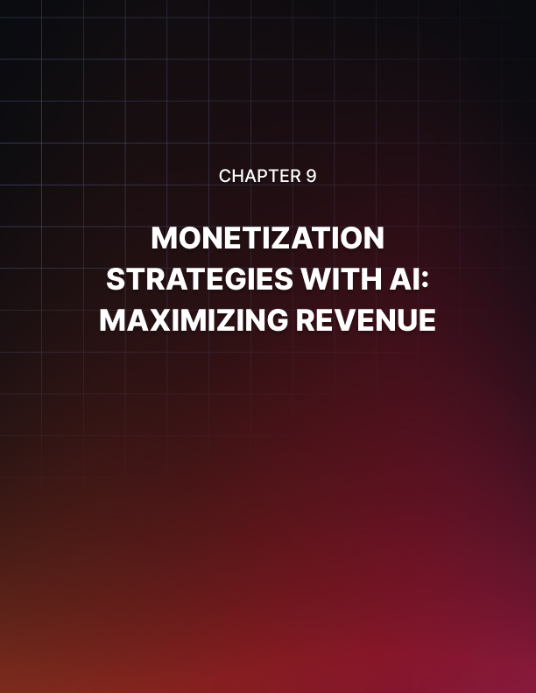

Chapter 9: Monetization Strategies with AI: Maximizing Revenue

In the vast ecosystem of online content creation, creators are not only storytellers but also entrepreneurs navigating the complexities of monetization. As the digital landscape evolves, the integration of artificial intelligence (AI) has become a game-changer in maximizing revenue for content creators. This chapter delves into the innovative ways in which creators leverage AI to optimize their monetization strategies.

The Landscape of Digital Monetization
Monetization in the digital age extends far beyond traditional advertising revenue. Creators explore diverse streams, including sponsorships, merchandise sales, memberships, and more. AI emerges as a powerful ally in this multifaceted journey, providing insights, personalization, and efficiency.

Understanding Viewer Behavior
AI algorithms analyze vast datasets to understand viewer behavior patterns. Creators gain invaluable insights into what content resonates most with their audience, facilitating informed decisions on monetization strategies tailored to viewer preferences.

Adapting to Platform Changes
Digital platforms continually refine their algorithms and policies. AI enables creators to adapt swiftly, ensuring their monetization strategies align with the latest platform dynamics. From changes in ad policies to emerging revenue streams, AI keeps creators ahead of the curve.

AI-Driven Ad Revenue Optimization
Monetization often begins with advertising, and AI brings a new level of sophistication to this realm. Creators harness AI to optimize ad revenue through targeted advertising, ad placement, and strategic scheduling.

Targeted Advertising
AI algorithms analyze user data to deliver highly targeted ads based on individual preferences, demographics, and behavior. This not only enhances the viewer experience by showcasing relevant content but also maximizes the effectiveness of advertisements, increasing click- through rates and revenue.

Ad Placement and Scheduling
AI assists creators in strategic ad placement within their content. Algorithms determine the optimal moments to insert ads, balancing viewer engagement with revenue generation. Smart scheduling ensures that ads are placed during peak viewing times, maximizing exposure and revenue potential.

Personalized Viewer Engagement for Monetization
AI plays a pivotal role in enhancing viewer engagement, a critical factor in successful monetization. By personalizing content recommendations, interactions, and calls to action, creators foster a deeper connection with their audience, laying the foundation for various revenue streams.

Personalized Content Recommendations
AI algorithms analyze viewer preferences, watch history, and engagement patterns to deliver personalized content recommendations. Creators leverage this to guide users toward premium content, promotions, or exclusive offerings, increasing the likelihood of conversion.

Interactive Monetization Features
Chatbots and interactive elements powered by AI create immersive and personalized experiences for viewers. Creators integrate interactive features seamlessly into their content, allowing viewers to make purchases, donate, or subscribe directly through the platform, turning engagement into revenue.

Diversifying Revenue Streams with AI
Beyond traditional ad revenue, creators are diversifying their income streams. AI facilitates the exploration of new monetization avenues, from merchandise sales to exclusive memberships and beyond.

Merchandising Strategies
AI assists creators in designing targeted merchandising strategies. By analyzing audience demographics and preferences, creators can develop merchandise that resonates with their viewers, driving sales and generating additional revenue.

Membership and Subscription Models
AI-driven personalization extends to membership and subscription models. Creators tailor subscription offerings based on individual viewer preferences, providing exclusive content, perks, and experiences. This personalized approach enhances the value proposition, encouraging viewers to become paying members.

Challenges and Ethical Considerations in AI-Driven Monetization
While AI presents immense opportunities for revenue optimization, creators must navigate ethical considerations and challenges. Maintaining a balance between monetization and viewer well-being is essential for sustained success.

Transparent Data Practices
Creations using AI must prioritize transparent data practices. Open communication about data collection, usage, and privacy safeguards builds trust with the audience. Ethical AI practices ensure that viewers feel secure engaging with monetized content.

Avoiding Exploitative Practices
AI-driven monetization should not exploit viewers. Creators must steer clear of manipulative tactics, ensuring that the use of personalization and engagement tools is ethical and respects the well-being of the audience.

The Future of AI in Monetization
As AI continues to advance, the future of monetization holds exciting possibilities. Creators anticipate even more sophisticated AI tools that offer granular insights, predictive analytics, and enhanced personalization, further elevating the effectiveness of monetization strategies.

Predictive Analytics for Revenue Forecasting
Future iterations of AI in monetization may focus on predictive analytics for revenue forecasting. Creators can anticipate trends, identify emerging opportunities, and proactively adjust their strategies to maximize revenue potential.

AI-Enhanced Collaboration with Brands
Collaborations between creators and brands may become more AI- driven. Algorithms can analyze brand affinity among viewers, suggesting optimal partnerships that align with both the creator's content and the audience's preferences.

In conclusion, Chapter 9 explores the dynamic intersection of AI and monetization strategies. From optimizing ad revenue to fostering personalized viewer engagement and diversifying income streams, creators leverage AI to navigate the evolving landscape of digital entrepreneurship. As the journey unfolds, ethical considerations and a commitment to transparency remain crucial, ensuring a sustainable and mutually beneficial relationship between creators and their audiences in the realm of AI-driven monetization.

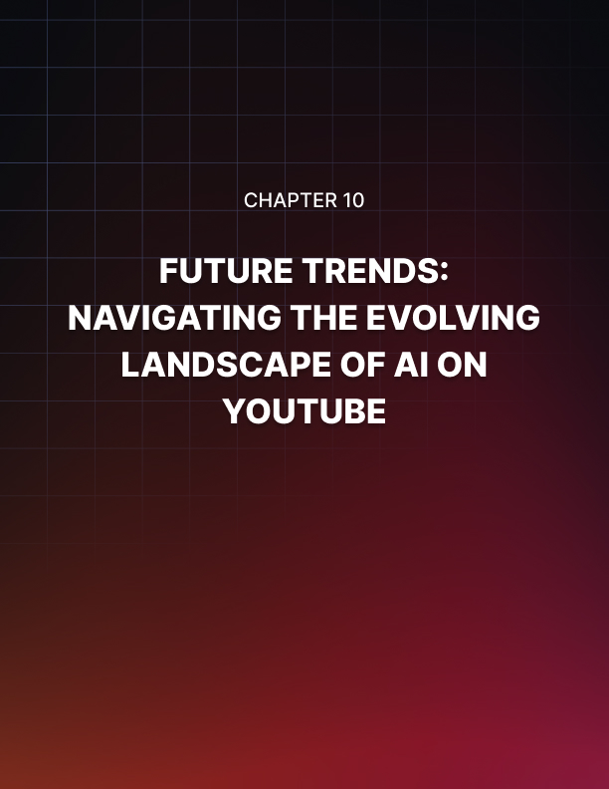

Chapter 10: Future Trends: Navigating the Evolving Landscape of AI on YouTube

As YouTube continues to be a dynamic platform at the forefront of digital content creation, the integration of artificial intelligence (AI) is reshaping the landscape in profound ways. Chapter 10 explores the future trends that creators and viewers can anticipate as AI technologies evolve on YouTube.

AI-Driven Content Creation
The future of content creation on YouTube is poised for a revolution with AI taking a more central role. Creators can expect advancements in AI-generated content, from automated video editing to AI-assisted scriptwriting. These tools will streamline workflows, allowing creators to focus more on creativity and storytelling while leveraging AI for efficiency.

Automated Video Editing
AI-driven video editing tools will become more sophisticated, enabling creators to automate mundane tasks such as cutting, trimming, and enhancing footage. This not only saves time but also empowers creators to experiment with more complex and creative editing styles.

AI-Assisted Scriptwriting
AI algorithms are likely to evolve to assist creators in scriptwriting. From generating ideas based on trending topics to offering language suggestions, AI-powered tools will become valuable collaborators in the content creation process.

Hyper-Personalization and Viewer Engagement
The future trends on YouTube indicate a shift towards hyper- personalization, where AI tailors content to individual viewer preferences. This personalized approach extends beyond recommendations and into interactive elements, creating a more engaging and immersive experience.

Individualized Content Recommendations
AI algorithms will become more adept at understanding nuanced viewer preferences. Creators can anticipate a future where each viewer receives highly individualized content recommendations, enhancing user satisfaction and increasing overall watch time.

Advanced Chatbots and Interactive Features
Chatbots and interactive elements will evolve to provide more meaningful and context-aware interactions. Creators will leverage AI to develop chatbots capable of engaging in dynamic and personalized conversations with viewers, creating a sense of community and connection.

Virtual and Augmented Reality Integration
The future of YouTube may see a deeper integration of virtual reality (VR) and augmented reality (AR). AI will play a pivotal role in creating immersive experiences that transcend traditional video content, allowing viewers to interact with the content in unprecedented ways.

VR and 360-Degree Content
AI-driven advancements will enable creators to produce more compelling VR and 360-degree content. Viewers can expect immersive storytelling experiences that go beyond the flat screen, providing a sense of presence within the content itself.

AR Overlays and Interactive Elements
AI-powered AR overlays will add layers of interactivity to videos. Creators can integrate interactive elements into their content, allowing viewers to engage with products, characters, or storylines in real-time, blurring the lines between the digital and physical worlds.

Enhanced Analytics and Monetization Strategies
The future trends in AI on YouTube signal a significant evolution in analytics and monetization strategies. Creators will have access to more granular data, allowing for more informed decisions and personalized monetization approaches.

Predictive Analytics for Monetization
AI will evolve to provide creators with predictive analytics for monetization. Creators can anticipate trends in viewer behavior, allowing for proactive adjustments to advertising strategies, sponsorship deals, and other revenue streams.

AI-Driven Sponsorship and Brand Collaborations
The future holds AI-driven tools that match creators with brands based on intricate data analysis. Creators can expect more tailored and mutually beneficial collaborations, maximizing the impact of sponsorships and brand partnerships.

Ethical Considerations and Regulation
As AI becomes more ingrained in the YouTube ecosystem, ethical considerations and regulatory frameworks will play a crucial role. Creators, platform administrators, and policymakers will need to collaborate to ensure responsible AI use and safeguard the well- being and privacy of the audience.

Transparent AI Practices
Creators will be under increased pressure to be transparent about their use of AI. Open communication regarding data practices, content generation methods, and AI-driven features will build trust with viewers and promote ethical content creation.

Regulatory Frameworks for AI on YouTube
Policymakers may introduce regulations to govern the use of AI on YouTube. These regulations will aim to strike a balance between fostering innovation and protecting users from potential misuse of AI technologies.

Collaborative Content Creation and AI Ecosystem
The future of YouTube will likely witness more collaborative content creation, facilitated by an interconnected AI ecosystem. Creators will have access to a suite of AI tools that seamlessly integrate into their workflows, from ideation to production, fostering a community- driven approach to content creation.

Real-Time Collaborative Editing
AI-powered tools will enable creators to collaborate in real-time, breaking down geographical barriers. Creators from different parts of the world can contribute to a video simultaneously, creating a diverse and globalized content landscape.

Community-Driven AI Development
As AI becomes more accessible, creators may actively participate in the development of AI tools tailored to their needs. Platforms may encourage a collaborative approach where creators contribute to the evolution of AI algorithms, ensuring that the technology aligns with the unique requirements of the YouTube community.

In conclusion, Chapter 10 envisions a future on YouTube where AI plays an integral role in every facet of content creation, viewer engagement, and monetization. As the technology continues to advance, creators and viewers alike can look forward to a more personalized, immersive, and interconnected YouTube experience. However, with these advancements, it becomes imperative for all stakeholders to prioritize ethical considerations, transparency, and responsible AI use to foster a sustainable and thriving digital ecosystem.

