Table of Contents
Introduction 5
The Essence of Angel Investing 7
The Origins and Evolution of Angel Investing 7
The Appeal and Myths of Angel Investing 8
The Role of Angel Investors in the Startup Ecosystem 9
The Changing Landscape and Future of Angel Investing 10
Legal and Ethical Considerations in Angel Investing 11
Inside the Mind of an Angel Investor 13
The Angel Investor's Manifesto 13
The Art of Assessing Startup Potential 14
The Multifaceted Role of an Angel Investor 15
The Essential Skill Set of a Successful Angel Investor 15
Risk Management and Portfolio Diversification 17
The Investment Process Decoded 20
Finding the Diamonds in the Rough 20
Separating Promise from Hype 21
Conducting Due Diligence 22
Negotiating Terms and Closing the Deal 23
Post-Investment Engagement and Legal Considerations 24
Your First Investment 27
Identifying Promising Startups 27
Key Factors to Consider 28
Conducting Effective Due Diligence 28
Negotiating Terms and Structuring Your Investment 29
Closing the Deal and Post-Investment Engagement 31
Recap and Next Steps 34
Key Takeaways from Your Angel Investing Journey 34
Continuous Learning and Growth 35
Evolving Your Investment Strategy 36
Measuring Success and Managing Expectations 37
Navigating Challenges and Ethical Considerations 37
Embracing the Angel Investor Lifestyle 37

Disclaimer
The information provided in this ebook is intended solely for educational and informational purposes. The author does not accept any responsibility for the outcomes that may arise from the application of the material within. While efforts have been made to ensure the accuracy and relevance of the content, the author cannot be held accountable for any errors or omissions, or for any consequences resulting from the use or misuse of the information provided. The responsibility for any actions taken based on the information in this ebook lies solely with the reader.



Introduction
Have you ever dreamed of being part of the next big thing? Imagine shaping the future of innovation while potentially earning substantial financial rewards. Welcome to the world of angel investing, where visionaries like you can help turn promising ideas into world-changing realities.
This book is your guide to exploring the exciting world of startup funding. By the end, you'll be equipped with the knowledge, strategies, and confidence needed to succeed in the world of angel investing. Unlike other guides, this one cuts through the jargon and focuses on practical, actionable insights. You'll gain insider tips that typically take years to learn, all in one accessible read.
You'll learn how to spot high-potential startups, negotiate deals, and build a portfolio that could deliver impressive returns. Beyond the financial side, angel investing allows you to be part of a forward-thinking community shaping the future of business and technology.
This isn't a get-rich-quick scheme. Angel investing requires dedication, sharp instincts, and calculated risks. That’s why this book is packed with real-world examples, expert advice, and practical strategies you can apply immediately. You'll learn from the experiences of others, giving you a competitive edge.
Picture the excitement of discovering the next big startup, mentoring entrepreneurs, and helping them bring their visions to life. With this book, you’ll have the tools to evaluate startups, understand their potential to disrupt industries, and make informed decisions.
By the time you finish, you'll have a solid understanding of the angel investing ecosystem. You'll be ready to step into the role of an angel investor, providing not only capital but also valuable guidance and connections to help startups thrive.
Whether you’re a seasoned entrepreneur or a professional new to the startup world, this book offers insights tailored to your goals. The journey ahead is filled with excitement and opportunities. Turn the page and begin your adventure as an angel investor today.


The Essence of Angel Investing
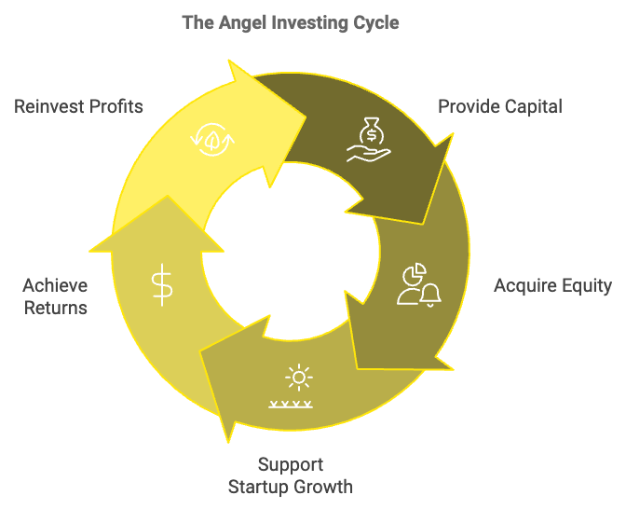
Angel investing stands as a beacon of opportunity in the vast sea of investment options. You've likely heard the term before, perhaps in hushed tones of excitement or with an air of mystery. But what exactly is angel investing, and why should you care?
At its core, angel investing is the practice of providing capital to early-stage startups in exchange for equity. You, as an individual with means and a passion for innovation, can become a key player in the growth of promising new businesses. This chapter will unravel the intricacies of angel investing, tracing its roots and illuminating its unique position in the investment landscape.

The Origins and Evolution of Angel Investing
The term "angel investor" has an interesting history. It originated in the early 20th century on Broadway, where wealthy individuals would provide financial backing for theatrical productions. These benefactors were seen as "angels" descending from above to save struggling shows. Fast forward to today, and the concept has evolved significantly. Modern angel investing took shape in the 1970s and 1980s as the technology boom created a new class of wealthy entrepreneurs looking to reinvest their success into the next generation of startups. You're part of this legacy when you step into the world of angel investing. It's a tradition of visionaries supporting visionaries, of experienced business minds nurturing the seeds of innovation.
While both angel investing and venture capital involve funding startups, they differ in several crucial ways. As an angel investor, you're typically investing your own money, whereas venture capitalists manage pooled money from many investors. Angel investments are usually smaller, ranging from $25,000 to $100,000, while venture capital firms might invest millions. This difference in scale affects the stage at which investments are made. You, as an angel investor, often get involved at the very early stages of a startup – sometimes when it's just an idea or a prototype. Venture capitalists, on the other hand, tend to enter the picture later, when there's more proof of concept and market traction. Another key distinction lies in the level of involvement. As an angel investor, you have the opportunity to be more hands-on, often acting as a mentor and advisor to the startup. Venture capital firms typically take a more formal approach, often securing board seats and having a say in major company decisions.

The Appeal and Myths of Angel Investing
So, why should you consider becoming an angel investor? The reasons are as diverse as the startups you might fund, but here are some compelling motivations:
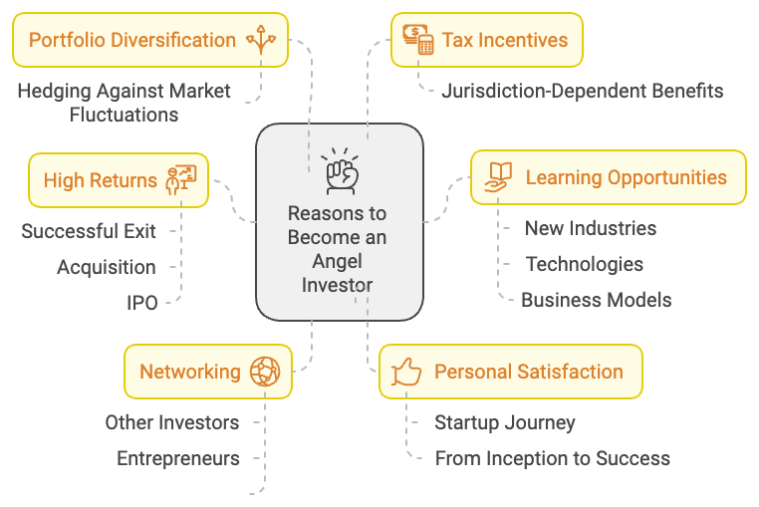
Potential for high returns, as a successful exit through an acquisition or IPO can multiply your initial investment many times over; portfolio diversification, allowing you to hedge against market fluctuations; personal satisfaction in being part of a startup's journey from inception to success; learning opportunities that expose you to new industries, technologies, and business models; networking with other successful investors, entrepreneurs, and industry leaders; and potential tax incentives, depending on your jurisdiction.
Angel investing, like any investment strategy, comes with its share of misconceptions. Let's address some of these myths head-on:
- First, angel investing is not only for the ultra-wealthy. While you do need to have a certain level of financial stability, you don't need to be a millionaire to become an angel investor. Many angels start with smaller investments and gradually increase their involvement as they gain experience.
- Second, while angel investing carries risks, these can be mitigated through careful due diligence, portfolio diversification, and ongoing education. The key is to approach it as a calculated risk rather than a gamble.
- Third, angel investors are not just in it for the money. While financial returns are important, many are equally motivated by the desire to mentor young entrepreneurs and contribute to innovation in their field of expertise.
- Lastly, you don't need to be a tech expert to be an angel investor. While many angel investments are in tech startups, there are opportunities across various industries. Your expertise in any field can be valuable to the right startup.

The Role of Angel Investors in the Startup Ecosystem
You might wonder where angel investors fit into the broader startup ecosystem. Think of the startup journey as a relay race, with different types of funding passing the baton at various stages:
Stage | Description | Typical Investors
Seed | Product development, no revenue yet | Angel investors
Early | Initial growth, seeking larger funding | Angel groups, early-stage VC
Growth | Significant expansion | Larger VC firms
Late | Preparing for exit | Private equity, corporate investors

Your role as an angel investor is crucial. You provide not just the initial capital that helps a startup get off the ground, but also the guidance and connections that can set it on the path to success.

The Changing Landscape and Future of Angel Investing
The world of angel investing is dynamic, constantly evolving with technological advancements and shifts in the global economy. Some trends shaping the future include the rise of crowdfunding platforms democratizing angel investing, increased syndication allowing for larger investments and shared due diligence, global reach breaking down geographical barriers, focus on impact investing seeking both financial returns and positive social or environmental impact, and efforts towards diversity and inclusion in funding a wider range of entrepreneurs.
As you consider stepping into the world of angel investing, it's important to prepare yourself: Assess your finances to ensure you have the disposable income to invest without jeopardizing your financial stability; define your goals, whether primarily seeking financial returns or also motivated by mentorship opportunities; identify your expertise to guide your investment decisions; build your network by attending startup pitch events and joining angel investor groups; educate yourself through books, workshops, and courses on angel investing; and start small with initial investments as you learn the ropes.

Legal and Ethical Considerations in Angel Investing
Being an angel investor means staying mindful of the legal and ethical responsibilities that come with the role. In many countries, including the United States, you need to meet certain financial criteria to be considered an accredited investor and participate in certain private investment opportunities. Due diligence is crucial, not only to protect your interests but also to ensure you're providing value to the startups you fund. Maintaining confidentiality is essential for building trust and protecting the interests of the companies you invest in. Be aware of potential conflicts of interest, especially if you're investing in multiple startups in the same industry or if you have other competing business interests. Lastly, consider the ethical implications of the startups you fund, ensuring they align with your values and will have a positive impact on society.
Wrapping up this introduction to angel investing, it's important to keep in mind that this is just the start of your journey. The world of angel investing is rich with opportunities for those willing to learn, take calculated risks, and support the next generation of entrepreneurs. In the following chapters, we'll dive deeper into the practical aspects of becoming a successful angel investor, equipping you with the knowledge and tools you need to make informed investment decisions and potentially reap significant rewards.


Inside the Mind of an Angel Investor
Stepping into the shoes of an angel investor is like donning a pair of multifocal lenses. You're not just looking at numbers and projections; you're peering into the future, assessing human potential, and navigating a complex ecosystem of innovation and risk. This chapter will take you on a journey through the intricate thought processes, motivations, and responsibilities that define the angel investor's mindset.

The Angel Investor's Manifesto
At the heart of every angel investor lies a unique blend of visionary thinking, calculated risk-taking, and a desire to nurture innovation. You're not just writing checks; you're betting on dreams and backing the dreamers who dare to bring them to life. This role requires a delicate balance of optimism and pragmatism, coupled with a willingness to embrace uncertainty.
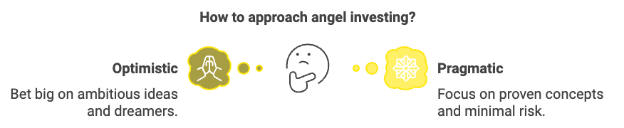
As an angel investor, you're often one of the first believers in a startup's potential. This early faith comes with both immense responsibility and the potential for significant rewards. You're not just providing capital; you're offering validation, guidance, and often, a crucial lifeline to fledgling businesses at their most vulnerable stage. The potential for substantial returns is a significant draw, with successful angel investments yielding returns of 10x, 20x, or even higher. However, it's important to note that these high returns come with equally high risks. Many angel investors are drawn to the opportunity to engage with cutting-edge ideas and technologies, staying at the forefront of innovation across various industries. For many successful entrepreneurs turned angel investors, there's a strong desire to "give back" to the startup ecosystem, sharing hard-earned wisdom and helping shape the next generation of business leaders. Angel investing also opens doors to a vibrant community of fellow investors, entrepreneurs, and industry leaders, with these connections being invaluable both personally and professionally. Additionally, angel investments can serve as a way to diversify your investment portfolio beyond traditional stocks and bonds, potentially hedging against market fluctuations. Sometimes, the motivation is as simple as a genuine interest in a particular industry or technology, allowing direct involvement in areas that excite you. Increasingly, angel investors are motivated by the potential to fund businesses that address pressing social or environmental issues, combining profit with purpose.

The Art of Assessing Startup Potential
One of the most crucial skills you'll develop as an angel investor is the ability to evaluate startups. This process is part science, part art, and a healthy dose of intuition honed through experience. When assessing a startup's potential, you'll consider factors such as the team, market opportunity, product-market fit, business model, competitive advantage, traction and milestones, exit potential, and valuation.
The team is often cited as the most critical factor. You'll look for founders who are not only passionate and knowledgeable but also coachable and resilient. The startup team's skills, experience, and dynamics can make or break a venture. When evaluating the market opportunity, you'll need to assess the market size, growth potential, and competitive landscape. Is the startup addressing a real, sizable problem? Product-market fit is crucial - does the product or service genuinely solve the problem it claims to address? Early traction or customer feedback can be indicative. The business model is another key consideration. How does the startup plan to make money? You'll evaluate the viability and scalability of their revenue model. A startup's competitive advantage sets it apart from existing solutions or potential competitors. This could be proprietary technology, unique partnerships, or a novel approach to a problem. Traction and milestones achieved so far, such as early customers, revenue, or strategic partnerships, can be strong positive indicators. While it may seem premature, considering potential exit strategies (acquisition, IPO) is crucial for your return on investment. Finally, the startup's valuation must be reasonable given its stage and potential, as this impacts your potential returns and the startup's ability to raise future funding.

The Multifaceted Role of an Angel Investor
Your role as an angel investor extends far beyond simply providing capital. You're often wearing multiple hats, each crucial to the success of your portfolio companies.
- As a mentor, you draw from your own experiences to guide entrepreneurs through the challenges of starting and scaling a business. Your role as a connector makes your network a valuable asset, allowing you to introduce startups to potential customers, partners, or future investors.
- As a strategist, you help shape the company's direction, offering insights on product development, market entry strategies, and growth plans. Your role as a cheerleader provides crucial moral support during tough times, as startups face numerous challenges.
- As a gatekeeper, your investment and involvement can lend credibility to a startup, opening doors to further funding and opportunities.
- Finally, as a risk manager, while embracing the inherent risks of early-stage investing, you also work to mitigate them through due diligence and ongoing involvement.

The Essential Skill Set of a Successful Angel Investor
To thrive in the world of angel investing, you'll need to cultivate a diverse set of skills. Financial acumen is crucial, including understanding financial statements, valuation methods, and investment terms. While you don't need to be an expert in every field, having solid industry knowledge of the sectors you invest in is invaluable. Strong networking skills are key to building and maintaining relationships with entrepreneurs, fellow investors, and industry players, which is essential for sourcing deals and adding value to your investments. Developing due diligence expertise and a systematic approach to evaluating startups can help you make more informed investment decisions. Negotiation skills are essential, from agreeing on investment terms to helping your portfolio companies navigate partnerships. Emotional intelligence - the ability to read people, manage relationships, and provide support during high-stress situations - is crucial. Adaptability is vital in the fast-moving startup world, where you'll need to be comfortable with change and uncertainty. Finally, over time, you'll develop pattern recognition skills, allowing you to spot trends and recognize successful patterns across different startups and industries.
Skill | Description | Importance
Financial Acumen | Understanding financial statements, valuation methods, and investment terms | High
Industry Knowledge | Solid grasp of the industries you invest in | Medium-High
Networking Skills | Building and maintaining relationships with key players | High
Due Diligence Expertise | Systematic approach to evaluating startups | High
Negotiation Skills | Agreeing on terms and helping navigate partnerships | Medium-High
Emotional Intelligence | Reading people and managing relationships | High
Adaptability | Comfort with change and uncertainty | High
Pattern Recognition | Spotting trends and successful patterns | Medium-High

Risk Management and Portfolio Diversification
Angel investing is inherently high-risk, high-reward. While the potential for significant returns is alluring, it's crucial to approach angel investing with a clear risk management strategy. A portfolio approach is essential - don't put all your eggs in one basket. Diversifying across multiple investments can help mitigate risk. Determine how much you're willing to invest in total and in each startup. A common rule of thumb is not to invest more than 10% of your investable assets in angel investments. Reserve capital for follow-on investments in your most promising startups. This can help you maintain your equity stake as the company grows. Thorough due diligence is your first line of defense against potential pitfalls. Develop a systematic process and don't skip steps, no matter how exciting an opportunity seems. Consider breaking your investment into tranches, tied to specific milestones. This can help manage risk and incentivize performance.
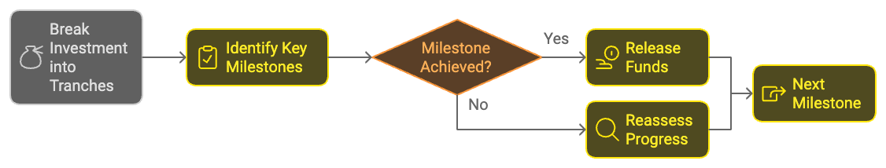
Investing alongside other angels or angel groups can help spread risk and leverage collective expertise in due diligence. Spread your investments across different industries to mitigate sector-specific risks. Consider investing in startups from different regions to tap into diverse markets and innovation hubs.
The journey of an angel investor is as much psychological as it is financial. You'll need to navigate a range of emotional challenges, including dealing with uncertainty, managing FOMO (fear of missing out), cultivating patience, handling emotional attachment, coping with failure, and balancing optimism with realism.
The early-stage nature of angel investments means dealing with a high degree of ambiguity and change. The fear of missing out on the next big thing can lead to rushed decisions, so develop the discipline to say no to opportunities that don't meet your criteria. Returns from angel investments can take years to materialize, so you'll need to cultivate patience and a long-term perspective. While it's natural to become emotionally invested in the startups you back, maintaining objectivity is crucial for making sound decisions. Statistically, many of your investments will fail, so developing resilience and the ability to learn from failures is key. While optimism is essential in the startup world, it needs to be tempered with a realistic assessment of risks and challenges.
Concluding this exploration of the angel investor's mindset, it's important to remember that success in this field is a journey of ongoing learning and adaptation. You're not just investing in startups; you're investing in your own growth as a savvy business mind and visionary thinker. The skills and perspectives you develop will serve you well beyond your investment portfolio, enriching your professional and personal life in unexpected ways.

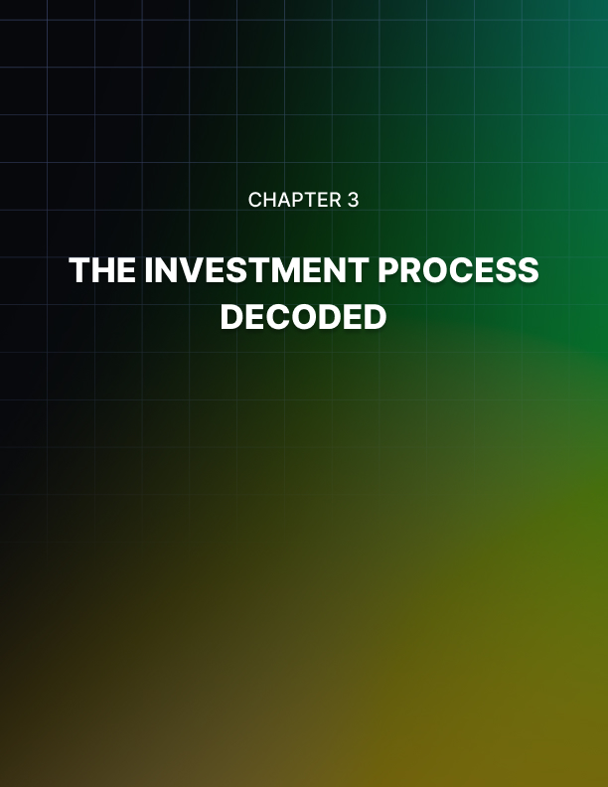

The Investment Process Decoded
The path from identifying a promising startup to closing a deal is a complex journey filled with critical decisions and meticulous steps. This chapter will guide you through each stage of the angel investment process, equipping you with the knowledge and tools to navigate this exciting terrain confidently.

Finding the Diamonds in the Rough
Your journey as an angel investor begins with finding high-potential startups. This process, known as deal sourcing, is both an art and a science. You'll need to cast a wide net while maintaining a discerning eye. Networking extensively is crucial; attend startup pitch events, entrepreneurship conferences, and industry meetups. These gatherings are fertile ground for discovering new ventures and connecting with founders. Joining angel groups can provide access to a curated flow of deals and the opportunity to learn from experienced investors. Leveraging online platforms like AngelList, Gust, and SeedInvest allows you to browse and filter startup investment opportunities based on your interests and criteria. Engaging with accelerators and incubators can be valuable, as these organizations nurture early-stage startups and often host demo days where you can see pitches from their latest cohorts. Utilizing professional networks such as LinkedIn can be instrumental in connecting with entrepreneurs and staying informed about new ventures in your areas of interest. Establishing a personal brand by positioning yourself as an expert in your field and a supportive investor may lead entrepreneurs to approach you directly with opportunities.
Quality is more important than quantity. As you source deals, focus on startups that align with your investment thesis, expertise, and interests. This alignment will not only increase your chances of success but also allow you to add more value beyond just capital. The key is to strike a balance between casting a wide net and maintaining a discerning eye, ensuring that the opportunities you pursue are not only numerous but also of high quality and relevance to your investment goals.

Separating Promise from Hype
Once you've identified potential investment opportunities, the next step is to evaluate their pitches. This is where your critical thinking skills and industry knowledge come into play. A strong pitch should articulate a clear problem statement, addressing a specific and significant pain point for customers. The startup's solution should be compelling, innovative, and differentiated from existing alternatives. Pay close attention to the market opportunity – consider the size of the target market, its growth potential, and how much of it the startup can realistically capture. The business model should be scalable and sustainable, with a clear path to profitability. Evaluate the startup's traction and milestones, looking for early customers, revenue, partnerships, or other relevant metrics that demonstrate progress and validation.
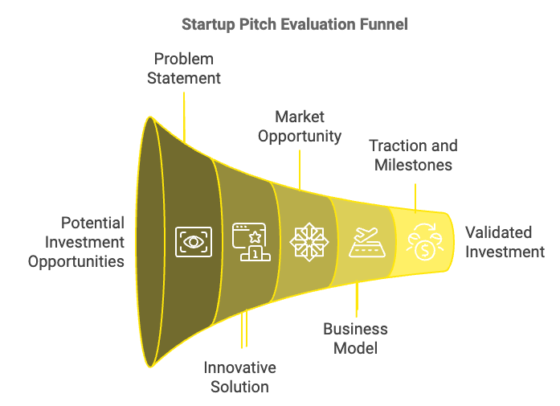
The capabilities of the founding team are crucial. Assess whether they have the skills, experience, and drive to execute their vision, and whether they are coachable and adaptable. Examine the competitive landscape, understanding who the main players are and how the startup plans to differentiate itself and maintain a competitive edge. While early-stage financial projections are often speculative, they should demonstrate an understanding of unit economics and key drivers of growth. Pay attention to how the startup plans to use the investment funds and whether there's a clear plan for achieving the next significant milestone. Although it may seem premature, having a vision for potential exit scenarios is important for your return on investment.
When evaluating pitches, it's important to strike a balance between enthusiasm and skepticism. Look for founders who are passionate but also realistic about the challenges ahead. Don't be swayed by flashy presentations alone; dig deep into the substance of the business. Remember that a great pitch is just the beginning – it's your job to look beyond the polished presentation and assess the true potential of the startup.

Conducting Due Diligence
Due diligence is a crucial step in the investment process, allowing you to verify the claims made in the pitch and uncover any potential red flags. While the depth of due diligence may vary based on the size of the investment and the stage of the startup, there are several key areas to investigate thoroughly. Start with the team background, conducting thorough checks on the founding team's professional history, educational background, and references. Verify the company's legal status, including incorporation documents and any existing contracts or agreements. If the startup claims to have proprietary technology or patents, verify these claims and assess their strength. A financial review is essential, examining financial statements, cash flow projections, and any existing debt or financial obligations.
Conduct your own market analysis to validate the startup's claims about market size, trends, and competitive landscape. If possible, speak with existing or potential customers to gauge the product's value proposition and market fit. For tech startups, consider bringing in a technical expert to evaluate the product or technology. Ensure the startup is compliant with relevant regulations and has necessary licenses or permits. If there are previous investors, try to understand their experience with the company and reasons for investing. Research the company's online reputation, including customer reviews and media coverage.
Remember, due diligence is not about finding reasons to say no; it's about gathering the information you need to make an informed decision. Be thorough, but also be respectful of the founders' time and maintain confidentiality throughout the process. The goal is to build a comprehensive understanding of the startup's potential and risks, allowing you to make a well-informed investment decision.

Negotiating Terms and Closing the Deal
If your due diligence confirms your interest in investing, the next step is negotiating the terms of your investment and closing the deal. This stage requires a delicate balance between protecting your interests and ensuring the startup has the support it needs to succeed. Key elements to consider include valuation, equity stake, investment instrument (common stock, preferred stock, convertible notes, or SAFE agreements), board seats or observer rights, pro-rata rights, information rights, liquidation preferences, anti-dilution protection, vesting schedules for founder shares, and exit clauses.
Negotiations should be collaborative, not adversarial. Remember, you're entering into a long-term partnership with the founders. Strive for terms that align incentives and set the foundation for a successful working relationship. Once you've agreed on terms, it's time to formalize the investment. This typically involves creating a term sheet, drafting and reviewing legal documentation, confirming due diligence items, obtaining board approval, transferring funds, and issuing shares or relevant investment instruments.
Throughout this process, clear communication is key. Ensure all parties understand their obligations and the timeline for closing. Consider using a digital deal room to securely share and sign documents. The closing process marks the beginning of your journey as an active investor, setting the stage for your ongoing engagement with the startup.
Investment Term | Description | Importance
Valuation | Company's worth | Determines equity stake
Pro-rata Rights | Right to maintain ownership % | Protects against dilution
Liquidation Preference | Order of payout in exit | Protects downside
Information Rights | Access to company updates | Ensures transparency
Board Seats | Formal governance role | Influences decision-making

Post-Investment Engagement and Legal Considerations
Closing the deal is just the beginning of your journey as an angel investor. Your post-investment engagement can significantly impact the startup's success and your potential returns. Establish regular check-ins with the founders, offer strategic guidance, provide networking support, assist with recruitment, offer operational support, provide emotional support, and help prepare for future funding rounds. Your role is to support, not to control. Respect the founders' vision and decision-making authority while offering your insights and resources.
Understanding the legal and tax implications of your investments is crucial for any angel investor. Be aware of accredited investor status requirements, tax implications, securities laws, confidentiality obligations, potential conflicts of interest, and the importance of thorough record-keeping. Consider consulting with a tax professional or attorney specializing in startup investments to ensure you're compliant with all relevant laws and regulations.
The angel investment process is a journey filled with excitement, challenges, and learning opportunities. By understanding each step of this process, from sourcing deals to post-investment engagement, you're well-equipped to make informed decisions and maximize your impact as an angel investor. Remember, every investment is a unique experience, and your approach will evolve as you gain more experience. Embrace the journey, learn from each investment, and enjoy the thrill of supporting the next generation of innovative companies.


Your First Investment
Your journey as an angel investor has led you to this pivotal moment: your first investment. This chapter will provide you with actionable advice and practical strategies to navigate this exciting yet challenging process. From identifying promising startups to closing your first deal, you'll gain the knowledge and confidence needed to take this significant step.

Identifying Promising Startups
The first step in making your inaugural angel investment is finding the right startup. This process requires a combination of strategic thinking, networking, and due diligence. Before you start looking for startups, establish clear investment criteria. Consider factors such as industry focus, stage of development, geographic location, investment amount, and return expectations. Your professional and personal networks can be goldmines for finding investment opportunities. Let your contacts know you're looking to invest in startups. Attend industry events, conferences, and meetups to expand your network and meet entrepreneurs. Angel groups provide a structured way to access deal flow and learn from experienced investors. Research groups in your area or industry of interest. Many groups allow you to observe before committing to membership. Utilize online platforms like AngelList, Gust, and SeedInvest, which offer curated lists of startups seeking investment. These platforms often provide detailed information about each startup, making initial screening easier. Engage with accelerators and incubators, which nurture early-stage startups and often host demo days where you can see pitches from multiple companies. Building relationships with accelerators can provide a steady stream of vetted opportunities. Create a personal brand by positioning yourself as an investor and thought leader in your areas of expertise. Write articles, speak at events, or maintain an active social media presence. This can attract entrepreneurs to approach you directly with opportunities. Set up a systematic approach to track and evaluate potential investments. This could be as simple as a spreadsheet or as sophisticated as a custom CRM system. Having a structured approach will help you manage deal flow efficiently.

Key Factors to Consider
Once you've identified potential investment opportunities, it's time to evaluate them thoroughly. While every startup is unique, there are several key factors you should consider. The team is often considered the most critical factor. Assess the founding team's experience, skills, and passion. Look for relevant industry experience, complementary skill sets among co-founders, track record of success or valuable failures, coachability and adaptability, and strong work ethic and resilience. Evaluate the size and growth potential of the target market, considering the total addressable market (TAM), serviceable addressable market (SAM), market growth rate, and market trends and potential disruptions. Assess the startup's offering and its potential for success, including its unique value proposition, product-market fit, competitive advantage, scalability, and intellectual property or barriers to entry. Look for evidence that the startup is making progress, such as customer acquisition and retention metrics, revenue growth (if applicable), key partnerships or contracts, and product development milestones. Understand how the startup plans to make money and grow by examining its revenue streams, pricing strategy, customer acquisition costs, lifetime value of customers, and path to profitability. While early-stage startups may have limited financial history, review their current financial position, burn rate and runway, financial projections and assumptions, and unit economics. Understand the startup's position in the market by analyzing key competitors, competitive advantages and disadvantages, and potential for new entrants or substitutes. Consider potential exit scenarios, including likely acquirers, IPO potential, and typical exit multiples in the industry. At this early stage, your evaluation will involve a mix of quantitative analysis and qualitative judgment. Trust your instincts, but back them up with thorough research and due diligence.

Conducting Effective Due Diligence
Due diligence is a critical step in the investment process. It helps you verify the claims made by the startup and uncover any potential red flags. Here's a practical approach to conducting due diligence:
Create a thorough due diligence checklist that covers all aspects of the business, including legal and corporate structure, financial info, intellectual property, team background checks, customer and market validation, product or technology review, and competitive analysis. Request and carefully review key documents, such as incorporation documents, capitalization table, financial statements and projections, contracts with customers, suppliers, and partners, employment agreements, and intellectual property filings.
Conduct interviews with key stakeholders to gather additional insights, including in-depth interviews with founders and key team members, conversations with customers or potential customers, discussions with industry experts, and talks with other investors (if applicable). Don't rely solely on information provided by the startup; perform independent research by conducting your own market research, analyzing competitors, checking online reviews and social media sentiment, and verifying claims about technology or product capabilities. If necessary, engage experts to assess specific aspects of the business, such as technical experts for product evaluation, legal counsel for contract review, and financial advisors for complex financial structures. If possible, visit the startup's office or workspace to gain valuable insights into the company culture and operations.
Compile and analyze all the information you've gathered, looking for consistency across different sources and identifying any areas of concern. Don't hesitate to ask follow-up questions or request additional information to clarify any uncertainties. The goal of due diligence is not to find reasons to say no, but to gather the information needed to make an informed decision. Be thorough, but also be respectful of the founders' time and maintain confidentiality throughout the process.

Negotiating Terms and Structuring Your Investment
If your due diligence confirms your interest in investing, the next step is negotiating the terms of your investment. This process requires a delicate balance between protecting your interests and ensuring the startup has the support it needs to succeed. Determine a fair valuation for the company, considering comparable company valuations, future potential and growth projections, and current traction and milestones achieved. Decide on the most appropriate investment vehicle, such as common stock, preferred stock, convertible notes, or SAFE (Simple Agreement for Future Equity). Determine the percentage of the company you'll own based on your investment and the agreed valuation. Negotiate pro-rata rights to participate in future funding rounds to maintain your ownership percentage. Ensure you'll receive regular updates on the company's progress and financial performance through information rights. Consider whether you want a formal role in governance through a board seat or observer rights. Negotiate terms that protect your investment in case of a liquidation event, such as liquidation preference. Consider provisions that protect your ownership stake in case of down rounds, known as anti-dilution protection. Ensure founder shares are subject to vesting to incentivize long-term commitment. Discuss potential exit scenarios and any related terms. When negotiating, aim for a win-win outcome. Remember, you're entering into a long-term partnership with the founders. Overly aggressive terms can strain this relationship and potentially harm the company's future prospects.
Investment Instrument | Description | Pros | Cons
Common Stock | Standard shares in the company | Simple, aligns with founders | Least protection for investors
Preferred Stock | Shares with additional rights | More investor protection | More complex, can create misalignment
Convertible Note | Debt that converts to equity | Defers valuation, simpler | Can be complex if not converted
SAFE | Simple agreement for future equity | Very simple, founder-friendly | Less protection for investors

Closing the Deal and Post-Investment Engagement
Once you've agreed on terms, it's time to formalize your investment. This process typically involves drafting and signing a term sheet outlining the key terms of your investment, working with legal counsel to prepare and review necessary legal documents, completing any outstanding due diligence items, ensuring the startup's board approves the investment, transferring the agreed investment amount, and receiving stock certificates or confirmation of your ownership stake. Throughout this process, maintain clear communication with the founders and any other involved parties. Consider using a digital deal room to securely share and sign documents.
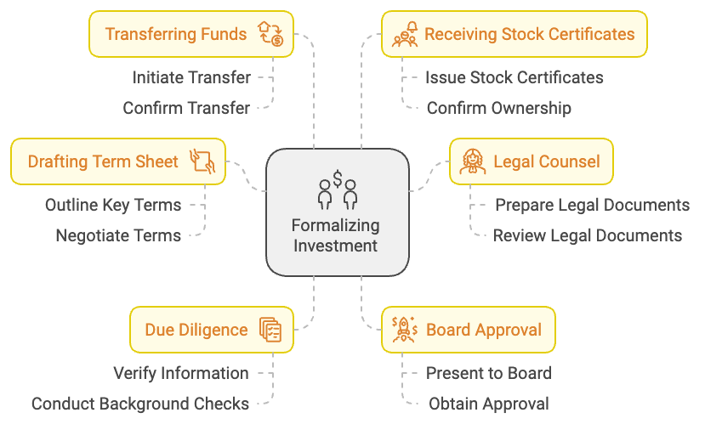
Closing the deal marks the beginning of your journey as an active investor. Your post-investment engagement can significantly impact the startup's success and your potential returns. Establish regular check-ins with the founders to stay informed about progress and challenges. Offer strategic guidance by sharing your expertise and industry insights to help the startup navigate challenges and seize opportunities. Provide networking support by introducing the startup to potential customers, partners, or future investors. Assist with recruitment by helping attract top talent through your network and experience. Offer operational support by providing guidance on issues ranging from financial management to marketing strategies. Be a source of emotional support and encouragement for the founders, as starting a company is challenging. Help prepare for future funding rounds, including introductions to potential investors. Remember, your role is to support, not to control. Respect the founders' vision and decision-making authority while offering your insights and resources.
Your first angel investment is a significant learning experience. Regardless of the outcome, it will provide valuable insights that will inform your future investments. Keep a journal of your experiences, decisions, and lessons learned throughout the process. After closing the deal, take time to reflect on the experience, considering what aspects of the process went smoothly, what challenges you faced, how effective your due diligence process was, whether you were comfortable with the negotiation process, and how you feel about your level of engagement with the startup post-investment. Use these reflections to refine your investment strategy and processes for future opportunities.
Making your first angel investment is an exciting milestone in your journey as an investor. By following this practical guide, you'll be well-equipped to identify promising startups, conduct thorough due diligence, negotiate fair terms, and provide valuable post-investment support. Each investment is a unique experience, and your approach will evolve as you gain more experience. Take on the learning process, stay curious, and enjoy the excitement of supporting innovative entrepreneurs as they bring their visions to life.


Recap and Next Steps
Standing at the threshold of your angel investing journey, you've gained a wealth of knowledge and insights. This final chapter serves as both a comprehensive recap of the essential points covered throughout this book and a roadmap for your continued growth as an angel investor. The path ahead is filled with opportunities, challenges, and endless potential for both personal and financial rewards.

Key Takeaways from Your Angel Investing Journey
You've learned that angel investing is more than just a financial transaction. It's a partnership between visionary investors and ambitious entrepreneurs, fueling innovation and driving economic growth. You understand the unique position angel investors occupy in the startup ecosystem, providing not just capital but also mentorship, connections, and strategic guidance at a critical stage of a company's development. You've delved into the psychology of successful angel investors, understanding the delicate balance between optimism and pragmatism required in this field. You recognize the importance of embracing calculated risks, maintaining a long-term perspective, and cultivating resilience in the face of inevitable setbacks. You're now equipped with strategies for finding promising investment opportunities, from leveraging your network to engaging with angel groups and online platforms. You understand the critical factors to consider when evaluating startups, including the team's capabilities, market potential, product-market fit, and scalability of the business model. You've learned the importance of thorough due diligence and have a framework for verifying a startup's claims and uncovering potential red flags. You understand that while due diligence can be time-consuming, it's a crucial step in making informed investment decisions. You've gained insights into the art of negotiating investment terms, understanding the key elements of term sheets and the various investment instruments available. You recognize the importance of striking a balance between protecting your interests and ensuring the startup has the support it needs to succeed. You understand that your role as an angel investor extends beyond writing a check. You're prepared to actively support your portfolio companies through mentorship, networking, and strategic guidance, recognizing that your involvement can significantly impact the startup's success and your potential returns.

Continuous Learning and Growth
Embarking on your angel investing journey, it's important to realize that the learning process is ongoing and never truly ends. The startup ecosystem is dynamic, with new technologies, business models, and market trends constantly emerging. To stay ahead and make informed investment decisions, you must commit to continuous learning and growth. Make it a habit to regularly read industry publications, startup blogs, and financial news. Platforms like TechCrunch, VentureBeat, and AngelList Insights offer valuable updates on startup trends and investment strategies. Subscribe to newsletters from thought leaders in the angel investing space to gain insights and perspectives. Attend industry conferences like the Angel Capital Association Summit, EBAN Annual Congress, or Y Combinator's Startup School to learn from experienced investors, network with peers, and discover new investment opportunities. Look for local startup events and pitch competitions in your area as well. Becoming a member of angel networks or syndicates can provide access to deal flow, due diligence resources, and opportunities to co-invest with experienced angels. Networks like Angel Capital Association, European Business Angel Network, or online platforms like AngelList can be valuable resources. Form or join a group of fellow angel investors to share experiences, discuss deals, and learn from each other's successes and failures. Regular meetups or online forums can facilitate this peer-to-peer learning. Consider taking courses specifically designed for angel investors. Programs like the Angel Resource Institute's workshops or online courses from platforms like Udemy or Coursera can provide structured learning opportunities. Engaging with startups as a mentor, even before you're ready to invest, can provide valuable insights into the challenges entrepreneurs face and help you develop an eye for promising opportunities.

Evolving Your Investment Strategy
As you gain experience and learn from each investment, it's important to continuously refine and evolve your investment strategy. Here are some considerations for developing a more sophisticated approach:
- Portfolio Approach: Instead of relying on a single "home run" investment, aim to build a diversified portfolio of startups. A common rule of thumb is to aim for at least 10-15 investments to spread risk and increase your chances of success.
- Develop a Thesis: As you gain experience, you may want to develop an investment thesis - a set of beliefs about where you see opportunities in the market. This could be based on industry trends, technological advancements, or societal shifts you've observed.
- Specialize: Consider focusing on a specific industry or type of technology where you have particular expertise or interest. Specialization can help you develop deeper insights and build a reputation as a value-add investor in that space.
Investment Strategy Evolution
Portfolio Approach
Develop a Thesis
Specialize
Follow-On Investments
Syndication
Explore Different Instruments

Measuring Success and Managing Expectations
Success in angel investing isn't just about financial returns, although that's certainly an important aspect. As you progress in your journey, consider these multiple dimensions of success: Financial Returns, Learning and Personal Growth, Network Expansion, Impact, and Entrepreneurial Support. It's important to manage your expectations, especially in the early years. Angel investing is inherently risky, and it's common for many investments to fail. The key is to learn from both successes and failures, continually refining your approach.

Navigating Challenges and Ethical Considerations
The deeper you get into angel investing, the more likely you are to encounter various challenges and ethical considerations. Being prepared for these can help you navigate them effectively. Finding the right level of involvement with your portfolio companies can be tricky. You want to add value without micromanaging. Establish clear expectations with founders from the outset. The startup world is full of ups and downs. Develop emotional resilience to weather the inevitable failures and setbacks without losing your enthusiasm. As your portfolio grows, managing your time and commitments can become challenging. Be realistic about how much time you can dedicate to each investment. Be aware of potential conflicts, especially if you're investing in multiple companies in the same space or if you have other business interests that could conflict with your investments. Consider developing an ethical framework for your investments. This might include considerations about the products or services you're willing to back, the impact of the companies you invest in, or the diversity of the founding teams you support. Maintain clear and open communication with both the startups you invest in and any co-investors. Transparency builds trust and can help navigate difficult situations.

Embracing the Angel Investor Lifestyle
Continuing your path as an angel investor, it's important to recognize that this journey is just as much about personal growth as it is about financial returns. You're not just investing in startups; you're investing in your own development as a business leader, mentor, and visionary. Embrace the lifestyle of an angel investor. Attend startup pitch events not just as an investor, but as an active participant in the ecosystem. Share your knowledge by speaking at events or writing about your experiences. Mentor young entrepreneurs, even if you're not investing in their companies. Engage with local universities or startup incubators to foster entrepreneurship in your community. Consider how your role as an angel investor aligns with your broader life goals and values. Are you using your resources and expertise to drive positive change? Are you supporting innovations that you believe will make the world better? Let these considerations guide your investment decisions and your level of involvement in the startup ecosystem. As you gain experience and success, think about how you can give back to the angel investing community. Could you mentor newer angel investors? Could you advocate for policies that support startup ecosystems and angel investing? Could you contribute to research or thought leadership in the field? Remember, every experienced angel investor was once in your shoes, making their first investment and learning the ropes. Your journey is just beginning, and the potential for impact – both financial and societal – is immense.

