Disclaimer

This ebook has been written for information purposes only. Every effort has been made to make this ebook as complete and accurate as possible.

However, there may be mistakes in typography or content. Also, this ebook provides information only up to the publishing date. Therefore, this ebook should be used as a guide - not as the ultimate source.

The purpose of this ebook is to educate. The author and the publisher do not warrant that the information contained in this ebook is fully complete and shall not be responsible for any errors or omissions.

The author and publisher shall have neither liability nor responsibility to any person or entity with respect to any loss or damage caused or alleged to be caused directly or indirectly by this ebook.
Table Of Content

Chapter 1: The Importance of Article Marketing 4
Some Effective Article Marketing Tips 5
Chapter 2: Writing Easy To Read Articles 8
Writing Articles About Internet Marketing 8
Writing the Articles 9
Chapter 3: Using Article Marketing To Help Your Business 12
Chapter 4: Writing Great Articles 15
1. Write as if you are talking to your readers 16
2. Use simple words 16
3. Write short articles 16

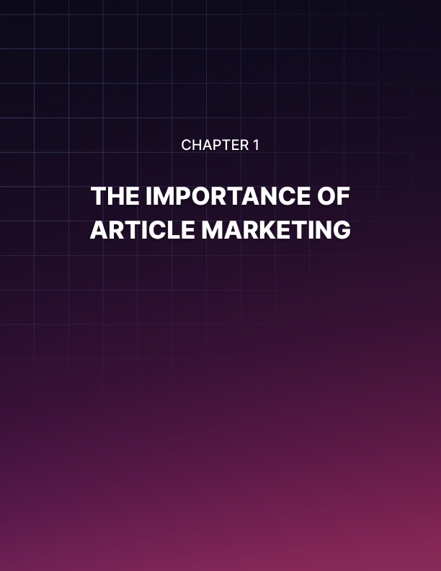

Chapter 1: The Importance of Article Marketing

Article marketing has been used for years. From media publications, it has shifted to the web which many experts say is timeless thus making it very important in the digital age.

The reason why article marketing is so important is that it will not only enhance your website with information but it will also make it go up the ranks of major search engines which all boils down to quality traffic.

This means that chances of people buying your items via the web are much higher and some of these customers might even come from out of state or from a different country.

- You can make this happen simply by choosing the right keywords which the search engines will pick up when someone decides to look for it.

- Another option is to send your articles only to those that cater to it. This can be done by uploading the article to your favorite online network. There are also popular article submission sites also known as directories as well as article search engines which you can submit to free of charge.

- You can also get help from friends who also have websites and also post your articles there. The more sites you are able to advertise in the better so you get to reach a larger audience.

- If you have written a lot of articles already, it is time to put these into categories. You can also put these all together in the form of an e-Book and give this away for free.

- The articles may also be submitted to ezine sites.

Article marketing is just one of the tools in promoting your site via the web. There are also meta- tags and pop up tags which happen to be very popular. The only difference is that you have to spend a few dollars in order for these to be posted on other sites.

So is article marketing important? The answer is yes because with 300 to 500 words, you are able to talk to the reader on a more personal level better than what a banner can do. Most people don’t even pay attention to a banner and just close it because many feel that it is a waste of time just entertaining it.

Perhaps the best part is that you don’t have to be an expert writer to tell the reader what your product is all about. The main thing is that you are able to say it simply so this will be easy for just about anyone to understand.

If you are having a hard time putting the words together, do some drafts, proofread it before submitting this online. For those who don’t write very well, maybe you should hire someone to do that for you by simply giving them certain guidelines about the message you are trying to convey.

People who want to search for something using the web have to type in certain keywords in one of the major search engines. If you want people to find your site, you have to put yourself in their shoes and then put in factual information so you can be trusted.

This is the essence of what article marketing is all about and why it is so important for anyone who wants to do business online.

Some Effective Article Marketing Tips
Article marketing can do a lot for your business. You just have to know a few things and here are some tips to help you out.

- First, you have to make sure that whatever you are writing about is relevant. If you know for a fact that your product could be very useful, then do some research about it and then end the article with a link to your website. Before you upload the article, check if the site you plan to put this on has this as one of their topics.

- Just like what you read in the newspaper or see on television, the article must be both timely and newsworthy. This will allow you to stay in touch with what is happening in the world. One good way is signing up with a site that gives you alerts with regards to certain topics.

- Some writers post one article and that’s it. Just like movie producers in Hollywood, you should post a sequel to this because there could already be new information available which you could share to the public.

- You should also make your articles viral. What this simply means is allowing other people to publish your article just as long as nothing is changed and you are given credit for it. Another way of doing this is offering your writing services to others which will become added revenue for you.

- Each article you write must be short and simple. It must be short so that it will not bore the reader. Simple so that they will be able to understand the message you are trying to convey.

- Just how many articles must your write to increase traffic? The good news is that you only need 2 to get things started. A good title will be “ how to do something” and “ x number of tips for something.” If this catches their interest, that person will most likely click on the link to your site and then buy something. The bottom line is that it increases web traffic.

- You can stop at just 2 articles to promote your site. If you have other products, you can write articles on it as well and then mention them in the resource box. This is known as cross- referencing which a lot of webmasters allow their contributors to do.

- Aside from posting your written work on other websites, don’t forget to also put these on your own. If you have written 10 or more about the same topic, put these together in what is known as an e-book and then pass this along for free. Again, if people like what is written there then people wouldn’t be reminded of reading it several times.

- Aside from posting in websites, make use of RSS feeds. There are plenty of them around so make use of it.

There are two ways to get into article marketing. The first is to write it yourself and just hope that people will appreciate your writing style. The other is to hire someone to do it. Some charge by the hour while others charge per word. It may be worth it if this increases traffic to your site.

By following these article marketing tips, it won’t be long before you get a lot of hits.



Chapter 2: Writing Easy To Read Articles

When writing articles, make sure to keep your readers in mind. Studies have shown that most Internet readers tend to scan a page to find the information they are looking for, rather than reading the entire page.

This means having good titles, a lot of subtitles, and making use of bullet points to help your readers easily scan your page.

Readers prefer a site like this that is easy to use and will be more willing to come back to your site time and time again. The more that your readers return, the more opportunities you will have to get them to click on each one of your affiliate links.

Failing to write your articles in this manner, or to have them written this way, could turn your site visitors away before they even have a chance to see what you have to say or to learn what your affiliate links are all about. Keeping your articles organized as recommended will keep your visitors returning and enable your site to continue making money for you.

Writing Articles About Internet Marketing
Going over an article on Internet marketing, you will gauge how the term has changed through the years.

It used to be focused on ad placements. The way to do it then was to create a web page and place banner ads on other sites so that you can have links to your own sites.

There are also some money making schemes that evolved wherein you are advised to join a program for you to earn through the Internet.

But as of today, Internet marketing has become synonymous to advertising. And the best way to do this is through creating valuable articles. This way, it is less costly especially if you have the knack for writing and you are going to create your own materials.

Writing the Articles
Writing for the web is a lot different as compared to feature writing in magazines or even in the newspapers. This can be easy to do once you get the hang of it. All you've got to have are ideas about a specific topic that you want to become an expert on. But if you really do not have the knack for this craft, you can always hire freelancers to do the task for you.

First thing that you have to remember when writing the articles is that you must have a specific audience in mind. You will address your materials to them. You are vying for their attention that is why you are writing your articles in a way to reach out to them.

This is the kind of topic which they are interested in, so you write about it until you are considered an expert. That will not be hard to do especially when you have good content which your target market is always on the lookout for.

You have to be subtle in promoting your own website, products and services. This rule applies when you get your articles published on different submission sites. Most of the time, you will be allotted a box, an ample space wherein you can create an author's bio.

That's the part where you can have a link to your site. The idea here is when you already have the trust of your readers, they will be interested enough to click on your specified links.

Take note of the word count. Other submission sites would accept 300 or so words for articles. But most sites prefer 500 to 550 minimum word count. Read the rules thoroughly so that you won't get banned from any of those useful sites.

Also be careful in using keywords. Do not use it too much to the point that it will annoy your readers. Stuffing your articles with keywords will just make your readers turn away from your materials as long as your motives become very obvious.

Lastly, choose an article submission site that ranks high on Google and in Alexa. You don't want to submit your work on spammy sites. That will not do your business any good. You can also study where your competitors do their submissions. This way, you can zoom in on those sites and start on your submissions.

Read through an article on Internet marketing just like this one before you plunge into a territory which is still unknown to you. This way, once you've entered the battle, there will be no turning back.

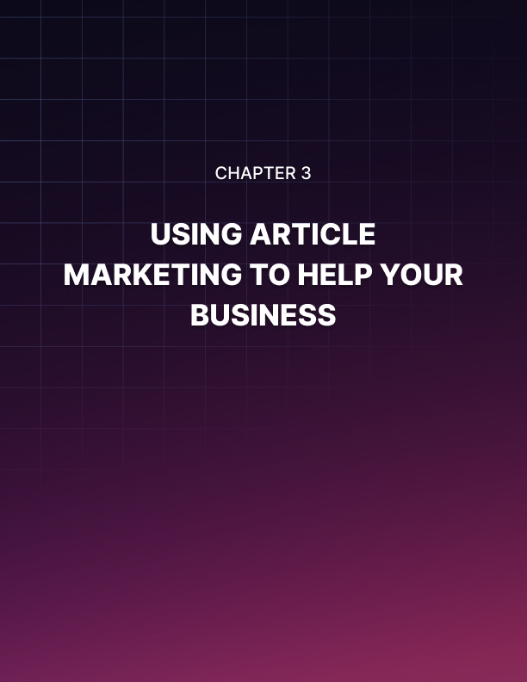

Chapter 3: Using Article Marketing To Help Your Business

Can article marketing help your business? The answer is yes because not only are you able to post your articles for free but you get to reach a specific audience that is interested in your product or service.

Article marketing can help your business the minute you submit these to different article directories. If these are approved for posting, people will be able to visit your site or may want to get in touch with you as they click the link or look at the resource box.

The resource box is usually found at the bottom of the web page. Here, writers can put their name, website and email.

If your article had a significant impact on the reader and they would like to post your article in their websites, they can do so which means more people will be able to see your work without you having to do anything.

Articles that are posted in directories usually ask you for keywords so this can easily be found when someone visits the site. These keywords are also given to search engines so if people type it in, your article will also appear and they will be able to view it.

Another way of getting people to see your site is giving this in the form of a report or e-book to potential customers. With all the information there, that person will surely want to know more and get in touch with you in the future.

People who are serious about article marketing have venues where the articles can be displayed. The first is high traffic distribution sites while the second is submitted to highly relevant niche publishers. The difference between the two is that although the second will not be read by many, it will be easy for those who run this site to refer qualified visitors to the author.

It doesn’t matter if the article you are writing about is for a small, medium or large business because there are ways to promote it. For instance, if your article is for a small restaurant, you should put in the title something related to the location of the establishment.

The same goes for the medium and large scale business. The key here is to come up with a catchy title that your audience can relate to.

Of course there are other ways of promoting your business such as paying for pop up ads and meta-tags. But why would you spend when you can get this for free? So, take advantage of this free marketing tool and see what it can do as it has done for others.

You surely wouldn’t want to pass up on the chance so write something about your business or get someone to do it for you.

Is article marketing better than conventional print publications? The answer is yes because people will easily find your article by typing in some keywords. Print publication on the other hand is difficult because you will have to browse through how many back issues of newspapers and magazines just to find it.

Also, conventional publication is only relevant to the time it was written. The online form will be there for many years ahead as this information is stored somewhere in cyberspace. Just make sure this is updated if something new comes along so you are sure that article marketing is able to help your business.



Chapter 4: Writing Great Articles

Article marketing is the new way to promote products nowadays. After all, what better way to reach the target market than to produce materials that directly affect them and articles that they can directly relate with.

For instance, if you have a product that treats diabetes, one way to reach your market and reach your target audience is to write articles that will benefit them like tips on how to prevent increase in sugar levels.

This is especially true with the range that the world wide web has brought us. With the faster connection and the amount of information that one can get with a single click of the mouse, more and more people are starting to recognize the importance of article marketing in raising the awareness of consumers.

In recent years that article marketing has gone online, it has not only been used to promote products and services over the internet but also in promotion of the site itself.

Site owners use the articles that they have in their sites to increase their ranking in search engines like Yahoo and Google. The more articles they have that correspond to the keyword being searched on, the better their ranking will be in the search results.

This is done not only to increase the viewers that will be able to look at the sites but also the advertisements that will be placed on the site.

More viewers and visitors of the sites will also mean more advertisements on the sites. This will mean more revenues for the site as they get a percentage for every person who will click on the advertisements.

But the proliferation of articles on the internet has lowered the quality of the posted works. More and more articles are being posted without proper editing. There are many articles that have wrong spelling and wrong grammar. There are also a lot of articles that have been copied from other sites. Some will be copied verbatim while other articles will only get the essence of the piece.

But you don’t have to sacrifice quality over quantity. Even with a lot of articles to do, you can create great articles. Here are some tips on how to do it.

Write as if you are talking to your readers
The best way to make your articles easy to read is to make it conversational. Write the articles in such a way that you are talking to your readers. This way, they will be able to relate more with the article and absorb the piece.

Use simple words
There is no sense in using words that can only be found in the dictionary. After all, your readers are not scholars who have a wide vocabulary.

Articles that use complicated words are also boring to read and hard to understand.

By using simple words, you can create a connection with your readers right there and then. That way, you will be able to accomplish what you came out to do, inform readers and promote your product and site.

Besides, if they did not like the article, will they be coming back to your site?

Write short articles
You are not writing a novel. With online content, shorter is better as most people who use the net will have really short attention spans. They will not have the time or the patience to weed through the additional words that you added just to lengthen the article. As much as possible, make short succinct articles that go straight to the point.

