Table of Contents
Introduction 4
The Power of Automation in Small Businesses 7
The Critical Need for Efficiency 7
Reducing Operational Costs and Minimizing Human Errors 7
Freeing Up Time for Strategic Initiatives 8
Essential Tools for Small Business Automation 9
Identifying Key Areas for Automation 14
The Art of Process Mapping 14
Prioritizing Automation Opportunities 15
Key Areas for Small Business Automation 16
Email Marketing Automation 16
Social Media Scheduling 17
Inventory Management 17
Customer Support Automation 18
Accounting and Bookkeeping 18
Implementing Your Automation Strategy 19
Implementing Scalable Automation Solutions 22
The Foundation of Scalable Automation 22
Setting Up Automated Workflows 23
Integrating Existing Business Tools 24
Leveraging Cloud-Based Solutions 25
Ensuring Security and Compliance 26
Planning for Future Growth 26
Measuring the Impact of Automation 29
The Importance of Measuring Automation Impact 29
Key Metrics for Measuring Automation Impact 29
Time Savings 29
Error Reduction 30
Productivity Increase 30
Cost Reduction 31
Setting Up a Measurement Framework 31
Real-World Examples of Automation Impact 32
Calculating Return on Investment (ROI) 32
Challenges in Measuring Automation Impact 32
Continuous Improvement through Measurement 33
Recap and Path Forward 36
The Power of Automation and Key Takeaways 36
Creating Your Automation Roadmap 37
Overcoming Common Automation Challenges and Future Trends 38



Introduction
In the fast-paced world of small business, every moment matters. You're juggling tasks, wearing many hats, and working hard to stay ahead of the competition. But what if you could amplify your efforts, streamline operations, and accomplish more with less? Welcome to the transformative power of automation for small businesses.
Unlike other resources that offer vague promises or complex solutions, this guide provides practical, actionable strategies you can implement right away. You'll learn how to harness automation to transform your business, reduce costs, and free up your most valuable asset: time.
Routine tasks can be seamlessly managed in the background, allowing you to focus on growing your company and serving your customers. With the right tools and strategies, you'll confidently navigate the challenges of entrepreneurship, leveling the playing field with larger competitors.
You'll discover how to identify the best automation opportunities tailored to your business, choose scalable solutions that grow with you, and measure the impact of your efforts for ongoing improvement. Real-world examples of businesses that have used automation to overcome challenges and achieve growth are included throughout, offering practical insights.
By the end, you'll have a clear roadmap for automating your business—knowing which tasks to tackle first, which tools to use, and how to measure success. More importantly, you'll be ready to take action and start seeing results.
This book is about more than just knowledge—it’s about giving you the confidence to take control. As your business becomes more efficient and profitable, you'll have the freedom to pursue new opportunities and achieve the work-life balance you’ve always wanted.
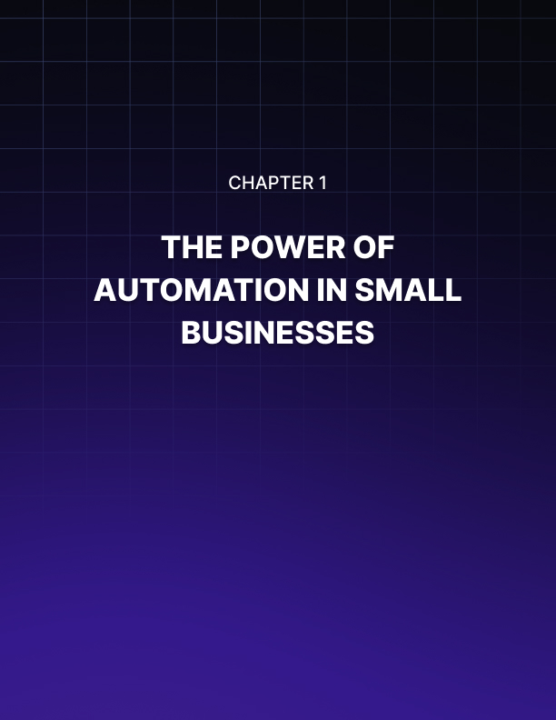

The Power of Automation in Small Businesses
Picture this: You're an entrepreneur, juggling countless tasks daily. From managing customer relationships to handling inventory, every minute counts. Now, imagine a world where your business runs like a well-oiled machine, with repetitive tasks taken care of automatically. Welcome to the realm of business automation – your secret weapon for success in today's fast-paced market.
As a small business owner, you're constantly seeking ways to maximize efficiency and minimize costs. Automation is the key that unlocks this potential. It's not about fancy robots or complex algorithms; it's about smart, strategic implementation of tools and processes that streamline your operations and supercharge your productivity.

The Critical Need for Efficiency
Small businesses must be efficient to survive and grow. They face larger, richer competitors. Working smarter, not harder, levels the playing field. Automation plays a key role here, allowing you to free up valuable time and resources by handling routine tasks. This shift in focus enables you to concentrate on strategic decision-making, creative problem-solving, and building meaningful relationships with your customers. Consider this: A recent study by Zapier found that small businesses save an average of 23 hours per week through automation. That's nearly three full workdays you could reclaim to grow your business!

Reducing Operational Costs and Minimizing Human Errors
One of the most significant benefits of automation is its impact on your bottom line. Streamlining processes and reducing manual labor can significantly cut operational costs. Take, for example, the case of Sarah's Boutique, a small clothing store. Sarah spent hours each week manually updating inventory and processing orders. Implementing an automated inventory management system reduced the time spent on these tasks by 80%. This not only saved her money on labor costs but also minimized errors in stock counts and order fulfillments. Automation can help you reduce labor costs by automating repetitive tasks, minimize errors that lead to wasted resources, and optimize resource allocation through data-driven insights. According to a report by McKinsey, automation can reduce costs in some industries by up to 40%. While your specific savings may vary, the potential for cost reduction is substantial.
We're all human, and humans make mistakes. While errors are a natural part of any process, they can be costly for small businesses. Automation helps minimize these errors, ensuring consistency and accuracy in your operations. For instance, automated data entry can reduce errors by up to 90% compared to manual entry. This level of accuracy is crucial for tasks like financial reporting, inventory management, and customer data handling. Consider the impact of even a small error in your financial records. A misplaced decimal point could lead to significant discrepancies in your books, potentially causing cash flow issues or tax complications. Automation safeguards against these types of mistakes, giving you peace of mind and more reliable data to base your decisions on.

Freeing Up Time for Strategic Initiatives
Perhaps the most valuable aspect of automation is the time it frees up for you and your team. Instead of getting bogged down in repetitive tasks, you can focus on high-level strategic initiatives that drive growth and innovation. Imagine being able to dedicate more time to developing new products or services, crafting marketing strategies to reach new customers, analyzing market trends and adjusting your business model, building relationships with key clients or partners, and improving your skills or those of your team. A survey by Salesforce found that 76% of small business owners say automation allows them to focus on higher-value tasks. This shift in focus can be the difference between stagnation and explosive growth for your business.
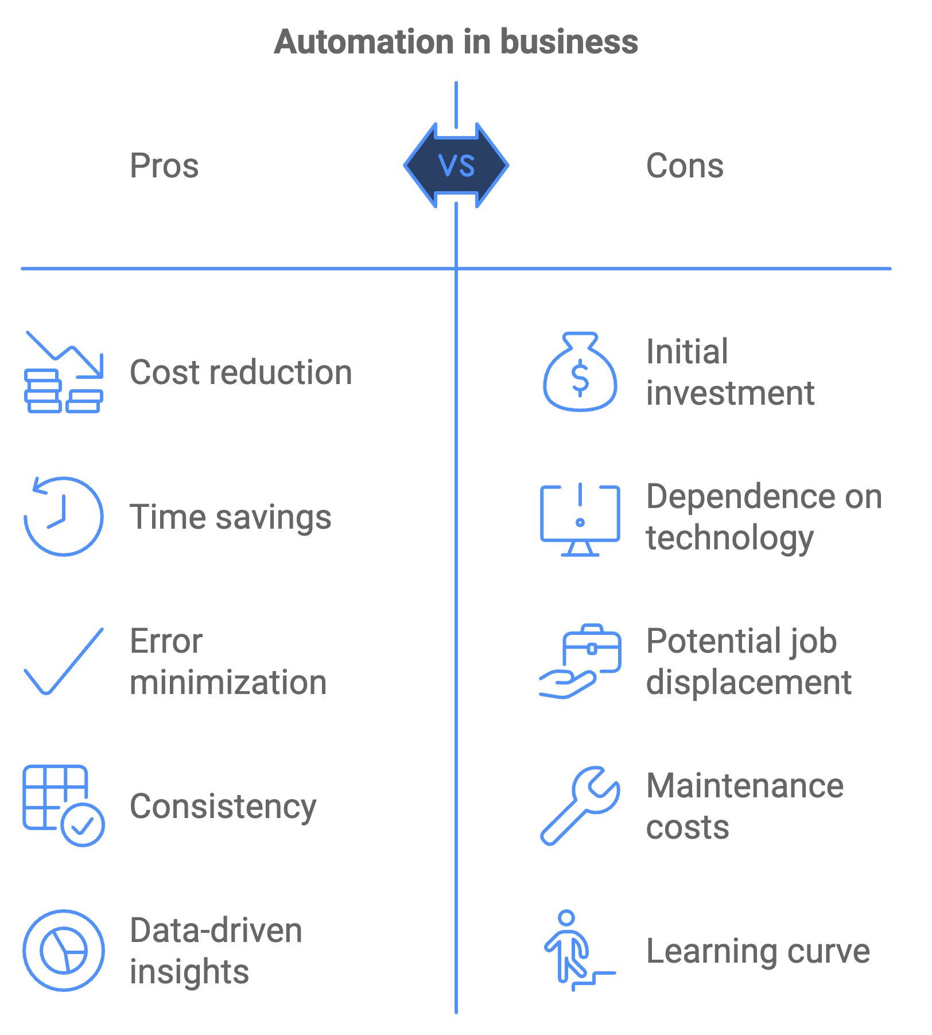

Essential Tools for Small Business Automation
Now that we've explored the benefits of automation, let's look at some essential tools that can help you get started. A Customer Relationship Management (CRM) system is the backbone of many successful small businesses. It automates customer data management, helping you track interactions, manage leads, and nurture relationships more effectively. Popular CRM options for small businesses include HubSpot CRM, which offers a free basic version with powerful features; Salesforce Essentials, tailored for small businesses with scalability in mind; and Zoho CRM, known for its user-friendly interface and affordability. Implementing a CRM can lead to a 29% increase in sales and a 34% increase in sales productivity, according to a study by Nucleus Research.
Workflow automation tools allow you to create automated workflows across various applications, streamlining your processes and reducing manual intervention. Some popular workflow automation tools include Zapier, which connects over 3,000 apps to automate workflows; IFTTT (If This Then That), great for simple automation tasks; and Microsoft Power Automate, ideal for businesses using Microsoft products. For example, you could set up a workflow that automatically adds new email subscribers to your CRM, sends them a welcome email, and notifies your sales team – all without lifting a finger.
Email marketing automation remains one of the most effective ways to reach and engage customers. Automation takes it to the next level by allowing you to send targeted, timely messages based on customer behavior or preferences. Tools like Mailchimp, Constant Contact, and SendinBlue offer robust email automation features. You can set up welcome series for new subscribers, abandoned cart reminders, birthday or anniversary messages, and re-engagement campaigns for inactive customers. A study by Epsilon found that automated emails generate 70.5% higher open rates and 152% higher click-through rates than traditional marketing messages.
Social media management tools can be incredibly helpful in managing multiple social media accounts, which can be time-consuming. These tools allow you to schedule posts, track engagement, and analyze performance across platforms. Popular options include Hootsuite, which manages multiple social networks from one dashboard; Buffer, known for its intuitive scheduling features; and Sprout Social, which offers in-depth analytics and reporting. By automating your social media posting, you can maintain a consistent online presence without spending hours each day on social platforms.
Accounting and bookkeeping software can automate your financial processes, saving time, reducing errors, and providing real-time insights into your business's financial health. QuickBooks, Xero, and FreshBooks are popular choices for small businesses. These tools can automatically categorize expenses, generate and send invoices, reconcile bank statements, and create financial reports. According to a survey by Sage, businesses using automated accounting software save an average of 2 weeks per year on bookkeeping and reporting.
Automation Tool Type | Examples | Key Benefits
CRM Systems | HubSpot CRM, Salesforce Essentials, Zoho CRM | Improved customer management, increased sales
Workflow Automation | Zapier, IFTTT, Microsoft Power Automate | Streamlined processes, reduced manual work
Email Marketing | Mailchimp, Constant Contact, SendinBlue | Higher engagement rates, targeted messaging
Social Media Management | Hootsuite, Buffer, Sprout Social | Consistent online presence, time savings
Accounting Software | QuickBooks, Xero, FreshBooks | Accurate financial records, time savings

Begin your automation journey with these key points:
- Start small by focusing on one or two processes that will significantly enhance your efficiency.
- Choose the right tools that integrate well with your existing systems and meet your specific needs.
- Train your team to ensure they understand how to use the new automated systems effectively.
- Monitor and adjust by regularly reviewing your automated processes to ensure they're delivering the expected benefits, and be prepared to make adjustments as needed.
- Stay informed about new automation technologies and industry trends to maintain a competitive edge.
Automation is not about replacing human workers; it's about enhancing their capabilities and allowing them to focus on tasks that require creativity, emotional intelligence, and strategic thinking. By embracing automation, you're setting your small business up for success in an increasingly competitive and fast-paced business environment.
Automation is a journey, not a destination. Start small, learn from each implementation, and gradually expand your automation efforts. With patience and persistence, you'll transform your small business into a lean, efficient operation ready to take on any challenge.
In the next chapter, we'll explore how to identify key areas for automation in your specific business. You'll learn how to assess your current processes and pinpoint opportunities for improvement through automation. Get ready to take your business efficiency to the next level!
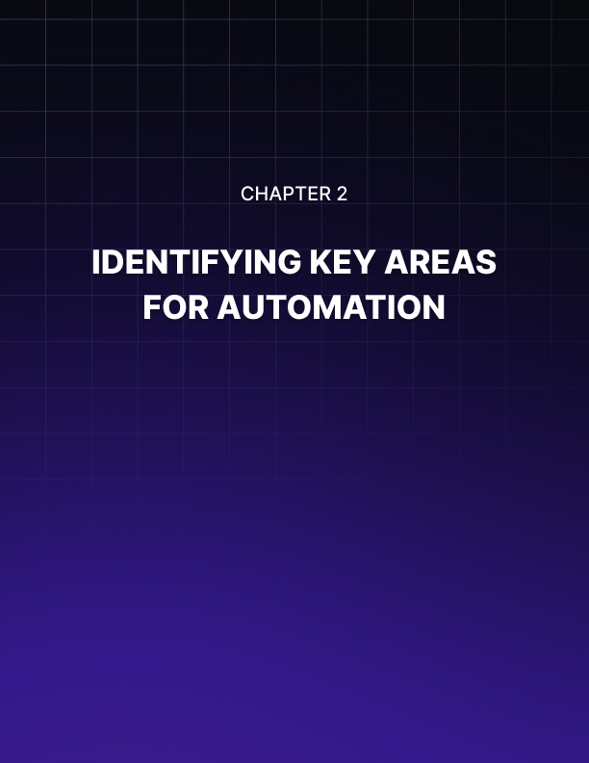

Identifying Key Areas for Automation
Opportunity knocks at your door. As a small business owner, you're constantly seeking ways to streamline operations and boost efficiency. The key to unlocking this potential lies in identifying the right areas for automation. This chapter will guide you through the process of pinpointing those tasks and processes that, when automated, will yield the most significant benefits for your business.

The Art of Process Mapping
Before you can automate, you need to understand your current workflows intimately. Process mapping is a powerful technique that helps you visualize your business operations from start to finish. By creating a visual representation of your processes, you'll easily spot bottlenecks, redundancies, and areas ripe for automation.
To begin process mapping, start by listing all the major processes in your business, such as customer acquisition, order fulfillment, and invoicing. Break each process down into individual tasks, arrange them in sequential order, identify who is responsible for each task and how long it typically takes, and note any decision points or places where the process branches. You can use simple tools like pen and paper, or digital solutions like Lucidchart or Microsoft Visio for this exercise. The goal is to create a clear, visual representation of your workflows.
Once you have your process maps, analyze them with these questions in mind:
- Which tasks are repetitive and time-consuming?
- Where do bottlenecks occur?
- Are there any tasks that frequently result in errors?
- Which processes involve a lot of data entry or transfer?
These questions will help you identify prime candidates for automation.

Prioritizing Automation Opportunities
Not all processes are created equal when it comes to automation potential. To maximize your return on investment, focus on areas that will have the biggest impact on your business. Consider factors such as time savings, error reduction, customer impact, cost reduction, and scalability.
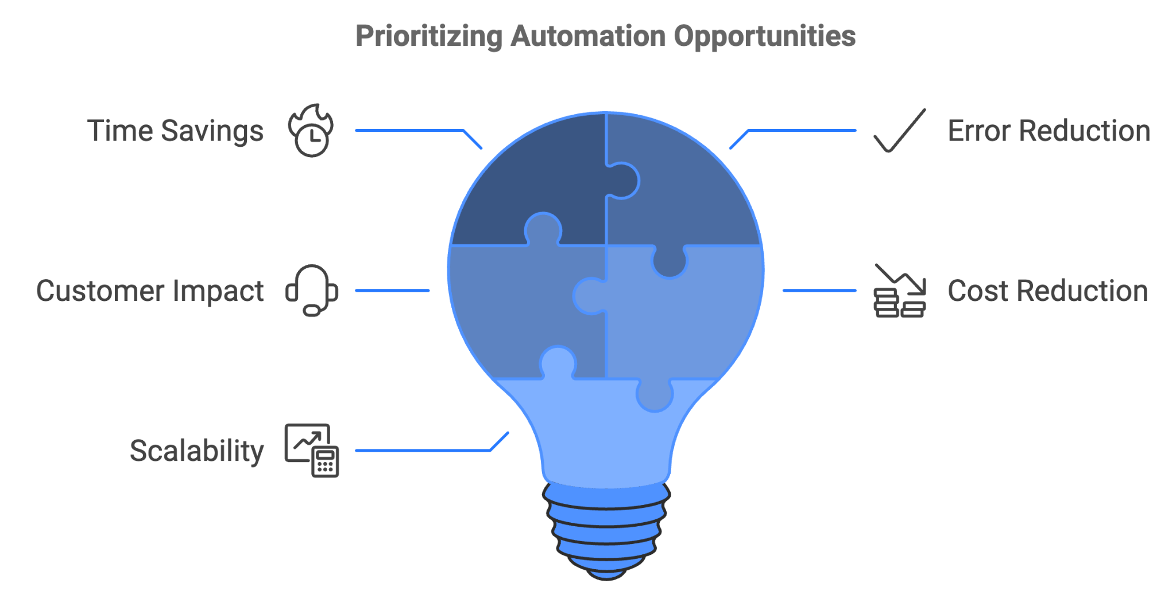
- Time savings refers to tasks that consume the most time, as automating these can free up significant resources.
- Error reduction looks for processes prone to human error, as automation can drastically improve accuracy.
- Customer impact prioritizes automation that will directly improve customer experience.
- Cost reduction considers which automation could lead to the most significant cost savings.
- Scalability focuses on processes that, when automated, will allow your business to handle increased volume without proportional increases in resources.
Create a simple scorecard for each potential automation opportunity, rating it on these factors. This will help you prioritize your efforts and focus on high-impact areas first. Systematically evaluating each opportunity ensures that your automation efforts are directed toward the areas that will provide the most significant benefits for your business.

Key Areas for Small Business Automation
Now, let's explore some specific areas where automation can make a significant difference in your small business operations. These areas include email marketing, social media scheduling, inventory management, customer support, and accounting and bookkeeping.

Email Marketing Automation
Email marketing remains one of the most effective ways to reach and engage customers, with an average return on investment of $42 for every $1 spent, according to the Data & Marketing Association. However, manually managing email campaigns can be time-consuming and inefficient. Automating your email marketing can help you send targeted, personalized messages based on customer behavior or preferences, create and manage drip campaigns to nurture leads, automatically segment your email list for more effective targeting, and track open rates, click-through rates, and other key metrics.
Tools like Mailchimp offer robust automation features. For example, you can set up a welcome series for new subscribers, abandoned cart reminders for e-commerce businesses, or re-engagement campaigns for inactive customers. A simple automated email workflow could include sending a welcome email immediately when a new subscriber joins your list, showcasing your top products or services three days later, sending a special offer if they haven't made a purchase after a week, and triggering a thank you email and customer onboarding sequence for those who make a purchase. This type of automation ensures timely, relevant communication with your audience without requiring constant manual effort.

Social Media Scheduling
Managing multiple social media accounts can quickly become a full-time job. By automating your social media posting, you can maintain a consistent online presence without spending hours each day on these platforms. Social media management tools like Hootsuite or Buffer allow you to schedule posts in advance across multiple platforms, analyze the best times to post for maximum engagement, track mentions and engage with your audience more efficiently, and generate reports on your social media performance.
For instance, you could set aside a few hours each week to plan and schedule your social media content for the entire week. This approach ensures a consistent posting schedule while freeing up daily time for other tasks. A sample automated social media schedule might include sharing a motivational quote related to your industry on Monday, posting a tip or how-to related to your products/services on Tuesday, sharing user-generated content or customer testimonials on Wednesday, promoting a specific product or service on Thursday, sharing a behind-the-scenes look at your business on Friday, posting an industry news update or trend analysis on Saturday, and sharing a fun or inspirational post related to your brand values on Sunday. By automating this schedule, you ensure a varied and engaging social media presence without daily manual effort.

Inventory Management
For businesses dealing with physical products, inventory management can be a complex and time-consuming task. Automating this process can lead to significant time savings and improved accuracy. Automated inventory management systems can track stock levels in real-time, automatically reorder products when stock falls below a certain threshold, generate reports on sales trends and stock movement, and integrate with your e-commerce platform for seamless order fulfillment.
For example, QuickBooks Commerce (formerly TradeGecko) offers powerful inventory management features. You could set up automated reorder points for your products, so when the stock falls below a certain level, a purchase order is automatically generated and sent to your supplier. An automated inventory workflow might look like this: A customer places an order on your e-commerce site, the order automatically updates your inventory levels, if the stock falls below the reorder point, a purchase order is generated, the supplier receives the order and ships new stock, and when the new stock arrives, it's scanned and automatically added to your inventory. This automation reduces the risk of stockouts, eliminates manual data entry errors, and ensures you always have the right amount of inventory on hand.

Customer Support Automation
While personal interaction is crucial in customer service, many support tasks can be automated to improve response times and customer satisfaction. Customer support automation can include chatbots for handling common queries, automated ticket routing to ensure inquiries reach the right department, self-service knowledge bases for customers to find answers independently, and automated follow-ups and satisfaction surveys.
Tools like Zendesk or Freshdesk offer comprehensive customer support automation features. For instance, you could set up a chatbot to handle frequently asked questions, freeing up your support team to deal with more complex issues. An automated customer support workflow might include a customer submitting a support ticket through your website, the system automatically categorizing the ticket based on keywords and assigning it to the appropriate department, an automated response being sent to the customer acknowledging receipt of their inquiry, and providing an estimated response time, an automated escalation notification being sent to a supervisor if the issue isn't resolved within 24 hours, and an automated satisfaction survey being sent to the customer once the issue is marked as resolved. This automation ensures prompt responses, efficient routing of inquiries, and consistent follow-up, all of which contribute to improved customer satisfaction.

Accounting and Bookkeeping
Financial management is critical for any business, but it can also be one of the most time-consuming aspects. Automating your accounting and bookkeeping processes can save time, reduce errors, and provide real-time insights into your financial health. Accounting automation can help with expense tracking and categorization, invoice generation and sending, payment reminders for overdue accounts, financial report generation, and bank reconciliation.
Popular tools like QuickBooks or Xero offer extensive automation features. For example, you could set up rules to automatically categorize transactions based on the vendor, or schedule recurring invoices for regular clients. An automated accounting workflow might include a sale being made through your e-commerce platform, the transaction automatically being recorded in your accounting software, the revenue being categorized based on predefined rules, an invoice automatically being generated and sent to the customer, an automated reminder being sent if payment isn't received within your specified timeframe, the payment being automatically matched to the invoice and marked as paid once received, and financial reports being automatically generated and sent to you for review at the end of the month. This level of automation ensures accurate, up-to-date financial records with minimal manual intervention.

Implementing Your Automation Strategy
As you identify areas for automation in your business, remember these key points:
- Start small by beginning with one or two processes that will have the biggest impact. This allows you to learn from the implementation and adjust your approach before tackling more complex automation. Involve your team, as your employees are on the front lines of your business processes and their insights can be invaluable in identifying automation opportunities and potential challenges.
- Set clear goals for each automation project, defining what success looks like. This might be time saved, error reduction, or improved customer satisfaction. Having clear metrics will help you evaluate the effectiveness of your automation efforts.
- Plan for integration by ensuring that any new automation tools you implement can integrate with your existing systems. This will help create a seamless workflow across your business operations.
- Provide training as you implement new automated systems, making sure your team is properly trained on how to use and manage them. This will help ensure a smooth transition and maximize the benefits of your automation efforts.
- Monitor and adjust by regularly reviewing your automated processes to ensure they're delivering the expected benefits. Be prepared to make adjustments as needed to optimize performance.
Systematically identifying and prioritizing areas for automation lays the groundwork for a more efficient, scalable, and competitive business. In the next chapter, we'll explore how to implement scalable automation solutions that can grow with your business.

Automation Area | Key Benefits | Popular Tools
Email Marketing | Personalization, Lead Nurturing, Segmentation | Mailchimp, ConvertKit
Social Media | Consistent Posting, Time Savings, Analytics | Hootsuite, Buffer
Inventory Management | Real-time Tracking, Automatic Reordering | QuickBooks Commerce, Zoho Inventory
Customer Support | Faster Response Times, 24/7 Availability | Zendesk, Freshdesk
Accounting | Accurate Records, Time Savings, Financial Insights | QuickBooks, Xero
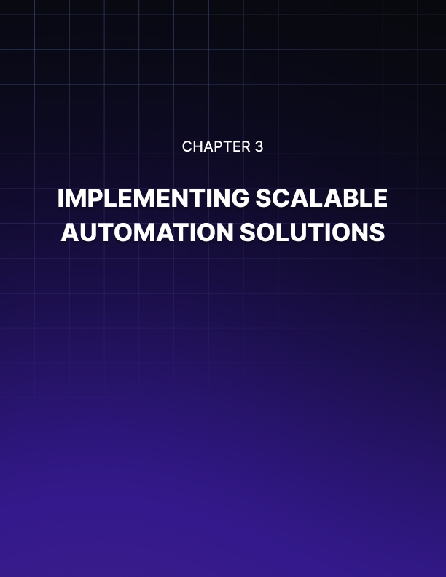

Implementing Scalable Automation Solutions
The horizon of your small business expands with each passing day. Your automation solutions need to keep pace as your company expands. This chapter focuses on implementing scalable automation solutions that can evolve with your business. You'll learn how to set up automated workflows, integrate your existing tools, and leverage cloud-based solutions for maximum flexibility and growth potential.

The Foundation of Scalable Automation
Scalability in automation means your systems can handle increased workloads without a proportional increase in cost or complexity. As your business grows, your automation solutions should be able to accommodate more users, higher transaction volumes, and more complex processes without requiring a complete overhaul.
To build a foundation for scalable automation, consider these key principles: modularity, standardization, flexibility, cloud-based infrastructure, and an API-first approach. Adhering to these principles will help you create an automation ecosystem that can grow and adapt alongside your business.
Modularity allows you to design your automation systems in components that can be easily added, removed, or modified without disrupting the entire system. Standardization ensures compatibility and ease of integration by using standardized processes and data formats across your automation solutions. Flexibility is crucial for adapting to changing business needs, so choose solutions that offer customization options. Cloud-based infrastructure provides inherent scalability and accessibility, while an API-first approach allows for easy integration with other systems.

Setting Up Automated Workflows
Automated workflows are the backbone of efficient business operations. They allow you to connect different applications and automate multi-step processes, saving time and reducing errors. Platforms like Zapier and Integromat (now Make) are powerful tools for creating these workflows without extensive coding knowledge.
Let's walk through the process of setting up an automated workflow using Zapier as an example. First, identify the trigger, which is the event that starts your workflow. Next, choose the action, which is what happens after the trigger. You can then set up additional steps, test the workflow to ensure each step works as expected, and finally activate and monitor the workflow.
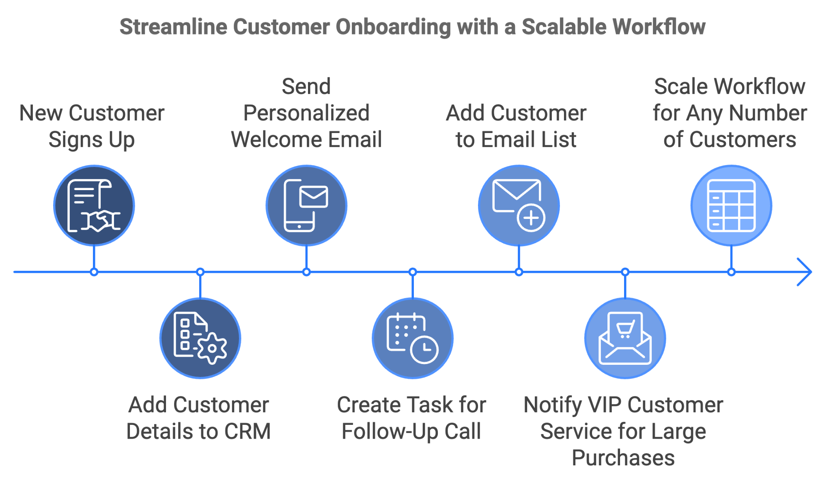
Here's a practical example of a scalable workflow for customer onboarding:
- Trigger: New customer signs up on your website
- Action 1: Add customer details to your CRM
- Action 2: Send a personalized welcome email
- Action 3: Create a task in your project management tool to schedule a follow-up call
- Action 4: Add the customer to your email marketing list
- Action 5: If the customer's purchase exceeds a certain amount, notify the VIP customer service team
This workflow can handle one new customer or hundreds without any additional manual effort on your part. As your business grows, you can easily add more steps or create parallel workflows to handle different customer segments.

Integrating Existing Business Tools
One of the key challenges in implementing scalable automation is integrating your existing business tools. Most small businesses already use a variety of software solutions, and getting these to work together seamlessly is crucial for effective automation. Start by creating an inventory of all the tools and software your business currently uses, such as CRM systems, email marketing platforms, accounting software, project management tools, e-commerce platforms, social media management tools, and customer support software.
Next, investigate the integration capabilities of each tool. Look for native integrations (direct connections between two platforms) as well as the availability of APIs. Many modern business tools offer extensive integration options, but you may find some legacy systems have limited connectivity. For tools that don't have native integrations, platforms like Zapier can often bridge the gap.

Here's an example of how you might integrate your existing tools into a scalable automated system:
Tool Type | Example | Integration Method
E-commerce | Shopify | Direct integration with QuickBooks
CRM | HubSpot | Zapier connection to Mailchimp
Project Management | Asana | Integration with Zendesk
Social Media | Hootsuite | Connection to CRM

Creating these connections builds a unified ecosystem where data flows freely between applications, reducing manual data entry and ensuring all your systems have up-to-date information.

Leveraging Cloud-Based Solutions
Cloud-based solutions are instrumental in creating scalable automation systems. They offer several advantages over traditional on-premise software, including scalability, accessibility, automatic updates, cost-effectiveness, and reliability. When selecting cloud-based solutions for your automation efforts, consider Software as a Service (SaaS), Platform as a Service (PaaS), and Infrastructure as a Service (IaaS) options.
SaaS solutions are typically the easiest to implement and require the least technical expertise. Examples include Salesforce for CRM, Google Workspace for productivity, and Dropbox for file storage. PaaS options like Google App Engine or Microsoft Azure App Service can be valuable if you have custom automation needs that aren't met by off-the-shelf solutions. For businesses with more complex automation needs or those requiring greater control over their infrastructure, IaaS solutions like Amazon Web Services (AWS) or Microsoft Azure can be powerful tools.
When implementing cloud-based solutions, start with core business functions that have the greatest impact on your operations. As you grow, you can add more specialized tools or custom applications built on PaaS or IaaS platforms.

Ensuring Security and Compliance
Implementing scalable automation solutions requires prioritizing security and compliance, especially as your business expands. Automated systems often handle sensitive data, which means you could face stricter regulatory requirements. Key considerations should include data encryption, access control, regular audits, data backups, compliance certifications, and vendor assessments.
Ensure that data is encrypted both in transit and at rest, and implement robust user authentication and authorization systems. Conduct periodic audits of your automated systems to identify potential security vulnerabilities or compliance issues. Implement regular, automated backups of your data and test your restore processes. If your industry has specific regulatory requirements, ensure your automation solutions meet these standards. When using third-party automation tools, assess their security practices and compliance certifications to ensure they align with your security requirements.

Planning for Future Growth
Scalable automation is not a one-time implementation but an ongoing process. Your business growth and evolution will necessitate changes in your automation needs.
To ensure your automation solutions can grow with you, use these strategies:
- conduct regular reviews,
- engage in capacity planning,
- stay informed about new technologies,
- establish a feedback loop, embrace continuous learning,
- and conduct scalability testing.
Periodically review your automated workflows and systems to ensure they're still meeting your needs. Monitor the performance and usage of your automated systems and plan for upgrades or expansions before you hit capacity limits. Keep up with new automation technologies and trends in your industry. Establish a system for collecting feedback from your team about the automated processes. Invest in ongoing training for yourself and your team to leverage new features and capabilities. Regularly test your systems with increased loads to ensure they can handle future growth.
Remember, the goal of scalable automation is to create systems that can grow with your business, reducing growing pains and allowing you to focus on strategic initiatives rather than getting bogged down in operational details. By creating flexible, integrated systems powered by cloud technology, you're building a business that can adapt quickly to new opportunities and challenges.
In the next chapter, we'll explore how to measure the impact of your automation efforts, ensuring that your investments are delivering the expected returns.
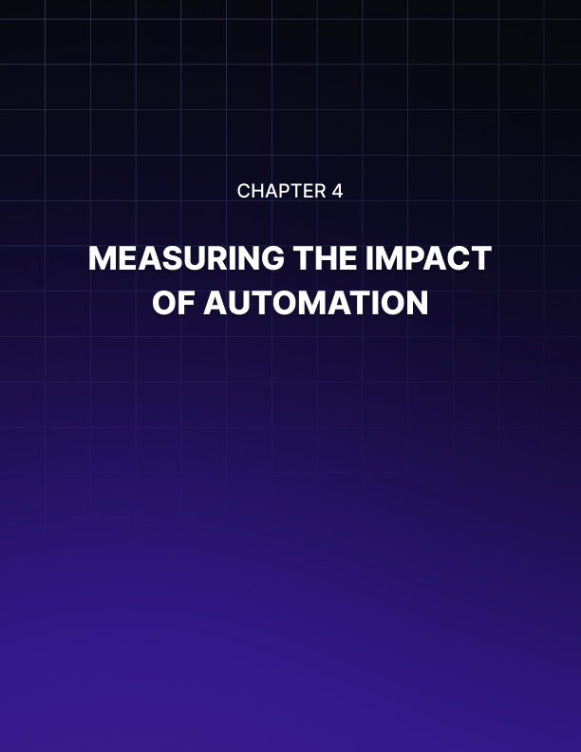

Measuring the Impact of Automation
Your journey into automation has begun, and you've implemented various solutions to streamline your small business operations. Now comes a crucial question: How do you know if these efforts are paying off?
Measuring the impact of automation is essential to justify your investment, identify areas for improvement, and guide future automation strategies. This chapter will equip you with the tools and knowledge to effectively measure and analyze the results of your automation initiatives.

The Importance of Measuring Automation Impact
Measuring the impact of automation isn't just about crunching numbers. It's about understanding how these technological changes are transforming your business. By quantifying the effects of automation, you can justify your investment in automation tools and processes, identify which automation initiatives are most effective, uncover areas where automation may be falling short, make data-driven decisions about future automation projects, and demonstrate the value of automation to stakeholders, including employees and investors. Remember, what gets measured gets managed. By establishing clear metrics for your automation efforts, you're setting the stage for continuous improvement and optimization.

Key Metrics for Measuring Automation Impact
To effectively gauge the success of your automation initiatives, you need to track relevant metrics. These metrics can be broadly categorized into four areas: time savings, error reduction, productivity increase, and cost reduction.

Time Savings
One of the primary benefits of automation is the time it saves. To measure this, you can track the time taken for tasks before and after automation, calculate the total hours saved per week or month, and measure the reduction in cycle time for key processes. For example, if you've automated your invoice processing, you might find that a task that used to take 30 minutes now takes only 5 minutes. Multiply this by the number of invoices processed per month, and you'll see a significant time-saving.
To calculate time savings, use this formula:
Time Saved = (Time taken before automation - Time taken after automation) x Frequency of task

Error Reduction
Automation can significantly reduce human errors. To measure this impact, compare error rates before and after automation, track the number of error-related customer complaints, and measure the time spent on error correction. For instance, if you've automated data entry, you might see a dramatic decrease in data errors. A study by Gartner found that automation can reduce manual data entry errors by up to 95%.
Calculate error reduction using this formula:
Error Reduction Rate = (Error rate before automation - Error rate after automation) / Error rate before automation x 100

Productivity Increase
Automation should lead to increased productivity. Measure this by tracking output per employee before and after automation, measuring the number of tasks completed per day or week, and analyzing the capacity to take on additional work. For example, if your customer service team can now handle 50% more inquiries after implementing a chatbot, that's a clear productivity increase.
Use this formula to calculate productivity increase:
Productivity Increase = (Output after automation - Output before automation) / Output before automation x 100

Cost Reduction
Ultimately, automation should lead to cost savings. Measure this by calculating labor cost savings from reduced manual work, tracking reductions in overtime hours, and measuring decreases in error-related costs. For instance, if automation allows you to process payroll without hiring an additional employee, you've saved the entire cost of that potential hire.
Calculate cost savings using this formula:
Cost Savings = Costs before automation - Costs after automation

Setting Up a Measurement Framework
To effectively measure the impact of automation, you need a structured approach. Here's a step-by-step guide to setting up your measurement framework: Establish a baseline before implementing automation, set clear objectives, choose your metrics based on your objectives, implement tracking systems to regularly collect data on your chosen metrics, define your measurement period, create a dashboard for easy monitoring and sharing with stakeholders, and regularly analyze and adjust your automation strategies as needed.
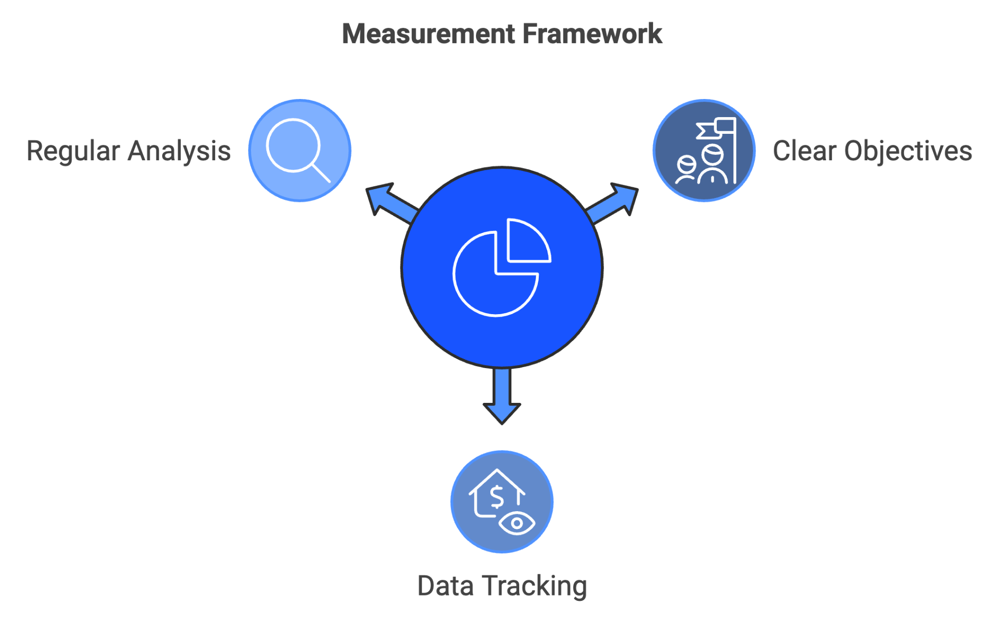

Real-World Examples of Automation Impact
To illustrate the potential impact of automation, let's look at some real-world examples from small businesses. An online retailer implemented an automated order processing system, resulting in reduced order processing time, decreased errors, fewer customer service inquiries, and the ability to handle increased order volume without additional staff. A small marketing agency automated their campaign management process, leading to reduced campaign setup time, decreased client reporting time, improved campaign performance, and the ability to take on more clients. A local accounting firm implemented automated bookkeeping software, resulting in reduced data entry time, decreased errors in financial reports, reduced client onboarding time, and an increased client base without additional hires.

Calculating Return on Investment (ROI)
While individual metrics are important, you also need to look at the overall return on investment (ROI) of your automation efforts. ROI helps you understand whether the benefits of automation outweigh the costs. To calculate ROI, use this formula:
ROI = (Gain from Investment - Cost of Investment) / Cost of Investment x 100
For automation, the gain from investment would include all the benefits (time savings, error reduction, productivity increase, etc.) translated into monetary value. The cost of investment would include the cost of automation tools, implementation, training, and ongoing maintenance.

Challenges in Measuring Automation Impact
Measuring the impact of automation is crucial, but it's not without challenges. Some common obstacles include dealing with intangible benefits, attribution difficulties, balancing long-term versus short-term impact, ensuring data quality, and overcoming resistance to measurement. To address these challenges, consider using surveys or net promoter scores for intangible benefits, isolate the effects of automation as much as possible, be patient and continue measuring over extended periods, implement reliable data collection methods, and be transparent about why you're measuring and how the data will be used.

Continuous Improvement through Measurement
Measuring the impact of automation isn't a one-time task. It's an ongoing process that should feed into a cycle of continuous improvement. Schedule regular reviews of your automation metrics, establish feedback loops for employees and customers, benchmark your performance against industry standards, experiment with different approaches, scale successful initiatives, address shortfalls, and set new, more ambitious goals as you achieve your initial objectives. By consistently measuring, analyzing, and acting on the impact of your automation efforts, you create a culture of continuous improvement. This iterative approach ensures that your business continues to reap increasing benefits from automation over time.
As you move forward with your automation journey, remember that measurement is not just about proving the value of what you've done. It's about providing the insights you need to make your business more efficient, productive, and competitive in the future. In the next chapter, we'll recap the key points from our exploration of small business automation and provide a roadmap for continuing your automation journey. Get ready to consolidate your knowledge and plan your next steps!

Metric | Formula | Example
Time Savings | (Time before - Time after) x Frequency | (30 min - 5 min) x 100 invoices/month = 2500 min/month
Error Reduction | (Error rate before - Error rate after) / Error rate before x 100 | (5% - 0.25%) / 5% x 100 = 95% reduction
Productivity Increase | (Output after - Output before) / Output before x 100 | (150 tasks - 100 tasks) / 100 tasks x 100 = 50% increase
Cost Savings | Costs before - Costs after | $50,000/year - $30,000/year = $20,000/year savings
ROI | (Gain - Cost) / Cost x 100 | ($30,000 - $10,000) / $10,000 x 100 = 200% ROI


Recap and Path Forward
Your automation journey has been transformative. You've discovered the power of automation, identified key areas for implementation, set up scalable solutions, and learned how to measure their impact. As we conclude this exploration of small business automation, let's recap the essential points and chart a course for your continued success.

The Power of Automation and Key Takeaways
Automation is not just a luxury for large corporations; it's a necessity for small businesses looking to compete in today's fast-paced market. By automating routine tasks, you free up valuable time and resources, allowing you to focus on strategic initiatives that drive growth. Throughout this book, we've covered a wealth of information about automating your small business. We learned how to prioritize automation opportunities by considering factors such as time savings, error reduction, customer impact, cost reduction, and scalability. The goal is to focus on high-impact areas that will provide the most significant benefits for your business.
As your business grows, your automation solutions need to keep pace. We explored how to set up automated workflows using platforms like Zapier and Integromat, integrate existing business tools, and leverage cloud-based solutions for maximum flexibility and growth potential. What gets measured gets managed, so we discussed key metrics for measuring automation impact, including time savings, error reduction, productivity increase, and cost reduction. We also learned how to calculate the return on investment (ROI) for automation initiatives.
Remember, automation is not a one-time implementation but an ongoing process. Regular review and adjustment of your automated systems ensure they continue to meet your evolving business needs.

Creating Your Automation Roadmap
With these key points in mind, it's time to create your personalized automation roadmap. This plan will guide your ongoing automation efforts, ensuring you continue to reap the benefits of automation as your business grows and evolves. Begin by thoroughly evaluating your current business processes. Identify manual, time-consuming tasks that are ripe for automation. Consider surveying your employees to get their input on processes that could benefit from automation.
Define what you want to achieve through automation. Your goals might include reducing operational costs by a certain percentage, improving customer response times, or freeing up a specific number of hours per week for strategic work. Make these goals SMART:
- Specific,
- Measurable,
- Achievable,
- Relevant,
- and Time-bound.
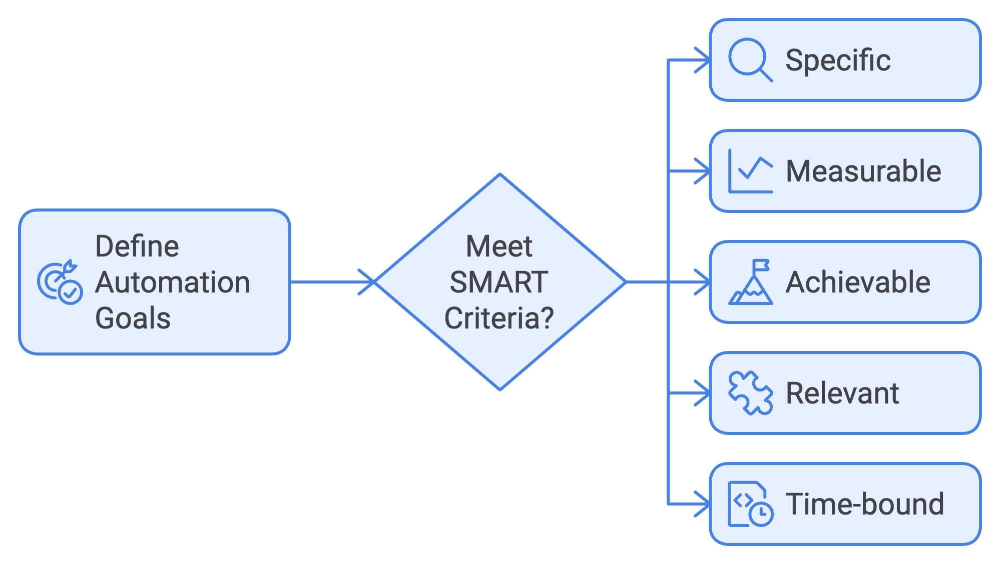
Based on your assessment and goals, create a list of potential automation projects. Prioritize these based on their potential impact and feasibility. Consider using a simple scoring system, rating each project on factors like potential time savings, cost reduction, and ease of implementation. Research and select the automation tools that best fit your needs. Consider factors such as ease of use, scalability, integration capabilities, and cost. It's often better to start with user-friendly, all-in-one solutions before moving to more specialized tools.
Develop a realistic timeline for implementing your prioritized automation projects. Start with one or two high-impact, relatively simple projects to build momentum and gain quick wins. Determine what resources you'll need for each project. This might include budget for tools, time for setup and training, and potentially external expertise for more complex implementations. Ensure your team is prepared to use and benefit from new automated systems. Plan for comprehensive training and allow time for adjustment periods. Establish systems to track the key metrics we discussed in Chapter 4. This might involve setting up analytics dashboards or regular reporting processes. Plan to review your automation efforts regularly. Quarterly reviews can be a good cadence to start with, adjusting as needed based on the pace of your implementations.

Overcoming Common Automation Challenges and Future Trends
Implementing your automation roadmap may present challenges, including some team members' hesitancy to adopt new automated systems. Address this by clearly communicating the benefits of automation, involving team members in the process, and providing ample training and support. You may find that some of your existing tools don't integrate well with each other or with new automation solutions. Look for middleware solutions like Zapier, or consider replacing tools that don't play well with others. Automated systems rely on good data. If your existing data is messy or inconsistent, you may need to undertake a data cleaning project before fully implementing some automation. It's easy to get carried away and try to automate everything at once. Remember to start small, focus on high-impact areas, and gradually expand your automation efforts. As you implement more automated systems, you'll need to ensure they're properly maintained. Build time for system checks and updates into your regular operations.
The world of automation is constantly evolving. To maintain your competitive edge, it's important to stay informed about emerging trends and technologies. Artificial Intelligence and Machine Learning are becoming increasingly accessible to small businesses. These technologies can power more sophisticated automations, from predictive inventory management to personalized customer interactions. Voice technology is evolving rapidly and may soon play a bigger role in business automation. Consider how voice-activated systems might streamline certain processes in your business.
More connected devices will create new opportunities for automation. For example, smart sensors could automatically trigger restocking orders or maintenance requests. While currently more common in larger enterprises, Robotic Process Automation (RPA) tools are becoming more accessible to small businesses. These tools can automate more complex, rule-based processes. Low-Code/No-Code platforms enable non-technical users to create custom automation, increasingly offering new possibilities for small business automation as they evolve.
Continuing to automate your business processes, it's crucial to remember the importance of the human element. Automation should enhance, not replace, human capabilities. Use automation to free up your team's time for tasks that require creativity, emotional intelligence, and strategic thinking. While many customer interactions can be automated, make sure to maintain a personal touch where it matters most. Encourage your team to continuously update their skills to work effectively with automated systems and focus on higher-level tasks. When implementing more advanced automation, be mindful of ethical considerations, particularly around data privacy and job displacement.

Automation Trend | Description | Potential Impact
AI and ML | Powering sophisticated automation | High
Voice-Activated Assistants | Streamlining processes through voice commands | Medium
Internet of Things (IoT) | Connecting devices for automated actions | High
Robotic Process Automation (RPA) | Automating complex, rule-based processes | Medium
Low-Code/No-Code Platforms | Enabling custom automation for non-technical users | High

Remember, automation is a journey, not a destination. Continually reassess your processes, stay informed about new technologies, and don't be afraid to adjust your approach as you learn what works best for your business. When moving forward with your automation journey, keep in mind the words of Bill Gates: "The first rule of any technology used in a business is that automation applied to an efficient operation will magnify the efficiency. The second is that automation applied to an inefficient operation will magnify the inefficiency." Before automating any process, ensure it's as streamlined and efficient as possible. Your small business has the potential to operate with the efficiency of a much larger enterprise, all while maintaining the agility and personal touch that makes it unique. By thoughtfully implementing automation, you're not just saving time and money – you're positioning your business for long-term success in an increasingly competitive marketplace.

