Table of Contents
Introduction 3
Shaping the Creative Mindset 5
The Entrepreneurial Mindset Shift 5
Conditioning for Creativity 7
Nurturing Your Creative Potential 9
Establishing Creative Routines 10
Daily Habits of Highly Creative Entrepreneurs 11
Overcoming Common Obstacles to Creative Routines 12
The Power of Iteration in Creative Routines 13
Advanced Brainstorming Techniques 15
Innovative Brainstorming Methods 15
Facilitating Group Creativity 17
Harnessing the Power of Diverse Thinking 18
Overcoming Mental Barriers 20
Identifying Creative Blocks 20
Strategies for Breaking Through 20
Embracing Failure and Building Confidence 21
Leveraging Technology and Breaking Routines 22
Executing and Nurturing Innovation 26
From Concept to Reality 26
Building an Innovator's Culture 27
Sustaining Innovation in the Long Term 28

Disclaimer
The information provided in this ebook is intended solely for educational and informational purposes. The author does not accept any responsibility for the outcomes that may arise from the application of the material within. While efforts have been made to ensure the accuracy and relevance of the content, the author cannot be held accountable for any errors or omissions, or for any consequences resulting from the use or misuse of the information provided. The responsibility for any actions taken based on the information in this ebook lies solely with the reader.



Introduction
In a world where innovation drives business success, your ability to harness creativity could be the difference between thriving and merely surviving. This revolutionary ebook will change how you view entrepreneurship and innovation. It will be your guide to unlocking your mind's and your business's untapped potential.
You're about to begin a journey that will challenge your preconceptions, ignite your imagination, and equip you with the tools to become a true innovator in your field. Whether you're a seasoned entrepreneur or just starting out, this ebook is designed to elevate your creative thinking to new heights, enabling you to spot opportunities others miss and solve problems with ingenuity and flair.
Imagine waking up each day bursting with fresh ideas, confidently navigating the uncertain waters of entrepreneurship, and transforming your wildest concepts into market-ready solutions. This isn't a pipe dream—it's the reality that awaits you on the other side of these pages. You'll discover how to rewire your brain for creativity, establishing daily routines that foster innovation and productivity. You'll learn advanced brainstorming techniques that will supercharge your ideation process, allowing you to generate groundbreaking concepts on demand.
But this book doesn't just stop at idea generation. It guides you through the entire innovation process, from conception to execution. You'll gain insights into overcoming the mental barriers that often stifle creativity, learning how to push past self-doubt and perfectionism to bring your ideas to life. With practical strategies for implementing your innovations and fostering a culture of creativity within your organization, you'll be equipped to turn your entrepreneurial vision into a thriving, innovative business reality.
What sets this book apart is its laser focus on actionable, real-world strategies tailored specifically for entrepreneurs. You won't find vague platitudes or recycled advice here. Instead, you'll dive into evidence-based techniques, cutting-edge research, and proven methodologies that have helped countless entrepreneurs revolutionize their industries. From mindset conditioning to advanced problem-solving frameworks, every page is packed with valuable insights you can apply immediately to your business.
As you progress through this book, you'll feel a profound shift in your approach to entrepreneurship. The challenges that once seemed insurmountable will become exciting opportunities for innovation. You'll develop a keen eye for spotting gaps in the market and the creative prowess to fill them with unique solutions. Your confidence will soar as you master the art of turning abstract ideas into concrete business strategies.
But perhaps most importantly, you'll cultivate a sustainable approach to creativity that will serve you throughout your entrepreneurial journey. This isn't about quick fixes or temporary boosts—it's about fundamentally changing how you think, work, and innovate. By the time you finish this book, you'll have developed a creativity toolkit that you can draw upon time and time again, ensuring that your well of ideas never runs dry.

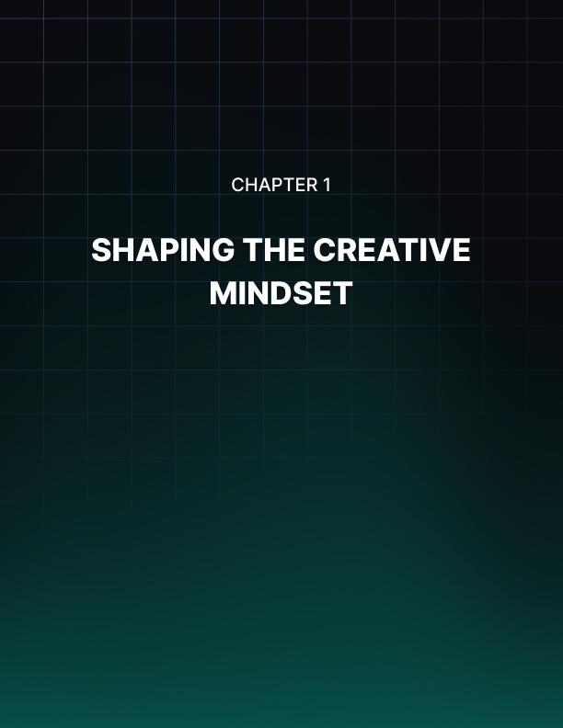

Shaping the Creative Mindset
You're about to tap into the power of creativity in your entrepreneurial journey. This chapter will guide you through the essential shifts in thinking and daily practices that can transform your approach to innovation. Let's explore how you can cultivate a mindset that nurtures creativity and propels your business forward.

The Entrepreneurial Mindset Shift
Imagine standing at the edge of a wide, unexplored wilderness. That's where you are as an entrepreneur facing the challenge of innovation. The world before you is filled with potential, but it's also uncertain and possibly intimidating. Your success in navigating this terrain depends largely on your mindset.
The foundation of creative thinking for entrepreneurs lies in understanding and reshaping your mental approach. You're not just looking for new ideas; you're cultivating a way of thinking that consistently generates innovative solutions to business challenges. First, let's address the elephant in the room: uncertainty. As an entrepreneur, you're no stranger to unpredictable situations. However, when it comes to creativity, embracing uncertainty is not just beneficial—it's essential. Think of uncertainty as the fertile soil from which your most innovative ideas will grow.
To shift your mindset, start by reframing how you view unknown outcomes. Instead of seeing them as risks to be avoided, consider them opportunities for discovery. This doesn't mean throwing caution to the wind. Rather, it's about taking calculated risks that have the potential for high rewards. Try this exercise: List three business challenges you're currently facing. Now, for each challenge, write down three potential solutions that you've never considered before, no matter how outlandish they might seem. This simple act pushes you out of your comfort zone and into the realm of creative possibility. Remember, some of the most successful businesses today started with ideas that seemed impractical or even impossible at first. Airbnb disrupted the hospitality industry by suggesting people rent out their homes to strangers. Tesla revolutionized the automotive sector by betting on electric vehicles when they were far from mainstream. These companies thrived because their founders embraced uncertainty and took calculated risks.
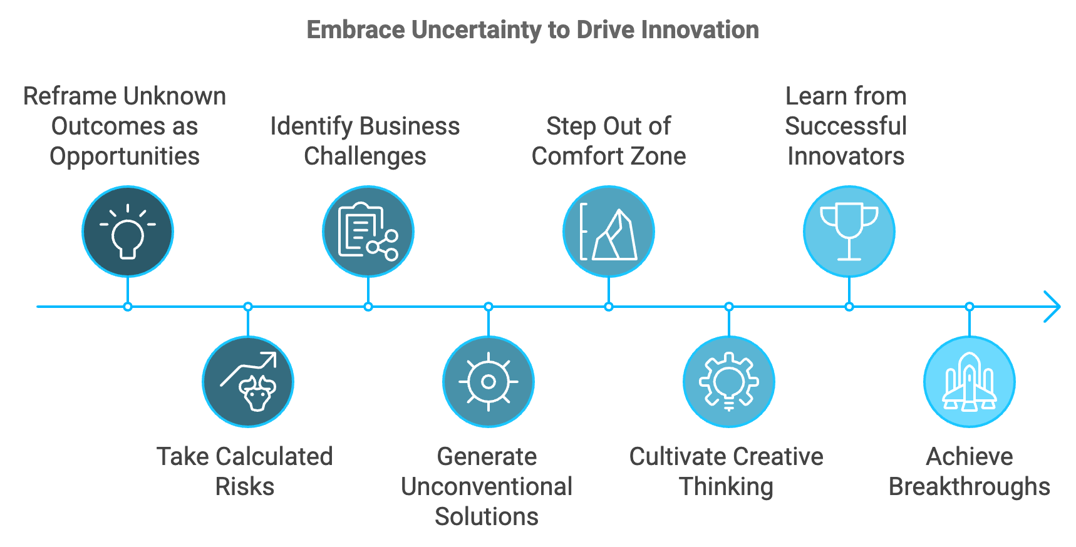
Now, let's talk about failure—a word that often sends shivers down an entrepreneur's spine. But here's a secret: failure is not the opposite of success; it's a crucial part of the creative process. To truly unlock your creative potential, you need to overcome the fear of failure. Start by redefining what failure means to you. Instead of viewing it as a final judgment on your abilities, see it as valuable feedback. Each "failure" provides insights that can refine your approach and bring you closer to success. To put this into practice, create a "Failure Resume." List your notable failures and what you learned from each. This exercise not only helps you see the value in setbacks but also builds resilience—a critical trait for any creative entrepreneur. Consider the story of James Dyson, who created 5,126 failed prototypes before perfecting his revolutionary vacuum cleaner. Each failure was a step towards his ultimate success. By embracing these "failures" as learning opportunities, Dyson was able to persist and eventually disrupt an entire industry.
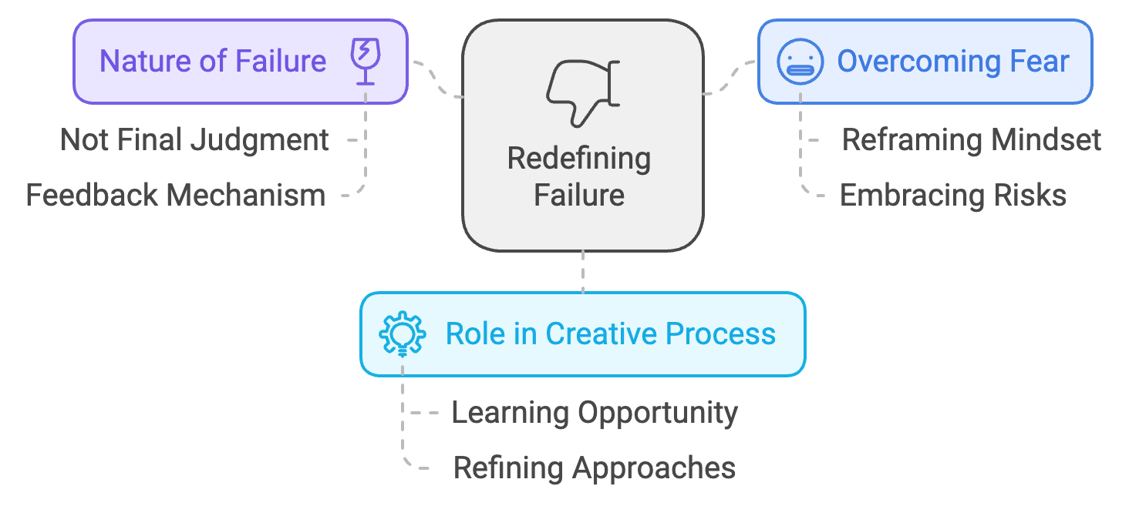
Adopting a growth mindset is another crucial step in your creative journey. This concept, popularized by psychologist Carol Dweck, suggests that your abilities and intelligence can be developed through effort, learning, and persistence. To cultivate a growth mindset, pay attention to your inner dialogue. When faced with a challenge, do you tell yourself, "I can't do this," or do you ask, "How can I learn to do this?" The latter opens up possibilities and fuels your creative problem-solving abilities. Practice reframing your thoughts. Instead of saying, "This is too hard," try, "This may take some time and effort." Rather than thinking, "I'm not creative enough for this," tell yourself, "I'm learning to be more creative every day." Remember, creativity isn't a fixed trait—it's a skill you can develop. Just as you would exercise a muscle to make it stronger, you can exercise your creativity to enhance it. The more you practice creative thinking, the more natural and powerful it becomes.

Conditioning for Creativity
Now that you've begun to shift your mindset, it's time to establish daily practices that will sharpen your creative edge. Think of these techniques as a workout regimen for your creative muscles. Let's start with a fundamental practice: mindfulness. In the fast-paced world of entrepreneurship, it's easy to get caught up in a whirlwind of tasks and deadlines. However, true creativity often emerges in moments of mental clarity and focus. Mindfulness meditation is a powerful tool for achieving this clarity. Start with just five minutes a day. Find a quiet space, sit comfortably, and focus on your breath. When your mind wanders (and it will), gently bring your attention back to your breathing. This simple practice can significantly enhance your ability to concentrate and generate fresh ideas.
Mindfulness Impact on Innovative Thinking
Study Duration: 8 weeks
Increase in Innovative Thinking: 22%
Source: Journal of Business Venturing, 2023

Another effective technique is the practice of 'morning pages,' popularized by author Julia Cameron. Each morning, before you dive into your work, write three pages of stream-of-consciousness thoughts. This exercise helps clear your mind of clutter and often leads to unexpected insights and ideas. To make these practices part of your routine, try linking them to existing habits. For example, you might meditate right after your morning coffee or do your morning pages immediately after breakfast. By anchoring new habits to established ones, you're more likely to stick with them.
Now, let's talk about the fuel that powers your creative engine: intrinsic motivation. While external rewards like money or recognition can be motivating, it's your internal drive that will sustain your creative efforts in the long run. To tap into your intrinsic motivation, reconnect with your 'why.' Why did you become an entrepreneur in the first place? What problems are you passionate about solving? What impact do you want to make in the world? Write down your answers and keep them visible in your workspace as a constant reminder. Consider the story of Yvon Chouinard, founder of Patagonia. His passion for environmental conservation has been the driving force behind Patagonia's innovative approach to sustainable business practices. This intrinsic motivation has not only led to groundbreaking products but has also resonated deeply with customers, contributing to the company's success.
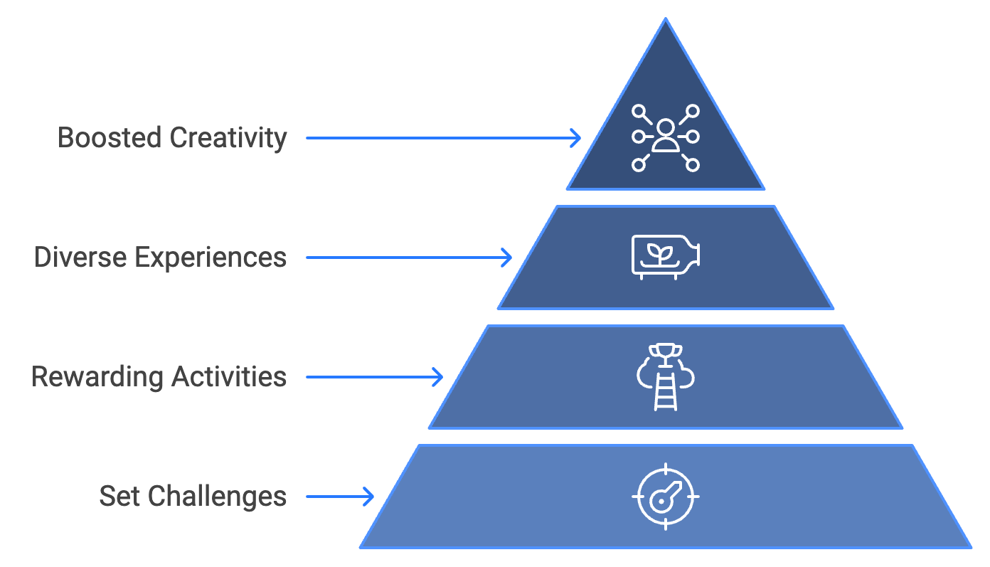
To further boost your intrinsic motivation, set challenges for yourself that align with your passions and values. These could be personal projects, learning new skills, or finding innovative solutions to problems in your industry. The key is to engage in activities that you find inherently rewarding and stimulating. Remember, creativity thrives on diverse inputs. Make it a point to expose yourself to new ideas and experiences regularly. Read books outside your field, attend lectures on unfamiliar topics, or try new hobbies. These diverse experiences create new neural connections in your brain, enhancing your ability to make unique associations—a key component of creativity. For instance, Steve Jobs credited his calligraphy class in college with inspiring the beautiful typography in the first Macintosh computer. This seemingly unrelated skill ended up revolutionizing desktop publishing.

Nurturing Your Creative Potential
As you implement these practices, be patient with yourself. Like any skill, creativity takes time to develop. You might not see immediate results, but with consistent effort, you'll notice a gradual shift in your thinking patterns and an increase in your innovative output. Remember, the goal isn't to force creativity but to create the conditions where it can naturally flourish. By reshaping your mindset and establishing daily practices that support creative thinking, you're setting the stage for breakthrough innovations in your entrepreneurial journey.
Your creative potential is vast and largely untapped. As you move forward, carry with you the understanding that creativity isn't a mystical gift bestowed upon a lucky few. It's a skill that you can cultivate and strengthen over time. With the right mindset and consistent practice, you're well on your way to unlocking new levels of innovation in your business. As we close this chapter, reflect on the key ideas we've explored. You've learned to embrace uncertainty, reframe failure, and adopt a growth mindset. You've discovered practices like mindfulness and morning pages that can enhance your creative thinking. And you've recognized the power of intrinsic motivation in fueling your creative journey. These are your first steps towards becoming a more creative and innovative entrepreneur. The path ahead is exciting and filled with potential. Trust in your ability to grow, learn, and create. Your next big idea could be just around the corner.

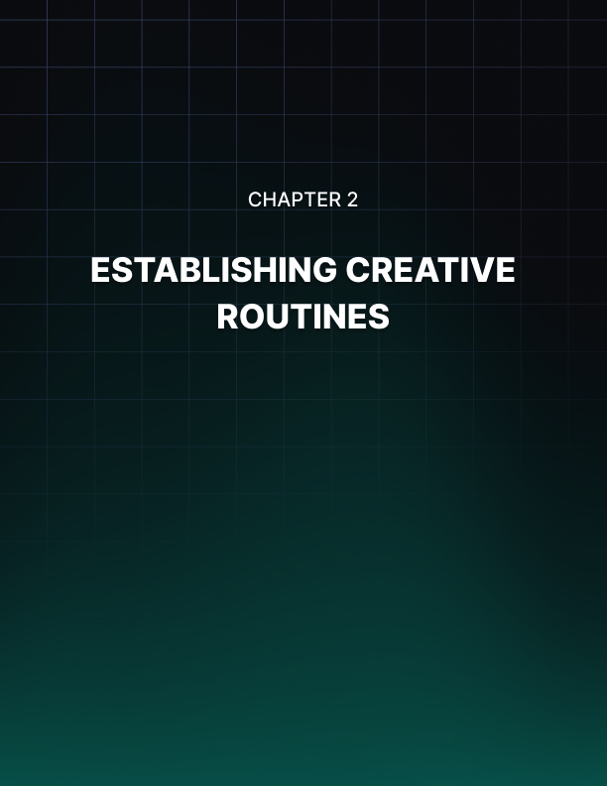

Establishing Creative Routines
Your physical environment plays a crucial role in shaping your creative output. To optimize your workspace for innovation, start by tackling clutter. A messy environment can lead to a messy mind, hampering your ability to think clearly and creatively. Clear your desk of unnecessary items, keeping only the essentials within reach. Create a "creativity corner" in your workspace - a dedicated area that signals to your brain it's time to think creatively.
Lighting is more important than you might realize. Natural light has been shown to boost mood and productivity. Position your desk near a window if possible, or invest in full-spectrum light bulbs that mimic natural daylight. Color psychology can also play a role in stimulating creativity. While personal preferences vary, certain colors have been associated with different cognitive effects. Blue, for instance, is often linked to enhanced creative performance.
Don't underestimate the power of plants in your workspace. A 2024 study published in the Journal of Environmental Psychology found that workers in offices with plants showed a 15% increase in creative problem-solving compared to those in plant-free environments. Plants not only improve air quality but also provide a connection to nature that can be calming and inspiring.
Ergonomics is crucial for maintaining physical comfort and mental focus. Invest in a chair that provides proper support for your back and promotes good posture. Your desk should be at a height that allows your arms to rest comfortably at a 90-degree angle when typing. Consider a standing desk or a sit-stand converter to allow for movement throughout the day. Physical movement can stimulate blood flow and oxygen to the brain, potentially boosting creative thinking.
Sound is another crucial factor in your creative environment. While some people work best in complete silence, others find background noise stimulating. If you fall into the latter category, consider using ambient noise generators or curated playlists designed to enhance focus and creativity. Apps like Brain.fm or Noisli offer soundscapes specifically designed to boost productivity and creative thinking.
Temperature can also impact your creative performance. A study from Cornell University found that workers were most productive in an environment between 68-77°F (20-25°C). Pay attention to how temperature affects your comfort and focus, and adjust your workspace accordingly.
Finally, consider the importance of separating your work area from your relaxation space. If you work from home, try to have a dedicated office or work area that's separate from where you relax. This physical separation helps create a mental boundary between work and rest, reducing the risk of burnout and allowing your mind to fully engage in creative work when you're in your designated space.

Daily Habits of Highly Creative Entrepreneurs
Establishing daily habits and routines is crucial for consistently sparking creativity. Start by implementing a morning routine that primes your mind for creative thinking. This could include mindfulness practices like meditation or morning pages, followed by a quick review of your goals and priorities for the day. Schedule specific "creative time slots" in your day, periods dedicated solely to creative thinking and problem-solving. During these times, turn off all notifications and focus entirely on the task at hand.
Implement the concept of "creative sprints" using techniques like the Pomodoro Method, which involves working intensely on a creative task for a set period, followed by a short break. Incorporate regular breaks into your day, using these moments of mental rest as opportunities for your subconscious mind to work on problems. Develop a habit of capturing ideas whenever they strike by keeping a small notebook with you at all times or using a note-taking app on your phone.
End each day with a brief reflection period to review your accomplishments, challenges faced, and lessons learned. Consider implementing a weekly review process every Friday afternoon to reflect on your week and refine your routines and habits continually.
Successful entrepreneurs like Elon Musk, Sara Blakely, Jack Dorsey, and Arianna Huffington have their unique approaches to scheduling creative processes. Musk uses "time boxing" to assign specific time blocks to different tasks, Blakely takes different routes during her morning drive to stimulate her mind, Dorsey uses themes for each day of the week, and Huffington prioritizes sleep as a crucial part of her creative routine. These examples illustrate that there's no one-size-fits-all approach to creative scheduling. The key is to find a routine that works for you and stick to it consistently.

Overcoming Common Obstacles to Creative Routines
As you implement new habits and routines, you're likely to encounter challenges. Here are some common obstacles and strategies to overcome them:
- Inconsistency: Use the "don't break the chain" method by marking each day you successfully complete your creative routines on a calendar.
- Distractions: Use website blockers during your creative time slots and turn off push notifications on your phone.
- Lack of Energy: Examine your sleep habits and diet, ensuring you're getting enough rest and eating foods that fuel your brain.
- Perfectionism: Embrace the concept of "good enough" for your first drafts or prototypes, remembering that the goal is to generate ideas, not perfect them.
- Lack of Inspiration: Review old notes and half-formed ideas in your idea capture system to spark new thoughts and connections.
- Time Constraints: Try the "bookend" method by setting aside 15 minutes at the beginning and end of your workday solely for creative thinking.
- Self-Doubt: Keep a "success journal" where you record your creative wins, no matter how small, and review it regularly to remind yourself of your capabilities.
Remember, establishing new routines takes time. Be patient with yourself and persistent in your efforts. Over time, these habits will become second nature, and you'll find your creative output increasing steadily.

The Power of Iteration in Creative Routines
As you implement these new habits and design your ideal creative environment, remember that this is an iterative process. What works perfectly for you today might need adjustment in a few months as your business evolves or your personal circumstances change. Set a reminder to reassess your creative routines every quarter, asking yourself which habits have been most effective, if any routines feel forced or unproductive, how your creative output has changed, and what new challenges you're facing that your current routines don't address.
Use these insights to refine your approach continually. Be open to discoveries and willing to adjust your routines accordingly. The goal is to create a sustainable system that consistently nurtures your creativity and drives innovation in your business. By thoughtfully designing your environment and establishing supportive daily habits, you're setting the stage for breakthrough ideas and solutions.
Remember, creativity is not about sporadic bursts of inspiration. It's about showing up every day, creating the right conditions for innovative thinking, and putting in the work. As you move forward with these practices, you're not just waiting for the next big idea—you're actively cultivating an environment where great ideas can flourish. Your creative potential is limitless. With the right routines and environment, you're well on your way to unlocking new levels of innovation in your entrepreneurial journey. Trust in the process, stay consistent, and watch as your creative capabilities grow and evolve.
Creative Environment Factor | Impact on Creativity | Optimization Strategy
Lighting | Boosts mood and productivity | Natural light or full-spectrum bulbs
Color | Influences cognitive effects | Experiment with blue and green accents
Plants | Increases problem-solving ability | Add plants to workspace
Ergonomics | Enhances physical comfort and focus | Invest in proper chair and desk setup
Sound | Can stimulate or distract | Use ambient noise or silence based on preference
Temperature | Affects productivity | Maintain 68-77°F (20-25°C)
Space Separation | Reduces burnout risk | Create dedicated work area

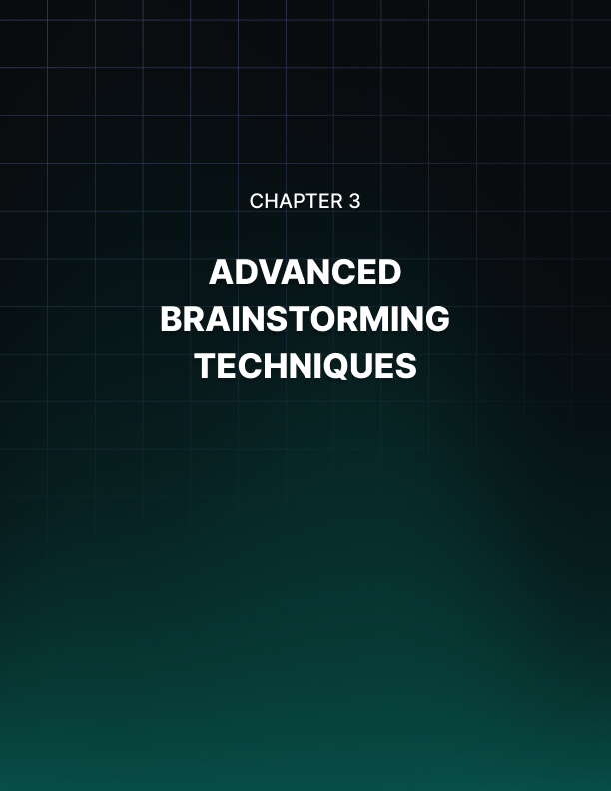

Advanced Brainstorming Techniques
You're about to take your creative problem-solving skills to the next level. This chapter will introduce you to powerful brainstorming methods that can supercharge your ideation process and help you generate groundbreaking solutions for your business. Let's explore these techniques and learn how to implement them effectively.

Innovative Brainstorming Methods
Traditional brainstorming sessions often fall short of producing truly innovative ideas. To break through creative barriers, you need to employ more sophisticated techniques. Let's start with the SCAMPER method, a powerful tool for generating new ideas by transforming existing ones.
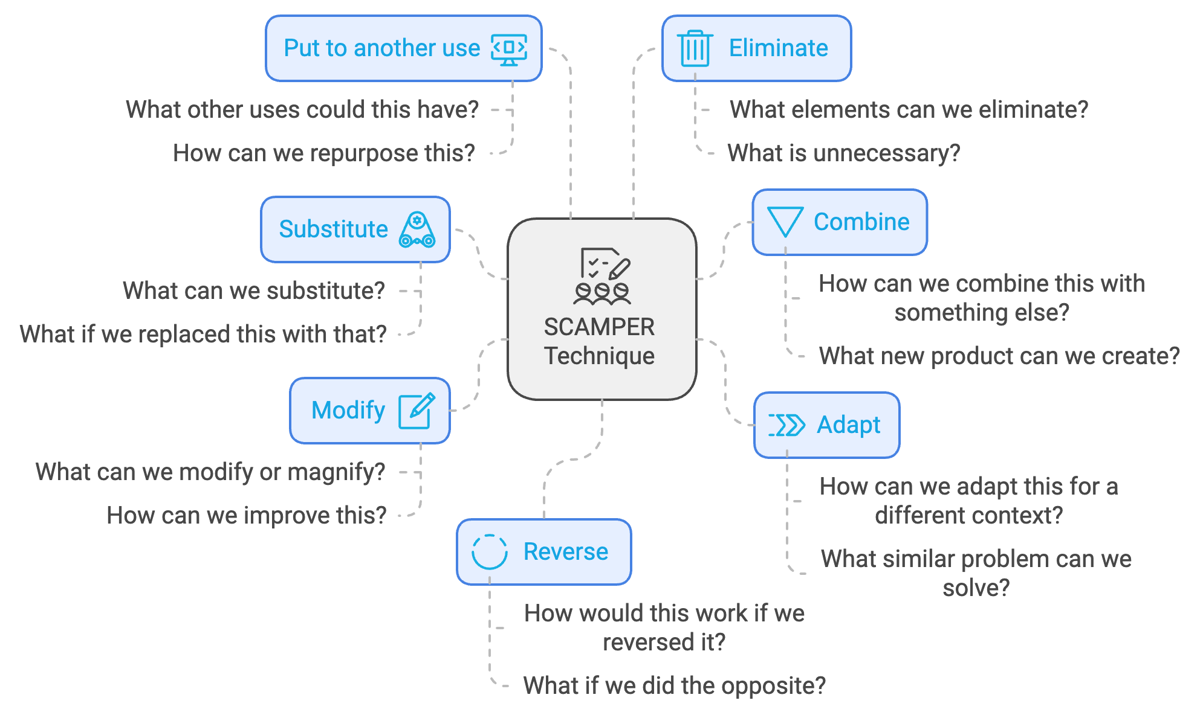
SCAMPER is an acronym that stands for Substitute, Combine, Adapt, Modify, Put to another use, Eliminate, and Reverse. To use SCAMPER, start with an existing product, service, or process. Then, apply each of these actions to it, asking questions like: What can we substitute in this product? How can we combine this with something else? How can we adapt this for a different context? What can we modify or magnify? What other uses could this have? What elements can we eliminate? How would this work if we reversed it?
For example, let's say you run a coffee shop and want to innovate your business model. Applying SCAMPER might lead to ideas like replacing coffee beans with tea leaves to create a hybrid cafe/tea house, merging your coffee shop with a bookstore for a unique customer experience, creating a mobile coffee truck to reach customers in different locations, offering a subscription service for weekly coffee bean deliveries, using coffee grounds as a base for eco-friendly beauty products, removing seating to focus entirely on quick, grab-and-go service, or instead of customers coming to you, delivering personalized coffee experiences to offices.

Another powerful technique is mind mapping. This visual brainstorming method helps you explore connections between ideas and uncover new possibilities. To create a mind map, write your central topic or problem in the center of a blank page, draw branches radiating out from the center, each representing a main subtopic or category related to your central idea, from these main branches, draw smaller branches with related ideas or solutions, and continue branching out, allowing your thoughts to flow freely and making connections between different parts of the map. Mind mapping is particularly effective for visual thinkers and can help you see relationships between ideas that might not be apparent in a linear format.

The Six Thinking Hats technique, developed by Edward de Bono, is another method that can elevate your brainstorming sessions. This approach involves looking at a problem from six different perspectives, represented by different colored hats:
Hat Color | Perspective
White | Focus on available data and information
Red | Express emotions and intuitions about the issue
Black | Consider potential risks and drawbacks
Yellow | Think optimistically about benefits and opportunities
Green | Generate creative ideas and possibilities
Blue | Manage the thinking process and ensure all perspectives are considered

By "wearing" each hat in turn, you ensure a comprehensive examination of the issue from multiple angles, leading to more well-rounded solutions.

Facilitating Group Creativity
While these techniques are powerful, their effectiveness largely depends on how well you facilitate the brainstorming process. Here are some guidelines to ensure productive and innovative group brainstorming sessions: Set clear objectives before the session, choose the right participants with diverse backgrounds and expertise, create a safe space that encourages open sharing of ideas without fear of criticism, use warm-up exercises to get everyone's creative juices flowing, encourage quantity over quality in the initial stages, encourage participants to build on each other's ideas, use visual aids like whiteboards or digital tools, take regular short breaks to prevent mental fatigue, and end with action items by identifying the most promising ideas and assigning next steps for further development.
A critical aspect of facilitating group creativity is ensuring psychological safety. This term, coined by Harvard Business School professor Amy Edmondson, refers to a shared belief that the team is safe for interpersonal risk-taking. To foster psychological safety in your brainstorming sessions, lead by example by sharing your own unconventional ideas and admitting when you're unsure about something, respond positively to all contributions, frame challenges as learning opportunities, encourage constructive disagreement, and celebrate failures as well as successes.
Even with these measures in place, you may encounter obstacles to group creativity. One common issue is groupthink, where the desire for harmony or conformity results in irrational or dysfunctional decision-making. To combat groupthink, assign a devil's advocate to critically examine all ideas, use anonymous idea submission to help introverted team members share ideas without feeling put on the spot, encourage individual reflection before group discussion, and bring in outside perspectives to provide fresh viewpoints.
Another challenge is managing dominant personalities who might overshadow quieter team members. To ensure diverse input, use round-robin techniques by going around the room and giving each person a chance to speak, implement a token system by giving each participant a set number of "talking tokens" to use during the session, and use written brainstorming by having participants write down ideas before sharing.

Harnessing the Power of Diverse Thinking
One often overlooked aspect of effective brainstorming is the power of cognitive diversity. While demographic diversity is important, cognitive diversity - differences in perspective, insights, and information processing styles - can be even more crucial for innovation. To harness this power, assemble cross-functional teams by bringing together people from different departments who can approach the problem from various angles, include people at different career stages by mixing experienced team members with newer employees who might not be as constrained by "the way things have always been done," consider personality types using tools like the Myers-Briggs Type Indicator or the Big Five personality test to understand and leverage different thinking styles in your team, and encourage "reverse mentoring" by having junior team members share their perspectives with senior staff, especially on topics like emerging technologies or market trends.
By embracing diverse thinking styles and perspectives, you're more likely to generate truly innovative ideas that can set your business apart in the marketplace. As you move forward with these advanced brainstorming techniques, remember that the process is just as important as the outcome. Each brainstorming session is an opportunity not just to generate ideas, but to build team cohesion, enhance problem-solving skills, and foster a culture of innovation in your organization. With practice and persistence, these methods will become powerful tools in your entrepreneurial toolkit, helping you navigate challenges and seize opportunities in an ever-changing business landscape.



Overcoming Mental Barriers
On the path to unlocking your creative potential, you might encounter unexpected roadblocks. This chapter will help you identify and overcome the mental barriers that can hinder your creative flow. By understanding these obstacles and implementing targeted strategies, you'll be able to push through creative blocks and tap into a wellspring of innovative ideas.

Identifying Creative Blocks
Creative blocks can manifest in various ways, often sneaking up on you without warning. Recognizing these barriers is the first step towards overcoming them. Some common mental blocks that entrepreneurs face include fear of judgment, perfectionism, cognitive overload, lack of confidence, fixed mindset, time pressure, fear of failure, and routine and comfort zone.
To identify which of these blocks might be affecting you, take some time for self-reflection. Ask yourself when you feel most creatively stuck, what thoughts or feelings arise when you're trying to generate new ideas, if there are patterns in the types of projects or situations where you feel blocked, and how you typically react when faced with a creative challenge. Keep a "creativity journal" where you note these observations. Over time, you'll start to see patterns emerge, helping you pinpoint your specific creative barriers.

Strategies for Breaking Through
Now that you've identified potential blocks, let's explore strategies to overcome them and reignite your creative spark. One powerful way to overcome mental barriers is to change how you perceive them. Instead of viewing a challenge as a problem, try seeing it as an opportunity for innovation. When faced with a setback, ask yourself, "What can I learn from this?" or "How might this lead to something even better?" Practice positive self-talk. Replace thoughts like "I'm not creative enough" with "I'm developing my creative skills every day." This shift in internal dialogue can have a profound impact on your creative confidence.
Creativity often flourishes in a relaxed state of mind. Implement stress-reduction techniques into your daily routine, such as practicing deep breathing exercises throughout the day, trying progressive muscle relaxation before brainstorming sessions, incorporating regular physical exercise into your schedule, and using mindfulness meditation to clear your mind and reduce anxiety. A study published in the Journal of Clinical Psychology in 2024 found that entrepreneurs who practiced mindfulness meditation for just 10 minutes a day reported a 30% increase in creative problem-solving ability after eight weeks.
Sometimes, the best way to solve a problem is to step away from it. Implement regular periods of detachment from your work by taking a walk in nature to clear your mind and gain new perspectives, engaging in a hobby unrelated to your work, scheduling "no-work" days where you completely disconnect from business tasks, and trying a digital detox to reduce information overload. These periods of detachment allow your subconscious mind to work on problems in the background, often leading to unexpected insights when you return to the task.
Exposing yourself to new ideas and perspectives can break you out of fixed thinking patterns. Try reading books or attending lectures on subjects outside your field, collaborating with professionals from different industries, attending workshops or classes in areas unrelated to your business, and exploring art galleries or museums for visual inspiration. By making connections between seemingly unrelated fields, you can spark innovative ideas for your own business.

Embracing Failure and Building Confidence
Shift your perspective on failure by viewing it as a necessary part of the innovation process. Create a "failure resume" where you list your notable failures and what you learned from each. This practice not only helps you see the value in setbacks but also builds resilience. Implement a "fail fast" approach in your business, where you quickly test ideas on a small scale. This allows you to learn and iterate without the fear of large-scale failure paralyzing your creativity.
Boost your creative confidence through small wins. Set achievable creative goals and celebrate when you reach them. Keep a "creativity victory log" where you record your innovative ideas and successful implementations. Surround yourself with supportive peers who encourage your creative endeavors. Consider joining a mastermind group of fellow entrepreneurs who can provide feedback and encouragement.
Allocate specific time for creative thinking in your schedule. Use techniques like time-blocking to ensure you have uninterrupted periods for ideation. Try the "Einstein Window" technique: set aside 90 minutes first thing in the morning for your most creative work, mirroring Einstein's practice of tackling his most challenging problems during his peak mental hours.

Leveraging Technology and Breaking Routines
While technology can contribute to cognitive overload, it can also be a powerful tool for overcoming creative blocks. Use apps like Evernote or Notion to organize your ideas and inspiration. Try AI-powered tools like ChatGPT to generate prompts or alternative perspectives on your challenges. Use virtual reality experiences to immerse yourself in new environments and stimulate creative thinking. Experiment with digital mind mapping tools like MindMeister for visual brainstorming. Remember, the key is to use technology as a supplement to your creative process, not a replacement for your own thinking.
Deliberately shake up your routines to stimulate creative thinking. Work in different locations, such as cafes or co-working spaces. Try new brainstorming techniques, like mind mapping or the Six Thinking Hats method. Reverse your usual problem-solving approach. If you typically start with the big picture, try focusing on details first, or vice versa. Use random word association exercises to generate unexpected connections.
Here's a table summarizing some key strategies for overcoming creative blocks:
Strategy | Description | Example
Reframing | Change perception of challenges | View setbacks as learning opportunities
Stress Management | Implement relaxation techniques | Practice daily mindfulness meditation
Periodic Detachment | Step away from work | Take regular nature walks
Cross-Disciplinary Learning | Explore new fields | Attend lectures outside your industry
Embracing Failure | Learn from setbacks | Create a "failure resume"
Time Management | Allocate creative time | Use the "Einstein Window" technique
Breaking Routines | Change work environment | Try new brainstorming methods
Leveraging Technology | Use digital tools | Experiment with AI-powered idea generation

As you work to overcome your creative blocks, remember that this is an ongoing process. Start small by choosing one or two techniques to focus on initially. As you see success, gradually incorporate more strategies. Be consistent in practicing your chosen techniques regularly, even when you're not feeling blocked. This builds resilience for when challenges arise. Track your progress by keeping a journal of your creative blocks and the strategies you use to overcome them. This will help you identify what works best for you.
Be patient with yourself, as overcoming mental barriers takes time. Celebrate small victories along the way. Stay curious by continuously seeking out new ideas, experiences, and perspectives to fuel your creativity. Build a support network by surrounding yourself with people who encourage your creative growth and can provide feedback on your ideas. Regularly assess the effectiveness of your strategies and be willing to adjust your approach as needed.
By implementing these strategies and maintaining a growth mindset, you'll be well-equipped to overcome the mental barriers that can hinder your creative potential. Remember, creativity is not a finite resource but a skill that can be developed and strengthened over time. As you continue to push through these blocks, you'll find yourself generating more innovative ideas and solutions for your business.
Your journey to unlock your creative potential is ongoing. Each time you overcome a mental barrier, you're not just solving an immediate problem – you're building the resilience and skills that will serve you throughout your entrepreneurial career. Embrace the challenges as opportunities for growth, and watch as your creative capabilities expand and flourish.

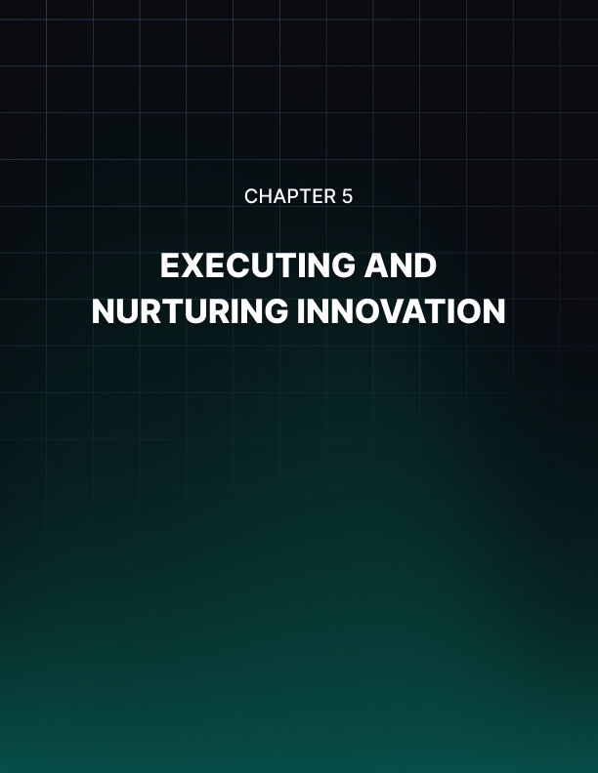

Executing and Nurturing Innovation
Transforming creative ideas into tangible business solutions requires a structured approach. Begin by clearly defining your concept, including its core features, target audience, and potential impact on your business. This detailed description serves as your roadmap moving forward. Next, conduct a thorough market analysis using tools like Google Trends, industry reports, and customer surveys to gather data. This step is crucial for validating your idea and identifying potential challenges or opportunities.

From Concept to Reality
With your concept defined and market research in hand, it's time to create a prototype. As Reid Hoffman, co-founder of LinkedIn, famously said, "If you're not embarrassed by the first version of your product, you've launched too late." Prototyping allows you to test your idea in a tangible form before investing significant resources. For physical products, this might involve 3D printing or creating a mock-up. For software or services, consider developing a minimum viable product (MVP) that includes only the core features necessary to solve the primary problem.
Once you have a prototype, gather user feedback from a small group of potential customers or users who represent your target audience. Present your prototype to them and observe their reactions. Ask open-ended questions about their experience and listen carefully to their responses. Be prepared for criticism and try to view it as valuable information rather than a personal attack. The feedback you receive at this stage is invaluable for refining your idea and improving its chances of success.
Based on the feedback you receive, iterate on your prototype. Make necessary adjustments and improvements, then test again. This iterative process of prototyping, testing, and refining is crucial for developing a product or service that truly meets your customers' needs. As you refine your concept, start developing a more comprehensive business plan that includes an executive summary, market analysis, product or service description, marketing and sales strategy, financial projections, operational plan, and team information.
With your business plan in hand, you can start seeking the resources you need to bring your innovation to market. This might involve securing funding from investors, allocating internal resources, or forming partnerships with other organizations. Throughout this process, remain flexible and open to change. The path from concept to reality is rarely straightforward, and you may need to pivot or adjust your approach based on new information or changing market conditions.

Building an Innovator's Culture
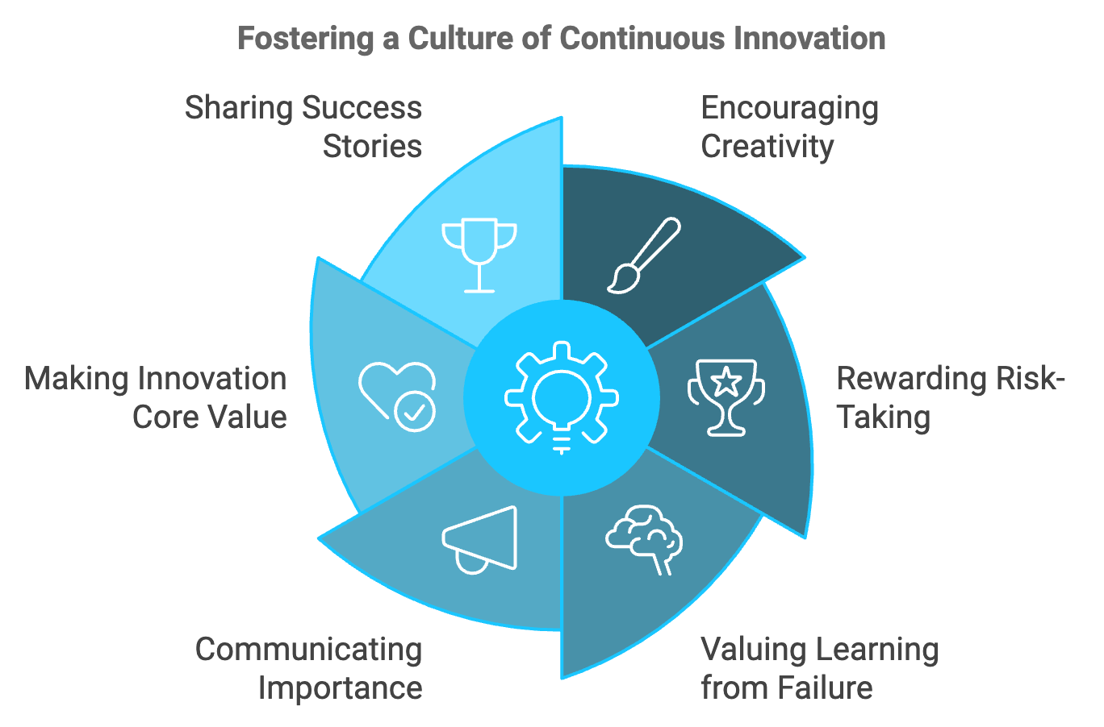
Creating a single innovative product or service is a significant achievement, but to truly thrive as an entrepreneur, you need to foster a culture of continuous innovation within your organization. This involves creating an environment where creativity is encouraged, risk-taking is rewarded, and learning from failure is valued.

Start by clearly communicating the importance of innovation to your team. Make it a core part of your company's mission and values. Regularly share stories of successful innovations, both from within your company and from other organizations, to inspire and motivate your team.
Leadership plays a crucial role in fostering an innovative culture. As a leader, you need to model the behaviors you want to see in your team. This means being open to new ideas, taking calculated risks, and demonstrating a willingness to learn from failures. Create opportunities for open dialogue with your team, where they feel comfortable sharing their ideas and concerns.
Implement structures that support innovation, such as innovation time, cross-functional teams, idea management systems, innovation workshops, and mentorship programs. Reward and recognize innovative efforts, not just successful outcomes. This encourages risk-taking and sends the message that the process of innovation is valued, even when it doesn't lead to immediate success. Consider implementing an "Innovation Award" program to highlight and celebrate creative thinking across your organization.
Create physical spaces that encourage creativity and collaboration. This might involve designing open workspaces, creating dedicated brainstorming rooms, or setting up informal meeting areas where employees can have spontaneous discussions. Invest in ongoing learning and development for your team. Provide opportunities for employees to attend conferences, take courses, or participate in workshops that expose them to new ideas and technologies. Encourage cross-industry learning by inviting speakers from different fields to share their experiences and insights.
Foster a culture of experimentation by encouraging small, low-risk tests of new ideas. Implement a "fail fast" approach where quick, inexpensive experiments are used to validate concepts before significant resources are invested. This reduces the fear of failure and encourages more innovative thinking. Regularly assess your innovation efforts to ensure they're effective and aligned with your business goals. Some key metrics to consider include the number of new ideas generated, implementation rate, time to market, revenue from new products/services, employee engagement in innovation, and customer satisfaction with new offerings.

Sustaining Innovation in the Long Term
As your business grows and evolves, maintaining a culture of innovation can become increasingly challenging. Larger organizations often struggle with bureaucracy and risk aversion, which can stifle creativity. To sustain innovation in the long term, consider implementing strategies such as decentralizing decision-making, creating an innovation fund, embracing open innovation, implementing continuous learning, regularly reassessing and refreshing your approach, fostering diversity and inclusion, and balancing exploitation and exploration.
Strategy | Description
Decentralize Decision-Making | Empower teams and individuals to make decisions about their innovative projects
Create an Innovation Fund | Set aside a dedicated budget for exploring and developing new ideas
Embrace Open Innovation | Partner with startups, universities, or customers to tap into a broader pool of creativity
Implement Continuous Learning | Provide resources for ongoing education and celebrate learning
Regularly Reassess and Refresh | Periodically review your innovation processes and culture
Foster Diversity and Inclusion | Create an inclusive environment where all voices are heard and valued
Balance Exploitation and Exploration | Focus on improving existing products while searching for new opportunities

Remember that building an innovative culture is an ongoing process. It requires consistent effort, reinforcement, and adaptation. Be patient and persistent in your efforts, and be prepared to adjust your approach based on what works best for your organization. By following these strategies, you're well-equipped to turn your innovative ideas into reality and foster a culture of continuous innovation within your organization.

