TABLE OF CONTENTS
____
INTRODUCTION 4
THE PSYCHOLOGY OF CONVERSIONS 8
Understanding Conversion Psychology 9
Psychology in the Customer Journey 12
Neuroscience in Conversion Psychology 14
Ethics in Conversion Psychology 16
Implementing Conversion Psychology 17
HARNESSING BIASES & EMOTIONAL TRIGGERS 24
Understanding Cognitive Biases 24
The Power of Emotional Triggers 27
Combining Biases & Triggers 29
Practical Strategies for Implementation 31
Ethical Considerations 33
BUILDING CREDIBILITY THROUGH SOCIAL PROOF 38
Understanding Social Proof 38
Types of Social Proof 39
Using Social Proof Across Channels 41
Best Practices for Using Social Proof 44
Measuring the Impact of Social Proof 46
Overcoming Challenges in Using Social Proof 47
Social Proof in the Customer Journey 49
SCARCITY AND URGENCY AS DRIVERS 54
Understanding the Psychology of Scarcity 54
The Urgency Factor 56
Types of Scarcity 57
Implementing Scarcity and Urgency 58
Best Practices for Using Scarcity and Urgency 60
Measuring Scarcity and Urgency 61
Putting Scarcity and Urgency into Actionsion 62
PERSUASIVE PSYCHOLOGY FOR WEB EXPERIENCES 65
The Psychology Behind Web Design 65
Key Elements of Persuasive Web Design 67
Advanced Persuasion Techniques 71
Optimizing for Mobile 74
The Role of A/B Testing in Persuasive Design 75
Ethical Considerations in Persuasive Design 76
PSYCHOLOGY IN YOUR CONVERSION STRATEGY 79
Holistic Conversion Optimization 79
Applying Psychology in Your Marketing Funnel 81
Crafting Persuasive Copy with Psychology 84
Designing for Conversion with Psychology 85
Data and Analytics in Your Strategy 87
FROM CONVERSIONS TO MASTERING PSYCHOLOGY 92
The Evolution of Psychological Marketing 92
Beyond Conversions Building Relationships 93
Psychology in Customer Experience Design 95
The Ethics of Psychological Marketing 98
FINAL THOUGHTS 101

DISCLAIMER
____
The information provided in this ebook is intended solely for educational and informational purposes. The author does not accept any responsibility for the outcomes that may arise from the application of the material within. While efforts have been made to ensure the accuracy and relevance of the content, the author cannot be held accountable for any errors or omissions, or for any consequences resulting from the use or misuse of the information provided. The responsibility for any actions taken based on the information in this ebook lies solely with the reader.



INTRODUCTION
____
Why do some businesses effortlessly turn visitors into loyal customers while others struggle to make a single sale? The secret isn’t flashy marketing or aggressive sales tactics—it’s rooted in the workings of the human mind. This book will transform how you approach marketing by revealing the psychological triggers that drive human behavior and decision-making.
You'll discover the hidden principles of conversion psychology and learn to understand your customers’ deepest desires, fears, and motivations. In today’s competitive market, success requires more than just a great product—it demands a genuine connection with your audience. This book goes beyond traditional marketing advice, equipping you with the art and science of persuasion to set you apart from the competition.
By the end, you'll have a toolkit of psychological techniques for crafting irresistible offers, designing user-friendly websites, and creating compelling marketing messages that resonate deeply with your audience. You’ll gain insights into what motivates people to buy, such as urgency, fear of missing out, or positive reviews—factors that can make a huge impact on your bottom line.
But this isn't just theory. You'll get practical, step-by-step strategies to optimize every customer touchpoint. From effective calls-to-action to persuasive landing pages, the techniques in this book are grounded in timeless psychological principles that apply across industries.
Explore cognitive biases that shape decision-making, like the anchoring effect, where the first piece of information influences subsequent choices. Learn how to structure pricing and offers to maximize perceived value. Dive into emotional triggers that play a bigger role in decision-making than logic, discovering how to evoke the right emotions at the right time for a deeper connection with your audience.
Building trust is more important than ever in today’s skeptical market. This book will show you how to leverage social proof, use testimonials and endorsements authentically, and establish authority without sounding boastful. You'll also master the principle of scarcity, ethically creating a sense of urgency with limited-time offers and exclusive deals to motivate action.
Even the smallest design choices, from color psychology to visual layout, can significantly impact user behavior.

You'll gain a new understanding of how to create user experiences that look great and are optimized to guide visitors toward your desired actions.
As you read, you'll start recognizing these psychological principles in marketing messages all around you. This awareness will not only make you a better marketer but also a more informed consumer.
This book isn’t about manipulating people into buying—it’s about understanding human nature and creating win-win situations. By aligning your marketing with the genuine needs and desires of your audience, you'll craft strategies that feel helpful, not pushy, building a brand that people trust and respect.
Are you ready to take your conversion strategy to the next level? Turn the page and discover the secrets of the human mind to boost your business like never before. The power to dramatically increase your conversions is now in your hands—let’s put it to work!

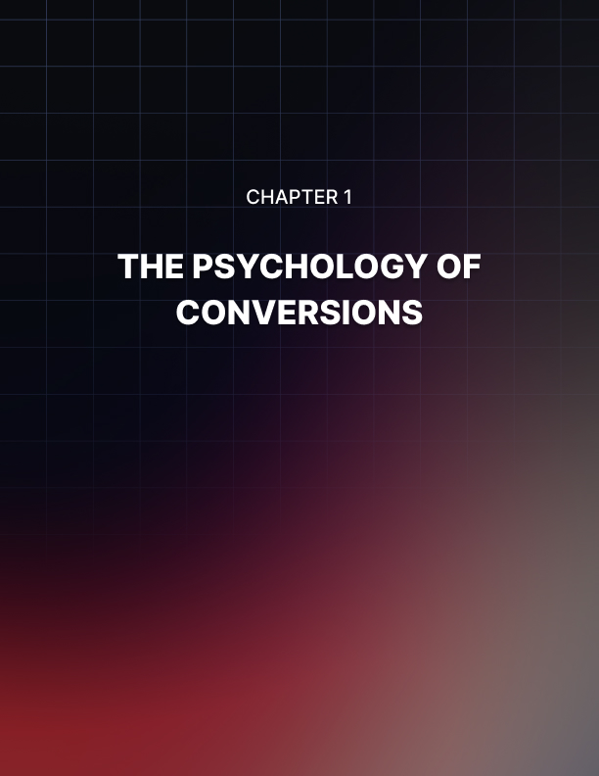

THE PSYCHOLOGY OF CONVERSIONS
____
The human mind is a complex web of thoughts, emotions, and decision-making processes. As an entrepreneur, understanding this complexity can be your secret weapon in the competitive business world. You're about to harness the power of psychology to boost your conversion rates and transform your marketing strategies.
Imagine you're standing at the entrance of a bustling marketplace. Everywhere you look, vendors are vying for attention, each with their unique methods to attract customers. Some use vibrant colors, others rely on aromatic scents, and a few employ persuasive speech. In this crowded space, how do you make your offering stand out? The answer lies in understanding the underlying psychological factors that influence human behavior and decision-making.
In this chapter, you'll explore the foundational concepts of conversion psychology. You'll discover how to tap into the innate human behaviors that drive purchasing decisions. By the end of this chapter, you'll have a toolkit of psychological insights that will empower you to craft more effective marketing strategies and significantly boost your conversion rates.

Understanding Conversion Psychology
At its core, conversion psychology is about understanding why people make the decisions they do. It's the study of how thoughts, beliefs, and perceptions influence behavior, particularly in the context of marketing and sales. By grasping these concepts, you can create marketing messages and experiences that resonate deeply with your target audience, compelling them to take action.
Think about the last time you made a purchase. What factors influenced your decision? Was it the product's features, the brand's reputation, or perhaps a limited-time offer that pushed you to buy? Chances are, multiple psychological factors were at play, subtly guiding your choice.
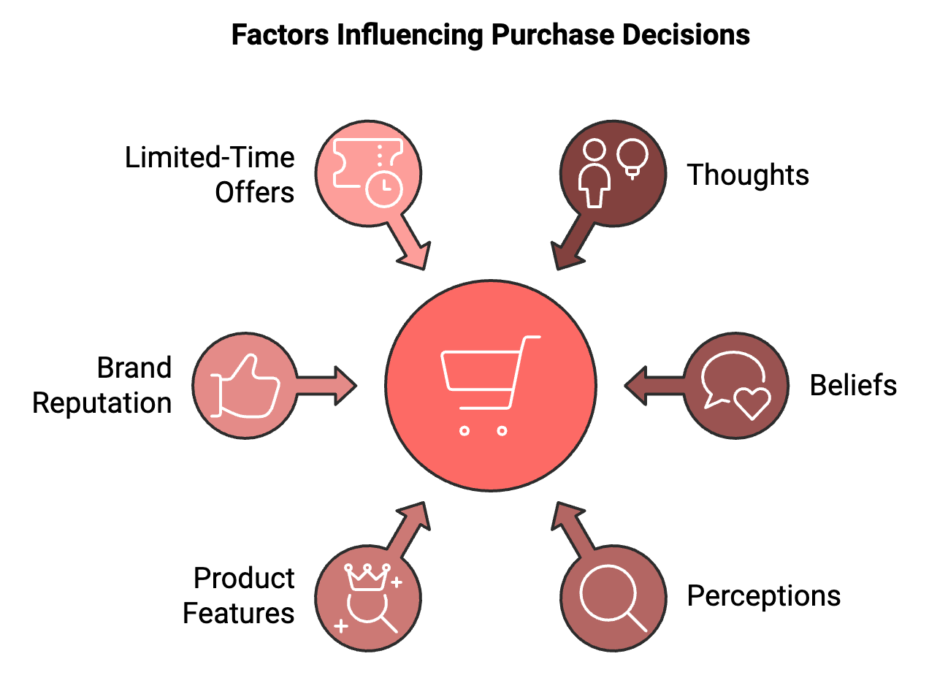

As an entrepreneur, your goal is to understand these factors and use them ethically to guide potential customers towards making decisions that benefit both them and your business. It's not about manipulation; it's about aligning your offerings with the natural decision-making processes of your target audience.

The Psychological Foundations of Decision-Making
To effectively leverage psychology for conversions, you need to understand the basic psychological principles that underpin human decision-making. Let's explore some of these key concepts:
- Cognitive Biases: Cognitive biases are systematic errors in thinking that affect the decisions and judgments people make. These biases are often a result of our brain's attempt to simplify information processing. Understanding these biases can help you frame your marketing messages more effectively. For example, the anchoring bias refers to the tendency to rely too heavily on the first piece of information encountered when making decisions. You can use this bias by presenting a higher-priced option first, making subsequent options seem more reasonable in comparison. Another common bias is the bandwagon effect, where people tend to do or believe things because many other people do the same. You can leverage this by highlighting the popularity of your products or services, encouraging others to join the crowd.
- Emotional Triggers: Emotions play a crucial role in decision-making. Despite what many believe, decisions are rarely made purely on logic. Instead, emotions often drive choices, with logic used to justify them afterward. Understanding the emotional triggers that resonate with your audience can significantly impact your conversion rates. For instance, fear of missing out (FOMO) is a powerful emotional trigger that can drive quick decision-making. By creating a sense of scarcity or urgency around your offerings, you tap into this emotion, encouraging faster conversions. Similarly, positive emotions like joy, excitement, or a sense of belonging can also drive conversions. Creating content or experiences that evoke these emotions can make your brand more appealing and memorable.
- Social Proof: Humans are inherently social creatures, and we often look to others to guide our behavior, especially in unfamiliar situations. This tendency is known as social proof, and it's a powerful tool in conversion psychology. You can leverage social proof by showcasing customer testimonials, user reviews, or case studies. When potential customers see that others have had positive experiences with your product or service, they're more likely to convert.
- Reciprocity: The principle of reciprocity suggests that people tend to return a favor. In the context of marketing, if you provide value to your potential customers upfront, they're more likely to reciprocate by making a purchase or taking the desired action. This could be as simple as offering free, valuable content or providing exceptional customer service. By giving first, you create a sense of obligation that can lead to higher conversion rates.
- Authority: People tend to follow the lead of credible, knowledgeable experts. Establishing yourself or your brand as an authority in your field can significantly influence potential customers' decisions. You can build authority by sharing your expertise through content marketing, obtaining certifications or awards, or partnering with respected figures in your industry.

Psychology in the Customer Journey
Now that you understand some of the key psychological principles, let's look at how you can apply them throughout the customer journey to increase conversions.

Awareness Stage
In the awareness stage, potential customers are just becoming aware of a problem or need they have. Your goal is to capture their attention and begin building trust. Use the principle of authority by positioning yourself as an expert in solving their problem. Create valuable content that addresses their pain points, demonstrating your understanding and expertise. Leverage the bandwagon effect by highlighting how many others are facing similar issues and finding solutions through your offerings.
Example: Imagine you're running a fitness app. In the awareness stage, you might create a blog post titled "5 Hidden Reasons You're Not Losing Weight (And How 10,000 People Overcame Them)". This title leverages both authority and social proof to capture attention.

Consideration Stage
In the consideration stage, potential customers are actively researching solutions to their problem. Your goal is to position your offering as the best solution. Use cognitive biases like the anchoring effect to frame your pricing favorably. For instance, you might present your premium offering first, making your standard offering seem more affordable in comparison. Apply the principle of reciprocity by offering free trials, demos, or valuable resources. This creates a sense of obligation and allows potential customers to experience the value of your offering firsthand.
Example: Continuing with the fitness app scenario, you might offer a free 7-day trial of your app, along with a downloadable meal plan. This reciprocity can increase the likelihood of conversion to a paid subscription.

Decision Stage
In the decision stage, potential customers are ready to make a choice. Your goal is to provide the final push needed for conversion. Leverage scarcity and urgency to encourage quick decision-making. Limited-time offers or exclusive bonuses can tap into the fear of missing out. Use social proof heavily at this stage. Customer testimonials, case studies, and user-generated content can provide the reassurance needed to make a final decision.
Example: For your fitness app, you might create a limited-time offer: "Sign up in the next 24 hours and get a personalized workout plan (valued at $50) for free!" Combine this with testimonials from successful users to maximize conversions.

Post-Purchase Stage
Don't forget about psychology after the purchase. The post-purchase stage is crucial for customer retention and encouraging repeat conversions. Use the principle of consistency. People like to be consistent with their past actions. Remind customers of their good decision to purchase and encourage them to make the most of their purchase. Continue to provide value and leverage reciprocity to encourage upsells, cross-sells, and referrals.
Example: After a user signs up for your fitness app, send them a congratulatory email reinforcing their decision. Include tips on how to get the most out of the app and offer a referral bonus for inviting friends.

Neuroscience in Conversion Psychology
While traditional psychology provides valuable insights into human behavior, recent advances in neuroscience have opened up new avenues for understanding how the brain processes information and makes decisions. This knowledge can be incredibly powerful when applied to conversion optimization.
Neuroscience research has revealed that our brains are wired to take mental shortcuts to conserve energy. These shortcuts, often referred to as heuristics, can significantly influence purchasing decisions. By understanding these neural pathways, you can design marketing strategies that align with the brain's natural decision-making processes.
For instance, neuroscience has shown that the brain processes images much faster than text. In fact, the human brain processes images 60,000 times faster than text, and 90% of information transmitted to the brain is visual. This insight suggests that using compelling visuals in your marketing materials can lead to faster and more effective communication with your audience.
Another neuroscience finding relevant to conversions is the power of storytelling.
When we hear a story, our brains react as if we're experiencing it ourselves.

This phenomenon, known as neural coupling, can create a strong connection between your brand and your audience. By incorporating storytelling into your marketing strategy, you can create more engaging and memorable experiences for your potential customers.
Neuroscience has also shed light on the importance of first impressions. Research shows that it takes only 50 milliseconds for users to form an opinion about a website. This rapid judgment affects their decision on whether to stay or leave. For entrepreneurs, this underscores the critical importance of creating a visually appealing and user-friendly website to maximize conversions.

Ethics in Conversion Psychology
Exploring the power of psychology in boosting conversions requires careful consideration of the ethical implications of these techniques. The line between persuasion and manipulation can sometimes be thin, and as an ethical entrepreneur, it's your responsibility to ensure you're using these psychological insights responsibly.
Here are some guidelines to keep in mind:
- Transparency
Always be honest about your products, services, and offers. Don't use psychological tactics to mislead or deceive your audience.
- Value First
Ensure that your primary focus is on providing genuine value to your customers. Use psychology to enhance the presentation of this value, not to mask a lack of it.
- Respect Autonomy
While you can guide decision-making, always respect your customers' right to make their own choices. Avoid using high-pressure tactics or exploiting vulnerabilities.
- Data Privacy
If you're using psychological insights derived from customer data, ensure you're complying with all relevant data protection regulations and respecting your customers' privacy.
- Continuous Learning
Stay informed about the latest research in psychology and neuroscience. This will help you use the most up-to-date and scientifically valid techniques.
Keep in mind that the goal is to create win-win situations where your conversions reflect genuine matches between customer needs and your offerings.

Implementing Conversion Psychology
Now that you understand the theoretical foundations of conversion psychology, let's explore some practical strategies you can implement in your business:
- Optimize Your Website Design
Your website is often the first point of contact between your business and potential customers. Use psychological principles to create a more compelling and conversion-friendly design. Use color psychology: Different colors evoke different emotions. For example, blue often conveys trust and security, while red can create a sense of urgency. Choose colors that align with your brand and the emotions you want to evoke. Implement visual hierarchy: Guide your visitors' attention to the most important elements on your page. Use size, color, and positioning to highlight key information and calls-to-action. Simplify choices: Too many options can lead to decision paralysis. Limit the number of choices you present to make decision-making easier for your visitors.
- Craft Persuasive Copy
Your website copy is a powerful tool for leveraging psychology to increase conversions. Use power words: Certain words have a strong psychological impact. Words like "free," "new," "instant," and "guaranteed" can be particularly effective in marketing copy. Frame benefits effectively: Instead of just listing features, focus on how your product or service will improve your customers' lives. This taps into the psychological principle of loss aversion by highlighting what they stand to lose by not choosing your offering. Create a sense of urgency: Use time-limited offers or highlight scarcity to encourage quick decision-making.
- Leverage Social Proof
As discussed earlier, social proof is a powerful psychological tool. Here are some ways to implement it: Display customer testimonials prominently on your website. Showcase the number of customers you've served or products you've sold. Use trust badges and certifications to build credibility. Implement a review system for your products or services.
- Personalize the User Experience
Personalization can significantly increase conversions by making each visitor feel valued and understood. Use data to tailor product recommendations. Implement smart forms that remember user information. Create personalized email campaigns based on user behavior and preferences.
- Optimize Your Checkout Process
The checkout process is a critical point in the conversion funnel. Use psychology to minimize cart abandonment. Reduce friction by minimizing the number of steps required to complete a purchase. Use progress indicators to show how close customers are to completing their purchase. Offer multiple payment options to cater to different preferences. Use trust signals (like security badges) to alleviate concerns about online transactions.
- Implement A/B Testing
Psychology isn't one-size-fits-all. What works for one audience might not work for another. That's why it's crucial to continually test and refine your strategies. Test different headlines, images, colors, and layouts. Experiment with various offers and pricing structures. Try different placements for your calls-to-action. A/B testing isn't just about finding what works best at the moment; it's also a way to gain insights into your audience's psychology for future marketing efforts.

Case Study: How Company X Used Psychology to Boost Conversions
Let's look at a real-world example of how these psychological principles can be applied to increase conversions significantly. Company X, an e-commerce store selling eco-friendly home products, was struggling with low conversion rates despite having high-quality products and competitive prices. They decided to revamp their marketing strategy using psychological principles.
Here's what they did:
- Leveraged Scarcity: They introduced a "Limited Edition" line of products, available only for a specific time period. This tapped into the scarcity principle, creating a sense of urgency among potential customers.
- Used Social Proof: They prominently displayed customer reviews and ratings on their product pages. They also added a feature showing how many people had purchased each product in the last 24 hours.
- Implemented Reciprocity: They offered a free e-book on "50 Easy Ways to Make Your Home More Eco-Friendly" to all newsletter subscribers. This provided value upfront, increasing the likelihood of future purchases.
- Optimized for Authority: They partnered with environmental experts to create content for their blog, positioning themselves as a knowledgeable source in the eco-friendly space.
- Applied Loss Aversion: Instead of just highlighting the benefits of their products, they also emphasized what customers stood to lose by not choosing eco-friendly options (e.g., "Don't let your home contribute to environmental damage").
The results were impressive: Conversion rate increased by 27% within three months, average order value went up by 15%, and customer retention rate improved by 22%. This case study illustrates how a thoughtful application of psychological principles can lead to significant improvements in conversion rates and overall business performance.
Understanding and leveraging the psychology of conversions is a powerful tool in your entrepreneurial toolkit. By tapping into the fundamental ways humans think and make decisions, you can create marketing strategies that resonate deeply with your audience and drive significant improvements in your conversion rates.
The key to successfully implementing these psychological principles is balance and authenticity. Use these insights to enhance the value you're already providing, not as a replacement for it. When applied ethically and thoughtfully, conversion psychology can create win-win situations where your business thrives by genuinely meeting your customers' needs and desires.
As you move forward, continue to learn, experiment, and refine your approach. The field of psychology is vast and ever-evolving, offering endless opportunities for innovation in your conversion strategies. Embrace this knowledge, and watch as your business transforms, one conversion at a time.
Psychological Principle | Description | Example Application
Cognitive Bias | Systematic errors in thinking affecting decisions | Using anchoring bias to frame pricing
Emotional Triggers | Emotions driving choices | Creating FOMO with limited-time offers
Social Proof | People following others' behavior | Displaying customer reviews and ratings
Reciprocity | Tendency to return favors | Offering free valuable content
Authority | Following credible experts | Showcasing industry certifications

Conversion Rate = (Number of Conversions / Total Visitors) * 100
This equation represents the basic calculation for conversion rate, a key metric in measuring the effectiveness of your psychological strategies in marketing.

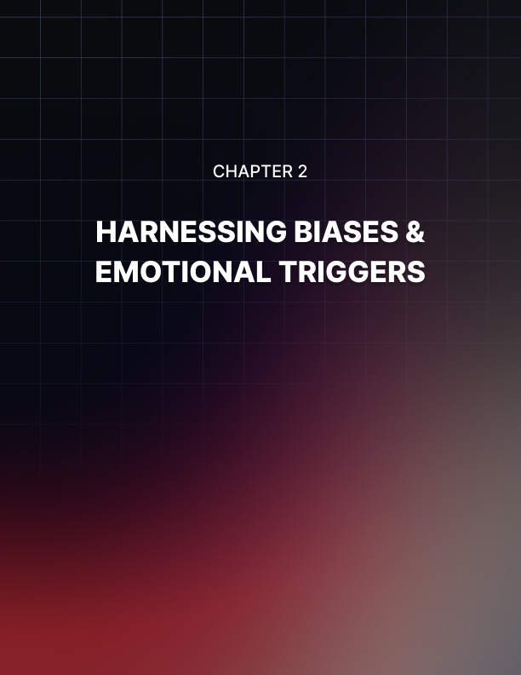

HARNESSING BIASES & EMOTIONAL TRIGGERS
____
The human mind is a complex mix of thoughts, emotions, and decision-making processes. As an entrepreneur, your ability to navigate this intricate system can make or break your business success. In this chapter, you'll explore the fascinating world of cognitive biases and emotional triggers, and learn how to harness their power to boost your conversion rates.

Understanding Cognitive Biases
Cognitive biases are systematic patterns of deviation from norm or rationality in judgment. They're mental shortcuts or 'rules of thumb' that your brain uses to make decisions quickly. While these shortcuts can be helpful in many situations, they can also lead to errors in reasoning, especially when it comes to complex decisions like purchasing.
As an entrepreneur, understanding these biases is crucial. They affect how your potential customers perceive your products, process information about your offerings, and ultimately make purchasing decisions. By recognizing these biases, you can design your marketing strategies to work with them rather than against them.
Let's explore some of the most relevant cognitive biases for marketing and how you can use them to increase your conversion rates:
Anchoring Bias: This refers to the tendency to rely too heavily on the first piece of information encountered when making decisions. In pricing strategies, present your most expensive option first. This sets a high anchor, making your other options seem more reasonable in comparison. For example, if you're selling software subscriptions, showcase your premium plan first. Even if customers don't choose it, it makes your standard plan appear more affordable. A study by William Poundstone found that diners at a restaurant spent 8.15% more on average when the menu didn't use dollar signs. The absence of the dollar sign weakened the 'anchor' to cost, leading to higher spending.
Bandwagon Effect: This occurs when people do something primarily because others are doing it, regardless of their own beliefs. Highlight the popularity of your products or services. Use phrases like "Join thousands of satisfied customers" or "Our best-selling item". This creates social proof and triggers the bandwagon effect. In 2023, a marketing study found that 71% of consumers are more likely to make a purchase based on social media referrals. This demonstrates the power of the bandwagon effect in modern digital culture.
Loss Aversion: This is the tendency to prefer avoiding losses over acquiring equivalent gains. Frame your offers in terms of what customers stand to lose by not taking action, rather than what they'll gain. For instance, instead of saying "Save $50," try "Don't miss out on $50 in savings." A recent experiment in behavioral economics showed that framing a penalty as a loss rather than a gain increased compliance by 74%. This illustrates the profound impact of loss aversion on decision-making.
Confirmation Bias: This is the tendency to search for, interpret, favor, and recall information in a way that confirms or supports one's prior beliefs or values. Provide information that aligns with your target audience's existing beliefs. Then, gently introduce your product or service as a natural extension or solution that fits with these beliefs. A 2023 study on consumer behavior found that customers were 63% more likely to engage with content that confirmed their pre-existing views on a product category.
Scarcity Bias: This refers to the tendency to place a higher value on items that are perceived as being limited or rare. Create a sense of scarcity around your offerings. Use limited-time offers, exclusive deals, or highlight low stock levels to trigger this bias. In a recent e-commerce study, products labeled as "Only 3 left in stock" saw a 24% increase in conversion rates compared to those without such labels.
By understanding and leveraging these cognitive biases, you can significantly influence your customers' decision-making processes. However, it's crucial to use this knowledge ethically. Your goal should be to guide customers towards decisions that genuinely benefit them, not to manipulate them into choices they'll regret.

The Power of Emotional Triggers
While cognitive biases operate largely at an unconscious level, emotions are a more conscious experience that can profoundly impact decision-making. Emotions are often the driving force behind purchases, with logic following to justify the decision.
As an entrepreneur, understanding and leveraging emotional triggers can be a game-changer for your conversion rates. Let's explore some key emotional triggers and how you can use them in your marketing:
Fear: Fear is a primal emotion that can be a powerful motivator. It's not about scaring your customers, but about highlighting potential negative consequences of not using your product or service. Identify pain points or potential losses your customers might face without your offering. Then, position your product or service as the solution or safeguard. Insurance companies often use fear effectively in their marketing. A recent campaign by a cyber security firm increased conversions by 28% by highlighting the potential financial losses from data breaches and positioning their service as essential protection.
Joy: Joy is a positive emotion that can create strong positive associations with your brand. Create marketing content that makes your customers smile or laugh. Show how your product or service can bring joy to their lives. A study by Unruly found that joy was the most effective emotion for viral video content, with joyful videos being shared 40% more often than other emotional content.
Trust: Trust is crucial in any business relationship. It's about making your customers feel secure in their decision to choose your brand. Build trust through transparency, consistent quality, and excellent customer service. Use trust signals like customer testimonials, security badges, and money-back guarantees. A 2023 survey found that 81% of consumers said they need to be able to trust a brand to buy from them. Brands that consistently demonstrated trustworthiness saw a 43% increase in customer loyalty.
Belonging: The need to belong is a fundamental human motivation. People often make purchases to feel part of a group or community. Create a brand community. Use inclusive language like "Join our family" or "Be part of the movement". Highlight how your product or service connects people. A fitness app increased its user base by 52% by creating challenge groups and fostering a sense of community among its users.
Pride: Pride can be a powerful motivator, especially for purchases that reflect on a person's identity or status. Position your product or service as something that will make your customers feel proud. This could be about personal achievement, status, or making a positive impact. Tesla's marketing often appeals to pride, positioning its cars not just as vehicles, but as a statement about the owner's commitment to innovation and sustainability. This approach has contributed to Tesla's strong brand loyalty.
Emotions are powerful, and with great power comes great responsibility. It's crucial to use emotional triggers ethically. The goal should be to genuinely improve your customers' lives, not to manipulate their emotions for short-term gain.

Combining Biases & Triggers
While understanding cognitive biases and emotional triggers separately is valuable, the real magic happens when you combine them. By leveraging both the unconscious shortcuts of cognitive biases and the conscious experience of emotions, you can create incredibly compelling marketing strategies.
Let's explore some effective combinations:
Scarcity Bias + Fear of Missing Out (FOMO): Combine the scarcity bias with the emotional trigger of FOMO to create a powerful motivator for quick decision-making. Create limited-time offers or exclusive deals. Use countdown timers or low-stock indicators to heighten the sense of urgency. A travel website increased bookings by 29% by showing real-time updates of how many people were viewing the same hotel room and how many rooms were left.
Social Proof + Belonging: Leverage the bandwagon effect (a cognitive bias) with the emotional need for belonging to encourage customers to join your brand community. Showcase customer testimonials, user-generated content, and community numbers. Use inclusive language to make customers feel part of something bigger. A fitness brand grew its Instagram following by 118% in six months by consistently featuring user-generated content and fostering a sense of community among its followers.
Anchoring Bias + Pride: Use the anchoring bias to set a high reference point, then appeal to the customer's sense of pride in making a premium choice. Present your premium offering first, then position your target product as a smart choice that still confers status or achievement. A luxury car manufacturer increased sales of its mid-range models by 23% by prominently featuring its most expensive models in showrooms and advertisements, then positioning the mid-range models as the smart choice for discerning buyers.
Loss Aversion + Fear: Combine the cognitive bias of loss aversion with the emotional trigger of fear to motivate action. Highlight what customers stand to lose by not choosing your product or service, framing it as protection against potential negative outcomes. A home security company increased conversions by 41% with a campaign that emphasized the potential losses from a break-in, framing their service as essential protection against these losses.
Confirmation Bias + Joy: Use the confirmation bias to align with your customers' existing beliefs, then associate your brand with the positive emotion of joy. Identify your target audience's values and beliefs, create content that confirms these, then show how your product or service brings joy in line with these values. An eco-friendly cleaning product brand increased market share by 17% with a campaign that confirmed consumers' environmental values and showcased the joy of making a positive impact through everyday choices.

Practical Strategies for Implementation
Now that you understand the power of cognitive biases and emotional triggers, let's explore practical strategies to implement these insights into your marketing efforts:
- Conduct Thorough Customer Research
Before you can effectively leverage cognitive biases and emotional triggers, you need to deeply understand your target audience. Conduct surveys, interviews, and analyze customer data to identify key pain points and desires, common cognitive biases in your industry, and emotional triggers that resonate with your audience.
- Craft Compelling Narratives
Humans are wired for stories. Use storytelling to engage emotions and illustrate how your product or service fits into your customers' lives. Create customer personas and develop stories around them, use case studies and testimonials to tell real customer stories, and develop a brand story that resonates with your target audience's values and aspirations.
- Optimize Your Website Design
Your website is often the first point of contact for potential customers. Design it with cognitive biases and emotional triggers in mind. Use scarcity indicators (e.g., "Only 2 left in stock") to leverage loss aversion, implement social proof elements like customer reviews and usage statistics, use color psychology to evoke specific emotions, and simplify navigation and product selection to avoid choice overload.
- Craft Persuasive Copy
Your written content is a powerful tool for leveraging cognitive biases and emotional triggers. Use framing to position your offerings positively, incorporate scarcity and urgency language where appropriate, appeal to emotional triggers in headlines and subheadings, and use sensory language to make your descriptions more vivid and emotionally resonant.
- Leverage Social Media Effectively
Social media platforms offer unique opportunities to engage with customers' cognitive biases and emotions. Use the bandwagon effect by highlighting your follower count or engagement rates, create emotion-evoking content that encourages sharing, use limited-time offers or exclusive deals to create urgency, and engage with your audience to build a sense of community and belonging.
By implementing these strategies, you can create marketing campaigns that resonate deeply with your audience, guiding them towards decisions that benefit both them and your business. The key to success is balance. Combine your psychological insights with a genuine commitment to providing value, and you'll not only increase conversions but also build a loyal customer base that trusts and advocates for your brand.

Ethical Considerations
While cognitive biases and emotional triggers are powerful tools for increasing conversions, it's crucial to use them ethically. Your goal should be to guide customers towards decisions that genuinely benefit them, not to manipulate them into choices they'll regret.
Here are some guidelines for ethical application:
- Transparency
Be honest about your products, services, and offers. Don't use false scarcity or misleading claims.
- Value-First Approach
Ensure that your product or service provides real value to the customer. Use psychological insights to highlight this value, not to mask a lack of it.
- Respect Customer Agency
Provide all necessary information for customers to make informed decisions. Don't use high-pressure tactics that make customers feel trapped.
- Data Privacy
If you're using customer data to personalize your psychological approach, ensure you're complying with all relevant data protection regulations and respecting customer privacy.
- Avoiding Exploitation
Be particularly careful when marketing to vulnerable populations. Don't exploit fears or insecurities for profit.
- Balanced Approach
While emotional appeals are powerful, also provide logical, factual information to support customer decision-making.
- Continuous Improvement
Use customer feedback to continually improve your products and services. Don't use psychological tactics as a substitute for genuine quality and customer service.
A fitness supplement company saw long-term growth and customer loyalty by combining psychological marketing tactics with a strong emphasis on product quality and customer education. They used scarcity and social proof in their marketing but also provided detailed, scientifically-backed information about their products and realistic expectations for results. This approach led to a 63% increase in customer lifetime value over two years.
Cognitive biases and emotional triggers are powerful tools in your marketing arsenal. By understanding how the human mind works, you can create marketing strategies that resonate deeply with your audience, guiding them towards decisions that benefit both them and your business.
Combine your newfound psychological insights with a genuine commitment to providing value, and you'll not only increase your conversions but also build a loyal customer base that trusts and advocates for your brand.
Moving forward, continue to learn and adapt. The field of psychology is always evolving, and your marketing strategies should evolve as well. Stay curious, keep testing, and always prioritize your customers' best interests. With this approach, you'll be well on your way to mastering the art of psychologically-driven marketing and achieving sustainable business growth.
Cognitive Bias | Description | Marketing Application
Anchoring Bias | Tendency to rely heavily on the first piece of information encountered | Present most expensive option first in pricing strategies
Bandwagon Effect | Doing something because others are doing it | Highlight product popularity and user numbers
Loss Aversion | Preferring to avoid losses over acquiring equivalent gains | Frame offers in terms of potential losses avoided
Confirmation Bias | Seeking information that confirms existing beliefs | Align marketing messages with audience's existing views
Scarcity Bias | Valuing items perceived as limited or rare | Create sense of scarcity through limited-time offers

Emotional Trigger | Description | Marketing Application
Fear | Primal emotion motivating action to avoid negative outcomes | Highlight potential problems solved by your product
Joy | Positive emotion creating strong brand associations | Show how your product brings happiness to customers' lives
Trust | Feeling of security in choosing a brand | Build trust through transparency and consistent quality
Belonging | Need to be part of a group or community | Create a brand community and use inclusive language
Pride | Emotion tied to personal achievement or status | Position product as something customers can be proud of



BUILDING CREDIBILITY THROUGH SOCIAL PROOF
____
Trust is the cornerstone of any successful business relationship. With face-to-face interactions increasingly replaced by online transactions, establishing trust has become more crucial—and more challenging—than ever. As an entrepreneur, your ability to build credibility and foster trust can be the difference between a thriving business and one that struggles to gain traction.
This chapter explores the powerful concept of social proof and how you can leverage it to build trust, enhance your brand's credibility, and ultimately drive conversions. You'll discover practical strategies to integrate different types of social proof across your marketing channels, ensuring that your brand's voice resonates with authenticity and authority.

Understanding Social Proof
Social proof is a psychological phenomenon where people look to the actions and behaviors of others to guide their own decisions. It's based on the idea that if others are doing something, it must be the correct thing to do. This concept is particularly powerful in marketing and sales, where potential customers often seek validation from peers or experts before making a purchase decision.
The power of social proof is rooted in several psychological principles, including informational social influence, normative social influence, social comparison theory, the authority principle, and the liking principle. Understanding these psychological underpinnings can help you craft more effective social proof strategies for your business.

Types of Social Proof
Social proof comes in many forms, each with its own strengths and ideal applications. Let's explore the most common types and how you can use them to build trust and credibility for your brand.

Customer Testimonials
Customer testimonials are one of the most powerful forms of social proof. They provide authentic, relatable accounts of customer experiences with your product or service. According to a 2023 survey by BrightLocal, 91% of consumers say that positive reviews make them more likely to use a business. To leverage customer testimonials effectively, feature them prominently on your website, use video testimonials for greater impact, include specific details in testimonials, and incorporate them into your email marketing campaigns.

User Reviews
User reviews are typically more numerous than testimonials and often include both positive and negative feedback. They're particularly important for e-commerce businesses. A 2023 PowerReviews study found that 98% of consumers feel that reviews are an essential resource when making purchase decisions. To leverage user reviews, implement a review system on your product pages, encourage customers to leave reviews after their purchase, respond to both positive and negative reviews, highlight your average star rating if it's high, and consider integrating reviews from third-party platforms.

Social Media Proof
With billions of active users worldwide, social media platforms offer a goldmine of social proof opportunities. From follower counts to user-generated content, social media can significantly boost your brand's credibility. To leverage social media proof, display your social media follower counts if they're impressive, showcase user-generated content featuring your products, use social media widgets on your website to display real-time social activity, and encourage customers to share their experiences with your brand on social media using a branded hashtag.

Influencer Endorsements
Influencer marketing has exploded in recent years, with 93% of marketers using influencer marketing in their overall marketing strategy in 2023, according to a report by Influencer Marketing Hub. Influencers can lend credibility to your brand through their established trust with their followers. To leverage influencer endorsements, partner with influencers whose audience aligns with your target market, encourage authentic, personal stories about how the influencer uses your product, use influencer-generated content across your marketing channels, and consider long-term partnerships for more authentic and impactful endorsements.

Expert Endorsements
Endorsements from industry experts or thought leaders can significantly boost your brand's credibility. These endorsements carry weight because of the expert's perceived authority in the field. To leverage expert endorsements, seek endorsements from recognized experts in your industry, feature expert quotes or testimonials prominently on your website and marketing materials, collaborate with experts to create content such as webinars or whitepapers, and highlight any awards or recognition from industry bodies.

Using Social Proof Across Channels
Now that we've explored the various types of social proof, let's discuss how to effectively implement them across your marketing channels. The key is to integrate social proof seamlessly into your marketing strategy, maintaining consistency and authenticity across all touchpoints.

Website
Your website is often the first point of contact between your brand and potential customers. It's crucial to incorporate social proof throughout your site to build trust from the outset. Feature key statistics, trust badges, and a selection of your best testimonials on your homepage. Include customer reviews, ratings, and user-generated content specific to each product on product pages. Tailor your social proof to the specific offer or campaign on landing pages. Showcase any notable press mentions, awards, or certifications your company has received on your About page. Display security badges and trust seals to reassure customers about the safety of their transaction during the checkout process.

Email Marketing
Email remains one of the most effective marketing channels, and incorporating social proof can significantly boost its impact. Include testimonials or user statistics in your welcome email series to reinforce the new subscriber's decision to join your list. Use product reviews or user-generated content featuring the abandoned product to encourage completion of the purchase in abandoned cart emails. Incorporate social proof that's relevant to the promotion in promotional emails. Feature customer success stories or case studies in your regular newsletters. Even order confirmations or shipping notifications can include social proof, such as inviting the customer to join your social media community or showcasing related products with high ratings.

Social Media
Social media platforms are inherently social, making them perfect for leveraging social proof. Regularly share and celebrate content created by your customers. Share content from influencer partnerships across your social media channels. Regularly feature customer success stories or testimonials in your social media posts. Incorporate social proof elements in your ad copy and visuals. Use live streaming to showcase real-time engagement with your brand.

Content Marketing
Your content marketing efforts can be significantly enhanced by incorporating social proof. Include relevant statistics, expert quotes, or customer testimonials within your blog content to support your points. Develop in-depth case studies showcasing how your product or service has helped specific customers achieve their goals. Include expert endorsements or industry statistics to lend credibility to your whitepapers and ebooks. Collaborate with industry experts or satisfied customers to co-host webinars, leveraging their credibility and expertise. If you have a podcast, invite customers or industry experts as guests to share their experiences and insights.

Paid Advertising
Incorporating social proof in your paid advertising can significantly improve click-through rates and conversions. Use ad extensions to showcase ratings or review snippets in your Google Ads. Include trust badges, customer testimonials, or key statistics in your display ad creative. Feature customer testimonials or showcase user-generated content in your video advertisements. For users who have already interacted with your brand, use social proof specific to the products they've shown interest in for retargeting ads.

Best Practices for Using Social Proof
While social proof can be incredibly powerful, it's important to use it effectively and ethically. Here are some best practices to keep in mind:
- Be Authentic
Always use genuine testimonials, reviews, and statistics. Fabricating social proof can severely damage your brand's credibility if discovered.
- Keep it Fresh
Regularly update your social proof to ensure it remains relevant and current. Outdated testimonials or statistics can actually harm your credibility.
- Be Specific
Whenever possible, use specific, detailed social proof. A testimonial that mentions concrete results or a specific problem solved is more powerful than vague praise.
- Context Matters
Ensure your social proof is relevant to the page or content it's featured on. A testimonial about your excellent customer service might not be the best choice for a product page focused on technical specifications.
- Quantity and Quality
While a large number of reviews can be impressive, don't sacrifice quality for quantity. A few detailed, high-quality testimonials can be more effective than numerous generic ones.
- Leverage Negative Reviews
Don't be afraid of the occasional negative review. Responding professionally to criticism can actually boost your credibility. It shows that your reviews are genuine and that you care about customer satisfaction.
- Optimize for Mobile
Ensure your social proof elements are easily viewable on mobile devices, as an increasing number of users browse and shop on smartphones.
- Test and Optimize
Regularly A/B test different types and placements of social proof to see what resonates best with your audience.
- Respect Privacy
Always get permission before using customer names, photos, or stories in your marketing materials.
- Diversify Your Social Proof
Use a mix of different types of social proof to appeal to various segments of your audience.

Measuring the Impact of Social Proof
To ensure your social proof strategies are working, it's important to measure their impact using specific metrics.
Start by monitoring your conversion rate to see how it changes when you add or adjust social proof elements. Track the click-through rate (CTR) for emails, ads, or webpage sections that feature social proof to assess engagement levels.
Time on page is another key metric to watch, as effective social proof should increase the time users spend on your site. A lower bounce rate may indicate that your social proof is successfully encouraging visitors to explore further.
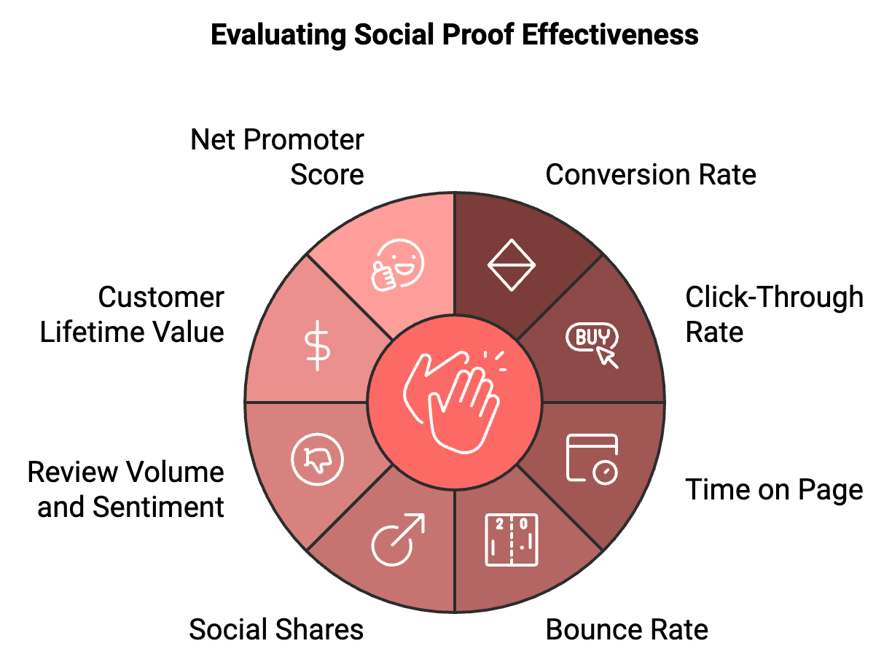

Keep an eye on social shares to gauge how often your content, like testimonials or case studies, is shared across social media. Review volume and sentiment should also be tracked to monitor changes in the number and quality of customer reviews over time.
Additionally, consider the impact on customer lifetime value (CLV), as strong social proof can help attract and retain customers. Net Promoter Score (NPS) is another useful metric, reflecting customer satisfaction and loyalty, which should improve with the effective use of social proof.
Leverage tools like Google Analytics, heat maps, and A/B testing platforms to gather these data points and make informed decisions about refining your social proof strategy.

Overcoming Challenges in Using Social Proof
While social proof is a powerful tool, it's not without its challenges. Here are some common obstacles you might face and how to overcome them:
- Lack of Reviews or Testimonials
If you're a new business, you might struggle to gather enough social proof. Start by reaching out to your first customers personally and asking for feedback. Consider offering incentives (but be transparent about this) or making the review process as easy as possible.
- Negative Reviews
It's inevitable that you'll receive some negative feedback. Instead of hiding it, respond professionally and use it as an opportunity to showcase your customer service. Many consumers actually look for negative reviews to get a balanced view of a product or service.
- Fake Reviews
In some industries, fake reviews are a significant problem. To combat this, ensure your review system is secure and consider using a third-party review platform that verifies purchases.
- Overreliance on Social Proof
While social proof is important, it shouldn't be your only selling point. Make sure you're also highlighting your unique value proposition and product features.
- Legal Considerations
Be aware of regulations surrounding testimonials and endorsements. In many countries, you must disclose if a testimonial was incentivized or if an endorser was compensated.
- Keeping Social Proof Current
Outdated testimonials or statistics can harm your credibility. Implement a system to regularly update your social proof across all platforms.
- Balancing Different Types of Social Proof
It can be challenging to know which types of social proof to prioritize. Use A/B testing to determine what resonates most with your audience.
By anticipating these challenges and planning for them, you can create a robust social proof strategy that builds trust and drives conversions.

Social Proof in the Customer Journey
To maximize the impact of social proof, it's crucial to integrate it throughout the entire customer journey. Here's how you can do this effectively:
Awareness Stage: Use social media to showcase user-generated content and customer stories. Highlight key statistics or awards in your advertising to capture attention. Feature expert endorsements or industry recognition in your PR efforts.
Consideration Stage: Include customer testimonials and case studies on your website's product pages. Use comparison charts that include user ratings for your products versus competitors. Share detailed reviews in your email marketing campaigns.
Decision Stage: Display security badges and trust seals prominently in your checkout process. Show real-time data about recent purchases or current product views. Include snippets of positive reviews right next to your call-to-action buttons.
Post-Purchase Stage: Send follow-up emails featuring testimonials from satisfied customers to reinforce the buyer's decision. Encourage customers to leave their own reviews or share their experiences on social media. Use social proof in your onboarding materials to boost confidence in your product or service.
Loyalty Stage: Highlight customer success stories in your loyalty program communications. Create exclusive communities or events for loyal customers, then showcase these to newer customers as aspirational social proof. Use social proof from long-term customers to encourage repeat purchases or upsells.
By strategically placing social proof elements at each stage of the customer journey, you create a consistent message of trust and credibility that guides potential customers towards conversion and fosters long-term loyalty.
Type of Social Proof | Key Benefits | Best Practices
Customer Testimonials | Authentic, relatable experiences | Use video, include specific details
User Reviews | Numerous, include both positive and negative feedback | Implement review system, respond to all reviews
Social Media Proof | Large reach, user-generated content | Showcase follower counts, encourage branded hashtag use
Influencer Endorsements | Leverage established trust with followers | Partner with relevant influencers, encourage authentic stories
Expert Endorsements | Boost credibility through authority | Seek recognized experts, collaborate on content creation
Trust Badges and Certifications | Instant credibility, especially for online businesses | Display relevant security badges, showcase industry certifications
Data and Statistics | Tell a powerful story with numbers | Highlight key metrics, regularly update data

This table summarizes the key types of social proof discussed in the chapter, along with their main benefits and best practices for implementation. It provides a quick reference guide for entrepreneurs looking to leverage different forms of social proof in their marketing strategies.
Social proof is a powerful psychological tool that can greatly influence your conversion rates and business success.

By using different forms of social proof—such as customer reviews, testimonials, expert endorsements, and user statistics—you can build trust, enhance credibility, and guide potential customers toward making a purchase.
The key to effective social proof lies in authenticity, relevance, and strategic placement. It’s not just about gathering positive reviews or impressive numbers; it’s about integrating these elements into your marketing strategy in a way that resonates with your audience and aligns with your brand voice.
When implementing social proof tactics, keep in mind the importance of testing and optimization. What works for one business may not work for another, so regularly assess the impact of your efforts and be ready to adjust based on the data.
Looking ahead, be prepared to adapt your social proof strategies to new technologies and shifting consumer behaviors. While the fundamental principle remains the same—people look to others for guidance—the ways in which social proof is applied will continue to evolve.
Mastering social proof is not just about boosting conversions; it’s about laying a foundation of trust and credibility that can lead to long-term customer relationships and sustained growth. Start implementing these strategies now, and watch your brand's credibility and conversion rates rise.



SCARCITY AND URGENCY

AS DRIVERS
____
In the bustling marketplace of ideas and products, capturing and maintaining customer attention is an ongoing challenge. As an entrepreneur, you're constantly seeking ways to stand out from the crowd and motivate potential customers to take action. One of the most powerful tools at your disposal is the principle of scarcity.
Scarcity, the psychological trigger that makes people want what they can't have or what they might lose, is a fundamental driver of human behavior. When combined with urgency, it becomes a potent catalyst for conversions. This chapter will explore how you can effectively leverage scarcity and urgency to accelerate consumer action, boost your conversion rates, and ultimately grow your business.

Understanding the Psychology of Scarcity
At its core, scarcity is about perceived value. When something is in short supply, difficult to obtain, or available for a limited time, people tend to want it more. This psychological principle is deeply rooted in human nature and has been observed across cultures and throughout history.
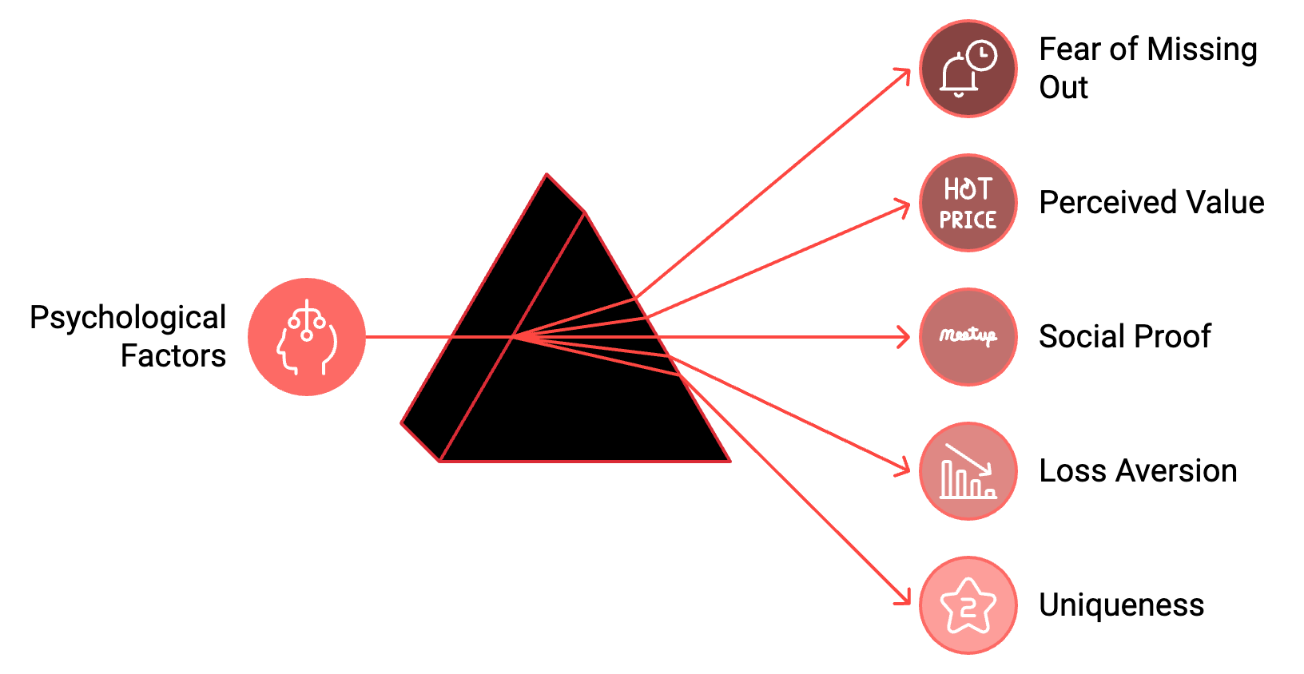
The power of scarcity stems from several psychological factors: Fear of Missing Out (FOMO), perceived value, social proof, loss aversion, and uniqueness. When resources are scarce, people worry about missing opportunities, driving them to take action quickly to avoid regret. Rare or limited items are often perceived as more valuable, making your product or service seem more desirable. Scarcity suggests that others want the item too, triggering the bandwagon effect and making it even more appealing. People are more motivated by the thought of losing something than by the prospect of gaining something of equal value, and scarcity plays into this by framing the situation as a potential loss if action isn't taken. Finally, scarce items make people feel special or unique for owning or experiencing them, appealing to their desire for individuality.

Understanding these psychological underpinnings will help you craft more effective scarcity-based marketing strategies. By tapping into these deep-seated human motivations, you can create marketing messages that resonate on a fundamental level with your target audience.

The Urgency Factor
While scarcity creates desire, urgency provides the push needed to convert that desire into action. Urgency is about creating a sense that time is running out, prompting immediate decision-making. When combined with scarcity, urgency becomes a powerful motivator for conversions.
Urgency works by reducing overthinking, creating excitement, simplifying choices, and leveraging present bias. When time is limited, people are less likely to overanalyze their decisions, which can often lead to inaction. The rush of making a quick decision can be thrilling, adding to the appeal of your offer. Urgency can make the decision binary - act now or miss out - which can actually make the choice easier for consumers. People tend to value immediate rewards more highly than future ones, and urgency plays into this bias by emphasizing the need for immediate action.
By understanding both scarcity and urgency, you can create marketing strategies that not only generate interest but also drive quick action. This powerful combination can significantly boost your conversion rates and accelerate your business growth.

Types of Scarcity
Before diving into specific strategies, it's important to understand the different types of scarcity you can leverage:
- Quantity-Based Scarcity
This refers to limiting the number of items available. Examples include limited edition products or services with a cap on the number of customers.
- Time-Based Scarcity
This involves limiting the duration of an offer or the availability of a product. Flash sales, seasonal products, and countdown timers fall into this category.
- Access-Based Scarcity
This type of scarcity limits who can access a product or service. Examples include exclusive memberships or invite-only services.
- Feature-Based Scarcity
This involves limiting certain features or benefits to specific products or time periods. For instance, offering special bonuses only with pre-orders.
- Information-Based Scarcity
This type of scarcity limits access to valuable information. Examples include exclusive reports or insider knowledge available only to select customers.
Each type of scarcity can be effective, but the key is choosing the right type for your product or service and your target audience. By carefully selecting and implementing the most appropriate form of scarcity, you can create compelling offers that drive conversions and boost your bottom line.

Implementing Scarcity and Urgency
Now that we've covered the psychological foundations and types of scarcity, let's explore specific strategies you can use to implement scarcity and urgency in your marketing efforts:

Limited Time Offers
Limited time offers are a classic example of combining scarcity and urgency. By putting a time limit on your offer, you create a sense of urgency that can drive immediate action. To implement this strategy effectively, use countdown timers on your website or in emails to visually represent the ticking clock. Send reminder emails as the deadline approaches to reinforce the urgency. Consider extending the deadline for a short period if it's successful, but be cautious not to overuse this tactic as it can erode trust.

Limited Quantity Deals
Limited quantity deals leverage the scarcity of supply to drive demand. This strategy works particularly well for physical products but can also be applied to digital goods or services. To implement this effectively, clearly display the number of items remaining and update the count in real-time to create a sense of competition among buyers. Consider using phrases like "Only 5 left in stock!" to emphasize scarcity.

Exclusive Access
Offering exclusive access to a product, service, or event can create a strong desire to be part of a select group. To implement this strategy, create a waitlist or application process for access, offer early access to loyal customers or email subscribers, and use language that emphasizes the exclusive nature of the offer.

Seasonal or Holiday-Themed Offers
Tying your offer to a specific season or holiday creates natural time-based scarcity. To implement this strategy, create special editions or bundles tied to holidays or seasons, use holiday-themed language and imagery in your marketing, and emphasize the limited-time nature of the offer.

Flash Sales
Flash sales create intense urgency by offering steep discounts for a very short period, often just a few hours. To implement this strategy effectively, announce the sale shortly before it begins to create excitement, use email, social media, and push notifications to spread the word quickly, and consider making flash sales a regular but unpredictable event to keep customers engaged.
By implementing these strategies thoughtfully and creatively, you can harness the power of scarcity and urgency to drive conversions and grow your business. Always balance these tactics with providing genuine value to your customers to build long-term loyalty and success.

Best Practices for Using Scarcity and Urgency
While scarcity and urgency can be powerful conversion tools, it's crucial to use them ethically and effectively. Here are some best practices to keep in mind:
- Be Honest
Never create fake scarcity. If you say something is limited, it should genuinely be limited. Dishonesty can severely damage your brand's credibility.
- Provide Value
Scarcity and urgency should enhance a genuinely good offer, not mask a subpar one. Ensure your product or service provides real value to the customer.
- Know Your Audience
Different types of scarcity and urgency tactics work better for different audiences. Understand your target market and what motivates them.
- Don't Overuse
If everything is "limited time" or "exclusive," nothing is. Use scarcity and urgency sparingly for maximum impact.
- Be Clear
Clearly communicate the terms of your offer. Don't hide important details in the fine print.
- Follow Through
If you say an offer will end at a certain time, end it at that time. Constantly extending deadlines can erode trust.
- Test and Optimize
Regularly test different scarcity and urgency tactics to see what works best for your audience and products.
- Balance Scarcity with Abundance
While scarcity can drive sales, also emphasize the value and benefits your customers will gain.
- Consider Long-Term Impact
Think about how your scarcity tactics might affect customer loyalty and lifetime value, not just immediate sales.
- Respect Customer Choice
While urgency can encourage quick decisions, always respect the customer's right to take their time if they need to.
By adhering to these best practices, you can ensure that your use of scarcity and urgency tactics enhances your overall marketing strategy and builds long-term customer relationships, rather than just driving short-term sales.

Measuring Scarcity and Urgency
To see if your scarcity and urgency tactics are working well, keep an eye on different measurements. Start with the conversion rate—check if more people are buying during these campaigns compared to normal times. You should also look at how quickly customers make a purchase; urgency should help them decide faster.
Track the average amount people spend during these campaigns, as scarcity can make customers buy more. For emails, see if urgency boosts the number of people who open the emails and click through. On landing pages with scarcity elements, a lower bounce rate might show that people are paying attention.
Make sure the return rate doesn't go up. If more people are returning items, it might mean they're unhappy with urgency-driven purchases. Think about long-term effects, too, like whether these tactics are creating loyal customers or just leading to one-time sales.
Notice how often your offers are shared on social media; if scarcity works, it can create a buzz. Also, check if urgency helps reduce abandoned shopping carts. Finally, pay attention to what customers are saying—are they excited about the deals, or do they feel pressured? Their feedback can give you important clues.
Use analytics tools to track these metrics and regularly review the data to optimize your strategies. By consistently measuring and analyzing the effectiveness of your scarcity and urgency tactics, you can refine your approach over time, ensuring that you're maximizing conversions while maintaining customer satisfaction and loyalty.

Putting Scarcity and Urgency into Actionsion
Scarcity and urgency are powerful psychological triggers that can significantly boost your conversion rates when used effectively and ethically. By understanding the underlying psychology, implementing a variety of tactics across your marketing channels, and always prioritizing customer value, you can create compelling offers that drive action and grow your business.
The most effective marketing strategies are those that create win-win situations. When used correctly, scarcity and urgency tactics should make your customers feel excited about their purchase, not regretful or pressured. As you implement the strategies discussed in this chapter, always keep your customer's best interests at heart. By doing so, you'll not only drive conversions but also build a loyal customer base that will support your business for years to come.
Now it's time to put these principles into practice. Start by identifying areas in your business where scarcity naturally exists or could be ethically created. Then, craft marketing messages that highlight this scarcity and create a sense of urgency. Be sure to test different approaches, measure your results, and continually refine your strategies. With the knowledge and techniques from this chapter, you're well-equipped to harness the power of scarcity and urgency in your marketing. Use these tools wisely, and watch your conversion rates soar.

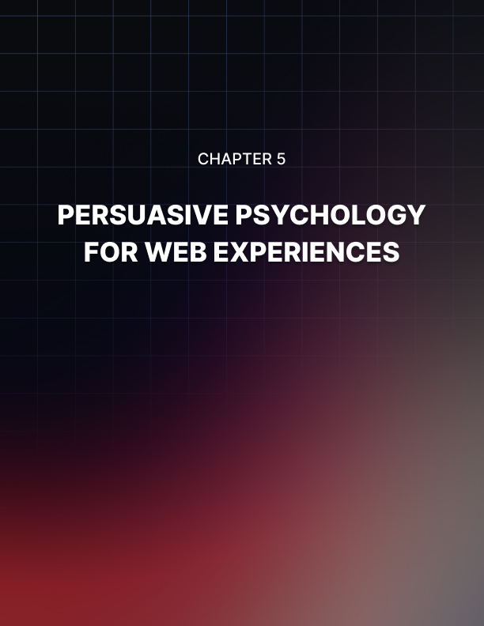

PERSUASIVE PSYCHOLOGY FOR WEB EXPERIENCES
____
The online world is a busy place where grabbing and keeping people's attention is really important. As an entrepreneur, your website is like your business's online store and often gives the first impression to potential customers. In this chapter, you'll learn how to use psychology to make web experiences that not only catch visitors' interest but also convince them to take action, helping you boost sales and grow your business.

The Psychology Behind Web Design
Before diving into specific design strategies, it's crucial to understand the psychological principles that underpin effective web design. By grasping these concepts, you'll be better equipped to create websites that resonate with your audience on a deeper level.
Visual hierarchy is the arrangement and organization of design elements to show their order of importance. This principle is based on the way the human brain processes information, prioritizing certain visual cues over others. By strategically using size, color, contrast, and placement, you can guide your visitors' attention to the most important elements on your page. For example, larger elements are typically perceived as more important, while contrasting colors can make certain elements stand out. The human eye naturally follows specific patterns when scanning a page (such as the F-pattern for text-heavy content or the Z-pattern for more visual layouts), and understanding these patterns can help you place your key messages and calls-to-action (CTAs) where they're most likely to be seen.
The Gestalt principles of visual perception describe how humans naturally organize visual elements into groups or unified wholes. These principles include proximity, similarity, continuity, closure, and figure/ground. By applying these principles in your web design, you can create layouts that are intuitive and easy for users to understand and navigate. For instance, elements that are close together are perceived as more related than elements that are farther apart, while elements that share similar characteristics (shape, color, size, etc.) are perceived as part of the same group. The eye tends to follow smooth, continuous lines or paths, and the mind tends to perceive complete shapes even when part of the information is missing. Understanding and applying these principles can significantly enhance the user experience on your website.
Color psychology plays a crucial role in web design, as colors evoke emotional and psychological responses that can significantly impact user behavior on your website. For example, blue often conveys trust, stability, and professionalism, making it a popular choice for financial institutions and corporate websites. Green is associated with nature, growth, and health, making it suitable for environmental or wellness-focused brands. Red can evoke excitement and urgency, often used for sales or clearance sections. Yellow is associated with optimism and youth, often used to grab attention or convey energy. Purple is often linked to luxury and creativity, popular in beauty and artistic industries. While color associations can vary across cultures, understanding these general principles can help you choose a color scheme that aligns with your brand message and encourages desired user behaviors.
Cognitive load theory suggests that our working memory has a limited capacity for processing information. When designing web experiences, it's crucial to minimize cognitive load to prevent overwhelming users. This can be achieved by breaking complex information into smaller, digestible chunks, using familiar design patterns and layouts, providing clear navigation and search functions, using visual aids like icons and images to supplement text, and employing progressive disclosure techniques to reveal information gradually. By reducing cognitive load, you make it easier for users to understand your content and take desired actions.

Key Elements of Persuasive Web Design
Now that we've covered the psychological foundations, let's explore the key elements of persuasive web design and how to implement them effectively.

Intuitive Navigation
Navigation is the backbone of your website, guiding users to the information they seek. An intuitive navigation structure reduces frustration and cognitive load, keeping users engaged with your content. To create user-friendly navigation, use clear, descriptive labels for menu items, limit the number of main navigation items to 7 or fewer to avoid overwhelming users, implement a logical hierarchy in your menu structure, use breadcrumbs to help users understand their location within your site, include a search function for larger sites, and ensure your navigation is mobile-friendly, considering options like hamburger menus for smaller screens. The goal is to make it as easy as possible for users to find what they're looking for. The fewer clicks required, the better.

Compelling Headlines and Subheadings
Headlines and subheadings are often the first elements users read on a page. They play a crucial role in capturing attention and encouraging further engagement. To create persuasive headlines, use action words and power verbs to create a sense of urgency or excitement, incorporate numbers or specific data to add credibility and intrigue, ask questions that pique curiosity or address common pain points, use the "How to" format to promise valuable information, and keep headlines concise, ideally under 70 characters for SEO purposes. For subheadings, use them to break up long blocks of text and make content more scannable, ensure they accurately summarize the content that follows, and maintain a consistent structure throughout your page or article. Headlines and subheadings should work together to tell a compelling story that encourages users to explore your content further.

Persuasive Copy
The words you use on your website can significantly impact user behavior. Persuasive copy should be clear, concise, and focused on the benefits to the user. Use the inverted pyramid style by starting with the most important information and getting more detailed as you go. Focus on benefits rather than features, explaining how your product improves the user's life instead of just listing what it does. Use active voice and direct language to create a sense of immediacy. Incorporate social proof, such as customer testimonials or usage statistics, to build credibility. Use power words that evoke emotion or create urgency. Address potential objections or concerns proactively. End with a clear call-to-action that tells the user what to do next. Tailor your tone and style to your target audience, as the language that resonates with young tech enthusiasts will differ from what appeals to senior business executives.

Strategic Use of Images and Video
Visual content can significantly enhance the persuasiveness of your website. Images and videos can convey complex information quickly, evoke emotions, and make your site more engaging. Choose high-quality, relevant images that support your message. Use images of people, particularly faces, to create an emotional connection. Incorporate product images or screenshots to give users a clear idea of what you're offering. Use infographics to present data or complex processes in an easily digestible format. Include videos to demonstrate products, share customer testimonials, or explain complex concepts. Optimize images for web use to ensure fast loading times. Use alt text for images to improve accessibility and SEO. Every visual element should serve a purpose. Avoid using images purely for decoration if they don't add value to your content.

Effective Calls-to-Action (CTAs)
Your calls-to-action are critical elements in guiding users towards conversion. Whether it's signing up for a newsletter, making a purchase, or requesting more information, your CTAs should be clear, compelling, and strategically placed. Use action-oriented language that creates a sense of urgency or excitement. Make your CTAs stand out visually using contrasting colors or button designs. Place CTAs in prominent locations, such as above the fold or at natural decision-making points in your content. Use first-person language (e.g., "Start my free trial" instead of "Start your free trial") to create a sense of ownership. Be specific about what will happen when the user clicks (e.g., "Get my free ebook" rather than "Submit"). Consider using directional cues like arrows or images of people looking towards your CTA to draw attention. Test different variations of your CTAs to see what resonates best with your audience. While it's important to make your CTAs noticeable, avoid overwhelming users with too many competing calls-to-action on a single page.

Element | Purpose | Example
Headline | Capture attention | "Transform Your Business with AI-Powered Insights"
Subheading | Provide additional context | "Unlock Hidden Opportunities and Drive Growth"
CTA Button | Prompt action | "Start Your Free Trial"
Social Proof | Build credibility | "Trusted by 10,000+ businesses worldwide"
Benefit Statement | Highlight value | "Increase productivity by 30% in just 30 days"

Advanced Persuasion Techniques
While the elements we've discussed form the foundation of persuasive web design, there are several advanced techniques you can employ to further enhance your website's ability to convert visitors into customers. Personalization involves tailoring the user experience based on individual user data or behavior. This can significantly increase the relevance and persuasiveness of your website. Use geolocation to display location-specific content or offers, implement product recommendations based on browsing or purchase history, personalize email marketing campaigns based on user behavior on your site, use dynamic content to show different messages to different user segments, and implement a personalized onboarding process for new users.
Scarcity and urgency can be powerful motivators for action. Display stock levels for products, especially when quantities are low, use countdown timers for limited-time offers, show the number of other users viewing a product or how many times it has been purchased recently, highlight limited edition or exclusive products, and use language that creates a sense of urgency, like "Limited time offer" or "Only 2 seats left". Use these techniques honestly and ethically, as false scarcity can quickly erode trust.
Social influence leverages the fact that humans are inherently social creatures and often look to others to guide our behavior. Show real-time activity on your site, such as recent purchases or sign-ups, display the number of customers or users you have, highlight trending or popular products, use social login options to make registration easier and show users which of their friends are also using your service, and implement a referral program and showcase successful referrers.
The principle of reciprocity suggests that people are more likely to give back when they receive something. Offer free valuable content, like ebooks, webinars, or tools, provide a free trial of your product or service, give unexpected bonuses or upgrades to customers, and offer excellent customer service or support.
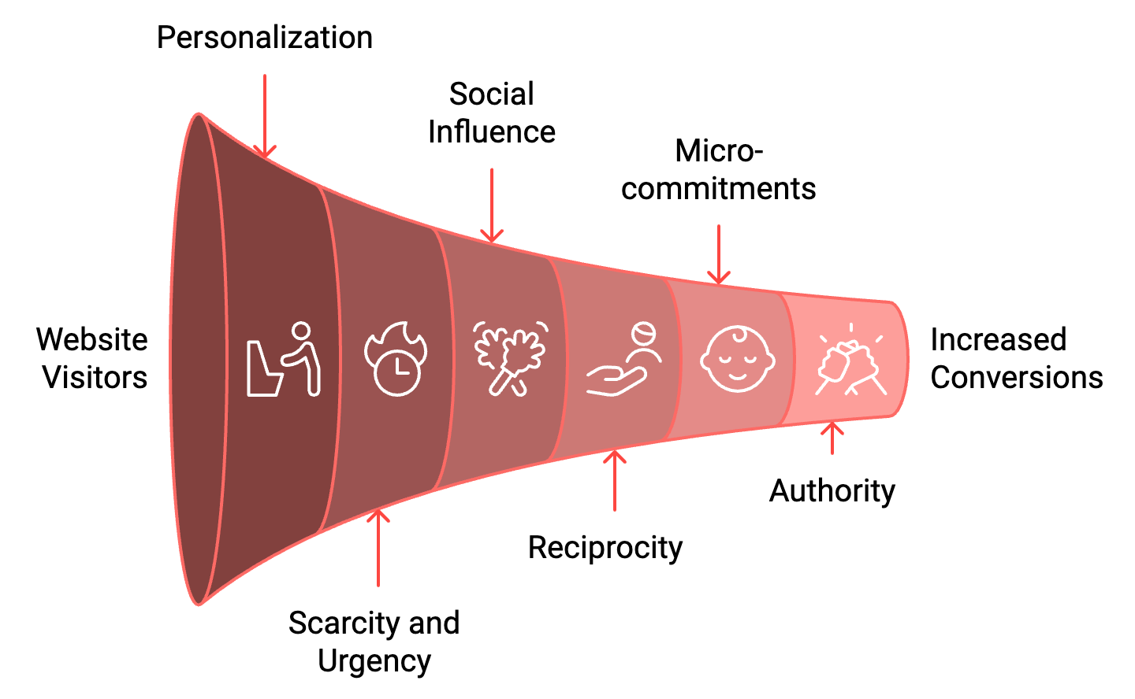
People generally like to be consistent with their past actions and commitments. You can leverage this tendency by using micro-commitments to guide users towards larger actions (e.g., "Take our 2-minute quiz to find your perfect product"), reminding users of their past interactions with your brand, allowing users to save their progress or preferences, and using progress bars to show users how close they are to completing a process.

People tend to respect and follow authority figures. Establish your authority through your web design by showcasing your credentials, awards, or certifications, highlighting media appearances or endorsements from respected figures in your industry, sharing your expertise through high-quality content, like blog posts, whitepapers, or webinars, and using professional, high-quality design to convey competence and reliability.

Optimizing for Mobile
With a mobile-first world, it's crucial that your persuasive design translates well to smaller screens. Ensure your website adjusts seamlessly to different screen sizes through responsive design. This not only provides a better user experience but is also favored by search engines. Make sure buttons, links, and other interactive elements are large enough and spaced appropriately for easy tapping on touch screens. Consider using a hamburger menu or other mobile-friendly navigation options to keep your interface clean and user-friendly. On mobile, you have less screen real estate to work with, so prioritize your most important content and calls-to-action, ensuring they appear prominently without requiring excessive scrolling. Compress images for faster loading on mobile devices, and consider using different image sizes for different screen resolutions. Optimize your site speed by minimizing HTTP requests, leveraging browser caching, and using a content delivery network (CDN). For businesses that rely on phone inquiries, make it easy for mobile users to call you directly from your website.
Take advantage of mobile-specific capabilities, such as GPS for location-based services or camera access for QR code scanning. Mobile optimization isn't just about shrinking your desktop site; it's about reimagining the user experience for mobile users, who often have different needs and behaviors than desktop users.

The Role of A/B Testing in Persuasive Design
While the principles and techniques we've discussed provide a solid foundation for persuasive web design, it's important to remember that every audience is unique. What works for one website may not work for another. This is where A/B testing comes in. A/B testing, also known as split testing, involves comparing two versions of a webpage to see which performs better. To effectively use A/B testing to optimize your persuasive design, start with a clear hypothesis about what you think will improve your conversions and why. Test one element at a time to get clear results. This could be the color of a CTA button, the wording of a headline, or the placement of a form. Ensure your test runs long enough to gather statistically significant data. The required sample size will depend on your current traffic and conversion rates. Consider running separate tests for different user segments, as different segments of your audience may respond differently to changes. A/B testing shouldn't be a one-time event. Continuously test and optimize to keep improving your results over time. While conversion rate is often the primary metric, also consider secondary metrics like time on page, bounce rate, or average order value. Keep a record of all your tests, including your hypotheses, what you changed, and the results. This can inform future tests and help you build a deeper understanding of your audience.
Remember, the goal of A/B testing is not just to find what works best now, but to continually learn about your audience and improve your persuasive design over time.

Ethical Considerations in Persuasive Design
While the techniques we've discussed can be powerful in increasing conversions, it's crucial to use them ethically. The goal should be to guide users towards decisions that genuinely benefit them, not to manipulate them into choices they may regret. Be transparent about what you're offering and what users can expect. Avoid hidden fees or unexpected obligations. While it's fine to guide users towards certain actions, always respect their right to choose. Avoid using manipulative tactics that make users feel they have no choice. Only use scarcity and urgency tactics when they're genuinely applicable. False scarcity can quickly erode trust. Be transparent about what data you're collecting and how you're using it. Give users control over their data and respect privacy regulations. Ensure your persuasive design doesn't exclude users with disabilities. Follow web accessibility guidelines to make your site usable for all. Be particularly cautious when your products or services could potentially be addictive or harmful. Ensure you're not exploiting vulnerable populations. Ensure all claims and promises made on your website are truthful and can be substantiated. By adhering to these ethical principles, you not only avoid potential legal issues but also build long-term trust with your audience, which is ultimately more valuable than any short-term gain from manipulative tactics.
In conclusion, persuasive web design is a powerful tool that combines psychology with effective design to guide users towards desired actions. By understanding your audience, applying psychological principles, and continually testing and refining your approach, you can create web experiences that not only attract and engage users but also drive conversions and business growth. The most effective persuasive design isn't about tricks or manipulation; it's about truly understanding your users' needs and presenting your product or service in a way that genuinely resonates with them. As you implement these strategies, always keep the user at the center of your design decisions, aiming to create experiences that are not only persuasive but also helpful, enjoyable, and respectful of the user's autonomy.

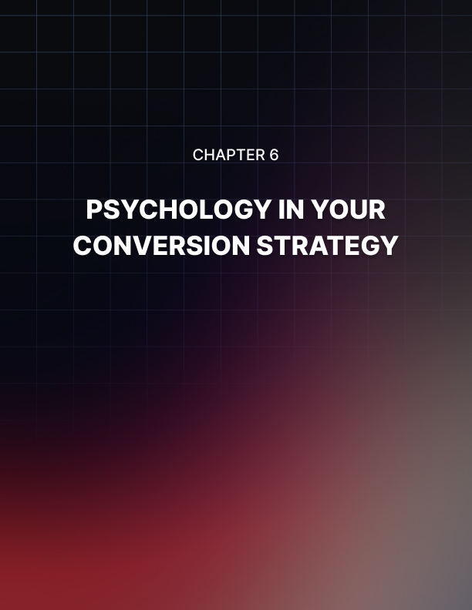

PSYCHOLOGY IN YOUR CONVERSION STRATEGY
____
The journey of understanding psychological principles and their application in marketing is just the beginning. The real challenge lies in integrating these insights into your conversion strategy effectively. This chapter will guide you through the process of transforming theoretical knowledge into practical, actionable tactics that will supercharge your conversion rates and drive business growth.

Holistic Conversion Optimization
Before diving into specific strategies, it's crucial to understand that conversion optimization is not a series of isolated tactics, but a holistic approach that permeates every aspect of your business. It's about creating a seamless customer experience that guides users naturally towards conversion, utilizing psychological principles at every touchpoint. To achieve this, you need to adopt a customer-centric mindset. This means putting yourself in your customers' shoes, understanding their needs, desires, fears, and motivations. It's about creating a journey that not only leads to conversion but also provides value and satisfaction to the customer at every step.
Here's a framework for developing a holistic, psychology-driven conversion strategy:
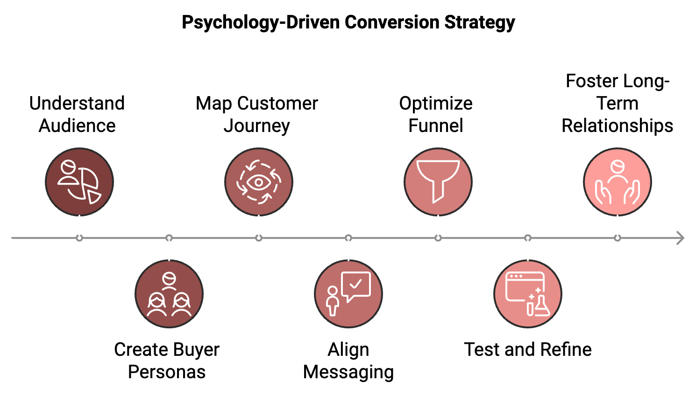
Understand your audience using data analytics, surveys, and customer interviews to gain deep insights into your target audience. Create detailed buyer personas that go beyond demographics to include psychological factors like motivations, fears, and decision-making processes. Map the customer journey by identifying all touchpoints where customers interact with your brand, from initial awareness to post-purchase support. At each stage, consider the customer's emotional state and what psychological triggers might be most effective. Align your message by ensuring that your messaging is consistent across all channels and touchpoints, speaking directly to your audience's needs and desires. Use psychological principles like social proof and scarcity where appropriate. Optimize your funnel by analyzing each stage of your conversion funnel to identify drop-off points. Use psychological insights to address barriers and smooth the path to conversion.
Test and refine by continuously testing different approaches, measuring their impact on both conversion rates and customer satisfaction. Use these insights to refine your strategy over time. Foster long-term relationships by remembering that conversion is not the end goal. Use psychological principles to build long-term customer relationships that lead to repeat business and referrals.
By adopting this holistic approach, you create a cohesive strategy that leverages psychology at every stage of the customer journey, maximizing your conversion potential.

Applying Psychology in Your Marketing Funnel
Now, let's explore how to implement psychological principles at each stage of the marketing funnel:
Awareness Stage: At the awareness stage, your goal is to capture attention and begin building trust. Use the Von Restorff Effect to make your brand stand out with unique value propositions, eye-catching visuals, or innovative marketing approaches. Leverage social proof by using testimonials, user numbers, or endorsements from respected figures in your industry to build credibility from the outset. Appeal to emotions using emotional storytelling to create a connection with your audience. Focus on the problems you solve and the aspirations you help fulfill. Use the Baader-Meinhof Phenomenon, which states that once someone is exposed to your brand, they're more likely to notice it again. Use retargeting ads and multi-channel marketing to increase brand recognition.
Interest Stage: As potential customers show interest, your goal is to deepen engagement and build desire for your offering. Utilize the Zeigarnik Effect, which suggests that people remember uncompleted tasks better than completed ones. Use cliffhangers in your content marketing or email sequences to keep users engaged. Implement the Principle of Reciprocity by offering valuable free content or resources. This creates a sense of obligation and goodwill towards your brand. Use the Mere Exposure Effect, as repeated exposure to your brand can increase liking. Use consistent branding across all channels and touchpoints. Leverage Loss Aversion by highlighting what potential customers might lose by not using your product or service, not just what they might gain.
Consideration Stage: At this stage, potential customers are actively evaluating your offering. Employ the Decoy Effect by introducing a slightly less attractive option to make your preferred option seem more appealing. Use the Anchoring Effect by presenting your most expensive option first to make other options seem more reasonable. Leverage the Bandwagon Effect by highlighting how many people are already using and benefiting from your product or service. Implement the Scarcity Principle by creating a sense of urgency with limited-time offers or exclusive deals.
Decision Stage: As customers approach the point of decision, use these psychological triggers to encourage conversion: Utilize the Endowment Effect by offering free trials or samples to create a sense of ownership before purchase. Use the Foot-in-the-Door Technique by starting with small commitments (like newsletter sign-ups) before asking for larger ones (like purchases). Implement the Peak-End Rule by ensuring the final stages of the customer journey (like checkout) are smooth and pleasant, as people tend to judge an experience based on its peak and end. Leverage the Power of Default by making the desired action the default option where possible.
Retention Stage: After conversion, focus on building loyalty and encouraging repeat business. Use the Sunk Cost Fallacy by highlighting the investment (time, money, effort) customers have already made in your product or service to encourage continued use. Implement the IKEA Effect by involving customers in the process (customization, feedback, etc.) to increase their perceived value of your offering. Leverage the Consistency Principle by reminding customers of their past positive choices regarding your brand to encourage consistent behavior. Use the Pygmalion Effect by showing that you have high expectations of your customers' success with your product, as people tend to rise to the expectations set for them.
By strategically implementing these psychological principles throughout your marketing funnel, you create a powerful, persuasive journey that guides customers naturally towards conversion and long-term loyalty.

Crafting Persuasive Copy with Psychology
Your copy is one of the most direct ways to apply psychological principles to your conversion strategy. Here's how to craft copy that resonates on a deeper level with your audience:
Use the Framing Effect: How you present information can significantly impact decision-making. For example, "90% fat-free" sounds more appealing than "10% fat." Frame your offering in the most positive light.
Leverage Loss Aversion: People are more motivated by the fear of losing something than by the prospect of gaining something of equal value. Instead of just highlighting benefits, also emphasize what customers might lose by not choosing your product or service.
Employ the Paradox of Choice: While choice is generally good, too many options can lead to decision paralysis. Simplify your offerings and clearly guide customers towards the best option for them.
Use the Power of Free: The word "free" has a strong psychological pull. Offer something for free (like shipping, a trial period, or a bonus item) to make your offer more attractive.
Implement the Primacy and Recency Effects: People tend to remember the first and last items in a series best. Put your most important points at the beginning and end of your copy.
Use Social Proof: Incorporate testimonials, user numbers, or endorsements to leverage the power of social influence.
Createa Sense of Urgency: Use time-limited offers or highlight scarcity to motivate immediate action.
Leverage the Commitment and Consistency Principle: If people commit to an idea or goal, they're more likely to honor that commitment. Get small commitments (like email sign-ups) before asking for larger ones (like purchases).
Use the Bandwagon Effect: Highlight the popularity of your product or service to tap into people's desire to follow the crowd.
Employ the Contrast Principle: People evaluate things in relation to other things. Strategically contrast your offering with alternatives to highlight its value.
The key to effective persuasive copy is to combine these psychological principles with genuine value and honesty. Your goal should be to guide customers toward decisions that truly benefit them, not to manipulate them into choices they may regret.

Designing for Conversion with Psychology
The design of your website or app plays a crucial role in guiding users towards conversion. Here's how to apply psychological principles to your design:
Use the Von Restorff Effect: Make your call-to-action buttons stand out by using contrasting colors or unique designs.
Implement Hick's Law: Simplify choices to reduce cognitive load. Use clear navigation and limit the number of options presented at any one time.
Leverage the Serial Position Effect: Place your most important elements at the beginning and end of lists or sequences, as these positions are most easily remembered.
Use the Gestalt Principles: Design elements that are close together or share similar characteristics are perceived as related. Use this to group related information or options.
Implement the Zeigarnik Effect: Use progress bars or checklists to show uncompleted tasks, motivating users to finish what they've started.
Use Color Psychology: Different colors evoke different emotions and associations. Choose colors that align with your brand and the desired user response.
Leverage the Principle of Least Effort: Make desired actions as easy as possible. Reduce the number of steps required to complete a purchase or sign up.
Implement Social Proof: Display user reviews, ratings, or usage numbers prominently to leverage social influence.
Use the Isolation Effect: Draw attention to key elements by making them visually distinct from their surroundings.
Leverage the Endowment Effect: Allow users to customize or personalize their experience to increase their sense of ownership and value.
Good design isn't just about aesthetics—it's about crafting an intuitive, enjoyable user experience that naturally guides users toward conversion.

Data and Analytics in Your Strategy
To truly optimize your conversion strategy, you need to combine psychological insights with data-driven decision making. Here's how to effectively use data and analytics:
- Set Clear Goals
Define what conversions mean for your business. This could be purchases, sign-ups, downloads, or any other desired action.
- Implement Comprehensive Tracking
Use tools like Google Analytics to track user behavior across your site or app. Set up event tracking for key actions.
- Use Heatmaps and Session Recordings
Tools like Hotjar can show you where users are clicking and how they're navigating your site, providing insights into user behavior and potential pain points
- Conduct A/B Testing
Systematically test different versions of your pages, emails, or ads to see which performs better. Use statistical significance to ensure your results are reliable.
- Analyze Your Funnel
Identify where users are dropping off in your conversion funnel. Use this information to optimize problematic stages.
- Segment Your Audience
Different user segments may respond differently to various psychological tactics. Analyze behavior by segment to tailor your approach.
- Monitor Key Metrics
Keep a close eye on metrics like conversion rate, bounce rate, time on site, and average order value. Look for trends and correlations.
- Use Predictive Analytics
Leverage machine learning algorithms to predict future behavior based on historical data, allowing you to proactively optimize your strategy.
- Implement Customer Feedback Loops
Use surveys, user testing, and customer interviews to gather qualitative data that can provide context to your quantitative insights.
- Create a Data-Driven Culture
Encourage all team members to base decisions on data rather than assumptions or personal preferences.
By combining psychological principles with robust data analysis, you create a powerful, adaptive conversion strategy that continually improves over time.
Psychological Principle | Application in Conversion Optimization | Example
Social Proof | Display customer testimonials, user numbers, or ratings | "Join over 1 million satisfied customers!"
Scarcity | Create a sense of urgency or limited availability | "Only 5 spots left for this webinar!"
Reciprocity | Offer something of value for free | "Download our free ebook to learn more"
Anchoring | Present a higher price point first | Show the original price crossed out next to the sale price
Loss Aversion | Emphasize what customers might lose by not converting | "Don't miss out on these exclusive benefits"
Commitment and Consistency | Get small commitments before asking for larger ones | Ask for an email sign-up before a purchase
Authority | Showcase expertise or endorsements from respected figures | "As featured in Forbes and The Wall Street Journal"
Liking | Create a personable brand voice and use relatable imagery | Use friendly, conversational copy and diverse user images
Framing | Present information in the most favorable light | "80% fat-free" instead of "contains 20% fat"
Paradox of Choice | Limit options to prevent decision paralysis | Offer 3-5 pricing tiers instead of numerous options

This table provides a quick reference for applying key psychological principles in conversion optimization, along with examples of how they might be implemented.

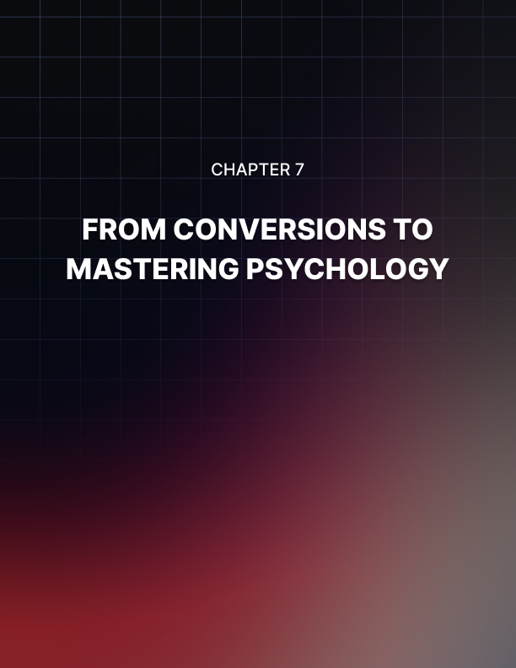

FROM CONVERSIONS TO MASTERING PSYCHOLOGY
____

The Evolution of Psychological Marketing
The field of marketing psychology has come a long way since its inception. From the early days of simple advertising techniques to today's sophisticated, data-driven approaches, the evolution has been remarkable. In the early 20th century, marketing was more art than science. Advertisers relied heavily on intuition and creativity to capture audience attention. However, pioneers like Edward Bernays, often called the "father of public relations," began to apply psychological principles to influence public opinion. Bernays, who was Sigmund Freud's nephew, used his uncle's psychoanalytic theories to manipulate consumer behavior. While some of these early techniques were controversial, they laid the groundwork for the scientific approach to marketing that would follow.
As the field of psychology advanced, so did its application in marketing. In the 1950s and 60s, researchers began to study consumer behavior more systematically. Motivational research, led by Ernst Dichter, sought to uncover the hidden psychological motivations behind consumer choices. This era saw the birth of focus groups and in-depth interviews as tools for understanding consumer psychology. The advent of the internet and digital technologies in the late 20th and early 21st centuries revolutionized marketing psychology. Suddenly, marketers had access to vast amounts of data about consumer behavior. This led to the rise of behavioral targeting, personalized marketing, and real-time optimization of marketing campaigns. The ability to track and analyze user behavior online opened up new avenues for applying psychological principles in marketing.
Today, we're seeing a more integrated approach to marketing psychology. Marketers are combining insights from various fields - psychology, neuroscience, behavioral economics, and data science - to create more effective and ethical marketing strategies. There's also a growing emphasis on ethical considerations in psychological marketing, with many companies striving to influence consumer behavior in ways that benefit both the business and the customer. Looking ahead, the future of psychological marketing is likely to be shaped by artificial intelligence and hyper-personalization. AI algorithms can analyze vast amounts of data to predict consumer behavior and tailor marketing messages to individual preferences. However, this also raises new ethical questions about privacy and manipulation that marketers will need to grapple with.

Beyond Conversions Building Relationships
While increasing conversion rates is a crucial goal for any business, it's equally important to focus on building long-term relationships with your customers. Psychological principles can be powerful tools in fostering customer loyalty and encouraging repeat business. Customer loyalty is not just about repeat purchases; it's about creating an emotional connection between your brand and your customers. Several psychological principles come into play when building customer loyalty:
- The Mere Exposure Effect
This principle suggests that people tend to develop a preference for things merely because they are familiar with them.
- The Endowment Effect
This psychological principle states that people ascribe more value to things once they own them.
- Cognitive Dissonance
This refers to the mental discomfort people feel when their actions don't align with their beliefs.
- The Ikea Effect
Named after the furniture retailer, this principle suggests that people place a disproportionately high value on products they partially created.
Now that we understand some of the psychological principles behind customer loyalty, let's look at how to implement strategies that foster long-term relationships:
- Personalization
Use data analytics to understand individual customer preferences and tailor your communications and offerings accordingly.
- Loyalty Programs
Design loyalty programs that offer genuine value to customers.
- Customer Education
Offer valuable information and resources to your customers.
- Community Building
Create platforms for customers to interact with each other and with your brand.
- Feedback Loops
Regularly seek and act on customer feedback.
- Surprise and Delight
Occasionally exceed customer expectations with unexpected perks or gestures.
- Storytelling
Share your brand's story and values.
By implementing these strategies, you're not just working to increase immediate conversions, but building a foundation for long-term customer relationships that can drive sustainable business growth.

Psychology in Customer Experience Design
Customer experience (CX) is now a key factor that sets businesses apart. By applying psychological principles to CX design, you can create experiences that not only satisfy but also delight customers, fostering loyalty and driving long-term success. Before we dive into specific strategies, it's important to understand some key psychological principles that underpin positive experiences:
- Peak-End Rule
People tend to judge an experience based on how they felt at its peak (i.e., its most intense point) and at its end, rather than based on the average of every moment of the experience.
- Dopamine-Driven Feedback Loops
Dopamine, often called the "feel-good" neurotransmitter, plays a crucial role in motivation and reward-seeking behavior.
- Cognitive Ease
People prefer experiences that are easy to process mentally.
- Emotional Contagion
Emotions can be "contagious," spreading from one person to another.
Now, let's explore how to apply these and other psychological principles to enhance your customer experience:
- Journey Mapping with Emotional Touchpoints
Create detailed customer journey maps that not only outline the steps customers take, but also the emotions they're likely to feel at each stage.
- Personalization and the Cocktail Party Effect
By addressing customers by name and referencing their specific history or preferences, you can cut through the noise and create a more engaging experience.
- Leverage the Power of Defaults
Use this principle to guide customers towards options that will give them the best experience (and benefit your business).
- Create Moments of Delight
Create unexpected moments of delight throughout the customer journey.
- Use the Zeigarnik Effect
Create a sense of progress towards a goal.
- Employ the Labor Illusion
Show some form of "work in progress" to increase perceived value.
- Leverage Social Proof
Incorporate elements of social proof into your CX, such as showing real-time numbers of other customers viewing a product or displaying a feed of recent purchases.
- Use the Framing Effect
Frame your communications in a way that emphasizes the positive.
- Implement the Foot-in-the-Door Technique
Start with a small request to increase the likelihood of agreement with a larger request later.
- Design for Cognitive Ease
Make every interaction as smooth and intuitive as possible.
- Utilize the Primacy and Recency Effects
Make sure the first and last interactions in any customer journey are particularly positive and memorable.
- Employ Reciprocity
Offer something valuable for free to encourage positive feelings and future engagement.
By incorporating these psychologically-informed strategies into your customer experience design, you can create more engaging, satisfying, and memorable experiences for your customers. This not only drives immediate conversions but also fosters the kind of long-term loyalty that leads to sustainable business success.

The Ethics of Psychological Marketing
Using psychological principles in marketing can be very effective, but it comes with responsibilities. The main question is where to draw the line between influencing people and manipulating them. Marketers need to think carefully about this.
Here are some important ethical principles to keep in mind:
- Transparency
Be clear about what you're doing in your marketing.
- Honesty
Don't mislead or lie to customers.
- Respect for Choice
Make sure customers always have real options.
- Doing Good
Your marketing should help customers, not just make money.
- Avoid Harm
Don't hurt customers or make them feel bad.
- Fairness
Treat everyone equally and avoid discrimination.
- Privacy
Protect customer data and be careful with how you use it.
When you apply these principles, make sure scarcity is real, and any social proof, like reviews, is true. Offer real value if you're using reciprocity, be honest about data use, and avoid framing information in a misleading way. Don't use tactics like anchoring or loss aversion to scare people or make them anxious.
Creating an ethical approach is more than just following rules; it’s about building a culture where people value doing the right thing. This means writing a code of ethics, training the team, encouraging open discussions about ethics, reviewing campaigns for any issues, checking how marketing affects customers, and setting an example of ethical behavior.
By focusing on ethical marketing, you can avoid problems and build stronger relationships with customers. In the long run, being honest and fair is better for your business than using manipulative tactics.



FINAL THOUGHTS
____
This book has explored the exciting world of conversion psychology, showing how understanding the way people think and make decisions can help you improve your marketing and grow your business. By using these insights, you can create strategies that connect with your audience and boost the chances of them taking action.
You started by learning basic psychology principles, like why people are influenced by certain things and how emotions can drive decisions. You discovered how to use these ideas to shape your marketing, whether by creating a sense of urgency, using social proof to build trust, or making customers feel like they belong. These strategies help guide customers to make a choice that benefits them and your business.
The book also showed how important it is to design for conversions, using psychology to improve the experience people have with your website, your ads, and your messages. Whether through eye-catching design, persuasive words, or smartly placed buttons, the goal is to make it easy and natural for customers to take the next step.
Ethics matter, too. Using these strategies responsibly is important so that your marketing doesn't just sell products, but also builds trust and strong relationships. When done right, marketing can help both your business and your customers succeed.
When putting these ideas into practice, keep in mind that there isn’t a one-size-fits-all approach. Always test, measure, and adjust your strategies to suit your audience and business goals. Keep learning, stay curious, and be ready to adapt as new trends and technologies emerge.
With the tools you've learned in this book, you can make your marketing more powerful. By understanding what motivates people and meeting their needs, you'll not only increase sales but also create a brand that people trust and come back to. Now it’s time to put these ideas into action and watch your business grow.

