TABLE OF CONTENTS
____
INTRODUCTION 5
WHY SEGMENTATION MATTERS 8
Understanding Segmentation in Email Marketing 8
The Psychology Behind Segmentation 10
Avoiding Common Pitfalls in Segmentation 10
Essential Tools for Effective Segmentation 11
Implementing Segmentation Strategies 11
Case Study: Spotify's Segmentation Success 12
DESIGNING MESSAGES THAT RESONATE 15
The Art of Personalization 15
Crafting Compelling Subject Lines 16
The Power of Dynamic Content 16
Emotional Triggers in Email Marketing 17
Maintaining Brand Consistency 17
Case Study: Airbnb's Personalized Email Strategy 18
Overcoming Challenges in Email Personalization 18
BEHAVIOR-DRIVEN AUTOMATION 21
Understanding Behavior-Driven Automation 21
Advanced Tagging and Scoring Systems 22
Enhancing Relevance and Timing 24
Case Study and Overcoming Obstacles 24
Measuring Success and Optimizing 25
METRICS AND OPTIMIZATION 28
Understanding Key Performance Indicators (KPIs) 28
The Power of A/B Testing 30
Refining Segments for Improved Outcomes 31
Real-Time Data Insights and Adjustments 32
Emerging Trends in Email Marketing Metrics 33
A CONCLUSION TO EMPOWER 36
The Power of Knowing Your Audience 36
Crafting Messages That Resonate 37
Behavior-Driven Automation 37
Measuring Success and Optimizing Performance 38
Embracing Emerging Trends and Technologies 39

DISCLAIMER
____
The information provided in this ebook is intended solely for educational and informational purposes. The author does not accept any responsibility for the outcomes that may arise from the application of the material within. While efforts have been made to ensure the accuracy and relevance of the content, the author cannot be held accountable for any errors or omissions, or for any consequences resulting from the use or misuse of the information provided. The responsibility for any actions taken based on the information in this ebook lies solely with the reader.


INTRODUCTION
____
Prepare to transform your email marketing strategy and achieve new levels of business success. This ebook offers a practical approach to crafting emails so personalized and engaging that your customers will eagerly anticipate each message you send.

Learn how to use behavior-triggered emails and personalized product recommendations to reach customers at just the right moment.

Imagine the impact of speaking directly to each customer’s unique needs and preferences. Picture open rates rising, click-through rates doubling, and conversions reaching new heights. This isn’t just a goal—it’s what becomes possible when you master segmentation and personalization.
What sets this ebook apart is its focus on practical, actionable strategies. You’ll dive into defining audience segments with precision, crafting messages tailored to each group, and implementing dynamic content that feels crafted for individual readers. Learn how to use behavior-triggered emails and personalized product recommendations to reach customers at just the right moment, fostering meaningful connections and driving results.
Along the way, you’ll gain a fresh perspective on your customer relationships, seeing your email list not as one large group but as individuals with distinct stories, needs, and preferences. This shift will deepen your understanding and strengthen customer connections.
By the end of this ebook, you’ll have the tools to create campaigns that resonate on a personal level—sending the right message to the right person at the right time. Whether you’re a startup or established business, this ebook will help you implement high-impact strategies that set you ahead of the competition.
If you’re ready to elevate your email marketing with tailored, high-impact communication, let’s begin. Your path to mastering segmentation and personalization starts now, opening doors to lasting customer relationships and measurable success.



WHY SEGMENTATION MATTERS
____
In email marketing, knowing your audience isn't just helpful—it's essential. Segmentation is the key that unlocks the door to truly understanding and connecting with your audience. It's the difference between shouting into a crowded room and having a personal conversation with each individual.
As a business owner or marketer, you're constantly seeking ways to improve your communication with customers. You want your messages to resonate, inspire action, and ultimately drive results. Segmentation is the tool that allows you to do just that.

Understanding Segmentation in Email Marketing
At its core, segmentation is the practice of dividing your email list into smaller groups based on specific criteria. These criteria can range from basic demographic information to complex behavioral patterns. Segmenting your audience allows you to tailor messages that speak directly to the unique needs, interests, and preferences of each group.
Imagine you're running a fitness equipment store. Would you send the same email to a seasoned bodybuilder and a new mom looking to get back into shape after pregnancy? Of course not. Their needs, goals, and interests are vastly different. This is where segmentation shines. It allows you to craft messages that speak directly to each group's specific situation, dramatically increasing the relevance and effectiveness of your emails.
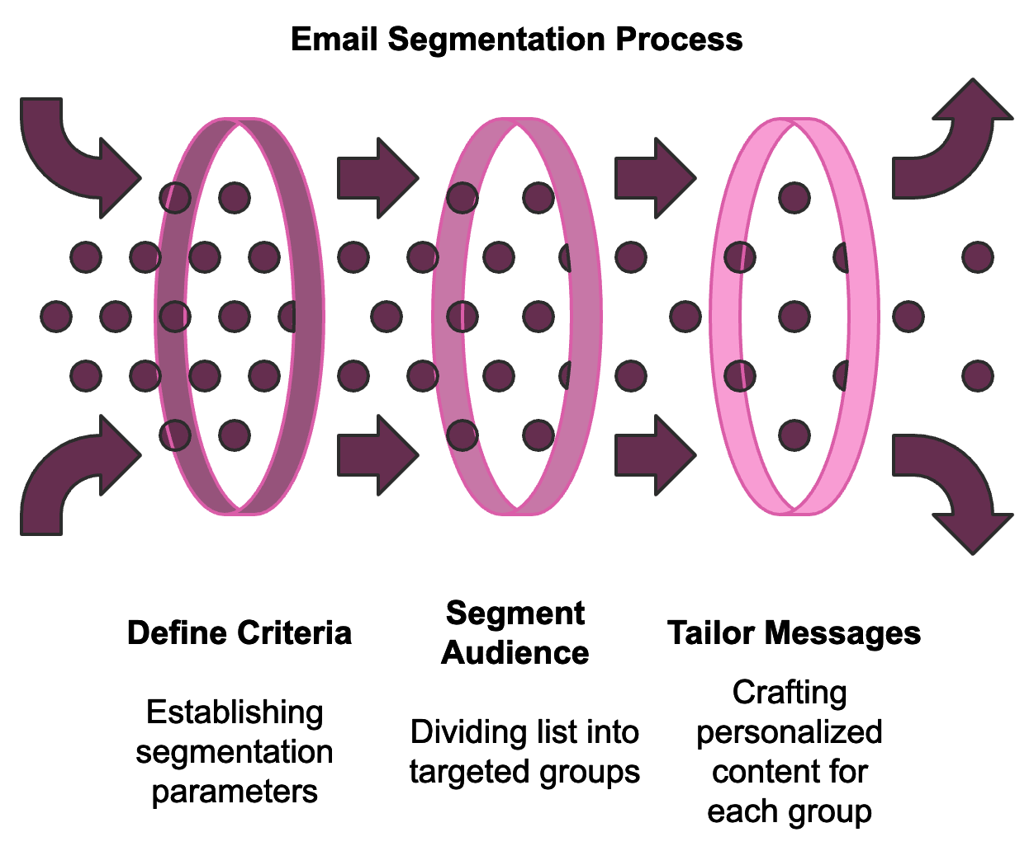
The power of segmentation lies in its ability to transform your email marketing from a one-size-fits-all approach to a personalized, targeted strategy. According to a 2024 study by Email Marketing Trends, businesses that use segmented campaigns note as much as a 760% increase in revenue. This staggering statistic underscores the tremendous potential of segmentation in driving business growth.

The Psychology Behind Segmentation
People are more likely to engage with content that feels personally relevant to them. When you receive an email that speaks directly to your interests or needs, you're more likely to open it, read it, and take action. Segmentation allows you to create these personalized experiences at scale.
Common ways to segment your audience include demographics (age, gender, location, income level), behavioral data (interactions with your brand), purchase history, email engagement, customer lifecycle stage, and preferences. Each of these segmentation methods allows for more targeted and effective communication.

Avoiding Common Pitfalls in Segmentation
While segmentation is powerful, it's important to avoid common mistakes:
- The "One-Size-Fits-All" Trap
Avoid creating a single email and blasting it out to your entire list. This approach ignores the diverse needs and interests of your audience.
- Over-Segmentation
Creating too many segments can lead to analysis paralysis. Start with a few key segments and expand as you become more comfortable with the process.

- Ignoring Data Quality
Segmentation is only as good as the data you're using. Regularly clean your email list and update your customer data to ensure your segments remain accurate and effective.
- Failing to Test and Optimize
Segmentation isn't a "set it and forget it" strategy. It requires ongoing testing and optimization to ensure you're getting the best results.

Essential Tools for Effective Segmentation
To implement effective segmentation strategies, you'll need the right tools and software. Customer Relationship Management (CRM) systems like Salesforce, HubSpot, and Zoho CRM allow you to store and analyze customer data, track interactions, and create detailed customer profiles. Email marketing platforms such as Mailchimp, Constant Contact, and Klaviyo often come with built-in segmentation tools. Analytics tools like Google Analytics and Hotjar provide insights into website behavior and user interactions. Data enrichment tools like Clearbit and FullContact can help fill in gaps in your customer data for more precise segmentation.

Implementing Segmentation Strategies
Here's a step-by-step approach to creating segments:
- Define Your Goals: Clarify what you're trying to achieve. Your goals will guide your segmentation strategy.
- Analyze Your Data: Look for patterns or groupings that naturally emerge.
- Create Buyer Personas: Develop detailed profiles of your ideal customers.
- Choose Your Segmentation Criteria: Decide which criteria you'll use to segment your list.
- Implement Your Segments: Use your email marketing platform or CRM to create your segments.
- Develop Targeted Content: Create email content that speaks directly to each segment's needs and interests.
- Test and Refine: Monitor the performance of your segmented campaigns and adjust your approach as needed.
Segmentation is an ongoing process. With each new piece of data and insight about your audience, you can keep refining your segments to achieve even better results.

Case Study: Spotify's Segmentation Success
Spotify, the popular music streaming service, is renowned for its personalized user experience. They use segmentation and personalization extensively in their email marketing, segmenting users based on listening habits, favorite genres, and engagement levels. This data is used to send highly targeted emails, such as notifications about new music from favorite artists or "We miss you" emails featuring tailored playlists for inactive users.
This approach has been incredibly successful for Spotify. According to their 2023 annual report, personalized playlists and recommendations drive over 30% of their total streams. While this isn't solely due to email marketing, it demonstrates the power of segmentation and personalization in engaging users and driving desired behaviors.
Segmentation Criteria | Example Email Campaign
Listening Habits | New Release Alerts
Favorite Genres | Genre-specific Playlists
Engagement Levels | "We Miss You" Reactivation

Starting your segmentation efforts in email marketing is a process of ongoing refinement, where each step brings new insights and improvements. You'll continually learn more about your audience and refine your approach over time. The key is to start small, test different approaches, and always keep your audience's needs and preferences at the forefront of your strategy.
Segmentation is more than just a marketing tactic—it's a fundamental shift in how you approach customer communication. When you address your audience as individuals rather than a single group, you demonstrate that you genuinely value their unique needs and preferences. This approach not only leads to better marketing results but also helps build stronger, more lasting relationships with your customers.
Moving forward, you'll learn to craft messages that resonate with each segment, automate your email marketing based on customer behaviors, and track the success of your segmentation efforts. Each of these elements builds on the foundation of segmentation, creating a powerful email marketing strategy that drives real results for your business.
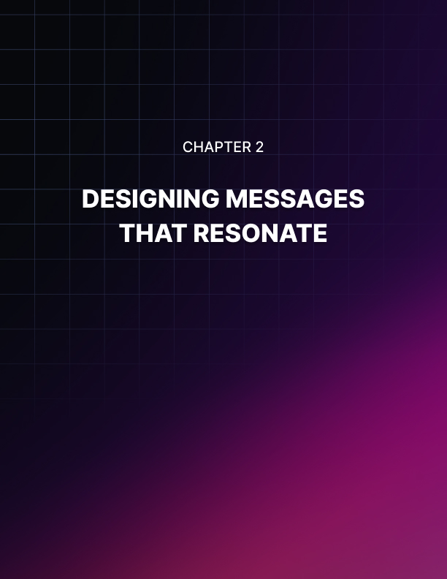

DESIGNING MESSAGES THAT RESONATE
____

The Art of Personalization
Personalization goes beyond addressing subscribers by name. It's about tailoring every aspect of your email to match the interests, needs, and behaviors of each segment. This level of customization can significantly boost your email performance. According to a 2024 study by EmailMarketingStorm, personalized email campaigns have an average open rate of 28.4%, compared to 18.3% for non-personalized campaigns.
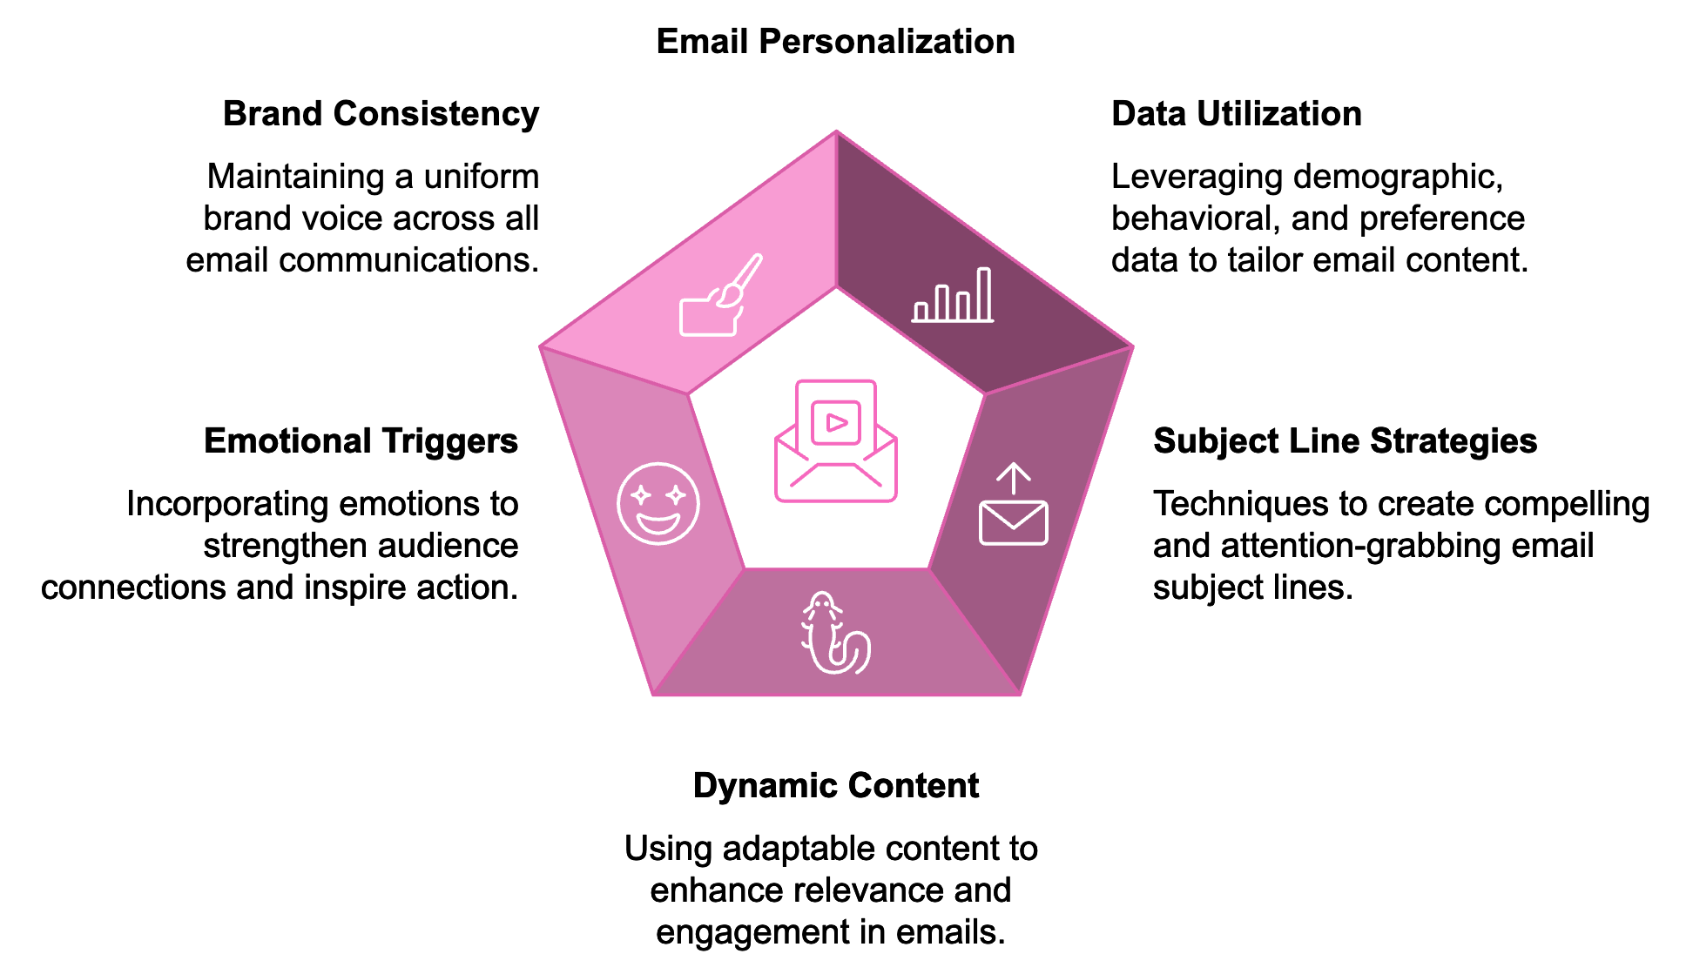
To achieve this level of personalization, you need to leverage the data you've gathered during the segmentation process. Different types of data can be used to personalize your emails, including demographic data, behavioral data, preference data, and purchase history. Effectively utilizing this information enables you to create highly targeted and relevant email content that truly resonates with your audience.

Crafting Compelling Subject Lines
Your subject line is the gateway to your email content. It's what entices subscribers to open your message in the first place. Strategies for creating subject lines that grab attention include using personalization, creating a sense of urgency, piquing curiosity, keeping it concise, and using numbers. Remember to A/B test your subject lines to see what resonates best with each segment of your audience.

The Power of Dynamic Content
Dynamic content is a game-changer in email personalization. It allows you to create a single email template that automatically adjusts its content based on the recipient's data. You can use dynamic content to enhance your emails through product recommendations, location-based content, weather-triggered emails, countdown timers, and personalized images. Implementing dynamic content may require more advanced email marketing tools, but the results can be well worth the investment.

Emotional Triggers in Email Marketing
Emotions play a crucial role in decision-making. By incorporating emotional triggers into your emails, you can create a stronger connection with your audience and inspire action. Some emotional triggers you can use include Fear of Missing Out (FOMO), trust, curiosity, joy, and belonging. Remember, the key is to use these triggers authentically and in a way that aligns with your brand values.

Maintaining Brand Consistency
While personalization is crucial, it's equally important to maintain a consistent brand voice across all your communications. Your brand voice is the personality and emotion infused into your company's communications. It should remain consistent whether you're writing to a new lead or a long-time customer. To maintain brand consistency while personalizing, create a brand style guide, use templates, train your team, and conduct regular audits.
Personalized product recommendations can significantly boost your email marketing results. According to a 2024 study by ShopifyInsights, emails with personalized product recommendations have a 50% higher conversion rate compared to generic product emails. Strategies for effective product recommendations include showcasing recently viewed items, complementary products, bestsellers in preferred categories, replenishment reminders, and new arrivals that align with the subscriber's interests.
Even with all the personalization tactics, your email's success ultimately comes down to the quality of your writing. Tips for crafting compelling email copy include starting strong, focusing on benefits, using active voice, creating scannable content, including a clear call-to-action (CTA), using power words, and telling a story.

Case Study: Airbnb's Personalized Email Strategy
Airbnb provides an excellent example of effective email personalization. They use a combination of user data, including past bookings, search history, and wish list items, to create highly personalized email campaigns. Their "Trip Inspiration" emails suggest destinations based on the user's previous searches and bookings, and include personalized recommendations for specific listings that match the user's preferences. This personalized approach has yielded impressive results for Airbnb, contributing to a 13% increase in bookings from existing users according to their 2023 shareholder letter.

Overcoming Challenges in Email Personalization
While personalization can significantly improve your email marketing results, it does come with some challenges. These include ensuring data quality, addressing privacy concerns, overcoming technical limitations, managing content creation, and avoiding over-personalization. Addressing these challenges head-on and refining your approach allows you to create email experiences that resonate deeply with your audience, fostering engagement, loyalty, and driving business growth.
Personalization Challenge | Solution
Data Quality | Regularly clean email list, use double opt-in
Privacy Concerns | Be transparent, follow data protection regulations
Technical Limitations | Invest in robust email marketing tools
Content Creation | Use templates and dynamic content
Over-Personalization | Find the right balance to enhance user experience

Implementing these personalization strategies is an ongoing process that evolves over time. Continually test different approaches, analyze your results, and refine your tactics. Pay attention to how different segments respond to various personalization techniques and adjust accordingly. Mastering these skills will enable you to craft email experiences that genuinely connect with your audience, boosting engagement, loyalty, and driving business growth.
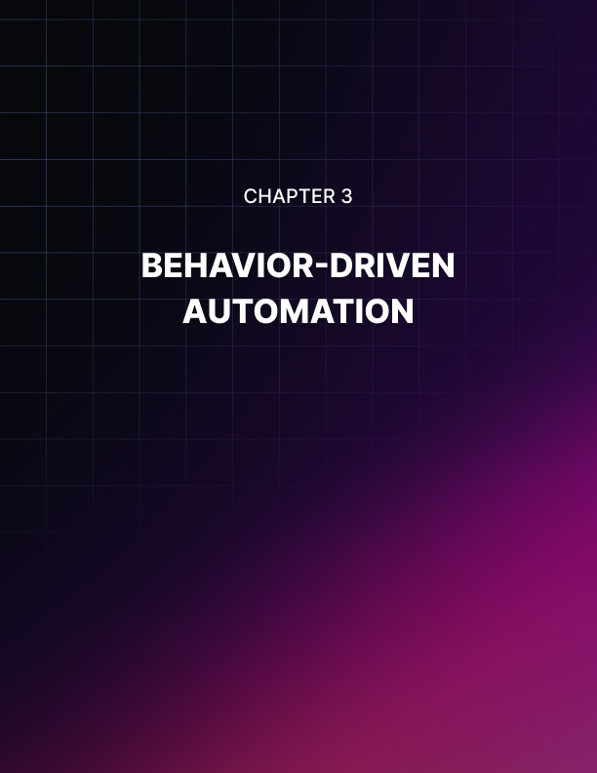

BEHAVIOR-DRIVEN AUTOMATION
____
Perfect timing can make all the difference in email marketing. When you send the right message at the right moment, you're more likely to capture your audience's attention and inspire action. This is where behavior-driven automation comes into play.
Behavior-driven automation allows you to send targeted emails based on specific actions your subscribers take (or don't take). It's like having a personal assistant who knows exactly when to reach out to each customer with the perfect message. This approach can significantly boost your email marketing effectiveness, leading to higher engagement rates and increased conversions.

Understanding Behavior-Driven Automation
Behavior-driven automation involves setting up email sequences that are triggered by specific customer actions. These actions could include signing up for your newsletter, abandoning a shopping cart, making a purchase, clicking on a specific link in an email, visiting a particular page on your website, or not opening emails for a certain period. Responding to these behaviors with timely, relevant emails helps create a more personalized and engaging experience for your subscribers.
To implement behavior-driven automation, you'll need to set up automated email sequences. This process involves identifying key customer behaviors, mapping out your sequences, creating compelling email content, setting up triggers in your email marketing platform, testing your sequences, and continuously monitoring and optimizing their performance. Common automated sequences include welcome sequences, abandoned cart sequences, and post-purchase sequences, each designed to address specific customer behaviors and needs.
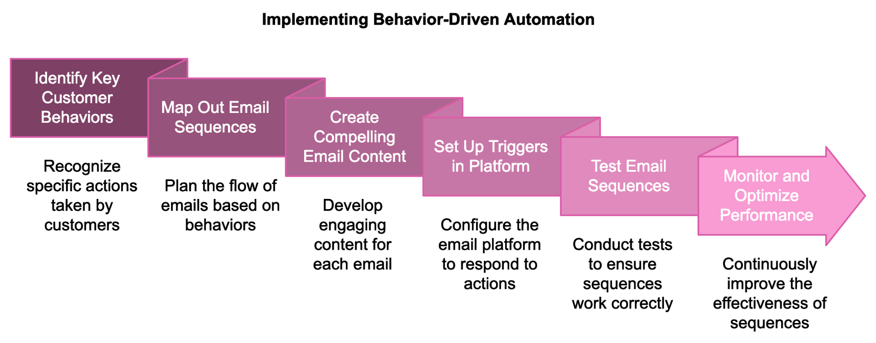

Advanced Tagging and Scoring Systems
To take your behavior-driven automation to the next level, consider implementing a tagging and scoring system. This approach allows you to categorize subscribers based on their behaviors and engagement levels, enabling even more targeted and effective email marketing.
Tagging involves applying labels to subscribers based on their actions or characteristics. For example, you might use tags like "Interested in shoes," "First-time buyer," or "High opener." Applying these tags enables you to create highly targeted segments for your email campaigns.
Lead scoring involves assigning point values to various actions and characteristics of your subscribers. This allows you to quantify how engaged and valuable each subscriber is to your business. You might assign points for actions like opening an email, clicking a link, visiting your website, downloading a resource, or making a purchase. Setting up a lead scoring system allows you to easily identify your most engaged subscribers, helping you tailor your marketing efforts effectively.
Action | Points
Opens an email | 1
Clicks a link in an email | 3
Visits your website | 5
Downloads a resource | 10
Makes a purchase | 50

Enhancing Relevance and Timing
The key to successful behavior-driven automation is ensuring your emails are both relevant and timely. Some strategies to achieve this include using real-time triggers, considering time zones, respecting frequency preferences, using dynamic content, and implementing conditional logic. It's equally important to avoid over-communication by setting frequency caps, prioritizing your sequences, allowing easy opt-outs, and monitoring engagement metrics.
To maximize the effectiveness of your behavior-driven automation, it's crucial to integrate it seamlessly with your other marketing systems. This integration allows for a more holistic view of your customers and enables more sophisticated automation strategies. Consider integrating your email marketing platform with your CRM system, e-commerce platform, website analytics, and social media tools.

Case Study and Overcoming Obstacles
Grammarly, the popular writing assistant tool, provides an excellent example of effective behavior-driven email automation. They use a combination of user behavior data and engagement metrics to send highly targeted, timely emails. For example, when a user's engagement with the tool starts to decline, Grammarly sends a re-engagement email showcasing new features or providing writing tips. They also send weekly writing stats to active users, encouraging continued use of the tool. For users on the free plan, Grammarly sends targeted emails highlighting the benefits of the premium version based on the user's specific writing habits and needs. This behavior-driven approach has contributed to Grammarly's impressive user retention rates, with over 30 million daily active users as of 2024.
While implementing behavior-driven automation, you may encounter challenges such as data silos, complex setup processes, maintaining relevance, and balancing personalization with scalability. To overcome these obstacles, consider investing in integration tools or a customer data platform, starting simple and gradually building more complex sequences, regularly reviewing and updating your automated emails, and using dynamic content and segmentation to achieve a good balance between personalization and scalability.

Measuring Success and Optimizing
To ensure your behavior-driven automation is effective, it's crucial to regularly measure its performance and make data-driven optimizations. Key metrics to track include open rates, click-through rates, conversion rates, revenue generated from automated emails, and unsubscribe rates. Use A/B testing to continually refine your automated emails, testing elements such as subject lines, email content, send times, and sequence structures.
As you master the art of behavior-driven automation, you'll find that your email marketing becomes more effective and efficient. You'll be able to create more meaningful interactions with your subscribers, leading to increased engagement, loyalty, and ultimately, business growth. The key is to always keep your subscribers' needs and preferences at the forefront, using automation as a tool to provide value and enhance their experience with your brand. Remember that optimization is an ongoing process – there's always room for improvement in the ever-evolving landscape of email marketing.
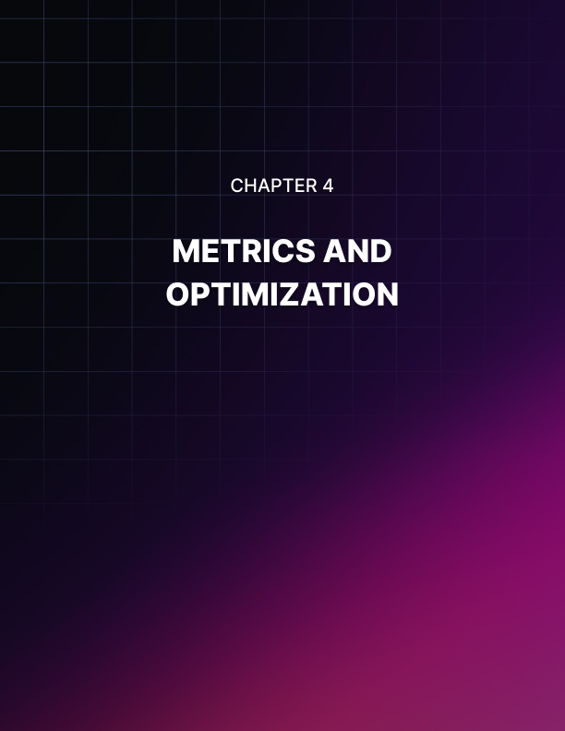

METRICS AND OPTIMIZATION
____

Understanding Key Performance Indicators (KPIs)
To gauge the effectiveness of your email marketing efforts, you need to track the right metrics. These key performance indicators (KPIs) provide valuable insights into how your campaigns are performing and where there's room for improvement. Some of the most critical KPIs for email marketing include open rate, click-through rate (CTR), conversion rate, bounce rate, unsubscribe rate, and return on investment (ROI).
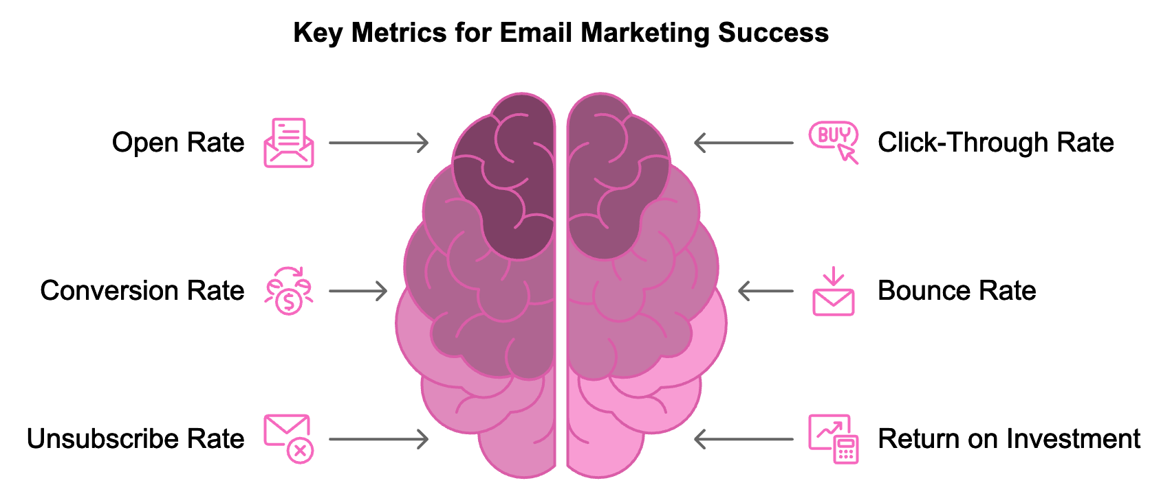
Your open rate tells you what percentage of recipients opened your email, indicating how effective your subject lines and sender names are at grabbing attention. The click-through rate measures the percentage of recipients who clicked on one or more links in your email, giving insight into how engaging and relevant your content is. The conversion rate is perhaps the most important metric as it directly ties to your business goals, measuring the percentage of recipients who completed a desired action after clicking through from your email.
The bounce rate represents the percentage of your emails that couldn't be delivered to the recipient's inbox, while the unsubscribe rate shows the percentage of recipients who opted out of your email list after receiving an email. Finally, ROI measures the profitability of your email marketing efforts by comparing the revenue generated from your campaigns to the cost of running them.
To calculate these metrics, use the following formulas:
Open Rate = (Number of Emails Opened / Number of Emails Delivered) x 100
CTR = (Number of Clicks / Number of Emails Delivered) x 100
Conversion Rate = (Number of Conversions / Number of Emails Delivered) x 100
Bounce Rate = (Number of Bounced Emails / Number of Emails Sent) x 100
Unsubscribe Rate = (Number of Unsubscribes / Number of Emails Delivered) x 100
ROI = ((Revenue Generated - Cost of Campaign) / Cost of Campaign) x 100

The Power of A/B Testing
A/B testing, also known as split testing, is a powerful tool for optimizing your email campaigns. It involves creating two versions of an email with one element changed and sending each version to a small subset of your audience. The version that performs better is then sent to the remainder of your list. This method allows you to make data-driven decisions about your email marketing strategies, continuously improving your campaigns based on real user behavior.
To conduct an A/B test, follow these steps:
- Choose one element to test (e.g., subject line, call-to-action, send time).
- Create two versions of your email, changing only the chosen element.
- Select a sample size (typically 10-20% of your list).
- Send version A to half of your sample and version B to the other half.
- Wait for results (usually 24-48 hours).
- Analyze the results and send the winning version to the rest of your list.
Elements you can A/B test include subject lines, sender names, email content, call-to-action buttons, images, send times, and personalization elements. Remember to only test one element at a time to ensure your results are clear and actionable. Consistently applying A/B testing to your email campaigns enables incremental improvements in performance, leading to higher engagement rates and ultimately a better ROI for your email marketing efforts.

Refining Segments for Improved Outcomes
Gathering more data and feedback can reveal opportunities to refine your existing segments or even develop new ones. This ongoing process of segment refinement can lead to significantly improved outcomes. Here are some strategies for refining your segments:
- Analyze performance by segment, looking at how different groups are performing in terms of open rates, click-through rates, and conversions.
- Identify common characteristics among your best-performing subscribers that you might not have considered in your initial segmentation.
- Create micro-segments by breaking larger segments into smaller, more specific groups for even more targeted messaging.
- Use behavioral segmentation based on how subscribers interact with your emails and website.
- Leverage machine learning algorithms for predictive segmentation to identify which subscribers are most likely to convert.
Remember, the goal of refining your segments is to create groups that are more homogeneous in their needs, preferences, and behaviors, allowing for more targeted and effective email marketing. This process requires ongoing analysis and adjustment, but the rewards can be substantial in terms of improved engagement and conversion rates.

Real-Time Data Insights and Adjustments
The ability to make real-time adjustments based on data insights can give you a significant competitive advantage. To leverage real-time data effectively, consider implementing the following strategies:
- Use real-time analytics tools that provide instant data on email opens, clicks, and conversions, allowing you to quickly identify and respond to trends.
- Set up automated alerts for significant changes in key metrics, such as a drop in open rate below a certain threshold.
- Implement dynamic content that changes email content at the moment of open based on real-time data, such as a countdown timer or current stock levels.
- Adjust send times automatically for individual subscribers based on when they're most likely to engage, using real-time engagement data.
- Conduct rapid A/B tests and use real-time results to automatically send the winning version to the rest of your list.
Utilizing real-time data and making swift adjustments allows you to create more responsive and effective email marketing campaigns. This approach allows you to capitalize on emerging trends, respond quickly to changes in subscriber behavior, and optimize your emails for maximum impact in the moment.

Emerging Trends in Email Marketing Metrics
With advancing technology, new methods continue to emerge for measuring and optimizing email marketing campaigns. Some emerging trends to watch include the use of artificial intelligence (AI) and machine learning to analyze vast amounts of data and predict effective email strategies for each subscriber. Advanced personalization metrics are also emerging, allowing marketers to measure not just whether an email was opened or clicked, but how each personalized element performed. Some companies are even experimenting with emotional response tracking technology that can gauge subscribers' emotional reactions to emails, providing insights beyond traditional engagement metrics.
Cross-channel attribution is becoming increasingly important as marketing becomes more omnichannel, with new models being developed to better attribute conversions across multiple touchpoints, including email. Additionally, as more people use voice assistants to check their email, new metrics may emerge to track how users interact with emails through voice commands. These emerging trends highlight the need for marketers to stay adaptable and open to new measurement techniques as digital marketing continues to evolve.
Trend | Description | Potential Impact
AI and Machine Learning | Analyze data to predict effective strategies | Highly personalized, data-driven campaigns
Advanced Personalization Metrics | Measure performance of individual personalized elements | More precise optimization of personalization efforts
Emotional Response Tracking | Gauge emotional reactions to emails | Deeper understanding of subscriber engagement
Cross-Channel Attribution | Attribute conversions across multiple touchpoints | More accurate ROI measurement
Voice Assistant Integration | Track email interactions through voice commands | New engagement metrics and optimization opportunities

As you continue to refine your email marketing strategies, remember that measurement and optimization are ongoing processes. Stay curious, keep testing, and always be ready to adapt based on what your data tells you. Maintaining a data-driven mindset positions you to create email campaigns that resonate deeply with your audience and drive meaningful results for your business.

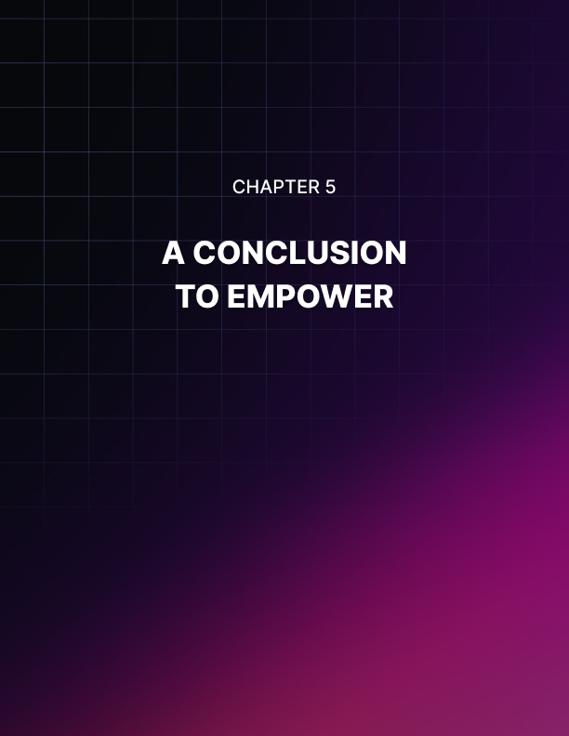

A CONCLUSION TO EMPOWER
____
You’ve navigated the intricate world of email marketing, discovering the transformative impact of segmentation and personalization. Now, it's time to take stock of what you've learned and prepare for the exciting road ahead. This final chapter will recap the essential strategies we've explored, reinforce the transformative benefits of targeted email efforts, and inspire you to continually refine your approach.

The Power of Knowing Your Audience
At the heart of effective email marketing lies a deep understanding of your audience. Segmentation isn't just a buzzword—it's the key to unlocking meaningful connections with your subscribers. By dividing your email list into distinct groups based on specific criteria, you've taken the first step towards more relevant, engaging, and successful email campaigns. Segmentation allows you to speak directly to the unique needs and interests of different customer groups, increase relevance and engagement rates, improve conversion rates and ROI, and build stronger, more lasting relationships with your customers. Keep refining your segments as you progress, ensuring they align with your evolving understanding of your audience. Look for new ways to slice your audience data, always keeping in mind the goal of creating more targeted, personalized experiences. Consider implementing advanced segmentation techniques, such as predictive segmentation using machine learning algorithms, to stay ahead of the curve.

Crafting Messages That Resonate
With your segments in place, you've learned the art of crafting personalized messages that truly resonate with each group. This precision crafting goes beyond simply addressing subscribers by name—it's about tailoring every aspect of your email to match the interests, needs, and behaviors of each segment. Key takeaways for creating impactful email content include using dynamic content to automatically adjust email content based on recipient data, crafting compelling subject lines that grab attention and entice opens, incorporating emotional triggers to create stronger connections with your audience, maintaining brand consistency while personalizing your message, and using personalized product recommendations to boost conversions. Continue honing your email crafting skills, focusing on striking the right balance between personalization and scalability for maximum impact. Use templates and dynamic content to create personalized experiences at scale, and always keep testing to find what resonates best with your audience.

Behavior-Driven Automation
You've discovered the power of sending the right message at the right moment through behavior-driven automation. This approach allows you to respond to specific customer actions with timely, relevant emails, creating a more personalized and engaging experience for your subscribers. Key strategies for effective behavior-driven automation include setting up automated email sequences triggered by specific customer behaviors, implementing advanced tagging and scoring systems to categorize and prioritize subscribers, enhancing relevance and timing through real-time triggers and dynamic content, and integrating your email marketing platform with other marketing systems for a holistic view of your customers. While refining your automation strategies, keep in mind the importance of balancing personalization with respect for your subscribers' preferences. Avoid over-communication by setting frequency caps and allowing easy opt-outs. Regularly review and update your automated emails to ensure they remain relevant and effective.

Measuring Success and Optimizing Performance
Your journey through email marketing wouldn't be complete without understanding how to measure success and continuously optimize your campaigns. Tracking the right metrics and making data-driven decisions ensures continuous improvement in your email marketing efforts. Key performance indicators (KPIs) to focus on include open rate, click-through rate (CTR), conversion rate, bounce rate, unsubscribe rate, and return on investment (ROI). Remember the power of A/B testing in optimizing your campaigns. Systematically testing different elements of your emails—from subject lines to send times—helps you incrementally boost email performance over time. Moving forward, leverage the power of real-time data insights to drive informed decisions and enhance your email marketing strategies. Use real-time analytics tools to quickly identify and respond to trends, and consider implementing dynamic content that adjusts based on real-time data. This agile approach to email marketing will help you stay responsive to your subscribers' needs and behaviors.

Embracing Emerging Trends and Technologies
The world of email marketing is constantly evolving, with new trends and technologies emerging all the time. To stay ahead of the curve, it's crucial to keep an eye on these developments and be ready to adapt your strategies accordingly. Some exciting trends to watch include Artificial Intelligence (AI) and Machine Learning, which are revolutionizing email marketing, from predictive segmentation to AI-powered content creation. Consider how you can leverage AI to enhance your email marketing efforts, such as using machine learning algorithms to optimize send times or predict which content will resonate best with each subscriber. Interactive emails are becoming more common as email clients become more sophisticated. This includes features like in-email shopping carts, surveys, and even mini-games. Think about how you can incorporate interactivity into your emails to boost engagement and provide value to your subscribers. Augmented Reality (AR) in email, while still in its early stages, could be a game-changer for industries like fashion and home decor, allowing customers to "try on" products or visualize them in their space directly from an email. Privacy-first marketing is increasingly important with growing concerns about data privacy and regulations like GDPR and CCPA. Look for ways to provide personalized experiences while respecting your subscribers' privacy preferences. When encountering new trends and technologies, approach them with a spirit of experimentation. Not every new trend will be right for your business or audience, but by staying open to new possibilities, you'll be well-positioned to take advantage of innovations that can enhance your email marketing efforts.
Trend | Description | Potential Impact
AI and Machine Learning | Predictive segmentation, AI-powered content creation | Improved targeting, more relevant content
Interactive Emails | In-email shopping carts, surveys, mini-games | Higher engagement, improved user experience
Augmented Reality | "Try on" products, visualize items in space | Enhanced product visualization, increased conversions
Privacy-First Marketing | Transparent data practices, consent-based marketing | Increased trust, compliance with regulations

The journey you've embarked on doesn't end here. Email marketing is a field that rewards continuous learning and adaptation. Continue moving forward with a commitment to ongoing education and experimentation. Stay informed by subscribing to reputable email marketing blogs, podcasts, and newsletters, and attending webinars and conferences when possible. Network with peers by joining online communities or local groups of email marketing professionals. Experiment regularly by setting aside time each month or quarter to try something new in your email marketing. Analyze and learn from each campaign or experiment, taking time to thoroughly examine what worked well, what didn't, and what surprised you. Seek feedback by regularly surveying your subscribers about their experience with your emails. Look for inspiration outside of email marketing, as techniques from content marketing, UX design, or even fields unrelated to marketing can often be adapted in innovative ways for email. The goal isn't to chase every new trend, but to continuously refine your approach based on solid data and a deep understanding of your audience.

Every email you send is an opportunity to connect, engage, and provide real value to your audience

As you stand at this point in your email marketing journey, take a moment to appreciate how far you've come. You've mastered the fundamentals of segmentation, learned to craft personalized messages that resonate, harnessed the power of behavior-driven automation, and developed a data-driven approach to measuring and optimizing your campaigns. But this is just the beginning. The world of email marketing is rich with possibilities, and there's always more to learn, more to test, and more to optimize.
Keep these key principles in mind: always put your audience first, embrace a test-and-learn mindset, stay curious and open to new ideas, respect your subscribers' privacy and preferences, and focus on providing value. The most successful email marketing doesn't just drive conversions—it enhances your subscribers' lives in meaningful ways. Every email you send is an opportunity to connect, engage, and provide real value to your audience.
With the strategies and insights you've gained, you're well-equipped to create email experiences that truly resonate with your subscribers, driving engagement, loyalty, and business growth. The future of email marketing is bright, and you're now prepared to shape that future. So go forth with confidence, continue to learn and adapt, and never stop striving to create email experiences that delight and inspire your audience. The road ahead is full of possibilities—embrace the journey and enjoy the ride!

