Table of Contents

Introduction 3
Chapter 1: The Fundamentals of Blockchain 5
What is Blockchain and how does it work? 5
All Blocks are Unique 6
Blockchain is very difficult to Hack 6
Blockchain is Decentralized 7
Blockchain Mining 7
Proof of Stake 8
Chapter 2: Real Applications for Blockchain Technology 10
Financial Institutions are leading the way with Blockchain 10
Tuna Fishing in the Pacific Ocean 10
Diamond Source Verification 11
Cryptocurrencies are already using Blockchain 11
Blockchain and Real Estate 11
Blockchain and the Healthcare Industry 11
Big Companies are Implementing Blockchain Projects 12
Chapter 3: How your Business can Benefit from Blockchain 14
It is not too expensive to implement Blockchain 14
You can use Blockchain for an Offline Business as well as Online 14
Accept Payments with Cryptocurrencies 15
Transfer Money with Blockchain 16
Recording of Transactions 16
Blockchain Contracts cannot be manipulated 16
Use Blockchain for Secure Storage of Data 17
The use of Smart Contracts is on the rise 17
Raise Capital using Blockchain 18
Bounty Campaigns with Blockchain 18
Find ways to take advantage of Blockchain Technology 18
Learn more about Blockchain for Business 19
What will Blockchain do for your Business? 19
Start with one small Blockchain Project 20
Conclusion 22
Essential Resources 23



Introduction

Blockchain is the technology that supports cryptocurrencies such as Bitcoin and Ethereum and this platform has the potential to be a revolution in the business world. There are many advantages that blockchain has to offer and more and more businesses and organizations across the world are taking a serious look at it.

Just because blockchain is associated with cryptocurrencies does not mean that there are no other applications for it. A lot of movers and shakers in the business world have already realized the potential that blockchain technology has to offer. Some are using it for their business processes right now and seeing some spectacular results.

The use of blockchain in the business world can add different layers of security and fast transaction processing for example. Not only that, blockchain can be used for the processing of payments and reduce the costs of conventional methods.

There are almost unlimited possibilities with blockchain technology. Some businesses and organizations are already benefiting from it and there is no reason why you cannot do the same. Applying the blockchain platform to your business could be one of the best moves that you ever make.

In this powerful report, we will take a deep dive into blockchain and show you how you can benefit from applying it in your business. You can apply the technology to your existing business and by understanding how it works and what it can offer you may come up with some new business ideas.

In the next section, we will discuss the fundamentals of blockchain so that you have a good understanding of what it is and how it works…



Chapter 1: The Fundamentals of Blockchain

You are probably aware that there are a lot of highly technical aspects to blockchain and we will not be discussing these here. What we will be doing is explaining what blockchain is so that you have the right amount of knowledge to consider how it can help you in your business.

What is Blockchain and how does it work?
So, what exactly is blockchain? In the simplest of terms blockchain is a digital record of who owns what that is updated continuously. With blockchain there are individual blocks of data that are encrypted and these are all joined together. Hence the name “blockchain”.

These data blocks can contain different types of information such as the owner of an asset, the date and time of transactions, the monetary amounts involved and a lot more. Every block is encrypted using cryptography which is where the name “cryptocurrencies” emanates from.

Imagine an everyday deal between two parties. There will be information about the deal that needs to be confirmed and all of this is stored in an individual block. A block can include a lot of different records about a deal or transaction which is part of the initial design of the blockchain.

A blockchain network will store details of many transactions conducted and each transaction has its own unique block. There could be millions of individual blocks in a blockchain and they are all linked together in a secure way.

In a cryptocurrency transaction there will be two parties that we will call party 1 and party 2. With a blockchain there will be records of these two people and the different coins that they own. So, if party 1 wants to sell some of their crypto coins to party 2, there are digital signatures in the individual blocks that require verification.

The job of the blockchain network is to check all of the details of the proposed transaction to ensure that everything is valid. There are computer nodes which perform these checks. If the nodes validate the transaction, then records are added to the blockchain.

All Blocks are Unique
Every individual block in a blockchain is totally unique and has a special code identifier known as a “hash”. As all of the blocks are connected together, the unique code will also include the hash of the block that was previously connected to it.

Everything is done in order and the hashes are used to link all of the blocks together properly. There is a complex mathematical function used to create each individual hash. Using this function, a unique string of characters, including numbers and letters, is generated to create the unique hash.

A blockchain network uses a uniform hash system so it doesn’t matter how large or small an individual block is the hash codes used will always be the same length. There is a database used with a blockchain and this is distributed across a network of computers. It is designed so that no single computer has the same information stored on it.

Blockchain networks continuously check block information to ensure that every single copy of the database is fully up to date. There is no margin for error with a blockchain network. Records on a blockchain are immutable. This means that they cannot be easily changed. Any changes made by the legitimate owners will change the database and create new hash codes.

Blockchain is very difficult to Hack
It is extremely difficult to hack a blockchain. Very experienced hackers have tried and failed. A hacker would need to recalculate hashes for the blockchain so that they can hack it and this is almost impossible as the original hash used will always remain. This has a knock-on effect to all of the blocks connected together.

To even stand a chance of hacking a blockchain you would need to use vast amounts of computing power. This would be very expensive and would take a great deal of time to do as well. Are you beginning to see the possibilities here?

Most conventional transactions are based on client server setups. This means that there is one central server (computer) that holds all of the important information and other computers (clients) connect to it to make the transactions.

The problem with client server technology is that it is a lot easier to hack. Companies and organizations that deploy the latest cutting-edge security methods have fallen foul of experienced hackers. Records are not immutable and if someone knows what they are doing they can change them without being noticed.

Blockchain is Decentralized
There are no centralized authorities controlling any of the cryptocurrencies which is why they appeal to so many people. Any user of a blockchain can have access to the same information as another user. The blockchain platform is very appealing because it provides total transparency.

Unlike with client server applications, there is not a central database involved with blockchain. It is a lot easier for a hacker to gain access to a central database and cause havoc. With blockchain, the information is spread over several different computers.

As blockchain is decentralized there is no requirement for a trusted third party to verify the transactions that take place. Users of a blockchain network are anonymous and you may think that this can cause trust issues. How do you know if some users are untrustworthy and will try to game the system?

The way that blockchain overcomes this trust problem is by testing all new computers that want to join the network. A new computer has to pass a consensus test which is a way to prove their trustworthiness. One of these is through the use of mining.

Blockchain Mining
New users of a blockchain have to prove their credibility and they can do this by solving a complex mathematical puzzle when they want to add a new block to the network. This process is called “mining” and requires a great deal of computational power to solve the required puzzles.
You may have heard of Bitcoin mining or Ethereum mining. In order to mine these crypto coins you need a powerful computer rig to solve the complex puzzles. This is a way of verifying blockchain transactions and successful miners are rewarded with crypto coins.

Proof of Stake
Another way that a computer can prove trustworthiness on a blockchain is through proof of stake. To achieve this, tokens are purchased which allows a new computer to access the blockchain.

The fact that a new user has spent money to purchase tokens provides a high degree of proof that they can be trusted. You can purchase cryptocurrencies such as Bitcoin in exchange for fiat currencies such as the US dollar.

In the next section we will discuss some of the real applications for blockchain technology…

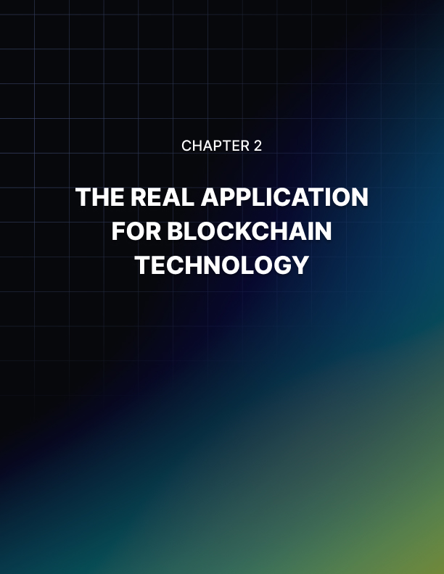

Chapter 2: Real Applications for Blockchain Technology

Now that you have a good understanding of what blockchain is and how it works, your mind may already be racing about how you could use this new technology in your business. There are already real applications for blockchain being used right now. Learning about these should help you to come up with even more ideas on how to utilize blockchain technology.

Financial Institutions are leading the way with Blockchain
It may not surprise you to know that financial institutions are leading the way when it comes to applications using blockchain. A number of finance companies have already invested in the technology because they know that it will enable them to manage their transactions and record keeping more efficiently and in a more secure manner.

A good example of where blockchain delivers better results than conventional technologies is in the money transfer sector. Abra is a company that provides a money transfer platform for people that work in another country to send money to their home countries. They support over 50 different currencies.

Using blockchain technology, Abra are able to provide their users with a cheaper and faster service. A well-known service such as Western Union cannot compete with Abra for speed or the cost of a transaction. The reason that Abra has such an advantage is because they utilize blockchain technology.

Another blockchain application for the financial industry is the Australian stock exchange. They announced that they will be using blockchain technology for all of their transactions. Blockchain will enable the Australian stock exchange to clear and settle equity transactions efficiently and also to keep safe records of all shareholdings.

Tuna Fishing in the Pacific Ocean
Tuna fishing in the Pacific Ocean has got its problems. The World Wildlife Fund is determined to use a sustainable process for tuna fishing in the Pacific so they have teamed up with Sea Quest Fiji which are a tuna fishing and processing company, ConsenSys which are a blockchain company and TraCeable which are an information tech company.

The plan is to use blockchain technology to monitor how tuna is fished and when and where this takes place in the Pacific Ocean. All four organizations have agreed to work closely together to make this happen utilizing a blockchain platform.

Diamond Source Verification
A lot of people that want to purchase diamonds are concerned that a proportion of their purchases may go towards financing wars in some countries. They want proof that they are not going to be purchasing “blood diamonds”.

In order to provide proof to customers that their diamonds are from a place which will not use the proceeds for war, a number of companies and organizations in the jewelry industry are looking to blockchain for a solution.

Cryptocurrencies are already using Blockchain
The level of interest in cryptocurrency has skyrocketed over the last few years. Bitcoin was the first cryptocurrency and it has used blockchain right from the start. Many others have followed such as Ethereum and Litecoin.

Today you can trade cryptocurrencies easily thanks to blockchain technology. When you know that a cryptocurrency is underpinned by a blockchain network you can be confident that all transactions will be safe and secure.

Blockchain and Real Estate
Another great application for blockchain technology is real estate. Property records could be easily stored on a blockchain. In addition to this, using blockchain for real estate transactions can also help to cut out some of the middlemen and reduce costs significantly. Proof of property ownership would also be enhanced by using blockchain technology.

Blockchain and the Healthcare Industry
All too often there are stories about medical records being lost or being changed. Using blockchain for the storage and retrieval of medical records makes a lot of sense and the healthcare industry is already investigating this.

Why should your doctor have sole control over your medical records? This has been challenged for many years and now blockchain offers a solution to storing medical records securely and placing them under the control of individual patients.

Using blockchain technology to ensure tamper proof elections is something that a lot of governments across the world are currently looking at. Blockchain records are immutable and will provide a much higher level of security than current election systems.

Big Companies are Implementing Blockchain Projects
Right now, there are several major companies that have either invested, or plan to invest in blockchain technology. Among these companies are giants such as Toyota, IBM, Unilever and Microsoft. IBM has already implemented over 400 blockchain projects across the globe.

In the next section we will discuss how your business can benefit from blockchain…

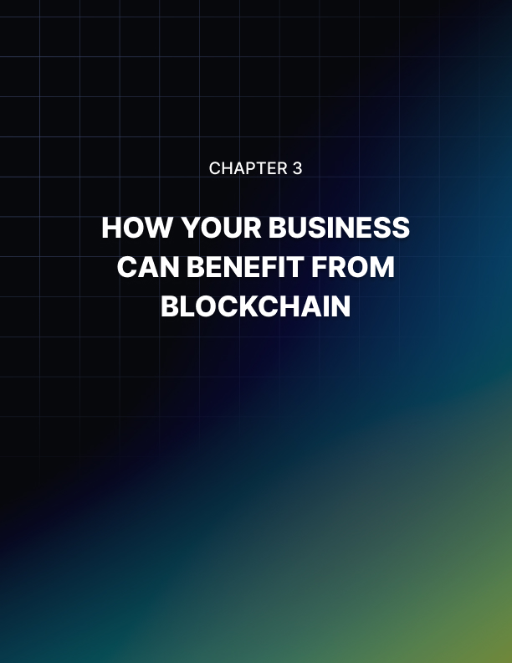

Chapter 3: How your Business can Benefit from Blockchain

As the owner of a business, you will no doubt be interested in anything that can enhance customer experiences and make your operations more productive. Blockchain can help you to achieve these things and more. You can even use blockchain to attract investment in your business.

It is not too expensive to implement Blockchain
If you are a small business owner then you might be thinking that it is too expensive for you to implement blockchain. The reality is that it is not as expensive as you probably think to take advantage of blockchain in your business.

It is simply not true that only large companies can afford to implement blockchain. There are now blockchain development companies that provide their services at a reasonable cost to small and medium sized businesses as well as Fortune 500 companies.

You can use Blockchain for an Offline Business as well as Online
Another popular myth is that blockchain is only for online businesses. Blockchain technology can provide several benefits to businesses that use real physical spaces to operate. Some offline businesses that are interested in blockchain technology include:

- Restaurants
- Wholesalers
- Gyms
- Bakeries
- Nail salons

As we have said many times in this report, the possibilities with blockchain are almost endless. Do not discount your business as not suitable to benefit from blockchain as this is very unlikely to be the case in reality.

Accept Payments with Cryptocurrencies
An easy way for you to embrace blockchain with minimal cost is to start accepting cryptocurrencies as a form of payment for your products and services. Many people now hold the popular cryptocurrencies such as Bitcoin and Ethereum and you are likely to attract more customers if you let them pay using these coins as well as fiat currency.

There are companies that have already made the move to accepting Bitcoin and other cryptocurrencies for payment. A couple of examples of this are Overstock and Expedia who will both accept Bitcoin as a payment method.

If you operate an online store (or are thinking about doing this), then you can use e-commerce platforms such as Shopify who already have the option to accept the major cryptocurrencies for payment. More business owners are turning to Shopify now due to the lower transaction fees and the fact that there are no chargebacks with cryptocurrency payments.

There are some things that you will need to put in place before you can accept payment by cryptocurrency. You need to plan this properly so that it is worth your while. A digital wallet is necessary and you need to know what “gas” fees apply on the different blockchain networks to convert crypto to fiat currency.

It will require thought, effort and testing to be able to accept cryptocurrency as a payment method but you will send a strong signal to your customers that you care about them and are willing to provide them with the features that they want. You are likely to attract new customers by doing this.

Another advantage of allowing your customers to pay using cryptocurrencies is that you can save on transaction fees charged by conventional financial institutions such as banks. Once a payment is made using Bitcoin for example, it cannot be reversed and it is permanent.

So, if one of your customers requires a refund for some reason and have paid using cryptocurrency, they will need to directly contact your business. This will provide you with the opportunity of discussing the issue with the customer and possibly preventing the refund.
Chargebacks are a nightmare for businesses. A customer will make a purchase using their credit card and then will cancel this payment with their credit card provider. This creates a big problem for your business. There are no chargebacks possible if the purchase is made using cryptocurrencies.

Transfer Money with Blockchain
Blockchain is perhaps most commonly known for its ability to handle money transfers in a secure and efficient way. When you use blockchain technology for transferring money you will also avoid high transaction costs from banks for example.

Businesses are now hiring people in different locations across the world. Sending money using conventional methods can be slow for the employee and expensive for the employer. These things are not an issue with blockchain.

Recording of Transactions
If there is an aspect of your business where you need to document transactions with some different parties properly then blockchain can definitely be the answer. Several businesses are considering blockchain and are looking at how they can use distributed ledger technology to their advantage.

Blockchain can provide a lot of benefits for supply chains, the processing of deals and audit trails. The use of distributed applications was first pioneered by Ethereum back in 2015. With the introduction of “smart contracts” on the Ethereum blockchain, many businesses were able to use this as a secure and fast way to manage multiple transactions.

There are other benefits as well such as the use of permission ledgers. This ensures that all transactions completed on the blockchain network are very secure. When a business uses a permission ledger, they can reduce the amount of time that they spend monitoring logistics and shipping activities for example.

Every party that is involved in a supply chain will increase the amount of work that a business has to do using conventional methods. Blockchain should reduce the amount of work required no matter how many parties are involved and it is much more secure.

Blockchain Contracts cannot be manipulated
It is likely that you have to deal with contracts in your business. Here you are placing your trust and confidence in words on pieces of paper. Unfortunately, there have been many situations when contracts have been manipulated and businesses have lost out.

You can use blockchain to create contracts with others and once these are in place then they are not easily changed. There is no need to use a lawyer when you implement a blockchain smart contract. When the conditions of a smart contract are fulfilled then the transfer of value will take place with certainty.

Use Blockchain for Secure Storage of Data
Blockchain technology is a lot more secure than client server technology. One of the things that you can definitely do is to use blockchain for the secure storage of your important data. When data is stored on a blockchain network it is always encrypted. Only those people that have the unique crypto key will be able to access the data.

These days you will find that many companies offer data storage using blockchain for a reasonable fee. Data is much safer stored on a blockchain network and several businesses are already utilizing these services.

Storing your important data using blockchain is a good alternative to using cloud services. There are billions spent on cloud storage each year and if you are using cloud storage it is likely to be more cost effective to switch to blockchain. Your data will be a lot safer as well.

The use of Smart Contracts is on the rise
Blockchain can provide a business with the ability to create smart contracts. These are self- enforcing and self-verifying contracts between a business and its customers. A blockchain network will store the smart contract and this cannot be changed without the right permissions.

Businesses are using smart contracts on blockchain right now for different applications such as:

- Contracts with employees
- Contracts with customers
- Contracts with suppliers
- Contracts for commercial leases

One of the major advantages of using blockchain smart contracts is that it provides you with an affordable level of protection. In a lot of cases you will not need to involve a lawyer with a smart contract and this can save you a lot of money.

Raise Capital using Blockchain
An increasing number of businesses are using blockchain as an alternative way to raise capital. They are creating Initial Coin Offerings (ICOs) or Initial Token Offerings (ITOs) as a way to attract investors in a virtual way.

For example, your business can use the Ethereum blockchain to issue coins and create secure records of the distribution of these coins. This can be a better alternative to conventional funding methods such as using financial institutions, venture capitalists, crowdfunding and more.

With an ICO or ITO, investors can freely trade their coins or tokens with others. You can use this alternative fund-raising method for revenue share models or the provision of company equity for example. When an investor decides to invest in your ICO they will receive coins from you on a blockchain network.

These coins could be accepted by your company in exchange for the products and services that you provide. Or an investor can keep hold of the coins to obtain a higher return in the future as their value increases.

Bounty Campaigns with Blockchain
Another way to raise the awareness of your brand is to provide small cryptocurrency rewards to your customers. You can do this with blockchain technology in the form of a bounty campaign. Your business will provide coins or tokens on the blockchain network that have some form of value.

An example of this is using these coins in exchange for the products and services you are going to provide in the future. You can use a blockchain platform for your bounty campaign and allow anyone to join in. Some companies pay coin holders for completing simple tasks. Promoting your brand is the main aim of a bounty campaign.

Find ways to take advantage of Blockchain Technology
Look for ways that the use of blockchain technology can be advantageous to your company. For example, if you are part of a supply chain (a lot of businesses are) it is likely that others involved in the supply chain will want you to track your processes digitally. Blockchain is an ideal way to do this.

When you are supplying products to the B2C or B2B market then being able to reliably track the source of your products will provide you with an advantage. These days, an increasing number of customers are demanding that their product purchases come from sustainable sources. You can use blockchain to prove this and charge higher prices.

The tracking of shipments is another ideal application for blockchain. You can use blockchain with smart contracts to ensure the accurate tracking of shipments. Shipping giant Maersk is already using blockchain to monitor their cargo with customs agencies in Holland, the Department of Homeland Security in the US and customers who use their services.

A smaller business could easily use blockchain to implement a similar system. For example, they can use smart contracts on a blockchain to automatically place orders with suppliers when their stocks reach a specific threshold. With blockchain all events in a process are recorded and any payments made verified properly.

Learn more about Blockchain for Business
While there are a lot of advantages to utilizing blockchain in your business, there are some potential disadvantages as well that you need to be aware of. It is important that you go beyond this special report and learn more about blockchain.

There are plenty of resources available online to learn more about the use of blockchain in business. You can find high-quality training courses offered for a very reasonable cost on platforms such as Udemy.com.

Alternatively, there are plenty of books published about using the power of blockchain in business. A good place to look for these books is Amazon.com. If you prefer to go to a physical store then Barnes and Noble could be a good choice.

What will Blockchain do for your Business?
You need to ask yourself some important questions if you are considering utilizing blockchain technology for your business. Here are some good questions to ask:

- Will using blockchain provide my customers with a better experience?
- Will using blockchain increase my customer base?
- Will using blockchain reduce costs?
- Will using blockchain simplify business processes and make them faster and more efficient?
- Will using blockchain in my business make my life easier?

It is very important that you have specific goals for any blockchain implementation project. You need to be able to measure your progress towards these goals.

Start with one small Blockchain Project
With all of the advantages of using blockchain it can be tempting to want to implement as many applications as possible to derive all of the benefits. It is not a good idea to tackle more than one blockchain project at a time as things can easily become overwhelming.

We recommend that you choose a small blockchain project first and focus all of your attention on it. Get used to this one blockchain system and closely monitor how well it is performing for your business before you move on to another project.


Conclusion

A lot of technology platforms come and go but blockchain is definitely here to stay. We believe that it will be a true “game changer” and if you have not considered the use of blockchain in your business then you need to do that right now.

In this powerful report we have provided some real-life examples of how companies large and small have implemented blockchain to their advantage. While blockchain remains a mystery to a lot of business owners, you know what it is and how it can be of benefit to you by reading this report. This puts you a step ahead of the rest.

Blockchain is not just for large corporations that have lots of money to spend. It is for all businesses no matter how large or small they are. With the information that you now have about blockchain it should not take you too long to come up with practical applications for your business.

One of the few disadvantages with blockchain is that it consumes a lot of energy. As the chains get larger it takes more power to process them. There is a lot of work being done to reduce the power consumption of a blockchain and new platforms have emerged that have achieved this.

Another issue is that there are several blockchain networks in existence right now and they cannot talk to each other. This is not a huge problem but again it is being looked at to provide a solution. If blockchain was just a flash in the pan technology then this would not be happening.

There are limitless opportunities with blockchain and you are truly in at the start right now. So, we encourage you to perform further research to see how you can benefit from deploying the technology in your business.

We wish you every success with blockchain implementation!

Essential Resources
Learn more about blockchain with high-quality low-cost training courses:
https://www.udemy.com/topic/blockchain/

Get IBMs view on blockchain for business:
https://www.ibm.com/topics/blockchain-for-business

Get the latest news about blockchain:
https://www.wired.com/tag/blockchain/

Probably the best book on the subject of blockchain for business:
https://www.routledge.com/Blockchain-for-Business-A-Practical-Guide-for-the-Next- Frontier/Kalfoglou/p/book/9780367773243

