List of Contents

Chapter 1: Getting Started: The Tools You Need 5
Chapter 2: Squeeze Page Design Guide 11
Compelling, Attention-Grabbing Headlines 11
Content/Body 11
Chapter 3: Create Multiple Squeeze Pages 16
Split Testing Squeeze Pages 16
Chapter 4: Setting Up An Email Broadcast Schedule 20
Test Out Your Subject Lines! 21
Message Format 21
Set up Click Tracking 22
Set Up Open Rate 22
Your Content 22
Testing Your Email 23
Determine Your Newsletter’s Cycle & Schedule 23
This is how it works 24
Public and Private JV Giveaways 25
Solo Ads 28
Ad Swaps 29
Chapter 5: Click Banking 33
Chapter 6: Video Marketing 36
Chapter 7: Free WSOs 38
Chapter 8: PPV/CPV List building 41
Chapter 9: Bartering For Leads 45
Chapter 10: Your Own Affiliate Program 48
Chapter 11: Exit Popups 51
Chapter 12: Reverse Opt-in Form 54
Buying Ad Space Direct From Webmasters 55
Nested Squeeze Page On Blog 56
Chapter 13: Tell-A-Friend Script 59
Chapter 14: Integrated Cross-Promotions 61
Chapter 15: Ezine Advertising 64
Viral PDF Reports 64
Affiliate List Cross-Promotions 65
Create Multiple Squeeze Pages 66
Implement Your Squeeze Page Into Social Profiles 66
Article Marketing 67
Chapter 16: Making Money With Email Campaigns 70
1) Affiliate Products 70
2) Sell Advertising Space 70
3) Sell Private Label Content 71
4) Create Your Own Products 71
Conclusion 74



Chapter 1: Getting Started: The Tools You Need

List building is all about connecting with your target audience by offering them high quality information in exchange for their subscription.

Once a subscriber is a confirmed member of your list, you can begin sending promotional based follow up emails in balance with relevant and useful content based on your overall market.

Email marketers (like you!) collect leads using a combination of squeeze pages and opt-in forms. These forms are generated by your autoresponder provider and are embedded into the HTML code of your squeeze page template.

Each time a visitor to your squeeze page enters in their name and email address, they are added to your mailing list database, and become an active subscriber of your newsletter.

List building helps facilitate the process of converting subscribers into active customers, since once your prospect has been added to our mailing list, you are able to develop a relationship with them that will encourage sales as well as repeat sales (which will make up the larger majority of your email marketing income).

In order to begin building a profitable email marketing campaign however, you will need to make sure that you have all of the tools that are required, including:

Professional Autoresponder Account
With autoresponder services like www.GetResponse.com and www.Aweber.com, you are able to set up an unlimited number of mailing lists, each one featuring customized code that serves as your opt-in box. By segmenting your lists, you will be able to tailor your emails so that they directly communicate with targeted groups of subscribers who are interested in specific information or topics.

Squeeze Page
A squeeze page houses your opt-in form and provides a place for your contacts to find you, evaluate what you are offering and make the decision to become an active subscriber of your list.

A squeeze page is very similar to a sales page in terms of its primary function is to pull in customers and motivate them to take action, in this case, subscribe to your list.

That call of action is essential in creating high performance squeeze pages, and you must place emphasis on ensuring that your visitors are directed to fill in the opt-in form, otherwise they will not be added to your list.

You need to clearly direct visitors to enter in their name and email address as well as instruct them to confirm their request to join your list (if you are using double opt-in).

One thing to keep in mind when developing your squeeze page is that it should motivate visitors in the same way that a traditional sales page should, however, the actual structure of your squeeze page will be very different.

With sales pages, they are typically designed to offer as much information about a particular product or service as possible, since the main focus is on transforming a visitor into a customer.

With a squeeze page, you aren't asking your visitor to make a decision to purchase or commit to anything other than to subscribe to your mailing list where they are rewarded with a free product.

Keeping this offer or giveaway in mind, when you develop a squeeze page, you need to have a strong focus on your market, and design your offer around an existing problem, need or question.

To come up with the best incentive offer possible, you'll need to thoroughly evaluate your market, as well as competing offers so that you can create a relevant product that is in demand and likely to capture attention from your target audience.

Squeeze pages should be designed to offer a clear navigation system, basic structure and template and a compelling offer.

To summarize, your list building funnel consists of three major parts:

1: Squeeze Page With Opt-In Form
2: Compelling High Quality Offer or Incentive
3: Follow Up Emails And Broadcasts

We will discuss the anatomy of a successful squeeze page in an upcoming chapter, so that you can begin to develop your own.

Giveaway (Incentive)
Your giveaway is essentially the most important element on your squeeze page.

If your offer doesn’t motivate visitors into subscribing, all of your marketing efforts will be lost. This means that you need your offer to be of interest to the majority of your target market, rather than to a small group of subscribers. The higher the quality of your giveaway as well as the more relevant your offer is to your market, the easier it will be to recruit new subscribers.

There are many different ways to ensure that the product you are giving away is of a high- perceived value by your subscriber base and likely to be successful in converting new subscribers.

To start, consider the different types of products that are being successfully sold in online marketplaces and create a shorter version of a hot selling product, and offer it for free to anyone who subscribes to your list.

If competitors are successful in selling a similar product and you are giving away a high quality product based on the same topic, imagine just how easy it will be to recruit visitors and subscribers to your site.

And better yet, what better way to begin building a relationship with an active subscriber base than by offering them something of equal value with no strings (or price tag) attached!

You could offer:

- Free Reports
- Free Ebooks (full length of leaked chapters)
- Free Tutorial Guides
- Video Tutorials
- Free or Trial Access To a Membership Program
- Free Booklet with “Top Tips”
- Free Weekly Newsletter Subscription
- Free templates or graphics
- Free Audio Interviews, Lessons, Tutorials

The key to creating a successful giveaway product is in its overall relevancy and existing demand. You want to make sure that your target audience is actively searching for similar information, and that it is being sold successfully in the marketplace. If you do that, you will have little difficulty building a massive list of targeted prospects who will be eager to receive your emails and broadcasts.

If you plan to promote an ebook or e-course of some kind, a very powerful method of building a massive mailing list while generating new business for your product is by offering a leaked chapter of your info product.

By offering this free chapter, you are able to provide new subscribers with a sample of the quality of your work, as well as generate buzz around your upcoming product launch.

If your product is well written, you will find it exceptionally easy to build a subscriber base of people who will likely purchase the full length version when it launches.

This is also a savvy method of creating a viral campaign for your upcoming launch as people pass around the 'leaked chapter' to everyone they know.

If you are interested in outsourcing your project to experienced freelancers, you can easily find a trustworthy professional from the following freelance marketplaces:

- http://www.oDesk.com
- http://www.vWorker.com
- http://www.freelancer.com
- http://www.fiverr.com
- http://www.Guru.com
- http://www.Scriptlance.com

Just make sure to provide your freelancer with a clear outline of what your project entails and be sure to follow up by requesting updates and reviewing the content as it's created.

You want to be available to your freelancer in the event they have questions about the project or need a bit of guidance. Consider signing up for a free Skype account at http://www.Skype.com and adding your freelancer to your contact list.

You could also consider using private label rights material to create your initial giveaway product.

You want to be careful doing this however, as it's important that you begin building a solid relationship with your subscriber base from the very beginning. This means that the product you give away will ultimately represent your quality and overall brand.

If you do decide to use private label content, make sure that you spend time revising the material so that it blends well with your own personal style.

You want people to begin to recognize your brand, and become familiar with your work, so taking a few minutes to tweak and update the content will help to develop a product that is exclusively yours.



Chapter 2: Squeeze Page Design Guide

To help you create the most effective squeeze page possible, here is a quick overview of the most important elements that you need to include in your own squeeze page.

Compelling, Attention-Grabbing Headlines
Your squeeze page's headline should be the very first thing that your visitor sees and therefore it needs to attract attention, draw them in and keep them focused long enough for them to become a confirmed subscriber of your mailing list.

Your headlines text size should be larger than the rest of the text on your page, and for increased exposure, consider adding color to your headline (red and blue works well).

You could also consider highlighting your headline and any sub headline that you use. You can use the <h1> and <h2> tags to enlarge your text, which will not only help with capturing attention from your visitors but will also alert search engine crawlers that the enlarged text is important.

Center your headline within your template and try to work in your opt-in box so that it is close to the headline itself. If you are using a CSS based squeeze page, your opt-in box could be placed in a right column, with a bullet list of benefits featured in the main body of your page.

Content/Body
You should keep your content trimmed down so that it focuses only on the most important information that you have to share.

Avoid wordy squeeze pages that offer endless paragraphs of information. Your squeeze page has ONLY one task, to convert visitors into subscribers and so you need to keep it clear, concise and of course, exciting!

You will want to split test your copy (including lengths) to determine what will increase conversion rates, but in the meantime, here is a quick overview of how to better structure your squeeze page content so that it is easy to read, understand and encourages subscriptions:

- Use Bullet Points To Highlight Benefits
Bullet points emphasize important features and draw attention to the special aspects of becoming a subscriber of your list.

This is a great way to showcase the benefits of becoming a subscriber, and what they will receive, in return, for their subscription.

For example, if you were offering a report on the 'Insider Secrets To Finding A Work At Home Job', your benefit list could include:

- Find out how to land a high paying telecommuting job even if you have absolutely no experience online!

- Avoid devastating work at home job scams that circulate the industry and target people just like you!

- Discover the #1 freelance website where 99.9% of new telecommuters are able to secure employment in their first week online.

- Create a compelling resume that guarantees you stand out from the crowd and get noticed by top paying companies online!

- Retain Focus At ALL Times
Eliminate any external links and keep your squeeze page focused. You want to avoid distractions or in directing potential subscribers to external websites (or even internal pages on your site).

Their ONLY option should be to subscribe to your mailing list. You don't want to confuse them or deter them from your one objective; getting that lead.

Avoid navigation menus, widgets, plugins, or links to articles. Your squeeze page should be one-page long, feature your bullet list, headline, opt-in box and private policy. Eliminate clutter and any information or content that is not necessary to securing the subscriber.

- Strong & Clear Call To Action
If you want your squeeze page to successfully recruit new subscribers, you NEED to clearly direct visitors to fill out your opt-in form and confirm their request.

Do NOT assume that people know what to do. Remember, not everyone is likely to have experience with mailing lists, and so you need to directly instruct them as to how they are able to gain access to your free, high quality offer.

Just the same, you also want to direct them to confirm their request to your list once they have entered in their name and email address.

If you are using a double opt-in format, you will NOT be able to communicate with subscribers who have not verified their request, so make absolutely certain that you are following up and instructing everyone to confirm.

(You can do this by automatically directing subscribers to a secondary page on your site that thanks them for subscribing and tells them that the final step is to check their email and confirm their request to join your list by clicking on the verification link sent out by your autoresponder system).

Just like your squeeze page, keep your confirmation page clean and crisp. Avoid ANY external links at this point because you need your subscriber to follow your instructions instantly, eliminating any chance of them forgetting to confirm.

Consider highlighting your call to action, or using bold text to emphasize it, like this:

“Submit Your Information Immediately To Claim This FREE Report – Before It’s Gone!”

This creates a sense of urgency and gets them excited about what you’re offering. This is an important element to keep in mind. You also may want to try a more specific scarcity tactic, like:

“Only 25 Copies Available ! Claim Yours Before It’s Gone!”

- Minimize Graphics and Use Them Wisely
Your squeeze page should load quickly and remain clean and focused. However, it's been proven that using report covers, or ecovers can increase subscriber rates by giving your visitor a visual picture of what they will receive after subscribing to your list.

Make sure that the graphics you use are high quality and original, and that your report cover portrays the product or offer you are giving away accurately.

If you are offering a short report on 'Dog Training Mistakes To Avoid', make sure that your report cover clearly illustrates the topic.

Always make sure that you personally go through the subscription process before launching your campaign to make sure that you receive the initial welcome email sent out by your autoresponder, and that your opt-in box itself works properly.

Squeeze pages can be as detailed and lengthy or as short and precise as you wish, depending on your target market and overall layout.

You NEED to make sure that you emphasize the benefits of joining your list, and that you highlight the opt-in box, drawing attention to it and whenever possible, keeping it visible above the fold.

Always use a headline that explains exactly what they will receive after they become a subscriber. People don’t always give away their email address so easily and it’s your job to explain exactly how they will benefit by doing so.

Regardless of how you structure your squeeze page, you need to thoroughly test what works and how you can improve it.

In the next chapter, I will show you exactly how to set up a simple split testing system so that you can tweak and improve your squeeze page conversion rates.



Chapter 3: Create Multiple Squeeze Pages

Rather than just constructing one squeeze page, consider creating a network of opt-in pages that cover various markets as well as the SAME market, but offering a different giveaway product.

By doing this, you are able to cater to all sorts of people who might not be interested in one giveaway but would gladly sign up to receive another. Plus, you can easily split test different layouts and templates by running various squeeze page offers at once.

Keep in mind that the more squeeze pages you have in circulation, the more exposure you'll receive.

Note: You can use the same autoresponder sequences for all of your squeeze pages within the same niche markets, as long as you customize the introductory email so that it features each unique giveaway/offer.

Split Testing Squeeze Pages
Regardless how well you design your site, or how thoroughly you analyze each section of your squeeze page, there is no way that you will be able to accurately predict how well your visitors will respond to your offer, without comparatively testing alternative layouts.

One easy method of testing your pages and evaluating conversion rates is by using Google’s Website Optimizer, a free tool that will help you run simple split tests of any websites you own. You can sign up for a free account at:
http://www.google.com/analytics/

You will need to add a snippet of code to your squeeze page after creating your Google Analytics account. This code is given to you by Google and is available within your account once you have added and verified your website’s location.

Once this code is placed on your website, Google Analytics will start tracking your visitors and traffic.

When split testing, start with only one element at a time.

For example, if you change the headline on your squeeze page, leave everything else in its original state until you determine whether tweaking your headline helps with conversion rates.

Once you have determined what headline works best, change another element of your squeeze page, such as the color scheme, opt-in box frame, or summary of your offer.

Always test the original against the variation and give it enough time to accurately determine whether your changes have increased your subscription rate before making any permanent changes.

If you find it difficult to create a squeeze page, one easy tactic is to study existing squeeze pages in your market, and then create yours so that it is modeled after successful pages.

Don't copy from them, but use it as inspiration and a foundation in which to build your own.

If you aren't familiar with HTML and aren't comfortable editing code or CSS, you could consider using Wordpress to develop squeeze pages, quickly and easily.

With Wordpress, you can set up a static website in just a few minutes, and by simply copy and pasting your autoresponder code into its main page, you can have a fully functional squeeze page set up within minutes.

You can download a copy of Wordpress from www.Wordpress.org and a free copy of Code Banter's Wordpress autoresponder plugin that will instantly feature an opt-in box on your blog, at http://www.CodeBanter.com

You can also purchase pre-designed HTML based squeeze pages that allow for you to instantly plug in your autoresponder code from high quality developers including:

- http://squeezepage.imbuzzcreators.com/viral/
- http://www.instantsqueezepagegenerator.com/
- http://squeezepagespire.com/karbon/
Another thing to consider is building video based squeeze pages, where you feature a video alongside your opt-in form that offers your visitors with a slideshow or presentation of what you are offering.

Use a free movie making program like Windows movie maker, if it came with your computer, or download a trial copy of Camtasia (http://www.TechSmith.com) and create a short video or slideshow that speaks directly to your target audience and showcases the benefits of your mailing list or newsletter.

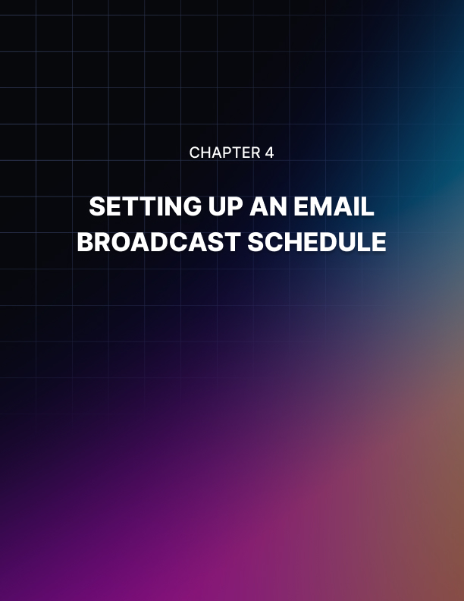

Chapter 4: Setting Up An Email Broadcast Schedule

To better organize and manage your email marketing, you should consider creating a schedule of when to plan on releasing new broadcasts, as well as your actual autoresponder sequence so that your emails are going out on a regular basis.

Being consistent will help you develop a relationship with your list while conditioning them as to what and when to expect your next broadcast. By doing this, you will find that your open-rates will increase as subscribers begin to look out for your emails.

When creating your first email campaign, I suggest creating 6-10 emails (to start), adding additional emails into your sequence as time goes on.

Remember though that subscribers who are already a part of your email cycle will not receive new emails that you add to the sequence unless you send out an actual broadcast.

You want your first email to send out automatically, after a new subscriber confirms their request to join your list, with additional follow-up emails being sent out every 2-3 days.

Example:
- Monday: Free Report
- Tuesday: Free Article
- Wednesday: Promotional email
- Thursday: Free article
- Friday: Promotional email
- Saturday: Promotional email
- Sunday: No email

Always keep notes of any ideas you have for email content, and if you are outsourcing content creation to freelancers, make sure that you always proof the material and add in your own style.

You want your subscribers to become familiar with your brand, and so even if you outsource the majority of the work you need to apply your own personal style to every email you send out.

You also want to focus on balancing the amount of promotional based emails that you are sending out to your list with informational ones, so that your subscribers have a reason to remain on your list.

The more value you offer, the more responsive your list will be. You can add instant value by purchasing private label rights material and revising it so that you can create free reports for your list. You can also compile articles into ebooks or reports as well.

Test Out Your Subject Lines!
Subject lines that invoke curiosity always work very well, but you want to test your subject lines just as you split test your actual squeeze page to determine what works for your target audience.

By monitoring your email open rates as well as your overall response rates, you will be able to keep a steady pulse on your subscriber base and know with certainty, what types of emails they are far more likely to respond to.

Sometimes even the smallest change can yield incredible results, and your subject line works as a headline on a sales page does, in drawing people in and motivating them to read your email and explore your offers, so it’s important that you use strong, targeted subject lines in every broadcast you send out.

With GetResponse, you can track performance stats which features information that includes open rates, and removals as well as how many people clicked on the links featured within your email.

Message Format
Single or Dual - I personally use Single so that my emails are sent out in regular text rather than HTML. This ensures that everyone is able to read my emails, however you can choose to enable dual and a copy in HTML as well as plain text will be available to all subscribers.

Set up Click Tracking
This is where the magic happens, and where you will be able to determine the number of subscribers who have clicked on any links contained within your email. When you enable this, your links will instantly change into ones that Get Response can track.

Set Up Open Rate
Enable this feature so that you can accurately measure the number of subscribers who opened your email broadcast.
Creating a winning subject line is critical when competing against other marketers also focusing on email marketing to the same audience base. Without a strong one, the best offer from the most established expert will fail, if it’s not opened and read.

While each subject line for your emails should be original and fresh, you want to ensure that your recipients will trust and recognize your emails.
Avoid deceiving email subject lines like “Payment Notification”, or other false claims that will
confuse and disappoint your readers.

It’s been proven from extensive case studies that shorter subject lines yield higher open rates, so keep this in mind when creating your emails, and always avoid potentially problematic phrasing and words that may trigger spam filters.

Your Content
You know the importance of high quality, unique content. Each mailing represents your brand and your credibility. This means that you need to focus on offering exclusive content to your list that they just can’t find anywhere else.

And just as you listed benefits on your squeeze page to prompt them into signing up, each time you include a link to an external site within your email broadcasts, you need to clearly outline the benefits of why your reader should visit the website or purchase the products that you recommend.

If you do your job in making sure that your audience clearly understands that the resources, links and websites that you direct them to will personally benefit them in some way, you will increase your CTR tremendously.

Testing Your Email
You need to test your email prior to sending it out to your list.
Never send an email out unless you have first sent a copy to your own email address and verified that the format is readable, grammar is correct and that it flows smoothly.

You should also make sure that images are coded as absolute URL’s which means that your
link structure is correct and any embedded images will appear properly and not broken (make sure that you directly link to images including http:// within your links).

You also want to make sure that your email looks correctly in different email programs, including Yahoo, Gmail and Hotmail, since what you see in your email client might be completely different with some of the popular free email providers.

Determine Your Newsletter’s Cycle & Schedule
Apart from the introductory email, you should also have at least one cycle worth of content integrated into your autoresponder sequence.

Depending on the frequency in which you send out emails to your list, if you run a campaign offering one email each week, you should have at least four emails (one month) of content readily available.

From personal experience, all of my email campaigns run on a bi-weekly basis, where I send out an email every Tuesday and Thursday.

I have found that with Monday being such a busy time for the majority of my subscribers who are returning to work, that by sending out my emails on Tuesday, I am able to maximize open rates.

On a similar note, by emailing my list on Thursday rather than Friday, I have also experienced a higher open rate, due to people simply being online, whereas on Fridays they are heading home for the weekend and less likely to be online.

There’s no guaranteed formula as to when you should email your list or how frequently, and it’s critical that you test out different intervals to determine what will work best for you. Launching Your List Building Campaign
Once you have your squeeze page set up and your autoresponder account created, you need to focus on developing an email sequence that is activated from the moment a website visitor becomes a subscriber.

This is how it works
Your visitor enters in their information via your squeeze page and confirms their request to be added to your newsletter.

Your autoresponder kicks in and emails your prospect a welcome email that you have written. This is sent out automatically within minutes of their subscription.

Your autoresponder continues to email your subscriber on pre-set dates, according to the system you have set up within your autoresponder account.
You can determine delivery dates and times from your administration panel, and all of the emails you create within your autoresponder account will be sent out to all active subscribers on a regular schedule.

Example:
You create 4 emails that are scheduled to be delivered accordingly:

- 1st Email: instantly sent to your subscriber thanking them for subscribing to your list and providing the download that you initially offered on your squeeze page, usually a direct link to the download location on your website.

- 2nd Email: Scheduled to be sent out on the third day after your subscriber has confirmed their request, and includes an email offering free content, additional articles or another report.

- 3rd Email: Scheduled to go out on the 7th day of the sequence, promotional based, advertising a related product.

- 4th Email: Scheduled to go out on the 10th day.. and so on.

The balance that you use, when mixing up free content with promotional based material is entirely up to you, however the more value you give to your list, the easier and faster it will be to develop a relationship with your subscribers.

Taking an aggressive approach to email marketing works for some, however for the majority, it's always best to tread carefully, initially focusing on building a relationship with your list, and then doubling that up with promotional offers, or recommendations to affiliate based products.

Essentially, you want to 'condition' your list so that they grow accustomed to receiving promotional based emails from you on a regular basis.

It's up to you to keep a pulse on your subscriber base, and determine what works best, how frequently you contact them, and whether they respond well to the products you are promoting.

Just don't be afraid to experiment and test out new ideas and innovative ways to consistently grow and maintain your subscriber base.

Public and Private JV Giveaways
The first one is JV giveaways. JV giveaways haven’t changed much as far as public JV giveaways go. You can go to newjvgiveaways.com anytime you want and jump in on any JV giveaways. But what has surfaced since 2011 is something called the private giveaway. There are a lot of little private giveaways taking place that you can be part of all over the internet.

I've personally used giveaways as a way to build generic lists, and then by sending out targeted offers to my contacts, I am able to weed out the freebie seekers from active customers, and manage my lists more effectively, but using GetResponse built in filtering system to unsubscribe a user from one list when they subscribe to another.

What this means, is that you can grow a large email list from giveaways and then offer specific downloads for different niches.

For example, if I was targeting the dog training niche, and weight loss niche, I would grow a quick list by participating in giveaways and then create two separate squeeze pages, one for each of my main niche markets.

Then, I would email my entire (generic) list and offer them specific free downloads.

This filters out your list quickly and easily because as a subscriber joins a new list that is focused on a specific subject (dog training), they are automatically removed from my generic list and placed into a targeted one.

Using this strategy, you can take advantage of the exposure available by joining giveaway offers and special events while still being able to build relevant mailing lists.

When joining giveaway websites, you will be required to offer a free download in the same way that you do on your own squeeze page.

Once you have joined a giveaway as a contributor, you will be able to edit your gift so that it directs potential subscribers to your hosted squeeze page.

Subscribers join your list directly, and are not managed by the giveaway host.

Here are a few resources to keep you up to date on future giveaways that you can join as a contributor:

- http://www.newjvgiveaways.com
- http://www.jvgiveawayblog.com
- http://jvgiveawayhq.com
- http://www.jv-giveawaycenter.com

You can go to people who are just as big as you are online, and even bigger, and start a private JV giveaway with them. What I mean is you can get 5 to 10 or more people in on a private giveaway, where no one else can join and be a contributor.

This means that the people who are on there, who are contributors, are responsible for generating all the traffic to the giveaway and there is a WordPress plug-in that you can use to host your own private giveaways called WP Venture.

So go do a search on Google for WP Venture and it’s being sold on the Warrior Forum for chump change, as a Warrior Special Offer.

A giveaway is where a group of contributors come together and submit their gifts. People who come and join the giveaway as members are going to opt in to different giveaways and this will add subscribers to your list.

If you’ve been around for awhile, you no doubt know what JV giveaways are, and I’m not going to dwell on what JV giveaways are or how they can build good business for you because you can go to a place like newjvgiveaways.com and find out all you need to know about giveaways freely on the net.

But just the fact that I’m pointing you in that direction is pretty valuable because if you’re just starting out and you have no money to spend on ads, getting giveaways is a really good way to start, because you can add that first 10, 50, 100 subscribers on your list fairly quickly.

Some of these giveaways get up to 30,000 subscribers joining; not to your list, but to the actual giveaway.

What happens is the host of the giveaway is going to get the most subscribers.

They’re putting the giveaway with all the contributors and setting the dates, and then once the giveaway is live, all the contributors send traffic to the JV giveaway main page, but the host is going to get all the subscribers onto their list.

Then the member who just joined will probably see a one-time offer or some kind of offer before they go and see all the different gifts that contributors have.

So when you’re a contributor and you promote one of these JV giveaways through your own link, you often make sales right there before they even get to the gifts.

That’s one thing about it.

My point is if you’re just starting out and you don’t have much money to buy traffic, then this may be one that you want to master.

The truth is, if you become just a master of one of these methods, then you’ll generate all the ads you’ll ever need.

Let me say that again.

If you become the master of just one of these methods I'm going to share with you then you will generate all the leads you’ll ever need.

So why not do something like JV giveaways?

You can do public ones, you can do private ones, and you can host ones and make real money. You could generate 10,000 leads in one day, 20,000 leads in one day from contributors blasting traffic to your own giveaway.

So just think about that.

If you were to jump headfirst into the world of JV giveaways as a contributor to start off with, then one day you may be able to host your own JV giveaways.

Solo Ads
The next list building tactic I want to talk about is solo ads.

If you can actively keep running solo ads, usually you’ll be able to generate hundreds of leads per day right now, this year.

This may change down the road, but as of right now, this year, solo ads are cheap, they’re effective and very easy because you don’t have to worry about landing page quality score or paying per click and keeping an eye on your ads and paying by the click. What you’re getting is an ad that goes out to a subscriber list, so whenever you buy a solo ad; let’s say you buy a solo ad for $300 for 1,000 clicks to your site, you pay 30 cents per click to your site and you know exactly how many clicks are going to come to your site and the guy who sends you a solo ad sends an ad out to his email list, which recommends your freebie or your website.

So they’re transferring their authority over to you, in a way, that’s what makes it the most effective way of generating traffic right now, in my opinion. Because the ads are still cheap, it’s very effective for anybody who has the money to risk it.

One place you can find a lot of great solo ad deals is by getting on Skype and talking to different solo ad sellers.

I realize it’s not going to be easy just to find a solo ad seller, or any solo ad sellers if you have no clue about the world of solo ads right now, but once you find some solo ad sellers, you want to start connecting with them on Skype and getting into the world of solo ads because you can meet so many different solo ad sellers who will give you great deals on Skype that they don’t give outside of Skype.

You can find solo ads at one place called soloaddirectory.com.
That’s where I would go if I were going to go and look for solo ads right now. The key to having profitable solo ads is your sales funnel.

You want to have the squeeze page that generates the free leads that gives away something. Then you have an upsell from there, which will be a one-time offer for something that’s below the $17 price point and then you want to have upsells from there so you can afford to pay for your solo ads.

Now you may also want to promote things on the download page for your freebies that you’re giving away.

That way you can come close to breaking even or you can profit directly right away from that solo ad before you even get the subscribers on your list.

Although many solo ads I haven’t profited from right up front, I made a profit on the backend from promoting strictly to the subscriber list.

That’s something you have to think about.

A lot of companies in advertising are willing to pay a lot of money upfront and even lose money on the front end because they know they’re going to make money on the backend with their follow up marketing, which is what email marketing is all about.

Ad Swaps
So let’s move on to ad swaps.

Ad swaps are where you send out an ad to your list promoting someone else’s squeeze page
and then someone else does the same for you on their list.

So it’s similar to solo ads except that no one is buying anything; you’re just trading off ads.
The place where everybody has moved to these days is called safe-swaps.com. There used to be a site called IMadswaps.com, which was like an ad swap forum.

There are other forums that kind of emerged in the last few years and they’ve pretty much slowed down because of safe-swaps.com.

The thing about ad swaps is that it is getting less effective because seeing that it emerged around 2009, that’s when everyone was discovering ad swaps and starting to do it.

Now people are over-mailing their lists with ad swaps.

They’re doing way more ad swaps so they’re getting less responses from the subscribers.

Retention rates are going down, click thru rates are going down, but if you still want to generate hundreds of leads per day, you still can do that.

The key to profiting from ad swaps is the same key to profiting with solo ads, which is your sales funnel.

So if you’ve got a good sales funnel, you can use it for your ad swaps.

Also, ad swaps are a great way to test your sales funnel before you start buying something like solo ads.

You’re probably going to get less quality leads from ad swaps than you are solo ads, yet it’s still a good indication of whether your sales funnel will convert traffic into sales, and that’s what’s necessary to profit with ad swaps, because you’re not promoting anything that’s going to be making money directly to your list; you’re promoting someone else’s squeeze page, so you’re relying on the traffic coming from the JV partner’s list to your sales funnel.

Depending on your sales funnel, you can do ad swaps every single day if you want to, become the master of ad swaps and just tweak your sales funnel and have very good business there.

You don’t want to overcomplicate marketing.

This kind of thinking is really profitable if you could get super focused. Think about how simple this business is right here.

You put together a sales funnel. You do ad swaps every day.

You test your sales funnel every day until you’re converting the maximum amount of visitors who land on your page.

That in itself is a business no matter what anyone says.

So that’s what I try to do in my business... SIMPLIFY.

I have a daily routine that I try to simplify down more and more every day until that is just brain dead stupid, and lately, it has been solo ads because I’ve found that I’m getting the best returns on solo ads.

But if I didn’t have any money, I would start off with JV giveaways just to generate 100 subscribers or so, then I would move to safe-swaps.com and I would start ad swapping. That’s what I would do if I didn’t have any money.



Chapter 5: Click Banking

There’s also another thing I would want to do if I didn’t have any money and I had a small list.

This goes out to the small list owners, people who are just starting their lists and what not.

If you have a list of 100 people or 1,000 people, you could start doing what’s called click banking.

It has nothing to do with ClickBank.com but what it is, is you go to a marketer with a huge list and you say, “I will send you 100 clicks or 1,000 clicks over the course of this month (clicks mean visitors) and what you will do is return those clicks all at once after I’m done.”

So what happens is the big marketer with a big list will give you a tracking link to use on all your emails.

You’ll work hard to build up your traffic to them through that link, and then when you’re ready to cash in your clicks you go to them and say, “I’d like to cash in my clicks,” and then they send you clicks; they send you as many as you have sent them.

This is similar to ad swaps, as you can see, but it works out well for small list owners because you can just focus on sending traffic to one big marketer without having to set up all kinds of ad swap deals.

For example, if you have an email follow up series, the first couple of days of your email follow up series could be sending the new people on your list to another marketer who you are click banking with.

Now this isn’t the greatest advice for product creators.

I don’t think that ad swaps or click banking is a great idea for product creators because if you’re a product creator, then you can have so much longevity on your own list by just promoting your own products.

If you’re a product creator, you might want to just focus on paid methods and getting affiliates to promote your stuff, but that’s just my opinion and that’s what I’ve seen from experience.

As an affiliate marketer, who doesn’t have a ton of products to promote to the list all month, who doesn’t crank out many products, it’s all about fresh lead flow, like I was saying in the beginning of this report.

Things like ad swaps and click banking are the mother load of free, fresh lead flow.



Chapter 6: Video Marketing

With video websites like www.YouTube.com, it's never been easier to use the power of viral video to generate fresh traffic to your websites. All you need to do is develop a video or slideshow presentation that highlights your giveaway and directs people to your squeeze page.

Better yet, you could incorporate video tutorials based on your niche market, with a direct link to your squeeze page that appears at the end of the video.

That way, rather than setting up video marketing campaigns that only offer a promotional slideshow, you are adding value to the community by offering useful information that your target audience will appreciate.

Like article content, search engines rank video pages individually, so if you upload a video that receives a good amount of exposure, you will benefit from a higher search engine ranking as well as the direct exposure from the video community itself.

Regardless of the traffic generation strategies that you use, always be sure to properly manage your mailing lists, so that you have an email campaign based around leads and others based on customers.

For instance, your squeeze pages will build lists of leads, however each time one of your subscribers purchases one of your own products, you could feature a different opt-in form on the products thank you page, where your subscriber can join to receive updates, new editions or special bonuses.

This will enable you to filter your subscriber over into an email list compiled of customers, and will make it easier for you to manage lists containing leads from those you know are active buyers.

Furthermore, it's exceptionally important that you properly manage your lists for other reasons including the fact that the last thing you want to do is advertise a product to a list of subscribers who have already purchased the product from you, especially if you end up offering it at a lower price or on a special offer.



Chapter 7: Free WSOs

Now let’s get into another method, which is something I’ve been doing since 2008 or so, which is running free WSO’s.

I'm talking about freebies that I give away on the Warrior Forum, which is WarriorForum.com and WSO stands for Warrior Special Offers.

So I will give away products on the Warrior Special Offers forum in exchange for opt-ins.

One thing that I’ve noticed between the Warrior Forum and the leads you may get from ad swaps, click banking, and solo ads is that Warrior Forum traffic is used to buying lower priced products.

So your funnel may be a lot different for free WSO’s than it will be with ad swaps, click banking,
or solo ads.

For one of my funnels they get a freebie on the squeeze page, then the OTO after that is a $10 offer, then the OTO after that is another $10 offer.

So you can see I’m keeping it at $10 or less because I know they buy $10 or less things, whereas with ad swaps, click banking, and solo ads I’ll have a freebie, a $9 offer, then to a $97 OTO and then it will go up from there.

Good luck trying to sell a $97 to Warrior Forum members because it’s not going to happen,
unless you have a done-for-you service or something that’s worth 25x $97 price points.

It’s just a different world there, but the good thing about running free WSO’s is that’s a business in itself, if you want it to be because you can run free WSO’s and then you can promote WSO’s as an affiliate to promote programs like offers through WSO Pro, which is at WarriorPlus.com or JVzoo.com or DigiResults.com.

So you know how I was talking about in one of the other sections how you can make a business just by focusing on one thing? Well this is a business for you too. Think about this.

All you need to do is to run free WSO’s.

You can have six or seven free WSO’s for six or seven different freebies that you create and you can rotate those once a day so that you’re launching a new WSO a day, but it’s giving away one of your six or seven freebies.

You can generate your list like that and your sales funnel will get you close to breaking even or making a profit right away on the front end, then on the backend you can promote WSO’s as an affiliate to your list you've built.

I’ve been known to have multiple free WSO’s that I rotate on a daily basis and I’ve done that model before.

You see... I get bored with certain things in marketing and then I try different models. I just simplify things and just go at them with a very narrow focus.

Right now I might be buying a lot of solo ads and doing what I described in the Solo Ads section, but just months ago, I was buying a lot of free WSO’s and trying to get as many leads as I could with that and just promoting WSO’s every day and making plenty of money.

So once you get that narrow focus and simplify everything, everything becomes clear and you can make a lot of money just focusing on that.



Chapter 8: PPV/CPV List building

Another way to generate hundreds of leads per day is through something called Pay Per View or Cost Per View advertising.

I have a friend who does around 1,000 leads a day.

I’ve only generated 25 leads or so per day with it, but the thing is, it's on autopilot.
So you can go to a site like leadimpact.com and you can buy cost per view or pay per view advertising.

It’s a little different from other types of advertising in that you’re paying per view of your page, you’re not paying per click on an ad.

It’s actually more like a pop up, so you’re paying for these ads to pop up on people’s sites, and it’s run through software, so it’s different from someone, say going to Google and seeing pay per click ads.

You can advertise on any URL on the internet as long as the user has the software installed on their computer.

So this allows you to bid on different URL’s online.

Now can’t you see how this could be popular and profitable? Because you could bid on your competitor’s URL.

You could bid on so many different URLs it’s not even funny. You could bid on PPC URLs even.

So for people who are spending gobs and gobs of money on PPC, you can take those URLs that they’re using for their landing pages, plug it into lead impact and then be bidding for ad space for those URLs through the software.

One place to learn more about PPV and CPV is cpvden.com.

It can be a nice little lead flow generator that’s different from the other lead flow sources you might be generating leads from right now.

What you need to know about also is you can generate tons and tons of traffic for a lot less money, but the traffic won’t be as responsive because they didn’t click through to your ad.

Because they didn’t click through to your ad it’s kind of like an annoying pop up that comes in their face but it’s all legal and they know they’re getting pop ups in exchange for using the software that they’re using.

It’s an agreement they made before downloading the software that they’re using on their computer.

Say a company, like leadimpact.com, let’s say they say, “You can use this software, which has huge value in exchange for being able to run an ad on your computer 5 times per day.” So instead of charging for the software each month, they get the software for free, but they have to see ads and this is where your ads can get in front of their face.

You can get in front of millions of people for .017 cents each time your ad is shown; that’s a fraction of a penny.

But like I said, with other forms of advertising you may get a high opt-in rate on your squeeze page such as 10% and on some ad sources, 10% is very good. On some ad sources, 10% is horrible.

On some ad sources, like solo ads, for example 30% is very good, depending on whether they actually send your solo ad or not because 60% may be considered good on there, as well.

But with PPV advertising, we’re talking 1-2% could be good, just depending on how much money you’re spending, how much money you’re making up front and how much money you’re making on the backend.

But because you can get traffic so cheap, it doesn’t mean that the traffic is created equal to other advertising sources. Because they haven’t clicked through any targeted advertising, the traffic responsiveness will be lower as far as opting into your squeeze page goes.

The point is... all that matters is your ROI, not your opt-in rate... because your opt-in rate is always going to be different depending on where your traffic is coming from.
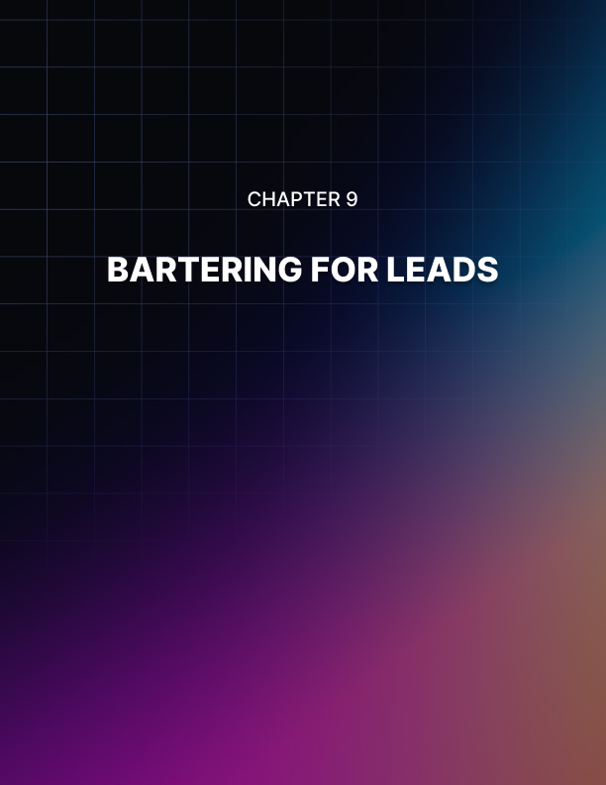

Chapter 9: Bartering For Leads

Let’s move on to bartering for leads.

Bartering for leads is a really great way to generate the highest quality leads you can generate besides having your own product and having an affiliate program.

In actuality, it is almost the same or identical to that, except for you are NOT selling your own product.

Here's how it works…

What you want to do is go to a marketer who does product launches, who is bigger than you online. They don’t have to be huge; you could just go to someone who does WSO’s, for example.

If you go to someone who does WSO’s often, you can say this, “I’ll do customer service for your launch,” or “I’ll write the sales page for your launch,” or “I’ll create bonuses for your launch,” or “I’ll help create the products for your launch,” or “I’ll help create buzz using social media for your launch,” or “I’ll help get JV’s on board for your launch” or, “I’ll do (something) for your launch in exchange for leads.”

So you’re not asking for money, you’re asking for leads.

You’re not asking them to export leads to you; we’re talking about just placing some kind of bonus on yours on their download page that customers have to opt-in for, which you get the lead for.

For example, this one time I did one of these bartering for leads deals with a top marketer, and for his bonuses on his actual sales page, I advertised my bonuses that they’re going to have to opt-in for.

So on the download page there was a link to my squeeze page, which allowed them to opt-in to download the bonuses. On the page after the squeeze page was the download page for the bonuses.

I didn’t send them through any kind of sales funnel, but the thing is, you get a list of red-hot buyers when you do this. I’m talking about scorching hot buyers.
That first week of having that list you want to promote your highest converting thing, do a webinar or do something that you made money within the past because this is the time to sell them while they’re the hottest and they’re buyers (you have gained trust by them listening or watching your bonus, depending on what the product is, so they will be responsive).

Actually, the way I came up with the bonus for these kinds of launches is I would just use private label rights. So I use private label rights material that was a video course that I didn’t even record, but I had rights to give away as a bonus to a paid product. So that's something to think about.

One of my best tactics was solo ads, one was ad swaps, and at one point click banking. I did click banking on a big scale.

Bartering for leads was a huge, huge tactic that I’ve done before. It’s not a current phase I’m going through but it works like a charm.

It’s not going anywhere.

It will always be effective.

It’s a very simple tactic where you barter your skills with a product launcher who adds your bonus to their download page and the customers have to opt-in for it.

It’s not like relying on Google for leads because they can slap that away somehow for you.

And it's not getting less effective like ad swaps are for example.

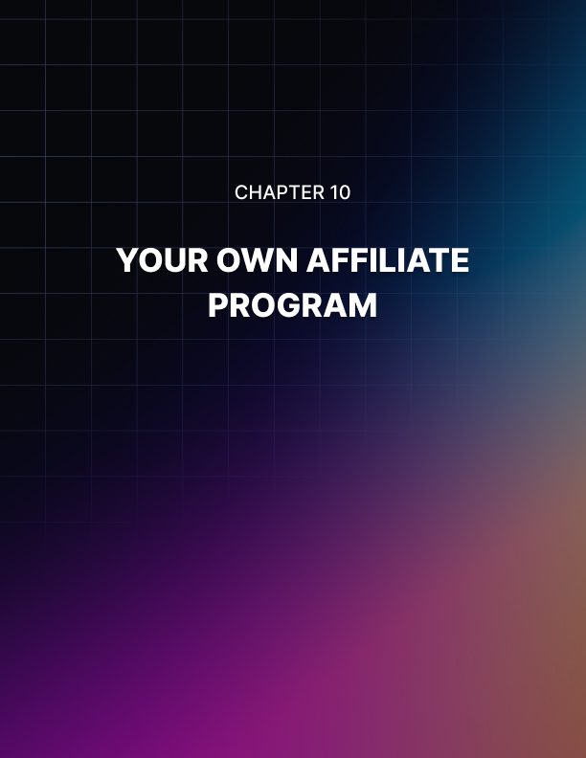

Chapter 10: Your Own Affiliate Program

Another way to generate red-hot quality leads is by having your own affiliate program.

Now I’m going to tell you that I’ve mainly generated leads through using Rapid Action Profits. I know that a lot of people in recent days have moved on to other scripts, such as Warriorplus.com, WSO Pro or JVZoo.com or DigiResults.com, but I like trusty old Rapid Action Profits. It may cost $197, whereas I bought it for something like $297.

It’s always being updated so it’s not out of date with technology or anything, but the reason why I like Rapid Action Profits over any other is two-fold. For one, I only have to pay a fee one time to use it. So I pay my $197 for the script and I use it over and over and over.

A lot of these other sites, you may not have an upfront fee, but they take out fees for every sale you make so you end up paying a lot more than you would pay with that one-time fee to RapidActionProfits.com. Or there may be, like with WSO Pro, you have to pay a fee every time you want to start a WSO with.

I’d rather have a script like Rapid Action Profits so I can use it over and over and over. This is just my personal opinion and preference.

Also, I think there is a lot of wisdom in what I’m about to tell you with Rapid Action Profits vs. the other solutions.

The other solutions are like affiliate networks, so when you’re recruiting affiliates to actually promote your product, they may end up promoting someone else’s product, but with Rapid Action Profits, you have complete control over the situation.

So once you show people your affiliate program, there’s only an option to promote you.

Therefore, whenever I launch a product on Rapid Action Products, at the bottom of the screen I have a link that says, “Affiliates make 100% commissions.”

They click there and then they sign up for my affiliate program through Rapid Action Profits. They can now get their link and they can then sell the product.

If I use the other programs, and I have a link at the bottom that says, “Sign up here to promote my product,” and then they go to some affiliate network, they’ll probably end up promoting some other product that they find.

They maybe will get lost trying in the sea of products trying to find mine; they give up and not promote any product at all.

The best kind of affiliate program that attracts affiliates is to have an instant PayPal commission affiliate program like the ones I’ve been talking about.

You can also use something like ClickBank, but you can’t give away 100% commissions from ClickBank.

With these other programs, you can give away 100% commissions, which is really attractive on the front end to affiliates, and then you can give 50% commission on the one-time offer, for example.

You’re making money off sales, but you are attracting affiliates that you don’t have to ethically bride much to promote for you.

If you’re giving away 100% commissions, in my mind, you’re not going to owe any other affiliates back for promoting you because you gave away 100% commissions. Those leads that you get right away are going to be red-hot leads.



Chapter 11: Exit Popups

Another way to add about 10% opt-in rate to any website you have is by adding an exit popup script. You’ve probably seen these and they’re pretty annoying.

You can get one at exitsplash.com.

What it will be is when someone tries to leave the page, a pop up will come up that says, “Here's a quick chance to get this freebie,” or whatever ad you want there.

This can add 10% more opt-in rate to your page or to any website you send traffic to. Actually, depending on how aggressive you want to be, you can have multiple exit pop ups that lead to different squeeze pages.

What I’ve noticed is in the past, doing a very aggressive launch with a marketer and bartering leads, what I’ve decided to do with him because he wanted to go balls-to-the-wall, I decided that it would probably be most profitable to do a squeeze page for one offer that pops up once.

If they don’t take that offer, have a squeeze page that pops up for another offer. If they don’t take that offer then another squeeze will pop up for another offer. So it will be three squeeze pages popping up in a row for different offers. You will be surprised at how many leads are added onto the product launchers list.

Just think about this, the first squeeze page pops up and they get a 10% opt-in rate on that; they’ve just got 10% of the traffic to sign up on their list.

But if they don’t take that, and another one pops up and they get 7% on that, well that’s an extra 7% tacked on.

If they don’t take that one though, and they see the third squeeze page up, then maybe 5% tops into that list and all together you’ve got what, 22% of the people getting on your sales page or site opting into your list. That’s almost as good as a decent converting squeeze page.

I’ll take 22% from a lot of different ad sources depending on the source.

But I will tell you this, that I believe exit pop ups are getting less effective over time because they’ve been used so much. It's similar to “ad blindness.”

What will likely happen is that people will stop using exit pop ups and then wait a little while and then they will start using them again and they will be just as effective as they were before.

That’s my prediction and that happens to a lot of things where trends and tactics come and go.

Tactics will be working well, then they stop working as well as they are and everyone stops using them and then someone starts using them again and talking about how profitable it is to use it and then everyone all of a sudden is using it again.

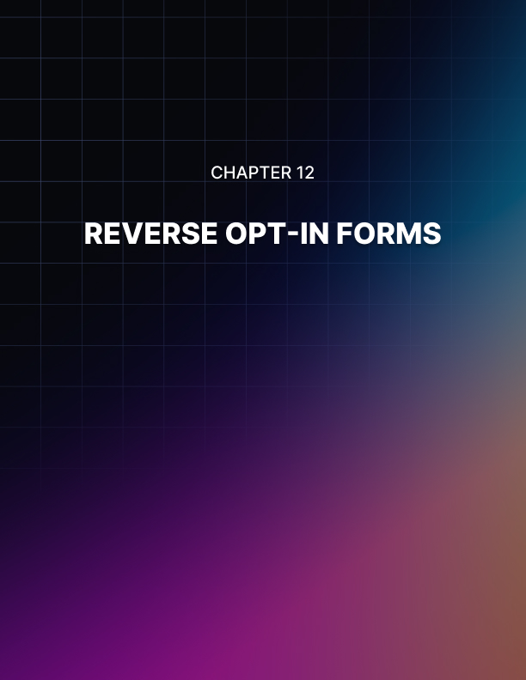

Chapter 12: Reverse Opt-in Form

Another way to generate about 10% of your website traffic to your list on a sales page is using a reverse opt-in form.

This is where someone clicks on the “Add to Cart” button or an “Order Now” button and then you have a page between your sales page and your order form. That page in between will be a Step 1 of 2 order confirmation form.

So at the top it will say, “Step 1 of 2 Order Confirmation,” then they’ll have to put in their email address to continue.

This is a Reverse Opt-in Page.

You want to grab the email address here so that everybody who buys your product, you already have them on your list.

Also, the people who chicken out on your product, you’ll have them on your list and they’re also very high quality subscribers to have on your list that almost buy; for some reason they are.

So you might find that the majority of people who actually opt in to that form won’t even order, but you’ll end up generating a lot more subscribers from your sales page by doing that.

So you can see how all these leads will add up if you’re promoting to a squeeze page or a sales page. You will see how all these leads add up by promoting to a sales page by using all the factors we’re talking about here.

Because if you’re getting 22% opt-in rates from doing exit pop ups and you’re getting 10% from doing reverse opt-in forms, then you are generating an extra 33% of people to your subscriber list during a launch.

That’s something to think about because when you have all these affiliates hammering your page, a lot of their traffic might not want to buy the product that you have, but there will be people who buy products that you may be able to sell something else to later on as an affiliate or as your own product.

Buying Ad Space Direct From Webmasters
The next tactic I want to talk about is buying ad space directly from webmasters.

This can be done as easily as going to different webmasters who have, say forums in your market, and asking how much it would cost to run an ad on the top of their page.

First of all you’re going to them and ask, “How much is your AdSense ad making you on a daily basis?”

Chances are you’re going to have more money to spend than they’re making on this ad from AdSense.

So they say, “Well I’m generating 200 people to my site every day, but I’m only making $3.00 in AdSense per day.”

Well, if you have an ad that has a 10% click-thru rate, then you can generate those people to your page for the same amount of money or more, so tell them that you want to take a test run on their page by advertising their ad in place of their Google ad.

You can pay them by PayPal and with a deal like this, “Will you run this ad one day and we’ll see how much money I make,” and you’ll give them $5 instead of the $3.00 he makes from AdSense, for example.

Then you see what happens when you run your ad on their site for that day and see how many opt-ins you get, how much in sales commissions you make from your sales funnel, and this will determine whether it’s profitable or not.

If it’s profitable then you can say, “Well I would like to rent that ad space from you on a monthly basis, for the rest of this month for x amount of dollars,” or whatever is equivalent to $5.00 a day, or whatever you’re testing.

If you go to some real busy forum, for example, and you do the same thing – and if we're talking about bigger numbers here, maybe you will do a $50 test run for one day.

You measure the results and see what happens and if it works out well, then what you need to do is just tell them that you want to run an ad that month for x amount of dollars.

And that’s traffic you don’t have to touch. That’s just autopilot traffic hitting your page.

You can run it on a weekly basis or anything that you can afford, but the point is these webmasters want to make more money on their sites because they’re probably not making as much as you can give them using the advertising that they’re running.

They’re making piss poor profits from AdSense, for example.

Actually, in the internet marketing space, WarriorForum.com has an option to run an ad at the top of the forum for $100 a day, and they run something like eight different spaces on there a day and yours would rotate with eight different advertisers.

That’s a good way to test something in the internet marketing niche.

If you want to test an ad out and see how internet marketers would respond before you go and promote something on internet marketing, then use the tactic of contacting vendors and webmasters directly and you could run a $100 ad and see what happens.

Chances are you could get at least $100 clicks of traffic, or you may get 50 to 100 opt-ins. You may get one sale at $100 that makes you break even.
You never know.

You never know until you try, but what I like about this media buying approach is that it’s very easy traffic that you don’t have to work toward, you just have to monitor your metrics.

Nested Squeeze Page On Blog
Here’s a tactic for generating a lot of leads from a blog.

I actually built my first list of 1,000 subscribers this way in the guitar niche before I even got into the internet marketing niche. It’s so easy.

You take a blog and maybe your blog is generating 100, 200, 300 visitors per day because you’re cranking content out on a daily basis.

Even if you don’t try to target certain keywords on your site, it’s pretty easy to start generating 200 to 300 visitors per day just by cranking out content and ranking it for long tail search terms without even trying to, and actually only doing it.

So what you do is, you take your squeeze page in your niche, and you nest it at the top and center of that blog. So before they actually see the blog site at the top of the page, they should see your squeeze page as it is.

You can nest it up there using an image and an opt in box, if you want. That’s if you don’t want the test of the squeeze page to interfere with any other on page SEO that’s happening. You’ll be surprised at the opt-in rate you can get from that.

Let’s say your site isn’t really an interactive site as much as you want it to be; it’s really difficult to get a site with a lot of interactivity. Maybe your site just has a lot of traffic coming to it and doesn’t really have people interacting, so it doesn’t really matter if you put your squeeze page up there or not.

One of the best ways to generate leads from a blog is to nest a squeeze page front and center.

Another way is by using Robert Plank’s WordPress Plug-Ins.

One is called Action Opt-In. This is where you can put an opt-in bar on your side bar that you go opt-in to. Once they opt-in to it, the form will disappear and say, “Thanks for subscribing,” and keep the people on the blog they’re on.

One is Action Pop-Up, which is a fade in window that fades into your site and asks for the opt-in there in exchange for a freebie or whatever you’re offering.

The other is Action Comments, which is where if someone comments on your blog, they check a checkbox and it automatically subscribes them to your list.

You can get all three, I believe, in one purchase from Robert Plank if you go to Actionoptin.com or search on Google for Action Opt-In and you’ll probably find it.

He’s always updating that.


Chapter 13: Tell-A-Friend Script

Another way to generate leads virally is by using a Tell-A-Friend script.

I think you have to be careful not to let others abuse your Tell-A-Friend script because they can go spamming the Internet with it, but I think the best practice for using a Tell-A-Friend script is to have one on your download page for your freebie that you just giveaway.

It will say, “I’ll give you this extra bonus if you tell 5 friends about this,” or “10 friends about this.” So, there will be a little form that they fill out and they’ll type in five different email addresses, for example, of their friends and when they hit submit it will send out a message to all their friends from them, which tells them to go and check out your squeeze page basically. It’s really good traffic because they’re endorsing you, in a way.

They are friends of friends recommending you to other friends on your site, which is better than running an ad on some site where no one knows you, no authority is being transferred to you, or not trust is being transferred to you. So you may be able to get really good leads by doing so.

Mike Filsaime, has a Tell-A-Friend script and there are other ones out there on the market that you can search for in Google by searching for Tell-A-Friend script.
I have a feeling those will also be on the rise in the future.

Those are one of those tactics that were used a lot years ago and you don’t see them as much anymore, but I think that they will emerge again, especially when people start using them in a way that makes the person who’s sending out the Tell-A-Friend script use their own email server to mail out the Tell-A-Friend invitation, that way they can avoid spam troubles altogether.

But the worst way to use a Tell-A-Friend script is if you’re telling people to send out one of their affiliate links and they’re an affiliate for you because then they may spam your site a lot because they’re trying to make money.

They may get excited, they might be spammers, or they might just get a little too excited and start sending it out to everybody and everyone they can find, thinking they’re going to make a million dollars overnight.



Chapter 14: Integrated Cross-Promotions

The next way I want to talk about generating leads is using integrated cross-promotions. I think Mark Joyner coined the term integrated marketing.

Well integrated cross-promotions are different kinds of cross-promos that you have with your joint venture partners other than ad swaps, click banking, or anything like JV giveaways.

These are different because these are integrated into your marketing on autopilot, so you should think about the different parts of your marketing systems that you can integrate some kind of joint venture link to.

For example, on your download page, you might have a banner that leads to one of your JV partner’s squeeze pages and they have the same for you on their download page. That would be an example of an integrated cross- promotion.

So instead of monetizing that part of your download page with an offer, what you’ll do is do an integrated cross-promotion with one of your joint venture partners.

Another way is to cross promote your joint venture partner in your follow up series. So in your email follow up series, maybe your fifth email in the follow up series will promote their squeeze page and their fifth email in their follow up series will promote your squeeze page.

Another way is through P.S.’s of your emails that you send out. So when you’re sending out an email to your list, you can make a deal with one of your joint venture partners to always promote their squeeze page in their P.S. and they have to do the same for you.

That’s one way to do it.

Think about the power of integrated cross-promotion.

You’re generating subscribers on autopilot by doing this.

You can add tons per day to your list or more, all on autopilot, by doing this a set of joint venture partners or with just one, but just think about this; let’s say you have 10 joint venture partners and you’re going to do integrated joint venture cross-promotions with your follow up series of emails.

Say all 10 of you in all 10 of your first follow up series emails, you all promote each other, well visitors would be flying all over the place and going onto your list if you do that.

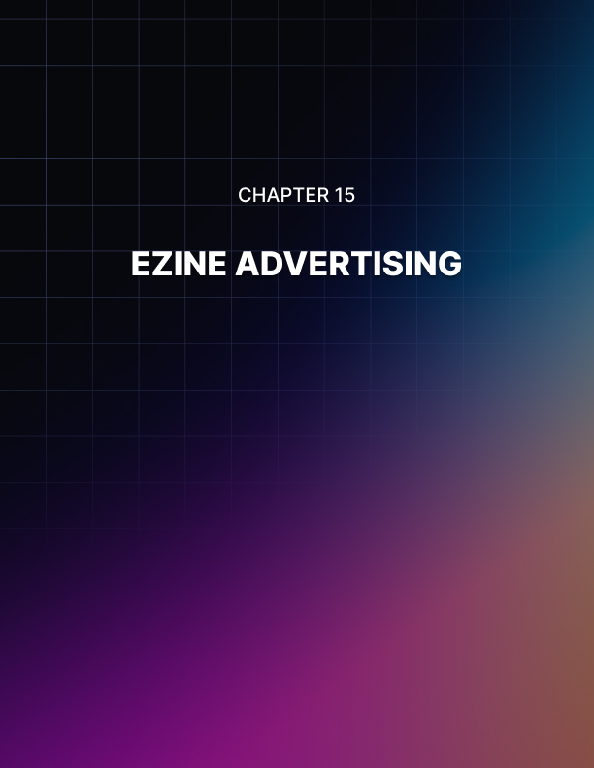

Chapter 15: Ezine Advertising

One of the easiest methods of building your own list of subscribers is by purchasing advertising in established ezines relating to your niche market.

You could consider purchasing a solo ad, or at a lower cost, purchase an ad spot within an existing newsletter. You need to track how well your ezine advertisements are performing, so that you can ensure that it’s worth the money you are paying to feature your advertisement.

If you find that your ezine promotions are generating enough traffic to justify further advertising, consider purchasing a top sponsor ad within select ezines and newsletters for maximum exposure.

Your advertisement should feature your squeeze page, and provide information about what you are offering.

Viral PDF Reports
The next tactic I want to talk about is using viral PDF reports.

So let’s say you write a little report that can be 2 to 5 pages long, as long as it’s rock solid content; it’s going to be for a free report anyway, and you create a PDF report out of it. Well, inside the PDF report, you want to say that this is free to distribute.

Also inside of your PDF report, you want to have a link at the end that leads to your squeeze page or an entire ad that leads to your squeeze page.

What I’ve found in the past is that other people started using my reports to build their lists with. So they would actually give my l reports away to their squeeze pages and I would generate those subscribers under my list, the ones who actually read the report and then clicked through at the end.

The ones who read the reports and clicked through to the end and discovered you that way, end up being some of the highest quality leads you’ll get because they’ve just read one of your reports, and they clicked through at the end to get your freebie, and you’ve got them on your list.

If you’re not sure how to do this, you can go to OpenOffice online.

You can just type into Google, “OpenOffice” and download OpenOffice Writer.

You’re going to open up OpenOffice Writer and write your report.

It’s kind of like Microsoft Word.

Then you’re going to click “File” and export as a PDF.

Once you do that, you have a PDF that you can give away, and you have clickable links inside the PDF that will become your viral report.

It’s a little different from rebrandable reports.

If you have your own affiliate program, you can give affiliates a way to give cool content to their list and to promote you at the same time by offering a viral brandable rewritable report.

This is a little bit different, a little more simplistic, and if you give enough of these reports away that are viral reports, you may see them circulating all over the place and generating leads from all over the internet.

Affiliate List Cross-Promotions
The last thing I want to tell you about list building is using affiliate list cross-promotions. This is very simple.

Let’s say you have your own offer on Rapid Action Profits and you’ve built an affiliate list, which is just a list of affiliates who promote your profits. Well, what you do is you go to other product owners who have affiliate lists and you say, “I will tell my affiliate list about your affiliate program if you do the same for yours.” You might pick up some really good affiliates like that.

They might pick up a few and once you pick up affiliates, that means more traffic heading into your paid offer, which means more people on your list of high quality.
This is one of those tactics that kind of make you want to slap yourself in the head.

Create Multiple Squeeze Pages
Rather than just constructing one squeeze page, consider creating a network of opt-in pages that cover various markets as well as the SAME market, but offering a different giveaway product.

By doing this, you are able to cater to all sorts of people who might not be interested in one giveaway but would gladly sign up to receive another. Plus, you can easily split test different layouts and templates by running various squeeze page offers at once.

Keep in mind that the more squeeze pages you have in circulation, the more exposure you'll receive.

Note: You can use the same autoresponder sequences for all of your squeeze pages within the same niche markets, as long as you customize the introductory email so that it features each unique giveaway/offer.

Implement Your Squeeze Page Into Social Profiles
If you have a Squidoo lens, you can now add opt-in pages right into your existing page. It's available as a module, and it's a great way to generate instant traffic to a remotely hosted opt-in page.

You can set up an unlimited number of Squidoo lens pages, incorporating your squeeze page into each one. Just make sure to make sufficient content into your lens so that you are offering something of value to visitors.

Note: Squidoo is considered an authority website and carries exceptional weight within the search engines, not only will you be able to generate fresh leads from your opt-in page itself, but you could also add links to your Squidoo lens pages that lead visitors to your other squeeze pages as well.

HubPages is also another great method of drawing in new traffic and subscribers. HubPages works similarly to Squidoo in terms of being able to create instant single websites even if you are unfamiliar with HTML.
- http://www.Squidoo.com
- http://www.HubPages.com

You should also add your squeeze page into your www.twitter.com profile, as well as every other social community you are a part of including Facebook, YouTube and MySpace.

Article Marketing
Article marketing is a very effective (and free!) marketing strategy and for many of us, ends up being our primary force behind generating consistent traffic to our squeeze pages.

With article marketing, it's all about offering high quality, relevant content that targets your market and propels them into investigating your resource box and visiting your website to find out more about you.

Article marketing is extremely easy to set up, and even if you aren't a proficient writer, you can easily outsource article creation to affordable, high quality writers.
Even if your budget is very small, there is no reason why you can't compile a small package of articles, spanning from 300-500 words in length, that are highly targeted and relevant to your squeeze page's topic.

Start out by submitting 3-5 articles every week, and before you know it, your article campaign will generate consistent traffic to your squeeze pages. As you continue to expand on the number or articles in circulation, you will be able to generate more traffic on a regular basis.

Just make sure that the articles you do submit into article directories are exceptionally well written and targeted.

After all, these articles represent you and your brand, and you want your readers to be impressed with the quality as they are likely going to base your other products on the information found within your article content.

Pay attention when constructing your author's resource box (which is attached to each article that you submit.)

This resource box is the only place in which you are allowed to include external links and you want to include a call to action that motivates your reader into clicking on your link and visiting your squeeze page.

You also want to use anchor text whenever possible, so that not only are you able to generate traffic from article directories, but you can also rank for specific keywords within the search engines.

Example:
“Click on the link for more free article marketing tips and techniques”.

Then in another article, I could use a different resource box that featured a slightly different keyword anchor such as:

'Click on the link below for a free guide to article marketing for newbies!'

Just the same, be sure to include your primary and long tail keywords within your article's content itself, so that your article content appears within search results for both the main search engines like Google.com, as well as via the internal search utility on the article directory websites.

Here are a few article directories to get started:

- http://www.EzineArticles.com
- http://www.GoArticles.com
- http://www.ArticlesBase.com
- http://www.articlecube.com
- http://www.gruks.com

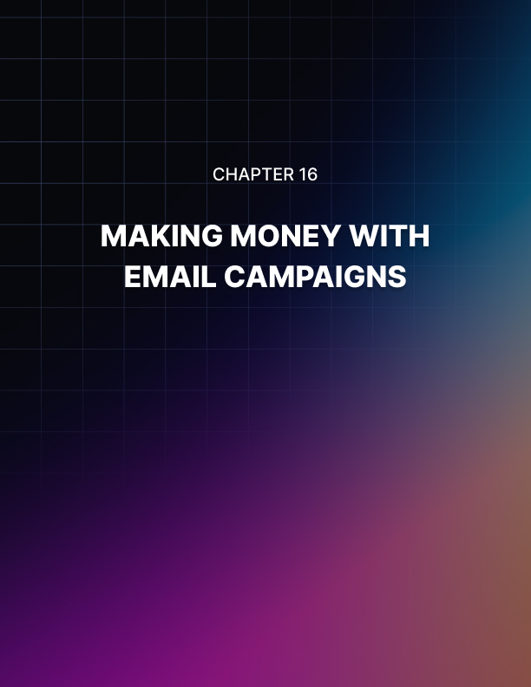

Chapter 16: Making Money With Email Campaigns

Here are a few ways to quickly monetize your lists.

Affiliate Products
You can promote third party products to your list, where you will earn a commission each time one of your subscribers purchases the product using your referral link.

To begin, visit http://www.ClickBank.com or http://www.PayDotCom.com and review products relating to your market from within their marketplace.
With these two resources alone, you will have an unlimited number of products available to promote, covering dozens of niche markets.

Sell Advertising Space
There are many benefits of offering ad space within your newsletter including the fact that you can set your own price structure based on the number of subscribers you currently have the exposure that you are able to offer to potential advertisers and sponsors, increasing your prices as your list grows.

You can also consider solo mailings at a higher price once your list has grown enough to make it worth their while.

With offering ad space within your newsletter, you are in full control of the types of advertisements that you accept, so if you currently have your own product line, you could avoid promoting competing products.

In order to set up a successful advertising program, you will need to be able to provide detailed statistics and demographics regarding your subscriber base.

I recommend building your list to at least 1,000 subscribers prior to offering advertising space so that you are able to offer greater value to potential advertisers who are looking to maximize exposure for their products and services.

Advertising Tip: When it comes to locating potential advertisers, you can sign up for a free account at http://chitika.com or http://www.Adbrite.com where you will be able to create advertising offers that feature your pricing, statistics and overall website or list theme.

Sell Private Label Content
Private label material is pre-created content that is available for resale, either with “transferable" rights (where you are allowed to transfer the right to sell the product to your customers) or with personal rights where only you are allowed to sell or distribute it.

What you want to do is purchase high quality reports, articles, ebooks and other material that is of high quality and relevant to your list.
Then, spend some time repackaging the content so that it’s an improved version of the original, and customized so that it showcases your personal style and brand.

You should also focus on purchasing private label content developed by writers who are offering only a limited number of licenses, which will dramatically increase the value of the material and minimize the amount of competition who are offering the same content.

Regardless of where you purchase private label material, you should always spend time going over the material, tweaking and improving it and increasing the quality of the information whenever possible.

This doesn’t have to be a time consuming process, and if you have purchased quality content you can easily re-package it just by editing the title, adding in a foreword, revising chapter titles, and adding in an introduction and conclusion page.

Create Your Own Products
With direct access to potential customers, you already know the types of products or services they are interested in, so the next logical step is to create your very own product or service catering to your existing subscriber base.

Consider surveying your subscribers to determine what types of products or services they would be interested in and create a secondary squeeze page so that subscribers can choose to join your new newsletter to receive information on when your product is ready to launch.

This will help you determine the overall demand for specific products prior to creating them.



Conclusion

Email marketing and list building is truly one of the easiest methods of building automated income online. With a single click of the mouse, you can instantly broadcast a promotional based email to a built-in customer base, without having to worry about the cost of customer acquisition or advertising.

In order to monetize your lists effectively however, you need to focus on treating your subscribers well so that they trust you and of course, respond to your offers.
You can stand out from the majority of email marketers in your industry by over-delivering on fresh, quality content.

Remember that people sign up to receive your emails believing that they will benefit in some way. If you deliver quality, relevant and useful information that truly helps them, you will be rewarded with an active and responsive subscriber base.

Focus on building a relationship with your subscribers through constant contact and updates.

Don't let your list run cold by failing to communicate with your subscribers. It's relatively easy to design an email marketing campaign by using high quality private label material, and by hiring content writers to create articles that can be used within your broadcasts.

