TABLE OF CONTENTS
____
INTRODUCTION 5
CRAFTING YOUR DIGITAL PERSONA 8
Establishing Your Core Values 8
Creating Visual and Messaging Consistency 9
Embracing Authenticity and Storytelling 10
Leveraging Content Marketing Strategies 11
Evaluating and Evolving Your Digital Persona 12
STRATEGIES FOR PROACTIVE ENGAGEMENT AND INFLUENCE 16
Developing an Adaptive Content Calendar 16
Harnessing the Power of Social Listening 17
Cultivating Influencer Partnerships 18
Balancing Promotion and Engagement 19
Leveraging User-Generated Content 20
TRANSFORMING FEEDBACK INTO OPPORTUNITIES 24
The Impact of Online Reviews 24
Encouraging Positive Reviews 25
Handling Negative Reviews with Grace 26
Effective Monitoring of Review Platforms 27
Identifying Patterns and Improving Your Business 28
Building a Culture Around Positive Reviews 29
PROTECTING AND REBUILDING YOUR ONLINE IMAGE 33
Understanding the Nature of Online Crises 33
Immediate Response: The Golden Hour 34
Transparency and Timely Communication 35
Leveraging Different Digital Channels 36
Case Studies: Learning from Success and Failure 37
Rebuilding and Learning: Post-Crisis Strategy 38
RECAP AND ROADMAP FOR CONTINUED GROWTH 41
The Importance of Adaptability 42
Building a Strong Team 43
Leveraging AI and Automation 44
Continuous Learning and Professional Development 45
Ethical Considerations in Digital Reputation Management 46
Future-Proofing Your Digital Reputation 47

DISCLAIMER
____
The information provided in this ebook is intended solely for educational and informational purposes. The author does not accept any responsibility for the outcomes that may arise from the application of the material within. While efforts have been made to ensure the accuracy and relevance of the content, the author cannot be held accountable for any errors or omissions, or for any consequences resulting from the use or misuse of the information provided. The responsibility for any actions taken based on the information in this ebook lies solely with the reader.



INTRODUCTION
____
Your reputation isn't just what others say about you; it's the story you tell through every interaction, post, and decision. In a world where connections are constant, your online presence isn’t merely part of your brand—it’s a reflection of your identity and values. The power to shape how the world perceives you is in your hands, and every digital interaction is an opportunity to build trust, inspire loyalty, and set yourself apart.
This book is designed to help you build, nurture, and protect your online presence in ways that make a lasting impact. Gain the skills to shape how others see your brand online. Here, you’ll learn to navigate social media, turn challenges into opportunities, and create a brand that both customers and competitors respect. Whether you’re an experienced business owner or new to marketing, this guide offers strategies for building and sustaining a powerful online reputation. You’ll discover how to craft a digital persona that resonates with your audience, engage meaningfully on social media, and turn customer feedback into an invaluable asset.
Explore the psychology behind online interactions and uncover the triggers that influence how people perceive your brand. Create emotional connections that build loyalty and go beyond mere transactions. This guide isn’t just about following tactics; it’s about thinking strategically with every aspect of your online presence.
Get ready to develop a proactive approach to crisis management, spot potential issues before they escalate, and turn challenges into stepping stones for growth. It’s not only about handling crises; it’s about using each situation to reinforce your brand values and strengthen your position in the market.
Every digital interaction is an opportunity to build trust, inspire loyalty, and set yourself apart.

Inside, you’ll find practical, actionable advice with real-world applications. Each chapter includes step-by-step guides, insider tips, and tools that you can start implementing right away. Years of experience and insights are distilled into a clear roadmap, crafted specifically for business owners and marketers aiming to elevate their online reputation.
If you’re ready to create an online presence that turns customers into loyal advocates, build a lasting reputation, and take control of your brand’s story, this guide will help you craft your path to digital success. Your future brand—and your future self—will thank you.



CRAFTING YOUR DIGITAL PERSONA
____
Your online presence is the new first impression. With connections reaching farther than ever, your digital footprint often speaks for you, shaping perceptions before you even step into the room. This chapter will guide you through the essential steps of creating a powerful and unified online presence that truly represents your brand.

Establishing Your Core Values
Let's start by examining the foundation of your digital persona: your core values. These are the guiding principles that define who you are and what you stand for. To identify your core values, ask yourself:
- What drives your business decisions?
- What beliefs do you want your brand to embody?
- How do you want to impact your customers and community?
Once you've pinpointed these values, you'll need to effectively communicate them across various online platforms. This consistency is key to building a recognizable and trustworthy brand.
Consider the case of Patagonia, the outdoor clothing company. Their core values of environmental sustainability and social responsibility are evident in every aspect of their online presence. From their website to their social media posts, Patagonia consistently showcases their commitment to these principles. This unwavering dedication has earned them a loyal customer base that aligns with their values.

Creating Visual and Messaging Consistency
To apply consistency to your own brand, focus on visual and messaging elements. Create a cohesive visual identity that reflects your brand's personality, including a consistent color palette, a recognizable logo, uniform typography across platforms, and a consistent image style. For example, if your brand values innovation and cutting-edge technology, you might opt for sleek, modern visuals with a futuristic color scheme. Develop a brand voice that aligns with your values and resonates with your target audience. This voice should be consistent across all platforms, from your website copy to your social media posts and email newsletters. If your brand values include friendliness and approachability, your messaging might be casual and conversational. On the other hand, if professionalism is a key value, your tone might be more formal and authoritative. Ensure that the content you share across platforms aligns with your brand values and supports your overall message. This doesn't mean posting the same content everywhere, but rather adapting your message to suit each platform while maintaining your core brand identity.

Embracing Authenticity and Storytelling
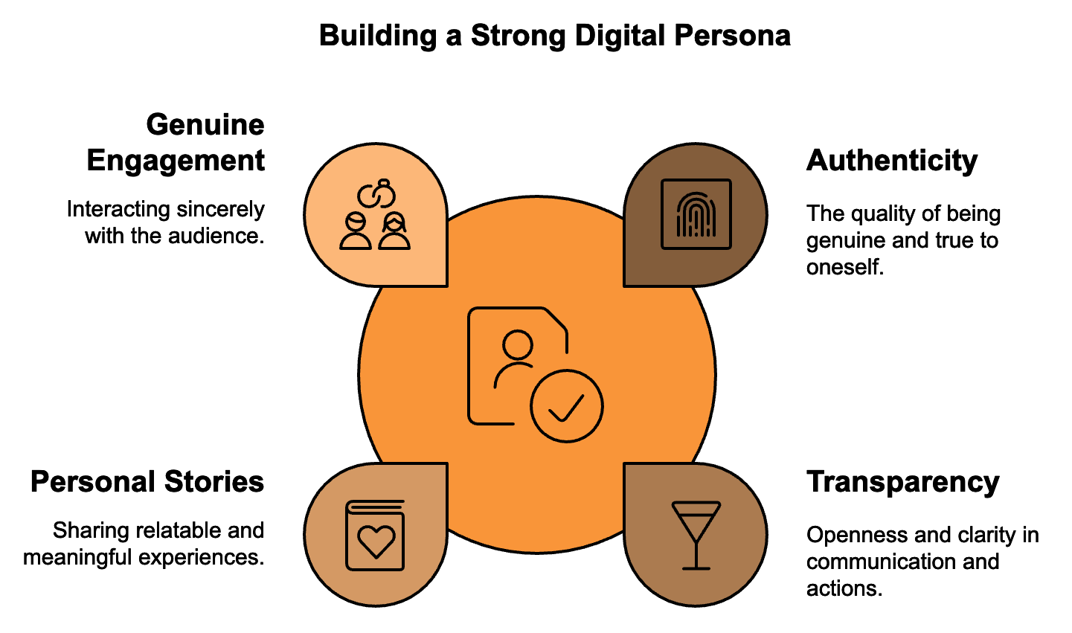
Authenticity is crucial in building a strong digital persona. In an age where consumers are bombarded with marketing messages, they've become adept at spotting insincerity. To establish authenticity, be transparent by sharing behind-the-scenes glimpses of your business, introduce team members, and be open about your processes. Admit mistakes if you make an error, own up to it publicly and explain how you're addressing the issue. Show your human side by sharing personal stories and experiences that relate to your brand values. Engage genuinely by responding to comments and messages in a personal, non-automated way.

One powerful tool for building an authentic and engaging digital persona is storytelling. Humans are wired to respond to stories, and incorporating narrative elements into your brand communication can significantly increase engagement and emotional connection with your audience. Share your origin story, highlighting how your business came to be, what problem you were trying to solve, and what inspired you. Showcase customer success stories to demonstrate how your product or service has positively impacted real customers. Highlight employee stories to showcase the people behind your brand and their personal connections to your mission. Tell the story of how your products are made, from concept to delivery, and share how your brand has grown and changed over time, always tying back to your core values. Remember, the key to effective storytelling is emotional resonance. Your stories should evoke feelings in your audience that align with your brand values and create a lasting impression.

Leveraging Content Marketing Strategies
Content marketing is another crucial aspect of crafting your digital persona. By creating and sharing valuable, relevant content, you position yourself as an authority in your field and build trust with your audience. Consider implementing various content marketing strategies such as regular, high-quality blog posts to drive traffic to your website and showcase your expertise. Utilize videos for product demonstrations, behind-the-scenes peeks, or educational content. If your audience prefers audio content, consider starting a podcast related to your industry. Create infographics as visual representations of data or processes that can be highly shareable and informative. Develop in-depth resources like e-books or whitepapers to position yourself as a thought leader in your field. Host interactive online seminars or webinars to provide value to your audience while allowing for direct engagement.
Your online presence is the new first impression.

When creating content, always keep your brand values and target audience in mind. Each piece of content should serve a purpose in building your digital persona and providing value to your audience. Let's look at a real-world example of effective content marketing: HubSpot. This inbound marketing and sales software company has built a strong digital persona through consistent, valuable content. Their blog covers a wide range of marketing and sales topics, providing practical advice for businesses of all sizes. They also offer free courses, e-books, and tools, positioning themselves as a helpful resource rather than just a software provider. This approach has helped them build a loyal following and establish themselves as industry leaders.

Evaluating and Evolving Your Digital Persona
In developing your digital persona, it's crucial to continually review and refine your strategies. The online environment is always changing, and your brand should adapt to keep pace. Set up regular check-ins to assess whether your visual elements are still relevant and appealing, if your messaging still resonates with your target audience, whether your content strategy is delivering the desired results, if you're maintaining consistency across all platforms, and whether you're effectively communicating your core values. Be prepared to make adjustments as needed, always ensuring that any changes align with your core brand identity.
One often overlooked aspect of building a cohesive brand identity is the importance of internal alignment. Your employees are your brand ambassadors, and their online presence can significantly impact your overall digital persona. Consider implementing guidelines for how employees represent your brand online, including social media policies, training on brand voice and messaging, encouragement to share company content, and guidelines for discussing work-related topics online. By ensuring that your team is aligned with your brand values and messaging, you create a more unified and powerful digital presence.
In the process of building and refining your digital persona, keep in mind that it’s an ongoing journey. The digital world is dynamic, and your brand should remain adaptable while staying true to its core values. Regular engagement with your audience, consistent messaging, and authentic communication will help you build a strong, recognizable brand that resonates with your target market. Your digital persona is more than just a logo or a tagline; it's the sum total of every interaction a person has with your brand online. By carefully crafting this persona, you create a powerful tool for building trust, loyalty, and ultimately, business success. Moving forward, keep your core values at the heart of everything you do, letting them shape your digital presence. With consistency, authenticity, and thoughtful content creation, you'll build a digital persona that genuinely represents your brand and creates meaningful connections with your audience.
Element | Purpose | Example
Visual Identity | Reflects brand personality | Consistent color palette, logo, typography
Brand Voice | Aligns with values and resonates with audience | Casual and conversational or formal and authoritative
Content Strategy | Positions brand as authority and builds trust | Blog posts, videos, podcasts, infographics
Storytelling | Creates emotional connection | Origin story, customer success stories, product journey
Internal Alignment | Ensures unified brand representation | Social media policies, brand voice training

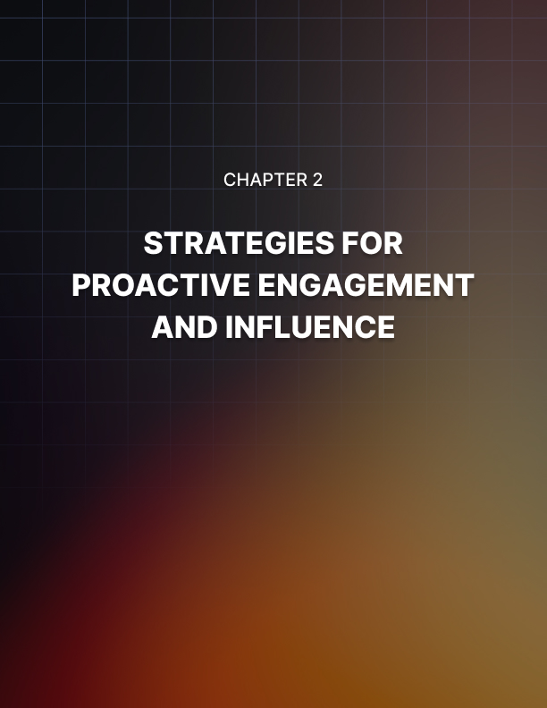

STRATEGIES FOR PROACTIVE ENGAGEMENT AND INFLUENCE
____
Think of social media as a busy, connected web, each platform with its own unique culture and audience. Your goal is to move through this space with purpose, building positive engagement and influence along the way. This chapter will provide you with advanced tools to go beyond basic posts and responses, allowing you to truly unlock the power of these platforms.

Developing an Adaptive Content Calendar
At the heart of your social media strategy lies your content calendar. This isn't just a schedule of posts; it's a living, breathing document that aligns your brand's voice with your audience's interests. You need to create a calendar that's both structured and flexible, allowing you to maintain consistency while also capitalizing on emerging trends and opportunities.
Start by mapping out your key business events, product launches, and industry dates. These form the backbone of your calendar. Next, layer in content themes that resonate with your brand values and audience interests. For example, if you're a fitness brand, you might have themes like "Motivation Monday," "Workout Wednesday," and "Nutrition Tips Friday." But here's where many brands fall short: they create a rigid calendar and stick to it religiously, missing out on real-time engagement opportunities. You need to build flexidbility. Leave slots open for spontaneous content, trending topics, or user-generated content. This adaptive approach allows you to stay relevant and responsive. Consider using a tool like Hootsuite or Buffer to manage your calendar. These platforms allow you to schedule posts in advance while also providing features for real-time posting and engagement monitoring. Remember, your calendar should be a guide, not a straitjacket. Be prepared to adjust on the fly when breaking news or trending topics align with your brand.

Harnessing the Power of Social Listening
Social listening is your superpower in the world of social media. It's not just about monitoring mentions of your brand; it's about tuning into the broader conversations in your industry and among your target audience. By effectively using social listening tools, you can anticipate trends, identify potential issues before they become crises, and engage with your community proactively. Tools like Brandwatch or Sprout Social can help you track keywords, hashtags, and trends relevant to your brand. Set up alerts for your brand name, products, key team members, and competitors. But don't stop there. Monitor conversations around broader industry topics and consumer pain points related to your products or services.
For example, let's say you're a skincare brand. Beyond tracking mentions of your products, you might monitor conversations about skin concerns, beauty routines, or even broader topics like self-care and wellness. This broader perspective allows you to join relevant conversations, offer valuable insights, and position your brand as a thought leader in your space. Use the insights gained from social listening to inform your content strategy. If you notice a surge in conversations about a particular skin concern, you can create content addressing that issue, showcasing how your products can help. This proactive approach demonstrates that you're in tune with your audience's needs and concerns.

Cultivating Influencer Partnerships
Influencer marketing has become a cornerstone of many brands' social media strategies, but it's not as simple as finding someone with a large following and paying them to post about your product. To truly harness the power of influencer partnerships, you need a more nuanced approach. Start by identifying influencers who align with your brand values and have an engaged audience that matches your target demographic. Look beyond follower count to engagement rates, content quality, and audience demographics. Tools like HypeAuditor or AspireIQ can help you analyze potential influencers and their audiences.
Once you've identified potential partners, focus on building genuine relationships. Engage with their content authentically before reaching out. When you do make contact, personalize your approach. Explain why you think there's a good fit between your brand and their content. Consider starting with smaller collaborations or gifting before proposing paid partnerships. When structuring influencer campaigns, prioritize authenticity and creative freedom. Provide clear guidelines about your brand message and any required disclosures, but allow influencers the flexibility to present your product or service in a way that feels natural to their audience. This approach leads to more genuine endorsements that resonate with followers. It’s important to recognize that influencer partnerships go beyond immediate sales. They’re about enhancing brand awareness and credibility within specific communities. Evaluate success through metrics such as reach, engagement, and sentiment, not just direct conversions.

Balancing Promotion and Engagement
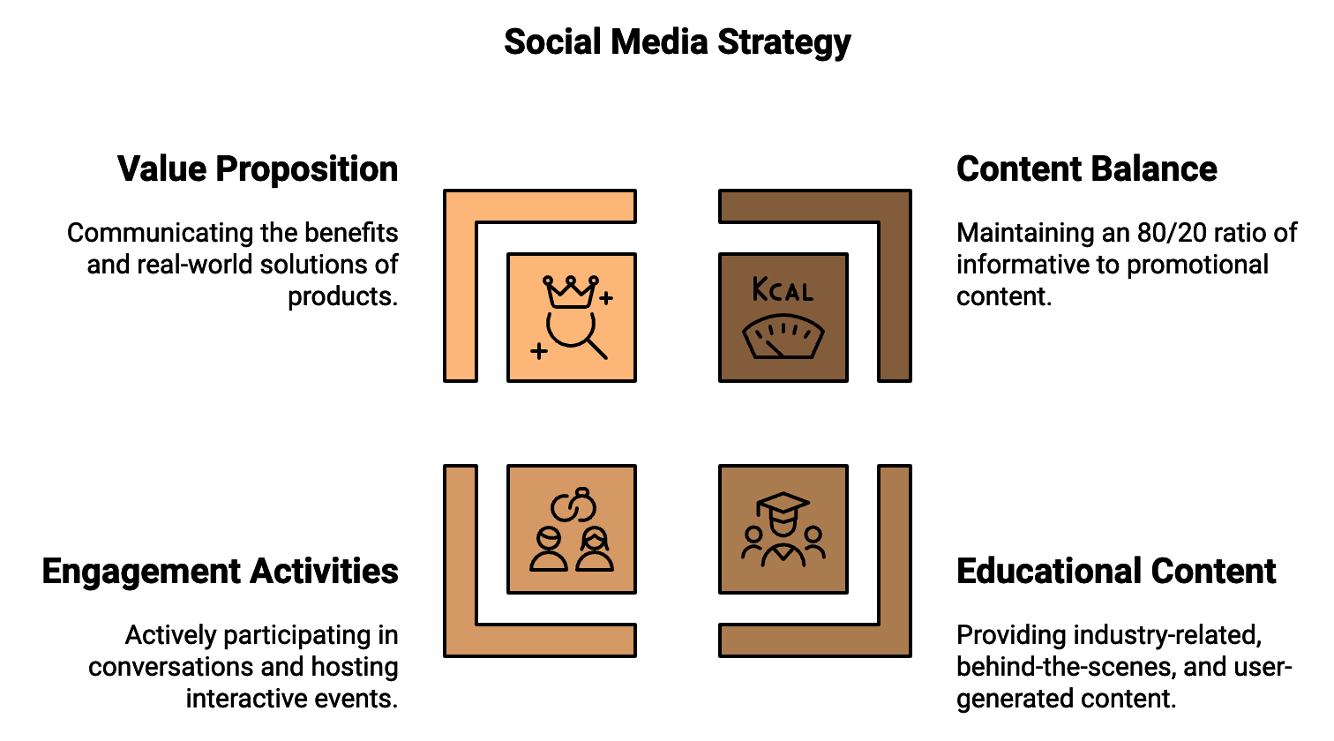
One of the biggest challenges in managing social media is striking the right balance between promotional content and community engagement. You're on these platforms to promote your brand, but audiences quickly tune out accounts that are overly salesy. The key is to provide value beyond your products or services. A good rule of thumb is the 80/20 rule: 80% of your content should inform, educate, or entertain your audience, while only 20% should directly promote your brand. This ratio ensures that you're consistently providing value to your followers, making them more receptive when you do share promotional content. For the 80% of non-promotional content, focus on educational content related to your industry, behind-the-scenes glimpses of your company, user-generated content, inspirational or motivational posts, interactive content like polls or questions, and relevant news or trending topics. When you do share promotional content, make it count. Instead of just announcing a sale, explain the value proposition of your product. Share customer testimonials or case studies. Use storytelling to showcase how your product or service solves real problems for your customers. Community engagement goes beyond just posting content. It involves actively participating in conversations, responding to comments and messages promptly, and creating opportunities for your audience to interact with your brand. Consider hosting Q&A sessions, live streams, or contests to boost engagement.

Leveraging User-Generated Content
User-generated content (UGC) is a powerful tool in your social media arsenal. It provides social proof, boosts engagement, and can significantly reduce your content creation workload. But how do you effectively encourage and leverage UGC? Start by creating a branded hashtag that your customers can use when posting about your products. Make sure it's unique to your brand and easy to remember. Promote this hashtag across your marketing channels and consider offering incentives for customers to use it. When customers do share content featuring your products, engage with it promptly. Like, comment, and share the best submissions. This not only encourages more UGC but also shows that you value your customers' input. Consider creating a dedicated space on your website or social media profiles to showcase UGC. This could be a gallery of customer photos or a feed of social media posts using your branded hashtag. Tools like Taggbox or TINT can help you aggregate and display UGC across your digital properties. Always ask for permission before reposting someone else’s content, even if they’ve used your hashtag. A quick comment requesting permission to share is usually all it takes.
Platform | Key Features | Best Practices
Instagram | Stories, Reels, IGTV | Use interactive stickers, mix ephemeral and long-form content
Facebook | Groups, Live Video | Build community, host Q&A sessions
Twitter | Threads, Chats | Real-time engagement, customer service
LinkedIn | Publishing Platform | Share industry insights, thought leadership
TikTok | Algorithm favors creativity | Create authentic, trend-aligned content

While refining your social media strategy, keep in mind that mastery is an ongoing process. The social media environment is constantly shifting, with new platforms emerging and existing ones evolving. Stay curious, keep learning, and don't be afraid to experiment. By applying these advanced techniques and continuously adapting to the changing digital environment, you'll be well on your way to becoming a true social media master.



TRANSFORMING FEEDBACK INTO OPPORTUNITIES
____
Your online reputation is a valuable asset, and customer reviews play a crucial role in shaping it. With potential customers frequently turning to reviews before making purchases, understanding how to navigate the review process is essential. Use feedback as an opportunity for growth and to build trust.

The Impact of Online Reviews
Online reviews wield significant influence over consumer behavior. According to a 2023 survey by BrightLocal, 98% of consumers read online reviews for local businesses. More importantly, 77% of consumers 'always' or 'regularly' read reviews when browsing for local businesses. These statistics underscore the critical role reviews play in shaping your brand's perception. Reviews serve as social proof, validating your product or service quality to potential customers. They can boost your visibility in search results, as many platforms consider review quantity and quality in their ranking algorithms. Positive reviews can increase trust and credibility, while negative reviews, if handled properly, can demonstrate your commitment to customer satisfaction.

Encouraging Positive Reviews
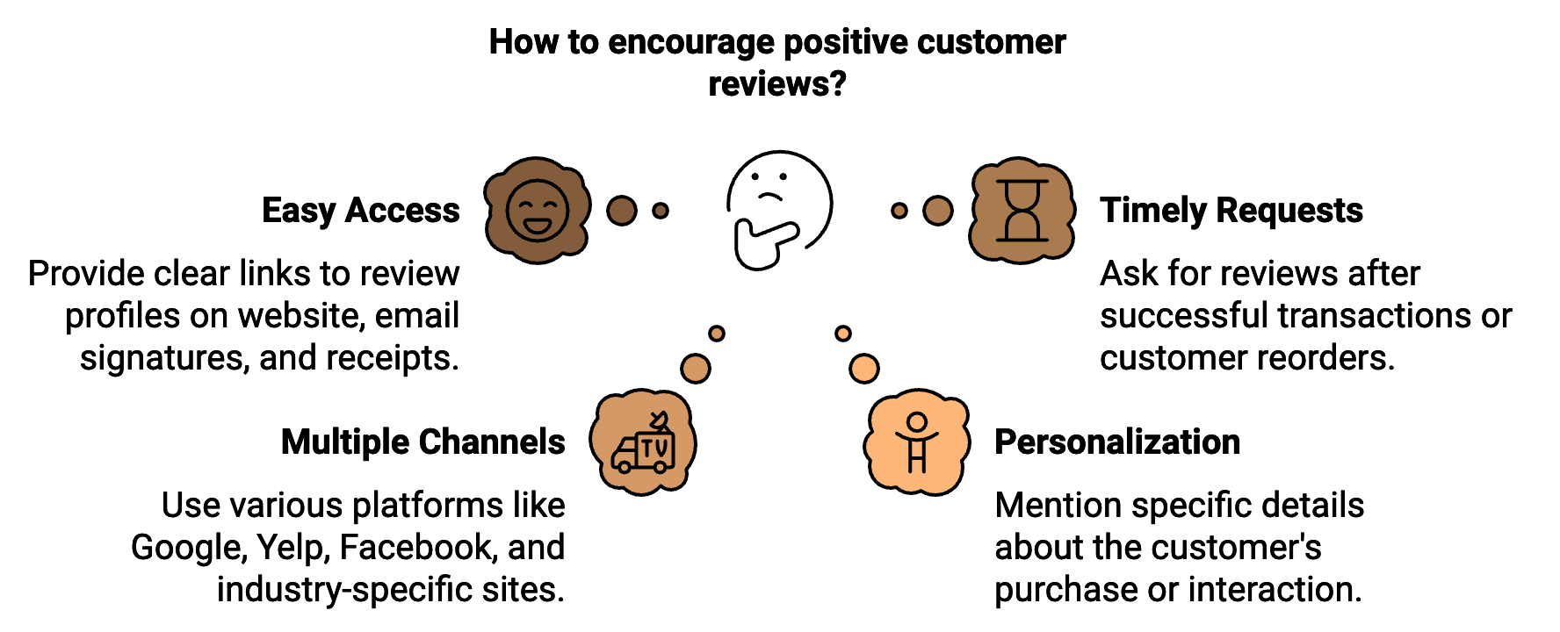
You can't simply sit back and wait for reviews to roll in. You need to actively encourage satisfied customers to share their experiences. Make it easy by providing clear links to your review profiles on your website, in email signatures, and on receipts. Time it right by asking for reviews at the right moment, such as after a successful transaction or when a customer reorders. Use multiple channels to create a well-rounded online presence, including Google, Yelp, Facebook, industry-specific sites, and your own website. Personalize your requests by mentioning specific details about their purchase or interaction to show that you value their individual experience. While it's tempting to offer incentives for reviews, be cautious as many platforms prohibit this practice, and it can undermine the authenticity of your reviews. Instead, focus on providing exceptional service that naturally motivates customers to share their experiences.

The key to encouraging positive reviews lies in consistently delivering high-quality products or services and providing exceptional customer experiences. No amount of clever tactics can replace genuine quality and attentive service.

Handling Negative Reviews with Grace
Negative reviews are inevitable, but how you handle them can turn a potential crisis into an opportunity to showcase your commitment to customer satisfaction. Respond promptly, aiming to address negative reviews within 24-48 hours. Stay calm and professional, even if you feel defensive. Acknowledge the issue by thanking the reviewer for their feedback and showing that you're listening. Apologize if necessary, offering a sincere apology if a mistake was made on your part. Take the conversation offline by providing contact information and inviting the customer to discuss the issue further in private. Offer a solution or explain how you're addressing the issue to prevent similar problems in the future. Follow up after resolving the issue and ask if they'd be willing to update their review. Many customers are happy to do so if their concerns have been addressed satisfactorily.
Let's look at an example of how this might play out:
Negative review: "I ordered a sweater from this company, and when it arrived, it had a hole in the sleeve. Terrible quality control!"
Your response: "Thank you for bringing this to our attention, [Customer Name]. We're sorry to hear about the issue with your sweater. Quality is extremely important to us, and we clearly fell short in this instance. We'd like to make this right. Please contact our customer service team at [email/phone number] so we can arrange a replacement or refund, whichever you prefer. We're also reviewing our quality control processes to prevent this from happening again. We appreciate your feedback as it helps us improve our service."
This response acknowledges the issue, apologizes, offers a solution, and indicates steps to prevent future occurrences. It also invites further communication to resolve the problem.

Effective Monitoring of Review Platforms
To manage your online reputation effectively, you need to keep a close eye on what's being said about your brand across various platforms. Start by identifying relevant platforms where your customers might leave reviews, such as Google My Business, Yelp, Facebook, industry-specific review sites, and your own website. Set up alerts using tools like Google Alerts, Mention, or Brandwatch to receive notifications for mentions of your brand name, products, or services across the web. Use platform-specific tools, like Google My Business's email notifications for new reviews. Consider implementing a dedicated review management platform like Podium or BirdEye to aggregate reviews from multiple sources, making it easier to monitor and respond to feedback across platforms. Assign responsibility by designating a team member or team to be responsible for monitoring and responding to reviews. Establish a response protocol with guidelines for handling different types of reviews, including response templates for common situations, escalation procedures for serious issues, and approval processes for responses to particularly sensitive reviews. Set up a system for regular reporting on review trends, including metrics like overall rating, review volume, response time, and sentiment analysis.

Identifying Patterns and Improving Your Business
Reviews aren't just about managing your online reputation; they're a goldmine of customer insights. By analyzing patterns in your reviews, you can identify areas for improvement in your products, services, or operations. When collecting reviews, categorize them based on the aspects of your business they address, like product quality, customer service, or shipping speed. Identify recurring themes that may highlight underlying strengths or weaknesses in your business. Consider using a scoring system to quantify feedback on different aspects of your business, which can help you track improvements over time. Share insights across your organization, ensuring relevant feedback reaches the appropriate departments.
Use these insights to make concrete improvements to your business, which might involve updating products, refining processes, or providing additional staff training. When you make changes based on customer feedback, let your customers know to show that you value their input and are committed to continuous improvement.

Review Category | Frequency | Average Rating | Key Themes
Product Quality | 45% | 4.2/5 | Durability, Design
Customer Service | 30% | 4.5/5 | Responsiveness, Friendliness
Shipping Speed | 15% | 3.8/5 | Delivery Time, Packaging
Website Usability | 10% | 4.0/5 | Navigation, Mobile Experience

This table provides a quick overview of review patterns, helping to identify areas of strength and potential improvement.

Building a Culture Around Positive Reviews
While managing negative reviews is crucial, don't forget to make the most of your positive reviews. Showcase reviews on your website by creating a dedicated testimonials page or integrating reviews into relevant product pages. Share positive reviews on your social media channels to help spread positive word-of-mouth and encourage more customers to leave reviews. Incorporate positive reviews into your marketing materials, such as brochures, email campaigns, or advertisements. Respond to positive reviews by thanking customers for their feedback, showing appreciation and encouraging others to leave reviews. For particularly enthusiastic reviews, consider reaching out to the customer to create a more in-depth case study.
To truly excel in the review space, you need to build a culture within your organization that values and prioritizes customer feedback. Educate your team to ensure all employees understand the importance of reviews and their role in generating positive feedback. Consider including customer satisfaction metrics derived from reviews in employee performance evaluations. Share positive reviews with your team and celebrate the employees mentioned by name. Use negative reviews as learning opportunities by discussing them in team meetings to brainstorm solutions and improvements. Empower your employees by giving them the authority to resolve issues that might lead to negative reviews. The more empowered they feel to solve problems, the better the customer experience will be.
In the process of working through the world of reviews, keep in mind that each piece of feedback presents an opportunity. Positive reviews can enhance your reputation and attract new customers, and negative reviews offer a chance to show your commitment to customer satisfaction and make improvements. By implementing these strategies, you'll be well-equipped to transform customer feedback into a powerful tool for growth and success. In the ever-evolving world of online reputation management, your ability to navigate the review world effectively can set you apart from your competitors. Value feedback in all its forms, respond with grace and professionalism, and leverage the insights to keep improving your business. This approach not only strengthens your online reputation but also helps you build a more customer-centered business positioned for long-term success.



PROTECTING AND REBUILDING YOUR ONLINE IMAGE
____
As social media and instant communication accelerate, a crisis can erupt in moments. A marketing misstep, product malfunction, employee misbehavior, or even a misunderstood statement can quickly spiral into a PR nightmare. The key to effective crisis management lies in understanding that these situations, while challenging, are also opportunities to demonstrate your brand's values, commitment to customers, and ability to adapt under pressure.

Understanding the Nature of Online Crises
Online crises tend to follow a predictable pattern: a trigger event sparks negative attention, which is then amplified across social media and other online platforms. Stakeholders react, impacting your brand's reputation, potentially leading to lost sales or decreased trust. Finally, your brand takes action to address the issue and mitigate its effects, followed by a recovery phase where you work to rebuild trust and repair any damage to your online image. Understanding this pattern can help you anticipate and prepare for each stage of a potential crisis.

Developing a Crisis Management Plan
Creating an effective crisis management plan is crucial for navigating the turbulent waters of online reputation management. Start by identifying potential crises specific to your industry and business. Assemble a crisis team including representatives from leadership, public relations, legal, customer service, and social media management. Establish clear communication channels for your team, such as a dedicated Slack channel or emergency conference call numbers. Develop response templates for common crisis scenarios that can be easily customized to fit specific situations. Define clear escalation procedures for when and how to involve higher management or external experts. Lastly, outline a post-crisis evaluation process to identify lessons learned and areas for improvement. Your crisis management plan should be a dynamic document, regularly reviewed and updated to stay relevant and effective.

Immediate Response: The Golden Hour
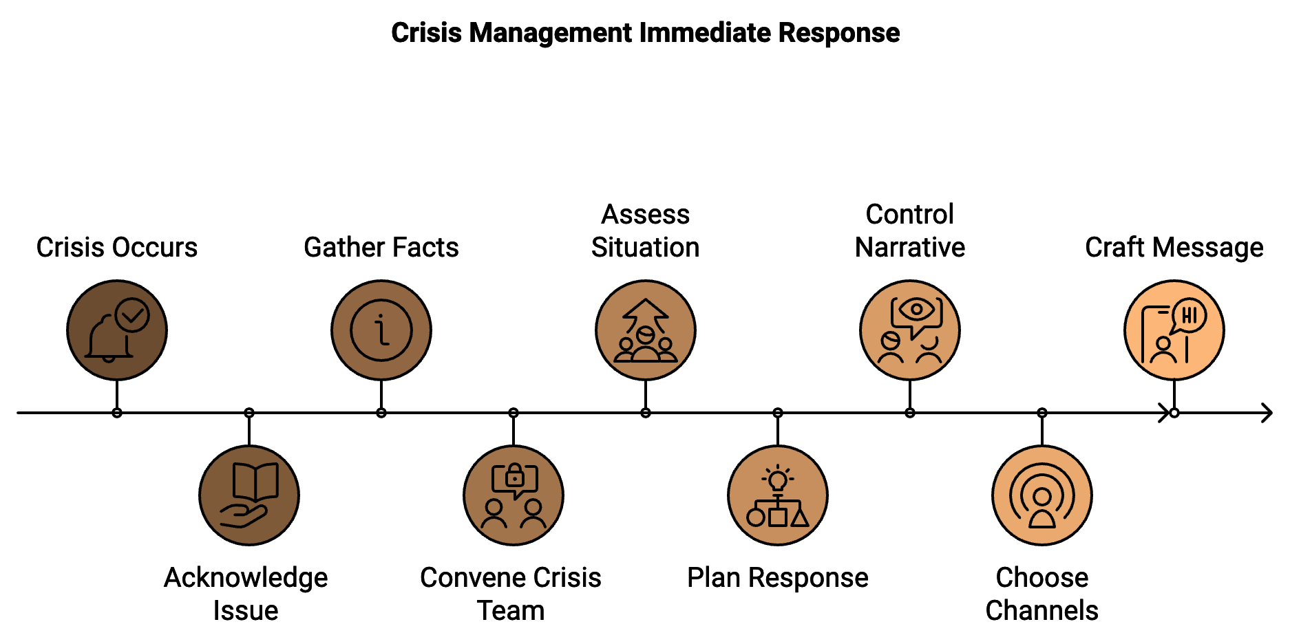
When a crisis hits, the first hour is crucial. Your initial response sets the tone for how the entire situation will unfold. Begin by quickly acknowledging the issue with a statement showing that you're aware and taking the matter seriously. Rapidly gather all available facts about the situation, including what happened, who's involved, and the potential impact. Convene your pre-designated crisis team to assess the situation and plan your response. Take control of the narrative by being the primary source of information about the crisis. Choose the most appropriate communication channels for your response, which might include your website, social media platforms, email, or traditional media. Craft a clear, concise message that addresses the situation without speculation or blame. An effective initial response might look like this: "We're aware of the issues surrounding [brief description of the crisis]. We take this matter very seriously and are actively investigating. We'll provide more information as soon as it's available. Thank you for your patience and understanding." This response acknowledges the issue, shows you're taking action, and sets expectations for further communication.

Transparency and Timely Communication
As the crisis unfolds, transparency becomes your most powerful tool. Being open and honest about the situation can help maintain trust and credibility, even in difficult circumstances. Provide regular updates to keep your audience informed, even if you don't have new information. Be honest about what you know and don't know, taking responsibility if your company has made a mistake. Show empathy by acknowledging the impact of the crisis on your stakeholders and clearly communicate the steps you're taking to address the issue and prevent similar problems in the future. Use clear, jargon-free language to ensure your messages are easily understood by your entire audience. In the age of social media, information and misinformation spreads quickly. Being transparent and communicative helps ensure that accurate information about the crisis reaches people directly from you.

Leveraging Different Digital Channels
Different crises may require different communication approaches. Understanding how to leverage various digital channels can help you reach your audience effectively and control the narrative. Create a dedicated crisis information page on your website to serve as a central hub for all updates and information related to the situation. Use social media platforms like Twitter, Facebook, and LinkedIn for real-time updates and to address customer concerns directly. For more detailed communications or for reaching out to specific stakeholder groups, email can be an effective tool. If the crisis requires in-depth explanation or a more personal touch, consider a blog post from your CEO or another company leader. For complex situations or when a more human touch is needed, video communication can be impactful. For major crises that may attract media attention, traditional press releases distributed through your website and newswire services can help shape the narrative. The key is to maintain consistency across all channels while adapting your message to suit each platform's unique characteristics.

Case Studies: Learning from Success and Failure
Examining real-world examples of crisis management can provide valuable insights. Let's look at two contrasting cases:
Company | Crisis | Response | Outcome
Airbnb | Discrimination allegations | Swift, comprehensive response including policy changes and #WeAccept campaign | Turned crisis into opportunity to reinforce values
United Airlines | Passenger removal incident | Slow, inconsistent response that initially seemed to blame the passenger | Significant damage to reputation and stock value

These cases highlight the importance of swift action, empathy, consistency, and taking responsibility in crisis communication.

Crisis Prevention Through Monitoring and Risk
Implementing robust monitoring and risk assessment procedures can help you identify potential issues before they escalate. Use social media monitoring tools to track mentions of your brand across platforms. Employ AI-powered sentiment analysis to spot negative trends early. Regularly review customer feedback from various sources to identify recurring issues. Keep an eye on industry news and trends that could potentially impact you. Establish clear channels for employees to report potential issues or concerns. Conduct periodic risk assessments to identify vulnerabilities in your operations, products, or communications. Regularly update your crisis management plan with new potential scenarios based on your monitoring insights. By staying vigilant and proactive, you can often address potential issues before they become full-blown crises.

Rebuilding and Learning: Post-Crisis Strategy
Once the immediate crisis has passed, focus on rebuilding trust and learning from the experience. Conduct a thorough review of every aspect of the crisis and your response, analyzing what worked well and what could have been handled better. Based on your review, implement concrete changes to prevent similar issues in the future. Communicate your learnings and the changes you're making with your audience to demonstrate your commitment to improvement and accountability. Monitor public sentiment in the weeks and months following the crisis, being prepared to address any lingering concerns. Reach out to key stakeholders who were impacted by the crisis, potentially through personalized communications, special offers, or face-to-face meetings. Use the insights gained from the experience to refine and improve your crisis management plan. Once some time has passed, consider launching a positive PR campaign to highlight the improvements you've made and rebuild your brand image. Remember, recovering from a crisis is a marathon, not a sprint, requiring time and consistent effort to rebuild trust and repair your online reputation.
As you navigate the choppy waters of online reputation management, remember that crises, while challenging, are also opportunities to demonstrate your brand's values, commitment to customers, and ability to adapt and improve. By preparing thoroughly, responding swiftly and transparently, and learning from each experience, you can turn potential disasters into stepping stones for growth and renewed trust. In the ever-evolving digital world, your ability to handle crises with confidence and grace can set you apart from competitors and deepen your relationship with your audience. View these challenges as opportunities to showcase your brand's resilience and commitment to excellence.

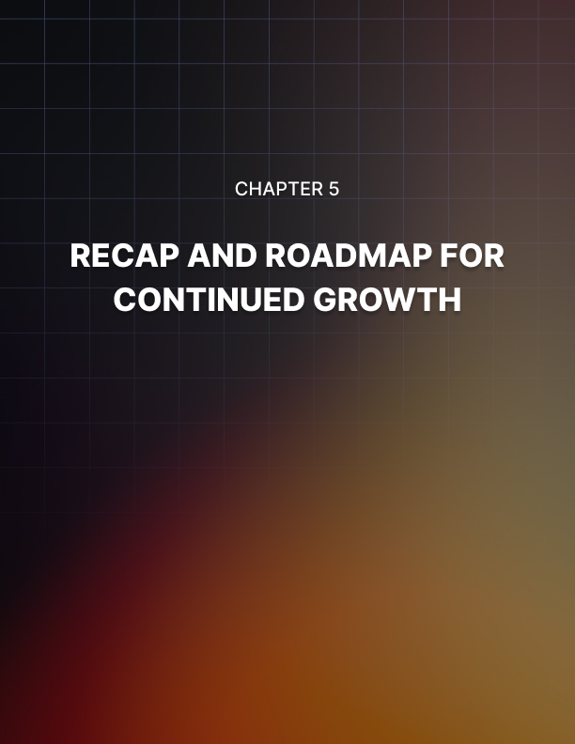

RECAP AND ROADMAP FOR CONTINUED GROWTH
____

Reinforcing Key Strategies
Let's revisit the essential strategies we've discussed throughout this book. These form the foundation of your ongoing digital reputation management efforts:
A cohesive brand identity should consistently reflect your core values across all platforms. Every interaction contributes to your digital persona. Proactive social media engagement involves authentically connecting with your audience, balancing promotional content with valuable, engaging posts. Use social listening tools to stay ahead of trends and potential issues. Review management is crucial; actively encourage positive reviews, respond professionally to negative feedback, and use insights from reviews to improve your business. Crisis preparedness involves having a solid crisis management plan in place, ready to respond swiftly and transparently to any issues that arise.
These strategies work synergistically to build and maintain your online reputation. Your cohesive brand identity informs how you engage on social media, which in turn influences the reviews you receive. Your ability to handle crises effectively ties back to your overall brand identity and social media presence.

The Importance of Adaptability
In the online space, change is the only constant. New platforms emerge, algorithms update, and user behaviors shift. Your ability to adapt to these changes is crucial for long-term success. Stay curious and open to learning. Follow industry news, attend webinars, and participate in professional forums to stay updated on the latest trends and best practices.
Consider the rise of TikTok as an example. In just a few years, it went from a niche app to a major player in the social media world. Brands that quickly recognized its potential and adapted their strategies to include TikTok content gained a significant advantage in reaching younger audiences.
To cultivate adaptability, regularly reassess your digital strategy. Set aside time quarterly to review your digital presence and strategy. Are your current tactics still effective? Are there new platforms or technologies you should be exploring? Experiment with new formats and platforms. Don't be afraid to try new things. Set aside a portion of your budget for experimenting with emerging platforms or content formats. Learn from your audience. Pay attention to how your audience engages with your content. Their behavior can provide valuable insights into emerging trends. Foster a culture of innovation. Encourage your team to bring new ideas to the table. Create a safe space for experimentation and learning from failures.

Data-Driven Decision Making
Data is one of your most powerful allies, offering objective insights into what’s working, what isn’t, and where new opportunities lie. Here’s how to leverage data effectively:
Set clear KPIs. Determine what success looks like for your digital presence. This might include metrics like engagement rate, follower growth, website traffic from social media, or conversion rates. Use analytics tools. Platforms like Google Analytics, social media insights, and specialized social listening tools can provide a wealth of data. Familiarize yourself with these tools and use them regularly. Conduct A/B testing. Test different approaches to see what resonates best with your audience. This could involve trying different post formats, content types, or posting times. Look beyond vanity metrics. While likes and followers are nice, focus on metrics that truly impact your business goals, such as conversions or customer lifetime value. Analyze competitor performance. Tools like SocialBlade or SEMrush can provide insights into your competitors' strategies and performance.
Data should guide your decisions, not control them. Always balance insights with your brand values and long-term goals.

Building a Strong Team
With the growth of your digital presence, you may find it necessary to build or expand your team. Here are some key roles to consider:
- Social Media Manager
Responsible for day-to-day content creation and community management across platforms.
- Content Strategist
Develops overarching content strategy aligned with business goals.
- Data Analyst
Interprets data from various sources to provide actionable insights.
Remember, these roles don't necessarily need to be full-time, in-house positions. Depending on your needs and resources, you might consider freelancers, agencies, or part-time staff. When building your team, look for individuals who are not only skilled in their specific areas but also adaptable and eager to learn. As the online world evolves quickly, staying open to ongoing learning is essential.

Leveraging AI and Automation
Artificial Intelligence (AI) and automation tools are revolutionizing digital reputation management. When used effectively, these technologies can enhance your efforts and free up time for more strategic tasks. Here are some ways to incorporate AI and automation:
Chatbots for customer service can handle basic customer inquiries 24/7, improving response times and freeing up your team for more complex issues. Content scheduling tools like Hootsuite or Buffer can schedule social media posts in advance, ensuring consistent posting even during off-hours. Sentiment analysis AI tools can analyze large volumes of social media posts and reviews to gauge overall sentiment towards your brand. Personalization AI can help deliver personalized content experiences to your audience based on their behavior and preferences. Predictive analytics advanced AI tools can forecast trends and potential issues, allowing you to proactively adjust your strategy.
While these tools are powerful, they should complement, not replace, human insight and creativity. The most effective strategies combine the efficiency of AI with the nuance and empathy of human interaction.
AI Tool | Function | Benefit
Chatbots | Customer Service | 24/7 availability, faster response times
Content Schedulers | Social Media Management | Consistent posting, time efficiency
Sentiment Analysis | Brand Monitoring | Real-time insight into brand perception
Personalization Engines | Content Delivery | Enhanced user experience, higher engagement
Predictive Analytics | Strategy Planning | Proactive decision making, trend forecasting

Continuous Learning and Professional Development
The field of digital reputation management is constantly evolving. To stay ahead, you need to commit to continuous learning. Here are some ways to keep your skills sharp:
Online courses on platforms like Coursera, edX, and LinkedIn Learning offer courses on various aspects of digital marketing and reputation management. Industry certifications from Google, HubSpot, or other reputable organizations in your field can enhance your credibility. Conferences and webinars allow you to learn from experts and network with peers. Books and podcasts help you stay updated with the latest thought leadership in your field. Mentorship, either finding a mentor who can provide guidance based on their experience, or becoming a mentor yourself, can solidify your knowledge.
Encourage your team to engage in continuous learning as well. Consider setting up a learning budget or dedicated time for professional development.

Ethical Considerations in Digital Reputation Management
In building and maintaining your online reputation, it's essential to consider the ethical implications of your actions. The digital world offers numerous opportunities for manipulation, but giving in to these temptations can severely backfire. Here are some ethical guidelines to keep in mind:
Transparency is key. Be open about your brand's identity and intentions. Avoid using fake accounts or bots to boost your online presence. Honesty in advertising ensures all your promotional content is truthful and not misleading. Respect for privacy means handling customer data with care and respecting privacy laws like GDPR. Fair competition avoids tactics that unfairly undermine competitors, such as posting fake negative reviews. Authenticity in influencer partnerships ensures all sponsored content is clearly labeled as such. Responsible crisis management means taking responsibility for mistakes and being honest in your crisis communications.
By maintaining high ethical standards, you build long-term trust with your audience, which is far more valuable than any short-term gains from questionable tactics.

Future-Proofing Your Digital Reputation
Although it’s impossible to predict exactly how the digital space will evolve, you can take steps to future-proof your reputation by:
Build a strong foundation. A solid brand identity and loyal community can weather many changes in the digital world. Diversify your digital presence. Don't rely too heavily on any single platform or tactic. Stay agile. Be prepared to pivot your strategy quickly when new opportunities or challenges arise. Invest in owned media. While social media platforms are important, don't neglect your website and email list – channels you have more control over. Focus on building relationships. Ultimately, your reputation is built on the relationships you forge with your audience. Prioritize genuine connections over short-term metrics.
As you continue your journey in digital reputation management, remember that success is not a destination but a continuous process. Stay curious, remain adaptable, and always keep your core values at the heart of your digital strategy. By doing so, you'll be well-equipped to navigate whatever changes the digital future may bring.
In conclusion, sustaining success in digital reputation management requires a combination of strategic thinking, continuous learning, ethical practices, and adaptability. By reinforcing key strategies, embracing data-driven decision making, building a strong team, leveraging new technologies, and committing to ongoing professional development, you can maintain and enhance your online reputation in an ever-changing digital world. Remember, your digital reputation is more than just your online presence – it's the trust you build with your audience, the value you provide, and the positive impact you make in the digital world. Moving forward, keep these principles close, and you’ll be well-prepared to tackle the challenges and seize the opportunities that the future of digital reputation management holds.

