Table of Contents

Introduction 3
Chapter 1: The Benefits of Selling Your Expertise 6
Chapter 2: Different Coaching Service Sales Models 12
Chapter 3: Sell Your Coaching Expertise Through Books 17
Advantages 17
Disadvantages 18
Step-by-Step Guide 19
Chapter 4: Sell Video Courses 23
Advantages 23
Disadvantages 24
Step-by-step guide 24
Chapter 5: Sell Your Expertise Through Scheduled Webinars 27
Advantages 27
Disadvantages 28
Step-by-step guide 29
Chapter 6: Live Webinars 33
Advantages 33
Disadvantages 34
Step-by-step guide 34
Chapter 7: Offer One-to-One Coaching 37
Advantages 37
Disadvantages 38
Step-by-step guide 39



Introduction

Let's be clear about something here before we begin: everybody is an expert (or "expert enough") in at least one body of knowledge. It doesn't matter what it is. Maybe you know how to sing a little bit better than everybody else, maybe you know your way around the basketball court, maybe have discovered a way of running a little bit faster, or maybe you know how to make money with Twitter or Facebook. Regardless of who you're dealing with, everybody has at least one area of expertise.

We can all agree on this because not all of us have the same experiences. Not all of us have had the same things happen to us. It is precisely this difference in experience levels that make hanging out with our friends and family members so rich and rewarding. We get to look at the world from many different eyes and different perspectives. We also get to explore it through our shared stories at different times.

Since this is the case, did you know that people might actually pay for your expertise? This is the reason why the online coaching business is a large multimillion dollar industry. People all over the world are interested in what other people have to teach them. In fact, you only need to look at platforms like Udemy and the huge following of tutorial channels on YouTube to get a rough idea of the demand out there.

There is also a tremendous variety of online education platforms that help people improve their expertise in a wide range of knowledge areas. Online coaching is really just a variation of online education.

Of course, this is informal. You normally do not get some sort of certification or diploma after finishing a course. Still, the essence is still the same. People are looking for information that others possess. What's more, people are willing to pay money to get this information.

There is a tremendous demand for online coaching services because, let's face it, we live in a world that is increasingly expertise-based. How come? Well, the internet actually has a paradoxical effect on people. As more and more information accumulates online, people feel isolated and alienated from any definitive claim of expertise. In other words, if you are going to claim to be an expert or a guru in a certain subject, you better know your stuff.

Most people lack that confidence, and that's why they hunger for specialized information. They know that, as information continues to grow on the internet, our knowledge becomes more and more specialized. It's as if we can only focus on topics that are an inch wide and a mile deep. We focus on the thing that we know and we rarely go beyond our comfort zone.

If we want to pick up certain information to at least get a practical understanding of it, that's when we need coaching. Because, let's face it, while you can figure this information out by going through all sorts of blogs and downloading all sorts of free resources, who has the time? Most people wish there were more hours in the day because they're so busy.

Not surprisingly, there's a tremendous demand for online coaching because you cut straight to the chase. Instead of your client going through website after website trying to chase after the right information, you dish it out in such a way that they get all the information that they need, and they can acquire the knowledge that they're looking for on their own terms and on their own schedule.

Given these market realities, the demand for online coaching services will continue to rise in the foreseeable future. Platforms like Udemy, as well as free resources like Codecademy and YouTube "how to" channels, are just the beginning. This space is continuing to evolve.

Become part of that market evolution by starting your own online coaching business. This book gives you an overview of what's out there, the different models you can explore, and what to look for in terms of opportunities and potential problems.

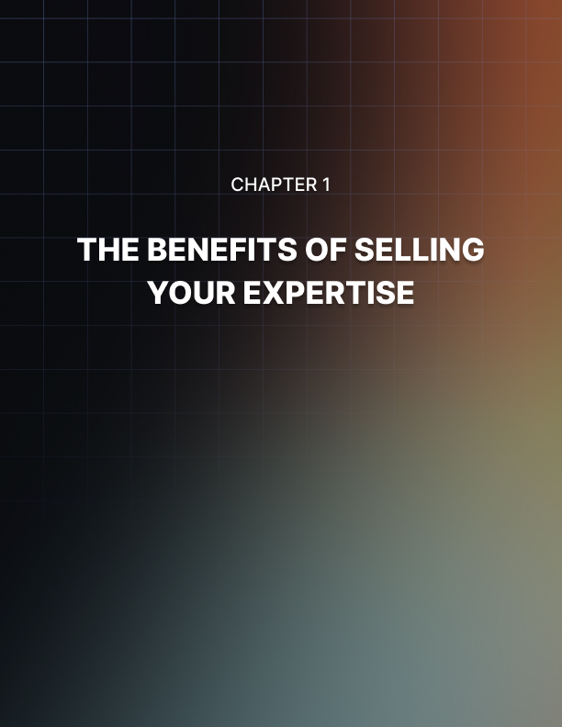

Chapter 1: The Benefits of Selling Your Expertise

Every person has at least some information or interest in information that they can potentially make money with. The next step is to figure out the forms this takes and what actual benefits you stand to gain.

Sell Information You're Passionate About
As I've mentioned earlier, people simply do not have the time to chase after information and then filter that material. They really cannot be bothered. Maybe they're too busy, maybe they feel that they do not have the proper expertise or the background to do it. Whatever the case may be, they would rather go to somebody who is so passionate about a specific body of knowledge that they have put in the time, effort and focus in compiling this information from third party sources.

Think of it like going to a specialized librarian. If you're looking to, let's say, practice permaculture in a tropical setting, you can wrack your brains trying to go through all sorts of online libraries, chase down all sorts of arcane or obscure materials, or you can go to somebody who has an ebook or online course focused on that specific topic.

Get Paid to Talk About Stuff You are Curious About
Another benefit of selling your expertise is that you get paid to talk about information that you are curious about. This means that you have all the incentive in the world to feed your curiosity. When was the last time that happened at your day job? Chances are, there is a big disconnect between what you do for a living and the activities and subjects that you are personally passionate about.

When you sell your expertise in the form of a course, an online program, or some sort of book, you get paid to talk about stuff that makes you curious or which pushes you to investigate. This is actually one of the most fulfilling and gratifying benefits of selling your expertise.

You're not being paid to push a button. You're not being paid to do something that you've done millions of times before and which feels like it drains your soul. Instead, you are being paid to really pursue your passions.

Get Paid for Others to Pick Your Brain
One of the most fulfilling things people can do on this planet is to interact with each other where their understanding is not only challenged, but enhanced. Let me tell you, when it comes to hanging out with other people, one of the most satisfying and rewarding experiences you could get is when you get that "aha" moment.

When somebody shares something with you that you didn't know before, or shared information with you that enabled you to realize something that you did not know before, the sense of discovery and putting pieces together in your mind is a very positive experience. It excites a lot of people. And you get this opportunity when you get paid for other people to pick your brain.

They ask you question after question, and it's your job to basically take those questions and mentally pick them apart and come up with an answer. You are not only challenging your present knowledge, but you're also being paid to think.

Let's face it, not all of us are engaged at this level. Not all of us are getting paid to achieve that "aha" moment. You're basically getting money to develop as a human being. What's not to love?

Benefit From Passive Models of Selling Your Expertise
One of the key selling points of selling your expertise to others is the fact that you can develop a passive income stream.

When you work for somebody else, generally speaking, you have to sell your time for money. That's the exchange. You agree to show up at a certain time, at a certain place, to do certain things, and in exchange for that, you get paid. You trade your time for money.

This is a serious problem because, obviously, there's only one of you. You cannot be in two places at one time. Also, there are only 24 hours in a day. It's not like you have an infinite inventory of time to sell at any given day.

It is no surprise that a lot of people burn out from active income. That's what this is. When you trade your time for money, you are engaged in active income. If you stop taking action, you stop earning.

Passive income works the other way. You work once or you work very little, and then the asset that you create continues to generate money.

The most obvious example of this involves books. You put in work to write a book. You write that book once, but once you have published it on Amazon Kindle and it continues to sell many times over, you earn many times from a book that you worked once to create.

In the brick and mortar world, a key example of a passive income is when you buy an apartment complex. You obviously have to work for the money to afford that complex, but once you buy it, every single month, your tenants have to come up with the rent. You just sit back and wait for the rent to come in.

From time to time, the property management company sends people out to make sure that the building is in good working order. But for the most part, you don't have to lift a finger to earn the rent money that comes in like clockwork every single month. That is the power of passive income.

The good news is, when you sell your expertise, the majority of these business models are passive in nature. You don't have to be there actively coaching people on a one to one basis. You can write a book, or you can shoot videos that people can view at their convenience. You can show up at a webinar and be recorded.

There are more passive versions of selling your expertise than active ones. You can stop selling your time for money.

Sell Your Personal Expert Brand
Wouldn't it be great if you earned more money the more you learned? Wouldn't it be awesome if you continue to grow your expertise in any kind of subject and end up getting paid more? That's precisely the position you put yourself in when you sell your expertise.

The more people buy your book, the stronger your brand becomes. The more seminars you give, the higher the likelihood that you will get interviewed or people would write about your seminars. In other words, the value of your business grows by you simply doing what you do and reaching out to interested audiences and building an organic following for your expert brand.

In other words, the more you sell your expertise, the more powerful your brand becomes. Compare this with working for somebody else.

Now, you may be the best employee on the planet and you may bring a lot of value to the table, but at the end of the day, only your boss sees your value and it's really up to that person whether they would promote you or not. It really boils down to their judgment whether you're going to make more money or not. This is not the case when you're selling your expertise.

Because when you impress one person, it's not unusual for that person to tell another person. And then the people they know might be bloggers, so don't be surprised if there are all sorts of blog articles written about you. Before you know it, people want to interview you and then your personal expert brand continues to grow every time you produce a product.

This is how experts build an author platform. They start out with books. They write down the things that they know in a particular specialized body of knowledge in the form of books. If enough of these books get published or if enough people buy these books and are impressed by your expertise, pretty soon they would want you to hold seminars or engage in one to one coaching.

You can shoot a series of videos and ask people to pay a one-time fee or a monthly membership fee to access those videos. You make passive income when you do this because you only work once to shoot these videos, but you make money every time somebody signs up to view those videos.

You obviously can make passive income every time somebody buys books that you have written in the past.

Similarly, your brand can get so big that you can hold a live webinar. Prospective audience members get notified that you are going to be holding an online seminar over a webcam. They then fill out an appointment form and pay a fee. They show up, and you answer people's questions, and a recording is made so seminar attendees can have access to the seminar long after it's over.

Finally, as word gets out about your ability to help people and the value of the information you have shared, you can make quite a bit of money doing one to one coaching. You can do this on Google Hangouts or Skype, it doesn't really matter. What matters is people can pay you quite a bit of money on an hourly basis or even every fifteen minutes.
Depending on your field of specialty, you can command hundreds of dollars per coaching hour. This is not unheard of. People have done this before. In fact, top earners charge quite a bit of money for every fifteen-minute block of time they spend coaching people over the internet. This can get all lucrative, and it all boils down to developing a solid personal expert brand.

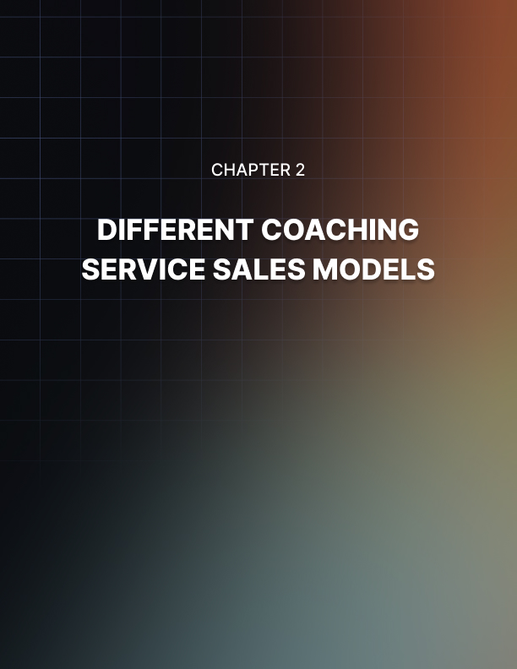

Chapter 2: Different Coaching Service Sales Models

In this chapter, I'm going to walk you through a quick overview of the different ways you can sell your personal expertise. If you have decided to coach people and earn money as a coach, please understand that there are many ways to do it.

You're not stuck with just one channel. There are actually several channels you can use to make money selling your personal expertise. This is just an overview. I'm going to devote one chapter for each of these specific channels.

Sell books
If you like to write or if you know somebody who does, you might want to write down your expertise, put together an outline and get somebody to write out a book. When you produce a book, you automatically get viewed as an expert.

I know this is kind of a big claim to make, but understand that if you go to any kind of party, the vast majority of people there have not written books. You have to remember that sitting down to write a book means several things.

First, you have to have something that is worth sharing. Maybe it's an interesting story. Maybe it's some sort of expertise or inside knowledge. Two, you have to have the time, effort and discipline to actually get stuff from your mind converted into text on paper and then edit that material so it's actually readable. In other words, this takes quite a bit of discipline and commitment.

The third option here is resourcefulness. Maybe you have interesting information you'd like to share, but you'd rather have somebody do it for you and that's where ghost writers come in. Regardless of how you cut it, when you sell books, people's inherent or instinctive respect for authors kicks in because they know how hard it is to write.

They know that putting a book together is not actually a walk in the park. You get instant respect and instant authority status by simply producing one book after another in your area of expertise.
Sell video courses
Let's face it. If you're trying to teach somebody a new concept, one of the most effective ways to do this is not to get them to sit down and read a book you wrote. Sure, your book might have all sorts of interesting graphics and diagrams, but at the end of the day, there's really no substitute for face to face interaction.

This doesn't mean that you have to be in front of them live. You can shoot a video and have the same effect. How come? Well, when people watch a video of you giving a lecture or speaking directly to them, sharing information, they pay close attention to your eyes.

They also pick up your facial expressions, your gestures and your body language. Finally, they make snap judgments about how you talk, what you talk about and how quickly you speak. All of these are instantly put together in their minds and they make a quick judgment.

Either they feel comfortable and they think that you are trustworthy enough to listen to and learn from or they simply reject you at some level or other. They may seem like they're listening, but they're not. Still, when people watch videos, a lot of this dynamic is replicated.

This is why platforms like Udemy.com are so popular and successful. People spend millions of dollars every single year on courses from this platform to learn all sorts of subjects. You don't necessarily have to put your video courses on Udemy, but you can benefit from the same dynamic.

Video courses do work because when people watch you and you're animated and they see you talk excitedly about a subject that they're interested in, chances are they will absorb that information and find you credible enough and authoritative enough to want to buy more courses from you.

Scheduled webinars
Scheduled webinars are quite different from video courses. When you shoot a video course, there's really no time element. You can shoot it all at one time and as long as people are able to access your website, they can pay you money to access your videos.

They can watch your video the next day, or they can watch your series 2 years from now. They still see you on video, they engage with what they see and they pick up information. Live scheduled webinars operate on a different dynamic.
The visitor actually has to show up to view your video at a scheduled time. When they go to your webinars sign up page, they have to set up an appointment. Once they have selected a specific date and time, they get an email reminder to show up. After all, they paid for the webinar or they paid when they showed up.

A lot of coaches prefer this method because you work less. Unlike a video course where you basically have to shoot hours of footage covering a wide range of topics because you are teaching people a fairly comprehensive set of information, scheduled webinars are actually more compact.

Usually, they run no more than 2 hours. When you hold a seminar, you only focus on a fairly narrow range of topics. This saves you a tremendous amount of time. In terms of presentation, it also saves you quite a bit of resources when it comes to actual research.

Still, the scheduled webinar is actually a recorded video. So, these people that are signing up for a specific type of information are actually just setting up an appointment to watch a pre-recorded video on a fairly narrow topic.

There is really no one to one interaction. There's definitely no interaction with the audience. People just sign up to watch the video at a specific date and a specific time.

Live webinars
A live webinar is pretty self explanatory. People show up at a specific time. They book that time and they pay for it. You show up and you speak relatively briefly about a pre-scheduled set of topics.

After that, it's free for all.

The people who show up in front of their computers to see you on webcam can then turn on their cameras and you can see them asking you all sorts of questions. The value of live webinars is the interplay between you and your audience members.

Please understand that different audiences have different interests and different questions. It also depends on when your webinar is set. If you're setting it at a specific time of the year where people are concerned about giving gifts or planning vacations, those are probably the kinds of questions you will get.

If you were to set up your webinar earlier in the year or in the middle of the year, people might have different interests. Whatever the case may be, live webinars can run anywhere from 1 to 4 hours and its value really all boils down to the questions people bring and your answer to those questions.

There's also a tremendous amount of call and response between you and your audience members. They send you signals, you send them signals. They're excited, you get excited and everybody has a good time.

One to one coaching
This form of coaching involves somebody going to your website, setting up a schedule for you to talk to them one to one over Google Hangouts or Skype. When that time comes, they show up, you show up and you provide coaching. For them to book you for that appointment, they have to pay. This is a great way to directly coach somebody.

There's really no right or wrong answer regarding which sales model you should choose. However, if you are serious about building a solid offer expert brand, you might want to consider doing all 5 because if you think about it, they all flow into each other. The more people are exposed to your books, the more famous and credible your author brand becomes. This increases the likelihood that people will sign up for more video courses. If people like your video courses, they may like it so much that they would sign up for live webinars, one to one coaching as well as scheduled webinars. These different channels actually reinforce you to them. They don't necessarily cancel each other out.

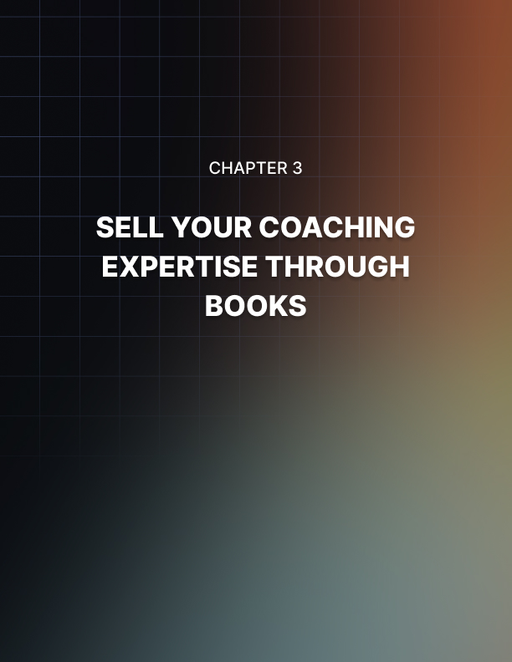

Chapter 3: Sell Your Coaching Expertise Through Books

This method of selling your coaching expertise involves publishing books in a narrow range of niches. You're not going to publish a book that claims to talk about everything and anything related to your industry. That's not going to work.

The narrower your range of topics, the better. You get a much better opportunity to highlight your expertise. In your book, you address key questions involved in your niche. For example, you know how to brew beer at home. If you write a book on home brewing, you can talk about ideal conditions for brewing as well as common problems people encounter that prevent them from brewing amazing beer.

These questions are predictable. They don't come out of left field and it's very easy to control the flow and shape of the expert information and opinion that you're sharing in your book. The name of the game is to showcase your knowledge and build up your personal expert brand.

This book is really your business card. It tells the world that you know what you're talking about. People only need to read what you have to say on certain topics to be shown in no uncertain terms that you walk the talk.

Advantages
The primary advantage of this coaching channel is that it's completely passive. You work only once to compile or write the book. Maybe you had the book ghost written at Ozki.org or other low cost yet high value writing services.

Regardless of how you got the book made, you only do it once. The good news is that books can sell many times over in the course of a year. In fact, there are many book authors on Amazon Kindle who make tens of thousands of dollars off a book that they have written several years ago.

Remember, they only worked once to publish that book, but every single year, they're making all this money. You can do the same with books covering subjects within your expertise. As I mentioned earlier, when you publish a book, you stand out from the crowd.

You have to remember that in any place, there are likely to be experts in the same specialization as you.

However, not all of them can write a book. Maybe they don't have the time or the discipline to do it.

However, you have come up with a book and this gives you a tremendous competitive advantage. Each book must be set up properly for it to benefit you optimally. What am I talking about? Each book should promote your author website. If you don't have one, put one up because this is the website that highlights your expertise and expert status.

Every book you produce must have a link to that site. When they click it, they see your picture, your biography, your resume, your list of books and other experiences. In other words, they get the information they need to determine whether you are an expert or not.

The good news here is you can make quick work of developing a solid author brand in your area of expertise. How? You can write tons of books through outsource. You don't have to lift a finger to write this material. You just hire low cost, high volume, high quality writing services like Ozki.org. They would be able to drill down in your narrow expert niche.

They crank out book after book all bearing your name. The more books you publish, the bigger of an expert you become. Interestingly enough, the more books you publish, the less promotions you need to do. How come? Your older books have promoted your author website so much that when people join your author website's mailing list, you only need to send out an update telling people that your latest book has arrived for you to wrack up quite a bit of sales.

In fact, a lot of expert coaches self publish only using Kindle yet they make quite a bit of money and are recognized experts in their field. You can do the same.

Disadvantages
Please understand that just because you published a book doesn't automatically mean clients will show up. This is especially true if you're just starting out. If you're starting out from square one and nobody has heard of you, you're going to have to do promotions.

The good news is the more books you produce and the more you promote it, the easier it would be to drum up attention for your later books. Please understand that you're going to have to spend time, effort and yes, even money, to promote your books.

This is not one of those things that you build and all of a sudden, demand will show up. It doesn't work that way. You have to put in the time to drive awareness for your books.

Also, unless you publish on a grand scale, and I'm talking about releasing a huge number of books in a short period of time, your author profile can take a while to develop. Keep this in mind. This is not something that will happen overnight.

Step-by-Step Guide
Step 1: Focus on a niche
The first thing that you need to do to succeed in coaching through books is laser target niche focusing. In other words, be clear as to what you want to specialize in and focus on that only. Master it. Seek out an area of expertise that is an inch wide, but plunge miles deep. Know it inside and out. This is how you build a solid foundation for your expert brand.

The flip side to this, which you also need to pay attention to, is that it has to be in a niche where there is enough demand. Let's be clear, you can be an expert basket weaver. But if nobody is really interested in getting coaching, much less books about basket weaving, you're not going to make any money.

Focus on a niche that people would actually pay money for. One way to estimate this is to go to Amazon Kindle and look at the sales rankings of books within a subject category. If you notice that a lot of the books sold that have lower rankings in the top seller lists have sales scores of ten thousand or lower, you are in a high demand niche. This may be a good niche to select.

Step 2: Find your niche on Amazon Kindle
Now that you have a clear understanding of the niche that you want to specialize in, find your niche on Amazon Kindle. It has to be there and it has to have decent demand.

Step 3: Pick a sub niche that doesn't have much competition
Assuming that there is a lot of competition in your Amazon Kindle niche, feel free to dial down or skip down to a sub niche. The key here is to look for a sub niche that doesn't have much competition but still enjoys decent demand. This takes quite a bit of research. You can use tools like Kdspy to find keyword demand patterns on Amazon.

Step 4: Focus your book on your target sub niche
Now that you've identified the sub niche that you're going to specialize in, sit down and focus your book's firepower on that sub niche. Demonstrate through your book that you are an expert in that sub niche. Nail it down. Hammer it. Bring home the point.

Step 5: Create a link in your book that highlights your author brand
At the top of your book, you should put a link to your official author website. This official author website is not just your online calling card. It's not just a place to put a nice picture of you. Instead, it highlights why you should be considered an authority.

Maybe you should list down the books you publish there. Maybe you should list your awards and accomplishments. Whatever the case may be, it drives home the point that you are worth listening to if people are looking for information in the niches that you cover.

Step 6: Find related sub niches and write a book on that sub niche
Now that you have written your first book in a sub niche within your specific field of expertise, now is the time to write your second book. Find a related sub niche and write a book on that sub niche.

Step 7: Repeat until you have covered your whole niche
By this point, you have chopped up your field of expertise into different sub niches. You've also written a specific book for each of those sub niches. Keep repeating the process until you have covered your whole niche.

Step 8: Write more books to drill down your expertise and your niches
Within this niche, you already have one book covering sub niches. At this point, you should drill down. What other topics within your sub niche haven't you talked about before? Write specific books on these. In other words, don't leave any stone unturned. Don't leave any issues unexplored.

Allow your author name to be found with all keywords related to your niche. This is how you develop a niche focus that is an inch wide, but miles deep. Every mile down is a book and every quarter or 1/8 inch is a sub niche that you have a specific book on.

Eventually, when people find themselves on Amazon, looking through books related to your niche, they will always keep running into your author brand. It's only a matter of time until they click on the author profile and they end upon your author page where you list your credentials.

Regardless, thanks to this constant branding, chances are you will be recognized by your book's buyers as a bonafide expert within your areas of expertise.

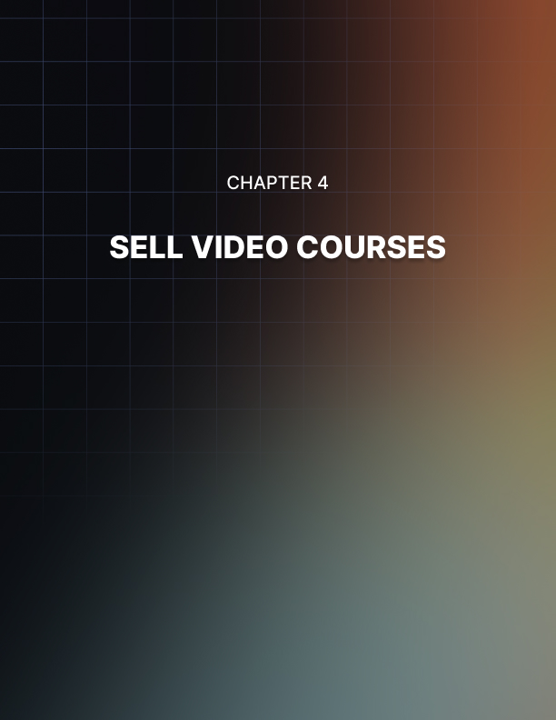

Chapter 4: Sell Video Courses

With this particular approach, you’re going to record videos based on scripts that you have written ahead of time. Each script covers a specific topic. When the videos are viewed in totality, your viewers will get the important information that they wanted to learn.

You present these videos through a membership access area. In other words, these are not publicly available videos. You have to actually go to a specific website and use a login and password to access these videos. To get that login and password, your viewers have to pay a membership fee. You can charge them a one-time fee or a monthly recurring fee.

Advantages
The big advantage of selling video courses is that you get a passive income business. You only record the videos once, but you get paid that one-time membership fee, or every time somebody renews their membership. Whatever the case may be, you do the work once and get paid many times over.

Also, when you offer videos, they’re more personable than books. Let’s get one thing clear. It takes a lot of effort to read. You have to use your imagination, read between the lines, and exert effort to understand the information. That’s a lot of work.

Video conveys a lot of information in a small space and in a short period of time. It is also very personable. When you look straight in the video, people can connect with your eyes. They can tell what your emotional range is based on the tone of your voice and your body language.

Another key advantage of selling video courses is you can get a lot of students if you use the right video course platform. Udemy is a very powerful and popular video coaching platform that covers most niches.

There are already thousands of people signed up to Udemy. If your course shows up in Udemy, there are certain preview sections as well as the servers’ built-in search engine that people can use to find your course within the platform. By simply putting your stuff on Udemy, you can become visible to the students who already use that platform.

Disadvantages
The big disadvantage of video courses is that you might not cover the specific topics your viewers are interested in. It may well turn out that you covered 60% of the information they want to know, but what about the 40%?

Also, there’s a risk that the information you talk about in your videos tend to be general in orientation. Even though you’re operating on an intermediate level of expertise or you’re giving out intermediate level information, it still might be too general for your specific audience members. This might cut down on their interest or they might want to ask for a refund because you haven’t exactly talked about what is most important to them.

Finally, if you’re going to be selling video courses on a platform like Udemy, it may well turn out that there are too many competitors specializing in the same niche that you are in. This might also cut down on your sales.

Step-by-step guide
Step #1: Avoid competition as much as possible
Look for your niche on Udemy and see how many existing direct competitors you have. If there’s too much for comfort, find a sub-niche with fewer competitors.

Step #2: Invest in better copywriting
Look at what your competitors are already doing on Udemy. How do they describe themselves? What kind of headlines and descriptions do they use? Come up with something better. Use clickbait- worthy titles and descriptions. Come up with a description that is worth sharing.

Now, if you don’t have this skill set, you can hire veteran sales copywriters from places like Upwork or Fiverr to write these materials for you. Whatever the case may be, your stuff has to stand out compared to your competitors.

Step #3: Use Catchier Preview Videos
A lot of Udemy videos and other video-based platforms have allowed course providers to post a preview video. Don’t waste this opportunity. Get a special video shot that really does a great job advertising the benefits people will get when they sign up for your video course.

Oftentimes. When it comes to video course platforms, you really only have one bite of the apple. Don’t waste it. Use a very catchy, slick, well-produced preview video so you can get your message across loud and clear.

Step #4: Over-deliver and Under-promise
You have to remember that Udemy is quite saturated. If you are offering coaching in any subject area that has decent demand levels, don’t be surprised if there are lots of people offering the same information. How do you stand out? How do you beat these people?

It’s very simple: over-deliver and under-promise. When people sign up for your stuff, give them so much value that they can’t help but write amazing reviews about you. Get them hyped about the value that you bring to the table that they can’t help but get excited about the next course you’re going to offer.

You can do this by simply promising more than your competitors, but delivering way more. In other words, you have to put your money where your mouth is.

Step #5 Use worksheets and other support materials that upsell your Kindle books
When people have signed up for your course, they will get support materials. Maybe these are worksheets or cheat sheets. Whatever the case may be, you should use these materials to upsell your kindle books so these should have links to your author profile.

You could also have links pointing to your scheduled Webinars. Finally, maybe you could have a link for people to sign up on your mailing list. Use your worksheets on Udemy or any other video course platform to build up your brand and get sales. At the very least, call people to action to share the word about your course.

Step #6 Create a course for all the sub-niches in your niche
For example, if your niche is wine making. You can start out by starting a video course on Udemy on how to make one type of wine. After that, you can focus on another sub-niche like sparkling wine. Make a video course on that. Then after that, use dry wines or something else.

By the time you’re done, you should’ve covered all the sub-niches involved with wine. Do this regardless of the niche you are focused on. Maybe you’re into animation, programming, or game design. Whatever the case may be, nail down the sub-niches by using the steps above.

This will ensure that you become a true expert within that niche. If a person is interested in that niche in whatever form, they will search for courses and if they see your name over and over again, they start to create an association between your name and a certain field of expertise.
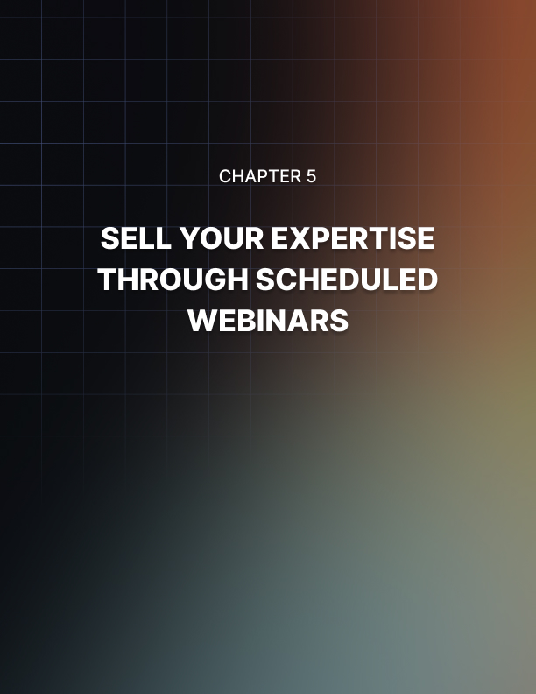

Chapter 5: Sell Your Expertise Through Scheduled Webinars

Scheduled webinars are simply pre-recorded video presentations that must be viewed on appointment. This is really a marketing trick. You should remember when people are made to feel that something is scarce and is going to go away soon, they are more likely to buy.

When you market your pre-recorded video as a webinar that people have to sign up for. People are more likely to sign up because they think that you have recorded it just for that event.

Little do they know that you’ve recorded it a while back to focus on one topic. People from all over the world can actually set an appointment to view it at different times. There’s really no sense of urgency as far as you’re concerned, but you create a sense of urgency on their end.

A distinguishing feature of scheduled webinars compared to live seminars is there is absolutely no question and answer section. After all, you’re not in front of a live audience.

Advantages
As I’ve mentioned above, this is really a promotional trick. You build up hype for the “launch” of the webinar. This increases its perceived value. Once you have achieved this, you get a sneaky way to collect email addresses.

When people show up to sign up for the seminar, you can offer part of it for free. To get that benefit, they have to sign up to your email list. You then send an update letting them know that the seminar is on, they see the initial video, they like it, and they sign up for more seminars. This time, they have to pay.

The hype period where you are involved in the launch enhances your author appeal. You’re basically sending a psychological signal to your intended audience that you are worth waiting for and that your stuff is so valuable that they should wait for it.
Another advantage you get is that you get to use the launch date for your promotional outreach and marketing. Maybe you’re buying ads. Maybe you’re sending out emails. Maybe you’re renting out other people’s addresses.

Whatever the case may be, you can keep coming back to that launch date so there is a perceived scarcity for the webinar. Another advantage to this is the comprehensive value-packed nature of this specific type of video. This usually involves more preparation than long drawn-out video series.

You are pushed to basically present your best materials in terms of graphic and content.

Also, the video that you are shooting is actually very short. You’re basically going to have to compress everything that is awesome about a specific subject within a short time frame. This increases the likelihood that the video you come up with is exciting, engaging, and very personable. It will probably do a better job of building up your expert brand than the normal videos you produce.

Another key advantage that you get with this way of selling your expertise is the webinar platform that you use will take care of payment processing. In fact, some of these platforms even have promotional capabilities where people can refer their friends after they’ve signed up.

Since this is a coaching method where you pre-record, you stand to take a passive exam. You record once and you get paid many times over because people sign up and view your materials many times over. The appointment system can be set to different dates.

This means that if people missed the launch date, they can enter their email address and they can get a reminder to check out the next date the video will be available. It turns out that since the video is pre- recorded, it’s available all the time, but you are pumping up the perceived value by only showing it at different times. People have to sign up for an appointment. To view the video, they have to pay for that appointment.

Disadvantages
The big drawback to this way of selling your coaching services online is the lack of engagement. Remember, this is canned content. This is not you talking or presenting live in front of a webcam. You have shot this material ahead of time and you’re focusing on a fairly narrow topic.

This brings up the second disadvantage. You might actually be talking about stuff that isn’t all that interesting to the viewer. This happens quite a bit. There’s a recognized expert who’s going to be holding a seminar on a specific topic.

When people show up to view the video about that specific topic, it turns out that the actual information that they’re looking for regarding that topic is either glossed over, mentioned in passing, or not explored. Talk about a let-down. You can bet that people are going to feel disappointed if they actually paid money to view the video.

Another disadvantage is that paid webinars carry huge pressure to deliver value “above and beyond” the normal value your books and canned video courses deliver. Otherwise, if people feel let down, your brand might suffer.

You might actually lose followers because they’d think that you rip people off or you over-promised and under-delivered. Please understand that since this is not live, you can’t engage the call and response effect. This effect is crucial in making live interactions so much more meaningful and fun.

Step-by-step guide
Step #1: Pick the right webinar platform
There’s a wide range of platforms out there, but the right one for you should have payment processing capabilities (which means they should be able to take PayPal easily). It should also have promotional elements. When people sign up for a seminar, they should be able to invite their friends or share the materials on their Facebook wall. Also, the appointment setting system must be very robust. It must be clear as to when they’re going to see the video and the system must remind them via email.

Step #2: Write your video script
Remember, you’re not going to be sharing everything you know about your specific subject of expertise. Instead, you’re going to focus on a fairly narrow range of topics within your expertise. Write your video script accordingly.

Step #3: Shoot your video
Don’t try to shoot everything in one take. Try to get audio guides ready or some sort of visual aid. Also, make sure that there is enough helpful audio with the presentation. Now, please understand that this is not a slideshow. This is you speaking to the camera and trying to engage with the viewers using all sorts of props and graphical aids.

It can get quite rough. You might have to do several takes, but what’s important is that the video comes off as smooth, authoritative, and professional as possible.

Step #4: Do outreach and promo
You have to promote. If people have signed up to your mailing list, send out an update. If people talk about your author brand on Facebook groups and Facebook pages, announce your webinar there. You might even have to buy Facebook page ads.

Step #5: Set up your appointment setting system
Make sure you set up the appointment setting system for your webinar platform. This way, when people respond to your ads, they can set up the appointment to view the video. Usually, you should ask for money at this point.

Step #6: Set up an email system to remind people
You should link the appointment setting system with the email system so that when people sign up, they automatically get a reminder that they’ve already signed up and paid, and that the webinar is happening soon.

Step #7: Send out event notifications and gather emails
If you’ve done this right, when people set up an appointment, they’ve already signed up on your email list. However, if these are somehow disconnected, you can still get people to sign up to your mailing list. Of course, when people show up, they can then watch the video.

Now, how exactly can you make money off your mailing list? Well, once you have people on your list, you can notify them of another seminar you’re having. You can also send them ads for affiliate programs. When people click on these affiliate links and they buy something, you get a commission.

You can also rent out your email ad blast to people looking for solo ads. They can pay you up to several hundred dollars per email blast. You can even sell your own products. Of course, you should push your own Kindle books as well as your courses on Udemy and other platforms.

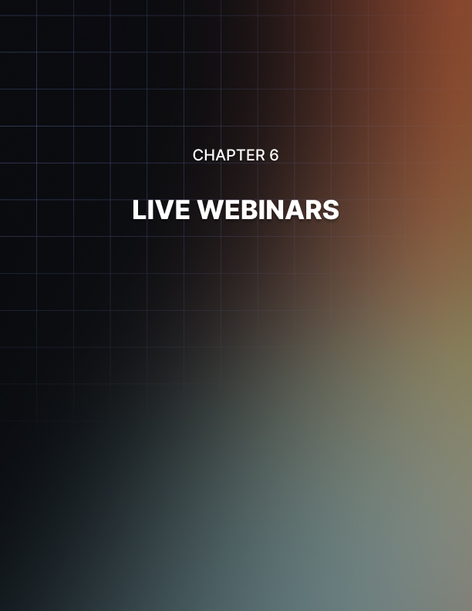

Chapter 6: Live Webinars

Live webinars involve actual live presentations in front of the camera. You’re going to be talking about a very narrow range of topics. The seminar is very specific in terms of subject matter. What makes this different is that you’re using a free-form approach. You just rehearse what you’re going to talk about in terms of talking points, but everything else is up to the crowd.

People will show up and view you on their webcams. They then type in their questions and you’ll answer these in real time. These live webinars are one-time events. However, you can set up an option where you can record the live webinar for viewing at a later date by people who have paid to view the original.

Appointments are set up for only one time. These can only be viewed when you’re talking or people who couldn’t show up can view the recorded version. That’s it. This is supposed to be special. It’s supposed to be a one-time thing.

Advantages
The big advantage here is you get to market anticipation for the seminar. This is supposed to be launched. It’s a one-time thing and it’s a special event. You have these things going for you. Also, when people sign up for your live webinar, it’s a golden opportunity for you to sign them up to your mailing list. The form usually has an email collection component. You can use this to get more mailing list members.

The biggest draw to live webinars is the live interaction. You’re actually coaching live. You’re coaching a group of people at once. You cater to each specific audience’s needs. These audiences vary so they all have different needs. This is why people get a lot more value from live webinars. They ask questions that are most important to them.

Have you ever gone to a live lecture and you get a chance to question the lecturer? It’s very interesting because different crowds have different questions. This adds to the perceived value of the seminar. Every single seminar is going to be different because there are different crowds there.

You actually get to charge more money for a live audience because of the impromptu and the improvisational nature of the call and response and audience dynamics involved. This is a golden opportunity to highlight your expertise. People can see that you really know your stuff because regardless of the questions they throw your way, you know how to answer them.

Disadvantages
You really have to know your stuff. This is the biggest disadvantage of live seminars. The worst thing that you can do is to say, “I don’t know.” You’re going to destroy your coaching brand if you let that bomb drop. The way to save face is to say, “I will get back to you,” or “I will find out.” Never ever say, “I don’t know.”

Also, please understand that a lot of other experts are using the same live webinar format. This is not new. This is revolutionary. Please note that depending on your niche, there might actually be saturation. It might seem like you’re the 100th person offering a live seminar on your topic. This saturation can lead people to believe that your stuff is not really all that valuable. After all, if it’s that unique, why is everybody and his dog offering it?

Finally, you have to be quick on your feet. As awesome as the call and response dynamic may be. It can also be very rough on your nerves. You have to know what you’re talking about. You have to listen to questions very carefully, understand them very quickly, and answer them in such a way that builds up your expert status.

Step-by-step guide
Step #1: Pick a live seminar software platform
At the very least, this platform must have a billing and promotional component. It must also have an email collection component or it must tie into your current email collection system for your mailing list.

Step #2: Pick a date
It’s really important to pick the right strategic date. You don’t want to pick a date that is too close because people might have other problems. You also don’t want to pick a date that’s so distant in the future that people can easily forget. There has to be enough urgency in the date. This is how you increase the likelihood that lots of people will book your live seminar.

Step #3: Practice prepared materials as well as possible stuff that might come up
You have to know your stuff. You can’t look like a fool. You can’t look like a deer stuck on headlights. It doesn’t really matter how much of an expert status you have managed to build up prior to this point. All of that will go up in smoke if people think that you are a complete moron. Brush up on your expertise. As much as possible, prepare stuff and keep rehearsing until you have become completely comfortable with the materials that you’re going to present.

Step #4: Look alive, motivated, and eager to help
If you’re having a tough time trying to figure out the kind of persona you want to project, look at motivational speakers. Look at how they pump up the crowd. Now, I’m not saying that you should be the second coming of Tony Robbins, but you have to look lively. You don’t want to look like a stiff robot. That’s not going to help improve your brand.

Step #5: Remember that your brand is on the line
Regardless of what you do, please understand that when you are in a live seminar, your brand is on the line. Things might get knocked loose. It might be an unforeseen accident. Any of these could be murder on your brands. Please conduct yourself professionally, don’t insult people, be helpful, be positive, and be optimistic.

Step #6: Call people to action regarding your books
You have to understand that although you’re getting paid for this live seminar, this should not be your only way to earn a living. You should also push your books, your canned videos, as well as your live coaching services.

Finally, you should call people to action to share the word about your seminars. Tell people to tell their friends and family members about the stuff that they’ve learned and that you’re always available. If people like your stuff, you’d be surprised how many people will refer you to people within their circle of influence.
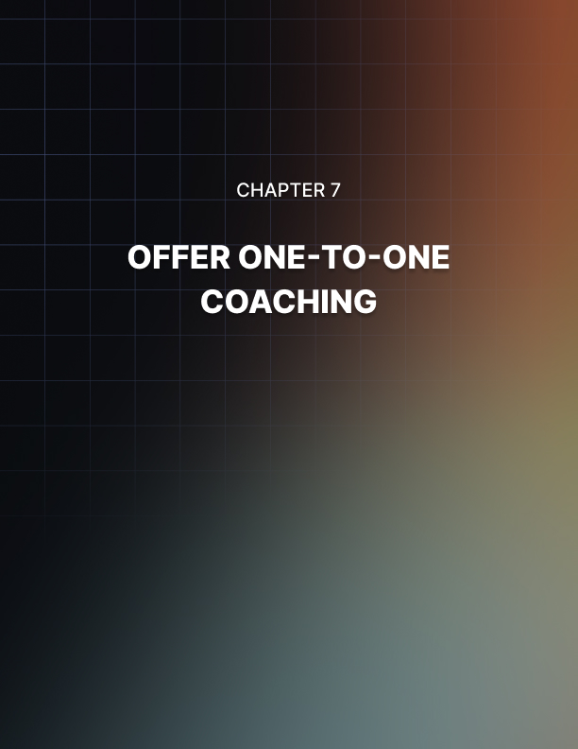

Chapter 7: Offer One-to-One Coaching

This form of coaching service provision is the most direct. Basically, you get in front of a webcam and you coach people via Skype or Google Hangouts. It’s that basic. It’s a one-to-one coaching system. In other words, there’s only one person there or if you’re coaching couples, two people, but that’s it.

You’re not coaching a whole audience or a wide range of people watching your recorded videos. This is for a specific individual at a specific time with a specific subject in mind.

The key to one-to-one coaching is live interaction. In other words, your advice exists only to help that person in front of you. Whatever questions or insecurities they may have, you’re there to help them. You’re operating on that one-to-one personal level. This is why a lot of people would pay good money for this. It’s all about them. They’ve booked and blocked off this specific amount of your personal time.

Advantages
The most obvious advantage of one-to-one coaching is that this is the most expensive form of coaching you could do. This is where you make the big bucks.

If you have developed a solid brand in your area of expertise, you can probably be justified to charge hundreds of dollars per hour. Imagine that. You’re sitting in front of Skype and talking to somebody. After an hour, you have $300 all the way up to $500. Not too bad, right?

Second, it is short. The person you’re coaching cannot talk your ear off. They can’t monopolize your time. You’re offering live one-on-one coaching for a very short period of time. We’re talking about one hour, or two hours at maximum. That’s it. For that amount of time, you’re going to get paid well.

Another key advantage is that you don’t have to worry about your presentation or your advice not helping your intended audience. Since you only have an audience of one, that person asks you all sorts of questions while you go through the coaching so you can see whether they’re absorbing this and you can also shake the material so that they can absorb it more fully.

Disadvantages
I wish I could tell you that you can start offering one-to-one coaching on day one. It doesn’t work that way. You have to be a premium expert before you start offering one-to-one coaching. This means that you have to pay your dues over an extended period of time.

If you expect people to pay you $300 per hour, you’re going to have to earn that right by paying your dues. What do I mean by that? Well, you’re going to have to publish books to at least document your expertise. You’re going to have to be interviewed by important people or important blogs in your industry. Your name has to be prominent enough for people to say, “Yes. That person’s time is worth $300 or more per hour.” That’s how it works.

Another key disadvantage is that these one-to-one coaching sessions are very expensive. This is why it’s a good idea to sell them in fifteen minute blocks. For example, if your base rate is $300 per hour, get people excited by telling them, “I’m going to give you live one-on-one coaching starting at $75.” That $75 buys 15 minutes of your time.

If you’re a big-enough expert, that should be good enough. If people like what you have to say and if they really feel that they’re making progress thanks to your coaching, don’t be surprised if they order more fifteen-minute blocks. Before you know it, this person has already paid $300 for an hour of your time.

Another big disadvantage here is you are selling your time. In other words, you can’t be somewhere else. You can’t help other people. You can’t work on something that might possibly earn more money. You’re stuck doing live one-on-one coaching. Sure, you’re getting paid a lot of money per hour, but you’re still trading your time for money.

Generally speaking, you can’t record your sessions. Reselling this one-to-one session is a big no. This person wanted you to interact with them directly. They’re not asking you to turn them into content so you can make money many times over by selling your recorded session.

Finally, you might have to produce custom worksheets for this one-to-one session. This might take quite a bit of time. Also, if that person has very specialized needs, this can actually take more effort than you have originally anticipated.

Step-by-step guide
Step #1: Set up live one-on-one appointment systems on your author website
When people find your brand online, they end up on your author site. This is an ideal place to offer live one-on-one coaching. The way they can access that is through an online appointment system.

Step #2: Set up a payment system
It’s very important for you to get paid first. The worst thing that you can do is to set up your one-to-one coaching wherein people can cheat you. Believe it or not, there are lots of otherwise well- renowned expert coaches that overlook this. Not surprisingly, after their clients show up, get coached, and get worksheets and supplemental information, they don’t get billed.

You have to get people to pay upfront. Overcome your fear of thinking, “If I ask for money, this person is going to drop.” Well, if they’re going to drop anyways because they’re not sure, then they were never your customers to begin with. Do you see where I’m coming from? Good.

Step #3: Review your clients’ background materials prior to each session
This is the key. You have to deliver solid value. You’re not just spouting the exact same stuff that you say to every random person in the street who’s interested in your areas of expertise. This person is asking for a one-to-one coaching session for a reason. They have specific needs and interests.

Read up on these. Research them. Give them information they don’t already know. Break this information down so they can actually get value from the one-to-one coaching.

Step #4: Show up on time and coach
This should be self-explanatory. Unfortunately, a lot of otherwise expert coaches manage to blow this. If you want to be viewed as a true professional, show up on time every time.

Step #5: Try to get another session
Play it by ear. If you notice that the person you’re coaching is responding favorably and is getting really excited, give them the idea that they can book another session. The more sessions you book, the more money you make. However, don’t be obvious or rude about it. If it’s obvious to them that you’re just milking them for every ounce of cash you can get, it’s going to be a major turn off for them. They’d probably not have a good impression of you. Play it by ear, but always try to get the next session going.

