Disclaimer

This ebook has been written for information purposes only. Every effort has been made to make this e-book as complete and accurate as possible.

However, there may be mistakes in typography or content. Also, this e-book provides information only up to the publishing date. Therefore, this e-book should be used as a guide - not as the ultimate source.

The purpose of this e-book is to educate. The author and the publisher do not warrant that the information contained in this ebook is fully complete and shall not be responsible for any errors or omissions.

The author and publisher shall have neither liability nor responsibility to any person or entity with respect to any loss or damage caused or alleged to be caused directly or indirectly by this e-book.
Table of Contents

Introduction 6
Qualities Of A Great Coach 7
Specialize: Make Real Money In Coaching 9
Chapter 1: You Have To View Coaching As A Business 12
Your Most Precious Coaching Asset is Your Personal Brand 13
Chapter 2: Coaches Need To Constantly Challenge Their Knowledge 16
Mistakes To Avoid When Coaching Online 17
Chapter 3: Finding the Root Cause of Your Client’s Obstacles 20
Ways To Make Coaching Difficult Clients Easier 21
Getting Over Your Fear of Failing Your Clients 22
Chapter 4: Reasons Life and Business Coaches Fail 25
Do You Need Certification to Be an Online Coach? 26
What Are the Best Coaching Training Programs? 27
Chapter 5: Successful Online Coaches Need To Work The Media 31
Social Media Is Indispensable For Coaching Business Success 32
Chapter 6: Enhance Your Market Value Through Controversy 36
Chapter 7: Group Coaching 39
Big Advantages Of Group Coaching 40
Chapter 8: Host a Successful Group Coaching Program 43
Building a Funnel For Your Coaching Program 45
Conclusion 48



Introduction

The first time I got interested in online coaching, I met a lot of different people.

A lot of these individuals were well on their way to developing an online coaching business. “So far, so good”, I thought to myself.

It turned out that a lot of the people I was rubbing shoulders with digitally were basically walking the wrong path. They had all the wrong ideas on how to build and run a successful online coaching business.

In fact, for the longest time, I struggled with my own coaching business because I absorbed a lot of their ideas.

One of the most confusing and toxic ideas that I subscribed to be the idea that I should recruit as many clients for one-on-one coaching. In theory, this made a lot of sense because, let's face it, if you want to learn from somebody, the best way to do so is to have that person right in front of you.

While that person is talking, you can engage that person and ask questions that mean I lot to you.

Maybe there are a lot of materials that don't make sense to you. Perhaps this person is skipping certain important materials.

Whatever the case may be, the fact that they're in front of you enables you to ask questions in real-time so they can engage with you in such a way that you pick up the information that will take your knowledge to the next level. All this is fairly easy to understand.

However, the problem is people are not going to seek out one-to-one coaches unless that person is worth seeking out. I hope you can understand that. I hope the value proposition is quite clear with the statement I just said.

Think about it. If you are just some random person who keeps saying to himself and to anybody who would bother to listen that you are an expert, do you think you will be viewed as an expert? Chances are you won’t.

You have to pay your dues. You have to write lots of books. You have to get interviewed a lot. You have to become some sort of minor media figure. You have to establish a name in your industry.

A lot of these activities take quite a bit of effort, focus and motivation. Yes, they also take a lot of time, and this is how you build a premium brand.

Once you have reached that stage, then it makes sense to market yourself in terms of one-to-one coaching. Prior to that point, it doesn't make a whole lot of sense because people couldn’t care less.

They’d rather read your book. They’ll give you a shot that way. Maybe
they’ll watch a video that you shot a long time ago.

However, in terms of paying up to $300 per hour for one hour of FaceTime, I don't think so. Unfortunately, there are so many other people who think like me.

Do yourself a big favor. Develop a premium brand first. There are many ways to do this. Some ways are more disappointing than others. Some ways lead to success.

Qualities Of A Great Coach
When it comes to coaching people, there are a lot of good qualities that many coaches exhibit.

In fact, every coach out there has some good qualities that you could list about them, but if you talk to enough coaches and you get to know the people at the top of the industry, you will notice a pattern starting to emerge.

You will see that the most successful coaches actually share some of the same attributes.

Here are five qualities that the greatest coaches have:

See if you can develop these same attributes so that you’ll be in that elite club of successful coaches who are making a difference with their practice.

Self-Awareness
Self-awareness is a big one. You want to know yourself intimately because if you are still struggling with finding out who you are, you are going to have a major problem coaching other people.

Great Communication
The best coaches have great communication. They say the right things at the right times, and even more importantly, they listen.

Listening is a skill that you want to develop, and you want to understand and empathize with the people that you’re listening to so that you can communicate not only what you want to say, but also exactly what they need.

Perceptiveness
Great coaches are perceptive. They notice things. Coaches can tell when someone is not as motivated as they used to be, or when someone is having a bad day.

This perceptiveness comes in handy when getting to the root of a client’s problem and digging down into the beliefs and thoughts that drive a specific behavior.

Organized and Professional
Great coaches are not only professional, dressing the part, and always having the right attitude, they are also very organized. Even if you
aren’t naturally an organized person, you should take a class or just learn to do better because organization is vital to running a good coaching business.

You’ll be collecting information about several different clients and helping them each with a different goal, and unless you are organized you are going to get confused and look unprofessional.

Flexible
The best coaches are also very flexible. They can easily bounce back when someone throws them a curveball.

If a particular style of coaching or method isn’t working with a certain client, they are happy to change things up and allow them to learn from a completely different place, even if it isn’t one that they are most comfortable with.

Specialize: Make Real Money In Coaching
A lot of people are under the impression that if you want to be a successful coach, you just need to talk well.

That’s right. You basically just need to have a nice speaking voice, and you must have the right facial expressions. You have to make the right gestures at the right time with the right people to produce the right results.

A lot of this does seem to make sense. After all, a lot of it is signaling. A lot of it is really all about interpersonal communication and sending out the right message and making sure that you get the message across.

All that is very easy to understand, but the problem is there are many concepts in this world that are easy to understand but hard to implement. This is one of those.

Let me tell you, no matter how convinced you are that you are some sort of super genius expert in any area of expertise, that doesn’t automatically translate that you will make real money in online coaching, not in a million years.

A lot of things have to happen between point A and point B for you to achieve the kind of success you're looking for. I know this is the kind of thing you probably didn't want to hear. I know too many people this is depressing. I know that to a lot of people, this is discouraging.

Unfortunately, this is also the cold, hard truth. The sooner you wrap your mind around this and the sooner you make peace with this information, the sooner you will actually position yourself for success.

Don't waste another moment. Wrap your mind around what I'm saying. Focus on specialization. This is the key. You cannot be a jack- of-all-trades. You cannot be everybody's best friend. Focus on what you know and knock it out of the park.

It's not rocket science because if you truly know your stuff and you are able to produce results in the lives of people who seek you out for hard answers, you stand out. You’re not that random person spouting out theory and anecdotal garbage. There's too much of that. People
couldn’t care less about that. People are not going to pay real money for that kind of “expertise”.

Become the real deal. How do you do this? Very simple. Specialize in a body of knowledge that is an inch wide and drills miles deep. Know everything about it. Know it like the back of your hand.

If you are able to communicate this in clear terms and, most importantly, you are able to deliver results in the lives of people looking for answers within your area of expertise, you become a hero. How come?

Very few people who are trying to achieve success in online coaching don't even bother to do that. They just focus on hype. They just focus on cheap brands. They just focus on the right connections and other shenanigans. They refuse to do the heavy lifting.

You, on the other hand, do the heavy lifting and the heavy communication. That is what makes the difference. Of course, there are many other moving parts.

This is the best resource you could ever get your hands on when it comes to online coaching success. Build your business the right way the first day.

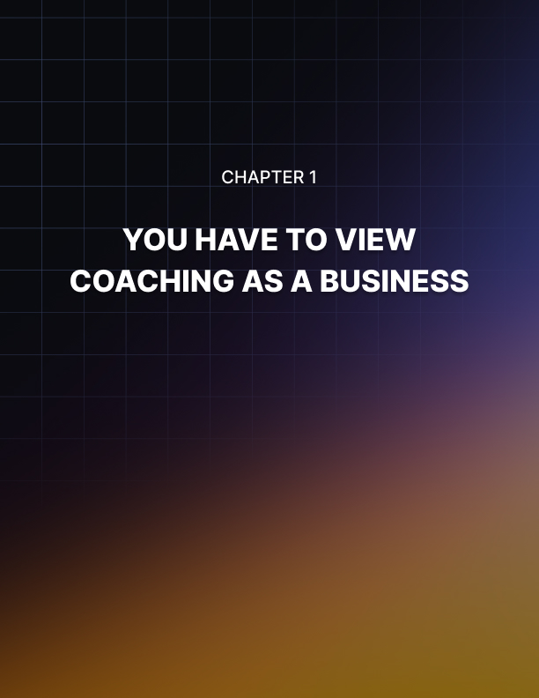

Chapter 1: You Have To View Coaching As A Business

Let's get one thing clear. Most people in this world are good in at least one field of their life.

Maybe they’re passionate about a certain subject. Perhaps they put in a lot of time, effort and energy doing all sorts of activities and tend to get good at at least one of them. All of us can be experts in at least one area of expertise.

The problem is just because we can be experts in those areas doesn’t necessarily mean that we will become successful coaches in those areas of expertise. This is the mistake too many people make. They get all excited about the fact that they know their stuff.

In fact, they would brag that they are the very best experts in the local area when it comes to doing certain things.

This may well be true, but the problem is if you look at your coaching business as something that you do on the side, you are doing yourself a big disservice. You really are. You are actually setting yourself up for eventual failure.

Too many people think that just because they are naturally ‘good’ at something that they can dispense high quality services whenever they want and based purely on their own terms. While this might work in rare cases, for most people, this doesn’t work.

They are either too distracted or too confused to build a solid brand providing a memorable service. This should not be a surprise since they view their service as more of a hobby than a vocation or, better yet, a business.

The truth is if you are serious about making money as an online coach, you have to wrap your mind around it; you have to commit to it and, yes, you have to treat it as a business. That's right. A real business means you have to lay out the difficulties you’re struggling with and solve them one by one.

Unfortunately, a lot of would-be online coaches never manage to do this. They’re just focused on how passionate they are. They’re just focused on how many people they can help with their expertise.

Those are well and good but until and unless you view your coaching activities as part of a business, chances are you will continue to struggle long into the future. Chances are you may not make the kind of money you had hoped.

You have to run it like a business; you have to make hard decisions and you have to set it up in a systematic and methodical way.

You will get access to information that will step you through the often difficult and confusing process of putting up a successful online coaching business. It is definitely not for everybody.

However, if you have the right plan, you definitely go a long way increasing your chances of success. You owe it to yourself. You would not want to waste a lot of time trying to figure things out the hard way.

Your Most Precious Coaching Asset is Your Personal Brand
I've talked to a lot of online coaching business owners. A lot of these coaches really know their stuff. In fact, many of these individuals have developed a high level of expertise due to many years of passionate curiosity regarding their areas of expertise.

When it comes to raw knowledge and the willingness and eagerness to help people learn such specialized knowledge, these people really have it made. They really know their stuff and they are at the top of their game.

The problem is most of these people continue to struggle with their coaching business. They really can’t understand why this is the case. If all it takes to be successful in online coaching is to know your stuff, these people should be making five to six figures every single year.

Sadly, they're not. There is a missing piece.

The problem is simply becoming an expert and knowing your stuff is just part of the battle. In fact, if you look at the big picture, these two things actually form a relatively small fraction of the big picture.

Most of your activities as an online coach, regardless of your competence and regardless of your experience, must involve building your personal brand.

Knowing your stuff is important and this is definitely the first step in building any kind of credibility, but you also have to market yourself. Having a product to sell is one thing, making sure enough people hear about the fact that you have that amazing product on offer is another.

Too many people think the selling process is ‘beneath’ them. It’s no surprise they continue to struggle. If you’re truly passionate about your personal expertise, you shouldn’t be shy about letting the rest of the world know.

You have to remember that there are so many other experts out there. There are so many people trying to make money as an online coach.

You have to figure out a way to stand above the crowd. You have to find a way to get noticed.

Unfortunately, if you just focus on what you know and keep it to yourself, you're not doing yourself any favors. Similarly, if you coach people and your service quality is spotty, you're not guaranteeing that a large chunk of your clients will keep coming back.

You have to build a solid brand. This is what separates corner burger stands from McDonald's. It doesn’t really matter what you think of McDonald’s food quality. You have to respect the fact that McDonald’s is a global brand.

Believe it or not you can develop a solid brand. You don't have to spend a lot of money. You don't have to have connections. You just have to know how to do it the right way. There is a certain sequence that you have to follow.

Believe me there are just so many different wrong ways to go about doing this. So many people fail in building a personal brand because they don't have a systematic and methodical plan.

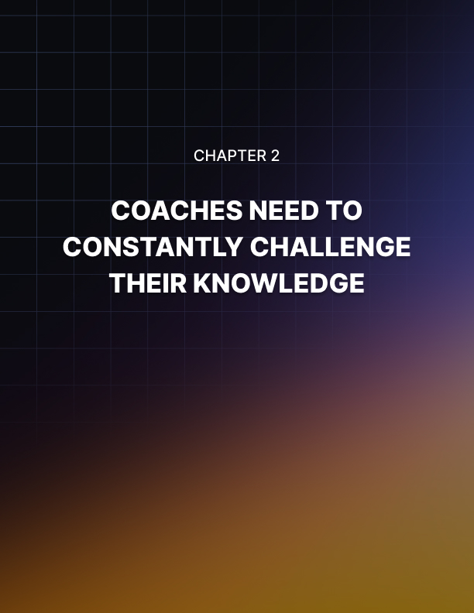

Chapter 2: Coaches Need To Constantly Challenge Their Knowledge

When it comes to life coaching, there are people all over the internet that claim to be professionals in this particular occupation.

Because starting a life coaching practice costs less than other types of businesses, and because you don’t need a lot of training to begin, many people have jumped on the bandwagon of life coaching, partly because of the popular programs out there that have made it look easy.

But how do you tell the professionals from the amateurs in the field?

Here are five signs to look for that will give you a clue as to if a coach is a professional or not:

They Have a Professional Website
The first thing that you will notice about professionals in this field is that they have a professional website.

Coaches that are just starting out and are trying to save money will often design their own using tools from their hosting provider, or they will have used a platform like WordPress that makes their site look like everyone else’s.

They Are Organized and They Write Everything Down
Good coaches are always taking notes. They know where everything is and can easily look something up when needs be.

They Can Show You Satisfied Clients Who Have Referred Others: If you want to know if a company is good or not, ask them to give you some referrals of clients that they have worked with in the past.

If you can’t get them to give you any, and they have been in business
for a while, they probably aren’t professional.

They Are Financially Comfortable and Not Desperate for Business

Good coaches make good money and they know how to manage it properly. That’s why you won’t see professional coaches slashing their prices or offering ridiculous deals in order to get people to sign up.

Professional coaches always have enough business and in fact, they get to pick and choose which clients they take on.

They Are Positive, Punctual and Prepared
The three P’s are another important part of being a professional coach. You will notice that with professionals, they have a positive attitude no matter what is going on.

They will look on the bright side of whatever challenge they are facing. They are also on time. They show up early to appointments, they are almost never late for anything and lastly, they are prepared.

They have their notes, their tools, their paperwork and everything they need to conduct a session or do other business.

Mistakes To Avoid When Coaching Online
If you want to be an online coach, you are going to want to get as good as you can at your job before you start taking on clients.

That means learning everything you can about coaching, developing a game plan for helping clients and being able to bounce back when
someone isn’t working properly. It also means making mistakes.

Making mistakes is a vital growing part of any new endeavor and while you can’t avoid all of them, there are four mistakes that you should avoid making as a new online coach, because it will kill your business before you even get started.

Doing Everything
People that do ‘everything’ actually get very little done. If you are a writer, a coach, a YouTuber, a web developer and internet marketer and a wife and mother (or husband and father) you are going to find that all of your endeavors will suffer because you are trying to do too much. Just concentrate on a few things and do them well.

Having a Crappy Website
Unfortunately, one of the other major problems that new coaches suffer from is a terrible website; many coaches seem to want to make the website themselves to save money, but they end up with an amateur-looking site that is not going to attract a single person.

Make sure that you spend some time and money making your website shine, because it is your face to the online world.

Concentrating Too Much On Training and Certification
Some coaches start their businesses and have enough money to invest and grow their coaching practice, but they end up spending everything they have on training and then wonder why they can’t get anyone to sign up; that’s not to say that training isn’t important – it definitely it – but you want to do just enough training to get you started and invest in your website, equipment, tools and promoting your coaching business.

Not Having Money To Start and Grow Their Business
Finally, many coaches go into the business without any sort of nest egg to build their business with. You’ll want some money to invest into your business, because the old adage is right: you have to spend money to make money.

You’re going to want to have a little bit saved to build your coaching business as well as money saved to live on if you have decided to do it full time.



Chapter 3: Finding the Root Cause of Your Client’s Obstacles

When you are helping a client, it can be easy to go with a quick solution to a problem.

For a person that is overweight and wants to diet, creating a menu for them and monitoring their progress might seem like the right way to help them. Someone who struggles with low self-esteem might be helped by counseling sessions and confidence builders.

But sometimes, the problem is deeper than something that can be helped with an easy solution. Sometimes, you have to find the root cause if you want to help someone.

So, how do you go about finding the root cause of someone’s behaviors in sporadic coaching sessions?

Believing, Thinking & Acting
There is a specific process that people go through when they exhibit behaviors. It is the belief-thought-action cycle; understanding that cycle can be the key to solving their deeper issues, because often, a behavior that is destructive is linked to a belief that is driving it.

You have to work your way back through this cycle in order to find out where a specific behavior or action comes from if you want to help your clients overcome these problems.

Actions
Actions seem like they are choices that we are making right there in that particular moment. But that’s actually not the case at all. In fact, most of the behaviors we have and the actions that we take are already predetermined because of our thoughts.

For example, if a client always clams up whenever they talk to a member of the opposite sex, and it is something they want to change, you have to look at the thoughts behind it.

Thoughts
The thoughts that you have are actually what drives that action. For example, this particular client might be thinking that they don’t know what to say, and they don’t have the ability to talk to this person. Those thoughts drive the actions, but where do the thoughts come from?

Beliefs
That’s where the beliefs come in. You can actually trace behaviors all the way back to the beliefs that a person holds. In the case of our example, they might have the belief that they just aren’t good enough to talk to attractive members of the opposite sex.

You have to help your clients figure out what these beliefs are, and then help them to evaluate them and decide if that particular belief is something they need to change or not.

Ways To Make Coaching Difficult Clients Easier
If you stay in the coaching business long enough, you are eventually
going to run into what industry professionals call “problem clients.”

These are clients that are difficult to deal with for whatever reason, and they often have to be handled with kid gloves. The behavior itself varies and can run the gamut from anger to inappropriate comments or touching.

You need to develop a strategy for dealing with these problem clients and see if you can change their behavior, and if not, your strategy should include a plan for parting ways with them.

Be Committed To Their Success But Don’t Let It Go Too Far
You want to be there for your clients, and you want them to succeed but if you invest too much of yourself in their success, you are going to be crushed when they don’t make it.

Don’t allow the outcome of a particular coaching project to make you feel emotional or responsible. Also, make sure that you simply aren’t getting too close to your client personally as well.

Watch Out For Warning Signs
There are often warning signs that you can look out for when you are working with clients to spot a problem long before it happens.

Of course, this does take some experience so you may still have some problem clients at first that sneak up on your but just learn from each one and look for those warning signs in future clients so that you can cut them off before it goes too far.

When Your Energy Is Waning, Cut Them Loose
If you have a client that is just draining you of your energy every time you talk to them, even if they aren’t doing it intentionally, you may want to consider cutting them loose. If you have a client that is making you feel badly after a session, it could easily leak into your personal life and your time with other clients.

Say What You Need To Say
Make sure that you are saying what you need to say and not being indirect or vague. Make sure that people understand you, and that you have laid down firm ground rules and are calling people on their BS when they need it.

In addition, if you have a client that you no longer think is a good fit for your coaching, speak up and tell them rather than letting it
continue, because you’re not doing either of you any favors.

Getting Over Your Fear of Failing Your Clients
So, you’ve taken the giant leap forward to setting up your own coaching practice and while you are excited to start helping people realize their dreams, you are also pretty nervous too.

In fact, you might be so nervous that you’re not even sure how you
are going to meet with your first client.

Suddenly, there are all these voices of doubt inside your head, telling you that you’re not good enough to be coaching anyone, that your advice sucks and that no one is actually going to pay for coaching with you, and if they do, they’re going to be disappointed.

Guess what? Those voices are perfectly normal; unless they start telling you to do other things, that is. Every coach that starts out in the business experiences doubt, and sometimes it can be crippling.

So, what do you do to get rid of this doubt and have a successful coaching business?

While the only real cure for the voices in your head is some actual experience and time being a coach, and experiencing success, there are some things that you can do to bring your doubts down to a manageable level.

Offer Free Sessions
One thing that you can do is to offer free sessions for a few clients so that you can get some experience coaching. You will be able to coach them without feeling guilty that they are paying you, and those feelings of doubt will slowly disappear once you see that you actually are making a difference.

Do Short Sessions At First
Another idea is to keep your sessions pretty short, so that you can charge less for them, and so that you can get your feet wet with coaching without having to jump in with a full-fledged hour-long session.

Practice With Friends Or Family
If you have some friends or family members that you could help with their problems, try coaching with them first.

It can be intimidating to coach strangers and a few sessions with people you know might allow you to become more comfortable with yourself and your coaching position.

Remind Yourself That You’re Supposed to be doing this: Finally, just keep in mind all of the reasons that you started coaching in the first place.

Remind yourself that you chose this path because you felt as if you truly had something to offer, and you’ll eventually see that you were right the whole time.

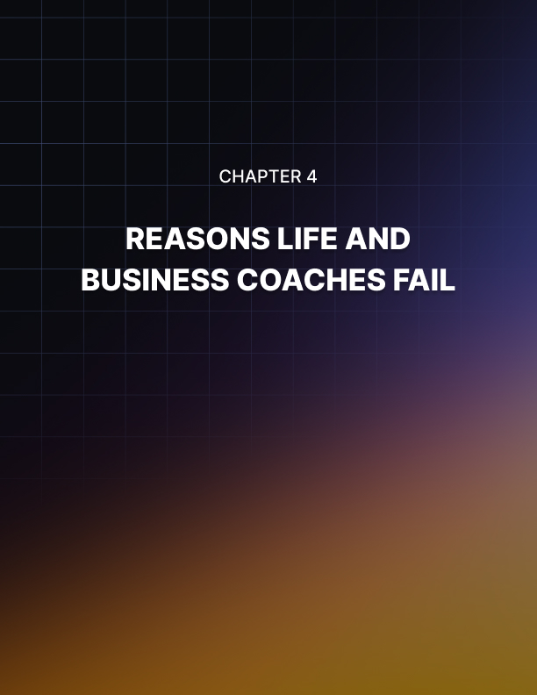

Chapter 4: Reasons Life and Business Coaches Fail

So, you want to be a life or business coach? That’s a great goal to have and many people have amazing success at it.

However, for everyone who is able to break into the industry, build a following and earn a decent living from their coaching, there are 15 who don’t make it.

This isn’t to make you think about quitting, but you should know what the odds are before you begin. More importantly, you want to find out what sort of things make other coaches fail – pitfalls that they have already experienced and failed because of – because you can learn how to avoid those same pitfalls that way.

Here are the top reasons why life and business coaches fail, and how to avoid them:

Being to Formulaic
If you use the same method for every single client, you are going to have very limited success. That’s because people are all different.

One size does not fit all when it comes to coaching, and you need to be flexible enough to try other methods when you see that one particular one isn’t working.

Lacking Confidence In Themselves
This is a big reason that coaches fail. They just don’t believe in
themselves, and so their clients never believe in them either.

Even if you never tell your clients that you don’t believe in your ability to coach them to success, they are going to know, because people can just sense that sort of thing.

Avoid this by making sure to work on yourself first before you start coaching and give yourself positive affirmations every day.

Copying Others

Some people learn one style of coaching, which is a method that they got from a mentor or a training program and they just coach the exact same way; but that’s not how leaders work.

Followers copy other people, but leaders forge their own way and take what others have taught them and develop their own style.

Lack of Persistence
Finally, the last thing that many coaches fail as a result of is a simple lack of persistence. If you continue working at your business, you are eventually going to make it, but it is going to take time.

Just like any other business, you’re going to have to work to build up a clientele and get it to the point where you are actually making a living from your coaching practice.

Do You Need Certification to Be an Online Coach?
When someone wants to get into life coaching, one of the things that they often ask about is the type of training or certification that is available or required.

While there is no regulatory committee that makes sure that life coaches all have a minimum amount of training and passing test scores like there is for doctors and psychiatrists, there are certifications that you can get and training programs that will not only give you some great tools to help you in your practice.

But this will also impress other coaches and some clients who are familiar with the organization, mentor or training program.

Certification and Training Available
There is a great deal of certification out there for life coaching, but the problem is, most of it isn’t worth the paper that it is printed on.

Since there is no regulation or oversight, there have been companies popping up all over with impressive sounding names and professional websites that offer you “professional” training. But you’ll want to stick with certification that actually means something to other people.

It doesn’t matter how much you paid for a training program, or how much time you spend learning the principles of it, if other people don’t accept it as valid training, you have wasted your time.

Finding Legitimate Training and Certification
So how do you find legitimate training certification? There are many ways that you can dig out the good ones, but one of the most effective ways is to visit forums where other coaches discuss their practices with each other.

They will be able to tell you which training programs they have heard of and which they can recommend. In fact, many of them will have that information already included in their forum signature.

There are hundreds of different coaching forums out there so find one that fits your style.

The second method of choosing a training program that we’ll discuss here is choosing one based upon the brand name. What does this mean?

It means, if Tony Robbins is offering the Tony Robbins Training Certification then having that training certificate will carry a lot of weight because it has Tony Robbins name on it.

If you choose a training program for someone who is well-known and well-respected within the coaching and self-help community, you will find that particular certification goes a long way when looking for new clients and hobnobbing with other life coaches.

What Are the Best Coaching Training Programs?
If you are interested in coaching, it is highly recommended that you enroll in a training program, especially if you don’t have a lot of experience coaching.

However, when you search for a training program online, there are literally thousands to choose from, so how do you know which ones are actually legitimate and which ones you should stay away from?

While most of them offer some kind of value to the person taking the course, there are only a few that you should concentrate on, because you want training that other coaches and potential clients will respect and appreciate.

Here are four of the best training programs out there for life coaches:

Institute for Professionalism Excellence in Coaching (iPEC): This is an accredited coaching program that is very well-respected by those in the coaching community.

They offer a variety of coaching tracks including business coaching, corporate and executive coaching, health & wellness coach and much more. They have training programs all over the country, from Seattle to New York and from Texas to Toronto as well as a training center in London.

The International Coach Federation (ICF): The International Coach Federation isn’t a school, it is a non-profit accrediting agency that vets coaching organizations and training programs.

However, you can visit their website and get their recommendations not only on what kind of training you should be taking but also what ICF-approved programs there are out there.

This organization is known by every professional coach in the world.

Ericson International: Ericson International is an accredited training school with a great reputation for turning out amazing coaches.

They have coaching training that extends all of the way from the basics to coaching topics that are intended for more advanced students or for later learning.

Unlike iPEC, the training and certifications that Ericson offers are over the internet through distance learning.

Robbins-Madanes Training: The founders of this organization are Anthony “Tony” Robbins, a famous and respected coach and speaker, Mark and Magali Peysha and therapist Cloe Madanes, who shares the honor of having the school named after her along with Robbins.

One of the many great things that this school has to offer is board certification as a coach by the Center for Credentialing and Education. They also have their basic Core 100 and Core 200 training as well as another training program called Breakthrough Training.

These programs are comprehensive and respected in the coaching world.

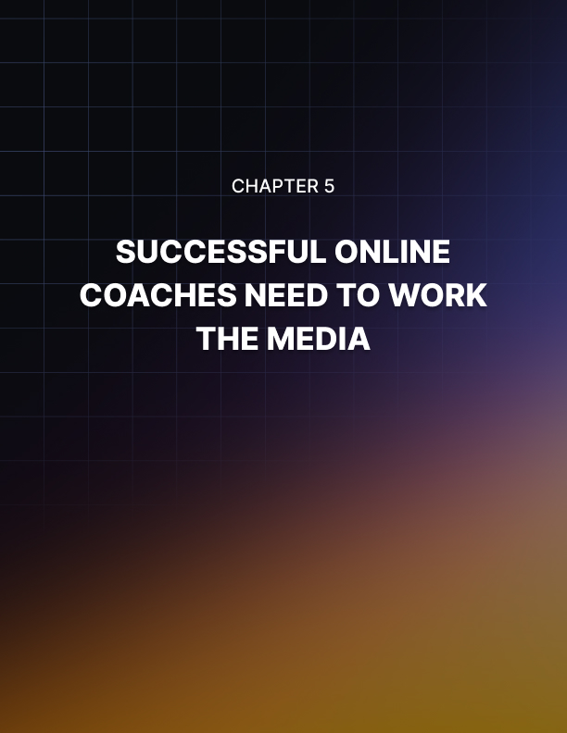

Chapter 5: Successful Online Coaches Need To Work The Media

I need you to pay close attention to the title of this article. Can you repeat it to me?

Good. Please note that I did not say successful coaches need to work for the media. This is a very important distinction. I said successful coaches need to work the media.

Unfortunately, a lot of people do not get the distinction. They think that if they want to achieve some sort of traction in their online coaching business, they have to work for the media.

This means that they have to essentially crank out all sorts of content in the hopes that the media would pay attention to their stuff.

The idea being once the media pays attention to your content, then somehow some way your brand is benefited. That’s too much to hope for.

In fact, if you are playing the game this way, you are playing it to lose. You can’t just assume that media exposure will be enough to carry your brand to the place you want it to go. You have to play a more direct role.

This is how a lot of people play the media game. In fact, don't be surprised that a lot of big-time public relations people say that this is the way to go. No.

In the world of social media and in the world of twenty-four-hour news cycles, you need to work the media instead of work for the media.

It's just too easy to spend good money after bad coming up with one worthless piece of content after another hoping and wishing and praying that somehow the media would pay attention to what you have published. It doesn't work that way.

You have to work in the media, and this means that you have to use online resources like HARO. This stands for Help a Reporter Out.

You submit your area of expertise and if media people from journalists to TV reporters and whatnot need resource people in your area of expertise, they will get in touch with you.

Another way you can work the media is to come up with press releases that are actually newsworthy. In other words, you position your brand within a controversial topic that involves your industry.

Of course, this requires a tremendous amount of imagination, resourcefulness and creativity. It might even seem impossible but, believe me, it happens all the time.

In fact, if you go to the typical news show and you notice that there's this random person who works for a company that doesn't seem directly related to a news trend, you're seeing this advice played out. A lot of people actually use this advice to get amazing results.

Make no mistake putting up a successful online coaching business is no joke. You really have to work all angles.

You have to go all the way. You have to go all the way. You have to do whatever it takes for however long it takes until you achieve success.

Social Media Is Indispensable For Coaching Business Success
A lot of people who run businesses are under the impression that there is a dividing wall between offline and online businesses. They can understand the value of online promotions provided that these promotions go to an online business.

They can see the effect of promotions on businesses like Amazon.com. However, they are flat-out stumped when it comes to the connection between online promotions and purely local brick-and-mortar businesses.

Make no mistake regardless of whether your business is completely online, offline or somewhere in between, you need social media. I did not say that social media is an option. I did not say that you want social media. I did not say that social media would be nice to have.

I’m talking about you needing social media. That's right. Your business must view social media as an absolute necessity.

Make no mistake. It is indispensable for the success of your online coaching business. The sooner you realize this and the sooner you can wrap your mind around this, the sooner you will get on the road to eventual success.

Just how powerful can social media exposure be? What exactly does social media popularity offer your personal coaching brand? Well, it’s a good idea to review just how viral social media is.

Believe it or not, even if you have a fairly small following-maybe less than 500 souls follow you on Twitter-this might be enough for your brand to go viral.

How come? For each follower you attract, they will also have followers. Those followers also have followers. So, on and so forth.

If any of your content happens to catch the attention of your followers, they might share your stuff. Their followers can in turn share your materials to their circle of followers who in turn might repeat the process.

I hope you see the process here. This process of sharing and resharing among circles of influence and familiarity can easily become exponential.

That initial sharing circle of 500 you started with might translate to a reach of millions. Again, it all depends on just how catchy the content you’re sharing is.

On the other hand, if you continue to kick the can down the road and continue to postpone truly responsive and strategic social media plan, then you are probably positioning your business for its eventual
collapse and failure. I’m not exaggerating here. I've seen this happen
quite a bit.

A lot of businesses think that they’ve done so well and have established such a solid brand that they can basically view social media as an afterthought.

Unfortunately, the majority of people who think this way have come to regret their decision.

It's extremely important to use social media and this means simply being visible. That's right. Create a YouTube channel. Set up a Twitter feed. Put up a Facebook page with a matching group.

This is not rocket science. As long as the messages that you send on all those platforms are consistent with the messages that you send on your online coaching business website, you are playing the game the right way.



Chapter 6: Enhance Your Market Value Through Controversy

One of the most powerful ways to become a recognized expert in your industry is to confront controversies head on.

That's right. Instead of turning around and running in the opposite direction because you don't want to go out on a limb and take controversial positions, take full advantage of controversy.

Don't get me wrong. Regardless of how seemingly harmless and innocent or esoteric your niche is, you can bet that there will always be areas for disagreement. This comes with the territory. After all, you are engaging in an activity that involves human beings.

Last time I checked, whenever there are at least two human beings in a room, there is always the possibility of disagreement. People will always fail to see eye to eye at least on certain issues. Instead of thinking that this is a negative and trying to avoid it as much as possible,look at it and look for what it is. There are endless possibilities and opportunities for disagreements both big and small. Controversy is always lurking around the corner.

It is an opportunity because any kind of controversy is really an opportunity for you to speak up and demonstrate to the rest of the world why you are an expert.

You break down why you view certain things about your industry a certain way. This doesn’t mean that people would have to agree with you.

However, when you take this opportunity, you let it be known to anybody watching that you really know your stuff because for people to develop a truly informed position on any kind of controversy and in any kind of niche, they really have to know what they're talking about.

At the very least, they need to have the same familiarity with the topics that they are approaching like the familiarity that they have with the back of their hand.

That's how familiar you should be. That's how on top of your game you should be. If you engage in respectful, fact-driven and results-oriented debates about certain controversial topics in your industry, niche or area of focus, you're going to stand out. Why?

All the other self-proclaimed experts and recognized gurus are actually too busy scrambling for the hills. You, on the other hand, are courageous because you are one of the few voices who decided to confront the controversy head on.

This makes you look good. At the very least, it makes you look like a million bucks because you're not turning tail and running in the opposite direction.

You can see that there are controversies in your field. You can see that there are areas for improvement and disagreement. Instead of using this as some point of division or a reason for some sort of professional hopelessness, you speak up and you let your voice be heard.

This can be a powerful way to promote your expertise. Don't be surprised if your brand becomes more famous because you decided to stand up to controversies.



Chapter 7: Group Coaching

Group coaching programs are extremely popular because they offer coaches the opportunity to serve more clients in less time.

This is especially true since Facebook introduced the private group feature to its members.

This type of coaching is based on the same basic approaches used by personal coaches while bringing the discussion into a smaller space for conversation.

Groups can be found on a wide variety of topics that are usually focused on goal setting, taking action, and accountability.

As they grow in popularity many people are finding that they prefer group coaching over the more traditional one-on-one programs. This is because it offers a sense of community that’s not found when it’s just you and your coach on a phone call or in a video chat.

With one-on-one coaching, it’s just you and your coach. The focus is all on you, what you did (or didn’t) accomplish in the last week or month, and how you can improve.

Don’t get me wrong this can have its benefits if you’re at a time in your life where having a coach will help you achieve your goals faster, but if you’re looking for accountability and support a group setting can be even better.

On the other hand, with a group program, there’s usually a forum or Facebook group where members can interact and support each other, ask for guidance and form beneficial relationships.

If you need a shoulder to cry on about a missed goal, you’ll have several supporters instead of one, that can help you get back on track, make your goals and hit those milestones you’re striving for.

Another nice perk of group coaching program is the price. While it might be nice to work with an in-demand coach in a private setting, the fact is that many people can’t or won’t be able to afford that kind of cash when they first start seeking help.

A group program gives them many of the same benefits at a more affordable cost.

This makes them a great lead in for a higher priced program because people are more comfortable investing a small amount at first.

Then when they become confident that they are getting a good return on their investment they are willing to invest more.

Big Advantages Of Group Coaching
One of the biggest advantages of group coaching is convenience for both you and your clients. When you host a group, you can log in at any time to post, read and respond to comments.

This makes it easy for people to ask questions as well as find and offer support from each other. This also means that you can work around your job and anything else you have going on in life, while still serving your clients.

When you start a group, you can have as few or as many clients as you want. Let’s say, for example, you start a subscription-based Facebook group and charge around $10 a month.

With a hundred members you could easily bring in $1000.00 a month. This is a very nice model, especially when you’re first starting out, because people aren’t as reluctant to pay a small fee for exclusive access.

Another advantage of using Facebook is that you can take advantage of all the tools they have available. For example, you can post pictures, video content, audio files, share links as well as use built-in post scheduling, messenger and live broadcasting functions.

It doesn’t matter if you’re a health coach, dating coach or a business coach. You have a large audience, and they’re out there looking for you, so if at any time you need more members, you can use Facebook advertising to reach them.

It’s easy and very cost effective to run a targeted ad campaign or simply boost posts that will interest your ideal client.
Enough about Facebook for now. Let’s go over a few things you can do to get members into your group no matter where you host it.

When it comes to selling anything online, even access to your group there is one important rule to always keep in mind, and that is to always make it easy for your customers to buy. I know it sounds simple, but you’d be surprised how often coaches (and others) get this wrong.

For instance, they don’t make the “buy” buttons noticeable or they make their contact information hard to find. Not providing clear calls to action (CTA) on their sales page is another big miss along with confusing website navigation.

It’s very important to make these things as simple as possible, so visitors can quickly find what they need. You don’t want them to have to search around trying to figure out what they should do next, or they’ll become frustrated and leave, before they take any action.

Keep in mind that not everyone will be ready to join the first time they see your group, so you want to make sure that you’re enticing new people to join.

There are many ways you can do this and one of the most effective is email marketing. You should always be building a list of contacts.

This way you can email them with updates, hints about what’s going on in the group and special offers that will make them eager to join.

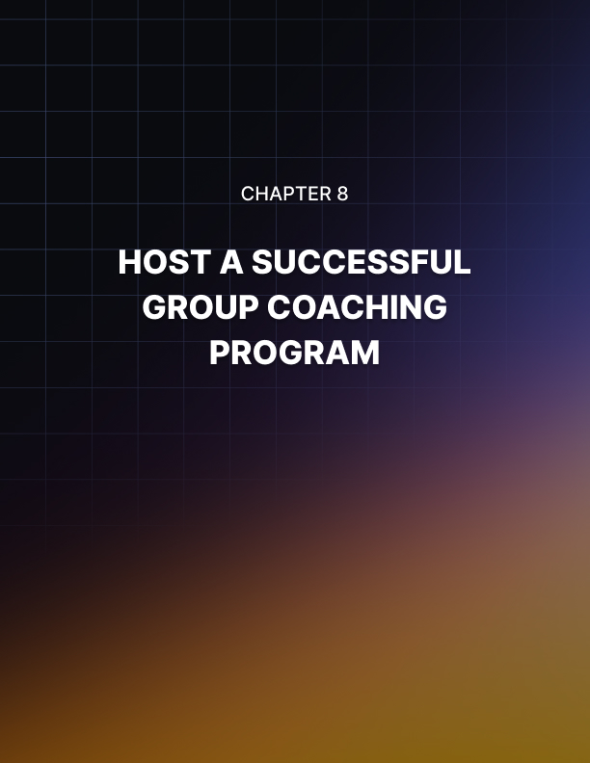

Chapter 8: Host a Successful Group Coaching Program

If you want to host a successful group coaching program there are a few things that you will need to attract people who are interested in working with you.

You’ll need a basic marketing funnel that includes things like:

- A website
- Compelling sales copy
- A way to collect email addresses. (Aweber, Getresponse, etc.)
- An offer to entice people to join your list (free report, training, etc.)
- A solid call to action (CTA) with a buy button.

These things all work together to create a marketing funnel that will help you attract a steady flow of potential clients to your group. Once you have these things in place it’s time to think about marketing.

This is a very important aspect of growing your client base but it’s the one thing that stops most coaches from achieving success.

Whether it’s that they don’t know where to begin, or perhaps they’re afraid of putting themselves out there, or they feel like it’s not important, which is a big mistake, because if you don’t promote, you’ll never fill your group.

Even if you have no marketing experience you can still promote your group. Try starting with a few proven strategies first and you’ll be an expert before you know it.

Here are a few ideas to get you started:

Build Your Public Profile
Use your website to create and promote your public image. Your brand if you will. Everything from the design of the site to the content and interaction that occurs there builds the image that you want the world to see. Think of it like an interactive billboard.
Use Social Proof
People make purchasing decisions based on recommendations more than any other factor. By including testimonials from customers, businesses can offer the proof that prospective buyers need.

Ratings and reviews are another way to help people make purchasing decisions, though they are more difficult to control.

Use Paid Traffic
Facebook ads are one of the easiest and most cost-effective ways to get more clients. Not only does it have incredible reach (almost everyone has a Facebook account) it allows you to target your market, so you can reach your ideal customer.

It also has a retargeting pixel, that makes it easy to reach people who have visited your website, liked your page or joined your email list.

Host a Webinar
Before a potential client becomes a paying customer, they want to get to know, like and trust you. There are several ways you can help them do that.

One of the fastest is by creating and hosting a webinar.
Live webinars give you the opportunity to show off your personality and interact with your consumers.

You can use them to show off your skills and share information that
will show attendees that you really know what you’re talking about.

Once you do that, they’ll want to learn more from you and be more
interested in joining your group.

When it comes to promoting your program, you don’t have to have a degree in marketing, but you do have to take steps to get in front of your audience.

Don’t make it too complicated, just start with the basics, and build from there, soon your group will be full of people eager to learn from you.

Building a Funnel For Your Coaching Program
I have a question for you. Do your consumers move predictably from one product to the next, allowing you to calculate your expected income every month? Or do you experience both high and low months, never quite knowing how much you’ll make?

If you can’t predict your income each month, chances are your funnel isn’t set up right or maybe doesn’t even exist yet. As we discussed in your last lesson, having a marketing funnel is what will help you attract a steady flow of potential clients into your group.

The good news is once you get your funnel right your business will grow almost automatically.

First let’s look at the top of your funnel. This is where all your potential clients first become aware of you and your business. In this case your group. It serves to create awareness, educate consumers, and cultivate interest in your product or service.

At this point they aren’t a paying customer yet, but they are getting to know you better. Learning whether your personality and style is a match for theirs, and whether they believe you can help them. Your job here is to entice them to take some form of action like joining your email list.

The next phase of your funnel should consist of low-cost offers, sometimes called “tripwires,” these items are a way for consumers to take you for a test drive, without the fear of commitment. This can be an ebook, short report, self-study course, or any other low-cost product. This will help them establish a connection with you.

Some people also include a related product as an upsell in their funnel. The reasoning behind this is that the consumer is already in a buying mood, so why not maximize profits by providing them with the next logical step (product) to help them achieve even better results.

Next, you’ll want to add mid and high-priced offers.

This is where your group coaching program will fit nicely. Even if it’s low cost monetarily it still requires a level of commitment from the consumer, which to them holds a higher perceived value. You can also offer different levels to your group program.

I’ve seen some coaches offer three or more levels, depending on what they’re teaching.

For instance, you could offer an entry level where people can have basic access to what you teach, mid-level where they can have more interaction and a higher level where they can get direct access to you for consultation.

A good funnel will move smoothly from free to low-cost to high-end, with each step along the way being the very next thing your client needs in their training.

A great coaching funnel might look something like this:

- A free webinar or video
- A short report, ebook or small training program
- A self-study course or membership
- Low cost group coaching
- Mid cost group coaching
- High end private coaching

Keep in mind that not all clients who enter your funnel at the top will make it all the way to your high-level coaching, but you should build your funnel as if that’s what you expect to happen.

As you increase the number of people who are active in your low-level group, you can adjust it to increase conversions and move them up to the next level.



Conclusion

If you are a life coach, then the only thing that you really live for is seeing your clients succeed.

There are so many benefits that come from one of your clients succeeding at the goal that they set for themselves.

First, you’ll get joy from the fact that they have actually achieved what they were working towards with your help. This can be a big motivator in the future when you work with other clients.

You’ll also get the benefit of impressing that client, who may come back for future coaching, as well as reap the reward of having them tell their friends and family about how you helped them.

If you want your clients to be successful you want to give them the best chance of success possible so here are three very powerful ways that you can improve your client’s, chances of success.

Is your client prepared to do whatever it takes to make the goal a reality? Your client needs to be completely committed to achieving that goal.

They need to be willing to put forth the effort, sacrifice countless hours of work and whatever else it takes to make it. If they know what the cost is and are willing to make the sacrifices needed to be successful, they will be almost unstoppable.

Does your client know what the risks are and are they willing to take them? With any goal that you are putting your entire effort into, there are going to be risks.

If your client is trying to start a business and they are going to be working an additional 25 hours a week on top of the 40 they are already working, they are risking their family’s happiness.

If they are investing money in their business, there is a chance that the business will fail, and they will lose that. As long as they know the risks and they are still willing, they have a good chance of success.

Does the client have a passion for whatever goal they are pursuing? How deep does that passion go? One of the things that you will notice about successful people is that they are absolutely, head-over-heels in love with what they do.

They are passionate about their chosen goal and they look at working towards it as something pleasurable instead of actual work.

That kind of passion will ensure that your client has the best chance of reaching their goals.

