TABLE OF CONTENTS
____
INTRODUCTION 4
DEFINE GOALS AND BUILD A QUALITY EMAIL LIST 7
Setting Clear and Actionable Goals 7
Identifying Your Target Audience 8
Building a High-Quality Email List 8
Integrating with CRM Systems 9
Ethical Practices and GDPR Compliance 9
CRAFTING IRRESISTIBLE COLD EMAILS 13
Anatomy of a Compelling Cold Email 13
Crafting Attention-Grabbing Subject Lines 14
Opening Lines That Hook Your Reader 15
The Key to Cold Email Success 16
Avoiding Cold Email Mistakes and Measuring Success 18
DYNAMIC FOLLOW-UP STRATEGIES 21
The Power of Timely Follow-Ups 21
Mastering Automated Sequences and Personalization 23
Handling Replies and Overcoming Objections 24
When to Move On and Keep Professional Relationships 25
THE PROFESSIONAL PLAYBOOK 29
Essential Tools for Cold Email Success 29
Navigating Email Compliance 30
Spam Avoidance 31
Best Practices for Email Marketing 33
BOOSTING IMPACT AND FOSTERING MASTERY 36
Reinforcing Strategic Planning 36
Mastering Email Craftsmanship 37
Refining Follow-Up Strategies 37
Leveraging Technology for Performance 38
DISCLAIMER
____
The information provided in this ebook is intended solely for educational and informational purposes. The author does not accept any responsibility for the outcomes that may arise from the application of the material within. While efforts have been made to ensure the accuracy and relevance of the content, the author cannot be held accountable for any errors or omissions, or for any consequences resulting from the use or misuse of the information provided. The responsibility for any actions taken based on the information in this ebook lies solely with the reader.

INTRODUCTION
____
Cold email marketing holds incredible potential for business growth with just a single click. This ebook is packed with practical strategies to help you master cold email outreach and drive real results.
Imagine your inbox buzzing with responses from high-quality leads and your business thriving like never before. With the insights from these pages, this vision can become your reality. Cold emailing is more than just sending messages; it’s about crafting compelling narratives that engage your audience and drive results.

Prepare for higher open rates, more replies, and a surge in leads and sales.

This ebook focuses on practicality, offering immediately applicable skills. You'll learn to create attention-grabbing subject lines, personalize messages at scale, and follow up effectively—all techniques used by professionals to consistently secure leads. Beyond email writing, you’ll master list-building, email compliance, and automation, ensuring your efforts are efficient, targeted, and compliant.
As you explore each chapter, you’ll uncover the psychology that makes people open, read, and respond to emails. You’ll finish equipped to craft email campaigns that feel like warm introductions instead of cold outreach. Whether you’re a startup founder landing your first big client or a marketer refreshing your approach, this book is your tool for sparking business growth.
Prepare for higher open rates, more replies, and a surge in leads and sales. Are you ready to elevate your cold email strategy and propel your business forward? Turn the page and let’s get started.

DEFINE GOALS AND BUILD A QUALITY EMAIL LIST
____

Setting Clear and Actionable Goals
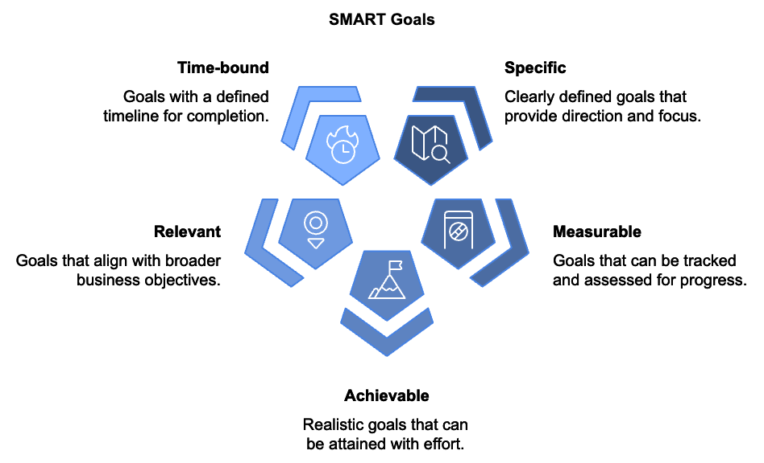
Before diving into cold email marketing, establishing clear, measurable objectives is crucial. These goals serve as your roadmap to success, guiding decisions, shaping strategies, and measuring progress. Your goals should align with broader business objectives and be specific enough to guide actions. SMART goals (Specific, Measurable, Achievable, Relevant, and Time-bound) ensure clarity and actionability.
For instance, instead of a vague goal like "improve email open rates," aim for "increase email open rates from 20% to 30% within the next three months." This goal is specific, measurable, achievable, relevant, and time-bound.

Identifying Your Target Audience
Understanding your target audience is crucial for crafting messages that resonate and drive action. Create detailed buyer personas based on real data and market research. Consider factors such as demographics, job title, industry, pain points, challenges, goals, aspirations, and preferred communication channels. For example, if you're selling project management software, your buyer persona might be "Tech-Savvy Tina," a 35-year-old marketing manager in a mid-sized tech company struggling to keep her team organized and meet deadlines. By understanding Tina's needs and preferences, you can tailor your cold emails to address her specific pain points and offer solutions that resonate with her.

Building a High-Quality Email List
Quality trumps quantity when it comes to email lists. A smaller list of engaged, interested contacts is far more valuable than a massive list of uninterested parties. Effective strategies for building a high-quality email list include creating compelling lead magnets, optimizing sign-up forms, leveraging social media, utilizing content marketing, and implementing referral programs. Lead magnets are valuable resources offered in exchange for contact information, such as e-books, free trials, exclusive webinars, or industry reports. Optimize your sign-up forms by keeping them short, using clear, action-oriented language in your call-to-action (CTA), and placing them strategically on your website. Leverage social media by sharing teasers of your lead magnets and running contests or giveaways. Create high-quality content that attracts your target audience and includes clear CTAs to guide readers towards signing up. Encourage existing subscribers to refer others by offering incentives.

Integrating with CRM Systems
To manage your growing list effectively, integrate your email marketing efforts with a Customer Relationship Management (CRM) system. This integration allows for seamless data management and provides a holistic view of your interactions with each contact. Benefits of CRM integration include automated data syncing, list segmentation capabilities, tracking of email engagement and other interactions, and personalization of emails based on CRM data. For example, you might use CRM data to segment your list based on industry, company size, or past interactions, allowing for more targeted and relevant emails to each group.

Ethical Practices and GDPR Compliance
Adhering to ethical practices and complying with regulations like the General Data Protection Regulation (GDPR) is crucial when building your email list. These practices not only keep you on the right side of the law but also foster trust and long-term relationships with your subscribers.
Key ethical practices include obtaining explicit consent before adding someone to your list, providing clear information about what subscribers are signing up for, including an easy unsubscribe option in every email, and never buying or renting email lists.
GDPR compliance involves additional steps such as obtaining explicit consent for data collection and processing, providing transparency about data usage, implementing data protection measures, and respecting data subject rights, including the right to be forgotten.
Implementing these strategies requires tracking your progress and refining your approach to achieve the best results. Key metrics to monitor include:
- List Growth Rate
- Sign-Up Form Conversion Rates
- Email Open Rates
- Click-Through Rates (CTR)
- Unsubscribe Rates
Use these metrics to identify what's working and what needs improvement. Building a high-quality email list is an ongoing process. Continually test and refine your strategies to improve your results over time. With clear goals, a well-defined target audience, and a high-quality email list, you're ready to craft compelling messages that resonate with your subscribers and drive results.
Goal Type | Example
Lead Generation | Increase qualified leads by 25% within the next quarter
Sales Growth | Boost sales of a new product line by 15% in the next six months
Partnerships | Secure 10 new partnerships with industry influencers by the end of the year

CRAFTING IRRESISTIBLE COLD EMAILS
____
You're about to discover the principles of creating cold emails that captivate and convert. This chapter will equip you with the tools and techniques to craft messages that stand out in crowded inboxes and compel recipients to take action.

Anatomy of a Compelling Cold Email
Your cold email is more than just words on a screen. It's a carefully constructed piece of communication designed to achieve a specific goal. The key components include:
- The Subject Line
Your first impression and the gatekeeper to your message.
- The Opening Line
The hook that grabs attention and encourages further reading.
- The Body Content
Here you provide value and make your case.
- The Call-To-Action (CTA)
The clear next step you want the recipient to take.
- The Signature
Your professional sign-off that includes relevant contact information.
Each of these elements plays a crucial role in the success of your cold email.

Crafting Attention-Grabbing Subject Lines
Your subject line is the make-or-break element of your cold email. It's the difference between your message being opened or ignored.

The best subject lines are clear, concise, and relevant to the recipient's interests or needs.

To create subject lines that demand attention, keep it short and sweet, aiming for 40 characters or less to ensure the full subject line is visible on mobile devices. Create a sense of urgency using words like "limited time" or "exclusive offer" to encourage immediate action. Ask a thought-provoking question to engage the recipient's curiosity with a relevant query. Use numbers, as specific figures can catch the eye and provide concrete value. Personalize when possible, including the recipient's name or company to increase open rates.
Examples of effective subject lines include:
- "5 ways to boost your sales in 30 days, [Name]"
- "Quick question about [Company]'s marketing strategy"
- "Exclusive offer for [Company] - 25% off until Friday"
Remember, the best subject lines are clear, concise, and relevant to the recipient's interests or needs.

Opening Lines That Hook Your Reader
Once your email is opened, you have seconds to capture the reader's attention.
Your opening line should be arresting, personalized, and relevant. Some effective approaches include starting with a compliment, referencing a mutual connection, mentioning a recent company news or achievement, or asking a thought-provoking question. The key is to immediately demonstrate value or relevance to the recipient. Avoid generic openings like "I hope this email finds you well" or "My name is..." These waste precious space and do little to engage the reader.
The body of your email is where you deliver your message and make your case. To make it count, keep it concise, aiming for 2-3 short paragraphs. Focus on benefits, not features, explaining how you can solve the recipient's problems or add value to their business. Use bullet points to break up text and highlight key information for easy scanning. Incorporate social proof by mentioning relevant case studies, testimonials, or statistics to build credibility. Personalize the content by referencing specific details about the recipient or their company to show you've done your homework.
Your call-to-action (CTA) is the bridge between your message and the desired outcome. It should be clear, specific, and easy to act on. Use action-oriented language, create a sense of urgency, make it low-commitment, and provide options. Your CTA should align with your email's goal. If you're aiming for a sales call, don't ask for a lengthy meeting. If you're offering a free resource, make it easy to access.

The Key to Cold Email Success
Personalization goes beyond using the recipient's name. It involves tailoring your message to their specific situation, needs, and interests.
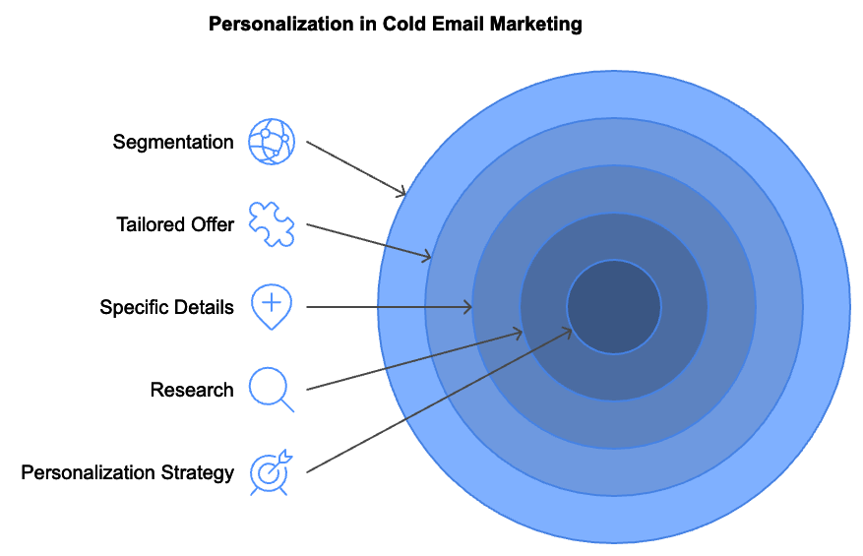
To personalize effectively, research the recipient by checking their LinkedIn profile, company website, and recent news. Reference specific details such as a recent company announcement, a shared connection, or a piece of content they've published. Tailor your offer by explaining how your product or service addresses their specific challenges or goals. Use industry-specific language to demonstrate your understanding of their field. Segment your list by grouping recipients by industry, company size, job title, etc., and customize your message for each segment.
Here's an example of effective personalization:
"Hi Sarah,
I enjoyed your recent LinkedIn post about the challenges of scaling customer support teams. As someone who's worked with fast-growing SaaS companies like yours, I've seen firsthand how critical this is for maintaining customer satisfaction.
At [Your Company], we've developed a solution that's helped companies like [Competitor] reduce support ticket volume by 30% while improving CSAT scores. I'd love to share some insights on how this could work for [Recipient's Company]..."
This opening demonstrates that you've done your research and are offering something relevant to the recipient's current challenges.

Avoiding Cold Email Mistakes and Measuring Success
Even with the best intentions, it's easy to fall into common traps that can derail your cold email efforts. Some pitfalls to avoid include over-selling, being too generic, writing lengthy emails, neglecting to proofread, sending at inopportune times, lacking a clear purpose, and ignoring mobile optimization. To continuously improve your cold email performance, implement A/B testing. This involves creating two versions of an email with one element changed, then seeing which performs better. Elements to test include subject lines, opening lines, email length, call-to-action phrasing, and sending time.
To gauge the effectiveness of your cold email campaigns, monitor key metrics such as open rate, click-through rate (CTR), response rate, conversion rate, bounce rate, and unsubscribe rate. Use these metrics to identify areas for improvement and refine your approach over time.
Metric | Description | Target Range
Open Rate | Percentage of recipients who open your email | 15-25%
Click-Through Rate (CTR) | Percentage of recipients who click on links in your email | 2-5%
Response Rate | Percentage of recipients who reply to your email | 5-15%
Conversion Rate | Percentage of recipients who take the desired action | 1-5%
Bounce Rate | Percentage of emails that weren't delivered | <2%
Unsubscribe Rate | Percentage of recipients who opt out of future emails | <0.5%

Implementing these strategies requires recognizing that crafting irresistible cold emails is both an art and a science. It requires creativity, empathy, and a deep understanding of your audience. Continuously test, refine, and improve your approach. With practice and persistence, you'll develop the skills to create cold emails that not only get opened but also drive meaningful results for your business.

DYNAMIC FOLLOW-UP STRATEGIES
____
The art of following up is where cold email marketing truly shines. This chapter will equip you with dynamic strategies to handle replies, overcome objections, and transform initial interest into meaningful connections and conversions.
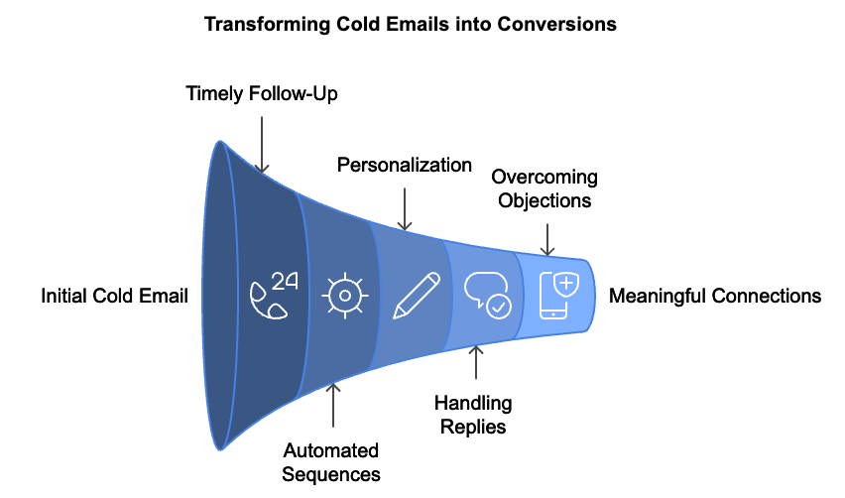

The Power of Timely Follow-Ups
Timing is crucial in cold email marketing. A prompt follow-up can make the difference between sealing a deal and losing a potential client. Studies show that 35-50% of sales go to the vendor that responds first, underscoring the importance of quick action. Your initial follow-up should ideally occur within 24-48 hours of your first email, keeping your message fresh in the recipient's mind and demonstrating your attentiveness and professionalism. However, don't stop at one follow-up. A strategic sequence of follow-ups can significantly increase your chances of getting a response.
A well-planned follow-up sequence maintains engagement without becoming a nuisance. Each follow-up should provide additional value, not just repeat your initial message. You might share a relevant case study, offer a useful resource, or provide industry insights. This approach positions you as a valuable resource, not just another salesperson.
For example, a value-adding follow-up might look like this:
"Hi [Name], I hope this email finds you well. I wanted to follow up on my previous message about [Your Product/Service]. I came across this industry report that I thought might interest you, given [Company's] recent expansion into [New Market]. It offers some interesting insights on [Relevant Topic]. I'd be happy to discuss how these trends might impact your business and how [Your Product/Service] could help you capitalize on them. Would you be open to a brief call next week?"
This follow-up adds value by sharing relevant information and tying it back to the recipient's business context.

Mastering Automated Sequences and Personalization
Automation can significantly streamline your follow-up process, allowing you to maintain consistent communication with a large number of prospects. However, it's crucial to strike a balance between efficiency and personalization. Most email marketing platforms offer automation features that allow you to set up follow-up sequences based on recipient actions (or inactions), such as opening an email but not responding, or not opening the email at all.
When setting up automated sequences, consider the following best practices:
- Personalize beyond just the recipient's name.
- Vary your messaging.
- Include opt-out options.
- Regularly monitor and adjust your sequences.
Here's an example of how you might structure an automated follow-up sequence:
- Email 1 (Day 3): Reiterate your main point and ask if they need any clarification.
- Email 2 (Day 7): Share a relevant case study or success story.
- Email 3 (Day 14): Offer a valuable resource or piece of content.
- Email 4 (Day 30): Final check-in with a clear call-to-action.
While automation can save time, it shouldn't replace human interaction entirely. Be prepared to step in and personalize your approach when a prospect shows interest or raises specific questions or concerns.

Handling Replies and Overcoming Objections
Not all responses are created equal. You'll encounter a range of replies, from enthusiastic interest to polite rejections. For positive responses, act quickly, thank them for their response, address any questions they've raised, and propose clear next steps. When handling requests for more information, provide the requested information promptly and concisely, using this opportunity to highlight the most relevant benefits of your product or service. For "not now" responses, respect their position but keep the door open by asking if you can check back in at a specific future date. If you receive a referral, thank them and ask if they'd be willing to make an introduction. Even negative responses can be an opportunity to gather valuable feedback for refining your approach.
Objections are a natural part of the sales process, and your ability to address them effectively can turn initial resistance into successful conversions. Common objections include concerns about cost, satisfaction with current solutions, time constraints, need for approval, and budget limitations. To overcome these objections, focus on shifting the conversation from cost to value, highlighting unique features or benefits, respecting time constraints while emphasizing long-term time savings, offering additional materials for decision-makers, and discussing the cost of inaction. Remember, the key to overcoming objections is to listen actively, empathize with the prospect's concerns, and respond with relevant, value-focused information.
Throughout your follow-up process, focus on providing value in every interaction. This approach positions you as a trusted advisor rather than just another salesperson. Share relevant industry news or insights, offer free resources such as whitepapers or webinars, provide case studies or success stories that align with the prospect's industry or challenges, offer a free consultation or assessment, and share tips or best practices that can help the prospect, even if they don't buy from you. Consistently providing value helps you build trust and keeps prospects engaged, even if they're not ready to buy right away.

When to Move On and Keep Professional Relationships
While persistence is important, it's equally crucial to recognize when it's time to move on. If a prospect has repeatedly expressed disinterest or hasn't engaged after multiple follow-ups, continuing to pursue them can damage your reputation and waste your resources. A good rule of thumb is to follow up 5-7 times over the course of 2-3 months. If you haven't received a response after this sequence, it's generally best to move the prospect to an inactive list.
Before ceasing contact, send a final "break-up" email that is polite, expresses your understanding that your offering may not be a fit at this time, and leaves the door open for future communication. For example:
"Hi [Name], I've reached out a few times about how [Your Product/Service] could help [Company Name] [Achieve Specific Goal]. Since I haven't heard back, I assume this isn't a priority for you right now. I don't want to bother you with continued follow-ups, so I'll stop reaching out after this email. If your situation changes in the future, please don't hesitate to contact me. I'm always happy to help. All the best, [Your Name]"
This type of email often elicits a response, even from prospects who haven't engaged previously. If not, it leaves a positive final impression and keeps the door open for future opportunities.
Implementing these follow-up strategies involves focusing on building relationships rather than simply closing deals. Providing value, addressing concerns, and respecting your prospects' time and preferences will help you establish yourself as a trusted partner. This approach not only improves your chances of success with your current outreach but also lays the groundwork for long-term business relationships. Your follow-up strategy is a critical component of your cold email marketing success, and by mastering these techniques, you're well-equipped to turn your cold emails into warm leads and ultimately, satisfied customers.
Follow-Up Stage | Timing | Key Action
Initial Follow-Up | 24-48 hours after first email | Reiterate main point, offer clarification
Second Follow-Up | 7 days after first email | Share relevant case study or success story
Third Follow-Up | 14 days after first email | Offer valuable resource or content
Final Follow-Up | 30 days after first email | Clear call-to-action or "break-up" email

THE PROFESSIONAL PLAYBOOK
____
You're on the cusp of transforming your cold email marketing strategy. This chapter will arm you with the essential tools, compliance knowledge, and spam avoidance techniques to elevate your campaigns to professional standards.
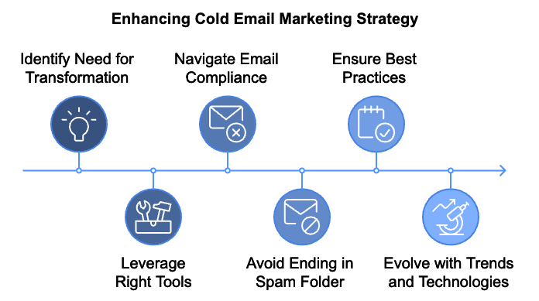

Essential Tools for Cold Email Success
Using the right tools can greatly boost your cold email marketing efforts. These tools streamline processes, provide valuable insights, and help you manage your campaigns more effectively.
Email automation platforms are the backbone of successful cold email campaigns, allowing you to schedule emails, create automated sequences, and track performance metrics. Popular options include Mailchimp, HubSpot, SendGrid, and Woodpecker. When choosing an automation platform, consider factors such as ease of use, integration capabilities, pricing, and specific features that align with your campaign goals.
Analytics tools provide crucial insights into your campaign performance, helping you refine your strategy over time. Key tools include Google Analytics, Yesware, and Mixpanel. These tools help you track metrics like open rates, click-through rates, and conversion rates, allowing you to identify what's working and what needs improvement.
Customer Relationship Management (CRM) systems are invaluable for managing your contacts and tracking interactions. They help you maintain a complete view of your relationships with prospects and customers. Popular CRM options include Salesforce, Pipedrive, and Zoho CRM. When integrated with your email marketing tools, CRM systems can provide a holistic view of your customer interactions, helping you tailor your approach and improve conversion rates.

Navigating Email Compliance
Compliance with email marketing regulations is not just a legal necessity; it's a crucial component of building trust with your audience.
The General Data Protection Regulation (GDPR) is one of the most thorough data protection laws, but it's not the only one you need to consider. GDPR applies to any organization that processes the personal data of EU residents, regardless of where the organization is based.
Key GDPR requirements for email marketers include:
- Obtaining explicit consent.
- Providing the right to withdraw consent.
- Implementing data protection measures.
- Maintaining a clear privacy policy.
- Honoring data subject rights.
To ensure GDPR compliance, implement double opt-in processes, maintain detailed records of consent, and regularly audit your data protection practices.
While GDPR is thorough, other regulations may also apply to your email marketing efforts, such as the CAN-SPAM Act in the US, CASL in Canada, and PECR in the UK. Familiarize yourself with the regulations applicable to your target regions and implement processes to ensure compliance.

Spam Avoidance
Avoiding the spam folder is crucial for the success of your cold email campaigns. Implementing email authentication protocols helps ISPs verify that your emails are legitimate, increasing the likelihood they'll reach the inbox.
Key authentication methods include:
- SPF: Sender Policy Framework
- DKIM: DomainKeys Identified Mail
- DMARC: Domain-based Message Authentication, Reporting & Conformance
Implementing these protocols can significantly improve your email deliverability and protect your domain reputation.
Understanding spam trigger words is essential. Certain words and phrases can trigger spam filters, potentially sending your emails to the junk folder. While the exact list of trigger words is constantly evolving, categories to be cautious of include urgent language, financial promises, excessive capitalization and punctuation, and pushy sales language. Instead of relying on these potentially problematic terms, focus on creating value-driven content that genuinely addresses your recipients' needs and interests.
Maintaining list hygiene is crucial for maintaining good deliverability rates. Best practices for list hygiene include:
- Regular Cleaning
- Segmentation
- Re-Engagement Campaigns
- Using Double Opt-In,
- Honoring Unsubscribes Promptly
Maintaining a clean, engaged list improves your chances of reaching the inbox and boosts the overall effectiveness of your campaigns.
Authentication Method | Description | Benefits
SPF | Verifies authorized sending servers | Improves deliverability
DKIM | Adds digital signature to emails | Ensures email integrity
DMARC | Builds on SPF and DKIM | Enhances domain protection

Best Practices for Email Marketing
To elevate your cold email marketing to professional standards, consider these best practices:
- Personalization at Scale
- A/B Testing
- Mobile Optimization
- Consistency in Branding
- Clear Value Proposition
- Respect for Recipient Preferences
- Regular Performance Reviews
Implementing these practices will help you create a more effective and professional email marketing strategy.
Email marketing is constantly evolving. To stay ahead, keep an eye on emerging trends and technologies such as AI and machine learning, interactive emails, accessibility considerations, and privacy-focused changes. Staying informed about these trends and continuously refining your approach will position you to maximize the impact of your cold email marketing efforts.
Implementing the tools, compliance measures, and spam avoidance techniques outlined in this chapter helps create a professional, ethical, and effective email marketing program. Focusing on providing value, respecting recipients' preferences and privacy, and continuously optimizing your approach will build a cold email strategy that complies with regulations and delivers real results for your business. The journey to mastering cold email marketing is ongoing, but with these professional strategies in your playbook, you're well-equipped to succeed in this dynamic and powerful marketing channel.

BOOSTING IMPACT AND FOSTERING MASTERY
____
You've explored the intricacies of cold email marketing, absorbing strategies, techniques, and best practices along the way. Now, it's time to synthesize this knowledge and chart your path forward. This final chapter will reinforce key concepts, provide actionable steps for implementation, and inspire you to continue refining your cold email marketing skills.

Reinforcing Strategic Planning
The foundation of successful cold email marketing lies in strategic planning. Setting clear, actionable SMART goals (Specific, Measurable, Achievable, Relevant, and Time-bound) serves as your roadmap, guiding every decision and action in your email campaigns. Regularly revisit and refine your objectives, ensuring they remain relevant and challenging. For instance, if you've consistently achieved your open rate targets, consider raising the bar or shifting focus to click-through rates or conversion metrics. Equally crucial is your understanding of your target audience. The buyer personas you've created are not static documents but living representations of your ideal customers. Continuously update these personas with new insights gained from your campaigns and market research. The more accurately you can pinpoint your audience's needs, pain points, and preferences, the more effectively you can tailor your messages to resonate with them.

Mastering Email Craftsmanship
Crafting compelling cold emails is an art form that requires constant refinement. Start by creating a swipe file of subject lines, opening lines, and email templates that have proven effective in your industry. Use these as inspiration, but always customize them to fit your unique value proposition and target audience. The goal is not to copy but to understand what makes these elements effective and apply those principles to your own writing.
Personalization remains a key differentiator in cold email marketing. Go beyond simply inserting the recipient's name and strive for deeper, more meaningful personalization. This could involve referencing recent company news, commenting on a shared LinkedIn post, or tailoring your offer to the specific challenges faced by the recipient's industry. The more relevant and personalized your email, the higher the chances of engagement. Continue to experiment with different email lengths, styles, and formats. While concise emails often perform well, there may be instances where a longer, more detailed message is appropriate. Test different approaches and let the data guide your decisions.

Refining Follow-Up Strategies
Your follow-up strategy can make or break your cold email campaign. Create a library of follow-up templates for different scenarios, such as no response, initial interest, or specific objections. These templates should serve as starting points, which you can customize based on the individual recipient and the context of your interaction. Experiment with different follow-up cadences. While the general rule of thumb is to follow up 5-7 times over 2-3 months, your optimal cadence may vary depending on your industry and target audience. Use A/B testing to determine the most effective timing and frequency for your follow-ups. Every interaction is an opportunity to provide value. Each follow-up should offer something new, whether it's additional information, a relevant resource, or a fresh perspective on how your product or service can address the recipient's needs. This approach positions you as a valuable resource rather than just another salesperson.

Leveraging Technology for Performance
The tools and technologies you employ can significantly impact the success of your cold email campaigns. Continually evaluate your tech stack to ensure it meets your evolving needs and takes advantage of the latest advancements in email marketing technology. Explore advanced features of your email automation platform. Many platforms offer AI-powered tools for subject line optimization, send time optimization, and predictive analytics. These features can help you fine-tune your campaigns and improve performance over time. Integrate your email marketing tools with your CRM system to create a seamless flow of data. This integration allows for more sophisticated segmentation and personalization, as well as better tracking of the customer journey from initial contact to conversion. Stay informed about emerging technologies that could enhance your email marketing efforts. For example, interactive emails that allow recipients to take action directly within the email body are gaining popularity. Similarly, AI-powered content generation tools are becoming more sophisticated, potentially offering new ways to create personalized email content at scale.
When scaling your cold email marketing efforts, it's essential to keep compliance and ethical practices at the forefront. Staying compliant with regulations like GDPR not only keeps you on the right side of the law but also builds trust with your recipients. Regularly audit your data collection and storage practices to ensure they meet the highest standards of data protection. Implement processes for honoring data subject rights, such as the right to access, rectify, or erase personal data. Go beyond mere compliance and strive to be a leader in ethical email marketing. This could involve being transparent about how you obtained the recipient's contact information, providing clear and easy opt-out options, and respecting recipient preferences even when it might limit your marketing reach. Consider obtaining relevant certifications or participating in industry standards programs to demonstrate your commitment to ethical practices.
The field of email marketing is constantly evolving, driven by changes in technology, consumer behavior, and regulatory landscapes. To maintain and improve your effectiveness, commit to continuous learning and adaptation. Stay informed about industry trends and best practices by following reputable email marketing blogs, attending webinars, and participating in industry conferences. Consider joining professional associations like the Email Experience Council (EEC) or the Direct Marketing Association (DMA) for access to resources and networking opportunities.
Regularly analyze your campaign performance data to identify trends and opportunities for improvement.

Even small improvements can lead to significant results when applied consistently across your campaigns.

Look beyond surface-level metrics like open rates and click-through rates. Dive deeper into metrics like conversion rates, revenue per email, and customer lifetime value to get a more complete picture of your email marketing ROI.
Metric | Description | Target
Open Rate | Percentage of recipients who open the email | 20-30%
Click-Through Rate | Percentage of recipients who click on a link in the email | 2-5%
Conversion Rate | Percentage of recipients who complete the desired action | 1-3%
Bounce Rate | Percentage of emails that couldn't be delivered | <2%
Unsubscribe Rate | Percentage of recipients who opt out of future emails | <0.5%

While cold email can be highly effective on its own, its power is amplified when integrated with other marketing channels. Consider how you can create a cohesive multi-channel strategy that reinforces your message across various touchpoints. For example, you might use LinkedIn to warm up your cold email prospects before reaching out. Engaging with their content or sharing relevant insights can increase the chances of your email being well-received.
Similarly, you could use retargeting ads to reinforce your message to prospects who have opened your emails but haven't yet converted. Explore ways to use your cold email list to fuel other marketing efforts. For instance, you could invite engaged email recipients to webinars or virtual events, providing another avenue for deepening the relationship and showcasing your expertise.
Mastering cold email marketing is an ongoing process that requires consistent learning and adaptation. The strategies, techniques, and best practices you've learned provide a solid foundation, but true mastery comes from consistent application, experimentation, and refinement. Commit to implementing what you've learned, starting with small, manageable changes to your current email marketing practices.
As you gain confidence and see results, gradually incorporate more advanced techniques. Even small improvements can lead to significant results when applied consistently across your campaigns. Stay curious and open to new ideas. The most successful email marketers are those who never stop learning and are always willing to challenge their assumptions. Treat every campaign as an opportunity to learn and improve, and don't be discouraged by setbacks. Instead, view them as valuable learning experiences that bring you one step closer to mastery.

