TABLE OF CONTENTS
____
INTRODUCTION 4
THE SHADOW SIDE OF HUMAN PSYCHOLOGY 8
The Nature of Dark Psychology 8
Understanding Manipulative Personalities 10
Protecting Yourself from Dark Psychology 12
THE MIND GAMES MANIPULATORS PLAY 15
The Hidden Architecture of Manipulation 15
The Arsenal of Psychological Manipulation 16
The Social Engineering Component 20
INFLUENCE VS MANIPULATION 23
The Foundations of Ethical Influence 23
The Power Dynamics of Professional Influence 25
Protecting Professional Autonomy 27
THE PSYCHOLOGY OF DEFENSE 31
Understanding Your Psychological Immune System 31
The SHIELD Framework for Active Defense 33
Building Long-Term Psychological Resilience 36
MASTERING ETHICAL INFLUENCE 40
The Psychology of Ethical Leadership 40
Building Trust Through Authentic Communication 43
Applying Ethical Influence in Practice 44
MOVING FORWARD WITH CONFIDENCE 49
The Integration of Protection and Influence 49
Building Your Implementation Strategy 52
Creating Sustainable Change 54

DISCLAIMER
____
The information provided in this ebook is intended solely for educational and informational purposes. The author does not accept any responsibility for the outcomes that may arise from the application of the material within. While efforts have been made to ensure the accuracy and relevance of the content, the author cannot be held accountable for any errors or omissions, or for any consequences resulting from the use or misuse of the information provided. The responsibility for any actions taken based on the information in this ebook lies solely with the reader.


INTRODUCTION
____
In the complex interplay of human relationships and social dynamics, psychological manipulation surrounds you more than you might realize. From subtle persuasion tactics in everyday conversations to calculated influence strategies in professional settings, the elements of dark psychology weave through the fabric of human interaction.
Understanding these hidden forces isn't just an academic exercise. It's a crucial skill for protecting yourself and maintaining authentic relationships in both personal and professional spheres. Awareness of these tactics empowers you to recognize manipulation and respond with clarity, confidence, and control.
You've likely experienced moments when something felt off about an interaction, but you couldn't quite identify why. Perhaps a colleague's seemingly innocent request left you feeling uncomfortable, or a sales pitch appeared genuine yet triggered internal warning signals. These instances often stem from sophisticated psychological manipulation tactics that operate beneath the surface of conscious awareness. This book illuminates these hidden mechanisms, bringing them into sharp focus so you can recognize and respond to them effectively.
The power of psychological manipulation lies in its subtlety. Unlike physical threats or overt coercion, psychological tactics can influence your decisions, alter your perceptions, and shape your behavior without triggering immediate defensive responses.
You may have found yourself agreeing to things against your better judgment in the past, doubting your own memories or experiences, or feeling inexplicably guilty about maintaining healthy boundaries. These effects aren't random, but are the result of calculated strategies that exploit natural human psychological vulnerabilities.
But knowledge is power, and understanding dark psychology doesn't mean you need to become cynical or distrustful. Instead, this book equips you with practical tools to navigate complex social dynamics while maintaining your autonomy and authentic self. You'll learn to distinguish between ethical persuasion and manipulative tactics, develop robust psychological defenses, and master the art of ethical influence. This knowledge transforms you from a potential target into an informed individual who can recognize, resist, and respond to manipulation while building genuine, mutually beneficial relationships.
Whether you're a business professional seeking to protect yourself from office politics, an entrepreneur wanting to maintain ethical standards in negotiations, or simply someone interested in understanding the psychological forces at play in your daily interactions, this book provides the insights and strategies you need. The journey through dark psychology leads not to paranoia but to empowerment, allowing you to interact with others from a position of awareness, confidence, and ethical strength.


THE SHADOW SIDE OF HUMAN PSYCHOLOGY
____
Have you ever felt that subtle unease when someone's words and actions don't quite align? Picture a charismatic leader who draws people in with magnetic charm, yet leaves a trail of manipulated relationships and broken trust. This invisible force that shapes human behavior and interactions is what psychologists call dark psychology, a powerful framework of influence that operates in the shadows of our daily lives.

The Nature of Dark Psychology
Dark psychology represents the study and application of psychological principles used to influence, manipulate, and control others for personal gain or malicious purposes. Unlike traditional psychology that focuses on healing and growth, dark psychology examines the shadow aspects of human nature, including the mechanisms and motivations that drive manipulation, deception, and exploitation. This field of study reveals how seemingly innocent interactions can mask calculated attempts to gain psychological advantage over others.
Throughout history, from ancient warfare strategies to modern-day social engineering, dark psychology has manifested in countless forms. The Greek historian Thucydides documented how Athenian leaders used fear and pride to manipulate public opinion during the Peloponnesian War. Today, these same principles appear in sophisticated forms across business negotiations, political campaigns, and social media influence operations.
The foundation of dark psychology rests on exploiting fundamental human vulnerabilities. You possess certain psychological traits that manipulators can target: your need for social acceptance, desire for validation, fear of rejection, and susceptibility to emotional triggers. These natural human characteristics, which normally help you build meaningful relationships and navigate social situations, can become weapons in the hands of skilled manipulators.
Dark psychology operates through four key mechanisms that interweave to create powerful influence systems. Through cognitive manipulation, manipulators target your thought processes and decision-making capabilities, often using logical fallacies or information control to shape how you perceive reality. They might present selective information, create false choices, or use complex argumentation to overwhelm your critical thinking.
Emotional exploitation involves targeting your emotional vulnerabilities to create dependency or generate feelings of obligation. A manipulator might alternate between lavish praise and harsh criticism, keeping you off balance and seeking their approval. Through behavioral conditioning, they can shape your actions over time using subtle reward and punishment systems, often without your awareness of the conditioning process. Finally, social pressure leverages group dynamics and cultural norms to influence your behavior and decisions, making you feel compelled to conform or risk social isolation.
Understanding these mechanisms becomes crucial as you navigate professional and personal relationships. For example, a sales manager might use cognitive manipulation by presenting selective data to create urgency, emotional exploitation through praise and criticism to maintain control over team members, behavioral conditioning through inconsistent rewards to keep employees seeking approval, and social pressure by creating an environment where questioning authority is seen as disloyalty.

Understanding Manipulative Personalities
At the heart of dark psychology lies the dark triad—three distinct but interrelated personality traits that often characterize individuals who employ manipulative tactics:
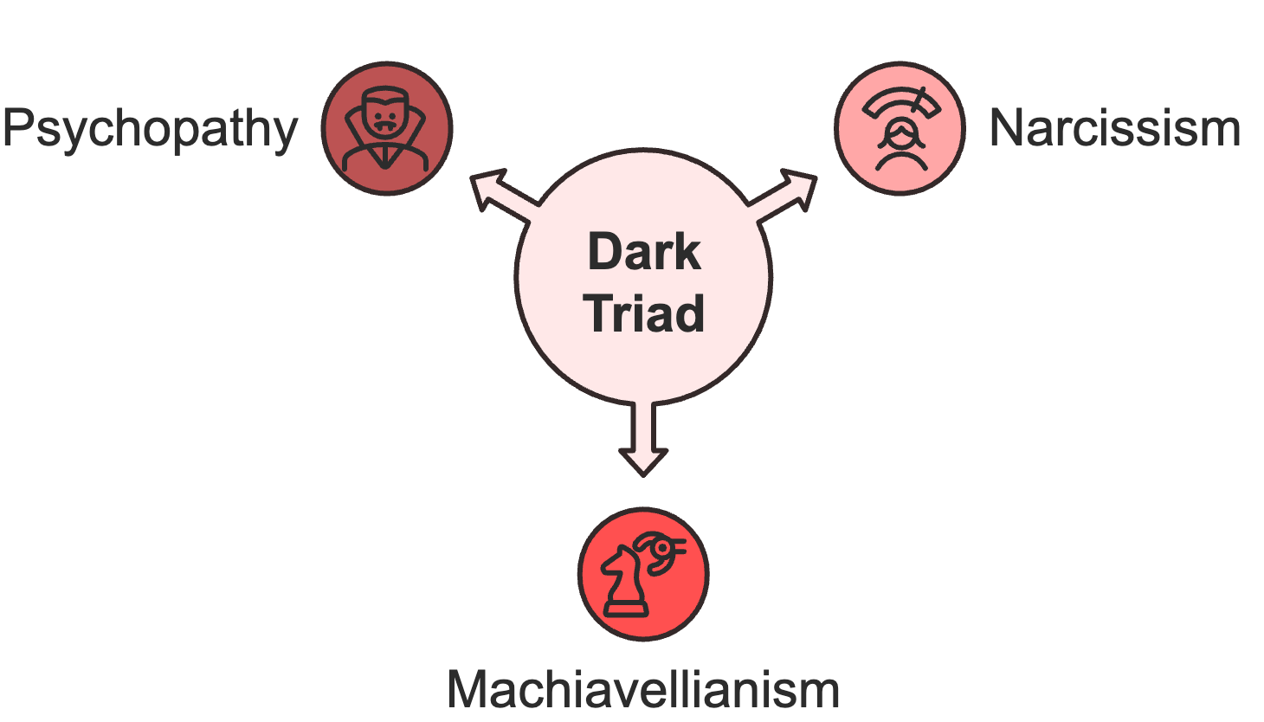
These traits exist on a spectrum, and understanding their manifestations can help you identify potential threats in your professional and personal life.
Narcissism manifests as an excessive need for admiration and recognition, coupled with a grandiose sense of self-importance. In professional settings, narcissistic individuals often create an initial positive impression through charm and confidence. However, their underlying behavior patterns reveal their true nature: taking credit for others' work, reacting poorly to criticism, and creating dependent relationships with colleagues. They excel at "impression management," which involves carefully crafting their public image while hiding their manipulative tendencies.
Machiavellianism reflects a strategic and calculating approach to relationships, characterized by emotional detachment and a focus on personal gain. These individuals excel at office politics, maintaining networks of useful connections while remaining emotionally uninvested. They view relationships as tools for advancement rather than genuine connections. Their manipulation often appears as skilled negotiation or strategic thinking, but their primary motivation remains self-interest rather than mutual benefit or organizational success.
Psychopathy in professional contexts manifests as a pattern of exploitation coupled with a remarkable lack of empathy or remorse. Individuals with high psychopathic traits often display superficial charm, engage in risky decision-making, and exploit others without consideration for consequences. They might appear as confident, decisive leaders, but leave a trail of damaged relationships and organizational chaos in their wake.

Protecting Yourself from Dark Psychology
Recognizing dark psychology is only half the battle. You must also develop strategies to protect yourself from manipulation while maintaining ethical standards in your own influence attempts. This requires building psychological resilience and establishing clear boundaries in professional relationships.
Start by developing awareness of your own psychological vulnerabilities. What emotional triggers make you susceptible to manipulation? Perhaps it's a fear of rejection that makes you vulnerable to praise manipulation, or a desire for recognition that leaves you open to flattery-based influence tactics. Understanding these personal triggers helps you recognize when they're being targeted.
Create systems for decision-making that resist manipulation attempts. This might include:
- Establishing waiting periods for important decisions
- Consulting trusted advisors before making significant commitments
- Documenting interactions where you feel manipulation might be present
- Regularly reviewing relationships for signs of unhealthy influence patterns
Build a strong support network of colleagues and mentors who can provide objective perspectives on situations where you suspect manipulation. These relationships serve as a reality check when your judgment might be clouded by sophisticated influence tactics.
The impact of dark psychology extends beyond individual interactions to affect entire organizational cultures. As a professional or leader, you have a responsibility to recognize and prevent manipulative practices within your sphere of influence. This includes establishing clear ethical guidelines for influence and persuasion, creating mechanisms for reporting manipulation, and developing organizational cultures that promote transparency and authentic leadership.
Understanding dark psychology empowers you to navigate professional relationships with greater awareness and resilience. By recognizing manipulative tactics and developing protective strategies, you can maintain your integrity while building genuine influence based on mutual respect and ethical principles.
Knowledge of dark psychology isn't about becoming a manipulator yourself. It's about developing the awareness and skills needed to protect yourself and others from psychological exploitation while promoting positive, ethical influence in your professional sphere.


THE MIND GAMES MANIPULATORS PLAY
____
You sit across from your colleague in the conference room, watching their carefully orchestrated performance unfold. They lean forward, voice dripping with urgency about a "critical project" that only you can handle. As they speak, you notice the subtle shifts, from effusive praise about your unique capabilities to carefully placed reminders of times they've helped you.
A familiar knot forms in your stomach. Something about this interaction feels calculated, yet you struggle to pinpoint exactly why. This scene represents just one example of the sophisticated manipulation tactics that permeate professional environments daily.

The Hidden Architecture of Manipulation
Manipulation tactics operate like invisible psychological levers, precisely calibrated to influence your thoughts, emotions, and behaviors without triggering your natural defenses. These techniques work because they exploit fundamental human needs, like your desire for recognition, fear of rejection, and innate drive for reciprocity. Understanding how these tactics function gives you the power to recognize and resist them before they take hold.
Professional manipulators rarely rely on a single approach. Instead, they weave together multiple techniques, creating complex influence patterns that can be challenging to detect. For instance, a manipulative colleague might combine guilt trips about team loyalty with strategic information control, while simultaneously using emotional invalidation to weaken your resistance. This multilayered approach makes their manipulation more effective and harder to identify.
Note how manipulation often begins with seemingly innocent interactions. A new team member might shower you with attention and support, creating what appears to be a strong professional alliance. Yet this initial period of love bombing serves a calculated purpose: establishing an emotional debt they can later leverage. They might strategically withdraw their support when you need it most, making their assistance conditional on your compliance with their requests.
This pattern of creating dependency through positive reinforcement, followed by strategic withdrawal, represents just one example of how sophisticated manipulation operates in professional settings. Recognizing these orchestrated tactics is the first step toward dismantling their power and reclaiming your ability to think and act freely in even the most covertly manipulative environments.

The Arsenal of Psychological Manipulation
Manipulators don’t rely on charm or persuasion alone—they deploy a calculated set of psychological tactics designed to destabilize, control, and dominate. These tools range from overt distortions of reality to covert control over information and expectations, each aimed at eroding your sense of autonomy and self-trust. Understanding these tactics is essential to recognizing when you're being targeted, and reclaiming your power before the damage is done.

Gaslighting: The Reality Distortion Field
Gaslighting represents one of the most psychologically damaging forms of manipulation, designed to make you question your perception, memory, and sanity. In professional contexts, gaslighting often manifests through subtle but persistent reality distortion:
A manager consistently denies giving instructions they clearly provided, making statements like, "I never said that. You must have misunderstood," or "That's not how I remember our conversation." Over time, these small incidents accumulate, creating a pattern that erodes your confidence in your judgment and memory.
Here’s a typical interaction:
You: "In our last meeting, you approved the budget increase for the marketing campaign."
Manipulator: "I don't recall ever discussing that. Are you sure you're not confusing this with another conversation? You've seemed rather stressed lately."
This exchange demonstrates how gaslighters combine denial with subtle implications about your mental state or competence. They might follow up by sharing their "concern" about your memory with other colleagues, further undermining your professional credibility.
The impact of gaslighting extends beyond individual interactions. Victims often experience:
- Decreased confidence in their professional judgment
- Hesitation to trust their memory or perceptions
- Increased anxiety about workplace communications
- Tendency to over-document interactions as self-protection

Advanced Control Tactics
Professional manipulators employ sophisticated control mechanisms that extend beyond basic emotional manipulation. These advanced tactics often include:
Information Control and Strategic Disclosure
Manipulators carefully orchestrate the flow of information to maintain power and control outcomes. They might:
- Release crucial information in carefully timed increments
- Create artificial information scarcity to force hasty decisions
- Present selective data that supports their narrative while concealing contradictory evidence
- Position themselves as essential information gatekeepers
This control over information flow allows them to shape perceptions and decisions while maintaining their position of influence. For example, a manipulative project manager might withhold critical timeline constraints until team members have committed to unrealistic deadlines, then use this commitment to pressure them into excessive overtime work.
The Moving Goalposts Syndrome
This sophisticated manipulation tactic involves continuously shifting expectations or requirements after initial goals have been met. The manipulator creates a perpetual state of inadequacy, preventing you from ever feeling secure in your achievements. For instance:
- You complete a project according to agreed specifications, only to hear, "Yes, but now we need these additional features..."
- You meet your sales targets, but suddenly the metrics for success change.
- Performance review criteria evolve just as you're about to meet them.
The psychological impact of constantly moving goalposts extends beyond immediate frustration. It creates a persistent state of uncertainty and anxiety, making you more susceptible to other forms of manipulation as you struggle to regain solid footing.

The Social Engineering Component
Modern manipulators blend traditional psychological tactics with sophisticated social engineering techniques, creating multilayered influence strategies that are particularly effective in professional environments. This combination allows them to exploit both individual psychological vulnerabilities and broader social dynamics.

Network Manipulation
Skilled manipulators often create elaborate networks of influence, using social proof and reputation management to strengthen their position. They might:
- Cultivate strategic alliances with key decision-makers
- Create artificial consensus through orchestrated support
- Use triangulation to pit colleagues against each other
- Build seemingly innocent coalitions that serve their hidden agendas
This social engineering approach extends their influence beyond direct interactions, making their manipulation more difficult to resist or challenge. They might, for example, ensure that multiple colleagues casually mention their "concerns" about your work, creating an artificial pattern of negative feedback that supports their manipulation goals.

Time Pressure and Urgency Tactics
Manipulators frequently exploit time pressure to bypass rational decision-making processes. They create artificial deadlines and emergencies to force quick decisions that serve their interests. This might involve:
- Presenting opportunities that are "about to expire"
- Creating crisis situations that require immediate response
- Using time zones or schedule conflicts to limit discussion
- Manufacturing deadline pressure to prevent due diligence
The effectiveness of these tactics lies in their ability to trigger stress responses that override careful analysis and boundary-setting. When combined with other manipulation techniques, time pressure can be particularly powerful in professional settings where quick decision-making is often valued.
The impact of these sophisticated manipulation tactics can be profound, affecting both individual well-being and organizational health. As you navigate professional relationships, remain alert to these patterns while maintaining appropriate boundaries. Understanding these tactics doesn't make you paranoid; it makes you prepared to recognize and resist psychological manipulation while building genuine, productive professional relationships based on mutual respect and transparent communication.
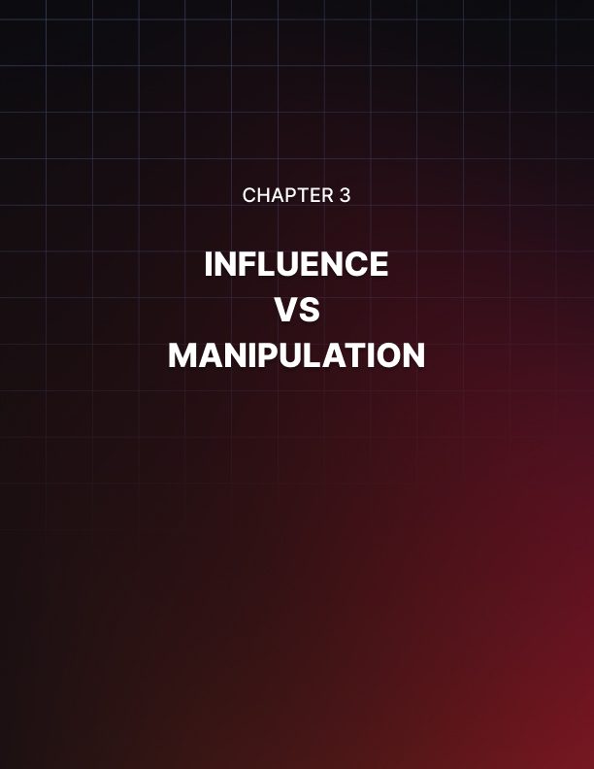

INFLUENCE VS MANIPULATION
____
The conference room falls silent as you observe a masterful display of influence unfold. Your colleague presents a compelling project proposal, their words carefully chosen, their timing impeccable. They weave together facts and emotions, making you feel both valued and needed.
Yet beneath the polished surface, questions arise. Is this genuine collaboration they're offering, or a sophisticated form of control? Are they respecting your agency to decide, or subtly removing your choice? This moment captures the complex reality many professionals face: the challenge of distinguishing between ethical persuasion and manipulation in the workplace.

The Foundations of Ethical Influence
At its core, influence represents the ability to affect others' thoughts, feelings, or behaviors. However, the methods and intentions behind influence attempts create a crucial divide between ethical persuasion and manipulation. Understanding this distinction requires examining the fundamental principles that separate these approaches.
Ethical persuasion operates on a foundation of transparency, respect, and mutual benefit. When you engage in ethical persuasion, you present your case openly while acknowledging potential drawbacks. You share complete information, even when it might work against your immediate interests. Most importantly, you genuinely respect others' right to make informed decisions, even if those decisions don't align with your preferences.
Take a look at how ethical persuasion manifests in a typical workplace scenario. A project manager using ethical persuasion might say:
"I believe this new initiative could increase our team's productivity by 30%, based on these specific data points. However, I want to be upfront about the challenges. We'll need to invest significant time in training, and there will likely be a temporary dip in output during the transition. I'd like to hear your thoughts on how we might address these challenges together."
This approach contrasts sharply with manipulation, which typically involves:
- Selective disclosure of information
- Creation of artificial pressure or urgency
- Exploitation of psychological vulnerabilities
- Use of emotional leverage or coercion
- Undermining of autonomous decision-making
The impact of these different approaches extends far beyond immediate outcomes. Ethical persuasion builds trust and strengthens professional relationships over time. People recognize that you consistently provide accurate information and respect their autonomy, leading to increased credibility and influence. Manipulation, while potentially effective in the short term, typically results in damaged relationships and decreased trust once people recognize they've been deceived.
Understanding the ethics of influence requires examining the psychological mechanisms at play in professional interactions. When you engage in ethical persuasion, you work with natural psychological processes rather than exploiting them. You acknowledge emotional factors without using them as weapons. You recognize cognitive biases but don't deliberately trigger them for personal gain.

The Power Dynamics of Professional Influence
Every attempt at influence occurs within a complex web of power relationships and organizational dynamics. These structures can either facilitate ethical persuasion or enable manipulation, depending on how they're leveraged and understood.
Power in professional settings manifests through multiple channels:
- Formal authority derived from organizational hierarchy
- Expert power based on knowledge and specialized skills
- Relationship power built through professional networks
- Resource control over information, budgets, or opportunities
Ethical leaders recognize these power dynamics while maintaining appropriate boundaries. They use their authority to guide and develop others, share knowledge to empower their teams, and leverage relationships to create mutual benefits. This approach stands in stark contrast to manipulative leaders who exploit power differentials to create dependency and compliance.
Consider how this plays out in the context of expert power. A manager using ethical persuasion might say:
"Based on my experience with similar projects, I believe approach A offers the best chance of success. Here's the data that supports this conclusion, and I'd welcome your analysis of any factors I might have overlooked."
This contrasts with a manipulative approach where expertise becomes a tool for intimidation. A controlling manager would say:
"Trust me, I've done this countless times before. You couldn't possibly understand all the complexities involved."
The impact of power dynamics becomes particularly evident in decision-making processes. Ethical persuasion maintains clear boundaries between influence and coercion. You might present compelling arguments for your preferred approach while explicitly acknowledging others' right to disagree or choose alternative paths. Manipulation, however, often blurs these boundaries, creating situations where formal or informal power structures make genuine choice impossible.
Organizational culture significantly shapes how power and influence operate. Different cultures maintain varying norms regarding:
- Communication styles and expectations
- Decision-making processes and authority
- Acceptable forms of influence
- Resolution of conflicts and disagreements
Understanding these cultural factors helps you navigate the line between appropriate influence and manipulation. What might be considered normal persuasion in one organizational context could be seen as manipulative in another. This requires developing cultural intelligence and adapting your influence approach while maintaining ethical standards.

Protecting Professional Autonomy
Maintaining autonomy in professional relationships requires developing specific skills and strategies. This becomes particularly important when facing sophisticated influence attempts that blur the line between persuasion and manipulation.
Start by establishing clear professional boundaries. These boundaries should address:
- Decision-making processes and timelines
- Information requirements and transparency expectations
- Professional relationship parameters
- Communication preferences and protocols
Document important interactions and decisions to maintain clarity and accountability. This might include:
- Detailed meeting notes capturing key points and agreements
- Email confirmations of verbal discussions
- Project timelines with specific milestones and deliverables
- Decision rationales with supporting data and analysis
Develop your emotional intelligence to better recognize manipulation attempts. Pay attention to:
- Physical responses during interactions
- Emotional patterns that seem unusual or uncomfortable
- Changes in relationship dynamics
- Pressure to make decisions despite discomfort
Watch for specific warning signs that often indicate manipulation:
- Artificial urgency or unnecessary time pressure
- Selective sharing of information
- Emotional leverage or guilt tactics
- Moving goalposts or changing expectations
- Creation of dependent relationships
Build a strong professional network that can provide objective perspectives and support. This network should include:
- Trusted mentors who can offer guidance
- Colleagues who provide honest feedback
- Professional contacts outside your immediate organization
- Subject matter experts for technical consultation
As you navigate these complexities, remember that the goal isn't just to avoid manipulation but to create positive influence that benefits both individuals and organizations. This requires ongoing attention to ethical standards, clear communication, and genuine respect for others' autonomy and well-being. By maintaining these principles while developing your influence skills, you can build strong professional relationships based on trust and mutual respect rather than control and manipulation.
Your ability to distinguish between ethical persuasion and manipulation ultimately rests on your commitment to maintaining professional integrity while respecting others' dignity and autonomy. As you continue to develop your influence skills, regularly examine your methods and intentions to ensure they align with ethical principles and contribute to positive professional relationships.


THE PSYCHOLOGY OF DEFENSE
____
In environments where manipulation operates beneath the surface, psychological defense becomes a vital form of self-preservation. Resisting covert influence requires more than instinct; it demands conscious strategies, emotional regulation, and a deep understanding of manipulative tactics. By cultivating these internal defenses, individuals can navigate complex social dynamics with clarity, assertiveness, and control.

Understanding Your Psychological Immune System
Just as your body maintains complex defense mechanisms against physical threats, your mind requires a sophisticated system to protect against psychological manipulation. Think of this as your psychological immune system—a network of awareness tools, response strategies, and protective barriers that work together to identify and neutralize manipulation attempts before they can take root.
Your psychological immune system operates through multiple layers of defense. At its foundation lies self-awareness, the ability to recognize your emotional states, triggers, and vulnerabilities. This awareness serves as your early warning system, alerting you to potential manipulation through subtle physical and emotional signals.
When you feel that familiar tightness in your chest during a conversation or notice your thoughts becoming unusually clouded while reading an email, these sensations aren't random. They're your psychological immune system's first response to perceived threats.
Building this immune system requires understanding your personal vulnerability. Everyone carries specific psychological weak points shaped by past experiences, core beliefs, and current circumstances. Perhaps you have a deep-seated need for validation that makes you susceptible to praise manipulation. Maybe childhood experiences left you with an excessive fear of conflict that manipulators can exploit.
These vulnerabilities don't make you weak. They actually make you human. The key lies not in eliminating them but in recognizing and protecting them.
Think of your psychological defenses like layers of armor, each serving a specific protective function. The outer layer consists of your boundary system, or the rules and limits you establish for professional interactions. Beneath this lies your emotional regulation system, controlling how you respond to manipulation attempts.
Deeper still is your cognitive defense system, helping you analyze situations logically even under pressure. The innermost layer comprises your core values and self-worth, which, when properly maintained, make you naturally resistant to manipulation. When all layers work in harmony, your psychological immune system becomes a powerful force, not only shielding you from manipulation but also empowering you to respond with clarity, strength, and integrity.

The SHIELD Framework for Active Defense
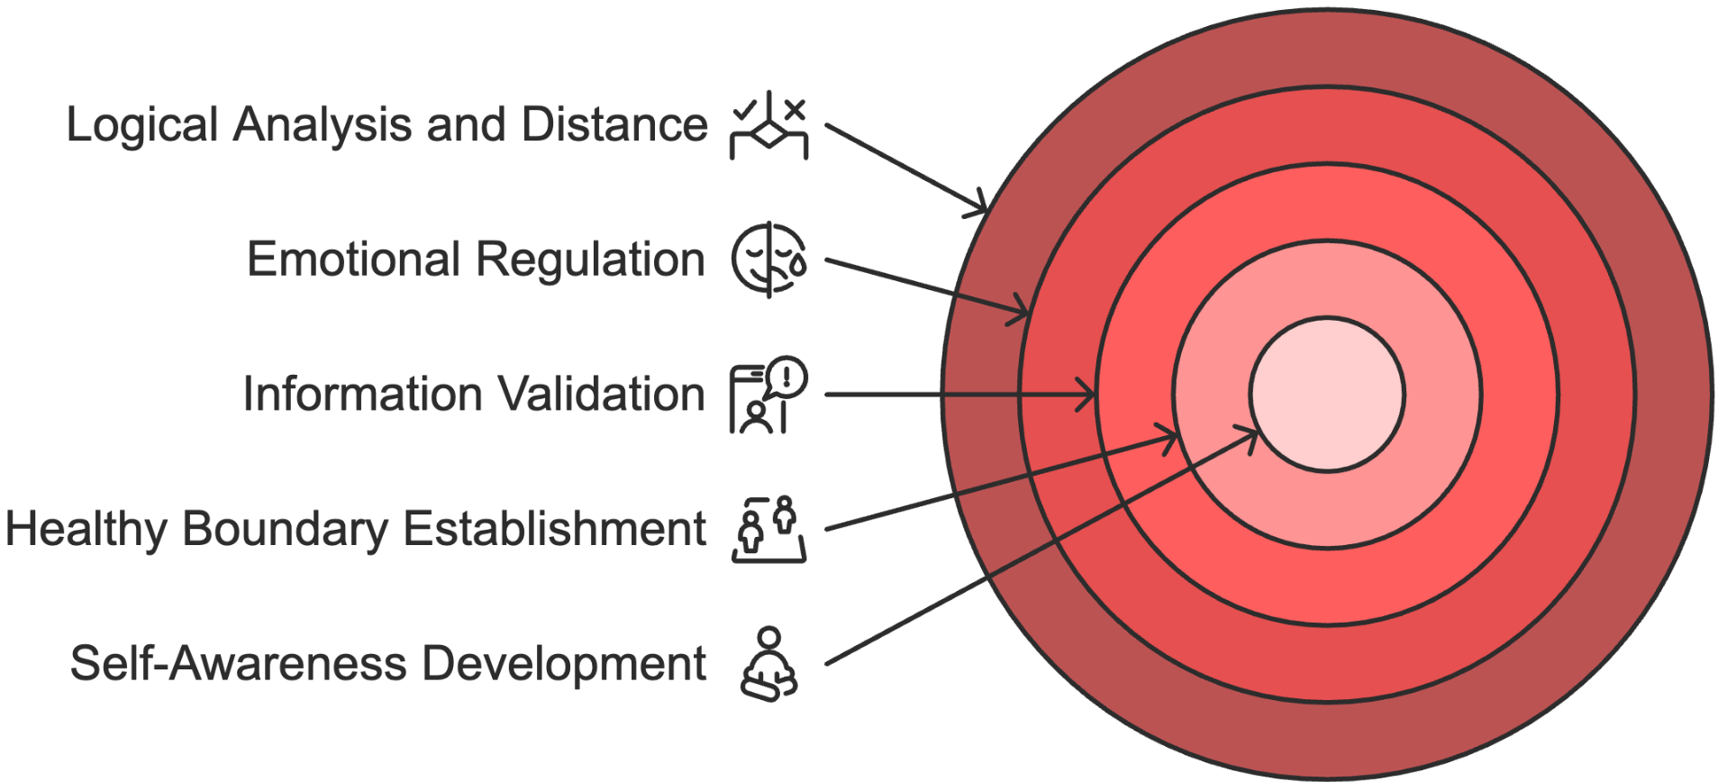
The SHIELD framework provides a structured approach to developing and maintaining your psychological defenses. Each component of this framework represents an essential aspect of protection against manipulation:
Self-Awareness Development
Your journey toward effective psychological defense begins with deepening your self-awareness. This involves regular practice of mindfulness techniques, emotional monitoring, and personal pattern recognition.
Start by maintaining an emotion journal, tracking your responses to different workplace interactions. Notice when your energy levels shift, when your confidence wavers, or when you feel an inexplicable urge to agree against your better judgment. These observations form the foundation of your defense system.
Healthy Boundary Establishment
Professional boundaries serve as your first line of defense against manipulation. See boundaries not as walls but as clearly marked property lines, defining where your responsibilities end and others' begin. Establish explicit boundaries around:
- Time management and availability
- Decision-making processes
- Communication expectations
- Personal and professional space
- Work-life balance requirements
Information Validation
In an environment where information can be weaponized, developing strong validation practices becomes crucial. Create systematic approaches to verify claims, check facts, and ensure you're making decisions based on complete and accurate information. This might involve:
- Cross-referencing important data
- Seeking multiple perspectives on critical issues
- Documenting key conversations and agreements
- Maintaining clear communication trails
Emotional Regulation
Your ability to manage emotional responses under pressure determines how effectively you can resist manipulation. Develop specific techniques for:
- Recognizing emotional triggers before they overwhelm you
- Creating space between stimulus and response
- Maintaining professional composure during challenging interactions
- Processing and releasing emotional tension appropriately
Logical Analysis
When emotions run high, your capacity for logical analysis becomes your anchor. Practice systematic approaches to evaluation and decision-making, such as:
- Breaking complex situations into manageable components
- Identifying underlying patterns in behavior or requests
- Analyzing potential motivations and consequences
- Maintaining an objective perspective despite pressure
Distance When Necessary
Sometimes, the most effective defense involves creating strategic distance from manipulative situations or individuals. This doesn't mean avoiding all challenging interactions, but rather:
- Recognizing when temporary withdrawal serves your best interests
- Maintaining professional distance in problematic relationships
- Creating buffer zones around high-stress interactions
- Establishing clear disengagement protocols

Building Long-Term Psychological Resilience
While immediate defense tactics are important, lasting protection against manipulation requires developing deep psychological resilience. This involves creating sustainable practices that strengthen your natural resistance to manipulation while maintaining your ability to engage authentically in professional relationships.
Psychological resilience is like a muscle that grows stronger with proper training and maintenance. Regular practice of specific resilience-building exercises helps develop this strength:

Mindfulness Training
Develop daily practices that enhance your awareness of thoughts, emotions, and physical sensations. This heightened awareness helps you detect manipulation attempts earlier and respond more effectively. Regular mindfulness practice might include:
- Brief meditation sessions during work breaks
- Body scan exercises to identify stress signals
- Conscious breathing techniques for emotional regulation
- Present-moment awareness during interactions

Support Network Development
Create and maintain a strong professional support system that can provide objective perspectives and emotional backup when needed. This network should include:
- Trusted mentors who can offer guidance
- Peers who understand your professional context
- External advisors for unbiased feedback
- Mental health professionals, when necessary
Remember that building psychological resilience isn't about becoming invulnerable, but about developing the strength to maintain your autonomy and well-being while engaging meaningfully with others. As you continue strengthening your psychological defenses, focus on creating sustainable practices that feel natural and authentic to your professional style—habits that support both clarity and connection.
When these defenses are firmly in place, they operate quietly in the background. They may be rarely dramatic, but they’re profoundly effective. True success often shows up not as a bold confrontation, but as the steady maintenance of boundaries, the absence of unnecessary conflict, and the ability to navigate challenges with calm, confident presence.
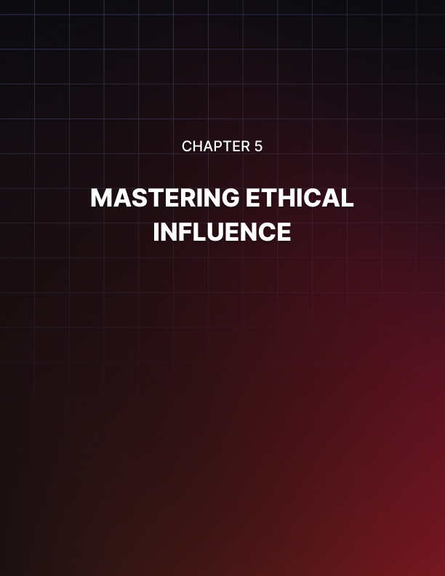

MASTERING ETHICAL INFLUENCE
____
Ethical influence replaces manipulation with integrity, transparency, and mutual respect. It involves guiding decisions and shaping outcomes through trust, open communication, and a clear alignment of values. Rather than exploiting vulnerabilities or applying pressure, ethical influence fosters collaboration, empowers others, and strengthens professional relationships through authenticity and shared purpose.

The Psychology of Ethical Leadership
Ethical influence represents a fundamental shift in how we approach persuasion and leadership in professional settings. While manipulation seeks to override others' autonomy for personal gain, ethical influence focuses on creating positive change through respect, transparency, and mutual benefit. This approach recognizes that lasting success in professional relationships stems not from controlling others, but from empowering them to make informed decisions aligned with shared objectives.
The psychology behind ethical influence differs markedly from manipulation. Rather than exploiting vulnerabilities, it works with natural human drives toward growth, connection, and meaningful contribution. This approach taps into what psychologists call intrinsic motivation—the internal desire to engage in behavior because it aligns with personal values and goals rather than external pressure or rewards. When people feel genuinely respected and valued, they naturally become more open to new ideas and willing to contribute their best efforts.
Observe how this manifests in practice. A manipulative leader facing resistance to change might withhold critical information about potential downsides, create artificial urgency, or use emotional leverage to force compliance. Their focus remains on achieving immediate objectives regardless of the psychological cost to team members.
In contrast, an ethical influencer openly shares both benefits and challenges, provides adequate time for consideration, and respects others' right to voice concerns or propose alternative approaches. This transparency might seem to slow progress initially, but it builds the trust and commitment necessary for sustainable change.
Emotional intelligence plays a pivotal role in ethical influence. This involves not just understanding others' emotions but respecting them as valid responses rather than obstacles to overcome.
When encountering resistance to change, an ethical influencer first seeks to understand the emotional foundations of that resistance, perhaps fear of job security or concern about increased workload. Instead of dismissing or manipulating these emotions, they acknowledge and address them directly through open dialogue and collaborative problem-solving.
The foundation of ethical influence rests on several core principles that distinguish it from manipulative approaches:
- Transparency in Communication and Intent
- Complete sharing of relevant information
- Clear articulation of objectives and reasoning
- Open acknowledgment of potential challenges
- Regular updates and progress sharing
- Mutual Benefit as a Fundamental Objective
- Focus on creating value for all stakeholders
- Recognition of diverse needs and interests
- Commitment to sustainable solutions
- Balance between individual and organizational goals
- Respect for Individual Autonomy
- Support for informed decision-making
- Recognition of personal boundaries
- Acceptance of different viewpoints
- Protection of individual dignity
- Alignment with Shared Values
- Connection to organizational purpose
- Consistency with ethical principles
- Support for long-term sustainability
- Promotion of positive cultural norms

Building Trust Through Authentic Communication
The cornerstone of ethical influence lies in developing authentic communication practices that foster trust and understanding. This requires mastering specific skills and approaches that promote genuine dialogue while maintaining professional boundaries.
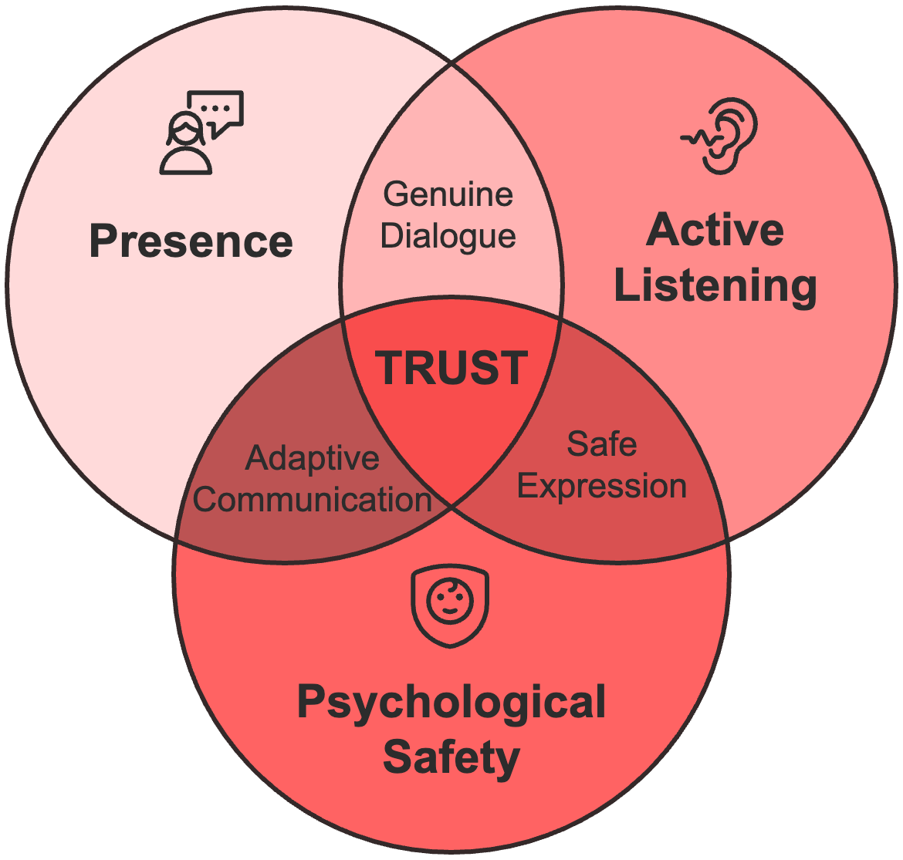
Presence serves as the foundation for authentic communication. It’s the ability to remain fully engaged in interactions while maintaining awareness of both your own and others' responses. This presence allows you to adjust your approach in real time based on genuine feedback rather than predetermined scripts. It involves:
- Maintaining focused attention during interactions
- Monitoring verbal and non-verbal cues
- Adjusting communication style as needed
- Responding authentically to emerging situations
- Creating space for genuine dialogue
Active listening becomes particularly crucial in ethical influence. This goes beyond simply hearing words to understanding underlying meanings, concerns, and aspirations. Effective active listening typically increases trust in professional relationships. Mastering active listening involves developing several key skills:
- Maintaining focused attention without planning responses
- Using reflective statements to confirm understanding
- Asking clarifying questions to deepen comprehension
- Acknowledging emotions without judgment
- Exploring unstated concerns or assumptions
Creating psychological safety represents another vital aspect of authentic communication. This involves developing an environment where people feel safe expressing concerns, sharing ideas, and taking interpersonal risks without fear of negative consequences.

Applying Ethical Influence in Practice
The real power of ethical influence emerges in its practical application across various professional scenarios. This requires adapting general principles to specific contexts while maintaining ethical integrity and professional effectiveness.

Leadership scenarios
Leadership scenarios provide particularly rich opportunities for ethical influence. When guiding teams through change or challenging situations, ethical leaders focus on:
- Vision Creation and Alignment
- Facilitating collaborative goal-setting
- Connecting individual contributions to the larger purpose
- Building shared understanding of objectives
- Creating space for diverse perspectives
- Maintaining focus on mutual benefit
- Capacity Building and Empowerment
- Sharing knowledge and expertise openly
- Creating learning opportunities
- Supporting skill development
- Encouraging autonomous decision-making
- Celebrating growth and achievement
- Performance Management and Development
- Providing constructive feedback
- Addressing challenges collaboratively
- Setting clear expectations
- Supporting professional growth
- Recognizing contributions effectively

Negotiation scenarios
Negotiation scenarios require particularly careful application of ethical influence principles. Instead of focusing solely on winning, ethical negotiators emphasize creating sustainable agreements that benefit all parties. This involves:
- Preparation and Understanding
- Researching all stakeholders' interests
- Identifying potential areas of alignment
- Developing multiple solution options
- Creating objective evaluation criteria
- Planning for long-term relationship maintenance
- Execution and Agreement Building
- Maintaining transparent communication
- Exploring underlying interests
- Building trust through consistency
- Finding creative solutions
- Ensuring sustainable outcomes
The path to mastering ethical influence requires ongoing commitment to personal growth and professional integrity. Success emerges not from perfecting specific techniques but from consistently choosing to influence others in ways that respect their dignity and autonomy while creating genuine value for all involved. While this approach might require more initial investment than manipulative tactics, it builds stronger relationships, creates more sustainable outcomes, and contributes to healthier organizational cultures where everyone can thrive through genuine collaboration and mutual respect.
Remember, every interaction presents an opportunity to demonstrate the power of positive influence in creating lasting professional success. By maintaining your commitment to ethical principles while developing your influence skills, you can build the kind of professional relationships and organizational cultures that support both individual and collective achievement.
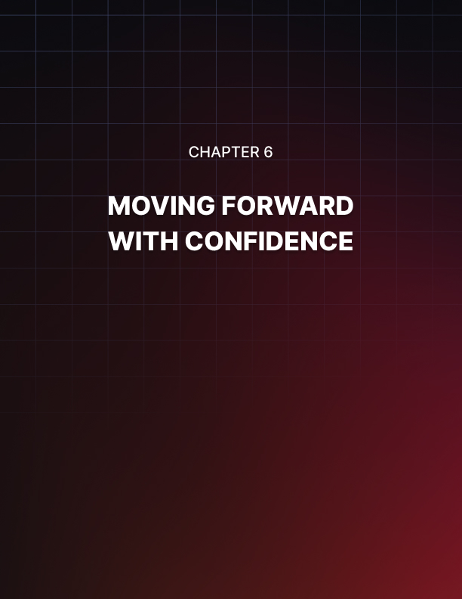

MOVING FORWARD WITH CONFIDENCE
____
The mastery of psychological awareness transforms professional life fundamentally. What once seemed like treacherous terrain filled with potential manipulation becomes navigable with confidence. This evolution represents the sophisticated integration of protection and ethical influence: understanding dark psychology's mechanisms while refusing to employ them exploitatively.
Those who develop this balanced awareness experience workplace interactions differently. The hypervigilance that once drained mental energy gives way to calibrated discernment, allowing for both protection and authentic connection. This final stage reflects psychological maturity at its most practical—recognizing manipulation without becoming cynical, influencing without manipulating, and maintaining integrity while achieving professional objectives.

The Integration of Protection and Influence
Moving beyond basic defensive techniques or influence strategies requires a sophisticated integration of skills that allows you to protect yourself while building meaningful professional relationships. This integration is like a martial artist who masters both defensive and offensive techniques but chooses to use their knowledge primarily for protection and positive influence. Your understanding of dark psychology becomes a shield rather than a weapon, while your influence skills serve to create value rather than exploit others.
The successful integration of protection and influence manifests through several key indicators that demonstrate your growing mastery. Your professional boundaries no longer feel like rigid walls but rather like flexible membranes that allow healthy interaction while maintaining personal integrity.
You've learned to adjust these boundaries contextually without compromising your core values. When working with trusted colleagues, you might maintain closer working relationships while establishing clearer limits with those who've shown manipulative tendencies. Your interactions reflect genuine engagement rather than strategic positioning—you share information openly while maintaining appropriate professional discretion. When concerns arise, you address them directly rather than retreating into protective withdrawal or lashing out with aggressive confrontation.
Your decision-making process has evolved to consider both protective and influential aspects simultaneously. Each choice you make evaluates not just immediate outcomes but long-term implications for relationships and organizational health. This balanced approach helps you maintain integrity while achieving professional objectives.
Perhaps most importantly, your professional network has transformed into a web of mutually beneficial relationships characterized by respect, trust, and clear communication. You've learned to recognize and distance yourself from toxic connections while nurturing positive professional associations that provide both support and opportunities for growth.
Consider how this integration plays out through Sarah's experience as a senior project manager at a technology firm. When faced with a stakeholder known for manipulation, she doesn't retreat into defensive withdrawal or respond with aggressive pushback. Instead, she maintains professional engagement while setting clear boundaries around project scope and timelines.
Her communication remains transparent yet strategic, sharing necessary information while protecting sensitive details. Through this balanced approach, she achieves project objectives while maintaining both personal integrity and professional relationships.
The real power of this integration emerges in daily workplace scenarios where you must navigate complex interpersonal dynamics while driving results. You might encounter a colleague attempting to use time pressure to force hasty decisions, a situation that previously would have triggered either immediate compliance or defensive rejection.
Now, you calmly acknowledge the urgency while maintaining your commitment to proper evaluation procedures. Your response might sound like: "I understand the time sensitivity of this decision. Let's review the critical factors together now and set up a follow-up meeting tomorrow to finalize our approach once I've had time to evaluate the full impact."

Building Your Implementation Strategy
Creating lasting change requires more than theoretical understanding; it demands structured implementation tailored to your specific context and challenges. Your implementation strategy serves as a roadmap for integrating protective awareness with ethical influence in your professional life, ensuring that new skills become natural habits rather than conscious efforts.
Start by conducting a thorough assessment of your current professional environment and personal challenges. Examine factors like typical communication patterns in your industry, organizational culture and expectations, your personal strength areas and growth opportunities, available support resources, and current professional challenges. This assessment helps you identify priority areas for development and potential obstacles to change.
Your implementation strategy should address several key areas:
- Communication Evolution
Focus on developing communication patterns that balance openness with appropriate boundaries. Practice preparing responses for challenging situations before they arise, allowing you to respond thoughtfully rather than reactively.
Document important interactions to track patterns and progress. Regular reflection on your communication effectiveness helps identify areas for continued improvement.
- Relationship Development
Audit your current professional relationships to identify those that support your growth versus those that drain your energy or expose you to manipulation. Establish clear criteria for healthy professional relationships and actively work to develop new connections that meet these standards. Build a network of trusted colleagues who can provide objective feedback and support your continued development.
- Decision-Making Framework
Create a structured approach to decision-making that incorporates both protective awareness and ethical influence considerations. Establish minimum information requirements for different types of decisions and build in appropriate reflection time. Practice using this framework in low-stakes situations so it becomes natural during critical moments.
- Leadership Influence
Develop specific strategies for exercising ethical influence in leadership roles. Focus on building team trust through transparent communication and consistent behavior.
Practice balancing authority with respect for individual autonomy. Document successful influence approaches and adapt them for different situations and personality types.
Implementation success requires systematic effort and regular evaluation. Start with one area of focus, allowing new habits to become natural before expanding your attention to additional aspects. Expect progress to follow a non-linear path, as breakthroughs will alternate with temporary setbacks as you develop these complex professional skills.

Creating Sustainable Change
Transforming theoretical understanding into permanent behavioral change requires building supporting structures that maintain positive development over time. This process involves embedding new practices into your daily routine while creating systems that reinforce desired behaviors and protect against regression.
Start by integrating specific practices into your daily schedule:
- Morning Review (15 minutes)
- Assess upcoming interactions for potential challenges.
- Review boundary maintenance strategies.
- Set specific communication goals for the day.
- Prepare responses for anticipated difficult situations.
- Mid-Day Check-In (5–10 minutes)
- Evaluate emotional state and stress levels.
- Adjust approach based on morning experiences.
- Reset boundaries if needed.
- Document any significant interactions or patterns.
- Evening Reflection (20 minutes)
- Review the day's communication effectiveness.
- Document successful influence approaches.
- Identify areas for improvement.
- Plan adjustments for tomorrow.
These daily practices build awareness muscles while creating habits that support long-term development. Complement them with weekly and monthly reviews that track broader patterns and progress toward larger objectives.
As you implement these practices, pay attention to how your transformed approach influences both immediate professional relationships and broader organizational culture. Your consistent example helps shift workplace norms toward more ethical practices, creating a ripple effect that extends beyond your personal sphere. This impact often manifests through increased trust in professional communications, more authentic dialogue in team settings, reduced tolerance for manipulative behavior, and enhanced psychological safety across your organization.
Mastering these skills represents an ongoing journey rather than a destination. Each new situation presents opportunities for growth and refinement of your approach. Maintain your commitment to continuous learning while celebrating progress along the way. Your enhanced awareness and ethical influence capabilities not only protect you from manipulation but also contribute to creating professional environments where everyone can thrive through authentic, positive interaction.
Your journey toward mastery of these skills contributes to a larger transformation in professional culture, where ethical influence replaces manipulation as the standard for success. Continue building your capabilities while helping others develop similar awareness and skills, creating a lasting legacy of positive change in your professional sphere.

