Disclaimer

This ebook has been written for information purposes only. Every effort has been made to make this ebook as complete and accurate as possible. However, there may be mistakes in typography or content. Also, this e-book provides information only up to the publishing date. Therefore, this ebook should be used as a guide - not as the ultimate source.

The purpose of this ebook is to educate. The author and the publisher do not warrant that the information contained in this e- book is fully complete and shall not be responsible for any errors or omissions. The author and publisher shall have neither liability nor responsibility to any person or entity with respect to any loss or damage caused or alleged to be caused directly or indirectly by this ebook.
Table of Contents

Introduction 6
Chapter 1: Acknowledging Your Cage 8
Unlocking your cage 8
Chapter 2: Rediscovering Who You Are 12
Who are you, really? 12
Take it slowly 13
Re-introducing yourself 13
Chapter 3: Learning To Love Yourself 16
Respecting yourself 16
Self-love is not self-centered 17
Chapter 4: Understanding Your Feelings 20
Awareness of your feelings 20
Your emotions and your relationships with others 21
Chapter 5: Motivation When Stuck In A Rut 23
The fire within you 23
Making motivation a habit 25
Chapter 6: Facing Your Fears 27
Fear is just ‘False Evidence Appearing Real’ 28
Responding to your fears 28
Turning fear into power 29
Chapter 7: Surrounding Yourself With Positivity 31
Take charge of your thoughts 31
Project positivity 32
Positive people 33
Chapter 8: Seeking Out Freedom 35
What comes next after freedom? 35
Living life with a purpose 36
Chapter 9: Making Better Choices 42
Stop overthinking 42
Emotion versus logic 43
What if your decisions cause you to fail? 44
Chapter 10: Living The Life You Want 46
Define your own meaning of success 46
Welcome change with open arms 47
Conclusion 49

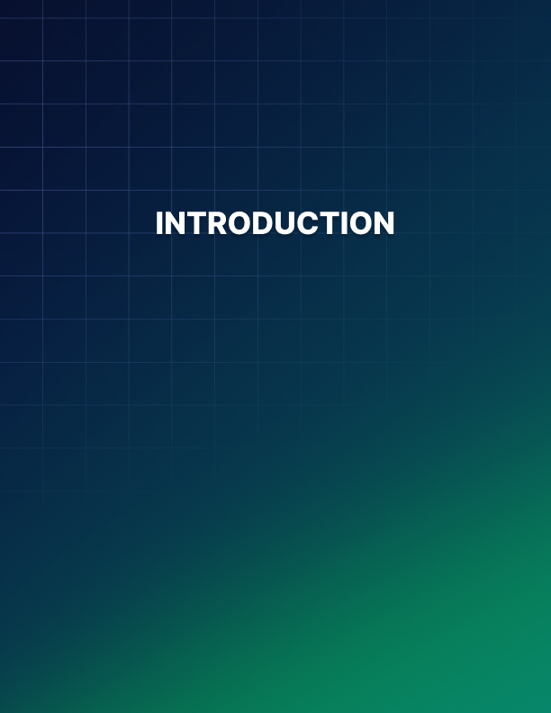

Introduction

It’s normal to get caught up in the frenzy of day-to-day life and forget all the dreams and hopes you once had. You go through the daily motions by rote as though you’re a robot.

You wake up, get dressed, prepare breakfast, send the kids off to school, go to work, come back home, play with the kids for a bit, have dinner, sleep.

Is that your life in a nutshell? Don’t you just get bored with it all?

Was there ever a time when you felt happy and free? Perhaps, when you were younger, when you didn’t have a ton of responsibility on your shoulders?

Wouldn’t you like to go back to that and just be happy again? You know, spend more time with your family and do stuff together?

While it may seem extremely difficult right now or maybe even impossible, depending on where you are at right now, know that freedom is within your reach.

Sure, it may take years and years, but if you plan your ‘escape’
properly, you can certainly make it.

In this guide, I will show you everything you need to know so you can choose your own path, and live a happy and fulfilled life.
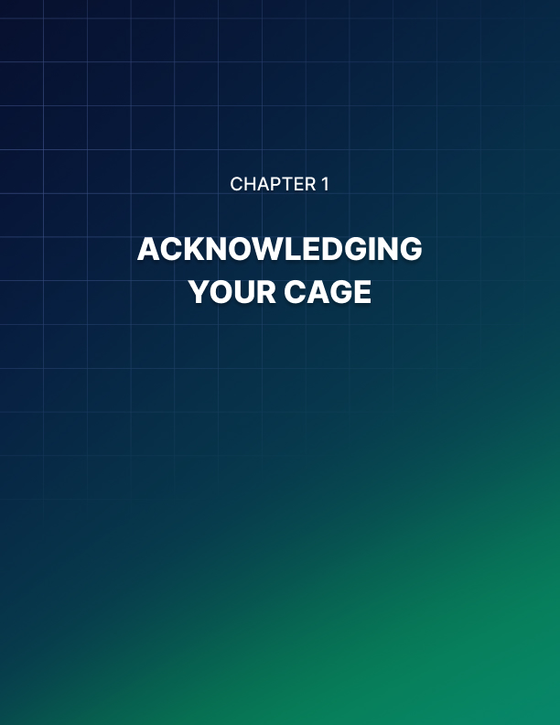

Chapter 1: Acknowledging Your Cage

“The secret to happiness is freedom... And the secret to freedom is courage.”
- Thucydides

Most of you reading this guide are probably living free lives. You’re not trapped in a physical cage or prison cell. But if you feel constricted, if you feel like the walls are closing in around you and you can’t breathe, then you’re most likely trapped in a mental cage or mental prison.

Your mental cage is exactly what the label says - it’s all in your mind. Your mind is trapping your thoughts and your physical body from within. It’s literally poisoning you from the inside out.

The truth is, even if you live in a real cage, you can still be happy and free. How? By breaking away from the stifling confines of your mind, of negativity, of various stressors in your life.

Unlocking your cage
The first thing you need to do to achieve freedom is to unlock your cage. But this is much harder than it sounds.

First of all, do you even know where the key is?

You can try looking for it in your surroundings, in your relationships, in your place of work, everywhere really, but you’re not going to find it there.

Instead, you need to look deep within you. YOU hold the key to your freedom.

You can walk out of your cage anytime you want to, but for some reason, which only you know of, you’re unwilling or unable to. You’re trapping yourself inside.

Is it because you feel safer there? Do you think the big bad wolves or the harsh reality of life is going to come get you the moment you step out of your cage?

Getting out of your self-imposed prison requires courage. Tons of courage. This is because breaking free of a mental cage isn’t exactly as clear-cut as trying to escape from a physical cage, where you can visually identify exit points.

With a physical cage, you can easily spot where the door, window, or any other weak points are, so you can break it down and be on the road to freedom. With a mental cage, on the other hand, you wouldn’t even know where to begin!

What you need to unlock
Getting out of your self-imposed prison is very much possible. Don’t let anyone tell you otherwise. Here’s what you need to free yourself from your cage:

Commitment
If you truly want to get out of your cage, then you need to be committed to getting out. If you don’t commit or stick to your plans, then you’ll just be going back to your cage. You’ll be imprisoning yourself again. And you’ll be back to square one.

You’ve identified your purpose – a life of freedom. You can’t ever achieve it
if you don’t commit and act towards achieving your ultimate goal

It’s so easy to fall back on old habits. One simple mistake can cause all your hard work to come tumbling down, and you’ll be back to where you started. And it’s oh so easy to say “I quit” the moment obstacles start blocking your path.

You must have the courage to keep on renewing your commitment every single day. Nobody said this was going to be easy. You’ve got to figure out what’s going to keep you motivated all throughout your journey.

The thing is you don’t actually need to be alone in your journey. Find someone to help you become accountable. You’ll get to your goals faster if you have someone cheering you on from the sidelines.

Positivity
There’s just too much negativity going on in the world right now. No matter how committed you think you are, if you don’t have an ounce of positivity within you, then you’re most probably going to fail.

You see, you’re fighting yourself. You’re fighting the darkness and the
negativity inside you. How can you do that if you don’t throw some light on?

It’s your positivity that’s going to show you the key to unlock your cage! It’s going to help you figure out what you need to do so you can be free.

Your positivity is going to be your main weapon throughout your journey of self-discovery. The road to happiness and freedom will be full of challenges and obstacles. You need all the positivity you can get to surpass and overcome every little thing that’s going to stand in your way.

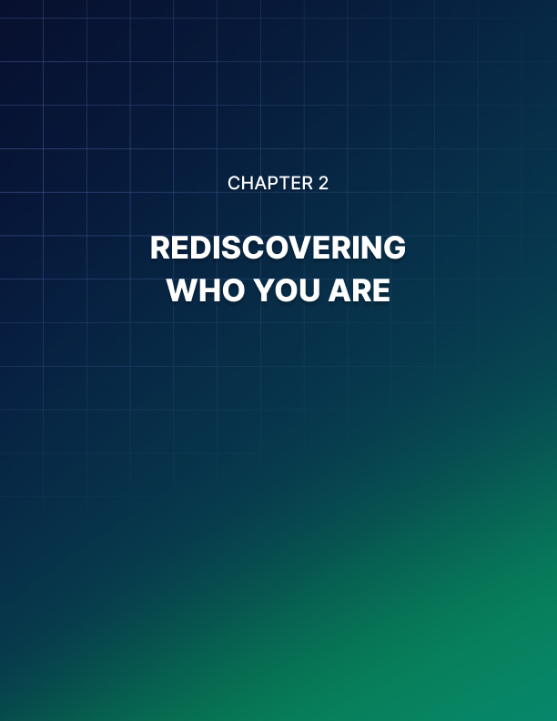

Chapter 2: Rediscovering Who You Are

“Whatever it takes to find the real you,
don't be daunted if the rest of the world looks on in shock.”
- Stephen Richards

When you’ve been trapped in your cage for far too long, you tend to forget who you really are. You’ve become so used to pretending to be someone else that you feel like you don’t know yourself anymore. You’ve buried the real you so long ago, you feel like it’s going to be impossible to revive your old self now.

The good news is that when you finally get to unlock your cage, you can reconnect with the old you - the real you. You never really left, you were just hidden from view underneath all the different hats you had to wear.

Who are you, really?
When you come out of your cage, you’ll realize the world isn’t what it once was. Everything’s changed. Your old friends have probably all moved away and now live very different lives from yours. What you used to find interesting may no longer appeal to you.

Fortunately, there are quite a few ways you can get to know who you really are right at this very moment.

The first thing you need to figure out is who you really want to be and what you really want to do. Sure, you may have other people dependent on you now, like your spouse and your kids, and your world revolves around them. But you don’t have to be just a wife and a mother, or a husband and a father. You can still be your own self!

You still have your own identity. But, the thing is, you’re not the same person anymore.

You’ve grown over the years – you’ve become more mature, you’ve become more experienced, you’ve become more knowledgeable about life.

That’s who you need to discover – the YOU in these present times.

Take it slowly
Over time, you may have forgotten your desires and lost touch with your old self. Rushing your journey may scare you back into your cage. You don’t want that to happen. You want to liberate yourself!

Let the process of rediscovering yourself happen naturally. Explore your wants and your desires, and let the “real” you come out slowly. Take baby steps if necessary, and get reacquainted with who you really are.

Take some ‘me’ time every day. Even just a few minutes a day can do wonders for you.

You can start a journal where you write down every little thing you can think of. Don’t worry if what you’re writing down seems silly. It’s okay, you’re the only one who’s going to read it!

Writing your thoughts down will help you figure out what you really want and who you really are. There’s something cathartic about writing, use it to help you get out of your shell.

You can also relive your favorite memories, your favorite places, your favorite people, the favorite things you used to do way back when.

What was it about those things that made you so happy and free? Is it possible for you to recreate those scenarios?

See if you can do that, and while it won’t be exactly the same as what you remember, it will still bring you plenty of joy. It will inspire you to continue doing more of the same things simply because it makes you happy!

Re-introducing yourself
Rediscovering yourself also means helping other people get to know the ‘new’ you as well. They don’t have to like you right away. In fact, some may even express anger or disappointment. But don’t let their opinions affect you, you’re no longer trapped in a cage where they can easily torment you.

You’re free to go as you wish. If they don’t like the real you, then they’ll have to find a way to deal with it. You’re not anybody’s slave, you’re free to go after your desires and your dreams in life. You’re free, period.

Spend time with people who will support the new and improved you. They’ll help you feel better about yourself. You can count on them when you need someone to remind you of why you needed to get out of your cage in the first place.

Taking the first step out of the cage is always the hardest, but after that, it becomes easier to walk away from the old you.

As time goes by, the memories of your time in your self-imposed prison will become hazy. But don’t you forget it though! Let it serve as a reminder of what will happen if you lose sight of yourself again.

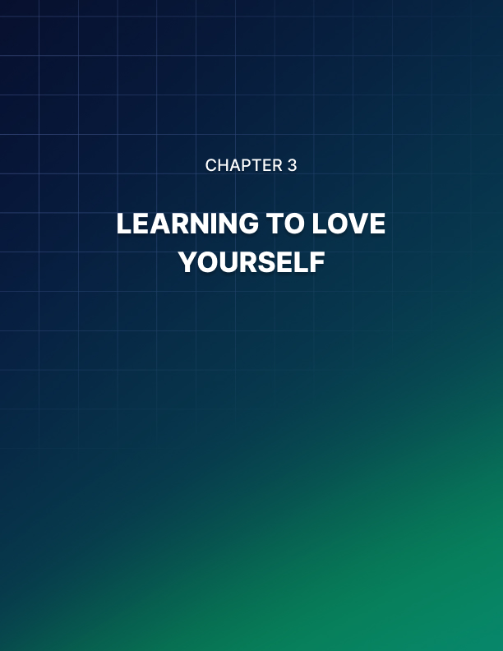

Chapter 3: Learning To Love Yourself

“Love yourself first and everything else falls into line.
You really have to love yourself to get anything done in this world.”
- Lucille Ball

You love your family, your spouse, your children, your friends. But do you love yourself? Do you know what you want for yourself? Do you know who you really are?

If you’ve been hiding the real you for years, then it’s time to come out. There’s no benefit in pretending to be someone you’re not. You’re just pushing yourself deeper and deeper into your self-imposed prison.

When you learn to love yourself, you’ll begin to see some changes you’ve never experienced before. You’ll learn to be freer with your choices. You won’t pay as much attention to what other people are saying. You’ll learn to say what you really want to say.

The new you might come as a surprise to the people around you. But really, as long as you’re happy, then what they say or think about you shouldn’t matter. That’s the power of loving yourself!

You won’t be bound by the old things that used to make you hate yourself. You’ll no longer care if you’re overweight, if you haven’t got perfect skin or pearly white teeth, or your hair naturally looks like a bird’s nest, or something superficial like that. You’ll be able to accept yourself for who you truly are.

When you learn to accept your imperfect self, you’ll open your eyes and see so many opportunities around you. You’ve missed these before because you were too busy pretending to be someone else.

Respecting yourself
With self-love comes self-respect. When you learn to respect yourself, you learn to respect your boundaries. You learn to put yourself on a pedestal whereas before you would have allowed others to walk all over you.

You learn to follow what your heart desires and fulfill your own wishes. You no longer wait for other people to approve your decisions (you may, of course, seek their advice to make sure you’re making the right ones).

You no longer crave the opinion of others. In the past, you may have followed bad advice from people you respected, simply because you respected them more than you respected yourself.

You’ll realize you respect yourself when you finally learn the power of the word “no.” You’ll no longer allow yourself to become everyone’s favorite doormat. You’ll learn to stand up and fight for yourself.

At the same time, you will also learn how to start saying “yes.” “Yes” to things that will bring good tidings to you. “Yes” to opportunities that can help you reach your goals faster. “Yes” to new relationships with people who’ll respect you.

Ultimately, your self-respect will lead you to self-discipline. You learn the importance of building positive habits and letting go of bad ones. You’ll become a better person who has the power to influence others positively.

Self-love is not self-centered
Loving yourself is not the same as being narcissistic or being self- centered. Narcissists don’t love themselves, they love the image they have of themselves. An image where everything revolves around them. They are blind to their faults and their bad qualities.

When you love yourself, you are fully self-aware. You know both your good and bad traits. You embrace your feelings. You take care not to antagonize others and cause problems in relationships. In everything you do, you consider both sides of the coin.

When you’re self-centered, you want everyone to bow down to you. You want people to respect your space and your rights, and not reciprocate the favor. You feel entitled to everything, and when your wishes get denied, you lash out and play the role of a sorry victim.

Self-love teaches you to be more compassionate, not just towards yourself but towards others as well. You become your own best friend, and as your best friend, you learn to accept your own emotions. This, in turn, leads to better awareness towards other people’s emotions as well.

Since you’re more open to everyone around you, you appreciate everyone’s uniqueness. As your self-love grows, so does your love for others. This is when you truly become selfless.

You’ve got so much love within you that it overflows to everyone around you! It’s easy to forgive yourself, and as such, it becomes easier to forgive those who’ve slighted you, too.

Imagine what the world will be like if everyone loves themselves. The song “Love makes the world go round” will finally start making sense to you.

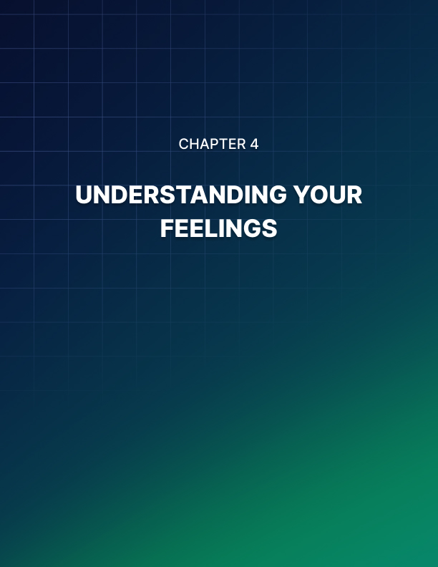

Chapter 4: Understanding Your Feelings

“I pay no attention whatsoever to anybody's praise or blame.
I simply follow my own feelings.”
- Wolfgang Amadeus Mozart

We go through different emotions and feelings every single day. We alternate between feeling happy, sad, angry, frustrated, stressed, anxious, hopeful, hopeless, etc. Sometimes, you may be too busy to pay attention and try to understand why you’re going through such emotions.

It’s important to pay attention to it though. Why? Because your emotions often lead you to the next direction you’re going to take. Your emotions can take you through a figurative roller coaster ride.

If you don’t understand why you’re feeling the way you do, then you’ll find it impossible to know how to contain it.

Awareness of your feelings
Learning how to contain or regulate your feelings is important. If left unchecked, your emotions can cause you to do something you may regret later on, something that will have long-lasting consequences on you and even other people.

Not understanding your feelings, especially negative ones, can lead to destructive behavior which would further drown you in misery.

If you don’t put a stop to it, it’s going to be a vicious, never-ending cycle. It’s very much possible to get trapped in that viciousness and never achieve the freedom you’ve always dreamt of.

Being aware of your emotions will allow you to put a stop to all the negativity that’s happening in your mind. Rationalizing your feelings will help you understand why you’re feeling the way you do. It will allow you to take a step back and analyze the root of your feelings.

For instance, if you’re always feeling stressed and overwhelmed at work or at home, then you may want to take a moment to think things through. You can ask yourself these questions:

Why do you feel the way you do? What can you do to change your situation? If the situation changes, would you feel happy? Would you feel better about yourself? Will the despair finally go away?

Putting a name to these emotions will help you figure out what you really want. You can even take it up to the next level by identifying the degree of a particular emotion.

For example, if you’re feeling stressed today. Are you slightly stressed or
severely stressed? Why? What caused it?

Identifying and understanding your emotions will help you figure out where you want to be and who you want to be. It plays a huge role in your desire to get out of your self-contained mental cage.

If you want freedom badly enough, your emotions will push you to go beyond your boundaries and explore new territories.

Your emotions and your relationships with others
When you’re in touch with your emotions, you tend to become a more productive individual. Instead of repressing your feelings, you’re able to channel it into more productive activities.

You can easily give your 100% to every little thing you do. You can take your performance at work and the different roles you hold in your life to new heights.

Understanding your emotions also helps you build more positive relationships. It helps you be more understanding of the people around you.

Communicating your feelings to others is also healthy in relationships as it helps build intimacy and trust. You become more transparent, and others can easily see you for who you truly are – a happy and free individual!
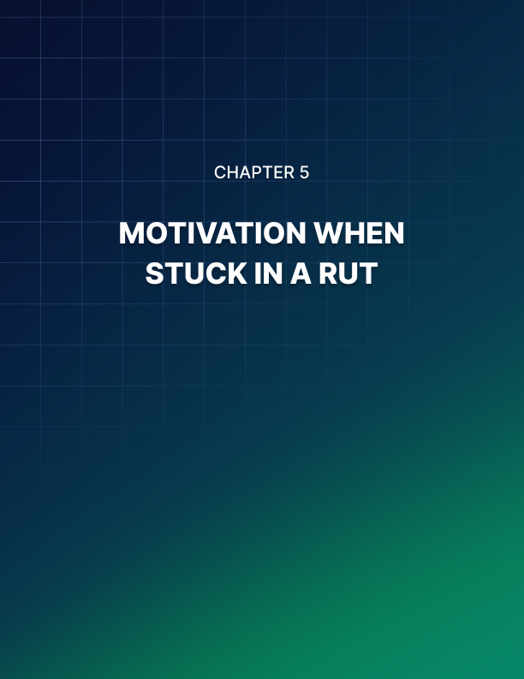

Chapter 5: Motivation When Stuck In A Rut

“People often say that motivation doesn't last.
Well, neither does bathing - that's why we recommend it daily.”
- Zig Ziglar

No matter how badly you want freedom and happiness, there will most probably come a time when you’ll feel demotivated. When you feel so hopeless and all you want to do is just give up.

When everything around you seems dark and bleak, and you can’t see what’s right in front of you, it’s easy to lose sight of your dreams. It’s easy to just go back to your comfort zone, to your old ways, and forget what you’ve set out to do.

But is giving up the right answer? Will it bring you closer to your goals or will it only drown you in despair?

I think you and I both know the answer to the question. Giving up when you’ve come a long way will mean you’ve wasted a considerable amount of time. You would have been better off doing something else instead of chasing the dream you once wanted so badly.

Will you be happy then when you’ve given up? Will you feel like you’ve accomplished something good? No, you won’t. You’ll probably feel bad, you’ll probably feel like you’ve lost someone you loved.

When the fire burning within you has been extinguished, you’re going to
need a lot of internal cleansing to get the fire burning again.

The fire within you
When you’ve reached the very bottom of despair, and you’re lying down by the ashes of your dreams, mourning its loss, you need to look deep within you again for the answers.

What happened? Why did you let it all slip away? Do you not want to be free and happy anymore?

Answering questions like this in the aftermath of your dream’s demise will be tough. Perhaps you’d need some time to process everything. Take some time off, but don’t take too long. Else, you risk totally forgetting what set the fire off in you the first time.

Go back in time and do your best to remember why you wanted freedom so badly in the first place.

Were you tired of being unhappy? Were you tired of always feeling you’re trying to catch up with life but you can’t, no matter how hard you try? Were you sick of having to pretend to live a life many wanted for you, but not you yourself?

Write everything down. Re-trace the path you took before and remember your ‘boiling’ point.

When did it all start to make sense to you? When did you finally put your foot down and said you’ve had enough? What pushed you over the edge?

Look for a quiet spot. Close your eyes and let yourself relive these feelings. Use it to try and rekindle the fire within you.

If the fire’s not catching on, continue digging deeper into your past until you feel a spark coming to life. Then fuel it with more of the same emotions until you get a big fire burning within you.

When you’ve got that fire back, try to see if you can go back to where you left off. If it’s not possible, then you may need to do everything from scratch. But that’s okay.

Use this failure as a learning tool. Take note of everything you’ve learned. The next time you start feeling low and running out of fuel, you can easily remind yourself how you overcame a similar challenge in the past.

Making motivation a habit
What better way to always keep yourself motivated than by making it a habit? That’s right, habits are something you do out of rote. You don’t need to remind yourself to do something when you’ve been doing it out of habit. You’re just going to do it.

So, when you successfully make motivation a habit, you’re essentially hitting two birds with one stone. You’re doing something that will take you closer to your goals, and you’re saving yourself some precious time.

Now, the thing with building habits is that they take time. You can’t expect something to stick overnight. You need to train yourself to do the activity you want so you can turn it into a habit. You can start by doing it right after, or before you do, another well-established habit.

For instance, toothbrushing. If you’ve made brushing your teeth a habit after you wake up and before you go to bed, then you can ‘anchor’ your new (motivation) habit to it.

So, for instance, you know you’re going to brush your teeth in the morning. After you brush your teeth, you can then do the new habit. Do this for a few weeks until you get used to the new routine.

Before you know it, you’ll be doing your new motivation habit every morning without you needing to remind yourself!

When you're motivated every single day, then it will be easier for you to reach your goals. You no longer need to constantly look for new sources of motivation.

Every time you do a new habit, you get motivated. Even if you sometimes feel low during the day, the moment you do the habit, it perks you right back up and helps keep you on track!

Achieving freedom and happiness is so much easier when you’ve got an endless supply of motivation. You can easily overcome your negative thoughts and any other obstacles that may be standing in your way.

Even if you get blindsided, you’ll always find a way to get back up and
continue fighting for your dreams.
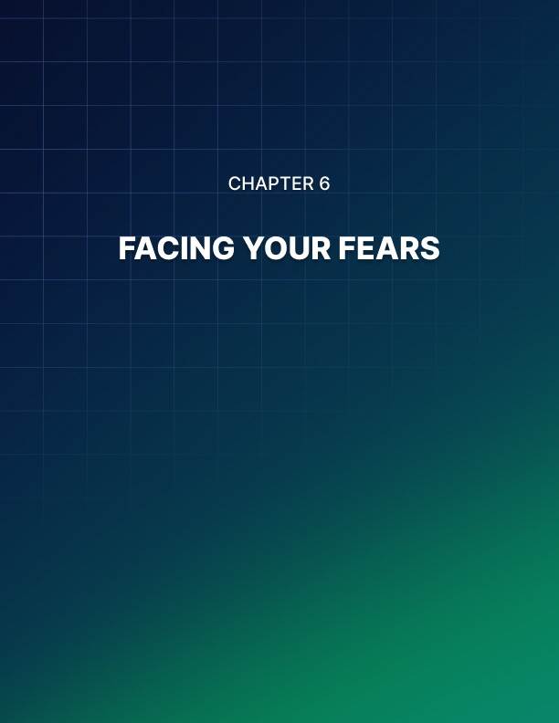

Chapter 6: Facing Your Fears

"Each of us must confront our own fears, must come face to face with them.
How we handle our fears will determine where we go with the rest of our lives.
To experience adventure or to be limited by the fear of it."
- Judy Blume

Fear is but a natural instinct. There’s no getting around it – it’s part of our survival mechanism. We’re hardwired to feel fear.

Without it, we would be putting ourselves in harm’s way all the time. It’s what stops us from doing crazy things that can either put us in a hospital bed or a coffin.

Can you imagine life without fearing anything? You’d be brave, sure, but do you think you can make it through an entire day without getting into an accident? Or rather, will you even live to see the end of the day? Probably not.

Not having an ounce of fear will probably lead you to crossing streets without looking both ways first. Or you’d foolishly experiment putting your hand somewhere it shouldn’t be. Sounds scary, right? The thing is there are an infinite number of ways you can inflict harm on yourself if you’re not afraid of anything.

As you can probably tell by now, experiencing (rational) fear is literally a godsend. It can save you from all sorts of harm and danger.

However, there is such a thing as being too fearful. Sometimes, your fear can literally paralyze you and make you immobile. You end up not doing anything because of your fear.

You don’t achieve any of the goals you’ve set for yourself. You’re not doing
yourself any favors if you let fear take control of your life.

When it comes to aiming for happiness and freedom, you need to learn how to put your irrational fears under control.

Fear is just ‘False Evidence Appearing Real’
Your fears may sound real to you. However, the truth is that it’s not always real. When you fear something, you’re thinking of something that may happen sometime in the future. This means there’s a significant chance that what you’re afraid of is NOT going to happen at all!

Ask yourself, how many of your fears have ever come true? All of them? 50%? 20%? 1%?!

Let’s say only 10% of your fears ever came true. This means that you spent a considerable amount of time worrying over the 90% that failed to materialize!

That’s a lot of time wasted just thinking of possibilities when you could have spent that time doing something productive, like working on things that will lead you closer to your goals!

Responding to your fears
If you’ve made it your life’s goal to achieve ultimate freedom and long- lasting happiness, and your fears are crippling you to inaction, then you need to learn how to respond to those fears.

One way to do this is by facing your fears head-on. Acknowledge what you’re so afraid of and find ways to overcome that fear!

For example, if you’re afraid of public speaking (but you know this skill is important to your success), then you need to figure out how you can speak in public without feeling like a deer in headlights every time you step in front of a crowd!

You can learn various techniques to help you become a more confident speaker. You can hire a trainer or a mentor to show you the ropes. With sufficient practice, you’ll be able to conquer your fear of public speaking in no time at all!

This is just one example. You may have other, equally-daunting fears that are blocking your way to success. Whatever your fears may be, just put it into perspective, and you’ll be able to put it under control.

Turning fear into power
Rationalize your fear and look at it from a neutral point of view. Think of yourself as a scientist looking at your fears under a microscope. Ask yourself some questions like:

- Is there any basis for my fears?
- Is there even a remote chance it will happen?
- What triggered the fear?
- What can I do to make the fear go away?

More often than not, it’s just your mind playing games on you and making you think irrational thoughts. Asking a few questions will help you think clearly. However, on the off chance your fears actually have a 100% probability of becoming a reality, then let your self-preservation instinct take over!

Analyzing your fear and breaking it down will help reduce the power it has over you. Rational thinking will literally show you the light and expose your fears for what it really is – a figment of your overactive imagination!

Once you’re able to overcome your fears, your path to success will become so much clearer.

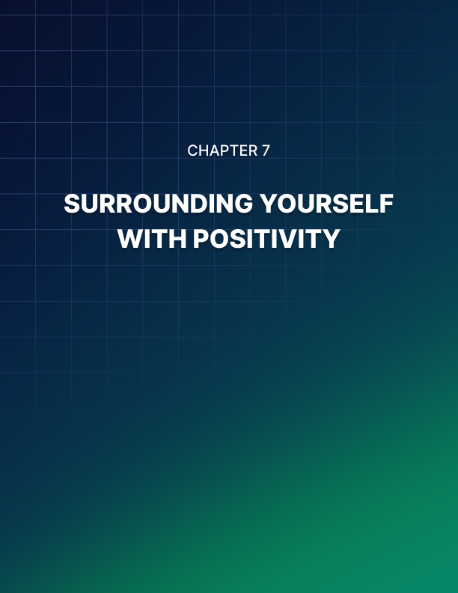

Chapter 7: Surrounding Yourself With Positivity

“Surround yourself with people who are going to lift you higher.”
– Oprah Winfrey

You’re surrounded by negativity. Everywhere you look, no matter which way you turn, you’ll see negative people. You’ll hear negative comments. Even your own mind has its share of negative thoughts.

When you let all the negativity get to you, that’s all you see. It’s like being surrounded by massive, black smoke and you can’t see what’s beyond it. You can’t even see what’s right in front of you!

You drown yourself in pessimistic thinking. You can’t get a handle on your fears – you let it control you instead. Every time your mouth opens, you utter words of doom and gloom. You think nothing good will ever happen to you. And with that kind of mentality? You’re probably right.

If you can’t see the good side of things, even in bad situations, then you’re practically hopeless. You won’t know when opportunity comes knocking on your door, you won’t recognize it even if it hits you in the face!

So, how do you fight such a ubiquitous presence? Here’s how: by
surrounding yourself with positivity, you can keep negativity at arm’s length!

Take charge of your thoughts
Yes, it’s possible to take charge of your thoughts. They’re not involuntary at all unless, of course, you choose to let your thoughts ramble on their own. Which really isn’t that great of an idea especially if most of your thoughts are the negative kind.

To start taking control of your thoughts, you need to be self-aware at all times. When you catch yourself thinking negatively, put a stop to it right away.

Tell yourself, “STOP!” Then do a quick 180. So, instead of going in a
negative direction, your thoughts will be going in a positive direction.

When you start thinking, “I can’t possibly….”, admonish yourself and say something like, “I can and I will… Here's what I’ll do to make sure I get there.”

It’s such a simple thing to do really. The trick is to catch yourself in the act of thinking negative thoughts!

When you do this often enough, you’ll find you’ve turned it into a (positive) habit. When it’s become so ingrained in you, you’ll find yourself thinking positively all the time, and you’ll finally put a stop to your negative thoughts.

Project positivity
Like attracts like. So, if you want more external positive energy coming into your life, you need to think of ways you can start projecting positivity to the outside world.

For starters, you can start using positive words. You can draw up a list of positive words you want to use frequently. Use these positive words and phrases in your conversations with others, and also when you’re conversing with yourself. When you say positive things, even if you don’t believe in them at first, sooner or later, you’ll start believing what you say.

Another thing you can do is to smile more often. When you smile, you appear friendlier to others. When you smile genuinely, you appear happier and more attractive to everyone around you.

Think about it. Who do you gravitate towards? Someone smiling and happy, or someone unsmiling and dour? I bet you’d approach the smiling person first. So, if you want to make new friends, simply learn how to smile more!

You should also start practicing gratitude. Think of things you’re thankful for in your life. Thank your loved ones. Thank people who’ve made a difference in your life – no matter how small it may have been. They’ll appreciate it, and it will help strengthen your bond with other people.

Positive people
Positive people are everywhere, but it’s going to be hard to attract them to your life if you keep up with your negativity. Sure, some kind soul may take pity on you and try to reform you on their own, but sooner or later, your negativity is going to get to them. When that happens, they’ll be bolting for the door. They wouldn’t want your negativity to rub off on them!

So, the first thing you have to do is to make sure you master the art of taking control of your thoughts. Take a deep breath whenever you feel like the negativity is going to burst out of you anytime soon. Erase your thoughts and try to imagine something serene – like a rainforest or the ocean or whatever mental image makes you feel calm.

When you learn to master your emotions, and you start projecting positivity, you’ll find positive people will be making a beeline towards you. Cultivate these new relationships. They’ll support you and cheer you up whenever you feel down.

Now, positive people aren’t perfect either. But they’re not going to hide their dark side. Instead, they look for ways to heal it. They acknowledge their mistakes and their failures, and they try to take something away from the experience.

Learn from positive people and follow their lead. They’ve been in your
shoes, and they certainly know how to keep their negativity in check.

Surrounding yourself with positivity will take time. Keep your self- awareness high at all times. Sooner or later, you’ll find that positivity will have taken hold of your life.

With positivity, you’ll find it much easier to deal with all the obstacles and challenges that’ll come your way as you work towards your ultimate goal – freedom and happiness!

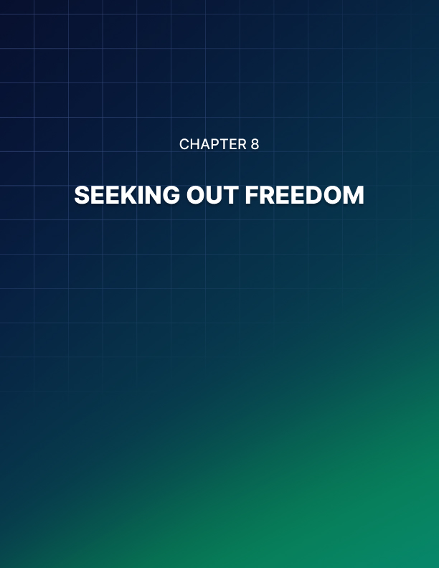

Chapter 8: Seeking Out Freedom

“Instead of trying to make your life perfect,
give yourself the freedom to make it an adventure,
and go ever upward.”
- Drew Houston

Seeking out freedom and wanting to live life on your own terms is a wonderful goal. You will no longer be limited by time or money, and you’ll be free to do as you wish. However, before you even start chasing this dream of yours, ask yourself what’s going to happen after you achieve it.

Will you find freedom fulfilling? Will you finally achieve true happiness?

You may say “yes” without really thinking things through. Who wouldn’t want that kind of freedom, right? When you finally become your own boss and you’re not indebted to anyone or anything, you may be beyond ecstatic. But sometimes, you do have to be careful of what you wish for.

What comes next after freedom?
The truth is that many people fail to understand what freedom will truly mean for them. People who don’t plan everything through are usually the ones who fall victim to this.

If you don’t plan everything through, that is, you only planned how you’re going to achieve freedom BUT NOT how you’re going to spend your time AFTER you’ve achieved that freedom, then you may end up regretting your decision.

Here’s an example:

You’ve been slaving away at your job for years and all you really want to do is work at home. So, you plan out how you’re going to achieve your freedom and finally be your own boss.

A few years later, you’ve saved up enough money and you feel comfortable enough to leave your job. However, in your newly-found freedom working from home, you suddenly realize it’s not all it’s cut out to be.

You realize you didn’t plan well enough on how you’re going to structure your days without somebody telling you what to do.

You didn’t have the right mindset going into this, so you’re probably going to hate it eventually. You’ll spend your days procrastinating and spending all the money you’ve saved.

Sooner or later, the money’s going to run out. And you’ll realize you were better off working for somebody else, so you go back to your old cage called ‘employment.’

So, you see, if you don’t plan how you’re going to live your life after you’ve achieved freedom, then you’re going to fail big-time. You’ll say freedom wasn’t meant for you, which in essence, is true.

Freedom is for people who can handle being free. It’s for people who have the discipline to live their life as planned. It’s not for the lazy and the undisciplined, people who are not willing to put in the work in their free and unencumbered life.

The good news is you really don’t need to go back to your life in the “cage.” You can still turn your life around. Just adjust your mindset and start living your life with a much higher purpose.

Living life with a purpose
When you’ve got too much free time on your hands, and you’re not used to having that much freedom, then you could end up bored or you could go crazy. This is why it’s important that when you plan a life of freedom, you also plan what comes after you finally achieve freedom.

For many, the answer is by living their free life with a fulfilling purpose. It can be anything you want, really. But for most people, their idea of a fulfilling life means the ability to help others. They want to make an impact on other people’s lives.

Living life with such a noble purpose is simply amazing. Imagine yourself devoting your time and your resources to help others, so they too can live a somewhat enjoyable life!

There are many people who live their lives like this. They don’t care about accolades or awards or monetary rewards. These people have so much love in their hearts and their selflessness is truly something to behold.

Freedom gives you the wonderful opportunity to pursue your own future. But it doesn’t have to be all about you. In fact, if you make your freedom all about you, you’ll find freedom will get old pretty fast.

Self-absorbed and self-centered people don’t get a lot of love in real life, and it can get lonely when everyone starts avoiding you because of your arrogance.

So, when you finally achieve the freedom you’re seeking right now, don’t just think about yourself. Think about others, too. The majority of people aren’t going to be as lucky as you.

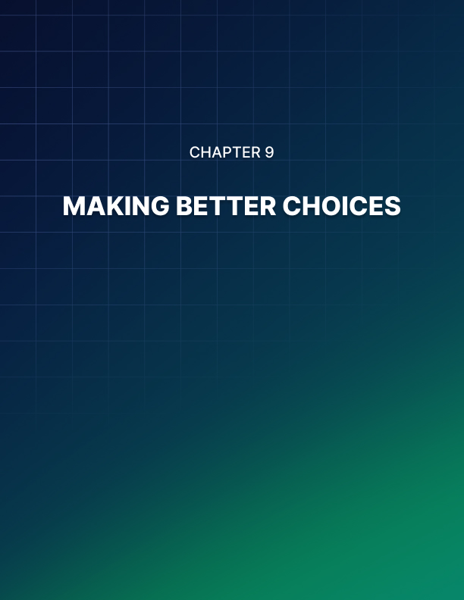

Chapter 9: Making Better Choices

“Life is a matter of choices, and every choice you make makes you.”
- John C. Maxwell

All throughout your life – and all throughout your journey to freedom – you’ll be facing plenty of forks in the road. From making trivial decisions to crucial ones, your choices will make an impact on your life as well as others.

So, you need to learn how to choose wisely. But how exactly do you make sure you’re making the right choices? Choices that will ultimately lead you to your dream of living a happy and free life?

Stop overthinking
Harnessing your mental power for big decisions is a must. However, in many cases, you won’t need to spend too much time thinking about the outcomes of your decisions, especially if you’re dealing with small, non-life- threatening decisions. In times like these, your efforts will be better spent doing something more productive.

Overthinking things is a big drag on your resources. It wastes time, it uses too much brain power, it saps your energy, and it fuels negative thinking.

You spend too much time thinking of the “what-ifs” instead of the “when.” You’ll find yourself thinking of all the negative things that can happen instead of the good ones.

Often, your decision hinges on what other people may think about you. When you inadvertently let other people take control of your choices, then you’re giving them way too much power over you.

If you’re dealing with something in your own life, something that won’t make
any impact on others, then you need to act in your own best interests. You’re not being selfish if you’re not hurting anybody.

You’re probably too afraid someone’s not going to like your choices, so you make your decisions based on what you think will make other people like you or respect you. That, my dear reader, is not the right way to live. You’ll never achieve freedom if you put too much weight on what others think of you.

Ask yourself, “Will I be happy with my decision?”

If your answer is “yes,” then that’s great. However, if you won’t be happy with it, then you better choose something else that will make you happy. You’re not living your life for others, you’re living your life for yourself.

If it makes you happy making others happy, then, by all means, do so. You just need to draw the line where your decisions aren’t going to make you unhappy.

Emotion versus logic
Difficult decisions require a different approach. You’ve got two ways to do it, either decide based on what feels right to you (emotion) or what you know is right (logic). These two approaches to making decisions aren’t mutually exclusive though.

You can decide to do something based on factual information that you’re doing the right thing, but at the same time, you know deep in your heart that it is indeed the right thing. This is the best of both worlds. When your logic and your emotions align, then you can definitely say you made the right call!

Weighing pros and cons is also a good idea especially if you’re making a big decision that will have repercussions on others. You can write your thoughts down on paper so you can easily see which decision will ultimately be right for you.

You can also share your ideas with your family members or whoever may be affected by your decision. Get input from everyone who’s going to be affected. You don’t want to make a decision you’re going to regret later on, so it’s best to have all bases covered.

When it comes to deciding on things that will affect your happiness and freedom in the long run, then it’s best not to make decisions on the spot.

Think things through and weigh your options. What does your head say and what does your heart say?

Try to find the common denominator between your logic and your emotion. Doing so will get you to your end goals faster.

What if your decisions cause you to fail?
Which would you rather choose? Choosing the wrong thing and having the opportunity to fix it, or not choosing at all? I hope you chose the first option. When you choose wrong, at least you now know what’s not working.

If you’re choosing from 5 different options, then you’ve got a 20% chance of getting it right. If you chose wrong the first time, then you’re only looking at 4 more choices which means you’ve got a 25% probability of picking the right answer.

Basically, the point here is that the more you fail, the closer you’ll be to your goals since you’re just eliminating the wrong choices. Every time you fail, you improve the odds of succeeding in your next attempt!

If you choose not to do anything at all, then you’ll never know the truth, you’ll never find out what the right answer is, simply because you did not try at all. So, by not choosing, your chances of choosing the right thing is a big, fat zero.

So, think about that the next time you fail. It really just means you’re getting closer to your goals!

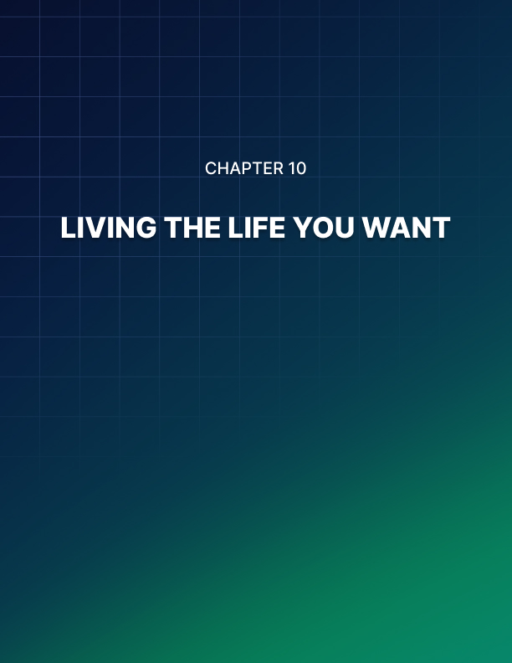

Chapter 10: Living The Life You Want

"The saddest summary of a life contains three descriptions:
could have, might have, and should have."
- Louis E. Boone

When you spend your whole life doing things you ‘should’ be doing, instead of what you ‘want’ to be doing, there’ll come a time when you’ll regret it all. Often, this happens on the deathbed.

When your imminent demise is staring at you in the face, and you’ve nothing to do but wait for your last breath, you look back at your life and think about everything that you’ve missed out.

Is there anything more painful than the realization you’ve wasted your time doing things somebody else wanted for you? And not actually live your life the way you wanted to?

You’ve only got one life. You need to make the most of it. If you’re stuck right now in a life you don’t want to live, then you need to find ways to get out of it.

Figure out what will make you happy and then work on a solid plan that will help you get to where you want to go.

Define your own meaning of success
Success to many people means having a ton of money and living a life of luxury. For others, it means finally buying their own house. For some, success means finally getting their dream jobs.

What’s your meaning of success?

Whatever it is, don’t let other’s definition of success color yours. You don’t have to follow the norm, especially if it means giving up your happiness for something you really don’t want. Again, you’ll end up regretting your decision later. So, it’s best to define what your own version of success looks like.

Spend your time and energy doing things that really matter to you, even if it means risking the disappointment of people you care about. In the end, you’ll be living your life exactly the way you want to.

And the people you care about? If they truly care about you, they’ll come around. They’ll eventually find a way to make peace with your decision, especially when they see you’re happy with your life!

Welcome change with open arms
If there’s one thing in life that’s a given constant, it’s change. Your needs and your wants in life will change. Your definition of success may change over time as well.

For instance, your definition of success in your 20s may be getting hired at your dream job. In your 30s or 40s, your definition of success may be having your own business and being your own boss.

In your 50s or 60s, when the kids have all grown up and flown the coop, then your definition of success may mean living on a boat or traveling the world, and not needing to work for it.

So, you see, you’re not tied to a single definition of success. As long as what you’re aiming for will make you happy, don’t be afraid to follow your dreams!

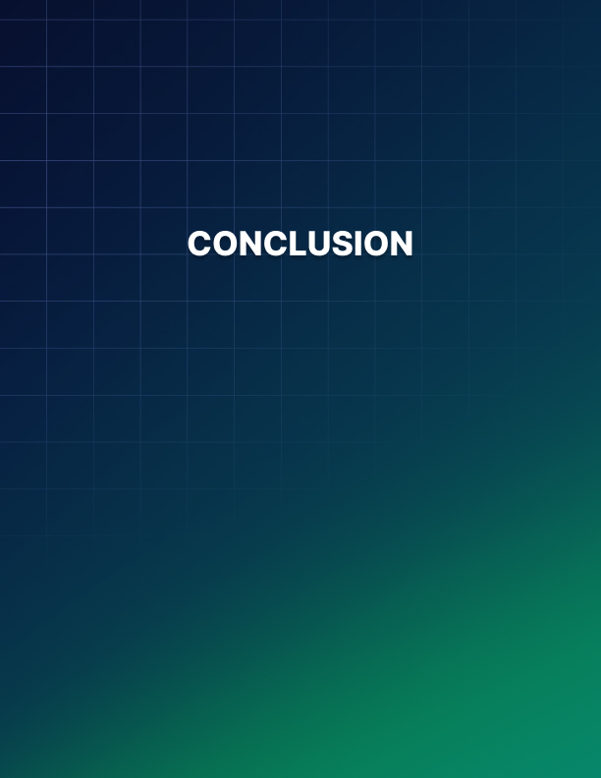

Conclusion

Living life on your own terms may sound impossible when you’ve got so many responsibilities and so many expectations to meet. Don’t bow down to the pressures of the outside world.

It may seem like an uphill battle, but if you build up your courage, you can break down all mental and physical barriers that stand in the way of your happiness and freedom.

