Table of Contents
Introduction 5
The Digital Service Revolution: Foundations and Fundamentals 8
Understanding the Shift 8
Key Trends Shaping Digital Customer Service 8
Integrating Online Communication Channels 9
Addressing Key Challenges 10
Implementing Solution Strategies 11
Mastering Online Communication Channels 15
The Power of Email in Customer Service 15
Leveraging Live Chat for Instant Support 15
Messaging Apps: The New Frontier of Customer Communication 16
Overcoming Common Hurdles in Digital Communication 17
Integrating Channels for a Seamless Experience 18
Social Media Savvy: Engaging and Interacting with Customers 21
Understanding the Social Media Landscape 21
Building a Comprehensive Social Media Customer Service Strategy 21
Mastering Public Complaint Management 22
Real-Time Engagement Best Practices 23
Cultivating a Loyal Online Community 24
Leveraging Technology to Elevate Customer Service 27
The AI Revolution in Customer Service 27
Machine Learning for Personalization 29
Augmented Reality (AR) for Enhanced Customer Support 29
Internet of Things (IoT) for Proactive Support 30
Your Blueprint for Thriving in the Digital Customer Service Era 33
Recapping Key Strategies 33
Unified Communication Platforms 33
AI-Powered Chatbots and Virtual Assistants 34
Social Media Engagement Strategies 34
Embracing Innovation While Maintaining the Human Touch 35
Measuring Success and Continuous Improvement 35
Future-Proofing Your Digital Customer Service 36
Building a Customer-Centric Culture 36
Conclusion 39
Disclaimer
The information provided in this ebook is intended solely for educational and informational purposes. The author does not accept any responsibility for the outcomes that may arise from the application of the material within. While efforts have been made to ensure the accuracy and relevance of the content, the author cannot be held accountable for any errors or omissions, or for any consequences resulting from the use or misuse of the information provided. The responsibility for any actions taken based on the information in this ebook lies solely with the reader.


Introduction
Customer service has undergone a seismic shift. Gone are the days when a friendly phone call was enough to keep clients happy. Today, the battleground for customer loyalty spans tweets, chats, and emails. But don’t worry—you’re holding the key to mastering this new era of online customer support.
In these pages, you'll find the secrets to transforming your business into a customer service powerhouse. This is more than just a guide; it's your playbook for navigating modern customer interactions. Imagine turning every online interaction into an opportunity to win a customer for life, positioning your business as a beacon of exceptional service.
This book is packed with cutting-edge strategies, real-world tactics, and insider knowledge that will elevate your customer service. By the final chapter, you’ll have an arsenal of practical skills to implement right away—from using social media to turn complainers into advocates, to leveraging AI for personalized service at scale, to mastering seamless omnichannel support.
This isn’t theory—it’s about real, actionable strategies. You’ll recognize your daily challenges and discover solutions you didn’t know existed. Each page is designed to inspire innovation and challenge your assumptions.
As you dive in, you’ll find yourself at the forefront of customer service innovation. You’ll learn to anticipate customer needs, create memorable experiences, and lead your team into a new era of customer engagement. This book is for entrepreneurs ready to roll up their sleeves, those who view customer service as a competitive advantage.
Are you ready to challenge everything you thought you knew about customer service? If so, buckle up—you’re about to embark on an exciting journey. By the end, you’ll have the knowledge, skills, and confidence to thrive in the digital age and turn your customer service into a growth engine for your business.
The future of customer service is here, and it's more dynamic than ever. Turn the page and begin your transformation into a customer service superhero. Your customers—and your bottom line—will thank you.



The Digital Service Revolution: Foundations and Fundamentals
Customer service dynamics are undergoing a pivotal shift, with traditional methods of client engagement giving way to innovative digital strategies. This change is a shift in how businesses interact with customers. It aims for faster, more personalized, tech-driven experiences. To stay competitive, we must adopt these new approaches. They are key to maintaining strong customer relationships.
As an entrepreneur, you're at the forefront of this revolution, tasked with navigating a complex web of online communication channels, each with its unique challenges and opportunities. The digital era has ushered in new expectations from consumers who demand instant, personalized, and seamless service across multiple platforms.

Understanding the Shift
The transition from traditional customer service models to digital-focused approaches represents a complete overhaul of how businesses connect with their customers. In the past, service was often limited to face-to-face interactions or phone calls during business hours. Now, companies are expected to be available 24/7 across various digital channels. This shift brings both opportunities and challenges. On one hand, businesses have unprecedented access to their customers, allowing for more frequent and meaningful interactions. On the other, they're faced with the daunting task of managing multiple communication channels simultaneously while maintaining consistency and quality.

Key Trends Shaping Digital Customer Service
To succeed in this new era, it's crucial to be aware of the trends shaping the industry. Omnichannel communication has become a standard expectation, with customers demanding seamless service across all platforms, whether it's email, social media, live chat, or mobile apps. They want to start a conversation on one channel and continue it on another without losing context. Self-service options are also gaining popularity, with many customers preferring to find solutions on their own through robust FAQ sections, knowledge bases, and AI-powered chatbots. Personalization has become a key differentiator, as generic responses no longer suffice. Customers expect interactions that take into account their history with the brand and individual preferences. Real-time responsiveness is another critical factor, with the expectation for immediate responses at an all-time high. Businesses that can provide quick, accurate answers gain a significant advantage. Lastly, data-driven insights have become invaluable, allowing companies to understand their customers better than ever before, anticipate needs, identify trends, and make informed decisions based on real-time data.
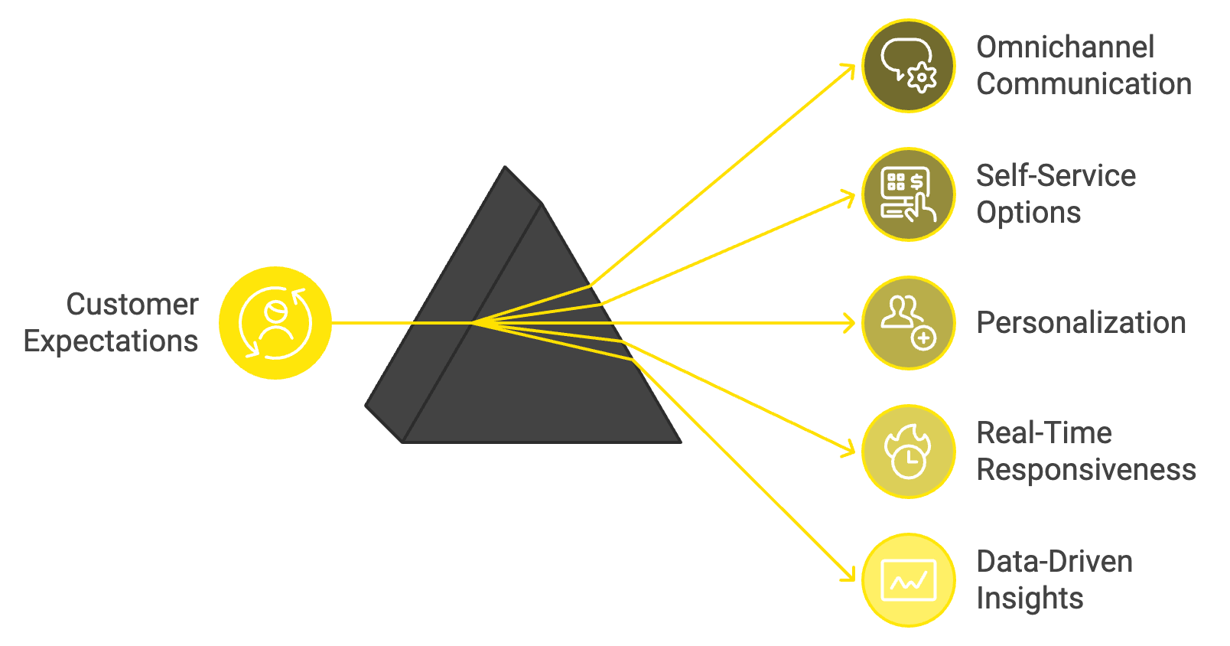

Integrating Online Communication Channels
One of the most crucial aspects of modern customer service is the effective integration of various online communication channels. Creating a unified experience across all touchpoints ensures that brand voice and service quality remain consistent. This integration involves more than just being present on multiple platforms; it requires a strategic approach that aligns communication channels with overall business objectives. To achieve this, businesses should map their customer journey, understanding how customers interact with the brand across different channels and identifying key touchpoints and potential pain points. Creating a unified strategy that outlines how each channel will be used and how they'll work together to provide a seamless experience is essential. Implementing cross-channel communication ensures that information is shared across platforms, allowing customers to switch between channels without losing context. Training customer service representatives with the skills and knowledge to navigate multiple channels effectively is crucial, as is investing in integrated technology solutions that allow for managing all communication channels from a single dashboard.

Addressing Key Challenges
As businesses navigate this new digital service landscape, they encounter several challenges. Inconsistent service delivery across channels is a common issue, where maintaining a consistent level of service quality across various digital platforms can be difficult. To address this, implementing a unified communication platform that centralizes all customer interactions is crucial. This allows teams to access a complete history of customer interactions, regardless of the channel used. Developing standardized response templates and guidelines that can be adapted for each channel while maintaining brand voice is also beneficial.
Managing high volumes of inquiries is another significant challenge. The ease of digital communication often leads to a substantial increase in the number of customer inquiries. To manage this volume without compromising on quality, utilizing AI-powered chatbots for initial interactions and frequently asked questions can help filter and categorize inquiries, allowing human agents to focus on more complex issues. Implementing a robust ticketing system that prioritizes and assigns inquiries based on urgency and complexity is also effective.
Balancing automation and personal touch is a delicate task. While automation can increase efficiency, overreliance on it can lead to impersonal interactions that frustrate customers. Striking a balance by using automation for routine tasks and initial interactions, while ensuring there's an easy path to human assistance when needed, is crucial. Training teams to add personalized elements to automated responses and to recognize when a situation requires a more human touch is essential.
Maintaining customer satisfaction in a fast-paced environment can be challenging, as the speed of digital communication can sometimes lead to rushed or incomplete responses. Investing in a robust Customer Relationship Management (CRM) system that offers a 360-degree view of each customer allows teams to quickly access relevant information and provide more accurate, personalized responses. Implementing quality assurance measures, such as regular review of customer interactions and feedback collection, ensures high standards are maintained.
Keeping up with technological advancements is an ongoing challenge due to the rapid pace of change in the industry. Allocating resources for ongoing training and development of customer service teams, staying informed about industry trends through professional networks, conferences, and publications, and considering partnerships with technology providers who offer regular updates and support for their solutions can help businesses stay current with the latest tools and best practices in digital customer service.

Implementing Solution Strategies
To address these challenges effectively, comprehensive solution strategies must be implemented. Developing a unified communication platform that integrates all communication channels is crucial. This platform should provide a single interface for managing customer interactions across email, chat, social media, and other channels, with features like real-time updates, automated routing of inquiries, integration with existing CRM systems, and robust analytics and reporting capabilities.
Investing in a comprehensive CRM system is essential for providing a 360-degree view of customers. The system should store detailed customer histories, allow for easy access to this information across all service channels, provide insights into customer preferences and behavior, and enable personalized communication based on customer data.
Implementing AI and automation strategically can enhance customer service without losing the human element. AI-powered chatbots for initial customer interactions and FAQs, automated email responses for common inquiries, predictive analytics to anticipate customer needs, and sentiment analysis to gauge customer satisfaction in real-time are all valuable tools.
Developing clear communication protocols is crucial for maintaining consistency across channels. These should include response time standards, tone and language guidelines that reflect brand voice, escalation procedures for complex or sensitive issues, and best practices for personalizing interactions.
Prioritizing continuous training and development for customer service teams is essential. This should focus on technical skills for using new tools and platforms, soft skills like empathy and problem-solving, product knowledge to provide accurate information, and cross-training to handle inquiries across multiple channels.
Implementing quality assurance measures helps maintain high standards of service. This can include monitoring and analyzing customer interactions across all channels, conducting customer satisfaction surveys, implementing systems for continuous feedback and improvement, and regular performance reviews and coaching for team members.
Fostering a culture of adaptability encourages teams to embrace change and continuously improve. This involves encouraging innovation and new ideas from team members, staying informed about industry trends and best practices, being willing to experiment with new technologies and approaches, and regularly reviewing and updating digital service strategies.
These strategies help businesses effectively navigate the challenges of the digital service revolution, ensuring they stay competitive and provide exceptional customer experiences. With the right tools and approaches, companies can enhance customer interactions, streamline processes, and maintain a competitive edge in the evolving marketplace. The key to success in this new era is not just adopting new technologies, but using them strategically to enhance the human elements of customer service. As we move forward in this digital age, it's important to remember that the fundamentals of excellent customer service remain unchanged. Empathy, problem-solving, and a genuine desire to help customers should always be at the core of any approach, regardless of the channel or technology used.

Challenge | Solution Strategy
Inconsistent Service | Unified Communication Platform
High Inquiry Volume | AI-powered Chatbots & Ticketing System
Automation vs. Personal Touch | Strategic AI Implementation & Human Escalation
Customer Satisfaction | Robust CRM & Quality Assurance Measures
Technological Advancements | Continuous Training & Partnerships

The digital service revolution presents both challenges and opportunities. By understanding key trends, integrating communication channels effectively, and implementing robust solution strategies, businesses can turn these challenges into competitive advantages. Staying adaptable, continuous learning, and always putting customers at the center of digital service efforts will not only help businesses survive but thrive in the ever-evolving world of digital customer service.


Mastering Online Communication Channels
The digital age has transformed the way businesses interact with their customers. As an entrepreneur, you're now faced with a myriad of online communication channels, each offering unique opportunities and challenges. Mastering these channels is no longer optional—it's essential for your business's success and growth.

The Power of Email in Customer Service
Email remains a cornerstone of digital communication. Its versatility and ubiquity make it an indispensable tool for customer service. When used effectively, email can foster strong customer relationships and resolve issues efficiently. To harness the full potential of email, you need to focus on several key aspects: response time, personalization, clarity and conciseness, tone and empathy, and call-to-action. Aim to reply within 24 hours, use the customer's name, reference specific details from their inquiry, use clear language, show empathy, and end each email with a clear next step. Implementing these strategies can significantly enhance your email communication. However, managing a high volume of emails can be challenging. Consider using email management tools that can categorize, prioritize, and even suggest responses to common inquiries. This automation can free up your team to focus on more complex issues that require a human touch.

Leveraging Live Chat for Instant Support
Live chat has become increasingly popular due to its immediacy and convenience. It allows customers to get real-time assistance without the need for phone calls or lengthy email exchanges. As an entrepreneur, integrating live chat into your customer service strategy can lead to higher satisfaction rates and increased sales. To make the most of live chat, focus on availability, response speed, proactive engagement, chatbots for initial interaction, seamless handoffs, visual aids, and post-chat surveys. Clearly communicate your chat hours, aim to respond within 30 seconds to a minute, use triggers to initiate chats based on customer behavior, implement AI-driven chatbots, ensure smooth transitions from chatbots to human agents, take advantage of live chat's visual capabilities, and gather feedback immediately after each chat session. While live chat offers numerous benefits, it also presents challenges. Managing multiple conversations simultaneously requires skill and the right tools. Invest in robust live chat software that offers features like canned responses, conversation routing, and analytics. Train your team to handle multiple chats effectively without compromising on quality.
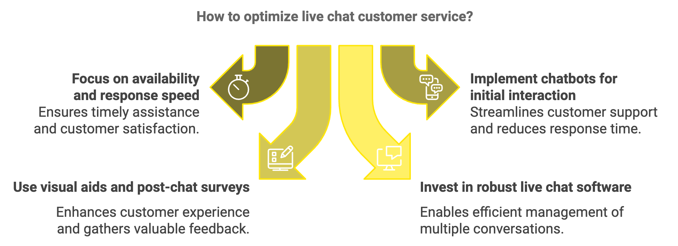

Messaging Apps: The New Frontier of Customer Communication
Messaging apps like WhatsApp, Facebook Messenger, and WeChat have become integral to people's daily lives. As a result, customers increasingly expect businesses to be accessible through these platforms. Integrating messaging apps into your customer service strategy can lead to more personal, convenient interactions. To effectively use messaging apps for customer service, choose the right platforms, set clear expectations, leverage rich media, use group chats wisely, maintain privacy and security, and integrate with CRM. Research which messaging apps your target audience prefers, communicate your availability and response times, take advantage of multimedia capabilities, use group chats judiciously, ensure your team is trained on data protection regulations, and connect your messaging app communications with your CRM system. While messaging apps offer a more casual and immediate form of communication, they also bring challenges. The informal nature of these platforms can sometimes lead to unrealistic expectations of constant availability. Set clear boundaries and use automated responses during off-hours to manage these expectations.

Overcoming Common Hurdles in Digital Communication
As you navigate these various channels, you'll encounter several common challenges. Here are strategies to overcome them:
- Ensuring Timely Responses: Implement a triage system to prioritize urgent inquiries, use automated responses for common questions, and set up alerts for messages that haven't been addressed within a certain timeframe.
- Managing High Volumes of Queries: Utilize AI-powered chatbots for initial screening and simple inquiries, implement a robust ticketing system to organize and track customer issues, and consider outsourcing or hiring additional staff during peak periods.
- Maintaining a Personal Touch: Train your team to use customer data effectively to personalize interactions, encourage employees to add their personality to interactions while staying within brand guidelines, and use video calls for complex issues to add a human element to digital interactions.
To effectively handle negative feedback, respond promptly to negative comments or reviews, take heated discussions to private channels when appropriate, and use negative feedback as an opportunity to showcase your commitment to customer satisfaction. When balancing automation and human interaction, use automation for routine tasks but provide clear paths to human assistance, regularly review and update your automated responses to ensure relevance and effectiveness, and train your team to recognize when to take over from automated systems.

Integrating Channels for a Seamless Experience
While mastering individual channels is crucial, the key to exceptional digital customer service lies in creating a seamless experience across all platforms. This omnichannel approach ensures that customers receive consistent, high-quality service regardless of how they choose to reach out. To achieve this, implement a unified communication platform, ensure data consistency, create channel-specific strategies, enable easy channel switching, provide self-service options, conduct continuous training, and measure cross-channel performance. Invest in a system that centralizes all customer interactions across channels, maintain a single source of truth for customer data, tailor your approach to leverage the strengths of each channel, allow customers to seamlessly move between channels without losing context, develop a comprehensive knowledge base or FAQ section, regularly update your team on best practices, and implement analytics tools that can track customer satisfaction and resolution rates across all channels.
Channel | Key Advantages | Challenges | Best Practices
Email | Detailed communication, Documentation | Response time, Volume management | Personalization, Clear CTAs
Live Chat | Immediate assistance, Multitasking | Managing multiple chats, 24/7 expectations | Quick responses, Proactive engagement
Messaging Apps | Personal, Convenient | Privacy concerns, Informal expectations | Rich media use, Clear boundaries

Using email, live chat, and messaging apps together in a smart way helps you create a top-notch customer service experience that sets your business apart. It makes communication smoother, responses faster, and allows for a more personal connection with your customers. Remember that mastering online communication channels is an ongoing process that requires dedication, flexibility, and a customer-centric approach.
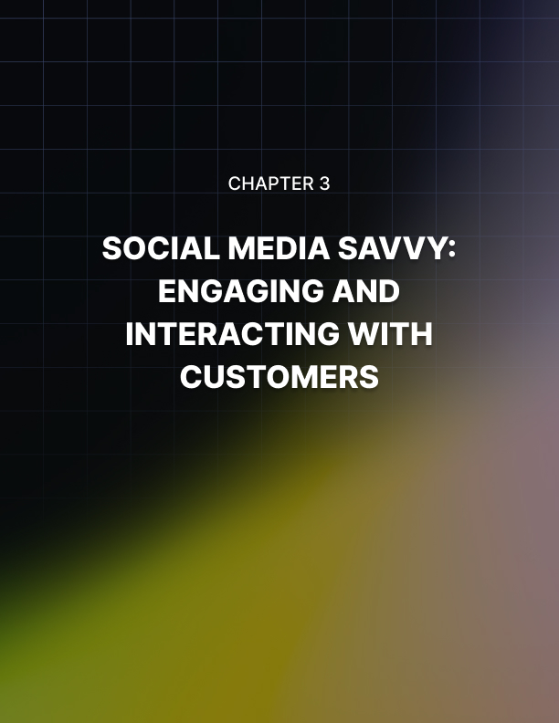

Social Media Savvy: Engaging and Interacting with Customers
Social media platforms have become the modern town squares where customers gather, share experiences, and expect businesses to be actively present and responsive. These spaces are now key to building relationships and managing customer expectations. As an entrepreneur, your ability to navigate these digital spaces can make or break your customer relationships and, ultimately, your brand reputation.

Understanding the Social Media Landscape
Before diving into strategies, it's crucial to understand where your customers are spending their time online. Each social media platform has its unique characteristics, user demographics, and communication styles. Twitter is excellent for quick updates and resolving issues publicly, while Facebook offers versatility with its diverse user base and Messenger feature for private conversations. Instagram is ideal for showcasing products and addressing visual concerns, especially among younger demographics. LinkedIn can be valuable for B2B customer service and building thought leadership, while TikTok offers opportunities for creative, video-based customer service interactions with younger audiences. Understanding these platforms allows you to tailor your approach and allocate resources effectively. However, remember that social media landscapes evolve quickly, so stay informed about emerging platforms and shifts in user behavior to ensure your strategy remains relevant.

Building a Comprehensive Social Media Customer Service Strategy
To effectively use social media for customer service, you need a comprehensive strategy. Start by clearly defining your goals, such as improving response times, increasing customer satisfaction, or reducing the load on other service channels. Choose your platforms based on your target audience and resources, focusing on excelling on a few platforms rather than spreading yourself thin across many. Establish guidelines that outline how your team should interact with customers, including tone of voice, response times, escalation procedures, and how to handle different types of inquiries. Train your customer service representatives in social media etiquette and your company's guidelines, ensuring they can communicate effectively in the concise, often public nature of social platforms. Implement social media monitoring tools to track mentions of your brand, relevant hashtags, and industry trends, allowing you to respond promptly and proactively engage with customers. Create a content calendar that includes proactive content such as FAQs, product updates, and tips that address common customer issues. Finally, ensure your social media customer service is integrated with your other service channels, allowing customers to seamlessly transition from social media to email or phone if needed.

Mastering Public Complaint Management
One of the unique challenges of social media customer service is the public nature of complaints. When a customer voices their dissatisfaction on a public platform, it's visible to potentially thousands of other customers and prospects. However, this challenge also presents an opportunity to showcase your commitment to customer satisfaction. To handle public complaints effectively, respond quickly, aiming to acknowledge issues within an hour. Stay calm and professional, maintaining an empathetic tone regardless of how angry or unreasonable a customer may seem. Take the conversation private when necessary, especially for discussions involving personal information or complex issues, but always ask for the customer's permission to do so. Offer a clear path to resolution, and if you can't solve the problem immediately, explain the next steps and when the customer can expect a resolution. Follow up publicly once the issue is resolved to demonstrate your commitment to seeing issues through to resolution. Use complaints as opportunities to identify areas for improvement in your products, services, or processes, sharing these insights with relevant teams in your organization. Remember, a well-handled complaint can actually improve your brand's reputation more than if the complaint had never occurred.

Real-Time Engagement Best Practices
Social media's real-time nature requires you to be agile and responsive. Be proactive by actively searching for mentions of your brand or product and engaging positively with customers. Use social listening tools to alert you to mentions of your brand, relevant hashtags, or industry keywords, allowing you to jump into conversations quickly. Personalize your responses by avoiding canned replies and taking a moment to tailor your response based on the customer's specific situation. While maintaining professionalism, don't be afraid to show personality by using appropriate humor, emojis, or GIFs when the situation allows. In your interactions, aim to provide value beyond just answering questions by sharing relevant tips, articles, or resources that could be helpful to the customer. Be transparent if you don't have an immediate answer, letting the customer know you're looking into the issue and providing a timeline for when you'll get back to them. Consider using video responses or live streaming for complex issues or to provide broader updates, adding a personal touch and allowing for more detailed explanations.
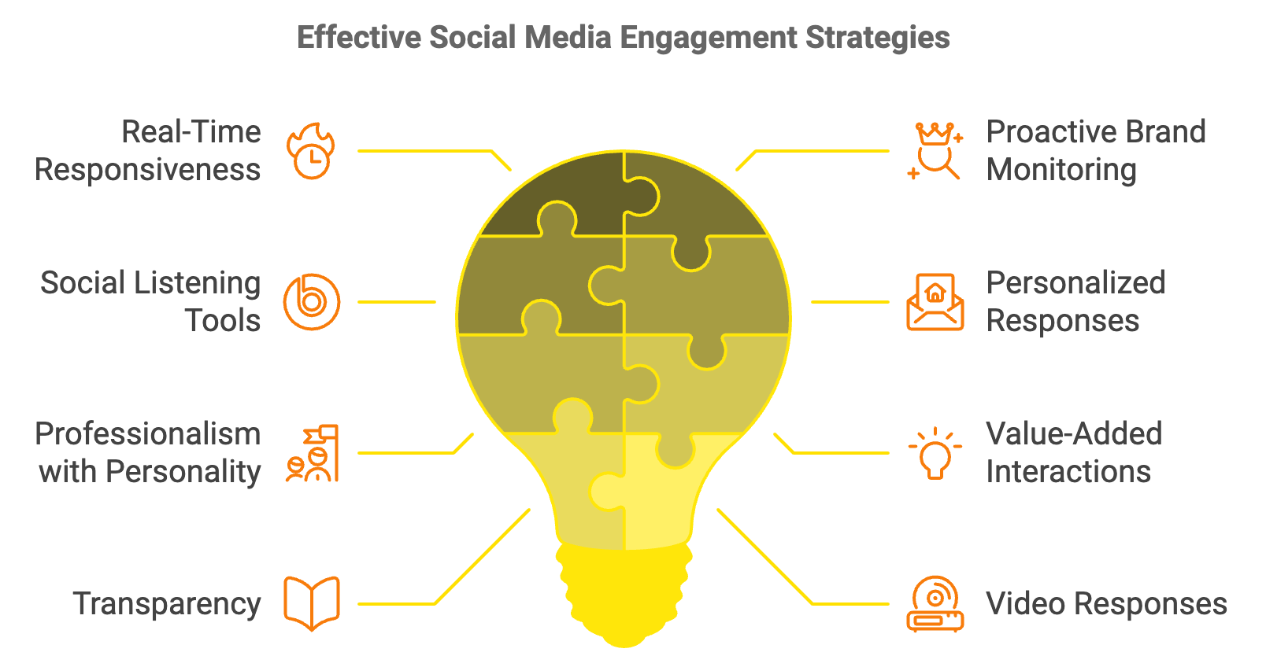

Cultivating a Loyal Online Community
Social media isn't just about addressing problems; it's also an opportunity to build a loyal community around your brand. Share content that your audience finds useful, entertaining, or inspiring, such as how-to guides, behind-the-scenes looks, or user-generated content. Encourage customers to share their experiences with your products or services, providing social proof and making customers feel valued. Host regular Q&A sessions, either through live video or a designated hashtag, to address common questions and foster a sense of community. Recognize and reward loyal customers by highlighting them through featured posts, exclusive offers, or early access to new products. Develop a unique hashtag for your brand and encourage customers to use it when sharing their experiences, creating a centralized place for community interaction. Don't just focus on complaints; acknowledge and thank customers who share positive experiences to encourage more positive engagement. Create spaces where customers can interact with each other, such as Facebook Groups or Twitter chats, fostering a sense of belonging and reducing the burden on your customer service team.
Metric | Description | Importance
Response Time | How quickly you respond to customer inquiries | Critical for customer satisfaction
Resolution Rate | Percentage of issues resolved on social media | Indicates efficiency of social media service
Customer Satisfaction | Overall sentiment of customer interactions | Key indicator of service quality
Engagement Rate | Number of customers interacting with content | Measures community involvement
Issue Categories | Types of problems being raised | Helps identify recurring issues
Channel Shift | Effectiveness of moving complex issues to appropriate channels | Ensures efficient problem-solving

To ensure your social media customer service efforts are effective, measure your performance using these key metrics and continuously improve. Use this data to set benchmarks and goals for your team, regularly reviewing performance and adjusting strategies accordingly. Social media is dynamic, and what works today may need to be tweaked tomorrow. When handling customer service on social media, make sure to stay real and show that you genuinely care about your customers. It goes a long way in building trust and keeping your audience happy. By mastering these platforms, you can turn everyday interactions into opportunities to strengthen your brand, build loyalty, and drive business growth in a constantly changing environment.
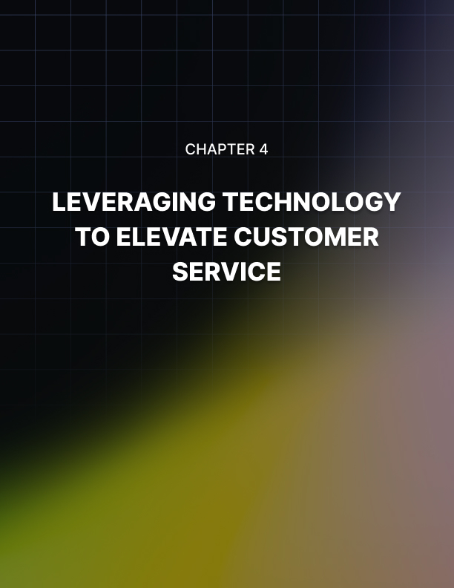

Leveraging Technology to Elevate Customer Service
Technology is now the backbone of great customer service, giving businesses the tools they need to meet customer expectations and improve their overall experience. As an entrepreneur, your ability to harness cutting-edge tools and innovations can set you apart from competitors and create memorable experiences for your customers. This chapter explores how you can leverage technology to transform your customer service operations, enhance customer satisfaction, and drive business growth.

The AI Revolution in Customer Service
Artificial Intelligence (AI) has emerged as a game-changer in the realm of customer service. By implementing AI-driven solutions, you can automate routine tasks, provide personalized experiences, and gain valuable insights into customer behavior. Predictive analytics is one of the most powerful applications of AI in customer service. By analyzing vast amounts of customer data, AI algorithms can identify patterns and trends, allowing you to anticipate customer needs before they even arise. You can use predictive analytics to forecast customer inquiries and allocate resources accordingly, identify potential issues and proactively reach out to customers, personalized product recommendations based on individual preferences, and optimize inventory management to ensure product availability. Implementing predictive analytics requires a robust data collection and management system. Ensure you're capturing relevant customer data across all touchpoints and integrating it into a centralized database. Choose an AI-powered analytics platform that aligns with your business needs and provides actionable insights.
AI-powered chatbots and virtual assistants have revolutionized customer support by providing round-the-clock assistance. These intelligent systems can handle a wide range of customer inquiries, freeing up your human agents to focus on more complex issues. To effectively implement chatbots, start with a clear understanding of your customers' most common questions and requests, design conversational flows that feel natural and helpful, regularly update your chatbot's knowledge base to ensure accuracy, implement seamless handoffs to human agents for complex queries, and continuously analyze chatbot interactions to improve performance. Remember, while chatbots can handle many inquiries, they should complement rather than replace human support. Ensure customers always have an easy option to connect with a human agent when needed.
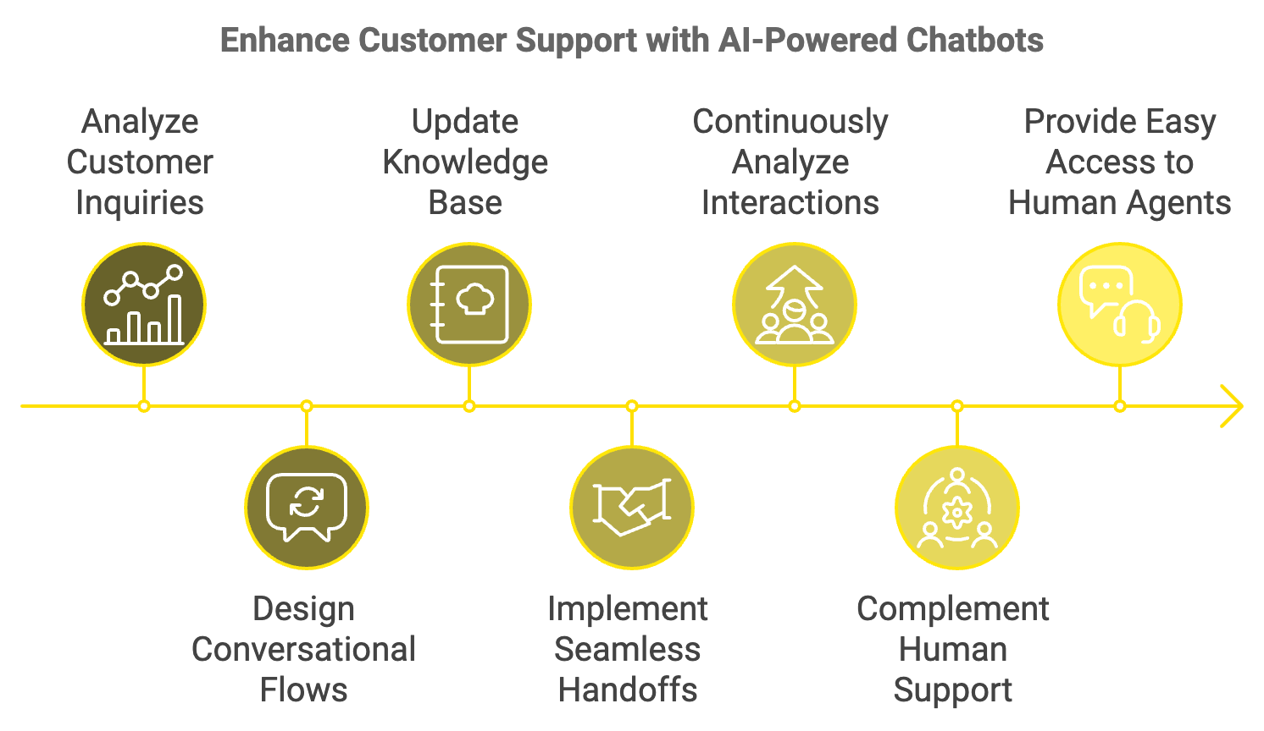
Sentiment analysis tools can help you gauge customer emotions in real-time. By analyzing text from customer interactions across various channels, these tools can identify positive, negative, or neutral sentiments. You can use sentiment analysis to identify frustrated customers who may need immediate attention, measure the overall emotional impact of your customer service interactions, tailor your responses based on detected sentiment, and track changes in customer sentiment over time. Implementing sentiment analysis requires careful consideration of privacy concerns and ethical use of data. Be transparent with your customers about how you're using their data and ensure you're complying with relevant data protection regulations.

Machine Learning for Personalization
Machine learning, a subset of AI, can significantly enhance your ability to personalize customer interactions. By analyzing customer data and behavior patterns, machine learning algorithms can tailor experiences to individual preferences. Implement a machine learning-powered knowledge base that adapts to user behavior. As customers interact with your FAQ section or help center, the system can learn which answers are most helpful and adjust the content accordingly. This dynamic approach ensures that the most relevant information is always easily accessible.
Use machine learning algorithms to analyze customer purchase history, browsing behavior, and preferences to offer tailored product recommendations. This not only enhances the customer experience but can also increase sales and customer loyalty. Leverage machine learning to personalize your communication with customers. This can include tailoring email content based on individual interests and past interactions, adjusting the tone and style of chatbot responses to match customer preferences, and recommending the most effective communication channel for each customer.

Augmented Reality (AR) for Enhanced Customer Support
Augmented Reality is transforming customer support by allowing you to provide visual guidance in real-time. This technology is particularly useful for industries dealing with complex products or services. Use AR to create interactive product demonstrations that customers can access from their smartphones or tablets. This allows them to visualize how a product works or fits into their environment before making a purchase. Implement AR-powered remote assistance tools that allow your support team to see what the customer sees. This can significantly reduce resolution times for technical issues and improve first-call resolution rates. Develop AR apps that guide customers through common troubleshooting steps or assembly processes. This empowers customers to resolve issues independently, reducing the load on your support team.

Internet of Things (IoT) for Proactive Support
The Internet of Things presents exciting opportunities for proactive customer service. By connecting products to the internet, you can monitor performance, predict issues, and provide support before problems arise. For products with IoT capabilities, implement predictive maintenance systems that alert customers or your support team when maintenance is needed. This proactive approach can prevent breakdowns and enhance customer satisfaction. Analyze data from IoT-enabled products to gain insights into how customers are using your products. Use this information to improve product design, create targeted support resources, and identify upsell opportunities. For consumable products, implement IoT-driven automated replenishment systems. These can trigger reorders or alert customers when supplies are running low, ensuring a seamless experience.
As you implement these advanced technologies, it's crucial to prioritize data privacy and security. Customers are increasingly concerned about how their data is collected, stored, and used. Be transparent about your data collection practices. Clearly communicate what data you're collecting, how it's being used, and allow customers to opt-out if they choose. Implement robust consent management systems that comply with regulations like GDPR and CCPA. Invest in state-of-the-art encryption technologies to protect customer data both in transit and at rest. Regularly audit your security measures and consider obtaining certifications like ISO 27001 to demonstrate your commitment to data protection. Ensure your AI systems are designed and trained to avoid bias and make ethical decisions. Regularly review AI outputs for any signs of unintended discrimination or unfair treatment.
Technology | Benefits | Considerations
AI and Machine Learning | Predictive analytics, 24/7 support, personalization | Data privacy, ethical use
Augmented Reality | Visual guidance, remote troubleshooting | Hardware requirements, user adoption
Internet of Things | Proactive maintenance, usage insights | Security, integration complexity

To justify your investment in technology and continuously improve your approach, it's essential to measure the impact of your implementations. Track relevant KPIs such as Customer Satisfaction Score (CSAT), Net Promoter Score (NPS), First Contact Resolution Rate, Average Handle Time, and Customer Effort Score (CES). Calculate the ROI of your technology investments by considering factors such as reduction in support costs, increase in customer retention rates, growth in sales attributed to improved customer service, and reduction in average resolution time. Implement systems to collect and analyze customer feedback specifically related to your technology-driven service initiatives. Use surveys, interviews, and social media monitoring to gather qualitative insights.
Leveraging technology to elevate customer service is no longer optional—it's a necessity for businesses looking to thrive in the digital age. Using AI, machine learning, AR, IoT, and other cutting-edge technologies helps create more efficient, personalized, and proactive customer service experiences. These tools allow businesses to stay ahead and offer smarter, faster solutions to customers. Remember that technology should enhance, not replace, the human touch in customer service. The most successful approaches will find the right balance between technological innovation and genuine human connection. As you implement these technologies, always keep the customer at the center of your strategy. Continuously seek feedback, iterate on your approach, and stay agile in the face of technological change. By doing so, you'll not only meet but exceed customer expectations, driving loyalty and growth for your business in an increasingly competitive landscape.
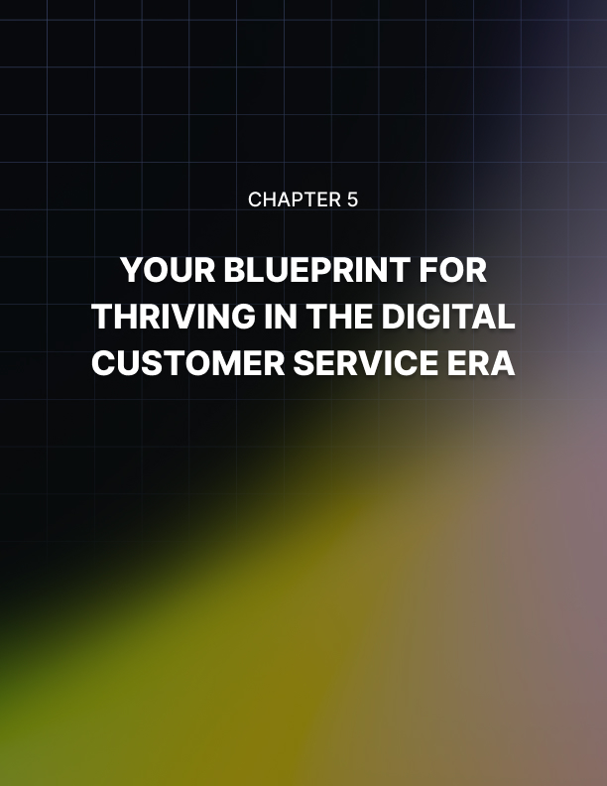

Your Blueprint for Thriving in the Digital Customer Service Era
The digital revolution has fundamentally altered the landscape of customer service, presenting both challenges and opportunities for entrepreneurs. Mastering the art of digital customer service is no longer optional—it's a critical factor in your business's success and longevity.

Recapping Key Strategies
Let's revisit the core strategies we've discussed for leveraging digital communication channels, mastering social media engagement, and harnessing cutting-edge technologies:

Unified Communication Platforms
Implementing a unified communication platform is crucial for maintaining consistency across all customer touchpoints. This approach allows you to manage interactions from various channels through a single interface. By centralizing your communication efforts, you ensure that your team has access to a customer's complete history, regardless of the channel they choose to use. This holistic view enables more personalized and efficient service, as your team can quickly reference past interactions and preferences.
To effectively implement a unified platform, start by auditing your current communication channels and identifying gaps or redundancies. Choose a platform that integrates seamlessly with your existing systems, particularly your CRM. Train your team thoroughly on the new system, emphasizing the importance of documenting all interactions consistently. Regularly review and optimize your processes to ensure you're making the most of the platform's capabilities.

AI-Powered Chatbots and Virtual Assistants
Artificial Intelligence has revolutionized customer service, particularly through the use of chatbots and virtual assistants. These AI-powered tools can handle a significant portion of routine inquiries, freeing up your human agents to focus on more complex issues that require empathy and nuanced understanding. When implementing chatbots, start with a clear understanding of your customers' most common questions and requests. Design your chatbot's conversational flows to feel natural and helpful, mirroring your brand's voice and tone. Regularly update your chatbot's knowledge base to ensure it provides accurate and up-to-date information. Importantly, always provide an easy option for customers to connect with a human agent when needed. Use analytics to continuously refine your chatbot's performance, identifying areas where it excels and where it may need improvement.

Social Media Engagement Strategies
Social media platforms have become critical channels for customer service, requiring a thoughtful and strategic approach. Your social media presence should be more than just responsive—it should be proactive and community-building. Develop a comprehensive social media strategy that outlines how you'll handle different types of interactions, from simple inquiries to complex complaints. Train your team in social media etiquette and crisis management to ensure they can handle public interactions professionally and empathetically. Implement social listening tools to monitor mentions of your brand across platforms, allowing you to engage in conversations even when you're not directly tagged. Create a content calendar that includes proactive posts addressing common customer issues, showcasing your products or services, and highlighting customer success stories. Encourage user-generated content and engage with customers who share their experiences with your brand. Remember, every interaction on social media is an opportunity to showcase your brand's values and commitment to customer satisfaction.

Embracing Innovation While Maintaining the Human Touch
As you implement these strategies and technologies, it's crucial to remember that the goal is to enhance, not replace, human interaction. The most successful digital customer service strategies find the right balance between technological efficiency and genuine human connection. Encourage your team to infuse empathy and personality into their digital interactions. While AI and automation can handle routine tasks, complex issues often require human understanding and problem-solving skills. Train your team to recognize when to step in and provide that personal touch that can turn a challenging situation into a loyalty-building experience. Consider implementing video chat options for complex support issues, allowing for face-to-face interaction that can build trust and rapport. Use personalization technologies to equip your human agents with relevant customer information, enabling them to provide more empathetic and tailored support.

Measuring Success and Continuous Improvement
To ensure your digital customer service efforts are effective, it's essential to establish clear metrics and regularly assess your performance. Some key performance indicators (KPIs) to consider include Customer Satisfaction Score (CSAT), Net Promoter Score (NPS), First Contact Resolution Rate, Average Handle Time, Customer Effort Score (CES), Channel Preference and Effectiveness, Response Time, and Resolution Rate. Regularly analyze these metrics to identify areas for improvement and celebrate successes. Use customer feedback, both solicited and unsolicited, to gain qualitative insights into your service performance. Implement a system for collecting and acting on this feedback, ensuring that customer voices drive your continuous improvement efforts.

Future-Proofing Your Digital Customer Service
As technology continues to advance, new opportunities for enhancing customer service will emerge. Stay informed about emerging technologies such as Advanced AI and Machine Learning, Voice-Activated Assistants, Extended Reality (XR), Blockchain, and 5G and Internet of Things (IoT). While it's important to stay abreast of these technologies, remember that not every new tool will be right for your business. Evaluate new technologies based on how they align with your customer service goals and overall business strategy.
Technology | Potential Impact on Customer Service
Advanced AI | More personalized and predictive support
Voice Assistants | Hands-free customer interactions
Extended Reality | Immersive product demos and support
Blockchain | Enhanced security and transparency
5G and IoT | Real-time support and predictive maintenance

Building a Customer-Centric Culture
Ultimately, succeeding in the digital customer service era is about more than just implementing the right technologies—it's about fostering a customer-centric culture throughout your organization. This mindset should permeate every aspect of your business, from product development to marketing to post-sale support. Encourage cross-departmental collaboration to ensure that customer needs are considered at every stage of the customer journey. Empower your employees to make decisions that prioritize customer satisfaction, even if it sometimes means bending the rules. Celebrate and reward employees who go above and beyond in serving customers. Regularly share customer feedback and success stories across your organization to reinforce the impact of great customer service. Consider implementing a customer advisory board to gather in-depth insights and involve customers in your decision-making processes.


Conclusion
The tools and technologies we've discussed are just the means to improve customer service, not the ultimate goal. The real focus should always be on delivering great experiences for your customers. The ultimate goal is to create meaningful, satisfying experiences for your customers that foster loyalty and drive business growth. Using the strategies outlined in this book—leveraging AI, data analytics, mastering social media engagement, and implementing omnichannel support—sets your business up to succeed in the digital age. But success in this arena requires more than just technological adoption. It demands a commitment to continuous learning, a willingness to adapt, and an unwavering focus on your customers' needs and preferences.
As you move forward, approach each customer interaction as an opportunity to strengthen your brand and build lasting relationships. Be bold in your adoption of new technologies, but never lose sight of the human element that lies at the heart of exceptional customer service.
The digital customer service landscape will continue to evolve, presenting new challenges and opportunities. By staying agile, customer-focused, and committed to excellence, you'll not only navigate these changes successfully but set new standards for customer service in your industry. Remember, customer service is not just a department—it's a key differentiator that can set your business apart in a crowded marketplace. Embrace this opportunity to transform your customer service into a powerful driver of success, loyalty, and growth.

