TABLE OF CONTENTS
____
INTRODUCTION 5
THE FUNDAMENTALS OF DIRECT SELLING 8
The Evolution and Power of Direct Selling 8
Building Your Direct Selling Foundation 10
Mastering Modern Direct Selling Techniques 11
THE PROS AND CONS OF DIRECT SELLING 15
The Hidden Truths of Direct Selling Success 15
The Advantages That Set Direct Selling Apart 16
The Real Challenges and How to Overcome Them 17
EXPLORING PROFITABLE DIRECT SELLING MODELS 22
The Power of Single-Level Marketing 23
Building Wealth Through Multi-Level Marketing 24
Revolutionizing the Party Plan Model 26
FINDING THE RIGHT PRODUCT AND COMPANY 30
Conducting Due Diligence 30
Product Portfolio Analysis 32
Understanding Compensation and Support 34
SUCCESS STRATEGIES FOR DIRECT SELLERS 38
Strategic Customer Acquisition 39
Mastering Digital Presence and Marketing 41
Systems for Sustainable Growth 42
Performance Optimization and Growth 44
IS DIRECT SELLING RIGHT FOR YOU? 50
Essential Traits and Skills Assessment 50
Evaluating Your Resources and Readiness 53
Setting Yourself Up for Success 55
YOUR PATH FORWARD IN DIRECT SELLING 58
The Direct Selling Journey 58
Revisiting the Key Success Strategies 59
Your Direct Selling Future 64

DISCLAIMER
____
The information provided in this ebook is intended solely for educational and informational purposes. The author does not accept any responsibility for the outcomes that may arise from the application of the material within. While efforts have been made to ensure the accuracy and relevance of the content, the author cannot be held accountable for any errors or omissions, or for any consequences resulting from the use or misuse of the information provided. The responsibility for any actions taken based on the information in this ebook lies solely with the reader.


INTRODUCTION
____
The business world offers countless paths to success, and direct selling stands as a unique opportunity that continues to attract millions of entrepreneurs worldwide. As a dynamic and flexible business model, it empowers individuals to build their own enterprises with low initial investment and extensive personal growth opportunities.
You might have heard various stories about direct selling: some highlighting remarkable achievements, others sharing cautionary tales. This book cuts through the noise to present you with a clear, practical understanding of what direct selling truly entails and how you can determine if it's the right path for your entrepreneurial journey.
Direct selling has evolved significantly from its door-to-door sales roots, transforming into a sophisticated business model that leverages personal relationships, social networks, and modern technology. As you consider this business opportunity, you'll discover that direct selling offers distinct advantages: flexible working hours, minimal startup costs, and the potential to build a sustainable income stream. However, like any business venture, it requires dedication, strategic thinking, and a solid understanding of both products and people.
Whether you're looking to supplement your current income or build a full-time business, direct selling presents a unique proposition. With its blend of flexibility, personal connections, and entrepreneurial potential, it has become an appealing choice for many aspiring business owners.
This book strips away the hype and misconceptions surrounding direct selling, replacing them with practical insights and actionable strategies. You'll learn how successful direct sellers combine time-tested principles with modern approaches to create thriving businesses. You'll also understand how to evaluate different companies, choose the right products, build a customer base, and develop the essential skills needed for long-term success.
Direct selling encompasses various models, each with its own set of opportunities and challenges. From single-level marketing to multi-level structures, from party plans to one-on-one consultations, you'll explore the nuances of each approach. More importantly, you'll gain the knowledge needed to assess which model aligns best with your goals, skills, and lifestyle. This book serves as your practical guide, helping you navigate the complexities of direct selling while avoiding common pitfalls that often derail newcomers to the industry.
As you progress through these pages, you'll find real-world examples, proven strategies, and essential tools that successful direct sellers use to build their businesses. Whether you're completely new to direct selling or looking to enhance your existing business, this book provides the foundational knowledge and advanced techniques you need to make informed decisions and achieve your business goals.


THE FUNDAMENTALS OF DIRECT SELLING
____
According to the World Federation of Direct Selling Associations, direct selling has contributed $180.5 billion to a thriving global industry that transforms ordinary people into successful entrepreneurs. When you step into direct selling, you're joining a movement that has revolutionized how products reach consumers and how individuals build sustainable businesses from the ground up.

The Evolution and Power of Direct Selling
At its core, direct selling means marketing products directly to consumers outside traditional retail locations. You become the bridge between exceptional products and the people who need them, creating value through personal relationships and customized service. While the roots of direct selling stretch back to traveling merchants of old, today's direct sellers harness sophisticated tools and techniques to build thriving businesses that can operate from anywhere.
There’s Sarah, who transformed her life through direct selling. She starts each day reviewing customer orders and engaging with her community on social media. By afternoon, she's hosting virtual product demonstrations and mentoring her growing team.
In the evening, she might lead an in-person event or connect with customers through video calls. Sarah's story illustrates how modern direct selling combines traditional relationship-building with contemporary business practices.
When you compare direct selling to other business models, its unique advantages become clear:
Business Aspect | Direct Selling | Traditional Retail | E-commerce
Initial investment | Low ($100–1000) | High ($50,000+) | Medium ($5000–20,000)
Overhead costs | Minimal | High | Medium
Customer interaction | Personal, direct | Impersonal, in-store | Virtual
Inventory requirements | Optional | Substantial | Variable
Location dependency | None | Critical | None
Scalability | High | Medium | High
Training support | Company-provided | Self-directed | Self-directed
Profit margins | 20–50% | 30–45% | 15–45%

Building Your Direct Selling Foundation
The path to success in direct selling begins with understanding the ecosystem that supports your business. As you build your enterprise, you'll interact with several key players who contribute to your growth and success.
The parent company provides products, training, and support systems. Your network of fellow distributors offers mentorship and collaboration opportunities. Customers become the lifeblood of your business, and industry associations ensure ethical practices and regulatory compliance.
Your journey starts with selecting the right products and company to represent. You'll want to consider factors like product quality, market demand, company reputation, and compensation structure.
The best direct selling opportunities align with your passions and values while offering genuine value to customers. For example, if you're passionate about health and wellness, you might partner with a company that offers nutritional supplements or fitness products.
As you develop your business, you'll learn to leverage various revenue streams. Most direct sellers earn through a combination of personal sales commissions, team-building bonuses, and leadership incentives. Understanding these compensation structures helps you create effective business strategies. For instance, if your company offers a 30% commission on personal sales and additional bonuses for team development, you might focus initially on building a strong customer base before expanding into team leadership.

Mastering Modern Direct Selling Techniques
Technology has transformed how you can build and manage your direct selling business. Social media platforms become powerful tools for sharing product demonstrations, connecting with potential customers, and building your brand. Mobile apps help you track orders, manage inventory, and stay connected with your team. Customer relationship management (CRM) systems enable you to provide personalized service and maintain strong relationships with your growing customer base.
The most successful direct sellers combine traditional and modern approaches. You might host a virtual party where customers can sample products through augmented reality demonstrations, followed by personal consultations to address specific needs. Or you could use social media to showcase product benefits while maintaining the personal touch aspect through individual follow-up messages and video calls.
Creating exceptional customer experiences becomes your competitive advantage. When you understand your customers' needs and preferences, you can offer tailored solutions that build loyalty and generate referrals. This might involve creating personalized product bundles, offering convenient reordering options, or providing ongoing support and education about product benefits.
Direct selling also emphasizes continuous learning and professional development. You'll have access to training resources that help you master product knowledge, sales techniques, and leadership skills. Many companies provide regular workshops, online courses, and mentoring programs to support your growth. As you progress, you might even become a mentor yourself, helping others achieve their business goals.
The realm of direct selling continues to evolve with changing consumer preferences and technological advances. Sustainability and social responsibility have become increasingly important, with many companies developing eco-friendly products and ethical business practices. You'll find opportunities to align your business with these values while meeting growing consumer demand for responsible commerce.
Success in direct selling requires dedication, persistence, and a commitment to personal growth. You'll need to develop strong organizational skills, effective time management, and the ability to build and maintain relationships. However, the rewards extend beyond financial gains to include personal development, flexible lifestyle, and the satisfaction of helping others achieve their goals.
Through direct selling, you become part of a dynamic industry that combines entrepreneurial opportunity with personal relationship building. As you move forward in your journey, remember that your success depends on providing value to customers, building strong relationships, and continuously adapting to meet changing market needs. The principles and strategies you'll learn in this book will help you establish and grow a thriving direct selling business in today's evolving marketplace.


THE PROS AND CONS OF DIRECT SELLING
____
Picture two entrepreneurs, both launching their direct selling ventures on the same Monday morning in January. Fast forward twelve months. The first entrepreneur manages a flourishing business generating $5,000 monthly, while the second one’s ambitious dreams have crumbled into disappointment.
Their contrasting journeys highlight a crucial truth about direct selling: success demands more than just enthusiasm and good intentions. It requires understanding both the golden opportunities and the challenging realities of this business model.

The Hidden Truths of Direct Selling Success
When Jennifer first considered direct selling, visions of quick profits and endless possibilities filled her mind. But reality delivered a different lesson.
"I thought it would be simple. Show products, make sales, earn money. But I quickly discovered that building a sustainable business required strategic thinking, unwavering persistence, and the ability to navigate through uncertain times. The flexible schedule that lets me be there for my children and the unlimited earning potential made every challenge worthwhile," she shares.
The path to direct selling success winds through both sunlit meadows and challenging valleys. You'll discover opportunities that traditional business models can't match, but you'll also face unique obstacles that require specific skills and mindsets to overcome. Understanding this dual nature helps you prepare for the journey ahead and increases your chances of joining the ranks of successful direct sellers who build thriving, sustainable businesses.

The Advantages That Set Direct Selling Apart
Direct selling offers unique benefits that make it an attractive business model for aspiring entrepreneurs. Unlike traditional business ventures that demand substantial capital and fixed locations, direct selling provides a more accessible path to business ownership. The financial barriers to entry are remarkably low, typically ranging from $100 to $1,000, compared to the tens or hundreds of thousands required for franchises or retail stores.
But the advantages extend far beyond the initial investment. Modern direct selling companies provide comprehensive support systems that would cost thousands to develop independently. You receive professional training programs, marketing materials, customer service support, and sophisticated technology platforms—all included in your starter kit or available at minimal cost. This infrastructure allows you to focus on building relationships and growing your business rather than getting bogged down in operational details.
The flexibility of direct selling creates unprecedented opportunities for work-life integration. You can design your schedule around personal commitments, choose your working environment, and scale your business operations based on your goals and life circumstances. This adaptability proves particularly valuable for parents, caregivers, or individuals seeking supplemental income alongside other commitments.
David approached his business by maintaining his full-time job while building my direct selling business during evening hours and weekends. This strategy allowed him to reinvest early profits and create a stable foundation.
After eighteen months, his direct selling income exceeded his corporate salary, giving him the confidence to transition to full-time entrepreneurship. The key to his success was treating it like a serious business from day one, even when he could only dedicate part-time hours.

The Real Challenges and How to Overcome Them
While the benefits of direct selling are compelling, ignoring the challenges would do you a disservice. Success requires navigating several key obstacles that cause many aspiring entrepreneurs to struggle or give up. Understanding these challenges helps you prepare effective strategies to overcome them.
Income variability stands as one of the most significant challenges. Unlike traditional employment with predictable paychecks, your direct selling income may fluctuate considerably, especially in the early months. Some weeks might bring exceptional sales, while others test your persistence with minimal results. Successful direct sellers address this challenge by maintaining emergency savings, diversifying their income streams within their business, and creating systems for consistent customer follow-up and acquisition.
Market saturation and competition present another significant hurdle. In popular direct selling companies, you might find yourself competing with other representatives in your area. However, successful entrepreneurs turn this challenge into an opportunity by developing unique value propositions and building genuine relationships that transcend traditional selling approaches. They focus on solving specific problems for defined customer segments rather than trying to appeal to everyone.
The freedom to set your own schedule can become a double-edged sword without proper boundaries and time management skills. You might find yourself working longer hours than intended or struggling to maintain consistent productivity without external structure. Successful direct sellers address this by creating detailed weekly schedules, establishing clear business hours, and using time-blocking techniques to maintain focus and efficiency.
Personal development requirements often surprise new direct sellers. Beyond product knowledge and sales techniques, success demands continuous growth in areas like leadership, public speaking, digital marketing, and emotional resilience. Top performers invest time and resources in developing these skills through company training programs, external courses, and regular practice.
Remember the two entrepreneurs in the introduction? The first entrepreneur’s success stemmed from understanding and preparing for these challenges before they arose. She created detailed business plans, set realistic goals with specific timelines, and built strong support systems through mentorship and peer relationships. The second one’s struggle, in contrast, resulted from underestimating the commitment required and failing to develop strategies for overcoming common obstacles.
As you consider your future in direct selling, use this knowledge to create a strong foundation for success. Develop clear plans for managing income variability, standing out in your market, maintaining work-life boundaries, and continuously improving your skills. Remember that successful direct sellers aren't just product representatives. They're entrepreneurs building sustainable businesses through strategic planning, consistent effort, and unwavering commitment to personal growth.
Your direct selling journey can transform your financial future and lifestyle, but it requires clear understanding, careful planning, and persistent effort. Use these insights to evaluate your readiness and create a strong foundation for your business venture.
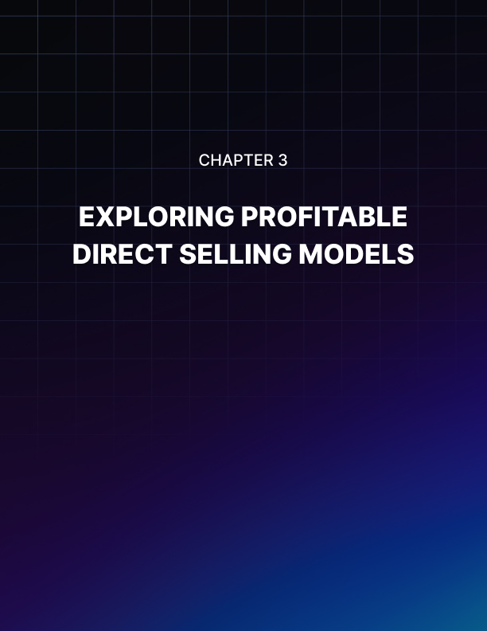

EXPLORING PROFITABLE DIRECT SELLING MODELS
____
Direct selling offers a variety of business models, each with its own advantages and opportunities for growth. Some entrepreneurs build thriving businesses by selling handcrafted products, while others leverage innovative marketing strategies to reach a wider audience.
From wellness and beauty to technology and home essentials, successful direct sellers find ways to connect with customers and create value. Understanding these different approaches is essential for choosing the model that best aligns with your goals, skills, and market demand.
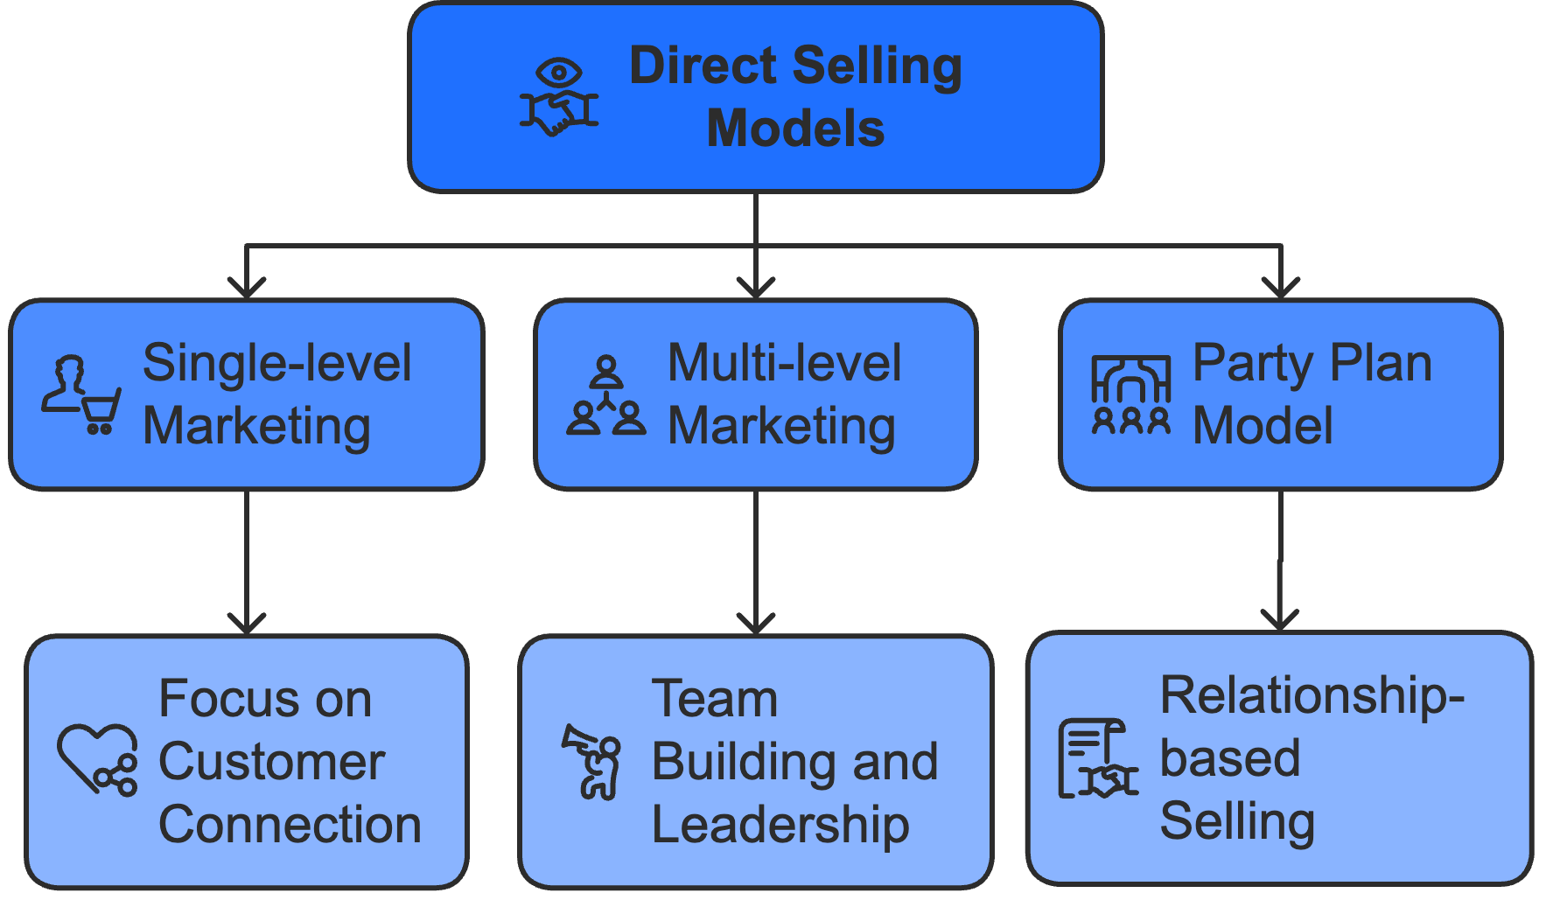

The Power of Single-Level Marketing
Single-level marketing (SLM) represents direct selling in its purest form: you focus entirely on connecting valuable products with customers who need them. Karen discovered this power when she launched her artisanal kitchenware business.
"I wanted genuine connections with customers, not the complexity of managing teams," she explains. "SLM let me pour all my energy into what I love most: helping people transform their cooking experience with exceptional tools."
In the SLM model, your success flows directly from personal sales efforts. Most companies offer commission rates between 20% and 40%, creating a straightforward path to profitability.
David, who left a corporate sales career to sell high-end home automation systems, finds this simplicity refreshing: "Every morning, I know exactly what drives my income: connecting great products with people who value them. No complicated bonus structures or team dynamics to navigate."
The beauty of SLM lies in its accessibility and control. You maintain direct relationships with every customer, allowing you to provide exceptional service that builds long-term loyalty. Your income grows in perfect correlation with your effort and skill at solving customer problems. This direct connection between work and rewards attracts entrepreneurs who value independence and straightforward business operations.
However, SLM's limitations deserve careful consideration. Your earning potential directly correlates with available selling time, creating natural constraints on growth. Without team leverage, you personally handle every aspect of the business, from prospecting to after-sales service. Successful SLM entrepreneurs overcome these challenges through sophisticated systems and strategic use of technology.
Rachel, who generates a consistent six-figure annual income through SLM, shares her approach: "I use automation tools for routine customer communication, inventory management, and order processing. This frees up my time for high-value activities like personal consultations and product demonstrations. I've also developed strategic partnerships with complementary businesses, creating referral networks that generate steady leads."

Building Wealth Through Multi-Level Marketing
Multi-level marketing (MLM) introduces a powerful dimension to direct selling: the ability to build and lead teams while earning from both personal sales and organizational growth. Maria's journey from solo seller to leader of a thousand-person organization illustrates MLM's potential: "Success in MLM requires thinking like a business architect. You're not just selling products; you're creating a self-sustaining ecosystem where everyone has the opportunity to grow."
The MLM compensation structure typically includes multiple revenue streams:
- Personal sales commissions (20–35% of retail sales)
- Team override commissions (3–10% of team sales)
- Leadership bonuses based on organizational performance
- Special incentives and recognition programs
However, building a sustainable MLM organization demands more than understanding compensation plans. Michelle, whose team generates over $5 million in annual sales, emphasizes the importance of leadership development:
"Our focus isn't on recruiting numbers but on creating successful entrepreneurs. We've built comprehensive training systems that combine online learning, personal mentoring, and hands-on experience. Every team member has access to the tools and support they need to achieve their goals."
The most successful MLM leaders recognize that team retention often proves more challenging than recruitment. They address this through sophisticated support systems:
"We created a mentorship program that pairs new team members with experienced leaders," explains Randi, who maintains a 70% annual retention rate. "Weekly training calls cover everything from product knowledge to personal development. Our mobile app tracks individual progress and celebrates milestones. Most importantly, we foster a community where everyone feels valued and supported."
Modern MLM success requires mastering both traditional relationship-building skills and digital tools. Tom's organization uses video conferencing for team meetings, social media for product education, and mobile apps for performance tracking.
"Technology amplifies our ability to connect and support team members," he notes. "But the fundamental keys to success remain unchanged—genuine relationships, ethical business practices, and consistent value delivery to customers."

Revolutionizing the Party Plan Model
The party plan model (PPM) in direct selling is a sales strategy where independent representatives (consultants, distributors, or hosts) sell products through social gatherings, either in-person or online. This model emphasizes relationship-based selling, product demonstrations, and interactive experiences to encourage purchases.
The PPM has undergone a remarkable transformation, blending traditional social selling with innovative digital experiences. Lisa, who averages $15,000 monthly in sales, demonstrates this evolution:
"Today's successful party plan business combines the best of both worlds. We host vibrant in-person events while reaching global audiences through virtual platforms. The key is creating engaging experiences that build community and drive sales, regardless of the format."
Modern party plan entrepreneurs leverage multiple channels to create immersive shopping experiences:
- Live streaming product demonstrations
- Interactive virtual showrooms
- Social media-based party rooms
- Mobile ordering platforms
- Augmented reality product trials
Janice's approach to virtual parties illustrates this innovation: "We use professional lighting and multiple camera angles to showcase products effectively. Interactive polls keep participants engaged. Private chat features allow for personal consultations during events. Post-party follow-up happens through automated systems that maintain the personal touch our customers value."
The social dynamics of party plan selling create unique advantages. When customers learn from each other's experiences and questions, it builds trust and excitement that drives sales. Smart entrepreneurs capitalize on this by designing events that foster interaction and community building.
Melissa consistently generates $3,000+ per virtual party by focusing on experience design: "Every event combines entertainment, education, and social connection. We might start with a quick makeup tutorial, move into product demonstrations, and end with a group challenge that gets everyone involved. The key is keeping energy high while delivering genuine value."
As you evaluate these various direct selling models, remember that success often comes from alignment between your chosen approach and personal strengths. Whether you prefer the simplicity of SLM, the leadership opportunities in MLM, or the social dynamics of party plan selling, your path to success starts with committed execution and continuous adaptation to market needs.


FINDING THE RIGHT PRODUCT AND COMPANY
____
Success in direct selling begins with choosing the right company and product line. A well-researched decision can lead to long-term growth, while a rushed choice may result in frustration and lost opportunities. Careful evaluation of factors such as company reputation, product demand, compensation structure, and alignment with personal values is essential.
Many top-performing direct sellers attribute their success to selecting a business opportunity that resonates with their interests and market needs. However, many newcomers overlook this step, joining without fully understanding the company or its offerings. A thoughtful approach ensures a solid foundation for building a profitable and sustainable business.

Conducting Due Diligence
When Elizabeth began researching direct selling opportunities, she felt overwhelmed by the hundreds of companies vying for her attention. "Every company promised amazing products and unlimited earning potential," she recalls. "What helped me was developing a systematic approach to evaluation, looking beyond the marketing promises to examine fundamental business factors."
The foundation of your evaluation should begin with the company's track record and financial health. Established companies with proven stability offer several advantages over newer entrants.
Amanda, who spent fifteen years in corporate finance before entering direct selling, shares her perspective: "I looked for companies with at least five years of consistent growth, transparent financial reporting, and a clear path to profitability. These indicators suggest staying power in an industry where many companies come and go."
Your investigation should extend beyond surface-level marketing materials to examine key stability indicators. Request and review the company's annual reports, distributor retention rates, and legal compliance history. Study their leadership team's background and track record in the industry. Pay particular attention to how they've navigated challenging periods, as their response to economic downturns or regulatory changes often reveals their true character and capability.
Examine the company's investment in technology and infrastructure. Modern direct selling demands sophisticated tools for order processing, customer relationship management, and team communication. Evaluate their mobile platforms, back-office systems, and digital marketing resources. These technological capabilities directly impact your ability to build and manage a successful business in today's market.
The quality of training and support systems proves equally crucial. Professional development programs should cover product knowledge, sales techniques, leadership skills, and compliance requirements. Look for companies that offer multiple learning formats, such as online courses, live workshops, mentoring programs, and field training events. The best companies invest heavily in their distributors' success, providing a wide range of resources that support both newcomers and seasoned professionals.

Product Portfolio Analysis
Your success in direct selling depends heavily on the products you represent. Marcus, who built a $3-million annual business, explains: "Products that solve real problems and deliver genuine value create loyal customers. I looked for items that customers would naturally reorder and recommend to others."
Begin your product analysis by examining market demand through multiple lenses. Study current trends, consumer behavior patterns, and demographic preferences. Analyze competing products, their pricing strategies, and market positioning.
Don’t forget to assess seasonal factors, navigate regulatory requirements, and anticipate potential market evolution. This research helps you identify genuine opportunities and avoid saturated markets.
Product quality and differentiation create sustainable competitive advantages. Investigating manufacturing standards, quality control processes, and ingredient sourcing helps ensure reliability. Verifying safety certifications and environmental impact assessments further establishes trust.
Additionally, comparing performance metrics with competing products and documenting customer testimonials or independent reviews provides valuable insights. This detailed understanding builds confidence and supports effective customer education.
Beyond quality, pricing strategy plays a crucial role in market success. Analyzing production costs, competitor pricing, and perceived value propositions helps determine an optimal price point. It’s also essential to consider your target market’s purchasing power and price sensitivity to align pricing with customer expectations.
Another key factor is the commission structure, which directly affects final pricing. A well-balanced model ensures that representatives earn competitive commissions while keeping products affordable. Look for opportunities that offer healthy margins while delivering excellent value to customers.
Building a sustainable product portfolio requires strategic thinking beyond individual items. Successful direct sellers often develop diverse product lines that:
- Generate consistent reorders through consumable items
- Meet varied customer needs across different price points
- Create natural cross-selling and upselling opportunities
- Offer seasonal relevance to maintain year-round sales
- Appeal to multiple demographic segments
- Support different buying preferences and patterns

Understanding Compensation and Support
The compensation plan fundamentally impacts your earning potential and business growth. Danny, a former financial advisor now earning six figures in direct selling, shares his approach: "I created spreadsheets modeling different scenarios: personal sales only, team building, leadership development. This analysis helped me understand the realistic earning potential and required activity levels."
Evaluate compensation plans based on:
- Base commission rates on personal sales
- Team override percentages and qualifying requirements
- Leadership bonus structures and advancement criteria
- Recognition programs and non-cash incentives
- Car allowances or lifestyle bonuses
- Stock options or profit-sharing opportunities
- Convention and travel incentives
Watch for compensation plans that reward consistent effort rather than front-loaded bonuses. Look for multiple income streams that support long-term growth. Verify that advancement criteria remain achievable without requiring unrealistic inventory purchases or recruitment quotas.
Support systems prove equally important for sustained success. Melanie emphasizes quality verification: "I personally tested every product, researched ingredients, and compared results with competing brands. This knowledge builds confidence and helps educate customers effectively."
Your chosen company should provide:
- Comprehensive product training programs
- Professional marketing materials and resources
- Customer service and technical support
- Compliance guidance and legal updates
- Business development coaching
- Digital marketing tools and training
- Inventory management solutions
The most successful companies invest continuously in distributor development through:
- Regular training events and workshops
- Online learning platforms
- Mentoring programs
- Leadership development initiatives
- Recognition and advancement opportunities
- Community building activities
- Professional networking events
Selecting the right company and product line represents your first step toward direct selling success. Take time to conduct thorough research, analyze options carefully, and make decisions based on facts rather than emotions. Your careful evaluation now will pay dividends throughout your direct selling journey.
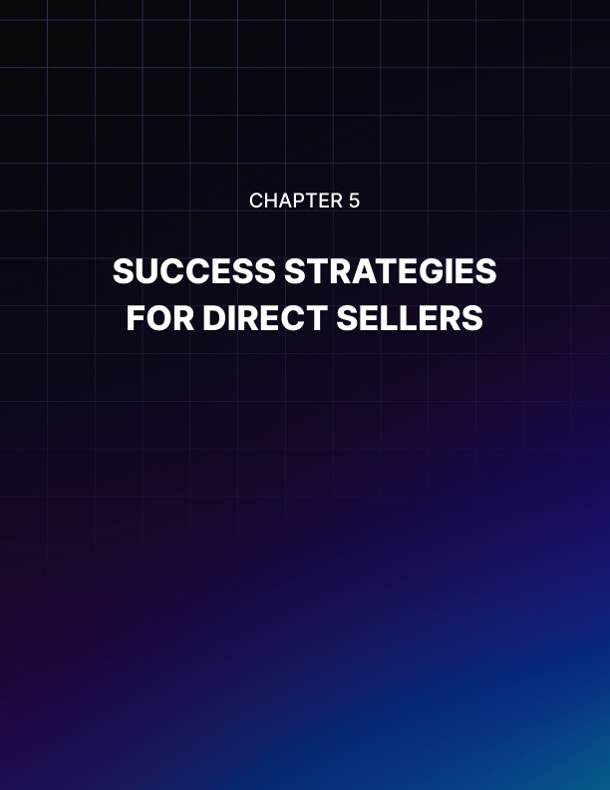

SUCCESS STRATEGIES FOR DIRECT SELLERS
____
Achieving long-term success in direct selling requires more than just effort. It demands strategic execution.
Those who develop effective systems for customer acquisition, marketing, and business operations are far more likely to build sustainable, profitable enterprises. Rather than relying solely on hard work, the key lies in leveraging scalable strategies that maximize efficiency and results.
A structured approach to business growth can make the difference between stagnation and consistent progress. By implementing proven methods, direct sellers can enhance productivity, strengthen customer relationships, and adapt to an ever-changing marketplace. Mastering these strategies is essential for building a thriving and resilient business.
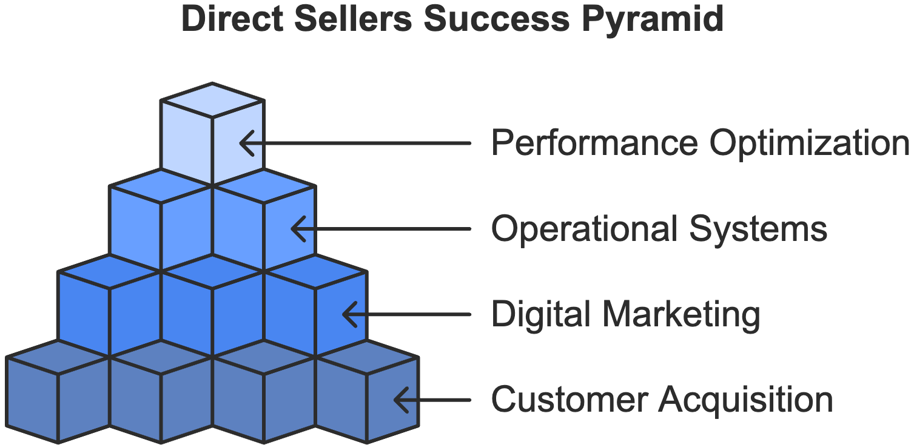

Strategic Customer Acquisition
Mark's evolution from struggling newcomer to consistent six-figure earner began when he stopped thinking like a salesperson and started thinking like a problem solver. "I realized my success wasn't about pushing products," he reflects. "It was about truly understanding my customers' needs and becoming their trusted advisor for solutions."
Building a thriving customer base requires enthusiasm and a systematic approach to identifying, attracting, and retaining ideal customers. You'll need to start by developing detailed customer personas that go beyond basic demographics.
Anastacia has her own approach with her wellness products: "I noticed that busy professional women between 35–50 were most responsive to my offerings. By focusing exclusively on their unique challenges and desires, I could craft messages that resonated deeply and build solutions that addressed their specific needs."
Your customer persona development should explore psychographic factors that influence purchasing decisions. Think about their daily routines, professional challenges, personal aspirations, and lifestyle preferences. Factor in how they consume information, what influences their buying decisions, and which problems keep them awake at night. This deep understanding allows you to position your products as natural solutions to their specific needs.
Gemma's success with skincare products demonstrates the power of detailed customer profiling: "I created comprehensive profiles of my ideal customers, including their morning routines, beauty concerns, and preferred information sources. This understanding helped me position my offerings as perfect solutions for their specific needs, leading to a 40% increase in conversion rates."
A customer acquisition funnel is a step-by-step process that guides potential customers from initial awareness to purchase and long-term loyalty through targeted marketing, engagement, and conversion strategies. Modern direct selling success requires building sophisticated customer acquisition funnels that nurture prospects through multiple touchpoints.
Your funnel should guide potential customers from initial awareness through to loyal customer status, providing value at each step. Bernadette's approach exemplifies this systematic funnel development:
In the awareness phase, focus on creating educational content that addresses common problems within your target market. Share valuable insights through social media, blog posts, and strategic partnerships with complementary businesses. This positions you as a trusted authority rather than just another seller.
During the interest phase, offer free consultations, detailed product demonstrations, and compelling customer success stories. These elements help prospects understand how your solutions can address their specific challenges. The consideration phase introduces personalized product recommendations, limited-time offers, and sample programs that reduce purchasing barriers.
Your purchase phase should feature a streamlined ordering process with multiple payment options and clear value demonstrations. The loyalty phase focuses on regular follow-up, VIP customer programs, and referral incentives that transform satisfied customers into passionate advocates for your business.

Mastering Digital Presence and Marketing
Modern direct selling demands a sophisticated approach to digital marketing and brand building. Lisa's journey from traditional home parties to digital marketing success illustrates this evolution:
"When I started leveraging social media strategically, my business grew tenfold. But success required more than just posting products,” she says. “It also required creating valuable content that educated and engaged my audience."”
Your professional online presence serves as the foundation of your digital marketing strategy. Today's consumers expect polished, cohesive branding across multiple platforms. Start by developing a mobile-responsive website or landing page that clearly communicates your value proposition, features professional imagery, and offers secure ordering options. Your social media profiles should maintain consistent branding while leveraging each platform's unique strengths.
Content creation becomes your primary tool for building relationships and establishing authority in your market. Maggie's content strategy demonstrates this approach. She creates in-depth content that addresses common skincare concerns, shares expert beauty tips, and helps her audience make informed decisions. Product recommendations flow naturally from this educational approach, leading to higher conversion rates and customer loyalty.
Your content calendar should balance educational posts, customer success stories, behind-the-scenes glimpses, live product demonstrations, expert interviews, and seasonal topics. Focus on solving problems and providing value rather than constant product promotion. This approach builds trust and positions you as a valued resource in your market.
Email marketing remains a powerful tool for nurturing customer relationships and driving consistent sales. Marissa's email strategy generates 40% of her monthly revenue through carefully segmented lists and targeted content. Build your email program around welcome sequences for new subscribers, regular newsletters with valuable content, product updates, special offers for loyal customers, and reactivation campaigns for dormant customers.

Systems for Sustainable Growth
Success in direct selling requires efficient systems that maximize productivity and ensure consistent customer service. Start by creating documented procedures for every aspect of your business. Your customer management system should organize contact information, track purchase history, schedule follow-ups, and monitor communication preferences. Develop efficient order processing systems that automate routine tasks while maintaining personal service quality.
Financial management forms the backbone of sustainable growth. James's systematic approach demonstrates the importance of tracking every expense, monitoring key performance indicators, and maintaining separate business accounts. This financial clarity enables informed decisions about investments in growth opportunities.
Your technology stack should support efficient operations while improving accuracy and customer service. Sharon's approach illustrates this principle. She uses specialized apps for different aspects of her business: CRM for customer management, scheduling tools for social media, and analytics platforms for tracking results. This automation saves hours while improving accuracy and allowing her to focus on relationship building.
Building for sustainable growth requires creating scalable systems that maintain consistency as your business expands. For example, you can focus on creating processes that could scale with your business. Every new team member receives the same training, every customer gets the same high-quality experience, and every process follows documented procedures.
Implementing these success strategies systematically creates a strong foundation for sustainable growth in your direct selling business. Remember that success results from consistent application of proven principles, continuous learning, and persistent effort toward your goals.

Performance Optimization and Growth
Success in direct selling requires constant monitoring and optimization of your business activities. An analytical approach can help drive continuous improvement. Track key metrics weekly and monthly to look for trends and opportunities. This data-driven approach helps you focus resources where they create maximum impact.
Your performance monitoring should encompass multiple business aspects. Start by tracking customer acquisition costs, because understanding how much you spend to acquire each new customer helps optimize marketing investments. Monitor average order values and identify opportunities to increase transaction sizes through strategic product bundling and upselling.
Customer retention metrics reveal the long-term health of your business. Jane's retention strategy demonstrates this focus: "I discovered that customers who receive personalized follow-up within 48 hours of their first purchase are 73% more likely to place a second order. This insight led me to develop an automated yet personalized follow-up system that significantly improved customer lifetime value."
Advanced performance optimization requires sophisticated tracking of multiple metrics:
- Product Performance Analysis
- Individual product sales velocity
- Seasonal buying patterns
- Bundle performance
- Return rates and reasons
- Customer satisfaction scores
- Inventory turnover rates
- Profit margins by product
- Marketing Effectiveness
- Channel-specific conversion rates
- Content engagement metrics
- Email open and click rates
- Social media reach and engagement
- Customer acquisition costs
- Lead generation efficiency
- Campaign return on investment
- Customer Behavior Insights
- Purchase frequency patterns
- Average customer lifetime value
- Product category preferences
- Communication response rates
- Referral program participation
- Customer satisfaction trends
- Churn risk indicators
John's approach to performance optimization illustrates the power of data-driven decision making: "When I started analyzing customer purchase patterns, I discovered that 65% of my top customers made their second purchase within 14 days of their first order. This insight led me to create a specialized new customer nurturing program that increased second-order rates by 40%."
Successful direct sellers maintain detailed tracking systems while focusing on actionable insights. For example, you can review your key performance indicators every Monday morning, looking for patterns and opportunities. This regular analysis will help you adjust strategies quickly and capitalize on emerging trends.
Your optimization efforts should extend beyond numbers to include qualitative feedback. Regular customer surveys, product reviews, and direct conversations provide valuable insights that numbers alone can't reveal.
Advanced growth strategies require balancing multiple business aspects:
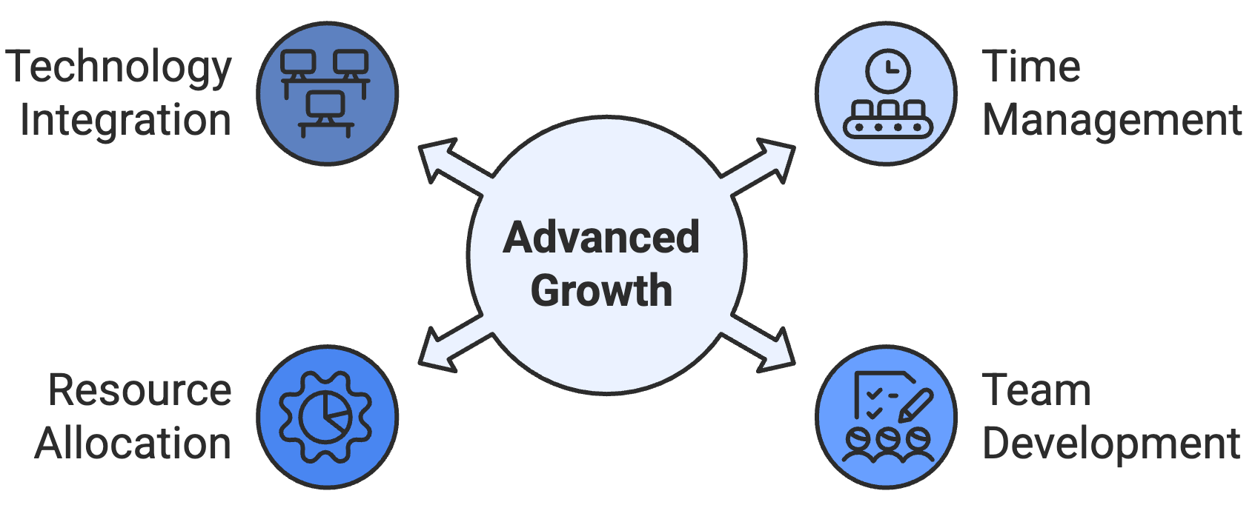
Time Management Excellence
Create structured schedules that allocate specific time blocks to different activities. Your daily routine should include focused periods for customer service, team development, marketing activities, and business planning. This structured approach ensures consistent progress across all business areas.
Team Development
As your business grows, develop systematic training and support programs for team members. Document best practices, create standardized onboarding processes, and implement regular performance reviews. This systematic approach ensures consistent quality as your organization expands.
Resource Allocation
Make informed decisions about investing time and money into different business aspects. Track return on investment for marketing activities, training programs, and technology solutions. This analytical approach helps optimize resource allocation for maximum growth.
Technology Integration
Leverage technology solutions that automate routine tasks while maintaining a personal connection with customers. Your technology stack should support efficient operations without sacrificing the relationship-building that drives direct selling success.
The most successful direct sellers maintain a relentless focus on continuous improvement. They regularly analyze performance metrics, gather customer feedback, and adjust strategies based on data-driven insights. This systematic approach to business optimization creates sustainable competitive advantages and supports long-term growth.
As you implement these success strategies, remember that sustainable growth requires patience and persistence. Focus on building strong foundations through systematic approaches to customer acquisition, marketing excellence, and business operations. Your success in direct selling will grow from consistent application of these proven principles combined with your unique talents and dedication to customer service.


IS DIRECT SELLING RIGHT FOR YOU?
____
Success in direct selling depends not only on the opportunity but also on personal readiness and alignment with the business model. Before committing, it’s crucial to evaluate your capabilities, resources, and long-term goals. Assess your support network, create detailed plans, and ensure you have the financial stability to invest time and effort into building your business.
Proper preparation helps ensure a more sustainable and fulfilling experience, while rushing into a decision without planning can lead to disappointment and unforeseen challenges. Understanding your personal strengths and weaknesses is key to determining if direct selling aligns with your aspirations and lifestyle.

Essential Traits and Skills Assessment
The foundation of direct selling success rests on specific characteristics and capabilities that consistently drive achievement. Justine, who has coached over 500 new entrepreneurs, shares her insight: "While technical skills can be developed through training, certain foundational traits like resilience, self-motivation, and emotional intelligence often determine who builds lasting success in this industry."
Your entrepreneurial DNA comprises both innate characteristics and developed capabilities that influence your potential success. Start by examining your natural tendencies with brutal honesty. When you meet new people, do you feel energized by the interaction or drained? When obstacles arise, do you instinctively seek solutions or feel overwhelmed? These inherent traits shape how naturally different aspects of direct selling will come to you.
Consider Brittany's revelation about personality alignment: "As an introvert, I initially questioned whether direct selling was right for me. However, by leveraging my strengths in deep listening and one-on-one relationship building, I've created a successful business that honors my authentic self. The secret isn't trying to become someone else, but rather adapting the business model to amplify your natural strengths."
Successful direct sellers demonstrate remarkable emotional resilience, or the ability to maintain momentum despite rejection or temporary setbacks. This trait proves especially crucial during your first year when you're building momentum and developing your customer base. Ramon, who now leads a team of over 1,000 distributors, recalls his early days:
"What separated me from others who started at the same time wasn't skill or knowledge. It was my ability to stay focused on long-term goals despite short-term challenges. I treated every 'no' as feedback rather than failure, using it to refine my approach."
Your capacity for continuous learning plays an equally vital role in sustainable success. The realm of direct selling evolves constantly, requiring you to master new technologies, adapt to changing consumer preferences, and develop enhanced leadership capabilities. Top performers consistently invest in their personal and professional development, viewing challenges as opportunities for growth rather than obstacles to success.
Time management capabilities often distinguish thriving direct sellers from those who struggle to gain traction. Without a traditional boss or fixed schedule, your ability to structure time effectively and maintain productive routines becomes crucial. Strategies like systematic time blocking can lead to consistent growth and your eventual success as a direct seller.
For example, you can dedicate specific hours each day to different business activities like prospecting, customer service, team development, and personal learning. This structured approach ensures you maintain momentum across all crucial areas of your business.
The modern direct selling environment demands increasing technical adaptability. While you don't need to be a technology expert, comfort with digital tools for customer relationship management, social media marketing, and virtual presentations has become essential. Your willingness to embrace and learn new technologies directly impacts your ability to compete effectively in today's market.

Evaluating Your Resources and Readiness
Building a successful direct selling business goes beyond possessing certain personal characteristics; it also involves adequate resources and thorough preparation. Jude's experience powerfully illustrates this principle:
"My first attempt at direct selling failed because I rushed in without a proper foundation. When I started again eighteen months later, I ensured I had adequate financial reserves, clear systems, and strong support networks in place. The difference in results was dramatic. I achieved more in three months than I had in my entire first attempt."
Financial readiness forms the cornerstone of sustainable business growth. Beyond covering initial startup costs, you need to evaluate your ability to maintain regular living expenses during the business-building phase.
Martha's strategic approach demonstrates thorough financial planning. She calculated her minimum monthly expenses and ensured six months of reserves before launching. This financial cushion allowed her to make decisions based on long-term strategy rather than immediate pressure. Additionally, she maintained part-time work during her first year, providing stable income while building her business foundation.
Your time availability requires equally careful consideration. While direct selling doesn't demand full-time hours for success, it does require consistent, focused effort. Cindy manages her growing business while raising three children:
"I started with 15 dedicated hours weekly, carefully scheduling specific times for different activities. Understanding my time constraints helped me create efficient systems and set realistic goals. The key wasn't having unlimited time, but rather making strategic use of the time I had available."
Technical readiness in today's direct selling landscape extends far beyond basic computer skills. You'll need to evaluate your comfort and capability with various digital tools for customer relationship management, social media marketing, virtual presentations, and team communication.
Linda's systematic approach illustrates effective technical preparation. She rated her proficiency in each required technical area from 1 to 5. For areas below 3, she created specific learning plans, allocating time and resources for skill development before launching. This systematic evaluation prevented technology from becoming a bottleneck in her business growth.
Professional networks and market knowledge significantly influence early success. Your existing relationships and understanding of your target market can provide crucial advantages during the startup phase.
Determine whether you have access to potential customers in your target demographic, relationships with complementary businesses, and an understanding of industry trends and regulations. These factors contribute to your initial momentum and long-term success potential.

Setting Yourself Up for Success
The direct selling journey offers substantial rewards for those who approach it with preparation, self-awareness, and strategic planning. By carefully evaluating your inherent traits, developing necessary skills, and establishing proper resources, you position yourself for sustainable growth rather than short-term achievements.
Success in this industry isn't about conforming to a single profile but rather about aligning the business model with your authentic strengths while addressing potential weaknesses through intentional development. The most thriving entrepreneurs in this field recognize that their journey requires both personal transformation and practical implementation.
Before making your decision, take time to conduct a thorough self-assessment covering your emotional resilience, learning capacity, time management abilities, and technical adaptability. Pair this with an honest evaluation of your financial stability, available time commitment, and existing networks. This dual approach (examining both internal qualities and external resources) provides the most accurate picture of your readiness.
The direct selling opportunity remains accessible to diverse individuals, but its greatest benefits flow to those who enter with clarity, preparation, and realistic expectations. By thoughtfully considering the factors outlined in this chapter, you're already demonstrating the strategic thinking that underpins long-term success in this dynamic and rewarding field.


YOUR PATH FORWARD IN DIRECT SELLING
____
The journey ahead in direct selling offers limitless potential for those who approach it with the right mindset, strategies, and dedication. Success in this field isn't just about selling products; it’s about building a sustainable business rooted in effective systems, personal growth, and long-term goals.
In this dynamic industry, the key to thriving lies in aligning your business approach with your unique strengths and values. Whether you’re just starting or refining your existing venture, the steps you take today will shape the foundation for your future success. By mastering customer acquisition, embracing digital marketing, optimizing operations, and focusing on continuous improvement, you’re setting yourself up for a rewarding entrepreneurial journey.

The Direct Selling Journey
The direct selling industry offers a unique entrepreneurial path with distinctive advantages and challenges. The core strength of direct selling lies in its flexibility and relationship-based approach. Unlike conventional retail or e-commerce, direct selling leverages personal connections and customized service to create value. This model empowers entrepreneurs to build businesses that align with their personal values and lifestyle goals while delivering genuine solutions to customer needs.
We've distinguished between single-level marketing, multi-level marketing, and party plan models, each offering different advantages depending on your personal strengths and business objectives. Your success depends largely on selecting the approach that best complements your natural abilities and goals.
The importance of proper due diligence when selecting a company and product line cannot be overstated. Evaluating factors such as company stability, product quality, market demand, and compensation structure creates a solid foundation for long-term success. This careful research separates sustainable businesses from short-lived ventures.

Revisiting the Key Success Strategies
Building a successful direct selling business requires a strategic blend of customer acquisition, operational systems, digital marketing, and personal readiness. Achieving long-term growth in this field requires not just hard work, but a calculated, methodical approach to each aspect of your business. Here’s one more look at the key success strategies that will help you thrive in the competitive direct selling landscape.

Strategic Customer Acquisition
To build a thriving customer base, you need more than just leads. You need to find the right people who truly need what you're offering. Start by developing detailed customer personas. Think about who your ideal customer is.
Ask specific questions. What are their pain points? What solutions are they looking for? Once you’ve identified these characteristics, create targeted acquisition funnels that guide potential customers from awareness to conversion.
For example, if you’re selling skincare products, understanding your audience might reveal that your ideal customer is someone with sensitive skin looking for natural alternatives. You could then tailor your content to emphasize the benefits of your products for sensitive skin, creating a funnel that guides this customer from finding your blog post to purchasing your product.
When you understand your target market deeply, you’ll be able to position your products as the natural solution to their specific challenges, turning random prospects into loyal, long-term customers.

Digital Marketing Excellence
Your online presence is your storefront. To extend your reach and build your brand, you need to master digital marketing techniques.
Whether you’re new to social media or already have a presence, the key is consistency. Regularly post valuable content that educates, informs, or entertains your audience. Think of Instagram stories, Facebook groups, or even YouTube videos that demonstrate how your product solves common problems.
Imagine you’re selling fitness products. Instead of just posting about your product, share transformation stories, workout tips, and nutrition advice. These posts should aim to build trust and authority, showing your audience that you understand their needs and can offer helpful solutions. By engaging with your audience through comments, messages, and social media interactions, you create a connection that fosters loyalty.
Using digital tools effectively amplifies your message and accelerates your business growth. The more strategic you are with your online presence, the more authority and trust you’ll build, which ultimately leads to increased sales.

Systems for Sustainable Operations
When you move from making occasional sales to building a sustainable business, it’s essential to implement systems that streamline your operations. Systems are the backbone of your business that allow you to scale efficiently. From managing customer data and processing orders to tracking finances and inventory, having solid systems in place ensures everything runs smoothly.
For example, you might use CRM software to track interactions with customers, ensuring follow-ups and support requests are handled promptly. This ensures that no customer is overlooked and that you can consistently deliver a high-quality experience.
With efficient systems in place, you free up your time to focus on higher-value activities like building relationships with clients or exploring new marketing opportunities. In the end, your business becomes more scalable and sustainable, which is key to long-term success.

Performance Optimization
To keep your business moving forward, it's crucial to continuously optimize your performance. This is where data-driven decision-making comes into play. Tracking KPIs such as sales conversions, website traffic, and customer feedback will give you actionable insights into what’s working and what needs improvement.
Let’s say you notice that a certain product page has a high bounce rate. By analyzing the page’s content and customer behavior, you might realize the copy isn't compelling enough or the product images don’t accurately represent the product’s benefits. By making small tweaks (like improving product descriptions or offering a special discount), you can enhance your customer experience and boost conversions.
Continuously measure, analyze, and adjust your strategies to create a feedback loop that drives consistent growth. The more you focus on optimizing performance, the better you’ll be able to allocate resources and maximize your return on time and investment.

Personal Readiness Assessment
Your personal readiness is a significant factor in your success as a direct seller. Beyond the right strategies, your mindset and resources are key to navigating the challenges of building a business. Start by assessing your emotional resilience. The road to success will have its ups and downs, and your ability to stay motivated and push through tough times is critical.
Additionally, assess your time, finances, and technical readiness. Do you have enough time to consistently put in the effort required for growth? Are you financially prepared to invest in your business when needed, whether that’s in marketing, inventory, or tools? If you're not confident with digital tools, you might want to invest in learning resources or hire a professional to help with the technical aspects of your online presence.
Having a clear understanding of your resources—both personal and financial—sets you up for success. It’s also important to have a solid support network. Surrounding yourself with mentors, peers, or a team who can encourage and hold you accountable will help you stay focused and push through the inevitable challenges.
A successful direct selling business is built on a foundation of strategic customer acquisition, digital marketing excellence, efficient operations, continuous performance optimization, and personal readiness. By consistently applying these strategies and continuously assessing your progress, you can achieve sustainable growth and long-term success in the industry.

Your Direct Selling Future
The direct selling industry continues to evolve, creating unprecedented opportunities for entrepreneurs who approach it with strategic thinking and dedicated effort. By combining time-tested principles with innovative approaches, you can build a business that provides both financial rewards and personal fulfillment.
Remember that your journey in direct selling represents more than just a business venture—it's a path of personal development and growth. The skills you develop, the challenges you overcome, and the relationships you build contribute to your success not only as an entrepreneur but as a leader in your community.
As you apply the principles and strategies outlined in this book, approach your business with patience and persistence. Sustainable success rarely happens overnight; it grows from consistent application of effective methods over time. Celebrate small victories while maintaining focus on long-term goals.
The direct selling opportunity remains accessible to individuals from diverse backgrounds and circumstances. Whether you seek supplemental income or full-time entrepreneurship, this industry offers a flexible path aligned with your unique strengths and aspirations. The greatest achievements come to those who enter with clarity, preparation, and realistic expectations.
Your success story begins with the decision to approach direct selling as a professional business builder rather than an occasional seller. By investing in your knowledge, skills, and systems, you position yourself among the entrepreneurs who create lasting value for customers and sustainable prosperity for themselves.
The future of direct selling belongs to those who combine ethical business practices with innovative approaches to meeting customer needs. As you begin or continue your journey in this dynamic industry, remember that your commitment to excellence today lays the foundation for your success tomorrow.

