Disclaimer

This ebook has been written for information purposes only. Every effort has been made to make this ebook as complete and accurate as possible. However, there may be mistakes in typography or content. Also, this e-book provides information only up to the publishing date. Therefore, this ebook should be used as a guide - not as the ultimate source.

The purpose of this ebook is to educate. The author and the publisher do not warrant that the information contained in this ebook is fully complete and shall not be responsible for any errors or omissions. The author and publisher shall have neither liability nor responsibility to any person or entity with respect to any loss or damage caused or alleged to be caused directly or indirectly by this ebook.
Table of Contents

Introduction 5
First, a Few Stats 6
Top Reasons You NEED to Invest in Email Marketing 8
Lesson 1: Autoresponder Comparison and Review 13
What is an Autoresponder? 13
How to Choose an Autoresponder 14
Comparisons 16
Lesson 2: Top Tools For Creating Landing Pages 20
Do You Really Need a Landing Page Tool? 23
More Useful Tools 24
Lesson 3: Opt-In Landing Page Tactics 27
Some Things to Consider 27
Diminishing the Cost 28
Increasing Value 28
Two More Techniques: Incentives and Pressure 29
Incentives 30
Getting People to Your Landing Page 31
Lesson 4: Email Copywriting 34
How to Write Well 35
How to Write Copy That Gets Clicked and Read 37
Lesson 5: Subscriber Relationship Building 41
Understanding the Value of Your List 41
How to Build Real Relationships 43
Actual Communication 44
Things Not to Do 45
Lesson 6: Autoresponder Sequence Power 48
Why an Autoresponder Sequence is Such a Good Strategy 48
Some Things to Consider 49
How to Write the Perfect Autoresponder Sequence 50
Lesson 7: Landing Page Traffic 55
PPC 55
Targeting 56
Blogging 57
Solo Ads and Ad Swaps 59
One Thing Not to Do 59
Lesson 8: List Monetization Tactics 62
Selling a Product 62
PLR 63
Affiliate Marketing 64
Selling Physical Products 65
Sell Ads 66
Lesson 9: List Segmentation 68
Targeting by Demographics 68
How to Segment Your Audience 69
The Way to Think About Your Subscribers and Leads 70
Using This to Your Advantage 71
Lesson 10: Getting Inboxed 75
How to Avoid the Spam Folder 76
Email Sender Reputation 77
How to Improve Your Sender Score 78
Getting Into the Main Inbox 79
Lesson 11: Email List Maintenance 82
Why Email Hygiene is So Important 82
Top Ways to Maintain Email Hygiene 83



Introduction

If you run a business, a website or a blog and you want to increase your audience as well as increasing engagement, then the single most effective way to do that is with email marketing.

If you listen to pretty much any top marketer, then they will almost always tell you this. They will almost always say that the most important aspect of their marketing – the thing that led to their success – was email.

And there’s a very good reason for this. Or ten…

Email marketing allows you to reach your audience in an incredibly direct manner. Unlike other forms of marketing, you’ll actually be able to reach your audience directly in their inboxes without having to go through any third party. That means that you’re not reliant on a platform like Facebook or Twitter, or at the mercy of potential changes to policies that could render your messages unheard. It wasn’t that long ago that Facebook made the decision to change its system so that only a small percentage of posts from pages got through to followers.

With email, your messages are going directly to the users. That means that nothing can prevent you from reaching them and you know that 100% of everything you send is going to reach the recipient.

It means that you don't lose your long list of subscribers if Facebook decides to inexplicably delete your account (this happens – in fact it has happened to me) or if they decide to delete their accounts.

This is a relationship that is directly between you and the subscribers. But that's only touching the very surface of what makes Email marketing so useful.

As you'll see in the rest of this report, there are many, many more advantages to email marketing and tons more reasons why you should invest more time and more energy into email marketing.

By the end of this report, you’ll understand precisely what makes email marketing important and
you'll hopefully be hyped to dive into the rest of the course to find out how you can make it work for you.

First, a Few Stats

First, let’s take a look at a few stats which perfectly illustrate just how impressive email marketing really is and how it is transforming business…

For example, did you know the following figures?

- Email marketing has a ROI of 4,300%
- 91% of consumers check email daily (most people check it much more!)
- When surveyed, companies say that email marketing is more profitable than: PPC, content marketing, display advertising, mobile ads, social media marketing, direct marketing, affiliate marketing…
- 66% of US consumers aged over 15 have made a purchase as a direct result of an email
campaign
- 1/3rd of consumers say that they open their emails on the basis of the subject line alone

So, what does all this tell us? Why are these stats the way they are?

Firstly, let’s consider the ROI. The reason that ROI is so high for email marketing is actually because the cost of entry is so low.

ROI is ’return on investment’, the amount of money you make versus the amount of money you spent in order to make it!

In the case of email marketing, you only need to pay for an autoresponder. Once you've done that, you have the means to collect and send emails, which means the only thing left for you to do is to write said emails. Guess how much writing an email costs? And it barely takes any time either (remember: time is money!). In short, this is an incredibly quick and cost effective way to start marketing.
Another stat that's interesting is the fact that 91% of consumers check their email every single day. That's a huge statistic but in reality it’s probably rather conservative. The reality is that most of us check our phones not only every single day but countless times throughout the day.

The reason for this is that we get a notification each time we get a new email. There is no way for us to miss an email, which stands in stark contrast to a Facebook post or a Twitter Tweet which is very easy to miss.

In fact, the main way that you tend to hear about new Facebook posts is via email.

Think about the Facebook pages that you have Liked. Can you honestly say that you get 100% of the messages that any of them put out? The answer for most of us is ’no’ and the obvious reason for that is that we'll only check Facebook every now and then and even then, we’ll likely only see a small percentage of what's on offer because that’s what will make it to our homefeed. The only way we would stand a chance of seeing 100% of the content from a given page is if we were to manually navigate to that Facebook page every single day and scroll down through the posts.

And who cares enough about a brand in order to do that?

With email on the other hand, you not only check your inbox multiple times a day anyway, but you also get alerted each time a new message comes through.

Of course, this is only true of your inbox and not of your ’social’ mailbox or spam – but using the tips you'll learn over the course of this… course… you’ll learn how to make sure you end up in the inbox and not one of the other two.

So, that’s what the stats have to say but what about the things that a survey can’t quite capture?

Top Reasons You NEED to Invest in Email Marketing

Here are some of the top reasons that you can’t afford not to invest in email marketing…

- Email Marketing is More Personal

The first and most important consideration is simply that email marketing is much more personal as compared with other forms of marketing. When you send someone a message via email, you are messaging them in their inbox and that means your messages are going to be placed right alongside messages from their friends and family, as well as all the other things that they signed up for.

All of a sudden, the way that your messages are parsed and interpreted changes. Suddenly, this is in a folder filled with correspondence that demands attention and your email message will take on that same importance as a result.

As a marketer, it’s your job to take advantage of this too – by making sure that your content is written in a way that feels personal and direct – this will have a much better impact on readers and make them much more likely to sit up and take notice of what you’re saying. People like getting messages from people – not companies.

- Email Marketing is Immediate

With email marketing, you have complete control over your message and that even includes the timing with which your message is sent.

On Facebook or Twitter, you will write a message and then hope that your followers see it at some point in the near future.

However, with email marketing we’ve already discussed that your recipients will get a buzz in their pocket as soon as the new message comes through. Even if they have several messages that they haven’t read (meaning that they won't get notified for each new message), they'll still tend to check their messages to dismiss those unread contacts at several times throughout a day.
That now means that you can time when your message gets seen and therefore you have some control over what mood the recipients are in when they get your message and how they are likely to respond.

This is crucial because – as with comedy – timing is everything when it comes to marketing. If you can send a message at the right time, then you can take advantage of current events, or of the fact that your subscribers are likely to be tired and thus more impulsive. You just don't get this kind of control with any other form of marketing.

We’ll learn more about how you can utilize timing in your email marketing over the next several reports.

- Email Marketing Requires Permission

This is actually a very important aspect of email marketing and it’s one that makes every message much more effective and impactful.

The simple fact is that in order to send a marketing email to someone, you first need their express permission. And that permission requires them to actually give you their email address and contact details. This isn’t as easy as clicking ’like’ and it’s not something they can possibly do by accident.

At first, you might think that this would be a negative thing. After all, it means that you’re going to have a much shorter mailing list and your subscribers might be less inclined to sign up.

But that is actually a positive thing. A big positive. Why? Because it means that the quality of your contacts is much higher. In marketing, quality trumps quantity every time and by a large margin at that.

If your recipients actually want to be there and if they're interested in signing up, then that means they'll actually read your messages and it means they’ll be much more likely to click ’buy’ or to pass the message on to friends.
And the very act of giving you their email address also increases that trust. When someone gives you their email and invites you to message them, they are showing that they trust you not to abuse that power and that they value your ideas enough to give up some of their privacy. This way, they become ’members’ of your movement.

Again, we'll look at how you can ensure your contacts are 100% valuable and the right fit for your list in future installments.

- Email Marketing Allows Smart Use of Data

Something that a lot of eBooks and blogs don't touch on is just how much data you get when you use email marketing, or how flexibly you can use that data. With email marketing, you’ll be able to sort your contacts into categories, so that you can choose to target only the right kind of recipient with your messages. That might mean that you send messages only to people of a certain age, a certain gender or in a certain location – and this can drastically increase your conversion rates.

What’s more though, is that email marketing allows you to monitor engagement. You can use cookies in order to see which of your subscribers are actually reading the messages you're sending and which aren’t. You can also see which of your subscribers are visiting your site and even whether or not some of them might have looked at your products.

All this means you can see which leads are cool, warm and ’hot’ and in turn, that means you’ll be able to try and convert only the right recipients that are likely to be tempted and not likely to be frustrated at your contact.

On top of that, seeing this kind of information can help you to design better campaigns – by seeing which types of message get opened the most and which types of recipients are more receptive to your message (so that you can try and get more like them).

In short, email marketing gives you control over numerous very important metrics which allows you to target precisely the right people at precisely the right times.

When you combine all these different factors, you have a method of marketing that is simply
unparalleled. Many marketers and business owners will put it off as it seems like a lot of work but in reality, once it is set up and you understand how it works, it couldn’t be simpler. And the payoff is enormous. Email marketing absolutely MUST be a part of your marketing strategy and over the rest of this course you’re going to learn how to take advantage of it in a MASSIVE way.

Buckle in!

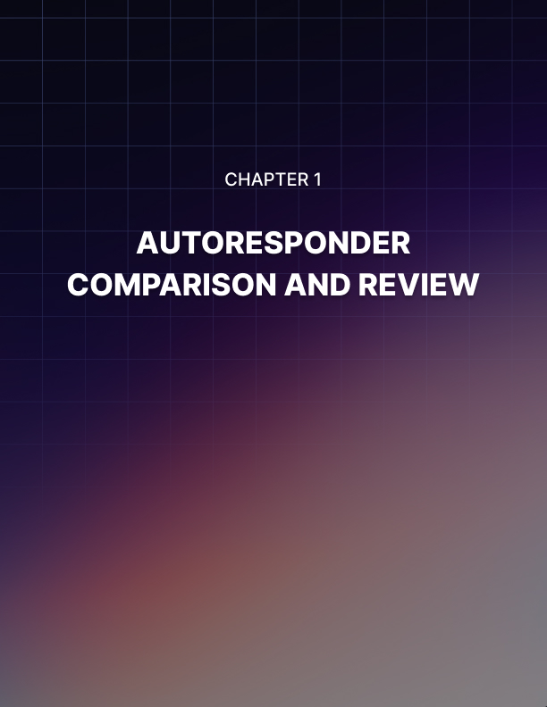

Lesson 1: Autoresponder Comparison and Review

If you’re going to build an effective mailing list, then you will absolutely need an autoresponder. There is simply no way that you can run an effective mailing list without this crucial tool, making it one of the most important investments you can make for your business.

This is also actually the only investment you’ll really need to make as an email marketer. Unless you pay for advertising to bring people to your squeeze page, the only money you’ll pay is the monthly fee that it costs to sign up for the mailing list.

That makes it rather important that you choose the right one. In this detailed report, we’ll be comparing the top autoresponders to see how they’re different and which one might be right for you!

What is an Autoresponder?
In case you’re completely new to email marketing, an autoresponder is the tool that you will use not only to build your opt-in form, but also to receive incoming new subscribers, to manage their addresses and to generally keep your mailing list ticking over. When you send a message out to your entire list, you will do so through your autoresponder. Likewise, if someone clicks ’unsubscribe’, then your autoresponder will handle that so that you don’t manually have to remove them from your mailing list.

In short, managing all the contacts that make up a mailing list would be an impossible task once you reach a certain size. An autoresponder is thus able to do this for you so that you can spend less time juggling emails and more time building a massive and highly successful list/sending out compelling messages.

Autoresponders go above and beyond these basic features though and also provide you with powerful functionality to expand your marketing and to make even more of a splash. For instance, an autoresponder can help you to see metrics for your users and your individual messages. This means that you can see things such as how many people have viewed your emails and what the ’open rate’ is. Likewise, you’ll be able to see which of your subscribers aren’t opening any of your messages (and thus delete them from your list) and which subscribers are the most highly engaged (so that you can try selling to them).

Then there’s the function that gives the autoresponder its name: the ability to send out autoresponder sequences. These are sequences of emails that are designed to be read in order and that will help to increasingly engage your subscribers and/or help to sell to them. A good example of an autoresponder sequence might be an online course that ends with you trying to sell something. With an autoresponder sequence, you can sit back and relax while your new leads are gradually converted into hot leads that are ready to buy from you!

How to Choose an Autoresponder
With that all in mind, one of the most important considerations when picking an autoresponder is what kind of marketing you intend on doing and what features you’ll need as a result.

There are generally four big email autoresponders that many people will consider. These are:

- Aweber (www.aweber.com)
- Infusionsoft ( www.infusionsoft.com)
- Get Response (www.getresponse.com)
- MailChimp (www.mailchimp.com)

The good news is that all of these big names should provide all of the features that I just subscribed to. No matter which of these you choose then, you should be able to accept new subscribers, remove people who want to leave and send out mass messages that everyone will receive.

Where they differ is in the price and in their specialism and their additional features.

For example, Infusionsoft is a mailing list autoresponder that is very much designed in order to work with a sales page. This is for people who want to sell a digital product and who want to promote that product through their email list. That’s because the tool combines a mailing list with a sales platform. This means it probably isn’t the best choice if you have a business that sells car windows but it might be a good choice if you’re a traditional internet marketer looking to sell an ebook. This kind of synergy will mean that you can see which of your subscribers has visited your checkout page before for example and which ones are previous customers – all at a glance.

On the other hand, Aweber, GetResponse and MailChimp are far more designed in order to be used as more ’conventional’ autoresponders. Their differences often revolve around the advanced features they might offer and the support that you get from third parties.

In particular, if you are working with WordPress, you will find that there are some widgets and plugins that will only support specific autoresponders. If you want to combine these in order to work together then, you’ll need to choose the right autoresponder to ensure compatibility.

As mentioned, the price is also different depending on which of these products you eventually choose.

Unfortunately, it’s not a simple matter to compare the prices of your different autoresponders, seeing as they each use a much more complex pricing structure that is based on the number of subscribers you have at any given time.

The prices are a little more complex to work out but really they aren’t all that different. For those reasons, you might be best advised to choose the autoresponder you want to use on the basis of its features rather than the price.

With that said, let’s take a look at each of these products in a little more detail to see how they’re different.

Note: If you really want to engage in some cost cutting and want to pay as little as possible for your autoresponder service, note that you can transfer your contacts from one to the other by exporting the list. This means that you can sign up to whichever service is offering the best rates for completely new members and then switch to the one that offers the best rates for bigger and more established marketing once you’ve grown a bit.

Do keep in mind though that this can sometimes result in an interruption in service for your customers though, as they might be requested to re-confirm their subscription in some cases and some others might get lost along the way. So it’s not ideal, but it is an option if you don’t want to commit right now!

Comparisons
MailChimp
MailChimp is probably the most affordable for completely new users, which will attract a lot of people to begin with. For a long time, it was offering a deal where you could sign up for free up to the first 2,000 subscribers.

This makes it a popular choice among the smaller, more niche businesses which actually helps to create something of a community around it.

MailChimp has a very cute interface with its little monkey mascot and lots of nice light blue coloring. It’s a nice environment to work in and one that feels very much right for a smaller business, rather than a large multinational corporation.

However, MailChimp is also a little slower to use than some of the others. The interface isn’t all that fast and unless you’re paying more, you’ll have to put up with that ’cute’ logo on all of your messages. This can detract from your own brand slightly.

It’s also a shame that there’s no way to import your own template. But other than that, you will get access to all of the essential features that you are probably looking for with your mailing list.

That means you’ll be able to create opt-in forms, check in with your subscribers, see how your messages are performing, send your bulk emails and set-up autoresponder sequences. It also has good support thanks to that small community that I mentioned. This means that a lot of WordPress plugins etc. will work with MailChimp.

GetResponse
GetResponse is an autoresponder that is a little better suited to the larger or more serious business. It has a ton of high-end features and offers great customer service and an excellent interface. Arranging the order of autoresponders is as simple as dragging and dropping with a nice touch interface for example.

One of the best features of GetResponse is the amount of control it gives you over your automated messages. You’ll be able to set up messages that will be sent automatically on the basis of specific actions taken by your visitors, or based on the time etc. This means you can write lots of emails in advance and then schedule them and it means you can also set up very smart automated systems to help convert more subscribers and to build trust and engagement over time without having to lift a finger.

GetResponse also features another great ’advanced’ feature, which is split testing. This means you’ll be able to send two slightly different versions of the same message to see which bounces the most and which gets the best open rates. You can use that then in order to copy the good behaviors that get you more engagement and more conversion and to cut out the strategies that aren’t working. The bottom line? More efficient marketing and better profits!

Aweber
Aweber is in many ways the most popular and well-known autoresponder. It’s arguably among the more expensive out there but it also gives you a huge amount of control over the look and feel of your messages, the way you handle your contacts and more.

You’ll get access to over 600 email templates which you can use to build professional-looking newsletters and info bursts. You’ll also get a lot of support from third parties seeing as this is probably the largest autoresponder out there.

Best of all, Aweber has been subjected to extensive testing to ensure that it will be effective at getting into the inboxes of your subscribers whether they’re using Outlook, Gmail or something else entirely.

Aweber has powerful reporting tools and gives you some control over when you want to send emails etc. (though perhaps not as much as GetResponse).

InfusionSoft
As mentioned previously, Infusionsoft is a little different from the other autoresponders on this list. That’s because its focus is on selling through a sales page and on integrating its email services to that end. This means you’ll be able to keep track of cookies to see which of your emails is resulting in the most sales and which of your customers is likely to be ready to buy from you.

This is a fantastic tool for those that are planning on selling a digital product because it will streamline the process considerably. Then again though, if you just want a standard mailing list, then you might find that MailChimp or Aweber are better suited to your purposes.

Infusionsoft is more expensive than the competition because it offers more features and that also makes it a bit more complicated to navigate. Following a recent redesign, some users find that it is no longer as user friendly as it once was.

It is up to you and to your specific marketing strategy whether or not the features that InfusionSoft offers will be worth the minor sacrifices in terms of cost and usability.

Summary
In conclusion then, any of these autoresponders will serve you well and should include all the features you need and plenty of support from the wider community. However, the precise choice that best suits you will always depend on the nature of your brand and your audience. For smaller startups, MailChimp might be a good choice. For those that want to use advanced autoresponder sequences, then GetResponse might be the best choice. Aweber is the best all- round professional package, while InfusionSoft is really only for those users that are planning on selling digital products and want to make this a big part of their strategy.

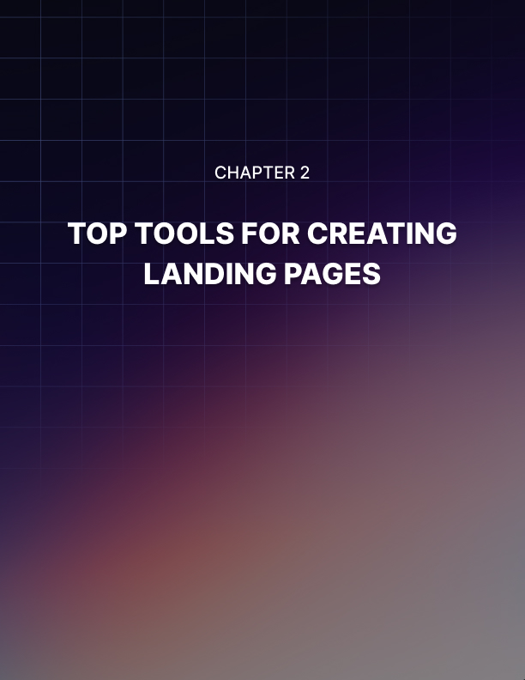

Lesson 2: Top Tools For Creating Landing Pages

Are you planning on building a mailing list and then using it to increase the engagement of your audience and maybe drive some sales?

Then you’re going to need a landing page!

A landing page is a single page on a website that has one purpose. This might be to help you sell a product (in which case it might also be referred to as a sales page) or it might be to help you get new subscribers for your mailing list (in which case we can also sometimes call it a squeeze page). In this case, we’re talking about the latter type of landing page – a single page that is dedicated to getting new emails.

This is a powerful tool when it comes to growing a list because it allows you to focus all of your attention – and all of your visitors’ attention – that opt-in form. That means that all the copy can be there to revolve around how amazing your mailing list is and that all the design features can point your audience toward the ’Sign Up Now’ button that you need them to click.

The good news is that a landing page is not that difficult to build and this is especially true for squeeze pages. These are often short passages of text with an opt-in form down the bottom designed to collect your messages.

But while you can probably whip together a landing page using nothing but a bit of HTML, you will likely find that you get a lot better results if you try using a tool designed to help you build better lists.

Let’s take a look at some of the best tools out there and how they can help you to make a more effective and highly converting page for your email list.

OptimizePress
OptimizePress (www.optimizepress.com) is a simple tool that works with WordPress and that can help you to make very professional looking pages in no time at all. As the name might suggest, these pages have been ’optimized’, meaning that the creators behind the tool have tested them over and over and refined them in order to ensure that they are highly effective at converting. In theory at least, simply installing OptimizePress on your site and using it to handle your opt-in page could help you to drastically increase your conversion rate and thereby drive up your sales and get more returns for any advertising or other marketing that you’re doing.

The great thing about OptimizePress is how clean, simple and professional everything looks. This is very important when creating a landing page because ultimately what you’re doing here is asking the new visitor to your page to trust you. You are asking them to share their personal details with you so that you can email them whenever you see fit – and that is a big ask for most people.

Now, if your website looks like it was designed by a ten year old, if the images are all low resolution or if the site appears to be somewhat broken, then you’re going to have a hard time getting that trust. And unless you’re a professional web designer yourself, you might find that your pages occasionally do look like this.

That’s why using something like OptimizePress can be such a good idea.

OptimizePress is also a good choice because it is very versatile. You can use this to create sales pages as well as landing pages, which is something that a lot of people might find themselves needing later on when they have a big enough list.

The downside is that OptimizePress is not cheap for most people. It costs $97 for the most basic package – which is limited in several ways – and that’s a big ask if you’re just starting out with your squeeze page for the first time.

LeadPages
LeadPages (LeadPages.net) is a tool that is designed specifically for mailing lists unlike OptimizePress that is more aimed at sales pages with additional capabilities.

This means that LeadPages is going to give you an even more comprehensive set of tools for that specific purpose. You’ll get the option to create welcome gates for instance, to integrate with Facebook, to sort landing pages based on their conversion rate and more. You can build multiple landing pages and serve them up at different times too and generally, you get a lot of capability here.

The pages themselves are also incredibly well designed. Whereas OptimizePress is more focused on sales and therefore provides the more typical ’pillar box’ design; LeadPages gives you a lot more flexibility and creativity to work with. You’ll also get access to landing pages that are designed to build leads in more creative ways. These include timers on the main page, countdowns and promotional pages for free ebooks and courses. There are landing pages with videos embedded in prominent positions and more and all of them look highly professional.

One big difference with LeadPages is that it is a hosted solution. That means that you aren’t going to be downloading the plug in and using it on your site, but rather redirecting your visitors to a different page where they can sign up. This will be a downside for some as it can mean that your audience is somewhat less engaged with your brand (seeing as they’re now on a different page entirely!). On the other hand though, others will like the fact that they can now manage an effective mailing list with no need to have built a website in the first place. Not all email marketing strategies are wed to websites or blogs, meaning that you can use this tool to create something without the headaches of hosting and web design.

The pricing structures are also more appealing here than OptimizePress. The most basic membership is $25 per month but this goes all the way up to $199 for the most advanced package – which is a large recurring fee.

Thrive Themes
Thrive (www.thrivethemes.com) is a product that provides a large range of different tools all in one package. You receive an entire ’Thrive Tool Suite’ which will include things like landing pages, the ability to manage leads, tools for creating more engaging email content, a headline optimizer and more.

In other words, Thrive will combine the ability to create attractive landing pages along with better tools for building great emails.

This is a powerful combination and more importantly, the landing pages themselves look great. You get 162 templates in total, which again revolve around a range of different features from promoting free ebooks to showing countdown timers and other time-based incentives.

Unlike LeadPages, Thrive is a hosted solution meaning that you’ll keep it right on your own page. At the same time, it is a WordPress plugin, which means that it will be quick and easy to set up if you’re already familiar with the CMS.

It is worth noting that both OptimizePress and Thrive rely on a WordPress installation. So if you have a site that you built yourself or with another tool, then you might need to consider LeadPages or a lesser known alternative!

All of Thrive’s themes are mobile responsive and built to load quickly. They look very professional with high quality, crisp images and are generally a great choice.

And better yet, is that this is also the most affordable package. Basic membership will only cost you $19 per month, whereas the top tier ’Agency Membership’ only costs $49.

Do You Really Need a Landing Page Tool?
Perhaps the question that you’re now asking is whether you really need a landing page tool… And the answer to that is no… but with caveats.

If you head over to the Four Hour Blog – Tim Ferriss’ blog – you’ll see that his landing page is incredibly simple (http://tim.blog/7-reasons-to-subscribe/). The page is simply called ’7 Reasons to Subscribe’ and it is designed like any other page on a WordPress site with 7 points, each giving you a reason that you should subscribe.

This was not built with any kind of tool, in fact it is nothing other than a simple WordPress page. And you could do the exact same thing and rely on the strength of your copy and the weight behind your name to drive those conversions.

But let’s face it, most of us are not Tim Ferriss and most of us don't have the ability to persuade people to sign up for our mailing list on the basis of a little text.

If you use Thrive or LeadPages, then you’ll benefit from large crisp images, background animations and smart layouts that feel like they belong on a top website. This instantly impresses your audience and makes them much more inclined to want to sign up.

This can really help you to convert if you didn't before and as such, all you have to do is to replace your current landing page with one of these and you might conceivably expect to see your conversion rate go up by several percent.

It's an investment, yes, but for most people it will be one that offers good ROI. Just know that you can get by without this feature and that you can always wait until you’re making some profit before you decide to reinvest in a landing page tool.

It's also worth considering the time aspect. Using a tool like this can save you a lot of time and that way help you to start making profit immediately – rather than wasting weeks or even months tweaking everything to get it just right.

Of course, this is also a feature that becomes more useful as you start managing multiple businesses, multiple websites and multiple mailing lists.

That said, seeing as Thrive will only set you back $19.99 for the first month, you can always try it to see if it makes a difference and then just unsubscribe if it does not!

More Useful Tools
There are a number of other useful tools that will also help you to grow your mailing list more quickly.

One excellent one to consider is Optimizely (www.optimizely.com). This is a split tester, meaning that it can help you to take your landing page and split it into two slightly different versions. Imagine one landing page with a red opt-in form and one with a green opt-in form. You can then monitor these two versions of your landing page with half of your traffic going to each. Over time, you might notice that one of them is getting better results than the other and at that point, you can choose to accept the change to green. Then you can test another change!

The great thing about this is that it allows you to gradually improve your site over time until it eventually evolves into the perfectly optimized funnel to grab as many new subscribers as possible.

Another thing to consider is a lightbox. This is a ’pop-over’ that appears over the top of your page and makes everything else go dark. You can use this in conjunction with a landing page or you can use it elsewhere on your site.

Either way, these tools are fantastically effective at driving conversions and numbers often get thrown around like ’400% improvement’. It can be a little annoying for visitors though, which is why you need to be careful with how you go about it. Make sure that your lightbox is easy to dismiss and that it only appears once someone has been on your page a certain amount of time.

Get this right though and it will simply ensure that nobody can miss your mailing list or all the good reasons they should consider signing up to it. One good hope is ’Huge-It’ for WordPress but there are many other similar plugins that will do the same job.

A bad workman may blame his tools, but the right tools will make you a better workman!

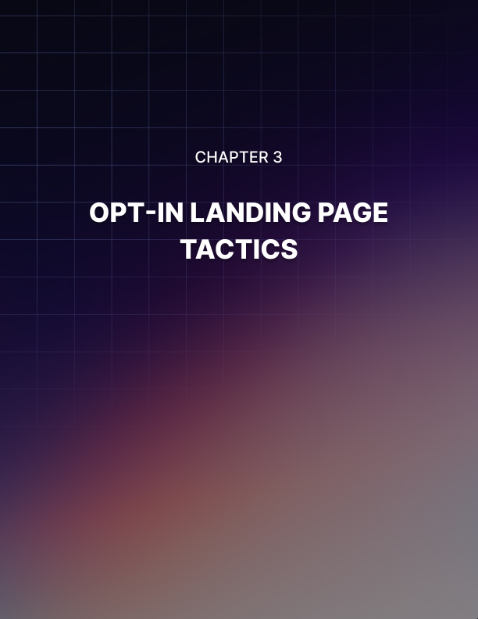

Lesson 3: Opt-In Landing Page Tactics

In the first lesson in this course, you discovered the massive importance of using email marketing as part of your campaign and you saw why it was so critical for the success of your business – even compared with other tactics like PPC and content marketing.

But while email marketing is crucial, it is also dependent on other factors. That is to say that you can’t have email marketing without having a great opt-in landing page. This is your ’squeeze page’ – it is the page that you use in order to encourage first time visitors to your site to sign up for your mailing list so that they can receive your emails.

This is the gatekeeper to your email marketing campaign and it is fundamentally important if you have any interest whatsoever in this form of marketing. After all, the best email marketing campaign in the world isn’t of much use if you can’t get anyone to read it!

So, the question is: how do you make sure that your landing page gets the attention it deserves and how do you ensure that the people who land there, convert?

Some Things to Consider
There are two types of landing pages, which are ’squeeze pages’ and ’sales pages’. A squeeze page is an opt-in landing page as we’ve been describing here, while a sales page is a page that attempts to convince someone to buy from you.

The reason that I mention both types of page here is that they are actually more similar than they are different. In essence, you are trying to sell your landing page and that means you’re going to face all the same challenges you would when selling a product.

Your objective here is to demonstrate that it is worth signing up to your mailing list – that it is going to provide significant value to the readers – while at the same time convincing your readers that the cost is worth it. In this case, the cost is that your readers have sacrificed some of their privacy and have given you permission to contact them right in their inboxes.

So, you need to inflate the apparent value and diminish the apparent cost.

Diminishing the Cost
Your job then is to demonstrate to readers that they don’t need to worry when they sign up to your mailing list. You can do this by mitigating and removing the risk – by alleviating the concerns that they might have.

For example, your visitors will likely be worried that if they subscribe to you, they will potentially get inundated with messages and spam. They might even be worried that you are going to pass their details on to other brands and companies.

So, you need to reassure your audience that this isn’t going to happen. Promise your readers that you will never share their details and that they can very easily unsubscribe at any point.

Likewise, let them know precisely the frequency and nature of your content. There are few things that are more daunting than the unknown so make it absolutely clear what your mailing list involves and what they can expect if they sign up.

If you take a look at Tim Ferriss’ opt-in page, then you can see he does all these things while also using a couple of other things. One clever line is:

’1,000,000+ monthly readers means something – the content works.

This is clever because it effectively removes the risk that the content might be a waste of your time by using ’social proof’. By alluding to the evidence provided by happy readers, Tim is showing his audience that they have nothing to worry about and that they can rely on his content to be great – a million people can’t be wrong!

Another ’cost’ is the amount of effort involved in actually signing up. This is something you don’t want to diminish too much because you might open the floodgates for low quality subscribers (people who aren’t really interested). Still, try and make your opt- in form big, obvious and readily apparent.

Increasing Value
The next thing to do is to consider the value proposition of your mailing list. Value proposition means the way in which you are providing value for your visitors – which is going to be more than the sum of its parts. More than what you are physically providing. Your value is not defined by the number of words you write, rather it is defined by what those words can do for people and how they will change their lives.

For example, if you have a mailing list about fitness then the ’value proposition’ comes from people getting into great shape and - even more than that – building amazing abs, glistening muscles, incredible confidence and oodles of sex appeal.

The value proposition should be the emotional hook – the thing that motivated the audience to come to you in the first place, even if they don’t know it.

Get them to imagine what your mailing list can do for them and get them to really think about all the ways that their lives will be better thanks to your messages. If you can do that, then they will feel the urge to subscribe right away.

And convince them at this point too that they are getting something for nothing. This is an amazing value!

Two More Techniques: Incentives and Pressure
Something that a lot of email marketing introductions miss out is the option of using pressure in order to encourage more subscriptions. This is something you see an awful lot in sales but not so much in squeeze pages.

The essential idea here is that you are going to get your audience very interested in what you’re offering and tempted to sign up and then you are going to apply a form of time pressure to get them to act quickly. The reason this works well is that most purchases – and subscriptions – are based on impulse. We buy things based on our emotions rather than based on our reason. If you are given time to go away and think about the purchase you want to make, then you will often eventually realize that you don’t need it – that’s because the emotion subsides and logic kicks in.

If you act quickly though and you’re spurred by emotion, then you’ll go ahead and sign up.

Only earlier today, I filled in a survey that I knew was spam and immediately regretted it afterward. I did it because I’d been trying to find a specific download for hours and this site promised to deliver it if I entered all my details. I knew it was probably spam and a trick, but I went ahead anyway because I was so emotionally charged by frustration and impatience. The result is that I gave away my personal details when I never would have done otherwise.

And if I had gone away to think about it, then I definitely wouldn’t have signed up!

Hopefully, your mailing list is not spam but is genuinely useful and interesting – so it should be even easier for you to get people to sign up. But by adding that time pressure to get people to act in the moment, you’ll get a lot more positive results. This might mean you run a competition, or that you mention a limited number of places on your list. Whatever the strategy, this is often highly effective.

Incentives
The other technique you can use to get even more people to sign up is to use an incentive, also called a ’link magnet’. This is a free giveaway that you are offering in exchange for people signing up to your mailing list and the objective is to convert people that are on the fence and debating whether or not to sign up.

The objective is not to give away such an incredibly high-value freebie that you convince people to sign up who otherwise would not have had any interest in your content.

The reason for this is simple: you don’t want people to sign up if they aren’t going to read your emails and you don’t want people to simply download your freebie and then unsubscribe.

This is why you shouldn’t give away huge eBooks or long courses. Doing this also devalues the products that you are offering and it means that if you try to sell a digital product in the future, people might think that it isn’t worth much.

If they just got a free ebook for signing up – which they probably haven’t read yet – then why would they bother paying $100 for another one?

Thus, giving away a short report is actually a much better incentive. Other good options include entering your readers into some kind of raffle (which can also be a great way to add time pressure) or simply to make the mailing list much more valuable in itself. Perhaps that means that you offer a newsletter rather than simple emails – filled with beautiful images, exclusive interviews and other extras that elevate it above the quality of other email lists.

Perhaps the best strategy of all if you can pull it off, is to make a product sound so interesting that people actively want to learn more about it. If you can make your product sound incredible, then people will sign up just to learn about its development or release.

This is fantastic because you are now not only getting permission from your readers to contact them – you are getting permission to talk about a product and to effectively sell to them!

Remember: permission is one of the key and most important aspects of a mailing list because it is what will allow you to message without people unsubscribing. This is also why it is so important that you never mislead your audience in order to gain subscribers.

Getting People to Your Landing Page
Now of course if any of this is going to be effective, then you need to ensure that people actually land on your landing page and get to see what you’re offering!

The most straightforward way to do this is through content marketing. This means running a blog that will contain content in the form of posts. These posts will not only help your site to show up through SEO and through social media (if your readers share the content they find) but they will also help you to demonstrate the kind of value that you are capable of providing. By filling your site with lots of great information, your visitors will see that you are capable of helping/entertaining them. As a result, they will then be more inclined to want to read more of the kind of content you have to offer and thus they will sign up for your mailing list!

The other method you may want to consider though is PPC. This is ’Pay Per Click’ advertising, which will likely be handled through Facebook Ads or Google AdWords. In either case, it is so named because you are only going to pay each time someone actually clicks on your ad. That in turn means that you can calculate the maximum amount of money you are paying for each visitor (you pay for these clicks with ’bids’ and you can set a maximum bid).

This then in turn means that you can calculate how much each new subscriber is worth to you by looking at CLV – Customer Lifetime Value. In other words, how often do your subscribers buy from you and become paying customers? How much profit do you get from each of those sales?

By calculating all of this, you can then see how much you can afford to pay for your new subscribers while still making a profit. Of course, you also need to consider what percentage of your landing page visitors become subscribers (this number is your ’conversion rate’) but that can be increased positively simply by employing the strategies we’ve looked at over the course of this report. That, and by paying attention to the tips that we’re going to look at in future reports!

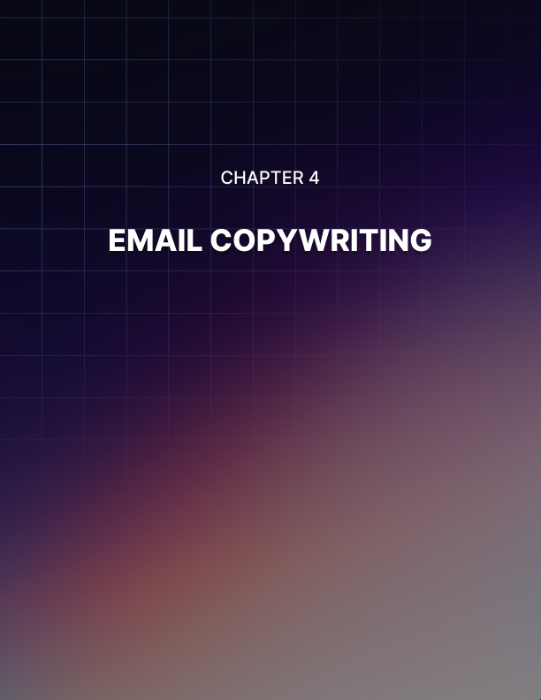

Lesson 4: Email Copywriting

If you are a marketer, then that makes you a writer.

These days there is no getting away from that fact – the two jobs go hand in hand and in order to be anywhere near effective at building and engaging an audience, you need to make sure that you understand how to write convincingly and how to grab attention.

This is especially true when it comes to your email marketing: a form of marketing that involves a lot of complex goals that are seemingly working contradictory to one another in many cases.

As an email marketer, you have been given privileged access to your subscribers’ inboxes. This is a huge gesture of trust and it demonstrates that your readers/visitors/customers must really enjoy your content and want to see more of it. They have given you their details because of that fact and because they want to get value from you.

So that is your first objective: to provide value without abusing that trust and without frustrating your subscribers.

At the same time though, you also need to fight to get your messages clicked. You need to make sure that your subject lines stand out among the other messages in their inbox and are interesting enough to be considered worth reading (while not looking like spam…).

Then you need to make sure that you are also able to persuade your audience and convince them to potentially buy from you, or to visit your site again, or simply to trust whatever it is that you’re saying.

Oh, and you need to write well as well. That means you need to write in a way that is captivating, entertaining, authoritative and accurate.

Over the rest of this report, you’re going to learn how to do all of those things.

How to Write Well
Is writing something that you can be taught?

Probably the best answer is a frustratingly non-committal ’yes and no’. That is to say that it can be very hard to teach someone to write well if they have no natural ’voice’ but in most cases, it will still be possible as long as they can grasp the basics and they have a decent command of English.

Problem is that this is going to take longer for some people than it is for others. And that means that in some cases, it will not be worth learning to write well from scratch. If you are someone that might be considered hopeless by your friends and contemporaries then it’s probably best just to hire a good writer.

Find a friend who speaks good English, get them to read a post you’ve written and then ask them to be completely 100% honest with you. If it’s terrible, then hire someone. If there’s hope, or you are a good writer, then continue and take on board some of these tips…

- Writing Should be Eﬃcient
The best place to start is by considering what the objective of good writing is. Writing is good if it manages to complete said objective, so what is it that you’re trying to do?

Usually, the most fundamental answer is that you want to impart meaning. You are trying to get your readers to understand something, to learn something or to think something and that all involves meaning.

In reality, nothing else really matters. And thus your objective should be to try and do this as quickly as possible and in as few words. Most of us are in a hurry these days and most of us have places we need to be. That means that we’re unlikely to have the patience to sit and dig through a massive paragraph of text and if your emails look like that, they’ll probably be ignored or binned.

Be respectful of your readers’ time then by getting them to understand the message you’re trying to convey as quickly as possible so that they are getting good ’value’ for their time. The more value you impart in the fewer words, the more likely they’ll be to want to keep reading.

So, look through your writing and ask yourself which words are entirely necessary and which need to go. Anything that is superfluous – that does not serve a specific purpose – should go.

- Vocabulary is Important
But this is not a ticket to write like a robot or to start writing in text speak! While your aim is efficiency, it is not necessarily brevity and there is still a place for flowery language and a large vocabulary.

Why?

Well, apart from the fact that it makes you sound clever – which in turn makes you more persuasive – using a larger vocabulary will actually help you to convey more meaning in fewer words. Why? Because you can choose words that provide a lot more value and
’do more’.

Not only that, but by choosing the right turn of phrase, you can convey more than pure meaning and also start to evoke an emotional response from your readers or to provide additional details. This becomes very important when you’re trying to write in a manner that is persuasive and engaging because it allows you to better motivate your readers and therefore make them more likely to buy from you.

The best way to improve your vocabulary is just to read more. Likewise though, it can also pay to become better at description and emoting – so try to really picture and feel the emotions that you’re trying to convey and the way you want to depict them.
- As is Tone
Also important is getting the right ’tone’. This means that your message should be on-point in terms of how friendly it is versus how formal. If you are writing about insurance and your target audience consists of big important business people, then you will want to adopt a more formal tone than you would for an email list about football or your favorite band. Make sure that your content fits the intended purpose and the intended audience.

Again, this is where good vocabulary can come in – it’s a matter of being able to choose the words that will be most comfortable for the audience reading them. A great writer is someone that writes for any audience and gets the same kind of positive response.

Note as well that things like perfect grammar actually don’t matter all that much if you’re aiming to be more colloquial. That’s because the way that you write is secondary to the meaning that you’re trying to convey. As long as your audience understands you and they feel that you’re on their level, then you will have done well.

How to Write Copy That Gets Clicked and Read
If you can follow the advice shared in the last section, then you will be an efficient and accurate English writer. That means that no one is going to read your content and wonder if you’re English… or over 10 years old.

But that in itself won’t help you to sell or even to get your messages read. The best writer in the world is not necessarily going to be a good salesperson and it’s our job here to marry those two distinct skill sets.

So how do you make sure that your content gets opened in the first place? How do you keep your recipients reading right to the end?

- Use Stories
One incredibly powerful tool is to use stories.

Stories are highly effective for a large number of reasons and sometimes storytelling is even referred to as ’SEO for the human brain’.

The human brain has evolved over countless years and all of our different psychological quirks and ticks that we carry with us are a result of that evolution. Now consider that we have been telling stories for generations and recounting our experiences this way: this is why the human brain loves story telling.

That and we continue to hear stories whenever we watch TV, turn on the radio or read the news. Stories engage us because they send signs that tell us they are important and relevant.

These are things that affect real people and so they may affect us? And because there’s that whole ’beginning, middle and end’ thing, we will almost always feel naturally compelled to stick around with a story until we get to the end.

So, the question now is how you’re going to use storytelling in your emails. Usually, the answer is to write the very same stuff, but to do it in a way that is framed within your own personal experiences or those of a friend.

Instead of saying that ’writing an ebook can make you rich’, explain how you got rich from an ebook and it changed your life. Which is most engaging and interesting?

- Provide Value
The next tip is to provide value. This may seem obvious but actually it’s something that a lot of marketers struggle with because they aren’t 100% sure what value actually entails.

What is value? How can you measure it?

The thing that everyone (hopefully) knows that they must NOT do, is to send emails that are nothing more than adverts for products. If you do this, then you are not providing value but rather spam.

Nearly everyone will ignore your messages and will likely hit unsubscribe because they won’t want to be pestered by you in the future.

But what’s also an example of not providing value is to write an email like ’How to Get Six Pack Abs’ and then list three different types of exercise.

Why isn’t this value? Simple: because it is generic and because it is content that most of us have read countless times before on other sites. It’s unexciting, unoriginal and it doesn’t build your relationship or convey that you have any useful knowledge beyond what the reader already has.

Think about it: if they can get the same information by Googling, then why would they subscribe to your mailing list?

Suddenly, this can create a bit of a challenging situation for you because now you need to continually come up with content that is going to be completely original or so jam-packed with value that it blows anything else out of the water.
In other words? You can’t fake it. You need to be an expert in your field or someone with truly unique ideas or you need to hire someone that is.

Always ask yourself the following simple question for your value litmus test: would you read it? If the answer is no, then go back to the drawing board and come up with something more interesting!

- Structure and Delivery
Finally, make sure that your content isn’t just read but is read all the way to the end. To do this, you’re going to need to fill it with things that are interesting and engaging but you’re also going to need to make sure it isn’t too long and that it is well spaced out.

That means lots of headings and lots of paragraphs. It means using bold titles and images and generally making sure that everything on the page is screaming for attention.

Think of this like arranging a shop window. A good store manager knows that if they have a ’top seller’, then they need to stick it right in the window so that people passing by on the street will stop and take a closer look. Hopefully they’ll see other things they like along the way.

So, in a similar manner, this is what you’re trying to do with your emails. You need to make sure that if you are providing amazing value, you are also conveying that value throughout the course of your messages. You need to ensure that people who open your emails will see lots of things that catch their eye and be able to jump in straight to those points.

Do all this and you’ll drastically increase your chances of actually getting read. Of course, you then need to think about how you’re actually going to sell as well – but that’s a conversation for another time…

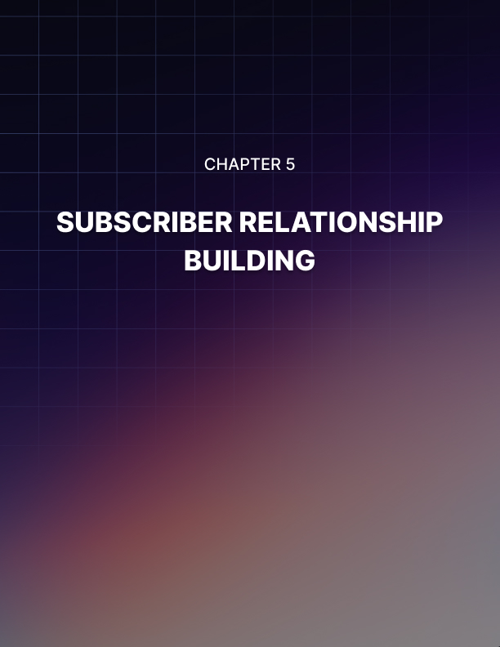

Lesson 5: Subscriber Relationship Building

Once you've built a high quality email list and you are ready to start emailing your fans, you need to think long and hard about what kind of content you are going to send. This is not just a matter of how to write a great email that will get opened and that will get read to the end – it means thinking about a long-term strategy that will gradually build more trust and develop the relationship you have with your audience. It’s about growing your connections and turning those initially cold leads into hot leads who are ready to buy from you.

So how do you go about doing this? Let’s take a look!

Understanding the Value of Your List
One of the biggest mistakes that many marketers will make when they start sending emails, is to spend too much time marketing and selling and not enough time building that relationship.

A lot of people will write to their subscribers and immediately try to sell something. That might mean that they promote something that they’ve made themselves, or that they recommend an affiliate product. In other cases, they might try to build hype for something that they plan to release in future.

Either way, this is often a quick way to lose followers and to turn off your audience. The problem is that no one likes being sold to at the best of times and certainly not inside their own inbox. If you were to get nothing but marketing messages from a contact, then would you see any good reason to keep opening them? Or would you eventually just stop looking at them?

Not only this, but sending nothing but marketing messages will cheapen the relationship you have with your followers. They will feel as though the only reason you were interested in them signing up was so that they could earn you money.

But on the other hand, if you write messages that actually provide value and that talk to the recipients, then this will be a great way to build trust and to engage your audience further.

And this actually earns you more from a business perspective in the long run.

Let’s say that you use your mailing list to try and sell a digital product that will make you $30. This might work and you might get a 10% conversion rate (which would be amazing). If you have 1,000 subscribers, then that’s $300 – not bad.

But it might also mean that a lot of those subscribers stop paying attention and it might mean that you ’blew your load’ a little too early!

Instead, focus on delivering value and building the relationship. This way you are increasing the
’CLV’ – the ’Customer Lifetime Value’. That means that you are creating customers that really love what you do and that will be likely to buy from you multiple times in the future. It also means you’re creating fans who will likely visit your site on a highly regular basis – and maybe even share your links on their social media pages and elsewhere!

Consider the book 1,000 True Fans. In this classic marketing tome, author Kevin Kelly explains that a brand with 1,000 true fans will always be destined to succeed and it will be almost impossible for it to fail.

So, what is a ’true’ fan? This is someone who will read every post you share, who will like every one of your Tweets, who will buy whatever products you put out and who will absolutely love your channel and what you do.

How does a true fan ensure that your business is a success? There are numerous ways. For starters, it means that your content will spread exponentially as people share what you’ve written and end up becoming ambassadors and promoters completely free of charge.

At the same time, it will guarantee a source of income. If you have 1,000 people who will buy nearly anything you create, then you will always be able to generate income – as long as you don’t take advantage of their interest.

Think of your first thousand true fans as being a tipping point – a threshold. Once you pass this point, you will find that everything you create in future gains more and more followers and your site begins to grow like wildfire.

This is why building true, loyal fans is far more important than simply focusing on trying to get a few quick sales. Don’t be short sighted – think about the long term and aim to build relationships that will last.

How to Build Real Relationships
So, you’re aiming for those 1,000 true fans and not trying to get a quick sale.

Now the next question has to be how you are going to go about doing that. How does this shift in objective change the way you work?

The first thing to do is to start writing your messages in a more personal and casual manner. People won’t be won over by your brand if they feel that it is completely removed from them. If you try and portray yourself as this big global brand, it will actually just alienate your audience and make them less interested in what you’re doing.

What’s more, is that this can often actually make you appear less professional. This is a big mistake that many small brands will make – trying to appear bigger than they are.

If you are one guy who runs a blog in the evenings and is trying to make some money on the side, then don’t say:

’We’ve been working hard to bring you this project’

Because you know what? People can tell that you are just one guy. And when you pretend to be bigger than you are, it hurts your reputation. It makes you sound like a kid who is trying to pretend they’re a big serious business.

Conversely, admitting you are one person and talking to your audience as human beings is going to help you to become more like-able and relatable for your audience. As a result, they will be more likely to want to help you to grow.

Another pointer is that if you use a more personal narrative in your emails, they are more likely to make it into the primary inbox. Use the recipient’s name by using the feature in your Autoresponder and write in a way that sounds like a regular letter. You know what makes a great subject line? ’Hi’!

Actual Communication
Also important, is to think about what an email is and how you can take advantage of the unique benefits of having one.

You know what email is for? Communication. And you know what communication is? Two ways!

In other words, if you can ask your recipients to message you back after they have received your correspondence then you will open up a communication that will let them feel as though you’re a real, approachable person. This will massively increase the trust, as well as helping your audience to feel as though you really value them.

So when you write your next email, why not include a message at the end asking your readers to respond with their ideas? Ask for suggestions as to what you should do on your blog or site next and maybe even ask for contributions or for help!

Doing this gets your audience involved in a big way and it will mean that they feel much more attached to your content and more like they are a part of your brand.

And of course, what is just as important is that you then actually look out for these messages and then you respond to them.

Suddenly, you have a two-way line of communication with some of your readers and that means that you can actually start to develop a real relationship. This way, you can get your audience to feel as though they actually know you. They’ll be far more likely to look out for your future messages and they’ll feel like an important part of your brand and the movement that you are promoting.

This takes time and it does mean that you’re now working even harder to not only send emails but also respond to the messages you get from fans and subscribers. But while this might seem like extra work, this is the kind of extra effort that will set you apart and help your site to grow at a much faster rate than the competition.

Things Not to Do
So that is how you go about building a relationship with your audience that is much more powerful and useful than the usual ’sending lots of marketing messages’.

But if you’re going to make the very most of this, then it is just as important that you consider the things that you must not do.

And there are a lot of mistakes that email marketers will make that can end up completely destroying all the good work they’ve put in.

Here are some things you should avoid doing…

Forgetting Your Account
One of the most obvious mistakes that a lot of marketers make is to go weeks or months without ever sending an email. This is a great way to fall off of your readers’ radars and to make them far less interested in what you’re doing. It will make you seem less professional and ultimately, it will lose you subscribers. When your remaining list sees a message from you months later, there’s a good chance they’ll be offended or upset by it – as though you were cold messaging them!

So be consistent and don’t let your mailing list turn into a ghost town.

Overdoing It
Similarly though, it’s also a mistake to send too many emails, which can quickly lead to your subscribers becoming irritated by your messages and wanting to unsubscribe. If you inundate your audience with messages then you are taking advantage of the relationship and of the trust and you will quickly get yourself black listed!

Likewise, try not to overdo it in terms of your content. Don’t send messages that are too long for instance or that contain too many large images. These will take a long time to read through and might even clog up your recipients’ inboxes.

Selling Things You Don’t Believe In
Eventually, there will come a time that you try and sell something from your blog. After all, this is a business proposition as your objective is to try and make a living from your brand.

And this is fine. People recognize this and they don’t mind being sold to – as long as you appear to really believe in what you’re promoting. What’s more, is that once your item has sold, it is highly important that it actually be good enough to be worth the money. If someone buys something on your recommendation and it is low quality or it doesn’t work… well then how likely do you think they will be to buy from you next time?

Breaking the Trust
There are many other ways that you can end up breaking the trust that you have built with your subscribers. An obvious example is if you pass on their email addresses to someone else. While it won’t be easy for your subscribers to find you are the culprit, if they do then it can completely destroy your brand – and it’s pretty obvious if they sign up to your list and they suddenly start getting lots more messages. So don’t risk it!

Okay, so there you have it: that’s how you go about building trust with your audience and getting them to feel that they are a true part of your brand.

The key thing to recognize here is that the relationship you are building is much more important than the direct sales you make. Think in the long term and focus on growing your engagement more than growing your profits and your numbers. Do this and you will create true fans that can help your business to explode!



Lesson 6: Autoresponder Sequence Power

There are lots of different ways you can approach email marketing and depending on the strategy you employ, the results can be very different.

One strategy that is actually somewhat underused and potentially very effective is to write an autoresponder sequence. What this means is that you are writing a series of emails that you will deliver automatically through your autoresponder without having to have any input in yourself. This will then help to build interest in your brand, engage your audience more and more and then eventually make a sale.

The sequence is going to trigger automatically as soon as the subscriber signs up and the best part is that you won’t even need to lift a finger!

Why an Autoresponder Sequence is Such a Good Strategy
There are many things that make autoresponder sequences a good way to go ahead. The first benefit is that autoresponder sequences involve less effort on your part. You don’t need to lift a finger like I said – and that means you can focus your efforts elsewhere. All you have to do is to create the email sequence in the first place.

Another benefit of an autoresponder sequence is that it can actually be more effective when it comes to introducing new subscribers to your list and it can be less alienating.

The problem with many email lists, is that they have a collection of both long-time subscribers as well as completely new members. Without an autoresponder sequence, you can't make sequential emails that refer to previous messages and you can’t build on ideas that you've laid out in previous messages because some of your visitors are going to be coming in halfway through. This is just like tuning into a movie and realizing that you are completely lost and have no idea who any of the characters are or how they factor into the wider story!

If you want to create an online course or some kind of lesson or story, you effectively need to use an autoresponder sequence.

Finally, an autoresponder sequence is powerful because it is consistent. This is the precise same message that is delivered to every single recipient on your list. And the reason that matters, is that it means you can tweak it, improve it and optimize it over time. In other words, if you find that people aren’t reading all the way through then you can try making a small change in order to see if that increases your engagement or your open rates. If that doesn’t work, then try making another change and seeing how that influences the data. In other words, you can iterate and tweak your formula to optimize it and create the perfect sequence that does whatever it is you've set out for it to do.

And speaking of consistency, autoresponder sequences are also very effective because they are completely consistent. That is to say that once you start sending an autoresponder sequence, it will be delivered at the same time and on the same day every single time meaning that your audience will learn what to expect from you and they will be able to enjoy high quality content that is predictable. This is one of the biggest tips in email marketing – being consistent – but it’s very easy to let it slip when you need to remember to manually write every single message!

Some Things to Consider
When creating your autoresponder sequence, there are a few things to keep in mind and to consider. This is a system that will work differently from other email messages and that means you need to approach it a little differently.

For example, when creating an autoresponder sequence, you need to make sure that it is 100% evergreen. In internet marketing, the term ’evergreen’ means that a piece of content is going to be just as relevant and interesting in 3 years as it is today.

So, a news story is not evergreen and neither is any story that references something that’s in the news.

Likewise, if you have written an email course that describes how to make money from a certain strategy, then you need to make sure that the strategy still works in a year’s time. This means you might need to update that strategy and make sure that it is working in the same way even when the next version of WordPress is released.

Another tip is to think about the types of content that lend themselves best to being shared in this manner. For example, courses tend to be very effective because they will come in steps and stages. The other great thing about a course is that it has very clear value and that it can act as an incentive in itself.

In fact, courses are something that we are used to paying for. So, if you’re told you can get one completely for free, then you might well feel as though you’re getting a very good deal and it’s worth signing up!

Likewise, any kind of series that imparts advice and ideas can also work well.

Finally, consider that your autoresponder sequence and regular email marketing need not be mutually exclusive. There is nothing wrong with having a welcome series to introduce new subscribers to your messages and then to send them handwritten emails subsequently once they've gone through your little initiation. At the same time, there’s nothing wrong with sending autoresponder sequences with your own personal messages interspersed in-between. This way, you can combine the benefits of an autoresponder sequence along with the benefits of having something that is manually written and where each message is unique.

How to Write the Perfect Autoresponder Sequence
With all that in mind, how do you go about making the perfect autoresponder sequence? Here are some tips that will help you to make the best first impression and to drive conversions and maintain engagement along the way…

Tease Your Next Message
One great strategy that often gets overlooked is to tease your next message. Another of the big strengths of an autoresponder sequence is that you will know with certainty what the next message is going to be about and when it is going to get sent.

That means that you can include a note at the bottom of your current message saying ’be sure to tune in next week for XXX’. This helps to build anticipation for what is coming up and it gives your emails a sense of sequence and importance.

Always Provide Value
This is the most important part of any email marketing campaign but it bears repeating here: it is always crucial that your email marketing campaign includes a tip of some sort, an actionable idea or some entertainment. In other words, you need to make sure that after reading your message, your audience feels that they spent their time well and they would do well to make sure they look out for the next message.

Along the same lines is delivering on your promises. You probably made certain promises on your landing page telling your audience what they would learn and why they should definitely sign up.

Make sure that you deliver on those promises in the actual content by doing the things you said you would do and by ensuring that your readers go away feeling more informed than they were before.

Be Conversational
This is once again true of most autoresponder sequences. It is very important that you give your email a conversational tone because it is going to end up right in the inbox of your recipient – which is a very personal place. This will help you to better build a real relationship with your audience and it will make sure that your emails aren’t filtered out by the spam filter quite so readily too.

Get the Welcome Message Right
Perhaps the single most important part of your autoresponder sequence is the welcome message. This is the point at which your new subscriber has just joined and they are going to get an early taste of what your series is going to be like. Getting this right is incredibly important because this is the email they are most likely to read and that will set the tone for everything that is to come.

Again, this is a fantastic opportunity to tease what lies ahead to make sure that your reader is excited and interested to look out for your future messages. Let them know the timescale and the subject line structure too so that they can actively seek out your messages and they won’t be as likely to get lost.

Also important in a welcome message is to make sure that you show your gratitude and you start out by building that trust. Invite them to message you if they have any questions and to get in touch if they want to strike up a conversation. This will help to make you feel like a real person (which is even harder when your sequence is being delivered automatically) and it will build more trust and a better relationship with your audience.

Consider Getting More Advanced
Autoresponder sequences don’t have to be the exact same for everyone. If you have a good autoresponder tool, then you should be able to introduce slightly more advanced features and options. For example, how about creating an autoresponder sequence that changes depending on how well engaged the user is? This way, you can try selling only to those subscribers that seem highly engaged.

Better yet is to use your mailing list in order to handle upsells. You can do this either with a secondary autoresponder sequence or one that responds to cookies and knows when a reader has viewed your checkout page. This allows you to follow up with a quick offer while the reader is in ’buy mode’ and therefore to capitalize on the sale.

How to Sell From an Autoresponder
Finally, the most important thing you need to learn is how to sell from an autoresponder series and more importantly: how not to. Unfortunately, this is something that is very easy to get wrong and if you are overly forceful in trying to push a product, you can upset your audience and lose subscribers.

What you need to do then is make sure that your autoresponder series builds the trust and provides value first. Think of this like a transaction where you are earning the right to try and sell to your audience. If you have provided lots of free, high quality tips, then your readers will usually be happy to consider buying from you – or at least just hear you out.

Even then, there is way to do this and a way not to do it. You need to make sure for example that you don’t announce your product or service out of the blue. Instead, weave it into your narrative gently in order to warm your audience up to the idea first.

You can use a strategy that is often referred to as AIDA. This stands for ’Awareness, Interest, Desire, Action’.

So, this means that the first email (after the welcome message) might provide a high value tip and some useful ideas and then mention that you've got something cool coming relating to X. The second email will then provide another tip or piece of advice, followed by a slightly longer section on what your product is and why it’s interesting. The third message can now include a shorter tip followed by a bit of exciting description of what the product is and why it’s desirable. Now you make your audience wait, which is a great way to build interest further and to get them to really want whatever it is you’re selling – we always want what we can’t have.

Finally comes ’action’. This final email is designed purely to sell the product and is all about getting the audience to act quickly while they are feeling emotive and impulsive. Get all this right and you can effectively sell without putting off your audience!

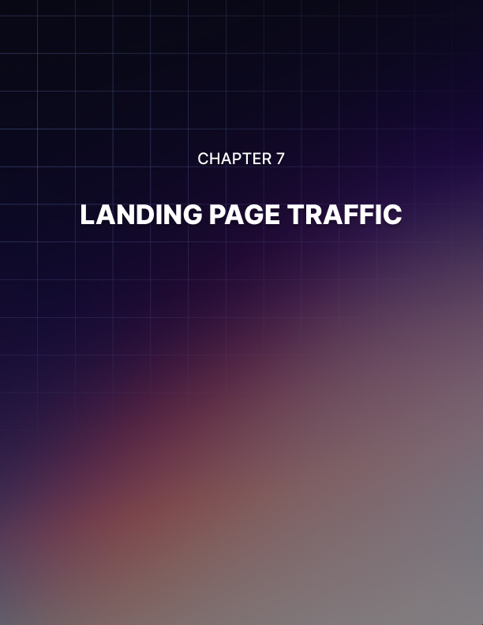

Lesson 7: Landing Page Traffic

Building a landing page to promote an email opt-in form is one of the simplest and most effective ways to grow a mailing list. A landing page is a page that is completely dedicated to helping you promote your mailing list and that will have no other distractions or purpose. This page is purely here to inform your audience about your mailing list and to encourage them to be interested in signing up.

If you do this well, then a landing page for a mailing list can have a high conversion rate, meaning that you might expect 1- 10% of every visitor to sign up.

This then means that the more people you can get to your landing page, the more rapidly you can grow your list and get more people to sign up so that you can build a relationship.

So how do you go about getting the maximum number of people to your landing page? And how do you ensure that the traffic you are sending there is the right kind of traffic that will be likely to sign up and that will actually read and engage with your emails once you start sending them?

In this report, we’ll take a look at some of the best strategies for doing this to help you build a massive and highly engaged list.

PPC
The first and easiest way to start generating traffic for any page is with PPC ads. PPC is ’Pay Per Click’ and this will generally refer to two different platforms: Facebook Ads and Google AdWords.

Any form of Pay Per Click advertising essentially means that you are paying each time someone clicks on your advert in order to be taken to your website. This is a powerful feature because it means that you now know precisely how much each visitor costs you.

And if you have been keeping track of your conversion rate – so that you know what percentage of your visitors end up signing up and becoming subscribers – then you’ll be able to calculate roughly what your individual subscribers cost you.

In other words, if you pay 10 cents for each click and your conversion rate is 1%, then you need to spend $10 for each new subscriber. If your conversion rate is 10% then that cost goes down to $1.

The next bit of math you need to do, is to work out just how much each subscriber is worth to you. You’ll do this by looking at your CLV – Customer Lifetime Value. This can once again be easily calculated by looking at some specific numbers. In particular, you need to consider how often a subscriber buys from you and how much profit you make from each sale. So if each subscriber buys 10 things from you on average in their lifetime and you make an average of $30 per sale, then your customers are worth $300 to you. If you’re paying $10 for each subscriber, then that’s a lot of profit!

Remember though, most subscribers will go a long time without buying anything and some might not buy at all. They still need to be calculated in your average, so in reality it will probably be much lower – closer to $15 per subscriber. As long as you’re making profit though, this is a good strategy!

When using Google AdWords to drive traffic to your opt-in page, be sure your page complies with AdWords’ guidelines.

Targeting
So PPC is a great strategy because it enables you to very precisely calculate how much each subscriber is worth and how much they cost you versus how much they earn you. But at the same time, it also has the huge advantage of being highly targeted. Now if you've been doing your research, you’ll know that the quality of a mailing list is much more important than its size. In other words, a good mailing list is one that is filled with engaged readers that are interested in what you’re offering.

Using Facebook Ads, you can decide precisely who sees your advertisements and target on the basis of age, sex, marital status, income, location and even hobbies and interests.

So, if you have a mailing list about martial arts fitness, you can make sure that the people who see it are young to middle aged and that they have an interest in fitness and in martial arts.

Suddenly, the conversion rate from those visitors will go up and so too will the open rate once you start delivering your messages.

Google AdWords works slightly differently because the ads aren’t placed on Facebook but are instead placed on Google on the basis of the search terms that people are looking for (called ’keywords’). There is some targeting built-in, but really the main targeting will come from the fact that the viewers are searching for specific things.

You choose the keywords that you want your ads to appear on in other words, so if someone is searching for ’martial arts workout’, you can rest assured that they’re probably interested in martial arts and in fitness.

This gives you less control over things like the gender of your viewers or their age, but what it does allow you to do is to aim adverts at people at the time that they’re looking for them. In other words, they are actively searching for something relevant to your mailing list at that point in time and so you’re not interrupting them at a point when they’re trying to chat with friends on Facebook or browse news.

This can help to make your landing pages convert more, but it is worth noting that these benefits mainly help paid products and free blogs. People don’t tend to actively look for mailing lists to sign up to. You can get around this to some extent if you offer a free ebook or report as an incentive, as this way you can then target search terms like ’fitness book’.

On the whole though, Facebook Ads are probably slightly superior compared with Google.

Blogging
While PPC ads are highly effective, they unfortunately do come with one major downside: they are not free. Blogging on the other hand is a method that you can use entirely for free and the only cost is the time that you’ll need to put in in order to keep your blog filled with great and interesting posts.

This is what is referred to in the industry as content marketing. Content is a powerful tool for bringing more people to your website because it appeals both to your audience and to Google.

If you want to get your site to show up for specific search terms as you do with Google AdWords, then actually the best way to do this is simply to do good SEO and to get there ’organically’. This means that you are adding lots of content to your site that is relevant to the search term and it means that you are going to build links pointing in toward your site. These two activities combined will give your site the attention it needs to grow on Google – but the content is what’s really key here because content is what most people are looking for when they search on Google.

What’s more is that content is what will keep people coming back to your site and help to build trust and interest in what you’re offering.

So, most people are going to find your site on Google because they’re searching for specific information or entertainment. They might look for the answer to a question for example and then if they enjoy what they read on your blog, they might decide that they’re going to look for more of your content again in future.

The next time they have that same question, they might go directly to your blog.

Only by continually impressing them and giving them lots of reason to keep revisiting can you get them to the point where they think that it might be worth signing up to your mailing list and that way being the first to hear about your new posts and your new ideas.

All that’s left for you to do is to link to your landing page from your blog post, or to place a link in your sidebar. Either of these options will ensure that people who come to your site to check out your content see that there’s a mailing list and have the option to sign up.

And don’t be afraid to simply remind people to sign up to your mailing list within your blog posts, or to tell them what your blog is all about and why they should definitely consider getting involved. If you can do all this, then you should find that you start to get more and more readers consisting of people who want to hear more of your ideas and information.

Solo Ads and Ad Swaps
There are many more forms of advertising you can use with your list too and some of these are specifically designed in order to work highly effectively with mailing lists.

One example is a solo ad. A solo ad is an advert that will appear in someone else’s mailing list. This is essentially a form of influencer marketing because the message will be spread by someone who has already done the work to build up a big list.

Solo ads can work well but only if you are careful about how you approach them. Always make sure that the email list you’re appearing in is one that has been built using the best methods and that is highly engaged and maintained. In other words, don’t pay to appear on a list filled with low quality contacts that never asked to be there. Try signing up to the list yourself first to check the quality of the messages and always ask to see metrics so that you have proof that the list is working.

Similar to solo ads are ad swaps. These are just like solo ads in that your ads will end up in the same place (on someone else’s mailing list) but they are different because you aren’t paying for them. Instead, you are swapping a shout-out for a shout-out and that means you need to share the message that you’re given with your audience in exchange for them doing the same. Again, do your research and look into the quality of the list before you agree to go ahead with this.

It’s also possible to pay for clicks from a number of sites. Good examples include Clickonomy (http://clickonomy.com) and Udimi (http://udimi.com). These sites provide you with a way to buy clicks that will take people to your landing page and the service is specifically designed to be used for email marketing as opposed to other forms of advertising.

One Thing Not to Do
This is a good strategy and it is much better than trying to pay for emails. In fact, the one strategy you should never use is to buy emails in bulk. When you do this, you are buying emails that have usually been captured through illicit means. In fact, some of these mailing lists will be resold – meaning that someone bought them simply in order to sell them on to you!
The problem with doing this is that the people now on your mailing list never agreed to be there in the first place and never showed any interest in your brand. This makes them essentially cold leads and that’s just the same as sending messages to emails that you made up out of thin air. Most of them will view your content as spam, many of them will simply bounce and this will badly hurt your sender reputation over time.

Always remember: the quality of your list is more important than how big it is. So if you are going to buy ads directly or indirectly, always make sure that they are going to be targeted and that they are people who really want to see your content.

The ideal situation is that you bring people to your site who actively search for content like the content you’re offering and who join your mailing list because they enjoy what you have to offer so much!

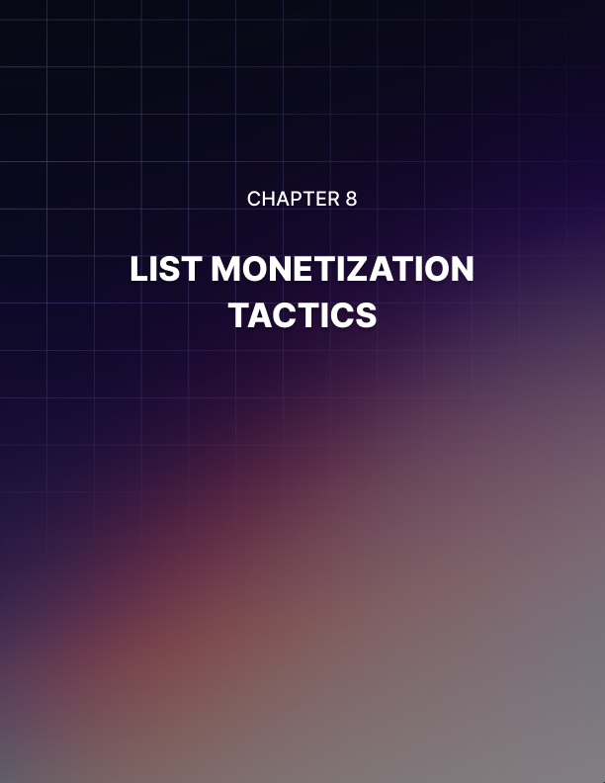

Lesson 8: List Monetization Tactics

Building a big mailing list filled with targeted subscribers that all really want to see more of what you have to offer is incredibly rewarding in itself. It’s a fantastic feeling knowing that people are looking forward to your messages and reading everything that you have to say with baited breath and it’s even better when you start to open up a two-way communication with those subscribers so that they’re responding to your messages and discussing the content you’re sharing.

It’s focusing on this – the long term building of relationships – that will eventually allow you to create those ’1,000 true fans’ and explode your brand into the stratosphere.

But while that’s all very nice, it’s also true that most of us need money in order to buy food and need food in order to live…

In other words, you’re going to need to monetize that list at some point and you’ll probably want to do this sooner rather than later.

So what are some monetization tactics you can use? And how do you go about monetizing your list without losing the trust that you’ve built or causing people to unsubscribe in a mass exodus? Let’s take a look at some of the best options out there.

Selling a Product
By far the best strategy of all when it comes to monetizing a mailing list is to create your own product and then to sell it.

Over the course of this report, we’ll see that there are plenty of other strategies that on the face of it will seem just as effective as creating your own product. Ultimately though, they will pale in comparison to creating something yourself and from scratch and the reason for this is that making something yourself means making something that you have completely control over. It will be up to you how you want to go about writing it, what hints and tips you want to include etc. Not only that, but it will be your voice in that ebook or that mailing list and it will be your advice and tips. This comes across and you should recognize that people really can tell the difference when you sell an ebook that you didn’t write – even if you edit it basically.

By creating something yourself, you can actually strengthen brand engagement by selling your product. You’re keeping people on your brand and your communicating the exact same message. You’ll know the book/course/report inside out and you’ll know how to perfectly promote it. What’s more, is that someone who has enjoyed your mailing list and decided to sign up is also likely to enjoy your ebook because it’s the same writer and the same kind of tips, style and advice.

Even if you buy an ebook and edit it, you can’t benefit from all those things.

And what’s more, is that when you create your own ebook, there are no overheads and there is nothing eating into your profits.

So, if you can create your own product: do. And then you can promote it through your emails in a way that will gradually build interest and finally encourage your audience to buy.

Best of all? This is the perfect opportunity to take advantage of the unique benefits that come from email marketing. In other words, why not ask your audience what they want to see from you and what they would be willing to buy? If you do this, then you can go ahead and create the precise product that your audience wants and massively increase your chances of making lots of sales.

PLR
PLR stands for ’Private Label Rights’. A PLR package is effectively a digital product that you are allowed to re-sell and that comes with all the rights. Not only that, but these rights entitle you to edit the package as you see fit and to put your name on it

A PLR product is slightly less desirable than a product you made from scratch. As we've already discussed, creating your own product allows you to maintain a consistent tone across everything you produce and it greatly increases the likelihood that your audience is going to enjoy the product that you sell them. It gives you much more freedom to position the product however you want and all this can help a great deal.
But PLR is also perfect in its way and specifically, it’s ideal for anyone who doesn't have the time, skill or inclination to make a product themselves. Some of us just aren’t great writers.

Others don't have the time to write a 10,000 word ebook along with multiple extra materials and full color covers to go with it.

A PLR product actually often packs in even more value by giving you all the extra materials you could want to sweeten the deal and extra materials that you can use in order to promote and sell the product. Specifically, you’ll often get access to a sales page with sales copy, to adverts, to emails, to free reports and more and you can use all of this in order to help your products sell.

Affiliate Marketing
Affiliate marketing is one of the most popular ways to earn money among internet marketers. This is similar to PLR in that you don’t need to create a product from scratch but it has the advantage of requiring no up-front payment and therefore being infinitely scalable.

The way this works is simple: you are effectively acting as a salesperson that gets commission on each sale. This is like going door to door in order to sell broadband, except in this case you’re usually going to be selling ebooks or online reports (digital products again) and instead of going door to door, you are simply using your own mailing list.

This works via a URL that will refer your subscribers to a site where they can buy products. When they click on this, they will be redirected and a cookie will be left on their computer, telling the seller that you sent them. If they make a purchase, that will be added to your profile, thereby increasing your overall earnings.

The great thing about becoming an affiliate though, is that it is endlessly scalable. Because you don’t need to buy PLR products or create your own digital products, you can collect hundreds or thousands of affiliate links with no limit. All you simply have to do then is to let your audience know about ’this great book [you] read’ and pass them the link.

Oh, and because the book isn’t yours, that means you don’t need to worry about returns or about people complaining about the product.
The other amazing thing about affiliate marketing, is that when you sell digital products, you’ll actually often get a HUGE amount of commission. In fact, many digital products will offer as much as 70% per sale or even more.

Note that when you sell affiliate products like this, you’ll often once again get access to lots of extras as well. Once again, this will often include things to help you sell the products more quickly and effectively – such as sales copy and advertising – as well as extra materials that you can offer. Often, becoming an affiliate will mean that you get access to special discounts and deals and you can pass these on to your subscribers in order to offer them some additional value!

To get started with affiliate marketing and to find a deal or product that you want to promote, check out JVZoo (JVZoo.com) or Clickbank (Clickbank.com).

Selling Physical Products
Now, you don’t only have to sell digital products when you have a mailing list and you’re an affiliate. You can also sell products through Amazon, which has an affiliate program called Amazon Associates. The commission here is considerably less (around 4- 8%) but there are some bonuses. For example, you actually make commission on every purchase that a customer makes when they visit Amazon from your link. So, if you recommend a book but the subscriber gets distracted and buys a widescreen television, you’ll get the money from that too! As long as it is during the visit that came from your link, you get the cash.

This means you could also get money from multiple purchases. So 8% might not sound like all that much but if it is 8% of a widescreen TV, computer and lifetime supply of cheese… that’s still a lot!

There are two ways to handle affiliate marketing through a mailing list. Either, you can build up each product and turn it into an ’event’ in much the same way that you might do for your own list, or you can simply drop the products into conversation and hope that someone clicks on them.

This might be as simple as saying ’I really enjoyed X product’ and then linking to it using an affiliate link. This can build you a bit of profit while you’re between big monetization strategies but the best part is that it won’t hurt your reputation. People know and trust Amazon and if you simply dropped the item into conversation rather than making a big deal of it, then it will seem more authentic and respectful.

Do try and avoid linking to multiple items in one email though. Apart from anything else, this is more likely to see your message end up in the spam or ’promotions’ folder.

Sell Ads
Finally, the last option available to you is to sell adverts that you will shout out to your audience. These are called ’solo ads’ and they can pay quite well if you have a large and targeted email list.

The only problem is that it can be very frustrating for your audience to receive unsolicited emails and this can end up leading to unsubscribes and complaints that hurt your sender reputation. Thus you need to be strategic: pick only advertisers that are relevant to your niche, use this monetization method sparingly where possible and try to work the ad into a natural sounding email that still provides value.

Discuss this with the buyer and make sure that they know your authenticity and integrity is not for sale!

Using all these methods, a mailing list can become a highly profitable endeavor and more than pay for itself. However, it’s also worth noting that there are many more ways that a mailing list can earn you money indirectly. Simply by engaging your audience with frequent and well-written messages, you’ll be able to build more brand loyalty and keep your audience glued to their screens. By doing this, you can actually get more visitors to your site and more sales from other channels. Even when you don’t see direct results then, keep at it!

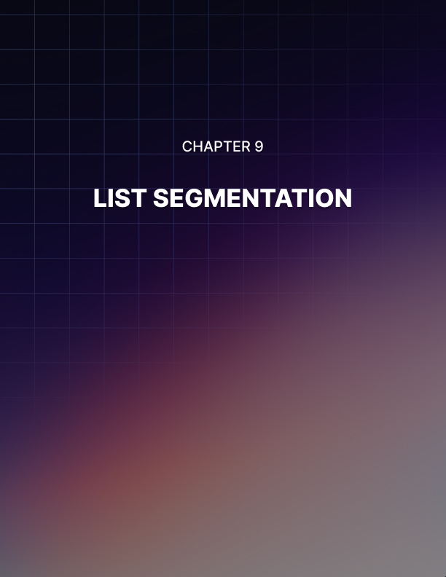

Lesson 9: List Segmentation

In the first report, we discussed the importance of email marketing and what made it so powerful even when compared to other effective forms of marketing. What we learned is that email marketing is not only more direct and more personal, but also a method that gives you a lot more control over the nature of your messages and the way you interact with your readers.

And one of the single most important aspects of that is list segmentation. List segmentation allows you to group the contacts that you are messaging into useful groups that can help you to better target your messaging going forward. In this post, we’ll take a look at the different strategies this can include and how you should go about executing them.

Targeting by Demographics
The first and most obvious way that you might segment your list is the same as you might consider focusing on specific targets for any other form of marketing – by demographic.

This is simple: you find out the names, the ages, the locations and the genders of your different subscribers and using that information, you then make sure that you are sending the right messages to the right people. The objective is to avoid ever sending anyone an email that they are completely unlikely to be interested in – so no trying to sell wedding dresses to young men.

Targeting is incredibly important when it comes to any form of marketing for this very reason – it allows you to decide precisely who sees each message and thereby to greatly enhance the chances of getting a conversion – convincing that person that they should follow the links and maybe buy the products you’re discussing.

This actually goes even further when it’s email marketing you’re talking about though. One reason for this is that in email marketing, you need to ensure that you are consistently delivering quality and value and that means ensuring that the messages are relevant to the people receiving them.

If you keep receiving messages that have nothing to do with you, chances are that you’re eventually going to completely unsubscribe. By making sure this doesn't happen, you ensure that people aren’t as likely to leave your mailing list.

How to Segment Your Audience
The next question is how you go about segmenting your audience in the first place. How do you collect all this information?

The answer is through your opt-in form, but there is a very delicate balance you need to walk here. If your opt-in form contains too many questions and asks for too much data, this can end up forming an unnecessary barrier between your potential subscribers and you. Either this is going to seem like a little bit too much work for the sake of signing up to a mailing list (which many people are dubious to do at the best of times) or it is going to seem like an invasion of privacy.

What you can likely get away with is just one or two questions such as gender, or perhaps age. The key then is to think about which questions are the most important for the sake of your particular campaign. Consider that your demographic information is on a tight budget… What is the most valuable to you?

Note as well that you can always get more information from specific users at a later date. You could do this by inviting your subscribers to take part in a survey (possibly in exchange for some kind of reward), or you could wait until they buy and then get information from there (such as their delivery address). You can also work out information through extrapolation. For instance, someone called Gary is probably male! Just make sure that whichever autoresponder you choose to use allows you to add this additional information later on as you go.

Finally, consider using multiple mailing lists. This is a very straightforward way to segment your contacts lists and means that you can keep your messages more niche. Instead of having a single messaging list on your site, why not have several? Or perhaps have multiple different websites, each with their own mailing lists.

So be careful about how you go about collecting data, but definitely look into doing it as it can be incredibly valuable going forward.

But while this is a very effective method, it is only one of several strategies that you can use involving segmentation.

The Way to Think About Your Subscribers and Leads
First, let’s take a look at what a lead is and what a landing page really is and how you need to think about it. Essentially, your landing page is a vehicle through which you are going to be converting ’cold leads’ into ’warm leads’ and ’hot leads’.

A cold lead is someone that you’ve never contacted before and that is discovering your brand for the first time. This is why it’s called ’cold calling’ – you are literally calling your cold leads. A warm lead is someone who has shown an interest in your brand and who has potentially given you the permission to contact them.

Finally, a hot lead is a lead that is ready to convert. A hot lead might also be someone that has bought in the past, or that has asked for more information about a product.

The thing to keep in mind is that you cannot convert someone directly from being a cold lead to being a hot lead. That is why email marketing is so important because it is what gives us the opportunity to trigger that next step where you warm our cold leads up. This is what preps a lead to be able to buy from us and where we start to convert them into buyers.

If we try to sell to them as soon as they land on our web page, then they will get frustrated at our lack of interest in providing value and look at the site as spam. Wouldn’t you, after all?

But if we don't attempt to hook the reader in at all, then they will likely simply leave the site and not come back! This is even worse in many ways.

The best way to think about this is to compare it to dating. Imagine that you see a woman/man that you’re attracted to in a bar. This person is your cold lead.

Now if you were to walk up to them and ask if they’d like to go on a date with you, or if they'd like to sleep with you, they would probably slap you. That's because you’re trying to convert them into a hot lead directly.

And if you talk to them but don't ask them for their number, then they'll leave and you'll never see them again. That’s because you never made the transition – they stayed cold.

But if you ask for their number, then you can contact them, build up a relationship and get them interested in you as a person. Now they’re a warm lead and now they’ll be much more susceptible to any requests for a date in future.

This is the exact same thing as collecting an email address before you try to sell to someone. It lets you build that all important relationship, it lets them learn about who you are and it lets them see why they should be interested in what you have to offer – and that they can trust you.

Why would a woman (or man) accept an offer for the date if they know nothing at all about you?

And why would someone buy from you if they've never heard of you before and they have zero reason to trust that you’re selling great products?

So, your landing page is crucial because it is what will allow you to build on your initial impressions and to create a relationship to the point where you can try and sell something.

Using This to Your Advantage
So, this is why the notion of ’types of leads’ is such an important one. But how do you use that to your advantage in your campaign? And what does it have to do with list segmentation?

Well, the exciting part is that most autoresponders actually allow you to segment your list based on what kind of lead they are.

This means that you can automatically sort your readers into cold, warm and hot leads and then only attempt to sell to the leads that are most likely to want to buy from you.

How can you know this? Simple: the autoresponder will calculate it on the basis of behavior. Using cookies stored on users’ computers, it is possible for your autoresponder to see who is most engaged in your content. For example, you might create a separate category for those users that read every single one of your messages and linger there for a long time, and then another for those users that never open any of your messages at all.

Likewise, you might be able to see which of your users have actually visited your site and looked at certain items in your store. These users that have lingered over items have likely considered buying them and thus might be ready for just that extra little ’push’.

And then there are the leads that have actually purchased from you in the past. These are particularly useful to separate from the pack because they have demonstrated an interest in what you sell and a willingness to pay. They've also already gone through the rigmarole of having entered their details and they know they can trust you (assuming you fulfilled their order on time and in good condition).

In other words, these readers are considerably more likely to be willing to buy from you again. But at the same time, it's also important to make sure that you have a note of what it is that they bought – because of course they are unlikely to want to purchase the same thing off of you twice and you need to ensure that you aren’t constantly trying to push the same item on them.

By using this information, you can then use segmentation in order to gradually move readers from cold to warm to hot. You can try using every trick up your sleeve (all of which will have been learned from these reports!) and then eventually you can get them more and more interested in what you have to say. Once they begin actively reading every message that you send them and once they start visiting your site to look at your products then you know that they’re likely to be interested in buying from you and it’s okay to go ahead and try to convert.

Oh and of course there are many more uses for this powerful feature too. For one, you can use this same data in order to look at which types of users are the most engaged and which types of emails are the most effective at increasing engagement.

In other words, which leads are the warmest? The women or the men? Which convert most often? Knowing this can help you to target your future marketing activities better.

Likewise, you can use this information in order to create entirely automated autoresponder sequences. These are sequences of emails that will be sent out automatically and in a set order as soon as someone signs up. When used correctly, these can allow you to take a list of contacts from being cold to hot all without lifting a finger and by combining it with useful information and segmentation, you can ensure that your autoresponder sequence only tries to sell at the point when your individual readers are most convinced by your value and therefore most interested in potentially buying from you.

So, there you have it: segmentation is another incredibly powerful tool for your email marketing campaign and one that can make a huge difference to your success. Make sure you are targeting your messages for the right audience members!

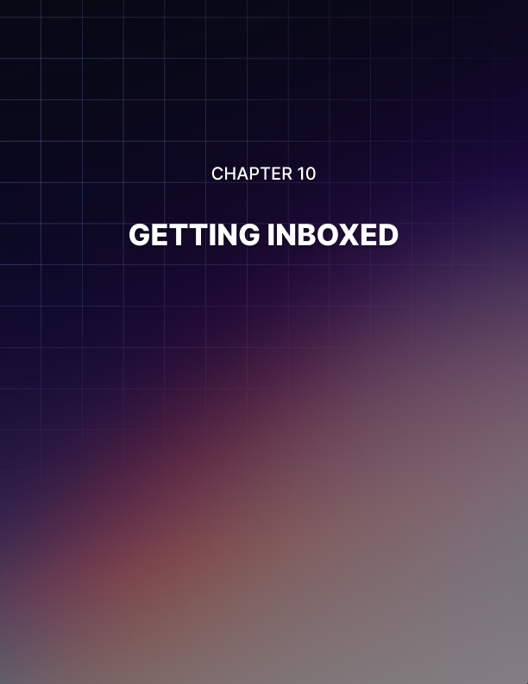

Lesson 10: Getting Inboxed

As an email marketer, your job is to write highly engaging contact that will grab the attention of your readers and make them want to click and then keep on reading. That means you need to know how to write a great subject heading that really jumps out at the reader and it means you need to know how to write a fantastic email body that provides value and makes the reader glad they decided to click!

But none of this is going to be worth anything if you don’t also know how to get your message into the inboxes of your readers. This is absolutely essentially, seeing as you can’t very well build trust or make conversions if none of your emails get read!

Before your subject line can have any impact on your readers, it first absolutely needs to make it into their inboxes. Even the most eye-grabbing heading in the world won’t work if it doesn’t get seen.

Problem is, there are quite a few challenges that you will face if you want your messages to show up in the inboxes of your contacts.

The first and most obvious challenge is the spam filter. Spam filters are built into pretty much every single email client and their job is to make sure that our mailboxes are filled to the brim with spam trying to sell us Viagra and handbags, or ’Nigerian princes’ that are giving us millions of dollars…

Problem is, these spam filters can be a little too effective sometimes and end up blocking content that the recipients actually agreed to receive – just like your messages!

This is one issue. The other issue is the fact that most inboxes are now divided into multiple sections. These days, providers like Google Mail and Outlook will divide messages into ’Primary’, ’Social’, ’Marketing’ and other subcategories. Users can create their own categories sometimes too.

The idea behind this is that it prevents us from getting notifications every single time that we get a new message from Facebook or every single time we get any kind of new sales attempt.

This is useful for most of us as we would otherwise be inundated with messages throughout the day. However, it is actually not such good news for us marketers because the fact of the matter is that few people will check their ’social’ inbox on a regular basis and the same goes for the ’promotions’ inbox. Think back to your own use, when was the last time you clicked on one of these?

That means that to all extents and purposes, it’s not much better getting messages into ’Social’ than it is getting them into ’Spam’!.

In this report, we’ll look at how you can not only avoid the spam folder but also get yourself into the ’Primary’ folder!

How to Avoid the Spam Folder
First, let’s start with the basics and look at how you can avoid the spam folder.

We need to think like a programmer here and consider the way that the filter has been designed and what tools it might use. A good place to start is by asking what the folder is for. What is the objective of the spam filter?

The answers are:

  - To keep out unwanted marketing messages that were unsolicited
  - To keep us safe from viruses and phishing scams

If you've been following the advice I've been sharing in these reports, then your mailing list should be filled with contacts that actively invited you to contact them. In other words, it shouldn't involve sending unsolicited messages at all.

And what this means is that you don’t belong in the spam folder. So that’s nice to know!

But there are a few things that might end up making the filter mistake you for spam. One such thing is the inclusion of certain keywords. The spam folder looks for keywords like ’shopping’, ’buy’, ’free’, ’Viagra’ etc. and will then block those emails on that basis. Think of this like ’reverse SEO’ and after you’ve written your message, scan through to check for any words that might look like spam.

Similarly, you also need to avoid trying to use cheap tactics to get readers to look at your subject line. Avoid using multiple exclamation marks or all-caps as these are things most people don’t want in their subject line and that might look like spam.

In order to protect users from viruses and other types of attack, spam filters will also look for other tell-tale signs. These include things like very long documents and certainly attachments. You also need to be careful about using images – because spam filters can't read what the image is of, it might treat it suspiciously.

Of course, it is okay to use images in some cases, but avoid large image files and make sure that there is a good ratio of text to images.

To an extent, it is impossible to be 100% certain that you have effectively managed to avoid the spam filters. The best thing to do then is to write in a way that is natural and that offers value to the reader and then to just hope that the spam filter sees that.

Email Sender Reputation
There’s another big factor that can have a large hand in affecting your deliverability and this is something called your ’email sender reputation’. Essentially, the email sending reputation works a lot like a credit score. This is a score that is shared between email providers that will allow them to get an idea of the kind of content you are sending. If you have a bad sending reputation, then it means that you've sent lots of spam emails in the past and you are going to be much more likely to be blocked or dropped in the spam box.

But if you send a lot of high quality emails that get read and provide value, then your sending reputation will be good and that means your message will be much more likely to get let in and you’ll be much more likely to get read.

The first thing you need to do is to try to ascertain what your score might be like in the first place. This score is tied to your domain, so it's important that it’s good or you'll need to set up an entirely new email address and transfer your contacts over – which will in turn confuse your subscribers and hurt you badly.

Take a look at your open rates. The industry standard open rate is around 20%, so if yours are much lower and have been diminishing over time, this is a bad sign.
If you are concerned, then you can try using a number of different sites and tools such as ’Return Path’. These claim to be able to give you a reliable score but often it will be clear simply from your statistics.

How to Improve Your Sender Score
So how do you go about improving your score?

One of the first and most important things to do is to look for the email addresses that are bouncing and to remove them from your list. These are the people that have either closed down their email or that sometimes used a fake account when they signed up (this is why it’s very important to use double-opt-in when set- up your mailing list). When an email bounces it hurts your sender reputation, so it’s very crucial that you keep on checking which accounts aren’t working and you remove them from your list.

Almost as bad as returned and bounced emails are emails that never get opened. This is why it’s so important to ensure that you use subject lines that engage your audience and that you build trust with your subscribers so that they want to hear from you in future.

A lot of this comes from forgetting all of the attempts to ’hack the system’ and instead just concentrating on delivering value for your end users.

Of course, getting blocked is also very bad for your score, as is receiving a complaint. Once more this points to the importance of quality over quantity when it comes to your contacts. You need to build lists that are filled with people who want to hear from you and who love your content. You need to avoid inundating people with nonsense they never asked for and that is just trying to ram sales down their throats.

The worst case scenario is that you get blacklisted. There are various sites that will help you to see if you’re on a blacklist and if so, then you’ll either need to contact the owner of the site that blacklisted you to try and get yourself removed or just set up a new email address. At this point, that is probably the best strategy.

One trick that some email marketing will use is to ’warm up’ their IP address/domain name. You do this when you start out by sending your emails out only to your best contacts – people that you know will open your messages. This way, you can get some good metrics out there early on and keep on impressing as you build momentum. For a similar reason, it is always a good idea to get your friends and family to sign up to your mailing lists and to ask them to actually open your messages and read them!

Finally, try to ensure that your messages are sent regularly and consistently. This is another good sign and it’s something that both your recipients and the email clients appreciate.

Getting Into the Main Inbox
Now your final challenge is to try and get your messages into the ’Primary’ inbox rather than social or marketing.

There are a few small tricks that you can use to increase your chances of getting into this inbox.

One is simply to mention the recipient by name. This is a feature that most autoresponders will offer and its benefits go beyond just improving the friendly tone of your messages.

Similarly, it’s a good idea to try and structure your messages like a letter, rather than structuring them like a newsletter. That means writing the person’s name followed by a comma and then talking about the things you’d like to let them know.

Again, images can be iffy here. Many sites recommend removing them entirely but looking at my primary inbox right now, several messages with images attached have made it through. The take- home is probably just to use images sparingly and knowing the risks that they represent.

Try not to include more than one link, keep all your messages nice and short and don’t try and sell anything – it’s super hard to sell things without using any of those negative keywords that we touched on.

But you know what the VERY best way to avoid the Social inbox and the spam filter is? The very best way to make sure that your readers are actually receiving your messages?
That’s just to ask them to consider adding you to their primary inbox. That sounds pretty simple but it’s something that a ton of marketers forget – just like they forget that they can ask people in their posts to sign up for the mailing list.

So, just mention in your email that you want to make sure your readers get your messages and that you’d really appreciate it if they would add you to their primary inbox and ’whitelist’ future messages for you.

You can even tie this in with the sign up process: if you use a double opt-in, then mention to your readers that they need to look for the confirmation inbox in their spam folders and other inboxes and that they might want to consider whitelisting you at that point to ensure that they don’t miss future correspondence from you.

Nothing is foolproof, but if you keep all of these tips in mind and ensure you are delivering great value then your likelihood of getting seen will go up immensely. Good luck!

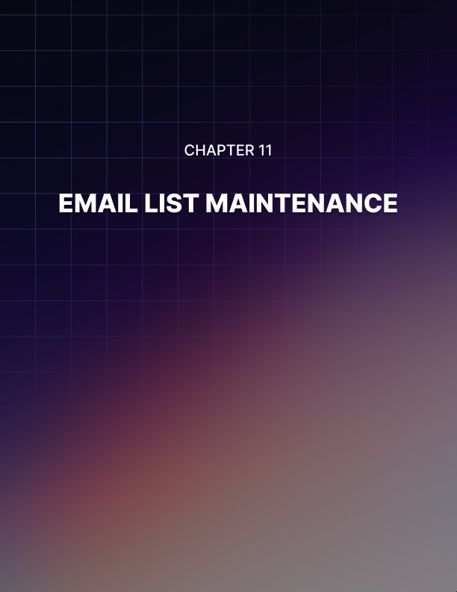

Lesson 11: Email List Maintenance

How is your email list hygiene? What’s that? You didn't know that an email list could be unhygienic?

Email list hygiene essentially means making sure that your email list is not only ’clean’ but also targeted, engaged and effective. What you need to realize is that a mailing list’s value is not at all based on its size. You can have a huge mailing list but it can still be worth very little to you if it is filled with people who don’t read your messages and who don’t really want to be there.

A list with ’bad hygiene’ is one that you have fought tooth and nail to build but while focusing purely on the numbers without giving any thought to whether those recipients are targeted and whether they actually want to be on your list at all.

What’s going to happen when you send that list a message? Probably the same thing that happens when you get unsolicited in your own inbox – it gets ignored. Some of these emails meanwhile are likely to be completely abandoned, meaning that the messages will simply bounce. Some users will complain, or they’ll send your email to trash. And generally, it will be a waste of your time.

But it’s actually much more destructive for you than that even…

Why Email Hygiene is So Important
Not only will poor email hygiene not work in the short term, but it can also lead to serious damage in the long term. We touched on this in a previous report where we discussed the issue of trying to avoid getting your messages sent to spam.

’Sender reputation’ is a score that is shared between email providers and that works very similarly to a credit score. The idea is that email providers and clients share your details and how your emails are performing. If it is found that emails from your IP or domain name are consistently being blocked and consistently being ignored, then this will result in a bad sender reputation. It may even lead to you getting completely blacklisted by some providers.

And guess what? This now renders your email list almost entirely useless as none of your messages are now going to reach their recipients. If you’ve been building your mailing list up over a long time, then you will lose all that hard work because now you’re not going to be able to reach any of the contacts on said list.

Even when you do get through, if most of the people who receive your messages simply ignore them, then this will ultimately amount to a waste of your time.

Then there’s the fact that poor hygiene will damage your statistics and metrics. A big part of succeeding in email marketing – or any form of marketing for that matter – is being able to reflect on the numbers that you see when you send your messages. Ideally, you should be able to see what percentage of your messages are getting through, which types of message are most successful etc.

But if your messages aren't getting through at all, or they're getting through in very small numbers, then you won't have the data to crunch. It might be that women don’t respond as well to your messages, or it might be that the women you added to your list never had any interest in your brand.

If you ever come to sell your mailing list as an exit strategy, then you’ll find that smart buyers will always want to see details like open rate etc. This means that poor email hygiene will render your mailing list effectively worthless and ultimately prevent you from getting any profit from it.

So, with all that in mind, quality is much more important than quantity when it comes to your list. And that means watching your hygiene.

So how do you go about maintaining your mailing list and keeping the quality there? Read on and let’s find out!

Top Ways to Maintain Email Hygiene
Never Buy Emails
The first and most important rule for good email hygiene is that you must never buy your emails. This is crucial because buying emails is always going to render them completely worthless to you.

If you buy a mailing list that someone else has collected, then chances are that the list will have been built using bad practices, resulting in something that won’t be effective and that is likely to already contain lots of defunct or abandoned email addresses.

But even if the mailing list you buy has been built with the utmost care and attention, the fact remains that it’s not your mailing list. This is not a mailing list filled with people who love your brand and who were won over by your amazing content. And that matters because that is the kind of list that is ultimately going to result in conversions.

If you signed up to a mailing list called ’Health Forever’ then you are going to ignore messages from ’Fitness Planet’ because you have no reason to trust that brand. You might even be offended at the fact that you are receiving messages from someone you never invited to contact you.

So, rule one is never buy emails.

Use Double Opt-In
A double opt-in is a two-step process for getting people to sign up to your mailing list. This essentially means that all new users will need to first sign up and then respond to a confirmation email.

Many people will initially balk at this idea. Of course, by introducing an extra step during the sign- up process, you are actually going to deter some people from signing up who otherwise might have.

But at the same time, having a double opt-in process means that you will only get people who are really committed to your brand. It means that if someone never checks their email, or if they are only in it to get your freebie, they will be filtered out by the process.

More importantly, double opt-in prevents people from accidentally miss-typing their emails when they sign up and it ensures that they don’t use fake addresses. It also means that you won’t get robots signing up and then responding to your messages with spam.

All of this results in a mailing list with a significantly higher open- rate and much lower bounce rate.

Avoid Overly Tempting Incentives
One of the primary strategies that many marketers use in order to grow their mailing lists, is to offer some kind of incentive.

Usually, this will be a free ebook or possibly a free report, and that in turn will provide some kind of value in exchange for the member signing up.

However, if you make this incentive too tempting, then you will get a situation where people are signing up purely because they want to get the free stuff and who have zero interest in the messages you send subsequently.

The best incentive is one designed to simply encourage someone to sign up who might otherwise have been on the fence. The idea is to provide a slight nudge to get someone to come to the right decision when they were already considering it.

Better yet, is to use some kind of incentive that encourages the recipients to answer their emails. For example, this might mean that your new signees sign up for a mailing list with useful and interesting news. Or it might mean that your subscribers sign up to enter some kind of raffle. Or perhaps it’s an online course?

Whichever of these options you pick, you have now created a situation where people will be eager to sign up and will then be motivated to look out for every message you send – creating a much more engaged list.

Look at Your Stats
If you log into your Autoresponder of choice, you’ll find that you have the option to look at specific stats for your messages.

These will include stats about your most recent messages and will let you see such things as the number of messages that got delivered and the stats that you received about that.

This will show you the open rates as well as which users are clicking on your links etc.

This is important firstly because it will let you see which of your subscribers are never clicking on anything and never opening your messages. These are your least engaged subscribers and the easy solution is just to remove those members from your list.

It’s also important because it will allow you to see which of your emails worked best. Which kinds of headlines grab attention the best? What times are your emails most successful?

Once you've figured this out, the next step of course is to do more of that.

Re-Engage Your Subscribers
Before you go ahead and delete all of those unengaged subscribers though, it can be a good idea to first try and win them back however you can. See if you can ’re-engage’ those disconnected subscribers and get them to sit up and pay attention to your mailing list again.

One excellent way to do this is to do a giveaway. This means offering your subscribers something for free and making that very apparent right in the subject line. Mention in that heading that you have a free gift they can download and direct them to where they can find that – it’s a great way to get people to wake up and to win over good will.

Another tip is to just try switching tack with your mailing list. That means trying a different approach from what you usually use, as this will help to make your recipients see you in a different way.

For example, if your emails are usually very ’newsletter-like’ with lots of images and links, then why not try something a little more simple and casual? Likewise, if your messages are normally brief updates, then how about sending something that’s a bit more formal? This can help your message to stand out and grab attention, potentially re-awakening interest in what you’re doing.

Target Your List Building Activities
When building your list, it’s important to think about how you’re marketing it, how you’re presenting it and how you’re selling it to your audience. In other words, you need to ensure that your list marketing is targeting the right kind of recipient so that the people who sign up are the right age, right sex and have the right interests. If you use Facebook ads for instance, then this is a very easy way to think about that.

Be Consistent
Be consistent with your messaging and make sure that you are sending your messages weekly or monthly and with a similar style. This will ensure that your audience knows what to expect from you and when and it will help you to keep your audience engaged and more effectively weed out the people who aren’t at all interested.

Provide Value
As with most things in internet marketing, the most important tip is simply to ensure you are providing value. Make sure that the content in your emails is good and that people really want to read it.

This will ensure that people sign up for the right reasons. It will ensure that they keep reading and it will generally help you to keep growing and avoid stagnation.

What you mustn’t do is to ignore your email list for long periods of time, to send out spam or to consistently market toward your audience. This is a quick way to lose the contacts that would otherwise have been high value subscribers and it can completely destroy your email marketing efforts.

Follow all these tips and you’ll keep a clean list, filled with people who are excited and grateful to receive your messages. It is MUCH better to have an email list with 10 people who love your site than it is to have a mailing list with 1,000,000 people who don’t care about it at all!

