Disclaimer

This ebook has been written for information purposes only. Every effort has been made to make this e-book as complete and accurate as possible.

However, there may be mistakes in typography or content. Also, this e-book provides information only up to the publishing date. Therefore, this e-book should be used as a guide - not as the ultimate source. The purpose of this e-book is to educate. The author and the publisher do not warrant that the information contained in this ebook is fully complete and shall not be responsible for any errors or omissions.

The author and publisher shall have neither liability nor responsibility to any person or entity with respect to any loss or damage caused or alleged to be caused directly or indirectly by this e-book.

Table of Contents

Introduction 6
More Than Email Marketing 7
Chapter 1: Professional Email Marketing 11
Becoming a Master Email Marketer 13
Chapter 2: How To Build a List Of Eager Subscribers 16
Crucial Things You Need To Do To Build Your List 18
Chapter 3: How To Get Your Subscribers Begging For More 22
How To Grab Your Reader's Attention With Your Subject 24
Using Articles To Build and Engage With Your List 26
Chapter 4: Content Writing and Editing 30
Skills For Effective Email Writing 30
Copywriting In Emails 31
Marketing Copy In Your Emails 32
Chapter 5: Writing Engaging Emails 35
Writing Emails That People Actually Read 36
Chapter 6: Things To Avoid When Emailing Your List 39
Staying Within The Lines 41
Chapter 7: Target Your Email Marketing 45
Types Of Email Marketing 46
Conclusion 50



Introduction

Deciding whether or not email marketing is a good idea for your business can be a difficult process.

The concept of email marketing is very simple to understand and the process of determining whether or not it is right for your business can be significantly more complicated. This is because you have to consider a number of different factors before making your decision.

You should consider your target audience and their propensity to use the Internet, whether or not your message can be effectively stated in an email and whether or not your message is likely to be misinterpreted as spam. All of these factors are important and can help you determine whether or not email marketing is right for your business.

One of the most important factors to consider when deciding whether or not to invest your money, energy and time into email marketing is your target audience and how likely they are to use the Internet regularly.

This is important because an email marketing campaign is not worthwhile if members of your target audience are not likely to use the Internet to purchase or research the products or services you offer.

Even if the use the Internet for other purposes it is not worthwhile because they will not be likely to become online customers for your products or services.

However, if you have a target audience who is very likely to use the Internet to purchase the products or services you offer and to research these items, an email marketing campaign is a good idea.

In this case it is absolutely worthwhile because you will be providing information which the members of your target audience will find useful and which they may already be looking for elsewhere.

Next you should consider the products and services you offer in an attempt to determine whether or not your message can be effectively stated in an email. This is important because if you offer a product or service which is difficult to explain, the emails you use for marketing are not likely to be understood or well received by the recipients of your email distribution list.

This is important because you want to be able to convince potential customers of the need for the products and services you offer, not make them feel more confused.

Finally, an important concept to consider is the possibility that your email messages will be viewed as spam. This is a very important concept because emails which are viewed as spam are not likely to be well received by the recipients and may not ever even make it to the recipients if their spam filters tag these emails as spam.

Even if the emails do reach the intended recipients, many Internet users have grown accustomed to weeding out spam rather quickly and will be quick to delete, without reading first, emails which are suspected to be spam. In determining whether or not your emails are likely to be viewed as spam, it is important to consider the subject of your business and therefore the emails you send out.

This is important because certain subjects such as weight loss pills are likely to be viewed as spam more quickly than other items. If you are in the business of marketing products or services which would likely cause your emails to be deemed spam, orchestrating an email marketing campaign may not be worthwhile.

More Than Email Marketing
If you have already entered the world of email marketing, you likely already realize the potential this type of marketing has to offer. However, you also likely realize it is not reasonable to expect your business to thrive if email marketing is the only marketing strategy you choose to utilize.

This is not unusual as most businesses do not typically have a great deal of success unless they make the decision to incorporate more than one type of marketing into their overall marketing strategy. This chapter will examine a few other types of Internet marketing which may be used in conjunction with email marketing.
Email marketing in itself can be multi-faceted. It may include sending out mass emails, distributing newsletters and even offering correspondence courses via email. Implementing only one of these email marketing strategies may result in a small increase in either website traffic or sales but implementing more than one strategy at a time can create a more pronounced effect.

Similarly, it is definitely worthwhile to incorporate other types of Internet marketing into promoting your business online if you are not already doing so. This can help you to enjoy a greater degree of success if you apply the strategies correctly.

Some of the other types of marketing strategies you may wish to employ include placing banner ads, participating in industry related message boards and starting an affiliate program.

Of the other types of Internet marketing available, placing banner ads may be the most expensive option. In many cases your business will have to pay another website for the privilege of placing your banner ad on their website. Choosing a website which sells products which complement, without competing, for your business is worthwhile. However, there are some free options for banner ads including exchanges.

However, you may be required to place more than one banner ad on your website for each time your banner ad appears on another lineup. Additionally, with this type of agreement you may not be able to control the type of website which displays your banner ad. For this reason, it is worthwhile to pay for ad space so you can have more control over where your banner ads are displayed.

Participating in industry related forums can be another way to promote your business online. Message boards are online meeting places where individuals who share an interest can get together to discuss their interests as well as pertinent issues. They can also ask and answer questions.

Most message boards allow users to place a link to their website in their signature line. If you regularly participate on an industry related message board and include a signature line with a link to your website you can reach a high concentration of members of your target audience.

When using message boards to promote your business it is important to follow all message board guidelines and to avoid techniques which may be deemed as spam such as posting your link when it is not appropriate.

Affiliate marketing programs are another type of online marketing which can be used in conjunction with email marketing. Affiliate marketing involves allowing website owners to place advertisements for your business on their website. These website owners are known as affiliates.

Each time one of their advertisements causes an Internet user to click through the advertisement or purchase an item the affiliate is compensated. This compensation schedule makes affiliate marketing incredibly cost effective.

Essentially you do not pay your affiliates unless the advertising generates a specific reaction from users such as making a purchase or generating website traffic. The amount of compensation should be determined beforehand and may be based on a flat fee or a percentage of the sale.

Business owners have to embed code into the affiliate ads to determine which ads are generating profit or traffic, so they know which affiliates to compensate but this information is also useful for determining which advertisements are most effective. This information can be used to fine tune the marketing effort.

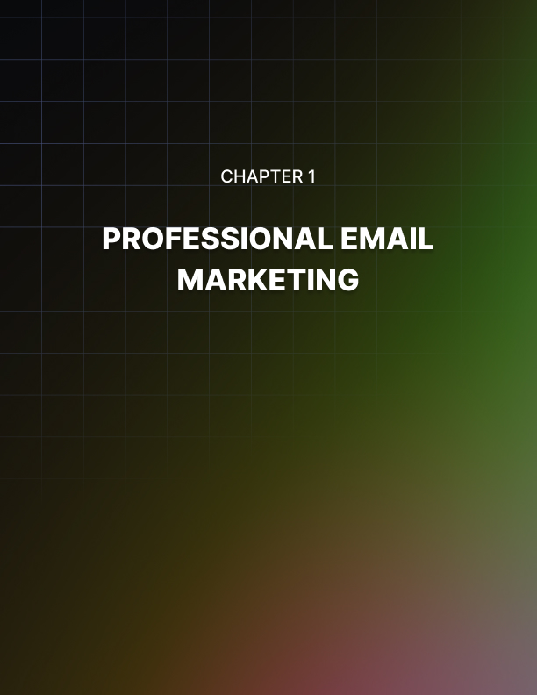

Chapter 1: Professional Email Marketing

Even if you are already running a successful business, you may be surprised to learn your business can benefit greatly from orchestrating an effective email marketing campaign.

An email marketing campaign and a number of different advantages including the ability to reach a worldwide audience, a variety of different marketing options at your fingertips and the ability to do a great deal of marketing with very little investment dollars.

This chapter will take a look at all of these different topics to provide insight into how email marketing can benefit your business.

For many business owners one of the most prominent advantages to email marketing is the ability to reach a worldwide audience with minimal effort.

While traditional marketing methods such as television advertisements, radio advertisements and advertisements in print media are typically targeted at a rather small geographic area, email marketing can reach a worldwide audience.

It is possible to reach an audience of this magnitude with other marketing methods, but it would be much more complicated to do and would likely involve launching advertising campaigns in several different markets. This is possible but would require an intense coordination effort and will likely require at least a few staff members to assist you in this effort.

Conversely, the ability to transmit instantly via email can make it much easier to reach target audience members with literally just the click of a mouse. The act of creating the marketing materials for your email marketing campaign is significantly more involved but once this is done reaching members of your target audience is quite simple.

Another advantage to email marketing is there are a multitude of advertising options available to those who wish to utilize this marketing strategy. The most commonly used method of email marketing is sending out group emails with product information and other promotional materials.

However, another way to approach the concept of email marketing is to publish and distribute newsletters to interested email recipients. A newsletter is typically much more in depth than the type of information which would normally accompany a promotional email.

These newsletters typically feature at least one in depth article as well as a few shorter articles which either offer useful tips or review products. Additionally, there may be some graphics, advertising and links included in the layout of the newsletter.

Email marketing campaigns can also take the place of email correspondence courses which typically focus on one niche subject and feature a few installments which provide detailed information on a specific facet of the niche subject.

Finally email marketing can benefit your business because it is an extremely cost- effective method of advertising. When you opt to orchestrate an email marketing campaign you will likely invest money in hiring professionals such as writers and graphic designers to assist you in creating content and an appealing layout for your promotional emails. However, this is typically not more than you would invest in hiring the same type of personnel for an offline marketing campaign.

However, unlike offline marketing methods there is not a great deal of cost associated with executing your email marketing campaign. Consider the creation of a television commercial where you will have to pay fees and purchase advertising space to allow your advertising to reach the public.

However, when you transmit your advertising via email, there is virtually no cost associated with this transmission. There are of course costs associated with maintaining an Internet connection and retaining employees to send these emails, but these costs are minimal and can be considered to be part of normal operating costs.

Becoming a Master Email Marketer
Do you understand email marketing? If you do not, you do not have to worry just yet. This is because the concept of email marketing is relatively new, and many business owners have not started to take advantage of this wonderful marketing tool yet.

However, there are some savvy business owners who are already employing email marketing techniques to create additional business for themselves and to gain an advantage over the competition.

While not having a great deal of knowledge about email marketing is not an immediate threat to your business, you should start learning about this concept to ensure it does not become a problem for you later as more and more business owners in your niche begin to take advantage of the concept of email marketing.

This part of the chapter will provide information on email marketing which should be useful to business owners who do not have experience with the subject matter.

Business owners should first understand the options available to them in terms of email marketing. The most common options include sending out mass emails with promotional materials, publishing and distributing newsletters and offering correspondence courses via email. The advantage to all of these marketing strategies is the ability to reach a worldwide audience.

Unlike traditional methods of marketing such as television and radio ads or print media ads which only reach an audience in a limited area anyone with access to the Internet can benefit from your email marketing techniques.

Mass emails are the most popular form of email marketing. This includes emails which are sent to hundreds, thousands or even millions of recipients at once. The problem with this type of marketing is the potential for having your emails viewed as spam.

This is likely to occur if you send your emails to recipients who have no interest in your products or services and have not expressed interest in receiving emails from you.

Newsletters are also becoming increasingly popular as a form of email marketing. Newsletters can be as simple or as complex as you prefer and may include text, graphics, advertisements, links or any combination of these elements. One of the first decisions you will have to make is whether you wish to make your newsletter strictly text or include graphics in the newsletter.

If you are on a tight budget, it may be worthwhile to only include text to avoid the need to hire a graphic artist. You may be able to incorporate graphics yourself, but they won’t look nearly as professional as the graphics provided by a professional.

Likewise, you can certainly write your own copy for your newsletter, but you will likely create a much better impression if you hire a qualified professional writer to create the content for you instead.

Hiring a professional graphic artist and a professional writer may seem like an extraneous expense but it is actually quite important. Your newsletter may be the first impression many potential customers get of you and your work, so it is important to make sure everything is of the highest quality.

Correspondence courses offered via email is the final email marketing strategy we will discuss. These courses may be either offered for a fee and turn into a source of income themselves or they may be made available for free.

The theory behind offering these courses for free is they often contain subtle advertising urging visitors to invest in the products and services offered by your business. Whether you charge for your email correspondences courses or offer them for free, care should be taken to ensure the information contained in these courses is completely accurate.

This is critical because potential customers who receive these email courses will be judging your business based on the quality and accuracy of these email courses. If they are filled with errors the potential customer may doubt the quality of your work and seek out the products and services offered by others including your direct competitors.



Chapter 2: How To Build a List Of Eager Subscribers

Every online business provides great service to generate satisfaction among their customers.

As each and every customer receives satisfaction over their products or the services they get, there is a great chance that they will become a return customer and buy again. Better yet, they will recommend you to other people that could generate more business for you and your site.

As more traffic is driven to your site, you can entice many of them to subscribe to your mailing list or opt-in list. This is a list where in website visitors agree to be sent promotional materials such as newsletters, catalogs and such that could keep them updated about your site or the niche of your site. These promotional materials are sent via email to the members of the list in different time intervals.

When using email as the media of your marketing and advertisements, you eliminate the need for high costs. Email is free and if you can manage to make your own promotional advertisements you can also save a bundle there. With an opt-in subscribers list, you are pretty sure that what you are sending out is received, viewed and read by the subscribers and not simply being deleted. They have signed up for service and have consented in receiving it.

This means that there are constant reminders to your subscribers about all your products, new products and services as well as any promotions and special deals you are having. There is also the chance that they can be forwarded to other potential customers as they tell their friends and families about you and your site.

Of course, you should be also aware that a subscriber may unsubscribe when they feel that they are not getting what they want or expected. Make sure that they are satisfied with your opt-in marketing strategies and keep them excited in receiving your newsletters and catalogs.

Here are some tips that can help you build a list of eager subscribers:
Make Your Promotional Materials Interesting and Fun
Try to use a little creativity but not too over artsy. Build around what your product or service is about. For example; if you are selling car parts, put some pictures of what is new in the auto parts world, a new wing door that can fit any car and make it look like a Lamborghini.

Try To Research What People Are Looking For
Try to research what people are looking for, this way, you stay one step ahead of them all the time and you will be their bearer of new tidings. They will be eager to receive what you are sending them because they know you always have fresh and new things to share with them.

Write Good Articles
Writing good articles that can be very informational but light at the same time. If your subscribers enjoy your articles, they will go to your site by clicking the links that you will be putting on your newsletter to read some more.

You can provide articles that can connect to many people. Be diverse in your articles. Put something humorous, then put something informational, then put something that has both.

Are you wary about this because you don’t like writing? No problem, there are many professional and experienced article writers that can do the job for you for minimal fees.

They know what they are doing and can provide the need that you have for your newsletters, the money that you pay for your articles are going to be met by the many sign-ups and the potential profit from the sales that you will get.

Create and Send an Ebook
Create and send an Ebook to your customers about anything that is related to your business or site. Use your knowledge and expertise in the field you have chosen to help other people who are similarly interested. Offer this e-book for free.

You can write about anything informational and helpful to your subscribers. For example; you can do manuals and guides on so many things. This e-book could be used as a reference for many people.
Share this ebook with everyone, even other sites; just make sure that they don’t change the links in the e-book that will lead people to your site. If you want, you can always get some people to write it for you just like your articles. Your investment once again will be covered by the great marketing this will generate.

Add Coupons In Your Newsletters
Add coupons in your newsletters that will help them avail to special discounts. Put a control number in your coupon so that they can only be used once. When people get discounts that can be found in your newsletters, they will be eager to receive your newsletter in anticipation of what you are promoting next.

If your subscribers can get benefits from your newsletters, they will be very eager to receive them. Just don’t flood your mailing list with mails so that you don’t annoy your subscribers.

Crucial Things You Need To Do To Build Your List
Online marketing may have developed a sudden surge these past few years, but many in the know have felt its rise even from then. As more internet- based businesses are put up, the need to develop new marketing skills and knowledge based on this new medium have arisen.

More and more marketing strategies are being discovered and developed to cope with the changing face of business and the business world.

The demand for online marketing tips and strategies have drastically grown and a new form of business has been born, internet marketing strategies. While there are companies that are all too eager to help your site and business build a clientele for a fee, there are also many ways that can spread the word about your site’s subsistence in a more costfree way. One of these is Opt-in email marketing, also known as permission marketing.

Opt-in marketing requires the permission of a willing customer to subscribe to your marketing materials, materials that take form in newsletters, catalogs and promotional mailings via email. The more opt-in marketing mail is sent, the more chances there is to bag sales and more sales. To do this, you must build a list of all those who want to subscribe to your opt-in marketing list.

From your list, you will get your targeted customer, this is a good list since they already have shown interest in what you have to show and sell since they have willingly signed in for your list.

These are the people who have liked what they have seen in your site and have decided they want to see more and maybe even purchase whatever product or service your company and site has to offer.

Many people would think that building their lists would take hard work and a lot of time to build and collect names and addresses. This is not so, it takes a bit of patience and some strategies but in doing this list, you open your site and your business to a whole new world of target market.

Take the effort to take your business to a new level, if traffic increase and good profits are what you want, an opt-in list will do wonders for your business venture.

There are many sources and articles on the internet available for everyone to read and follow in building a list. Sometimes they may be confusing because there are so many and there are different ways. Different groups of people would have different approaches in building an opt-in list, but no matter how diverse many methods are, there are always some crucial things to do to build your list.

Here are four of them:

Adding a Form To Your Site
Put up a good web form in your site that immediately follows the end of your content. While some may say this is too soon to subscribe for a website visitors’ application, try to remember that your homepage should provide a quick good impression.

If somehow a website visitor finds something that he or she doesn’t like and turns them off, they may just forget about signing up.

A good web form for subscribing to an opt-in list is not hard to do. Just write a simple short statement about how they would like to see more and get updated about the site.

Then there should be an area where they could put in their names and email address. This web form will automatically save and send you the data’s inputted. As more people sign in, your list will be growing.

Making Your Home Page Impressive
As mentioned in the first tip, make your homepage very, very impressive. You need to have well written articles and descriptions of your site. Depending on what your site is all about, you need to capture your website visitor’s fancy.

Make your site useful and very easy to use. Do not expect everyone to be tech savvy. Invest in having good programming in your site, make your graphics beautiful but don’t over do it.

Don’t waste your time making the homepage too overly large megabyte wise. Not all people have dedicated T1 connections, the faster your site gets loaded, the better. Go for a look that borders between simplicity and sophisticated knowledge.

Provide Good Service and Products
A return customer is more likely to bring in more business. Even then and now, a satisfied customer will always recommend a business. Word of mouth and recommendations alone can rake in more business than an expensive ad. As your clientele roster grows so shall your list. With more members on the list, the more people will get to know about what you have to offer.

Keep a Clean and Private List
Never lose the trust your customers have entrusted you. If you provide emails to others and they get spammed, many will probably unsubscribe to you. Remember, a good reputation will drive in more traffic and subscribers as well as strengthen the loyalty of your customers.



Chapter 3: How To Get Your Subscribers Begging For More

Just as an experiment, a friend of mine subscribed to ten different opt-in email marketing lists to see which ones are effective.

Many websites and online businesses have resorted to sending promotional materials to people who have subscribed to them in an effort to boost their sales or traffic.

Opt-in email marketing sends newsletters, catalogs updates and many more promotional materials to website visitors who have agreed to be updated whether monthly, weekly or semiannually.

Through email, an internet user that is on the list will receive their updates through email. If a promotional material piques their interest, they will go to the site to learn more or to purchase outright. For the website operators or owners, this is a chance to remind their list of their existence and parlor their wares. With the numerous sites on the internet that offer the same products or services in one way or the other, the competition can get pretty tight and it is easy to be forgotten.

Back to my experimenting friend, he tried to find out which opt-in marketing strategies grabbed a person into begging for more. Some would send in very simple fashion, some would be very outlandish while there are some that would just lie in between.

The differences could easily be noticed, and some have gotten the idea of an effective opt-in marketing strategy. He dubbed them effective because he felt like he just couldn’t wait to go to their site and learn more, the more persuasive ones even got him halfway to reaching for his wallet and to his credit card before he realized this was only for an experiment.

Many companies and sites present their promotional materials in a wide variety of concepts. Each has their own distinctive style and designs, but more than the outline and the presentation, the content and the articles are what keeps the attention of your potential customer locked on to your opt-in marketing medium. Creativity is the key here.

From talking to many satisfied opt-in list subscribers and forums, I have learned of what is essential in opt-in marketing and what makes the subscribers begging for more instead of lining up to unsubscribe.

Keep your promotional materials light, creative and original. Many people are stressed out as it is. Getting a stuffy business proposal rather than a lighthearted email may just agitate them more.

A warm friendly smile or banter is always more welcome than a serious business meeting or proposal. While you do want your customers to take you and your products and services seriously, you also want to show them that you know how to have fun.

Splash some color in your emails as well as provide some photos and articles that can be related to you but show good news or good lighthearted images as well.

Provide a newsletter or promotional materials that will keep them in a light mood. Make your materials eye-catching and grab attention so that they won’t be able to take their eyes off them. Pique their interests.

Have good content and articles, even if it means investing in an experienced and professional copywriter to write them for you. An effective copy writer should be able to build trust between you and your customers.

They should be able to establish your credibility in what they write. It must be informative but not too stuffy. Let go of the professional jargon and “talk” to your recipients.

A good article and content should be able to outline the benefits of your product and services and why they need what you are offering. But do not look to be overeager and too persuasive. It should be able to entertain as well as lead them to buying from you.

Your promotional materials should be clear. Don’t leave people guessing. You should lead them to you and not vice versa. Explain to them what they need to do in a manner that won’t be confusing. Try to anticipate also what your target client needs. Do your research and information gathering, many sites will be able to help you with that.

Provide clear and crisp images of what you are offering. If the people know what you have for them, they are more likely to beg for more. For example, if you are selling a car, provide them with photos but only enough to encourage them to go to your site for more.

How To Grab Your Reader's Attention With Your Subject
The race for supremacy in the internet-based businesses has been really heating up and many sites have been put up to help others to get ahead for a small fee. But there are also ways in which you don’t have to pay so much to make yourself a good list of loyal followers.

Having a satisfied web traffic and visitors allows you to put up a foundation wherein you can build an opt-in list and make it grow from there.

An opt-in list allows you to provide newsletters to your subscribers with their consent. When people sign up, they know that they will be receiving updates and news from your site and the industry you represent via an email. But that doesn’t mean that all of those who subscribe read them at all.

Many lists have been built due to an attachment with free software or for a promotional discount and such. Some are not really interested in receiving emails from companies and just treat them as a waste of cyberspace and delete or trash them without so much as opening the email and scanning them.

You can change all that. While forwarding an email message is relatively after producing your newsletter. Getting people to open them is not as easy.

You don’t want to waste all the time and effort used in making the newsletters, you want people to read them and have their interests piqued. Interested enough to go to your website and look around and most especially purchase and acquire your products or services.

One of the numerous ways you can tempt or persuade your subscriber is by providing a well thought out and well written subject. The subject of an email is what is often referred to when a person or a recipient of an email decides whether he or she wants to open or read an email. The subject could easily be regarded as one of the most important aspects of your promotional email.

Your subject must be short and concise. They should provide a summary for the content of the email so that the recipient will have basic knowledge of the content. This is really vital in grabbing the attention of your readers and subscribers. You want your subject to instantly grab the attention of your subscriber and get them to be intrigued to open up your mail. Remember, it is not necessarily true that a subscriber opens up subscribed mails.

A good subject must always tickle the curiosity of your recipient. It must literally force the recipient to open the mail. A certain emotion must be ignited and get them to open the mail. It is essential to use specific words to get the reaction you need.

Keep in mind that the recipient or subscribers spends only a few seconds looking over each subject of the emails he receives. You must grab your reader’s attention right away.

There are many forms you can use for your subject. You can provide a subject that says your email contains content that teaches them tips and methods on certain topics. An example of this is using keywords and keyword phrases such as, “How to,” “tips,” “Guides to,” Methods in and others like that.

You can also put your subject in a question form. These may include questions like, “Are you sick and tired of your job?” Or “Is your boss always on your case?” Try to stay on the topic that pertains to your site so that you’ll know that your subscribers have signed up because they are interested in that topic.

This form of subject is very effective because they reach out to your recipient’s emotions. When they have read the question on your subject, their mind starts answering the question already.

You can also use a subject that commands your reader. Statements such as “Act now and get this once in a lifetime opportunity,” or “Double, triple and even quadruple what you are earning in one year.” This type of subject deals with the benefits your company provides with your product and services.

You may also use breaking news as your subject to intrigue your subscriber. For example, if you deal with car engine parts you can write in your subject, “Announcing the new engine that uses no gasoline, It runs on water.” This creates curiosity with the reader and will lead them to open the mail and read on.

Using Articles To Build and Engage With Your List
Getting customers on your site should always be ranked as high as the importance of the quality and the excellence of the product and the services you provide.

They should go hand in hand in providing your customers the satisfaction they get in exchange for the money they have paid for them. Customer service should as well be fantastic so that the customers are provided with the same satisfaction.

One of the ways you can combine marketing and customer service is through opt- in marketing. With an opt-in list you get the opportunity to introduce your site and products on a good time basis.

Opt-in marketing strategy is a marketing strategy that is virtually low cost and not time consuming. Here, you get the consent of your website visitors to subscribe to your newsletters and other promotional materials such as catalogs and free promotions.

Opt-in marketing uses your list of subscribers to send email to. These emails will contain the materials you will send to your subscribers. It is essential that you present your promotional items in a manner that will catch the interest and the eye of your subscribers to keep them wanting for more. The best way to do this is to provide fun, entertaining and informational articles.

Well written articles full of content and useful information will help in building your list as more subscribers will be enticed to your list. When they have read the samples of your contents in your sites, they will be intrigued as to what will come next.

Subscribing to your newsletter will offer them a glimpse of what you have to offer next.

Many sites and companies have captured the importance of articles and this also aids in search engine optimization. As more people are heading towards the internet for their information needs, serving the right information to them via articles in your site will increase the flow of your website traffic. With more traffic, the percentage of your sales will grow. More sales turn into more profit.

There has been a rise for the importance of well written, information enriched and keyword packed articles for the content of their site as well as for newsletters.

These articles provide the information many are seeking on the internet. If your site has them, more people will be going to your site for information and research.

Well written articles would also boost your site's reputation. If they are filled with many information you will be regarded as well informed and an expert on the subjects that you tackle. Your articles must be well researched so that the people will trust you. When you have gained their trust, they will always come for you for their needs on that subject.

In connection, you must write articles or commission them to tackle subjects that are closely connected with your type of business. If you have a site for a medicine tackling a certain disease, your articles must be about the diseases. Or if you sell materials for home improvements, provide articles with those themes.

Most articles searched for are tips, guidelines, methods, manuals and such. If you provide these articles to your customers and you have their trust, they will always go to your site for help and advice as well as for your products.

With the loyalty of these customers, they may subscribe to your opt-in list to receive all the information you have. If you provide them with the answers for that need, they will be happy to be receiving your newsletters as well as other promotional materials to keep them well informed. Others may even forward your newsletters to other people when they find a certain article interesting.

You should provide links in your newsletter so that when other people are reading it and want to read more, they may click on the link and go to your site. With the articles you have in your site that are good, they may decide to sign up as well for your opt-in list. This will build your list and make it bigger.

Make sure to keep your subscribers happy and interested in your newsletters and promotional materials. Keep on posting and writing good articles for your site and newsletter.

If you are not interested in writing them or if you just don’t have the time, there are many available well experienced and knowledgeable writers available to help you out. This is an investment that will pay for itself in time.



Chapter 4: Content Writing and Editing

A good email is often appreciated by its reader when the content of the message in the email’s body convinces its reader of your main idea of focus.

Anything else that comes across may have the potential to ruin the effect, including bad grammar, spelling, style and content.

Requirements For Good Writing
Grammar – No need to be textbook perfect. But do refer to basic grammar rules from high school or college texts. Search online for a grammar software tool, as there are many out there.

Spelling – Don’t reply solely on your spell check. Research unfamiliar words in a handy print dictionary or online.

Style – Don’t be afraid to develop your own style. Read favorite authors and you’ll find they each have their own style combining favorite phrases, sentence structure and mood throughout. Experiment with your content and see what flows well and naturally.

Content – Use real, solid information. Include client and industry case studies and feedback where you can provide solid, real content. Editing your email messages is a must because improper words, usage and content matter can affect the clarity of your presentation as well as reflect on you. It is what makes your effort worthwhile.

Skills For Effective Email Writing
The main way to communicate effectively via email is to target the right audience with your message. This largely depends upon what you are trying to sell and to whom you are trying to sell.

Email writing should hopefully have one or more effects on the readers. Recipients should feel the satisfaction of reading the message and want to continue reading, like in further messages you send later. And they should want to follow up directly for more information or to purchase.

For this the writer must imply some techniques for making the writing more effective:

Basic Outline
Begin with a basic outline; an opening sentence that leads into your opening paragraph. Then discuss no more than 3 main points. And end with a close and invitation to purchase, visit a website for more information, instructions to sign up for a freebie or other direct response.

Eye-Friendly
People see a lot during each day. So, make your message clear and make it stand out. Keep sentences short & to the point. And use bullets and headings.

So, avoid as many negative responses as possible when readers get your email messages. Instead of readers asking to unsubscribe from further messages or delete the ones you’ve sent, practice effective skills in your communications.

Copywriting In Emails
Whenever you email someone, you’re basically trying to sell a point. So, what better way to communicate than with the language of advertising, copywriting.

Copywriting is the art of using attractively written content focusing around a service or product to sell. A tool used to tempt the reader by making the items for sale seem attractive, desirable and useful at the same time and immediately (before supplies run out), copywriting is often described as a hardcore play of words where the best and the most persuasive campaigns win.

Copywriting Tips
Headline – Pack a powerful punch here. Check top magazine article headlines of the day to see what’s working best. Tailor yours accordingly.

Lead – Draw readers in with a great opening. Look to top articles in the news for ideas. And reach out and grab your readers in a similar fashion.

Main Message – Keep this focused on no more than 3 main benefits your product or service offers the reader. Present credible info, not hype. And include testimonials when possible to back up claims.

So, go for the selling of your email messages with good, old-fashioned copywriting techniques. Sell recipients on reading more, clicking on your site, or communicating in some other way to show they got your message.

Marketing Copy In Your Emails
Want to double or triple the number of new leads and customers you generate each month with your emails? Try focusing on copy marketing.

And a secret is to balance the right blend of benefits and features in your marketing copy.

In order to do this, try some of the things in your next email marketing communications:

- State your proposition in a personal way, since the focus is all about the customer – i.e. write in the “You” form, not “he or she.” And talk about them or things that they can relate to.

- Focus on customer benefits; people like to save money, join and be a part, learn more, earn more.

- Offer multiple selling points in bullet form. Write them from the customer's point of view & reflect their needs.

- Thoroughly describe the product. Give the customer all the information they need on the product or service in order to make a well-educated decision.

- Create a call to action. TELL the customer what to do – exactly, step-by- step. Click here, fill out the form, hit “Submit.”

- State your USP (unique selling position) to differentiate yourself from competition. For example, tell why your product is better than the competition’s.

Rewriting the text on your email message so that it focuses on marketing copy can help readers feel more comfortable. It can also help improve your sales results.

Now there’s a win-win!

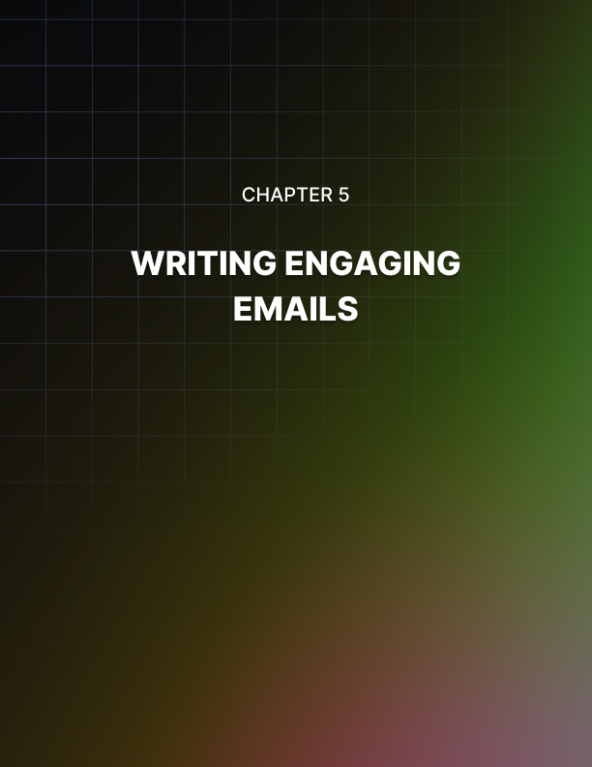

Chapter 5: Writing Engaging Emails

Make Your Content Scannable
You have to break your content up into short paragraphs. Your subscribers are busy living their lives, so you have to adapt to this situation, by making your emails easy to scan by including images and subheading.

These images and subheading will lead them through the email easily. A teaser should be added at the top of your newsletter to let your subscribers know what is in store for them. Make your subject-line easy to digest and to the point too.

Leave tons of time for revision and editing. Check your style and grammar, as these components are very important for your emails.

Being Friendly
Write using a friendly, informal tone. Since your subscribers will be in a relaxed frame of mind when they check out their emails, a friendly tone will work most effectively. Therefore, avoid using a strong formal tone in your emails; instead make sure to write naturally. In addition, you should include the subscriber's first name in the greetings to make the email personalized and to make them feel valued.

Knowing Your Audience
You need to figure out what is important for the subscribers of your list. What do they love? Are they young or old? Did they purchase products or services from you in the past? You need to know a lot of things about your audience, as this will allow you to be able to send relevant and targeted copies to them.

The Value Proposition And Unique Selling Proposition
You need to find out the reasons why your customers buy your service or product. What are the main benefits of the product? Why is your service or product a lot better than its competitors? What makes it unique?

This is the kind of information that can make your email copy standout. If your offer really stands out from the competition, you will get a great response.

Therefore, you need to emphasize something that your competitors do not offer or that they will not offer in the future to your subscribers. Your proposition must be so strong that your subscribers feel they are pulled by the features or the proposition.

Creating Compelling Subject Lines
In the subject line, you will try to convince your subscribers that they really need to open the email. “You” is the best word you can use to attract the attention of your readers.

This word says that the message is not about your product but about them. This personal touch allows you to connect with your readers and build relationships.

Writing Emails That People Actually Read
Email Marketing can be a driving force in lead generation and for quite some time now businesses looking for an affordable method of marketing have turned to email marketing.

However, the biggest challenge most marketers face is improving the “open and read rate.” There are a lot of creative ways marketers can explore to ensure that emails targeted towards a specific subset of customers are read and in this part of the chapter we will discuss some of the most common methods.

Develop Catchy Subject Lines
One of the best ways to improve your “open and read Rate” is to develop catchy and creative subject lines for all your emails. A lot of people often decide whether or not to open an email message based on the subject line, so making it interesting and provoking can be a perfect strategy to increase the percentage of emails which are actually read.

You can try to put in some numbers and facts in your subjects but also make sure they are short, non-formal and most importantly concise and straight to the point.

Optimize Your Mailing List
Secondly, it is important to always send out your email messages to people who actually care. There is no value in sending loads of emails to lots of people who perhaps have no idea who you are.

Therefore, when you are developing the mailing list, always target potential subscribers that may have some interest in your business or the products it offers. Additionally, try to refresh and improve your mailing list so that every time your email goes out someone somewhere is expecting it.

Know The Right Time To Hit Send
Well, email marketing has since been automated with a broad diversity of software, but you can still schedule your emails so that they are sent at specific time frames. It is important to first of all understand at what time your target audiences check out their inbox.

Ideally, people would normally check their inboxes at mid-morning hours and as such sending your messages at this time can be a great way to improve your open and read rates.

However, this is not definite and it’s crucial that you adapt to your own target audience and understand when they check their inboxes and at what frequency so that you can schedule your email marketing campaign accordingly.

Email marketing is a great tool to maintain customer loyalty and improve sales. The above three tips should help you improve your “open and read rates” with no hassle at all.

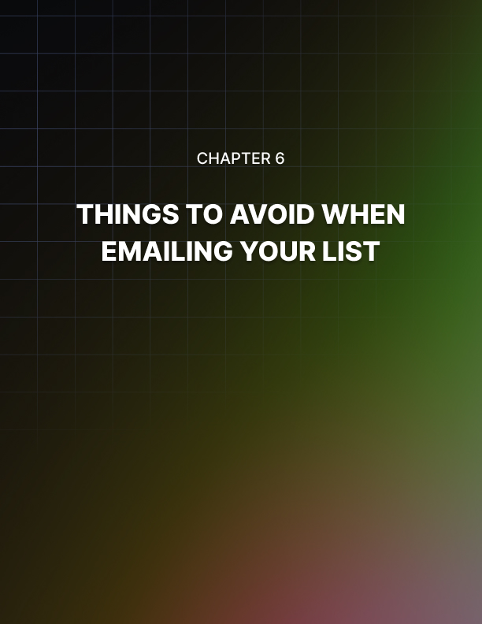

Chapter 6: Things To Avoid When Emailing Your List

When you decide to have an opt-in list, it is not just a matter of sending your subscribers your promotional newsletters or catalogs.

There are many things to consider in avoiding many complications. While there are so many ways you can make people subscribe to your list, there are also some things you must do to avoid subscribers from wanting to get off your list.

Aside from that, you also want to avoid any problems with the law and your internet service provider or ISP. There are now many laws and rules that are applied to help protect the privacy of the internet users from spamming and unwanted mails.

With the popularity of the electronic mail as a medium for marketing because of the low cost, many companies have seized the opportunity and have flooded many people’s email accounts with promotional mail.

But, with an opt-in list, you avoid this annoyance because people subscribe to the list; they want to receive the newsletters and promotional materials.

They have consented to being on the list by subscribing themselves, just don’t forget to put an unsubscribe feature every time in your opinion list so that you avoid any confusion. There may be times when an email account was provided when the real owner didn’t want to subscribe.

It is essential that you keep your list clean and manageable. Arrange it by using the many tools and technologies available for your opt-in list. Do not worry; your investment in this marketing strategy is well worth it with all the coverage you will get which will likely be converted into sales then to profit.

Keep yourself and your business out of trouble and potential run-ins with the law and the internet service providers. Keep your operation legit and clean. Your reputation as a legitimate businessman and a legitimate site depends on your being a straight and true marketing strategist.

As a tip, here are some things to avoid when emailing your list:

Take Notice Of Your Unsuccessful Sends
These are the emails that bounce. Bounced emails, also known as undeliverable messages, are those messages that, for whatever reason, were not successfully received by the intended recipient.

There are bounces that happen or occur because the server was busy at that time but can still be delivered at another time. There are also bounces because the inbox of the recipient is full at that time.

There are those bounce messages that are simply undeliverable ever. The reason for this is that it may be an invalid email address, a misspelled email address, or an email address that was abandoned and erased already.

Manage your list by putting markings on those that bounce. Erase an email account from your list so that you have accurate statistics and records as to how many are actually receiving your mail.

You may also want to check the spellings of your email addresses in your list. One common mistake is when an N instead of an M is placed in the .com area.

Always Provide An Unsubscribe Link
Always provide an unsubscribe feature in your site and an unsubscribe link in your mails. When someone in your list files a request to be unsubscribed, always take that request seriously. If you don’t take them off your list and keep sending them your emails, you are now sending them spam mail.

When you are reported as a spammer, you and your business can get into a lot of trouble. You can be reported to the authorities and maybe blacklisted by many internet service providers. You will lose a lot of subscribers this way and many more potential subscribers.

Do Not Provide Disturbing Content
Do not provide pornographic or shocking and disturbing content in your newsletters. It is hard to decipher the age of the recipient and many complaints may stem from these. Controversial issues also are to be avoided to not be branded by your subscribers. Stick to the nature of your site and business.

Always remember these tips in this chapter so that you can have a healthy relationship with your subscribers as well as be kept within the boundaries of what is allowed in sending mails to an opt-in list.

Staying Within The Lines
There is a fine line between advertising and spam and unfortunately many business owners do not understand the difference between the two.

This is important because while a clever, well planted Internet marketing campaign can help to attract new customers and keep existing customers loyal, spam is likely to alienate both new customers and existing customers.

This can be extremely damaging to profit margins for the business owners. This chapter will take a look at a few basic Internet marketing strategies such as banner ads, email campaign and message board posts and describe how each can quickly cross the line from clever advertising to spam.

Banner ads are one of the most popular strategies which accompany an Internet marketing plan. These ads are usually ads which appear at the top of websites and span the width of the website. It is from this appearance that they earned the name banner ads, but actually banner ads can refer to ads of a variety of different sizes and shapes which appear in an array of different locations on a website.

In many cases the business owner purchases advertising space on these websites, but the banner ad may also be placed as part of an exchange or an affiliate marketing campaign. Banner ad exchanges are situations in which one business owner posts a banner ad on his website in exchange for another business owner posting his banner ad on the other website.

These agreements may be made individually between business owners with complementary businesses or as part of exchanges facilitated by a third party.
In the case of affiliate marketing, an affiliate posts an advertisement for your business in exchange for compensation when the banner ad produces a desired effect such as generating website traffic or generating a sale. The terms of these agreements are determined beforehand and are generally based on a scale of pay per impression, pay per click or pay per sale or lead.

Now that you understand what banner ads are, it is also important to understand how they can be overused and appear to be spam. Judiciously placing your banner ad on a few websites which are likely to attract an audience similar to your target audience is smart marketing, placing your banner ad on any website which will display the ad regardless of the target audience can be construed as spam.

Internet users who feel as though your banner ads are everywhere, they in turn will not likely take your business seriously and are not likely to purchase products or services from you as a result of your banner ads.

Email campaigns can also be very useful tools in the industry of Internet marketing. These campaigns may involve sending periodic newsletters filled with information as well as advertisements, short, informative email courses or emails offering discounts on products and services.

Loyal customers who opt into your email list will likely not view these emails as spam and may purchase additional products and services from your business as a result of this marketing strategy. Additionally, potential customers who have specifically requested additional information on your products and services will also find this type of marketing to be useful.

However, email recipients who did not request information are likely to view your emails as spam. Harvesting email addresses in a deceptive manner and using these addresses to send out mass emails will likely always be considered to be spam.

Finally, message boards provide an excellent opportunity for business owners to obtain some free advertising where it will be noticed by members of the target audience. If the products and services you offer appeal to a specific niche, it is worthwhile to join message boards and online forums related to your industry of choice.

Here you will find a large population of Internet users who may have an interest in your products. You might consider including a link to your business in your signature or posting the link when it is applicable to the conversation.

However, care should be taken to carefully review the message board guidelines to ensure you are not doing anything inappropriate. This technique is smart marketing. Conversely, replying to every message with a link to your website when it is not relevant to the conversation is likely to be construed as spam by other members.

Once they begin to view your posts as spam, they are not likely to visit your website via the links you post.

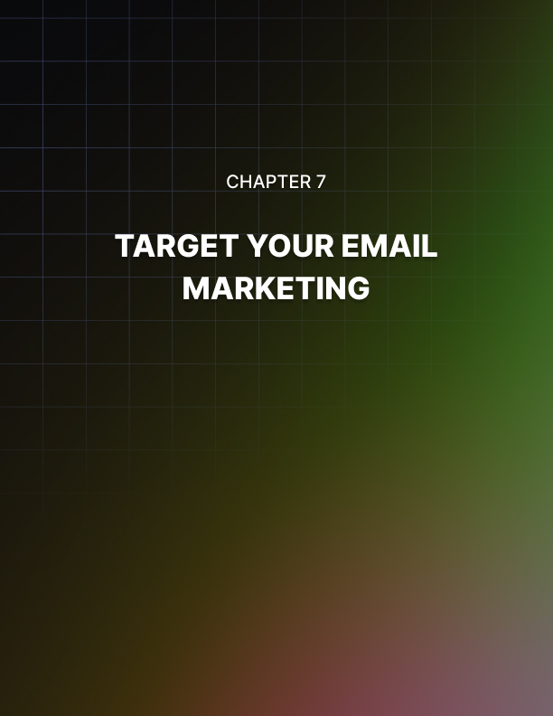

Chapter 7: Target Your Email Marketing

In theory email marketing is not any different than other types of marketing.

This means the basic principles of marketing apply to your email marketing efforts as well. One of these most important principles is the importance of reaching your target audience.

The ability to reach your target audience and convince them to make a purchase cannot be underestimated. This chapter will provide some insight into how Internet marketers can effectively reach their target audience.

The simplest way to reach your target audience is to allow existing customers as well as potential customers to register on your website and decide whether or not they want to receive emails with additional information and advertisements.

When the users register, they should be required to enter an email address. This registration process will allow you to compile a list of email addresses from each potential customer who expressed an interest in receiving additional information.

Sending your email marketing materials to the members of this distribution list is much more effective than sending out a mass email to recipients whose email addresses you purchased.

This is because the group of email addresses you compiled all have an interest in the products or services you offer while there is no information on the other set of email addresses to indicate whether or not the members will even have an interest in the products or services you offer.

Another tip for reaching your target audience is to do adequate research to determine how to communicate with the members of your target audience.

This may include changing the language of your emails to suit the preferences of your target audience members, designing the layout and colors of the email to be appealing to the target audience and tailoring the emails to include content which is of interest to the members of the target audience.

This type of research can really pay off because it will make your emails significantly more effective. Still another tip for reaching your target audience when email marketing is to keep your message simple.

Being subtle is important so your email does not seem like a blatant sales pitch, but it is also important to present your message in a clear and concise manner which will be easily understood by the members of your target audience.

If you have any doubts your target audience will be able to understand your message, you can certainly leave information for the email recipients to contact you with your questions. This interaction can prove to be extremely useful. Through these communications you can learn about the needs of your target audience and how you can tailor your email marketing strategy to meet these needs.

Finally, it is important to solicit feedback from the members of your target audience to ensure you are meeting their needs with your email marketing campaign. This should be done on a continual basis as the needs of your target audience may change over time.

When you solicit feedback from your target audience you should be sure to ask specific questions which require answers which can be interpreted easily.

This is important because the ability to interpret these answers will greatly impact your ability to further refine your email marketing efforts to conform to the expectations of your target audience members.

Types Of Email Marketing
If you are currently participating in other types of Internet marketing but not email marketing, you should seriously consider why you are avoiding this type of advertising.

This is important because email marketing can be a very important part of an Internet marketing campaign. Many business owners avoid email marketing for fear of being accused of spamming.

Internet marketers may not have a clear understanding of what is spam and what is not, so they avoid participation in email marketing campaigns to avoid the potential for being labeled a spammer.

Why are Internet marketers so afraid of being accused of being purveyors of spam? This is a common fear for a number of reasons. First of all, there may be harsh penalties associated with sending spam emails. Recipients of spam have the option of reporting the spam to their Internet service provider who will investigate the validity of the claim. If the originator of the email is determined to be a spammer there can be harsh consequences.

Internet marketers are also afraid of email marketing because they believe it will not be well received by potential customers. This is an important concept because Internet users are bombarded with spam each day.

Receiving this quantity of spam each day can be frustrating and can anger some Internet users. These Internet users are not likely to be receptive to email marketing. The fear that these potential customers will view email marketing and stray to competitors keeps many Internet marketers from taking advantage of this type of marketing strategy.

However, it is important to note that despite the prevalent problem with spam, many Internet users are quite receptive to email marketing. This is especially true in situations where they specifically requested to receive more information from the business owner regarding his products and services.

Potential clients are particularly receptive to email marketing which provides something of value to the recipient of the email. Emails which contain in-depth articles, useful tips or product reviews may be appreciated by consumers.

Additionally, items such as newsletters and correspondence courses offered via email can be of particular interest to potential customers. Newsletters are typically longer documents than traditional email marketing pieces and can provide a great deal of additional information to the email recipient.

Email correspondence courses may be offered in short segments and typically amount to a significant amount of information which is likely to be greatly appreciated by the email recipients.

One final way to prevent email recipients from viewing your email marketing efforts as spam is to only send the emails to recipients who register with your website and specifically request for you to send them additional information and promotional materials. This opt-in formula is ideal because it ensures you are not wasting your email marketing efforts on recipients who are not interested in your products or services.

It also ensures the recipients of the email marketing campaign do not view the informative and promotional materials they are receiving as spam. This technique for compiling an email distribution list is quite effective but it is important to remember you should always include information on how recipients can opt out of receiving future emails.

This is important because the email recipients may have once been interested in receiving marketing emails but over time this may change. If they are no longer interested in these emails, they may begin to view the emails as spam if they are not given the option of being removed from the distribution list.



Conclusion

Email marketing may include sending email advertisements to a large distribution list, publishing and distributing a newsletter and sending informative emails with a soft sell approach to encourage recipients to make a purchase or visit your website.

Whether you opt to utilize one or all of these email marketing techniques, you will be faced with one specific dilemma and that is writing the content which will appear in these emails.

This is critical because these emails may be the first impression potential customers are receiving for your products and services. Superior content will give the potential customers a good first impression which may make them more likely to purchase your products or services.

To end, we will discuss some proven techniques for ensuring the content you use in your email marketing campaign will reap the maximum benefits.

The importance of hiring a professional writer to assist you in your email marketing campaign cannot be stressed enough. It is one of the most critical elements to the success of your campaign.

You may be a decent writer or you may have a staff member who you think can do a good job creating the content for your email marketing but unless you or your staff member is a professional writer by trade, the quality of the work will likely not be of the same quality as a professional can produce.

This can be very damaging especially if your competitors are hiring writers to create their content. Your emails will likely not be viewed as favorably as the emails written by professionals.

The content you decide to include in your email marketing efforts is largely a matter of personal preference but there are some methods which have traditionally been more successful than others.

The type of content which may be effective often includes informative articles, short useful tips, links to relevant websites, advertising for complementary products and even some subtle forms of advertising which are meant to persuade the recipients of the email to either make a purchase or visit your website.

Full length insightful articles which are likely to be of interest to the members of your email distribution list are an excellent idea for your email marketing campaign.

These articles are a good idea because they will likely contain information which the recipients of your email will appreciate.

Additionally, these articles give you the opportunity to include information about your products or services in the copy of the email. This can be a subtle form of advertising when it encourages the recipients to purchase a product or service or visit the website without actually asking the recipient to do so.

Short product reviews can also be very useful and helpful when you include them in your email marketing campaign. These reviews can help to attract a great deal of attention especially when the reviews focus on the products you offer and provide favorable reviews for these products.

This type of information can either be subjective in nature or can remain objective by simply specifying the features of the products and offering other concrete pieces of information as opposed to opinions of the products.

Advertising is often a quite important part of an email marketing campaign. This advertising may either be direct or indirect in nature. Direct advertising may include banner ads or other graphical advertisements which encourage website visitors to click through the link to reach either your website or a sponsor’s website.

Indirect advertising may apply to content in the copy of featured articles which subtly encourage visitors to make a purchase or visit your website. The indirect marketing in an email marketing campaign is usually supporting the products or services you offer while direct marketing will likely promote products and services offered by sponsors who paid to receive advertising space on the email.

Email recipients are usually well aware these graphics are part of an advertisement and will choose to click on these links when they have an interest in the products or services being offered.

