Disclaimer

This eBook has been written for information purposes only. Every effort has been made to make this eBook as complete and accurate as possible. However, there may be mistakes in typography or content. Also, this eBook provides information only up to the publishing date. Therefore, this eBook should be used as a guide - not as the ultimate source.

The purpose of this eBook is to educate. The author and the publisher do not warrant that the information contained in this eBook is fully complete and shall not be responsible for any errors or omissions. The author and publisher shall have neither liability nor responsibility to any person or entity with respect to any loss or damage caused or alleged to be caused directly or indirectly by this ebook.

This eBook offers information and is designed for educational purposes only. You should not rely on this information as a substitute, nor does it replace professional medical advice, diagnosis, or treatment.

Table of Contents

Introduction 6
Chapter 1: Getting Started on Etsy 9
Chapter 2: Crafting a Winning Product Listing 14
Chapter 3: Building Your Brand on Etsy 20
Chapter 4: Mastering SEO for Etsy Success 26
Chapter 5: Effective Marketing Strategies 32
Chapter 6: Providing Excellent Customer Service 37
Chapter 7: Scaling Your Etsy Business 42
Chapter 8: Financial Management for Etsy Entrepreneurs 46
Conclusion 50



Introduction

Whether you’re an aspiring entrepreneur or a seasoned seller looking to refine your skills and boost your sales, this guide is designed to be your roadmap to success. Etsy offers a great platform for creative individuals to showcase their talents, connect with customers, and build a thriving business. Navigating the ins and outs of this marketplace successfully requires some inside knowledge, strategy, and even a touch of your creativity.

In this guide, we’ll start from the very basics of setting up your Etsy shop to creating winning product listings that captivate your audience and convert to sales. You’ll learn how to take your passion and turn it into profit. The journey of an Etsy seller is filled with both excitement and challenges, and the goal here is to equip you with the tools and knowledge you need to overcome obstacles and celebrate your successes.

We’ll start with the essentials of creating your storefront that looks appealing and resonates with your target audience. Then, it’s all about creating those winning product listings. You’ll learn how to make your products stand out in a crowded marketplace with irresistible product descriptions and perfect product photography.

Building your brand on Etsy is a critical part of success and this guide will teach you how to craft a unique shop brand, utilize brand elements well, and establish a strong shop identity. This will only help you attract more customers and foster that important loyalty and recognition.

The key to Etsy success is mastering SEO and we’ll teach you the mysteries of Etsy’s search algorithm, showing you how to optimize your product titles and tags. You’ll learn how to use keywords strategically to increase your visibility and drive more sales.

After mastering keywords, you’ll learn how to navigate the most effective marketing strategies and discover how to leverage social media, collaborations, and paid advertising. You’ll get the best strategies to promote your Etsy shop and expand your reach.

Beyond those crucial elements, you’ll learn how important customer service is for success and gain the skills to handle customer inquiries, manage orders and shipping efficiently, and deal with all feedback, whether negative or positive, constructively. These are skills that are necessary especially if you want to scale your business, add new products, and expand.

Last, the financial aspects of owning a business can be daunting. We’ll help you learn the financial side of running an Etsy shop, including pricing strategies, tracking expenses and revenue, and understanding your tax considerations.

So, let’s get started on sharing all the essential skills you’ll need to turn your Etsy dreams into reality.


Chapter 1: Getting Started on Etsy

The first step in becoming a successful online entrepreneur is setting up your shop. Etsy offers a unique opportunity for artists, crafters, and vintage sellers to connect with buyers looking for something special. But how do you make sure that your shop stands out and attracts customers? Let’s dive into the essential steps and strategies for setting up your Etsy shop.

Setting up Your Etsy Shop
The first impression you give potential customers is through your shop name. You’ll want to pick a name that reflects your brand and what you sell. At the same time, you want it to be memorable and easy to search. Choosing a name isn’t as random as most believe it to be. Etsy requires that shop names be 4-20 characters long, without spaces or special characters.

When working on choosing your shop name, brainstorm several options just in case your first choice is already taken. Also, remember that this name will be a part of your shop’s URL, so choose wisely.

Starting Your Shop
To begin, you’ll need an active Etsy account. If you already have one, log in and click on “Sell on Etsy”. From there you can navigate to “Open your Etsy Shop”. You’ll need to choose your shop’s language, country, and currency. These are the details that set up your shop’s operations.

According to Etsy, shops that offer free shipping are favored in search results, so take a moment to consider how shipping will impact your pricing strategy right from the beginning.

Crafting Your Brand
While we’ll get into your shop’s brand in greater detail in a later chapter, your brand is what sets you apart from the millions of other sellers on Etsy. As of 2023, your competition is steep with Etsy hosting over 4.3 million active sellers. That many sellers mean your unique brand is more important than ever. Your shop’s logo, banner, and descriptions should be cohesive and tell your potential customers about who you are and what you offer. High-quality images and a clear and engaging shop story can significantly enhance your appeal. Use this space on your storefront to connect with your customers by sharing your journey, your inspiration, and your passion.

Listing Your Products
If your brand is the face of your shop, your listings are the heart. Each listing should include high-quality photos from multiple angles. They should be detailed and include captivating product descriptions with clear pricing information. According to Etsy, listings with ten photos are 50% more likely to be purchased than those with fewer images. It’s best to use natural lighting for the photos and provide measurements and care instructions.

Your goal is to try and answer all potential questions a buyer might have.

Pricing Your Products
Your pricing strategy can make or break your Etsy business. When setting your price points, consider the cost of materials, your time, taxes, and Etsy fees. Etsy charges a $0.20US listing fee per item and takes a 5% transaction fee, plus any payment processing fees. Your prices need to be competitive, but not undervalued. Many successful sellers use this formula: Material Costs + Labor + Expenses + Profit = Wholesale price x 2 = Retail Price.

SEO Optimization
While SEO is another topic we’ll be expanding on again in a later chapter, it’s a crucial part of setting up your shop. You need to research relevant keywords and include them in your titles, descriptions, and tags. Etsy’s search algorithm favors listings with high-quality photos, complete and engaging descriptions, and positive customer reviews. You need to consider the terms that your target audience might use when searching for products like yours and incorporate those into your listings.

Setting Up Payment Methods
Payment methods take more thought than you might think. Etsy offers various payment method options, including Etsy Payments, which lets your buyers use credit cards, PayPal, and other payment methods. Selecting Etsy Payments can simplify transactions and build trust with your customers. Etsy provides certain guarantees that other payment methods don’t. Make sure your bank account information is up to date to ensure smooth transactions.

Shop Policies
Your potential customers have certain expectations. The best way to manage these is with clear shop policies that get it all out up front. These include information on shipping, returns, exchanges, payment options, and any custom order policies. Your policies need to be transparent to help prevent disputes and enhance customer satisfaction. According to Etsy, shops with clear policies tend to have higher customer trust and fewer issues.

Monitoring Your Shop’s Performance
Etsy has some incredible stats features right at your fingertips. Track your shop’s performance, including views, favorites, and sales. This data can help you understand your customer’s behavior, popular products, and areas for improvement. Regularly updating your inventory, refining your SEO strategies, and talking with your customers through messages and updates can keep your shop fresh and appealing.

Setting up your shop is just the beginning. With over 96 million active buyers, Etsy offers a huge market for your products. Success requires more than just creating listings though, it requires dedication to branding, customer service, and continuous improvement. You can build a thriving Etsy shop that stands out in a crowded marketplace. Every successful Etsy seller starts right where you are now and with effort and creativity, you can achieve your entrepreneurial dreams.

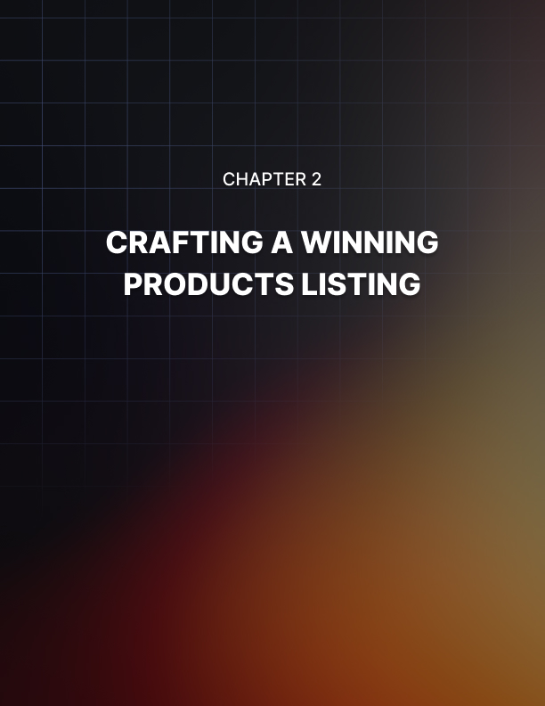

Chapter 2: Crafting a Winning Product Listing

Product descriptions are about listing the features of your item, yes, but they’re also about telling a story that connects with your potential buyers on an emotional level. That’s what sales and marketing is. An engaging product description not only informs but also entices and persuades. The emotional connection is the critical component in crafting a winning product listing, especially when you consider the 96 million active buyers on Etsy.

Creating Irresistible Product Descriptions
The first step is to understand your target audience. What are their needs, desires, and pain points? A well-crafted description speaks directly to its intended audience, making them feel like the product was made just for them. For instance, if you’re selling handmade jewelry, consider whether your audience values sustainability, craftsmanship, or the story behind each piece. Tailoring your message to match their values can significantly increase the appeal of your products.

Highlight the Benefits
The features of your product are important, like the dimensions, materials, and color options, but don’t stop there. You need to sell these features as benefits. For example, instead of simply stating that a scarf is made of 100% organic cotton, explain how this material offers unparalleled softness and comfort, perfect for sensitive skin. This approach shifts the focus from what the product is to what the product does for the customer. It makes your descriptions more compelling.

Use Sensory Words
Bring your descriptions to life with sensory words. They allow your customers to see, touch, smell, hear, and taste the experience of owning your product. Describing a candle’s “warm, inviting glow” or the “crisp, refreshing scent of pine” can transport your audience into a vivid, sensory- rich world. These little details help create that emotional connection, making it easier for potential buyers to imagine the product in their lives.

Tell a Story
Every single product has a story. It could be the inspiration behind its creation, the craftsmanship that went into making it, or how it can be part of memorable moments in your customers’ lives. Sharing this story in your description can differentiate your product from similar items on the market. For example, sharing how you were inspired by a trip to the mountain to create a line of nature-inspired pottery adds depth and personality to your listings. This makes them more attractive to buyers who value uniqueness and authenticity.

Use Clear and Concise Language
Yes, you want to be creative, but clarity and conciseness are equally important. Your description needs to be easy to read and understand. Avoid jargon or overly complex language that might confuse your audience. Use short paragraphs and bullet points to highlight key features and benefits. This makes your description skimmable for shoppers who are quickly browsing through listings.

Include a Call to Action
A subtle call to action (CTA) can be a powerful way to encourage potential buyers to take the next step. Invite them to message you with questions, encourage them to view more items in your shop, or suggest they add the item to their cart. A CTA guides customers toward making a purchase. It’s a gentle reminder of what they can do if they’re interested.

Optimize for Search Engines
While your primary goal is to appeal to potential buyers, don’t forget about Etsy’s search algorithm. Include the relevant keywords in your product description and help your listing rank higher in search results, However, make sure to integrate these keywords naturally into the text. They need to be included in a way that maintains the flow and readability of your description.

Captivating Product Photography Tips
Good, high-quality photographs of your products are a necessity. High- quality images can significantly increase the perceived value of your products, attract more customers, and ultimately lead to higher sales. Your product photos are the first thing a customer sees and your chance to make a memorable first impression. Here are some essential tips to help you capture stunning images that will make your listings stand out:

- Utilize Natural Light: Aim for soft, indirect natural light by photographing near a window. Avoid harsh sunlight to prevent overexposure and shadows. The ideal times are early morning or late afternoon.

- Simple Backgrounds: Choose neutral, uncluttered backgrounds to keep the focus on your product. White or light colors are preferred for consistency and making your product pop.

- Detail Shots: Provide close-up photos to showcase the quality, texture, and unique features of your product, giving your customers a virtual “feel” of your items.

- Use a Tripod: Stabilizing your camera ensures sharp, clear images. It also allows for consistent shot framing.

- Show Scale and Use: Help your customers understand the size and practical use of your product by including images with common objects for scale or demonstrating the product in use.

- Honest Editing: You can enhance the photos to adjust brightness, contrast, and saturation, but make sure the edits don’t misrepresent the true appearance.

- Consistent Style: Maintain a uniform look across all product photos with the same lighting, background, and editing style, reinforcing your brand identity and professionalism.

- Experiment with Angles: Capture your product from various angles to provide a comprehensive view.

Setting Competitive Prices for Your Products
Begin by calculating the total cost of creating your product. This includes direct costs like materials and indirect costs like the time you spend on making each item. Don’t forget to factor in your overhead expenses, such as equipment, utilities, and Etsy’s fees. Etsy charges a 5% transaction fee and a 3% +$0.25US payment processing fee per sale, as well as a
$0.20US listing fee per item. You need to understand these costs so you can set prices that cover your expenses and yield a profit.

Research Your Market
Knowing your competition is key when it comes to setting your prices. Spend some time browsing Etsy to see what similar items are selling for. Pay attention to how established shops price their products and note any pricing trends. This kind of research will help you identify a price range that is competitive and fair. Pricing too low can signal poor quality, while pricing too high may deter potential buyers.

Consider the Perceived Value
Perceived value is the worth that customers believe a product has. This can be influenced by its uniqueness, quality, and presentation. Enhance your perceived value through high-quality product photography, detailed descriptions, and exceptional customer service. Sometimes, a higher price can actually increase sales by elevating the perceived value of your products.

Factor in Shipping Costs
Shipping costs can significantly influence a buyer’s decision. Etsy favors listings with free shipping in search results. This only encourages sellers to offer free shipping and then include the costs of shipping in their item prices. Offering free shipping can increase your items’ visibility and appeal. If you decide to charge for shipping, make sure the costs are reasonable and transparent to avoid cart abandonment.



Chapter 3: Building Your Brand on Etsy

You have 4.3 million competitors on Etsy. Crafting your unique shop brand on Etsy is essential for standing out in this crowd. It’s not just about being different, it’s about creating a memorable and cohesive experience that attracts and retains customers.

Crafting a Unique Shop Brand
Your brand is the heart and soul of your Etsy shop. Your story sets you apart from others selling similar products. A compelling brand story includes your inspiration, your journey, and the passion behind your creations. It needs to reflect your values, such as sustainability, craftsmanship, or innovation, and communicate the purpose of your brand. Sharing this story in your shop’s bio, product descriptions, and through social media can create an emotional connection with customers.

A strong visual identity is important to brand recognition. This means your logo, color scheme, typography, and packaging. Your visual elements should be consistent across your Etsy shop and all marketing channels.

This consistency helps customers quickly identify your brand and builds trust. When designing these visuals, consider how they reflect your brand’s personality and values. For instance, if your brand is all about handcrafted, eco-friendly products, consider using natural colors and textures in your branding materials.

Create a Signature Product Line
Many successful brands use a signature product line to enhance their uniqueness. These are products that are distinctly yours, whether through design, materials, or the story behind them. A signature product line will differentiate your brand and give customers a reason to choose your shop over others. It can become what you’re known for, driving word-of-mouth marketing and repeat business.

Provide Exceptional Customer Service
Customer service is an integral part of having a business and your brand. How you interact with your customers, handle inquiries, and manage issues can leave a lasting impression. You can enhance the customer service experience and reinforce your brand values with personalized service, such as custom orders, gift wrapping, or a thank you note with each purchase. Positive customer interactions build loyalty and encourage reviews and referrals that can further elevate your brand.

Engage with Your Community
Working on building a community around your brand can amplify its reach and appeal. If you engage with your customers and followers on social media, in Etsy forums, or through your blog, you’re building that community. Try sharing behind-the-scenes glimpses of your creative process, upcoming products, or personal insights. This engagement helps to humanize your brand, making it more approachable and appealing.

Collaborating with other Etsy sellers or brands that share similar values can also expand your visibility and reinforce your brand’s identity.

Utilizing Branding Elements in Your Listings
You need to weave your unique brand identity throughout your shop and making sure to add branding elements in your listings is a great way to do this. It reinforces your brand’s message and creates a seamless and professional shopping experience for your customers. Branding elements can significantly increase the recognition and memorability of your shop.

Consistent Visuals
It was mentioned before, but keeping your visuals consistent across your product listings is important. This includes using a clear color scheme, typography, and imagery that aligns with your brand’s visual identity. For instance, if your brand is known for its minimalist aesthetic, your product photos should reflect this with clean, simple backgrounds and a neutral color palette. Consistent visuals help your customers quickly recognize your products amidst a sea of listings.

Logo and Packaging
Incorporate your logo into your product images or as part of the packaging shown in photos. This promotes brand recognition and adds a professional touch. Custom packaging, with your logo and brand colors, photographed with your product, can also illustrate to potential buyers the care and attention to detail you put in every order, elevating that perceived value.

Themed Product Descriptions
The language and tone of your product descriptions should express your brand voice. Whether your brand is playful, sophisticated, or eco- conscious, the way you describe your products should reflect this. Use thematic language that touches your intended audience and incorporate keywords that help with search visibility and strengthen your brand identity. For example, a brand focusing on sustainable products might use terms like “eco-friendly,” “biodegradable,” or “handcrafted with care.”

Brand Story in Every Listing
Always include a brief mention of your brand story or ethos in each product listing. This doesn’t have to be lengthy, a sentence or two will do.
Highlighting your brand’s unique qualities or mission in each listing reinforces your identity and values. This makes your products more attractive to buyers who share or support those values.

Customized Banners and Graphics
Use unique banners and graphics within your listings or as part of your shop’s announcement section to promote special offers, highlight collections, or convey your brand’s seasonal message. These elements should maintain the same visual alignment as your overall brand aesthetic.

Establishing a Strong Shop Identity
Your unique value proposition (UVP) is what makes your shop stand out from others. It’s the specific benefits that make your products more desirable to your target audience. Highlight your UVP in every element of your shop, from the banner and shop announcement to item descriptions and thank you messages. Whether it’s exceptional craftsmanship, innovative design, or sustainability, make sure that your UVP is clear and evident.

Consistency in Communication
A strong shop identity is consistently communicated across all channels. This includes your tone and the style of your product descriptions, your interactions with customers, and the content you share on social media. Consistent communication reinforces your brand identity and helps customers develop a clear understanding of what your shop represents.

Use Customer Feedback
Customer feedback is invaluable for reinforcing your shop identity. Encourage reviews and engage with customers’ comments and questions. Highlight positive feedback in your shop updates or on social media to help build your trust and credibility. Listening to your customers can also provide insights into how your brand is perceived and where you can make improvements.

Live Your Brand
Incorporate your shop identity into everything you do. This means living out the values and promises of your brand in every interaction and decision.

From the way you source materials to how to package your products. Every action you make should reflect your shop’s identity and ethics. This authenticity resonates with customers and builds a strong, trustworthy brand.



Chapter 4: Mastering SEO for Etsy Success

Mastering SEO (Search Engine Optimization) is a huge part of any entrepreneurial endeavor. For Etsy success, it’s crucial for any seller to learn if they’re looking to increase visibility and sales.

Understanding Etsy Search Algorithm
Understanding Etsy’s search algorithm is the first step towards optimizing your listings and making sure they reach your target audience. Etsy’s search algorithm is designed to provide the most relevant, high-quality listings to shoppers, based on a variety of factors.

Relevancy and Keywords
The heart of the algorithm is relevancy. When buyers enter a search query, Etsy aims to match them with listings that closely align with their intent. This means that your titles, tags, and descriptions need to be strategically crafted with the proper keywords that potential customers are likely to use. Do keyword research to understand the terms and phrases buyers use when searching for products like yours. Then, use those keywords naturally in your listings, focusing on the first few words of titles and including a variety in your tags.

Listing Quality Score
Etsy assigns a quality score to each listing. This greatly influences its search ranking. The listing score is determined by a listing’s performance history, including click-through rate and conversion rates. Listings that attract more views and sales are deemed more relevant and are ranked high in search results. To improve your listing quality score, ensure that your products have compelling photographs, competitive prices, and detailed and engaging descriptions that encourage clicks and purchases.

Customer and Market Experience Score
The algorithm also considers the overall customer and market experience score, which reflects your shop’s history of customer service and compliance with Etsy’s policies. Factors like positive reviews, completed orders, and a record of on-time shipping contribute to a higher score.
Maintaining high levels of customer satisfaction and ensuring your shop adheres to Etsy’s selling practices can boost your visibility in search results.

Recency
Etsy favors fresh content. Newly listed or recently renewed items get a temporary boost in search rankings. Regularly updating your listings or adding new products can help maintain visibility and attract attention from potential buyers.

Personalization
Etsy’s algorithm results are personalized. This is based on the shopper’s past behaviors and preferences, such as items they’ve viewed, favorited, or purchased. While this aspect of the algorithm is beyond anything you can control, creating diverse and appealing listings can increase the chances of appearing in personalized search results.

Optimizing Product Titles and Tags
Optimizing product titles and tags is vital when it comes to achieving success on Etsy. Given the platform’s competitive market with millions of listings vying for attention, a well-optimized title and tags can make the difference when it comes to the visibility of your listings in search results.

Product titles on Etsy should be clear, descriptive, and keyword-rich. The initial few words are especially crucial as they’re the most likely to catch a buyer’s eye and influence click-through rates.

- Start with Primary Keywords: Begin your title with the most important keywords that describe your item. These are terms a potential buyer is likely to search for and should directly relate to the product’s main features or category.

- Be Descriptive: Use the rest of the title to include additional details and secondary keywords. Describe the product’s materials, purpose, color, size, or any unique features. This helps with search visibility and aids shoppers in understanding what you’re selling at a glance.

- Avoid Overstuffing: While keywords are important, avoid overstuffing your title. Keep the title readable and customer-friendly. Etsy suggests using natural, conversational phrases that make sense to shoppers.

Use Tags Wisely
Just as the title, tags are essential for search optimization. They provide another opportunity to capture the relevant search queries. Here’s how to make the most of your tags:

- Use All Available Tags: Etsy allows you to use up to 13 tags per listing. Maximize his opportunity and use all available tags to cover a wide range of potential search queries.

- Think Like A Buyer: Include tags that reflect what your target audience might type into the search bar. Consider synonyms, related terms, and common misspellings.

- Include Long-Tail Keywords: Long-tail keywords are phrases that are more specific and often less competitive than single-word keywords. They can attract more targeted traffic, as they match closely with what a buyer is searching for. For example, instead of just “scarf”, use “hand-knit wool scarf for winter.”

- Mix Broad and Specific Tags: Use a combination of broad and niche- specific tags. This captures both the general and more targeted search traffic. Broad tags might be “necklace” and more specific tags could be “boho turquoise necklace.”

- Seasonal and Occasional Tags: Don’t forget to consider seasonal trends and upcoming holidays or occasions. These tags can temporarily boost visibility when buyers are searching for related items.

Utilizing Keywords Strategically
Just in case, keywords are the terms and phrases that shoppers use when searching for products on Etsy. Selecting the right keywords and placing them thoughtfully throughout your listings can enhance your visibility and attract more targeted traffic to your shop.

Begin by identifying keywords that are relevant to your products and likely to be used by your target audience. Use Etsy’s search bar to see auto- suggested terms, which indicate popular searches. Tools like EtsyRank and Marmalead can also provide some insights into keyword popularity and competitiveness. You’ll want to consider both broad keywords that describe your category and long-tail keywords that are more specific to your product’s features, materials, and uses.

Your keywords should be prioritized in titles. If you recall, the first few words of your listing title carry the most weight with Etsy’s search algorithm. Start your titles with the most important keyword that accurately describes your product. This not only helps with search ranking but also ensures that your listings are immediately relevant to potential buyers. Any other relevant terms should be used in your 13 tags.

While the primary focus for keywords is in titles and tags, incorporating them into your listings’ descriptions can also help. This reinforces the relevance of your listings to Etsy’s search algorithm. Craft your descriptions to be engaging and informative while naturally weaving in some of those keywords.

Your customers’, or potential customers’ interests change with seasons, holidays, and trends. Regularly update your keywords to reflect these changes and keep your listings relevant and visible. For example, adding “Christmas gift” during the holiday season can attract shoppers looking for holiday presents.

When it comes to SEO on Etsy, it’s not a set-it-and-forget-it task. Regularly monitor the performance of your listings in terms of views, favorites, and sales. Use Etsy’s Shop Stats and other analytics tools to keep track of which keywords are driving traffic and conversions. Be prepared to adjust your keywords over time as you gather more data on what works best for your shop.

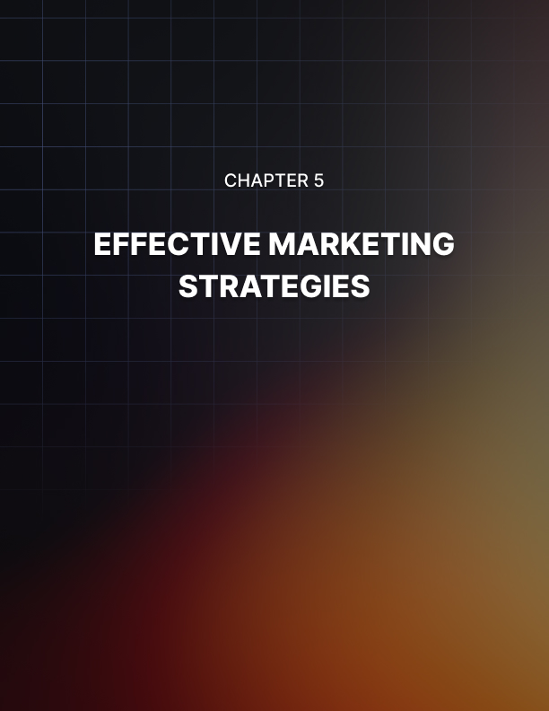

Chapter 5: Effective Marketing Strategies

Social media promotion is an indispensable tool for Etsy sellers aiming to broaden their reach and engage with potential customers. With billions of active users across platforms like Instagram, Facebook, Pinterest, and TikTok, leveraging social media not only enhances your shop’s visibility but also creates a community around your brand.

Social Media Promotion for Etsy Shop Instagram: Showcase and Storytell
Instagram is visual-centric and ideal for showcasing your products and the stories behind them. Use high-quality images and videos to highlight your creations, share behind-the-scenes glimpses of your process, and tell the story of your brand. Using Instagram Stories and Reels can also increase engagement, allowing you to share more spontaneous content, tutorials, or customer testimonials. Remember to use relevant hashtags to increase the discoverability of your posts and engage with your followers through comments and direct messages.

Facebook: Build a Community
Facebook’s strength lies in its ability to build communities. Create a Facebook Page for your Etsy shop to share updates, promotions, and engage with your audience through posts and comments. Facebook Groups are also a powerful tool for creating a dedicated space where your customers can interact with each other, share their purchases, and provide feedback. This sense of community can lead to increased loyalty and word-of-mouth referrals.

Pinterest: Drive Traffic
Pinterest is a powerful search engine for inspiration and shopping. Create pins for your products that link directly to your Etsy listings. Use eye- catching images and include keywords in your pin descriptions to improve their visibility in searches. Creating boards that relate to the lifestyle or interests of your target audience can also attract followers who are likely to be interested in your products.

TikTok: Engage with Videos
The short-form videos of TikTok are a perfect way to engage potential customers in a creative and yet informal way. Share videos that showcase your products, the creative process, or fun behind the scenes. TikTok’s algorithm favors content that generates engagement, so encourage comments, shares, and likes by creating interactive and entertaining videos.

Collaborations and Cross-Promotions
Tap into new audiences by collaborating with other creators, influencers, or brands. Together, you can leverage each other’s strengths, share customer bases, and create mutually beneficial marketing opportunities.

Identify Complementary Partners
The first step is to find potential partners whose products or services complement your own. Look for Etsy sellers, influencers, or brands that share a similar target audience but are not direct competitors. For example, if you sell handmade jewelry, partnering with a clothing boutique or a fashion blogger could be a perfect match. The key is to find partners whose audience would genuinely be interested in your products.

Co-Create Exclusive Products
One proven effective collaboration strategy is co-creating exclusive products or collections. This generates excitement among both partner audiences and offers something unique and new to the market. Exclusive collaborations can create buzz on social media, attract media attention, and drive traffic to your Etsy shop.

Host Joint Giveaways or Contests
Giveaways are always good for engaging with your audience and gaining exposure but they’re even better when you’re exposing them to two or more groups of followers. Joint giveaways should require participants to follow both accounts and engage with your content to enter. This can significantly increase your social media following and email list. Make sure the giveaway prize is attractive and relevant to both audiences to maximize participation.

Share Each Other’s Content
The simplest cross-promotion strategy is sharing each other’s content. This could be as simple as reposting each other’s posts, sharing customer testimonials, or creating dedicated content that highlights the partnership.

This reciprocal promotion helps introduce your products to a wider audience and builds social proof.

Paid Advertising on Etsy
Etsy has a built-in advertising platform where sellers can promote their products within Etsy’s search results and other areas on the site. This reaches out to potential customers actively searching for similar items. Etsy Ads is a simple and effective tool that allows sellers to pay for their listings to appear in prominent positions in search results and on category pages. This service operates on a cost-per-click (CPC) model, meaning you only pay when a potential customer clicks on your ad. Etsy offers an easy-to-use interface where sellers can set their daily advertising budget, starting as low as $1US per day.

To start, select the listings you want to promote that are likely to convert well or have historically performed well. High-quality images and optimized product titles and descriptions are a must for your ads to be effective. Once you’ve selected them, you can set your daily budget. Etsy’s algorithm will automatically manage bids for you, aiming to get the most clicks for your budget by adjusting bids in real time based on the competition and search relevance.

While Etsy Ads automatically targets relevant search terms based on your listings’ titles and tags, it’s important that your listings are optimized for the right keywords before you begin advertising. Conduct keyword research to find the high-traffic, relevant keywords that potential buyers are using.

You’ll want to regularly monitor the performance of your ads through Etsy’s Shop Manager. It will provide insights into views, clicks, and sales generated from your ads. Use this data to adjust your daily budget, pause underperforming listings, and optimize listings for better performance.

Testing different listings and budgets can help you find the most effective strategy for your shop.

While paid advertising can boost visibility, it’s the most effective when it’s used in conjunction with organic SEO strategies. Make sure that your shop and listings are fully optimized, engage with your customers through excellent service, and use social media and other marketing channels to support your Etsy shop’s growth.

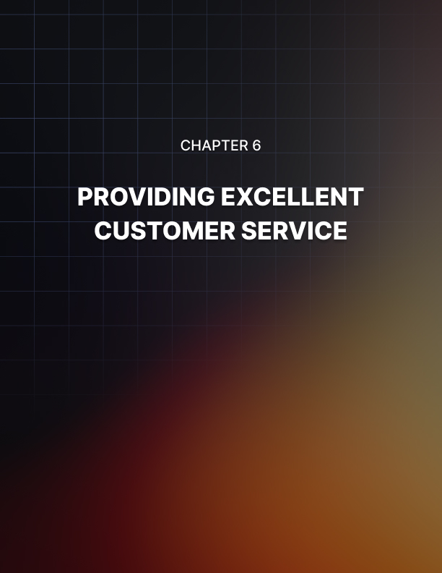

Chapter 6: Providing Excellent Customer Service

Excellent customer service is the cornerstone of success for any business, Etsy sellers included. Among the various aspects of customer service, responding to customer inquiries promptly and effectively is a critical factor in building trust, creating loyalty, and enhancing your shop’s reputation.

Combine this with good shipping standards and handling feedback with grace and you’re on your way to excellence.

Responding to Customer Inquiries
Our world is fast-paced thanks to our abundance of technology and the internet. Your customers are going to expect quick responses. Aim to reply to any inquiries within 24 hours, if not sooner. This prompt reply shows your customers that you value their time and are eager to help them out.

Etsy’s Seller Dashboard can help you keep track of messages, and setting up notifications for new inquiries makes sure that you don’t miss any communication.

Personalize Your Responses
While efficiency is the most important, personalization can set your shop apart. Address customers by name and tailor your responses to their specific questions or concerns. This personal touch demonstrates your commitment to customer satisfaction and helps build a connection between you and your buyers.

Be Clear
While you want to make your responses personal, you still need to be as clear and detailed as possible. Whether your customer is asking about product details, shipping times, or return policies, providing thorough and accurate information will help prevent misunderstandings and build confidence in your shop. If a question requires a more complex answer, don’t hesitate to break down your response into smaller, digestible parts.

Establish a Positive Tone
No matter what the nature of the message is, always maintain a positive and professional tone. Even when you’re dealing with complaints or challenging questions, a positive attitude can help defuse tension and lead to more satisfactory resolutions. Make sure to express your gratitude for the customer’s interest or patience to help keep up the overall positive tone of the interaction.

Handling Orders and Shipping Efficiently
Excellent customer service also means processing your orders and shipping with efficiency. This part of service directly impacts customer satisfaction, influencing both their immediate experience and their likelihood to return or recommend your shop.

Develop a systematic approach to processing orders in order to minimize delays. This can include setting a daily schedule for order review, packaging, and dispatching. Use tools and resources provided by Etsy, like the Orders & Shipping tab in your Shop Manager, to help you stay organized and responsive. It helps if you clearly communicate your average processing times in your listings and shop policies to set realistic expectations from the start.

Offer Multiple Shipping Options
Customers appreciate having choices that cater to their needs and urgency. If you offer a range of shipping options, from standard to expedited services, your customers can choose according to their budget and time constraints. Be transparent about shipping costs and times for each option, in order to help your customers make informed decisions.

Keep Customers Informed
Communication is key in sales, and more so throughout the shipping process. Send a confirmation message once an order is placed, including an estimated shipping date. When you ship the product, provide tracking information and an expected delivery date. Proactively inform customers of any delays or issues that may arise. Then you can offer solutions or alternatives to mitigate any inconvenience.

Package with Care
You have no control over what happens to your packages once they’re in the hands of the shipping company. It’s your responsibility to securely package your products and match the presentation shown in your listings. Good packaging protects your product during transit but also enhances the unboxing experience, leaving a positive impression. Consider including a personal note or a small freebie as a thank you gesture. This serves to reinforce that positive brand experience.

Dealing with Customer Feedback
An integral part of your customer service is dealing with feedback, whether positive or negative. Feedback is a valuable tool for understanding your customers’ experiences, improving your products and services, and building that strong shop reputation. You need to embrace all types of feedback as opportunities for growth. Positive feedback reinforces what you’re doing right, while constructive criticism highlights areas for improvement. Acknowledging and appreciating every piece of feedback demonstrates your commitment to customer satisfaction and continuous improvement.

Respond Promptly and Professionally
By quickly responding to feedback, especially if it’s negative, you’re showing that you value your customers’ opinions and are proactive about resolving issues. You want to always maintain a professional and empathetic tone, regardless of the feedback’s nature. Apologize for any shortcomings and offer solutions to rectify the situation like replacements, refunds, or discounts on future purchases.

Learn and Adapt
Feedback should always be used as a learning tool. Analyze the comments to identify any patterns or recurring issues and then take action to address them. This could involve refining product descriptions, improving your quality control, or enhancing your packaging. By implementing changes based on customer feedback, you’re not only improving your shop but also showing your customers that their opinions have a tangible impact.

Showcase Positive Feedback
You’ll want to highlight positive feedback in your shop updates or social media to build trust and attract new customers. Sharing customer testimonials can serve as powerful social proof. This can reassure potential buyers about the quality of your products and your dedication to customer service.
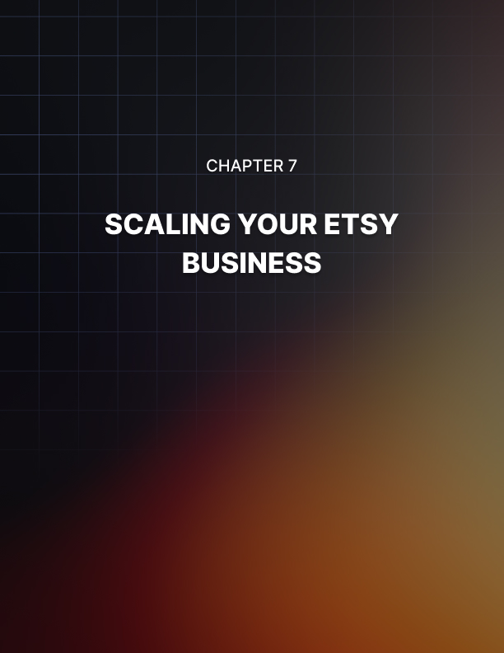

Chapter 7: Scaling Your Etsy Business

You want to aim for continuous growth and adaptation for a successful Etsy business. It’s important to do this with intent and at a pace that you can manage easily without neglecting other areas of your business.

Adding New Products to Your Shop
One effective strategy for expansion is adding new products to your shop. This approach keeps your storefront fresh and engaging but also opens up opportunities to attract new customers and meet the evolving needs of your existing audience.

Before introducing new products, conduct thorough market research to identify trends, gaps, and customer demands within your niche. Talk with your current customers through surveys or social media to get insights about their preferences and needs. This is a proactive approach that ensures that your new offerings are aligned with market demand and have better chances of success.

You should also aim to capture a broader market segment with diversification. Consider adding products that complement your existing lineup which encourages customers to make additional purchases. For instance, if you sell handmade jewelry, you might expand into related accessories like scarves or bags. Diversification also helps you protect your business and risks by making sure you’re not depending on a single product for success.

As you introduce new products, maintain that high-quality that your customers expect. Make sure that your new additions are cohesive with your brand and values. They need to reinforce the unique selling proposition of your Etsy shop. Consistency in quality and branding helps build customer trust and loyalty.

Expanding Your Product Line
Expanding your product line is a strategic approach to scaling your Etsy business that goes hand-in-hand with adding new products. You’re going to broaden your existing categories or venture into new ones to cater to a wider audience and increase your sales potential.

Identify Opportunities for Expansion
Look at your shop’s performance data and customer feedback to identify your best-selling products and areas with high demand. Look for trends or requests that indicate a desire for more variety within your current offerings or for entirely new categories that align with your brand. Social media conversations and customer feedback are great places to find this information.

Leverage Cross-Selling Opportunities
With a broader product line, you can create bundled offers or recommend complementary products to encourage larger purchases. Highlight how new items pair with existing products to enhance the customer experience and increase the average order value.

Time Management and Scaling Tips
When you want to scale your business, you need to make sure you’ve already established effective time management. If you’re already struggling to manage the hours in the day, it may not be the time for you to expand.

As your shop grows, so does the demand on your time, from creating and listing new products to fulfilling orders and engaging with customers.

Implementing solid time management strategies and scaling tips can help optimize your workflow, increase productivity, and sustain business growth.

- Prioritize Tasks: Identify your tasks and prioritize them based on their impact on your business. Use tools like the Eisenhower Box to categorize tasks into urgent, important, non-urgent, and non-important. This helps you focus on activities that directly contribute to your shop’s growth, such as product development and marketing.

- Automate Repetitive Processes: There are plenty of tools on Etsy and through third-party applications that can automate repetitive tasks. This can include automated messaging for order confirmations and shipping updates, using templates for product listings, and scheduling social media posts. Automation frees up valuable time.

- Schedule Time for Creativity: Scaling your business requires continuous innovation. Schedule regular time blocks dedicated to creativity and strategic planning. This way you’re consistently developing new ideas for products, marketing strategies, and business improvements.


Chapter 8: Financial Management for Etsy Entrepreneurs

When it comes to finances, unless you have a degree in business, becoming an entrepreneur can be confusing and complicated. You have to create strategies for pricing, track your expenses and revenue, and then there are the applicable taxes to consider.

Pricing Strategies for Profitability
Effective pricing goes beyond simply covering costs. You need to understand your market, your value proposition, and your financial goals.

- Cost-Plus Pricing: Begin with a cost-plus pricing model, where you calculate the total cost of producing your product, including materials, labor, overheads, and Etsy fees, then add a markup for profit. This method ensures that all costs are covered, and a profit margin is secured. It's essential to regularly review and adjust your costs, as materials and operational expenses can fluctuate.

- Market-Oriented Pricing: You need to understand your market and competitors in order to set prices that are competitive and still profitable. Analyze similar products on Etsy to gauge the average price point. Pricing too low might increase sales volume but can simultaneously devalue your brand and squeeze your margins. Pricing too high without a clear value proposition can deter potential customers. Striking the right balance is key.

- Perceived Value Pricing: Perceived value pricing involves setting prices based on the value customers believe your product provides. This strategy can allow for higher price points if your product offers unique benefits, exceptional quality, or emotional appeal. Enhancing your product's perceived value through branding, packaging, customer service, and marketing narratives can justify premium pricing.

- Psychological Pricing: Leveraging psychological pricing tactics, such as pricing items just below a round number ($19.99 instead of $20), can make prices appear more attractive to buyers. This strategy plays on customer perception and can increase the likelihood of purchase due to the perceived deal or value.

- Dynamic Pricing: Adopting a dynamic pricing strategy allows for flexibility in response to market demand, competitor prices, and seasonal trends. Special promotions, discounts for bulk purchases, and limited-time offers can attract new customers and boost sales during slower periods.

Keeping Track of Expenses and Revenue
Invest in reliable accounting software designed for small businesses to simplify tracking your expenses and revenue. Tools like QuickBooks, Xero, or Wave can automate much of the financial management process, from recording transactions to generating financial reports. Many of these platforms offer integrations with Etsy, streamlining the process of capturing sales data and related expenses.

You’re going to want to maintain a detailed record of all business-related expenses, categorized for ease of analysis. Your categories might include materials, shipping, Etsy fees, advertising, and equipment. Categorizing expenses not only helps with your financial organization but also simplifies your tax preparation and deductible business expenses.

Make sure to regularly monitor your cash flow or the movement of funds in and out of your business. This ensures that you have enough capital to cover your upcoming expenses, such as restocking materials or investing in marketing campaigns. A positive cash flow indicates that your business is on a solid financial footing.

Tax Considerations for Etsy Sellers
Understanding and complying with tax obligations keeps your business legally sound and can provide opportunities for savings through deductions.

Etsy sellers are typically considered independent contractors or sole proprietors. This means that it’s your responsibility to report your Etsy income on your tax returns. This includes both income tax and self- employment tax, which covers Social Security and Medicare taxes in the US. Depending on where you live and operate your business, you may be liable for other local taxes.

In addition, many jurisdictions require the collection of sales tax on goods sold online. Etsy provides features to help sellers manage this by automatically calculating, collecting, and remitting sales tax for items sold to buyers in certain states or countries.

Utilize Tax Deductions
Be proactive in identifying and utilizing tax deductions available to small business owners. Common deductions for Etsy sellers include the cost of materials, shop fees, shipping costs, and home office expenses. Properly leveraging these deductions requires keeping detailed records and understanding how to apply them on your tax returns.

Seek Professional Advice
Tax laws can be complex and vary widely by location. Consulting with a tax professional who understands the specifics of online businesses and self- employment can provide tailored advice and ensure you're taking advantage of all applicable tax benefits while remaining compliant with tax laws.


Conclusion

To become a successful Etsy entrepreneur you need to master the intricacies of effective shop management, SEO optimization, strategic marketing, exceptional customer service, and financial management. From crafting irresistible product listings to leveraging social media, collaborating for cross-promotion, and deploying savvy paid advertising strategies, each step is a building block toward establishing that profitable store among many on the Etsy marketplace.

Reinforce the foundation of trust and loyalty with your customers by maintaining responsive customer service, including handling inquiries, orders, shipping, and feedback. Your brand is everything! At the same time, you need to constantly manage your finances through strategic pricing, diligent tracking of expenses and revenue, and navigating your tax obligations.

As you apply everything you’ve learned, remember that continuous learning and adaptation are key to staying competitive and innovative. Explore further resources like Etsy’s Seller Handbook, join sellers forums for community advice, and consider professional consultations.

Stay strong with a commitment to excellence, creativity, and strategic planning and you’ll not only enhance your Etsy shop’s success but also enrich your experience as an entrepreneur in the amazing Etsy community.

