Disclaimer

This ebook has been written for information purposes only. Every effort has been made to make this ebook as complete and accurate as possible. However, there may be mistakes in typography or content. Also, this ebook provides information only up to the publishing date. Therefore, this ebook should be used as a guide - not as the ultimate source.

The purpose of this ebook is to educate. The author and the publisher do not warrant that the information contained in this ebook is fully complete and shall not be responsible for any errors or omissions. The author and publisher shall have neither liability nor responsibility to any person or entity with respect to any loss or damage caused or alleged to be caused directly or indirectly by this ebook.
Table of Contents

Chapter 1: How To Get Started With Facebook Ads 5
What Exactly Are Facebook Ads? 5
Why Should You Advertise On Facebook Ads? 6
How To Get Started With Facebook Ads 7
Chapter 2: Getting To Know The Facebook Ads Manager 12
What Is The Facebook Ads Manager? 12
How To Create An Advert On The Facebook Ads Manager 12
Chapter 3: Facebook Ads vs. Boosted Posts 19
What Are Facebook Boosted Posts? 19
How To Boost A Facebook Post 20
Key Differences Between Boosted Posts and Facebook Ads 21
When To Use Boosted Posts Instead Of Ads 24
When To Use Facebook Ads Instead Of Boosted Posts 24
Chapter 4: How To Optimize Your Facebook Ad Design 27
Why You Should Optimize Your Facebook Ad Design 27
How To Optimize Your Facebook Ad Design 29
Chapter 5: Gain Maximum Exposure Using Custom Targeted Audiences 34
What Is A Custom Audience? 34
The 5 Types Of Custom Audiences You Can Create On Facebook 34
What Is A Lookalike Audience? 36
How To Use Custom And Lookalike Audiences To Get More Conversions 36
A Word Of Advice On Custom Audiences 39
Chapter 6: How To Use Retarget Marketing With Facebook 42
The Facebook Pixel’s Role In Retarget Marketing 42
Why You Should Set Up The Pixel Asap 43
How To Create Your Facebook Pixel 45
How To Apply Pixel Data For Retarget Marketing 45
Facebook Retarget Marketing Versus Google Remarketing 46
Chapter 7: Split Testing Your Facebook Ads For Optimum Performance 49
What Is Split Testing? 49
What Are The Benefits Of Split Testing? 50
Best Practices In Split Testing 52
How To Split Test In Facebook Ads 53
Chapter 8: Boost Your Profits With Facebook Dynamic Ads 57
What Are Dynamic Ads? 57
How To Get Started With Facebook Dynamic Ads 58
How To Create And Start A Dynamic Ad Campaign 60
How Facebook Dynamic Ads Can Boost Your Profits 61
Chapter 9: How To Lower Your Overall Facebook Ad Budget 64
How To Make The Most Of Your Facebook Ad Budget 64
How To Lower Your Overall Facebook Ad Spend 65
Chapter 10: How To Create A Facebook Lead Capture Funnel 71
What Is A Lead Capture Funnel? 71
Why Are Lead Funnels Important? 73
How To Structure Your Funnel And The Right Ads To Use 73
Top Of The Funnel Facebook Ad Strategies (Awareness) 73
What’s Next After Creating A Successful Lead Funnel? 76

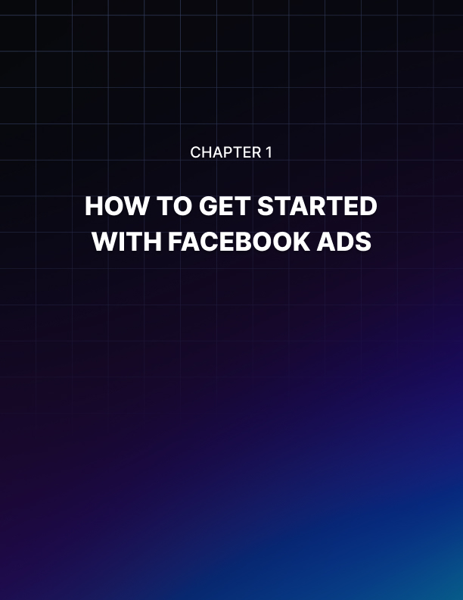

Chapter 1: How To Get Started With Facebook Ads

In this first chapter, you’ll learn the basics of Facebook Ads and how you can get started with advertising on Facebook. You've probably read a lot of success stories on the Internet of marketers spending a few hundred dollars and earning tens of thousands in return.

That sounds like a crazy return on investment (ROI), right? Well, not really. With Facebook Ads, it’s possible to replicate these successful marketers’ techniques so you too can experience an extraordinary ROI!

There’s no denying the fact that when it comes to marketing and advertising your business on social media, Facebook is the way to go. With over 2 billion users logging in to Facebook every month from all corners of the globe, Facebook is king of social media. Whether you want to reach people in your town or city or people on the other side of the world, it’s possible with Facebook ads.

What Exactly Are Facebook Ads?
If you scroll down your Facebook news feed, you’ll most probably see a post which says Sponsored or Suggested Post on it. Or if you’re on a desktop computer, you’ll see ads on the right side of your screen. You’ll even see in-stream video ads while you’re watching a video on Facebook.

Also, you’ll see ads or sponsored messages on Facebook Messenger, Instagram, and the Audience Network. These adverts are known as Facebook ads.

Individuals, small businesses, and large corporations pay Facebook billions of dollars a year to show their ads to Facebook users. And it’s not surprising because compared to other platforms, Facebook gives their advertisers the best bang for their buck.

Why Should You Advertise On Facebook Ads?
Before I show you how you can get started with Facebook ads, let me go through a few reasons why you should consider investing in this platform.

- Your potential customers and clients are all on Facebook.
Well, maybe not all. But some, if not most of them, will be on Facebook. Not everyone likes Facebook, but everyone who’s ever heard of this thing called the Internet will have heard of Facebook. Whether you’re looking to target people in your location or another continent, it’s very easy to do so on Facebook.

- Hyper-targeting is a Facebook Ads specialty.
When you sign up for a Facebook account, you give Facebook a wealth of information about yourself. Advertisers can then target you based on the information you provide. Other advertising platforms don’t come anywhere near Facebook ads’ targeting options.

For instance, you can target people based on their location, their hobbies, their favorite sports teams, their language, their education, their life status, their work, their finances, their travel preferences, and so much more.

- Facebook ads won’t get you bankrupt.
Unless, of course, you give Facebook all your money. But that’s not a very wise business decision, is it? With Facebook ads, you can spend a few dollars each day, and Facebook is not going to complain about it.

If you compare the amount that you’ll spend advertising on Google Adwords, Bing ads, native ads, banner ads, billboard or newspaper advertising, you’re literally going to save a fortune on Facebook! With the amount you’ll save, you’ll be able to reach even more of your target market, that is, you can quickly scale your budget and get in front of more people.

- You can measure your Facebook ads results.
You’re not going to be playing the guessing game with Facebook ads. The platform is very transparent, and you can see how many impressions, clicks, and conversions your ads are receiving in real-time. To be able to measure your results, you do need to add the Facebook pixel to your website.

This snippet of code is all you need to track important activities on your website – who’s buying, who’s signed up to your list, who’s visited and bounced off your site without doing anything, etc.

- Facebook advertising can grow your website traffic and foot traffic, too.
With Facebook ads, you can direct people to do anything you want. For example, if you want them to visit your site, simply include the right call of action to your ad. If you want them to drop by your physical store, let them know. If you make your ad enticing enough and give people what they want (by addressing their pain points), then you make it easy for them to follow your call to action.

- You can quickly get your brand in front of many people.
It’s possible to get your ad in front of more than 2 billion Facebook users. You just need to have very deep pockets. Of course, not everyone will be interested in your brand, and what you do so this may lead to high costs. In Facebook ads, the goal is to get in front of the right audience, not just any audience.

With the right audience, people will be more receptive to what you’re offering. They’ll engage more with your ad, and this will lead to lower Facebook ad costs.

- Facebook ads are more effective than organic Facebook marketing.
In the old days, you could simply put up a new Facebook page, and pay a few bucks to have people like your page. When you publish a new post on your page, a huge percentage of your fans and followers see your update in their news feeds. Today, it’s a different story.

With so many friends and so many pages and groups Facebook users join, the news feed has become crowded, and organic reach has dropped significantly. If you want to reach your target audience, it’s best to just pay Facebook instead of needlessly twiddling your thumbs waiting for your fans and followers to like your new post.

How To Get Started With Facebook Ads
Just like most things in life, there’s a steep learning curve that comes with Facebook ads too. Let’s take it one step at a time so you don’t become confused as doing so will lead to money down the drain.

Step 1: Determine Your Goals
Before you get started with Facebook ads, you need to know the goals you want to accomplish with your adverts because that’s going to be your goal post. You’re going to be aiming for that, and you will set up your ads in such a way that your goals will be met.
Some example goals are:

- Do you want people to like your page?

- Do you want people to click through to your website?

- Do you want people to join your mailing list?

- Do you want people to attend an event?

- Do you want people to buy your product or try it out for free?

- Do you want people to download your mobile app?

Determining your goals will help you create the most suitable ad for your audience. On Facebook Ads, these are the different goals or campaign objectives you can choose:

  - Awareness – this objective is great if you want to reach out to cold audiences or people who haven’t interacted with your brand or website yet. You can choose between two options:

    - Brand Awareness – you can increase people’s awareness of your brand
    - Reach – you can reach the most number of people in your audience with this objective

  - Consideration – this objective is great if you want people to start thinking about your brand or your business and encourage them to know more about what you can do for them. You can choose from 6 options:

    - Traﬃc – choose this objective if you want people to visit your website or increase engagement with your mobile app.
    - App Installs – if you want people to download and install your mobile app, this is the objective you should choose.
    - Engagement – if you want to boost your Facebook posts, promote your Facebook Page, get people to claim an offer on your Page, and get more people to attend an event on your Page, then you need to choose this objective.
    - Video Views – to get more awareness about your brand, you can create a video ad that showcases behind the scenes stories or customer testimonials.
    - Lead Generation – if you want to get leads or email addresses from people interested in your business, then use this objective. The Lead Generation objective makes it very easy for prospects to sign up for your service.
    - Messages – get people to send your business messages on Facebook messenger and even Instagram. This objective will help your business to answer questions from prospects, generate more leads and drive more transactions.

  - Conversion – conversion ads encourage interested people to buy your product or subscribe to your service. You can choose from 3 different options:
    - Conversions – if you want to send people to your website, Facebook app or mobile app, use this objective. To maximize, track and measure your conversions, you will need to install the Facebook pixel on your website.
    - Catalog Sales – to use this objective, you will need to create a catalog to show off your inventory. Once you have this setup, you can then create ads that will automatically show items from your catalog based on your target audience.
    - Store Visits – if you’re running an offline business, that is, you have a brick and mortar store, then you can use this objective to get more people to visit and shop in your store.

Step 2: Know Your Audience
Now that you have defined your goals, you need to know your audience.

- Who are you hoping to target with your Facebook ads?
- Do you want to target women, men or both?
- Is your product or service going to be a fit for single or married people?
- Are 20-30-year-old sports fans going to be your target?
- Do you want to get the attention of people who like classical music in New York?
- Are you going to be selling your products just in the US or do you intend to ship to Europe, Asia and the rest of the world?

As we've mentioned before, there are literally more than 2 billion people you can target on Facebook right now. You just need to find a certain group of people who will benefit the most from your product.

If you don’t know your audience, if you’re going to target just about anyone, it can lead to astronomical advertising costs for you. So before you start creating your ads, at least have an idea of who will be most interested in what you have to offer.

Creating a customer persona is great for this purpose. Not only will you get to save a lot of money, but you’ll also get better results with the right target audience.

Step 3: Know Your Budget
No matter how big or small your marketing budget is, Facebook ads will help you out. Even if you've only got $1 to $2 to spend on ads each day, you can still get your ads in front of a few hundred or a few thousand people. Of course, this will depend on your targeting, your ad placements, and your overall ad strategy.

In the beginning, expect to lose money while you optimize your ad sets. You can spend $5 on different adverts every day and see which one converts the best. You will do a lot of testing.

Trial and error is the name of the game. But when you find the winner, you’re going to be winning big. And your $5/day budget is going to be a thing of the past.

Getting started with Facebook Ads might seem difficult at first, but once you get the hang of social media’s number one advertising platform, you’re in for a ride.

Read the next chapter to know more about the Facebook Ads Manager and how you can start using it to grow your business.

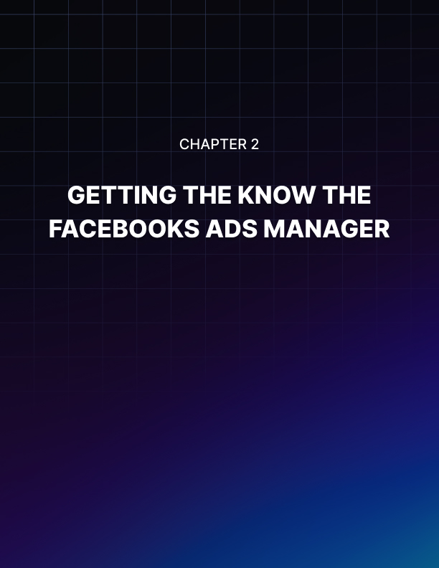

Chapter 2: Getting To Know The Facebook Ads Manager

In this chapter, you will learn how the Facebook Ads Manager works. I will walk you through the different sections and I will also include screenshots to make it easier for you to find your way around the Ads Manager.

What Is The Facebook Ads Manager?
The Facebook Ads Manager is your ad campaign command center for all your Facebook ads, Instagram ads, or Audience Network ads. It is where you go to create new ads, edit and manage your existing ads, view your ad reports, manage your Facebook pixel events, your billing info, and so much more.

In addition to accessing your Ads Manager on a desktop computer, you can also access your ads using the official Facebook Ads Manager mobile app. You can download this on both Google Play Store and the Apple App Store for free. The mobile app allows you to:

- Create new ads
- Track your ads performance
- Edit and manage current ads
- Edit ad budgets and schedules
- Receive push notifications

It’s important to mention here that with Ads Manager, you can only manage 1 ad account. If you want to manage more than 1 ad account, you will need to create a Facebook Business Manager account. So if you have clients or you need to keep your ad accounts separate (like one ad account for each business), then you need the Facebook Business Manager.

How To Create An Advert On The Facebook Ads Manager
When you’re ready to create an ad, simply follow the steps I've outlined in the previous section to access the Facebook Ads Manager. In the Ads Manager, you have to go through 3 different levels – the campaign level, the ad set level, and the ad level.

Level 1: Campaign Level
In Chapter 1, I mentioned you should have a goal in mind before you set up your Facebook ads. When choosing from any of 11 objectives below, keep your goal in mind and choose the most suitable objective from the list:

- Brand awareness
- Reach
- Traffic
- Engagement
- App installs
- Video views
- Lead generation
- Messages
- Conversions
- Catalog sales
- Store visits

Once you’ve chosen your marketing objective, your Campaign name will be your objective. In this example, I selected the Traffic objective, therefore, my Campaign name is Traffic. You can edit the Campaign name as you see fit.

When you’re ready to proceed, click on the blue Set up ad account button.

Setting up your ad account is very straightforward. Simply select your country from the list, then your currency, and lastly, your time zone. Click Continue. Now we go to the second level.

Level 2: Ad Set Level
In the Ad Set level, the options that will appear will depend on your chosen objective. If you want, you can always go back to the Campaign level and change the objective so you can see the different options. But the three options that are present in the Ad Set level of ALL campaigns are the following:

Audience, Placements, Budget and schedule
For this chapter, I am using Traffic as my campaign objective. These are the options available for Traffic campaigns at the Ad Set level:

Traﬃc, Other, Audiences, Placements, Budget and schedule
At this point, you should fill out the different sections with information relevant to your specific campaign. If you’re using a Traffic campaign like I’m doing in this example, here’s more information on the different settings you need to define at the Ad Set level:

- Traﬃc – choose whether you want people to go to your website, your app, or to send you a message on Messenger

- Offer – if you’re running a promotion in your business, you can create an offer that people can save and receive reminders about.

- Audience – this is where you define who you want to show your ads to. You can either create a new audience, use a saved audience, or create a custom audience composed of people who have interacted with your business either online or offline.

- Placements – you can choose to have Facebook decide the placements automatically or choose yourself manually. It’s best to choose manual placements so you can decide whether you want to show your ads on desktop, mobile, right column, Instagram, Audience Network, or Messenger. Manual placement gives you control over your ads.

- Budget and schedule – in this section, you can decide whether you want to use a daily budget or a lifetime budget. Facebook will give you an estimate of your total weekly spend.

Level 3: Ad Level
The options you see at the Ad level will depend on your Campaign objective. If you choose Brand Awareness as your objective, you will see different options at the Ad Level. If you choose Conversions, you will see a different set of options.

Since we chose Traffic as our ad objective in this chapter, these are the options available at the Ad level:

Identity, Format, Links
At the Ad level for Traffic campaigns, you will need to specify the following details:

- Identity – choose your Facebook page or Instagram account

- Format – choose how you want your ad to look. As you can see in the screenshot, you can choose from Carousel, Single Image, Single Video, Slideshow or Collection ad formats. If you chose mobile placements at the Ad Set level, you could even add a full-screen landing page for your ad for a more immersive experience for those who engaged with your ad.

- Links – this is where you write down the text, images or videos for your ad. You can also view your ad preview here so you can see what your ad looks like based on the placements you chose at the Ad Set level.

You can play around with the different settings until you’re happy with how your advert looks like. When you’re ready to publish, hit the green Confirm button.

A Quick Tour Of All Tools On The Facebook Ads Manager
To access all the tools on your Ads Manager, click on Ads Manager at the top left corner. You will then see the Ads Manager Menu. If you don’t see that, make sure you click on All Tools at the bottom.

The Ads Manager menu is divided into six columns.

- Frequently Used column
This column contains a link to 4 of your most frequently used tools in the Ads Manager

- Plan column
In this column you can access Audience Insights and Creative HubAudience Insights – this is where you create hyper-targeted audiences. Facebook gives you a lot of data to play with, and you can target people based on their location, interests, and behaviors.

Creative Hub – if you’re not ready to pay for real ads, but you want to see how it would look to your audience, simply go to Creative Hub and create mockups for your ads. This is also where you can check the percentage of text in images you’re going to use in your ads. If there’s too much text on your image, your advert’s reach may be affected.

- Create & Manage column
In this column, you have access to 6 different tools, such as:

Business Manager – this is simply a link to the Facebook Business Manager where you can manage multiple ad accounts in one place

Ads Manager – this is where you create your Facebook ads (I already gave an overview of how to create ads in the previous section of this chapter)

Power Editor – in the Power Editor, you can import and export ads as well as bulk-edit your work

Page posts – you can create new posts here. You can also create posts by going to your page. In this menu, you can choose whether to use your newly created post as an ad or have it published to your page as well.

App dashboard – if you are a Facebook app developer, you can create and manage settings for your apps in your app dashboard

Automated rules – with automated rules, you have more control over your hands. You no longer need to check your campaigns daily. You can just set up automated rules that will notify or update you when there are changes in your campaigns, ad sets, or ads.

- Measure & Report column
In this column, you can track and measure your ads and your events. The tools in this column are:

Ads Reporting – you can create and export reports in Ads Manager to see your most important ad metrics. You can also schedule reports to be emailed to you directly.

Analytics – this tool will help you analyze data from your Facebook pages as well as the pixel installed on your website

Events Manager – this tool allows you to create and manage your Facebook pixel, offline events, app events, add custom conversions and partner integrations.

- Assets column
In this section, you have easy access to important assets that you have used or will be using to create your ads, these include:

Audiences – this tool will help you create and manage custom audiences, lookalike audiences, and saved audiences
Images – this tool will allow you to upload and manage images for your pages and ads
Catalogs – if you have a store with many products, you can add and manage your inventory here

- Settings column
You can access three tools in this column. These are:

Settings – you can access your ad account settings here, your pages, your payment settings, and your email and Facebook notifications.

Business settings – if you have Business Manager set up, this is where you manage your ad accounts, pages, and the people who work on them.

Billing – you can manage your payment settings here, and you can see all the billing transactions that have ever occurred in your ad account

Need Help Navigating Your Facebook Ads Manager?
If you’re afraid of getting lost in the Ads Manager maze, don’t be. If you need help with anything, you can simply type your query on the search bar. Alternatively, you can also click on the Help button in the upper right corner of your screen, and the Advertiser Help Center will appear on your screen.

Final Thoughts On The Ads Manager
I hope this chapter has helped you get to know more about the Facebook Ads Manager and how you can get started creating your first Facebook advert. In the next chapter, I will discuss and compare Facebook Ads with Boosted Posts. See you there!

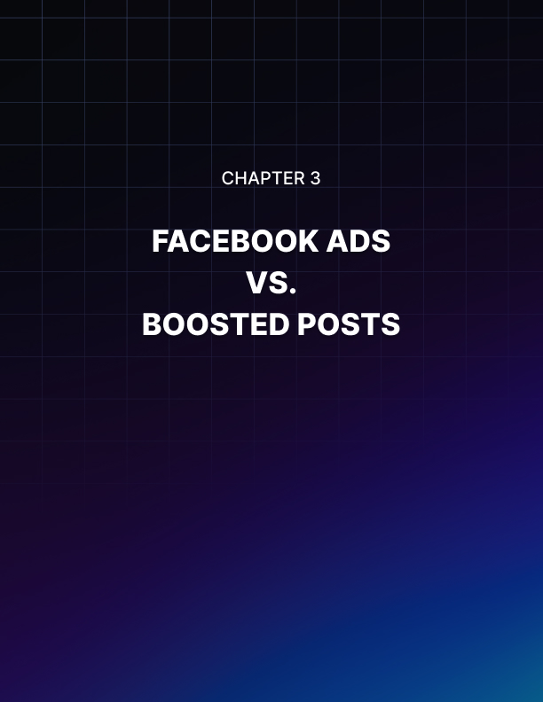

Chapter 3: Facebook Ads vs. Boosted Posts

In the first two chapters of this Facebook Ads Ninja series, I discussed Facebook Ads and the Facebook Ads Manager in great detail. I talked about how and why you should get started with Facebook Ads.

There are so many benefits to creating an ad using the Ads Manager. However, it does have a steep learning curve attached to it. If you want to know a faster and easier way to get your first very first advert launched, then you need to consider boosting a post.

In the third chapter of this series, I will contrast and compare Facebook Ads versus Boosted Posts so you can decide which method is best for your business goals. But before I do this, I’ll introduce you to Boosted Posts first and show you how it works.

Also, at this point, I would assume you already have a Facebook page created for your business. If you don’t have one yet, please take the time to create one now. You can always edit your page settings later on.

Let’s begin!

What Are Facebook Boosted Posts?
If you are a Facebook page admin, you won’t miss the blue Boost Post button that appears in every single post on your page. If you don’t see that button anywhere on your timeline, then you’re probably not a page admin. Make sure you are one so you can follow the steps I've written down in this chapter.

Boosted posts are quite literally published posts on your Facebook page that you boost or promote to your followers or another target audience. Your posts appear on your page timeline so if anyone checks out your page, they’ll be able to see all your posts, both boosted and non-boosted.

If you’re wondering why you need to boost a post to people who already like your page, then read on for the explanation.

A few years ago, posts published on a fan page were immediately seen by people who liked and followed that page. This led to a lot of free organic traffic and engagement levels were very good (think 80-90% of fans engaging with every post!). However, in recent years, organic reach has been declining steadily.

In fact, many page owners are reporting that their organic engagement has plummeted to 1-5% per post! This basically means that if you have 10,000 followers, only a few hundred people will see your post. If you have a million followers, a few thousand people will see your post and engage with it.

This is why page likes are mainly a vanity metric nowadays. It looks good on your page but if only a small percentage of your fans see your posts, then why bother paying for page likes? If you want to increase the chances of your followers seeing your all-important post, then you should consider boosting your post instead.

How To Boost A Facebook Post
First, you’ll need to go to your Facebook page. Then look for the post you want to boost. At the bottom right corner of your post, you’ll see a blue button that says Boost Post.

Unlike the seemingly complicated Facebook Ads Manager interface, the Boost Post interface is relatively simple and straightforward.

When boosting a post, you have fewer options to choose from unlike with Facebook Ads. Here are the options you can change:

  - Objective – you can choose if you want to get more engagement (reactions, comments, shares), get people to visit your website, or receive messages from your target audience.

  - Call-to-action button – you can choose to have no button, or you can use Shop Now, Book Now, Learn More, Sign Up, Send Message, or Send WhatsApp Message.

  - Audience – you can choose people through targeting, people who like your page, and people who like your page plus their friends.

  - Budget and Duration – you can choose your daily budget for the duration of your campaign. The minimum budget is $1 a day.

  - Tracking conversions – you can use the Facebook pixel to track your conversions. You need to have the pixel installed on your website so you can use this feature.

  - Payment – you can define the currency you’d like to use for your payment here as well as the ad account you’re going to be paying from (you’ll have multiple options if your Facebook page is connected to your Business Manager)

When you’re ready to boost your post, simply click on the Boost Post button and Facebook will then start promoting your post.

Now that you know how Boosted Posts and Facebook Ads work (remember Chapters 1 and 2), it’s time to compare the two so you can make an educated decision when it’s time for you to do some content promotion on Facebook.

Key Differences Between Boosted Posts and Facebook Ads
Whether you’re in the Boosted Posts camp or you’re a firm believer of Facebook Ads, both have their advantages and advantages. In this section, we’re going to be looking at key features.

- Campaign Objective
- Boosted posts - choose between 3 objectives (engagement, traffic, messages)
- Ads - choose up to 11 campaign objectives (brand awareness, reach, traffic, engagement, app installs, video views, lead generation, messages, conversions, catalog sales, and store visits).

- Budget Control
- Boosted posts – you can only choose your total budget
- Ads – you can choose your daily or lifetime budget

- Ad Scheduling
- Boosted posts – when you boost your post, the ad will start right away. You can’t schedule it, but you can set an end date.
- Ads - you can set a start and end date for your ads so if you’re going away on vacation, you can plan your ads in advance and have it run even while you’re away.

- Audience Targeting
- Boosted posts – you can choose audience targeting, but it’s very limited. For instance, you can’t target people by their language, and you can’t add a connection type. You can target people who liked your page and their network of friends as well.
- Ads – you can hyper-target with Facebook ads. You can use custom audiences, lookalike audiences, you can target by language, you can add connection types. There’s even an option to let Facebook automatically expand your interests if it thinks people outside of your audience will engage with your ad.

- Geographic Targeting – you can target specific locations with both boosted posts and ads.

- Age and Gender Targeting – you can target both the age and gender of your audience with both boosted posts and ads.

- Interest and Behavior Targeting - you can target your audience’s interests and behaviors with both boosted posts and ads.

- Language Targeting
- Boosted posts – you cannot target your audience’s language with boosted posts
- Ads – yes, you can target languages with ads

- Ad Placement
- Boosted posts – your post will only appear on both desktop and mobile news feeds. You can’t choose just desktop or just mobile.
- Ads – you have full control over where you want your ads to appear. You can choose to have them appear just on desktop news feeds, or just on mobile news feeds, Instagram, audience network, column, instant articles, and so much more.

- Dark Post
- Boosted post – no, you can’t create a dark post with boosted posts. A boosted post has to be published and will appear on your page’s timeline.
- Ads – yes, you can create a post solely for use in an ad, and you can choose not to have it shown on your page timeline

- Ad Delivery
- Boosted post – you can’t adjust how you want your ads delivered
- Ads – you can choose between standard and accelerated delivery. You need to set a bid cap though to use accelerated delivery which is useful for time-sensitive promotions.

- Instagram Ads
- Boosted post – no, you can’t boost your Facebook post on Instagram
- Ads – yes, you can choose to show your ads on Instagram by making sure it’s ticked in the Placements section

- Audience Network Ads
- Boosted post – no, you can’t boost your Facebook post on the Audience Network
- Ads – yes, you can choose to show your ads in the Audience Network by making sure it’s ticked in the Placements section

- Right Column Ads
- Boosted post – no, you can’t show your boosted post in the right column on desktop computers
- Ads – yes, you can choose to show your ads in the right column on desktop computers.

- Retargeting
- Boosted post – no, you cannot retarget people
- Ads – yes, you just need to make sure the Facebook pixel is installed on your website and is working properly

When To Use Boosted Posts Instead Of Ads
There’s a lot of advantage to using Facebook Ads, but in certain scenarios, Boosted Posts will work just as well, at a much faster rate at that. Here’s when it’s best to use Boosted Posts:

- If you have a post that’s already receiving good organic engagement, then you may want to consider boosting it. If the people who saw your post organically are interacting with it, that is, they’re liking, sharing and commenting on it, then chances are those who did not see your post in their news feeds will find it interesting too!

- If your post is informational, that is, you’re not selling anything on it, then people would be more receptive to your boosted post. If you’re selling something, then it’s best to use Facebook Ads as you have more options over the format of your ads.

- If you don’t have much time and you don’t want to learn the complexities of Facebook Ads Manager, then boosting a post is your best option.

With that being said, boosting posts is, quite simply put, for beginners. If you truly want more bang for your buck, then you really have no choice but to dive in and learn how the Facebook Ads Manager works.

When To Use Facebook Ads Instead Of Boosted Posts
Generally speaking, Facebook Ads are a much better option than Boosted Posts simply because it offers advertisers full control over their ads.

The Ads Manager will allow you to split test every single aspect of your campaign. It’s so much more flexible, and in the end, your campaign will be so much more profitable.

You can hyper-target your audience and reach even more people who have the same characteristics as your winning audience (you do this by creating a lookalike audience – something you can’t do on boosted posts).

Creating custom audiences is easy and thanks to the audience insight tool you can research the best demographics who might be a fit for your product or service.

With Facebook Ads, you have many different kinds of campaign objectives to choose from. With Boosted Posts, you’ve only got a few options. Since you’re spending money either way, it’s best just to go all the way in and use Facebook Ads.

If you think it’s beyond your skills or it’s too technical, you can always hire an agency or a consultant to help you out with your Facebook Ads campaign.

Final Words
Boosted Posts works great on its own and is great for beginners who are just starting out with paid promotion. However, it gives you very little control over your ads and may not be a very cost- effective option for your business.

If you want complete control over how your ads run and determine the best possible adverts that will convert with your pre selected audience, then you need Facebook Ads. Granted, learning how to manage Facebook Ads is not an easy job but it will be worth it in the end especially once you find the right combination of a high-converting advert and target audience.

While Facebook Ads and Boosted Posts are great promotion vehicles, there are still so many other things to consider. In the next chapter, you’re going to learn how to optimize your Facebook Ad design because first impressions do matter, especially to cold audiences.

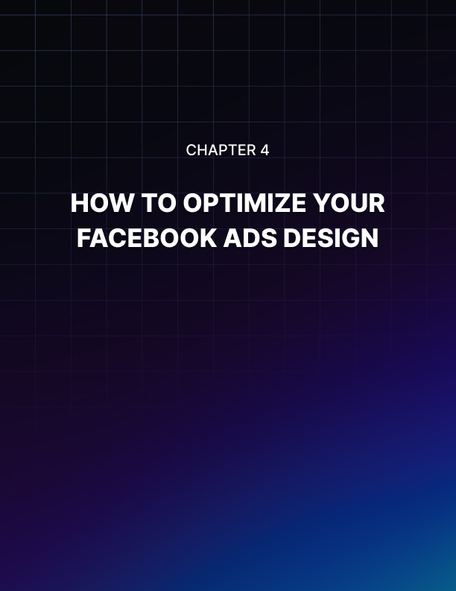

Chapter 4: How To Optimize Your Facebook Ad Design

In the earlier chapters of this Facebook Ads Ninja series, you learned all about the technical aspects of Facebook Ads. In this chapter, you’re going to be learning about how to optimize your Facebook ad design because if you don’t, you might just as well be throwing your money away.

Try not to get lost in the technical aspects of creating your ad because designing your ad and making sure it gets noticed by your target audience is just as equally important.

Why You Should Optimize Your Facebook Ad Design
Before I answer this question, I’d like you to think about the last time you were scrolling on Facebook. In what instances did you stop scrolling to take a look at an ad that appeared on your feed?

Was it because the Page name was familiar? Or was it because the image they used was eye-catching? Or did the headline somehow grab your attention? Or was it maybe because they used a video that told the brand’s story in the first few seconds?

Whatever it was, it was effective enough to get you to stop scrolling your feed. And the people behind the advert surely thought about how they can get people like you, as a part of their target audience, to pay attention to their ad. They made sure to optimize their ad design so that their advert won’t go unnoticed and ignored.

The example I gave is just one of the possible answers to the question above. Here are a few more reasons why you should optimize your Facebook ad design:

- Good design makes your target audience engage with your brand. You need to optimize your Facebook ad design so that people in your target audience will engage with your ad and do whatever it is you want them to do so you can meet your campaign objective. If you want them to download a free eBook, your ad design should encourage that and get people to download your stuff.

- Your design communicates your brand. If your design looks elegant and luxurious, then people are going to associate your brand with being an elegant and luxurious brand. If your design is fun, then people are going to think of you as a fun-loving brand.

- Good design makes you more visible to people. If you’ve ever come across a unique ad that’s gone viral or that’s been shared by many, many people, then you can understand why good design makes your brand highly visible. The more unique and engaging your ad design is, the more people will share your ad. Remember that getting excellent organic reach on a paid advert helps lower your ad costs.

- Good design drives conversions. Don’t ever underestimate the power of good design. When you have a well-designed advert with compelling design, it speaks directly to the people viewing your ad. If they see themselves in your design, they’ll be more willing to follow your call to action.

For instance, if you were a grandmother and you see an ad with a heartwarming image of a child getting a hug from his grandma, wouldn’t you be compelled to follow the ad’s call to action? If the ad was selling a child’s handmade sweater, wouldn’t you want to click on the Buy Now button so you can buy that sweater for your grandkid?

- Good design reinforces your ad’s message. It’s important to truly understand what this point means. Some advertisers only care about having a nice image on their ad. Some only care about the message because they believe it’s more important than their ad graphics.

However, an advert that uses an eye-catching image AND conveys a message that resonates with the target will result in more conversions. Continuity is important in advertising. If your message and your image complement each other, you’ve got the recipe for success.

Now that you know why ad optimization is important let’s now discuss how you can optimize your Facebook ad design.

How To Optimize Your Facebook Ad Design
There are many factors you need to look at if you want to optimize your Facebook ad design. As we mentioned in the previous section, your message and your accompanying graphic should work well together.

Psychology also plays a huge role in design so I’ll be talking about that a bit in this section, too.

- Use Great Visuals
When you use eye-catching and attractive visuals or graphics, people are more likely to stop scrolling their news feed to take a closer look at your ad. If you use lackluster or boring graphics that don’t stand out from people’s crowded news feeds, then expect to NOT get a lot of engagement on your ad.

Also, it’s important to note here that Facebook doesn’t like too much text on images. When you upload the images for your ad, their algorithm will check the images for text. Having too much text will affect the delivery of your ad so make sure you pass this requirement.

Here are a few tips to make sure you use the right visuals for your ad:
- Use high-quality images - some stock images are great, but most are overused. If you have original images that showcase your brand and your customers, then use that. People love authentic and original images; stock imagery often looks fake, and most savvy Facebook users can spot cheesy stock images right away. Most will probably skip your ad and just continue scrolling down their news feeds.

- Use original graphics – this option is a bit pricey, but if you want to really stand out, you can hire a graphic designer to create original graphics for your ad. This way you know your ad will be unique and may increase the probability of people engaging and sharing your ad with their friends.

- Use close-up photos of people’s faces – an image of a person projects an emotional connection with the audience. Don’t just use any image with a person on it though. A photo showing a smiling, friendly face up close may work wonders for your ad. Don’t you find yourself smiling whenever you see a happy person in a photo? If you’re promoting a more somber event, however, then you need to find the right imagery. You may not want to use a happy picture if you’re promoting something like a funeral home (but of course this depends on your audience and how you position your advert).

- Use location-specific images – if you are promoting a local business, you should use images which showcase your city or your state. For example, if you’re promoting a business in Paris, France, you can probably use an image with the Eiffel Tower as a backdrop. People who recognize the Eiffel Tower will know your ad is related to France.

- Use visual contrast or filters – using the right contrast and filter for your images are very useful. There’s a reason why filters on Instagram are so popular – people love them. Just make sure you don’t overdo it though. Too much contrast and filter may convey the wrong message to your audience – and that message is they’re looking at an ad made by an amateur.

- Use carousel ads if possible - carousel ads are awesome if you have excellent and high-quality images. You can create a theme or a story with just a few connected images, and carousel ads are perfect for this reason. When used correctly, carousel ads create an effect similar to that of a panoramic shot. Take a look at this example from Facebook. Wouldn’t you say it’s eye-catching?

- Have An Excellent Value Proposition
Now that you captured your audience’s attention thanks to the excellent graphics you used in your ad, they’re going to be curious about what you’re offering them.

This is where the value proposition comes in. You have to convince your reader that they’re going to get awesome value from choosing your brand over your competitors.

For instance, if you’re promoting a gym membership, you should make it clear in your ad that you’re offering something of really high value for a fraction of the price. You can say that for the first 100 customers who take advantage of your offer, they’re going to get an 80% discount on their gym membership.

Who wouldn’t love that, right?

In your ad, you can list down what is included in their membership so they can decide right away that your offer is too good to pass up. And let’s not forget to mention the scarcity mentioned in the ad. Telling them the offer is only good for the first 100 people will spur them into action!

So where do people find your awesome value proposition? In the headline and the description of your ad, of course. This is why when writing your ad’s text, you have to make sure the headline will grab your reader’s attention.

Here’s how to write a great headline that puts your offer in the limelight:
- Mention the pain point you’re solving – if you’re solving a problem, say it in the headline. Don’t make your audience look for it in the description. People only have a few seconds for your ad – make the most of it by telling them what they want to read!

- Ask questions – when you ask a question in your headline, people’s involuntary reaction is to answer it in their minds. Some may dismiss it, but more often than not, if you ask the right kind of question, people will stop scrolling enough to answer your question in their mind.

- Add a little humor – a funny and witty headline is catchy, there’s no denying that. A headline that gets a reaction from your audience is a great advertising tool so try to think of something witty that will make your reader smile, even for just a second.

- Use language your audience will understand – if you’re targeting a specific group of people, know their language. If you’re targeting anime lovers, you may want to use some references to anime. Basically, try to get your audience’s attention and their trust by letting them know you speak their language.

Once you’ve got your headline down, you can then put the rest of the details in your ad description. Keep your description short and to the point. You don’t want people to read an essay – it will just turn them off your brand – and they’ll continue scrolling down their feed.

In your ad description, include social proof and testimonials. If you've got customer reviews, pick the best ones and use it in your ad. If you’ve got a lot of users or customers, mention that too.

- Have A Clear Call To Action
Even if you have the most attractive imagery used in your ad and the most engaging headline ever written, if you don’t have a clear call to action people are going to be confused by what you want them to do.

If you want to get conversions, then you need a clear call to action on your ad. You’re paying Facebook for your ads, therefore you want to make sure you’re getting the most out of your investment.

For example, if your goal is to have people download a PDF, then make it clear in your ad that you’re going to give them access to a PDF that’s going to solve some pain points for them. If you want them to buy products from your store, make it easy for them to do so.

Final Words
Optimizing your Facebook ad design is an important part of your ad campaign. With the right audience and the right ad design, you can have a very successful Facebook ad campaign.

In the next chapter, I’m going to be showing you how your advert can gain maximum exposure by using custom targeted audiences. Stay tuned!

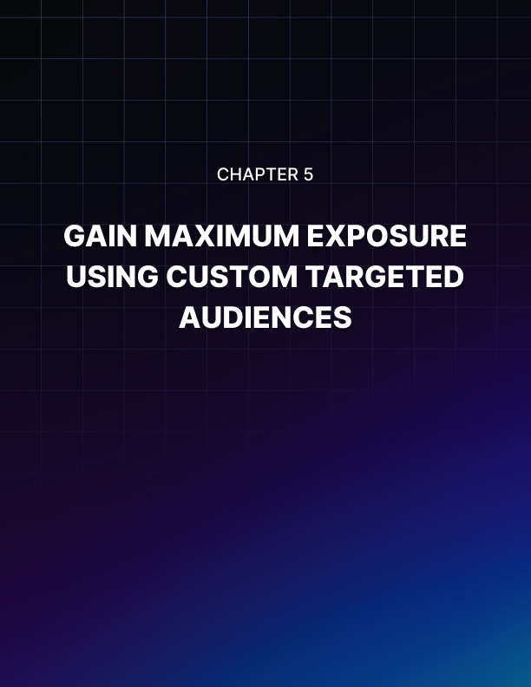

Chapter 5: Gain Maximum Exposure Using Custom Targeted Audiences

In this chapter, you will learn all about custom audiences and lookalike audiences and how you can target these two audiences to gain maximum exposure on Facebook. To begin with, let’s define what custom audiences and lookalike audiences mean.

What Is A Custom Audience?
A custom audience in Facebook is composed of a group of people who have interacted with your business either on Facebook, other online platforms and even offline. Targeting such a group usually results in higher conversions for businesses because these are people who are already familiar with your brand. They’re not total strangers to your business. These people are what we call a ’warm’ or ’hot’ audience.

The typical audience you create at the Ad Set level (we’ll refer to this as the default targeting system) can be targeted using their location, age, gender, languages, interests, connections, and more.

While this default targeting system is very comprehensive by itself, the Custom Audience feature allows advertisers to reach people you can’t target with the normal settings you find in the Audience tab in Ads Manager.

The 5 Types Of Custom Audiences You Can Create On Facebook
Here are different types of custom audiences you can target with your Facebook ads:

- Customer file
If you collect email addresses from your blog subscribers, then you have a mailing list. You can upload your list to Facebook, and it will look for your subscribers’ Facebook accounts. You can also directly import from MailChimp.

If you don’t have a mailing list, but you have a customer file of your subscribers which include any of the following details – email address, phone number, name, date of birth, gender, age, Facebook user ID, city, zip code, and more – then Facebook can also use these to look up your customers’ Facebook accounts and add them to your custom audience.

- Website traffic
To create an audience from people who have visited and took specific actions on your website, you need to have the Facebook pixel installed on your site. Installing the pixel isn’t really complicated.

However, to make sure there are no errors, ask assistance from someone who knows how to install the pixel. Also, to get usable data, wait for at least 30 days so that Facebook can get a more accurate read and create a bigger audience size for your custom audience.

- App activity
If you have an app or game linked to your account, you can create a custom audience of people who have launched, or took specific actions, on your app or game.

- Offline activity
You can target people who have interacted with your business in-store, by telephone, or via other offline means.

- Engagement
The engagement option allows you to target people who have engaged with your content on either Instagram or Facebook. This includes people who have watched your videos, opened or completed one of your lead forms, opened your collection or canvas ad and interacted with your events.

In any of the custom audience options above, Facebook guarantees that the process is secure and that your customers’ details will be kept private. This means that you won’t be able to see the individual profiles of your custom audience.

What Is A Lookalike Audience?
A lookalike audience is an audience that has similar characteristics to another existing audience. Facebook has an active user base of 2 billion people that logs onto the platform each month. Their algorithm is so advanced it can detect and scope out people who are similar to your first group.

It will look for patterns and characteristics that your first group has in common and create a second group of very similar users who most probably have not interacted with your business before.

You can create a lookalike audience based on a customer list, a custom audience, your Facebook conversion pixel, or people who like your page.

For example, if you’ve got a custom audience of 20-25 year-old single females based in the United States who like Pokemon, you can create a lookalike of that audience by targeting the same demographic of women in Australia or the United Kingdom or wherever else you want.

Facebook does the hard work for you. All you have to do is just basically select the audience source, the new location, the number of lookalike audiences you want to create and select the audience size. That’s it – just wait a short while, and you’ll have your lookalike audience in no time at all!

How To Use Custom And Lookalike Audiences To Get More Conversions
There are quite a number of different strategies you can employ to get more conversions for your business. However, the fastest way you can possibly get more sales and leads is by using a combination of custom and lookalike audiences.

As we have mentioned earlier in this chapter, custom audiences are people who are already familiar with your brand. They may already like and trust you, and thus would be more willing to sign up or buy your products and services.

Here are a few techniques to try and get more conversions for your business:

- Get In Touch With Old Customers
If your business is new on Facebook and you want to get more social proof by having people who know your business like your Facebook page, you can try setting up a campaign that targets everyone who’s ever done business with you. You can upload your mailing list, subscriber or customer database and Facebook will then match their info with their Facebook profiles.

Once you have your custom audience set up, you can then start an Engagement campaign and have your existing customers like your page. Make sure your advert clearly identifies who you are so that they can recognize you.

It’s important to note here that Page Likes are mainly a vanity metric nowadays. Organic engagement from page fans and followers are shockingly low, however, having a ’warm’ audience liking your page is beneficial for 2 reasons:

The numbers look good on your page (again, vanity metric), and It translates to lower conversion costs.

Facebook experts agree that it seems to be a common trend to have lower conversion costs when targeting a page’s fans. Yes, you still need to pay Facebook to reach all your fans but it’s not going to be expensive (results may vary from page to page so please take this advice with caution).

The reason this strategy usually leads to lower conversion costs is because ’warm’ page fans are more likely to click through or engage with your ads since they already know and trust you.

Once you've racked up a nice number of page likes, you can then create a second advert offering them a sweet deal – something like a loyalty discount for returning customers.

People love discounts! If they’ve had a good experience with your business in the past, chances are they’ll be more likely to take you up on your offer.

When you see good results on this initial campaign, you can then create a lookalike audience and target even more people with the same characteristics as your original custom audience!

Take note this strategy is just one of many. You can even forego the Page Likes campaign and just go straight to targeting your custom audience with the loyalty offer. It’s really all up to you – and your budget!

- Offer New Products or Upgrades To Existing Customers
Customer segmentation plays a huge role in this strategy. Simply put, if you sell several products, you’d need to create one list for each product. Yes, it’s going to take a lot of work upfront, however, when it’s time to create those ads, your job will be much easier.

Here’s an example:

Say you are selling ten products (products A to J). For each product you sell, you keep a list of all the customers who bought each product. In a few months, you release an updated product, say version 2.0 of Product A. It’s not an entirely new product, but it has significant upgrades to version 1.0.

If you’re selling version 2.0 at $100, you can set up a Facebook ad campaign targeting those who bought version 1.0 and offer the new version at a huge discount (for example, a 50% discount).

You then set up a separate advert targeting those who did not buy Product A but bought products B to J and offer version 2.0 at the original $100 price (or maybe give them a small discount for being a past customer).

The key takeaway here is that the more specific your audience, the more you can create ads that speak directly to them and address their pain points. Lumping everyone into the same group will not only lead to fewer people engaging with your ad but will also lead to higher conversion costs. The more targeted your audience, the more engaged they would be, and the lower your conversion costs.

To get even more conversions, create a lookalike audience for each of your custom audiences. This means that if you have 10 Custom Audiences based on each product (Products A to J), then you can create 10 Lookalike Audiences. This strategy is especially useful if your products are geared towards different markets or different industries.

- Target Subscribers Who Never Read Your Emails
People receive so many emails from marketers and companies all the time. We hear marketers say this popular phrase all the time – the money is in the list. But if people are getting a barrage of emails every single day, chances are your emails (and everyone not on their contact list) goes into the Spam folder or some other folder they will never open.

But with Facebook Ads, you have a new channel to reach them. You can upload your mailing list and create an ad targeted specifically to your subscribers.

Offer them something enticing or maybe just let them know about your new blog post and how it can be of value to them. You just need to be creative to get your brand in front of them so they’ll remember you when they need your products or services.

It’s true that the money is still in the list – you just need to pay Facebook a little bit more so you can reach those who choose to ignore your emails.

A Word Of Advice On Custom Audiences
We hope by now you can see just how powerful custom audiences and lookalike audiences are. But don’t be trigger happy – don’t think you can use stolen Facebook data and target people who've never signed up to your list. If you do this, you can get into a lot of trouble with Facebook, and possibly get your account banned!

Before you create any custom audience, you'd need to make sure of the following:

  - You have permission from your customers or mailing list to use their data. This means you can't create a custom audience using data you've bought from a third-party, especially unscrupulous marketers. This basically goes against the premise of custom audiences which are people who have interacted with your business before.

  - The people in your custom audience have not opted out or unsubscribed from your mailing list. If people opted out of your list, it means they don't want to receive any more communication from you. They don't want to receive your emails, your newsletters, and they don't want to look at your Facebook Ads.

If you don't follow these rules, your ad account could get banned. Getting banned is probably one of the worst things that can happen to any business especially if your target audience lives and breathes on Facebook. So make sure you don’t go against the rules when targeting custom audiences!

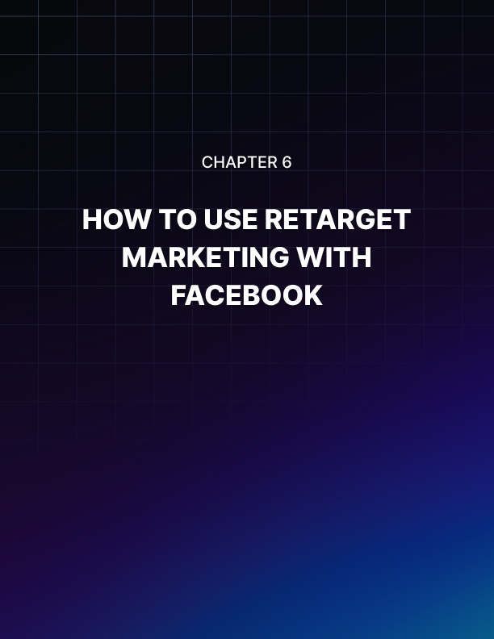

Chapter 6: How To Use Retarget Marketing With Facebook

We are pretty sure in this day and age, you've been retargeted or remarketed by various advertisers on Facebook. Imagine this scenario: you're looking at nice sweaters on a random website, and moments later you go on Facebook.

While checking out your news feed, you see an advert for the nice sweaters you've browsed earlier. Think it's a coincidence? Nope, that's Facebook retarget marketing in action, and it's what we're going to be discussing in depth here in the 6th chapter of the Facebook Ads Ninja series.

The Facebook Pixel’s Role In Retarget Marketing
To set up a retarget marketing campaign and reap its virtually unlimited possibilities for your business, you need to install the Facebook Pixel on your website. If you don't have a website, you can't launch a retargeting campaign.

Don’t worry if this sounds too technical for you – you can easily hire a web developer or designer to build your website and have them install your Facebook pixel on it.

The Facebook pixel is basically a small piece of code that you need to insert into your website's heading. It's just a few lines of code, but it can add a lot to your businesses’ bottom line! Going back to the scenario we described in the introduction, here's what happened:

That website had Facebook’s code installed, and when you visited their site, it left a cookie (not a real cookie, mind you, but a small piece of code) on your browser that allowed the website to track the actions you take on their site.

If the site owners have set up their pixel to track specific events like clicking a button or visiting a specific page, then they can also track if you do any of these tagged events.

In your particular case, they probably tagged you as someone who visited the site but did not purchase anything and added you to their custom audience for retargeting later on Facebook. Hence, the sweater ad you saw.

Why You Should Set Up The Pixel Asap
The Facebook pixel is so powerful that experts suggest you set it up even if you have no immediate plans of advertising on Facebook. This is to allow your pixel to gather your site visitors’ data so when you’re finally ready to pay for ads, you can add your pixel data to your custom audience.

And just like we've covered in Chapter 5, targeting a custom audience (or people who’ve interacted with your business before) is so much easier than targeting a ’cold’ audience or those who probably have never heard of you before.

Here are five reasons why you need to set up the pixel on your website as soon as possible:

- Track your site visitors.
You can use the pixel to track your website visitors and the actions they are doing on your site. Armed with this information, you can segment your visitors into different custom audiences.

For instance, you can create a custom audience of people who’ve been on your website but have not purchased anything. You can create a second custom audience of people who added your products to their cart but did not purchase. And lastly, you can create a third audience of people who successfully bought something from you.

- You can monitor and optimize your Facebook ad campaigns.
When you optimize your ads, you're better able to create ad campaigns that result in better ROI or return on investment for you. You're no longer blindly hoping for someone to click on your ad, rather you have real data to back you up, and you can then make informed decisions on the best way to move forward with your ad campaigns. With the pixel, you can see which ads are performing best with which audiences.
- Installing the pixel is free.
You don't have to pay Facebook to install their pixel. However, when the time comes for you to utilize the pixel data, then you need to pay Facebook. But just like we’ve mentioned quite a few times in this series, your pixel data is from a warm audience, so these people are not total strangers to your brand. You really have nothing to lose if you install the pixel (unless you pay a developer to install the code for you!) and everything to gain thanks to better audience targeting.

- You can easily track standard or custom events on your website.
The facebook pixel is divided into two parts. The first one is the base code which you install into your website’s global header – this means that ALL pages on your website will be tracked by the pixel. The second code is the events code which you can add to specific pages on your website.

For example, if you want to track people who’ve signed up to your mailing list, you can add an event code for this. If you want to track people who clicked on the ’add to cart’ button you can add an event code for this as well. If you want to track people who purchased something, you can add an event code on your thank you or product delivery page.

- The Facebook pixel is not limited to a single device or IP address.
If your website visitor logs onto Facebook from a new computer or a new mobile device, it's able to accurately track that user's activities. This is why even if your website visitors checked your site on their desktop computer when they opened Facebook on a mobile device or a tablet, they'd still be able to see your ads!

As you can see, the Facebook pixel is very powerful. The ability to track and determine a user's habits across your website is an advertising weapon you can leverage with Facebook ads. If you want to maximize your ad spend and get more conversions, then install the pixel as soon as you read this chapter.

If you are running an e-commerce store, the Facebook pixel will help you reach your business goals faster at a much smaller ad spend than if you advertise on other platforms. You have practically nothing to lose and everything to gain by adding just a few lines of code to your website!

How To Create Your Facebook Pixel
Creating the pixel is very easy. You just need to go to your Facebook Ads Manager (we showed you how to do this in Chapter 2) and look for the Pixels tool. Note that you can only create one pixel per ad account.

Follow the onscreen instructions carefully. Once you have the pixel set up on your website, you will then be able to create custom audiences and lookalike audiences based on your website’s pixel data.

How To Apply Pixel Data For Retarget Marketing
Now that you know just how powerful the combination of Facebook pixel and retarget marketing is, let’s get into the nitty-gritty of just how you can take advantage and leverage your audience data.

In the previous chapter (Chapter 5: Gain Maximum Exposure Using Custom Targeted Audiences), we covered custom audiences and lookalike audiences in great detail. In this section of this 6th chapter, we will just quickly show you a sample application on how you can leverage your pixel data for retargeting.

Create A Custom Audience Of People Who Have Visited Your Website
The pixel keeps a record of people who have been on your website in the past 180 days or 6 months. To target this audience, here’s what you need to do:

  - Go to Ads Manager Menu, go to the Assets column, then click on Audiences.
  - Click on the blue Create a Custom Audience button.
  - Select Website Traﬃc
  - You can choose whether to target people who meet any or all of your criteria.
  - Choose whether you want to target all website visitors, people who visited specific web pages, or target them by time spent on your website.
  - If you want to target a combination of any of these audiences or exclude some, you can do so by clicking on Include more or Exclude.
  - When you’re done setting up the details of your custom audience, you then need to create an Audience Name. Make sure it’s something you can easily remember so when you’re creating your ads you can identify the right audience.
  - If you’re happy with your custom audience, hit the Create Audience button to finalize your audience.

The targeting options on Facebook’s custom audiences are really extensive. No other platform can compete with the level of targeting you can do with your Facebook ads thanks to the pixel. If you’re still on the fence about whether it’s worth taking the time to install such code on your website, then you’re leaving a lot of money on the table. Tap into your audience’s behaviors and target them using the all-powerful pixel today!

Facebook Retarget Marketing Versus Google Remarketing
Facebook is not the only platform that retargets site visitors. It’s not the only game in town to do that, but there’s no doubt that it’s one of the most powerful due to the hyper-targeting options you can do on Facebook. The top alternative to Facebook remarketing is Google remarketing.

Google remarketing works almost the same way as Facebook remarketing. Where Facebook remarketing ads are limited to Facebook, Google remarketing can follow you all around the web! For instance, if you read an article on Website 1, when you go to Websites 2 and 3, you’ll see an ad for Website 1 on these websites even though Websites 2 and 3 are totally unrelated to Website 1!

The Google equivalent of the Facebook pixel is known as the ’Google remarketing tag.’ It’s not a fancy name, but it’s easier for beginners to understand exactly what that code does. It works basically the same way as the Facebook pixel wherein the tag or code is placed on pages you want to track.

When a site visitor lands on a ’cookie’ page, it enables Google to follow you around the web which is why you’re able to see Website 1 ads even though you’ve long since left that site.

What most marketers love about Google remarketing is that the click-through rates are much higher which results in a lower cost per click or action. Of course, the same thing is happening with Facebook retargeting.

And the reason for this is because with remarketing, whether it be on Google or Facebook, you’re targeting people who have already interacted with your brand or your website. These people already know you – you just need to make sure that your ads remind them of who you are.

The main thing Google remarketing has over Facebook is that Google’s Display Network is quite vast. So you can pretty much have your ad follow people around the web for as long as your budget allows you to! Of course, this might not be the most sensible thing to do.

After all, if people have been seeing your ad constantly for the past few days and they’re not taking any action, it might mean they’re not interested. They could also develop this thing called ’ad blindness.’

The key takeaway here is that whether you use Facebook or Google for remarketing to warm audiences, you need to create ads that will help them remember your brand. Create something outstanding, something they can relate to. Don’t follow them with boring ads that don't really speak out to them and address their pain points.

Final Thoughts About Retarget Marketing
There’s no doubt that retarget marketing is a very powerful tool in any serious marketer’s arsenal. However, if you want to have consistently high conversions, you’d also need to change up your ads from time to time.

Keep your ads fresh and relevant so you don’t annoy your potential customers. Keep in mind that annoyed users mean no sales for your business.
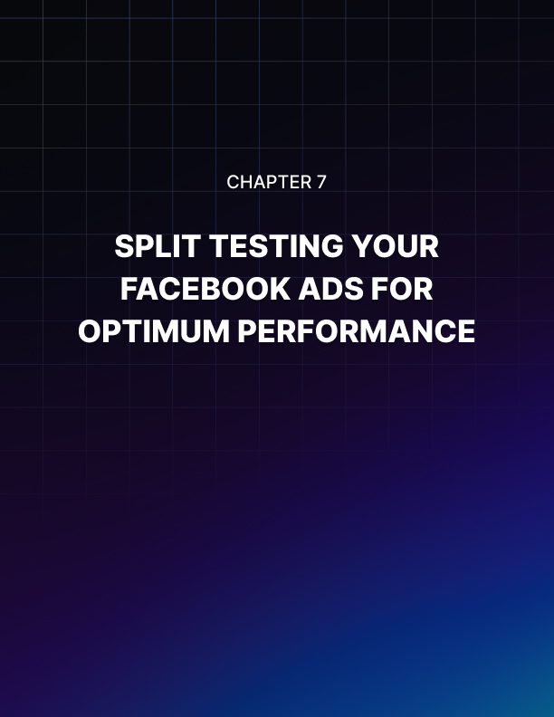

Chapter 7: Split Testing Your Facebook Ads For Optimum Performance

Split testing ads have a lot of benefits, however, most advertisers won’t bother split testing their ads. Why? Because it’s a lot of work and it’s expensive. But are the results not worth it though? Let’s find out together in the 7th chapter of this Facebook Ads Ninja series!

What Is Split Testing?
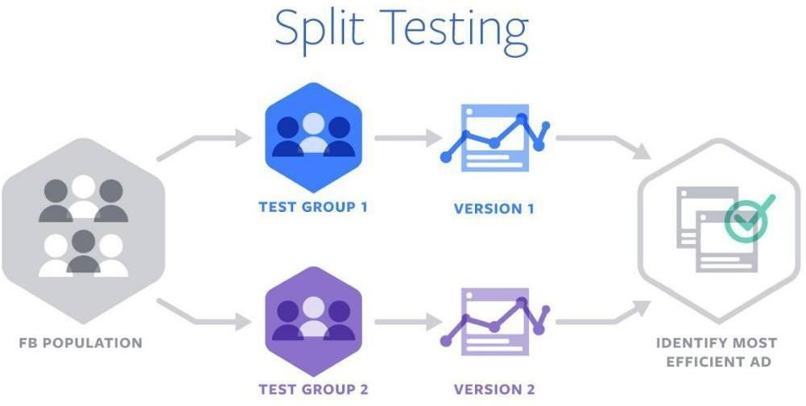

(Split testing in action. Image Source: Facebook.com)

Split testing, also referred to as A/B testing, is testing 2 or more ad elements against each to find the best converting one. It’s a lengthy process especially if you want to test all elements in your advert – from the images to the headline, description, placements, call to action, and more.

Successful marketers and advertisers on Facebook will tell you that their secret to success is split testing their ads. By split testing, they are able to eliminate ads that don’t result in good conversion numbers. By the end of their tests, the highest converting ads are used when they scale their advertising and target a bigger audience.

For instance, if you have three different audiences and you want to see which audience is going to convert best for your ad, you can do a three- way split test. This means you show the same ad to Audience 1, Audience 2 and Audience 3. After a period of time, you then look at the data Facebook gives you and you’re able to determine which audience responded best to that ad.

With that knowledge, you can then create a lookalike audience to target other people with similar characteristics as the winning audience. So if Audience 1 won the split test, you could create a lookalike audience of Audience 1. This not only increases your probability of success but you know with 100% certainty that that specific advert is optimized for a particular audience.

What Are The Benefits Of Split Testing?
Split testing will undeniably benefit those who have the budget to burn through in the early stages of a campaign. Most adverts won’t convert – that’s money down the drain. You may split test a lot of adverts, and you may not find a winning ad set until the 101st ad you launch.

That essentially means you paid for the first 100 ads for nothing. But is that really the truth? Of course not. It just means you’ve sifted through the dirt to find the pot of gold at the end! In most cases, the winning ad set can easily pay for all the failed ads!

So, here are some of the benefits of split testing and why you should start implementing this in your Facebook ads right away:

- There’s no guesswork involved – only pure, hard facts.
With split testing, you’re eliminating many reasons for why your ad isn’t successful. It’s sort of like a checklist. Ads 1 to 100 failed, but Ad 101 is smashing success. So you literally just crossed off 100 poor-converting variations of your ad. Split testing also allows you to optimize your ad – you already know the elements that are not converting so you’re not going to use it in the next iteration of your ad.

- Your results are both credible and tangible.
Who would say 100 failed adverts is not credible? You’ve spent all that money just to arrive at the end of the proverbial rainbow where the pot of gold is. If someone asks you why your campaign was successful, you can easily say, ’Oh, it’s because I removed all the low-converting elements in my ad and used only the highest converting elements to make one super successful ad.’ After so many failed tests, you can pinpoint the exact recipe for your success!

- It’s a very smart investment.
Most naysayers will say split testing is like giving Facebook free cash. While it may be true in the beginning, just one successful campaign can pay off all your failed adverts. But what if you don’t ever find a successful campaign?

There are unlimited possibilities when it comes to split testing. Maybe you just haven’t found the right combination of good ad design and target audience. For example, if you’re promoting a lady’s t-shirt and you’re promoting to an audience consisting of men, then it’s probably not surprising you’re getting very low conversions.

Split testing is only a smart investment when you’ve thought about all possible angles thoroughly. Going in blind is not smart at all – have a solid campaign plan to help you find that winning ad set sooner rather than later.

- You will learn a lot about your audience.
Once you know what makes an audience tick or makes them motivated to follow the call to action in your ad, you can try to offer similar products and services and expect to get good results.

For instance, you know that a particular type of headline and image works best with a particular audience to get them to buy Product A. You can then use similar elements in a future advert and try to hook in the same audience sometime in the future to buy a product similar to Product A.

There’s really a lot of possibilities you can explore once you get to know what your winning target audience likes!

Best Practices In Split Testing
There is an infinite number of possibilities with which you can carry out your split testing. However, for all split tests, there are some things in common which usually lead to successful tests. Here are some best practices for split testing:

- Start testing vastly different elements at the beginning of your campaign.
At the start, you don’t want to test one element’s variation only. What you want to do is to try and cover all possible bases, so you can get an overall sense of what’s working for your audience. Start with broad variables first and for each successful split test where one advert clearly comes out on top, use that element to narrow down your ad sets and do further split testing.

For instance, if you’re looking for the optimum age group to target, you may want to test first an age group of 18-30-year-olds and then 30-50- year-olds. Once you have the winner for this test, you can then refine your experiment to look for a narrower age range.

If, for example, the winner was the 18-30-year-old group, then in your next split test, you can target users from 18-22, 23-26, and 27-30.

This method not only saves you money, but it also saves you time as testing multiple specific variations at once may take you anywhere from several days to a few weeks to get reliable data.

- Change only one element and keep everything else the same.
This information is important because if you change many elements or variables in a split test, then you won’t know which variable caused your ad to fail or succeed. The process of elimination is helpful as you go through each element and cross out those non-performing or non-converting variables.

As an example, you can run the same advert to 2 different audiences. You’ll use the same image, headline, ad copy, and call to action, however, the first audience will be 18-25-year-old women in relationships while the second audience will be 18-25-year-old single women. If one of the audiences comes out on top, then you know which audience group to target in your next ad campaign.

- Run your split test ads for at least 3-4 days.
Facebook recommends letting your split tests run between 3 and 14 days. Running tests for only 1-2 days may not produce data sufficient enough to determine a clear winner, and a 2-week test is just far too long and inefficient for your budget. The benefit of letting ads run for a few days is you can see which particular times of day your audience is engaging with your ad. You can then keep this factor in mind when optimizing your ad.

- Have a sufficient budget in mind.
Before you begin your tests, you should have a defined budget in mind otherwise you run the risk of losing a fortune on Facebook ads. The bigger the audience size, the bigger the budget you need to allocate. The important thing to note here is that your budget should allow Facebook to conduct the split test effectively and produce a convincing winner.

When setting up your ads, Facebook will give you a suggested budget, but oftentimes, this can be quite expensive. Most Facebook ads experts say you can start with a $5/day budget for each ad set.

However, if you want to see results fast enough, then you need to increase your daily budget. Moreover, you should know that you can also choose to split the budget evenly or weigh one more heavily than others.

How To Split Test In Facebook Ads
In this section, we’ll give you a general overview of how to split test Facebook ads.

  - To begin a split test campaign, you need to go to the Ads Manager and create a new ad.

  - Choose a campaign objective. Note that Facebook does not support split testing all campaign objectives. Here’s the complete list of objectives you can and cannot test:

- Brand awareness - no
- Reach - YES
- Traffic - YES
- Engagement - YES
- App installs - YES
- Video views - YES
- Lead generation - YES
- Messages - no
- Conversions - YES
- Catalog sales - YES
- Store visits – no

  - Once you've chosen a suitable objective, tick the ’Create split test’ box. As you can see in the screenshot below, we chose Traffic as our campaign objective.

  - Create your Campaign Name and click ’Continue’.

  - The next steps in the ad creation process will depend on the Variable you'll choose to split test.

There are four main variable categories you can split tests. These are:

- Creative – you can experiment and split test the image, headline, ad text, etc. For instance, you can split test an ad with one image versus an ad with a video. You can also try and use the same image but with different headlines.

- Delivery optimization – choose whether you want to split tests between link clicks, landing page views, impressions, or daily unique reach. As an example, you can split tests by having one ad optimize for conversions and have the second ad optimize for link clicks.

- Audience – you can split test your audience’s location, gender, interests, age, relationship status, education level, purchase behaviors, and even test between custom audiences. For example, you can show one ad to a group of women living in London and then show the same to a second group of women living in Brisbane.

- Placement – split test where you want your ads to display (mobile, desktop, newsfeed, right column, Instagram, Audience Network, etc.). An example would be you can test whether you want customized placements versus automatic placements. You can also compare mobile placements versus desktop placements.

Choose the variable you want to split test. Once you've set up your adverts, Facebook will then record and compare the results. Once the winning advert is determined, you'll receive a notification email with your split test results on it.

You can then use this information to move forward with the next split-test (for instance, further narrowing the variables you want to test), or to design your next ad campaign and refine your overall advertising strategy.

Conclusion
The mantra of successful Facebook ads marketers is to ’always test, test, test.’ Yes, it can get costly, but a successful split test often leads to impressive ROIs!

Only a few marketers attribute their success to luck – most of them credit split testing as the reason for their success. As the saying goes, the numbers don't lie!

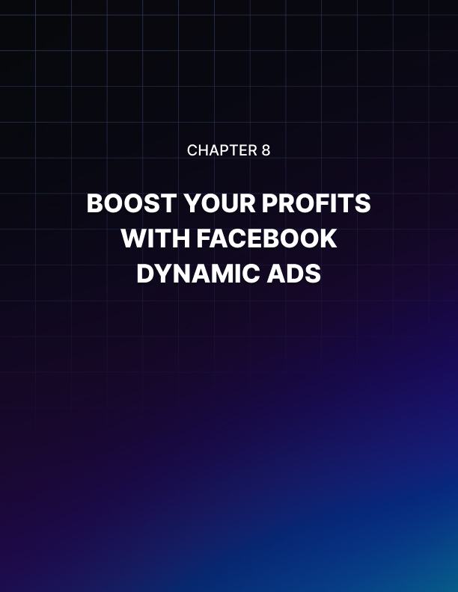

Chapter 8: Boost Your Profits With Facebook Dynamic Ads

Facebook Ads is a very powerful platform for marketers. However, compared to keyword-based advertising on search engines, Facebook Ads cannot determine purchasing intent because users don't normally go on Facebook to search for things to buy.

Facebook came up with a way to circumvent this inherent weakness by introducing dynamic ads. Many advertisers have been won over by the impressive results they get from dynamic ads as compared to the usual static ads. In this chapter, we’re going to be showing you how you too can boost your profits using Facebook dynamic ads!

What Are Dynamic Ads?
Dynamic ads are simply automated Facebook Ads. Other marketing experts call it ’retargeting ads on steroids.’ It targets people who have been on your website or app and serves them ads based on what they've been doing on your web property.

The Facebook pixel tracks their actions, and when they go on Facebook, your dynamic ads will then come into play in a completely automated manner.

If you have an online store and you’re selling tens of thousands of products, instead of creating an advert for each product, you can simply upload your product catalog to Facebook. Just imagine how many hours you’re saving with dynamic ads!

The only real work you and your team needs to do is just basically make sure your catalog is up to speed and that it contains all relevant details about your products. Once you’ve set up your ad template and defined your budget, then it’s pretty much a hands-off advertising machine!

For example, when a customer views or adds a product to his cart, your pixel tracks that action. When he buys that product, your pixel will know it. So when they go into Facebook, the system will know exactly what that customer has been doing on your website.

If they viewed a product but did not buy it, they’ll see an advert for the very same product on their news feed or wherever you chose to display your dynamic ads. Likewise, if that customer bought that product, they’re NOT going to be seeing an ad for that product on Facebook (that will be very annoying!). Instead, they’ll see another product on display. And since they already bought from you, they therefore know you and will most likely buy from you again especially if they had a good experience with the first product.

Additionally, dynamic ads help circumvent ad blindness. With so many ads flooding people’s news feeds, it’s not surprising that a lot of people are developing banner ad blindness. But with dynamic ads, your ads are so relevant and so timely (they were just looking at that particular product 10 minutes ago!), people feel more compelled to purchase your ad on the spot!

In short, Facebook dynamic ads are a very smart way to retarget your customers by serving them highly relevant ads no matter where they are in the sales funnel!

How To Get Started With Facebook Dynamic Ads
Setting up dynamic ads can be difficult at the beginning. However, if you want to save time and resources in the long run, then you’d need to invest some time (and money), so your dynamic ads will run smoothly in the future.

To get started with dynamic ads, you’d need the following:

- The Facebook Pixel
If you’ve read our previous chapters in this Facebook Ads Ninja series, you’d know that the Facebook pixel is key to generating custom audiences and maximizing your ROI. With dynamic ads, the pixel plays yet another important role in helping you boost your profits even more.

If you’ve already set up the base pixel code on your website, you would now need to edit or modify the custom audience pixel. Dynamic ads require 3 Custom Data events, and you must edit the pixel code for these three events on your website:

- Product pages (event name is ViewContent) – the code will report product IDs from the catalog which have been viewed.

- Add to cart pages (event name is AddToCart)– the code will report the product IDs from the catalog which have been added to cart.

- Purchase confirmation pages (event name is Purchase) – the code will identify the product IDs which have been purchased.

If the code looks intimidating, it’s best to get help from an experienced developer to make sure there are no errors in the code.

- Facebook SDK
If you have a mobile app or are planning to have one, you can integrate the Facebook SDK into your iOS, Android or web app to target your app users with dynamic ads. Just like the Facebook pixel for websites, you would also need to integrate the three required events added to your app (ViewContent, AddToCart, and Purchase).

Here’s an example code for an iOS app event:

If all that alphanumeric code made your head spin, please get the help of a qualified mobile app developer to make sure your dynamic ads will run properly.

- Business Manager
Getting a business manager account is free and easy to do. You can add pages and ad accounts to your business manager, and assign specific roles to other people. It also makes it easy for you to manage all your assets in one place.

- Facebook Page
Your business needs to have a Facebook page when you launch dynamic ads. It will represent your business on Facebook.

- Product Catalog
The Facebook product catalog is the last essential component to make your dynamic ads run successfully. It quite literally is your business’ virtual database on Facebook. It is an inventory of all the products you want to promote on Facebook. You can upload one data feed for all your products, or you can upload multiple data feeds especially if your business operates in more than one country or has multiple divisions.

You can create a catalog by going to your Business Manager Menu > Assets > Catalogs.

These are the different catalog types you can create:

- E-commerce – if you have an e-commerce store, you can upload a data feed of all your products to your catalog. If you already have a Shopify, WooCommerce, Magento, BigCommerce, or Google shopping product feed, you can set up your catalog quicker just by using the Facebook Feed plugin.

- Travel – upload a data feed of hotels, vacation properties, flights, and destinations.

- Real estate – create a catalog of real estate listings and rental properties.

- Auto – create a catalog of vehicles and vehicle offers for your auto business.

Once you've created your catalog, you then need to create a data feed which contains all the information you want to advertise in your dynamic ads. The required item information will vary for each catalog type, and you have to use Facebook’s required format and file type to create a proper data feed.

Now that you know the key requirements to get started with dynamic ads, let’s head into the next section where we’ll discuss how to launch your dynamic ads and the best practices for doing this.

How To Create And Start A Dynamic Ad Campaign
To create a dynamic ad, you need to have all requirements we mentioned in the previous section up and running. Otherwise, you may not be able to finish creating a dynamic ad.

- The first thing you need to do to create a dynamic ad is to make sure you select Catalog Sales as your marketing or campaign objective.

- In the next section, select the Catalog you want to use and name your Campaign name (or you can use the default name).

- Follow the next steps to set up your ad set. Choose the correct product set that you want to advertise. Then set up your audience (who you want to show the ads to), the placement (where your dynamic ads will be shown), your budget (how much you want to spend per day or for the lifetime of your campaign), and your schedule (how long you want the campaign to run).

- In the ad section, set up your ad’s format. You can choose to use a carousel ad, a single image ad, or a collection ad.

- Lastly, in the Links section, set up your ad creative template and preview how your dynamic ad is going to look like. Here's a sample preview:

Double check your work and make sure you’re happy with how your dynamic ads are going to look like. Again, your ads are going to be served dynamically and automatically, so you need to make sure all the elements of a good ad are still in place in your catalog data feed.

How Facebook Dynamic Ads Can Boost Your Profits
Remarket targeting is a powerful advertising strategy on its own since you’re targeting a ’warm’ or
’hot’ audience. With Facebook dynamic ads, you not only retarget these audiences, but you’re also showing them dynamic ads that are relevant to what they've been doing on your website or app! Aside from this main benefit, let’s go through a few more points how dynamic ads can boost your profits:

- You spend less time creating and editing ads.
With dynamic ads, you only need to create your ad once. You define the product variables you want to use in your ad, and Facebook will automatically pull the data from your data feed.

You don’t need to set up a reminder on your calendar to help remind you that you need to update the pricing on some of your ads – you can simply edit your data feed, and Facebook will then use your new data.

If you want to update a product image, simply update the link in the data feed. You also don’t need to manually update the inventory levels so if you run out of stock, your pixel will know it and Facebook won’t serve up a dynamic ad of that particular product.

- Spend more time growing your business.
Dynamic ads will help you grow your business in a hands-off manner. Once you've set up your catalog and your ad creative, you pretty much have a lot of free time on your hands. You can use that to look for new avenues or platforms to reach your target audience.

Since dynamic ads basically cater to people who’ve interacted with your business, you can then focus on reaching out to ’cold’ audiences or people who haven’t interacted with your site or app before.

- Offer personalized recommendations.
Since the Facebook pixel can track your customer’s actions on your site or app, your ad will dynamically show the product your customer was looking at or added to their cart but did not buy. For those who already bought an item from you, your dynamic ad won’t show them the same product. Rather, your dynamic ad will upsell or cross-sell a different product.

- Improve your conversion rates.
Ideally, you’d want a 100% conversion rate on your ads. But doing this is near to impossible as there are far too many factors that come into play during the buying process. Facebook’s retargeting system helped conversion rates go up for many advertisers. But with dynamic ads, it’s taken retargeting to an entirely different level, and many advertisers are reporting impressive conversion rates and massive profits!

Final Words
Facebook dynamic ads are a step-up from retarget marketing. However, not everyone can create dynamic ad campaigns. For now, this option is only available to businesses who have an inventory of products to sell.

If you’re selling one or two products, you can still remarket to your customers, just not at the scale and ease of dynamic ads.
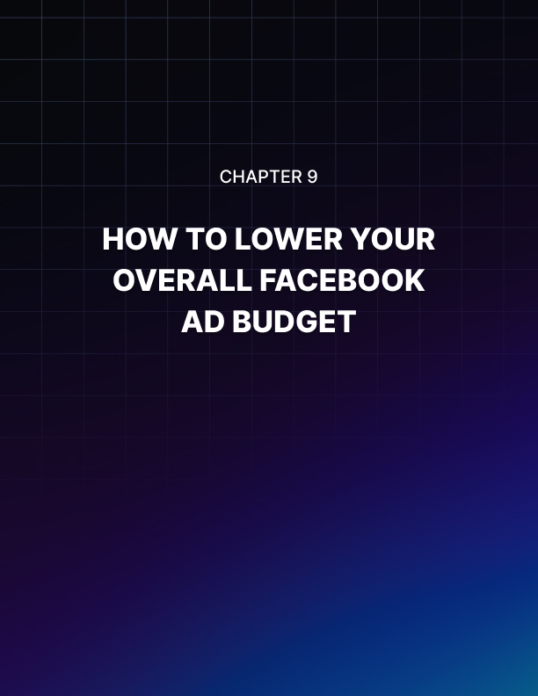

Chapter 9: How To Lower Your Overall Facebook Ad Budget

You can set your own budget on Facebook Ads. You can go as low as $1 per day, a few hundred dollars, or go as high as you want. However, if you really want to get the best conversion rates and reach the right audience, then you’d need to shell out more than a dollar per day.

You also don’t want to spend too much, even if you have the cash to burn, because it’s simply not a very good business decision.

In fact, for smart business owners and marketers, the reason you’re advertising on Facebook is so you can get the highest conversion rates at the lowest possible price. If you think you’re spending too much and you’d like to know how you can lower your overall Facebook Ad budget, then you’re reading the right chapter in this Facebook Ads Ninja series.

How To Make The Most Of Your Facebook Ad Budget
Before you set up any advert on Facebook, you’d need to have some rules in place first. You need to identify your campaign goals, your target audience, your ad schedule, and so much more. You need to have some key metrics in place as well, so you know whether your campaign is profitable or not.

Ideally, you should know where every single dollar of your ad spend is going so you’re not throwing away money. If your campaign is in the red, you need to figure out how to optimize your campaign so you’ll end up in the green.

Here are a few techniques to help you make the most of your ad budget:

- Set a target revenue
Revenue means tangible and real dollars. It does not mean page likes and comments on your ad that went viral. While ad engagement is a useful metric, at the end of the day, you want to get enough revenue to make a healthy profit.

For example, if you want to make a $10,000 revenue for your week-long campaign, and your product price is $100, then you need to make at least 100 sales in 7 days. You can then work your way backward and estimate how much your ad budget should be to make at least 100 sales.

- Set up the Facebook events pixel code on your website.
If you want to track what your web visitors are doing after they go from Facebook onto your website, then you need the pixel installed. Set up the events you want to track.

For example, if you want to track how many people have purchased your $100 product, then you can track the Download or Thank You page. Every time someone lands on that page, the pixel will record that as a lead or sale. Knowing this data lets you adjust your budget as your campaign progresses.

- Plan out your ad campaign.
Use the right campaign objective so Facebook can help optimize your ad for you. The Facebook algorithm is advanced, and advertisers can use it to help maximize their investment in the platform. Some objectives will result in higher conversion costs while some may result in lower conversion costs. Set the right objective to help you work within your budget.

- Monitor your results and adjust your campaign as needed.
Your ad budget is not set in stone. You can adjust it anytime you see the need to. Facebook’s reporting tool is accurate and happens in real time so you know you are making business decisions based on time-sensitive data.

If you see that you’re underspending, then you might want to scale your ads or increase your audience size. If you’re overspending, then double down on ads that are returning a profit for you and deactivate the rest.

How To Lower Your Overall Facebook Ad Spend
There are quite a number of techniques you can use to lower your overall ad spend. Some of the tips we’ll share on this chapter may work for you, while some may not. However, the only way for you to find out if any of these tips will help you with your budget, is for you to try them out.

- Know your target audience
Don't just randomly target everyone in a specific location. With Facebook Ads, you can hyper- target people in a way that other advertising platforms can only dream of. If you're in a niche business, then you should already have an idea of who your target customers are. The more targeted your audience, the easier it will be for you to create ads that resonate with that audience.

For example, if you're selling fishing accessories for women, then you might want to exclude males from your audience. You can then create separate ads for each age group, and then craft your ads in such a way that your audience will think the product was made specifically for them. When you make your ad relevant, the higher the chances that that customer will click on your ad and purchase your product.

- Set a bid cap
At the ad set level, in the Budget & Schedule section, you can set a bid cap per link click and per 1,000 impressions. This helps you control your bid and make sure you don't go beyond your allotted budget per action.

For example, if you've got a daily budget of $20 and you're paying per link click, then you can set a bid cap of $1 per click, so you know you're going to get at least 20 clicks per day.

If you don't set a bid cap, Facebook can cost you maybe $2 or $4 per click, or even more. So it's best to use this feature when you create your ad. Just remember that if your bid cap is too low, then it might not be competitive, and your ad may not be shown to your target audience.

- Make sure there’s no audience overlap
When you have overlapping audiences, you're essentially going to be bidding against yourself. For instance, if you are targeting freelancers, a small part of your audience may also be entrepreneurs.

This means that you're bidding twice to show your ads to the same audience. The good thing is that Facebook won't allow you to compete against yourself but it may drive up costs. This will ultimately result in an inefficient use of your budget.

To check that your audiences are not overlapping, go to the Ads Manager > Audiences, then check the boxes next to the audiences you want to compare. Click Actions > Show Audience Overlap.

- Always split test your ads.
In the 7th chapter of this series (Chapter 7: Split Testing Your Facebook Ads For Optimum Performance), we covered all the details on how to split test. Just remember that split testing will not only help you save time, it will also help you save money since you already know what's NOT working.

Split testing helps you narrow down your choices to find the winning combination of audience, placement, and ad creative.

- Retarget people who have been on your website or app.
Retarget marketing works as we've shown you in Chapter 6: How To Use Retarget Marketing With Facebook. It works because you're not targeting cold audiences. Instead, you’re targeting people who have already been on your website, your mobile app, and even people who've been to your brick-and-mortar business location.

Facebook makes it easy for you to create custom audiences, so you're showing your ads to people who have looked at your products and even purchased from you. This means they already know your business to an extent, and this increases the likelihood of them doing business with you, as opposed to a total stranger who's never heard of you before.

- Refresh your ad creatives
If you're noticing a trend of more expensive ad costs, you may want to look at your ad creatives. If you've been using the same image for several weeks and the very same ad has been shown to the same audience ten times, chances are they've already developed ad blindness.

Your ad no longer stands out to them, so you need to think of another way to try to get their attention. Alternatively, if your target audience isn't responding, maybe you’re targeting the wrong audience.

- Use video ads
If a picture paints a thousand words, a video plays a thousand pictures. Many advertisers are reporting very low ad costs thanks to video ads.

People are engaging with video ads because they don’t have to read a lot of text, and video is just easier to consume than other media.

Billions of video views are happening on Facebook every single day. Facebook is literally on the brink of overtaking YouTube as the biggest video platform any day now so you should capitalize on this and use video ads.

One strategy that successful marketers use is to create video ads – nothing fancy, just an iPhone-shot video where they talk to prospects on camera and show their products in action.

You just have to get really creative. If you’ve studied your target market, then you should have an idea of their likes and dislikes, hit their pain points, and offer your solution.

- Let your ads run for a few days or a few weeks to optimize
If you've just run your ads for 1 or 2 days, then chances are your ad costs will be relatively higher. Don't be impatient. Instead, give Facebook time to optimize your ad and reach your target audience. If your audience is 1,000,000 and you’re running a $5/day campaign, then you’re not going to reach that 1,000,000 in 1-2 days.

When you set up your budget, Facebook gives you an estimated reach or estimated daily result for your campaign. Once your ad has optimized, and more people are engaging with your ad, then you can expect to pay lower ad costs.

- Use powerful words in your ad copy
Your advert's headline should catch your reader’s attention right away. If you're selling a product that will solve a specific problem, mention that in the headline. Don't hide your product's main benefit on your landing page. Instead, reel them in with powerful words that will resonate with them and get them to click on your ad and follow your call to action.

- Give away freebies
If you want people to engage with your ad, give them something for free. This might sound like you're tricking people, but if you want to get more leads and customers, you have to give them something valuable for free.

If you're selling a high-priced product or service, consider giving away a small item for free. Or you can try giving away a discount. Give your audience some incentive to click on your ad and Facebook will reward you with lower ad costs.

- Try advertising outside of peak sale seasons
During certain times of the year, you will experience higher ad costs. This is especially true during Christmas, Thanksgiving, Black Friday, Valentines Day, and other hallmark holidays. At these times of the year, people are spending and buying things online.

So it's natural for marketers to want to put their brands and products in front of the buying crowd. When there are more advertisers competing, the higher the ad costs for everyone. If you want to lower your budget, try advertising outside of these peak seasons.

Final Words
Just because you can advertise on Facebook for $1 or $2 a day doesn't mean you should stick to this rock-bottom budget all year long. You’re not going to get far with such a budget. If you want to make the most of Facebook Ads, then you need to spend some money.

The tips and techniques we've shared in this chapter should help you reach your target audience without breaking the bank. Test each technique and see what works best for you and helps you lower your overall Facebook Ads spend.

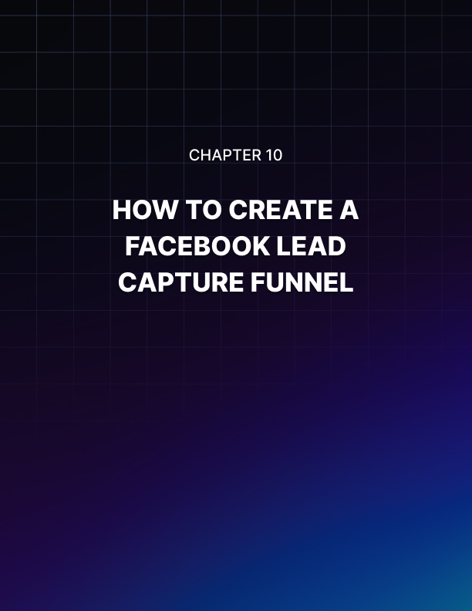

Chapter 10: How To Create A Facebook Lead Capture Funnel

Everywhere you go in the marketing world, whether it be online or offline marketing, you'll hear the words ’lead generation funnel’ or ’sales funnel’. But what do these terms really mean? And why is it important for you to know what a funnel is and how it works?

Well, read on because in this chapter, you’re going to be learning all about the lead funnel, specifically how you can use Facebook Ads to create the perfect lead capture funnel for your business.

What Is A Lead Capture Funnel?
No matter the product or service you're offering, it’s important that all of your customers and clients go through a sales funnel.

You need to know each step of the funnel so you can guide your customers through it and lead them to the bottom of the funnel, which is where product purchase occurs. Essentially, a lead capture funnel will guide your lead from being a potential customer to a paying customer.

Here is a good example of what a lead capture or sales funnel looks like:
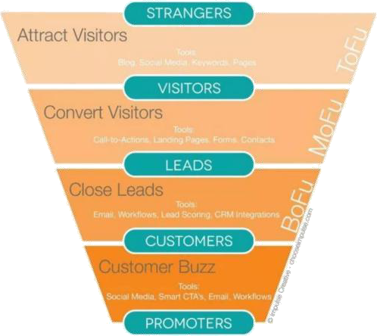

While many marketers call the different funnel stages by different names, the idea is the same. Let’s go through each stage here:

At the top of the funnel (ToFu), your prospects are total strangers to your business. They don’t know who you are, but they found you on social media or Google or wherever. At this point, you want them to be aware of your business and what you can do for them.

For instance, if you are selling a weight loss product, you want people at the top of the funnel to know your brand exists, so you try to offer them something of value to help them retain your brand in their minds.

At the next stage of the funnel – the middle of the funnel (MoFu) – you try to convert your visitors from being strangers to becoming leads. At this point, you want them to seriously consider your business for whatever pain point you can help them with or provide a solution to.

To continue our previous example, at this stage, you want your potential customers to start engaging with your brand by hooking them in with valuable posts, ebooks, white papers, and more. In short, make your brand stand out from your competitors.

At the bottom of the funnel (BoFu), your leads are ready to be converted from potential customers to paying customers. Since you already gained their trust, this is the right time to ask them for the sale.

Lastly, as you can see on the sample funnel image above, once you’ve converted your leads into customers, and you provide them with excellent service or product, they’ll help create buzz around your brand by promoting you to their own networks.

While there are many tools you can use to drive your visitors from the top of the funnel to the bottom, in this chapter, we will be focusing on using Facebook every step of the way. We’ll discuss the different Facebook ad strategies you can use to create a successful lead capture funnel.

Why Are Lead Funnels Important?
Understanding how a lead funnel works is important so you can optimize your adverts for your potential customers’ sales journey. For instance, if you’re targeting a cold audience, they would be at the top of the funnel.

They don’t know you and they don’t trust you, so if you try to sell them something, they’re most probably not going to buy from you.

This is especially true for high-ticket products that require a relatively hefty investment – say anywhere from a few hundred to several thousands of dollars.

You can probably make some sales to a cold audience if you’re selling a product that’s relatively cheap and doesn’t require too much thinking. If your price range fits within an impulsive buyer’s budget, and your target audience has a good number of impulse buyers, then you’re off to make some hefty profit even with top of the funnel customers!

How To Structure Your Funnel And The Right Ads To Use
In this section, we’ll cover a few strategies you can use to move your leads from being a potential customer to a paying buyer.

Top Of The Funnel Facebook Ad Strategies (Awareness)
At the top of your sales funnel, you want people to get to know more about your brand or your business. You want to gain their trust, and you want to appear as an authority in your niche.

The best way to hook a cold audience is by using the following campaign objectives:

- Brand Awareness Reach
With these objectives, you're letting people know you exist and you’re basically establishing your presence in their minds. Give them something of value so they’ll remember you.

At this point, you should also be adding the Facebook pixel to your website. The pixel will start tracking people who land on your site, and you can then retarget them later on in the sales funnel.

The pixel plays a huge role in the success of your sales funnel so make sure you set it up correctly. You should also add events to relevant pages so that you can further segment your audience and target the most relevant people later on.

The number of people you reach with your awareness ad will depend on the size of your target audience as well as your budget. The higher your budget, the faster you can get your ad in front of a large number of people, and the more people you have at the top of your sales funnel.

In some cases, you may get lucky and have a few sales here and there from your Brand Awareness and Reach ads. But generally, conversion rates are low at this point. Again, you're just introducing yourself to your target market – you’re not selling anything.

In real life, most of us are turned off by people who try to sell something to us the first time we meet them. We generally think people who do these are sleazy salesmen and we tend to keep our distance from people like these. To use another analogy, consider this your ’first date’ with your potential customer.

- Middle of Funnel Facebook Ad Strategies (Consideration)
In the middle of your funnel, the people you are targeting are already aware of your brand. After all, this is already your ’second date’ or even the third, fourth, or fifth date (this depends on how you structure your funnel).

You introduced yourself and offered them something valuable in the previous stage, and now it’s time to get them to consider your business. The marketing objectives you should choose at this point are the following:

- Traﬃc
- Engagement
- App installs
- Video views
- Lead generation
- Messages

We covered these different objectives in detail in Chapter 1: How To Get Started With Facebook Ads. The important thing to note here is that at this stage, you have to continue giving your leads plenty of value so they'll move forward to the next stage – the bottom of the funnel.

When you give people value, they'll be more willing to click on your ads to visit your website, engage with your posts and your page, install your app, view your videos, fill out your lead generation form, and send you inquiries and messages on Facebook.

Should you ask for the sale at this stage? You certainly can. However, don’t expect a huge amount of sales. Your leads are still getting to know you, some may already even trust you, and a few may be willing to part with their cash at this stage. But most of them won't be buying anything from you yet. You'd need to work a little bit more to encourage them to move down to the bottom of the funnel.

- Bottom of Funnel Facebook Ad Strategies (Conversions)
You’ve done a lot of work on the top and middle stages of your sales funnel. Now here comes the fun part – asking people for the sale. This is where you ask people to decide to commit to your business – either as a one-time customer or as a subscriber.

Going with the dating analogy, you’re asking your leads to commit themselves to a relationship with you. You've gained their trust, and they’ve gotten to know you very well over the previous ’dates.’ With just a little more push and persistence, you can ask them to commit and give you their money in exchange for your product or service.

This stage is also known as the Conversion stage because, well, you’re asking your leads to convert from being potential customers to paying customers. Facebook makes it easy for you to choose the right campaign objectives for your bottom of the funnel leads, these are:

- Conversions Catalog
- Sales Store Visits

Facebook already knows your leads’ behaviors and will help you optimize your ad to increase your conversion rates. However, Facebook can only do so much. You have to use some very persuasive copy and ad materials to sway your leads over to your side.

No matter how interested your leads are, and no matter how engaged they are with your ads, if you don't give them an incentive to sign up or buy from you, then chances are you’re not going to get any sales.

Most experts suggest using customer testimonials and product demos to get your leads to convert. Testimonials or endorsements are very powerful tools because it helps reassure your leads that you are trustworthy.

Testimonials will help put their mind at ease that you're not going to be running away with their money and they're going to get the product exactly as advertised.

Product demos, on the other hand, help assure your leads that your products are in fact going to work. If you’re selling a novelty kitchen product, you want to show your leads exactly how they can use the product.

If your product can be used outside the kitchen, make a demo video as well. Show as many possible uses of your product in real life. Make your leads see the value they’ll receive by investing or buying your product.

When you've painted a very convincing image of your product in your leads’ minds, then it's going to be easier for them to convert and buy from you. You'll get people buying your products on your website, on your app, or in your store(s) in no time at all. You’ll not only get higher conversion rates, but Facebook may also reward you with lower ad costs.

What’s Next After Creating A Successful Lead Funnel?
Getting your leads from the top to the bottom of your sales funnel will take a lot of hard work and probably a lot of money as well. But your work doesn’t stop there. Facebook Ads may help you capture and convert your leads into customers, but at the end of the day, you'd still need to provide your customers with good service.

If you invested a lot into getting people to buy your product, you better make sure your product actually works. There are far too many sleazy salesmen nowadays all trying to make a quick buck off of unsuspecting customers – don't be one of them!

Provide your customers with excellent service, give them excellent value for their money, and you'll have plenty of testimonials and social proof soon.

And what can you do with happy testimonials? You can use them in your next round of Facebook Ads, of course! Scaling your business is much easier if you’ve got hundreds or thousands of satisfied customers.

They'll help spread your word about your business, and you'll have even more people at the top of your sales funnel. Thanks to Facebook Ads, your business will be growing at top speed, and you could soon be on your way to dominating your niche!

