Disclaimer

This ebook has been written for information purposes only. Every effort has been made to make this e-book as complete and accurate as possible.

However, there may be mistakes in typography or content. Also, this e-book provides information only up to the publishing date. Therefore, this e-book should be used as a guide - not as the ultimate source. The purpose of this e-book is to educate. The author and the publisher do not warrant that the information contained in this ebook is fully complete and shall not be responsible for any errors or omissions.

The author and publisher shall have neither liability nor responsibility to any person or entity with respect to any loss or damage caused or alleged to be caused directly or indirectly by this e-book.
Table of Contents

Introduction 6
Kinds of Facebook Ads 6
Customize Your Ads 7
Chapter 1: Facebook Marketing Strategies That Work 9
Benefits Of Facebook Marketing 11
Chapter 2: Competing In Facebook Marketing 14
Tips On Facebook Marketing 15
The “Dos” and “Don’ts” of Facebook Marketing 17
Chapter 3: All About Facebook Ads 21
Sponsored Ads 21
Facebook Ad Retargeting 23
Chapter 4: Achieving Facebook Marketing Success 26
Steps To Facebook Marketing Success 28
Chapter 5: Exploring the Benefits of Facebook in Business 31
Chapter 6: Using Facebook For E-commerce 34
Achieve Realistic Results with Facebook Lead Generation 36
Chapter 7: Using Curated Content For Facebook Marketing 40
Pick Winning Curated Content for Facebook Page Marketing 41
How To Pick The Very Best Content 42
Chapter 8: Reverse Engineer Your Competition On Facebook 44
How To Take Advantage Of Reverse Engineered Consumer Intelligence Information Using Free Promotions 45
Conclusion 48



Introduction

Facebook is probably one of the biggest innovations in the web over the past decade.

It is indeed the largest social media site with over a billion users all around the globe. With a very large number of users who log in on a daily basis, most brands take advantage of this site to expose and market their brands.

The most significant part of Facebook marketing is the accessibility and easy access to information. You can search for your specific target market just by filtering the people by demographics, interests and even by exact geographical location.

This becomes an opportunity for start-up businesses and budding entrepreneurs to openly promote their products and services.

As a brand and a marketer, here are some important tips for beginners on how to utilize Facebook for your business:

Kinds of Facebook Ads
Coming from a public page that can be created for free, you can purchase the paid ads offers from Facebook. There are many kinds of paid ads. First, you can build one that directs to your public page, or your actual site. You can even make ads to publicize your events.

These ads on Facebook can be bought through an auction. The brands are required to pay for every click, action and impression. There are a wide number of formats for the paid ads, depending on how you want to promote.

You can even make and publish all sorts of advertisements yourself, using Facebook’s free public page interface or by using an ads API developer.

Facebook marketing presently has 10 various ad categories that fall in the Ad classification:

- Event ad
- App ad
- Mobile App ad
- Domain ad
- Page like ad
- Coupon or Offer ad
- Page post link ad
- Page post video ad
- Page post photo ad 10.Page post text ad

These ads would require you as a business to input your desired text, photo thumbnail and meta description. Each type comes with a specific number of characters and photo size.

You just need to maximize your ads, and make sure your descriptions would entice viewers to click on it.

Facebook has also developed a feature that would allow users to hide your ad, if they refuse to like the page. A dialog box would then appear, asking for an opinion from the user on why he or she declined to like the ad. This can be very helpful info for you to specify further improvements.

Customize Your Ads
Another significant tool that Facebook can do is to customize your ads, according to the people you want to target. You can have your ads linked to a related page they previously liked, or even previous external links they visited.

Facebook also gives you a powerful analytics tool to give you an idea on how well your marketing scheme is doing.

You can view the trend in how many people reach your posts, or the rate of growth of your followers. With this, you can have an idea on which ads work, and which ones don't.

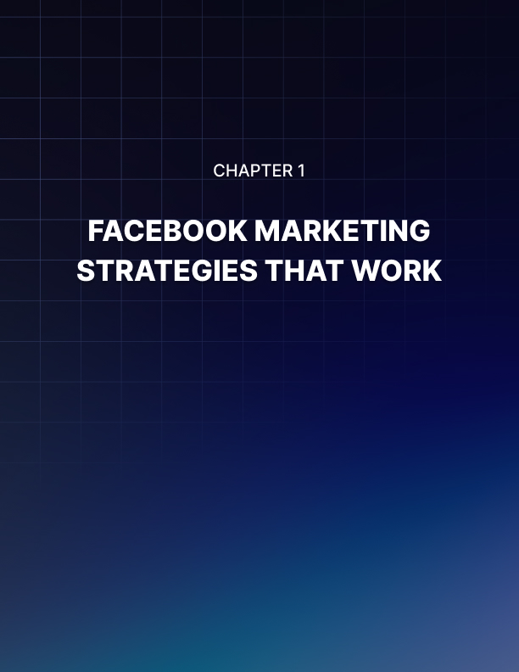

Chapter 1: Facebook Marketing Strategies That Work

While other people use Facebook to chat with their friends or to share pictures and videos, business people use it for marketing and branding.

In order to become successful through gaining traffic and sales, businesses should use the most effective strategies of Facebook marketing.

Within the first part of this chapter there is a comprehensive list of effective strategies:

- Making use of the site’s existing traffic. It is essential to have a company website because it will serve as a hub where people purchase the products and know everything about the particular services. To maximize existing traffic, insert clickable social media icons on the website which can redirect the user to the company’s Facebook page or any social media pages it has.

- It is recommended to put these icons on the homepage header because they are noticeable in this area. This action could also provide better CTR (click-through rate) placements.

- Displaying fan page URLs by using email signatures. When sending emails to potential customers, include fan page URLs beneath the email message or signature. By doing this, there will be an increase in traffic or following if the recipients click these attached URLs.

- Sending out email blasts. One way of letting people know that a particular business has a Facebook page is through sending email blasts. AWeber and MailChimp are some of the tools used in email marketing.

- In-store promotion of a Facebook page. Offline promotion is an ideal way of telling people that a business is now on Facebook. Print and include the Facebook page URLs on the store's wall, glass doors, business cards, paper bags, etc.

- Knowing when the best time is to post and schedule the status updates. By consistently planning the posting schedule, the target audience will be more engaged in liking, sharing and commenting on posts especially if they are educational and entertaining.

- Using Facebook Ads. They can help in gaining followers and business growth. They are also used to create Facebook marketing campaigns. Plus, they are not that expensive.

- Creating Facebook Contests. Facebook users like a particular fan page in order to participate in its contests. Conducting a simple photo contest can increase Facebook likes for up to 5 times more than a regular post. Prizes to be given away may vary ranging from items to services. Don’t forget to do promotions during the contest period to draw more fans.

- Using Facebook’s “@” Feature. Tagging people and other pages with this feature will make them feel recognized. Therefore, it establishes relationships between the business and its customers.

- Developing Facebook custom tabs and apps. It is an additional option that can be used to gain more likes and fans by allowing fans to access event details, deals and other exclusive advantages.

- Engaging with your own Facebook community and other Facebook fan pages. This is like a win-win situation. Apart from building strong relationships with customers, it could also create fan conversions when additional people will like the page upon seeing it on other Facebook pages.

- Joining and creating Facebook groups. Their privacy is classified into three: open, closed and secret.

  - Open Facebook groups are typically used for increasing brand awareness and growing networks. Therefore, it should focus on interactions and participation from the fans.

  - Closed Facebook groups can be seen by anyone but only the members can see the posts inside it. It is mainly used for customer support services.

  - A secret group is only seen by members and is used for confidential discussions.

Even if these 3 groups have different functionalities, the ultimate goal is to build the ideal relationship for every group type.

There are a lot of Facebook marketing strategies out there but having the above- mentioned examples on hand is enough for businesses to do marketing wonders.

Benefits Of Facebook Marketing
The number of Facebook users is growing exponentially. This means the amount of people you can reach through Facebook becomes almost limitless.

Here are some of the reasons why Facebook Marketing is the best way to improve your digital marketing:

- It is cost-effective and boasts faster return on investment. Facebook marketing is a very accessible entry point for start-ups. Just by creating a public page for your brand, you can jumpstart your promotions and publicity schemes for free.

- The fees only occur when you start signing up for sponsored ads, which depend on the length of the exposure and type of ad you want to acquire.

- The good thing about paid ads is that the results can be observed right away through specific metrics like reach, number of people who viewed and more importantly, the increase in your site traffic. You can filter the people according to demographics, to aim at your specific target market.

The good thing about social media is that you have the information about the users, ready at hand. This is ideal for local marketing, especially when you need to target a specific age range and geographical location.

For sponsored ads, the link is designed to appear to people who liked similar or related pages.

- You can easily see how people respond to your posts. With every post you create, viewers can send their insights and suggestions through the comment section.

Whether it's constructive criticism, a positive review or even a rant, Facebook allows you to hear out your customer's demands and needs, so you can have more room for improvement. It can be a good threshold to getting "viral". If there's something very special about social media, it's the fast-paced cycle of fads and trends.

- Any video or photo posted online can have a good chance to circulate around the net. Facebook is very flexible when it comes to reaching out to your audience. It can offer sponsored ads, or ads through recommendation.

- It can promote any form including events, offers, pages or external links. It can also be designed to fit mobile browsers, especially if you're promoting a mobile app.

- If you want a platform where you can freely check your immediate competitors, Facebook is the best way to do it. Through the ‘Pages to Watch’ feature, the site allows you to see the trend behind a certain page’s growth and posts.

This might not be fully valuable, but it can help you set a benchmark on how to assess your brand’s success in marketing.

Facebook can be an interactive platform for your marketing programs. You can ask your followers to answer a quick poll, to fill up a sign-up sheet, or even for promos. Facebook can even support a third-party website embedded into your public page.

- It will improve your SEO ranking. When your page is a popular link on social media and your posts are frequently being shared by your followers, search engines recognize your site better. This is why client engagement and link sharing in social media is very powerful.

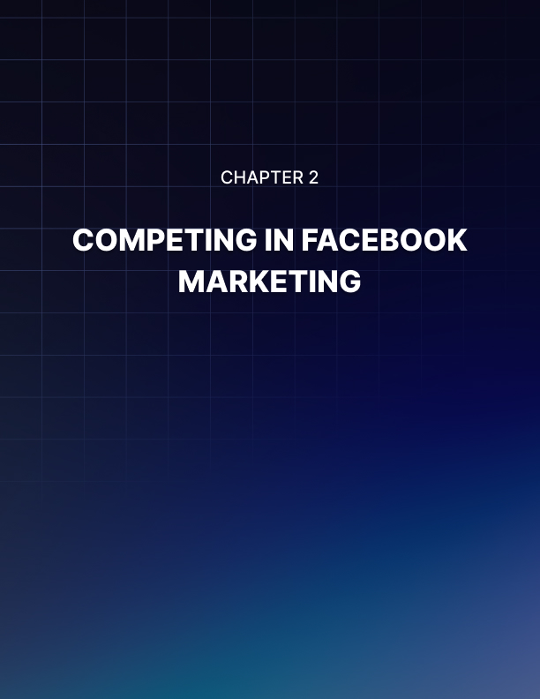

Chapter 2: Competing In Facebook Marketing

In a very competitive platform such as Facebook, many businesses and brands end up doing creative things just to win over their target market share.

This vast social media site is all about competition, and to win over others, here are some this to consider in Facebook marketing:

Description, Thumbnail and Headline
If you’re going to use sponsored ads, maximize your chance to promote your brand. This can be done through many ways. First, you need to give your viewers an idea, in a concise way, through the Meta description.

This is the short description that would appear next to your ad. Also, choosing the right thumbnail on your post is highly essential. When Facebook users browse through the site, they barely even notice the ads, unless the photo is highly striking, and would eventually catch their interest.

More importantly, the ad title should be short, yet appealing. You can try mixing up teaser style that would spark curiosity, or a full headline that would compel the reader to click.

Checking Out Other Pages
To succeed in Facebook marketing, you need to follow other pages. This might seem like an odd tip, but by following and getting a benchmark from other similar pages, you can have an idea on the trend’s customer feedback and insights from their end.

Moreover, you can also check the average likes and number of followers they have. This can be a good start on assessing your room for improvement.

Try not to post anything during the peak hours. Yes, you might be thinking that the most strategic time to post is when a lot of people are online. However, it is also during these times that the people’s new feed gets bombarded with stories, posts and links.

By posting during non-peak hours, the tendency is that people would be seeing your post upon checking their feeds. This can be before 8am or after 6pm.

Creativity Is Key
Be creative on your posts. Again, following the trend is an important aspect in this part. Most people nowadays, share and repost photos that are exceptionally funny, motivating and provide insights.

These photos come in forms of doodle photos, captioned photos or simply text photos. The trick here is to incorporate your brand well to the gist of every post.

Post Questions
If you want to improve on your customer interaction, you need to ask some pools or survey your followers. This is an easy way to increase likes and improve engagement and also to hear out their ideas.

It is ideal to ask questions that are open-ended and are likely to stir up meaningful conversations among users. This might even invite more people to join the discussion, and like your page.

Digital Customer Care
Show that you care. Facebook is a very good platform to show how much you value customer insights, so you need to take advantage of this opportunity.

Customers are more likely to trust a brand that could be easily reached through social media. You can do this by replying to comments and showing that you immediately address issues and concerns raised by page followers.

Tips On Facebook Marketing
Thinking of how to improve marketing strategies on Facebook? Ever wonder what tactics are being used by professionals?

There’s no need to worry because this part of the chapter will show some examples of the hottest Facebook marketing tips and tactics today:

- Consider using ActionSprout. If marketers think that Facebook pages are the real battlegrounds on Facebook, think again. Users typically interact with the page updates appearing in their news feeds apart from visiting the actual Facebook pages.

ActionSprout is a good additional custom tab on Facebook pages. While most Facebook pages require users to visit their pages before doing any actions, ActionSprout works differently by letting marketers create action options directly on the news feed.

Once users have already clicked the action of their choice in the news feed update, they will be automatically redirected to another page in order to continue the completion of the action.

- Boost announcements for new products. Boosted posts for a newly launched product can increase the demand as well as the fans that like the page.

It is ideal for small scale business even though it is not recommended by some Facebook marketing experts. Do not hesitate to test this kind of technique.

After all, refusal of recommendation doesn’t mean that this is ineffective and will not work.

- Make use of website custom audiences. While Facebook ads are used to target a specific audience, running a Facebook ad through the use of “Power Editor” can target all the visitors of a Facebook page (website custom audiences). In order to increase leads and potential customers, Facebook ads should be creative.

- Increase PR Efforts. Facebook is not only used for marketing campaigns, it can also support the brand’s publicity efforts. A lot of journalists rely on Facebook to look for stories. With the help of the said social media platform, sharing stories is now easy.

As a result, there will be faster information delivery to the public especially if there are emerging issues and breaking news regarding new developments, etc.

- Use Facebook’s audience insights. Better return of investments can be generated if a business knows how to target a particular type of audience for advertising and optimize content strategies after understanding the audience insights.

This will let the marketers see what’s engaging for the audience and what type of post does this audience like. By investing time to understand their insights, fans will become more receptive to posted contents.

- Do split testing on Facebook ads. Finding the right keywords to use is crucial for Facebook advertising. To prevent wasting money, it is recommended to do a split advertising test first.

Allocate portions of the advertising budget on running a variety of ads one at a time. Then, study the comparisons to assess which particular advertisement works best.

Only split testing can answer what particular benefit can a marketer get if he targets a narrow or wider audience.

Before anything else, it is important to plan ahead. This can give marketers enough time to develop Facebook marketing campaigns and incorporate these tips and tactics afterwards.

The “Dos” and “Don’ts” of Facebook Marketing
About 1.39 billion users are active on Facebook and half of them log in every day. There are 5 newly-created profiles every second and approximately 30 million fan pages belong to businesses.

On top of all this, about 1 billion Facebook searches are made every day.

Given all the statistics, it is important to use Facebook marketing strategies in order to catch up with the growing number of active Facebook users and fan pages.

While it is hard for marketers to build loyal followings on Facebook fan pages, knowing the “dos” and “don’ts” is essential for them to see what’s working and what’s not in the field of Facebook marketing.

This part of this chapter will compile some of the important things to apply and the classic mistakes to avoid as a Facebook marketer:

- Draw fans by being authentic. Use Facebook to post original contents that should not be missed. In the end, let people know what makes a company stand out among the rest.

- Value customer service at all times. Satisfied customers keep coming back for more and might also end up recommending the business to their connections. In order to keep them coming back, a Facebook marketer must be able to listen and quickly respond to customer queries.

- Set-up Facebook fan pages, not profile accounts. Using profile accounts for business is clearly a violation of Facebook policies. Also, Facebook pages have certain privileges on analytics, ads and apps which are not applicable in profile accounts. While Facebook pages can accommodate unlimited fans, profile accounts can only accommodate 5,000 friends/connections.

- Develop solid posting strategies. Content and consistency are the two main keys to have a firm posting strategy. Identify the marketing goals first then come up with solid posting strategies that can achieve the ideal results.

- Understand customers’ needs by getting their feedback. What they will say is important for the improvement of products and services. There are a lot of ways for them to give feedback. Some of these include:

  - Completing surveys
  - Responding to posts
  - Giving recommendations

- Remember that investing time on reading customer feedback is good for any business.

- Never spam Facebook pages. Spamming people is the worst thing to do in marketing because it can lead to the loss of followers and prospective customers.

- It is important to mix up contents through sharing videos, quotes and articles as well as asking questions about particular issues. Contents that contain pushy marketing messages are considered as spams.

- Do not measure success through the number of likes. The real basis for having a successful Facebook page are the following: engagement, conversions and reach. Getting a lot of likes doesn’t equate to having connections. They are built through customer interactions.

- Do not be confined to using marketing strategies on Facebook alone. Relying solely on it is effective but integrating it with other marketing strategies of social media platforms is more effective. Doing cross-promotional strategies on various social media networks could expand the content’s reach.

Moving forward, it is essential to apply these “dos” and “don’ts” of Facebook marketing because Facebook isn’t definitely going anywhere.

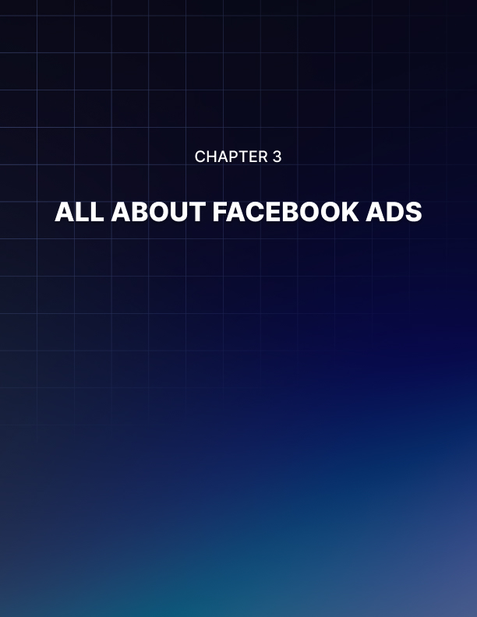

Chapter 3: All About Facebook Ads

Facebook marketing has revolutionized the way digital marketing is done, in many ways possible.

What used to be just banner ads on the internet can now be done in many forms, especially in this vast social media platform.

Here are some of the types of Facebook ads you need to know.

Creating A Public Page
You can always start with the conventional type of Facebook Marketing, which is setting up a public page for free. All you need to do is to maintain posts and update the page regularly.

It comes with all the necessary tools and self-service interface that is easy to use, even for beginners. This is cost-effective, and very easy to manage.

Sponsored Ads
Domain Ads
Domain ads are the most common type of paid ads that you would often see, and when you click, would take you to an external site. These ads are normally done to increase site traffic and improve customer interaction.

Domain ads can also illustrate social context like for instance, a certain friend “likes this page/site.” For this to take place, Facebook should be able to go with the target URL of your domain ad with a relevant Facebook public page.

Event Ads
Event ads are very helpful if you need total exposure for the publicity of your events. It is also shown on the right-hand side of the desktop, with a maximum of 90- character description.

Mobile App Ad
As the name suggests, this kind of ad only shows up when a user is on mobile view. Once the ad is clicked, the ad directly leads the user to AppStore or Google Play to install the mobile app.

The effectiveness of the ad is measured by the number of downloads, while being integrated with Facebook.

Page Post Ads
The easiest and widely used type of ad is the page post ad, in which your Facebook page can be posted as ‘sponsored’ or ‘promoted’. Once the user clicks on the link, Facebook will direct it to the public page.

Offer Ads
Offer ads are useful and enticing, especially when written well. The key to a successful offer ad is to include the important details, the number of people who previously accepted the offer and the expiration date.

The photo should also speak a lot, because it’s what the users would notice at first glance.

Sponsored Stories
Besides the usual ads, sponsored stories can also be purchased through Facebook Marketing. These are frequently the most interactive type of ads.

They are, in reality, support and endorsement made by the user’s friends, and thus tend to get higher click-through and rates of engagement. Once a person likes a certain page, it becomes an ad that appears onto other user’s new feed.

This is more effective in some cases because the credibility of a recommendation from friends is likely to be higher.

There are certain types of stories ad. Some include page or place ad, which was mentioned earlier, the app story, game played or even event RSVP sponsored story.

All of which work similarly, by showing who among your friends list are using the same app or going to the same event.

Facebook Ad Retargeting
If you’re reading this chapter, you’ve probably heard all sorts of things about Facebook’s ad retargeting technology. Let me tell you, most of the things you’ve heard are absolutely correct.

Perhaps you’ve heard that ad retargeting enables merchants to bring customers back to their shopping carts so they can buy something. That is absolutely true. It doesn’t work 100% of the time, but it works enough to make quite a bit of a difference.

Similarly, ad retargeting also enables merchants to drive people back to content pages that would eventually convert customers into paying buyers. That part is true as well.

However, despite all the excitement about ad retargeting technology, there is a secret sauce that you cannot ignore. Seriously. If you understand how the secret sauce works, then you would know how to craft together a more effective ad retargeting campaign.

On the other hand, if you remain clueless regarding this element, chances are your campaign would probably be hit or miss. Oftentimes, it’s more of a miss than a hit.

What secret sauce am I talking about? Proven interest. That’s right. When people come to your website, they have a proven interest. Ad regarding essentially gives you a tool to bring those people back to your website.

However, here’s the problem. If you’re just going to bring them back to the home page, you’re wasting your time. Real proven interest boils down to internal pages. That’s when you know that this person is serious. That’s when you know that this person actually is engaged enough with your content that they would go to internal pages.

I’m not just talking about one main page. I’m talking about secondary pages or other internal pages. In fact, the deeper you get them into your website, the better the results. This means that they have looked through other content, they’ve somehow figured out how everything works, and they’re more likely to convert later on.

This is why if you’re running an ad retargeting campaign, it’s really important to focus on bringing back people who have gone into an internal page and not just the home page.

Two Ways To Retarget
Now that you fully understand that ad retargeting is all about getting people who have gone to an internal page to come back, there are two ways to retarget.

You can remind them to go back to where they left off. Maybe this is a purchase page. Maybe it’s a shopping cart. Maybe it’s some sort of article that goes into a conversion page with one click. Whatever the case may be, you just remind people to go back to your website and they end up where they left off.
The other way you can retarget is to pull them deeper into your website. This is an often-neglected strategy when it comes to ad retargeting, but this is actually quite powerful.

You have to understand that not anybody’s going to interact with your content the exact same way. Some people will find themselves very deep into your site, others will find themselves in a fairly shallow or common secondary page.

The key here is to pull them deeper from that page, but not necessarily driving them to a sales page. In other words, you’re just going to be pulling them deeper into your content, but not necessarily dumping them into a shopping cart, sales page, or any other type of conversion page.

This is how you get better sales. You condition the mind of the visitors, so they voluntarily drill deeper into your site until they eventually convert.

Maximize Ad Retargeting’s Results
How do you take your results to the next level? It’s very simple. Instead of pushing sales with your content retargeting, push your squeeze page. This is the page that recruits people to your mailing list. It will be your mailing list that will do the heavy- lifting of converting that visitor into a buyer.

Of course, if you already have people showing up at your shopping cart, then your ad retargeting should focus on bringing them back to the shopping cart. But outside of that, if you’re dealing with people who stop short at content pages, push them to sign up to your squeeze page and let your mailing list convert them eventually.

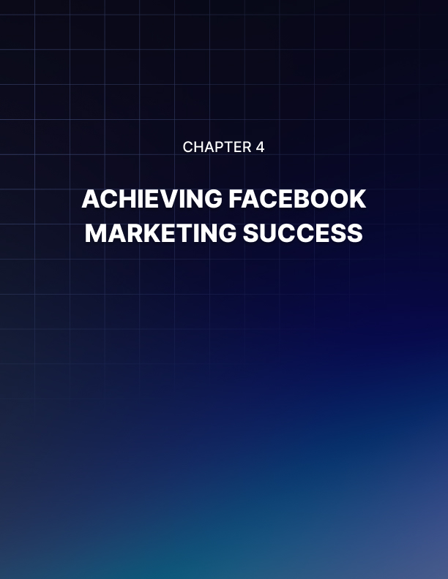

Chapter 4: Achieving Facebook Marketing Success

In all businesses, the game plan is always the key to success.

To come up with a solid game plan and strategy in Facebook marketing, do not forget these easy steps:

When putting up a business, it is important to have a clear mission and vision. A lot of brands’ success stories came from these two objectives. These two points must explain the purpose of the company and why it exists.

In starting his Apple Company, Steve Jobs was motivated by supporting people’s creativity, not by selling computers. Before becoming the largest florist shop, Jim McCann’s 1-800-Flowers.com was motivated to help people express their feelings to others.

Therefore, before planning to do some social media marketing strategies, a person should:

- First, exactly know the type of business he will engage himself into, and

- Second, fulfill other people’s desires and solve their problems.

Take the six Vitamin C’s of Facebook every day. In order to come up with a successful marketing campaign, keep all these 6 C’s in mind:

- Content: post stories that will gain a lot of shares, likes and comments. In short, it should be interesting.

- Clarity: clearly show what the fan page is all about and what it has to offer. Update the “About” section of the page and add taglines on the cover photo if necessary.

- Campaign: maximize the use of Facebook’s promotional tools in order to support a particular campaign.

- Connection: build and grow the page’s network.

- Culture: make the fan page as an extension of the company’s culture or a particular brand. The same look and feel of the fan page should not be used all over again. This will depend on proper page management which includes: the type of content shared, response time, way of response, humor, etc.

- Conversion: convert fans and followers into a network of paying customers.

Post shareable contents. Consider these basic rules on creating shareable contents:

- Make it short. (a content with 80 characters will gain more shares) Vary the contents by using photos, videos, audios and links.

- Reply to people who shared the content by liking their shares. Interact by asking questions

- Visit other pages to know what people like

- Determine when is the best time of the day and week to interact with the fans.

Consider experimenting and testing then, track the results. It is important to learn what Facebook marketing strategy is working and what’s not. Try variating the post frequency, contents and time zones.

Learn from the success of other Facebook fan pages. Oreo, Disney, Coca-Cola, Starbucks and Skittles are some of the popular consumer brands that are doing well on this social media platform.

Monitor their Facebook pages and view other fan pages in order to see what particular types of content could gain a significant number of shares.

Examine everything on their fan page starting from updates up to the promotional campaigns used.

To become good at Facebook marketing, it takes time and patience. By following the above-mentioned steps and seeking the help of people who are knowledgeable in this field, success will be on its way!

Steps To Facebook Marketing Success
When dealing with a fast-paced environment such as social media, not all businesses fare well. Some may enjoy an exceptionally high growth at first and end up slipping off at a later date.

How do you succeed in Facebook marketing? Read on to find out the recipe towards S.U.C.C.E.S.S.

Sponsored Stories
When it comes to Facebook marketing, a lot of people tend to give high regard to their friends' recommendations. This means that you should invest more in sponsored stories, where the ad appears with a corresponding story. For instance, when promoting an event, a sponsored story would say, "Friend 1 and 10 others are going." This would spark credibility in the eyes of the user.

Updates
If there's something that is very essential in social media marketing, it's the constant updates. Fresher contents would make your audience engage more and will ignite frequent visits to your page.

Keeping up with the recent trends is also a must to survive in the online world. Hence, you should always make sure to include updated posts on your page.

Curiosity
To further entice your audience on your posts, you can use a cliff hanger statement as your headline to spark curiosity. The posts will act like bait that will lead your customers to the desired page.

You can also include interesting thumbnail images that will convey a message without giving out the entire story.

Competition
Facebook marketing is all about competition, and to get ahead, you must know your equivalents. You can use the watch page feature of Facebook to consistently watch over certain pages.

You can use this to learn more about customer feedback on which works, and which does not.

Engagement
The key to a healthy and fruitful Facebook page is to engage your customers well on your posts. By engaging them, this means that your page must be conducive to activities and involves a lot of audience participation. You can add questions, or even start some promos to further invite more people to like your page.

Moreover, the more active your page is, the better chance it would be to fare better in SEO. Search engines can easily find their way to pages that are frequently shared by people.

Schedule
For a more efficient page management, it is ideal to take advantage of the scheduled post feature. This means you can write, type, edit or upload any photo in advance, and post it at a later date.

It can be editable and can be canceled as you like. This is recommended especially when targeting certain day parts.

Sustain
Once you have established a group of followers and a strong fan base, you need to maintain a certain level of growth rate, just like in any other business. You need to constantly invite more people and extend your reach as much as possible.

With over a billion users, Facebook is indeed an excellent ground to promote and extend your network. By keeping in mind the steps to S.U.C.C.E.S.S., you can easily win over your competitors, increase your site traffic and more importantly, translate every click into sales.
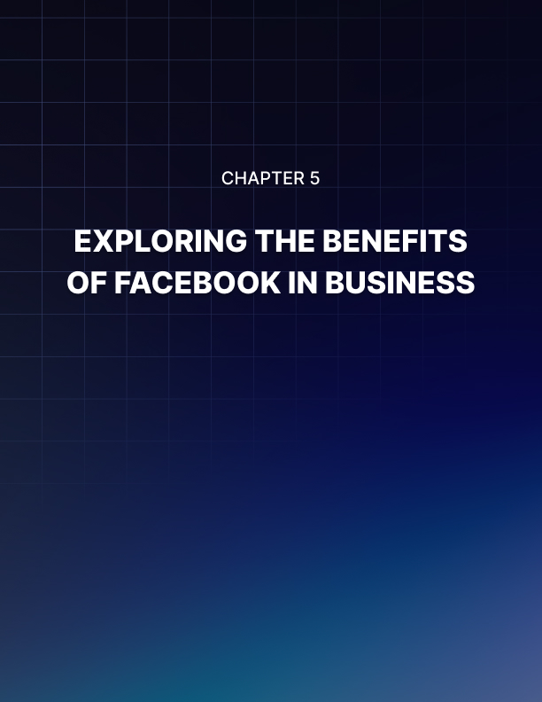

Chapter 5: Exploring the Benefits of Facebook in Business

Touted as one of the most popular social media platforms today, Facebook has its own unique advantages and benefits.

Apart from personally connecting with the members of the family and friends, it can also be used for advertising and promoting a business.

Marketing strategies play a vital role in the success and growth of a business because they are used to draw customers’ attention. This is where a Facebook business page has the advantage over an existing company website.

This chapter will show some advantages of using Facebook marketing:

- Using Facebook for business is a low-cost type of marketing strategy. Signing-up on Facebook for free is ideal especially for small and medium start-up businesses that are on a tight budget. Without going for expensive marketing activities that cost about thousands of dollars, these companies can target millions of audiences which can turn into potential paying customers as they go along. Large businesses also take the opportunity to use Facebook for their trial marketing plans and concepts before stepping up on bigger campaigns.

- Business information can be shared. Since Facebook is the right avenue to promote a business, it is important to provide information about the business name, address and its contact details. In order to draw more customers, a business page should also contain brief descriptions on every aspect including its products and services as well as its history and staff listing.

- It is interactive. Apart from posting texts, uploading of photos and videos is also allowed, thus, making Facebook easier to personalize than a company website. There are no technical skills needed in order to maintain, customize and personalize a Facebook business page because it’s pretty much the same as managing a personal Facebook account. Interaction takes place when audiences tag themselves in the photo that is used to advertise and promote a business.

- It allows communication with current and prospective customers through the exchange of messages. Listening to their feedback regarding the products and services is essential in Facebook marketing.

- It is easier to provide customer support on Facebook. Questions can be posted directly based on the customers’ experience in using a particular product or service. This is more effective than taking phone calls as customers can already see common queries and responses from other people. As a result, problems and issues can be quickly resolved. In addition, these can increase the satisfaction level of customers.

- Brand awareness can be raised through Facebook likes. Apart from word of mouth, liking the Facebook page will increase the popularity of a business page.

- It can increase website traffic by including Facebook page URLs on posts. Exposing these links to Facebook users can also convert visits into potential business purchases. Maximize this advantage especially when people are motivated to buy products or services as consumers.

- Advertising can be targeted to a particular group of people. Marketers can maximize the creation of Facebook ads for certain people that have listed a particular interest by making these ads appear on the right side of their Facebook pages.

Facebook is the only social media platform that can provide these advantages. Therefore, take the opportunity to use Facebook marketing while Facebook is still not going anywhere.
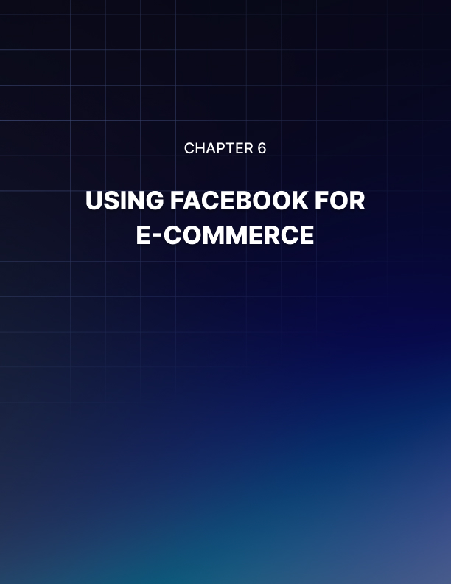

Chapter 6: Using Facebook For E-commerce

One of the biggest misconceptions about Facebook’s marketing potential turns on whether Facebook can be a good source of traffic that actually buys stuff from online stores.

For every positive story you hear of merchants killing it with Facebook traffic, you’d probably hear dozens more merchants who are frustrated with Facebook.

They really cannot make heads or tails of Facebook’s traffic, as far as their e- commerce sales are concerned. They’re drawing a blank. They just cannot, for the life of them, convert a heavy volume of traffic from the social network into actual buyers of products.

The bottom line is that there are many horror stories of low ecommerce conversions. I’m not saying that there are absolutely no conversions at all. Nobody can make that claim.

But the problem is, you cannot run a successful online store with a few sales here and there. You need some sort of stability. You need some sort of increasing or at least, a stable predictable conversion rate. You need some sort of minimum baseline of predictable conversions.

The reason why a lot of people have these horror stories is because they focus on the direct sale. They think that if they post an ad on Facebook selling some sort of trinket and if they show it to enough eyeballs, that people would buy.

That is a common misconception about Facebook, and this can get really expensive very quickly. It really can. This pretty much makes up the bulk of low e- commerce conversion horror stories involving Facebook. They’re all about a direct ad that fails to generate that direct sale.

The truth about Facebook e-commerce conversion rates Here’s the good news. Facebook can deliver e-commerce sales.

However, oftentimes, it’s not in the form that you would like. Seriously. You have to be more creative. How does this work? Well, Facebook traffic can convert if you retarget.

In other words, people who have found your website on their own and who have gone to internal pages might have a Facebook account. The next time they log on into their Facebook account at the same time you’re running a retargeting campaign, your ads will be visible to them. Your ads will remind them to go back to your shopping cart, or to your website. This has been proven to increase ROI.

Facebook can also deliver e-commerce sales through squeeze page marketing. In other words, you use Facebook to recruit people to your mailing list. It’s actually your mailing list that’s doing the heavy-lifting, as far as selling stuff to your list members go.

Another way Facebook can deliver e-commerce results through your business is through a Facebook page boost. Basically, you create a Facebook page and you target lookalike audiences based on the interest of people who already like your page.

Then, you send out content. Using this content, you can profile the interests of the typical high-engagement members of your page. Once you get this very important piece of consumer intelligence, you can then run a lookalike audience campaign on Facebook targeting people with those same interests.

The idea being: if you know the interest of the person who actually buys from you and you advertise to another person with the exact same set of interests, the chance of that second person buying is much higher than a complete and total stranger.

The bottom line? Yes. Facebook can deliver e-commerce sales, but you have to use its tools the right way. You can’t just go in there, advertise an affiliate link, or a direct link to your Shopify store, or a direct link to your product, and expect a sale.

It doesn’t work that way. Sure, you can convert every once in a while, but chances are you’re not going to get the results you’re looking for. You have to use it using the techniques outlined above.

Achieve Realistic Results with Facebook Lead Generation
As you probably already know, when you run a paid campaign on Facebook, its ad platform allows you to collect leads. That’s right. You can run a lead generation campaign. The problem is there are so many myths and misconceptions surrounding lead generation on Facebook that you’ll probably fail.

I don’t mean to depress you. I definitely don’t say that to discourage you, but let’s get real here. If you believe in these misconceptions, then chances are you’re just setting yourself up for a let-down.

One of the most powerful myths, that’s very hard to shake, is that straight lead opt- ins can be had for cheap on Facebook. Nothing could be further from the truth. In fact, I see tweets about this for marketers all the time.

These are people who know their way around Facebook. These are not people who just tried Facebook or are in any way, shape, or form wet behind their ears. These are veterans. All I can see is them complaining, moaning, and groaning that it’s just too expensive.

In fact, one person was saying that in her niche, you basically had to spend $80 just to get a lead. Now, you probably already know that a lead is very different from a sale and that $80 per lead is very expensive.

How do you make things better for yourself if you’re running a Facebook lead generation campaign? How do you set yourself up in such a way that you don’t end up like these people who’re complaining that generation leads are just too expensive or downright impossible?

Well, it’s actually quite easy. Follow the steps below:

Find Competitors And Figure Out Their Freebies
The first thing that you need to do is to like your competitors’ pages and join their groups. This way, you set up your user profile to be targeted by their ads. Find their ads and figure out what they’re using for freebies.

What will this tell you? First of all, it will tell you what kind of incentives are available. It also tells you that nine times out of ten, your competitors have tested their campaign.

This means that if you keep seeing the same type of freebie come up again and again, chances are that it should be the kind of freebie you should be offering.

They’re not doing it for their health. They’re not doing it because they have nothing else better to do. They did not just take some wild stab in the dark to come up with that freebie.

The reason why that type of freebie crops up again and again is because people somehow, someway get results from that. Stick to that.

Figure Out How They Offer The Freebie
You have to understand that to generate a lead on Facebook or any other platform, you give out a freebie in exchange for an email. So, the key here is to figure out how they position the freebie.

Are they saying that it saves you money? Are they saying that it’s some sort of secret hack or trick to save time, effort, and money? How exactly do they position it?

Pay attention to this because you’re going to copy and optimize what they’re doing. I’m not saying you should copy and paste. I’m saying you should copy and optimize. This is different.

Run A Long-Term Campaign
The next step to success is to accept the fact that you’re going to run a long-term campaign. You’re going to run ad, after ad and you’re going to resolve to fail quickly. In other words, you’re going to spend very little money on each ad as you test it out.

You figure out the ad that works best and then you optimize it to try to improve its conversion rate. Using an elemental approach, you should be able to identify the ad that works best for you.

You keep running these long-term campaigns while focusing on successful ads. These lower your total campaign costs.

Keep Optimizing Until You Find The Best Results For The Lowest Amount Of Cash
The bottom line is for you to keep running these ads, focusing on the best converting ones, and then keep optimizing them until you find the best results for the lowest amount of cash. You then scale up your campaign by increasing the amount of money you pay for the ads.

This ensures that you get a lot more eyeballs and if your ads are optimized right, your ad will be converting at an optimal rate.

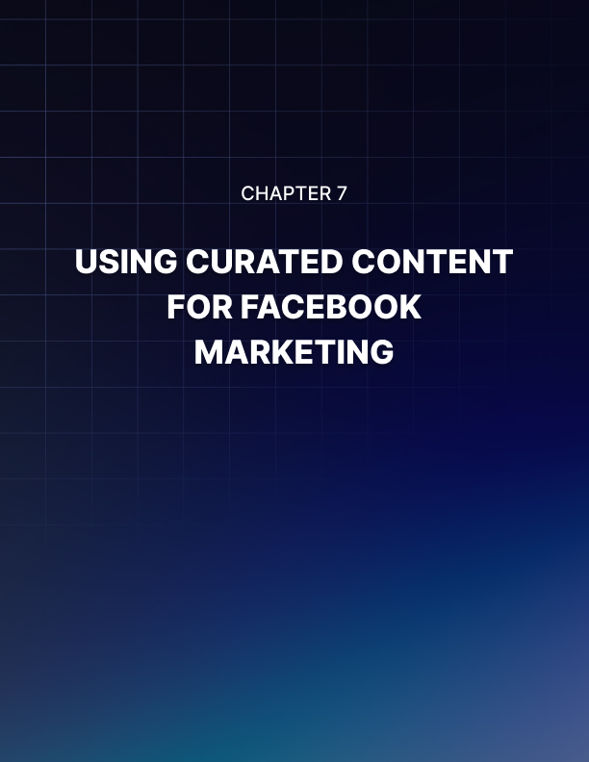

Chapter 7: Using Curated Content For Facebook Marketing

I don’t want you to misunderstand this article. I’m not at all saying that you should be lazy and just rip off or copy your competitors wholesale.

I’m not saying that you should be involved in some sort of copy and paste marketing because that’s not going to work.

Sadly, that’s precisely how too many Facebook marketers defined ‘curated content.’ They just find content that seems to be related to their niche and run with it.

In fact, many think that as long as a piece of content has their target keywords in the titles of blog posts and articles, these are ‘good enough.’ Unfortunately, ‘good enough’ is never good enough in the dog eat dog world of Facebook content marketing. Nothing but the best will do.

Instead, you need to identify your competitors’ best content, as well as highly popular content produced by third parties. You use these materials to test your page in terms of response. If you notice that a lot of your page fans respond better to a specific type of content, then you need to produce more of that content.

You need to either find other third-party content you can curate, or you can come up with your own stuff. Whatever the case may be, this is a simple example of finding what works. When you start your page, you really don’t know what will work. You don’t even know if enough people would like your page.

What’s important is you keep showing content out there to the extent that some people would engage with it. Some people might like it enough that they would like your page. When enough time passes, you should be able to see certain patterns. You should be able to see which pieces of content your most successful posts are.

You publish this type of content more often to see if you can maintain your engagement level. If that’s the case, then find more of the same type of content, come up with your own version, and increase your engagement levels.

This will also enable you to get more likes to your page. How? Since you know what type of content is popular and what kind of themes and topics keep coming up, you can target the interests of your average user and drive traffic using Facebook’s lookalike audience feature. Engagement is the linchpin of successful content.

Don’t just focus on getting likes though. You should scale up your engagement types and intensity. Focus first on likes. Once you achieve a high enough level, encourage your readers to post comments. Keep running experiments.

Once you get them to post lots of comments, go to the next level and encourage them to share. Make no mistake, user engagement is no different than traffic-you have to optimize it.

You have to scale it up. You have to fine tune it so it eventually leads to your ultimate goal: conversions. This is the part of the process that actually produces money in your bank account. This is where things get real.

Pick Winning Curated Content for Facebook Page Marketing
As I mentioned previously, one of the best ways to build up your Facebook page is to not come up with original content. At least, not in the beginning. You should look at your competitors’ Facebook pages and find their very best content.

You should then publish these pieces of content on your page and study your statistics very carefully. Which of your posts gets shared the most? Which ones get commented the most? Which ones get liked the most?

Once you’re able to figure out the specific pieces of content that get the most engagement, you should be able to see a larger pattern. You should be able to see that certain pieces of content simply draw a lot more attention. They engage your users more.

Your job then, is to pick out these winning pieces of content. You look for related or similar types of content and publish those on your site. Eventually, you come up with your own version.

If you did it right, your engagement level will be the same as the materials produced by third party publishers. That’s how you will know that you’re doing this right.

How To Pick The Very Best Content
Now it’s one thing to say that you’re going to pick the best content your competitors have, it’s another to actually do it the right way. You see, the big danger here is you’re going to be using your opinion as to what “the best content” means.

I’m telling you, it’s not about you. People don’t care about what you like or don’t like. What they care about is what they like. It’s all about them. So, how do you use this as a winning strategy?

It’s actually very simple. You look at your competitors’ Facebook pages and scan through their posts. Which of their posts is the most popular? Which of their posts gets shared a lot, get the most likes, or get the most comments?

Pull the link for those posts and post those on your website. See if you get the same level of engagement. If you do this enough time with many different competitors’ contents, certain patterns emerge.

You would quickly realize that the audience you’ve built up, up to this point, are more likely to engage with certain types of content than others. You figure out what works, and you ditch everything else. That’s right. You forget about them, you focus on the stuff that works, and then you scale them up.

You publish more of it and eventually, you come up with your own version. That’s how you play the game. It’s not a question of hunches or guesses. You have to look at objective indications of popularity such as page likes, comments, shares, and other types of engagement.

I hope you see how this works. If you do this right, you will be able to put up a fairly compelling Facebook page that can lead to conversions later on.

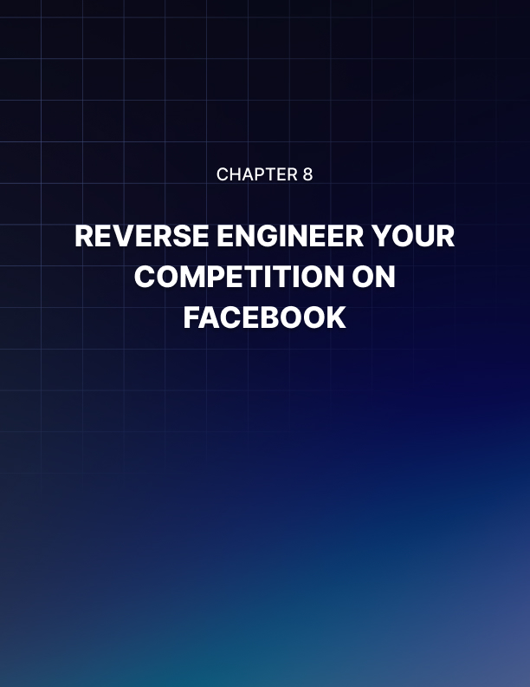

Chapter 8: Reverse Engineer Your Competition On Facebook

A lot of people who try their hand at Facebook marketing are quick to say that it’s a failure and that it doesn’t really work.

What they’re really doing is they’re engaging in sour grapes. They don’t know how it works. They don’t know how to optimize their campaigns. They think that since it did not produce the kind of results they were expecting, then it must be a worthless source of traffic. No. They’re just doing it wrong.

The good news is you don’t have to be one of those people. They struggle because they tried to figure out Facebook from scratch. They basically tried to learn Facebook on their own and they ended up spending too much money while getting very little results and eventually failing.

You don’t have to do that. There is an alternative path for you. There is an easy way to achieve success on Facebook. How? Reverse engineering. To put it simply, you figure out what your competitors are doing, and you learn important lessons from the way they run their Facebook pages, as well as the content that they share so you can achieve better results. Here’s how you do it.

Find And Like Your Competitors’ Pages And Groups
The first thing that you need to do is get a massive list of your competitors. Find them on Facebook and join them. Of course, you’re going to use an individual account for this.

You’re not going to use an account that is somehow, someway linked to your fan page. You’re going to have to do this incognito. Find as many of their pages as possible and like them. Find all their groups and join those.

Sit Back And Pay Attention To Their Content
Once you’ve joined all these places, sit back and pay attention to the content they’re receiving. You should be able to see some patterns. You should be able to connect the dots.

You would notice that nine times out of ten, they share the same type of content. Maybe this content talks about a common theme. Maybe it focuses on certain common topics. Whatever the case may be, the same stuff crops up again and again. Pay attention to that pattern.

Analyze Their Most Engaged Users
Now that you have a clear idea of the type of content your competitors keep talking about, the next step is to look at the users that always keep commenting. Pay attention to the users that keep liking and keep sharing.

What are their interests? Do they share common interests? You’d be surprised as to what you will find because you will notice that the most engaged people, seemingly different as they are, share a handful of common interests. That is a very important clue. In fact, that clue can make you a lot of money.

How To Take Advantage Of Reverse Engineered Consumer Intelligence Information Using Free Promotions
Use the following free promotions to take advantage of the information you got through reverse engineering. First, you can post similar content. When you do this, your engagement levels go up because you are sharing the content that you know your target audience members would be more likely to engage with.

Second, look at your content patterns and figure out your most popular content. Once you’ve identified this popular content, share similar types of content. This enables you to increase the engagement level of your page, pretty much uniformly.

This doesn’t happen overnight, but with enough attention to detail, this will happen. You just scale up the amount of very popular content that you’re already sharing.

You then republish the same type of content over an extended period of time, so you can reach more people as more and more of your audience members engage with your content at a higher level.

How to leverage this information with paid ad campaigns?
If you’re paying for your ads, you use your audience insights to get clues as to how to target new eyeballs for your direct ad links or your page posts. Make sure that they share common interests with your competitors’ users.

Also, when you profile the most engaged users that your competitors have, you should use the same common set of interests when targeting your ads. This can increase your click through rate and ultimately, your conversion.



Conclusion

While this idea started as purely social, it has turned into something that businesses are embracing as well.

Each time the internet changes, businesses need to change, too or else they won't get the sales they want.

Now, in order to find success with sites like Facebook, a business needs to think about the very elements that make the site special and unique. The site is a place for people to socialize and participate in communities. If the business wants to sell their product or service, they need to build a community around it.

For example, if you're a writer and you want to sell information products to help other writers, you can start a group on Facebook that is designed to teach other writers. If they like the group, they'll likely buy your product.

One huge advantage to using Facebook for business is that you have access to the profiles and information for a lot of users. For a business owner, this will help you target the demographics of those who will be interested in your product or service.

Facebook Is Growing
Facebook is one of the largest social networking and Web 2.0 sites out there right now, and it just keeps growing. It started out as a site primarily for college students and has grown into a world-wide phenomenon.

Unlike some social sites, Facebook actually embraces the idea that people can use their site to build their businesses. The founder and developers are devoted to providing a positive user experience for everyone on the site, business owners included.

But, there's an art to using this site in that way. If you don't embrace Web 2.0 and the way social networking is, your efforts to build a business using Facebook will be in vain.

