Disclaimer

This ebook has been written for information purposes only. Every effort has been made to make this ebook as complete and accurate as possible. However, there may be mistakes in typography or content. Also, this ebook provides information only up to the publishing date. Therefore, this ebook should be used as a guide - not as the ultimate source.

The purpose of this ebook is to educate. The author and the publisher do not warrant that the information contained in this e- book is fully complete and shall not be responsible for any errors or omissions. The author and publisher shall have neither liability nor responsibility to any person or entity with respect to any loss or damage caused or alleged to be caused directly or indirectly by this ebook.

Table of Contents

Introduction 5
Chapter 1: Why Facebook Retargeting Works 8
Chapter 2: How Facebook Retargeting Works 13
Custom Audiences Explained 14
Facebook Dynamic Ads 15
Chapter 3: How to Get Started With Facebook Retargeting 18
Getting Started With Facebook Advertising 18
Setting Up Facebook Retargeting 19
Creating the Ad 22
Chapter 4: Designing the Perfect Ad: Tips and Tricks 26
Creating a Highly Profitable Campaign 28
Creating Ads That Work for You 30
Chapter 5: Limitations of Facebook Retargeting 33
Conclusion 36



Introduction

Whether they originally set out to or not, when Zuckerberg and cohorts built Facebook, they also built perhaps the most powerful marketing platform/tool ever created (only Google gives it a potential run for its money).

Facebook is a place where users will actively, willingly offer up huge amounts of data about themselves. This includes demographic data such as their age, sex, and location – but also deeply personal information such as their hobbies and interests, where they went for dinner last night, and even their income bracket.

What’s more, is that they also provide us with a huge network of other potential users that might share the same interests or have access to the same things.

This matters to us as marketers because it allows us to TARGET our audience. And as you will learn over the course of this eBook, targeted marketing is by far the most powerful.

As Facebook grew in size and functionality, its reach and usefulness as a tool for digital marketers grew in kind.

Meanwhile though, in other corners of the net, other new marketing tools would also emerge. Google was the first to introduce ‘retargeting’ to a large audience – a concept that helped advertisers reach the most targeted and qualified leads – people who had already demonstrated an interest in their brand and even a willingness to spend money.

That this feature would eventually come to Facebook was inevitable. And when it did, a perfect match was made.
Retargeting on Facebook is perhaps THE most effective way to reach a primed and ready consumer base and to make sales as a result.

In short, retargeting allows you to advertise more than once to the same people that have previously engaged with your brand – even spent time on checkout pages, or having added specific items to their shopping cart.

The best part is that Facebook actually goes beyond the likes of Google by offering an even more powerful version of this feature – letting you remarket in numerous different ways, to numerous different types of lead and customer.

This tends to fall under the broader category of Facebook’s ‘Custom Audiences’, which can be custom for a variety of reasons.

To put it simply, if you have any product you want to sell online – whether digital or physical – Facebook retargeting might be one of the most powerful and effective ways to do just that. And not only that, but you’ll also find that this is one of the best tools for promoting a cause, increasing brand awareness, and growing your audience and your authority.

The best marketers know that success online is a matter of human psychology, numbers, and knowing the right tools. If you can invest correctly in Facebook retargeting, then you can see that money returned in huge quantities. And in this book, you’ll learn precisely how to make the most of this type of marketing to potentially grow your audience and increase your profits.

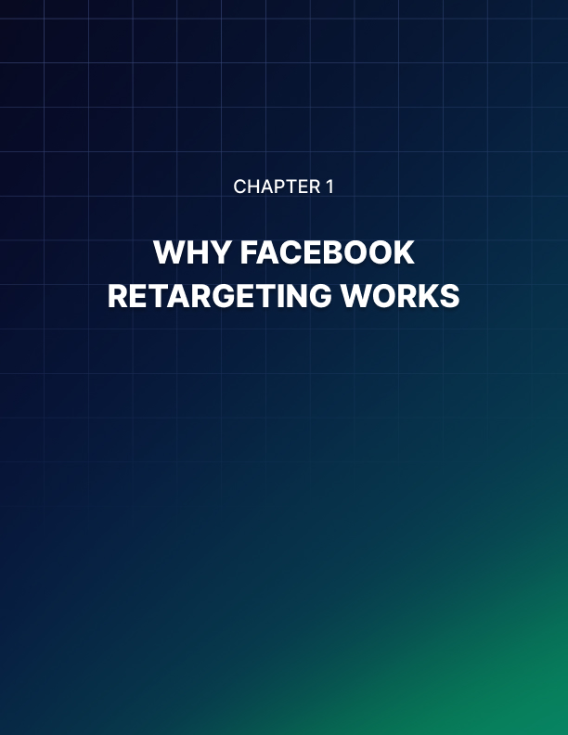

Chapter 1: Why Facebook Retargeting Works

So, the basic idea behind Facebook retargeting, is that you’re able to ‘remarket’ to people who have already spent time on your site, or even on specific pages from within your site.

This is powerful stuff, because it means that you can market to warm, hot, and qualified leads.

Let’s rewind for a moment and think about what that means.

Normally, when you show someone an advert, you do so while knowing very little about them, and having had no contact with them previously. You might be browsing the web and then notice an advert for something that you have never heard of. A nice pair of shoes for instance, a holiday, a useful service.

Problem is, you just bought a pair of shoes, you’re just back from holiday, and you have no use for the service because you don’t have a house (for example).

So, chances are that you’re simply going to scroll right past that ad and not give it any further thought. This was then essentially a wasted investment for the advertiser who put that advert there in the first place.

That’s why a targeted ad is theoretically worth so much more than a regular ad. When an ad is targeted, it means that it is being purposefully aimed only at people who are likely to be interested in whatever the advert is for – at least based on their demographics and statistics.

So, for example, adverts for home cleaning services will only be shown to people who actually own homes. Likewise, adverts for athletic sports shoes will only be shown to people who own athletic sports shoes.

All of this ensures that the money is not wasted nearly as often.

But it’s still not perfect. Because it’s still advertising to someone that you’ve had no prior contact with – who has never heard of your brand.
Why do you buy Apple products? Or Nike products? Why do you use Netflix?

Because you know the brand. You’ve learned what they have to offer and you know that they typically provide a certain level of quality.

You would buy a hugely expensive tablet from Apple because of the trust and authority they have built up over decades.

But now imagine that someone comes up to you in the street and offers you a thousand dollar computer that has no branding on it. Would you be willing to pay a thousand dollars for that? Would you trust that it works?

Even if you’re in the market for a tablet?

No.

It only takes a minute to go to the Apple website, or another retailer that stocks those devices – such as Amazon. So why would you spend money on an unknown commodity?

That’s why big companies will spend millions on advertising that is designed to increase brand visibility first. From that point, the customers will then come to them rather than vice versa.

Most of us smaller marketers don’t have that kind of budget though, so we don’t have the luxury to build that kind of awareness and visibility. That’s why we instead use content marketing.

Content marketing is marketing that uses blog posting, YouTube, social media and whatever else in order to create a relationship with the customer. To demonstrate that we know what we’re talking about, that we are trustworthy, and that we are able to offer something unique.

If you read an incredible blow-post about fitness and that author then recommends a supplement at the end of the post, you’re now much more likely to be successful.

Don’t accept supplements from strangers, kids!

Another analogy we can use is dating. You wouldn’t walk up to a complete stranger and ask for their number – because chances are that they would turn you down. They’ve never met you – you could be completely insane – so why would they trust you with their number? You have yet to impress them with your personality.

To get someone’s number, you instead have to put time in chatting and making your acquaintance. Get to know them, demonstrate you’re not a psychopath… and then you may be in with a chance. It’s just groundwork.

Content marketing is that groundwork in this gig we call digital marketing.

But unfortunately, that only gives us a very small window of opportunity in which to sell to someone – while they’re reading our blog post. What happens if they then leave and forget all about our brand?

What if they want to buy the supplement, but they’re on their phone and they want to wait until they get home… at which point they forget all about you?

Well, that’s when you REMARKET. You show the potential customer the precise same product again, at a point when they’re able to buy. When they have been mulling over what you’re offering for a while.

They know the brand, they’re feeling a little more susceptible… and so they click buy.

This works even better when you consider that different people are more likely to buy at specific times.

Did you know for example that you are more likely to buy if it’s later in the evening? That’s because your tiredness means that you have slightly less impulse control – and are thus slightly more likely to give into your emotions and click buy.

Or what if you use retargeting to offer a special deal?

Picture the scene: someone has been looking at your website, eyeing up a product you’re offering and considering buying. They add it to their shopping cart, then spend a while gazing at it. They conduct an entire argument in their head:

Do they really need it?
What if it isn’t as good as it looks?

Didn’t they just treat themselves to something else recently? Aren’t they meant to be saving??

They stop short of clicking buy, because they’re not sure they want to spend the money right now. And therefore, you would normally lose that customer.

But then they’re thinking about it during the day and wondering if they made the right decision. It’s evening, they’re tired, and they feel like they need a pick-me-up.

That’s when they see your advertisement for the same product, only now with 50% off. What’s going to stop them from clicking buy?

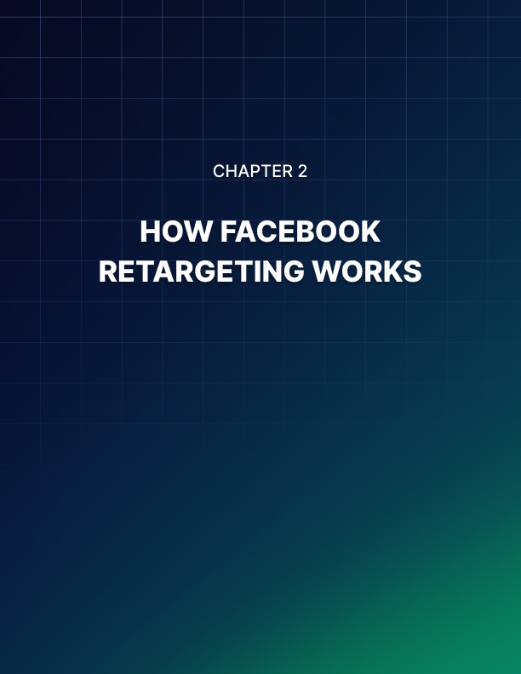

Chapter 2: How Facebook Retargeting Works

Chances are that you have been on the receiving end of retargeting at some point or other. You’ve probably also heard people talk about retargeting without really knowing what it is.

Maybe your Mum exclaimed at some point how weird it was that she kept seeing ads for a new heating unit… and just when she was shopping for a new heating unit!

How did Facebook know to show her those ads? That’s some incredible coincidence!

Of course, you and I know that this is not a coincidence at all. But perhaps you’re not entirely sure how precisely it works.

The answer is cookies. Cookies are actually small files that can get saved on your computer via the browser. These files are stored there by websites, and that in turn enables the website to identify that user again in future. This is how you can stay logged into a website when you return to it later on – because the website checks for the file, which identifies you.

This also means that other websites can interact with cookies placed by yours. In the case of Facebook retargeting, your website might leave a file on the visitor’s computer, and then Facebook can identify that file in order to use it to show you the correct ads.

Any page on a website can leave a cookie, which means that you can not only tag users, but also tag their specific actions.

So, one cookie might tell Facebook that a visitor came to your website, but another might tell Facebook that they looked at THIS specific product and then added it to their checkout but stopped just short of clicking buy.

The cookie can even contain additional information – such as the time of day that they were active.
Facebook retargeting actually allows you to do several different things with this basic functionality though, and uses some unique terminology to describe the various different methods. These can work in slightly different ways in some cases too.

Many of these fall under the category of the ‘Custom Audience’.

Custom Audiences Explained
Custom audiences on Facebook are basically lists or filters that you create in order to show your adverts only to specific members off the public that you have somehow pre-selected.

One example of this is the ‘Website Traffic’ custom audience. This is the type we just discussed – audience members who have visited your website OR your specific web pages. That allows you to use cookies to identify visitors at different points in your sales funnel, and thereby help to push them toward clicking buy.

We’ll go into depth on how to set this up, as well as how to make it work wonders for you in a moment.

First, we should address the two other types of options here. One is the Customer List.

A customer list is exactly that: a list of people with their details. You will collect things like their emails, their phone numbers, their Facebook IDs, etc. You can also integrate this with email marketing tools such as MailChimp and simply upload an entire list.

Facebook will then match those visitors to its own huge user base, looking for users that added those same numbers and emails as their contact details.

This form of retargeting works slightly differently in that it doesn’t look for a specific action the user has taken, but rather looks for leads that you have already generated.

A lead is any contact that has had some kind of interaction with your brand and that you have the contact details of. Leads are important because they give you the option to take further action and convert them into customers.

Leads can further be broken down into cold leads, warm leads, and qualified leads. The more engaged with your brand the lead is, the ‘warmer’ they are, and the more likely they are to be persuaded to buy from you.

If someone has willingly and knowingly subscribed to your mailing list, then you should certainly consider them ‘warm’ – as they clearly know your brand and at least want more information about them.

And of course, you can always create lists based on the engagement of the users. Some autoresponders (mailing list tools) will allow you to organize your lists based on how many emails they open, and how many links they click.

Likewise, you may have one mailing list for people who are interested in your brand generally, and another mailing list for people who want to hear about news for a specific product. In that way, this form of retargeting can become just as highly targeted.

Finally, the ‘App Activity’ option is for retargeting to people who have taken an action of some sort in an app or game that you created. This is a useful option for those marketing across multiple formats, but otherwise works similarly to the two mentioned above.

There are other methods you can use to target your audiences. You might use a ‘Lookalike Audience’ for instance, which looks for potential customers that share similar properties with your lists and your warm leads. Likewise, you can filter audience members based on a whole range of different factors from their interests, to their age, to their geographic location.

These alternative forms of Facebook marketing may be useful when used in conjunction with retargeting strategies, but are distinct and separate from that approach.

Facebook Dynamic Ads
Another great feature Facebook has introduced to make retargeting that much simpler, is its dynamic product ads. These are adverts that you only have to create once, but which will adapt to show visitors the products that are likely to be most relevant to them.

Facebook’s dynamic product ads will employ a simple template which will show a number of different products, along with their details, depending on the data provided by the cookie or the app SDK you provide.

To use this, you will need to create a product catalog, which Facebook lets you do by adding your products through your account. It’s worthwhile doing, as it allows you to effectively turn Facebook into a storefront!

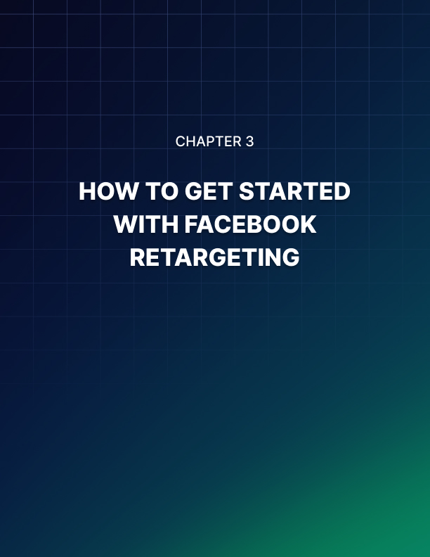

Chapter 3: How to Get Started With Facebook Retargeting

Now you know how custom audiences and retargeting work, the next question is how to go about setting up your own retargeting campaign and get it up and running.

What’s important to recognize at this point is that Facebook is a constantly evolving platform and is constantly updating its UI, its systems, and its features. That is to say that while this instruction is accurate at the time of writing, it may well have changed by the time you get around to employing it.

That said, the changes introduced are gradual and in most cases, it should be easy enough to extrapolate the information and work out where things have changed.

Getting Started With Facebook Advertising
Before you can get started, you will first need to have a Facebook account, and it is a good idea to set up a Facebook page as well.

To do this, you first need to set up a Facebook Ads Manager account. One of the best ways to do this is by making a Facebook business page. We recommend doing this as it will provide a very powerful way to interact with Facebook’s 2.2 billion users, and provides a hub that will be very useful when used in conjunction with your advertising.

Creating a page is very simple: just go to facebook.com/business and then click ‘Create a Page’ (it’s currently found in the hamburger menu on the left, or on the right from a drop down button where it also says ‘Create an Ad’. You can then type the page you want to create (local business or place, company, brand etc.).

From here, it is very easy to then set up your page by filling out the information prompted – such as a profile image, a description of your business, a link to your website, a call to action etc.

Setting Up Facebook Retargeting
From here, you can log into the Facebook Ads Manager. This will show you any live campaigns you have going on, which of course will be empty if you’re signing up for the first time. Click the button that says ‘Create’ in order to get started creating your ad.

But we’re going to rewind for a moment, because there’s a little more you will need to do when creating a retargeting campaign specifically.

To get this working, you are going to need to use what Facebook calls a ‘Facebook pixel’. This is simply the name of the cookie, and it works by storing information on the user’s computer as described. This will be a small snippet of code that you will need to paste onto the HTML of your relevant pages. But don’t worry – if you aren’t sure what that is then you can ask your website developer. Better yet, if you have a WordPress site, then you’ll be able to use a number of plugins to automatically add the pixels to every relevant page.

The pixels can either be added to ad campaigns that are already live, or can be used to set up brand new ones – so it is up to you which order you do this in.

To create a pixel, go to the hamburger menu on the left and then select ‘Pixels’ from the category beneath ‘Measure and Report’.

From here, the next steps are fairly self-explanatory. You can then choose to ‘Create a Pixel’ and then name and create said pixel. The pixel itself is neutral and won’t in any way contain any information pertaining to your audience.

This makes it very important that you choose a sensible name for your pixel, so that you can easily identify it when you’re looking at your list of pixels and thereby apply the correct one to the correct campaign.

So, for example, if you want to identify visitors who have looked specifically at a brand of trainer, then you should call the pixel by the brand and the model of that product. If you want to identify all customers who have been to your site however, then you might use something more generic like ‘Site Visitor’. Or you might create a pixel for a specific category of product, such as ‘shoe shopper’.

These aren’t either/or decisions. You can create a pixel for all these different categories and then use them in conjunction to cast your net far and wide, then hone in on specific members where you have enough information.

Once you have made the pixel, you can then return to your ad manager to create your custom audience. Select ‘Website Traffic’ for this example, and then choose the parameters that the site visitor is going to need to meet.

You can actually add some other interesting and useful metrics in order to get more granular information without making a million different pixels – for example you can look for visitors who have been to pages that contain the word ‘shoe’ in the URL!

Once you have built your custom audience, you then need to create your ad. That is where you can apply the custom audience to the particular campaign.

Of course, you will now also need to go ahead and copy and paste the Facebook pixel code onto the relevant pages of your website.

Where do you place the pixel? The idea is that you’re trying to identify specific actions that the user has taken, which in turn gives you specific information about that user and what they may be interested in purchasing.

There are generally considered to be 17 different standard ‘pixel events’ that you can use in this capacity.

These are:

- Purchase – When someone buys a product on your website. After all, there is no lead that is more qualified than someone who has already bought from you. If they like the product, they may well be happy to buy from you again, and now they know they can definitely trust you.

- Lead – A lead is someone who signs up for a trial or perhaps a mailing list – though these can also be categorized in other ways.

- Complete registration – Someone who has completed any kind of registration form. This is another way you might categorize those who sign up for your mailing lists, but it can also include those who sign up to your site, or who create a profile for your forum.

- Ad payment info – Someone who has added their payment details to your website. This is a very ‘hot’ lead, as the person has demonstrated a clear interest in buying from you at some point in the future.

- Add to cart – Someone has added a product to their shopping cart. If someone does this and then leaves the page, you stand a very good chance of convincing them to buy at a subsequent time.

- Add to wishlist – Someone has added your product to some kind of wishlist function you have on your website. This is another very strong indicator that they are open to buying from you in future – and that they have interest in that product specifically.

- Initiate checkout – This person is about as hot as they come. These are the ‘ones that got away’ who added the item to their cart, then headed over to the checkout page. They might even have begun filling out their delivery address before something tore them away. So close! But thanks to Facebook retargeting, there is such a thing as a second chance!

- Search – This means someone has used the search function on your website. That might mean looking for a specific product, or perhaps searching for specific information.

- View content – Someone has visited a particular page on your website. This could mean they read a particular blog post that suggests that they have a particular interest, or it could be a category of product.

- Contact – Someone has contacted your business in any way.

- Customize product – A person has looked at a specific type of product, or in some way selected criteria. For example, they might have entered their shoe size.

- Donate – Someone has donated to your cause. Remember, these tools are not only for ‘for profit’ businesses.

- Find Location – Someone has looked for the location of your business.

- Schedule – Someone has booked some form of appointment or meeting with your business.

- Start trial – Someone has signed up for a free trial of a product, or a free trial membership to a service.

- Submit application – Someone has submitted an application for a service or product.

- Subscribe – Someone has subscribed to a paid product or service.

While this list might seem to cover just about every possibility, it’s also possible to create your own custom events which can behave in any way you like and register any action you want.

When creating your pixel, you will be given the option to choose ‘automatic advanced matching’. This is an option that will add hashed customer data from your website to Facebook profiles. This can be a useful tool for more accurately tracking conversions and building bigger customer audiences. The information will only be that which customers have already added.

You can also test your pixel once it’s installed on your website. You can do this by entering the website URL and then clicking ‘Send Test Traffic’. If it’s tracking then congratulations! You’re ready to go ahead and take the next step.

There’s also a Google Chrome extension you can add called the Facebook Pixel Helper. This extension will look for the pixel when you visit your pages and will show you how many pixels are live on that page if any. It can also let you know if everything is working properly.

Creating the Ad
With the ad now created, you can next head back to your Ad Manager and build the specific ads that you are going to use in conjunction with the pixels.

Click the ‘Create an Ad’ button that is just by the ‘Create a Page’ button. Now you’ll be asked to choose an objective for your campaign. This of course is going to reflect what you plan on achieving via the use of your ads and there are several options here:

- Brand awareness – Help more people discover and become familiar with your company/products.
- Reach – Get your ad to reach as many people as you possibly can.
- Traffic – Drive traffic to your page or website.
- Engagement – Increase engagement by gaining more page likes, comments, return visits etc.
- App installs – Get more people to download and install an app
- Video views – Increase the number of views for your videos
- Lead generation – Get more prospects for your sales funnel
- Messages – Get more messages via Facebook messenger. A message is a lead and you shouldn’t underestimate its potential value.
- Conversions – Get people to make a certain action once they’re on your website. Of course this can include buying a product, which is going to be the number one action many readers of this book are looking for!
- Catalog sales – Show people the ads for products that they might want to buy (more on this in a moment)
- Store visits – Get nearby visitors to visit your actual store location.

In many cases, a retargeting campaign will be aimed at driving conversions – purchases. However, you can also use this to increase engagement and visibility etc.

After all, someone is more likely to read a blog post from you if they have read previous blog posts and enjoyed them. Keeping your brand foremost in the minds of your fans and followers is one of the most important ways to keep growing your business. Retargeting applies to nearly any goal.

After you’ve chosen a goal, you’ll next choose a name for the campaign. Again, this can be an important way to identify specific campaigns you have previously created. You will also have the opportunity here to create an ‘A/B split test’ – this allows you to create two slightly different versions of the same ad in order to compare which performs best and adopt positive changes.

The budget optimization option can help you to keep tabs on how much you're spending across multiple campaigns. This is useful for the budget conscious, but also for anyone who wants to maximize their earnings by cleverly manipulating the numbers.

If you haven’t already, you’ll need to fill out your details to create an ad account. Next, you can choose the audience – and this is where you can opt for the custom audience that you’ve just created with your pixel! Alternatively, you could use the lists that we discussed early to fill in this section.

OR you can go ahead and choose the precise demographics and details that will qualify people to be suitable for your campaign. As mentioned, using a combination of retargeting and this traditional form of targeted marketing is the very best way to bring in the most possible customers.

You’ll employ a one-two punch: bringing in new visitors who might be interested based on their age, location, interests, etc. Then keeping those new visitors engaged by retargeting to them when they leave.

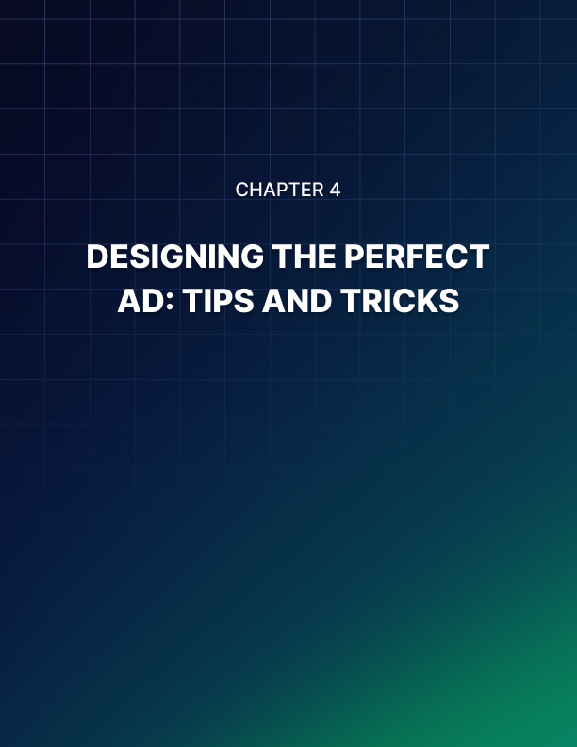

Chapter 4: Designing the Perfect Ad: Tips and Tricks

At this stage, you have your custom audience set up and ready to remarket. You have an ad manager account, and you have a goal.

Next, you need to actually create the advert, which will involve taking a few more steps and then thinking creatively about what is likely to encourage people to buy and what will actually make you a profit.

The next question you’ll be prompted to answer is regarding Facebook ad placements. In other words, where are the ads going to appear? If you are new to Facebook advertising, then you can simply select automatic placements, which will put your ads in the most optimal positions.

Note as well that Facebook is not a single site or app, but actually a network of apps and tools. So your ads can also appear automatically on Facebook, Instagram, Messenger, and the ‘Audience Network’.

If you choose to take control of this yourself though, then you’ll be able to select whether the ads appear on only the desktop or mobile version of the site, whether they appear on platforms like Instagram or not, and which operating systems you want to support.

Next up, you will choose the budget and schedule.

You’ll next need to think about how to create an ad campaign that will be cost effective. In other words, you’ll set up your budget and your schedule. The budget is the amount you’re willing to spend on these ads per day. You should make sure to set this number only once you have assessed your finances and cash flow to ensure that you can afford to support this kind of campaign.

You can also choose whether to set your ads live during a set period, right away, or to go live after a set amount of time.

Go into fine detail regarding how you want to spend money using the ‘advanced budget’ option.

You can also think about the precise times of day when you want your ad to show. Ideally, that should be when your visitors are awake.

Next, you’ll be able to create your ad format. This can be a single image, video, slideshow or other.

Make sure to check Facebook’s guidelines for the size and format of images etc. You can find those at: https://blog.hootsuite.com/facebook-ad-sizes/.

Next, you’ll need to consider the number of words that you can ad to the headline, as well as to the body of the text etc.

Here is a quick reference to help you identify how many words you have available for each section:

Photo ads
- Headline: 25 characters
- Link description: 30 characters
- Body text: 125 characters

Video ads
- Headline: 25 characters
- Link description: 30 characters
- Body text: 125 characters

Carousel ads
- Headline: 40 characters
- Link description: 20 characters
- Body text: 125 characters

Slideshow ads
- Headline: 25 characters
- Link description: 30 characters
- Body text: 125 characters

Collection ads
- Headline: 25 characters
- Link description: n/a
- Body text: 90 characters

Instant Experience ads
- Headline: No strict limits—insert text blocks using Facebook’s templates
- Link description: (same as above)
- Body text: (same as above)

Lead ads
- Headline: 25 characters
- Link description: 30 characters
- Body text: 125 characters

Messenger ads
- Headline: 25 characters
- Link description: n/a
- Body text: 125 characters

Of course, these all give you a finite number of words/characters through which to get your message across. While remaining inside those parameters, it is your job to create something that will stand out and that will get the right kind of visitor to click through and visit your website.

It’s not quite as simple as just trying to ‘trick’ as many people as you can into clicking on your ads though. There is more to it, which we will go into in more depth now.

Creating a Highly Profitable Campaign
Facebook ads are a type of ad referred to as PPC. If you have been marketing online for any length of time, then you should be familiar with this term. To recap, PPC means ‘Pay Per Click’, which in turn means that you only have to pay for the ad each time someone clicks on it.

You will set a maximum amount you are willing to pay for each click on each ad. So, for instance, if you set your maximum CPC (Cost Per Click) to be 50 cents, then that means you will get a minimum of 20 clicks a day before you spend more than your daily budget.

In truth though, you may get more clicks than this. That’s because Facebook ads work on a bidding system. When there is a ‘space’ on the site for an ad to show to a specific customer, Facebook will then look at the ad campaigns it has live and find the relevant options.

A bidding war will then be carried out between those different ads, so that the one with the highest CPC will end up being shown.

That said, the advertiser will only pay the amount they need to in order to win the bid. So if all the other ads in your niche only set their CPC to 20 cents, then you will only pay 21 cents per click, thus getting a lot more clicks in total!

So, if you set your CPC too low, then you will lose out on the bids and your ads won’t show – or will only show a few times, to less competitive audiences.

That said though, if you set your CPC too high, then you’ll only reach a few people before you exceed your budget and your ads stop being served for the day.

And so there is a highly precarious balancing act that must take into account all three of these factors: the competitiveness of the niche, the CPC, the daily budget… and you thus must choose the right amount to spend.

Do you aim for a smaller niche with fewer people, and thus be able to get more exposure for a lower cost? Or do you compete head to head with the big players, and perhaps only get your ad displayed once or twice?

As ever, the best option is often to work your way up. When you’re a small business with a small budget, aim for smaller sub- sections of the market and try to establish yourself there. From that point onward, you can then try to reinvest the profits you make in order to expand your reach further and further and compete with the bigger brands.

If you’re brand new, then targeting males interested in fitness between 20-30 with a supplement brand will be out of your price bracket as you compete with big supplement companies, Amazon, and Bodybuilding.com.

But if you target martial artists who do Brazilian Jiu Jitsu with the same product, all located in a specific area, then you might be able to make a dent.

The other thing to consider is your CLV – Customer Lifetime Value. In other words: how much do you stand to earn from each of these ads? And therefore, how much should you realistically be willing to spend on each ad?

The best case scenario is that someone sees your ad, clicks on your ad, and then visits your site to buy your product. Remember: you only pay each time someone clicks on your advert. So as long as you earn more from each visitor than you pay for each click, your ads will make more money than they cost you. If you make $30 profit for each sale, then that should be very easy.

But of the 100 people who visit your website, it’s likely that only one or two will actually buy a product. That’s a 1-2% conversion rate, which is actually considered to be pretty good.

That means that the ‘average’ value of each visitor to your site is closer to $30 / 100 – so 30 cents.

If you consider that a few people might sign up to your mailing list and buy later, or might buy more than one product, then you can potentially increase the number to 60-70 cents. This is why it’s called the lifetime value – it’s the lifetime of the customer. You might take a while to see this return though, which is why you also need to consider your cash flow.

Either way, make sure you are earning money from your campaign on average, before you start spending.

Creating Ads That Work for You
The quality of the ad will of course determine whether it gets looked at and whether it gets clicked.

The mistake people make though is to make an ad that is just begging to be clicked – that is so interesting that even someone with no interest in your product will still want to click on it and check out your site.

This is a mistake, because of course you aren’t trying to maximize clicks. You’re trying to maximize profit.

Therefore, you need to think once again in terms of targeting, and your ‘buyer persona’. Who are you selling to? Who is most likely to buy your product?

And what types of images will that person respond to, more so than the average Joe? What kind of text will get them excited and curious? And how can you dissuade people from clicking who are statistically unlikely to buy.

Reading about persuasive writing is highly advisable. So too is thinking about how to create eye-catching images that are high quality. This will help establish trust with the viewer.

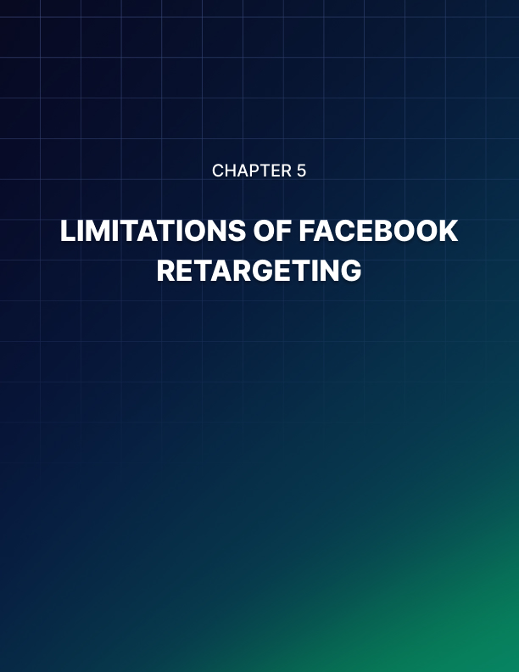

Chapter 5: Limitations of Facebook Retargeting

While Facebook retargeting and retargeting generally are highly beneficial for the myriad reasons we’ve already outlined in this book, it’s also important to recognize that no single marketing method is perfect. This is also true of retargeting.

There are limitations and issues with retargeting, which ensure that it won’t be the perfect choice in all situations. The good news is that all these issues can be mitigated – circumvented – as long as you know what you’re doing.

GDPR – This is the ‘elephant in the room’ when it comes to any type of marketing that involves cookies. Cookies require a website to collect personal information from visitors, often without them being explicitly aware. Unfortunately, that directly flies in the face of the General Data Protection Regulation and ePrivacy Directive set up by the EU.

In other words, it’s now illegal to track users or collect their data without explicitly saying so. This is not an insurmountable challenge – in fact it is easily remedied by adding a notice to your website. With that said though, it’s very important that you do this, in order to ensure you are in compliance with the law.

Redundant Ads – Another issue is that you might end up retargeting to people who have already bought your product. This is now the most redundant and least targeted form of ad imaginable! We’re not talking about retargeting with new products, but rather retargeting the precise same product.

That’s why it can be a good idea to also exclude some people from your lists – such as if they actually land on the ‘Thank You’ page. Another fortunate saving grace is that most people won’t click on ads for things they just bought – meaning that you won’t actually pay for them. So it’s not as much of a waste as it might at first seem.

Mistaken Identities – As a professional writer, I am often tasked with writing about products for resellers. Thus, I spend a lot of time looking at store listings for things I have no interest in buying. The bad news? That means I get all kinds of strange adverts.

Likewise, you’ve no doubt at some point bought something for a family member or friend only to have that item repeatedly shoved in your face for weeks afterward wherever you go online.

Occasionally this can happen, but the good news is that once again, it shouldn’t cost you as long as no one actually clicks those ads. What’s more, is that you can use other filters (such as demographics) to reduce the likelihood of this happening.

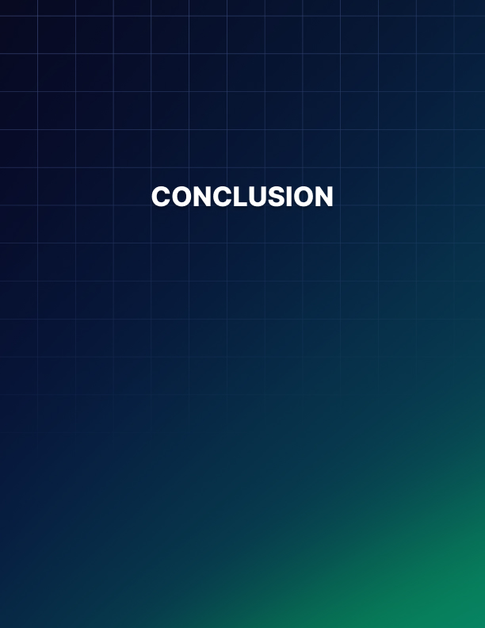

Conclusion

So, there you have it: that’s how to utilize retargeting on Facebook in a nutshell.

Hopefully, this has given you enough information to head out and start creating your own campaigns. You now know to include a warning on your site for GDPR purposes. You know how to build an ad. You know how to use Pixels. And you know how to combine this information to create an effective retargeting campaign that drives sales and that increases engagement and traffic.

But hopefully that’s not all you’ve learned. Perhaps the most important takeaway from this book should be why retargeting is so effective: and how the best way to use it might not be focused on selling a product at all in the first place.

The most important aspect of Facebook retargeting is engagement and targeting. This is a form of marketing that lets you address people directly who have already shown interest in your brand and your products. It is a form of marketing that lets you keep the engagement with your brand high – such that visitors don’t forget you.

And this is just as valuable as the selling itself.

Remember: people don’t like to buy things off of strangers. And they don’t like buying products they have no experience with.

We can’t compete directly with the HUGE marketing campaigns of big businesses. We likely don’t have the budget to become household names like Nike or McDonalds or Apple.

But we CAN build a loyal and dedicated following. We can gradually spread the word via word of mouth. We can build repeat business that will sustain our business indefinitely. And we do that by ensuring people keep seeing our brands.

That’s where the true power of retargeting comes in.

