TABLE OF CONTENTS
____
INTRODUCTION 5
DISCOVER YOUR NICHE FOR GIG ECONOMY SUCCESS 8
Understanding the Importance of a Niche 8
Analyzing Your Skills and Identifying Your Passions 9
Assessing Market Demand and Finding the Overlap 10
Testing, Refining, and Overcoming Challenges 11
CRAFTING YOUR UNIQUE SELLING PROPOSITION 15
The Power of a Strong USP 15
Understanding Your Target Market 16
Analyzing Your Competition 17
Identifying Your Unique Value 19
Crafting Your USP Statement 20
BUILDING AN IMPACTFUL ONLINE PRESENCE 25
Your Professional Portfolio Website 25
Leveraging Social Media Platforms 26
Content Marketing 27
Building Credibility with Reviews and Testimonials 28
Networking and Maintaining Your Digital Presence 29
RELATIONSHIP-BUILDING STRATEGIES 33
The Power of Strategic Networking 33
Leveraging Online Platforms for Networking 34
Engaging in Industry-Specific Communities 35
Mastering the Art of In-Person Networking 35
Building and Nurturing Relationships Over Time 36
Leveraging Your Network for Opportunities 37
Overcoming Challenges and Measuring Success 38
RECAP AND ENCOURAGEMENT FOR GROWTH 41
The Power of Niche Specialization 42
The Heart of Your Personal Brand 42
Your Digital Footprint 43
Building Relationships, Not Just Contacts 43
Embracing Continuous Learning and Adaptation 44
CONCLUSION 49

DISCLAIMER
____
The information provided in this ebook is intended solely for educational and informational purposes. The author does not accept any responsibility for the outcomes that may arise from the application of the material within. While efforts have been made to ensure the accuracy and relevance of the content, the author cannot be held accountable for any errors or omissions, or for any consequences resulting from the use or misuse of the information provided. The responsibility for any actions taken based on the information in this ebook lies solely with the reader.



INTRODUCTION
____
In today's gig economy, standing out as a freelancer is essential. You’ve made the bold move into freelancing, armed with your skills and determination, but how do you ensure you’re more than just another face in the crowd? How do you become a sought-after brand that clients can’t resist?
Welcome to your personal branding journey. This book is your guide to transforming from a freelancer into a powerhouse entrepreneur, where clients are drawn to you for your expertise and unique value. You'll learn the secrets that set thriving freelancers apart, elevating your brand to industry authority.

Imagine waking up to client inquiries perfectly aligned with your skills, commanding premium rates based on your value, not price.

Picture building a personal brand that opens doors to speaking engagements, collaborations, and opportunities you once thought were out of reach.
This isn't just another guide filled with generic advice. It's a toolkit designed to propel you from freelance anonymity to industry stardom. You’ll learn how to craft a compelling personal narrative, build a magnetic online presence, and position yourself as a thought leader in your niche. We'll show you how to build strong client relationships and forge a network that becomes your personal marketing machine.
As you read, you’ll discover hidden strengths, confront limiting beliefs, and craft a clear vision for your freelance future. This is about more than landing gigs—it’s about building a career that aligns with your values and aspirations.
By the end, you’ll have the tools and confidence to attract dream clients, charge what you’re worth, and grow your freelance business. Ready to stand out and transform your freelance hustle into a thriving personal brand? Turn the page and get started—your journey begins now.


DISCOVER YOUR NICHE FOR GIG ECONOMY SUCCESS
____
Carving out your unique space in the rapidly evolving job market is more crucial than ever. The gig economy has opened up a world of opportunities, but it has also intensified competition. To succeed, you need to find your niche - that sweet spot where your skills, passions, and market demand intersect. This chapter will guide you through the process of identifying and defining your niche, helping you stand out in a crowded freelancer market and attract high-quality opportunities.

Understanding the Importance of a Niche
Before we get into the process of finding your niche, let’s talk about why it’s so important in the gig economy. When you specialize in a specific area, you become an expert by focusing on a particular field, developing deep knowledge and skills that set you apart from generalists. You attract ideal clients seeking specialized services, who are more likely to find and choose you when you have a clear niche. Expertise in a specific area often justifies premium pricing for your services, allowing you to command higher rates. A defined niche makes it easier to target your marketing efforts and messaging, streamlining your marketing process. Specialization allows you to build a name for yourself in a particular field, leading to more referrals and repeat business, thus building a strong reputation.
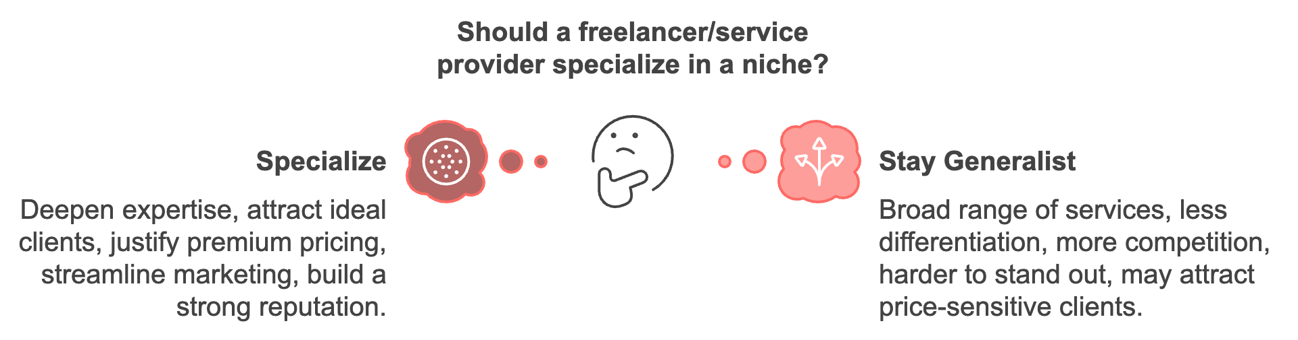

Analyzing Your Skills and Identifying Your Passions
The first step in discovering your niche is to take a deep dive into your skillset. This involves more than just listing your abilities; it requires honest self-reflection and assessment. Start by making a comprehensive list of all your skills, both hard and soft.
- Hard skills are specific, teachable abilities that can be defined and measured, such as proficiency in a particular software or fluency in a foreign language.
- Soft skills, on the other hand, are interpersonal attributes that help you interact effectively with others, such as communication, leadership, or problem-solving.
Once you have your list, rate each skill on a scale of 1 to 10, with 10 being expert-level proficiency. This will help you identify your strongest areas.
While skills are crucial, passion is what will fuel your long-term success and satisfaction in your chosen niche. When you're passionate about your work, it shows in the quality of your output and your ability to persevere through challenges. Think about the tasks or topics that excite you.
- What kind of work makes you lose track of time?
- What subjects do you enjoy learning about in your free time?
These are clues to your passions. Write down 10 activities or subjects that you genuinely enjoy. Don't worry about whether they're related to work - just focus on what brings you joy and satisfaction. Once you have your list, look for patterns or themes. Do several items relate to creativity? Problem-solving? Helping others? These themes can guide you towards potential niches.

Assessing Market Demand and Finding the Overlap
Having identified your skills and passions, it's time to consider market demand. After all, a viable niche needs to have clients willing to pay for your services. Start by researching trends in your areas of interest. Look at job boards, freelance platforms, and industry reports to see what skills are in high demand. Pay attention to emerging technologies or methodologies that align with your skillset.
For instance, a recent study by Upwork found that 73% of hiring managers are continuing or increasing their use of independent professionals. The most in-demand skills as of 2023 include artificial intelligence, blockchain, and data analytics.
Now comes the crucial part - finding where your skills, passions, and market demand intersect. This sweet spot is your ideal niche. Look at your top-rated skills, your identified passions, and the results of your market research. Are there any areas that appear in all three categories? These are strong contenders for your niche. Remember, your niche doesn't have to be extremely narrow from the start. You can begin with a broader focus and narrow it down as you gain experience and recognize specific client needs.
Skills | Passions | Market Demand
Web Development | Creative Design | AI Integration
Data Analysis | Problem Solving | Blockchain Solutions
Content Writing | Environmental Issues | Data Analytics
Project Management | Health and Wellness | Remote Team Management
Digital Marketing | Social Impact | E-commerce Optimization

Testing, Refining, and Overcoming Challenges
Once you've identified potential niches, it's time to test them out. This doesn't mean you need to immediately quit your job and dive in headfirst. Instead, start small and gather feedback. Create a sample project that showcases your skills in your chosen niche. This could be a mockup, a case study, or a small piece of work. Share your new focus with your professional network. Ask for their thoughts and if they know anyone who might need your services. Start bidding on small projects in your niche to get a feel for the market and client expectations. Participate in conferences or webinars related to your niche. This will help you stay updated on trends and network with potential clients.
While working on discovering your niche, you might encounter some challenges. Here's how to address them:
- If you fear limiting opportunities, remember that niching down often leads to more, not fewer, opportunities. You become the go-to expert in your field.
- If you're having difficulty choosing between multiple options, try each one out on a small scale before committing. It's okay if your passions evolve. Your niche can grow and change with you.
- If you lack experience, focus on building your skills and portfolio in your chosen niche, even if it means taking on some lower-paid or pro bono work initially.
Specializing in a niche doesn't mean you can never do other types of work. Instead, think of it as your primary focus and the core of your personal brand. This specialization will set you apart in the gig economy and attract clients who value your specific expertise. As you continue to refine your niche, remember that it's an ongoing process. The market evolves, and so will your skills and interests. Regularly reassess your niche to ensure it still aligns with your goals and the market demand. By taking the time to discover and develop your niche, you're setting yourself up for success in the gig economy. You're not just another freelancer - you're a specialist with unique value to offer. This focused approach will help you attract better clients, command higher rates, and find greater satisfaction in your work.
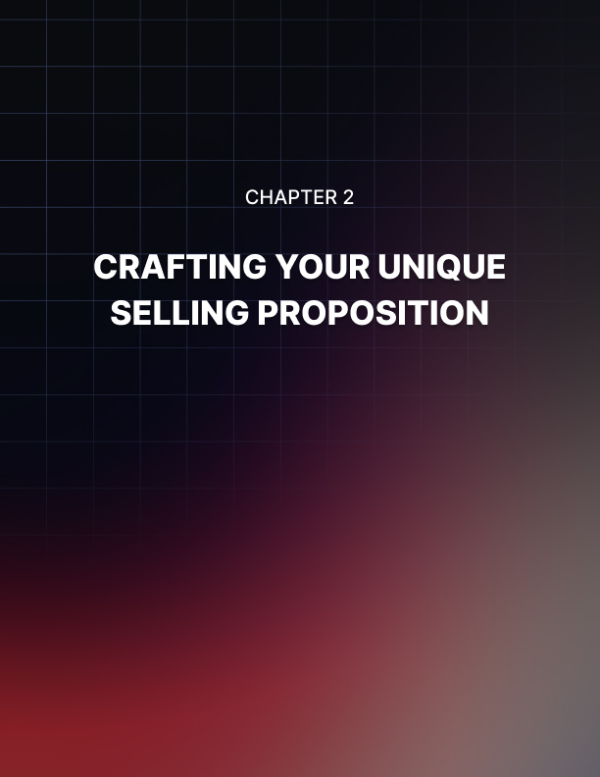

CRAFTING YOUR UNIQUE SELLING PROPOSITION
____
You've identified your niche, and now it's time to make yourself stand out in a sea of competitors.

Your Unique Selling Proposition (USP) is the secret weapon that will set you apart and make potential clients choose you over others.

This chapter will guide you through the process of creating a compelling USP that resonates with your target market and communicates your unique value effectively.

The Power of a Strong USP
Your USP is more than just a catchy slogan or a clever tagline. It's the core of your personal brand, encapsulating what makes you unique and valuable to your potential clients. A well-crafted USP can differentiate you from competitors, clearly communicate your value to potential clients, guide your marketing efforts, help you focus on your strengths, and attract your ideal clients. In today's competitive gig economy, having a strong USP is not just beneficial—it's essential. According to a 2023 survey by Freelancer.com, 68% of clients said a freelancer's unique value proposition was a key factor in their hiring decision. This statistic underscores the importance of crafting a compelling USP that resonates with your target audience.

Understanding Your Target Market
Before you can create a USP that speaks to your ideal clients, you need to understand who they are and what they need. Start by creating detailed buyer personas for your target market. These are fictional representations of your ideal clients based on real data and market research. To create effective buyer personas, consider demographics, psychographics, professional information, pain points, goals, and buying behavior.
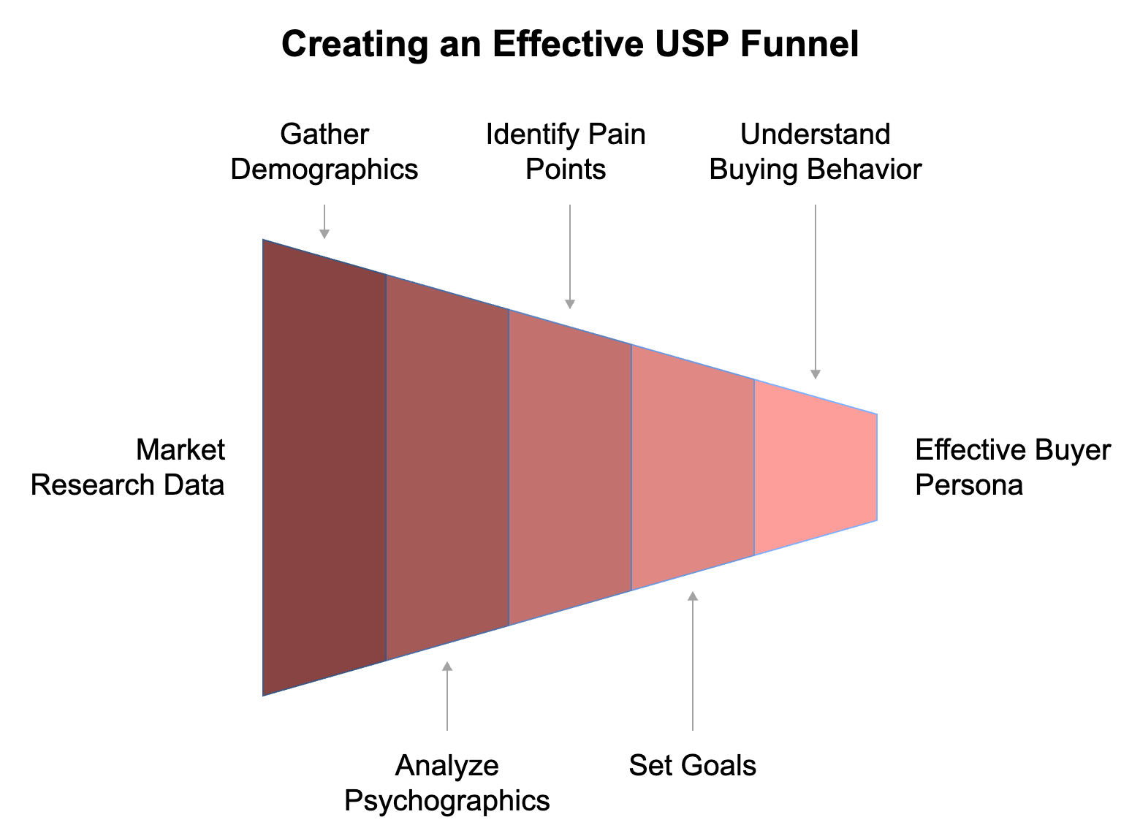
For example, if you're a freelance graphic designer specializing in branding for tech startups, your buyer persona might look something like this:
"Sarah is a 32-year-old founder of a San Francisco-based SaaS startup. She has a Master's degree in Computer Science and values innovation and creativity. Sarah is looking for a graphic designer who understands the tech industry and can create a brand identity that will help her startup stand out in a crowded market. Her main challenge is finding time to focus on branding while also developing her product and seeking funding. She makes decisions based on recommendations from her network and portfolio examples that demonstrate an understanding of tech branding."
Creating detailed buyer personas gives you insights into what your ideal clients are looking for and how to position yourself to meet their needs.

Analyzing Your Competition
To stand out, you need to know what you're standing out from. Conducting a thorough competitive analysis will help you identify gaps in the market and opportunities to differentiate yourself. Here's how to do it: Identify your main competitors by looking for freelancers or agencies offering similar services in your niche. Analyze their USPs by examining what promises they make to clients and how they position themselves. Evaluate their strengths and weaknesses, examining what they do well and where they fall short. Examine their online presence, including their websites, social media profiles, and content marketing efforts. Read client reviews and testimonials to understand what clients appreciate about their services and what complaints they have. Compare pricing and service offerings to see how your rates and services stack up. Create a comparison chart to visualize how you measure up against your competitors. This will help you identify areas where you can differentiate yourself.
Competitor | USP | Strengths | Weaknesses | Pricing
You | ? | ? | ? | ?
Competitor A | "Fast turnaround for busy entreprene-urs" | Quick delivery, streamlined process | Limited customization | $XX/  hour
Competitor B | "Award-  winning designs for Fortune 500 companies" | High-profile clients, prestigious awards | High prices, long wait times | $XXX/hour
Competitor C | "Budget-  friendly branding for small businesses" | Affordable rates, packages for startups | Generic designs, less experienced | $X/  hour

This analysis will reveal gaps in the market that you can fill with your unique offerings.

Identifying Your Unique Value
Now that you understand your target market and your competition, it's time to identify what makes you unique. This is the foundation of your USP. Consider the following questions:
- What specific skills or experiences do you have that set you apart?
- How does your approach or process differ from others in your field?
- What results can you deliver that others can't?
- What personal qualities do you bring to your work that clients appreciate?
- How do you solve your clients' problems in a unique way?
For each of these questions, try to come up with at least three answers. Then, look for patterns or themes that emerge. These will point you towards your unique value.
Let's say you're a content writer specializing in the healthcare industry. Your unique value might stem from your background as a registered nurse, which gives you insider knowledge of medical terminology and practices. Or perhaps you've developed a unique research method that allows you to produce highly accurate and up-to-date content faster than your competitors. Remember, your unique value doesn't have to be something completely revolutionary. It could be a combination of factors that, together, make you the ideal choice for your target clients.

Crafting Your USP Statement
With a clear understanding of your target market, your competition, and your unique value, you're ready to craft your USP statement. This is a concise, powerful statement that communicates your unique value to potential clients. A strong USP statement should be clear and concise, focus on the benefits to the client, differentiate you from competitors, be memorable, and be authentic to who you are and what you offer.
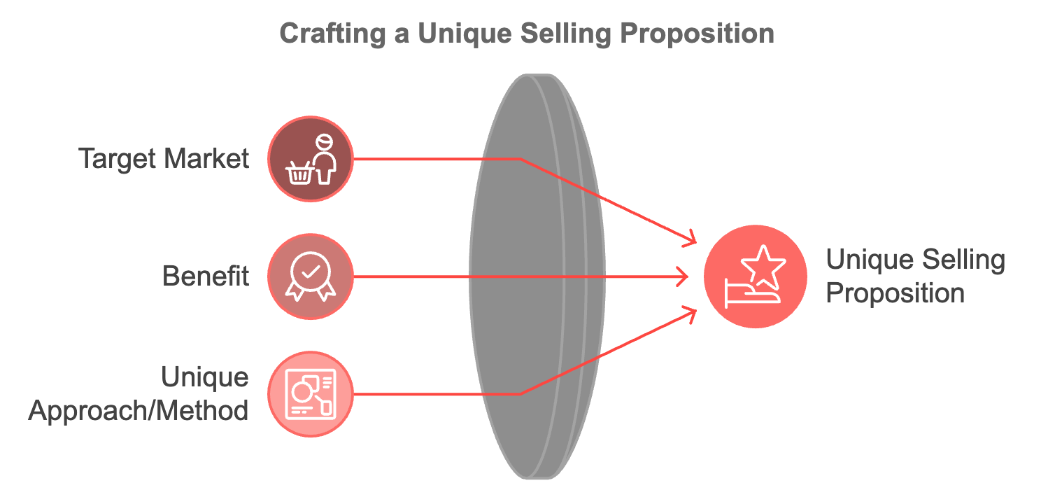
Here's a simple formula you can use to structure your USP:
"I help [target market] to [benefit] by [unique approach/method]."
For example:
"I help tech startups to create memorable brand identities by combining cutting-edge design trends with deep industry insights." or "I help healthcare companies to produce engaging, accurate content by leveraging my nursing background and proprietary research methods."
Draft several versions of your USP and test them out. Ask for feedback from colleagues, mentors, or even potential clients. Which version resonates most strongly? Which one is most memorable?
Once you've crafted your USP, it's time to integrate it into every aspect of your personal brand. Your USP should be reflected in your portfolio website, social media profiles, marketing materials, elevator pitch, content marketing, and client proposals. Remember, your USP isn't just a statement—it's a promise to your clients. Every interaction a client has with you should reinforce this promise.
Your USP isn't set in stone. Gaining experience, developing new skills, and responding to market changes may require your USP to evolve over time. Regularly reassess your USP to ensure it still accurately reflects your unique value and resonates with your target market. Here are some signs that it might be time to update your USP:
- Your skills or services have significantly changed.
- You're attracting the wrong type of clients.
- Your USP no longer differentiates you from new competitors.
- Your target market's needs have shifted.
- You're not seeing the results you want from your current USP.
When updating your USP, follow the same process you used to create it initially. Analyze your current market and competition, reassess your unique value, and craft a new statement that reflects where you are now.
While crafting and implementing your USP, you might face some challenges. Here's how to overcome them:
- If you can't think of anything unique about your services, look beyond your specific skills to your approach, your background, or your results. Often, it's the combination of factors that makes you unique.
- If your USP sounds too similar to your competitors, dig deeper into what truly sets you apart. Consider your personal qualities, your process, or the specific results you achieve for clients.
- If your USP feels too limiting, remember that it's a focus, not a limitation. You can still offer other services, but your USP helps you stand out in your primary area of expertise.
- If you're worried about turning off potential clients with a specific USP, remember that a strong USP will attract your ideal clients more strongly than it will repel others. Focus on appealing to your target market rather than trying to please everyone.
- If your USP doesn't feel authentic to you, keep refining it until it feels true to who you are and what you offer. Authenticity is key to a strong personal brand.
Crafting a compelling USP is a crucial step in building your personal brand and standing out in the gig economy. Clearly communicating your unique value to potential clients will attract better opportunities and help build a stronger, more successful freelance career. Your USP is more than just words—it's the essence of what makes you the best choice for your ideal clients. Invest the time to get it right, and you'll reap the benefits in your freelance journey.


BUILDING AN IMPACTFUL ONLINE PRESENCE
____
You've discovered your niche and crafted your unique selling proposition. Now it's time to showcase your value to the world. Your online presence is often the first impression potential clients have of you these days. This chapter will guide you through creating a powerful online presence that resonates with your target market and attracts high-quality opportunities.
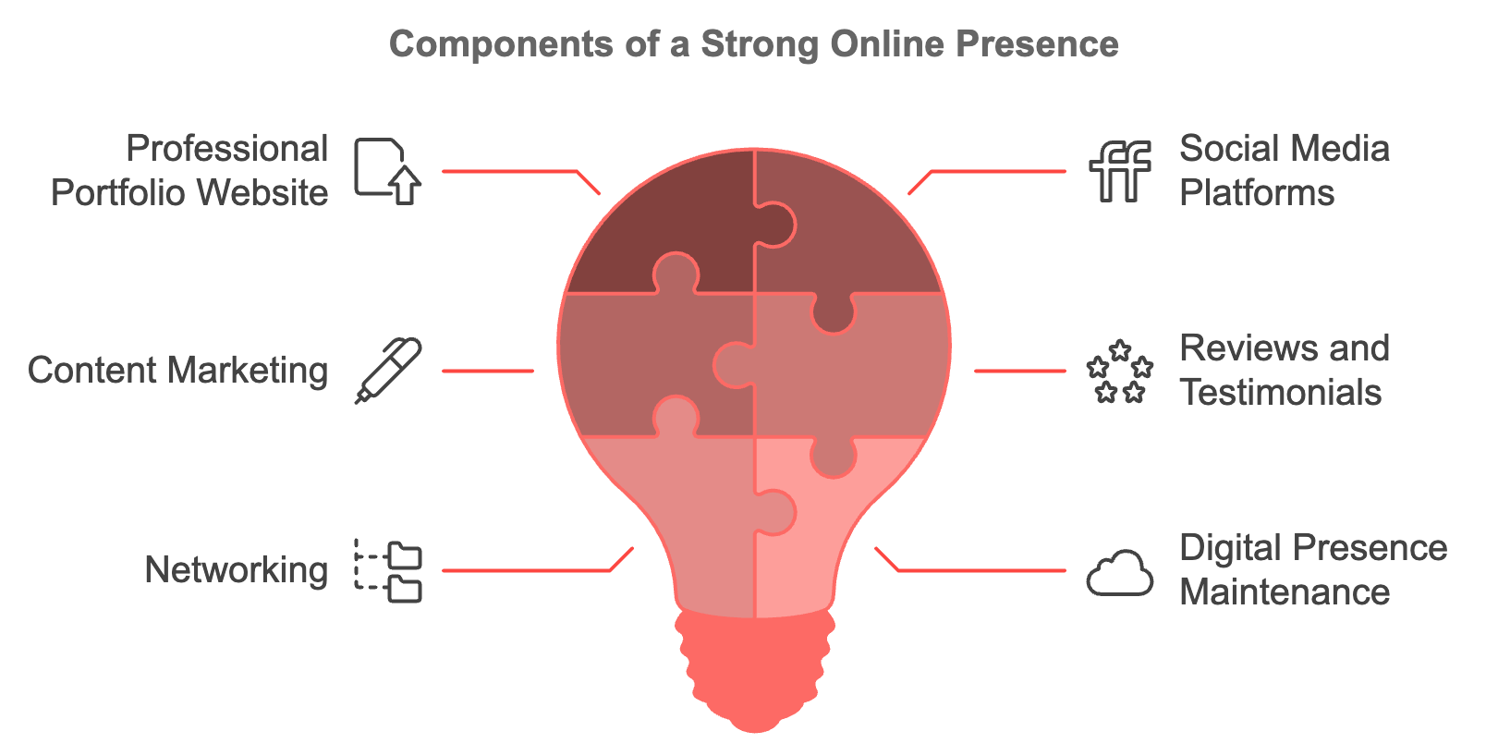

Your Professional Portfolio Website
Your portfolio website is the foundation of your online presence, where you have complete control over your narrative and can showcase your best work. To create a website that impresses potential clients, choose the right platform that offers professional templates and is easy to use. Popular options include WordPress, Squarespace, and Wix. Design for user experience with a clean, professional layout that aligns with your personal brand and ensures mobile responsiveness. Craft compelling content that clearly communicates who you are, what you do, and why clients should choose you. Include a strong homepage that quickly communicates your Unique Selling Proposition (USP), an 'About' page that tells your story, a services page detailing your offerings, a portfolio showcasing your best work, testimonials from satisfied clients, a blog to demonstrate your expertise, and clear calls-to-action on every page. Optimize for search engines by implementing basic SEO practices, using relevant keywords, creating quality content, and ensuring your site loads quickly. Make it easy for potential clients to reach you by including a contact form and your professional email address. Your website is not a "set it and forget it" project; regularly update your portfolio with new work, refresh your content, and ensure all information is current.

Leveraging Social Media Platforms
While your website is your home base, social media platforms allow you to extend your reach and engage with your audience. Focus on platforms where your target clients are active, with LinkedIn being a must for most freelancers. Depending on your niche, you might also consider Twitter, Instagram, or even TikTok. Optimize your profiles with a high-quality profile picture, a compelling bio that includes your USP, and a link to your website. Regularly post content that demonstrates your expertise and provides value to your audience, such as industry insights, tips related to your services, or behind-the-scenes looks at your work process. Engage with your audience by responding to comments, participating in relevant conversations, and building relationships with potential clients and peers in your industry. Use hashtags strategically to increase the visibility of your posts, showcase your work by sharing snippets of projects, client testimonials, or case studies, and maintain consistency in your posting schedule.
For example, if you're a graphic designer specializing in branding for tech startups, you might use Instagram to share snippets of your design process, LinkedIn to post in-depth articles about branding trends in the tech industry, and Twitter to engage in conversations about design and technology.

Content Marketing
Content marketing is a powerful tool for establishing yourself as an expert in your field and attracting potential clients. By creating and sharing valuable content, you demonstrate your knowledge and build trust with your audience. To develop an effective content marketing strategy, start by identifying your audience's pain points and addressing these issues in your content. Choose content formats that align with your skills and audience preferences, such as blog posts, videos, podcasts, or infographics. Develop a content calendar to ensure consistency and cover a range of relevant topics. Create high-quality, original content that provides real value to your audience by sharing your unique insights and experiences. Optimize your content for SEO by using relevant keywords naturally, and promote it on your social media platforms. Consider guest posting on other relevant blogs to expand your reach. Encourage engagement by ending your content pieces with questions or calls-to-action to spark discussions.
Here's an example of how content marketing can be applied effectively:
Content Type | Topic | Purpose
Blog Post | "10 Proven Strategies to Improve Email Open Rates" | Showcase expertise in email marketing
Video Tutorial | "Crafting Subject Lines That Drive Clicks" | Demonstrate practical skills and provide value
Infographic | "Email Marketing Trends for 2024" | Present industry insights in a visually appealing format

Building Credibility with Reviews and Testimonials
Social proof is crucial in the digital age. Potential clients often look for reviews and testimonials before deciding to work with a freelancer. Collect testimonials by asking satisfied clients for feedback after completing a project, guiding them with specific questions about their experience and the results achieved. Showcase these testimonials prominently on your website, particularly on your homepage and services page. Consider using various formats, such as written testimonials, video testimonials, or case studies for more impact. Leverage third-party platforms by encouraging clients to leave reviews on LinkedIn, Google My Business, or industry-specific review sites. Always respond to all reviews, thanking clients for positive feedback and addressing any negative comments professionally and constructively. Authenticity is key; never fabricate testimonials or reviews, as this can severely damage your reputation if discovered.

Networking and Maintaining Your Digital Presence
Online communities can be goldmines for networking and attracting clients. Identify relevant forums, Facebook groups, LinkedIn groups, or Slack channels related to your niche. Observe the community's culture and rules before actively engaging, then provide value by answering questions, sharing insights, and offering help without expecting immediate returns. Share your expertise when appropriate, focus on building genuine connections rather than just promoting your services, and be consistent in your participation to become a recognized and trusted member of the community. For example, if you're a freelance web developer, you might join communities like Stack Overflow, GitHub, or niche-specific forums where you can share your knowledge, learn from others, and potentially connect with clients needing your services.

Your online presence should grow and evolve with your career:
- Regularly update your portfolio with new projects and remove outdated ones to keep it fresh and relevant.
- Stay active on social media, maintain a consistent posting schedule, and engage with your audience regularly.
- Keep your content current by publishing new pieces and updating existing ones to reflect current trends and information.
- Monitor your online reputation by setting up Google Alerts for your name and business.
- Stay informed about changes in social media algorithms, SEO best practices, and digital marketing trends, and adjust your strategy accordingly.
- Seek feedback from clients and peers about your online presence and make improvements based on their input.
- Be open to experimenting with new platforms or content formats that might help you reach your target audience more effectively.
Building a strong online presence takes time and effort, but the rewards are well worth it. A robust digital footprint can open doors to new opportunities, help you command higher rates, and establish you as a leader in your field. By creating a professional website, leveraging social media, producing valuable content, showcasing social proof, and engaging in online communities, you can create an impactful online presence that resonates with your target market and positions you to thrive in the competitive world of freelancing.



RELATIONSHIP-BUILDING STRATEGIES
____
Building strong, genuine relationships is crucial for long-term success as a freelancer or entrepreneur.

Your network is your net worth.

This chapter will equip you with advanced techniques for networking and relationship-building that lead to more opportunities, repeat business, and referrals.

The Power of Strategic Networking
Networking isn't just about collecting business cards or adding connections on LinkedIn. It's about cultivating meaningful relationships that can support your professional growth and open doors to new opportunities. According to a 2023 survey by the Freelancers Union, 71% of freelancers reported that networking was crucial to their success, with 45% stating that they found their highest-paying clients through networking.
Strategic networking involves identifying the right people to connect with, nurturing those relationships over time, and providing value to your network. It's not just about what others can do for you, but how you can contribute to the success of those in your network.
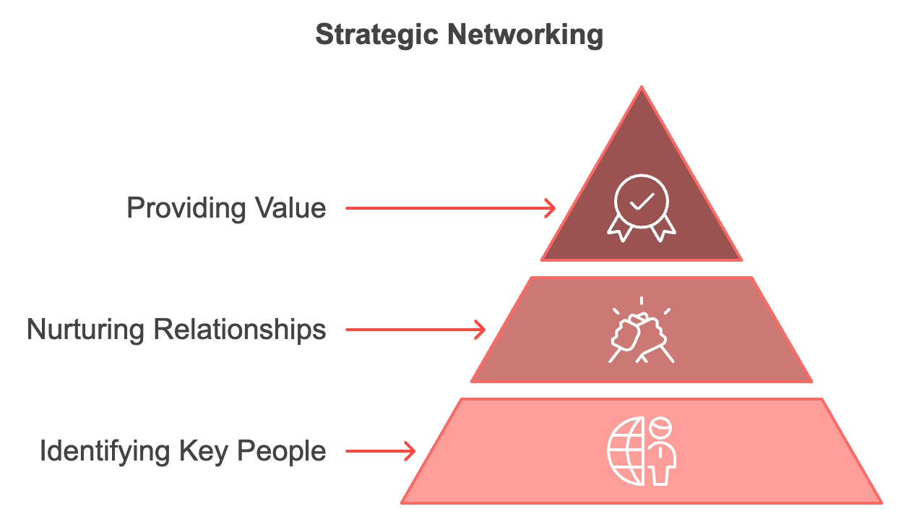

Leveraging Online Platforms for Networking
Online platforms play a crucial role in networking. LinkedIn is an invaluable tool for professional networking. To make the most of it, optimize your profile with a professional photo, compelling headline, and summary highlighting your skills and accomplishments. Engage regularly by sharing valuable content, commenting on others' posts, and participating in relevant discussions. Join industry groups, use LinkedIn's advanced search features to find potential clients or collaborators, personalize connection requests, and utilize the recommendation feature. Beyond LinkedIn, consider platforms that align with your niche, such as Behance or Dribble for designers, and GitHub for developers.

Engaging in Industry-Specific Communities
Industry-specific online communities can be goldmines for networking opportunities. These communities allow you to connect with peers, potential clients, and industry leaders in a more focused environment. Identify relevant communities like forums, Facebook groups, Slack channels, or Discord servers related to your niche. Observe before participating to understand the community's culture, rules, and dynamics. Provide value by sharing your knowledge, answering questions, and offering help without expecting immediate returns. Be consistent in your participation to become a recognized and trusted member of the community. Share your expertise through blog posts, case studies, or other content you've created that could benefit the community. Organize or participate in community events such as virtual meetups, webinars, or AMAs (Ask Me Anything sessions). The goal is to build relationships, not to overtly promote your services. Consistently providing value naturally attracts attention and opportunities.

Mastering the Art of In-Person Networking
While digital networking is crucial, in-person interactions still hold immense value. Face-to-face meetings can help you build stronger, more memorable connections. Attend industry events like conferences, workshops, and seminars, researching them in advance and setting goals for who you want to meet or what you want to learn. Perfect your elevator pitch, crafting a concise, compelling introduction that clearly communicates who you are and what you do. Listen more than you talk, showing genuine interest in others by asking thoughtful questions and actively listening to their responses. Follow up promptly after meeting someone, sending a personalized message referencing your conversation within 24-48 hours. Consider volunteering at events for behind-the-scenes access and opportunities to connect with speakers or organizers. Host your own meetups or join professional associations that offer networking events and resources. Remember, quality trumps quantity when it comes to in-person networking. It's better to have a few meaningful conversations than to rush through dozens of superficial interactions.

Building and Nurturing Relationships Over Time
Networking doesn't end after the initial connection. The real value comes from nurturing these relationships over time. Stay in touch regularly by setting reminders to check in with important contacts periodically. Share relevant articles, congratulate them on achievements, or simply ask how they're doing. Offer help before asking for favors, looking for opportunities to support others in your network. Be a connector by introducing people in your network who could benefit from knowing each other. Remember personal details about your contacts, keeping notes on important information such as their interests or family details. Celebrate others' successes, reaching out with genuine congratulations when someone in your network achieves something noteworthy. Seek mentorship by identifying potential mentors and asking for guidance. Give credit where it's due, acknowledging others' contributions publicly when appropriate. Always be authentic in your interactions, as people can sense insincerity, and it can damage relationships.
Networking Platform | Key Features | Best Practices
LinkedIn | Professional profiles, industry groups, advanced search | Optimize profile, engage regularly, personalize connections
Industry Forums | Focused discussions, expert insights | Provide value, participate consistently, share expertise
Professional Events | Face-to-face interactions, immediate feedback | Prepare elevator pitch, listen actively, follow up promptly
Slack/Discord | Real-time communication, niche communities | Observe community norms, contribute meaningfully, organize events

Leveraging Your Network for Opportunities
A strong network can be a powerful source of opportunities. Clearly communicate your goals, letting your network know what kind of opportunities you're looking for. Ask for introductions if there's a company or individual you'd like to work with. Offer referral incentives to encourage your network to refer clients to you. Look for opportunities to collaborate on projects with others in your network, which can lead to larger projects and new client relationships. Share your expertise by offering to speak at events or contribute to publications your contacts are involved with. Participate in mastermind groups to gain support, accountability, and new ideas. Use your network for market research when considering new services or pivoting your business.

Overcoming Challenges and Measuring Success
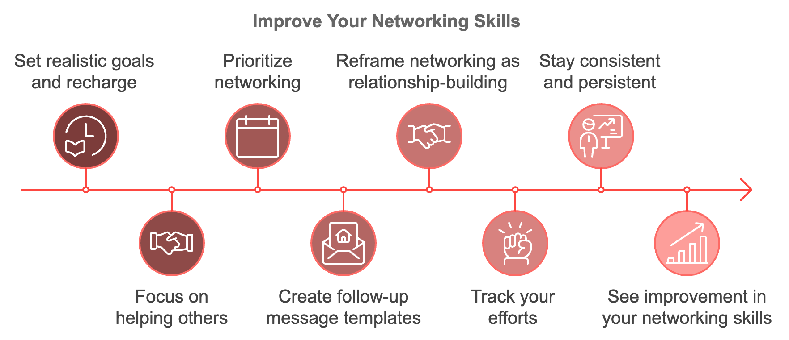
Even seasoned professionals can find networking challenging. If you're introverted, set realistic goals for events and allow yourself time to recharge afterwards. Remember that most people are open to networking, focusing on how you can help others rather than what you can gain. Prioritize networking by scheduling it into your calendar, even if it's just 15 minutes a day spent engaging online or following up with contacts. Create templates for follow-up messages to make the process easier, personalizing them for each contact. If networking feels forced, reframe it as building relationships, focusing on genuine connections rather than transactional interactions. Keep in mind that networking is a long-term strategy, and track your efforts to stay motivated.

To measure networking success, track metrics such as new connections made, engagement rate on professional social media platforms, referrals received, speaking or collaboration opportunities, revenue from network-sourced clients, network diversity, and relationship depth. Networking is both an art and a science, requiring patience, persistence, and a genuine interest in others. Implementing these strategies and consistently nurturing your professional relationships will help you build a powerful network that supports your success in the gig economy.
While growing your network, always keep in mind the value of authenticity and reciprocity. The strongest networks are built on mutual support and genuine connections. Whether you're networking online or in person, focus on how you can add value to others' lives and careers. Over time, this approach will naturally lead to a robust network that not only provides opportunities but also enriches your professional life in countless ways.
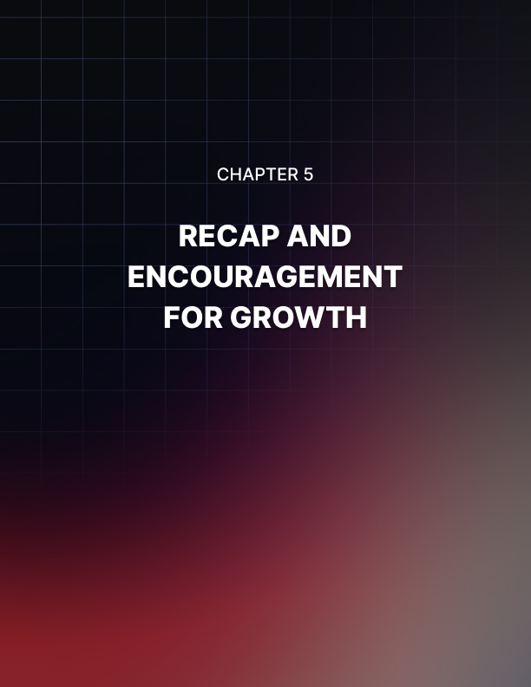

RECAP AND ENCOURAGEMENT FOR GROWTH
____
Your journey through personal branding in the gig economy has been an enlightening one. You've navigated the complexities of finding your niche, crafting a compelling Unique Selling Proposition (USP), building an impactful online presence, and mastering the art of networking. Standing at the threshold of implementing these strategies, take a moment to reflect on the key insights you've gained and prepare for the road ahead.
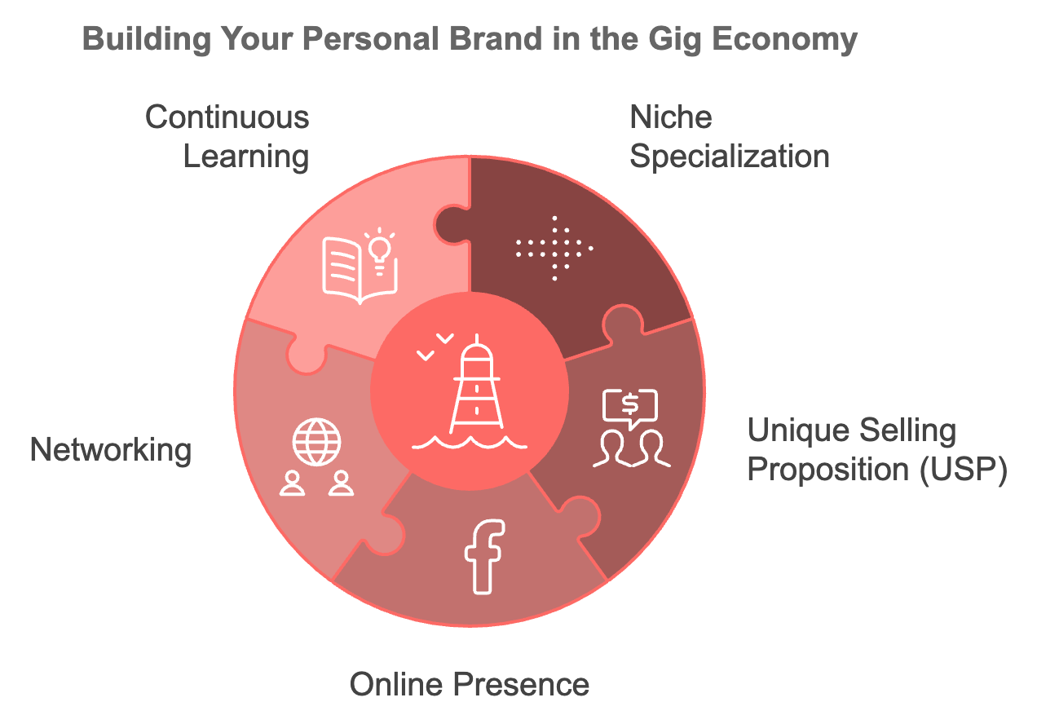

The Power of Niche Specialization
In the vast sea of freelancers and entrepreneurs, specialization is your lighthouse. Focusing on a specific niche positions you as an expert rather than a generalist. This targeted approach not only sets you apart from the competition but also allows you to command higher rates and attract clients who value your specialized skills. Your niche is the intersection of your skills, passions, and market demand. It's where you can offer the most value and find the most fulfillment in your work. Continue refining your niche as you move forward. Stay attuned to market trends and be willing to adapt. Your niche may evolve as you gain experience and as market needs shift, and that's okay. The key is to remain flexible while staying true to your core strengths and interests.

The Heart of Your Personal Brand
Crafting your Unique Selling Proposition was more than just coming up with a catchy tagline. It was about distilling the essence of what makes you valuable to your clients. Your USP is the cornerstone of your personal brand, communicating clearly why clients should choose you over your competitors.
When implementing your USP across your marketing efforts, keep in mind that it's not set in stone. Like your niche, your USP may need to evolve as you grow and as market conditions change. Regularly reassess your USP to ensure it still accurately reflects your unique value and resonates with your target market. Don't be afraid to refine it based on client feedback and your own experiences.

Your Digital Footprint
Building your online presence is an ongoing process. Your professional website, social media profiles, and content marketing efforts work together to create a cohesive digital brand. This online ecosystem serves as your 24/7 brand ambassador, working tirelessly to attract and engage potential clients even when you're not actively prospecting. Remember to keep your online presence fresh and up-to-date.
Regularly update your portfolio with your best and most recent work. Maintain a consistent content schedule, whether it's blog posts, social media updates, or video content. Engage with your audience regularly, responding to comments and participating in relevant online discussions. Your digital presence is often the first point of contact for potential clients, so make sure it always puts your best foot forward.

Building Relationships, Not Just Contacts
You've learned that effective networking goes beyond collecting business cards or LinkedIn connections. It's about building genuine, mutually beneficial relationships. These connections can lead to new opportunities, collaborations, and referrals that can significantly boost your career.
When implementing your networking strategies, keep in mind that quality is more important than quantity. Focus on building deeper connections with a select group of individuals rather than trying to connect with everyone. Be genuine in your interactions, always looking for ways to add value to others before seeking benefits for yourself. Consistency is key in networking, so make it a regular part of your routine, whether it's attending industry events, engaging in online communities, or simply reaching out to contacts for catch-up conversations.

Embracing Continuous Learning and Adaptation
The gig economy is dynamic, with new technologies, platforms, and market demands emerging regularly. To stay competitive, you must commit to continuous learning and adaptation. This doesn't just mean keeping your technical skills sharp, though that's certainly important. It also means staying informed about industry trends, evolving client needs, and new tools that can enhance your productivity and service delivery. Consider setting aside time each week for professional development. This could involve taking online courses, attending webinars, reading industry publications, or experimenting with new tools and techniques. Staying at the forefront of your field positions you to better anticipate and meet client needs, further solidifying your expert status.
When faced with obstacles, revisit the foundations we've discussed. Are you truly targeting the right niche? Does your USP clearly communicate your value? Is your online presence effectively showcasing your expertise? Often, the solution lies in refining these core elements of your personal brand. Remember, building a strong personal brand is a marathon, not a sprint. It takes time, consistency, and persistence to see results. Celebrate small wins along the way, whether it's a positive client review, a successful networking interaction, or an uptick in website traffic. These small victories can provide the motivation to keep pushing forward.
When implementing your personal branding strategies, it's crucial to track your progress and measure your success. This allows you to see what's working, what isn't, and where you need to make adjustments. Here are some key metrics you might consider tracking:
- Website traffic and engagement (page views, time on site, bounce rate)
- Social media followers and engagement rates
- Content performance (views, shares, comments)
Regularly review these metrics and look for trends. Are certain types of content performing better than others? Are you seeing more engagement on particular platforms? Use these insights to refine your strategy, doubling down on what's working and adjusting or eliminating what isn't.
Throughout this book, we've emphasized the importance of authenticity in personal branding. In a world where consumers are increasingly savvy and skeptical, authenticity is your secret weapon. It builds trust, fosters genuine connections, and sets you apart in a crowded marketplace.
As you implement your personal branding strategies, always stay true to your values, personality, and unique perspective.
Don't try to mimic someone else's brand or voice – clients will appreciate and respond to your authenticity.

This doesn't mean sharing every aspect of your personal life or being unprofessional. Rather, it means being genuine in your interactions, honest about your capabilities, and true to your values and vision.
One of the challenges you may face is balancing your personal branding efforts with your client work. It's easy to get caught up in client projects and neglect your own brand-building activities. However, consistent effort in personal branding is crucial for long-term success in the gig economy. Consider blocking out specific times in your schedule for personal branding activities, just as you would for client work. This might mean dedicating an hour each morning to content creation, or setting aside Friday afternoons for networking and relationship-building. Treating your personal brand as a client ensures it gets the attention it deserves.
When your personal brand grows stronger, look for ways to leverage it for business growth. This might involve expanding your services based on client demand and your evolving expertise, raising your rates to reflect your growing reputation and value, exploring new revenue streams, such as creating digital products or offering online courses, collaborating with other professionals on larger projects, or speaking at industry events or contributing to publications to further establish your thought leadership. Your personal brand is a powerful asset – don't be afraid to use it to push your business to new heights.
Personal Brand Element | Key Metrics to Track
Website Performance | Traffic, Bounce Rate, Time on Site
Social Media | Followers, Engagement Rate, Reach
Content Marketing | Views, Shares, Comments, Conversion Rate
Networking | New Connections, Referrals, Collaboration Opportunities
Client Satisfaction | Reviews, Testimonials, Repeat Business Rate
Financial Growth | Income, Client Acquisition Cost, Average Project Value



CONCLUSION
____
Concluding this book and starting your personal branding journey, keep in mind that this is just the beginning. Building a strong personal brand is an ongoing process that requires consistent effort, continuous learning, and regular adaptation. There will be challenges along the way, but with persistence and the strategies you've learned, you're well-equipped to overcome them. Stay focused on your goals, but remain flexible in your approach. Be patient with the process, but don't be afraid to take bold steps when opportunities arise.
Most importantly, enjoy the journey. Building your personal brand is not just about attracting clients or growing your business – it's about defining who you are as a professional, clarifying your values and vision, and creating a career that aligns with your passions and strengths. Keep pushing your boundaries, challenging yourself to grow, and striving to deliver ever-greater value to your clients as you move forward. Your personal brand is a reflection of you – make it shine bright.
Remember, in the gig economy, you are your own best asset. By investing in your personal brand, you're investing in your future success. So take what you've learned, apply it with confidence, and watch as your personal brand opens doors to new opportunities and propels your career to new heights. The world is waiting for what you have to offer. Go forth and make your mark!

