Disclaimer

This ebook has been written for information purposes only. Every effort has been made to make this e-book as complete and accurate as possible.

However, there may be mistakes in typography or content. Also, this e-book provides information only up to the publishing date. Therefore, this e-book should be used as a guide - not as the ultimate source.

The purpose of this e-book is to educate. The author and the publisher do not warrant that the information contained in this ebook is fully complete and shall not be responsible for any errors or omissions.

The author and publisher shall have neither liability nor responsibility to any person or entity with respect to any loss or damage caused or alleged to be caused directly or indirectly by this e-book.
Table of Contents

Introduction 6
The Barriers Of Selling 7
Chapter 1: The Power Of Increments In Selling 10
Cognitive Biases and Psychology 10
Selling With Increments 10
The Importance Of Why in Sales 11
What Makes a Brand 11
How To Create True Fans 12
Chapter 2: Targeting Is Everything For Your Sales Funnel 14
Warming Up Your Leads 15
The Basic Elements of a Sales Funnel 16
Chapter 3: Sales Funnel Automation 19
Your Sales Cycle Length 20
Chapter 4: Content Marketing For Sales Funnels 23
Sales Funnel Templates 24
Chapter 5: Sales Funnel Metrics 27
Chapter 6: Driving Traffic To Your Online Sales Funnel 31
Catch Those Escaping Leads With Retargeting 32
Chapter 7: Different Types Of Sales Funnel Techniques 35
Creating High-Converting Funnel Pages 36
Basic Components Of a Solid Sales Funnel 37
Chapter 8: Sales Funnel Tactics 41
Steps To Building Your First Sales Funnel 42
Plugging The Leaks In Your Sales Funnel 43
Conclusion 46
Analyzing Your Funnel 47

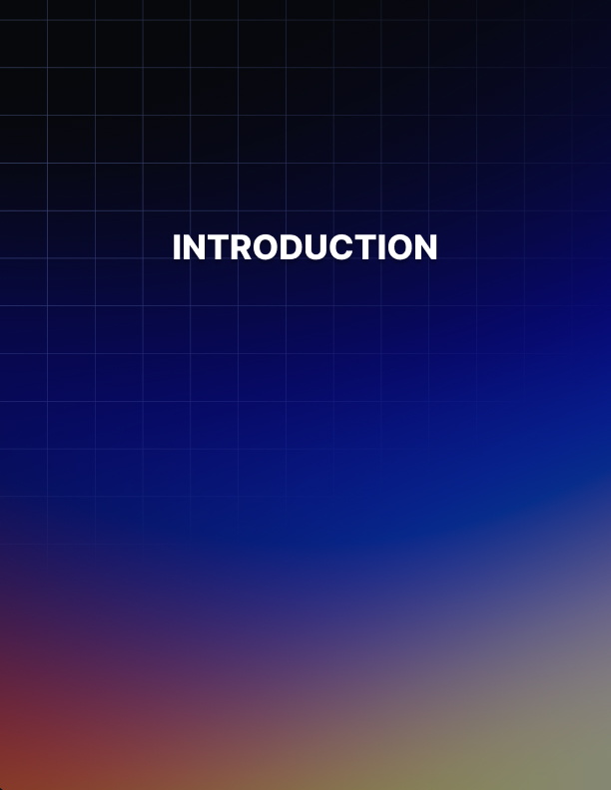

Introduction

Do your market research right. That means forgetting about yourself and putting yourself in the place of your customer. What do they want from your sales funnel?

Forget about what you think is great about it, and start thinking like your customer. You may focus on how your vacuum cleaner is so powerful it can suck freshly spilled wine from your carpet, but what size is it and how economical is it? Your customer may want a vacuum cleaner that fits in their utility closet or doesn't use much power.

Add the most stupid simple, one-click payment option you can to your website. That includes making said payment option mobile responsive. The use of the internet on mobile devices continues to rise on a monthly basis and shows no sign of slowing down.

Sites that minimize the requirement to jump through hoops are maximizing on purchases from mobile devices, where users are more likely to drop out rather than continue the purchase when faced with multiple steps in the buying process.

Keep sales and marketing separate. The term “sales and marketing” gets bandied about quite a lot - and almost always treated as if they are the same department. They're not.

The role of your marketing department is to gain and nurture leads, and the sales department are responsible for taking orders. The majority of the work belongs to the marketing department, who should help shape the customer's awareness of the product before the sales department takes over.

Follow up with leads continually. Don't allow a gap anywhere in your funnel where a CTA is missing for the next step. Always Be Closing. Not in the old- fashioned sense of pressure selling, but in the modern application of always being there for your customer.

Hire the best copywriter you can afford. A good copywriter can look at your sales pages and eliminate the unnecessary copy, ditch the parts that focus on features where benefits are more suitable, and more. Having a clear and distinct purpose for each landing page in your funnel is vital.

Challenge objections head on. If you ignore objections or try to sweep them under the carpet, you're going to start worrying every time you get close to a sale.

You're also going to lack the real confidence you need that your customer isn't going to come back to you the day after they have bought from you, requesting a refund.

Finally, you can't do all this alone. Outsource where you lack the proper skills. It's a small investment in your long term profitability.

The Barriers Of Selling
When it comes to selling things to your visitors, a good way to think about your objective is in terms of ‘barriers to sale’.

Of course you need to make sure that your visitors are interested in what you’re selling, that they know what it is and that they think it’s worth the money.

But even at this stage, you might find they still don’t buy from you. In that case, the likelihood is that they’re psychologically blocked from buying by something that puts them off of the idea.

These are your barriers to sale. And at this point, these are all that is between you and a new customer! So what are these barriers and how do you break them down?

Trust
The first barrier to sale is trust. That means that you need to make sure your buyer trusts you enough to buy from you and trusts your website as well so that they know their details aren’t going to get lost in the clouds. Buying from brands online can be nerve wracking because we have no way of guaranteeing they’re really going to send us the products.

So how do you overcome this? One option is to show social proof with customer reviews. Also important is to make sure your site looks as professional as possible so that there’s no question as to whether
you’re a professional outfit.

Effort
Also standing in your way is the effort of buying. That is to say that people hate having to input their details and go through the process of getting out their debit card and this can be enough to put them off buying something they want!

The solution is to make sure you’re making it as easy as possible for them. One of the best ways to do that is to use a well-known payment gateway – like PayPal!

Buyers’ Remorse
Buyers’ remorse is the guilt that someone often feels upon buying –and the guilt they anticipate to feel prior to making that purchase. You need to mitigate this and one way to do that is to demonstrate that your product is an investment in some way, or that it will make life genuinely better.

Risk
There is still always risk with a product. For example, it might just not be as good as it looks on your website! To overcome this, one thing you can do is to offer a full money back guarantee.

In reality, few people are likely to use it. Simply having it there though will usually be enough to make them much more likely to buy from you!

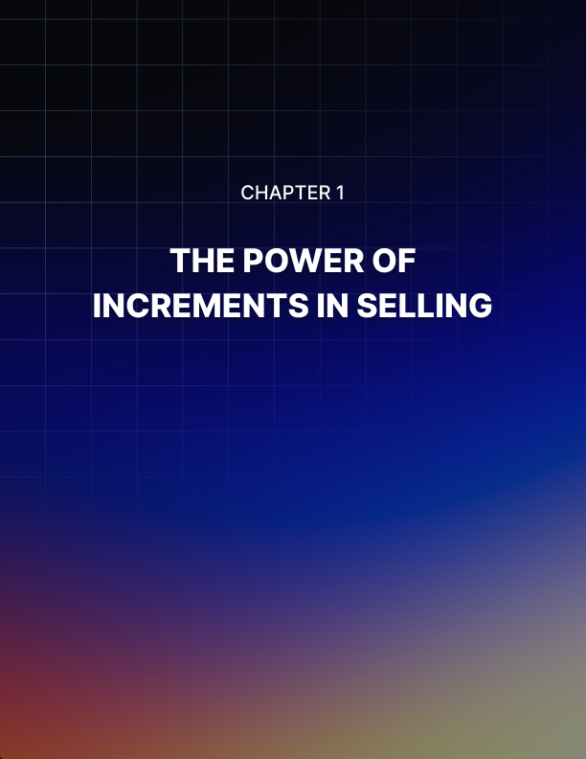

Chapter 1: The Power Of Increments In Selling

An increment is a small change. If you count to ten by going from 1.1 to 1.2 to 1.3, then you are counting in increments.

In psychology, increments are a powerful concept that have been shown to accomplish incredible things. And in selling, this psychological concept becomes an incredibly powerful tool. So what is an increment in this context and how can you use it to your advantage to sell more?

Cognitive Biases and Psychology
The reason an increment is a powerful concept, is because we are less prone to notice small steps. This is due to a flaw in our thinking (known as a ‘cognitive bias’) that causes us to look at things as they relate to other things.

For example, if you are buying a house for $260,000 and the vendor asks to increase the cost by $1,000 – chances are that you won’t bat an eyelid. After all, what is $1,000 in relation to $260,000? But now imagine that you’re buying a $5 chocolate bar and the seller wants to increase the value by $1,000… how do you react? You just lost $1,000!

But here’s the thing – you still lost just as much the first time around. You should still have fought just as vehemently not to let the price increase. But you didn’t… And as a result, the vendor got to keep $1,000 extra of your cash!

Increments are similar – they mean gradual increases in price that make the item seem cheaper because it’s only X amount more expensive than it was previously. People are never afraid to spend just $1 more. But if they do this 1,000 times – suddenly they’re spending $1,000!

Selling With Increments
So how are you going to use this in your sales funnel? Simple: by slightly increasing the cost of each item that you sell, so that your customers will gradually be spending more and more money with you and not noticing it.

If you tried to encourage your visitor to spend $1,000 right away on a training course, chances are they wouldn’t be interested. Buy them an ebook for $100, a video series for $250 and a workshop for $600 and suddenly the jump to $1,000 doesn’t seem quite so much.

They’ve already spent $600 with you, they’ve already had a good experience doing that… so what is $400 more? Why should that matter?

The Importance Of Why in Sales
When you’re selling something through a sales funnel, a landing page or an ecommerce store, the most important thing to keep in mind at all times is why.

- Why are you selling what you’re selling?
- Why should your audience care?
- Why is your product worthwhile?

And when you answer this question, you can’t give reasons like ‘to
make money’ or ‘because it sells’. You need to believe in your product, know why you’re selling it and understand your audience. Here’s why…

What Makes a Brand
A brand is not just a logo and a company name. Rather, a brand is the collection of ideals and promises that set you apart from the competition. This is your mission statement, it’s what your company is here on this Earth to accomplish.

So if you focus on creating healthy foods, your mission statement might be to make the world healthier. If you make disposable boxes, then you might want to make the world a greener place. If you sell
‘make money online’ ebooks, then perhaps your mission is to liberate people to work how and when they want.

Whatever the case, knowing your reason for being will then help you to make all subsequent decisions for your company. It will tell you which products are worth developing, which partners to work with and how to market your business to others. What’s more though, is that it will allow you to build real fans and a real following.

How To Create True Fans
As any wise internet marketer knows, you can’t sell to people as soon as they land on your page. First, you need to build trust, build authority and ensure that they feel as though they know and
understand your business. This is what enables you to create ‘true fans’ and people who will be loyal to your brand.

But if all your company is about is selling something to make money, then you’re not giving people to get behind you or to show an interest in you.

Try to have a vision and a passion and to make sure this comes across and then your audience will want to subscribe to your mailing list, buy your latest product and generally follow you to the ends of the Earth.

And once you have that kind of loyalty, your business will always be sure to succeed. Start with why!

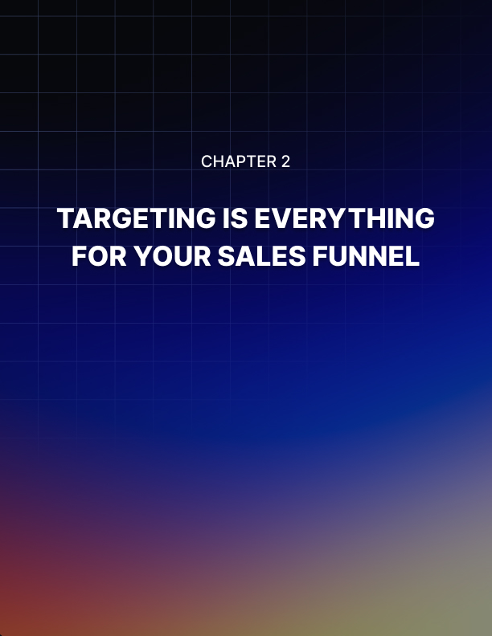

Chapter 2: Targeting Is Everything For Your Sales Funnel

If you’re hoping to make money from a sales funnel, then by far the most important thing to consider is your targeting.

In other words, how are you ensuring that it’s the right person who is receiving your marketing messages? How are you ensuring that the people who find their way to start off your funnel are the right kinds of customers? This is called ‘targeting’ and it is actually the difference between making massive money and making no money whatsoever.

The best way to demonstrate why targeting works so well is to think about sales. In sales, you have the people who start out their careers cold calling and selling things like training courses. These are people who will be picking up the phone and trying to sell something expensive to a random stranger.

Now, some people will be very good at that and those people are going to be the ones who do well. As they progress, they will be given better and better jobs within their organization and eventually this will result in them earning big bucks.

What’s the best position? Selling to qualified customers who have a lot of money. Think about it: if you can sell something to strangers who probably don’t have much money, it will be child’s play to sell to wealthy individuals who have already told you they want to buy!

This is the concept that sales is based on and it’s how you’re going to make sure your business is successful when you’re using a sales funnel.

Because the equivalent with a sales funnel is simple – it means finding targeted customers and sending them to your site. It means finding people who are interested in your niche, who are the right age and sex and who have the right income.

How?
Using PPC of course! PPC stands for Pay Per Click and this is a type of advertising where you only pay each time someone clicks on your links. PPC ads can be placed either on Google searches (through Google’s ‘Ads’) or they can be placed on Facebook, where they will target people based not only on their age, sex and location but also on their hobbies, interests and job title!

If you can do this, then you can find the exact kind of person who is likely to buy from you and then make sure that these are the people who start their journey through your sales funnel. That way, you are destined to succeed!

Warming Up Your Leads
DO you have a proper sales funnel set up for your business yet? Do you have a plan for attracting new customers and then leading them by the hand from the point where they’re just discovering your brand, to the point where they feel familiar enough and trusting enough that they’re willing to part with their hard earned cash?

If not, then there’s a good chance that you’re driving your visitors away before they’ve had a chance to buy. If your landing page right now is simply an attempt to sell, then you’ll be putting off visitors and not collecting any of their details before they do. Consider this analogy…

The Watch Salesman
Imagine that you’re out in town and someone comes up to you with a watch and offers to buy it for $5,000. What do you do? The vast majority of us would say no – even if we liked the watch. Why?

Because we don’t know anything about that person and don’t know if we can trust them not to sell us a counterfeit. At the same time, we don’t know anything about the watch or what it’s like beyond the looks. Then there’s the even more fundamental fact that we might not
be in the market for a watch.

Maybe we already have a watch. Maybe we don’t have $5,000 spare. Maybe we hate watches.

Well this is exactly how a vast majority of websites operate. If you are driving traffic to your site and then trying to sell, you’re essentially trying to get someone to hand over their cash with zero preamble and zero targeting.

The Better Approach
So what does the smart watch salesman do? For starters, they hand out fliers rather than trying to sell right away. They’ve got your attention and now they’re actually going to do something useful with that by establishing contact so they can sell to you in future.

At the same time, they should stand in the right place – outside a watch- lovers conference for example or a watch repair shop.

And instead of trying to sell their $5,000 watch right away, maybe they should try and sell a $500 watch to start with.

Now they’re gradually building a relationship and building trust and only then trying to sell. This is how you need to operate and if you can do that, you’ll be 100% more successful.

The Basic Elements of a Sales Funnel
Sales funnels. Maybe you understand the concept and even the importance, yet they still seem somewhat vague as a practicality.

Too often, we allow jargon to put us off learning simple practices that would make a huge difference to our business. Let's take a look at the framework for a sales funnel and how you can adapt it to create your own.

Lead Magnet
This is the honey trap: the bait that your reader will gladly trade their email address for and it may be the most difficult thing to create. A free info product was once the way to go, but readers have become overwhelmed by the amount of info products out there, and more than a little apprehensive about giving their email addresses in exchange for yet another same-as-every-other-ebook they'll never get around to reading.

Lead magnets need to deliver tremendous value and the most successful ones now come in the form of software applications such as Excel worksheets, or resource guides.

The Loss Leader
This is the product you sell for less than its worth. Amazon is a great example of a business that thrived on the use of a loss leader when it rolled out the Kindle e- reader.

The company manufactured and sold its Kindle devices at a loss, but knew that they'd make the money back when their customers bought ebooks to read on those devices.

Follow Up Content
This is content designed to establish rapport, entertain, educate and influence your reader to continue their buyer's journey with you. Typically it will focus on how your high end products solve a problem for the end user.

The High End Product
This is your Rolls Royce product - the ultimate sale your funnel is designed to deliver.

The Up-sell/Down-sell
Make it easy for your site visitors to spend money with you. The upsell does so because your customer has overcome their own buying objections and spent money with you. Now is the time to allow them to spend more.

The down-sell, conversely, allows the customer who still has objections to buying a lesser priced product or receives a special offer to allow them to buy the main product at a cheaper price.

The buyer gets some feeling of satisfaction at having been able to buy one of your products and not go away empty handed, having come this far on the journey.

Each part of your sales funnel must reward your site visitor for the investment of time they have made in arriving at that point.
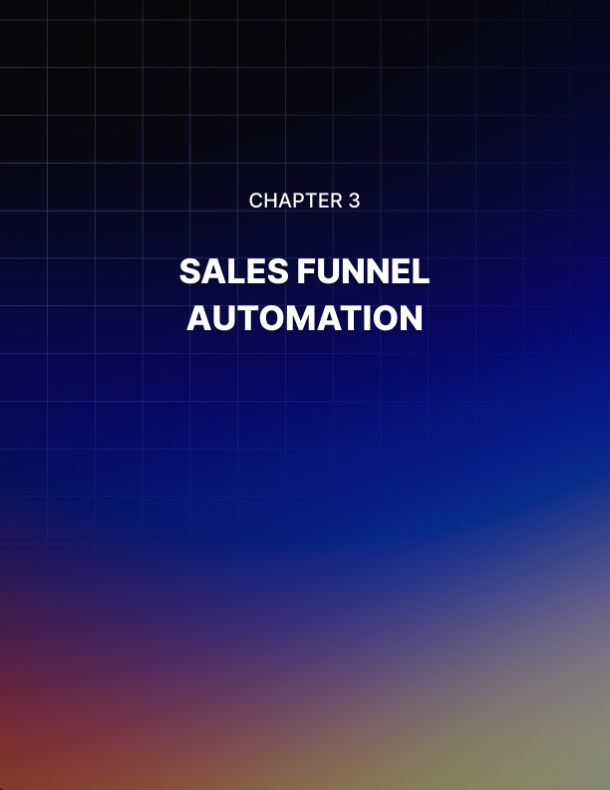

Chapter 3: Sales Funnel Automation

The sales funnel is such an effective tool because it can be automated.

Though it needs analysis and alteration to maximize its potential, it operates largely on autopilot, and it operates at a mere fraction of the cost of offline sales and marketing teams.

Sales funnels boil down to:

- Content pages for various stages of the buyer journey.
- Squeeze pages that offer a lead magnet.
- Landing pages that direct visitors to take a specific action.
- An introductory offer - often a loss leader.
- Your main offer.

If your site doesn't have at least one of each of these pages (per product or service) you are missing out on a complete funnel. The key is to direct your website visitor to take an action that leads them into a funnel that has a well thought out end result. One that benefits you.

Each aspect of your funnel should solve its own specific problem without the need for your intervention - unless one part of qualifying your leads is to involve yourself in a webinar or consultation.

Modern websites are far easier to use than the old HTML ones that required coding knowhow and experience. Now, content management systems such as WordPress allow users to upload all sorts of files for their subscribers to access, including checklists, audio files, videos, webinar replays, buyer's guides and resource lists.

Membership plugins and/or email marketing software allow you to schedule courses for delivery. There is almost no limitation to how you might deliver value to your leads without the necessity to be present when they are. Even at 4 am!

Once your choice of value-laden content has been made, your sales funnel will very much depend on a good copywriter. Be aware that these days a good copywriter will understand not just the compelling use of language, but what color schemes work on buy buttons and where they should be placed.

Other small details like the fact that an image beside a buy button works better than a buy button on its own set aside the average copywriter from the pro.

Autoresponders allow you to connect with your leads through a series of targeted emails, each with a specific purpose and call to action.

There's only one part of your sales that you shouldn't automate, and that's customer service. Aside from an automatic response to say you’ve received their email, every interaction from there on should be personally dealt with. Though it's not considered a part of the traditional sales funnel - word of mouth is a powerful lead generation tool and shouldn't be ignored.

Your Sales Cycle Length
A sales cycle length is the amount of time it takes for your would-be customer to go from becoming a lead to becoming a customer.

Without a reasonably accurate prediction of this lead time, you might not be able to estimate your income over time - which makes virtually all other facets of your business difficult to manage. Predictability in business is always a good thing!

Reducing sales cycle length increases revenue generation, which makes understanding how to calculate your sales cycle a very attractive part of creating and measuring your sales funnel.

The sales cycle is a combination of the "average lead to opportunity length" and the "average opportunity to close length".

The duration of each of these timelines will vary greatly between businesses and industries.

Add to that, the AHT or average handling time - which is how much time a salesperson needs to spend on phone calls, emails and meetings with a customer - and you can see that it's not an easily measured period of time.

A CRM or Customer Relationship Management system (software) will typically help you analyze your sales cycle. All you need to do is define it. You might look at it as being the time from lead creation until the sale is made.

The problem with this is that the process is not always linear - it may often be that after entering their email on your website, your customer goes through the buyer's cycle multiple times before making a purchase.

When a lead becomes an opportunity - in other words, when it is moved from being handled by the marketing department to being handled by the sales department is a valid choice for determining the cycle because at this point there is far less chance of duplication in the CRM.

It's still not ideal because it severs one part of the funnel from the other. However, it's the closest we can come to a complete picture if we are to be personally involved in the process.

That's why, for a truly informative look at your sales cycle, you absolutely need to make the investment in CRM software.

There are many well respected CRM tools available, including Pipedrive, HubSpot, Insightly and Teamgate.

Hubspot has a free "lite" version of their CRM which comes highly recommended if you are new to relationship management software.

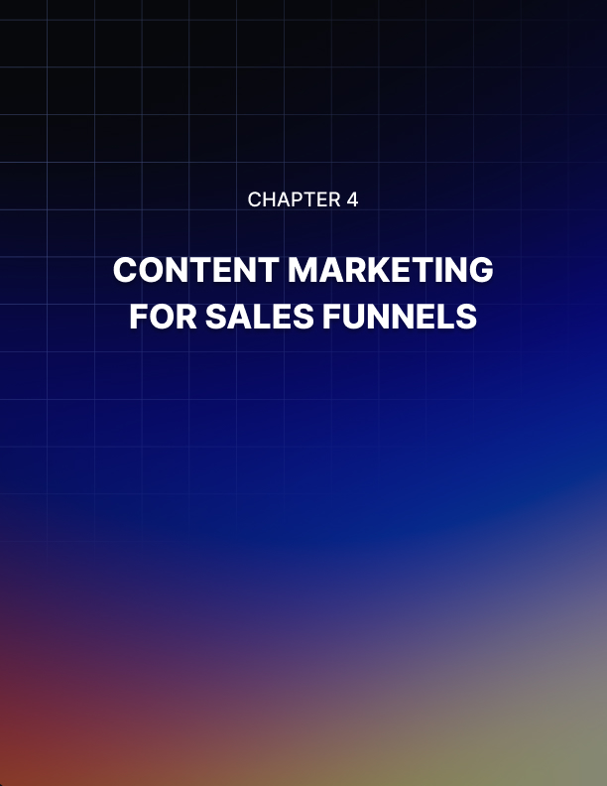

Chapter 4: Content Marketing For Sales Funnels

Every sales funnel will include content designed to help move its consumer forward (or down) the funnel.

A good sales funnel will include content that addresses the needs of your ideal consumer as they make their way along the buyer's journey, which makes understanding the buyer's journey a fundamental requirement for your marketing department.

The three stages of the buyer's journey are:

- Awareness
- Consideration
- Decision
- Awareness Stage

At the awareness stage, the buyer is not aware that they need to buy your product. Rather, they are aware they have a problem that needs a solution. An example of content marketing for a person at this point of the journey might be an article that explains how bleeding gums is a sign of health issues such as gum disease.

If someone were to have bleeding gums they need to start taking care of their teeth and one important aspect of that would be to investigate the cause of their bleeding gums.

What if this situation were allowed to continue? They may suffer further ill health which is associated with gum disease, they may lose teeth and their existing oral hygiene may be turning off potential romantic interests.

At this point, they are aware that they need to do something about the situation or face less desirable consequences.

Consideration Stage
During this stage, the potential customer is deciding on a course of action to take - and which product they need. In this example, they may decide that their toothbrush needs replacing, or that they need to schedule a visit to the dentist, or a change of toothpaste - or all of the above.

They understand that they have a problem, and need to decide on the best form of action to take.

Decision Stage
At this point, the buyer is deciding between brands in their hunt for a solution. They are looking at different brands and makes of toothbrushes, different dentists, or different kinds of toothpaste. They are prepared to buy and are actively looking for information based on budget and efficacy.

When creating content for your sales funnel, it's important that you create it for each buyer stage of the journey because each individual buyer will be at a particular stage of that journey when they arrive at your site.

One of the most important aspects of using the buyer's journey in your content marketing is matching your traffic source with your buyer's stage.

There's no point in sending a seasoned professional to a beginner's guide or someone with no knowledge of what your product does to a product catalog.

Sales Funnel Templates
If you spend any great length of time online in your own niche, chances are you'll have come across your competitors landing and squeezing pages - the outer edge of the black hole they call their sales funnel.

Here's a quick rundown of what your competitors use to attract customers into their funnel so that you can get some ideas for your own.

The Free Ebook - This is the oldest one in the book (pardon the pun) and its efficacy has dropped off somewhat. However, its replacement -the free physical book - works a treat. Of course, usually, the recipient has to pay a minor shipping and handling fee, but usually it's a good enough deal that it’s more than worthwhile for the recipient.

Free Consultancy - For many potential customers, they crave interaction with you or your business to learn how seriously they will be taken or to create a personal bond with your brand. Often they feel that given a virtual meeting with your team, they may have their problem solved without any further involvement.

Calendar/Event Management - The interested party can choose from an online calendar to initiate contact, whether that is by phone or in person.

Webinars - Webinars are a great way to include video in your sales funnel and engage prospects at all levels of the buyer journey. The ability to answer Q&A directly on a webinar makes it a multipurpose tool for your business.

The Impulse Buy - This template makes use of the lead loss product to grab an immediate sale and follow it up with the rest of your sales cycle, including up- sell and down-sell offers.

The Launch Offer - This is where early subscribers are offered a deal for signing up for the "early bird offer". By taking you up on this offer, the subscriber will get a special deal on your product when it launches, moving them through the funnel at a faster pace.

Direct advertising - This is the template used in advertising for a direct sale. The funnel is implicit in the ad targeting and is a very direct approach.

There is no typical sales funnel. Many are a combination of the above and as always, they require testing on a continual basis to ensure a smart return.

Some work more efficiently than others in certain marketplaces. For example, calendar bookings to view properties work best for offline businesses such as realtors, while free books work best for consultants.
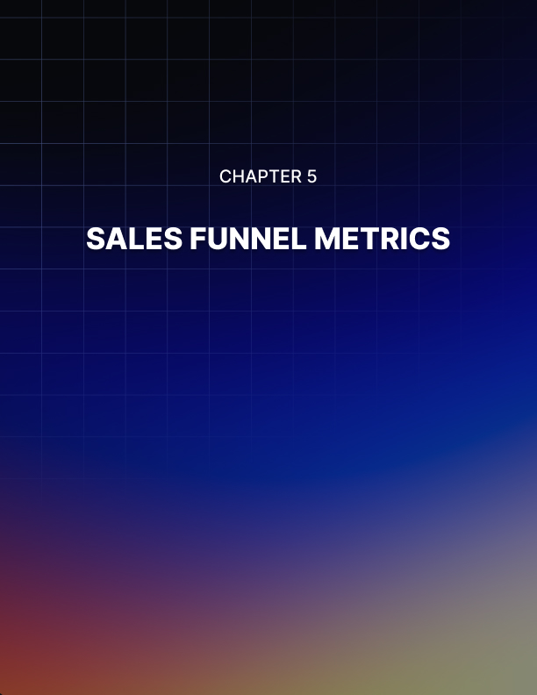

Chapter 5: Sales Funnel Metrics

There are a number of different options available to track the efficiency of your sales funnel, and the range of pricing for those options is broad.

However, regardless of the tool you use to analyze your metrics, it's important to understand what you are looking at (how to understand what's working and what's not in your funnel).

Monitoring the shape of your funnel is an essential part of your marketing campaign so that the top is broad enough to catch the attention of the majority of potential customers, and at its narrower end, encourages the least attractive customers to fall off.

At each stage in between, there should be a significant event that encourages potential customers to stay or leave.

Here are 5 aspects of your sales funnel that should be monitored for effectiveness:

- Your Traffic Sources
Traffic alone isn't a suitable metric to analyze. How that traffic behaves on your site is the telling factor. Does it engage with your content?

What are your bounce rates and more importantly, are they typical of your industry? Do those who remain on your site continue to the next part of the funnel (as you have defined it)?

What percentage of traffic do you realistically plan to convert?

- Engagement
Ignore comments, likes, and shares. They are great metrics for social media marketing, but in terms of your sales funnel they give no concrete data concerning your sales funnel. What content encourages engagement in terms of newsletter subscriptions?

Not all content should sell, but what isn't created with that aim in mind should be created with the aim of encouraging subscriptions.

- Your CTA performance
Split test (you're going to get sick of hearing this, but split testing is vital to your business survival). Your landing page's Call to Action should be the best one possible.

Audit your CTA on a continual basis and maintain the highest performing one. Conversion metrics will shape much of your funnel.

Click Through Rates (CTRs) in your email marketing can help you evaluate what interests your customers. Always segment your list rather than risk split testing different content on the same segment of subscribers. That is the fastest way to lose subscribers.

Email marketing metrics are a more direct way of measuring your engagement than blog content, so take them seriously.

- Funnel Velocity
Understanding how fast your whole funnel operates to bring a completely new visitor through the process and to turn them into sales.

Excessively slow movement through your sales funnel results in an unacceptable amount of drop off in sales.

- Sales Funnel Mistakes
Are your sales funnels leaking? While it's not as difficult as we imagine to create a sales funnel, there is room for error.

While a well-designed funnel will fast track your road to success, a poorly designed one will leave you stranded, wondering where you went wrong.

Here are 4 mistakes that are easy to make, but just as easy to avoid:

- Not Split Testing
Split testing is everything. The first draft of everything is crap, whether it be the next big movie script or the sales and marketing copy for your site.

Not that your copywriter will ever send you their first draft, but all copywriters understand that the best performing content becomes the control, and the object of the game is to beat the control. Even a difference of 1% in conversion rate makes the effort worthwhile when selling online.

- Not Nurturing Leads
Don't allow your sales team to ignore leads if they don't buy immediately. Modern selling online is all about relationship building, not going in for the quick kill. You need to build rapport with your leads. Time is not linear as we once suspected, and that includes time to a sale. Your ideal customer may jump back and forth through their buying cycle rather than straight through it.

- Mishandling Up-Sells and Down-Sells
This really depends on your niche. It's never really an issue in the often quoted example of a burger joint waitress asking if you'd like fries with that. But in some niches, too many upsells or down-sells do little but irritate your customer.

Don't ignore the opportunity to offer something additional right at the point of purchase, when your customer has just made an order and are

still receptive to other offers, but limit those additional offers to ones that make sense to offer (maybe they offer complementary goods or services) or have an affinity to the original offer.

- Assuming What Your Customer Can Afford
You do your customer a disservice if all you offer is a range of similar products at similar prices. Many people want to buy the premium model. They don't want the budget one! There are others who just want an accessory - an impulse buy to make them feel they've picked up a bargain.

You will often avoid this mistake when you do your market research properly, but never forget that low price points are only there to introduce people to your brand.

Always be testing and never be shy about letting people know what you have to offer - it's advice that works just as strongly in the business world as it does the dating one.
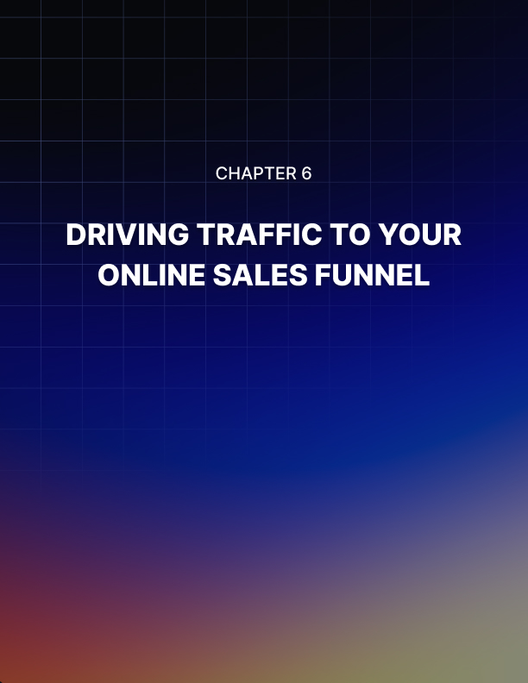

Chapter 6: Driving Traffic To Your Online Sales Funnel

Your sales funnel is like a spider's web, carefully constructed to lure your ideal prey (customer) into your web and sticky enough that they can't possibly escape.

But how do you attract the right visitors?

We can only assume that you have put the necessary time and thought into your landing and squeeze pages. If not, do so before you drive traffic to them.

Always test your funnel. Understanding how traffic responds to your landing page is vital. Without an optimal funnel, traffic is useless. You could drive thousands of visitors a day only to end up with no sales to show for it.

Once you have your site optimized, it's time to drive traffic! Where from?

Wherever it already exists is usually a good place to start. Where does your audience hang out? This answer is the one that almost every online business knows and understands, yet they rarely take the time to take full advantage of.

Q&A Sites and Forums
The internet is awash with forums, social groups, fan pages and blogs dedicated to some aspect of your business. Even if you were in the vacuum cleaner business - an example of something very unsexy for the sake of demonstration - there are question and answer sites where people look for information about their intended purchases.

The point of joining a forum or answering questions on blogs and Q&A sites is twofold. Not only do you position yourself as an authority, but you create backlinks to your website and when your answer appears on a

highly trafficked site as a result of a question that gets a high volume of searches - you siphon some of that traffic back to your website.

Social Media Traffic
Traffic from social media can be free or paid - often a combination works best. Just what blend of free vs. paid you use will depend on your business.

Special offers are almost always shared by users and only require enough paid advertising dollars to get them to a tipping point, whereas other posts may require a more consistent budget.

Test paid advertising on social media, but only do so where your audience already hangs out. This is the crux of traffic plans. You may hear that Google Plus or Pinterest has driven thousands of dollars’ worth of business to a particular business, but unless your market spends their time on those sites, there's little point in blindly following suit.

Lead Magnets
Always have something to offer in return for your reader's email address. This is highly effective if its value is such that your existing traffic feels it is valuable enough to share with their peers, effectively extending the reach of your campaign.

There's nothing new in traffic generation, yet many marketing gurus like to pretend they have secret sources. Test what works for you and keep doing it.

Catch Those Escaping Leads With Retargeting
One gap that modern marketing has plugged in the typical sales funnel is that of the abandoned cart - or literally any other part of your website.

Prior to retargeting, a lost customer was usually gone forever: blamed on short attention span and the overwhelming amount of distracting internet content.

Now that we have retargeted, it means that your would-be customer doesn't escape so easily.

Retargeting uses internet cookies - those little files that your website plants on your visitor’s laptop when they visit you. The file is made up of code that is unnoticeable and does not slow down your site.

When you receive a new visitor to your site, the code places a cookie that connects your advertising server to that laptop - allowing it to serve your ad to those who have visited your site and left.

Retargeting code is JavaScript based and often referred to as a retargeting pixel. Unfortunately, ad blockers and any browser technology that blocks JavaScript will render it useless, but the majority of people prefer to keep JavaScript operational on their browsers to view video and other content formats that rely on it.

Usually, retargeting is not implemented alone, but forms part of a larger campaign involving paid advertising. The internet user clicks a PPC ad, visits your site, leaves and then is reminded of what they looked at on your site when your ad is served to them via an advertising display network.

Retargeting works and it's easy to understand why. Your brand remains front and center in your prospect's mind when your advertising continues to be displayed to them even after leaving your site.

It's like that feeling of fate when a shopper feels that yours is the product that's meant for them because they keep seeing it all the time. Or, it's got to be good

because it seems to be advertised everywhere. Whatever way you look at it, it's the familiarity that often makes a sale.

The most effective way to make use of retargeting in your campaigns is to segment your retargeting pixels so that you can target those interested in specific products, such as red shoes versus blue shoes, or menswear versus women's.

Retargeting can be scheduled according to a timeframe, which makes it ideal for those in industries such as travel, where a decision needs to be made sooner rather than later.
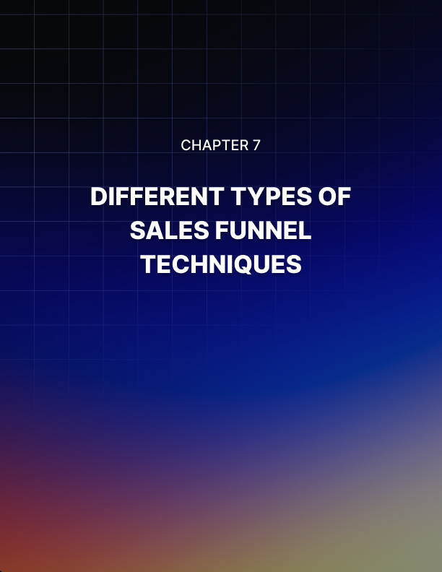

Chapter 7: Different Types Of Sales Funnel Techniques

There’s more than one way of creating a successful and profitable sales funnel.

There’s several methods, in fact, that can help you to make profit from your product offers. You will learn about some of these different methods below.

The most basic type of sales funnel is that you use a squeeze page to capture the prospect’s name and email address in return for a quality free report on a topic of interest to the prospect.

You then send email messages with more information on the topic of interest and make brief mentions of your main product offer, implying that this product will help them solve or alleviate the problem they are having (and a key reason why they downloaded the free report in the first place).

You include a link to your main product’s sales page in your email messages.

Over time, the prospect will learn to trust you and your recommendations; as a result, they will check out your main product’s sales page.

Provided the sales letter “sells” the main product to the prospect, he/she will become a customer, which can lead to him/her being added to a buyer’s email list, letting you know that this person has bought from you before.

Now, you can add more to your basic sales funnel, specifically upsells and downsells, also known as one-time offers or OTOs. After a person has paid for your main offer, the person will be shown an upsell offer, an offer that enhances the value of the main offer, whether that is an upgraded version of the main offer or a complementary offer to boost the value of the main offer.

The person only has that one chance to purchase it at that special price – hence why it’s called a “one-time offer.”

If the person chooses to decline the offer, he/she may be presented with a downsell offer, an offer that is either exactly the upsell offer he/she just rejected at a lower price or a similar offer to the upsell offer, but with one or more missing components from the upsell offer, at a lower price.

If the person chooses to buy this offer, he/she will gain access to it and may be taken to another upsell offer. If he/she chooses to decline the downsell offer, he/she may still be taken to another upsell offer.

Thus, to earn maximum profit from your product offers, you should use a squeeze page to get the person’s name and email address, follow up with email messages to get him/her to visit the main product’s sales page, and present him/her with upsells and downsells to enhance the value of the main offer for him/her, while increasing your profits.

This is the main sales funnel strategy for most Internet marketers, and if done properly, can be highly effective and highly profitable.

Creating High-Converting Funnel Pages
Your funnel pages must be effective in order to create the profits you expect from your products. If your funnel pages are not converting your prospects into buyers or your buyers into repeat buyers (i.e. OTO buyers), you will not make nearly as much profit as you could.

Thus, there are tips provided below to help you create higher- converting funnel pages so you can gain more profits from the products and sales funnels you create.

Be sure to use headings and subheadings in your sales letters. Most people don’t read sales letters word-for-word; they don’t have the time or the desire to go through every sales letter they encounter word-for-word.

Thus, use headings and subheadings to help point out the important points, features, and benefits your prospect will gain from ordering your product and OTOs.

Another key is to focus on the benefits your product will deliver to the customer. The customer doesn’t really care how the product will deliver the benefits to him/her; he/she just wants to know what is in it for him/her- how does his/her life get better by purchasing your product?

While you can include features in your sales letter, be sure to highlight and focus on the benefits the person will get from ordering your product.

Specifically, you should really focus on the benefits that will eliminate or alleviate the person’s problem or pain-this will make it more likely he/she will order your product.

On upsell and downsell pages, be sure to put text down under the order button when they are ready to pass on an upsell or downsell offer that reminds them of the benefits they will be passing up on by rejecting the upsell or downsell.

Human psychology tells us that people do not like pain and they do not like missing out on things. Thus, by reminding people of what they will be missing out on by passing up your upsell or downsell offer, you will make it harder for them to hit the “no thanks” link, potentially leading some of them to hit the “order now” button instead.

Thus, you have learned that using headings and subheadings in a sales letter will enable people to scan your sales letter and learn the important points without having to read it word-for-word. You also learned that you should focus on the benefits of your product that the person will get by ordering your product.

Finally, you learned that by reminding people of what they will be missing out on when bypassing upsell or downsell offers, it will be more difficult for them to pass on it and may even convince some of them to order the upsell or downsell instead.

Basic Components Of a Solid Sales Funnel
You need to have a solid sales funnel in order to earn the most profits from your digital product. If your sales funnel is not solid, your profit potential will be much lower and the hard work you put into your product will not be as profitable as it could be.

There are basic components of a solid sales funnel in order to maximize its effectiveness; we will discuss them below.

The first component is a good squeeze page. A squeeze page is a Web page that offers a valuable report, ebook, software program, etc. for
free in return for the requester’s contact information (usually name and email address).

The person gets the free gift, while you get his/her contact information to follow up with him/her.

Through good email marketing practices, you show that you are a trusted expert in your field. Over time, the prospect will come to trust you and your recommendations.

In your emails, you provide a link to your main product’s sales page. At some point in time, it’s likely the prospect will click onto it.

Thus, the prospect is now at your main product’s sales page. Provided your sales letter is convincing enough of the product’s value and usefulness to the prospect, that prospect will order it and become a customer.

Then, the customer will be shown one or more upsells or one-time offers (commonly referred to as OTOs). This is a product enhancement of the main offer that provides more value or it’s a related offer that will help to provide more value to the main offer.

If the customer orders it, he/she will gain access to it as well. Either the customer will gain access to the two offers he/she purchased or will be taken to another upsell offer that again increases the value of the original offer.

There can be a number of upsells in a quality sales funnel, all of which are to provide increased value to the buyer, while providing increased profits for the seller.

Now, if the prospect decides to reject an upsell, he/she may be presented with a downsell, which is an offer either identical or very similar to the upsell he/she just rejected, but often with one or more components of the corresponding upsell missing and offered at a lower price. The idea of the downsell is to encourage the customer not to walk away without increasing the value of his/her original purchase, so the downsell is offered as a compromise to the rejected upsell offer.

Therefore, a quality sales funnel will have a squeeze page, quality email marketing messages convincing the prospect to visit the main product sales page, the main product offer sales page, and a combination of one or more upsells and downsells to add value to the main product for the buyer and add profits for the seller.

This is how Internet marketers make the most profit from their own digital products.

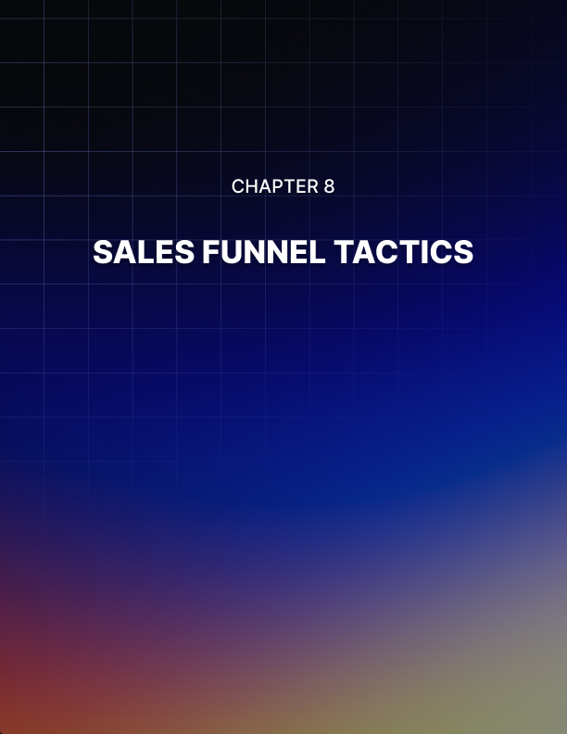

Chapter 8: Sales Funnel Tactics

Many new Internet marketers stress out over how to create an effective sales funnel.

They often panic and get overwhelmed by the entire process of a long sales funnel. What has helped some Internet marketers to overcome this challenge is to start at the end of the sales funnel.

Many Internet marketers like to use a “whiteboard,” similar to a chalkboard in where you can write on it using markers. Such a tool may be useful for you to diagram exactly how your sales funnel will work. Plot out exactly how many upsells and downsells you will have and what their price points will be.

Usually, the last upsell and downsell will be the highest-priced offer in your sales funnel. Oftentimes, this is some type of coaching offer or 1-on-1 mentoring, usually costing $100s or even $1000s.

By starting at the back of the sales funnel first, you can determine exactly what your greatest offer will be and how much it will cost, then work your way back through the funnel, presenting smaller offers that cost less.

For instance, you may offer a 1-on-1 mentoring program on how to build an online business as your final upsell and downsell. You may be charging $997 for it (and maybe $497 for an equivalent downsell that involves a 3-on-1 mentoring program).

For the previous upsell and downsell, you may offer to coach five people on how to write more convincing emails at price points of $497 and $197 for the downsell.

For the upsell and downsell before that, you may offer written critiques of five email messages your students write at price points of $197 and $97 for the downsell. You then reach the main product offer, an ebook that shows you how to write convincing emails that convert more prospects into buyers for $47.

The key is to figure out what your greatest product offer is, then work backwards through the funnel, cutting out some services and benefits and dropping the price accordingly until you reach your main product offer.

This will help you to determine what extra product offers you can provide to fill out your sales funnel so you can get maximum value from each prospect who enters your sales funnel.

It also will show your customers that you are a well-rounded expert in your field who can help them in many ways.

By working backwards through your sales funnel, you can determine what is your greatest product offer and then work your way back accordingly until you reach your main product offer, working your way to lower prices as you go through the funnel.

Steps To Building Your First Sales Funnel
It may seem overwhelming to build your first sales funnel since you have never built one before. Fortunately, the process is not that difficult and can be learned relatively quickly. We present a five-step process below that will help you build your first sales funnel.

First, you need to create an effective squeeze page. This squeeze page must include a free report on some topic of interest to the squeeze page visitor so that he/she is convinced to provide his/her name and email address in order to receive that free report.

This needs to be connected to your autoresponder so that the prospect’s name and email address is added to it so you can email him/her after receiving it.

Second, once you have that prospect’s name and email address, you need to send out a welcome email to that prospect, include the download link to the free report that the prospect was promised for submitting his/her contact information, inform him/her about who you are, and let him/her know what information he/she can expect to receive from your email messages.

Third, over the course of at least seven email messages over a period of two weeks or so, you will present more information on the topic/issue/problem related to your free report to show the prospect that you are a respected expert in this field and can be trusted.

By providing mostly information and including a link to your main product offer, you can build the relationship with your prospect and get him/her to trust you and your recommendations.

Fourth, when the prospect is comfortable enough with you and your recommendations, he/she will click the main product link and go to your main product’s sales letter. If the sales letter is convincing enough of the benefits your product will provide to him/her, he/she will order your main product.

Fifth, you will present one or more upsells and optionally one or more corresponding downsells. The first upsell will be presented as soon as the prospect has bought your main product offer. The upsell is designed to provide more value to the main offer for the customer, while it is designed to provide you with more profit.

The corresponding downsell is the same upsell offer or a slightly different offer at a lower price. The first upsell and corresponding downsell can be followed by more upsells and downsells, each presented after the purchase or denial of a previous upsell or downsell. All upsells and downsells are designed to provide extra value to the customer and extra profit to you.

When the customer has gone through your entire sales funnel, he/she will receive email(s) with access instructions for the product(s) he/she has purchased, while you will have added a new buyer to your buyer’s list.

Plugging The Leaks In Your Sales Funnel
Plugging the leaks in your sales funnel is essential to getting the most conversions and profits from your sales funnel. Any leaks in your sales funnel indicate that your prospect is not purchasing any of your offers, whether it’s your main offer, your upsells and downsells, etc.

It is vital that you take steps to correct the weaknesses in your funnel so that you can improve the conversion rates and profitability of each prospect or customer that comes through your funnel.

By using Google Analytics, setting up goals, and mapping every URL in your sales funnel, the funnel visualization report will show the number of people who have entered the funnel and the percentage that have gone to the next step of the funnel.

You will also see a red triangle alerting you to how many people got out of the funnel before they went where we wanted them to go, as well as where they went.

This will help you to learn the weaknesses in your funnel and address them properly so you can have a more effective and profitable sales funnel.

Using the report, determine which page or pages are having the lowest percentage of transferring visitors to the next page of the funnel. Go back to those pages and analyze them carefully.

See what could be driving them away from your funnel and not to the next step/page of it. Look at the headlines and subheadlines, look at the sales copy, look at the spacing of the sales copy, and look at the graphics and photos that are used on the page.

Also check to make sure that those pages emphasize the benefits of the product to the visitor; what is in for the visitor to purchase this product?

Make sure to check the site loading speed as well on all types of devices, from PCs and laptops to smartphones and tablets. Ensure that the site displays properly on all devices.

Be sure to analyze all of these facets and test changes using A/B testing, then attempt to send more visitors through the funnel and see if the conversion percentages improve. Continue to test to improve the conversion percentages and the profitability of your sales funnel.

A key to successful Internet marketing is to never stop testing, as you can always improve the effectiveness of your marketing, whether its sales letters, email messages, sales funnel conversions, and more.

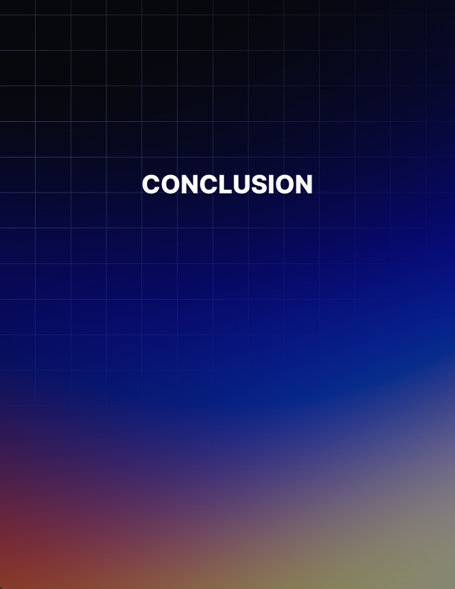

Conclusion

It is imperative for your product to have a sales funnel if you are to attain maximum profitability from your product.

Having just one product, even a successful one, is not going to allow you to make a sustainable income or a sustainable business online. Additionally, most prospects need to be contacted an average of seven times before they will purchase your product.

If you do not have a sales funnel for those prospects to enter into, you will earn little to no profit from them.

Having a sales funnel is key to earning the most profit from your digital products. First, you need to have a squeeze page that offers a free report on a topic of interest or some problem or issue that entices the prospect to give up his/her name and email address. This will allow them to enter your funnel.

You then communicate with them via email, both to provide the free report they were promised, plus follow up with additional information about the issue or problem and what your expertise is. You also provide a link to your main product offer and imply in most of your messages that your product is the solution to that problem brought up in the free report.

In a few of the messages, you can directly market your product and explain exactly why it will be of benefit to them.

After the prospect is convinced of the value of your product, he/she will use one of the links to head to the sales page and purchase it. Once he/she has done that, that person will be presented with an upsell offer that is designed to provide more value to the original offer.

It is an optional, one-time offer that the customer must purchase at that time in order to benefit from it. The scarcity factor will make it more enticing for the prospect to buy it.

If he/she buys the upsell offer, he/she may be presented with one or more of them. If he/she doesn’t buy the upsell offer, he/she will be presented with a downsell offer that is either the same or similar to the upsell offer but at a lower price.

This is to encourage the customer to purchase this offer to add value to the main offer he/she purchased.

Having multiple offers makes it more likely the customer will purchase, as it’s been shown that people are more willing to buy multiple related offers after he/she has purchased the first one.

A perfect example is buying fries and a soft drink with a burger. By employing this marketing tactic into your sales funnel, you will provide more value to the customer and make more profit from him/her.

Analyzing Your Funnel
Many new Internet marketers either don’t know the benefits of analyzing their Web pages and sales letters, don’t know how to do it, or think that tools to do this cost too much for them to afford. This is often why they don’t analyze the effectiveness of their sales funnel, a key mistake that hurts their profitability. Fortunately, you can analyze your sales funnel with free tools from Google.

You will set up goals in Google Analytics to analyze how far each prospect goes in your sales funnel and where they may fall off at- that will indicate that there is a problem at that specific point in the funnel that needs to be addressed to improve the effectiveness of the sales funnel.

You need to log into your Google Analytics account, choose the profile you want to add the sales funnel to, and click “Admin” in the top-right corner.

Then, choose the “Goals” tab underneath the profile that you wish to add the sales funnel to, click “Create Goal.” Then you will set the settings of the actual goal and sales funnel. You’ll name the goal, then choose the type of goal that it is, such as “Destination.” You’ll then
choose “Next Step” and actually fill out the goal and sales funnel details.

For “Destination,” you’ll enter the URL of where you want your customer to end up at, which is the last page of your sales funnel. If they are buying a product, you’ll want them to wind up on the “Thank You” page, confirmation page, or receipt page after the last purchase.

You then assign the “Value” to each conversion. If your product costs
$49.99, then you would enter $49.99 as the value. You then plot out your sales funnel; you add the home page, the product page, and the checkout page to cards.

You’ll then enter the URLs of all those pages into the Screen/Page form field, then click “Create Goal.”

This sets up your sales funnel in Google Analytics and allows you to track the effectiveness of your funnel in converting prospects into customers via the funnel visualization report. You can see the number of people who have entered the funnel and the percentage that have gone to the next step of the funnel. You will also see a red triangle alerting you to how many people got out of the funnel before they went where we wanted them to go, as well as where they went.

This will help you to learn the weaknesses in your funnel and address them properly so you can have a more effective and profitable sales funnel.

