TABLE OF CONTENTS
____
INTRODUCTION 5
UNDERSTANDING GDPR 8
The Foundation of Modern Data Protection 8
Essential GDPR Principles for Your Website 10
Understanding Your Role and Responsibilities 11
Implementing GDPR-Compliant Data Practices 12
PRIVACY POLICIES AND DATA COLLECTION 16
Crafting Effective Privacy Policies 16
Implementing Transparent Data Collection Systems 18
Managing Valid Consent and User Rights 19
Technical Implementation and Security Measures 21
COOKIES AND TRACKING 24
The Transformation of Website Analytics and Privacy Rights 24
Cookie Classifications and Implementation Requirements 25
Building Privacy-First Analytics Systems 29
USER RIGHTS AND DATA REQUESTS 32
Understanding and Implementing Data Subject Rights 32
Building Effective Request Management Systems 35
Managing Complex Requests and Compliance Challenges 37
TERMS AND CONDITIONS 40
Transforming Legal Documents into Trust-Building Tools 40
Essential Components for Modern Terms 42
Creating Clear and Actionable Terms 44
Maintaining Dynamic Terms in a Changing Landscape 45
STAYING COMPLIANT 49
Creating Living Compliance Systems 49
Building Privacy-First Operations 51
Future-Proofing Your Privacy Framework 53

DISCLAIMER
____
The information provided in this ebook is intended solely for educational and informational purposes. The author does not accept any responsibility for the outcomes that may arise from the application of the material within. While efforts have been made to ensure the accuracy and relevance of the content, the author cannot be held accountable for any errors or omissions, or for any consequences resulting from the use or misuse of the information provided. The responsibility for any actions taken based on the information in this ebook lies solely with the reader.


INTRODUCTION
____
The General Data Protection Regulation (GDPR) represents one of the most significant shifts in data privacy laws, transforming how businesses handle personal information online. As your business grows and maintains an online presence, understanding and implementing GDPR compliance isn't just a legal requirement—it's essential for building trust with your customers and protecting your business from substantial fines.
Whether you're running a small e-commerce site or managing a large corporate platform, your website likely collects various types of personal data. From contact forms and newsletter subscriptions to cookie tracking and user accounts, each interaction with your visitors falls under GDPR scrutiny. The complexity of these regulations, combined with the severe penalties for non-compliance, makes it crucial for you to clearly understand your obligations and the practical steps needed to meet them.
This book serves as your practical guide to navigating GDPR compliance for your business website. You'll discover how to implement proper consent mechanisms, craft clear privacy policies, and manage user data rights effectively. Rather than overwhelming you with legal jargon, we focus on actionable strategies and real-world examples that you can apply immediately to your website.
The stakes are high: GDPR violations can result in fines of up to €20 million or 4% of your global annual revenue, whichever is higher. But beyond avoiding penalties, proper GDPR compliance helps you build a more trustworthy and professional online presence. When your visitors see that you take their privacy seriously, they're more likely to engage with your business and become loyal customers.
This book provides practical templates, checklists, and step-by-step instructions for implementing GDPR-compliant practices. We've broken down complex legal requirements into manageable tasks, making it easier for you to protect both your users' privacy and your business interests. Whether you're starting from scratch or updating existing policies, you'll find the guidance you need to confidently manage your website's data protection responsibilities.
GDPR compliance isn't a one-time task but an ongoing commitment to protecting personal data. As you work through this guide, you'll develop a deeper understanding of not just what the law requires, but how to maintain compliance while running an effective, user-friendly website that your visitors can trust.


UNDERSTANDING GDPR
____
A small online boutique, thriving with loyal customers and steady growth, receives a notice of a €50,000 fine. Their mistake? Failing to properly implement GDPR requirements on their website.
This isn't a hypothetical scenario. It's a reality faced by countless businesses since the implementation of GDPR in 2018. You might think you're too small to attract regulatory attention, but GDPR compliance isn't just about avoiding penalties; it's about honoring your customers' trust and protecting their fundamental rights in the digital space.

The Foundation of Modern Data Protection
The General Data Protection Regulation emerged from growing concerns about personal data protection. It evolved from the 1995 Data Protection Directive, which had become inadequate as technology advanced. After four years of preparation and debate, the GDPR was adopted by the European Parliament in April 2016 and became enforceable on May 25, 2018, replacing the outdated directive and unifying data privacy laws across Europe.
GDPR is a far-reaching data protection law that gives EU citizens greater control over their personal data. It applies to all organizations processing EU residents' personal data, regardless of the organization's location.
Key provisions include requirements for clear consent, data breach notifications, the right to access one's data, the right to be forgotten, and data portability. Organizations face substantial penalties—up to millions of euros—for non-compliance.
The General Data Protection Regulation transformed how businesses handle personal data, replacing a fragmented system of privacy laws with a unified, extensive framework. Before GDPR, you could collect customer data with minimal oversight. Now, every piece of information you gather comes with serious responsibilities and potential consequences.
In 2021 alone, GDPR fines totaled over €1.1 billion, with penalties ranging from a few thousand euros for small businesses to hundreds of millions for tech giants. As a business owner, you can't afford to ignore these requirements, especially since GDPR's reach extends far beyond European borders. If you collect data from even one EU resident, you must comply, regardless of your location.
The regulation's impact reaches deep into your daily operations. Every contact form, newsletter signup, and customer account on your website must align with GDPR principles. You're not just following rules; you're participating in a fundamental shift in how businesses respect and protect personal data.

Essential GDPR Principles for Your Website
When you're running a business website, GDPR compliance might seem overwhelming. Let's break down the core principles into practical, actionable guidelines that directly apply to your operations.
The principle of lawfulness, fairness, and transparency forms the cornerstone of GDPR compliance. Think of it as a three-part promise to your website visitors. You must have a legal reason to collect their data, use it in ways they would reasonably expect, and be completely open about your practices. This means every data collection point on your website (from contact forms to cookie notices) needs clear, accessible explanations of what you're collecting and why.
For example, if you run an e-commerce site, you can't just collect customer addresses for shipping and then use them for marketing without explicit permission. Each use of personal data needs its own legal basis and transparent disclosure. Your privacy policy should read less like a legal document and more like a straightforward conversation with your customers.
Purpose limitation and data minimization work hand in hand to prevent data overreach. These principles challenge you to be intentional about data collection.
Before adding any field to your forms, ask yourself: "Do I really need this information to provide my service?" If you're collecting phone numbers but never calling customers, you're violating these principles. Similarly, if you're storing customer data indefinitely "just in case," you must establish clear retention periods and deletion protocols.
The practical application of these principles extends to every corner of your website operations. Your analytics tools should be configured to collect only necessary data. Your customer database should have regular cleanup procedures. Even your email marketing lists should be regularly reviewed and pruned.
Being GDPR-compliant goes beyond mere regulatory checkbox-ticking. Adherence to it is also about running a more efficient, focused operation.

Understanding Your Role and Responsibilities
GDPR introduces specific roles and responsibilities that directly impact how you manage your website. As a website owner, you're likely a data controller, the entity that determines why and how personal data is processed. This role comes with significant responsibilities and potential liabilities.
See your role as a data controller as being the captain of a ship. You're responsible not just for your own actions but for everyone you bring on board. This includes your choice of:
- Website hosting providers
- Analytics services
- Email marketing platforms
- Payment processors
- Customer service tools
Each of these services acts as a data processor, handling personal data under your direction. You must ensure they meet GDPR requirements through appropriate contracts and security measures. This means carefully vetting service providers, understanding their data protection practices, and maintaining documentation of these relationships.
Let's examine how this plays out in practice. When you choose a hosting provider, you need to consider:
- Where they store data physically
- Their security measures and certifications
- Their track record with data protection
- Their ability to help you fulfill data subject rights
- Their procedures for data breaches
- Their subcontractors and data transfer practices
These considerations apply to every service that touches personal data on your behalf. You must document these relationships and regularly review their compliance. Remember, while processors have their own obligations under GDPR, you remain ultimately responsible for protecting your visitors' data.

Implementing GDPR-Compliant Data Practices
Creating a GDPR-compliant website requires a systematic approach to data handling. Let's explore practical implementation strategies that work for businesses of all sizes.
Start with your data inventory. Document every piece of personal data your website collects, including:
- Form submissions
- Customer accounts
- Newsletter subscriptions
- Cookie data
- Analytics information
- Payment details
- Server logs
For each data type, record:
- The purpose of collection
- The legal basis for processing
- How long you'll retain it
- Who has access to it
- Whether it's shared with third parties
- Security measures protecting it
This inventory becomes your roadmap for compliance. It helps you identify gaps, unnecessary data collection, and potential risks. Use it to create clear processes for handling data subject requests, managing consent, and responding to data breaches.
GDPR compliance isn't a one-time project but an ongoing commitment to protecting personal data while running an efficient, customer-focused business. Regular audits, staff training, and process updates ensure your website maintains compliance while building trust with your visitors.
Understanding and implementing GDPR requirements might seem challenging, but it's essential for modern business success. By following these principles and practices, you're not just avoiding penalties—you're building a more trustworthy, professional online presence that respects your customers' privacy rights.


PRIVACY POLICIES AND DATA COLLECTION
____
A small e-commerce business faced a €25,000 fine in 2024 when regulators discovered their privacy policy was copied from a template, containing irrelevant clauses and missing crucial information about their actual data-processing activities.
This cautionary tale reflects a broader trend. Many business websites operate with non-compliant privacy policies, risking not just financial penalties but also their customers' trust.

Crafting Effective Privacy Policies
The era of dense, legal jargon-filled privacy policies is over. Your website's privacy policy must transform from a mere legal requirement into a clear communication tool that builds trust with your visitors. It’s like having an honest conversation with your customers about how you handle their personal information.
Creating an effective privacy policy requires understanding both legal requirements and user expectations. When visitors land on your website, they shouldn't need legal expertise to understand how their data will be handled. Every statement should answer practical questions about data usage in language that resonates with your target audience.
Let’s take streaming giant Netflix as an example. Their privacy policy breaks down complex data processing activities into simple, understandable sections with clear headings and straightforward explanations. They use everyday language to explain technical concepts, making their policy accessible to their diverse user base. This approach not only ensures compliance but also demonstrates respect for user intelligence and time.
Your privacy policy must address several key components while maintaining clarity and specificity. Begin with clear details about your business. Publish your legal company name and registration numbers, physical address and country of operation, data protection officer contact information (if applicable), and specific channels for privacy-related inquiries.
Proceed with a clear data collection purpose statement that avoids vague generalizations. Instead of writing "we collect data to improve our services," specify exactly how you use the information: "We collect your email address to send order confirmations and shipping updates" or "We use your browsing history to recommend products based on your interests."
When detailing the types of data collected, create a detailed inventory that includes:
- Information actively provided by users (names, addresses, payment details)
- Automatically collected data (IP addresses, device information)
- Third-party data sources (social media integrations, payment processors)
- Derived or inferred data (purchase patterns, preference profiles)

Implementing Transparent Data Collection Systems
Transparency in data collection isn't just about listing what you collect, but about creating a system that respects user privacy at every touchpoint. Your website's data collection practices should reflect this commitment through carefully designed interfaces and clear communication.
When designing contact forms, resist the temptation to collect "nice-to-have" information. Every form field should pass a strict necessity test.
Ask yourself: "Can we provide our service without this piece of information?" If the answer is yes, make that field optional or remove it entirely. For example, while you need a shipping address for physical products, collecting phone numbers should be optional unless it’s necessary for delivery coordination.
Account registration presents another critical opportunity for privacy-respectful design. Implement a progressive data collection approach where users provide only essential information initially, with optional details requested later as needed. This builds trust and gives users control over their information sharing.
Here's a practical example of how to implement progressive data collection:
- Initial registration - Email and password only
- Basic profile - Name and communication preferences
- Service-specific information - Shipping address when making a purchase
- Optional details - Interests and preferences for personalized recommendations
Newsletter subscriptions require particular attention in the age of GDPR. Your signup process should:
- Collect only the email address initially.
- Clearly state the type and frequency of communications.
- Provide immediate access to your privacy policy.
- Include a double opt-in mechanism.
- Offer granular choices about content preferences.

Managing Valid Consent and User Rights
GDPR sets specific requirements for obtaining and managing user consent. Your consent mechanisms must be designed to give users genuine choice and control over their data. This means moving beyond simple "I agree" checkboxes to create more nuanced and informative consent experiences.
Valid consent under GDPR must be:
- Freely given - Users should face no penalty for refusing consent.
- Specific - Separate consent must be obtained for each purpose.
- Informed - Users must receive a clear explanation of what they’re consenting to.
- Unambiguous- Consent must require an active opt-in, not pre-checked boxes.
- Revocable - Users must be able to withdraw consent at any time.
Your consent management system should maintain detailed records, including:
- Timestamp of consent
- Version of privacy policy accepted
- Method of consent collection
- Context in which consent was given
- IP address and user agent information (for audit purposes)
Create a robust consent withdrawal process that:
- Provides multiple withdrawal methods (email, account settings, contact form)
- Processes requests promptly (within 72 hours)
- Confirms withdrawal and its consequences
- Updates all relevant systems automatically
- Maintains withdrawal records for compliance

Technical Implementation and Security Measures
Your privacy framework must be supported by robust technical infrastructure. This includes careful database design, strong security measures, and thoughtful integration of third-party services.
Design your databases to:
- Segregate personal data from other information.
- Enable easy extraction for data portability requests.
- Facilitate selective deletion for the right to be forgotten.
- Maintain complete consent and processing records.
- Track data lineage and usage.
Implement security measures that protect personal data through:
- End-to-end encryption for data in transit and at rest
- Role-based access control systems
- Regular security audits and penetration testing
- Real-time breach detection and alerting
- Comprehensive incident response plans
When integrating third-party services, maintain a vendor assessment process that evaluates:
- GDPR compliance status and documentation
- Data processing agreements and responsibilities
- Security certifications and measures
- Data transfer mechanisms and locations
- Incident response capabilities
Privacy protection represents a strategic investment that extends far beyond regulatory compliance. When you implement thorough data collection practices, transparent consent mechanisms, and robust security measures, you're not just avoiding fines—you're building a foundation of trust that differentiates your business in a crowded digital marketplace.
As consumer awareness of data rights continues to grow, organizations that demonstrate genuine respect for privacy will increasingly gain a competitive advantage through enhanced customer loyalty and brand reputation. Ultimately, a strong commitment to privacy fosters lasting relationships and strengthens brand integrity.


COOKIES AND TRACKING
____
The digital footprints left by website visitors have become valuable currency in the last few years. While cookies and tracking technologies provide businesses with crucial insights into user behavior and preferences, they also represent one of the most scrutinized areas under GDPR compliance.
The intersection of analytics and privacy creates both challenges and opportunities for website operators seeking to understand their audience while respecting fundamental data rights. By embracing privacy-by-design approaches and transparent consent practices, businesses can transform GDPR requirements from obstacles into opportunities to demonstrate respect for user autonomy while still benefiting from meaningful data collection.

The Transformation of Website Analytics and Privacy Rights
Twenty years ago, website owners celebrated the simple ability to count visitors. Today's sophisticated tracking systems can analyze mouse movements, predict purchasing behaviors, and create detailed psychological profiles of users. This remarkable evolution brings unprecedented business insights but also introduces complex privacy challenges that every website owner must address.
Modern analytics platforms collect vast amounts of personal data, often without users realizing the extent of tracking. Your website might gather hundreds of data points about each visitor, from their device specifications to their exact clicking patterns. While this information helps optimize user experience and business operations, it also carries significant privacy implications under GDPR.
For instance, when someone browses your product catalog, analytics tools might record their shopping patterns, create behavioral profiles, and share this information with third-party services. Without proper consent and privacy protections, these common practices violate GDPR requirements and risk substantial penalties.
Privacy-conscious consumers have increasingly abandoned websites with aggressive tracking practices. But many still express greater trust in businesses that offer transparent privacy controls. This means your approach to cookies and tracking directly influences user trust, engagement, and ultimately, your bottom line.

Cookie Classifications and Implementation Requirements
The world of website cookies extends far beyond simple text files stored in browsers. GDPR recognizes distinct categories of cookies, each with specific implementation requirements and privacy implications. Understanding these classifications helps you build compliant tracking systems that respect user privacy while gathering necessary business intelligence.
Strictly necessary cookies represent the foundation of website functionality. These essential tools enable core features that users explicitly request, such as shopping cart management, user authentication, and security protections. While they don't require explicit consent under GDPR, you must still implement them thoughtfully and document their usage thoroughly.
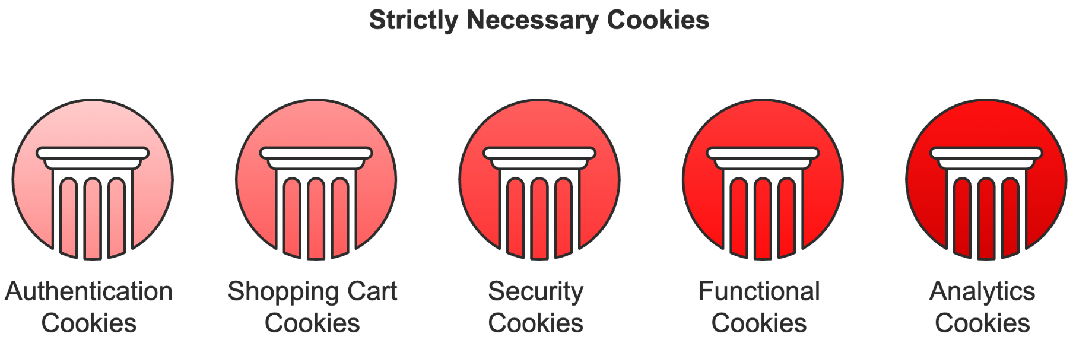
Here's a detailed examination of strictly necessary cookies and their implementation requirements:
Authentication cookies maintain user sessions and protect account security. They should:
- Expire immediately after session end
- Use secure transmission protocols
- Implement rotation mechanisms
- Store minimal identifying information
- Apply strict access controls

Shopping cart cookies preserve selected items during browsing. These must:
- Delete automatically after checkout
- Store only product identifiers
- Avoid capturing personal data
- Implement encryption for sensitive data
- Maintain separation from tracking cookies
Security cookies protect against fraud and unauthorized access. Implementation requires:
- Regular token rotation
- Strict domain boundaries
- Minimal lifetime settings
- Robust encryption standards
- Clear security documentation
Functional cookies enhance website usability but aren't essential for core operations. They remember user preferences, customize content presentation, and enable social media features. While these cookies require explicit consent, their purpose typically aligns with user expectations and preferences.
Let’s look at a real-world implementation example. A media streaming website uses functional cookies to:
- Remember volume settings
- Store playback preferences
- Customize interface layouts
- Save language selections
- Enable social sharing features
Each functional cookie implementation must include:
- Clear purpose documentation
- Consent management integration
- Regular functionality reviews
- Data minimization practices
- User control mechanisms
Analytics cookies present unique challenges under GDPR. They provide valuable business insights but often collect more data than necessary. Your analytics implementation requires careful configuration to balance information gathering with privacy protection.
Modern analytics platforms often deploy multiple cookies for comprehensive tracking. A typical implementation might include:
- Session tracking cookies
- User identification tokens
- Performance measurement tools
- Behavior analysis markers
- Cross-device tracking elements

Building Privacy-First Analytics Systems
Creating GDPR-compliant analytics requires a fundamental shift in how you approach data collection. Instead of gathering everything possible, focus on collecting only what's necessary for specific, documented purposes. This privacy-first approach often yields cleaner, more actionable data while protecting user rights.
Start by evaluating your current analytics implementation:
- Audit all tracking scripts and cookies.
- Document each data point's purpose.
- Identify unnecessary collection.
- Implement privacy-enhancing configurations.
- Establish regular review processes.
When implementing analytics tools, consider these privacy-enhancing techniques:
Server-side tracking offers enhanced privacy protection by processing data on your servers rather than users' browsers. This approach:
- Reduces cookie dependency
- Improves data accuracy
- Enhances security
- Provides better control
- Simplifies compliance
Data minimization in analytics requires careful consideration of each metric:
- Using sampling instead of full tracking
- Implementing IP anonymization
- Disabling user-level reporting
- Reducing geolocation precision
- Limiting session duration tracking
Configure your analytics platform to respect privacy:
- Set appropriate retention periods.
- Enable automatic data deletion.
- Implement consent checks.
- Configure privacy-friendly defaults.
- Document all privacy settings.
Compliant tracking is about building lasting trust with your users while gathering the insights needed to improve your business. Regular reviews, updates, and user feedback help maintain this balance while ensuring continued compliance with GDPR and other privacy regulations.
Modern websites need sophisticated analytics, but they must implement them responsibly. By following these guidelines and maintaining a privacy-first approach, you can gather valuable insights while protecting user rights and building trust with your audience.
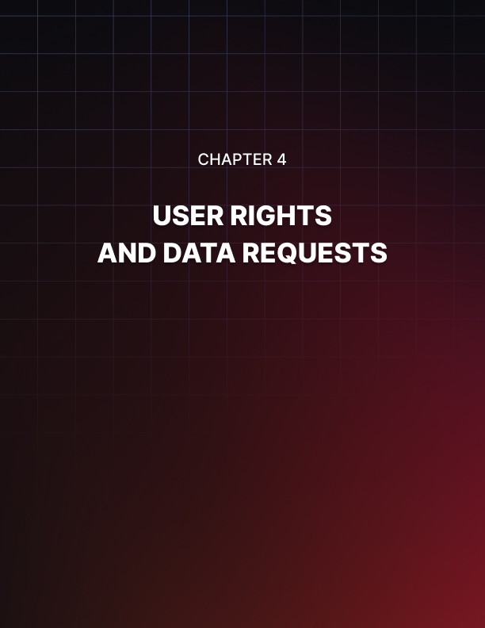

USER RIGHTS AND DATA REQUESTS
____
A mid-sized e-commerce company recently found itself in a challenging situation when fifty customers simultaneously demanded access to their personal data. Their manual processing system buckled under pressure, missing critical deadlines and risking substantial GDPR violations.
This real-world example highlights a growing challenge for businesses: effectively managing data subject requests while maintaining regulatory compliance and customer trust.

Understanding and Implementing Data Subject Rights
GDPR empowers individuals with unprecedented control over their personal information, transforming how businesses must respond to customer data requests. These rights represent fundamental tools through which your customers exercise control over their privacy.
Sarah's Online Boutique received its first deletion request last month. Despite good intentions, the owner spent three weeks manually searching through databases, email archives, and backup systems to remove all traces of customer data. By the time she finished, she had missed the 30-day compliance deadline and risked both regulatory penalties and customer trust. This scenario perfectly illustrates why businesses need robust systems for handling data subject requests before they arrive.
When implementing data subject rights in your business, remember that each request represents an opportunity to demonstrate your commitment to customer privacy. A well-handled request strengthens customer relationships and builds trust in your brand. Conversely, poor handling can damage reputation and trigger regulatory investigations.
Your data subject rights implementation should address four fundamental rights:
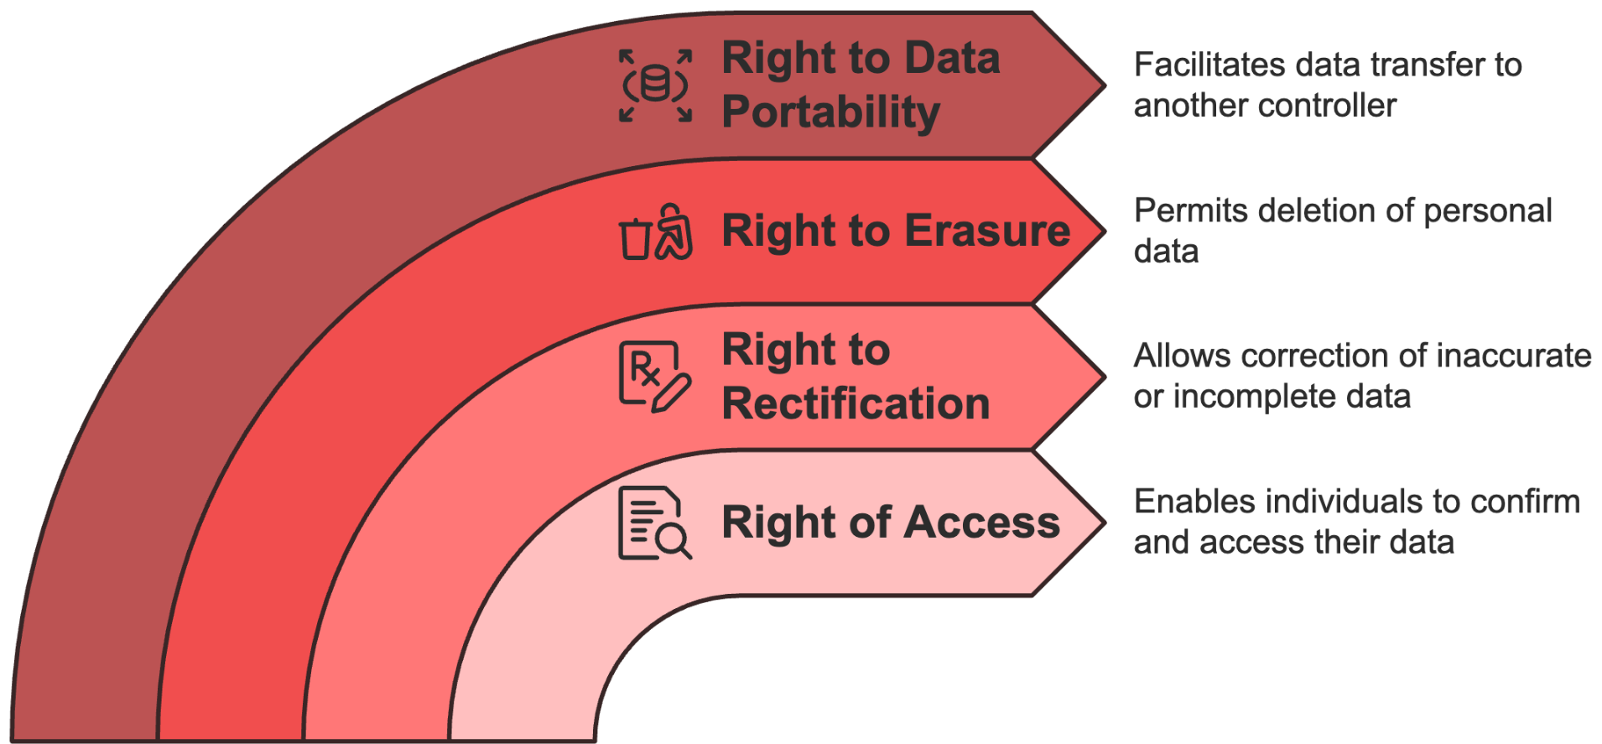
The right of access enables individuals to obtain confirmation about whether you're processing their personal data and receive copies of that information. This means creating systems that can quickly locate and compile all personal data across your organization. For example, when a customer requests access to their data, you must provide:
- All personal information you hold about them
- The purposes for which you use their data
- Categories of personal data being processed
- Recipients or categories of recipients who have access to the data
- Predicted data retention periods
- Information about automated decision-making processes
- Details about international data transfers
The right to rectification allows individuals to correct inaccurate personal data or complete incomplete information. This requires flexible database structures and clear procedures for updating information across all systems. When implementing this right, consider:
- How to verify the accuracy of new information
- Methods for updating data across multiple systems
- Procedures for notifying third parties about corrections
- Documentation requirements for change requests
- Impact assessment procedures for significant changes
The right to erasure (or "right to be forgotten") permits individuals to request deletion of their personal data. This complex right requires careful implementation considering:
- Legal grounds for retention
- Technical capabilities for complete deletion
- Impact on related data and services
- Backup and archive management
- Third-party notification requirements
The right to data portability enables individuals to receive their personal data in a structured, commonly used format and transmit it to another controller. This technical challenge requires:
- Standard data export formats
- Secure transmission methods
- Clear documentation of data structures
- Procedures for handling large data sets
- Quality control measures for exported data

Building Effective Request Management Systems
Creating a robust system for handling data subject requests requires careful planning and implementation. Your system must scale efficiently while maintaining security and compliance standards. This section explores the essential components of an effective request management system and provides practical guidance for implementation.
Start by establishing a dedicated team responsible for request management. Your data request response team should include:
- A primary contact person who coordinates all incoming requests.
- Technical staff with expertise in data extraction and processing.
- Legal advisors who can handle complex cases and ensure compliance.
- Quality control reviewers who verify response accuracy.
- Documentation specialists who maintain detailed records.
Invest in appropriate technology solutions that streamline request handling. A modern request management system should include:
- Secure online forms for request submission
- Automated acknowledgment and tracking systems
- Workflow management tools for request processing
- Document generation capabilities for standardized responses
- Secure communication channels for sensitive information
- Comprehensive audit logging and reporting features
Training plays a crucial role in successful implementation. Your staff needs a thorough understanding of:
- The fundamentals of data subject rights and GDPR requirements
- Procedures for identifying and categorizing different request types
- Verification protocols for confirming requestor identity
- Processing timelines and regulatory requirements
- Documentation standards and record-keeping procedures
- Security protocols for handling sensitive information
- Escalation procedures for complex or unusual requests

Managing Complex Requests and Compliance Challenges
The real challenge in handling data subject requests often lies in managing complex cases while maintaining compliance. This section addresses common challenges and provides practical solutions for maintaining efficient request processing.
When handling complex requests involving multiple systems or departments, implement a structured approach:
- Initial request assessment and categorization
- Data mapping and location identification
- Processing timeline establishment
- Resource allocation and coordination
- Regular progress monitoring
- Quality control checks
- Final review and documentation
Consider implementing a tiered response system based on request complexity:
- Tier 1 - Simple requests handled through automated systems
- Tier 2 - Moderate complexity requiring manual processing
- Tier 3 - Complex requests needing specialized attention
- Tier 4 - High-risk requests requiring legal review
Your verification procedures must balance security with accessibility. Create a risk-based verification framework that takes into account:
- The sensitivity of requested information
- The relationship with the requestor
- Previous interaction history
- Available verification methods
- Potential risks of unauthorized access
Managing data subject requests effectively requires ongoing commitment to process improvement and adaptation to changing requirements. Regular system reviews and updates ensure continued effectiveness while maintaining compliance with evolving privacy regulations.
By implementing robust systems for managing data subject requests, you protect your business while honoring your customers' fundamental privacy rights. The investment in proper procedures and technologies pays dividends through enhanced customer trust and reduced compliance risks.


TERMS AND CONDITIONS
____
Terms and conditions serve as the foundational contract between your website and its users, establishing the rules of engagement for all interactions. In the GDPR era, these documents must evolve beyond traditional liability limitations and intellectual property protections to explicitly address personal data handling, user rights, and consent mechanisms that align with current privacy regulations.
Crafting compliant terms requires a delicate balance between legal protection and user comprehension. While thorough coverage of necessary clauses remains essential, equal emphasis must be placed on clarity, accessibility, and integration with your broader privacy framework. The most effective terms documents seamlessly connect to your privacy policy and consent mechanisms, creating a coherent ecosystem that both protects your business interests and respects user privacy rights.

Transforming Legal Documents into Trust-Building Tools
The age of impenetrable legal documents is over. Your terms and conditions must evolve from dense walls of text into clear communication tools that build trust while protecting your business interests. See your terms as a transparent contract with visitors—one that defines expectations, responsibilities, and rights while ensuring compliance with data protection regulations.
You face a unique challenge when crafting modern terms and conditions. Your document must address complex interactions between users, your website, and an ecosystem of third-party services, all while maintaining GDPR compliance.
In practice, when a customer makes a purchase on your e-commerce site, your terms should cover payment processing, shipping partnerships, marketing communications, and data-sharing practices. Each element requires careful consideration of privacy principles while keeping your business operations practical and efficient.
According to a Pew Research Center article, only 9% of users actually read the terms and conditions before accepting them. This isn't user behavior, but a reflection of a fundamental failure in how businesses communicate their terms. Your goal is to break this pattern by creating terms that users want to read and can easily understand. This means moving beyond legal compliance to embrace genuine transparency and user empowerment.
A properly structured terms document serves multiple purposes. It protects your business interests, ensures regulatory compliance, and builds trust with your users. When drafting your terms, consider how different user types interact with your service. A casual browser needs different information than a power user or business client. Your terms should address all these perspectives while maintaining clarity and legal effectiveness.

Essential Components for Modern Terms
Your terms and conditions must balance complete coverage with accessible presentation. Let's examine the core components that every GDPR-compliant terms document needs, along with practical implementation strategies that work for businesses of all sizes.
Start with your service definition and usage rights. This foundational section establishes the relationship between your business and your users. Instead of vague statements, provide specific details, such as:
"Our platform provides cloud storage solutions for business documents. You receive 50GB of secure storage space, accessible through our web interface and mobile apps. While we maintain 99.9% uptime, we schedule maintenance during off-peak hours (2–4 AM GMT) and notify you 48 hours before any planned downtime exceeding 30 minutes. You may create up to five user accounts per business subscription, each with individual access controls and audit logs."
When addressing data processing terms, move beyond generic statements to provide concrete examples of how you handle personal information. For instance:
"When you upload documents containing personal data, we process this information on secure servers located in the European Union. We use industry-standard encryption during transfer and storage. Our automated systems analyze document metadata for indexing, but human staff never access your files without explicit permission except in emergencies (such as preventing illegal activities or responding to valid legal requests)."
Your terms should establish clear user rights and responsibilities that protect both parties. Instead of listing prohibitions, explain the reasoning behind restrictions and provide examples of acceptable use. Try this approach:
"You trust us with your business data, and we take this responsibility seriously. While you retain ownership of all uploaded content, you grant us limited permission to process your files as needed to provide our service. This means we can compress images for faster loading, generate previews for quick browsing, and create backups for data protection. We won't use your content for marketing, training our systems, or any purpose beyond providing and improving our core service features."
Create a detailed section on account management and security that empowers users to protect their data:
"You control access to your account through your login credentials and security settings. We recommend enabling two-factor authentication, which adds an extra layer of protection beyond your password. If you notice suspicious activity, use the emergency lockdown feature in your dashboard to temporarily freeze all access while our security team investigates. We monitor login attempts and automatically block suspicious patterns, but you're responsible for maintaining the security of your account credentials and promptly reporting any unauthorized access."

Creating Clear and Actionable Terms
Transform complex legal concepts into understandable guidelines without sacrificing protection. Your terms should read like a conversation with users, explaining rights and responsibilities in practical terms while maintaining legal enforceability.
Think about how traditional legal language creates barriers to understanding. Instead of writing "The party of the first part hereby agrees to indemnify and hold harmless the party of the second part," use clear language: "If someone sues us because of content you uploaded or actions you took on our platform, you agree to help defend us and cover any resulting costs."
Structure your terms document for easy navigation and comprehension. Use descriptive headings that answer common questions:
- "What happens to my data if I close my account?"
- "Who can see the content I upload?"
- "How do you handle payment disputes?"
- "What security measures protect my information?"
Include practical examples throughout your terms to illustrate complex concepts. For instance, when explaining data sharing:
"We share limited information with trusted partners to provide specific services. For example:
- When you make a purchase, our payment processor receives your card details to complete the transaction.
- If you enable social media integration, those platforms receive the content you choose to share.
- Our analytics service sees anonymous usage data to help us improve performance.
- Customer support tools access your account details when you request help."
Remember that your terms form part of a larger trust relationship with users. Frequent reviews and updates ensure your terms remain effective while adapting to changing business needs and regulatory requirements. By creating clear, user-focused terms that respect both legal requirements and user understanding, you build lasting trust while protecting your business interests.

Maintaining Dynamic Terms in a Changing Landscape
Your terms and conditions need regular updates to reflect evolving business practices, technological changes, and regulatory requirements. Implement a systematic approach to terms management that keeps your documentation current while maintaining user trust and legal compliance.
Create a comprehensive version control system that tracks changes and maintains accountability. Your system should:
- Document every modification with clear rationales.
- Maintain an accessible archive of previous versions.
- Record when and how users accepted various terms.
- Track the effectiveness of different versions of terms.
- Monitor user feedback and dispute patterns.
Here’s an example of practical implementation:
"We maintain a detailed changelog of our terms updates, accessible at example.com/terms/history. Each entry includes:
- The date and nature of changes
- Plain-language explanations of modifications
- Technical implementation details
- User notification methods used
- Acceptance tracking metrics"
Develop clear procedures for updating terms and notifying users about changes to your terms and conditions. Your process should respect user rights while maintaining operational efficiency. Instead of forcing users to accept new terms immediately, provide reasonable review periods and clear explanations of changes. For example:
"When we update our terms, you'll receive:
- An email notification summarizing key changes
- A side-by-side comparison of old and new versions
- At least 30 days to review major changes
- The option to download both versions for reference
- Clear instructions for closing your account if you disagree with the changes"
Creating GDPR-compliant terms requires balancing legal protection with user understanding. When you follow these principles and maintain systematic management practices, you protect your business while building lasting trust with your users. Regular reviews and updates ensure your terms remain effective while adapting to changing requirements and user needs.


STAYING COMPLIANT
____
A successful e-commerce platform's experience in early 2024 exposed a critical truth about GDPR compliance. Despite investing heavily in initial privacy measures, they discovered significant gaps during a routine audit that threatened their operations and customer trust.
Their automated consent management system had fallen out of sync with updated regulatory requirements, staff training had lapsed for over 18 months, and their vendor agreements failed to address new data processing standards. This wake-up call cost them €150,000 in fines and remediation efforts, highlighting that GDPR compliance isn't a one-time achievement but an ongoing commitment requiring constant vigilance and adaptation.

Creating Living Compliance Systems
Your GDPR compliance framework must evolve alongside your business operations and regulatory changes. It’s like a living organism that needs regular nurturing, not a static set of rules you implement once and forget.
Your journey starts with establishing a strategic compliance calendar that aligns privacy activities with your business cycles. When planning major website updates, incorporate privacy impact assessments into your development timeline. Schedule staff training during slower business periods to ensure maximum engagement. Coordinate policy reviews with your quarterly business planning to maintain alignment between privacy requirements and operational goals.
A medium-sized digital marketing agency transformed their compliance approach after facing similar challenges. Instead of centralizing privacy responsibilities within their legal team, they created a network of privacy champions across departments. These individuals received specialized training and became the first point of contact for privacy-related questions within their teams. This distributed approach reduced response times to potential issues from weeks to hours and improved overall compliance awareness throughout the organization.
Your compliance calendar should orchestrate multiple timeframes of activity. Daily operations require monitoring data processing activities, tracking consent management effectiveness, and handling data subject requests promptly. Weekly reviews focus on assessing new vendor relationships and checking consent management performance. Monthly evaluations analyze privacy metrics and trends, while quarterly deep dives involve comprehensive compliance reviews and strategic planning sessions.
A robust internal policy framework translates GDPR requirements into practical operational guidelines. Your policies should address everything from handling customer data requests to implementing privacy-enhancing technologies. For example, when introducing new processing activities, your guidelines should outline specific steps for conducting privacy impact assessments, documenting processing purposes, and implementing appropriate security measures.
An effective compliance training program goes beyond annual refresher courses. Modern privacy challenges require continuous learning opportunities that adapt to emerging threats and regulatory changes.
Your training approach should combine foundational privacy principles with role-specific guidance, hands-on workshops for technical teams, and specialized sessions for privacy decision-makers. Regular micro-learning modules, delivered through interactive platforms, help maintain awareness without disrupting daily operations.

Building Privacy-First Operations
Implementing privacy by design principles ensures that data protection becomes an integral part of your business operations rather than an afterthought. This proactive approach reduces compliance risks while building customer trust through a demonstrated commitment to privacy protection.
When developing new features or services, your privacy considerations should start at the conceptual stage. Think of the impact your decisions will have on user data and privacy.
Ask yourself: How will user data flow through this system? What security measures need to be in place? How can we minimize data collection while maintaining functionality? These questions shape your development process and lead to more robust, privacy-respecting solutions.
A striking example comes from a retail analytics company that redesigned their customer tracking system with privacy by design principles. Instead of collecting individual shopping patterns, they implemented aggregate data analysis that provided valuable insights without compromising personal privacy. This approach not only ensured GDPR compliance but also increased customer trust and reduced data storage costs by 40%.
Your technology infrastructure must scale alongside your privacy measures. Implement automated compliance tools that grow with your business:
- Consent Management Platforms - Deploy systems that automatically adapt to changing regulatory requirements and user preferences.
- Data Mapping Tools - Use solutions that update in real-time as your data processing activities evolve.
- Privacy Impact Assessment Systems - Implement automated workflows that guide teams through assessment processes.
- Documentation Management - Create dynamic systems that maintain audit trails and version control.
Regular adaptation reviews ensure your privacy framework remains effective as your business grows. These reviews should examine system performance, identify potential scaling issues, and plan necessary upgrades. Document these assessments thoroughly to demonstrate your commitment to continuous improvement and compliance.

Future-Proofing Your Privacy Framework
The privacy landscape continues to evolve with new technologies and regulatory interpretations. Your compliance framework must anticipate these changes while maintaining robust current protections.
Start by monitoring emerging technologies that could impact your privacy practices. This vigilance allows you to anticipate and address novel privacy challenges before they become problematic.
Artificial intelligence and machine learning, for instance, introduce new challenges in automated decision-making and data processing. The Internet of Things creates complex data collection scenarios that require careful privacy consideration. Blockchain applications might offer new approaches to consent management and data transparency.
Your privacy framework should incorporate flexible elements that adapt to changing requirements:
- Modular Privacy Policies - Create documentation structures that easily accommodate new requirements without complete rewrites,
- Scalable Consent Systems - Implement consent management that adapts to new processing purposes and user preferences.
- Adaptive Security Measures - Deploy security solutions that evolve with emerging threats and technological advances
- Flexible Training Programs - Develop learning modules that quickly incorporate new privacy considerations and regulatory changes.
Remember to regularly engage with privacy professionals and industry peers to stay informed about emerging challenges and best practices. Join professional associations, attend privacy conferences, and participate in industry forums. This network provides valuable insights into upcoming changes and practical solutions to common challenges.
Maintaining GDPR compliance requires constant attention and adaptation. By implementing these comprehensive approaches and regularly reviewing their effectiveness, you build a resilient privacy framework that protects both your business and your users' rights while preparing for future challenges. Your commitment to privacy protection demonstrates your dedication to customer trust and regulatory compliance, creating a strong foundation for sustainable business growth.
Stay vigilant in your compliance efforts, maintain flexibility in your approach, and continue building on your privacy framework. These practices ensure your business remains both compliant and competitive as privacy regulations continue to evolve.

