Table of Contents

Introduction 3
Chapter 1: 10 Mindsets that Crush Personal Effectiveness 5
Chapter 2: Life Rewards Action 11
Chapter 3: Decide to Be More Effective Now 14
What Needs to Get Done? 14
You Have to Decide to Boost Quality 15
Everything Must Relate to the Big Goals of Your Life 15
Set a Timeline to Start Acting More Intentionally 16
Chapter 4: Rework and Reorder What You’re Currently Doing 20
Set Your Goals Down Right 20
Keep Filtering Your List Until You’re Crystal-Clear 21
Filter Your Daily To-Do List the Right Way 22
Chapter 5: Creating and Following a Personal Effectiveness Ritual 25
Chapter 6: Use the Power of Emotional Ownership to Get More Stuff Done 30
Decide to Truly Own the Stuff You are Working On 30
Let Personal Pride Push Your Personal Effectiveness Upward and Out 31
Pride Gives You a Power of Emotional Ownership 31
Pride Leads to Efficiency 32
Chapter 7: Achieve More by Working More Purposefully 33
Write and Rewrite Your Grand Visions for Your Life 33
What Purposes Does Your Vision Reveal? 33
Work Towards Those Purposes 33
Practice Purpose-Driven Problem Solving 34
Chapter 8: Challenge Yourself Daily 37
Chapter 9: Document Your Journey for Maximum Control 41
Track Your Journey 41
Isolate Your Challenges in Writing 42
Chapter 10: Best Practices for Getting Things Done 44



Introduction

I've got some bad news for you: the world doesn't care about your plans. Seriously. You may have all sorts of ideas, you may be excited about your grand visions, but let me tell you, nothing will come of any of these unless and until you take action.

You have to understand that the world only cares about one thing and one thing alone: results. The world is always asking: Can you get things done? Can you do the big things in your life that truly matter? Everything else doesn't matter.

Sadly, most people fail to take action on the big things... because they are having a tough time with the small stuff. As you probably have already heard, life is what happens when you have other plans. Don't be surprised if you constantly put your big dreams and visions on the back burner.

Chances are, if you're like most people, you end up wasting a tremendous amount of your personal focus on the penny ante stuff right in front of you. You're sweating over the small stuff. But each and every day that passes is a missed opportunity to do the things that truly matter in your life.

If you're like most people, you can't even manage to take care of these small things so you can free up enough time for the things that truly matter... This is why you struggle. Your big dreams remain as distant as ever because you're just so caught up with the small stuff in the here and now.

If you are sick and tired of living far below your fullest potential, listen up. This book is the answer to your problems. This book will teach you to become a more effective person.

Personal effectiveness means building a system that helps you do more stuff, in less time, and at higher levels of quality. Do this right and you will be able to free up enough time and motivation for the big projects that will move your life forward.

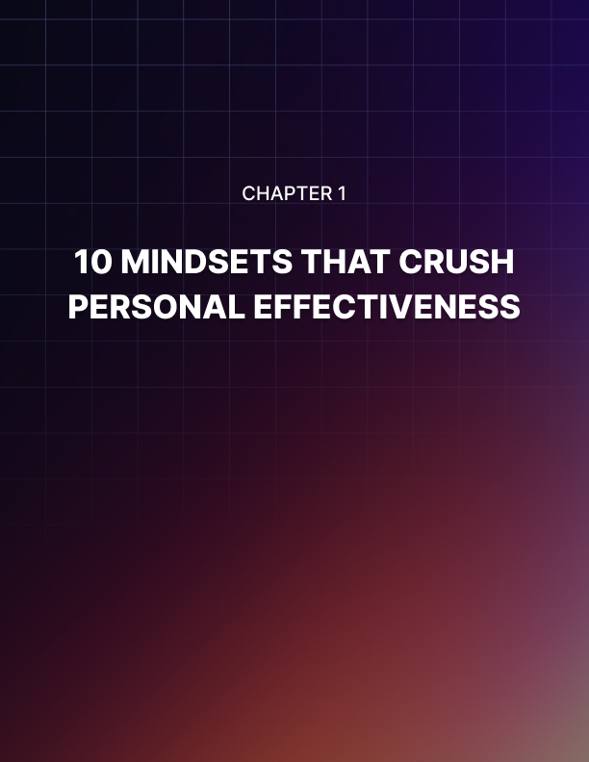

Chapter 1: 10 Mindsets that Crush Personal Effectiveness

Before I help you become a more effective and productive person, you have to have the right mindset. Unfortunately, it‟s too easy to adopt mindsets that trip you up and sabotage your success on your path to optimal effectiveness. You need to become aware of these and eliminate them from your life.

Mindset #1: My potential for achievement will carry me through
Everybody's got potential. In fact, everybody has the potential to become very wealthy. Everybody has the potential to excel at one sport or another. But the problem is, most people never live up to their potential, yet they keep celebrating the fact that they have potential for achievement.

Let this sink in: do not confuse actual achievement for potential and potential for achievement. They are two totally different things. You can't just coast for the rest of your life, thanks to the realization that you have potential. Your potential is not going to do you an ounce of good unless you turn it into actual achievement and results.

Mindset #2: I have achieved stuff in the past, so I can coast now
Please remember that your ability to do stuff erodes with time. I'm not just talking about physical action here. I'm talking about mental action as well.

Scientific studies show that people's mental abilities decline with age. In fact, your IQ goes down as you get older.

To think that just because you have achieved certain things in the past that you can continue to achieve them long into the future is wishful thinking. It takes more effort to maintain the same results. And also, you would be required to learn new things so you can produce the same or better results in the future.

Don't entertain the idea that just because you were able to get stuff done in the past that you will continue to perform at a similar level. It doesn't work that way. You cannot give yourself the luxury of "coasting" through life.

Mindset #3: I can achieve the same results without having to change
Just because you were able to do things in the past, it doesn't mean that you only need to continue doing the same things. Conditions do change.

For those achievements to take place, you have to level up your skills, you have to be adaptable, and you have to find yourself at the right time and the right place doing the right things. This means keeping up with the changing situation on the ground.

Otherwise, it becomes so easy to think that since you are unable to produce the same results, then there is something wrong with the activity itself, or the industry you're in, or your career, or other people. It turns out that the only problem is your refusal to change and keep up with the times.

Mindset #4: Success only comes through intuition
A lot of people are under the impression that for them to be successful, they just need to find themselves at the right place, at the right time, doing the right things, with the right people around them.

This is wrong.

Success is a habit. Even if you are dealt a lousy hand and you are dealing with an almost impossible situation complete with toxic people, you can still pull out a victory.

How come? You're not relying on your intuition. You're not relying on your gut feeling. You're definitely not relying on getting lucky. Instead, you're focusing on the personal success systems that you have built for yourself.

You become more adaptable. You are able to spot opportunities as they present themselves. In other words, you learn how to do the right things at the right time to produce a predictable set of results.

This is how you can tell truly successful people who may be down on their luck and people who just got lucky. I'm telling you, if you just rewind history, people who got lucky probably will not achieve the same results.

Mindset #5: Achievement comes through raw insight
A lot of people are under the impression that you really don't have to put in the time or pay your dues to become really good at what you're doing. A lot of people are under the impression that they just need to be at the right place at the right time and all of a sudden this enlightenment about their work, their career and their industry will all fall into place.

This raw insight is like trying to win the lottery. Seriously. You might as well just run out and get yourself a lottery ticket because you are hoping for the same type of result.

You can have all the raw insights you want, but if you don't know what to do with them and you don't have a system for producing the same type of success day after day, week after week, month after month, then you're just setting yourself up for disappointment.

Mindset #6: No matter how hard I try, success is ultimately random
This thinking actually concludes with another sentence: so why try so hard? If random luck is just going to put you in the same place as you would if you had worked hard, why even try?

I hate to say this, but people who think this way are simply just giving themselves reasons for being lazy. I know that's unpopular and not politically correct, but it's true.

Because you have to understand that people who become successful are not successful 100% of the time. Instead, they're successful enough. Regardless of the conditions and regardless of whatever is going on on the ground, they are able to succeed enough times.

Successful people are able to succeed at a fairly predictable rate. People who play everything by ear cannot say that. Things happen to them randomly. Sometimes they get lucky, most of the time they don't.

Truly successful people don't settle for that. Instead, they have a system where, chances are, they will achieve success more likely than not.

Don't let your belief in the randomness of success rob you of the motivation you need to learn how to build a personal success system.
Mindset #7: Personal effectiveness is hardwired
People who believe this think that some people are just born effective while the rest struggle.

Personal effectiveness is something that you learn. It is not something that you're either born with or you're not born with.

Don't give yourself the excuse that you may not be predisposed to being effective or being all that organized. All this tells you is that you just need to put in a little bit more work and time and eventually you will get there.

Mindset #8: Effectiveness is not as important as efficiency
You can be an efficient failure. Seriously. You can take whatever little resources you have and constantly fail. That's efficiency.

Please understand that effectiveness involves managing the quality of the results you do. It also directly impacts whether you are able to produce results at all.

Efficiency is important, but you have to focus on being effective first. Because if all you focus on is efficiency, it's very easy to just do the very least to produce barely passable results.

Mindset #9: I don't have to build learning systems
Sustainable effectiveness can only come about if you have a system for learning what you need to learn to produce the results you want to produce.

Unfortunately, if you can't be bothered to put in the time, effort and energy to build such a system, you're going to have to settle for surface learning. You're basically going to be focusing on the tip of the iceberg and nothing more.

This is a serious problem because if you really want to become an authority or expert in any kind of field, you have to scratch beneath the surface. You have to put in the time, effort and focus. This requires sacrifice. This requires paying your dues over an extended period of time.

Mindset #10: I can't rely on others to boost my personal effectiveness
Whatever struggles you may currently have with your personal effectiveness is actually acquired through „mental inheritance.‟ Seriously. You picked it up at some earlier point. I am,of course, referring to your parents or family members.

Regardless of whatever habits you may have, you can bet that you have learned it from somewhere. It's not something that you were born with.

Do yourself a big favor, learn from the right people to boost your personal effectiveness. Just as you can learn from others how to be lazy, unproductive or unimaginative, you can be inspired by other people to really stretch your limits so you can become the most effective person you can be.

Make sure you don't subscribe to any of these mindsets because if you do, your chances of success are greatly diminished. What I'm going to teach you in this book requires that you free yourself from these ideas.

This is no time to be in denial. Don't feel embarrassed if you believe in these. Just own up to them and get rid of them. At the very least, neutralize their effect so the information that I'm going to share with you sinks in and changes your life.

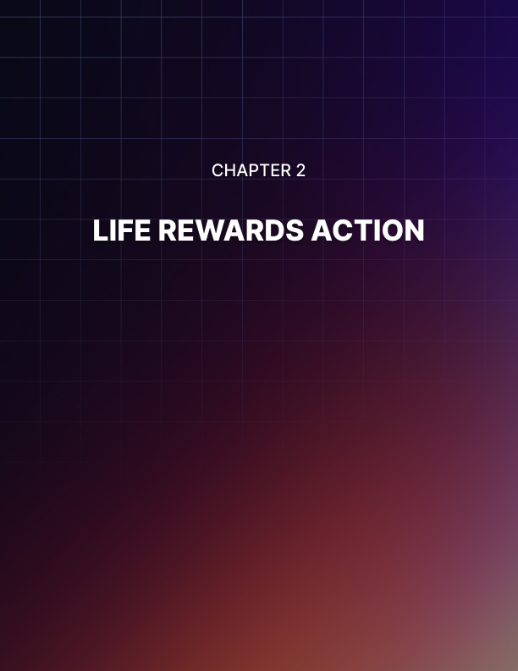

Chapter 2: Life Rewards Action

As I've mentioned in the introduction to this book, there's only one thing that the world cares about: results. I think we could all agree on that.

It doesn't care about your feelings. It doesn't care about your intentions or motivations. It doesn't care about any of that. All it cares about is what it actually sees.

The world is objective. Do you earn $100,000 a year or not? Do you have a big house or not? Do you have a Ferrari or not? Can you dunk a basketball or not?

These are the very basic black and white questions that the world asks. Everything else is just fluff. If you are able to wrap your mind around this, let's take things a little deeper.

Success is defined by what you do. Please understand that results are only possible when you take action. Everything else is empty talk. Accordingly, if you want to be successful, you have to do things. You have to take action.

Success is defined by what you do, not what you dream about, your potential, your hopes and wishes. Everybody's got those. Anybody can daydream. But to actually achieve your dreams, you have to do it.

Similarly, to live a life of purpose, you have to do. You can't live a life of purpose doing nothing except hoping and wishing. Believe it or not, to achieve happiness and joy, you have to do it. You have to take action.

This is a big problem for a lot of people because most of us are afraid to take consistent action. Most of us can wrap our minds around the need to take action. Most of us can manage to do that. Unfortunately, we think that we only need to take action one time in a big way and the rest will follow. It doesn't work that way.

If you've ever worked on a big project like, getting a college diploma or building a successful business, you should have noticed that it takes consistent action. You don't just get the reward the first time you press the lever or the first time you swing the bat. It doesn't work that way.

You have to keep trying over and over again, despite the fact that there are obstacles in the way.

Consistent action trips people up because we are afraid that the road ahead is long and hard. We tend to focus on the obstacles. The more we look at the obstacles, the more we lose sight of our ultimate destination. We get taken aback by the stuff we need to let go.

Remember, if you are on the road to success or to great riches or wealth, the road or the process changes you. You have to sacrifice. You have to change. You have to let go of certain parts of your personality.

This is painful because most people fear change. We've grown accustomed to doing things a certain way or thinking about things a certain way. It's very scary to let go of the things that we are familiar with. We end up worrying about what we stand to lose.

The more you hang on to the harmful mindset that you can "coast through life" relying on your past successes is an illusion. Your skill sets erode over time. Eventually, you reach a point where you don't even know what to do to produce any kind of result. That's the path that you're on.

The way out of this dilemma is to understand that the world rewards action right here, right now. Not tomorrow, not the day after, not next week, but right here, right now.

I need you to do one thing right now. If you want to proceed with this book. I need you to decide to get things done... NOW! If you have decided to do things right here, right now, meet me in Chapter 3.

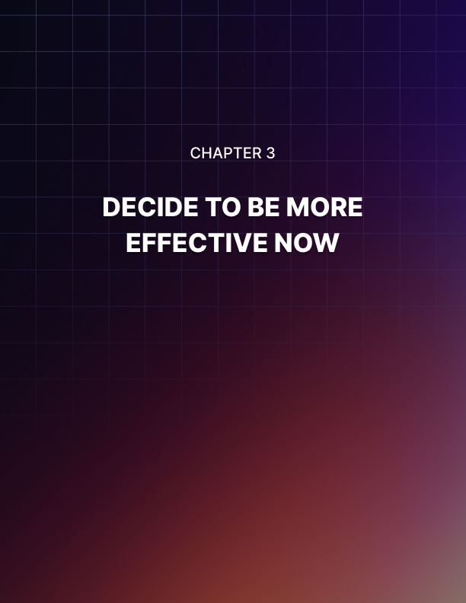

Chapter 3: Decide to Be More Effective Now

A lot of people downplay the importance of making decisions. In fact, a lot of us think that decisions are automatic. We only need to see where we are and the benefits that we stand to gain and the decision will flow naturally.

This is why most people assume that they have decided to change when they go on a diet or they apply for a new job or they apply for a promotion. It is no surprise that most of these people fail.

Why? They completely assume one of the most powerful steps to personal success and effectiveness: decision. You have to be as conscious as possible about your choice.

Your power of choice is one of the most important personal powers you have. Don't assume that it is always in play. Don't assume that you have exercised it. You have to be as conscious as you can be about your choice of Get It Done now.

Two things are happening here. You are choosing to do things and you're choosing to do them now. These must flow together.

What Needs to Get Done?
First, you're going to decide that you will step up the quantity of your output. I don't care whether you are a sales rep, a lawyer, a doctor, a medical professional, a janitor, or a mall owner or anything else, you have to do more. You have to produce more output.

You have to see a lot more of your effort turned into actual units of results. It could be sales, website views, website visitors, or it could be mall visitors. It doesn't matter. You have to produce results that are quantifiable.

You Have to Decide to Boost Quality

A lot of people are under the impression that just because they're able to crank up the amount of output they produce on a day to day basis that they are doing well. I wish it were that simple.

Last time I checked, if you produce substandard work, it doesn't really matter whether you multiply it a million times-it will still be substandard work. That kind of work is still not going to get you promoted or earn you a raise. Instead, you're just producing more garbage.

A key part of personal effectiveness involves stepping up the quality of your output.

For example, if you are a sales manager, each contract you close must be worth a lot more than the previous contract. That's how you know you are stepping things up.

If you are a mall owner, the quality of the shops and brands that you are attracting must be on the way up. That's how you know you're doing a good job.

A lot of people are too eager to dispense with quality. They think that as long as they can rack up high numbers, that is good enough. I'm telling you, there is no such thing as "good enough."

If you multiply crap by a million times, it's still crap. In fact, you make your problems worse because there's more crap you have to deal with.

Everything Must Relate to the Big Goals of Your Life
Becoming a more effective person means being a more purposeful person. You're not just typing out numbers into a computer because you have some sort of quota to fill. You're not just seeing patients at a hospital because you can't wait until you hit the golf links.

If that's your mindset, you are just going through the motions. You're not really allowing yourself to become the most effective person you could be because there's no reason for you to pursue that goal.

You have to be purpose driven. What's the point of cranking out sales when it doesn't really lead to anything meaningful in your life? What's the point in studying tons of books when it doesn't really lead to a big goal in your life?

Please understand that figuring out what to do and how to do them is not as important as understanding why you're doing them in the first place. You have to be motivated by the "why" because the sense of purpose, urgency and focus that you get will give you the power and the immediacy you need to not only crank up quantity and quality, but also to be able to withstand all sorts of negativity, discouragement and setbacks. Believe me, there will be setbacks.

Ineffective people set themselves up in such a way that when the challenge arises, they fold like a wet rag. They say to themselves, "Well, maybe my best isn't good enough. Maybe I wasn't meant to do that in the first place." They just give themselves all sorts of excuses to make up for the fact that they are not driven by a big enough purpose.

Now, what makes this a little tricky is the fact that the big goals in your life are completely personal. They may be very deep and meaningful to you, but they might not mean all that much to the next person.

It's your job to zero in on these big goals because they are part of your personal truths. As long as you're clear about them, you should be able to benefit from the sense of emotional urgency that they produce.

Set a Timeline to Start Acting More Intentionally
Now, it's great that at this point you understand why you need to decide to be more effective. But the problem is, deciding to be effective and understanding the reasons why you should become so are not going to help you all that much.

At this point, all these insights just resonate on an intellectual level. Until and unless you feel a sense of urgency, this is just going to be theory to you. All these insights are not going to push your life forward.

It's kind of like going to some sort of seminar where you pick up very interesting information, but at the end of the day, it doesn't really move your life forward. It doesn't really change how you look at yourself as well as your place in your life.

Unfortunately, unless the things that we learn with our minds doesn't sink to the level of our hearts, nothing is going to change. Seriously. This is why you need to set a timeline.

This is when the theory or the possibility of change becomes a cold, hard reality. Because now, you're not screwing around. You're now setting a timeline for you to start acting more intentional.

You're not going to allow your feelings to dictate when you should get your act together. You're no longer going to play games with yourself where you say that you will only take action "when things are right." Most importantly, when you set a timeline to start acting on boosting your personal effectiveness, you're no longer going to be waiting for other people.

I want you to be honest with me. Think about the key decisions that you've been holding off in your life. Chances are, at least one of those involves other people. Chances are, you're playing this game with yourself where you're saying to yourself, "When X gets it together, I will do..."

Stop playing this game with yourself because when you do this, you're just giving yourself an excuse not to do anything right here, right now.

You know what you need to do. You know the kind of actions that will take your life to the next level. But as long as you can see that another person hasn't quite gotten it together or hasn't "arrived" to where you are, you give yourself an excuse to wait for them.

You're not really waiting for them. You're waiting for yourself. Maybe you're scared. Maybe you feel you have other better things to do. Whatever the reason may be, you're waiting.

I'm telling you, the more you wait, the more ineffective you become. Set a timeline to start acting more intentionally right here, right now.
Remember to Set the Right Time to Start

If you're feeling pumped up right now, I congratulate you. Obviously, this material is sinking in and is having the right emotional effect. Congratulations.

However, I need to warn you. You cannot commit the common mistake of giving yourself so much time. I know you're pumped up about setting a time right now, but the time that you have selected may be too far in the future.

Why is this a problem? Let me tell you, if you set a deadline that is so far into the future, chances are, you will become busy with other stuff. You will fill up that time. So by the time that date comes, you will find yourself completely unprepared.

Believe me, I know this first hand because I used to do this.

Don't do that. Don't give yourself too much time. Instead, it has to be close enough to the present moment so that you can remain focused on that start date.

Now, this brings up the related problem of setting the start date so close to the present date that you end up intimidating yourself. Seriously.

Don't set up your start date so close to today that you end up freezing. You get so intimidated by what you need to do and the things that you need to go through and the changes that you have to make that you become really scared. You're afraid of the work that's involved and you get thrown off track.

Shoot for something in between. It shouldn't be so far out in the future that you lose all sense of emotional urgency. It shouldn't be so imminent that you essentially freeze because you're intimidated.

The bottom line?
The bottom line is simple: effectiveness starts with scheduling. When you schedule, it highlights the fact that you have decided to start taking action.
Pick a schedule. Stick to it.

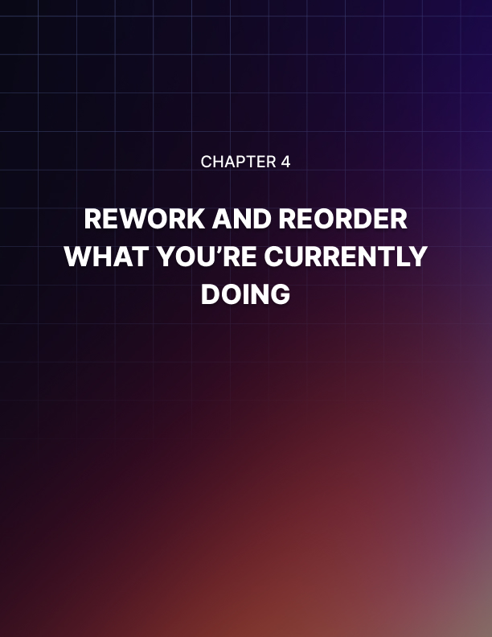

Chapter 4: Rework and Reorder What You’re Currently Doing

This book is very practical. I‟m not going to teach you how to completely replace your current routine. Instead, you're just going to work with what you already have.

This is the first step. Ask yourself this question: What is truly important? Let that question sink in. It should be fairly clear to you what things you do on a day-to-day basis are important. If you need more clarity, ask yourself: “Does this move my career forward? Does this help my business in a profound way? Do these things push me closer to my life goals?”

You may be thinking to yourself that as long as you can tie any of your routine to your life goals that you should continue doing them. Not so fast. You also need to test your life goals.

Are you assuming that certain goals are your life goals? Are these objectives really all that important to you? Are these what you really want out of life?

A lot of people actually haven‟t bothered to ask themselves these questions. They tend to go on autopilot and if they do manage to achieve those grand objectives, it turns out those aren‟t what they‟re looking for.

Test your life goals. Don't be afraid. Ask yourself if you truly want these. Maybe you need to refocus. Maybe you need to redefine.

Set Your Goals Down Right
Now that you have a clear understanding of what you think you want out of your life, write them down. I can't insist on this enough. When you just think about your life goals, it's not unusual for you to keep redefining them. In fact, it's not unusual for you to think about them when you‟re emotional.

However, once that emotional moment passes, you forget about them. They‟re not clearly defined; they‟re just free-floating and you only “remember” them for their emotional effect.

You don't have life goals, if that's the case.

Write them down. You would clearly see if there are holes in your understanding of what you want for your life. Ask yourself the question “why” over and over again when looking through your goals. Don't be afraid to restate them or change them.

Ultimately, when you ask yourself certain why statements - Why should I do this? Why should I invest time into this? Why should I sacrifice for this? Why should I dedicate my life to this?, on and on, - these big goals start to become clearer and clearer.

Once you're happy with the specific statements of your big goals, the next step is to break them down. That's right. Break them down into smaller sub-goals.

Let me tell you there's no such thing as an impossible goal. Seriously. If you break them down into small enough parts and if you have a realistic timeline, there is no such thing as an impossible goal.

You can make goals even more probable by simply breaking them down into sub-goals. You can then turn sub-goals into smaller daily “to-do” tasks. These are the things that you do everyday that lead to you achieving subgoals, which then in turn lead to bigger goals, which ultimately help you achieve your life goals.

Keep Filtering Your List Until You’re Crystal-Clear
Don't write your goals one time and call it a day. It doesn't work that way. Write and rewrite your goals and subgoals until you‟re sure. This is a process of discovery. Don't think that you are stuck with these goals in their present form. Just keep writing them and rewriting them until they become clear.

Once the details are clear, then you will know whether you are sure or not. However, once you reach that state of certainty, allow yourself to feel recharged. Allow yourself to get a nice boost of inspiration triggered by your sense of purpose.

To further help clarify things, break down your daily to-do tasks. I know that these are already broken down from sub-goals, but break them down into small, miniscule tasks. Try to reduce them to their bare essentials where you basically are left with just one simple action.

Filter Your Daily To-Do List the Right Way
At this point, a lot of people drop the ball. They really do. They think that as long as they have a daily to-do task list, they have a clear action road map for the future.

Absolutely wrong. You see, when you look at your daily to-do task list, not all of them deserve to be on your list. There are two factors that you need to be aware of when looking at your daily to-do list and filtering it.

First, there are tasks that are important. Second, there are tasks that are urgent. This means that they can‟t wait. When filtering through your task list, use these two factors so you can make the right decision.

First, are absolutely essential actions you need to take. These are things that cannot wait and are vitally important. You need to do these things right now. You cannot hesitate. Put them at the top of your list. Reserve all your personal willpower and focus on knocking out these tasks.

Second are important tasks. These are important but they can wait. Time is not of the essence as far as these are concerned. These should be second on your agenda. You should free up time to do these because their importance enables you to reach your big goals sooner rather than later.

Maybe they build up certain skills. Perhaps they improve your attitude. Possibly, they open you up for greater success. These are the things that you should do to take things to the next level.

Next are ministerial tasks. These are not all that important, but they cannot wait. They have to be done on a daily basis. This can involve answering e-mails, shuffling paperwork or other small tasks.

Finally, there are optional to-do list items. These are not important and they can wait.

They‟re not high-priority items by any stretch of the imagination.

So, what do you do with these tasks? Well, you need to look at your to-do list and come up with a “focused” to-do list. In other words, all the items there are absolutely essential.

For everything else like ministerial tasks, delegate or outsource them. If you have to do them yourself, tightly budget your time and just knock out those ministerial task items. Do not waste an extra minute on them. They‟re that unimportant.

As for everything else, you can postpone or simply forget about them. This is especially true of optional to-do list items. They're not all that important and they‟re not priority so why waste precious focus and willpower on these to-do list items?

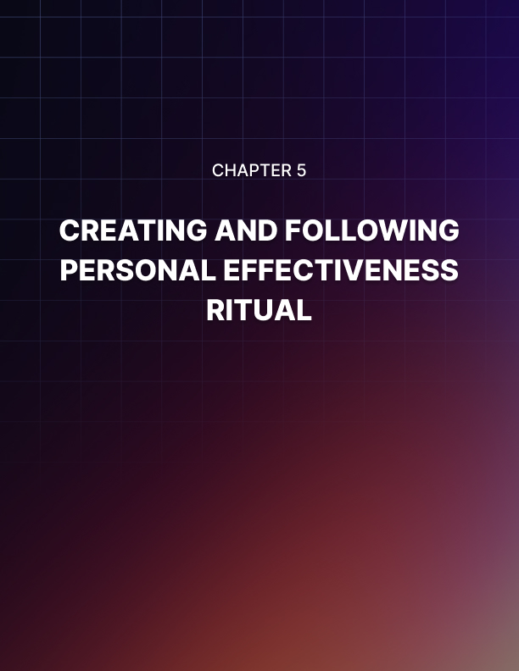

Chapter 5: Creating and Following a Personal Effectiveness Ritual

Before you can become more effective, you must have the right lifestyle that will give you the personal focus and willpower you need to get things done. Follow the advice below. This doesn‟t apply to everybody, but try to adopt as many of these as possible.

Sleep Longer
When you sleep, you are recharging your willpower.

Think of willpower as a set of coins in your hand. You only have a fixed number. Whenever you have to make a decision or whenever you have to analyze something, you have to spend one of these willpower “coins”. At the end of the day, you have no coins left. When you sleep, you recharge the willpower that you have and if you get deep, high quality sleep, you actually end up with more willpower “coins” to start your day.

Wake Up Early
When you wake up early, you energize your focus. You also achieve a sense of newness or tap into a sense of possibility or adventure. These are very important states of mind that you need to leverage for greater effectiveness. Make it a point to wake up early.

Exercise
I know that a lot of people are scared of exercise. I know a lot of people are under the impression that they simply do not have the luxury of time to exercise. I get that. Believe me I know where you're coming from.

The good news is exercise doesn't have to be big or dramatic. You can adopt a daily exercise routine that doesn't have to take up much time. What's important is that you‟re consistent. This is the key.

As long as you do it morning after morning, you are fine. It may be something as simple as walking around the block or just walking your dog. That's okay. Just do it in the morning to turbocharge your focus and do it consistently, and you should be okay.

Take a Cold or Short Shower
This is controversial because, hey, let's face it, most people do not like to be inconvenienced. A lot of people think that when you take a very cold shower first thing in the morning (especially if you live in the colder parts of the United States), it is a form of torture.

Believe me I understand where you're coming from but you need to shock your system. You must have a certain bright line in your daily routine when you wake up and the best way to send your body this signal is to take a cold shower. The good news is you don't have to stand under that blast of frigid water. You can use this opportunity to speed up showering.

Also, when you do this, you not only wake up in a very clear way to start your day but you also build up your ability to withstand discomfort. You can look at this as increasing your ability to withstand challenging situations. Believe me taking an ice-cold shower first thing in the morning can be quite challenging.

The good news is you get used to it. If you're able to handle that, then you will probably be able to handle a lot of other challenging situations.

Eat a Light Low-Carb Breakfast
If you have followed the advice above, you should be feeling energized. You should be very pumped up right now. Don‟t throw it all away by eating a very heavy, high-carb breakfast.

I'm talking about lots of pancakes, possibly mashed potatoes or hash browns or rice or any other breakfast that involves a lot of starch. When you do that, you not only get a huge surgeon in insulin, which gives you some sort of brain freeze but it also bloats you. This is a lousy way to start the day.

Instead, eat a very light, low-carb breakfast. This means that you can load up on protein. Maybe you can eat sausages or corned beef or even scrambled eggs. Whatever the case may be, focus on the fat content so you get the energy you need without getting loaded down by a sudden spike in your blood insulin levels.

Practice Gratitude or Some Other Form of Mindfulness
Before you start working or before you start doing what you normally do every day at work or at school, practice gratitude. This doesn't have to be anything elaborate. You don't have to use some sort of complicated ritual. Just focus on the things that you're grateful for.

Think about your greatest achievement in life. For most people, this has something to do with education. Maybe they finished high school or they have a college or graduate school diploma. Whatever the case may be, focus on something big that you have achieved and how thankful you are.

When you do this, you take your focus away from your stress, your worries or anything else that soaks up mental energy. Instead, you focus on feeling open. When you achieve that state of emotional openness, you can tap into emotional energy that you can then direct to the task at hand.

Alternatively, you can practice mindfulness. Again, this doesn‟t have to be a formal version of meditation. It can be a simple exercise involving you holding your breath for a few seconds, releasing and then holding again. Whatever form it takes, do it if it enables you to lock into the present moment and completely unwind your mind.

Give Yourself the Gift of a Sense of Urgency When Attacking Your Task List
When you show up to work or when you sit down to do your job, at home, look at your to-do list and focused on Item #1 with all emotional force and concentration. Attack it with everything you've got.

Ideally, you should put the most challenging task of the day at the top. Give it everything you've got and, believe me, you will feel a nice emotional surge if you pull this off.

Why? You get a nice sense of accomplishment. You are able to take out the tasks that you would have rather postponed or procrastinated on.

Pat yourself on the back. You've done a great thing because hey, let‟s face it. If left up to you, you probably would not have done it. So, make a conscious effort to knock out the hardest task first thing in the morning or first thing in the day.

Chop Each To-Do List Item into Bite-Sized Pieces
At this point, you should have simplified the tasks on your to-do list items. However, there's always room for improvement. Keep simplifying them until you reach a point where you only need to do one thing for you to take care of a bite-sized task. Once you take care of that, then you do another bite-sized task until you knock out an actual to-do list item.

When you do things this way, you become less afraid of each task. You stop worrying about how much time it would take. You stop thinking about how difficult it is. You just focus on doing it right here right now.

So, simplify everything as much as possible by reducing them to bite-sized tasks and just plow through them like a bulldozer.

Attack Thoroughly
Now that you have everything in bite-sized pieces, like I said, attack them with everything you've got but don't just blow them out of the water. Don‟t just get rid of them for the sake of getting rid of them.

Instead, be very thorough. In other words, when you are supposed to file a report for your sales job, you need to look at all the details. Make sure that everything is what your boss expected. Make sure you don‟t overlook any kind of detail. In other words, focus on quality.

If you are a student and you need to read a novel for a class, make sure you‟ve thoroughly read the book and you‟ve taken useful notes.

If you are working at a factory, don‟t just do what's expected of you, but make sure that the output meets the highest quality standards.

Attack and be thorough. These go hand-in-hand. These are not alternatives.

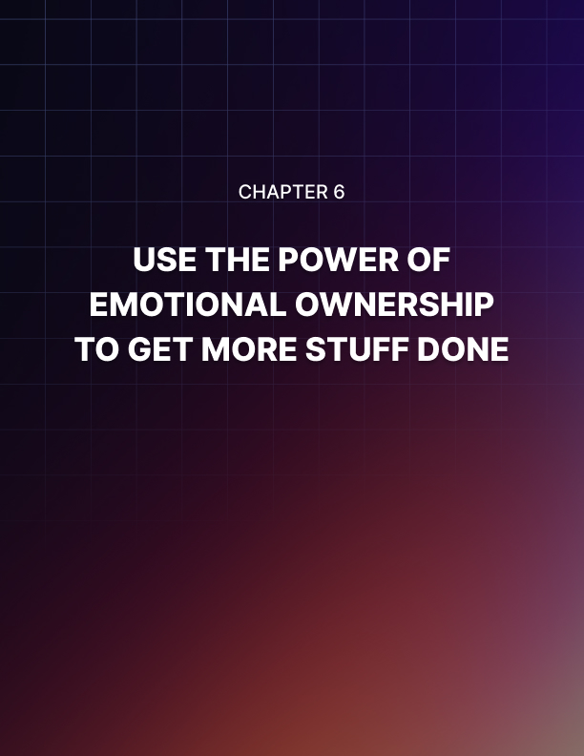

Chapter 6: Use the Power of Emotional Ownership to Get More Stuff Done

Personal effectiveness is not just about doing stuff. It's also about doing them right and doing more of them.

One way to truly take things to the next level is to use emotional ownership. You see, a lot of Americans struggle with their job because, at some level or other, they feel divorced from their work. There‟s an emotional disconnect between who they are and the things that they do to put food on the table.

It is no surprise that a lot of people simply hate their jobs. It's not a shock that a lot of these people are not all that productive. Also, the quality of their work is nothing to write home about.

If any of these applies to you, you can turn things around by simply using the power of emotional ownership. Here's how you do it.

Decide to Truly Own the Stuff You are Working On
When you are assigned a task or a project, understand that it will reflect you. It's not just a job. It is not some trivial collection of tasks on a piece of paper. Also, you're not just a cog in the machine.

I know it may seem basic. It may seem simple. It might even be a task that almost anybody can do. But guess what? It's still important. It is still worth doing to the very best of your ability.

It is also imperative that you do more of it. Why? The results you produce with this task reflects your character. You have to operate at that level.

This is no longer a question of doing things to put food on the table. This is no longer a question of punching the clock for eight hours and then punching out so you can earn a paycheck. This is about personal pride.

Let Personal Pride Push Your Personal Effectiveness Upward and Out
Ask yourself these questions: What does my work say about me? What does my work reveal about my values? What does my work say about my destiny as a person on this planet? What does my performance at work say about my impact on my world?

These are very big questions because most people refuse to ask these questions. They think that their boss is somehow entitled to give them a paycheck every two weeks.

If you, on the other hand, ask yourself these questions, chances are you will be able to produce more work at a higher level of quality and guess what will happen? Your boss would be a fool not to promote you. Your boss would be an idiot not to give you leadership positions.

Most people struggle with their income precisely because they want to do the very least to avoid getting fired. I'm telling you that's not good enough. That's not going to cut it.

You„re not performing at a highly effective level if that is your attitude. You have to let your work reflect your personal pride. This is about you. You may be pushing a button at a factory all day every day but guess what? You have to be the very best button pusher if you really have pride in yourself.

Pride Gives You a Power of Emotional Ownership
You know when people act out of pride, things get real because there is an emotional component there. Use this to work for you instead of against you. I know a lot of people who get into fights because of pride issues.

Well, use that same dynamic to work for you. However, this time, the fight is not against other people but against yourself. It's a fight against laziness, mediocrity and lack of imagination. It's also a fight against inefficiency.

You see, when you accept the idea that whatever you produce is a reflection of your personal pride, you take emotional ownership. This is not just small stuff. These are not trivial tasks that really don't add up to much of anything.

Instead, this is a big deal. This is about you - who you are, what you're about, what your values are and your qualities as a person.

If you think along these lines, you will no longer be going through the motions. Instead, you're going to be looking at the actual results that you're doing and will try to line that up with the personal image you have of yourself.

Framing things this way mentally enables you to work to produce the highest quality. It also enables you to work to produce more.

Pride Leads to Efficiency
Have you ever been assigned to a workgroup where you were lucky enough to know somebody who actually took pride in their work? It really is mind-blowing because these people go beyond the call of duty.

They look at what they're doing and then they don't just go through the motions. They don't believe in “good enough”. Instead, they connect the dots and see if they can step things up in terms of output, quality or both.

Also, they look at automation. The most effective people I know always look for existing software to speed up what they‟re doing. They're not doing this just to save time, mind you.

They‟re doing this to give themselves enough time so they can step up the quality of their work and give them enough resources to automate their jobs even further.

Many highly effective people also use their previous work as templates. They then learn from their previous work cars to constantly increase quality and this yields greater efficiency. Do you see how this works? This is the mindset that you need to adopt.

Unfortunately, if you don't take pride in what you‟re doing, it‟s going to be very hard to assume emotional ownership. It's going to be too tempting to just go through the emotions. It‟s just too tempting to look at what you're doing as something that is really not all that important because, hey, let‟s face it, you're just another cog in the machine. Well, if you don't take pride in what you do, don't be surprised if your boss doesn't take pride in you.

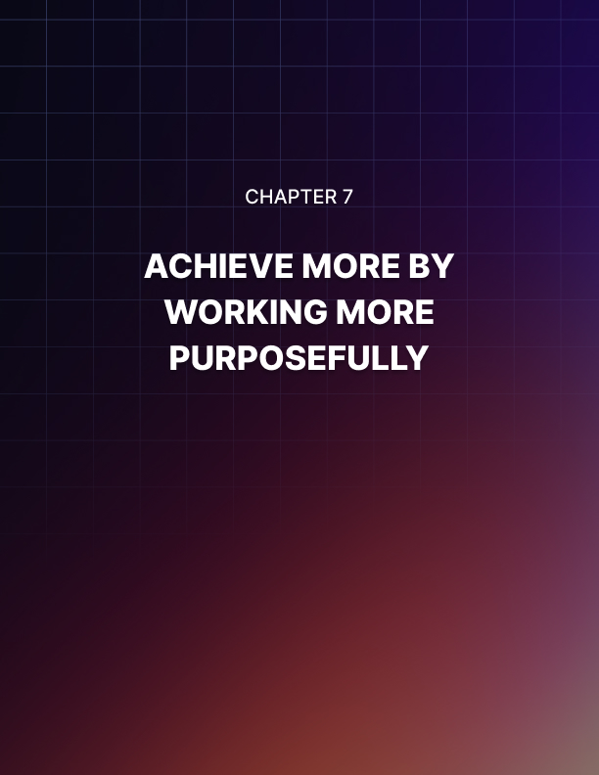

Chapter 7: Achieve More by Working More Purposefully

Oftentimes, it's more important to focus on why you‟re doing things instead of obsessing about what to do and how to do them. Don't get me wrong. You have to be competent so you have to know what to do and how to do them and how to follow a certain sequence of actions.

However, if you don't have a clear understanding of your purpose, a key ingredient is missing. This is the key ingredient you need to take your results to the next level. This is why you need to follow the steps below.

Write and Rewrite Your Grand Visions for Your Life
What do you want out of your life? By this point, you should already have a set of big goals that you have clarified in Chapter 4.

In this chapter, you're going to keep writing and rewriting these grand visions. Be as clear as you can. What's important is that they are vivid in your mind. They have to stand out. They have to trigger an emotional state.

What Purposes Does Your Vision Reveal?
When you write down all your visions, you should be able to read between the lines. You should be able to connect the dots. By reading your grand vision, you should be able to see the big picture of your life.

What does it reveal about you? What direction does it call you to? What kind of person do you have to be to achieve these? Allow yourself to get pumped up. Allow yourself to get inspired.

Work Towards Those Purposes
When you read your grand visions, allow yourself to feel purposeful. Allow yourself to get excited by the fact that you are not just surviving day-to-day. There's a reason you‟re still breathing. There is a logic that you're following. All of this leads somewhere.

If you are able to get that sense of direction and meaning, allow yourself to feel motivated. Unlike most people who are just simply chasing their tails and going around in circles, you actually have a direction.

What's more every single day is a day closer to your big objectives. You're not just going through motions. You're not just wasting day after day seeing one day blur into another. Every challenge you overcome gets you closer. Every solution you come up with gets you closer.

Practice Purpose-Driven Problem Solving
As you pursue your goals, chances are you probably will hit a rough spot from time to time. This is to be expected. That's how life works.

The big difference between winners and losers is that winners are able to snap back up very quickly when they get knocked down by circumstances. They don't wallow in self-pity. They don't waste time looking for other people to blame. They definitely don't look at themselves as victims. As much as possible, when they get knocked down, they spring back up, and they try again and again and again. Sure, they get knocked down again, but they keep trying.

Losers, on the other hand, stay down. They think that the reason they lost is that they were born poor, their parents were divorced or separated, people did not treat them properly or they got abused. In other words, they look at themselves as victims. The world owes them something.

Stop thinking like a victim because the longer you do that, the longer it will take for you to achieve victory assuming you achieve it.

There are only two types of people in this world: victims or victors. When you practice purpose-driven work, you are positioning yourself as a victor. Now, a victor is not some sort of magical person who is immune to life‟s challenges. There will be setbacks. There will be failures.

What's important is how you deal with them.

Focus on purpose-driven problem solving. Oftentimes, these big challenges that threaten to rob you of your opportunities are actually opportunities in disguise. This is how winners get over because they look at their problems as simple stepping stones to higher states of success.

Losers, on the other hand, look at their problems and stay so fixated that the only thing that they can focus on is their problems. Let me tell you, when you focus on any problem, it gets bigger and bigger and your resolve gets weaker and weaker.

Stop looking at the problem and start focusing on what you can do to solve that problem. Focus on your pride. You‟re smarter than this. You're more resilient than this. You‟re more resourceful than this.

Most importantly, focus on your purpose and the challenges fall into perspective. I‟m not saying that they become ridiculously easy. I'm not claiming that.

What I am saying is that you now have a better framework and a better emotional state so you can solve these problems. They no longer have to be paralyzing. They no longer have to debilitate you and rob you of your willpower.

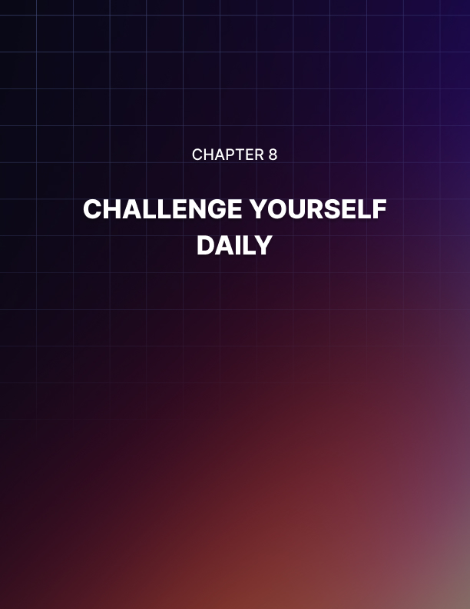

Chapter 8: Challenge Yourself Daily

On a daily basis, you have to ask yourself a series of questions. More importantly, you have to take action on these questions. You have to answer these and take these actions.

Can I Produce More?
It doesn‟t matter what kind of job you do. Maybe you're a teacher. Perhaps you‟re construction worker. Possibly, you're a business person. Ask yourself, “Can I produce more units?”

When you ask yourself this question repeatedly, it triggers your internal imagination, resourcefulness and creativity. Things start to fall into place because you are an evolving learning organism. You learned certain things in the past, and you're able to connect the issues that you have now with the things that you have witnessed or experienced in the past.
Eventually, things fall into place.

Unfortunately, that is not going to happen if you do not ask yourself this question repeatedly. This dynamic applies to the following questions as well.

Can I Produce Higher Quality Work?
Don't settle for the quality that you‟re producing now. See if you can step it up.

Can I Network Better?
As the old saying goes, “Two heads are better than one.” It's absolutely true because we're all different. We‟re all limited and, oftentimes, we look at the world in our own limited way. We end up developing tunnel vision.

If you network with people who look at whatever puzzles you're struggling with from a completely different perspective, your chances of solving that problem go up tremendously. Network as much as possible.

Try to learn from as many people as possible. Sure, they may have a very toxic personality. Some of them may be flat-out unpleasant, but try to learn from them anyway.

Can I Reduce My Work Time?
Look at the amount of time you're putting into your work. Ask yourself if you can dramatically reduce the amount of effort you put into your daily tasks. You can do this through automation. You can do it through software. You can do this through networking, delegation or outsourcing.

Ask yourself if you're doing enough to reduce your work time. Now, you're doing this not because you want to slack off. You‟re doing this so you can invest that freed-up time to further automation or further efficiency.

Can I Automate Better?
If you are not automating your tasks, then you are not doing it right. I don‟t care what kind of work you do. There's always space for automation. So, try to find a mobile app or a local installed piece of software or some other technological solution to automate what you‟re doing. It can be a small part or it can be a large chunk of your daily work.

Can I Pack More Value into My Work?
Value is crucial to how much money you make. Let me tell you if you're complaining about your salary, it's because the value you produce is fixed at a certain level. If you want your boss to get excited by giving you a pay raise, increase the value of your work. This can take two forms: either you produce more units or you increase the quality of each unit you manage to produce.

Can I Solve More Problems?
I understand a lot of people don't intentionally look for problems. In fact, if you're a normal person, you would try to stay away from problems as much as possible. Believe me I understand that.

However, if you are looking to maximize your effectiveness, you have to look at problems for what they truly are. They are opportunities to step up your game.

Let‟s put it this way. What doesn't kill you makes you stronger. So, that should be your attitude regarding your problems.

Can I Connect the Dots Better for Innovative Breakthroughs?
Not only should you challenge the things that you're doing; you should also challenge your mindset or your problem-solving skills. This doesn't have to involve a massive overnight explosion. As long as you are intentional about this, you will achieve some breakthrough.

It doesn't have to be big, but every little breakthrough you achieve can be scaled up. So, focus on connecting the dots better. Don‟t assume that you've figured everything out. Always look at whatever challenges you face with a fresh set of eyes.

Personal Effectiveness is Like a Muscle
Remember, if you want to boost your personal effectiveness, understand that it's no different from going to the gym. When you first hit the gym and your muscles aren‟t used to the weights, you're going to feel like crap in the morning. However, the more you work out and the more you put pressure on your muscles; the leaner, the stronger and the more powerful they become.

The same applies to your personal effectiveness. For it to grow, it has to be challenged. So, put yourself in difficult situations. Don't ignore challenges. You have to put a lot of stress on your ability to solve problems and your ability to function effectively. Otherwise, you‟re going to stagnate. You‟re not doing yourself any favors.



Chapter 9: Document Your Journey for Maximum Control

Please understand that when you keep a journal for personal effectiveness, you're doing this not because you have nothing else better to do. You're doing this because you want to control the process.

Boosting effectiveness is not something done on a whim. It's not something that you do casually. It takes calculated action. It takes a lot of analysis, and you have to be strategic about it. This is why you have to keep a personal effectiveness journal. Here's how you do it.

Track Your Journey
The first thing that you need to do is to focus on tracking. This means you need to record who you were before and after you've decided to become more effective. When you look at who you were and your level of performance when you started, you can‟t help but get motivated.

Maybe you are one week from your start date or maybe you're several months. Whatever the case may be, you're going to be in a better position than when you started. Allow yourself to get pumped up and motivated.

You should also track your solutions. Every journey is going to involve some pothole or some sort of challenge. Overcoming these, of course, involves solutions. Track them. See if you can get a clear idea of how you came up with a solution and figure out how to improve these solutions.

Look at the results that you‟ve been producing and ask yourself, “Are these the very best results that I can achieve? Am I capable of more?” Ask yourself, “Can I do more? How do I get better quality?”

As you go through your journey, you should be able to document certain tweaks and modifications to your personal efforts. Learn from these. Isolate these.

Isolate Your Challenges in Writing
The worst thing that you can do is to just emotionally accept that you're going through a tough time. That‟s the worst thing that you can do. Why? You're just going on a feeling.

You have to write these challenges down. You have to clearly define and isolate these challenges. Break them up into small parts. When you write them down, you can then start researching solutions to them and start running experiments.

This is the most effective way of changing your behavior so whatever challenges you run into will not derail your progress. They're not going to throw you off track. They‟re not going to make you emotional.

Instead, if you keep repeating this process over and over again, you will never run into a problem that will throw you off. You won't automatically assume that something is “impossible”.

Instead, you know that you have taken care of these challenges in the past because you‟ve attacked them systematically and methodically. You can do the same again and again far into the future. All it took was isolating your challenges in writing.

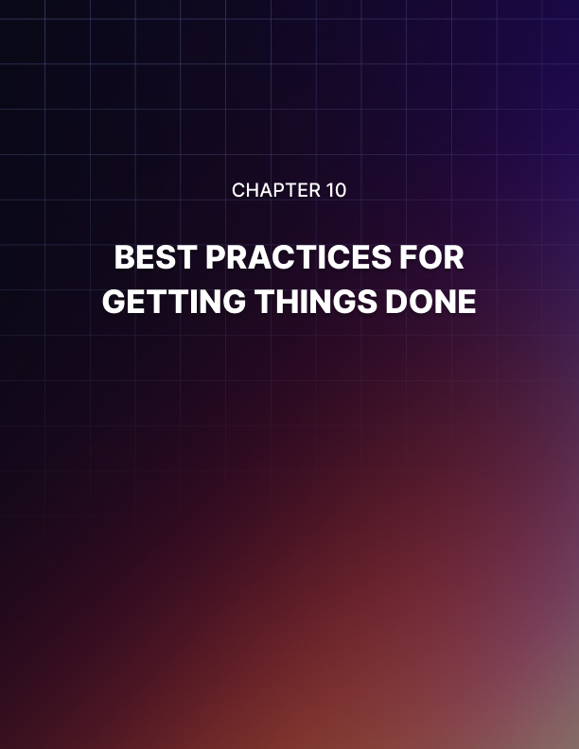

Chapter 10: Best Practices for Getting Things Done

These are some best practices that you should adopt if you would like to become a more effective person. Not all these best practices apply to all people. They don‟t apply across the board. However, if you see any of these applying to your set of circumstances, don't hesitate to adopt them.

Start Now
I don't care what's going on in your life, but you have to commit to starting now. I know it may seem inconvenient. You probably are tempted to hold things off until tomorrow.

However, let me tell you, tomorrow will never come. The more you keep saying to yourself there is always a tomorrow, the more you doom yourself. You‟re just giving yourself an out. You're giving yourself excuse after excuse not to start. You're giving into your fear.

Don't do that. Resolve to start now. Of course, what I mean by that is not immediately, but starting at a certain predefined date. However, regardless of what you're feeling, when that date comes, you snap into action and start.

Every Baby Step Forward You Take is a Victory
A lot of people are under the impression that if they are looking to boost their personal effectiveness that they have to get out of the gate like some sort of Kentucky derby thoroughbred. Absolutely wrong.

You don't have to get out of the gate like a champion. You can take baby steps. That‟s okay. As long as those steps are consistent, you are making progress. Always remember that every baby step forward you take is still a step forward. In other words, it's still a victory.

Every Failure is a Victory in Disguise
When you run into a snag, don't allow yourself to get emotionally down. Seriously. When you run into a problem, you get an opportunity. You get to learn how to fix problems.

More importantly, you learn how to change your personal character to get poised for greater success. Your failures don't have to define you. Your emotional stress doesn't have to derail your forward progress to eventual victory. Focus on the big picture and, most importantly, focus on solving problems in the here and now to take you one step closer to your eventual goal.

Now, understand that sometimes when you attack the front door, you can't make any progress. That is the cue you need to go through the side door. If that is sealed off or is unavailable, try the roof or the basement. Whatever you do, keep trying.

Focus on Building Systems
People who fail are focused on hacks. They're focused on figuring out what to do at the right time at the right place. Now, this is a problem because you're basically just betting that you will get lucky.

Oftentimes, luck doesn't appear when you need it. So, focus instead on building a system. It's not terribly sexy, but it's effective. It's all about having the right sequence of tasks that you do so you can tackle whatever comes your way.

Get Enough Sleep
If you really want to give your all to your daily tasks every single day, get enough sleep. When you get enough sleep, you get enough willpower. Willpower is the “currency” that you pay to achieve things every single day.

Improve the quality and length of your sleep so you can have the resources you need to accomplish things that truly count every single day.

