Table of Contents
Introduction 4
Chapter 1: Introducing Google Ads with AI 6
The Evolution of Online Advertising 6
The Emergence of Google Ads with AI 8
Google's Evolution to AI-Powered Ads 9
What Is AI and How Does AI Work in Advertising? 10
Chapter 2: Understanding Google Ads with AI 13
How AI Powers Google Ads? 13
How Google Ads, powered by AI, is helping marketers 14
How Marketers Can Benefit from Artificial Intelligence in Their Google Campaigns 14
Key Features and Capabilities 15
Key Features of Generative AI, including its application in Google Ads 15
Benefits for Advertisers 16
Chapter 3: Getting Started with Google Ads with AI 20
Setting Up Your AI-Enhanced Ad Campaign 20
How AI Can Help You with Google Ads 20
Navigating the Google Ads Interface 22
Best Practices for Beginners 23
Chapter 4: Performance Insights 26
What are performance insights? 26
Types of Performance Insights in Google Ads 28
How do you use performance insights to improve your campaigns? 29
Understand Key Metrics 29
Chapter 5: Audience Targeting and Personalization 32
Leveraging AI for Precise Audience Segmentation 32
Understanding AI and its role in Google Ads 33
The Future of Audience Segmentation in Google Ads 33
Traditional vs. Google Ads with AI-Powered Segmentation 33
Dynamic Ad Personalization 34
Understanding Dynamic Google Ads 35
The Role of AI-Powered Personalization 36
The Future of Advertising 37
Chapter 6: Ad Creatives and Copywriting 39
AI-Generated Ad Copy 39
Advantages of AI-Generated Ad Copy 40
The Future of Google Ads with AI 40
Creating Engaging Ad Creatives 41
The Power of Ad Creatives in Google Ads 41
Chapter 7: The Future of Google Ads with AI 45
Predictive Analytics and Trends 45
Emerging Trends in Google Ads with AI 46
Ongoing Innovations 47
The Advantages of These Innovations for Advertisers 48
How AI Continues to Shape Online Advertising? 49
Chapter 8: Challenges and Considerations 51
Ethical Concerns in AI Advertising 51
Adapting to Changes and Challenges 53
Chapter 9: How to Use AI in Google Ads 56
Choosing the right AI-powered features for your business 56
Choosing the Right AI Features in Google Ads 56
Tips for choosing the right AI features 58
Setting up and managing your AI-powered campaigns 58
Understanding AI in Google Ads 59
Ways to Make Your Ads More Effective 59
Elevate Ad Creativity 59
Analyzing your results and making adjustments 60
The Power of Data Analysis 60
Tips for using AI to analyze your Google Ads results and make adjustments 61
Chapter 10: Case Study on Google Ads with AI 63
The Impact on Revenue and Customer Experience 63
Conclusion 66



Introduction
In the ever-evolving digital marketing realm, the synergy of Google Ads with AI expertise represents a monumental leap forward. This dynamic fusion of advanced technology and advertising strategies has fundamentally transformed how businesses connect with their audiences, driving a paradigm shift in online advertising.
By leveraging the power of AI, advertisers can save time, improve performance, and gain a deeper understanding of their customers. With AI, advertisers can focus on their goals, while Google Ads takes care of the rest.
The constant evolution of Artificial Intelligence is reshaping the landscape of online advertising. As AI's capabilities expand, its integration with Google Ads is becoming increasingly vital for businesses seeking a competitive edge. Through this training guide, you will explore the symbiotic relationship between Google Ads and AI expertise, unveiling the remarkable ways they work to revolutionize the digital marketing landscape.
Let's get started on this path!
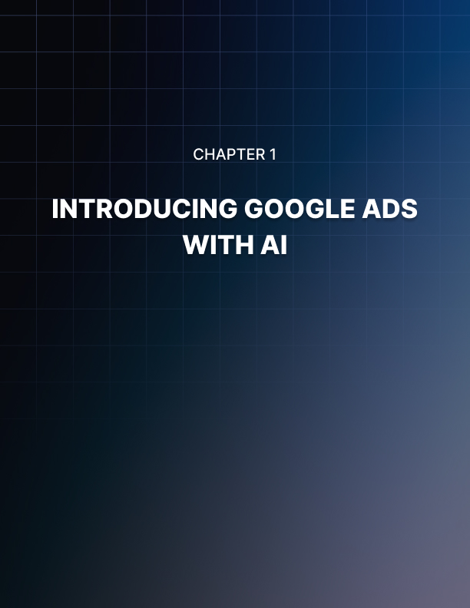

Chapter 1: Introducing Google Ads with AI
Google Ads, a leading online advertising platform, has harnessed AI's immense power to deliver more innovative, efficient, and highly effective advertising campaigns. AI is the driving force behind data-driven decision- making, allowing advertisers to harness the vast reservoirs of information available on the internet. It empowers businesses to decipher complex consumer behaviors, identify patterns, and extract actionable insights. With AI's guidance, advertisers can tailor their messages with surgical precision, ensuring that their ads reach the right audience at the right time, resulting in higher engagement, better conversion rates, and, ultimately, greater returns on investment.

As we navigate this chapter, we will unveil how Google Ads, enriched with AI capabilities, is reshaping the future of online advertising, opening up exciting possibilities for businesses in an increasingly competitive digital world.

The Evolution of Online Advertising
Online advertising has come a long way since its inception, and its evolution mirrors the rapid changes in technology, consumer behavior, and the digital landscape. Over the years, it has grown from simple static banners to highly sophisticated, data-driven, and personalized campaigns. Understanding this evolution is crucial for businesses seeking to navigate the ever-shifting currents of the digital marketing world.
The Era of Banner Ads:
The era of banner ads started in 1994 with the first clickable web ad in HotWired magazine, marking a new period in online advertising. Initially considered a novelty, these ads generated website revenue but had limited effectiveness.
However, they evolved with more engaging designs and improved targeting over time, becoming a significant part of online advertising by the early 2000s.
Yet, the rise of ad blockers in recent years has reduced their effectiveness as these tools prevent users from seeing ads on websites, impacting the reach of banner ads.
The Rise of Search Advertising:
Web advertising before 1998 consisted of banner advertisements generally priced by the number of impressions delivered (i.e., Cost-Per-milli (CPM) pricing).
In 1997, Yahoo first returned banner advertisements based on search queries on its website. GoTo.com (renamed Overture in 2001 and acquired by Yahoo! in 2003) created the first sponsored search auction, followed by Google’s first sponsored search auction in 2002.
Social Media Advertising:
The rise of social media has ushered in a new era of advertising. In the past, businesses relied on traditional forms of advertising such as television, radio, and print to reach their target audience. However, with the advent of social media, businesses now have a more direct and personal way to connect with potential customers. Social media advertising offers several advantages over traditional forms of advertising. First, it is more targeted. Businesses can use social media platforms to target their ads to specific users based on their demographics, interests, and behaviors. This helps to ensure that ads are seen by people likely to be interested in them.
Personalization and Data-Driven Advertising:
Today, personalization is key. Thanks to AI and big data, advertisers can create highly tailored ads based on user behavior and preferences. This level of personalization has transformed online advertising, increasing engagement and conversion rates.
Native Advertising:
When native advertising stepped into the digital age, it took on a new level of sophistication and relevancy. Although the basic premise of native advertising remained the same, digital media opened up many possibilities for brands to enlist in their quest to reach potential customers.
The future promises further evolution as we stand at the forefront of online advertising. Emerging technologies, like augmented reality (AR), virtual reality (VR), and voice search, are poised to reshape the digital advertising landscape once again. Advertisers must remain agile, adapting to the ever- changing digital environment and leveraging new tools and techniques to stay ahead in the competitive world of online advertising. The journey of online advertising is far from over, and it continues to be an exciting and transformative ride.

The Emergence of Google Ads with AI
AI-powered Google Ads are online advertising that uses AI to help marketers create and optimize their ads, reach the right audiences, and measure their results.
With AI's data-driven capabilities, advertisers can dissect complex consumer behaviors, identify patterns, and extract actionable insights from vast datasets. This knowledge allows for creating highly tailored ad content that resonates with specific target audiences, leading to higher engagement, conversion rates, and, ultimately, better returns on investment.
Moreover, AI-driven tools in Google Ads offer real-time tracking and optimization, ensuring campaigns can adapt swiftly to the ever-evolving dynamics of the digital advertising landscape. Integrating AI with Google Ads has opened up exciting possibilities, making it a vital chapter in the evolution of online advertising.
AI-powered Google Ads can help you achieve your marketing goals faster and more efficiently with features such as:
Responsive search ads.

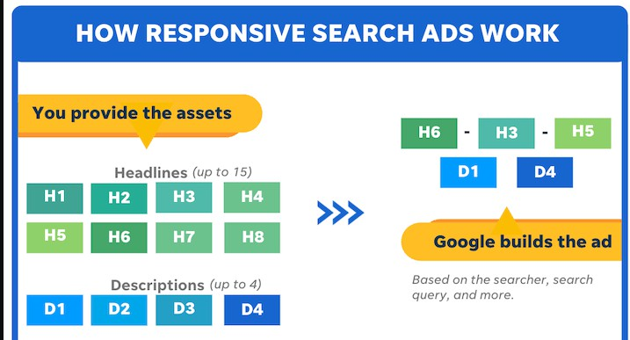
These ads automatically generate the best combination of headlines and descriptions for each user's search query based on the assets you provide.

Responsive search ads can help you create more relevant and personalized ads, increase your ad performance, and simplify your ad management.
Performance Max campaigns.
These campaigns use Google's AI to deliver your ads across all of Google's inventory, including Search, Display, YouTube, Gmail, and Discover. Performance Max campaigns can help you find new customers, unlock additional performance opportunities, and accelerate your business growth.

Google's Evolution to AI-Powered Ads
Google's move to AI-powered ads reflects a commitment to delivering more personalized and effective advertising. In the early days of online advertising, ads were static and not specific to users. However, as Google collected more user data, delivering more relevant ads through contextual targeting became possible, where ads match the content users view. With a deeper understanding of user behavior, Google introduced behavioral targeting, delivering ads based on a user's browsing history, ensuring even greater relevance.
The advertising landscape shifted profoundly as Google's understanding of user behavior expanded. The emergence of behavioral targeting became possible, allowing ads to be displayed based on a user's past browsing history. This level of personalization went beyond just the current content and delved into a user's online journey, significantly enhancing the relevance and engagement of the ads. The result was a more dynamic and user-centric advertising experience.
Examples of AI-Driven Google Ads in Action
Experience from Rothy's, an eco-conscious footwear brand, demonstrates the prowess of Performance Max. This entirely AI-driven campaign covers Google's inventory: Search, YouTube, Display, Discover, Gmail, and Maps.
Performance Max harnessed Google's AI to determine the ideal combination of ad structures, creative elements, bids, and targeting for every channel and auction.
The journey of Discovery+, a streaming service, further underlines Performance Max's impact across Google's offerings. Entrusting their aspirations and budgets to Performance Max's AI capabilities, Discovery+ witnessed transformative outcomes. Performance Max leveraged machine learning to fine-tune Discovery+'s campaigns toward customer acquisition while supplying insights for improving their creative assets and audience strategies.
The emergence of Google Ads with AI signifies a dynamic transformation in how businesses connect with their target audiences. This strategic marriage of AI's data-driven decision-making with Google Ads' extensive reach offers a promising chapter in the journey of online advertising, promising advertisers unprecedented opportunities for relevance and success in the evolving digital realm.
Significance of AI in Advertising
AI has become a game-changer in the advertising industry, reshaping how businesses connect with their target audiences, optimize campaigns, and achieve remarkable results.
The significance of AI in advertising cannot be overstated, as it revolutionizes multiple facets of this dynamic and highly competitive field.

What Is AI and How Does AI Work in Advertising?
AI is a branch of computer science that leads to designing computer programs that can simulate human intelligence. With programs that can reason, learn, and act autonomously, they can make decisions, solve problems, and understand complex concepts like humans.
Furthermore, AI is gaining popularity due to its application in different industries, such as HR, education, and retail, helping humans resolve complex issues and develop credible solutions.
It has acquired various significances:
Enhanced Targeting
AI empowers advertisers to target their audiences with pinpoint accuracy. By analyzing vast datasets and user behavior, AI can identify the most relevant demographics and consumer segments, ensuring that ads are delivered to those most likely to engage and convert. This level of precision maximizes ad effectiveness and minimizes ad spend wastage.
Improved Efficiency
The automation of advertising tasks through AI streamlines operations and increases efficiency. Bidding strategies, ad placement, and even the creation of ad variations can all be optimized with minimal human intervention, saving time and resources while delivering better results.
Personalization
AI enables highly personalized ad content creation. Machine learning algorithms can analyze user preferences, behaviors, and purchase histories to tailor ad messages and recommendations, creating a more engaging and relevant user experience. Personalized ads are not only more effective but also foster stronger brand-customer relationships.
The significance of AI in advertising is profound. It empowers advertisers to engage their audiences with highly relevant and personalized content while increasing operational efficiency and campaign performance. AI optimizes ad campaigns by fine-tuning targeting, bidding strategies, and content delivery in real time. This results in more effective and efficient advertising, as budgets are allocated judiciously, and resources are directed where they yield the best results. Advertisers who master AI technology are not only better equipped to meet current market demands but also to anticipate and adapt to future trends, staying at the forefront of a dynamic and ever- evolving industry. In essence, AI empowers advertisers to not only lead the way in delivering compelling advertising experiences but also to maintain their competitive edge as they navigate the intricacies of the advertising landscape.
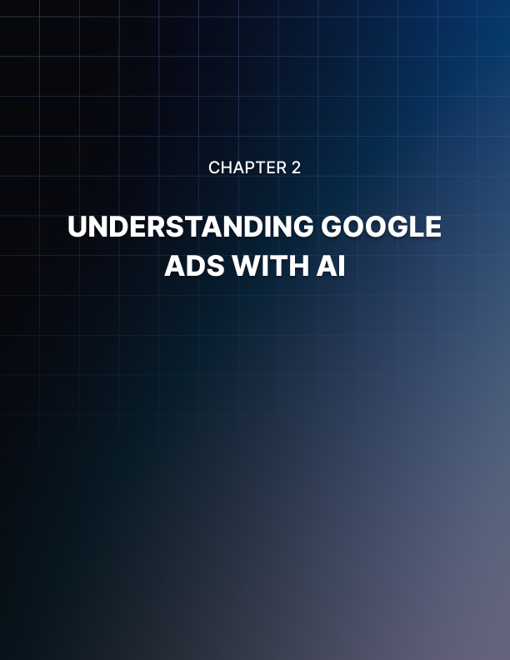

Chapter 2: Understanding Google Ads with AI
Online advertising has evolved into a dynamic and intricate landscape in the digital age. The emergence of AI has played a pivotal role in reshaping the advertising industry, enabling businesses to reach their target audiences more effectively and efficiently. Among the various advertising platforms available, Google Ads stands as a prominent and versatile tool. This chapter explores the synergistic relationship between AI and Google Ads, delving into how AI technologies have revolutionized the advertising experience.
Through this exploration, we aim to unravel the fundamental principles and strategies that underlie the successful integration of AI in Google Ads, shedding light on the symbiotic potential of these two transformative forces in the digital advertising sphere. Overall, AI is a powerful tool that can help you improve your Google Ads campaigns. By using AI to set suitable bids, reach the right people, and create relevant ads, you can get more out of your advertising budget and achieve your marketing goals.

How AI Powers Google Ads?

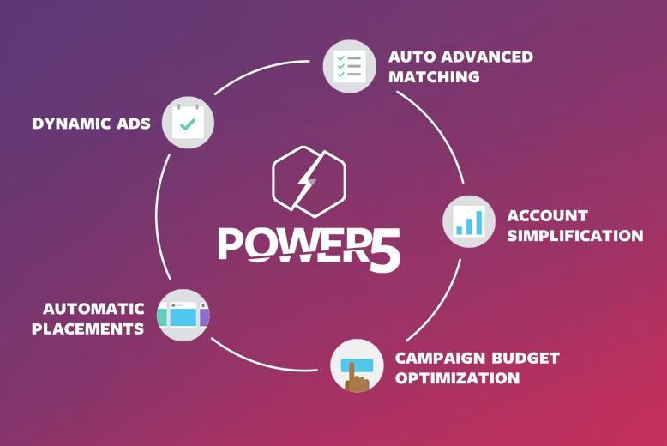
In the ever-evolving world of digital advertising, one name stands out as a trailblazer: Google Ads. With its vast reach and diverse advertising options, Google Ads has become a cornerstone of online marketing for businesses of all sizes.

In this topic, we will delve into the symbiotic relationship between AI and Google Ads, exploring how AI has become the driving force behind its success.

How Google Ads, powered by AI, is helping marketers
For over a decade, Google has led AI development, and AI plays a crucial role in Google Ads. This includes using AI to create responsive search ads and optimize bids for every auction.
Why use AI for Google Ads
Access to unprecedented amounts of data empowers marketers with precision and clarity. With defined objectives and specific targeting, AI steps in to streamline tasks, eliminating the mundane and leaving you with the essentials. Embracing AI is essential for staying competitive, as it enables you to work smarter, not harder, ensuring efficiency and agility in the ever- evolving marketing landscape.
New Customer Acquisition Objective
A notable addition is a feature to target new customers more effectively, enabling campaigns to prioritize recent customer acquisitions over existing ones, potentially leading to a more extensive customer base, increased revenue, and reduced acquisition costs.

How Marketers Can Benefit from Artificial Intelligence in Their Google Campaigns
Artificial Intelligence has become a hot topic of discussion, and for good reason. It continually introduces innovative tools that assist professionals across various fields in saving time, fostering creativity, conserving resources, and boosting performance. Google's AI-powered search ads mark a new chapter in the platform's evolution, emphasizing enhanced results for advertisers and user experiences. By offering personalized ads, automating ad creation and delivery, and expanding testing capabilities, these features promise to revolutionize online advertising. As more companies embrace AI in their advertising strategies, we can anticipate more inventive and efficient campaigns, a development that benefits marketers and consumers.
AI has undoubtedly become the driving force behind the success of Google Ads. It empowers advertisers to optimize their campaigns, target the right audience, and achieve better results with less effort. However, it's crucial to approach AI-powered advertising ethically, ensuring that data privacy and transparency is upheld. As AI continues to evolve, we can expect Google Ads to become even more effective and precise in delivering advertising campaigns that meet the needs of businesses and consumers alike. The future of advertising is here, and it's AI-driven.

Key Features and Capabilities
In the fast-paced world of digital marketing, staying ahead of the curve is essential for success. Google Ads, one of the most influential advertising platforms, has harnessed the power of AI to provide advertisers with a range of sophisticated tools and capabilities. These AI-driven features have not only transformed the way businesses advertise but have also made the process more efficient and effective. In this topic, we explore the key features and capabilities of Google Ads with AI and how they have revolutionized the advertising landscape.

Key Features of Generative AI, including its application in Google Ads

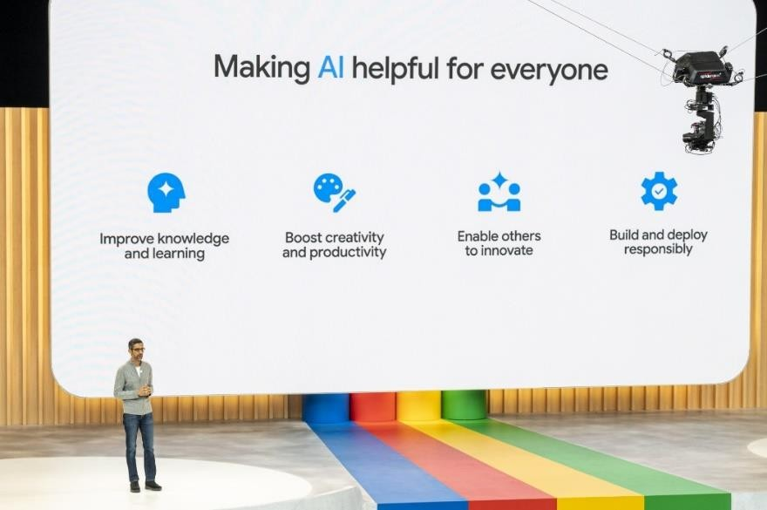
Generative AI encompasses a set of features that enable it to produce content, images, or other data that are both original and valuable. Its applications extend to various domains, including Google Ads, where it plays a crucial role in content creation and ad personalization.

In the context of Google Ads, generative AI can dynamically generate ad copy, images, and even videos, tailoring them to specific audiences. This capability has a profound impact on ad relevance, click-through rates, and overall campaign effectiveness. It allows advertisers to create and test ad variations efficiently, enhancing the user experience and ultimately driving better results.
AI is also used throughout Google Ads to improve the platform's overall performance. For example, AI is used to:
- Detect and prevent fraud
- Improve the relevance of search results
- Optimize the delivery of ads
- Measure the performance of campaigns
As AI evolves, advertisers can expect even more advanced features and capabilities to emerge. Google Ads with AI represents a win-win situation for both marketers and consumers. Marketers can reach their audience more precisely and efficiently, while consumers benefit from more relevant and personalized advertisements.

Google Ads with AI has ushered in a new advertising era characterized by data-driven precision, automation, and personalization. As the digital marketing landscape continues to evolve, businesses that leverage the power of AI in their advertising strategies will be better positioned to succeed in a highly competitive market.

Benefits for Advertisers
Given below are some benefits of AI for smarter Google Ads that marketers must take advantage of:
Improved Ad Relevance
Artificial intelligence allows Google Ads to analyze landing pages and ad copy to match their relevance to the users’ search queries. As such, it shows relevant ads to the viewers, increasing conversions. This relevance is a significant factor in improving the user experience and ensuring optimum usage of the ad budget.

Accurate Audience Targeting
AI makes Google Ads highly accurate and targeted, analyzing user data such as search queries, user behavior, and browsing history.
Leveraging this data, AI in digital marketing generates comprehensive user profiles and delivers ads precisely to the target audience, including existing customers.
Increased Competitiveness
With Google Ads AI being the talk of the town, businesses can take advantage of this sophisticated technology to stay ahead of the game. As they make positive changes in their local campaigns and create effective ads, they will have the edge over competitors who may need AI-driven Google Ads for marketing.
Continuous Improvement
AI-driven testing and optimization are transformative processes within advertising, playing a pivotal role in the evolution and enhancement of ad campaigns.

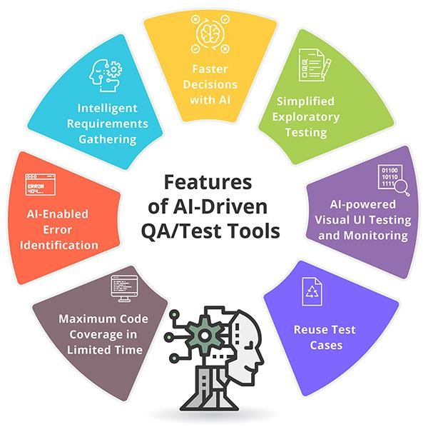
These strategies, powered by AI, are designed to respond dynamically to changing market conditions and improve overall campaign performance.

Remarketing
AI algorithms identify people who have interacted with your business in the past and show even the slightest bit of interest in its products and services.
AI and machine learning fuel marketers and businesses to succeed in today’s dynamic industry. Employing appropriate AI tools and strategies allows companies to achieve their marketing objectives efficiently, leading to high- performing ads, increased ROI, and overall business growth.
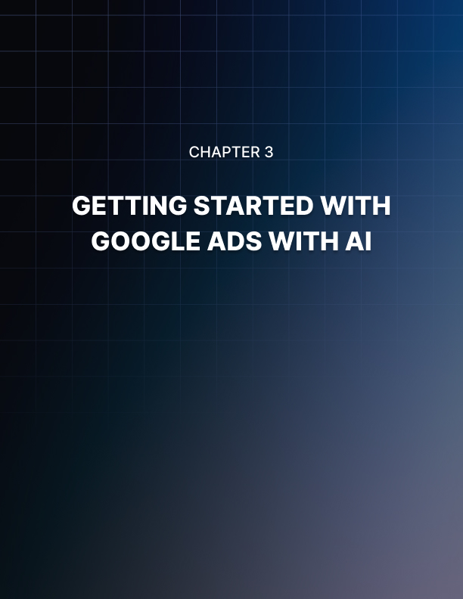

Chapter 3: Getting Started with Google Ads with AI
In the ever-evolving world of digital marketing, staying ahead of the competition requires harnessing the power of technology. Google Ads, one of the most influential advertising platforms, has undergone a significant transformation with the integration of AI. This fusion of AI and advertising has unlocked a wealth of opportunities for businesses looking to enhance the efficiency and effectiveness of their ad campaigns.
In this chapter, we embark on a journey to explore the seamless convergence of Google Ads and AI, providing you with the essential knowledge and tools to get started on a path that leads to more dynamic and data-driven advertising endeavors. Whether you're a seasoned marketer or a newcomer to online advertising, understanding how to leverage AI in Google Ads is your gateway to reaching the right audience, optimizing budgets, and achieving better results.

Setting Up Your AI-Enhanced Ad Campaign
In the ever-evolving digital marketing landscape, staying competitive requires embracing cutting-edge technologies. AI has emerged as a game- changer, and Google Ads is at the forefront of this transformation. Leveraging AI in your advertising campaigns can provide a substantial advantage, enabling you to reach your target audience more effectively and efficiently. This chapter will guide you through setting up an AI-enhanced Google Ad campaign, ensuring you maximize this powerful tool.

How AI Can Help You with Google Ads

Targeting and Audience Segmentation
Google Ads and Facebook Ads use AI for audience targeting, categorizing users based on online behavior. While this helps advertisers reach their target audience, AI-generated segments may be flawed, so testing different audiences is crucial.
Utilizing Google's AI-based segmentation enhances understanding of your target customers, creating more resonant ads and increasing engagement, click-through rates, and conversions.
Keyword Optimization
AI can also help you optimize your keyword targeting by analyzing search query data and identifying new opportunities. This can lead to more efficient ad spend and increased conversions. It's essential to continually monitor your keyword performance and adjust bids and targeting to maximize your results.
AI and Search Ads
In search ads, AI helps determine which keywords are more likely to convert and adjusts your ad rank accordingly. This means that the top ad is only sometimes the one that pays the most but rather the ad that aligns best with Google's guidelines.
Here are some specific steps you can take to set up an AI- enhanced Google Ads campaign:
Create a new campaign
When creating a new campaign, select one of the AI-powered campaign types, such as a Performance Max or Smart Shopping campaign.
Set your campaign goals
When setting your campaign goals, be sure to select a plan that is aligned with one of the AI features that you want to use. For example, if you use Smart Bidding, you should choose a goal such as Increase conversions or Maximize conversions.
Provide audience signals
When creating your campaign, you will be prompted to provide audience signals. Be sure to give as much information as possible about your target audience.
Launch your campaign
Once you have created your campaign and provided the necessary information, you can launch your campaign.
Setting up an AI-enhanced Google Ad campaign requires a clear understanding of your objectives, an in-depth analysis of your target audience, and a commitment to ongoing monitoring and optimization. With AI as your ally, you can harness the power of data-driven advertising to reach your goals more efficiently and effectively than ever before. Embrace the future of advertising with AI, and watch your campaigns soar to new heights.

Navigating the Google Ads Interface
In digital advertising, Google Ads stands as a colossus, offering businesses a powerful platform to reach a global audience. However, to harness the full potential of this platform, one must navigate its intricate interface.
In this topic, we will embark on a journey to explore the essentials of navigating the Google Ads interface, providing you with the knowledge and tools needed to make the most of this influential advertising tool.
Google Ads Interface
Upon signing in to your Google Ads account, you'll be on the Overview Page. This page offers a quick performance review and provides essential insights, serving as your initial destination upon logging in.
The Navigation Panel
To navigate through your campaigns and ad groups, utilize the left-hand navigation panel. On smaller screens, this panel may be initially hidden. To make it visible, click either the menu or arrow icon in the top-left corner. Using this panel, you can filter your campaigns and ad groups, purifying the content displayed in your primary account workspace.
The Page Menu
The page menu is next to the navigation panel, which provides swift access to key features. It lets you navigate between various account sections like Ad groups, Ads & extensions, or Keywords. The page menu adapts its options based on your current location in the navigation panel, showing only the relevant choices for the selected Campaign or ad group. The content in your main workspace is directly related to your navigation panel selection. For example, if you're looking at a particular ad group and select the settings page, the information and actions pertain specifically to that ad group's settings.

Your Campaigns
To create and manage campaigns, go to the Campaigns page by selecting All campaigns in the navigation panel and then clicking Campaigns in the page menu. To make a new campaign, use the blue + button. For adding ad groups, keywords, or ads, click the relevant page in the menu and look for the same blue + button.
Check Your Campaign Performance
To see campaign performance, go to the Campaign in the Page menu or click Ad Groups, Keywords, or Ads to see more.
Your Keywords
Click Keywords in the Page menu to continue. Keep an eye on your keywords. Keywords match your relevant ads to searches people make on Google.
The Tool Icon
Access essential optimization and planning tools by clicking the tool icon. Features like Billing & payments, Keyword Planner, Conversions, and Audience manager are in the main tool menu.

Best Practices for Beginners
In the world of digital advertising, Google Ads is a powerful tool that allows businesses to connect with their target audience and reach their marketing goals. Integrating AI into Google Ads has made advertising more accessible and practical for beginners. However, harnessing the full potential of this combination requires a clear strategy and understanding of best practices. In this topic, we'll explore the best practices for beginners using Google Ads with AI to help you get started on the right foot.
Set Clear Goals and Objectives
Having well-defined objectives will guide your campaign strategy and help you measure success.
Understanding the Target Audience
AI in Google Ads excels at audience segmentation. Understand your target audience's demographics, interests, and behaviors. Knowing your audience allows you to create more tailored and effective ad campaigns.
Keyword Research and Optimization
In a Search campaign, keywords are crucial. Conduct keyword research to identify relevant search terms that your target audience uses. Utilize AI- powered tools to optimize your keyword selection and improve ad performance.
Choose the Right Campaign Type
Google Ads offers various campaign types: Search, Display, Video, and App. Select the campaign type that aligns with your objectives. Starting with a Search campaign is often a good choice for beginners, as it allows you to display text ads when users search for relevant keywords.
Keyword Research and Optimization
In a Search campaign, keywords are crucial. Conduct keyword research to identify relevant search terms that your target audience uses. Utilize AI- powered tools to optimize your keyword selection and improve ad performance.
Google Ads with AI offers a powerful platform for beginners to reach their target audience and achieve their advertising goals effectively. By following these best practices, beginners can make the most of AI-driven advertising, ensuring their campaigns are efficient and successful. As you gain experience, you can refine your strategies and explore advanced features to maximize your advertising ROI.


Chapter 4: Performance Insights
In the fast-paced and data-driven landscape of online advertising, success hinges on one's ability to reach the right audience and fine-tune campaigns for optimum results. Enter Google Ads with AI, a dynamic platform that has redefined the rules of engagement in the digital advertising arena. With the integration of AI, Google Ads offers a wealth of performance insights that empower advertisers to make informed decisions, maximize ROI, and achieve their advertising objectives with unprecedented precision.
Performance insights in Google Ads with AI are a revelation for advertisers, allowing them to tap into the power of data-driven decision-making. These insights offer a window into the performance of campaigns, keywords, and ad groups. In this chapter, we will embark on a journey to explore the world of performance insights in Google Ads with AI, uncovering the tools and strategies that can elevate your digital advertising campaigns to new heights.

What are performance insights?
Performance insights in Google Ads with AI are a revelation for advertisers, allowing them to tap into the power of data-driven decision-making. These insights offer a window into the performance of campaigns, keywords, and ad groups.
Key performance insights and metrics involve:
Click-through rate (CTR)
It is a crucial metric in Google Ads that measures the percentage of people who see and click on your ad. A high CTR is important because it indicates that your ads are relevant and interesting to your target audience.
Conversion Rate
This metric tracks the percentage of users who take a desired action, such as purchasing or filling out a form, after clicking on an ad.
Quality Score
Quality Score is a diagnostic tool in Google Ads that measures the quality of your ads, keywords, and landing pages. A high-quality Score can help you improve your ad performance and reduce costs.
Audience Insights.
Information on user demographics, interests, and behaviors helps target audience and segment.
Keyword Performance.
Insights into how well specific keywords perform regarding CTR, conversion rate, and cost per click.
Specific examples of how AI is used to provide performance insights in Google Ads:
Auction insights
Auction insights show you how your ads are performing in auctions against your competitors. This information can help you identify areas where you need to improve your bids or ad quality.
For example, you may need to increase your requests if competitors are often outranking your ads.
Conversion insights.
Conversion insights show how your conversions are happening across different channels, devices, and audience segments. This information can help you understand which touchpoints are most important to your conversions and how you can optimize your campaigns accordingly.
AI is also used throughout Google Ads to give advertisers insights into their campaign performance. Overall, AI provides advertisers with various performance insights that can help them improve their Google Ads campaigns. Using these insights, advertisers can get more out of their advertising budget and achieve their marketing goals.

Types of Performance Insights in Google Ads
Google Ads offers a variety of performance insights that can help you improve your campaigns. These insights can be categorized into four main types:
Auction insights
Auction insights show how your ads perform against your competitors in auctions. This information can help you identify areas where you need to improve your bids or ad quality.

Asset insights
Asset insights show how your ad assets, such as headlines, descriptions, and images, perform. This information can help you identify which investments resonate with your target audience and which ones need improvement.
Conversion insights
Conversion insights show your conversions across different channels, devices, and audience segments. This information can help you understand which touchpoints are most important to your conversions and how you can optimize your campaigns accordingly.
Budget and spend insights
Budget and spend insights show how your budget and spending are distributed across your campaigns. This information can help you identify areas to allocate your resources more efficiently.

Advertisers can use these performance insights to improve their campaigns in various ways. For example, if auction insights show that competitors often outrank your ads, you may need to increase your bids or improve your ad quality. If asset insights illustrate that a particular ad asset is performing poorly, you may need to replace it.
If conversion insights show that a specific conversion path is converting well, you may want to invest more heavily in that path. If budget and spend insights show that you are overspending on a particular campaign, you may need to reduce your budget.

How do you use performance insights to improve your campaigns?
In the fast-paced world of digital advertising, understanding your campaign's performance is crucial to achieving optimal results. Google Ads, armed with AI, offers an array of performance insights that allow advertisers to make data-driven decisions and refine their ad campaigns for greater effectiveness. This topic explores leveraging these performance insights to supercharge your Google Ads campaigns with AI.

Understand Key Metrics
It would help if you first grasped the critical performance metrics to improve your Google Ads campaigns with AI. These include Click-Through Rate CTR, Conversion Rate, Quality Score, Impressions, and more.
Regularly Monitor and Analyze Data
Consistent monitoring of your campaign's performance is vital. AI-equipped Google Ads provide real-time data on various metrics, allowing you to keep a close eye on the progress of your campaigns.
Refine Targeting Strategies
AI can analyze audience insights to help you better understand your target audience. Leverage this data to refine your targeting strategies. Adjust demographics, interests, and behaviors to align with your campaign objectives. This targeted approach will result in more efficient ad delivery.
Optimize Budget Allocation
Review your budget allocation across different campaigns and ad groups. Performance insights can reveal which campaigns deliver the best results and which need adjustments. Allocate more budget to high-performing campaigns and scale back on underperforming ones to maximize ROI.
Tips for using performance insights to enhance your Google Ads with AI campaigns:
Use filters to segment your data.
Google Ads allows you to filter your performance data by various criteria. This can help you to identify trends and opportunities for improvement in specific areas of your campaigns.
Use AI to predict future performance.
Google Ads offers a variety of AI-powered tools that can help you to predict future performance. This can help you to make better decisions about your campaigns and to budget more effectively.

Specific examples of how you can use performance insights to enhance your Google Ads with AI campaigns:
Use Smart Bidding to automate your bidding strategy.

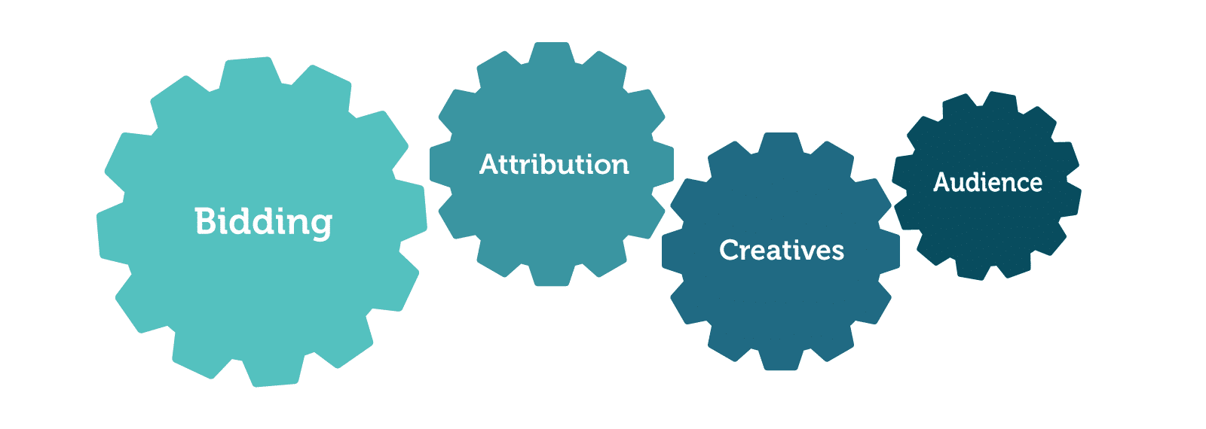
Smart Bidding is a set of automated bidding strategies that use AI to set bids for each auction in real-time. Smart Bidding can help you achieve your campaign goals without manually managing your requests.

Use audience targeting to reach the right people.
Audience targeting allows you to target your ads to people based on their interests, demographics, and other factors. Use AI to create and manage your audience lists. Performance insights to improve your Google Ads campaigns with AI is an intelligent strategy for any advertiser. These insights provide a data-driven roadmap to refine your campaigns, target the right audience, optimize your budget, and achieve better results.
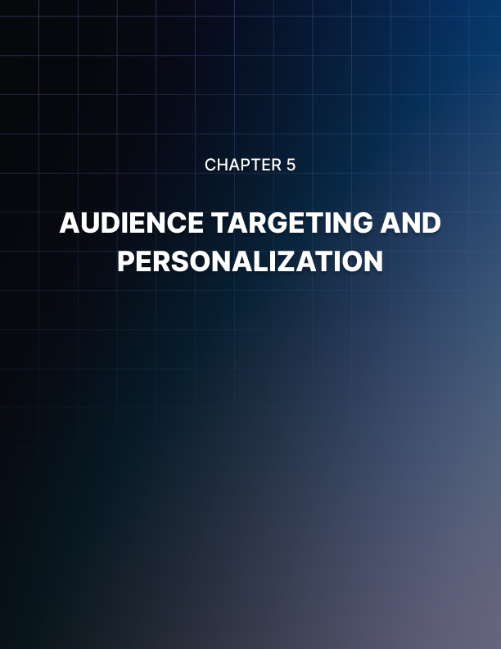

Chapter 5: Audience Targeting and Personalization
In the vast universe of online marketing, reaching the right audience with the right message is the ultimate goal. The rise of AI has redefined how we approach this challenge, and Google Ads stands at the forefront of this transformative journey. As we delve into the captivating realm of audience targeting and personalization in Google Ads with AI, we explore how technology is revolutionizing digital advertising. This chapter takes you on a tour through the present and future of precision marketing, where AI is the guiding star.
In the age of data-driven decision-making, the synergy of creativity and technology is powering digital advertising. Google Ads with AI epitomizes this fusion. As advertisers, marketers, and businesses strive to connect with their audience on a more personal and engaging level, AI-driven audience targeting and personalization have become the cornerstones of success. Join us in uncovering the possibilities, strategies, and transformative potential of audience targeting and personalization in Google Ads with AI.

Leveraging AI for Precise Audience Segmentation
In digital advertising, the ability to reach the right audience is paramount to the success of any marketing campaign. Google Ads, one of the most popular and influential advertising platforms, provides businesses with a wide range of tools and features to reach their target audience effectively. However, as the digital landscape becomes increasingly competitive, the importance of precise audience segmentation must be balanced. This is where AI steps in as a game-changer.
Audience segmentation divides your potential customers into groups based on specific characteristics such as demographics, interests, behaviors, etc. Google Ads has long offered manual audience segmentation tools, often relying on broad categorizations and limited data analysis. This is where AI comes into play, offering a more sophisticated and data-driven approach to audience segmentation.

Understanding AI and its role in Google Ads
AI, or artificial intelligence, allows machines to mimic human thinking and perform tasks that typically need human intelligence. In Google Ads, AI enhances campaigns through advanced algorithms and data analysis. AI examines extensive data, spotting patterns to help nonprofits make informed choices and boost their ad performance. Using AI in Google Ads offers nonprofits multiple advantages, including better targeting, improved ad content creation, and more efficient campaign management.
AI can be leveraged for precise audience segmentation of Google Ads in some ways, involving:
Machine learning is used to analyze first-party data.
AI-driven algorithms can examine your data, like customer purchase records, website traffic, and email lists, to find patterns. With this, you can make precise audience groups, like customers who left their shopping carts or visitors who looked at a specific product page often.
Using AI to identify new customer segments.
AI can find new customer groups you have yet to consider, like people similar to your current customers or those interested in related products. This helps you broaden your reach and gain new customers.

The Future of Audience Segmentation in Google Ads
As AI technology advances, the potential for audience segmentation in Google Ads will only grow. AI will help advertisers gain a deeper understanding of their audience, enabling hyper-personalized advertising experiences that yield remarkable results. In this journey toward precision, a symbiotic relationship between AI and human creativity is vital. While AI excels in data analysis and segmentation, the human touch remains essential in crafting compelling ad creatives and maintaining a brand's authenticity.

Traditional vs. Google Ads with AI-Powered Segmentation
In the realm of Google Ads with AI, traditional segmentation methods, which rely on demographics and psychographics, have been adequate to a certain extent. However, they must catch the dynamic shifts in customer behaviors and preferences.
In contrast, AI excels at processing extensive data, uncovering patterns and trends that human analysts might miss.
This data-driven approach provides a deeper and more nuanced understanding of the target audience in Google Ads.
Specific examples of how AI-powered audience segmentation can be used to improve Google Ads campaigns:
Upselling and cross-selling to existing customers.
AI can help you spot trends in your customers' buying habits, which can be used to develop campaigns for upselling and cross-selling. For instance, if you run a women's clothing store, you can group customers who recently bought dresses and promote complementary items like shoes or accessories to enhance their outfits.
Targeting new customers based on their interests.
AI can help you discover potential customers interested in products related to yours. For instance, if you sell pet supplies, you can find people who visit pet training or pet care websites and show them ads for your pet products.
Leveraging AI for precise audience segmentation in Google Ads is not merely a trend but a strategic imperative. It's about reaching the right audience with remarkable precision, a feat that AI makes not only possible but also scalable. Embrace the transformative potential of AI in audience segmentation and stay at the forefront of the competitive landscape of digital advertising.

Dynamic Ad Personalization
In the fast-paced world of digital advertising, reaching the right audience with the right message at the right time is the ultimate goal. As competition intensifies, advertisers constantly seek innovative ways to make their ads stand out and engage potential customers.

One of the most potent tools in their arsenal is dynamic Google Ads with AI- powered personalization. This dynamic duo is revolutionizing the advertising landscape, enabling brands to deliver highly relevant and tailored content to their audience. In this chapter, we'll explore what dynamic Google Ads with AI-powered personalization are, how they work, and the benefits they offer to advertisers.

Understanding Dynamic Google Ads
Dynamic Google Ads DSAs are a type of ad that uses your website content to create ads and landing pages tailored to what users are searching for. They're great if you have a well-established website or a large inventory. To set up a DSA campaign, you provide Google with your website or product feed. Google uses this information to automatically generate ad headlines and landing pages when users search for relevant keywords or phrases. DSAs can be effective for reaching new customers and boosting sales. Still, it's essential to note that they can be pricier than keyword-based campaigns because you're paying for Google's ad content generation service.

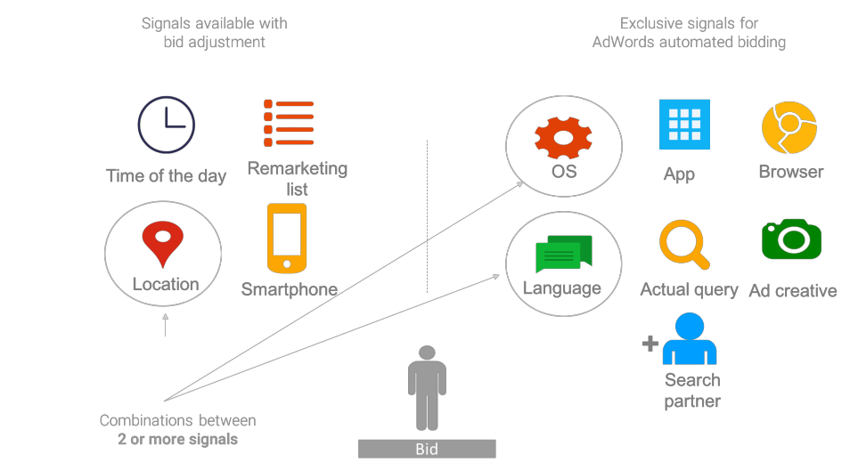

The Role of AI-Powered Personalization
AI-powered personalization is the secret sauce that makes dynamic Google Ads so effective. Artificial Intelligence, specifically machine learning, is harnessed to analyze vast amounts of data and make split-second decisions on tailoring the ad content for each viewer.
AI-powered personalization can be used in a variety of ways, such as:
E-commerce
Retailers can use AI to personalize product recommendations, search results, and email marketing campaigns. For example, an online retailer could use AI to recommend products to customers based on their past purchase history and browsing behavior.
Media and entertainment
Streaming services and social media platforms can use AI to personalize content recommendations. For example, a streaming service could use AI to recommend movies and TV shows to users based on their viewing history and ratings.
Travel and hospitality
Travel websites and hotels can use AI to personalize flight recommendations, accommodations, and activities. For example, a travel website could use AI to recommend flights to users based on their past travel destinations and preferences.
Benefits of Dynamic Google Ads with AI-Powered Personalization:
Enhanced Relevance
Dynamic Google Ads ensure that the content presented to users is highly relevant to their interests and needs. This increased relevance leads to higher click-through rates and conversion rates
Time Efficiency
With AI handling the personalization process, advertisers save valuable time that would be spent manually creating and managing multiple ad variations.

The Future of Advertising
The future of advertising in Google Ads with AI is poised to be a dynamic landscape where artificial intelligence continues to drive innovation and effectiveness. AI will enable hyper-personalization of ad content, leading to more relevant and engaging user experiences.
Advertisers will leverage AI-powered tools to optimize campaigns, harness predictive analytics, and enhance targeting, ensuring ads reach the right audience at the right moment. Ethical AI usage and privacy-compliant strategies will be paramount in an environment with increasing data regulations.
Moreover, as AI technology evolves, advertisers must adapt to new AI capabilities, including augmented reality and voice search, in their advertising strategies, fostering a more interactive and immersive ad environment that adapts to changing user behaviors and preferences.
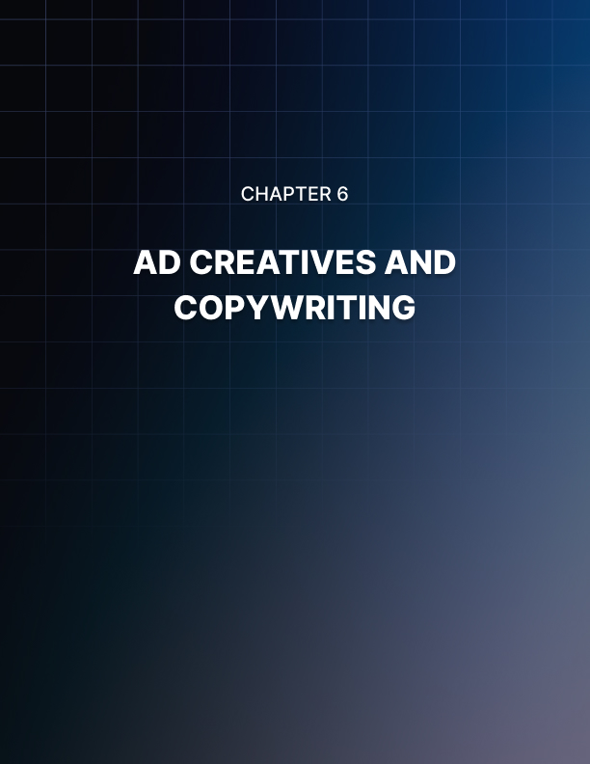

Chapter 6: Ad Creatives and Copywriting
In the dynamic world of online advertising, the quest for the perfect formula to capture a user's attention, engage their interest, and drive them to take action has been a longstanding challenge for marketers. This quest has led to a transformative partnership between Google Ads and AI. Ad creatives and copywriting, essential elements of any advertising campaign, are being reinvented through the power of AI.
In this digital age, where personalization, relevance, and efficiency are paramount, the integration of AI in Google Ads is revolutionizing how businesses craft compelling ad creatives and persuasive copy, offering a pathway to greater engagement and improved campaign performance. This chapter delves into the exciting world of ad creatives and copywriting in Google Ads with AI, exploring the innovations, benefits, and future of this dynamic duo in online advertising.

AI-Generated Ad Copy
In the ever-evolving digital marketing landscape, staying ahead of the curve is crucial. Google Ads, a prominent and influential platform for online advertising, has been at the forefront of adopting cutting-edge technologies to help businesses connect with their target audiences effectively. One such transformative technology is AI-generated ad copy, a game-changer in online advertising.
AI-generated ad copy reshapes how businesses create, test, and optimize ad content. It leverages artificial intelligence to craft compelling, data-driven ad copy that resonates with audiences and drives better results. In this article, we'll explore the world of AI-generated ad copy in Google Ads, how it works, and its advantages to advertisers.
Understanding AI-Generated Ad Copy
AI-generated ad copy in Google Ads is text for ads made using artificial intelligence. AI ensures the ad copy matches what users are searching for and is appealing and persuasive. Various methods exist for AI-based ad copy generation. For instance, pre-trained AI models like GPT-3 which have learned from vast datasets, can be employed to create text, handle language translations, produce creative content, and provide informative responses to questions.

How AI-Generated Ad Copy Works?
Generative AI, a facet of AI, uses data patterns to create custom ad copy. It leverages customer data, employs techniques like natural language processing and machine learning, and is harnessed by tools like Adcreative.ai, helping marketers craft engaging, conversion-focused ad text.

Advantages of AI-Generated Ad Copy
Scalability
AI-generated ad copy can be scaled to meet the needs of even the most prominent marketing campaigns. AI can generate thousands or even millions of ad variations in seconds. This is impossible for human copywriters to do.
Personalization
AI-generated ad copy can be personalized to each user. AI can consider factors such as the user's search history, demographics, and interests to generate ad copy that is more likely to resonate with the user.
Examples of how AI-generated ad copy can be used to improve the performance of Google Ads campaigns:
Responsive Display Ads
AI can be used to generate responsive display ads that are optimized for different devices and placements. This can lead to higher engagement and reach.
Dynamic Search Ads
AI can be used to generate dynamic search ads that are tailored to each user's search query. This can lead to higher click-through rates and conversion rates.

The Future of Google Ads with AI
Generative AI is transforming Google Ads by enabling personalized ad creation. These algorithms analyze vast user data to identify trends and preferences, helping advertisers design tailored ads. The key benefit lies in creating dynamic ads that adapt to the user's context, adjusting based on location, device, and search history. This boosts ad relevance, engagement, and, ultimately, click-through and conversion rates.
Overall, AI-generated ad copy can be a powerful tool for improving the performance of Google Ads campaigns. By leveraging the advantages of AI, businesses can create more scalable, personalized, creative, and cost- effective ad copy.

Creating Engaging Ad Creatives
In the ever-competitive landscape of online advertising, the ability to capture the attention of your target audience has become paramount. Google Ads, a cornerstone of digital marketing, offers a powerful platform to reach potential customers, businesses increasingly turn to AI to create engaging ad creatives that resonate with their audience.

The Power of Ad Creatives in Google Ads
Ad creatives are the heart of successful Google Ads. They include visuals and text like headlines, descriptions, images, and videos, significantly affecting your click-through rates, conversion rates, and ROI. Crafting engaging ad creatives is an art involving understanding your audience's behavior and creating content that speaks to their needs. AI has become a powerful ally, helping businesses connect with their audience effectively.
How AI-Powered Ad Creatives Work
- The AI model is given a product or service to advertise, as well as a target audience.
- The AI model analyzes its dataset of existing ad creatives to identify patterns and trends.
- The AI model uses this information to generate new ad creatives that are relevant to the product or service, the target audience, and the patterns and trends that it has identified.
- The AI model outputs the generated ad creatives in a format that can be used in Google Ads.
AI-powered ad creatives are already being used by businesses of all sizes to improve the performance of their marketing campaigns. Some of the examples are given below:
E-commerce
E-commerce businesses are using AI to generate personalized ad recommendations for each user based on their past purchase history and browsing behavior. This can increase click-through rates and conversion rates.
Travel

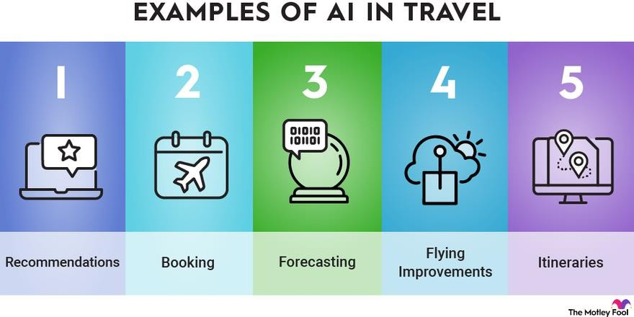
Travel websites are using AI to generate dynamic ad creatives that are tailored to the user's search query and location. This helps ensure that users are seeing the most relevant ads.

Software
Software companies are using AI to generate ad creatives that highlight the key benefits of their software for different industries and job roles. This can help to reach a wider audience and generate more leads.
As AI technology continues to evolve, the future of Google Ads is set to be more personalized, efficient, and data-driven. AI-powered ad creatives will play a pivotal role in helping businesses connect with their audience in a more meaningful way. As marketers continue to embrace these innovations, they'll find themselves at the forefront of a new era in digital advertising, where the fusion of creativity and data optimization redefines success in the online marketplace. AI-powered ad creatives are not just about capturing attention; they're about forging lasting connections with customers and driving superior results in the competitive world of online advertising.

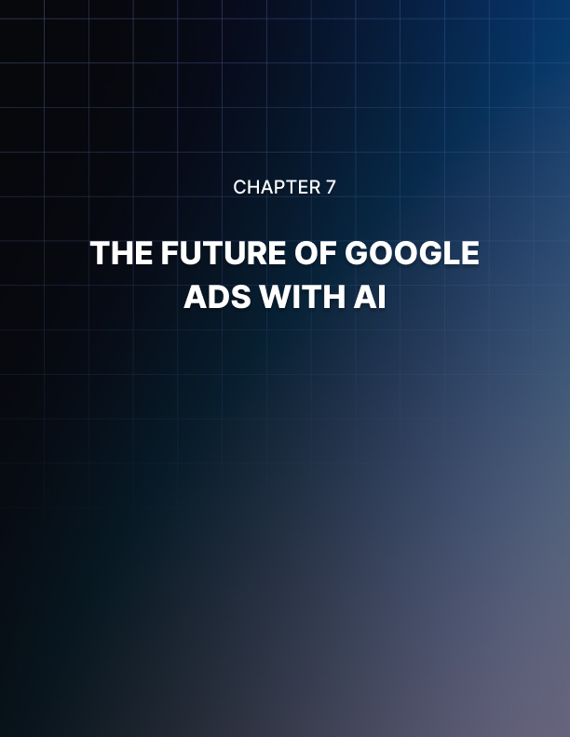

Chapter 7: The Future of Google Ads with AI
In an era defined by rapid technological advancements and the ever-evolving landscape of digital advertising, the integration of AI has emerged as a game- changing force in online marketing. Among the most prominent players in this transformation is Google Ads, a platform that has continually adapted to harness the power of AI to revolutionize the way businesses connect with their target audience.
As we embark on this journey into the future of Google Ads with AI, we find ourselves at the intersection of innovation and opportunity, where the synergy of machine intelligence and human creativity promises to reshape the advertising landscape in ways we are only beginning to comprehend. This chapter will delve into the exciting developments in AI-powered advertising and the profound implications it holds for businesses, marketers, and consumers alike.

Predictive Analytics and Trends
In online advertising, staying ahead of the curve is a perpetual challenge. As the digital landscape evolves, businesses constantly seek innovative ways to engage with their target audiences effectively. One such innovation that has reshaped the advertising landscape is the infusion of AI into platforms like Google Ads. AI has opened the door to predictive analytics, enabling advertisers to anticipate trends, understand consumer behavior, and optimize their advertising campaigns with unprecedented precision.
Understanding Predictive Analytics
Predicting the future, even in small ways, aids in better preparation for business and life.
Just as weather forecasts guide our clothing choices, forecasts of holiday shopping trends, coupled with Google Ads with AI, enable companies to stock the right products and tailor their advertising strategies.

Emerging Trends in Google Ads with AI
Search Ads Relevance with Generative AI
As AI plays a more significant role in advertising, advertisers must adapt to changes in user behavior and PPC strategies due to evolving search experiences. Google's search engine utilizes NLP and machine learning to match user queries with expected search results.
Generative AI in Performance Max
Google Ads' Performance Max feature employs generative AI to create personalized text and image assets, tailoring ad content to the target audience and campaign objectives. This innovative tool maximizes ROI through real-time ad optimization using advanced machine learning algorithms.
Examples of how these emerging trends are being used in Google Ads today:
Scene Generation
This feature uses AI to generate lifestyle product imagery from essential product photos for merchants, eliminating the need for expensive and time- consuming photoshoots.
Remove Background
This feature allows advertisers to create distraction-free product imagery by removing the background from their photos.
Increase Resolution
This feature allows advertisers to improve the quality of their images so they appear clear and focused on phones with higher resolution.
Here are some key aspects where predictive analytics with AI is making a substantial difference:
Audience Targeting
To succeed in advertising, it's vital to target the right audience. Predictive analytics with AI enable advertisers to create precise customer profiles by analyzing past data and predicting engaged audiences. This ensures highly personalized and well-targeted campaigns.
Ad Copy and Creatives
AI-driven predictive analytics assess ad elements like copy and images, helping advertisers craft compelling ads by identifying what resonates with the audience, resulting in improved click-through rates and campaign performance.
As AI technology advances, advertisers should embrace these trends to ensure they remain at the forefront of the evolving world of Google Ads. The future is undeniably AI-powered, and those who harness its capabilities stand to reap the rewards of more effective, efficient, and engaging online advertising.

Ongoing Innovations
In the ever-evolving realm of online advertising, Google Ads stands at the forefront of innovation. As businesses strive to connect with their target audiences in increasingly competitive digital spaces, the integration of AI within the platform has not only been transformative but also heralds a future marked by ongoing innovations. Here, we explore some of the most exciting and continuing advancements in Google Ads powered by AI.
Smart bidding to help businesses.
With this new approach, Google has taken the need for guessing the bid price out of the picture. With Machine Learning, the Google Smart Bidding option will create the best ad campaign within your budget.
It would help in maximizing conversions, targeting cost per acquisition, and improving your return on investment.
Prioritizing Target Audiences Over Keywords in Search Engine Marketing
With new features allowing the selection of target audiences, Google Ads allows efficient utilization of advertisement expenditure.
Automation and AI enhance ad campaigns with guidance
With more data available for machine learning algorithms to function, human intervention can be reduced.
Enhanced Shopping Campaigns
For e-commerce businesses, Google Ads with AI is a boon. Enhanced Shopping Campaigns use machine learning to optimize product listings. Ongoing developments include the ability to showcase products on additional Google platforms and use innovative shopping campaigns for even better performance.

The Advantages of These Innovations for Advertisers
Stay up-to-date on the latest AI features
Google is constantly releasing new AI features in Google Ads, so it's essential to stay up-to-date on the latest developments. You can do this by reading the Google Ads blog, following the Google Ads Help Center, and attending Google Ads webinars and events.
Experiment with new AI features
As new AI features are released, experiment with them to see how they can help you improve your campaign performance. Google often offers beta programs for new AI features so you can try them out before they are released to the general public.
Use AI to automate tasks
AI can automate many tasks that advertisers must manually do, such as keyword research, bidding, and ad optimization. This can free up your time to focus on other aspects of your business, such as developing new products and services.
The collaboration between Google Ads and AI is an ongoing journey filled with innovation. As AI technologies continue to evolve, advertisers can expect even more effective and efficient advertising campaigns. The ability to harness the power of AI and stay attuned to these ongoing innovations will be crucial for businesses looking to remain competitive in the dynamic landscape of online advertising. As the future unfolds, it promises exciting possibilities for advertisers willing to embrace the potential of AI in Google Ads.

How AI Continues to Shape Online Advertising?
In the ever-evolving world of online advertising, AI has emerged as a transformative force that has fundamentally altered the landscape for businesses and consumers. AI, with its data-driven insights and automated decision-making capabilities, continues redefining the creation, delivery, and optimization. As we delve into the digital age, it's clear that AI is not just a trend but a pivotal component that will continue to shape the future of online advertising.
AI in SEO is Enhancing Search Rankings and User Experience
AI-driven algorithms are driving SEO success. From semantic search to natural language processing, search engines are getting more competent at understanding user intent. Brands that embrace AI-powered SEO strategies gain a competitive edge in search rankings and deliver seamless user experiences that keep visitors returning for more.
AI-Enhanced Content Marketing, Redefining Creativity
AI is transforming content creation, automating the generation of engaging blog posts, social media content, and product descriptions, saving time without compromising quality. Brands can use AI-generated content for consistent audience engagement and direct their efforts toward crafting creative high-level strategies.
The Rise of Chatbots and Conversational Ads
AI-driven chatbots are pivotal in online advertising, engaging users in real time, answering queries, and steering them through the sales funnel. Beyond immediate assistance, they gather valuable data on user preferences, enhancing ad targeting.
AI's impact on online advertising is not a passing trend but a fundamental shift in how businesses and consumers interact digitally. The ongoing evolution of AI in advertising promises more personalized, efficient, and effective campaigns.

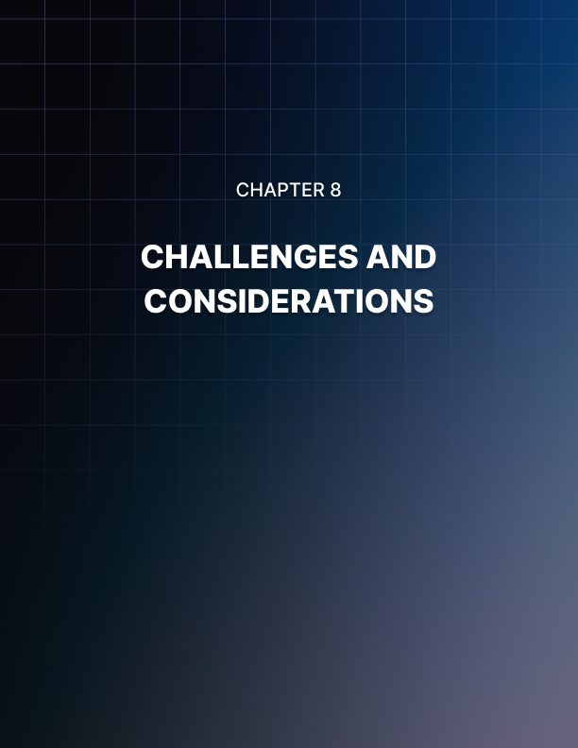

Chapter 8: Challenges and Considerations
In the fast-paced and dynamic realm of online advertising, staying competitive and relevant has become an intricate dance between human expertise and AI capabilities. Google Ads, a cornerstone of digital marketing, has evolved significantly with the infusion of AI technologies. While this fusion has brought tremendous potential, it has also introduced a complex web of challenges and considerations that advertisers and businesses must navigate.
In this chapter, we embark on a journey to unravel the challenges and considerations inherent in Google Ads with AI. From the complexities of algorithm-driven bidding strategies to the ethical dimensions of data usage, we will dissect the intricate landscape where artificial intelligence meets digital advertising, shedding light on the intricacies that demand careful thought and strategy from advertisers and marketers alike.

Ethical Concerns in AI Advertising
The rapid advancement of AI has transformed the landscape of digital advertising, offering unparalleled targeting capabilities and campaign optimization tools. Google Ads, one of the most widely used platforms for online advertising, has harnessed the power of AI to enhance ad campaigns and deliver more personalized content to users. While this AI-driven evolution has undeniably improved the effectiveness of online advertising, it has also raised profound ethical concerns.
Challenges faced while using AI in Google Ads:
Lack of transparency and control
One of the biggest challenges of using AI in Google Ads is more transparency and control. Advertisers often need more insight into how AI algorithms make decisions, making it difficult to troubleshoot problems or optimize campaigns.
Addictive Design and User Exploitation
AI can be used to optimize ad delivery and engagement, which may lead to addictive design elements aimed at keeping users on a platform for more extended periods.
Over-reliance on AI
It is important to remember that AI is a tool, not a replacement for human expertise. Advertisers should be more responsive to AI to manage their Google Ads campaigns.
Transparency and Accountability
The opacity of AI algorithms and the decision-making processes of digital platforms can create ethical challenges. Advertisers should strive for transparency in their practices and be accountable for the content they disseminate.
Considerations taken while using AI in Google Ads:
Data privacy
Advertisers should know the data privacy implications of using AI in Google Ads. AI algorithms need access to large amounts of data to learn and make decisions. Advertisers should ensure that they are collecting and using data in a compliant and ethical manner.
Brand safety
AI-generated ads can risk brand safety, especially if not carefully monitored. Advertisers should take steps to ensure that their AI-generated ads are aligned with their brand values and that they do not appear on inappropriate websites.
Performance measurement
It can be challenging to measure the performance of AI-powered Google Ads campaigns. This is because AI algorithms are constantly learning and changing, and it can be challenging to isolate the impact of AI from other factors that affect campaign performance.
The integration of AI in Google Ads has undeniably transformed the advertising landscape, offering powerful tools to reach and engage with target audiences. However, we must confront the ethical concerns associated with AI advertising head-on.
Responsible data handling, combating algorithmic bias, avoiding manipulation and deception, ensuring transparency, and respecting user privacy are all essential components of ethical advertising.
Ultimately, striking a balance between the effectiveness of AI advertising and the ethical considerations it raises is crucial. It is the responsibility of advertisers, marketers, and digital platforms to uphold the highest ethical standards, prioritizing user trust and well-being. As AI continues to shape the future of advertising, ethical considerations must remain at the forefront to ensure that technology serves society responsibly and ethically.

Adapting to Changes and Challenges
In the dynamic world of digital advertising, staying competitive and effective often hinges on adapting to technological advancements. AI has emerged as a game-changer, particularly when integrated into Google Ads. While AI promises enhanced targeting, better campaign optimization, and improved ROI, it also brings various challenges that advertisers must address and adapt to effectively. In this topic, we explore the changes and challenges encountered while using AI in Google Ads and offer strategies for successful adaptation.
AI is transforming Google Ads in several ways, including:
Simplified campaign management
AI is also simplifying campaign management for advertisers. For example, Smart Recommendations suggests advertising campaign changes that can improve performance. AI can also be used to automate tasks such as reporting and budgeting.
Improved campaign performance
AI is helping advertisers to improve their campaign performance by optimizing their bids, targeting, and creativity. For example, Smart Bidding uses machine learning to set recommendations automatically based on various factors, such as user behavior and conversion history. This can help advertisers to get more conversions for their budget.

Increased creativity and personalization
AI is also helping advertisers to create more creative and personalized ads. For example, responsive search ads allow advertisers to enter multiple headlines and descriptions, and Google's AI will automatically test different combinations to find the ones that perform best. AI can also personalize ad content based on user data, such as location and interests.
Strategies for Adapting to AI-Driven Changes and Challenges:
Ethical Considerations
Ensuring adherence to ethical standards is a fundamental imperative in AI- driven advertising, especially when using platforms like Google Ads. It entails the responsibility of advertisers to align their practices with principles that prioritize transparency, safeguard user privacy, and uphold the ethical utilization of AI technologies within their Google Ads campaigns.
To achieve this, advertisers must commit to conducting comprehensive and rigorous assessments of their advertising content and the parameters used for targeting while also adhering to Google's advertising policies and guidelines.
Diversified Marketing Channels
To reduce reliance on a single channel, consider diversifying marketing efforts. Utilizing a mix of platforms and strategies can help mitigate risks associated with potential changes or challenges in one specific medium.
Collaboration and Communication.
Effective communication between marketing and IT departments is essential. Collaboration ensures that AI implementation aligns with business objectives, complies with regulations, and adapts to the changing landscape.
Adapting to changes and challenges using AI in Google Ads is an ongoing process. Embrace AI as a powerful tool to enhance your advertising efforts and be prepared to evolve as it continues to shape the digital marketing landscape.
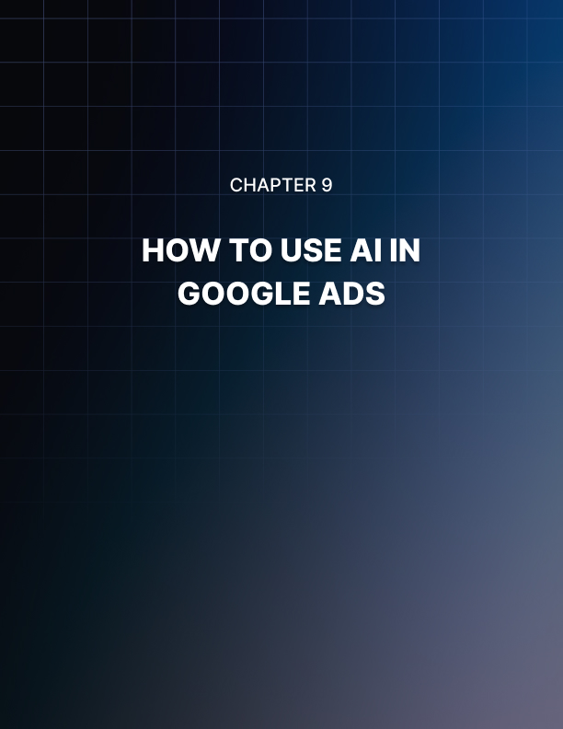

Chapter 9: How to Use AI in Google Ads
In the ever-evolving digital advertising landscape, harnessing the capabilities of AI has emerged as a pivotal strategy for businesses seeking to achieve remarkable results with their online campaigns. Google Ads, a dominant force in the advertising world, offers a powerful platform for implementing AI to optimize ad performance and reach the right audience.
Integrating AI within Google Ads is not just a trend; it's a transformative approach that empowers advertisers with data-driven decision-making, intelligent targeting, and ad personalization. In this chapter, we'll explore the practical steps, tips, and best practices for harnessing the power of AI to boost the performance of your Google Ads campaigns, from maximizing your return on investment to delivering highly relevant ads to potential customers.
Whether you're looking to enhance your existing campaigns or embark on a new advertising venture, this chapter will equip you with the knowledge and tools to use AI effectively in Google Ads.

Choosing the right AI-powered features for your business
In the dynamic world of online advertising, staying competitive and achieving your advertising objectives necessitates embracing the latest technological advancements. The integration of AI within platforms like Google Ads has revolutionized the way businesses create and manage their digital advertising campaigns.
However, selecting the right AI-powered features for your Google Ads business is a pivotal decision that can significantly influence the effectiveness of your advertising endeavors. In this topic, we will explore the essential considerations and best practices for choosing the most suitable AI-powered features to drive your Google Ads business forward.

Choosing the Right AI Features in Google Ads
Responsive Search Ads
These dynamic ads automatically adjust to different device types, ad placements, and user queries. Using AI, they test various combinations of headlines and descriptions to present the most effective ad to your target audience, ultimately improving ad performance and user engagement.
Audience Targeting

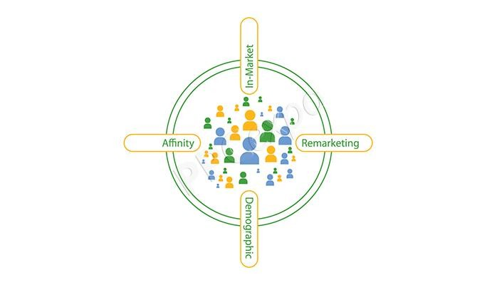
Google Ads has AI-powered ways to reach people likely to be interested in your products or services. These include targeting people actively searching for similar products or services or who share similar characteristics to your existing customers.

Ad Customizers
AI-driven ad customizers facilitate ad personalization based on user location, device, and other criteria. Personalization enhances ad relevance and engagement.
Dynamic Search Ads
DSA campaigns employ AI to create ad headlines and landing pages based on the content of your website. This can be particularly advantageous for businesses with extensive or frequently changing inventory.

Tips for choosing the right AI features
Thinking about the business goals.
Once you know your goals, you can identify the AI features to help you achieve them.
Consider the budget.
Some AI features, such as Smart Bidding, can be more expensive than others. However, it is essential to remember that AI features can help you improve your campaign performance, leading to a better ROI in the long run.
The field of AI in online advertising is continually evolving. Google Ads regularly introduces new features and updates. To remain at the forefront of your industry, it's imperative to stay informed about the latest developments and be prepared to adapt your strategy to leverage the most current AI capabilities for your Google Ads business.
Selecting the right AI-powered features for your Google Ads business necessitates a strategic understanding of your goals, a precise definition of your target audience, and the choice of AI features that align with your
advertising objectives. By effectively harnessing AI within Google Ads, your business can elevate campaign performance, reach the right audience, and ultimately attain success in the digital advertising arena.

Setting up and managing your AI-powered campaigns
In the rapidly evolving world of digital advertising, staying at the forefront of technology is not merely an advantage; it's a necessity. Integrating AI in platforms like Google Ads has become a game-changer for businesses looking to optimize their online advertising efforts. This article is your guide to effectively setting up and managing AI-powered campaigns in Google Ads. Whether you're a seasoned digital marketer or a newcomer to the online advertising arena, these insights will help you harness the full potential of AI to achieve your advertising goals.

Understanding AI in Google Ads
AI-Powered Training Platforms
You can find AI-driven training platforms that provide customized learning experiences for Google Ads. These platforms use AI to track your progress, find areas where you need help, and offer personalized lessons and quizzes to improve your understanding of Google Ads concepts.
Virtual Assistants
AI-enabled virtual assistants can be helpful to learning companions for Google Ads. These assistants can provide real-time advice, answer your questions, and provide practical ideas and best practices for optimizing your Google Ads campaigns. They may also analyze campaign data and provide actionable insights to help you improve your marketing efforts.

Ways to Make Your Ads More Effective
Harness AI for Real-Time Behavior Prediction
AI learns from diverse data sources like user history, demographics, browsing habits, and device preferences. It also understands the connection between keywords and campaigns. With this knowledge, AI can quickly spot which web searches will likely lead to conversions.
Suspend Underperforming Ads
AI empowers marketers to swiftly pause PPC ads that aren't delivering the expected return on investment (ROI). It's not cost-effective to keep bidding on ads that need to be fixed.

Elevate Ad Creativity
While AI can't replace human creative professionals, it can enhance their efforts, as demonstrated by Google's Responsive Search Ads (RSAs).
Marketers provide multiple headlines and descriptions for an RSA, and AI helps optimize the ad copy for improved effectiveness.
Setting up and managing AI-powered campaigns in Google Ads is a strategic process that involves clear goal-setting, the selection of the right AI features, data-driven decision-making, continuous optimization, and adaptation to new developments.

Analyzing your results and making adjustments
In online advertising, staying ahead of the curve is essential for businesses seeking optimal results. The integration of AI into platforms like Google Ads has revolutionized the way advertisers create and manage their digital campaigns. However, setting up AI-powered campaigns is just the first step.
In this article, we will explore the importance of analyzing your Google Ads results and how AI can assist you in making the proper adjustments to improve your campaign's performance.

The Power of Data Analysis
Data analytics is important because it helps businesses optimize their performances. Implementing it into the business model means companies can help reduce costs by identifying more efficient ways of doing business and storing large amounts of data.
Data analysis involves several steps:
- Define Data Requirements
First, determine how the data is categorized, which could be by age, demographics, income, or gender. Data can be numerical or categorical.
- Collect Data
Gather data from various sources like computers, online platforms, cameras, or personnel.
- Organize Data
Use software, like spreadsheets, to structure the data for analysis.

- Clean Data
Scrub and review the data to remove duplicates, errors, and incomplete information to ensure accuracy before analysis.

Tips for using AI to analyze your Google Ads results and make adjustments
Use Google Ads Performance Max to optimize your campaigns across all of Google's channels
Performance Max uses machine learning to optimize your ads across Search, Display, YouTube, and Shopping.
Use Responsive Search Ads for Google Ads testing to reach the right users
Responsive Search Ads use machine learning to determine which ad variation will perform well for each user.
Try Google Ads recommendations for campaign improvement suggestions
The recommendations tool uses machine learning to analyze your campaigns and suggest improvements.
Integrating AI in Google Ads offers a powerful opportunity to analyze and adjust your advertising campaigns continually. By harnessing the data insights and real-time adjustments AI provides, you can refine your strategies, optimize your campaigns, and ultimately achieve better results in the ever-competitive world of online advertising.
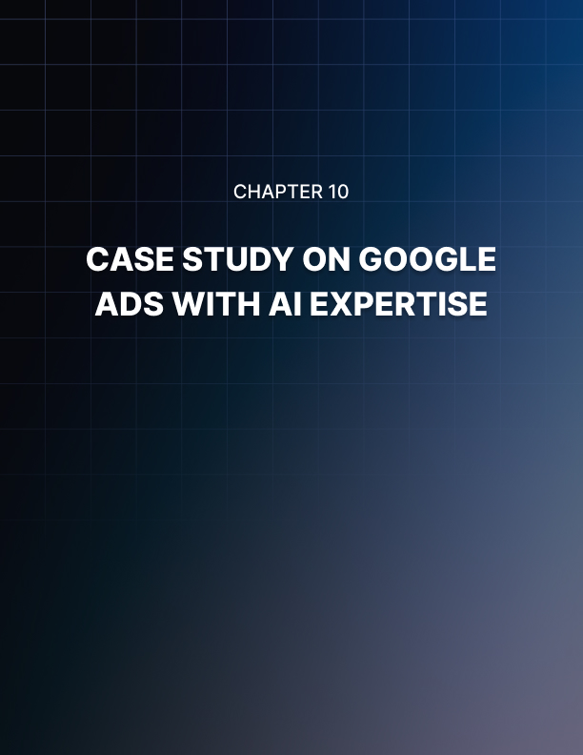

Chapter 10: Case Study on Google Ads with AI
Before delving into the story, take a moment to consider how you'd like to structure your campaigns and enhance your revenue journey. Now, there's some news to share.
This story is about a company called Bellhop, which operates in a competitive industry. They've made a bold move to distinguish themselves. Using Google's AI technology and in-depth understanding of its customers, Bellhop has turned the usual stressful moving experience into a hassle-free one.
Bellhop made a significant choice by adopting Google's AI technology, which became a pivotal moment for their business. They used AI to make the moving process smoother and put customers at the center of their efforts.
Now, see how Bellhop has doubled this revenue by implementing AI in Google ads:
Personalized Customer Engagement
Bellhop utilized Google AI to analyze customer data, allowing them to understand individual preferences, needs, and pain points. This led to personalized and relevant communication at every stage of the customer journey.
Efficient Operations
With AI, Bellhop optimized its operations. They could accurately predict resource requirements, assign the right crew for each job, and plan efficient routes. This not only reduced operational costs but also enhanced their reliability.

The Impact on Revenue and Customer Experience
Doubled Revenue
Bellhop's innovative approach, fueled by Google AI, led to an impressive outcome - they doubled their revenue. The seamless customer experience, along with improved operational efficiency, made Bellhop the preferred choice for both individual and corporate clients.
Increased Customer Loyalty
By offering a stress-free move, Bellhop built more robust customer relationships. Satisfied clients were not only more likely to return but also to recommend Bellhop to others, bolstering brand loyalty.
Bellhop's journey to doubling its revenue through implementing Google AI stands as a testament to the power of technology in enhancing the customer experience and driving business growth. In doing so, they not only significantly increased their revenue but also earned the trust and loyalty of their customers. By pairing their deep customer knowledge with AI-driven solutions, Bellhop turned the notoriously stressful process of moving into a seamless and hassle-free experience.
Bellhop's success story serves as an inspiration to businesses looking to leverage AI, including Google Ads, to transform their industries and deliver exceptional customer value.
Much like this, you too can unlock your success with Google Ads' AI expertise – your pathway to intelligent advertising!


Conclusion
The synergy of Google Ads with AI expertise has ushered in a new era of digital advertising. This transformative integration of Artificial Intelligence has revolutionized campaign management, enabling businesses to create highly personalized and efficient ad campaigns. With AI's analytical prowess and real-time adjustments, advertisers can navigate the dynamic landscape with unprecedented precision and effectiveness. The result is not just cost- efficient campaigns but also a superior reach to the intended audience, ultimately translating into better outcomes.
Embracing Google Ads with AI expertise is no longer an option but a necessity for businesses aiming to thrive in the fiercely competitive world of online advertising. As AI continues to evolve and adapt, advertisers who harness its capabilities will enjoy a distinct advantage, delivering the right message to the right audience at the right time. This technology-driven approach is shaping the future of advertising, and those who seize the opportunity to leverage AI in Google Ads will be best positioned to maximize their online advertising success.
Unleash the Future of Advertising with Google Ads AI Expertise - Your Key to Effortless Success in Online Marketing!

