TABLE OF CONTENTS
____

INTRODUCTION 6
GOOGLE BUSINESS PROFILE FOR LOCAL SUCCESS 9
Immediate Visibility Where It Matters Most 9
Building Trust Through Transparency 10
Cost-Effective Marketing That Works 12
Mobile-First Customer Connection 12
Local SEO Boost 13
Real-Time Customer Engagement 14
Performance Tracking Made Simple 14
Customer Reviews: Your Social Proof 15
CREATING A COMPELLING GOOGLE BUSINESS 18
Setting Up Your Account 18
Adding Your Business to Google Maps 19
Choosing Your Business Type 19
Verifying Your Business 20
Filling Out Basic Information 21
Adding Your Business Category 21
Writing Your Business Description 22
Adding Photos and Videos 22
Setting Up Additional Features 23
Creating Your First Post 24
Double-Checking Your Work 25
HOW TO OPTIMIZE YOUR GOOGLE BUSINESS PROFILE 27
Core Business Information 28
Business Categories 29
Business Description 30
Products and Services 30
Attributes 31
Questions & Answers 32
Opening Hours Optimization 33
Menu (For Food Businesses) 33
Service Areas 34
Appointment Links 34
Special Features 34
Regular Updates 35
Profile Verification 36
BOOST YOUR GOOGLE PROFILE WITH VISUALS 38
Why Visuals Matter on Your Profile 38
Types of Visuals That Drive Customer Action 39
Best Practices for Business Profile Photos 41
Video Content Best Practices 42
Photo Organization Tips 43
Creating Emotional Connection Through Visuals 43
Common Visual Content Mistakes to Avoid 44
Mobile Optimization for Visuals 45
MANAGING REVIEWS TO BUILD TRUST 47
Why Reviews Matter More Than Ever 47
Setting Up Your Review Management System 48
Responding to Positive Reviews 48
Handling Negative Reviews 49
Crafting Professional Review Responses 50
Encouraging More Reviews 51
Using Reviews for Business Growth 52
Dealing with Fake or Unfair Reviews 53
Building a Review-Rich Culture 53
USING GOOGLE POSTS TO ENGAGE CUSTOMERS 56
Making the Most of Google Posts 56
Creating Posts That Get Noticed 58
Timing Your Posts for Maximum Impact 59
Using Google Messaging Effectively 59
Combining Posts and Messaging for Better Results 60
Promoting Offers Effectively 61
Managing Customer Interactions 62
Tips for Special Events and Seasonal Promotions 62
Building Long-Term Engagement 63
ANALYZING GOOGLE PROFILE PERFORMANCE 66
Understanding Your Profile's Key Metrics 67
Accessing Your Performance Data 68
Making Sense of Your Metrics 69
Using Insights to Improve Your Profile 70
Tracking Competitor Performance 71
Creating a Performance Dashboard 71
Setting Performance Goals 72
Common Performance Issues and Solutions 72
Using Advanced Analytics Tools 73
CREATING GOOGLE POSTS THAT DRIVE ACTION 76
Understanding Google Posts Types 76
Creating Posts That Get Noticed 78
Timing Your Posts for Maximum Impact 80
Crafting Different Post Types 80
Using Posts to Drive Sales 82
Common Post Mistakes to Avoid 83
Measuring Post Success 83
Advanced Post Strategies 84
CONCLUSION 87

DISCLAIMER
____
The information provided in this ebook is intended solely for educational and informational purposes. The author does not accept any responsibility for the outcomes that may arise from the application of the material within. While efforts have been made to ensure the accuracy and relevance of the content, the author cannot be held accountable for any errors or omissions, or for any consequences resulting from the use or misuse of the information provided. The responsibility for any actions taken based on the information in this ebook lies solely with the reader.


INTRODUCTION
____
Picture this: A potential customer in your area searches for the exact product or service you offer. Your business appears at the top of their Google search, complete with eye-catching photos, glowing reviews, and all the information they need to choose you over your competitors. Within minutes, they're walking through your door, ready to become a loyal customer. This is the power of a well-optimized Google Business Profile, and this book will show you exactly how to make it your reality.
46% of all Google searches are looking for local information, and 88% of people who do a local search on their smartphone visit or call a store within 24 hours.

Yet countless businesses are missing out on these opportunities because they either don't have a Google Business Profile or haven't optimized it properly. You might be one of them, watching potential customers slip through your fingers while your competitors thrive.
The good news is that creating and optimizing a Google Business Profile does not require advanced marketing skills or a big budget. It requires the right strategies, which are outlined in this book. Whether you are starting fresh or improving an existing profile, you will find practical techniques to make your business more visible and attract more customers.
Take Sarah, a bakery owner who applied the methods shared in this book. Within three months, her profile views increased by 157%, and her website visits grew by 35%. Stories like hers show how businesses in all industries can achieve similar results by focusing on their Google Business Profile. The question is, will you be next?
This book focuses on actionable steps and proven results. You will find clear instructions, expert tips, and strategies that are relevant now and for the future. From selecting the best photos to writing engaging posts, managing reviews, and using analytics to measure success, this book covers every aspect of creating and maintaining a strong profile.
When you finish, you will know how to make a profile that attracts attention, builds trust, and turns visitors into loyal customers. You will learn how to appear in local searches, highlight your business's strengths, and use Google’s tools to your advantage. With these skills, you will be ready to keep your business ahead of the competition and succeed in reaching more customers.
The strategies in this book have helped thousands of local businesses increase their visibility, attract more customers, and grow their revenue. Now it's your turn. Let's get started on your journey to local business success.

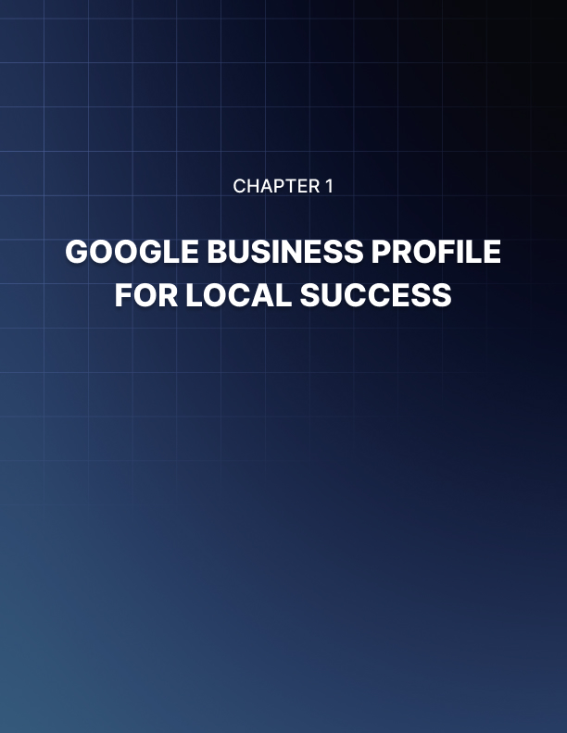

GOOGLE BUSINESS PROFILE FOR LOCAL SUCCESS
____
Your small coffee shop sits nestled in a busy downtown street. Every day, hundreds of potential customers walk by, searching on their phones for the perfect place to grab their morning brew. Without a Google Business Profile, these searchers might never find you. Even if you're just steps away from them.
A Google Business Profile puts your business on the map - literally. This free tool helps you show up when nearby customers search for businesses like yours on Google Search and Google Maps. Recent data shows that 46% of all Google searches are looking for local information, making this tool vital for capturing customer attention (Local Falcon).

Immediate Visibility Where It Matters Most
Think about how you search for businesses. You probably pull out your phone and type something like "coffee shop near me" or "best Italian restaurant downtown." That's exactly how your potential customers look for businesses like yours. A Google Business Profile ensures you appear in these crucial local searches.
When you set up and optimize your profile, you gain several instant benefits:
- Your business shows up on Google Maps
- Customers see your exact location, hours, and contact information
- People can read reviews from other customers
- Searchers view photos of your products or services
But the benefits go deeper than just showing up in searches. Businesses with complete profiles are 70% more likely to attract visits from browsing customers compared to those with incomplete listings (ExpertBeacon). This means filling out your profile thoroughly isn't just helpful - it's essential for attracting customers.

Building Trust Through Transparency
Today's customers want to know everything about a business before they visit. Your Google Business Profile serves as a trust-building tool by providing:
- Updated Business Hours: Customers know exactly when you're open
- Recent Photos: They see what your business looks like inside and out
- Customer Reviews: They read real experiences from other visitors
- Direct Communication: They can message you with questions
- Special Announcements: They stay informed about events or changes
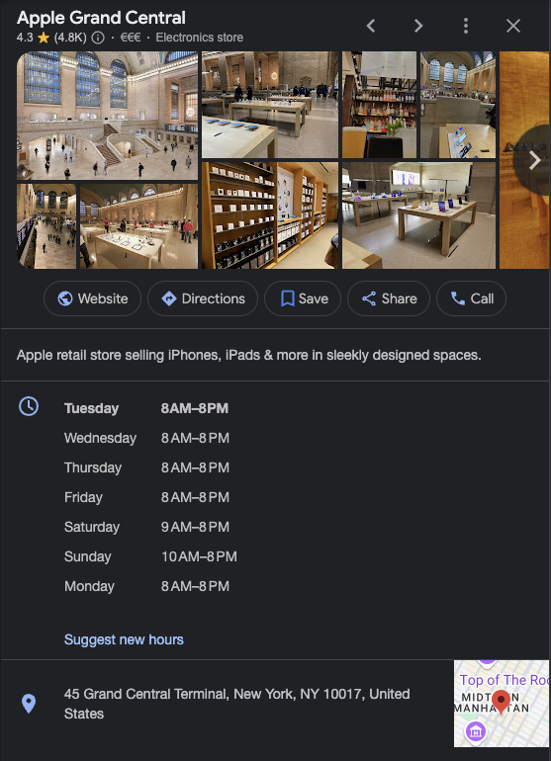
This transparency helps customers feel confident about choosing your business. According to research, 88% of consumers trust online reviews as much as personal recommendations (BCC Interactive). By maintaining an active profile with positive reviews and regular updates, you build credibility that turns browsers into buyers.

Cost-Effective Marketing That Works
Marketing budgets can stretch thin for local businesses. Your Google Business Profile offers powerful marketing features without costing you a dime.
Free Features You Get:
- Business listing in Google Search and Maps
- Photo and video uploads
- Customer review management
- Post updates and offers
- Message with customers
- Track profile performance
- Share business updates
These tools would cost hundreds or thousands of dollars through other marketing channels. Instead, Google provides them free, letting you focus your budget on other growth areas.

Mobile-First Customer Connection
Most of your customers use phones to find local businesses. Your Google Business Profile is optimized for mobile devices, making it easy for on-the-go customers to:
- Call you with one tap
- Get directions instantly
- Visit your website
- Send messages
- Read reviews
- View photos
- Make reservations
This mobile-friendly design matches how modern customers shop and search. When someone needs a product or service quickly, they can find and contact you within seconds.

Local SEO Boost
Search engine optimization (SEO) helps your business appear higher in search results. Your Google Business Profile strengthens your local SEO by:
- Improving Local Rankings: Google favors businesses with complete, accurate profiles
- Increasing Online Visibility: Your business appears in maps, local packs, and regular search results
- Building Local Authority: Reviews and engagement signal your business's importance to Google
- Targeting Local Customers: You reach people specifically looking for businesses in your area
The impact is significant. Businesses that optimize their profiles appear in an average of 157 discovery searches per month (ExpertBeacon). These are searches from people who didn't know your business by name but found you through local search terms.

Real-Time Customer Engagement
Your Google Business Profile lets you interact with customers in real-time through several features:
- Messaging: Answer customer questions instantly
- Posts: Share updates about sales, events, or new products
- Reviews: Respond to customer feedback quickly
- Photos: Show off new items or changes to your business
- Q&A: Address common questions publicly
This engagement keeps your business active and visible. When customers see you actively managing your profile, they're more likely to trust and choose your business.

Performance Tracking Made Simple
Understanding how customers find and interact with your business helps you make better decisions. Your Google Business Profile provides valuable insights about:
- How customers find your business
- What actions they take (calls, website visits, direction requests)
- When they search for you most often
- Which photos attract the most attention
- How your profile performs over time
These insights help you adjust your strategy to attract more customers. You'll know which efforts work best and where to focus your attention.

Customer Reviews: Your Social Proof
Customer reviews significantly influence buying decisions. Your Google Business Profile centralizes review management by:
- Making it easy for customers to leave reviews
- Letting you respond to feedback publicly
- Showing your average rating prominently
- Helping potential customers make informed decisions
Reviews also provide valuable feedback about your business. You learn what customers love and what needs improvement, helping you refine your offerings and service.
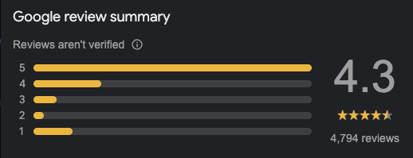
A Google Business Profile transforms your local business's online presence. It puts you where customers are looking, builds trust through transparency, and provides tools to engage and grow your customer base. All without costly fees or complex technical requirements. Nowadays it's not just helpful for local business success, it's essential.
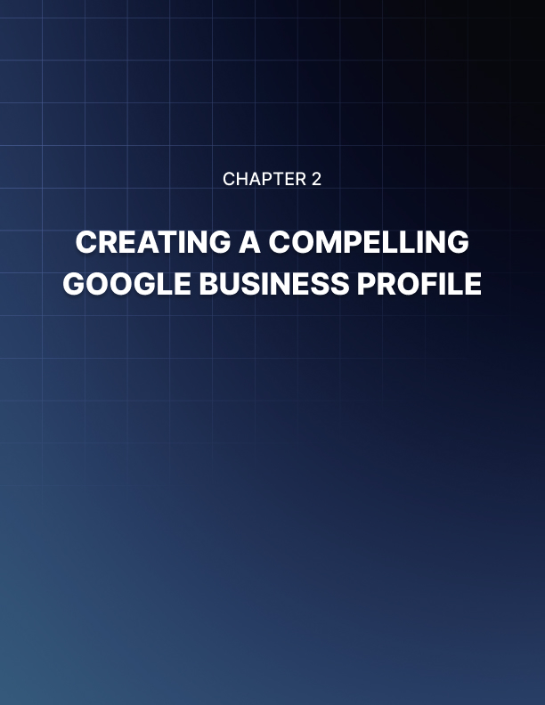

CREATING A COMPELLING GOOGLE BUSINESS
____
Looking for your local coffee shop online, a potential customer finds your competitor instead. Why? They have a complete Google Business Profile, while yours sits empty and unnoticed. Let's fix that by building your profile from the ground up.

Setting Up Your Account
Before you can create your Google Business Profile, you'll need a Google Account linked to your business. Follow these steps to get started:
- Visit accounts.google.com/signup
- Choose "To manage my business" when asked about account purpose
- Use a professional email address connected to your business
- Complete the basic account setup process
Make sure to use an email address you check regularly - Google will send important updates and alerts to this account (Seodity, 2024).

Adding Your Business to Google Maps
Now that you have your account ready, it's time to put your business on the map:
- Open Google Maps and sign in with your business account
- Click the menu icon (three lines) in the top-left corner
- Select "Add your Business"
- Enter your business name and check if it already exists
- If not found, click "Add your business to Google"

Choosing Your Business Type
Google offers three main business types. Pick the one that matches your operation:
- Storefront Business
You have a physical location customers visit.
- Service Area Business
You travel to customers or deliver services.
- Online-Only Business
You operate exclusively through the internet.
Your choice affects which features and options appear in your profile, so choose carefully (Seodity, 2024).

Verifying Your Business
Verification proves to Google that your business is real and you're authorized to manage its profile. Google offers several verification methods:
- Postcard Verification:
- Google mails a postcard with a verification code
- Usually arrives within 5 business days
- Enter the code in your profile to complete verification
- Phone Verification:
- Available for some businesses
- Receive code via call or text
- Quick and simple process
- Email Verification:
- Limited to certain business types
- Code sent to your business email
- Fastest verification method when available
- Instant Verification:
- Available if you've verified your website with Google Search Console
- Immediate access to your profile
Most businesses will use postcard verification. While waiting for your code, you can still add information to your profile (Google Support, 2024).

Filling Out Basic Information
Your profile needs accurate, complete information to attract customers. Start with these essentials:
- Business Name: Use your exact legal business name
- Address: Provide your complete street address
- Service Area: Define where you serve customers
- Phone Number: Add your main business line
- Website: Link to your homepage or landing page
- Business Hours: Include regular and holiday schedules
Keep this information consistent across all your online listings. Different addresses or phone numbers on various platforms can confuse customers and hurt your local search rankings (Brandography, 2023).

Adding Your Business Category
Your primary business category helps customers find you when searching for specific services. Choose carefully:
- Select the most specific category that fits your business
- Add additional categories if relevant
- Update categories if your business expands
For example, instead of just "Restaurant," you might choose "Italian Restaurant" or "Pizza Restaurant" to attract more specific searches.

Writing Your Business Description
Your business description tells your story and helps customers understand what makes you special. Follow these guidelines:
- Start with your most important information
- Use relevant keywords naturally
- Highlight unique features or services
- Keep it between 150-300 words
- Avoid promotional language
Example: "Your neighborhood coffee shop serving locally roasted beans since 2010. We offer fresh pastries baked daily, free WiFi, and comfortable seating for both quick stops and long work sessions."

Adding Photos and Videos
Visual content grabs attention and builds trust. Include these types of images:
Logo: Your business logo for brand recognition
Cover Photo: An appealing image representing your business
Interior Photos: Show your space and atmosphere
Exterior Photos: Help customers find your location
Team Photos: Put faces to your business
Product Photos: Showcase what you sell
Follow Google's image guidelines:
- Format: JPG or PNG
- Size: Between 10KB and 5MB
- Resolution: At least 720px wide
- Quality: Clear, well-lit, and professional-looking
Businesses with photos receive 35% more clicks to their websites and 42% more requests for driving directions (Taggbox, 2024).

Setting Up Additional Features
Make your profile more useful by enabling these features:
Messaging: Let customers contact you directly
Booking: Add appointment scheduling if relevant
Products: List items you sell with prices
Services: Describe what you offer
Questions & Answers: Add common customer questions
Attributes: Highlight features like:
- WiFi availability
- Outdoor seating
- Wheelchair accessibility
- Payment methods
- COVID-19 safety measures

Creating Your First Post
Start engaging with customers by creating a welcome post:
- Click "Add Update" in your profile
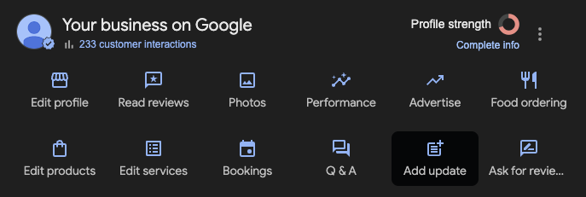
- Choose a post type (Update, Offer, Event)
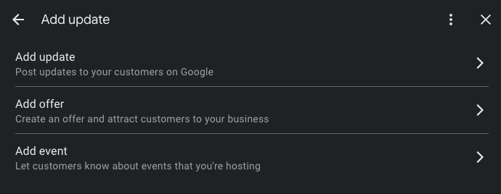
- Add an eye-catching image
- Write clear, engaging text
- Include a call-to-action button
- Set an expiration date if relevant
Keep your posts fresh by sharing updates at least weekly. This shows Google and customers that your business is active and engaged (Google Support, 2024).

Double-Checking Your Work
Before publishing, review your profile for:
Accuracy: All information matches your other business listings
Completeness: No empty sections or missing details
Professionalism: Everything looks polished and professional
Mobile Display: Check how it appears on phones
Working Links: All buttons and links function correctly
Your Google Business Profile is now ready to attract local customers. Keep it updated with fresh content, respond to reviews promptly, and monitor your insights to understand what works best for your business. Remember, a complete profile is 70% more likely to attract location visits from potential customers (ExpertBeacon, 2024).
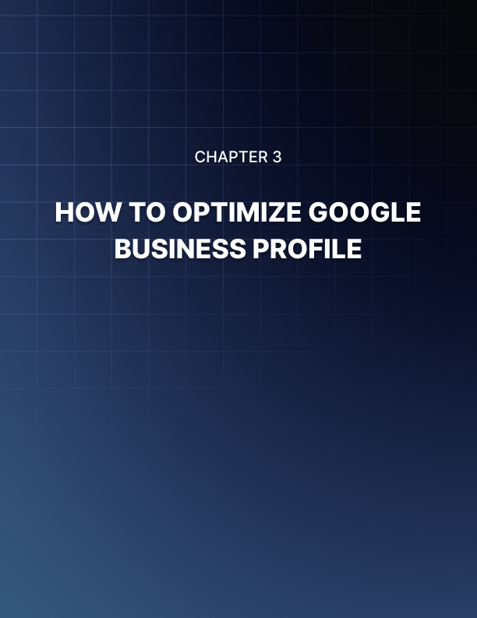

HOW TO OPTIMIZE YOUR GOOGLE BUSINESS PROFILE
____
Your local bakery sits ready to welcome customers, but online searchers can't find you. Why? Your Google Business Profile lacks the key details that make businesses visible and attractive to potential customers. Let's fix that by optimizing every important element of your profile.
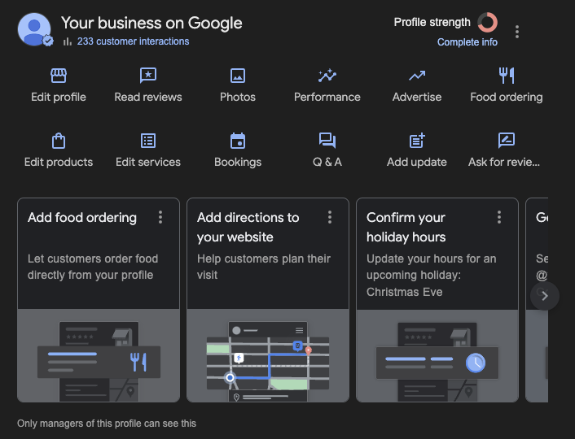
When you're optimizing your Google Business Profile, Google automatically recommends actions in the tabs under your dashboard. These recommendations guide you on what to fill out to complete the basic optimization of your profile based on its setup.

Core Business Information
The foundation of your Google Business Profile starts with accurate basic information. Getting these details right helps customers find and trust your business.
Business Name
Use your exact legal business name - no keywords or locations added. For example, use "Sarah's Bakery" instead of "Sarah's Best Downtown Bakery & Cafe." Adding extra words can get your listing suspended.
Address
Your physical location must be precise and consistent across all online platforms. Even small differences like "St." versus "Street" can confuse Google and hurt your rankings. If you serve customers at their location, you can hide your address but must set a service area (Diffuse Digital Marketing, 2024).
Phone Number
Add your main business phone number - this should be a local number when possible. Mobile numbers work too, but avoid toll-free numbers as primary contact options since they seem less local.
Website URL
Link to your homepage or a specific landing page for local customers. Make sure this page loads quickly and works well on mobile devices since most searches happen on phones.
Business Hours
Be extremely accurate with your hours. Include:
- Regular operating hours for each day
- Special holiday hours
- Temporary changes due to events or renovations
According to research, profiles with complete and accurate basic information are 70% more likely to attract location visits (ExpertBeacon, 2024).

Business Categories
Your primary category significantly impacts where you show up in search results. Choose carefully:
- Select the most specific primary category that describes your main business
- Add relevant secondary categories to capture other services
- Update categories if your business expands into new areas
For example, instead of just "Restaurant," you might choose "Italian Restaurant" or "Pizza Restaurant" as your primary category. You could then add "Caterer" or "Meal Delivery" as secondary categories if you offer those services.

Business Description
Your business description tells your story and helps customers understand what makes you special. Follow these guidelines:
- Start with your most important information
- Use relevant keywords naturally
- Highlight unique features or services
- Keep it between 150-300 words
- Focus on facts rather than promotional language
Example: "Your neighborhood coffee shop serving locally roasted beans since 2010. We offer fresh pastries baked daily, free WiFi, and comfortable seating for both quick stops and long work sessions."

Products and Services
List everything you offer to help customers find exactly what they need:
Products
- Add clear names and descriptions
- Include prices when possible
- Group similar items into collections
- Update regularly as inventory changes
Services
- List all services you provide
- Add detailed descriptions
- Include pricing if fixed
- Mention service areas if relevant

Attributes
Attributes tell customers specific features about your business. Select all that apply to help customers make informed decisions:
Accessibility
- Wheelchair accessible entrance
- Wheelchair accessible restroom
- Wheelchair accessible seating
Amenities
- Free WiFi
- Outdoor seating
- Parking availability
- Public restrooms
Health & Safety
- Mask required
- Staff wear masks
- Temperature checks
- Sanitization between visits
Payment Options
- Credit cards accepted
- Digital payments
- Cash only
- Contactless payment
According to Google data, businesses that fill out all relevant attributes receive 35% more clicks than those that don't (GMB Briefcase, 2024).

Questions & Answers
The Q&A section gives you a chance to address common customer questions before they ask. Take control of this section by:
- Adding your own questions and answers
- Monitoring for new questions daily
- Providing detailed, helpful responses
- Updating answers as information changes
Popular questions to answer:
- Do you offer parking?
- Are reservations required?
- What payment methods do you accept?
- Do you have vegetarian options?
- Is there outdoor seating?

Opening Hours Optimization
Your opening hours need special attention because they directly affect customer visits:
Regular Hours
- Set exact opening and closing times
- Include any mid-day breaks
- Note different weekend hours
Special Hours
- Holiday schedules
- Seasonal changes
- Event-related adjustments
- Temporary changes
Additional Hours Info
- Kitchen closing times (for restaurants)
- Happy hour times
- Delivery hours
- Drive-thru hours

Menu (For Food Businesses)
If you run a restaurant or food service business, your menu needs careful optimization:
- Add all menu items with descriptions
- Include prices
- Organize items into categories
- Update seasonal items
- Mark popular dishes
- Note dietary options (vegetarian, gluten-free, etc.)

Service Areas
For businesses that travel to customers or deliver:
- Define your primary service area
- List specific neighborhoods or cities you serve
- Set distance limits if applicable
- Note any minimum order requirements
- Include delivery fees or travel charges

Appointment Links
If you take appointments or reservations:
- Add booking links
- Connect scheduling software
- Note lead time requirements
- Include cancellation policies
- Mention any booking fees

Special Features
Depending on your business type, optimize these special features:
Hotels
- Check-in/check-out times
- Room types
- Amenities list
- Pet policies
Restaurants
- Cuisine types
- Dress code
- Reservation policy
- Private dining options
Retail
- Return policy
- Fitting rooms
- Gift wrapping
- Special orders

Regular Updates
Keep your profile fresh with regular updates to these elements:
- New photos (at least monthly)
- Special offers or promotions
- Event announcements
- Holiday hours
- Menu changes
- Service updates
Businesses that update their profiles weekly see 350% more views than those who rarely update (SocialPilot, 2024).

Profile Verification
Complete Google's verification process to unlock all features:
- Choose your verification method:
- Postcard (most common)
- Phone
- Email
- Instant verification
- Follow verification instructions exactly
- Enter verification code promptly
- Keep verification information secure
A fully optimized Google Business Profile acts as your most powerful local marketing tool. By carefully optimizing each element, you make it easier for customers to find, trust, and choose your business. Remember to review and update your profile regularly to maintain its effectiveness and stay ahead of competitors.
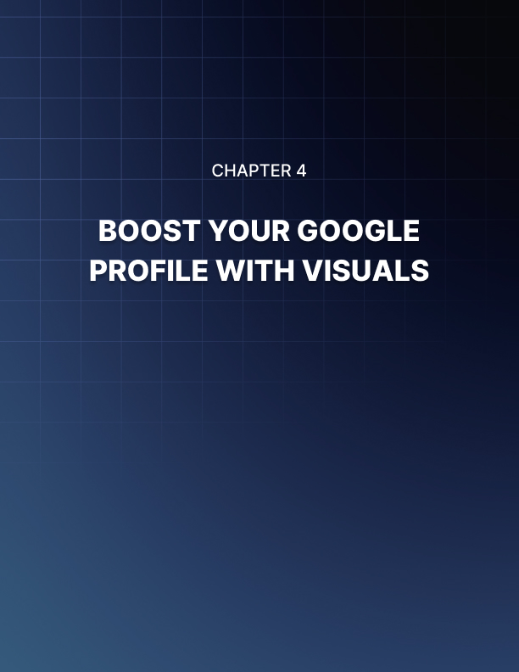

BOOST YOUR GOOGLE PROFILE WITH VISUALS
____
Walking past your storefront, potential customers decide whether to step inside based on what they see. Your Google Business Profile works the same way - the photos and videos you share create that crucial first impression. Strong visuals tell your story and convince people to choose your business over competitors.

Why Visuals Matter on Your Profile
Pictures speak louder than words when customers search for local businesses. Research shows that business listings with photos get 42% more requests for driving directions and 35% more website clicks compared to those without photos (Baboost). These numbers prove that good visuals directly lead to more customer visits.
But not just any photos will do. You need high-quality images that showcase your business properly. Think about it - if you're choosing between two restaurants and one has bright, appetizing food photos while the other has dark, blurry pictures, which would you pick? The same logic applies to your Google Business Profile.

Types of Visuals That Drive Customer Action

Cover Photo
Your cover photo appears prominently in search results and sets the tone for your entire profile. Choose an image that:
- Shows your business at its best
- Represents your main offering
- Looks professional and eye-catching
- Matches your brand style
For example, a coffee shop might use a warm, inviting shot of their café space with natural light streaming in and happy customers enjoying their drinks.

Logo
Your logo helps customers recognize your brand across different platforms. Make sure it's:
- High resolution and clear
- Properly sized (minimum 250x250 pixels)
- Consistent with your other marketing materials
- Easy to read at different sizes

Interior Photos
Interior shots help customers picture themselves in your space. Include photos that show:
- The overall layout and atmosphere
- Unique features or décor
- Seating arrangements
- Clean, well-maintained spaces
Businesses with interior photos receive significantly more engagement, as customers feel more confident visiting a place they can preview (Wolfable).

Exterior Photos
Help customers find your location easily with clear exterior shots:
- Your storefront during daytime
- Your building at night if you're open late
- Parking areas
- Entrance and signage
- Street view and landmarks

Product Photos
Show off what you sell with high-quality product images:
- Individual product shots
- Product collections or displays
- Items in use or being enjoyed
- New arrivals or seasonal items
According to research, businesses that regularly update their product photos see 520% more calls and direction requests (BetterBunch).

Team Photos
Put faces to your business with team photos that:
- Show your staff in action
- Highlight customer service moments
- Feature team achievements
- Demonstrate professionalism

Best Practices for Business Profile Photos

Image Quality Standards
Follow these technical guidelines for best results:
- Format: JPG or PNG
- Size: Between 10KB and 5MB
- Resolution: At least 720px wide
- Aspect ratio: 3:2 for most photos
- Lighting: Bright and clear
- Focus: Sharp and well-defined

Photo Quantity
More quality photos mean more customer interest. Research shows businesses with over 100 images receive:
- 2,717% more direction requests
- 960% more search views
- 520% more calls
(BetterBunch)

Regular Updates
Keep your visual content fresh by:
- Adding new photos weekly
- Removing outdated images
- Showcasing seasonal changes
- Highlighting special events
- Featuring new products or services

Video Content Best Practices
Videos offer an even more engaging way to showcase your business. Follow these guidelines:
- Video Types to Include
- Welcome message from owners
- Virtual tour of your space
- Product demonstrations
- Customer testimonials
- Behind-the-scenes footage
- Event highlights
- Technical Requirements
- Length: 30 seconds maximum
- Resolution: 720p minimum
- File size: Under 75MB
- Format: MP4
- Stable footage without shaking
- Clear audio if included

Photo Organization Tips
Help customers find what they're looking for by organizing your photos effectively:
- Categories to Use
- Products & Services
- At Work
- Team
- Interior
- Exterior
- Food & Drink (for restaurants)
- Room/Suite (for hotels)
- Common Areas
- Events
- Naming Conventions
- Use descriptive file names
- Include relevant keywords
- Add dates for seasonal content
- Specify locations if multiple branches

Creating Emotional Connection Through Visuals
Your photos and videos should tell your business story and connect with customers emotionally. Consider showing:
- Customer Experience
- Happy customers using your products
- Positive interactions with staff
- Special moments (birthdays, celebrations)
- Before and after results
- Community Involvement
- Local events participation
- Charity work
- Sponsorships
- Environmental initiatives
- Behind the Scenes
- Product creation process
- Team training
- Quality control measures
- Preparation and setup

Common Visual Content Mistakes to Avoid
Don't let these mistakes hurt your profile's effectiveness:
- Poor Quality Images
- Blurry or unfocused shots
- Bad lighting
- Unprofessional angles
- Low resolution
- Poorly cropped photos
- Irrelevant Content
- Personal photos
- Unrelated subjects
- Stock photos that don't represent your business
- Outdated seasonal content
- Missing Context
- No captions or descriptions
- Unclear purpose
- Lack of branding consistency
- Random assortment without organization

Mobile Optimization for Visuals
Most customers will view your profile on mobile devices, so optimize accordingly:
- Mobile-First Approach
- Test how images appear on phones
- Ensure text is readable on small screens
- Check load times on mobile networks
- Verify video playback on different devices
- Quick Loading Tips
- Compress images appropriately
- Use recommended file sizes
- Optimize file formats
- Remove unnecessary metadata
Keep adding fresh, high-quality visuals to your Google Business Profile regularly. Strong visual content helps you stand out from competitors and gives customers confidence in choosing your business. Remember, your photos and videos often make the first impression - make sure it's a good one.
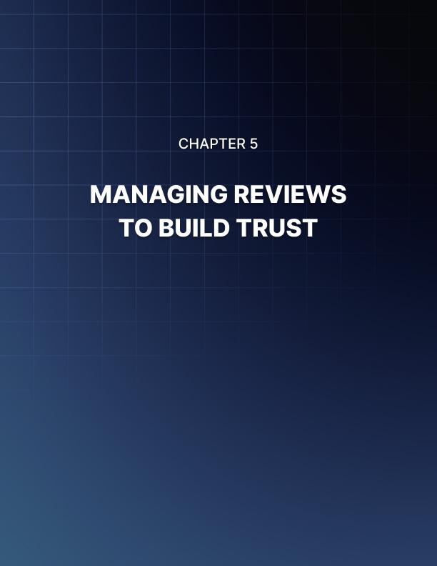

MANAGING REVIEWS TO BUILD TRUST
____
Your phone buzzes with a notification - another customer just left a review on your Google Business Profile. Whether it's a glowing 5-star rating or a scathing complaint, how you handle that review can make or break your business reputation. Let's master the art of review management to turn feedback into fuel for growth.

Why Reviews Matter More Than Ever
Think about your own shopping habits. Before trying a new restaurant or service, you likely check the reviews first. You're not alone - 84% of people trust online reviews as much as personal recommendations from friends and family (Breakthrough3x). Your potential customers do the exact same thing before choosing your business.
But here's something surprising - a perfect 5-star rating isn't always best. A few less-than-perfect reviews can actually make your business appear more authentic. Customers understand that no business is perfect, and seeing how you handle criticism often matters more than the criticism itself (US Chamber of Commerce).

Setting Up Your Review Management System
Before diving into specific responses, you need a solid system to track and manage reviews effectively. Here's how to build one:
- Assign Responsibility
- Choose who will monitor reviews (owner, manager, or team member)
- Set clear guidelines for response timing
- Create a process for escalating serious issues
- Use Management Tools
- Install review monitoring software to track all platforms
- Set up email alerts for new reviews
- Create a dashboard to organize reviews by rating and urgency
- Create Response Templates
- Draft basic templates for common situations
- Include spots to personalize each response
- Update templates regularly based on what works

Responding to Positive Reviews
Happy customers who take time to leave positive reviews deserve your attention. A thoughtful response can turn them into loyal advocates for your business. Follow these steps:
- Respond Quickly
Thank the customer within 24-48 hours. Quick responses show you value their feedback.
- Be Personal
Use the customer's name and reference specific details from their review. Instead of "Thanks for your review," try "Thanks Sarah, we're so glad you enjoyed our homemade pasta!"
- Add Value
Share related information they might find helpful:
- Mention upcoming events
- Suggest complementary products
- Invite them back with new offerings
- Keep It Brief
Limit positive review responses to 2-3 sentences. You want to show appreciation without overwhelming the conversation.

Handling Negative Reviews
Negative reviews feel personal, but they're actually opportunities to showcase your customer service. Here's your action plan:
- Take a Deep Breath
Never respond when you're feeling emotional. Wait at least an hour to clear your head.
- Acknowledge the Issue
Start with a sincere apology and show you understand their frustration. For example:
"I'm very sorry to hear about your experience with our delivery service. We pride ourselves on punctuality, and we clearly fell short."
- Move the Conversation Offline
Provide contact information to resolve the issue privately:
"Please email me directly at owner@business.com so we can make this right. I'm personally committed to resolving this for you."
- Follow Up
Once resolved, ask if they'd consider updating their review. Many customers appreciate the effort and will revise their rating (Gray Group International).

Crafting Professional Review Responses
Your responses should follow these guidelines to maintain professionalism:
Do:
- Thank the reviewer for their feedback
- Stay positive and solution-focused
- Provide specific next steps
- Use proper grammar and spelling
- Keep responses concise
Don't:
- Get defensive or make excuses
- Share private customer information
- Argue about facts or opinions
- Use automated responses
- Ignore the review

Encouraging More Reviews
More reviews mean more credibility. Try these tactics to generate authentic reviews:
- Time Your Requests Right
Ask for reviews when customers are most satisfied:
- Right after a positive interaction
- When they make a repeat purchase
- After receiving compliments
- Following successful problem resolution
- Make It Easy
- Send direct links to your review page
- Create step-by-step instructions
- Offer multiple platform options
- Follow up with gentle reminders
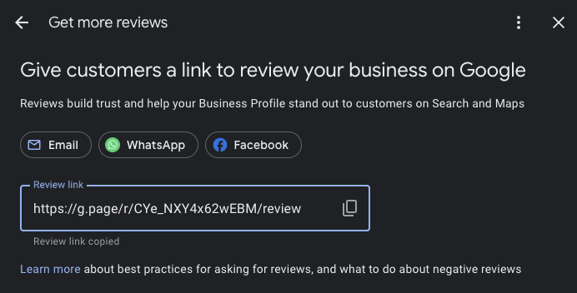
- Train Your Team
- Teach employees when to ask for reviews
- Provide scripts and talking points
- Share success stories and feedback
- Reward team members who generate reviews

Using Reviews for Business Growth
Reviews provide valuable insights to improve your business. Analyze them regularly to:
- Identify Patterns
Look for common themes in feedback:
- Frequently mentioned problems
- Most appreciated features
- Staff members who stand out
- Peak times for issues
- Make Strategic Changes
Use review data to guide improvements:
- Adjust staffing levels
- Update training programs
- Modify products or services
- Enhance customer communication
- Track Progress
Monitor how changes affect review sentiment:
- Average rating trends
- Comment themes
- Response effectiveness
- Resolution rates

Dealing with Fake or Unfair Reviews
Sometimes you'll face reviews that seem unfair or suspicious. Here's how to handle them:
- Verify Authenticity
- Check customer records
- Look for patterns in reviewer history
- Document suspicious activity
- Report Violations
If a review violates platform guidelines:
- Flag it for removal
- Provide evidence
- Follow up with support
- Respond Professionally
Even with suspicious reviews:
- Stay calm and factual
- Address any valid points
- Maintain your professional tone

Building a Review-Rich Culture
Make review management part of your business DNA:
- Create Review Guidelines
- Response timeframes
- Tone and language standards
- Escalation procedures
- Quality control checks
- Train All Staff
Everyone should understand:
- How reviews impact business
- Their role in generating reviews
- Proper response protocols
- When to escalate issues
- Celebrate Successes
- Share positive reviews with the team
- Recognize staff mentioned in reviews
- Track improvement metrics
- Use reviews in marketing materials
Managing reviews effectively takes time and effort, but the rewards are worth it. When you respond thoughtfully to feedback, encourage honest reviews, and use insights to improve, you build trust that attracts new customers and keeps existing ones coming back. Remember, every review is an opportunity to showcase your commitment to customer satisfaction and business excellence.
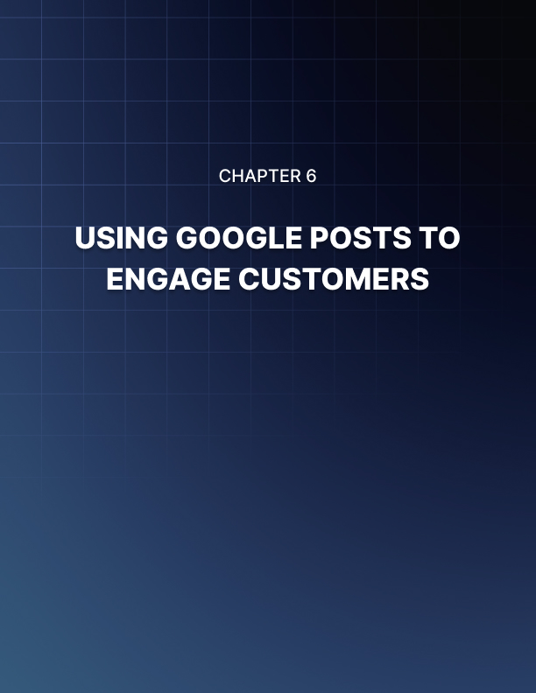

USING GOOGLE POSTS TO ENGAGE CUSTOMERS
____
Your phone buzzes with a message from a potential customer asking about your holiday sale. Meanwhile, another customer just saw your latest Google Post about new products arriving. These tools - Google Posts and Messaging - give you direct ways to connect with customers and share your offers right where they search for your business.

Making the Most of Google Posts
Think of Google Posts as your free billboard on Google Search and Maps. When customers look for businesses like yours, your posts appear alongside your business listing, letting you share updates, offers, and news that catch their attention.

Types of Posts That Drive Action
Google gives you several post types to choose from, each serving a specific purpose:
- Updates: Share general news about your business
- New product launches
- Changes in services
- Company announcements
- Behind-the-scenes glimpses
- Offers: Promote special deals and discounts
- Holiday sales
- Limited-time promotions
- Seasonal specials
- Loyalty rewards
- Events: Tell people about upcoming happenings
- Grand openings
- Special celebrations
- Workshops or classes
- Product demonstrations
- COVID-19 Updates: Keep customers informed about
- Safety protocols
- Operating hours changes
- New service options
- Health guidelines
According to InMoment, businesses that regularly use Google Posts see higher engagement and more customer interactions compared to those who don't post at all.

Creating Posts That Get Noticed
Your posts compete with countless others for customer attention. Follow these guidelines to make yours stand out:
- Use Strong Visuals
- Include bright, clear photos
- Keep images relevant to your message
- Maintain consistent brand style
- Show products in use when possible
- Write Compelling Copy
- Start with attention-grabbing headlines
- Keep text short and focused
- Include key details upfront
- Use action words that motivate
- Add Clear Calls-to-Action
Every post should tell customers what to do next:
- "Shop Now" for product promotions
- "Book Now" for appointments
- "Learn More" for detailed information
- "Call Now" for immediate contact
According to Pluspoint, posts with clear calls-to-action get 35% more engagement than those without.

Timing Your Posts for Maximum Impact
Posting regularly keeps your business visible, but timing matters too:
Weekly Schedule
- Post 2-3 times per week minimum
- Space posts evenly throughout week
- Avoid posting multiple times daily
- Remove outdated content promptly
Best Times to Post
- Early morning (7-9am) for commuters
- Lunch hours (11am-1pm) for browsers
- Evening (6-8pm) for planners
- Weekends for leisure searchers

Using Google Messaging Effectively
Google Messaging lets customers contact you directly through your Business Profile. It's like having a customer service desk right on Google.

Setting Up Messaging
- Turn on messaging in your profile settings
- Set up automatic welcome messages
- Choose notification preferences
- Set business hours for responses

Best Practices for Message Management
Response Time
- Answer within 24 hours maximum
- Aim for faster responses during business hours
- Use auto-replies when unavailable
- Set realistic response expectations
Message Content
- Keep responses professional but friendly
- Provide complete information
- Use templates for common questions
- Include next steps or actions
Direction reports that businesses responding within 4 hours see 40% higher customer satisfaction rates.

Combining Posts and Messaging for Better Results
Make your posts and messages work together:
Strategy 1: Drive Message Engagement
- Create posts about new products
- Encourage questions via messaging
- Respond quickly with detailed info
- Track conversion rates
Strategy 2: Use Messages to Inspire Posts
- Note common customer questions
- Create posts addressing these topics
- Include messaging CTA for more info
- Monitor engagement patterns

Promoting Offers Effectively
Your special offers need the right mix of timing, messaging, and follow-up:

Creating Compelling Offers
Structure Your Offer
- Clear value proposition
- Specific timeframe
- Simple redemption process
- Obvious next steps
Example Format: "Get 25% off all winter boots this weekend only! Message us to reserve your size or visit our store. Sale ends Sunday at 8pm."

Tracking Offer Performance
Monitor these metrics to improve future promotions:
- Post views and clicks
- Message inquiries
- Redemption rates
- Customer feedback
SocialBee found that offers with specific end dates get 47% more engagement than open-ended promotions.

Managing Customer Interactions
Keep conversations productive and professional:
Do:
- Answer questions completely
- Stay positive and helpful
- Provide accurate information
- Follow up when needed
Don't:
- Ignore messages
- Give unclear answers
- Share private information
- Make promises you can't keep

Tips for Special Events and Seasonal Promotions
Make your event posts stand out:
- Pre-Event Posts
- Announce early
- Share details gradually
- Build excitement
- Encourage questions
- During Event
- Post live updates
- Share photos/videos
- Highlight special moments
- Answer questions promptly
- Post-Event
- Thank attendees
- Share highlights
- Collect feedback
- Preview next events

Building Long-Term Engagement
Create a posting and messaging strategy that keeps customers coming back:
- Content Calendar Ideas
- Monthly specials
- Seasonal updates
- Customer spotlights
- Behind-the-scenes peeks
- Tips and advice
- New product previews
- Engagement Builders
- Ask questions in posts
- Run polls through messaging
- Share customer success stories
- Celebrate milestones
- Thank loyal customers
Townsquare Interactive shows that businesses posting at least weekly see 520% more customer actions than those posting monthly.
Your Google Posts and Messages give you powerful tools to connect with customers where they already look for businesses like yours. Use them consistently, respond promptly, and track what works. Soon you'll build a steady stream of engaged customers eager to hear what you'll share next.
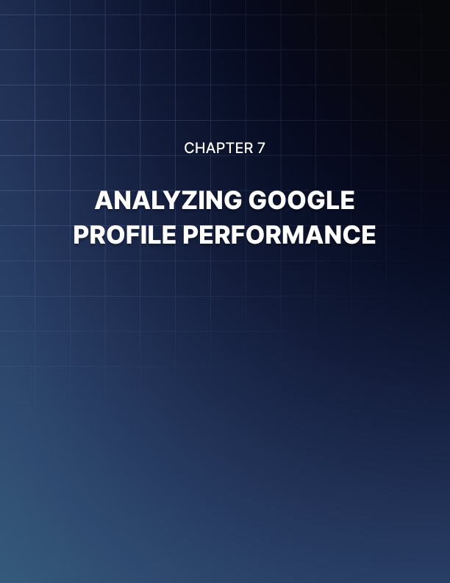

ANALYZING GOOGLE PROFILE PERFORMANCE
____
Your phone buzzes with another notification: a new customer just found your business through Google Search. But how many others searched for businesses like yours today and didn't find you? Understanding your Google Business Profile's performance helps you answer these questions and make smart changes to attract more customers.
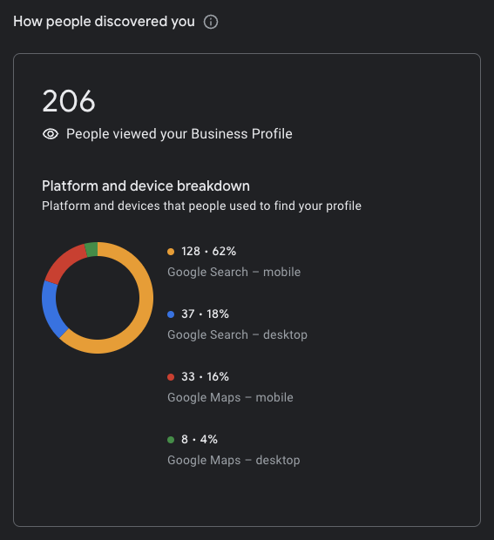

Understanding Your Profile's Key Metrics
Think of your Google Business Profile metrics like a report card for your local marketing efforts. These numbers tell you what's working and what needs improvement. Let's break down the most important metrics to track.

Search Performance
Your search metrics show how often people find your business on Google. Pay attention to:
- Direct Searches: When customers search for your business name
- Discovery Searches: When they find you while searching for products or services
- Branded Searches: When they search for brands related to your business
For example, if you run a coffee shop, direct searches might be "Main Street Coffee," while discovery searches could be "coffee shop near me." High discovery searches suggest you're reaching new potential customers who didn't know about your business before (Content and Marketing).

Customer Actions
These metrics show what people do after finding your profile:
- Phone calls
- Website visits
- Direction requests
- Messages
- Bookings
According to research, businesses that regularly track and optimize these metrics see 520% more customer actions than those who don't (Local Falcon).

Accessing Your Performance Data
To check your profile's performance:
- Sign in to your Google Business Profile
- Click "Performance" in the menu
- Choose your desired date range (up to 6 months)
- View your metrics by day, week, or month
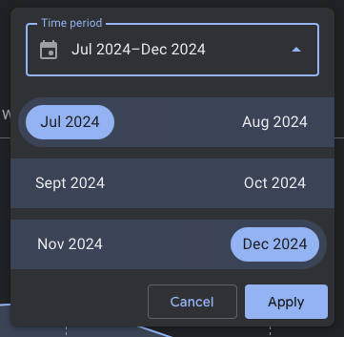
This data shows patterns in customer behavior and helps you spot trends. For instance, you might notice more searches on weekends or increased calls during certain hours (Hamman Interactive).

Making Sense of Your Metrics
Raw numbers only tell part of the story. Here's how to interpret your data:

Search Insights
Look for patterns in when and how people find you:
- Which days get the most searches?
- What search terms lead people to you?
- How many searches convert to actions?
If you notice high searches but low actions, your profile might need better photos or more compelling descriptions to convince people to choose your business.

Customer Behavior Analysis
Study how customers interact with your profile:
- What percentage of viewers call your business?
- How many ask for directions?
- Which photos attract the most attention?
These insights help you understand what motivates customers to take action. For example, if many people view your menu but few visit your website, you might need to improve your website's appeal (Search Engine Land).

Using Insights to Improve Your Profile
Let's turn these insights into actions that boost your visibility and customer engagement:
- Photo Performance
If your data shows low photo views:
- Add new, high-quality photos weekly
- Include different types of images (products, interior)
- Remove outdated or poor-quality photos
- Add captions to describe your images
Businesses with over 100 photos get 520% more calls and 2,717% more direction requests (BetterBunch).
- Search Optimization
When discovery searches are low:
- Update your business description with relevant keywords
- Add complete service and product lists
- Choose accurate business categories
- Keep your hours and information current
- Customer Action Improvement
If customer actions need a boost:
- Add clear calls-to-action in your posts
- Ensure your contact information is correct
- Respond quickly to messages and reviews
- Share special offers and promotions

Tracking Competitor Performance
Understanding how you stack up against competitors helps refine your strategy:
- Search Local Rankings
- Check your position for important keywords
- Monitor competitors' review counts and ratings
- Compare photo quantities and quality
- Engagement Comparison
- Look at competitor post frequency
- Study their successful offers and promotions
- Note their response times to customer interactions

Creating a Performance Dashboard
Build a simple spreadsheet to track your key metrics monthly:
Metric | Previous Month | Current Month | % Change
Total Searches
Phone Calls
Direction Requests
Website Visits
Review Count

This helps you spot trends and measure improvement over time.

Setting Performance Goals
Based on your metrics, set realistic goals for improvement:
Monthly Goals Example:
- Increase discovery searches by 10%
- Boost direction requests by 15%
- Add 5 new high-quality photos
- Respond to all reviews within 24 hours
- Post weekly updates or offers

Common Performance Issues and Solutions
When your metrics show problems, try these fixes:
- Low Search Visibility
- Update your business description with relevant keywords
- Add more services and products
- Post regular updates
- Encourage customer reviews
- Few Customer Actions
- Improve photo quality and quantity
- Add special offers
- Make contact information more prominent
- Respond faster to messages
- Poor Review Performance
- Ask satisfied customers for reviews
- Respond to all reviews promptly
- Address negative feedback professionally
- Share positive reviews in posts

Using Advanced Analytics Tools
While Google provides basic metrics, consider using additional tools for deeper insights:
- Local Rank Tracking Tools
- Monitor position in local search results
- Track keyword performance
- Compare competitor rankings
- Review Management Platforms
- Track review sentiment
- Manage responses efficiently
- Monitor competitor reviews
- Photo Analytics Tools
- Track photo performance
- Compare visual content with competitors
- Identify most engaging image types
Your Google Business Profile performance data provides valuable insights for improving your local marketing strategy. By regularly checking your metrics, understanding what they mean, and making data-driven improvements, you can attract more customers and stand out in local search results. Remember to set clear goals, track your progress, and adjust your strategy based on what the numbers tell you.
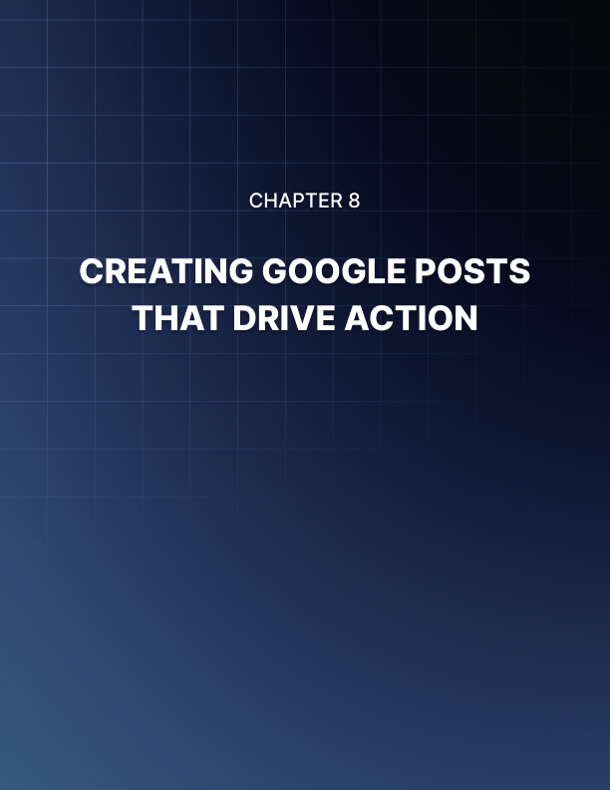

CREATING GOOGLE POSTS THAT DRIVE ACTION
____
Opening your phone, you see another notification - a customer just clicked on your latest Google Post about your weekend sale. Your previous posts barely got any attention. What changed? The right strategy and content made all the difference. Let's master the art of creating Google Posts that grab attention and drive real results for your business.

Understanding Google Posts Types
Google gives you different post types to share your message. Like choosing the right tool for a job, picking the right post type helps you achieve better results.
- What's New/Update Posts
- Share general business news and updates
- Show new products or services
- Highlight team achievements
- Post about community involvement
- Offer Posts
- Promote sales and discounts
- Share special deals
- Announce seasonal promotions
- Feature limited-time offers
- Event Posts
- Advertise upcoming events
- Share workshop schedules
- Announce product launches
- Promote special celebrations
- Product Posts
- Showcase specific items
- Display new inventory
- Feature bestsellers
- Highlight product benefits
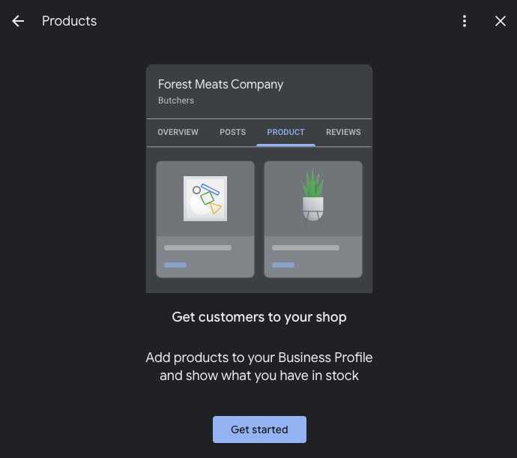
According to InMoment, businesses that regularly use Google Posts see higher engagement and more customer interactions compared to those who don't post at all.

Creating Posts That Get Noticed
Your post competes with countless others for customer attention.
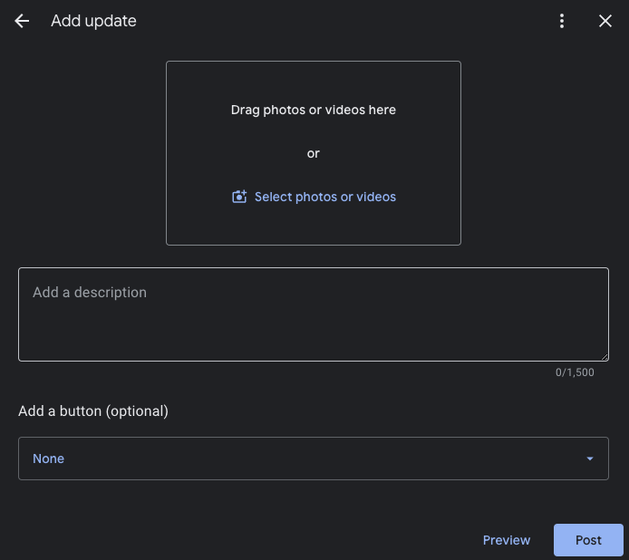
Follow these guidelines to make yours stand out:
- Strong Visual Content
Every post needs an eye-catching image or video:
- Use bright, clear photos
- Show products in use
- Include people when possible
- Maintain consistent brand style
Pluspoint reports that posts with quality visuals get 35% more engagement than text-only posts.
- Compelling Copy
Write text that motivates action:
- Start with attention-grabbing headlines
- Keep messages short and focused
- Include key details upfront
- Use action words that motivate
For example, instead of "Sale This Weekend," try "Save 30% on All Winter Boots - This Weekend Only!"
- Clear Calls-to-Action
Tell customers exactly what to do next:
- "Shop Now" for product promotions
- "Book Now" for appointments
- "Learn More" for detailed information
- "Call Now" for immediate contact
Research from Direction shows that posts with clear calls-to-action get 40% more clicks than those without.

Timing Your Posts for Maximum Impact
Just like a good conversation, timing matters with Google Posts:
- Best Times to Post
- Early morning (7-9am) for commuters
- Lunch hours (11am-1pm) for browsers
- Evening (6-8pm) for planners
- Weekends for leisure searchers
- Posting Frequency
- Share 2-3 posts per week minimum
- Space posts evenly throughout week
- Remove outdated content promptly
- Keep special offers current
SocialBee found that businesses posting at least weekly see 520% more customer actions than those posting monthly.

Crafting Different Post Types
Each post type needs its own approach to be effective:
- Offer Posts
Make your deals impossible to ignore:
- State the offer clearly
- Set specific timeframes
- Show original and sale prices
- Include any conditions
- Add urgency with deadlines
Example: "Flash Sale! All Handbags 40% Off - Today Only! Regular $100, Now $60. While Supplies Last."
- Event Posts
Help customers plan ahead:
- List date, time, and location
- Explain event benefits
- Include registration details
- Add parking information
- Mention any costs
Example: "Free Small Business Workshop - Learn Marketing Secrets, March 15th, 6-8pm. Limited Seats - Register Now!"
- Product Posts
Make your items irresistible:
- Show clear product photos
- List key features
- Include pricing
- Mention availability
- Add special offers
Example: "New Arrival! Memory Foam Running Shoes - Ultimate Comfort for $89. Available in All Sizes. Try Them Today!"

Using Posts to Drive Sales
Turn your posts into sales opportunities:
- Direct Sales Posts
- Feature specific products
- Include clear pricing
- Show product benefits
- Add purchase links
- Promotional Posts
- Share limited-time deals
- Create urgency
- Show savings amounts
- Include redemption details
- Service Highlight Posts
- Showcase expertise
- Share customer results
- Feature team members
- Include booking options
Townsquare Interactive reports that businesses using strategic post types see 350% more customer actions than those posting random updates.

Common Post Mistakes to Avoid
Learn from others' mistakes to improve your results:
Don't:
- Post without images
- Write long, complex messages
- Skip calls-to-action
- Leave old posts active
- Ignore post performance
- Use blurry photos
- Forget mobile viewers
Do:
- Keep messages clear
- Update content regularly
- Track engagement
- Use quality images
- Test different approaches
- Stay consistent
- Follow Google's guidelines

Measuring Post Success
Track these metrics to improve your posts:
- Engagement Metrics
- Views
- Clicks
- Calls
- Direction requests
- Website visits
- Content Performance
- Which posts get most views
- What times work best
- Which offers convert
- Popular products
- Effective calls-to-action

Advanced Post Strategies
Take your posts to the next level:
- Seasonal Planning
Create posts around:
- Major holidays
- Local events
- Industry seasons
- Weather changes
- School schedules
- Customer Spotlights
Share stories about:
- Happy customers
- Success stories
- Team members
- Community involvement
- Behind-the-scenes moments
- Q&A Posts
Answer common questions about:
- Products
- Services
- Policies
- Location
- Hours
Your Google Posts give you free advertising space right where customers look for businesses like yours. Use these tips to create posts that catch attention and drive real results. Remember to test different approaches, track what works, and keep updating your strategy based on performance. Like any marketing tool, Google Posts work best when you use them consistently and thoughtfully.



CONCLUSION
____
Your Google Business Profile is more than just an online listing. It is a powerful tool to connect with customers, showcase your brand, and drive business growth. Throughout this ebook, you have learned how to create, optimize, and manage your profile effectively. From crafting engaging posts and managing reviews to leveraging insights and improving local SEO, every step is designed to make your business stand out and succeed.
The strategies and techniques shared here are practical actions you can implement right away. By keeping your profile updated, using visuals to attract your audience, and engaging with customers through messaging and reviews, you can build trust and lasting relationships with your audience.
As you continue to refine and improve your Google Business Profile, consistency is essential. Regular updates, thoughtful interactions, and a focus on providing value will keep your business visible and relevant. Your profile is a living asset that grows with your efforts and helps you attract new customers while retaining loyal ones.
Now is the time to take action. Apply what you have learned, monitor your progress, and adjust your strategies as needed. With dedication and persistence, your Google Business Profile can become a key part of your local marketing success.

