Table of Contents

Introduction 3
Chapter 1: Why Provide Google Maps Services? 5
The Market Potential for Providing Google Maps Services 5
The Benefits of Providing Google Maps Services 6
Understand the Google Maps Platform 7
How to Get Started Providing Google Maps Services 7
Key Features and Functionality of Google Maps 9
Chapter 2: Profitable Google Maps Services you can Provide 12
Optimizing Business Listings 12
Promoting a Google Maps Business 13
Google Maps Search Engine Optimization (SEO) 13
Help Businesses Build a Positive Online Reputation 14
Analyzing Performance and Making Adjustments 14
Virtual Tours on Google Maps 15
Chapter 3: Finding Customers to Sell Google Maps Services to 17
Decide which Type of Business You Will Target 17
Geographical Targeting 18
How Many Potential Customers? 18
Contacting Potential Businesses 21
Chapter 4: Optimizing a Google Business Profile for Higher Search Rankings SEO Optimization 24
Factors that Determine High Rankings 24
The Proximity of a Business 24
The Relevance of the Business 25
The Prominence of Your Business 25
Chapter 5: The Importance of Citations and How to Get Them 28
Chapter 6: The Importance of Google Reviews and How to Get More 33
Benefits of More Google Reviews 33
Generate a Google Review Link 34
Show Existing Google Reviews 35
Use Email Marketing to Generate more Google Reviews 36
Conclusion 38



Introduction

Welcome to this powerful guide on providing Google Maps services to customers for a profit. Many businesses have a Google Business Profile but do not take full advantage of it. You can provide businesses with valuable services related to their listings on Google Maps as you will discover in this guide.

In the first chapter, you will discover the major benefits of providing Google Maps services to customers. You can choose to work with customers from any country in the world that uses Google Business Profiles. The market is huge and some businesses will be more than happy to pay you for your services.

We recommend that you provide as many different Google Maps services as you can and the second chapter will give you profitable ideas for services that you could provide. In chapter 3 you will learn proven strategies for finding prospective customers for your Google Maps business.

Your customers must rank as high as possible in the Google search results so that prospective customers can find them. You will learn the best ways to optimize Google Business Profiles so that they have a much greater chance of showing up in the top search results.

Citations are very important for high search rankings and you will learn in Chapter 5 how you can get these for your customers. You want to get the best citations possible for your customers as these are valuable backlinks that will help with local SEO optimization.

In the final chapter, we will discuss some of the best tactics that you can use to get more Google reviews for your customers. This will help them to stand out more and generate more leads and sales. Generating reviews needs to be an ongoing task and you can agree on a monthly fee with your customers to do this.
There are people and companies making thousands of dollars every month providing high-quality Google Maps services to their customers. There is no reason why you cannot do the same. So, follow the advice and guidance in this powerful guide and pay attention to the details.

OK, let’s dive right in…

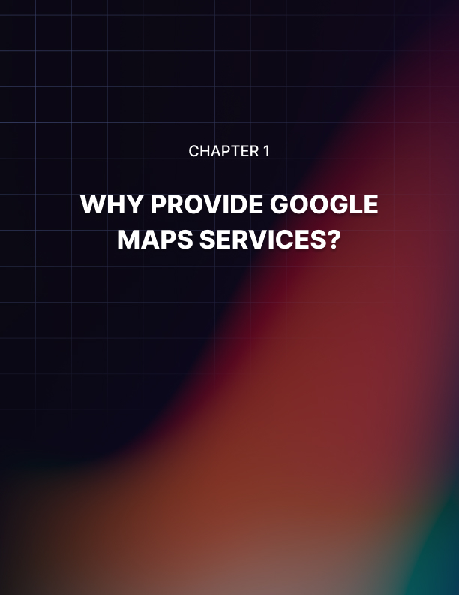

Chapter 1: Why Provide Google Maps Services?

Google Maps (which used to be called Google My Business and is now called Google Business Profile) has become an essential tool for consumers looking for businesses and services in their local area. Whether it's finding a nearby restaurant, locating a dentist, or discovering a new retail store, Google Maps is the go-to platform for millions of people worldwide.

This presents a massive opportunity for entrepreneurs to offer Google Maps services to local businesses and help them optimize their online presence.

The Market Potential for Providing Google Maps Services
The market potential for offering Google Maps services is vast. According to Google, over 1 billion people use Google Maps every month to explore and discover new places. This staggering number indicates the sheer volume of potential customers that local businesses can tap into by leveraging the power of Google Maps.

Local businesses, such as restaurants, salons, and shops, are constantly seeking ways to attract more customers and increase their visibility.

By offering Google Maps services, you can position yourself as a solution provider and help these businesses achieve their goals.

Whether they are looking to improve their search rankings, increase foot traffic, or enhance their online reputation, your expertise in Google Maps optimization can make a significant difference. Also, the potential market is not limited to small, local businesses. Even larger companies with multiple locations can benefit from Google Maps services.

With the ability to manage and optimize multiple listings, you can offer your services to franchises, corporate chains, and other businesses with a wider reach. By tapping into this market, you can position yourself as a valuable service provider and help businesses thrive in their local area.

The Benefits of Providing Google Maps Services
Offering Google Maps services to local businesses comes with a multitude of benefits, both for the businesses you serve and for your own entrepreneurial journey. Let's explore some of the key advantages that make this opportunity highly profitable.

  - Increased visibility: By optimizing a business's presence on Google Maps, you can ensure that they appear prominently in local search results. This increased visibility can drive more foot traffic, as well as online conversions, leading to a boost in revenue for the businesses you assist.

  - Improved online reputation: A strong online reputation is crucial for businesses in today's digital age. With Google Maps services, you can help businesses gather positive reviews and ratings, enhancing their credibility and attracting more customers. Positive reviews can also lead to higher search rankings, further amplifying their visibility.

  - Targeted marketing: Google Maps allows businesses to target their marketing efforts to specific geographic areas. By optimizing their listings and utilizing features like Google Ads, you can help businesses reach their target audience with precision, maximizing their marketing budget and driving higher conversion rates.

  - Competitive advantage: Many local businesses are unaware of the potential benefits Google Maps optimization can bring. By offering your expertise, you can give them a competitive advantage over their peers who have yet to leverage the platform. This unique selling point can help you attract clients and build a strong client base.

  - Recurring revenue: Google Maps services can provide a recurring revenue stream for your business. Once you establish a client base, you can offer ongoing maintenance and optimization services, ensuring that businesses stay ahead of the competition and continue to reap the benefits of Google Maps visibility.

As you can see, offering Google Maps services to local businesses offers a range of benefits. These advantages make it a highly profitable opportunity for entrepreneurs looking to make a significant impact in the digital marketing landscape.

Understand the Google Maps Platform
To effectively offer Google Maps services to local businesses, it is essential to have a solid understanding of the Google Maps platform and its key features. This knowledge will empower you to optimize and leverage the platform to its full potential, delivering exceptional results for the businesses you serve.

Google Maps is a web-based mapping service developed by Google. It provides detailed maps and satellite imagery of nearly every place on Earth, along with business information, directions, and geolocation services. The platform is available on various devices, including desktop computers, smartphones, and tablets, making it accessible to a wide audience.

For local businesses, Google Maps serves as a crucial tool for online visibility and discovery. Business listings on Google Maps include essential information such as the business name, address, phone number, website, hours of operation, and customer reviews. Optimizing these listings can significantly impact a business's visibility and attract more customers.

In addition to basic listing information, Google Maps offers a range of features and functionality that can enhance a business's presence. This includes the ability to add photos and videos, respond to customer reviews, create posts to share updates and promotions, and even offer virtual tours of the business premises.

Understanding the Google Maps platform and its features will enable you to effectively optimize business listings, utilize advanced functionality, and drive tangible results for the businesses you serve. In the next section, we will explore how to get started with offering Google Maps services.

Google provides some excellent free training on this which you can find at:
https://skillshop.exceedlms.com/student/catalog/list?category_ids=678-google-my-business

How to Get Started Providing Google Maps Services
Getting started with offering Google Maps services to local businesses requires a strategic approach and a few essential steps. By following these guidelines, you can position yourself as an expert in Google Maps optimization and start building a successful business.

- Familiarize yourself with Google Maps: Before diving into offering Google Maps services, take the time to familiarize yourself with the platform. Explore its features, functionality, and best practices for optimizing business listings. This foundational knowledge will provide a strong basis for delivering effective services to your clients. Take the free Google training and get certified!

- Develop your expertise: To position yourself as an expert in Google Maps optimization, invest time in developing your skills and knowledge. Stay up to date with the latest trends and updates in local search and digital marketing. Attend industry conferences, join online communities, and take advantage of online resources to continuously expand your expertise.

- Build a portfolio: To attract clients and showcase your capabilities, build a portfolio of successful Google Maps campaigns. Offer your services to a few local businesses for free or at a discounted rate in exchange for permission to feature their success stories in your portfolio. A strong portfolio will instill confidence in potential clients and demonstrate the value you can provide.

- Create a website and online presence: Establishing a professional website and online presence is crucial for attracting clients and building credibility. Create a website that highlights your services, showcases your portfolio, and provides a means for potential clients to contact you. Leverage social media platforms and online directories to further expand your reach and visibility.

- Network and build relationships: Networking is vital in any business endeavor. Attend local business events, join professional organizations, and connect with potential clients and industry influencers. Building relationships will not only help you attract clients but also provide valuable insights and referrals for your business.

- Offer a range of services: When offering Google Maps services, consider offering a range of services to cater to different business needs. This can include optimizing business listings, managing online reviews and ratings, implementing Google Ads campaigns, and providing ongoing maintenance and monitoring. Offering a comprehensive suite of services will make you a one-stop solution for businesses seeking Google Maps optimization.

By following these steps, you can lay a strong foundation for your Google Maps services business and set yourself up for success. In the next section, we will delve into the key features and functionality of Google Maps for local businesses.

Key Features and Functionality of Google Maps
Google Maps offers a range of features and functionality specifically designed to help local businesses enhance their online presence and attract more customers.
Understanding these key elements will enable you to optimize business listings and leverage the platform effectively.

- Business listing: The business listing is at the core of a business's presence on Google Maps. It includes essential information such as the business name, address, phone number, website, hours of operation, and customer reviews. Optimizing this listing is crucial for improving search rankings and attracting more customers.

- Photos and videos: Google Maps allows businesses to add photos and videos to their listings. Visual content can significantly impact a business's visibility and engagement. Encourage businesses to add high-quality photos and videos that showcase their products, services, and ambiance to attract potential customers.

- Customer reviews and ratings: Customer reviews and ratings are a vital component of a business's online reputation. Google Maps allows businesses to respond to customer reviews, demonstrating their commitment to customer satisfaction.

- Posts: Google Maps offers a feature called Posts, which allows businesses to share updates, promotions, and events directly on their listings. Posts can help businesses stand out in search results and attract more customers.

- Google Ads: Google Maps offers advertising opportunities through the use of Google Ads. Businesses can create targeted ad campaigns to reach their desired audience and increase visibility. Help businesses set up and manage Google Ads campaigns to maximize their marketing budget and drive higher conversion rates.
- Virtual tours: Google Maps enables businesses to offer virtual tours of their premises using Google's Street View technology. Virtual tours provide a unique and immersive experience for potential customers, allowing them to explore the business before visiting physically.

By leveraging these key features and functionality, you can optimize business listings on Google Maps and help local businesses maximize their visibility and attract more customers.

In the next chapter, we will discuss profitable Google Maps services to provide…
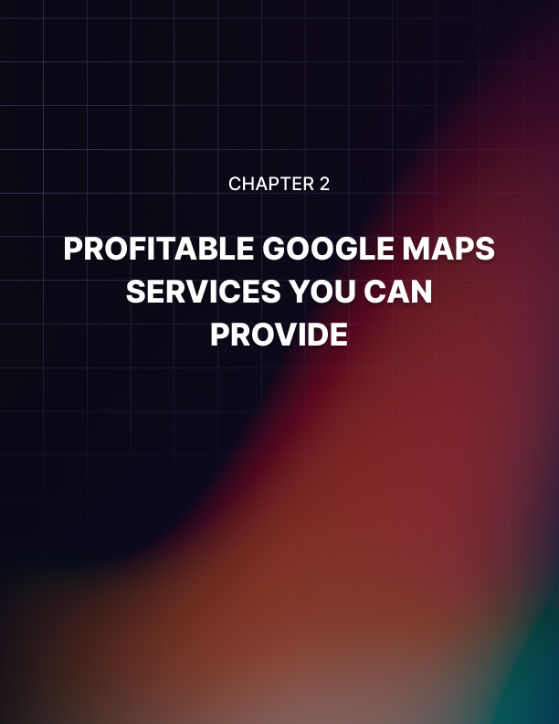

Chapter 2: Profitable Google Maps Services you can Provide

Having a strong presence on Google Maps is crucial for any local business. With the majority of consumers turning to online search when looking for products or services in their area, being easily discoverable on Google Maps can significantly impact a business's success.

When a potential customer searches for a specific business type on Google Maps, they are presented with a list of nearby options, with additional information such as ratings, reviews, and contact details.

By claiming and optimizing their Google Business Profile listing, businesses can ensure that their information is accurate and up-to-date, making it easier for potential customers to find them. Google Business Profiles allow businesses to provide essential details such as their address, phone number, website, and hours of operation.

Additionally, businesses can add photos, respond to customer reviews, and even post updates or special offers.

Optimizing Business Listings
A lot of businesses need their listings fully optimized. To make the most of Google Business Profiles, businesses should ensure that their listing is fully optimized and you can help them to do that. This involves providing detailed and accurate information, using relevant keywords, and engaging with customers through reviews and posts.

Optimizing a Google Business Profile listing can improve the business's visibility in local search results, increasing the chances of attracting new customers. When optimizing a Google Business Profile listing, it's important to choose the most appropriate categories to accurately represent the business's offerings.

This helps Google understand the nature of the business and present it to the right audience. Adding high-quality photos of the business, its products, and its team members can also enhance the listing and make it more appealing to potential customers.

Promoting a Google Maps Business
In addition to optimizing their Google Business Profile listing, businesses can also take advantage of Google Maps advertising to further promote their offerings. Google Maps advertising allows businesses to display targeted ads to users who are actively searching for products or services in their area.

These ads appear directly on the map, making them highly visible and effective in driving foot traffic to physical locations. You can assist businesses with their advertising. To set up a Google Maps advertising campaign, you can use Google Ads and select the "Local campaigns" option.

This allows businesses to create ads that are specifically designed to drive store visits. By setting a budget and targeting specific geographic locations, businesses can ensure that their ads are shown to the right audience at the right time. Additionally, businesses can track the performance of their ads and make adjustments as needed to maximize their return on investment.

Google Maps Search Engine Optimization (SEO)
Just like traditional search engine optimization (SEO), businesses can also optimize their presence on Google Maps to improve their rankings in local search results. Google Maps SEO involves optimizing various factors to increase the visibility and relevance of a business's listing when users search for related keywords or phrases.

One of the most important factors in Google Maps SEO is the consistency and accuracy of the business's name, address, and phone number (NAP) across various online directories and platforms.

Inconsistent information can confuse Google and lower the business's ranking. Businesses should ensure that their NAP is consistent and up-to-date on their website, social media profiles, and other online directories.

Using the right keywords is very important for SEO success. You can perform keyword research for your clients and ensure that their listings are keyword-optimized. By using the right keywords, you help Google to understand what a business is all about and what they can offer to their customers.

Help Businesses Build a Positive Online Reputation
Reviews play a crucial role in a business's online reputation, and Google Maps is no exception. Positive reviews can help build trust and attract new customers, while negative reviews can have a detrimental effect on a business's reputation. Encouraging customers to leave reviews on Google Maps can significantly impact a business's success.

To leverage the power of Google Maps reviews, businesses should actively engage with their customers and encourage them to leave feedback. This can be done by providing excellent customer service, promptly responding to reviews, and even offering incentives for leaving reviews.

Additionally, businesses should monitor their reviews regularly and address any negative feedback in a professional and timely manner. You can assist local businesses in optimizing their reviews. This includes getting more reviews from clients and helping them to drive up customer satisfaction.

Analyzing Performance and Making Adjustments
To measure the effectiveness of their Google Maps strategies, businesses can utilize Google Maps analytics. Google Maps analytics provides valuable insights into how customers are finding and interacting with a business's listing. By analyzing this data, businesses can identify areas for improvement and make data-driven decisions to optimize their Google Maps presence.

Some key metrics to track in Google Maps analytics include the number of views, clicks, and calls generated by the business's listing. Businesses can also gain insights into the geographic locations of their customers and the keywords or phrases that led them to the listing.

This information can help businesses refine their targeting and tailor their marketing efforts accordingly. We recommend that you position yourself as an expert with Google Maps analytics. Study all of the features and look for case studies online of how businesses used the data to their advantage.

Virtual Tours on Google Maps
In today's visually-driven world, businesses can enhance their Google Maps presence by offering virtual tours of their premises. Google Street View virtual tours allow businesses to showcase their interiors and give potential customers a glimpse of what to expect before visiting in person. This can be especially beneficial for businesses in the hospitality, retail, or real estate industries.

To create a virtual tour, you can arrange for a professional photographer or use a specialized camera to capture 360-degree images of their premises. These images can then be uploaded to Google My Business, allowing users to explore the business virtually.

Virtual tours not only provide a unique and immersive experience but also increase the likelihood of customers visiting in person, as they already have an idea of what to expect. This is a service that you can charge a high price for as the impact should be significant for your clients.
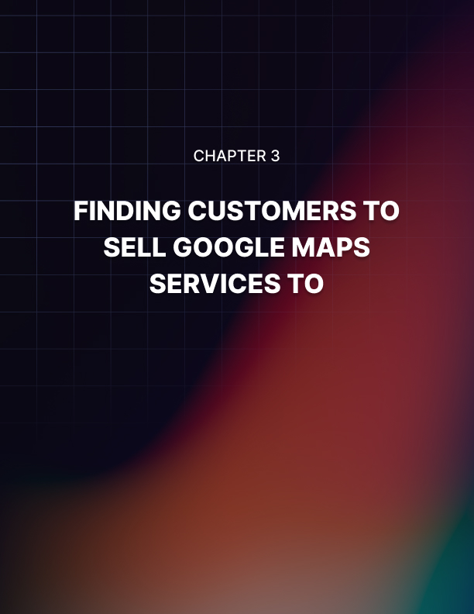

Chapter 3: Finding Customers to Sell Google Maps Services to

You are not going to make any money from Google Maps if you don’t find a steady supply of customers for your business. Yes, this is an obvious statement to make, but many people who try to make money with Google Maps underestimate what it takes to find customers.

In this chapter, we will provide you with proven methods for finding customers who need your services. We recommend that you focus on one type of customer to start with and one geographical area.

Decide which Type of Business You Will Target
It doesn’t matter where you live, you can sell Google Maps services to businesses anywhere in the world. Speaking the same language as the customers you are targeting is definitely an advantage. If English is your second language for example, you can target businesses in the United States, United Kingdom, Australia, and other English-speaking countries.

A lot of people make the mistake of trying to target professionals such as dentists who charge their clients a lot of money. The problem with this is that there will be many others trying to do the same thing so it is likely you will have competitors.
The other issue with professions like dentistry is that they are likely to have a “gatekeeper” who answers all phone calls and reads all emails that the practice receives. This doesn’t mean that you should never target dentists, lawyers, real estate agents, etc. We just recommend that you start with smaller businesses first to see some results to keep your motivation levels up.

If you target dentists then it is unlikely that your targeting will reach the decision maker. These kinds of professionals usually train their receptionists to get rid of callers trying to sell services or delete emails.

But if you target plumbers or painters, your call or email is likely to be received by the business owner. They can decide on the spot, allowing you to make money with Google Maps in the fastest possible time.

Geographical Targeting
Now you know what type of business where are you going to look for your potential customers? We are going to choose plumbers for our example. You could target your local area. This is a strategy that works well for some people that sell Google Maps services.

But this will be a problem if you live in a big city like New York or London. Why? Ranking Google Business Profiles in the top 3 for these cities is going to be very tough. You must get your customer into one of the top 3 positions because then they will appear on the first page of Google searches – more on this later.

The keywords “plumber New York City” and “plumber London” are very competitive. We recommend that you look elsewhere for your customers to start with. You could choose a smaller town outside of a big city for example.

If you can land a customer in cities like New York and London then you can charge them top dollar for your Google Map services. But providing them with the best service will be a major challenge. It could take months or even longer to rank the business in Google search.

For our example, we have chosen the town of Hardwick, Massachusetts (MA) in the United States. This town has a population of just over 3,000 people. We should be able to achieve some great results fast for our customers in this town.

How Many Potential Customers?
Fire up your favorite browser and go to Google. There are many versions of Google and we are going to keep it simple by going to Google.com. You can search for “Google Maps” or click on the “Maps” option at the top of the page.

For this example, we have searched for Hardwick, MA in Maps:
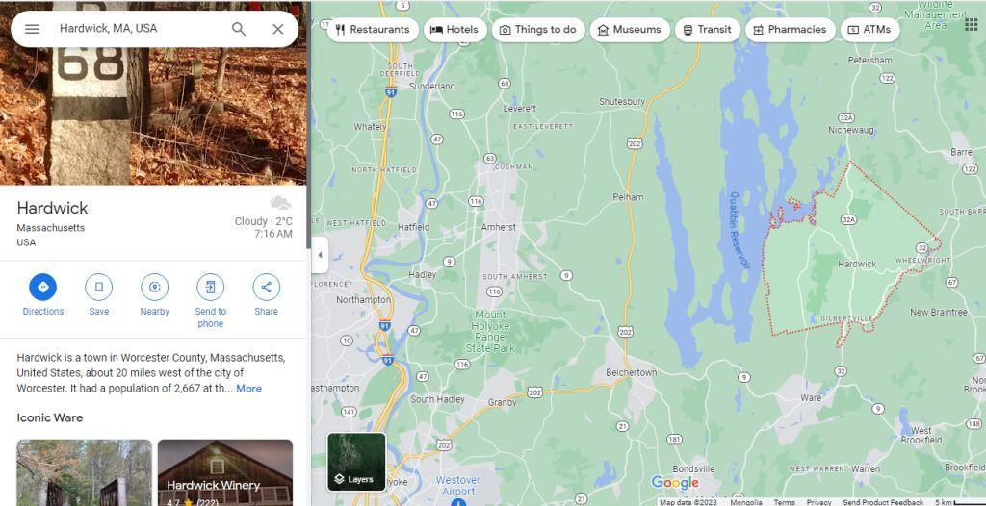

Now we will search for “plumber Hardwick MA”

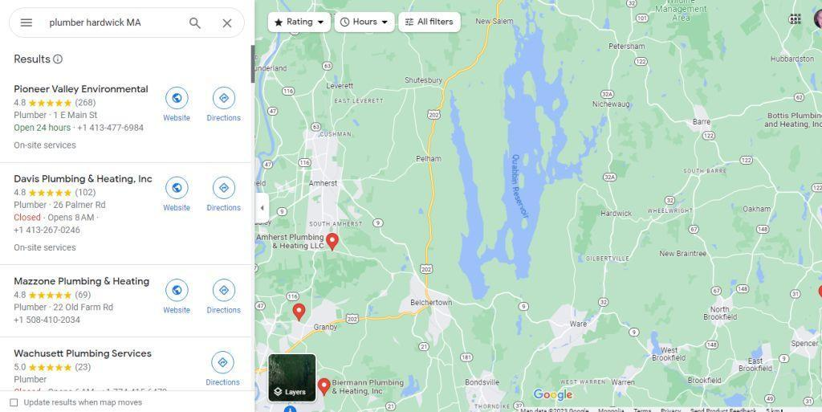

On the left-hand side, you will see a list of the plumbers in the Hardwick area that have a Google Business Profile. There are several of them. Now you want to go through this list to identify potential customers for your Google Maps services.

Here are some of the things that could qualify a plumber as a potential customer:
- No website
- No phone number
- No pictures or poor-quality pictures
- No reviews or very few reviews
- Listing is low in the search results
- They have not claimed their business profile

If a business doesn’t claim its Google Business Profile, then they are not going to be ranked high in search. Click on each company in the list to bring up their profile: “plumber Hardwick MA”

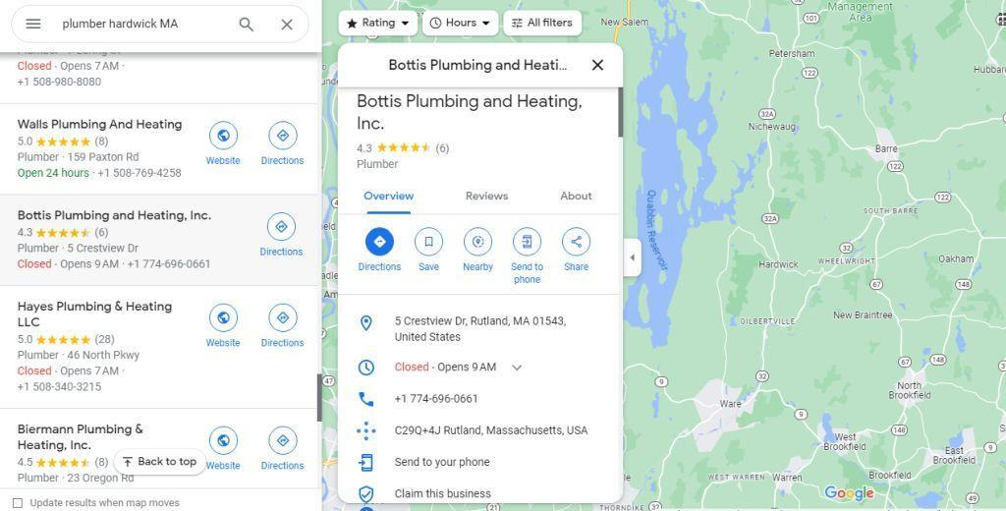
In the example above, this plumbing company has not claimed its business. They also have no website, 2 very poor pictures, and only 6 reviews. Use a Google Sheet to make a note of this company and record their contact details.

Go through the other plumbers in the list and find as many as you can that have potential. The businesses near the top will usually have everything in place so you can skip over them. Once you have around 20 or so potential businesses then you can contact them and offer your services.

Contacting Potential Businesses
There are two main ways that you can contact potential businesses for your Google Maps services. The first of these is to call them. This is the most effective method. A lot of people don’t like cold calling which is why they will not succeed with this business.

If you cannot bear the thought of cold calling then find someone who can do it for you. You can go to freelancing sites like Fiverr.com and find people who are willing to make cold calls to businesses for a fee.

It is always a good idea to create a script for either yourself or an outsourcer to follow. Here is a sample script that you can use (you need to change the details to your own) that we have had success with:

“Hi, my name is [your name] and I am calling you from [your business name]. We help small and medium-sized businesses to stand out in searches, particularly in Google.

I’m sure you know that these days, when people want to find a local business they will use their phone and search using Google. Your business must show up when people perform this search. You have a Google Business Profile but unfortunately, it is not showing up when a search for “plumber Hardwick, MA” is made.

With our expertise and proven strategies, we can help you get the most out of your Google Business Profile. We will optimize it with compelling information, professional photos, and several positive customer reviews, and get you the citations you need to rank high in Google search.

Imagine what it would mean for your business to be at the top of the search results! This would help to generate leads and new customers for you passively. We have conducted a free-of-charge assessment of your Google Business Profile and made recommendations to help boost your visibility. Can I send this to your email address now?

Excellent, I’d love to discuss how we can help you improve your Google Business Profile and attract more customers. It will be worth your while as I am confident we can make a significant impact for you.

If you would like to place an order go to [URL] and we will start work immediately. I look forward to working with you”.

[Sign off]

This is a sample script and not a guarantee of success. You need to be realistic and accept that you are not going to convert all of your potential leads into customers.

The second method that you can use to contact potential customers is via email. This can work but you do not have the same level of control that you do with a phone call. You can use the above script as the basis for your email.

Shorten it and add a call to action (CTA) link at the end to grab their free assessment and place an order with you. You can accept payment using PayPal, Stripe, or another payment method that works for you in your country.

In the next chapter, we will discuss how to optimize a Google Business Profile for higher search rankings with SEO optimization…
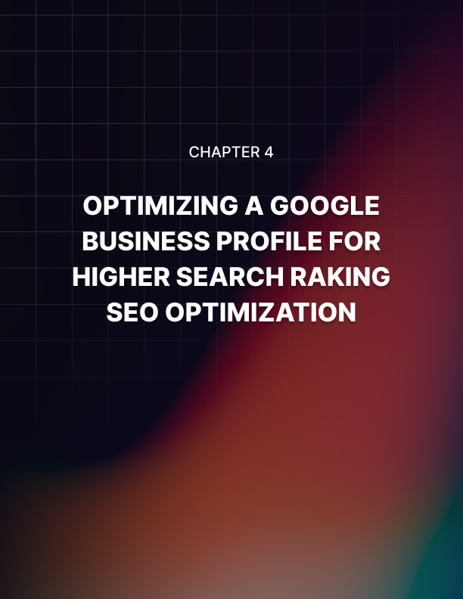

Chapter 4: Optimizing a Google Business Profile for Higher Search Rankings SEO Optimization

One of the best Google Maps services that you can provide to customers is the optimization of their Google Business Profile so that they can rank higher in search and maximize the conversions that they receive.

You need to know what the most important factors for ranking in Google search are and then apply these to the profile of your customer. If you want to do this work yourself you can by following the advice in this chapter. Alternatively, you can find a freelancer on a platform like Fiverr.com and pay them a few dollars to do it. We will explain in more detail later.

Factors that Determine High Rankings
The correct optimization of a customer’s Google Business Profile is essential to achieve the highest rankings in Google search. Google uses an algorithm to determine which businesses should rank the highest in search. There are 3 important factors that the algorithm will look for in a profile:

The Proximity of a Business
This is an obvious factor but you need to ensure that the Google Business Profile of your customer takes full advantage of this. When someone searches for a type of business in Google, it will give priority to those businesses that are the closest to the person performing the search based on where they are currently located and historical data if this is relevant.

Research has confirmed that nearly 50% of searches for businesses focus on a specific location. This has increased consistently over recent years. When Google perceives that the business of your customer is located nearby then they will have a much greater chance of being included in the search results.

The Relevance of the Business
The Google algorithm will check that your customer’s profile accurately reflects what the searcher is looking for. To ensure this, you need to optimize your customer’s Google Business Profile with keywords that are relevant as well as accurate information about the products and services that they provide.
For example, if someone searches for a plumber in Hardwick then Google will provide a list of businesses that have optimized their profiles with the keyword “plumber in Hardwick”. It is essential that you optimize your profile for the most popular search terms that people use when trying to find a business in their area.
You need to be careful when adding keywords to your customer’s Google Business Profile as you don’t want to overdo it and add too many (this is known as keyword stuffing). Perform keyword research using a tool like the Google Keyword Planner to identify the most relevant keywords.

Don’t be concerned about the lack of different keyword options or low search volumes. When you are dealing with small towns this is inevitable. The likelihood is that there will be more searches than those indicated.

The most important thing is that you can now add these 3 keywords to your profile. This will help the Google algorithm to see that your business profile is relevant to what the searcher is looking for when they use these terms.

The Prominence of Your Business
There are internal and external factors that determine how prominent a business is when it has a Google Business Profile. Having a complete profile and several Google reviews are internal factors. The amount of quality backlinks (a link from another website) is an important external factor.

Google has publicly stated in one of its reports that when a business has a complete profile that has accurate details in it then it is 70% more likely to be visited by local people searching for what the business has to offer.

Here are the most important steps you need to take to improve the SEO of your customer’s profile:

Complete the Customer’s Profile in Full
You need to work with your customer to ensure that all of their profile is completed with relevant and accurate information. Some areas are considered very important by the Google algorithm such as:

- The category for the business
- The full address of the business
- The telephone number
- The hours of operation
- The website of the business

If these details are inaccurate or missing, this is likely to penalize your customer when it comes to SEO. This is especially true when it comes to the category of the business.

Sometimes it will not be easy to assign a category to a business but you must do this.

Research has shown that over 80% of views to Google Business Profiles come from search traffic e.g. “plumber in Hardwick” which is why the right category must be chosen for a business. A business may belong in more than one category and you can add more if this is needed.

If the customer doesn’t have a website, this is another Google Maps service opportunity for you which we will discuss in another chapter. For now, you can provide the URL of one of their social profiles (e.g. LinkedIn or Facebook), but explain to your customer that having their own website is preferable.

Use Keywords in Your Description
You can add keywords that are relevant to your business description. In addition to this, you can create “posts” to your profile and ensure that they are keyword optimized too (more about adding posts later).

The more relevant keywords that you can find for your customer’s business the better. If you don’t have the time or the inclination to do this then go to Fiverr and hire a competent freelancer for a few dollars. Make sure that you take note of all of your costs.

In the next chapter, we will discuss the importance of citations and how to get them for your customer…


Chapter 5: The Importance of Citations and How to Get Them

One of the most effective ways to make your customers stand out in the market and increase the traffic to their Google Business Profile is through local citations. With good local citations, you will help your customer’s business appear more often in the local search results as it is something that the Google algorithm will pick up.

In this chapter, we will explain what local citations are and how you can get them for your customers. You need to explain the benefits of creating local citations to your customers and you can charge them a high price for providing them on an ongoing basis.

Local Citations Defined
The best way to think about a local citation is an online mention of the business of a customer that you have. A citation will include NAP (name, address, phone number) details and can also include other helpful information.

Citations can come from several different sources. These can include:

- Listings in directories
- Mentions on social media platforms
- News articles and press releases
- Review websites
- Blog posts

By creating high-quality citations for your customer, you will improve their chances of ranking higher in the Google search results. The reason for this is that large search engines such as Google and Bing use these citations to verify how accurate the details of a business are.

Citations will also increase the credibility and authority of a business which in turn will improve local SEO factors for the business. This will help your customers get more traffic to their Google Business Profile and increase the leads that they generate and the sales that they make.

There are 3 main categories of citations:

- Local listings
- Data aggregators
- Industry-specific or niche websites

Examples of local listings would be from the Yellow Pages site or Yelp which have a focus on local geographic areas in a country. You can pay a data aggregator network like Data Axle or BrightLocal to distribute the NAP information from your customer to several other directories and websites.

Industry-specific websites or niche sites have listings that are directly relevant to the business that they are in. For example, legal firms can benefit from being listed on Avvo, and businesses connected to the real estate industry can benefit from being listed on a website like Zillow.

Citations help to Build Trust
Businesses need their potential customers to trust them to maximize their chances of increased sales. With several citations, potential customers can see that the information provided on a Google Business Profile is accurate. A business may say that they provide plumbing services but is this the truth?

All business owners want to increase their visibility in the market and building citations is an effective way of doing this. Many potential customers use websites like Yellow Pages and Yelp to find the companies that they need. The same goes for news sites and industry-specific sites.

Different Types of Citations
You need to be aware that there are two main types of citations which are structured and unstructured. It is a good idea to create a mixture of these citations for your customers as they should both help to improve local SEO.

Structured Citations or NAP Citations
These have a specific format and are mainly seen on review sites and directories. They are also known as NAP citations as they will include the name of the business, the address, and the phone number. Yellow Pages and Yelp have structured citations.

You should also consider these structured citations as providing good-quality backlinks to your Google Business Profile. These directories have high domain authority and should provide an SEO boost. Please be aware that some directories will charge a fee for these structured citations.

Claim your Customer’s Google Business Profile
One of the easiest citations you can get for your customer is their Google Business Profile. If your customer has not claimed their profile then you can help them to do this. Businesses that don’t claim their profile from Google will usually not rank in search results and get very little traffic.

There are verification steps that you can help your customer follow to claim their Google Business Profile. They will need to go to Google Business at https://www.google.com/business/ and sign in to claim their profile. It is not difficult to claim a business profile and there are plenty of videos on YouTube that explain this.

Get Citations from High-Authority Directories
There are several local directories where you can add the details of your customer for a good backlink and to increase the number of citations. Good examples are Yellow Pages, Yelp, and Angi (this used to be called Angie’s List). You need to use the right websites here as some of these have directories in different countries such as the UK, Australia, Canada, and so on.

When you are adding citations on these websites make sure that all of the information you provide is completely accurate and up-to-date. Google will be expecting these structured citations to be consistent so be careful not to make errors.

Use Data Aggregators to Get the Word Out
It is a good idea to use data aggregators to get the word out about your customers. They will distribute their business information to websites and directories across the Internet. The advantage here is that the business data becomes centralized making it easier for Google and the other search engines to present accurate data about your customer.
In turn, your customers should receive more traffic to their Google Business Profile that can be converted into customers for them. A survey by HubSpot determined that the best data aggregators to use for local SEO citations were:
Factual

Data Axle Foursquare Neustar Localeze
Please be aware that there are many other data aggregators available. Some of them may demand payment to list a business while others provide free listings. We recommend that you do some research in this area to find the best data aggregators for you and your customers.

Outsource Your Citation Building
Some freelancers will create citations for your customers on your behalf. Building citations can be time-consuming and there are competent freelancers on Fiverr.com and other gig sites that can do this work for you for a fee.

You can charge your customers a monthly fee to continue to build citations for them. Check the freelancing sites to find the best people and get the best price for the work that you can. We recommend that you use freelancers for citation building that have a lot of positive reviews.

Add your markup to what the freelancer charges you and ask your customer to pay this so you make a good profit each month. This applies to any Google Maps service that you provide to your customers where there is the possibility to outsource the work. It then becomes passive income for you.

In the final chapter, we will discuss the importance of Google reviews and how to help your customer get more…


Chapter 6: The Importance of Google Reviews and How to Get More

You can help your Google Maps customers to get more Google reviews. When a business has many positive Google reviews, potential customers are far more likely to become paying customers. Only a personal recommendation from someone that the potential customer trusts is better.

In this chapter, we will discuss how you can help your Google Maps customers to get more reviews for their profiles. While it may be possible to purchase fake reviews, we do not recommend this as it can lead to profiles being shut down by Google if they discover the reviews are fake.

Benefits of More Google Reviews
There are several benefits to obtaining more Google reviews for your customers. When customers leave reviews, they will tell the business a lot about themselves. No business is perfect, and there is always room for improvement. Usually, a customer will leave a business a 5-star review if they are satisfied.

Businesses that have more Google reviews tend to rank higher for local searches. In turn, this is likely to result in more customers for the business and more reviews. If a person is searching for a business using Google Maps, they tend to have a high purchasing intent. More Google reviews will help your customer rank higher on Google Maps.

The most exciting thing about obtaining more Google reviews is that your customers should attract more business. This is because surveys have shown that around 88% of consumers trust reviews from Google. Your customers will want to keep using your Google Maps services again and again if you get them more customers. They will also recommend you to others.

People will Write Reviews if they are Asked
You need to educate your customers and tell them that according to recent surveys, around 86% of consumers will be willing to write a review if they are asked to do so. Google leads the way when it comes to consumers trusting online reviews. Nowadays, around 87% of consumers use Google to assess local businesses. In 2020 this was just 63%.

Generate a Google Review Link
You can help your customers to generate a Google review link. The way that consumers leave a Google review is to go to the Google Business Profile of your customers and then navigate to the reviews section and click on the link that says “write a review”.

Very few consumers are going to know about the 3 steps that they need to take to write a review for your customers. So, you want to make it easy for them by helping them to generate a Google review link. Here is the process:

- To generate a review link you need to go to the Google Business Profile of your customer.
- Click on “reviews”.
- Then click on “get more reviews”.
- You will then see the reviews link which you can copy and save.

Usually, the review link is long so it is a good idea to shorten it by using a service like Bit.ly. If your customer has a WordPress-based website then you can install the “Pretty Links” plugin and create a new link that has their domain name in it and then review for example mycustomer.com/review

Create a QR Code for Google Reviews
You can help your customers by creating a QR code for leaving reviews that they can add to their website, business cards, and so on. There are many free QR code generation services online such as Cloutly.com where you can easily create a Google review link QR code.

Create a Review Request Template for your Customer
Did you know that there were free templates available from different sources that your customers can use to request more reviews? There are, and you should recommend that your customers use one of these to obtain more reviews. You can get templates from:

- Canva
- Google (marketing kit)
- WordStream

Create a Google Review Page for your Customer’s Website
This is another service that you can offer your Google Maps customers. Design a “please leave us a review” page for their website. When people click on this page they need to see smiling faces on a well-designed page requesting that they leave a Google review.

There needs to be a call to action (CTA) button which will have the Google review link you created earlier.

Show Existing Google Reviews
If your customers have existing Google reviews then help them to showcase these on their website and social profiles. This will help to persuade visitors to these pages that the business is reputable, reliable, and credible enough to spend their money with.

By helping your customers to display their existing reviews you can encourage visitors on the types of reviews they could write for the business. These existing reviews can inspire and make the writing of a review much easier.

It is important to embed the Google reviews of your customers into their websites and social pages. When you do this, Google will notice this and this should help with SEO. If you take a screenshot and create an image then Google will not know what this is about.

If your customers have social accounts with popular sites like Facebook, LinkedIn, YouTube, Instagram, and more you can use a free template available at Canva.com to showcase Google reviews. Post these review images regularly on the social profiles that your customers have to encourage the writing of more reviews.

Encourage your Customers to Respond to Existing Google Reviews
Providing feedback to a review left by the customers of a business is something that you should encourage. It shows that your customer cares about how their customers feel. If the business receives a negative review which can happen from time to time, it is even more important that your customer responds to this.

You could offer a service on a monthly retainer where you will monitor the Google reviews that your customer receives and draft a response for them to use. Most business owners are very busy and are likely to appreciate an offer like this. Roll this service into your monthly Google Maps service for your customers.

Use Email Marketing to Generate more Google Reviews
These days, most businesses will use email to communicate with their customers. If this is the case for your Google Maps customers, you can create a series of email templates that your customer can use for the following situations:

- When you have completed an order for a customer.
- When the business has just interacted with a customer.
- When your customer sends their customer an invoice or a follow-up.
- When your customer is sending a promotional email to their existing customers.

The emails that you craft need to be as concise as possible. But they also need to show the recipients how they can easily leave a review for your customer. Explain the Google review link and include it in the email.

You could also craft an email that gently reminds existing customers to leave a review for your customer. People are always busy these days and writing reviews for businesses is not going to be something that is always at the top of their to-do list. A persuasive “reminder” type email can help your customer to get more Google reviews.

It is also a good idea to get your customer to add the Google review link that you created as part of their email signature. Add a persuasive CTA to the bottom of the email signature such as “Happy with what we do for you? Please leave us a review HERE”.


Conclusion

If you have read this guide from start to finish you will have learned why you should sell Google Maps services and what you need to do to give yourself the best chance of creating a profitable business. It is essential that you fully understand how the Google Business Profile platform works and how it can help your customers.

Now it is over to you. While reading this guide will make you a bit smarter, only by taking action will you get started by deciding which services you are going to provide and which businesses you are going to target.

We hope that you found this guide to be informative and useful. Get started today by deciding which Google Maps services you want to provide to your customers. We wish you every success with your Google Maps services business!

