TABLE OF CONTENTS
____

INTRODUCTION 4
DEMYSTIFYING P-MAX CAMPAIGNS 7
What Makes Performance Max Different 8
Making Performance Max Work for You 9
PLANNING YOUR P-MAX CAMPAIGN 11
Setting Clear Goals and Resources 11
Implementing Tracking and Measurement 13
CREATING WINNING AD ASSETS 16
Building Effective Ad Elements 17
Testing and Optimization 19
NAVIGATING AUDIENCE SIGNALS 21
Using Audience Signals 21
Optimizing and Measuring Performance 23
LEVERAGING AUTOMATION TO YOUR ADVANTAGE 26
Understanding AI and Control Mechanisms 26
Recognizing Warning Signs and Acting 27
OPTIMIZING AND SCALING CAMPAIGN PERFORMANCE 29
Building Your Optimization Framework 30
Scaling for Success 31
TROUBLESHOOTING P-MAX CAMPAIGNS 33
Spotting and Solving Common Problems 33
Building a Strong Recovery Strategy 34
YOUR PERFORMANCE MAX JOURNEY AHEAD 37
The Future of Digital Advertising 37
Maintaining Your Competitive Edge 38

DISCLAIMER
____

The information provided in this ebook is intended solely for educational and informational purposes. The author does not accept any responsibility for the outcomes that may arise from the application of the material within. While efforts have been made to ensure the accuracy and relevance of the content, the author cannot be held accountable for any errors or omissions, or for any consequences resulting from the use or misuse of the information provided. The responsibility for any actions taken based on the information in this ebook lies solely with the reader.
Foreword

INTRODUCTION
____

Imagine standing at the edge of a breakthrough in advertising. Your competitors are spending countless hours juggling multiple ad campaigns across different platforms, while you've discovered a way to streamline everything into one powerful system.
That's exactly what Google Ads Performance Max offers, and this book will show you how to master it.
In today's fast-moving world, staying ahead means working smarter, not harder. You've probably heard about Performance Max campaigns, but maybe you're unsure about taking the plunge.
Perhaps you've tried them but haven't seen the results you wanted. Or maybe you're already using them but know there's untapped potential waiting to be discovered. Wherever you are in your journey, this book is your roadmap to success.
Think of Performance Max as your marketing Swiss Army knife—one tool that does the work of many. While other marketers struggle with separate campaigns for Search, Display, YouTube, and Shopping, you'll learn how to unify your approach and let Google's advanced AI work for you.
But here's the catch: like any powerful tool, Performance Max needs skilled hands to guide it. That's where this book comes in, transforming complex concepts into clear, actionable strategies you can implement right away.
What makes this guide different? We're not here to overwhelm you with technical jargon or vague theories. Instead, you'll get practical, proven techniques that real businesses are using right now to drive results.
For example, one small e-commerce business increased its conversion rate by 47% within just two months of implementing the strategies you'll learn here. Another company cut its ad management time in half while improving its return on ad spend by 35%.
These aren't outliers. They're the kind of results you can achieve when you know how to harness the full power of Performance Max.
You'll discover how to create magnetic ad assets that grab attention across every platform, from Search to YouTube. You'll learn the secrets of audience targeting that even experienced marketers often miss. Most importantly, you'll master the art of working with automation without losing control of your campaigns.
This isn't just about setting up campaigns. It's about optimizing them for maximum impact and scaling your success.
Changes in advertising happen very fast these days, but this book keeps you ahead of the curve with the latest strategies and insights. According to ExpertBeacon, advertisers using Performance Max campaigns effectively are seeing an average of 13% higher conversion rates compared to traditional campaign methods. By the time you finish this book, you'll have all the tools you need to join—and exceed—these success stories.
Whether you're a small business owner looking to make every advertising dollar count, or a marketer aiming to sharpen your skills, this book speaks your language. No fluff, no filler. Just practical knowledge you can put to work immediately. You'll learn not just the "what" but the "why" and "how" of successful Performance Max campaigns, empowering you to make informed decisions that drive real business growth.
Ready to transform your advertising approach? Let's begin this journey together and unlock the full potential of your marketing efforts. The pages ahead contain everything you need to master Performance Max and achieve the kind of results you've always wanted from your advertising investments.
Part One

DEMYSTIFYING

P-MAX CAMPAIGNS
____

If you're looking to maximize your advertising reach across Google's platforms, Performance Max (PMax) campaigns offer a powerful solution.
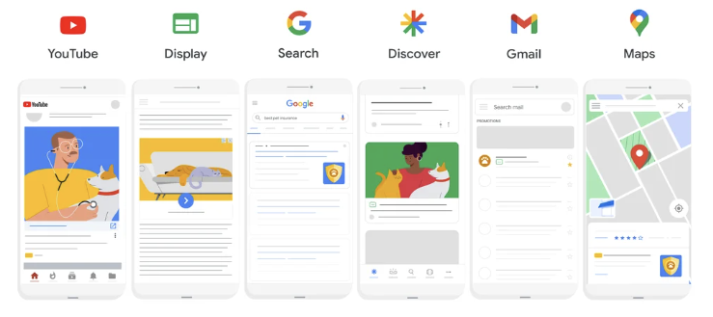
Launched in 2021, this innovative campaign type helps you connect with your audience across all of Google's advertising channels through one unified campaign. By leveraging artificial intelligence and automation, you'll reach potential customers wherever they are in the Google ecosystem.

What Makes Performance Max Different
PMax fundamentally changes how you approach digital advertising by combining multiple channels into one streamlined campaign. Instead of managing separate campaigns for Search, Display, YouTube, Gmail, Maps, and Discover Feed, you can now reach your audience across all these platforms simultaneously.
The heart of Performance Max lies in its AI-driven optimization system. As you run your campaigns, the platform analyzes user behavior, demographics, and intent patterns in real time to maximize your results. You'll set specific business goals (e.g., maximizing conversion value, increasing conversion rates, or acquiring new customers) and the system optimizes your campaign accordingly.
To create effective PMax campaigns, you'll work with asset groups—collections of your advertising materials that include headlines, descriptions, images, videos, and brand logos. These elements combine to create seamless advertising experiences across different platforms. Consider creating multiple asset groups to test different creative combinations and optimize your campaign performance based on real-world results.

Making Performance Max Work for You
Understanding how PMax differs from traditional campaigns will help you make informed decisions about your advertising strategy.
Unlike standard Search campaigns that rely on keywords and operate only on the Search network, Performance Max uses AI-driven audience signals across all Google properties. While you'll have less direct control over keywords, you'll gain broader reach and automated optimization across channels.
When implementing Performance Max, you'll need to consider several key factors. First, ensure you have a sufficient budget for a multi-channel presence and various creative assets. The system needs time to learn and optimize, which is typically 2–3 weeks. During this period, you might see performance fluctuations as the AI learns what works best for your audience.
PMax works best if you:
- Want to reach audiences across multiple channels
- Feel comfortable letting AI optimize your campaigns
- Have diverse creative assets available
- Focus on conversion-driven goals
However, you might want to consider other campaign types if you need granular keyword control, have very limited budgets, or are new to Google Ads.
The platform offers sophisticated targeting capabilities that set it apart from traditional campaigns. You'll benefit from advanced audience signal processing and real-time optimization based on user behavior, helping you reach the right people at the right time.
Performance Max represents a significant step forward in digital advertising. While it requires proper planning and resource allocation, it offers unprecedented opportunities to reach and engage your target audience effectively across Google's entire advertising ecosystem.

Part Two

PLANNING YOUR P-MAX CAMPAIGN
____

Before you launch a Performance Max campaign, proper preparation will set you up for success. A well-structured PMax campaign can significantly boost your advertising reach and effectiveness across Google's networks. Let's explore how to build a strong foundation for your advertising efforts.

Setting Clear Goals and Resources
Your campaign's success begins with defining clear objectives. Start by determining what you want to achieve, whether that's increasing sales, generating leads, or building brand awareness. Your goals will guide Google's AI optimization and help you measure success effectively.
For sales growth campaigns, focus on metrics like return on ad spend (ROAS) and revenue. ROAS measures the revenue generated per dollar spent on advertising and overall revenue growth to ensure your campaigns are driving profitable sales outcomes.
If you're generating leads, track cost per lead and lead quality. Cost per lead helps you understand how much you're spending to acquire each potential customer, while lead quality metrics assess how likely these prospects are to convert into valuable customers.
Brand awareness campaigns should monitor impression share and reach. Impression share shows how often your ads appear compared to their total eligible impressions, while reach measures how many unique users are exposed to your brand message across different platforms and touchpoints.
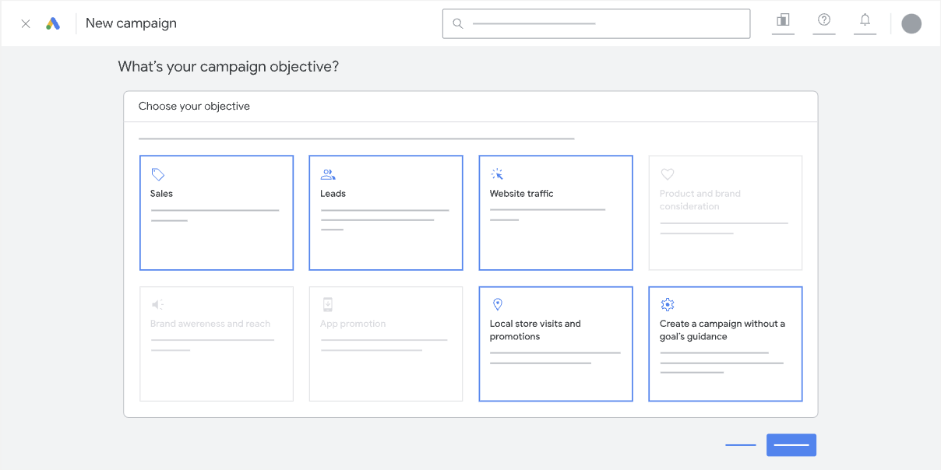
For each area, choose no more than two primary goals to help Google's algorithms optimize effectively.

Next, assess your budget carefully. Plan to allocate enough funds for at least six weeks of learning time, during which Google's AI will optimize your campaign. Set your daily budget at roughly ten times your target cost per acquisition (CPA), and include a 20% buffer for testing and optimization. This approach gives your campaign room to learn and adapt while maintaining cost control.
Your creative assets form the backbone of successful Performance Max campaigns. You'll need various text elements, including headlines and descriptions, along with different image formats and video content. Consider preparing:
- Multiple headlines (both short 30-character and long 90-character versions)
- Diverse descriptions that highlight your unique value
- High-quality images in landscape, square, and portrait formats
- Engaging video content showcasing your products or services

Implementing Tracking and Measurement
Proper tracking setup ensures you can measure your campaign's effectiveness accurately. Start by installing Google Tag Manager and configuring conversion tracking. Choose an attribution model that matches your business needs. Data-driven attribution works well for accounts with many conversions, while last-click attribution suits simpler conversion paths.
Enable cross-device tracking to understand how customers interact with your ads across different devices. This insight helps you optimize for the full customer journey rather than individual touchpoints. Consider implementing value tracking for better ROAS optimization and micro-conversion tracking to understand your conversion funnel in detail.
For e-commerce campaigns, your product feed requires special attention. Keep it updated with accurate titles, descriptions, pricing, and availability. Include essential product attributes like GTINs and categories, and update your feed daily for pricing and inventory changes. Regular maintenance ensures your ads always display current and relevant information.
Understanding performance expectations helps you stay patient during the initial phases. The first two weeks typically show variable results as the system learns. Weeks three and four usually bring more stable performance, with notable improvements appearing in weeks five and six. After week seven, you can focus on refinement and scaling opportunities.
Before launching your campaign, verify that all elements are in place: conversion tracking works properly, your assets meet Google's requirements, your budget and bidding strategies are set, and your audience signals are configured. Set up automated alerts for key metrics and schedule regular performance reviews to stay proactive about campaign management.
With careful planning and preparation complete, you'll be ready to launch a Performance Max campaign that connects with your audience across Google's advertising platforms. In the next chapter, you'll learn how to create compelling ad assets that drive engagement and conversions.
Part Three

CREATING WINNING

AD ASSETS
____

You've laid the foundation for your Performance Max campaigns. Now it's time to create compelling ads that drive results.
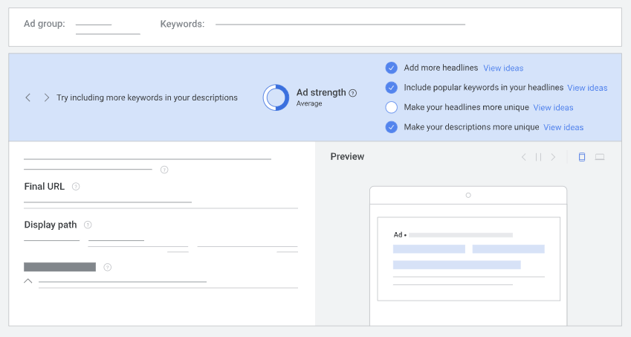
Well-optimized assets make campaigns more likely to achieve "Good" or "Excellent" Ad Strength ratings. You'll now learn how to craft ad elements that captivate your audience across Google's advertising networks.

Building Effective Ad Elements
At the heart of every successful Performance Max campaign lies strategically crafted ad content. Your ads need multiple headlines that grab attention, descriptions that compel action, and visuals that tell your story. Think of these elements as building blocks that Google's AI mixes and matches to create the perfect ad for each viewer.
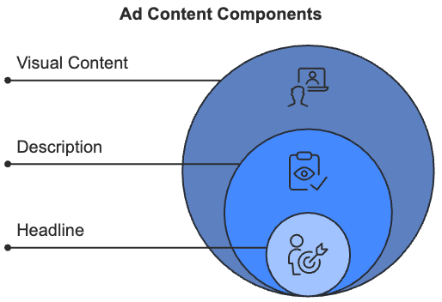
Start with your headlines—they're often the first thing people notice. Write headlines that focus on benefits rather than features. Instead of "Professional Camera with 50MP Sensor," try "Turn Every Photo into a Masterpiece." This benefit-focused approach helps potential customers imagine how your product or service will improve their lives.
Your descriptions should expand on your headlines' promise while maintaining clarity and purpose. Include social proof like awards or testimonials when possible, and always end with a clear call to action. Keep your descriptions focused on value by stating what customers will gain by choosing you.
Visual content plays a crucial role in catching and keeping attention. Your images should feature clear focal points, minimal text overlay, and high-resolution quality. Professional-looking visuals build trust and credibility with your audience. Include multiple formats (landscape, square, and portrait) to give Google's AI flexibility in creating ads for different placements.
Video has become increasingly important for PMax success. Create videos that hook viewers in the first 5 seconds and tell your story effectively even without sound. Keep your videos between 10–30 seconds, and ensure they maintain consistent branding throughout. Consider adding captions to improve accessibility and engagement when viewers have their sound off.

Testing and Optimization
Success with Performance Max requires ongoing testing and refinement of your ad assets. Create variations of your headlines, descriptions, and visuals to discover what resonates best with your audience. Give each test at least 2–3 weeks to gather meaningful data before making decisions.
Monitor key metrics like click-through rate, conversion rate, and engagement time to understand how your assets perform. Pay attention to Google's asset performance ratings, as they'll help you identify which elements need improvement. When you find winning combinations, use them as inspiration for creating new variations.
Consider seasonal and event-based opportunities to keep your content fresh and relevant. Create themed asset variations for major holidays, industry events, and seasonal promotions. This approach helps maintain engagement while addressing changing customer needs throughout the year.
One retailer saw impressive results by consistently testing and optimizing their assets. By testing multiple headline variations, optimizing video content for mobile viewing, refreshing image assets monthly, and implementing seasonal messaging, they achieved a 47% increase in conversion rate and reduced their cost per acquisition by 28% over three months.
Stay organized by creating an asset production calendar that schedules regular content refreshes and plans for seasonal themes. Document what works and what doesn't. This knowledge will prove invaluable as you continue to optimize your campaigns.
With your creative assets optimized and ready to perform, you're prepared to take the next step: reaching the right audience.
Part Four

NAVIGATING AUDIENCE SIGNALS
____

Advertisers using optimized audience signals in their Performance Max campaigns achieve higher conversion values compared to basic targeting. This dramatic improvement demonstrates why mastering audience signals is crucial for your campaign’s success. Let's explore how you can leverage these powerful tools to connect with your ideal customers across Google's advertising network.

Using Audience Signals
Unlike traditional campaign targeting that sets rigid boundaries, audience signals work as flexible guides that help Google's AI identify your most valuable potential customers. These signals analyze various data points, including demographics, interests, online behaviors, and past interactions with your brand, helping the system learn and refine its understanding of your ideal audience.
Your existing customer data serves as the foundation for creating effective audience signals. Start with your valuable first-party data like customer email lists, website visitor information, and purchase history. This helps Google's AI understand your ideal customer profile more quickly and accurately.
You can enhance this foundation by combining multiple signal types. For example, layering demographics (like the 25–34 age group) with specific interests (such as fitness enthusiasts) and purchase behaviors (such as premium brand shoppers).
Creating separate campaigns or asset groups for different audience segments can significantly boost your performance, so consider segmenting by customer lifecycle stage, product category interest, or purchase frequency.
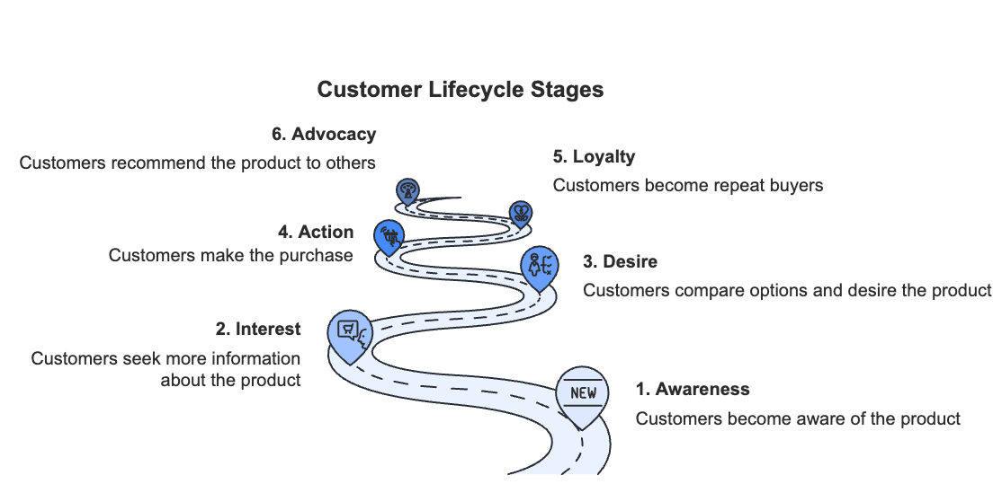
A home furnishings retailer implemented this strategy by creating distinct asset groups for different product categories and using in-market audience signals for specific furniture types. After 90 days, they saw a 47% increase in conversion rate and a 28% decrease in CPA.

Optimizing and Measuring Performance
To get the most from your audience signals, you'll need to regularly test and refine your approach.
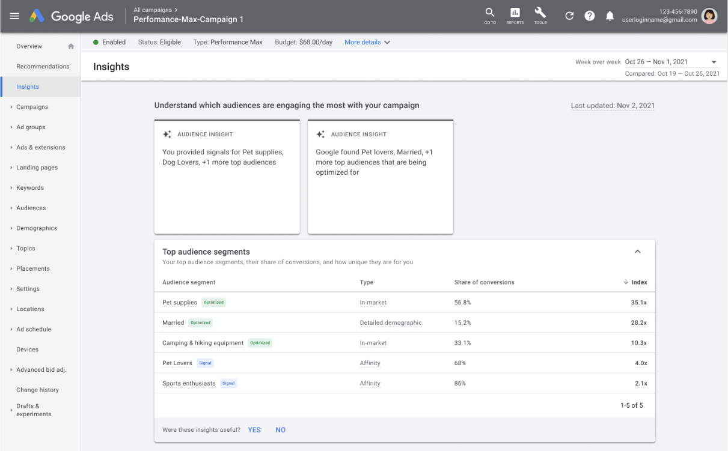
Start with specific, focused signals and monitor their performance for several weeks before making adjustments. To evaluate the effectiveness of your signals, track essential metrics like:
- Conversion rate by audience segment, which shows how well each targeted group responds to your ads
- Cost per acquisition, which reveals how much you're spending to gain each customer across different segments
- Return on ad spend, which measures the revenue generated compared to your advertising investment
When combining signals, avoid using too many simultaneously, as this can confuse the AI and dilute your targeting effectiveness. Instead, focus on creating thoughtful combinations that align with your business goals.
For example, if you run a cycling equipment store, you might combine signals like "cycling enthusiasts" and "outdoor activities" to reach passionate hobbyists more likely to engage with your products.
Remember to consider privacy in your audience strategy. Always use anonymized and aggregated data, provide clear opt-out options, and comply with data privacy regulations. Avoid targeting sensitive personal information, and regularly update your first-party data lists to maintain accuracy.
As you monitor performance, pay attention to seasonal trends and adjust your signals accordingly. A successful strategy also requires regular performance reviews, gradual expansion of working signals, and careful documentation of winning combinations. Keep testing new audience segments while maintaining signal relevance to scale your success effectively.
You've now learned how to harness the power of audience signals to reach your ideal customers. By implementing these strategies thoughtfully and measuring their impact consistently, you'll be well-positioned to maximize your PMax campaign's effectiveness and ROI.
Part Five

LEVERAGING AUTOMATION TO YOUR ADVANTAGE
____

Many marketers struggle to find the right balance between automation and control in their Performance Max campaigns. While automation offers unprecedented efficiency, maintaining strategic oversight ensures your campaigns align with business goals. You'll discover how to harness automation's power while keeping control of your marketing strategy.

Understanding AI and Control Mechanisms
Performance Max's artificial intelligence evaluates multiple factors in real time to optimize your campaigns. The system analyzes historical performance, user behavior patterns, auction dynamics, and audience engagement signals to make informed decisions. Understanding this process helps you work with the system rather than against it.
You retain several important control mechanisms while letting automation handle the day-to-day optimization. Automation layering—adding custom rules and monitoring systems on top of Google's native automation—helps maintain oversight while benefiting from AI optimization. Try implementing automated alerts for performance changes, custom rules for budget pacing, and safeguards against overspending to improve campaign efficiency.
Setting clear performance boundaries prevents automation from straying from your objectives. Establish maximum CPA thresholds, minimum ROAS targets, and daily budget caps. While automation handles asset combinations, you maintain control over asset group organization, creative quality standards, and brand messaging consistency.

Recognizing Warning Signs and Acting
Automation generally improves performance, but certain red flags warrant your immediate attention.
Watch for sudden performance drops, including more than a 20% decrease in conversion rate or significant increases in cost per conversion. Budget issues like unexpected spending spikes or uneven daily distribution need quick intervention. Monitor for targeting problems such as irrelevant placements or wrong audience segments.
Integration with your business systems enhances automation's effectiveness. Connect your automation with CRM systems, inventory management, and pricing data. Advertisers integrating business data with automation typically see a notable improvement in ROAS. Keep track of seasonal patterns and adjust automation parameters for holiday periods, industry events, and promotional calendars.
To maximize automation benefits, develop a systematic approach to testing asset variations, audience signals, and bidding strategies. Make data-driven adjustments based on historical performance trends and market conditions. Monitor how automation performs across different channels to optimize budget allocation and identify top-performing placements.
Future-proof your automation strategy by staying current with PMax updates and building internal expertise. Train team members, document best practices, and maintain flexibility to adapt to new features.
Remember that automation serves to enhance, not replace, your marketing expertise. The most successful advertisers work alongside automation, using it to amplify their strategic decisions rather than fighting against it.
Part Six

OPTIMIZING AND SCALING CAMPAIGN PERFORMANCE
____

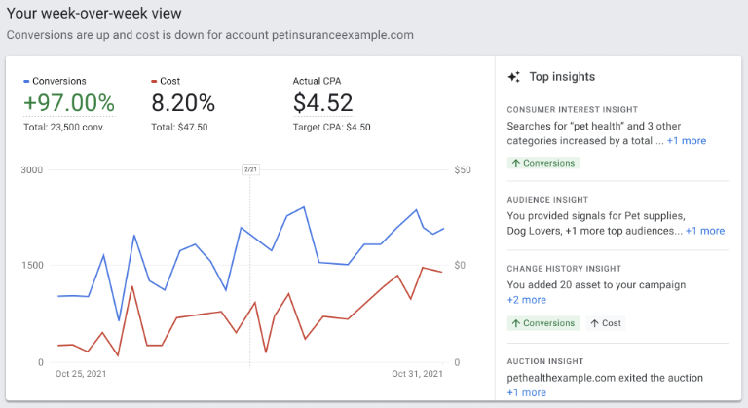
Performance Max campaigns can deliver impressive results when properly optimized. However, achieving and sustaining this success requires systematic optimization and strategic scaling.

You'll learn how to maximize your ROI and take your campaigns to the next level through proven strategies and real-world examples.

Building Your Optimization Framework
Before diving into advanced techniques, you need a solid foundation for tracking and improving performance.
Start by establishing clear metrics that align with your business goals. Focus on key indicators like conversion rate, ROA, CPA, and impression share. Create a structured schedule to review these metrics—weekly during your first month, then bi-weekly once campaigns stabilize.
Understanding performance patterns across different dimensions helps you make data-driven decisions. Pay attention to how your campaigns perform during different times of day, days of the week, and across various devices and locations.
For example, a home furnishings retailer discovered their campaigns performed 40% better during evening hours and weekends. By adjusting their bidding strategy to capitalize on these peak periods, they increased ROAS by 32% while maintaining stable conversion volume.
Value-based optimization can significantly improve your campaign ROI. Consider setting different target ROAS for high-margin versus low-margin products and adjusting conversion values based on customer lifetime value. One e-commerce company increased its ROAS by 45% simply by assigning higher conversion values to first-time purchases from its most valuable customer segments.

Scaling for Success
Once your campaigns show consistent performance for at least 30 days, you're ready to scale strategically. Before expanding your campaigns, verify you have:
- Stable or improving ROAS
- Consistent conversion volume
- Strong asset performance ratings
- Clear understanding of successful audience segments
When increasing budgets, take a gradual approach to maintain performance. Start with 20% increases and monitor results for 7–10 days. If your metrics remain stable, you can implement another 20% increase. However, if performance declines, return to your previous budget level and analyze what changed.
Track your campaigns' performance across different channels to optimize your marketing mix. Create a simple dashboard to monitor conversion rates, cost per conversion, and engagement metrics across platforms. This insight helps you allocate your budget more effectively and identify new optimization opportunities.
A retail brand successfully scaled its Performance Max campaigns by implementing weekly asset performance reviews, value-based bidding adjustments, and regular audience signal refinement.
Their systematic approach led to remarkable results over three months:
- 47% increase in conversion rate
- 28% reduction in CPA
- 65% improvement in ROAS
When you encounter performance plateaus, test new audience segments and refresh your creative assets. For inconsistent ROAS, implement value-based bidding and segment campaigns by product margin.
If you see high CPAs, review your audience signals and optimize asset performance. Document your optimization efforts and results - this data becomes invaluable as you continue refining your campaigns.
Maintain a balance between automation and control as you scale. While PMax's AI handles many optimizations, your strategic oversight ensures campaigns align with your business goals.
Part Seven

TROUBLESHOOTING

P-MAX CAMPAIGNS
____

When your Performance Max campaigns aren't delivering the results you expected, you're not alone. Whether you're seeing unexpected performance fluctuations, limited data visibility, or questioning your budget effectiveness, there's always a path to improvement. Let's explore how you can identify and fix common issues to get your campaigns back on track.

Spotting and Solving Common Problems
The first step to resolving campaign issues is knowing what to look for. Keep an eye out for sudden drops in conversion rates, unstable ROAS, or unexpected spending patterns. These warning signs often indicate underlying problems that need your attention.
Set up automated alerts to monitor key performance indicators. Track significant changes in conversion rates (especially those exceeding 20%), ROAS fluctuations outside your acceptable range, and dramatic shifts in audience engagement.
One retailer discovered their campaign's performance drop was tied to seasonal changes they hadn't anticipated. By catching this early through automated alerts, they adjusted their strategy and improved their ROAS by 45%.
When you notice issues, start with a systematic review of your campaign's foundation. Check your conversion tracking setup, review your audience signals, and analyze your asset performance.
Often, what seems like a complex problem has a straightforward solution. For example, poor performance might stem from outdated creative assets or misaligned audience signals rather than complex technical issues.

Building a Strong Recovery Strategy
Think of campaign optimization as regular maintenance for your car, which means prevention is better than cure.
Implement a weekly check-in routine to review key metrics, analyze new search terms, and monitor asset performance. This proactive approach helps you catch small issues before they become major problems.
To improve campaign visibility and control, consider these proven solutions:
- Start by enhancing your conversion tracking. Use Google Tag Manager to capture detailed event data and implement custom parameters for specific user actions. This gives you deeper insights into how your campaigns actually perform. Track not just basic conversions but also the quality of those conversions through value-based measurement.
- When facing creative performance issues, take a systematic approach to asset optimization. Review your asset performance ratings weekly and replace underperforming content promptly. One advertiser saw a 32% improvement in click-through rates simply by implementing regular creative reviews and updates based on performance data.
- To target challenges, focus on refining your audience signals. Use your customer match lists strategically, implement thoughtful audience exclusions, and test different signal combinations. Pay attention to which audience segments deliver the best results and adjust your strategy accordingly.
- Budget control issues often require a combination of solutions. Use time-based advertising adjustments, implement seasonal bid modifications, and set up automated rules for budget pacing. Monitor your budget performance across different times and channels and make adjustments based on performance patterns.
Successful troubleshooting isn't just about fixing immediate problems; it's about building systems that prevent future issues while maintaining optimal campaign performance. When you implement these strategies and maintain vigilant oversight, you'll be well-equipped to handle any challenges that arise with your Performance Max campaigns.
Part Eight

YOUR PERFORMANCE MAX JOURNEY AHEAD
____

As we conclude our exploration of Performance Max campaigns, it's clear that digital advertising has entered a transformative era. With advertisers seeing an average 12% increase in conversion value compared to traditional campaigns based on a Google report, Performance Max represents not just a new campaign type, but a fundamental shift in how you approach digital marketing.

The Future of Digital Advertising
The world of digital advertising continues to evolve rapidly, with PMax leading the charge.
According to iMark Infotech, you'll soon see more sophisticated AI systems that better understand and predict customer behavior. These advances will enable more precise audience targeting while maintaining user privacy, particularly important as third-party cookies phase out.
Performance Max and Google Analytics 4 integration will give you deeper insights into your customer's journey. You'll benefit from enhanced cross-channel attribution, allowing you to better understand how your advertising efforts contribute to conversions. This integration will also provide more comprehensive audience insights, helping you make more informed decisions about your marketing strategy.
As privacy concerns continue to shape digital advertising, you'll need to focus on building strong first-party data strategies. Search Engine Land reports that successful advertisers are already shifting toward privacy-first approaches, implementing robust data collection methods while maintaining transparency with their customers.

Maintaining Your Competitive Edge
To stay ahead in Performance Max advertising, focus on continuous improvement across three key areas.
First, keep your creative assets fresh and engaging. FraudBlocker reports that advertisers who regularly update their creative materials see a 27% improvement in campaign performance.
Second, embrace advanced automation while maintaining strategic control. Set up sophisticated rules for budget management and performance monitoring, but don't let automation run unchecked. Your oversight ensures campaigns align with your business objectives while letting AI handle day-to-day optimizations.
Finally, commit to data-driven decision-making. According to Dataiads, advertisers who maintain a structured approach to campaign management consistently achieve higher conversion rates and better return on ad spend. Use advanced analytics to predict performance trends and identify optimization opportunities.
Remember that success with Performance Max isn't about mastering a static set of rules. It's about embracing continuous learning and adaptation.
You've now learned how to harness the power of audience signals to reach your ideal customers. By applying the principles and strategies covered in this book, you're well-equipped to navigate the evolving horizon of digital advertising and achieve your marketing objectives.
Keep experimenting, learning, and growing—the future of digital advertising awaits.

