TABLE OF CONTENTS
____
INTRODUCTION 4
HIGH-TICKET AFFILIATE MARKETING WORLD 8
Understanding High-Ticket Marketing 8
Building Success Through Relationships and Value 9
CHOOSING PROFITABLE AFFILIATE PROGRAMS 13
Commission Structures and Program Quality 13
Conducting Thorough Program Research 15
YOUR PERSONAL BRAND 19
Establishing Your Authority Foundation 19
Amplifying Your Authority Through Relationships 20
ATTRACTING HIGH-QUALITY LEADS 23
Understanding and Generating Quality Traffic 23
Measuring and Optimizing Traffic Quality 24
CRAFTING A WINNING SALES FUNNEL 27
Building Your Premium Sales Process 28
Optimizing Your Funnel for Maximum Results 29
CLOSING THE GAP FROM AWARENESS TO ACTION 32
Building Trust with Premium Buyers 32
Converting Trust Into High-Ticket Sales 33
ADVANCED PROMOTION STRATEGIES FOR SUCCESS 36
Building Your Strategic Foundation 36
Leveraging Advanced Technologies and Analytics 37
TRACKING, TWEAKING, AND SCALING YOUR SUCCESS 41
Mastering Essential Performance Metrics 41
Scaling Through Advanced Technology and Automation 42
THE FUTURE OF HIGH-TICKET AFFILIATE MARKETING 46
The Landscape of Premium Affiliate Marketing 46
Building Sustainable Growth Systems 47
DISCLAIMER
____
The information provided in this ebook is intended solely for educational and informational purposes. The author does not accept any responsibility for the outcomes that may arise from the application of the material within. While efforts have been made to ensure the accuracy and relevance of the content, the author cannot be held accountable for any errors or omissions, or for any consequences resulting from the use or misuse of the information provided. The responsibility for any actions taken based on the information in this ebook lies solely with the reader.



INTRODUCTION
____
Earning $500 from a single sale instead of scrambling to make dozens of $10 commissions? High-ticket affiliate marketing makes this possible, offering an opportunity to generate significant income by promoting premium products to a quality audience. While many affiliates settle for small commissions, you’ll learn how to break into the high-value market where real money flows.
Affiliate marketing often feels like an uphill battle. You work tirelessly to drive traffic and optimize conversions, yet the rewards rarely justify the effort. High-ticket affiliate marketing changes the game by focusing on fewer, larger commissions. Instead of chasing volume, you’ll target value, working smarter, not harder.
Here’s a fact: The top 20% of high-ticket affiliate marketers earn $50,000 to $100,000 monthly. These results aren’t luck or flukes. They’re the outcome of applying proven strategies to promote premium products effectively. Now, you have the chance to learn those same strategies and unlock this lucrative earning potential.
You don’t need a massive following or years of experience.
“But is high-ticket affiliate marketing realistic for me?” you might ask. The answer is yes, with the right approach. This book provides actionable, battle-tested techniques to help you succeed. You’ll discover how to choose profitable programs, build a compelling personal brand, and develop sales funnels that convert high-end buyers.
What sets this journey apart is its focus on strategies that work today. You’ll learn how to connect with premium buyers, create engaging content, and establish automated systems that generate sales consistently. Real-world examples from affiliates earning six and seven figures will demonstrate exactly how these strategies deliver results.
The best part? You don’t need a massive following or years of experience. This book caters to beginners and seasoned marketers alike. You’ll learn how to attract targeted traffic, build trust with affluent customers, and implement systems that run on autopilot.
Here's an interesting point to consider: If an affiliate using classic commissions puts in the right effort, they can earn their first $10,000 within three months. However, how much could they earn by putting the same effort into promoting high-ticket products? With a combination of systematic effort, proven strategies, and carefully chosen high-ticket products, they could scale to $50,000 in monthly recurring revenue within six months. This example highlights what you can achieve with the proven system you’re about to access.
By the end of this book, you won’t just know what to do, you’ll have a clear action plan to build your high-ticket affiliate business. You’ll understand how to identify profitable programs, create content that sells premium products, and grow your earnings through smart partnerships and automation. Most importantly, you’ll gain the confidence to step into this space and start achieving premium profits.
Your journey to high-ticket affiliate success begins here. Let’s turn your efforts into results and transform your affiliate marketing strategy into a business that earns thousands per sale.
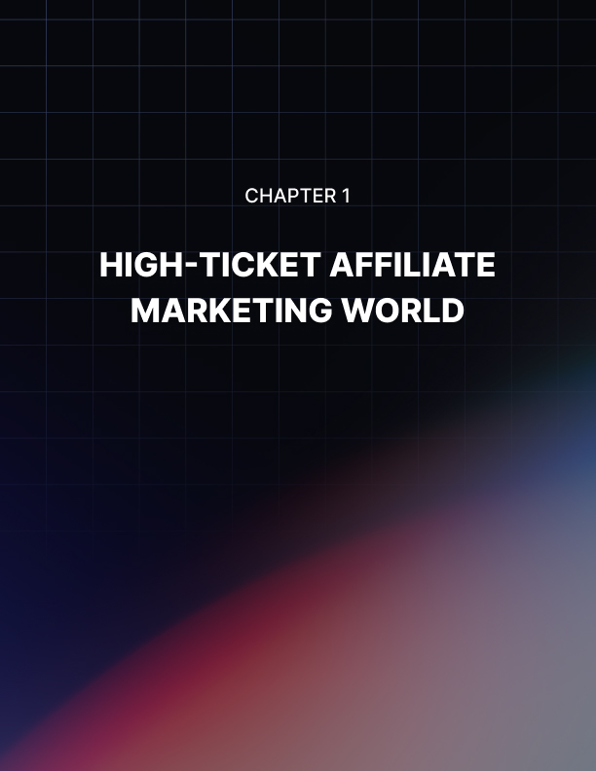

HIGH-TICKET AFFILIATE MARKETING WORLD
____
Imagine earning $545 from a single sale instead of making dozens of $10 commissions to reach the same amount. This striking difference shows the potential of high-ticket affiliate marketing, a strategy that boosts your earning power by promoting premium products. Top performers in this space consistently earn between $100,000 and $150,000 annually, proving the incredible opportunity that awaits.

Understanding High-Ticket Marketing
High-ticket affiliate marketing represents a strategic shift from traditional volume-based approaches. Rather than promoting countless low-priced items, you'll focus on premium products or services typically priced at $500 or more. This fundamental difference creates unique opportunities and challenges that set it apart from conventional affiliate marketing.
When you compare high-ticket to low-ticket affiliate marketing, the differences become clear. While low-ticket marketing requires hundreds of sales at 1-10% commission rates to generate significant income, high-ticket programs offer 10-50% commissions on premium products. This means you can earn $500-$5,000+ from a single sale, rather than struggling to make dozens of smaller commissions. The trade-off? High-ticket sales typically involve longer, relationship-based sales cycles and target more specific, qualified buyers.
The specialized nature of high-ticket products naturally reduces competition. Many affiliates avoid this space due to perceived complexity and longer sales cycles. This creates a valuable opportunity for you if you're willing to invest time in building expertise and relationships with your audience. According to SelfEmployed.com, this reduced competition stems from higher barriers to entry and the need for specialized knowledge - factors that actually work in your favor when you're committed to mastering this approach.

Building Success Through Relationships and Value
High-ticket affiliate marketing thrives on building strong customer relationships. Your success depends on establishing trust and providing comprehensive product education. Instead of quick, transactional sales, you'll focus on creating long-term value for your audience through:
- Detailed, educational content that helps buyers make informed decisions
- Personalized support throughout the customer journey
- Regular engagement with your audience to understand their needs
- Authentic case studies and testimonials that build credibility
The high-ticket customer shows distinct characteristics that influence your marketing approach. These buyers make decisions based on value rather than price, conduct thorough research, and seek expert opinions before purchasing. They typically follow a detailed decision-making process that includes problem recognition, extensive research, alternative evaluation, and careful value assessment.
Many high-ticket programs offer recurring commission structures, particularly in software-as-a-service (SaaS) and membership programs. This means you can generate ongoing income from a single customer acquisition, multiplying the value of each conversion. The market continues to expand, with growing demand for premium digital products, luxury experiences, high-end coaching services, and exclusive memberships.
To succeed in high-ticket affiliate marketing, focus on choosing the right niche that aligns with your expertise and has verified market demand. Build your authority through valuable content creation and consistent audience engagement. Implement robust systems for tracking, conversion optimization, and follow-up processes.
Top-performing niches include business and finance (investment programs, trading courses), technology (enterprise software, premium hosting services), and lifestyle and luxury (travel packages, designer goods). The future looks particularly bright for digital transformation services, sustainable luxury products, premium online education, and exclusive membership communities.
Success in high-ticket affiliate marketing isn't about volume. It's about strategically positioning yourself, building meaningful relationships, and promoting high-value products that truly serve your audience's needs. By focusing on these elements and maintaining a commitment to excellence, you'll be well-positioned to tap into this lucrative opportunity.
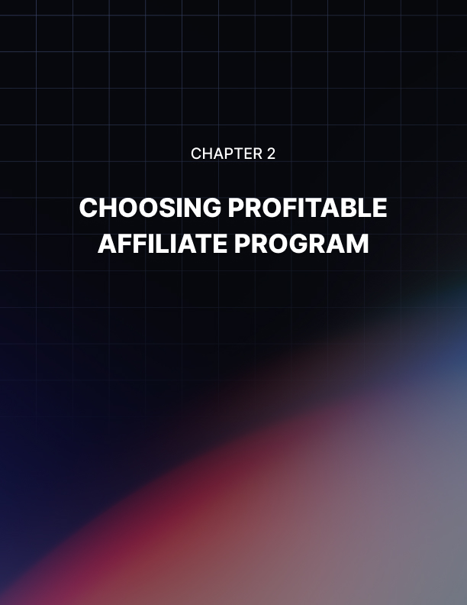

CHOOSING PROFITABLE AFFILIATE PROGRAMS
____
When you're aiming to earn $500 to several thousand dollars per sale through high-ticket affiliate marketing, choosing the right program becomes crucial to your success. Your journey starts with understanding how to evaluate these premium opportunities effectively and strategically.
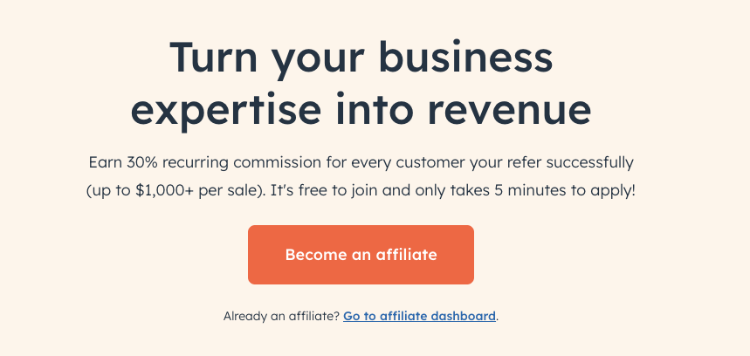

Commission Structures and Program Quality
The most lucrative high-ticket affiliate programs offer diverse earning potential through various commission types. For instance, HubSpot's program demonstrates this perfectly by providing initial commissions of $250 to $1,000 per sale, plus ongoing earnings from customer subscriptions. This combination of immediate and recurring revenue can significantly boost your income potential.
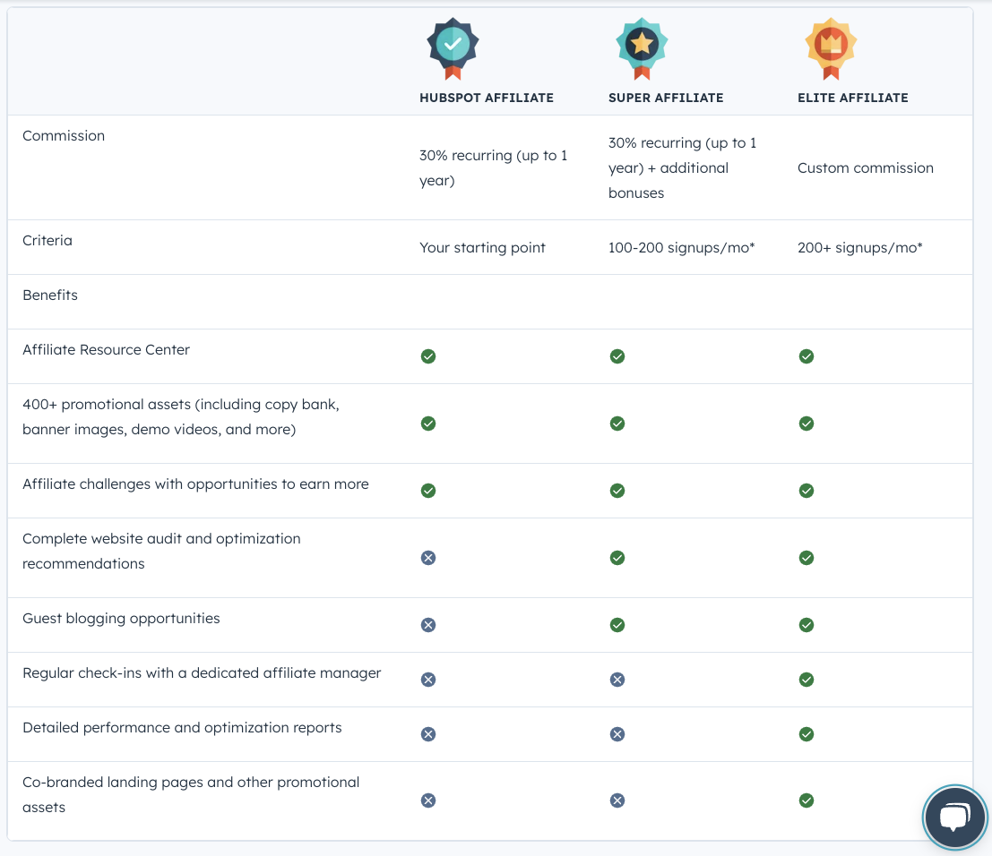
When evaluating programs, examine their commission structure carefully. Look for programs offering a mix of base commissions for initial sales, recurring payments for subscription products, and performance bonuses for meeting targets. Some programs even provide two-tier commissions, allowing you to earn from sub-affiliate referrals, creating multiple income streams from a single program.
Product quality and market position play equally important roles in your success. You'll want to promote products with clear unique selling points and strong competitive advantages. Check current market trends, search volumes, and competition levels to ensure sustainable demand. Customer reviews and testimonials provide valuable insights into product effectiveness and market reception. According to Commission Academy, programs backed by solid social proof consistently deliver better results for affiliates.

Conducting Thorough Program Research
Before committing to any high-ticket affiliate program, you'll need to verify several crucial elements. Start by investigating the company's history, reputation, and payment track record. Reliable programs maintain transparent payment schedules, reasonable minimum payout thresholds, and flexible payment methods.
The quality of support systems can make or break your success. Look for programs offering comprehensive marketing materials, responsive technical support, and in-depth training resources. Top programs provide professional creative assets, email templates, and landing page designs to help you succeed. They also offer extensive educational resources, including product training modules, marketing strategy guides, and sales conversion techniques.
You'll want to ensure the program has robust tracking and analytics capabilities. This includes reliable sales attribution systems and detailed reporting tools that help you monitor your performance and optimize your strategies. According to Digital Fodder, programs with sophisticated tracking systems tend to provide more stable and profitable opportunities for affiliates.
When evaluating potential programs, consider these key factors in order of importance:
- Commission Structure (25%)
- Product Quality (20%)
- Market Demand (15%)
- Support System (15%)
- Payment Terms (15%)
- Brand Reputation (10%)
Programs scoring well across these categories typically offer the best potential for long-term success.
Once you've selected a promising program, focus on proper implementation. Start by thoroughly reviewing and completing all application requirements. Download and organize your marketing materials, access training resources, and set up your tracking systems. Develop a promotion strategy and content calendar that aligns with your audience's needs and the program's goals.
Successful high-ticket affiliate marketing isn't about jumping into the first program you find. Take time to evaluate each opportunity thoroughly, considering both immediate earning potential and long-term sustainability. Your careful selection process now will pay dividends in your future success as you build your high-ticket affiliate marketing business.
In the next chapter, you'll learn how to establish yourself as an authority in your chosen niche, a crucial step in successfully promoting high-ticket products to your audience.


YOUR PERSONAL BRAND
____
High-ticket affiliate marketers who establish themselves as trusted authorities see conversion rates up to 5 times higher than those relying solely on promotional tactics. When a single sale can generate thousands in commissions, this difference becomes transformative. Building authority isn't just about claiming expertise, it's about consistently demonstrating your knowledge while maintaining authenticity across multiple channels.

Establishing Your Authority Foundation
Your path to becoming an authority starts with finding your sweet spot, the intersection between your genuine expertise, market demand, and competitive gaps. Rather than positioning yourself broadly, focus on specific, underserved segments within larger markets. For instance, instead of being a "digital marketing expert," you might become the go-to authority for "enterprise SEO software solutions for e-commerce brands."
To demonstrate your expertise effectively, you'll need to create various types of content that showcase your knowledge while providing real value. In-depth guides incorporating original research and expert interviews serve as cornerstone content pieces. Case studies highlighting specific, measurable results build credibility through real-world examples. Video content allows you to demonstrate your expertise personally, while podcasts enable you to bring valuable insights through expert conversations.
Your personal experience stories can significantly boost engagement, up to 300% according to AWeber. Share specific challenges you've overcome, document your learning journey, and highlight client success stories. When you back your content with concrete data and research, it receives 121% more social shares than opinion-based content. Consider conducting original research, analyzing industry trends, and creating comprehensive comparison studies that showcase your deep understanding of the field.

Amplifying Your Authority Through Relationships
Building authority extends beyond creating content, it requires strategic relationship building within your industry. Collaborate with other experts to co-create content, participate in expert roundups, and host joint webinars. Take leadership roles in your niche community by creating and moderating groups, organizing virtual events, and facilitating knowledge sharing.
Technology plays a crucial role in modern authority building. Utilize AI writing assistants to maintain consistent content production, implement scheduling tools for multi-channel presence, and leverage analytics platforms to track your content's performance. CRM systems help manage professional connections, while social listening tools identify engagement opportunities.
Speaking engagements can rapidly accelerate your authority building journey. Seek opportunities to present at virtual summits, appear on industry podcasts, create online courses, and facilitate workshops. When you create content, maximize its impact by repurposing it across multiple formats. Transform blog posts into video content, convert webinars into downloadable guides, and create social media snippets from longer content.
To measure your authority growth, track key metrics including content engagement rates, social proof indicators, audience growth, expert citations, and media mentions. Regular analysis of these metrics helps refine your strategy and ensure continued progress in establishing your authority position.
Building authority in high-ticket affiliate marketing requires sustained effort over time. While it typically takes 6-12 months to see significant results, your investment brings compound returns through higher conversion rates, stronger relationships, and increased earning potential. Document your journey along the way, your experiences become valuable content that helps others while further cementing your expertise in the field.
Consider starting today by auditing your current position, developing a content strategy, and identifying key industry contacts for potential collaborations. Your success in high-ticket affiliate marketing depends on becoming a trusted voice in your chosen niche.


ATTRACTING HIGH-QUALITY LEADS
____
When promoting products with commissions ranging from $500 to several thousand dollars per sale, attracting the right visitors becomes crucial. Studies consistently show that targeted traffic converts 5-10x better than general traffic in high-ticket affiliate marketing. You'll need to master the art of bringing qualified leads to your offers while maintaining strict quality standards.

Understanding and Generating Quality Traffic
Quality traffic for high-ticket offers goes beyond simple visitor numbers. Your ideal visitors should have genuine interest in premium solutions and the means to make substantial purchases. According to Pretty Links, the most valuable traffic comes from people actively searching for solutions, having the budget for premium purchases, and possessing decision-making authority.
Content marketing remains your most powerful tool for attracting qualified leads. Create in-depth product reviews that thoroughly analyze features, benefits, and real-world applications. Develop comprehensive guides addressing specific pain points your audience faces. The Savvy Marketer emphasizes the effectiveness of video content - from product demonstrations to expert interviews - in building trust with potential buyers of premium products.
When implementing SEO strategies, focus on high-intent keywords that signal buying readiness. Target phrases like "best [premium product] for [specific use case]" or "[product name] vs [competitor] review." These specific search terms help you connect with buyers who are already evaluating solutions. Pretty Links suggests optimizing for keywords that indicate purchasing intent rather than basic information gathering.
Your paid advertising strategy should focus on precision targeting. Create custom audiences based on previous buyer profiles and engage in sophisticated retargeting. According to Film Lifestyle, successful paid campaigns for high-ticket products require high-quality visuals that showcase value, along with clear social proof elements. Implement segmented retargeting based on content interaction and adjust your messaging as prospects move through their buying journey.

Measuring and Optimizing Traffic Quality
Implementing detailed tracking systems helps you maintain and improve traffic quality over time. Monitor engagement metrics like average time on site, pages per session, and video watch time. Track conversion indicators including email sign-up rates, resource downloads, and consultation bookings. Nixxe Solutions emphasizes using these metrics to optimize traffic sources and improve your return on investment.
Build strategic partnerships to enhance your traffic quality. According to Advertise Purple, collaborating with industry experts through joint webinars, collaborative content creation, and shared email promotions can significantly boost your results. Guest posting on authority sites and making podcast appearances help establish your expertise while bringing in pre-qualified traffic.
Develop sophisticated email marketing campaigns that segment audiences based on interest and engagement levels. The Teach.io Blog highlights email marketing's crucial role in nurturing high-ticket prospects over time. Share valuable content, industry insights, and exclusive resources to build relationships with potential buyers.
Regular analysis and optimization keep your traffic quality high. Review traffic quality weekly, analyze source performance monthly, and adjust your strategy quarterly. Test different landing pages, optimize ad creative, and continuously enhance your content. Shopify recommends maintaining this regular optimization schedule to ensure consistent improvement in traffic quality.
Keep in mind that attracting the right visitors matters more than pure traffic volume when promoting premium products. Focus your efforts on bringing in qualified leads who demonstrate genuine interest and have the means to purchase. By implementing these targeted strategies and maintaining strict quality standards, you'll build a steady flow of high-quality traffic that converts into valuable sales.


CRAFTING A WINNING SALES FUNNEL
____
Picture earning $1,500 from a single sale instead of struggling to make hundreds of small commissions. This is the power of a well-crafted high-ticket sales funnel. Top performers consistently achieve 5-15% conversion rates with premium products, compared to the typical 1-2% seen in standard e-commerce. The secret lies in building a sophisticated system that nurtures relationships and establishes deep trust with potential buyers.
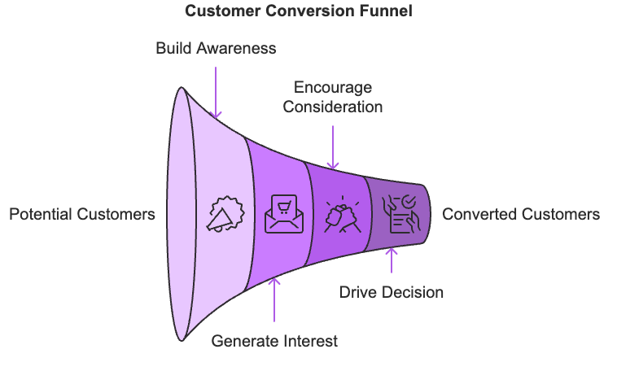

Building Your Premium Sales Process
Unlike quick-transaction funnels, your high-ticket approach needs to guide prospects through a careful decision journey. You'll start by sharing valuable content that addresses specific challenges in your market. Think comprehensive solution guides, detailed case studies, and expert video demonstrations that showcase your deep understanding of their needs.
Your lead magnet should offer substantial value while qualifying prospects. Consider creating an exclusive video training series or offering a free consultation session. These premium resources help identify serious buyers. According to GetResponse, targeted lead magnets focusing on industry-specific challenges convert three times better than generic offerings.
Once you've captured a prospect's interest, you'll nurture them through a strategic sequence:
- Welcome them with a quick win and clear next steps
- Build credibility through case studies and expert insights
- Present your solution with concrete benefits and ROI analysis
- Address concerns with social proof and targeted support
This methodical approach acknowledges that premium purchases require more consideration. Rather than pushing for instant sales, you're building a relationship that can lead to long-term value.

Optimizing Your Funnel for Maximum Results
Your funnel's success depends on consistently measuring and improving its performance. Track essential metrics like email engagement, content interaction, and most importantly - conversion rates at each stage. This data helps you identify where prospects might get stuck or lose interest.
Personalization plays a crucial role in high-ticket conversions. Use your prospect's behavior to tailor their experience. When someone shows interest in specific content, follow up with related resources. If they attend a webinar, send them additional insights on topics discussed. This targeted approach makes each interaction more meaningful and moves them closer to a purchase decision.
Build exclusivity into your funnel through private communities and member-only events. These elements create a sense of belonging and allow prospects to see others succeeding with your solutions. Consider hosting expert Q&A sessions or celebration events where successful clients share their stories.
Don't forget about post-purchase care, it's crucial for referrals and repeat business. Create a solid onboarding sequence, provide implementation support, and celebrate client successes. According to Martech360, effective after-sale nurturing can boost customer lifetime value by 33%.
A real-world example shows these principles in action: A high-ticket software training program achieved impressive results by following this systematic approach. Their free video course converted 40% of visitors into leads, while their nurturing sequence kept 85% of prospects engaged. One-quarter of qualified leads booked consultations, with 15% of those calls resulting in sales. The key? Highly targeted content, personalized follow-up, and clear value demonstration at every stage.
Your success in high-ticket sales depends on building a funnel that educates and nurtures prospects while demonstrating clear value. Start by auditing your current process against these principles, then make improvements one stage at a time. Test, measure, and refine based on real results. With patience and consistent optimization, your funnel can become a reliable engine for generating premium sales.


CLOSING THE GAP FROM AWARENESS TO ACTION
____
When promoting high-ticket products worth $500 or more, your success hinges on one crucial element: trust. Affiliate marketers who prioritize trust-building strategies achieve conversion rates up to 5 times higher than those focused purely on promotion. With potential commissions reaching thousands of dollars per sale, mastering the art of building trust becomes essential to your success.

Building Trust with Premium Buyers
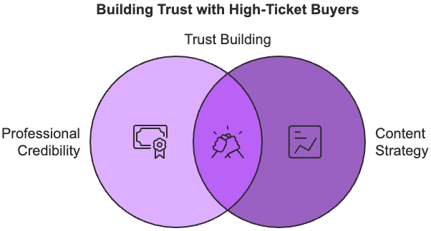
High-ticket buyers think differently than typical online shoppers. They conduct thorough research, seek multiple proof points, and value expertise over promotional content. You need to adapt your approach to match these expectations. Instead of pushing for quick sales, focus on demonstrating your deep understanding of their needs and challenges.

Start by establishing your professional credibility through a well-designed online presence. Your website should reflect the premium nature of your offerings with clean aesthetics, clear navigation, and secure browsing. Share your authentic story and business credentials on your about page, and maintain consistently high-quality content that showcases your expertise.
Your content strategy plays a vital role in building trust at scale. Create comprehensive product analyses that go beyond basic reviews. Develop detailed comparison guides that help prospects make informed decisions. Share implementation guides and ROI calculators that demonstrate the practical value of your recommended solutions. When you support these materials with real case studies and expert interviews, you create a compelling trust framework that resonates with high-ticket buyers.

Converting Trust Into High-Ticket Sales
Building trust is only half the equation, you need to effectively convert that trust into sales. Personalization becomes crucial at this stage. Track how prospects engage with your content and customize your recommendations based on their interests and behaviors. When someone shows particular interest in specific features or use cases, follow up with targeted resources that address those exact points.
Reduce perceived risk by highlighting money-back guarantees and sharing concrete success metrics. Feature detailed case studies that walk through the entire customer journey, from initial challenges to measurable results. Build an active community where prospects can interact with existing customers and see real implementation success stories.
Your conversion strategy should focus on maintaining consistent engagement through:
- Regular webinars and Q&A sessions that showcase your expertise.
- Personalized email sequences based on prospect behavior.
- Individual consultation offers for qualified leads.
- Active community spaces where buyers can connect and share experiences.
Track your trust-building efforts by monitoring key metrics like content engagement time, testimonial impact, and trust-attributed sales. Regularly review these metrics to identify areas for improvement and adjust your strategy accordingly. Remember that building trust takes time, but the payoff in high-ticket sales makes it worth the investment.
Keep refining your approach based on feedback and results, always prioritizing authentic value over quick wins. By consistently demonstrating expertise, reducing risk, and maintaining active engagement with your audience, you'll build the trust necessary to succeed in high-ticket affiliate marketing.
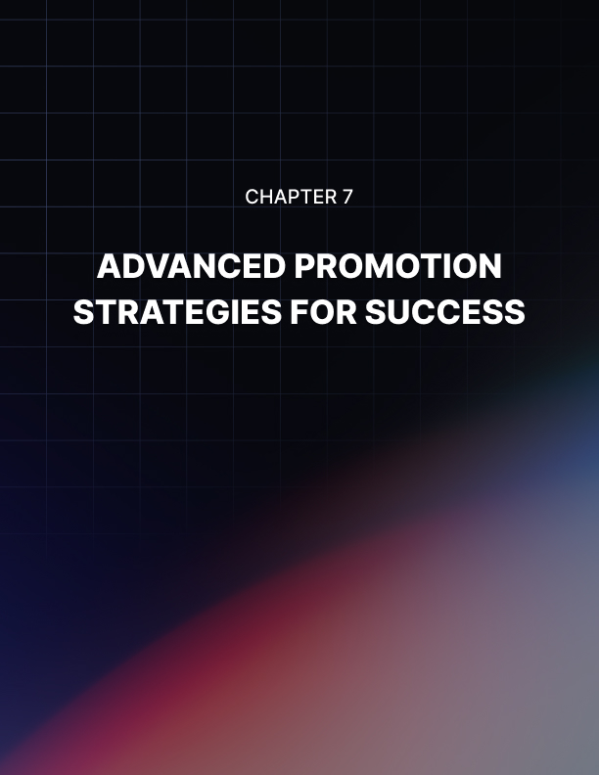

ADVANCED PROMOTION STRATEGIES FOR SUCCESS
____
Imagine earning five times more from your promotional efforts without increasing your advertising budget. According to recent data from Dropshipping Copilot, affiliates who implement sophisticated multi-channel strategies consistently outperform those relying on basic promotional tactics. Your success in high-ticket affiliate marketing depends on mastering these advanced promotional approaches.

Building Your Strategic Foundation
High-ticket promotion requires a carefully planned approach that leverages multiple channels while maintaining consistent messaging. You'll need to start by understanding which promotional channels deliver the best results for premium products. Content marketing typically generates the highest trust levels, while webinars often produce the strongest conversion rates. Social media advertising excels at precise audience targeting, and email marketing remains unmatched for nurturing prospects through complex buying decisions.
The key to your success lies in combining these channels effectively. Rather than treating each one as a separate entity, think of them as interconnected touchpoints in your prospect's journey. Your content marketing efforts should feed into your email nurturing sequences, while your social media presence reinforces your authority established through webinars and live events.
When creating content, focus on demonstrating deep expertise rather than making surface-level recommendations. Develop comprehensive product comparisons that include detailed ROI calculations and real-world implementation scenarios. Create video content that goes beyond basic reviews – showcase actual product implementations, expert interviews, and behind-the-scenes looks at how premium solutions solve complex problems.

Leveraging Advanced Technologies and Analytics
Modern high-ticket promotion increasingly relies on sophisticated technology to deliver personalized experiences at scale. AI-powered tools now enable you to predict purchase likelihood, deliver customized content sequences, and optimize timing for your promotional messages. According to Medium's analysis of emerging trends, affiliates who integrate AI-driven personalization see up to 40% higher engagement rates.
Your testing and optimization efforts should follow a systematic approach. Start by establishing clear baseline metrics for each promotional channel. Track not just surface-level KPIs like click-through rates, but deeper engagement metrics that indicate genuine interest in premium solutions. Monitor how prospects move through your content, where they spend the most time, and which sequences lead to successful conversions.
Email remains a cornerstone of successful high-ticket promotion, but modern approaches focus on sophisticated segmentation and behavioral triggers. Build sequences that adapt to prospect engagement levels, delivering increasingly detailed information as interest grows. Use automation to ensure consistent follow-up while maintaining a personal touch through strategic live interactions.
Your social media strategy should prioritize building authority over direct promotion. Share insights from your experience, engage with industry discussions, and showcase customer success stories. Partner with relevant influencers for co-created content that adds genuine value rather than simple endorsements.
Remember to maintain a cohesive brand message across all channels while adapting content formats to each platform's strengths. LinkedIn posts should emphasize professional insights, while Instagram can showcase the lifestyle benefits of premium solutions. YouTube provides an ideal platform for detailed product demonstrations and educational content.
By implementing these advanced promotional strategies systematically while staying attuned to emerging trends, you'll build a sustainable foundation for high-ticket affiliate success. Start by mastering one or two channels completely before expanding your reach, and always let data guide your optimization efforts.


TRACKING, TWEAKING, AND SCALING YOUR SUCCESS
____
Imagine transforming your affiliate business from generating occasional sales to consistently earning five-figure monthly commissions. Data-driven affiliate marketers achieve 23% higher ROI compared to those relying on intuition alone. When individual commissions can reach thousands of dollars, implementing sophisticated tracking and analysis becomes crucial for your growth and success.

Mastering Essential Performance Metrics
Your success in high-ticket affiliate marketing starts with understanding the right metrics to track. While basic metrics like total sales matter, you'll need to dig deeper to optimize your performance effectively. Start by monitoring your revenue metrics, including gross sales, net commissions, and average order value. These numbers help you identify your most profitable programs and opportunities for growth.
Focus on tracking customer behavior patterns that impact your bottom line. Monitor your conversion rates across different traffic sources, the average time prospects take to make purchase decisions, and the lifetime value of your customers. According to Cleartail Marketing, successful affiliates pay special attention to customer acquisition costs and ROI per marketing channel to optimize their resource allocation.
Your engagement metrics deserve equal attention. Track how prospects interact with your content, including time spent on pages, video completion rates, and email response patterns. This data helps you understand which content resonates most effectively with your audience and guides your creation of future materials.
Pay particular attention to your customer journey analysis. Use attribution modeling to identify which touchpoints contribute most significantly to conversions. According to Medium, understanding these patterns helps you focus your efforts on the most effective parts of your sales process while eliminating inefficient activities that drain your resources.

Scaling Through Advanced Technology and Automation
To scale your high-ticket affiliate business effectively, you'll need to leverage modern technology solutions. AI-powered tools now enable you to predict purchase likelihood, personalize content delivery, and optimize your promotional timing automatically. According to Lesson on Marketing, implementing AI tools can improve your conversion rates by up to 47% while reducing customer acquisition costs.
Build your automation framework around these key areas:
- Email sequence management that adapts based on prospect behavior.
- Social media content distribution that maintains consistent presence.
- Lead scoring systems that help you focus on your most promising prospects.
- CRM integration that ensures no valuable lead falls through the cracks.
Your testing and optimization efforts should follow a systematic approach. Create a regular schedule for reviewing and improving your:
- Landing page elements and conversion points.
- Email sequence effectiveness and timing.
- Traffic source quality and cost efficiency.
- Content engagement and response rates.
Remember to document your testing results and use them to inform future decisions. According to Digital Fodder, successful affiliates review their metrics weekly for quick adjustments and conduct deeper quarterly analyses to guide their strategic planning.
Looking ahead, prepare for emerging trends in affiliate analytics, including enhanced AI capabilities, improved cross-channel attribution, and privacy-compliant tracking solutions. Stay informed about these developments to maintain your competitive edge in the high-ticket affiliate marketing space.
Your journey to scaling your high-ticket affiliate business requires commitment to data-driven decision making and continuous optimization. Implementing robust tracking systems and regularly analyzing your results helps build a sustainable foundation for long-term success. Start by choosing one area to optimize, measure your results, and gradually expand your optimization efforts across your entire operation.
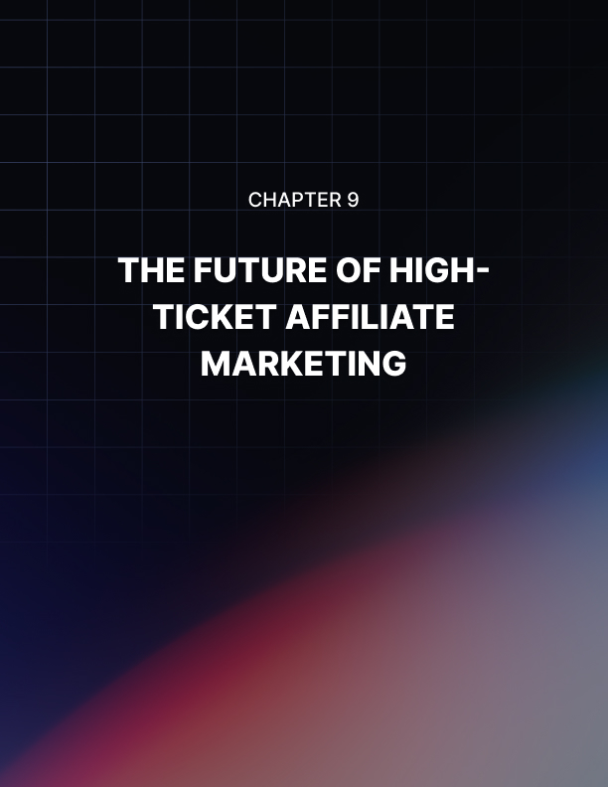

THE FUTURE OF HIGH-TICKET AFFILIATE MARKETING
____
Picture Jossie's journey: a digital marketer who transformed her affiliate business from occasional $50 commissions to consistent $15,000 monthly earnings within a year. Her success wasn't luck, it came from embracing emerging trends while building sustainable systems for long-term growth. As you conclude your high-ticket affiliate marketing journey, let's explore how you can achieve similar results by staying ahead of industry changes and building for the future.

The Landscape of Premium Affiliate Marketing
The affiliate marketing space is undergoing rapid transformation, driven by technological advances and changing consumer behaviors. Privacy regulations are reshaping tracking and analytics approaches. You'll need to adapt by implementing cookieless tracking solutions while maintaining detailed performance insights. According to LinkedIn, successful affiliates are embracing privacy-first marketing methods that build trust while respecting user data. This includes transparent promotional practices and ethical marketing approaches that resonate with today's conscious consumers.
AI-powered personalization is becoming essential for standing out in the premium space. Advanced algorithms now enable you to deliver customized experiences at scale, from intelligent product recommendations to personalized content sequences. These tools can increase your conversion rates by up to 47% by ensuring each prospect receives relevant information at the right time.

Building Sustainable Growth Systems
Creating lasting success in high-ticket affiliate marketing requires thinking beyond quick wins to establish robust systems for continuous growth. Start by diversifying your affiliate portfolio across complementary niches that share audience characteristics. According to Dropshipping Copilot, this approach helps protect your income from market fluctuations while opening new opportunities for expansion.
You'll want to monitor key warning signs that indicate the need for strategy adjustment. Watch for declining conversion rates, rising customer acquisition costs, or reduced engagement with your content. When you notice these indicators, consider expanding into related niches or adding complementary revenue streams to your business model.
Strategic partnerships can significantly accelerate your growth. Look for opportunities to collaborate with complementary service providers, industry influencers, and technology partners. These relationships not only expand your reach but also enhance your authority in the space. Focus on creating win-win scenarios where both parties bring unique value to their audiences.
Building your authority should remain a constant focus. Share regular industry insights, document success stories through detailed case studies, and foster engagement within your community. Consider speaking opportunities, industry publications, and collaborative projects that position you as a thought leader in your chosen niche.
The future of high-ticket affiliate marketing offers tremendous potential for those willing to adapt and grow. Remember that success comes from consistently providing value while staying attuned to emerging trends and opportunities in this dynamic space.
Keep evolving, stay focused on quality over quantity, and never stop building meaningful relationships with your audience. Your high-ticket affiliate journey is just beginning, and the possibilities ahead are limitless.

