TABLE OF CONTENTS
____
INTRODUCTION 4
WEBSITE 101: WHAT MAKES A GREAT WEBSITE? 8
Creating Your Professional Digital Presence 8
Building Trust and Driving Engagement 10
WHICH WEBSITE BUILDER WORKS BEST FOR YOU? 13
Choosing Your Perfect Website Builder 13
Making Your Decision 14
HOW DO YOU DESIGN A WEBSITE FOR YOUR BRAND? 18
Creating Your Brand's Visual Story 18
Building a Consistent Brand Experience 20
HOW DO YOU ADD THE ESSENTIALS TO YOUR WEBSITE? 24
Creating Pages That Connect and Convert 24
Making Your Website Work Smarter 25
HOW DO YOU PUBLISH YOUR WEBSITE? 29
Preparing for Your Website's Big Debut 29
Making Your Launch a Success 32
HOW DO YOU OPTIMIZE FOR SEARCH ENGINES? 36
Making Search Engines Love Your Website 36
Building Your Website's Authority 37
HOW DO YOU KEEP IT UPDATED AND ENGAGING? 41
Keeping Your Content Fresh and Engaging 41
Making Your Website Work Smarter 43
FUTURE-PROOFING YOUR DIGITAL SUCCESS 46
Building Your Digital Growth Engine 46
Embracing Future Trends 47

DISCLAIMER
____
The information provided in this ebook is intended solely for educational and informational purposes. The author does not accept any responsibility for the outcomes that may arise from the application of the material within. While efforts have been made to ensure the accuracy and relevance of the content, the author cannot be held accountable for any errors or omissions, or for any consequences resulting from the use or misuse of the information provided. The responsibility for any actions taken based on the information in this ebook lies solely with the reader.


INTRODUCTION
____
You're standing at the edge of a vast online world, knowing your business needs a website, but feeling overwhelmed by the endless choices and technical jargon.
You're not alone. In 2023, 73% of small businesses in the US have websites based on research conducted by Zippia, yet many entrepreneurs struggle to create one that truly works for them.
The good news? You don't need to be a coding wizard or have deep pockets to build a professional website that attracts customers and grows your business.
Your website is your 24/7 salesperson and a gateway to reaching customers worldwide.

Think of this book as your trusted friend who's been through the website-building journey and is ready to share all the secrets, shortcuts, and strategies that actually work. We're cutting through the noise to show you the simplest path to creating a website that not only looks professional but also drives real results for your business.
Here's what makes this journey different: instead of drowning you in technical terms or pushing you toward expensive solutions, we're focusing on what truly matters for your success. You'll discover which website builders are genuinely easy to use (and which ones to avoid), learn how to make design choices that reflect your brand's personality, and master the essential features that turn visitors into customers.
We've tested hundreds of tools and strategies, and we're bringing you only the ones that deliver real value for entrepreneurs like you. You’ll learn how to navigate this evolution confidently and easily, as we’ll only share straightforward strategies that work.
The world of online business may be moving at lightning speed, with new tools and trends emerging daily, but don't let that intimidate you. Through these pages, you’ll learn how to pick the perfect website builder for your needs, create content that connects with your audience, and optimize your site to attract more visitors—all without getting tangled in technical complexities or burning through your budget.
What sets this guide apart is our laser focus on practicality. You won't find any fluff or theoretical concepts here. Instead, you'll get step-by-step instructions, real-world examples, and proven techniques that you can implement immediately.
For instance, you'll learn how one coffee shop owner increased their online orders by 300% just by making three simple changes to their website's layout. Or how a freelance designer doubled their client inquiries by optimizing their portfolio page using the strategies we'll share.
By the time you finish this book, you'll have more than just knowledge, you'll have the confidence to build a website that works as hard as you do. You'll understand how to create a site that not only looks professional but also converts visitors into customers. You'll know exactly which features you need (and which ones you can skip), how to make your site appear in search results, and how to keep it running smoothly without spending hours on maintenance.
Your website is more than just a digital business card—it's your most powerful marketing tool, your 24/7 salesperson, and your gateway to reaching customers worldwide. Whether you're starting from scratch or looking to improve your existing site, this book will guide you through every step of creating a website that helps your business thrive in the online world. Let's get started on transforming your online presence into your greatest business asset.
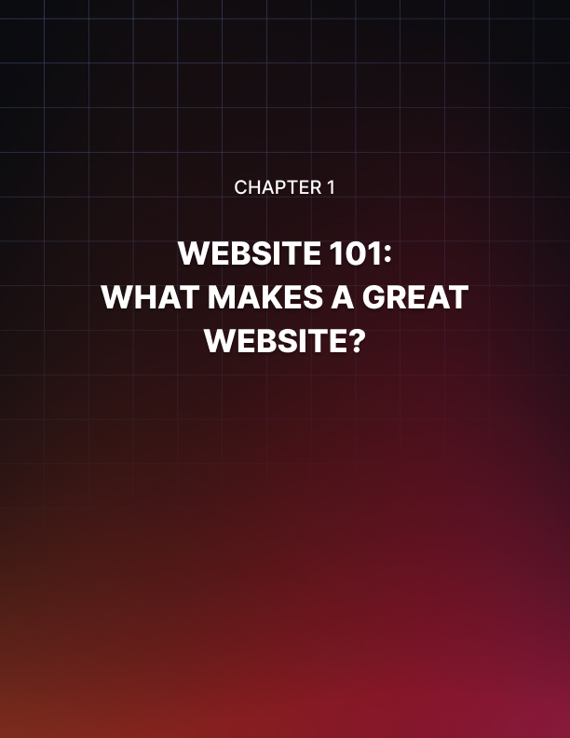

WEBSITE 101: WHAT MAKES A GREAT WEBSITE?
____
Your website is more than just an online presence. It's the face of your business.
A study conducted by Stanford University reveals that 75% of potential customers judge your credibility based on your website design, so you need to get it right from the start. Let's explore what makes a website not just good, but great.

Creating Your Professional Digital Presence
Your website acts as your digital storefront, making those crucial first impressions that can either attract or repel potential customers. To create a lasting positive impression, you'll need to focus on both visual appeal and technical excellence.
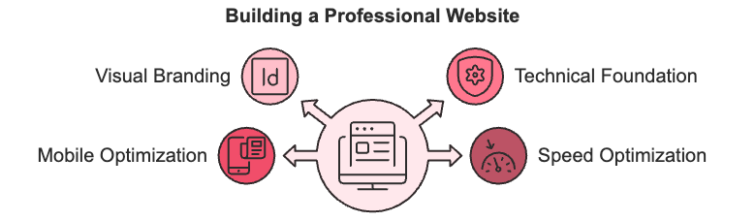
Start with your visual branding. It's the first thing visitors notice, to begin with.
Choose 2–3 primary colors that reflect your brand personality and stick to them consistently across your website. Select no more than two complementary fonts that are easy to read, and maintain a consistent style in your images and graphics.
This consistency isn't just about looking good. According to a Lucidpress survey, businesses that maintain cohesive branding see an average 33% increase in revenue.
The technical foundation of your website is equally crucial. A well-built foundation ensures your site loads quickly, functions smoothly, and provides a seamless user experience across all devices.
Start with a professional domain name that's memorable and relevant to your business. Avoid hyphens and numbers, and stick to common extensions like .com or .net. Your hosting should be secure and reliable, with a security certificate (often called SSL) that protects your visitors' data. Regular backups and guaranteed uptime ensure your website stays accessible when customers need it.
With most web traffic coming from mobile devices, your website must work flawlessly on smartphones and tablets. This means ensuring your text is readable without zooming, buttons are easily tappable, and pages load quickly on mobile networks.
Speaking of speed, optimize your images and use content delivery systems to ensure your pages load rapidly. Customers won't wait around for slow websites.

Building Trust and Driving Engagement
To convert visitors into customers, your website needs to establish trust and facilitate easy communication.
Begin by showcasing social proof. Display customer testimonials, reviews, and case studies prominently. Include trust badges like industry certifications and security seals. Websites that effectively use these elements will see higher conversion rates than those who don’t.
Make it easy for customers to reach you by providing multiple contact options. Include a professional contact form, live chat functionality if possible, and clear phone numbers or email addresses. Consider adding interactive elements like FAQ sections, booking systems, or appointment schedulers to make it even easier for customers to engage with your business.
Your content plays a vital role in engaging visitors. Place your value proposition (or what makes your business unique) prominently above the fold on your homepage. Structure your content clearly with descriptive headlines and subheadings, and use compelling calls-to-action throughout. Keep your content fresh and relevant with a blog or news section that showcases your industry expertise and company updates.
Next, track how visitors interact with your website using tools like Google Analytics and heat mapping software. This data helps you understand what's working and what needs improvement. Regularly monitoring performance metrics ensures your website continues to serve your business goals effectively.
Don't forget about e-commerce capabilities. Even if you're not selling online today, building your website with e-commerce in mind gives you flexibility for future growth. Include secure payment systems, shopping cart functionality, and inventory management tools to prepare for expansion.
Remember these key points to avoid common pitfalls:
- Keep your design clean and uncluttered.
- Ensure fast loading times.
- Make contact information easily visible.
- Regularly update your content.
In short, think of your website as a window to your business. Keep it clean, clear, and inviting.
Your website is often the first step in your customer's journey with your business. By thoughtfully implementing these essential elements and maintaining high standards in both functionality and design, you create a strong foundation for your online success.
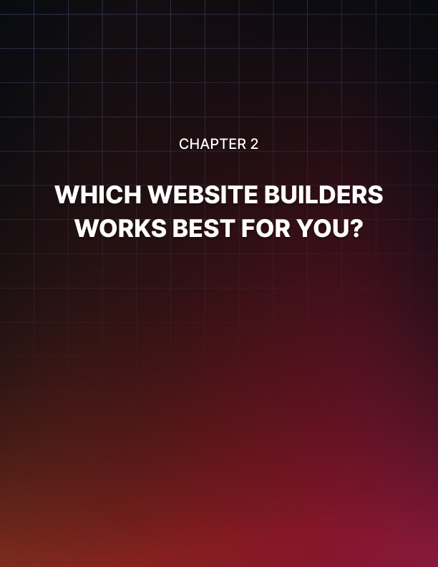

WHICH WEBSITE BUILDER WORKS BEST FOR YOU?
____
Creating a website today is simpler than ever, with website builders becoming the go-to choice for more small businesses. You don't need technical expertise—just the right tools and a clear vision for your online presence.

Choosing Your Perfect Website Builder
Website builders come in two main flavors: visual builders and AI-powered solutions.
Visual builders like Squarespace let you arrange elements on your pages by simply dragging and dropping them where you want them. These builders give you complete control over your design while keeping things simple and intuitive.
AI-powered builders take a different approach. Tools like Wix ADI can create a complete website in minutes by learning about your business and preferences. Think of it as having a digital designer who understands your needs and creates a website tailored to your business. For instance, Hostinger's AI tools help write your content and analyze how visitors use your site, all starting at just $2.69 per month.
To help you make an informed choice, here's how the most popular builders stack up:
Builder | Best For | Starting Price
Wix | Creative businesses needing flexibility | $17/month
Squarespace | Brands focused on visual impact | $16/month
GoDaddy | Local businesses wanting quick setup | $10/month
Hostinger | Budget-conscious entrepreneurs | $2.69/month

Making Your Decision
Before you choose a website builder, decide what matters most to your business. If you're new to creating websites, consider platforms like Squarespace that offer step-by-step guidance.
Also, make a list of features you can't live without. Do you need an online store? A booking system? A blog? Your must-have features will help narrow down your choices.
Your budget plays a crucial role, too. While Hostinger offers an attractive starting price, look beyond the basic cost. Think about which features you'll need as your business grows. Some builders include everything in their base price, while others charge extra for essential tools like SSL certificates or custom domains.
Different businesses have different needs. If you're a service provider like a consultant or freelancer, focus on builders that excel at showcasing portfolios and handling appointments. Squarespace and Wix shine in this area.
Running an online store? Shopify offers robust e-commerce features, while Wix works well for smaller shops. Local businesses often find GoDaddy's straightforward approach and local SEO tools most helpful.
When making your final choice, consider these key factors:
- Growth potential
Can the platform grow with your business?
- Support quality
What help is available when you need it?
- Mobile performance
How well does it work on smartphones?
- Integration options
Will it work with your existing tools?
Once you've picked your builder, getting started is straightforward.
Begin by gathering your brand materials and planning your site structure. Then choose a template that matches your style and start adding your content.
Most businesses can launch their site within two weeks, following this simple timeline:
- Planning (1–2 days): Outline your website structure and gather materials.
- Setup (1–3 days): Choose your template and configure basic settings.
- Content creation (3–7 days): Add your text, images, and products.
- Testing and launch (2–3 days): Check everything works and go live.
Starting with a free trial helps you test the waters before committing. Take time to explore templates and test the editor's capabilities. Add content gradually rather than trying to build everything at once. Remember, your website can evolve, so start with the basics and expand as your business grows.


HOW DO YOU DESIGN A WEBSITE FOR YOUR BRAND?
____
Your website isn't just a collection of pages and images; it's where your brand's personality shines through and connects with visitors.
When someone lands on your site, they should instantly understand who you are and what makes your business special. Let's explore how to create a website design that tells your unique story and builds lasting connections with your audience.

Creating Your Brand's Visual Story
Before you dive into design tools, take a moment to reflect on the story you want to tell.
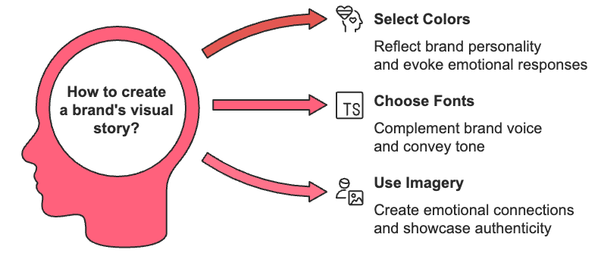
Your brand's visual elements work together like characters in a story, each playing a crucial role in communicating your message. Start by selecting colors that reflect your brand's personality—they're powerful emotional triggers that shape how people perceive your business.
For instance, if you're a financial advisor, deep blues can help convey trust and stability, while a creative agency might opt for vibrant colors to showcase innovation.
Choose fonts that complement your brand voice. Think of typography as your brand's tone of voice in written form.
For a law firm, traditional serif fonts like Times New Roman convey authority and trustworthiness. If you run a modern tech startup, clean sans-serif fonts like Arial or Helvetica might better match your innovative spirit.
Remember to stick to two or three font families maximum. Any more and your design starts to look cluttered and unprofessional.
Your website's imagery should create emotional connections with visitors. Skip the generic stock photos—they can make your site feel impersonal and forgettable. Instead, invest in high-quality photos of your team, your work, and your products in action.
Show real people using your services or products, and include behind-the-scenes content that gives visitors a glimpse into your company's culture. This authenticity helps build trust and makes your brand more relatable.

Building a Consistent Brand Experience
Create a brand style guide to ensure your website maintains a consistent look and feel. Think of it as your brand's rulebook. It should detail everything from your color codes (HEX, RGB, CMYK) to your logo usage guidelines.
Include rules for spacing, button styles, and how images should be treated. This consistency helps visitors recognize and remember your brand, whether they're on your homepage or reading your blog.
Interactive elements can bring your brand to life in unique ways. From subtle hover effects to engaging animations, these dynamic touches can make your website feel more responsive and engaging while reinforcing your brand personality.
Consider adding subtle animations when visitors hover over buttons, or implement scroll-triggered effects that reveal content as users explore your pages. These micro-interactions should feel natural and enhance the user experience without becoming distracting. For example, a gentle fade-in effect as testimonials appear can make your site feel more dynamic and engaging.
Make sure your brand translates seamlessly across all devices. Your website should look and function beautifully whether someone's viewing it on a large desktop monitor or a small smartphone screen.
To achieve this, create flexible layouts that adapt to different screen sizes while maintaining your brand's visual identity. Pay special attention to how your images scale and ensure your text remains readable without zooming.
Guide visitors through your content using clear visual hierarchies. This means making important information stand out by using larger text sizes for headlines and maintaining consistent spacing throughout your pages.
Strategic use of white space helps prevent visual overwhelm and keeps visitors focused on your key messages. Place your most compelling content (like your value proposition or latest product) in your hero section, the first thing visitors see when they land on your site.

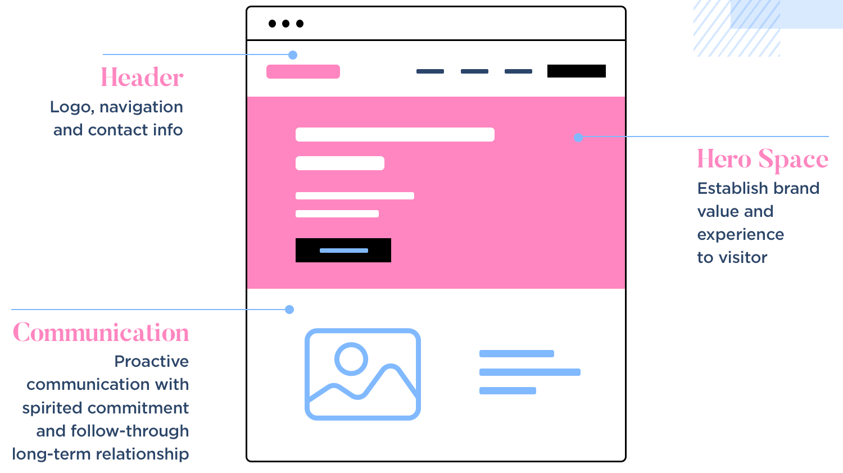
Source: Jennifer Pelegrin in Justinmind
Remember to make your website accessible to everyone. Use sufficient color contrast to ensure text is readable, provide alt text for images, and ensure your site works well with screen readers. These considerations not only make your site more inclusive but also help improve your search engine rankings.
Your website's design should grow and evolve with your business while staying true to your core brand identity. Keep track of how visitors interact with your site using analytics tools, and don't be afraid to make data-driven adjustments to better serve your audience's needs.
The most effective websites balance aesthetic appeal with practical functionality, creating an experience that both looks great and works seamlessly. Keep track of how visitors interact with your site using analytics tools, and don't be afraid to make data-driven adjustments to better serve your audience's needs.
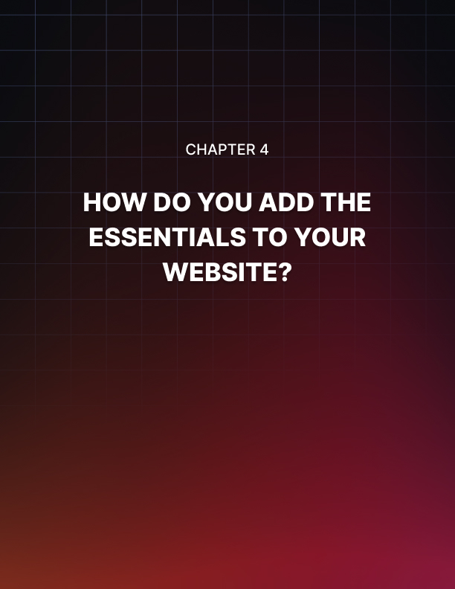

HOW DO YOU ADD THE ESSENTIALS TO YOUR WEBSITE?
____
With over 5 billion internet users worldwide according to Statista, your website needs more than just an attractive design to succeed. You need carefully crafted pages and strategic features that turn visitors into loyal customers. Let's explore how to build these essential elements that will make your website work hard for your business.

Creating Pages That Connect and Convert
Your homepage acts as your digital handshake, making that crucial first impression.
Start by placing your business offering front and center in the hero section. Use clear language that speaks directly to your customers' needs, paired with engaging visuals that support your message. Businesses that structure their homepages this way tend to see higher conversion rates.
Your About page builds trust by telling your story authentically. Share your company's journey, focusing on how you help customers solve their problems.
It’s also helpful to include real photos of your team. Webvince's 2024 study shows that About pages with personal elements receive 47% more engagement than those without. Remember to highlight key achievements that prove your expertise, but keep the tone conversational and approachable.
When showcasing your products or services, think like your customer. Group similar offerings together and explain how each one benefits your clients.
Use high-quality photos or videos that demonstrate your products in action. If you sell products, display prices clearly and make it easy to make a purchase. For services, include clear next steps for getting started.
A regularly updated blog or resources section helps establish your expertise while bringing more visitors to your site. Websites with active blogs generate more leads than those without.
Organize your content into clear categories, add a search function, and make it easy to share articles on social media. Focus on solving real problems your customers face, as this builds trust and keeps them coming back for more.

Making Your Website Work Smarter
Today's websites need robust security to protect both you and your customers. Beyond basic security certificates, implement extra safety steps for admin access, set up regular backups, and ensure your payment processing meets security standards if you're selling online to increase user trust.
Track how visitors use your site to make smart improvements. Keep an eye on key numbers like how long people stay on your pages, which content they engage with most, and how many take action like making a purchase or contacting you. This data helps you understand what's working and what needs adjustment.
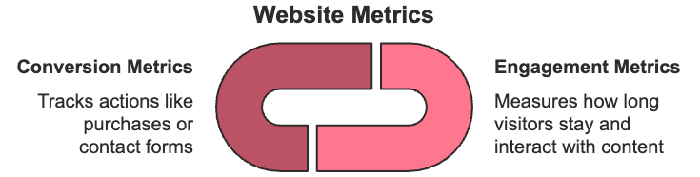
Ensure everyone can use your website easily. Add text descriptions for images, ensure your site works with keyboard navigation, and use colors and fonts that are easy to read. You’ll reach more potential customers if you make your site accessible.
Before launching new pages or features, test everything thoroughly. Check that all links work, forms submit correctly, and your site looks good on both computers and phones.
Don’t forget to create a schedule for regular maintenance. Check security weekly, review your content monthly, and keep everything up to date.
When adding these elements to your site, work systematically. Start with your core pages in the first week: homepage, about, contact, and product pages.
In the second week, focus on security, tracking, and testing. Using the right tools can considerably cut your setup time and improve how well your site performs.
Keep improving your website based on how visitors use it. Websites that regularly update their content and features see higher conversion rates than static sites. By following these best practices and making data-driven improvements, you can create a website that not only attracts visitors but converts them into loyal customers.
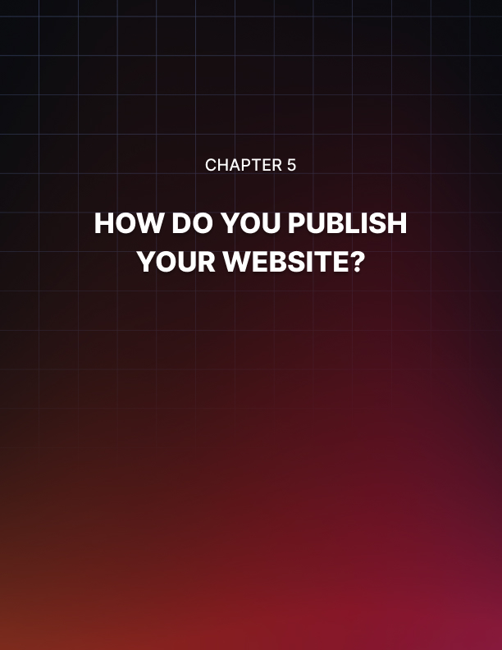

HOW DO YOU PUBLISH YOUR WEBSITE?
____
Launching your website is like opening night at a theater. Every detail matters, and you need to ensure a flawless performance.
Ledgeview Partners’ study says that 88% of online consumers are unlikely to return after a poor first experience, so your website's debut needs careful planning and execution. Let's explore how to make your site's launch a success that keeps visitors coming back for more.

Preparing for Your Website's Big Debut
Before showing your website to the world, you need to run through a thorough preparation process.
Begin by checking every page on your site works perfectly. Click all links, fill out every form, and test any special features like shopping carts or booking systems. Make sure your content reads well and looks great. Check for typos, proper formatting, and that all your images display correctly.
Your website needs to work smoothly for everyone, regardless of how they're accessing it. Test it on different devices: computers, tablets, and various smartphone models.
This also means pulling up your site in popular browsers like Chrome, Firefox, and Safari to ensure it looks and works consistently. According to Medium's 2024 report, websites that perform well across all major browsers see 15% higher engagement rates.
Speed matters more than ever. Your pages should load in under three seconds—any longer and you'll lose potential visitors.
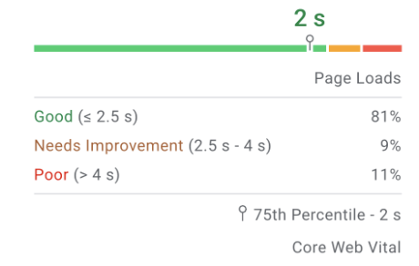
Source: Google for Developers - PageSpeed Insights
Use tools like Google PageSpeed Insights to check your site's performance. If pages load slowly, compress your images and remove any unnecessary features that might be slowing things down.
Lastly, install an SSL certificate to protect your visitors' data. Many users just leave websites that aren't secure.
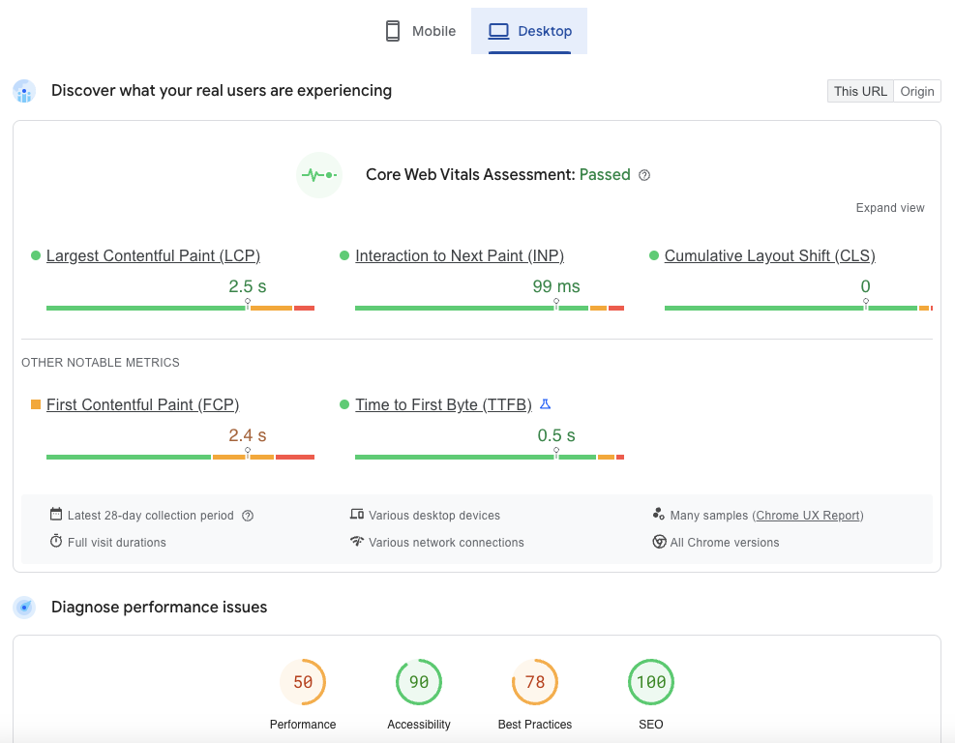
This example report from Google PageSpeed Insights shows how well a website performs on desktop devices. The site has passed Google’s Core Web Vitals test, meaning it provides a good user experience.
Key results include:
- Largest Contentful Paint (LCP)
Measures how long it takes for the main content (like a big image or text) to fully load. A good score is under 2.5 seconds.
- Interaction to Next Paint (INP)
Checks how quickly the site reacts when users click, type, or scroll. A good score is under 200 milliseconds.
- Cumulative Layout Shift (CLS)
Measures how much the page layout shifts while loading. A perfect score is 0, meaning no unexpected movement.
- First Contentful Paint (FCP)
Shows when the first part of the page appears on the screen. Lower is better, and under 1.8 seconds is ideal.
- Time to First Byte (TTFB)
Measures how fast the server starts loading the page. A good number is under 0.8 seconds.
Below, the diagnose performance issues section highlights scores in Performance, Accessibility, Best Practices, and SEO, suggesting that while the site is well-optimized for search engines, there is room for improvement in performance and best practices.

Making Your Launch a Success
Instead of immediately opening your doors to everyone, consider starting with a soft launch. Share your site with a small group of trusted customers or colleagues first. This approach helps you catch any issues before your main launch.
Set up your analytics tools before launch day so you can track how visitors use your site from day one. Install Google Analytics 4 and set up goals to monitor important actions like contact form submissions or purchases.
Think of adding heat mapping tools to see exactly how visitors interact with your pages. Businesses that set up proper tracking before launch are more likely to quickly identify and fix issues.
When launch day arrives, follow a clear checklist to ensure nothing gets missed. Start by running one final security scan and backing up all your content. Once you're ready to go live, remove any maintenance mode notices and verify your site is accessible.
Monitor your server performance closely during the first few hours to catch any potential problems early. This critical window will help you catch any issues quickly and ensure your site is performing as intended.

Post-Launch Monitoring Checklist
- Keep a close eye on your site during the first 48 hours after launch.
- Watch your real-time analytics to see how visitors move through your pages.
- Pay attention to any error messages or unusual patterns in user behavior.
- Collect feedback through short surveys or feedback forms to understand what's working well and what needs improvement.
- Create a regular maintenance schedule to keep your site running smoothly.
Don’t forget to back up your site daily to protect against any potential issues. Update your security features weekly, refresh your content monthly, and review your site's overall performance quarterly. When problems do arise, have a clear plan for handling them. Know who to contact and what steps to take whether you're dealing with technical issues, user experience problems, or content updates.
Remember to measure your success against clear goals. In your first month, focus on technical metrics like page load times and error rates. By the three-month mark, look at broader measures of success like conversion rates, return visitor numbers, and how long people spend on your site.
Your website launch is just the beginning of your online journey. Keep monitoring, maintaining, and improving your site based on how your visitors use it. Continuously adapt and optimize your approach to ensure ongoing success and growth for your site.


HOW DO YOU OPTIMIZE FOR SEARCH ENGINES?
____
According to BrightEdge’s report, 68% of online experiences start with a search engine. This means making your website visible to potential customers is crucial for your success. Let's explore how you can improve your website's visibility and attract more visitors through search engines.

Making Search Engines Love Your Website
Search engines use smart computer programs to understand what people are looking for and show them the most helpful results. See these programs as librarians who know exactly where to find the information readers want.
Today's search engine optimization (SEO) isn't about stuffing your content with keywords. It's about creating valuable content that answers people's questions.
Before diving into content creation, you need to understand what your potential customers are searching for.
Start by making a list of topics related to your business. If you run a local bakery, people might search for "best birthday cakes near me" or "custom wedding cake prices." Tools like Google Keyword Planner can help you discover these search terms for free.
Think about why someone is searching. Are they ready to buy, or just looking for information? Someone searching "how to decorate a birthday cake" needs different content than someone searching "order birthday cake delivery."
According to Content Whale's research, successful websites create content for both types of searches. This approach helps you attract both immediate customers and those who might need your services later.
Once you know what people are searching for, create content that helps them. Write naturally, as if you're explaining things to a friend. Break up your text with subheadings and short paragraphs to make it easy to read. And don’t skimp on relevant images with descriptions (alt text) to help both search engines and visually impaired visitors understand your content.

Building Your Website's Authority
Search engines trust websites that other reputable sites link to, much like how you trust a business that is recommended by people you respect.
Instead of trying to get as many links as possible, focus on building relationships within your industry. Share valuable content that others want to reference, write guest posts for industry blogs, and participate in online communities related to your business.
If you serve local customers, make sure search engines know where to find you. Complete your Google Business Profile with accurate information about your location, hours, and services.
Encourage satisfied customers to leave reviews. Positive reviews help both your search rankings and customer trust. They also serve as social proof, influencing potential customers to choose your business based on the experiences of others.
Voice search is changing how people look for information online. People tend to use longer, more conversational phrases when speaking to devices.
For example, instead of typing "bakery Chicago," someone might ask, "Where can I get a custom birthday cake in Chicago?" Include these natural language phrases in your content and create FAQ sections that answer common questions about your products or services.
Keep track of how well your SEO efforts are working by watching a few key numbers in Google Analytics:
- How many people visit your site from search engines
- Which pages they spend the most time on
- How many visitors take action (like making a purchase or contacting you)
Review these numbers monthly and adjust your approach based on what's working best. For quick improvements, start with these simple steps:
- Write clear, descriptive titles for every page.
- Make sure your website loads quickly.
- Fix any broken links.
- Add helpful descriptions to your images.
- Create a site map to help search engines find all your pages.
Improving your search engine visibility takes time and consistent effort. Focus on creating helpful content for your audience while following these principles, and monitor your results to see what works best for your business. Keep learning and adjusting your approach as search engines evolve.


HOW DO YOU KEEP IT UPDATED AND ENGAGING?
____
Your website is more than just a digital presence—it's a living, breathing part of your business that needs consistent care to thrive.
Like tending to a garden, regular attention keeps your website fresh and engaging for visitors. When you maintain your site well, you'll see up to 52.6% higher engagement rates than static websites that rarely change, based on Mediafly’s data.

Keeping Your Content Fresh and Engaging
Your website's content is like store inventory. It needs regular reviews and updates to stay relevant.
Start by examining your content every quarter. Look at which pages attract the most visitors and which ones might need refreshing. You don't need complex tools. A simple review of your website analytics will show you what's working and what isn't.
Website analytics play a crucial role in keeping your content fresh and engaging. By regularly reviewing your site’s performance data, you can identify which pages are attracting the most visitors and which may need updates or improvements.
Key metrics to focus on include page views, bounce rates, and average session duration, as they can highlight content that resonates with your audience or areas that may be underperforming.
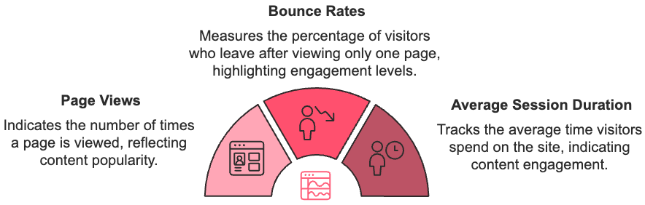
Tools like Google Analytics offer valuable insights without requiring complex setups. Tracking these metrics quarterly helps ensure that your content remains relevant and compelling, driving both engagement and long-term success for your site.
Create a rhythm for your content updates that matches your business pace. If you run a fast-moving tech company, you might update your blog weekly. For a local service business, monthly updates might work better. The key is consistency—regular small updates work better than occasional massive overhauls.
Make your content work harder by repurposing it in different ways. Turn customer testimonials into featured stories on your homepage. Transform frequently asked questions into helpful blog posts. Share your expertise through how-to guides that solve common customer problems.
When you consistently provide value, visitors have reasons to return. By continuously updating and diversifying your content, you can keep your audience engaged and attract new visitors, ensuring your website stays dynamic and impactful.
Don't forget to tap into your customer community. Encourage reviews, share success stories, and feature customer photos (with permission). This user-generated content adds authenticity to your site and keeps it dynamic without requiring constant work from you. Plus, potential customers trust real experiences from their peers more than polished marketing messages.

Making Your Website Work Smarter
Your website should evolve based on how visitors use it. Watch how people interact with your pages using simple analytics tools.
Which pages keep visitors reading? Where do they lose interest? Use these insights to make smart improvements rather than random changes.
Keep your site running smoothly with regular maintenance. Set aside time each month to:
- Update any time-sensitive content.
- Check that all your forms and links work.
- Ensure your security features are current.
- Compress new images to maintain fast loading times.
- Review and respond to customer feedback.
Make your website more engaging by adding interactive elements that encourage participation. Simple features like calculators, quiz tools, or live chat can transform passive readers into active participants. Websites that include interactive features tend to see visitors staying longer.
Show visitors you understand their needs by personalizing their experience. Welcome returning customers by name, suggest products based on their interests, or display location-specific information. These small touches make your website feel more like a conversation than a bulletin board.
Remember to measure what matters to your business. Instead of getting lost in complex metrics, focus on numbers that tie directly to your goals.
If you're selling products, track your conversion rates. If you're building your expertise, measure how long people spend reading your content. Use these insights to guide your improvements.
Keep your website fresh, engaging, and working hard for your business by making website maintenance part of your regular routine. Small, consistent updates will serve you better than sporadic overhauls, helping you build lasting connections with your visitors while growing your business online.


FUTURE-PROOFING YOUR DIGITAL SUCCESS
____
Your website journey has only just begun. With more and more businesses seeking to accelerate their digital growth, a static website is no longer enough to stay competitive.
Your website isn't just a digital brochure;
it's a dynamic asset that grows with your business.

Let's explore how your digital presence can evolve to drive lasting business success.

Building Your Digital Growth Engine
Your website is the heart of your digital business—it needs to pump life into every aspect of your operations. By connecting your website with tools like your customer database, email marketing, and social media, you create a seamless experience that drives growth.
The key to sustained growth lies in understanding how visitors interact with your site. Watch how people engage with your content, which pages keep their attention, and where they take action. Use these insights to make improvements that matter.
For example, if visitors frequently leave your checkout page, you might simplify the buying process or add trust signals like security badges. Alternatively, if users spend a lot of time on a particular blog post but do not engage with your calls-to-action, you could update the post with stronger, more relevant CTAs to guide them toward taking the next step.
As you grow, consider expanding your digital toolkit thoughtfully. Start with essential tools like Google Analytics to track visitor behavior and a reliable CRM to manage customer relationships. Add more sophisticated tools like marketing automation or personalization engines when your business needs them.
It's better to master a few key tools than to spread yourself thin across many. This approach allows you to make data-driven decisions and scale effectively without overwhelming yourself with unnecessary complexity.

Embracing Future Trends
The digital world is evolving rapidly, bringing new opportunities to serve your customers better. Artificial intelligence is transforming how websites interact with visitors, offering personalized experiences based on individual preferences and behavior. Consider implementing AI-powered chatbots to provide 24/7 customer support or recommendation engines that suggest products based on browsing history.
Immersive technologies are also changing how customers experience your products online. Virtual showrooms and 3D product visualization help bridge the gap between digital and physical shopping experiences. While these technologies might seem advanced, starting small with simple interactive elements can help you test what works for your audience.
Sustainability in digital business is becoming increasingly important. Think of adopting eco-friendly practices like choosing green hosting providers or optimizing your site to use less energy. These choices not only benefit the environment but also appeal to environmentally conscious customers.
Looking ahead, focus on creating authentic connections with your audience. While automation helps streamline operations, maintain the human touch in crucial interactions. Respond personally to customer feedback, share behind-the-scenes glimpses of your business, and create content that genuinely helps your audience solve their problems.
Your website’s success depends on consistent attention and strategic growth. Set aside time each week to review your site's performance, monthly to update content and features, and quarterly to assess your overall digital strategy.
Stay informed about digital trends, but don't chase every new technology. Focus only on changes that truly benefit your customers.
Remember, your website isn't just a digital brochure—it's a dynamic asset that grows with your business. By staying committed to continuous improvement and focusing on your customers' needs, you're building a digital presence that will drive your success for years to come.

