TABLE OF CONTENTS
____

INTRODUCTION 4
PREPARING YOUR BRAND FOR YOUTUBE ADS SUCCESS 7
Understanding Campaign Objectives and Strategy 8
Creating a Strategic Campaign Blueprint 10
Technical Setup and Optimization 14
CREATING IRRESISTIBLE AD CONTENT 18
The Psychology of Viewer Connection 18
Mastering the Opening Moments 22
Technical Excellence and Production Value 23
REACHING YOUR TARGET AUDIENCE 26
Understanding the Core of Targeting 26
Advanced Targeting Methods That Drive Results 28
Measurement and Optimization Strategies 31
FROM DATA TO OPTIMIZATION 33
Understanding Performance Metrics That Matter 34
Advanced Analysis for Strategic Growth 36
Leveraging AI for Performance Enhancement 37
TURNING VIEWERS INTO CUSTOMERS 41
Creating Deep Emotional Bonds That Last 42
Nurturing Relationships Through Multi-Touch Engagement 44
Measuring and Optimizing Loyalty Growth 47
THE ROAD AHEAD 50
The Next Wave of Advertising Technology 50
Privacy-First Innovation 53
The Evolution of Commerce and Community 54

DISCLAIMER
____

The information provided in this ebook is intended solely for educational and informational purposes. The author does not accept any responsibility for the outcomes that may arise from the application of the material within. While efforts have been made to ensure the accuracy and relevance of the content, the author cannot be held accountable for any errors or omissions, or for any consequences resulting from the use or misuse of the information provided. The responsibility for any actions taken based on the information in this ebook lies solely with the reader.
Foreword

INTRODUCTION
____

YouTube has evolved far beyond its roots as a simple video-sharing platform. With over 2.7 billion active users watching billions of hours of content daily according to research performed by the GMI Team, it stands as one's most powerful marketing channels available to businesses.
As you browse through countless videos, you've likely noticed the sophisticated ads that appear before, during, or alongside your chosen content. These aren't random occurrences. They represent carefully crafted campaigns by marketers who understand the platform's immense potential for reaching and converting audiences.
Whether you're a seasoned marketing professional or an entrepreneur looking to scale your business, mastering YouTube Ads can transform your marketing strategy. The platform offers unparalleled opportunities to connect with your target audience through visual storytelling, precise targeting, and measurable results. Yet, many businesses struggle to harness its full potential, often overwhelmed by its complexity or discouraged by initial setbacks.
This book serves as your practical guide to building and scaling successful YouTube Ads campaigns. You'll discover proven strategies for creating compelling video content that resonates with viewers, learn how to leverage YouTube's sophisticated targeting options to reach your ideal customers, and master the art of optimizing your campaigns for maximum return on investment.
Unlike other marketing channels where users actively try to avoid advertisements, YouTube's format allows you to present your message naturally and engagingly, making it more likely for viewers to connect with your brand. By the end of this guide, you'll have the knowledge and tools needed to create YouTube Ad campaigns that not only capture attention but establish real connections with the people you want to reach.
This book focuses on actionable insights and real-world applications. It presents clear, step-by-step instructions backed by data-driven strategies that have been tested and refined across numerous successful campaigns. You'll learn how to craft ads that drive meaningful conversions, turning casual viewers into loyal customers.
The strategies and techniques shared in these pages reflect the latest developments in video advertising, incorporating both timeless marketing principles and cutting-edge tactics. Whether your goal is to boost brand awareness, generate leads, or drive direct sales, you'll find the tools and knowledge needed to achieve measurable results through YouTube Ads.
Success in video advertising isn't about having the biggest budget. It's about understanding your audience, crafting compelling messages, and optimizing your approach based on real data. With the right strategy and consistent effort, even small businesses can create YouTube campaigns that compete with industry giants and forge lasting connections with their target audience.
Part One

PREPARING YOUR BRAND FOR YOUTUBE ADS
____

Video advertising has transformed how brands connect with their audiences, and YouTube stands at the forefront of this revolution. With its massive reach of over 30 million daily active users and 5 billion videos watched every day, as reported by LYFE Marketing, YouTube offers unparalleled opportunities for businesses to share their stories, products, and services.
However, launching successful YouTube ad campaigns requires more than just uploading videos and setting a budget. It demands careful preparation, strategic thinking, and a rock-solid foundation.

Understanding Campaign Objectives and Strategy
Before diving into the technical aspects of YouTube advertising, you need to establish clear, purposeful objectives that align with your business goals. Think of your campaign objectives as a compass guiding every decision you make throughout your advertising journey. Without well-defined goals, your campaigns risk becoming unfocused, leading to wasted resources and missed opportunities.
Your YouTube advertising objectives typically fall into three main categories: awareness, consideration, and conversion. Each category serves a specific purpose within your marketing funnel and requires different approaches to execution and measurement. Let's explore each in detail to help you determine which aligns best with your goals.

Awareness campaigns
Awareness campaigns focus on introducing your brand to new audiences and expanding your reach. These campaigns work particularly well when you're launching new products, entering fresh markets, or building brand recognition.
Success in awareness campaigns relies heavily on maximizing visibility while maintaining relevance to your target audience. For example, if you're launching a new sustainable fashion brand, your awareness campaign might focus on reaching environmentally conscious consumers through videos that highlight your eco-friendly manufacturing processes and materials.
When running awareness campaigns, you'll want to track metrics like impressions, view rates, and brand lift studies. These metrics help you understand how effectively your message is reaching and resonating with your intended audience. A successful awareness campaign should show steady growth in these metrics over time, indicating increasing brand recognition among your target demographic.

Consideration Campaigns
Consideration campaigns target viewers who already know about your brand but haven't yet made a purchase decision. These campaigns work to demonstrate product value, showcase what makes your offering unique, and build emotional connections with potential customers.
The key to successful consideration campaigns lies in creating content that addresses specific pain points and demonstrates clear solutions. For instance, a software company might create detailed video tutorials showing how their product solves common business challenges, or a fitness brand might share transformation stories from real customers.
To measure the success of consideration campaigns, focus on engagement metrics such as watch time, click-through rates, and website visits. These indicators help you understand how effectively your content captures and maintains viewer interest, ultimately moving them closer to a purchase decision.

Conversion Campaigns
Conversion campaigns represent the final stage of your marketing funnel, where you're actively working to transform interested viewers into paying customers. These campaigns focus on driving specific actions, whether that's completing a purchase, signing up for a service, downloading an app, or joining a mailing list. Success in conversion campaigns requires careful attention to your call-to-action (CTA) placement, timing, and messaging.

Creating a Strategic Campaign Blueprint
Setting measurable objectives forms the cornerstone of your YouTube advertising strategy. The SMART framework helps transform vague goals into actionable targets that drive real results.
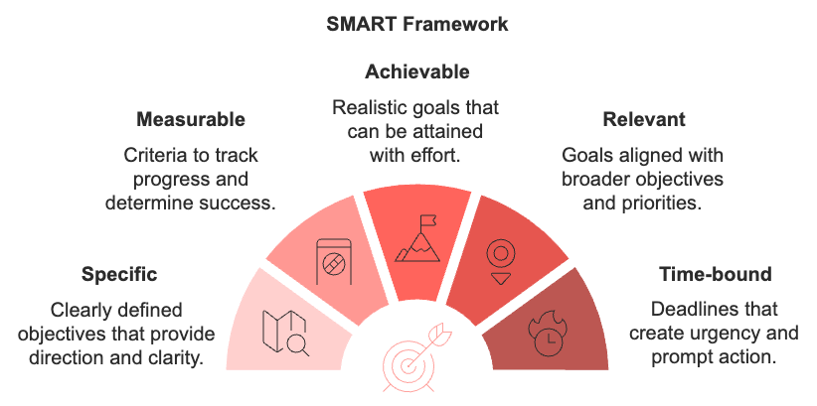
When applying the SMART framework to your YouTube ads, consider both short-term and long-term objectives. For instance, instead of simply aiming to "increase brand awareness," set a specific goal like "achieve a 25% (specific) increase (achievable—ambitious but realistic for a focused campaign) in brand recognition (relevant—brand recognition directly ties to marketing objectives for sustainable fashion) among US-based millennials interested in sustainable fashion (specific) within the next three months (time-bound), as measured by brand lift surveys (measurable)." This detailed approach gives you clear parameters for success and helps guide your campaign decisions.
Understanding your audience goes beyond basic demographics. It requires deep insights into their behaviors, preferences, and motivations.
Start by creating detailed viewer personas that include not just age ranges and locations, but also interests, online behaviors, and content consumption patterns. For example, if you're targeting young professionals interested in personal finance, you might discover they prefer watching educational content during their morning commute on mobile devices.
When developing your campaign blueprint, be mindful of your audience's preferred content formats and viewing habits, as these directly influence your ad format selection. YouTube offers several ad formats, each serving different purposes:
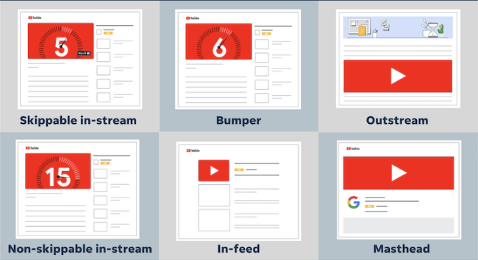
Source: Jyll Saskin Galles in Word Stream by LocaliQ
- Skippable in-stream ads work best for longer, story-driven content where you can hook viewers in the first five seconds.
- Non-skippable in-stream ads deliver your complete message but require highly engaging content to maintain viewer interest.
- Bumper ads create quick brand impressions through six-second, non-skippable spots.
- Outstream ads expand reach by appearing on partner sites and apps, playing without sound unless tapped.
- In-feed ads promote videos in YouTube search results, the homepage, and the "watch next" section.
- Masthead ads offer premium placement at the top of YouTube’s homepage for maximum visibility and brand awareness.
The success of your campaign also depends heavily on proper budget planning and allocation. Consider your market factors, business goals, and available resources when setting your budget. For instance, if you're in a highly competitive industry like fitness equipment, you might need to allocate more budget during peak seasons (like January for New Year's resolutions) and adjust your bidding strategy accordingly.
Your bidding strategy should align with your campaign objectives:
- Maximum cost per view (CPV) suits view-focused campaigns where you want to maximize audience reach.
- Target cost per acquisition (CPA) works best for conversion-focused campaigns where specific actions matter most
- Maximum cost per thousand impressions (CPM) helps reach-focused campaigns achieve broad visibility.
Success in YouTube advertising comes from harmonizing deep audience understanding, strategic format selection, and smart budget allocation into a cohesive campaign strategy. But even the most precisely targeted ad with an optimal budget won't succeed if it doesn't resonate with your viewers' interests and behaviors.
Take time to test different approaches, analyze your results, and continuously refine your strategy based on real performance data. The most successful advertisers on YouTube aren't those who follow a rigid formula, but those who remain flexible and responsive to their audience's evolving preferences while maintaining a clear focus on their business objectives.

Technical Setup and Optimization
The technical foundation of your YouTube advertising success involves several crucial elements that must work together seamlessly. Start with your YouTube channel optimization. This serves as your brand's home base on the platform. Your channel should reflect your brand identity through professional visuals, clear messaging, and well-organized content.
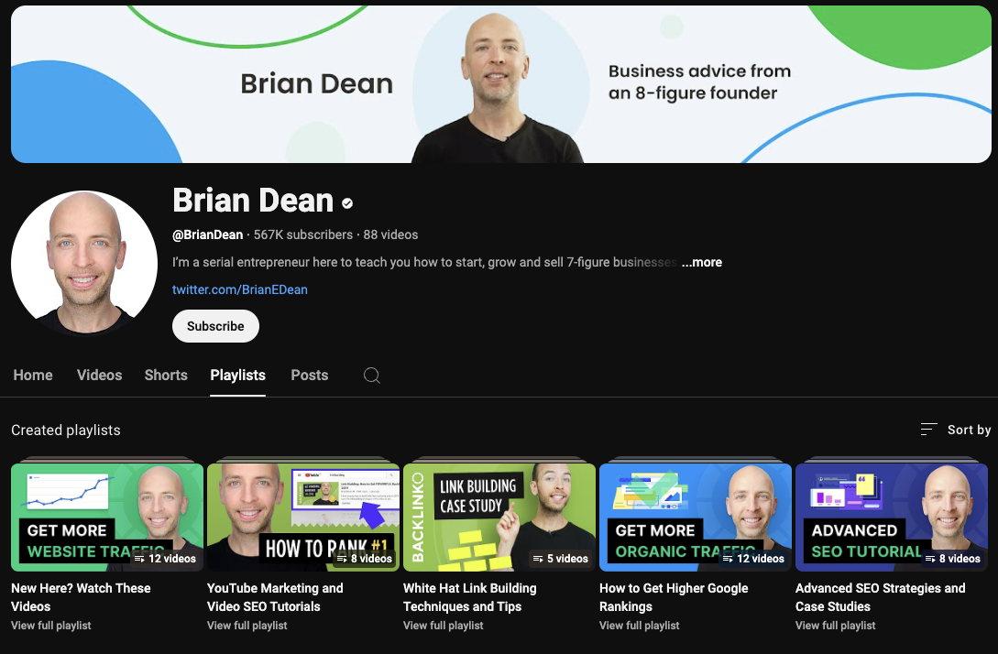
A properly optimized YouTube channel includes:
- A professional channel banner that maintains quality across all devices.
- A recognizable profile picture that matches your brand's visual identity.
- A compelling channel description with relevant keywords and clear contact information.
- Well-organized playlists that help viewers find relevant content easily.
Integrating your YouTube channel with Google Ads unlocks powerful targeting and tracking capabilities. This integration enables you to access advanced features like remarketing to viewers who've engaged with your content, implementing detailed conversion tracking, and utilizing sophisticated audience targeting options.
Your landing pages play a crucial role in converting viewers into customers. With most YouTube views occurring on mobile devices, mobile-first design isn't optional—it's essential.
Your landing pages should feature responsive designs that adapt seamlessly to different screen sizes, touch-friendly navigation elements, and fast-loading content. Implement the following technical optimizations to enhance landing page performance:
- Compress images and videos without sacrificing quality.
- Enable browser caching to improve load times for returning visitors.
- Use content delivery networks (CDNs) to serve content quickly regardless of viewer location.
- Optimize code efficiency by removing unnecessary scripts and plugins.
Creating effective conversion paths involves the strategic placement of clear, compelling calls-to-action throughout your landing pages. Your value proposition should be immediately apparent, addressing viewer pain points and offering clear solutions. Support your claims with social proof, such as customer testimonials or case studies, and make it easy for visitors to take the next step.
Your YouTube advertising journey requires continuous testing and refinement. Before launching full-scale campaigns, conduct thorough technical testing of all components, from landing page functionality to tracking implementation. Run small-scale pilot campaigns to gather initial performance data and identify areas for improvement.
Building a strong foundation for YouTube advertising success takes time and attention to detail, but the effort pays dividends through more effective campaigns and better returns on your advertising investment. Remember to regularly review and adjust your foundation as you gather more data and insights about what works best for your brand and audience.
As you move forward with implementing your YouTube advertising strategy, let the solid foundation you've built guide your decisions and optimize your chances for success. Keep testing, learning, and refining your approach based on performance data and audience feedback.
Part Two

CREATING IRRESISTIBLE AD CONTENT
____

Every single day, millions of viewers scroll through YouTube, their thumbs hovering over the "Skip Ad" button.
Your mission? Creating video content so compelling that they not only watch but take action.
Recent data from HYROS reveals that expertly crafted video ads convert 3.5 times better than traditional display advertising. So this isn't just about making pretty videos—it's about understanding the science of attention and the art of persuasion.

The Psychology of Viewer Connection
Your brain can identify an image you saw for as little as 13 milliseconds, according to MIT neuroscientists. This little fact makes video advertising incredibly powerful.
However, creating content that converts requires more than just putting attractive visuals together. You need to tap into the fundamental ways humans make decisions and form connections.
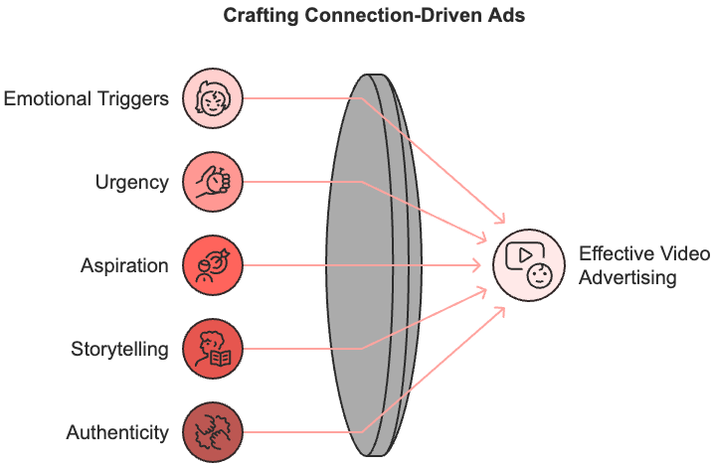
When crafting your video ads, understanding emotional triggers becomes your secret weapon. Think about the last time you made an impulse purchase. Chances are, emotion drove that decision more than logic.
This same principle applies to your viewers. By strategically incorporating emotional elements into your content, you create deeper connections that drive action.
Consider how urgency influences behavior. When viewers feel they might miss out on something valuable, they're more likely to take immediate action. However, you must wield this power responsibly. Instead of creating artificial scarcity, focus on genuine time-sensitive opportunities.
For example, if you're launching a new course with early-bird pricing, emphasize the real value of acting quickly without resorting to manipulative tactics. This honest approach not only drives immediate action but also builds long-term trust with your audience, creating a foundation for sustainable business growth through authentic engagement.
The concept of aspiration plays an equally crucial role in viewer engagement. This means your audience isn't just buying a product or service; they're buying into a vision of their improved future.
Show them what's possible. If you're advertising a fitness program, don't just showcase the exercises. Paint a picture of the confidence, energy, and vitality they'll gain. Use real success stories to demonstrate transformation while maintaining authenticity.
Stories form the backbone of human communication, and their power in advertising cannot be overstated. According to Collabs.io, advertisements incorporating storytelling elements generate 22% higher emotional engagement compared to straight promotional content. This isn't surprising when you consider how stories have shaped human understanding for millennia.
Your story structure should mirror the journey your customers take. Begin with a character facing a challenge your audience recognizes. Maybe it's a small business owner struggling with time management, or a parent trying to balance work and family life.
As you develop the narrative, show how your solution transforms their situation. This creates an emotional investment that makes your call-to-action (CTA) feel like a natural next step rather than an interruption.
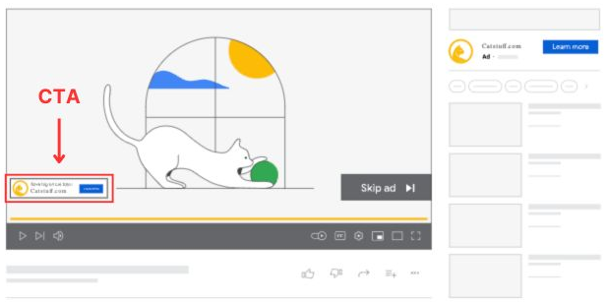
Building trust through authenticity has become more critical than ever in an age of increasing advertising skepticism. Your viewers can spot insincerity from miles away, so every element of your content must ring true.
Share real customer experiences, but don't just focus on the successes. You must also acknowledge the challenges and learning curves. This transparency builds credibility and sets realistic expectations.
The most effective testimonials include specific details and measurable results. Instead of having a customer say, "This product changed my life," encourage them to share their journey: "After using this software for three months, I reduced my administrative tasks by 70% and finally had time to focus on growing my business." These concrete examples make your claims more believable and help viewers envision similar results in their own lives.

Mastering the Opening Moments
The first five seconds of your video ad determine its fate. Viewers tend to make their stay-or-skip decision within 2–3 seconds, making your opening sequence arguably the most crucial element of your entire ad.
Creating pattern interrupts (i.e., unexpected elements that grab attention) requires understanding how your audience typically encounters ads. One effective approach is to challenge expectations by incorporating elements that break the usual ad format, such as an unexpected twist or a surprising visual, to make your message stand out.
Start with something surprising but relevant. If you're advertising a productivity tool, you might open with a close-up of someone frantically juggling multiple phones and laptops, then zoom out to reveal an absurdly chaotic workspace. This related visual immediately captures attention while highlighting the problem your product solves.
Your audio-visual elements must work in perfect harmony to maintain engagement. Think of your ad as a mini-movie where every sound and image serves a purpose.
The music should match your content's emotional arc, starting with tension-building beats during problem presentation, then shifting to uplifting tones as you reveal the solution. Voice-over timing needs to complement rather than compete with visual information, creating a seamless flow of information that keeps viewers engaged.

Technical Excellence and Production Value
While compelling storytelling forms the foundation of effective ads, technical execution can make or break your success. Most YouTube views happen on mobile devices, so optimizing for small screens is a no-brainer.
Consider how your content appears on different devices. Text that looks perfect on a desktop monitor might become illegible on a phone screen.
Test your ads across multiple devices and screen sizes.
Pay special attention to text size, contrast, and placement. Remember that mobile viewers often watch without sound, so your visual elements must tell a complete story even without audio.
The pacing of your edit plays a crucial role in maintaining attention. Mobile viewers typically have shorter attention spans, but that doesn't mean your content should feel rushed. Instead, create a rhythm that allows viewers to absorb information while maintaining interest. Use quick cuts for high-energy sequences and slower pacing for important information or emotional moments.
Your call-to-action strategy requires careful consideration. Rather than waiting until the end to present a single CTA, consider integrating multiple subtle prompts throughout your video. These shouldn't feel pushy or interrupt the flow but should emerge naturally from the content. For example, if you're demonstrating a product feature, you might include a small "Learn More" button that appears briefly in the corner of the screen.
The visual composition of your ad must support both your message and your brand identity. Color choices influence viewer emotions and behavior, so select your palette strategically.
Blue might convey trust and professionalism for a financial service, while vibrant colors could better suit a creative product. See how these choices appear across different devices and viewing conditions.
Creating content that converts requires attention to every detail, from the broadest storytelling elements to the smallest technical specifications. By understanding and implementing these principles while continuously testing and refining your approach, you can create YouTube ads that not only capture attention but drive meaningful action.
Successful video advertising is an iterative process. What works today might need adjustment tomorrow as viewer preferences and platform capabilities evolve. Stay curious, keep testing, and always prioritize providing genuine value to your audience. Your commitment to excellence in every aspect of your video ads will set you apart in the increasingly competitive world of advertising media.
Part Three

REACHING YOUR

TARGET AUDIENCE
____

Imagine being a matchmaker in a room of billions of people, tasked with finding the perfect match for your product or service. That's exactly what YouTube advertising allows you to do, connecting you with ideal customers among its 2.7 billion monthly active users.
Research from ExpertBeacon reveals that businesses mastering YouTube's targeting capabilities achieve 70% higher engagement rates than those using broad targeting approaches. Let's transform this overwhelming task into a strategic advantage for your business.

Understanding the Core of Targeting
YouTube's targeting system operates like a sophisticated filtering mechanism, analyzing countless data points to connect your ads with the right viewers.
Think of it as a powerful matchmaking algorithm that regards not just basic characteristics, but deep behavioral patterns, interests, and intentions. This system draws insights from Google's vast network, including search behavior, website visits, and app usage patterns, creating a rich collection of user information that helps predict viewer preferences and behaviors.
The foundation of effective targeting begins with understanding how machine learning enhances your targeting precision. When leveraged correctly, these AI-driven insights can help you move beyond simple demographic targeting to create highly nuanced audience segments that align perfectly with your marketing objectives.
YouTube's artificial intelligence systems continuously analyze billions of user interactions, learning from each engagement to better predict viewer behavior. For example, when you launch a campaign, these algorithms automatically identify patterns in viewer responses, adjusting your targeting parameters in real time to maximize performance. This dynamic optimization means your targeting becomes more refined as your campaign progresses, leading to increasingly better results over time.
Let’s look at how a local fitness equipment company transformed their targeting approach through machine learning insights. Initially targeting broad demographics of fitness enthusiasts, they discovered through AI-driven analysis that their highest-converting audience actually consisted of home-based professionals searching for space-saving workout solutions. This insight led to a 40% increase in conversion rates simply by refining their targeting strategy to match this specific viewer behavior pattern.
The true power of YouTube targeting lies in its ability to combine multiple targeting layers while maintaining campaign efficiency. Each targeting option is like a filter that helps refine your audience further. However, it's crucial to strike the right balance. Too many filters might restrict your reach, while too few might waste your budget on uninterested viewers.
For instance, when targeting professionals interested in productivity software, you might combine custom intent signals (searches for productivity solutions) with affinity audiences (technology early adopters) and demographic data (business decision-makers), creating a highly focused yet sufficiently sized audience pool.

Advanced Targeting Methods That Drive Results
Moving beyond basic demographic targeting opens up a world of sophisticated targeting options that can dramatically improve your campaign performance.
Custom intent audiences represent one of your most powerful tools for reaching high-potential customers. This targeting method identifies viewers actively researching solutions related to your offering, even if they haven't directly engaged with your content yet. For example, someone searching for "best project management software for small teams" might see your ad for a collaboration tool, even if they've never watched business software reviews on YouTube.
Building on this foundation, affinity audiences allow you to connect with viewers based on their established interests and lifestyle patterns. These audiences are particularly valuable for brand awareness campaigns because they help you reach people who align with your ideal customer profile, even before they actively search for your solution.
Think how a sustainable fashion brand might target the "eco-conscious shoppers" affinity audience to introduce their products to environmentally mindful consumers who haven't yet discovered their brand. When the company taps into these predefined interest groups, it can ensure that the brand reaches potential customers at the right moment in their decision-making process, fostering a stronger connection and encouraging future engagement.
In-market audiences focus on capturing viewers who display strong purchase intent signals across the Google network. KeywordSearch data shows these audiences generate 10% higher conversion rates compared to standard demographic targeting.
This targeting method proves especially effective when combined with custom intent signals, creating a powerful filter for identifying viewers most likely to convert. For example, a digital camera retailer might target in-market audiences for photography equipment while also incorporating custom intent signals from searches for specific camera models or photography techniques.
Understanding how to layer these targeting methods creates opportunities for sophisticated campaign strategies. A comprehensive targeting approach might look like this:
Start with an in-market audience for your product category, add relevant affinity audiences to ensure interest alignment, then further refine with custom intent signals to capture active buyers. This layered strategy helps maintain sufficient reach while ensuring each impression counts.
Geographic and temporal targeting add another dimension to your targeting strategy. Rather than simply selecting locations, successful advertisers look into local market dynamics, cultural preferences, and seasonal factors. For instance, an online education platform might adjust its targeting and messaging based on different academic calendars across regions, while also considering local peak usage times and competitive landscapes.

Measurement and Optimization Strategies
Transforming targeting data into actionable insights requires a systematic approach to measurement and optimization.
Begin by establishing clear baseline metrics for each targeting combination, then continuously test and refine your approach based on performance data. Pay particular attention to view-through rates, engagement metrics, and conversion data, as these indicators help identify which targeting combinations drive the best results for your specific objectives.
Your optimization strategy should follow a structured testing process. Start with broader targeting combinations to establish performance benchmarks, then gradually refine your approach based on data insights.
For example, you might start by testing different affinity audiences, identify the top performers, then layer on custom intent signals to improve conversion rates further. Document your findings and use them to inform future targeting decisions.
Audience insights provide valuable feedback for targeting optimization. By analyzing viewer behavior patterns, engagement rates, and conversion data across different targeting combinations, you can identify opportunities for improvement and expansion. For instance, you might discover that viewers from certain geographic areas show higher engagement rates during specific times of day, allowing you to adjust your targeting and bid strategies accordingly.
Looking toward the future of YouTube targeting, privacy-focused solutions will become increasingly important. As the advertising industry evolves, successful advertisers will need to balance precise targeting capabilities with user privacy concerns. This might involve greater reliance on contextual targeting and first-party data strategies while maintaining the effectiveness of your campaigns through sophisticated audience modeling and AI-driven optimization.
Your success in YouTube advertising depends not just on reaching the right audience, but on delivering relevant, engaging content that resonates with their needs and interests at the perfect moment. Keep experimenting with different targeting combinations, monitor your results closely, and stay adaptable as new targeting capabilities emerge.
Part Four

FROM DATA TO OPTIMIZATION
____

When analyzing your YouTube advertising performance, you're like a detective piecing together clues from thousands of viewer interactions. Each metric tells part of your campaign's story, from the initial viewer engagement to the final conversion.
According to Search Nurture, marketers who master data analysis achieve 300% better performance from their YouTube campaigns compared to those who rely on basic metrics alone.
By diving deeper into advanced analytics, you can uncover hidden insights that not only enhance the current campaign but also inform future strategies, driving long-term success and improved ROI.

Understanding Performance Metrics That Matter
Your journey into YouTube analytics begins with understanding how different metrics work together to reveal your campaign's true performance. Think of these metrics as interconnected puzzle pieces. Individually, they provide limited insight, but together, they create a complete picture of your advertising effectiveness.
The relationship between key metrics often reveals unexpected insights about your campaign performance. For instance, a high view rate might seem positive, but if it's accompanied by poor conversion rates, it could indicate that your content attracts the wrong audience. Similarly, a lower view rate with strong conversion metrics might suggest your targeting is precise but your opening hook needs refinement.
Different campaign objectives demand different measurement approaches. For awareness campaigns, reach and frequency take center stage, while conversion-focused efforts prioritize click-through rates and conversion data. Below are short checklists that teach you how to align your metrics with your objectives.
Brand awareness campaigns should focus on:
- View rate as a measure of content relevance
- Unique reach to understand audience breadth
- Brand lift studies to measure recall and recognition
- Frequency to ensure optimal exposure without fatigue
Engagement-focused campaigns prioritize:
- Watch time to gauge content quality
- Audience retention graphs for content optimization
- Social actions (likes, shares, comments)
- Click-through rate to measure interest
Conversion campaigns track:
- Cost per conversion to measure efficiency
- Return on ad spend (ROAS)
- View-through conversions
- Customer lifetime value
Let’s look at a software company running awareness campaigns that initially celebrated their high view rates, only to discover through deeper analysis that most viewers weren't in their target market of business decision-makers. By adjusting their targeting and measurement focus to emphasize viewer quality over quantity, they reduced their cost per qualified lead by 45%.

Advanced Analysis for Strategic Growth
Modern YouTube analytics offers sophisticated tools that transform raw data into actionable insights. Performance pattern analysis helps you identify trends across different dimensions of your campaign, revealing optimization opportunities that might otherwise remain hidden.
Let's examine how to conduct a comprehensive performance analysis that drives real results. Start by analyzing your data across these key dimensions:
- Time-based patterns reveal when your audience is most receptive. A thorough analysis includes:
- Hourly engagement rates to optimize ad scheduling
- Day-of-week performance variations
- Seasonal trends that affect viewer behavior
- Response time patterns for different ad formats
- Geographic insights help refine your targeting strategy. Consider:
- Regional performance differences
- Urban vs. rural response rates
- Cultural factors affecting engagement
- Local competition levels
- Device-specific data shapes your creative strategy:
- Mobile vs. desktop viewing behaviors
- Tablet-specific engagement patterns
- Cross-device conversion paths
- Platform-specific technical requirements
Creating a robust testing framework ensures continuous improvement. Start with a clear hypothesis, establish control groups, and maintain testing discipline. For example, when testing ad creative:
- Define specific elements to test (thumbnail, intro sequence, call-to-action).
- Create variations that isolate single variables.
- Run tests for statistically significant periods.
- Document results and implement winning variations.
- Start the next test cycle with new hypotheses.

Leveraging AI for Performance Enhancement
Artificial intelligence transforms campaign optimization from a manual process into a sophisticated, data-driven operation. Modern AI tools analyze vast amounts of performance data to identify patterns and opportunities beyond human capability. However, success lies in understanding how to blend AI capabilities with human strategic insight.
AI-powered optimization excels at:
- Predicting viewer behavior patterns
- Identifying optimal bidding strategies
- Recommending targeting adjustments
- Detecting performance anomalies
- Automating budget allocation
For example, a retail brand used AI analysis to discover that their audience responded better to product demonstrations in the first five seconds, rather than brand storytelling. This insight led to a 60% improvement in view-through rates and a 40% reduction in cost per conversion.
Creating a data-driven optimization framework requires systematic testing and refinement. Your framework should include:
- Daily monitoring that focuses on:
- Significant performance changes
- Budget pacing and efficiency
- Technical issues affecting delivery
- Competitive landscape shifts
- Weekly analysis that examines:
- Audience segment performance
- Creative element effectiveness
- Bidding strategy outcomes
- Campaign objective progress
- Monthly strategic reviews that cover:
- Overall campaign performance
- Return on investment analysis
- Strategic alignment assessment
- Future optimization planning
Understanding the evolving landscape of privacy and measurement becomes increasingly crucial. As traditional tracking methods face limitations, successful advertisers adapt by:
- Implementing first-party data strategies
- Developing privacy-compliant measurement solutions
- Adopting probabilistic attribution models
- Creating robust cross-channel measurement frameworks
The most successful YouTube advertisers combine technological capabilities with human insight to create campaigns that consistently improve over time. They understand that while AI can process vast amounts of data and identify patterns, human judgment remains essential for strategic decisions and creative direction.
Your analytics journey requires continuous learning and adaptation. Stay current with platform changes, industry trends, and emerging measurement techniques. Document your findings, share insights across teams, and build a knowledge base of best practices. There's always room for improvement, even in high-performing campaigns.
Mastering YouTube Ads analytics transforms your advertising from guesswork into a precise, data-driven operation. By combining careful analysis with strategic thinking and continuous testing, you'll build campaigns that deliver consistently strong results while adapting to changing market conditions.
Part Five

TURNING VIEWERS INTO CUSTOMERS
____

Imagine scrolling through countless YouTube videos searching for the perfect skincare solution. That's exactly what Sarah Martinez's future customers were doing before they discovered her sustainable skincare brand through a seemingly simple YouTube ad.
What made viewers stop, watch, and eventually become devoted customers wasn't just the product. It was her masterful approach to building genuine connections through video advertising.
Within six months of implementing her relationship-focused strategy, Sarah's brand saw customer retention rates soar by 40%.
According to Brian Cliette's research, loyal customers become five times more likely to make repeat purchases and four times more likely to refer others. This powerful combination of retention and referral demonstrates how strategic YouTube advertising can create a self-reinforcing cycle of growth, where each successful customer relationship helps fuel the next.

Creating Deep Emotional Bonds That Last
The path from casual viewer to brand advocate begins with understanding why people form lasting connections with brands. Think about your favorite brands. Chances are, your loyalty stems from emotional ties rather than purely rational decisions. This psychological foundation shapes how successful brands craft their YouTube advertising strategies to nurture long-term relationships instead of chasing quick sales.
When viewers encounter your ads, they're subconsciously evaluating alignment with their values, aspirations, and self-image. These split-second emotional assessments play a far more significant role in their decision-making process than features or pricing alone, making it essential to craft content that resonates on a deeper, more personal level.
Take luxury automotive brands like BMW or Mercedes-Benz. Their most effective YouTube content rarely focuses on horsepower or fuel efficiency. Instead, they weave narratives around achievement, sophistication, and lifestyle aspirations. These emotional anchors create connections that transcend individual purchases, laying the foundation for years of brand loyalty.
Your first task in building these emotional bonds is identifying your audience's core motivations. Are they seeking confidence? Security? Personal growth? A sense of belonging? Your content must reflect these deeper emotional needs while maintaining authenticity.
Look at how Dove's "Real Beauty" campaigns on YouTube succeeded by addressing women's desires for self-acceptance and challenging conventional beauty standards. Their approach isn't about selling soap; it's about creating meaningful conversations that resonate with viewers' personal struggles and aspirations.
The key to crafting emotionally resonant content lies in balancing authenticity with strategic storytelling. According to TapeReal, ads using narrative structures see 28% higher emotional engagement compared to traditional promotional content.
This doesn't mean every ad needs a complex plot. Sometimes the most powerful stories are simple but genuine. For instance, when a small business owner shares their genuine journey of overcoming challenges, viewers connect with the human element behind the brand.
A particularly effective approach involves using visual and audio elements to enhance emotional impact without feeling manipulative. Soft, warm lighting might convey trust and comfort in a healthcare ad, while dynamic editing and upbeat music could generate excitement for a fitness product. These technical choices should support your narrative naturally, never overshadowing the authentic connection you're building with viewers.

Nurturing Relationships Through Multi-Touch Engagement
Building loyalty requires a sophisticated understanding of how viewers progress from first exposure to brand advocacy. Think of it as nurturing a friendship—each interaction should deepen the connection and provide value to both parties. This process demands careful attention to every touchpoint in the viewer's journey.
A viewer's path to loyalty typically progresses through several distinct stages, each requiring tailored content and engagement strategies. From initial awareness to active participation and ultimately advocacy, each phase presents unique opportunities to strengthen the relationship through targeted messaging and personalized experiences.
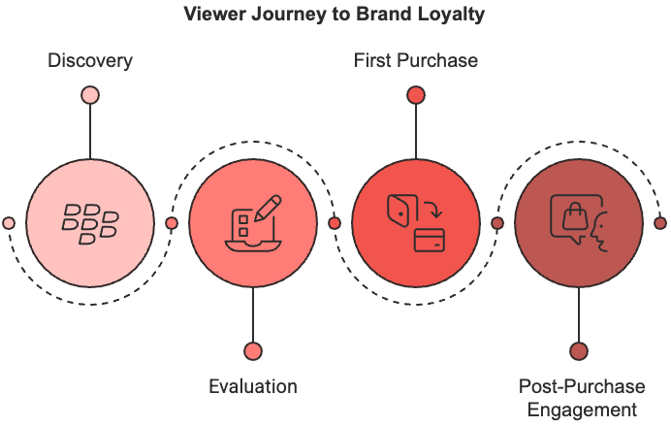
The journey begins with discovery, where viewers first encounter your brand through YouTube ads. During this crucial phase, your content must quickly establish relevance and value.
The evaluation stage follows, where viewers compare your offering with alternatives. Here, detailed product demonstrations, comparison videos, and authentic customer testimonials prove most effective.
The first purchase marks a critical transition, but it's what happens next that determines long-term loyalty.
Post-purchase content should focus on ensuring customer success, addressing common challenges, and introducing customers to your broader community. Channels utilizing interactive features tend to see higher viewer retention rates than those relying solely on traditional video content.
One powerful way to strengthen these relationships is through the strategic use of YouTube's interactive elements. Instead of viewing these features as simple navigation tools, successful brands use them to create immersive experiences that encourage deeper engagement.
End screens become gateways to valuable related content, while cards offer timely, relevant information that enhances the viewing experience. Community posts transform one-way communication into dynamic conversations, fostering a sense of belonging among viewers.
Here’s an example of a comprehensive approach to interactive engagement. A cooking brand might use end screens to guide viewers to recipe variations, cards to highlight essential ingredients and techniques, and community posts to encourage viewers to share their own cooking successes.
Its live streams could feature cooking demonstrations where viewers ask questions in real time, creating an immediate connection with the brand. This multi-layered strategy ensures viewers remain engaged while constantly receiving value from their interaction with your content.

Measuring and Optimizing Loyalty Growth
Understanding the impact of your loyalty-building efforts requires sophisticated measurement systems that go beyond basic engagement metrics. Brands that track advanced loyalty metrics will achieve significantly better customer retention rates. This improvement comes from their ability to identify and optimize the most effective elements of their strategy.
Your measurement framework should track both immediate engagement indicators and long-term loyalty metrics. While views, likes, and comments provide valuable short-term feedback, metrics like repeat engagement rate, content sharing patterns, and customer lifetime value reveal the true strength of your brand relationships.
Pay particular attention to comment sentiment analysis. You’ll notice that the emotional tone of viewer interactions often provides early indicators of shifting brand perception.
Creating personalized retention strategies based on viewer data requires a delicate balance between customization and scalability. Use viewing patterns and engagement history to segment your audience effectively, then develop targeted content strategies for each segment. For instance, viewers who consistently engage with technical content might receive more detailed product information, while those who respond to emotional storytelling might see more narrative-driven ads.
The most successful loyalty programs integrate YouTube advertising with broader customer relationship initiatives. This means ensuring consistent messaging across all platforms, connecting YouTube engagement with reward programs, and creating seamless transitions between different channels. Brands with active YouTube communities often see dramatically higher customer retention rates compared to those without community engagement strategies.
Community building itself requires a strategic approach focused on creating genuine value for members. Regular live sessions, user-generated content campaigns, and community challenges all contribute to a sense of belonging that strengthens brand loyalty. For example, a fitness brand might organize monthly challenges where community members support each other's progress, creating bonds extending beyond the brand itself.
Long-term success in building customer loyalty through YouTube ads requires patience, commitment, and continuous optimization based on performance data. By focusing on authentic emotional connections, strategic engagement, and meaningful measurement, you can transform casual viewers into passionate brand advocates who drive sustainable business growth.
Building genuine loyalty takes time, but the rewards (higher customer lifetime value, increased referrals, and reduced acquisition costs) make it one of your most valuable marketing investments. Keep testing, measuring, and refining your approach while always maintaining focus on providing real value to your viewers.
Part Six

THE ROAD AHEAD
____

Picture yourself watching a product demonstration through your smart glasses while simultaneously interacting with the content through voice commands and gestures. This isn't science fiction; it's the approaching reality of YouTube advertising.
By the end of 2025, YouTube's user base will surge to almost 4 billion monthly active, transforming how brands connect with audiences through groundbreaking technologies and innovative approaches.

The Next Wave of Advertising Technology
Tomorrow's YouTube advertising environment will be shaped by technological breakthroughs that fundamentally change how viewers interact with content.
These advancements won’t just be incremental improvements; they’ll represent a complete reimagining of the advertising experience. The integration of augmented reality (AR), voice interaction, and artificial intelligence will create opportunities for deeply personalized and immersive advertising experiences that were impossible just a few years ago.
Augmented reality integration stands at the forefront of this transformation, moving beyond simple novelty to deliver practical value for both advertisers and viewers. Imagine trying on virtual clothing while watching your favorite fashion vlogger, or visualizing how a new sofa would look in your living room through your mobile device.
These capabilities are becoming increasingly sophisticated, with Digital Sprout reporting that AR-enabled YouTube ads achieve 75% higher engagement rates compared to traditional video formats. The technology's success lies in its ability to bridge the gap between digital content and physical reality, creating memorable experiences that drive purchasing decisions.
Voice-activated engagement represents another frontier in YouTube advertising innovation. As smart speakers and voice-controlled devices become ubiquitous, the ability to interact with advertisements through natural speech patterns creates new possibilities for engagement.
Advertisers must now consider how their content sounds as much as how it looks, optimizing for voice search and commanding interactions. This shift requires rethinking traditional call-to-action structures and developing voice-friendly navigation paths that feel intuitive and effortless.
The future of artificial intelligence in YouTube advertising extends far beyond current capabilities. While today's AI focuses primarily on optimization and targeting, tomorrow's systems will participate actively in content creation and real-time personalization.
Campaigns utilizing advanced AI-driven creative optimization already achieve higher engagement rates compared to traditionally produced content. This advantage will only grow as AI systems become more sophisticated in understanding and predicting viewer preferences and behaviors.
These technological advances converge in what experts call intelligent interactive advertising, where advertisements adapt and respond to viewer behavior in real time. This new paradigm combines predictive analytics, behavioral understanding, and dynamic content delivery to create advertising experiences that feel less like interruptions and more like valuable interactions. For instance, an ad might adjust its narrative flow based on viewer engagement signals, or modify its calls-to-action depending on the viewer's previous interactions with similar content.

Privacy-First Innovation
The future of YouTube advertising must navigate an increasingly complex privacy landscape while maintaining effective personalization and targeting capabilities. This challenge requires fundamental changes in how advertisers collect, process, and utilize viewer data. The phase-out of third-party cookies represents just the beginning of a broader shift toward privacy-centric advertising models.
Successful advertisers are developing sophisticated first-party data strategies that prioritize transparent value exchange with viewers. Instead of relying on third-party tracking, brands must create compelling reasons for audiences to willingly share their preferences and information. This might include exclusive content access, personalized recommendations, or unique interactive experiences that enhance the viewing journey.
Contextual intelligence emerges as a powerful alternative to traditional targeting methods. Rather than relying on personal data, advanced contextual targeting uses AI to understand content themes, viewer intent signals, and engagement patterns.
This approach allows for precise audience targeting while respecting privacy preferences. Advertisers implementing sophisticated contextual targeting strategies achieve conversion rates much higher than those relying solely on demographic targeting.
The future of privacy-compliant measurement requires new approaches to attribution and performance tracking. Advertisers must develop privacy-preserving measurement solutions that provide accurate insights without compromising viewer privacy. This includes:
- Aggregate data modeling that identifies patterns without tracking individuals
- Privacy-safe cross-platform measurement frameworks
- Probabilistic attribution models that maintain accuracy while protecting privacy
- First-party measurement infrastructures that respect user consent preferences
Success in this privacy-first future requires building trust through transparent practices and clear communication. Brands must clearly articulate their data collection and usage policies while demonstrating tangible value in exchange for viewer information. This shift toward transparency and value exchange will define successful YouTube advertising strategies in the years ahead.

The Evolution of Commerce and Community
YouTube Shopping experiences are transforming from traditional advertisement-to-purchase journeys into seamless, integrated commerce experiences. The platform's future lies in creating immersive shopping environments where entertainment, education, and transaction capabilities merge naturally. This evolution reflects changing consumer expectations for convenient, engaging shopping experiences that feel organic rather than forced.
These new shopping capabilities extend far beyond simple "Buy Now" buttons. Future YouTube shopping experiences will incorporate:
Feature | Benefit | Implementation
Live shopping integration | Real-time purchase during streams | Interactive overlays and chat commands
AR product visualization | Virtual try-before-you-buy | 3D product modeling and camera integration
Voice commerce | Hands-free shopping experience | Natural language processing and secure voice authentication
Social Shopping | Community-driven purchase decisions | Collaborative viewing and group buying features

The transformation of YouTube into a comprehensive commerce platform requires advertisers to rethink their approach to content creation and audience engagement. Success in this new environment demands a careful balance between entertainment, information, and commercial elements. Brands that effectively integrate commerce features into their content see average viewer engagement times increase exponentially compared to traditional advertising approaches.
Community building takes on new significance in this evolved landscape. The future of YouTube advertising isn't just about reaching audiences but creating and nurturing active communities around your brand. These communities become powerful drivers of organic growth, word-of-mouth marketing, and customer loyalty. Successful community-building strategies focus on:
- Creating valuable, shareable content that encourages discussion and interaction.
- Facilitating meaningful connections between community members.
- Developing feedback loops that inform product development and content strategy.
- Building recognition and reward systems that acknowledge community contributions.
As you prepare for these future developments, remember that technology serves as an enabler rather than the end goal. The most successful YouTube advertising strategies will be those that use innovative technologies to create genuine value for viewers while building lasting relationships based on trust and mutual benefit.
Your journey into the future of YouTube advertising requires continuous learning, experimentation, and adaptation. Stay focused on creating value for your audience while embracing new technologies and approaches that enhance the viewer experience. The platforms and tools will continue to evolve, but the fundamental principle remains constant: successful advertising connects with people in meaningful ways that respect their privacy, time, and attention.

