Disclaimer

This eBook has been written for information purposes only. Every effort has been made to make this eBook as complete and accurate as possible. However, there may be mistakes in typography or content. Also, this eBook provides information only up to the publishing date. Therefore, these eBooks should be used as a guide - not as the ultimate source.

The purpose of these eBooks is to educate. The author and the publisher do not warrant that the information contained in this eBook is fully complete and shall not be responsible for any errors or omissions. The author and publisher shall have neither liability nor responsibility to any person or entity concerning any loss or damage caused or alleged to be caused directly or indirectly by this eBook.
Table of Contents

Introduction 8
Chapter 1: The Basics To Being A Freelancer 11
Chapter 2: Creating A Business Plan And Choosing Your Goals 17
Things to consider before starting 17
Chapter 3: The Legal Stuff; Taxes, Ethics, And Contracts 22
Legalities 22
Business ethics 23
Contracts 23
Chapter 4: How To Start Working With Little Experience 26
Gaining experience first 26
Working for free 26
Work for less 27
Gaining clients 27
Cold contacting and pitching 27
Be confident 28
Chapter 5: Best Places To Find Freelance Work 31
Chapter 6: How To Advertise Yourself: Creating A Portfolio 37
Building a portfolio 37
Chapter 7: The Importance of Valuing Your Work And Your Time 41
Choosing a niche 41
Time management 42
Value your time 42
Chapter 8: The Next Adventure: Scaling Your Business 45
Conclusion 48



Introduction

So, you think you want to be a freelancer? Let us guess, you want freedom, flexibility and to be in control of your life? There is no denying that starting a freelance business will change your life; but it will also change your relationship with, and your perception of, work.

Being a freelancer is one of the most liberating career paths. It is also one of the toughest. Starting a freelance business is not just as simple as waking up in the morning, rolling out of bed, and opening your laptop. Freelancing is not just an easy way to monetize your hobbies and nor is it easier than a “proper” job.

Nevertheless, freelance work is some of the most rewarding work you will ever do.

One of the most significant things to remember when becoming a freelancer is that the worst thing someone can say to you is “no.” You need to put yourself out there. There is no shame in being rejected, but there is some shame in not trying the first place. You may have to reach out to people— things do not always come to you; you will have to seek them out.

Freelance can be done part-time, on the side, or, eventually, it may turn into a full-time job.

This eBook will give you all the tools that you need to be a successful freelancer. It will tackle common problems and answer the most common questions that new freelancers have.

There are numerous perks that exist within a freelance business that other jobs simply do not provide.

The first section of this book outlines the basic foundations required to start a freelance career; it will ask you some questions and force you to think about your dream life. This will make you think about whether a freelance business is the right path for you and will give you some hints on structuring your new lifestyle. It will emphasize the fact that a plan is essential, a freelance business is not just something you can make up as you go along. Effectively researching and planning extensively before beginning will be the hallmark of success—ensure that you understand your service, your industry, and your audience properly, first.

After discussing planning, goal setting, and briefly touching on legalities, this eBook will talk about how essential a portfolio is. It will also go on to provide some tips on how to fill it up effectively to attract your target audience. Following this, it will also discuss how you can start working without much experience, and also delve into the positives and negatives of different platforms and places to find freelance work.

You will also have to think about the importance of time management and valuing your work. Your time is valuable, and the way that you manage it will help to dictate your work-life balance.

The book will conclude by suggesting some forms of business expansion. Once you have reached a level of success you will have the opportunity to upscale it.
So, future freelancer, read on for the ultimate guide to starting a freelance business, and changing your life.
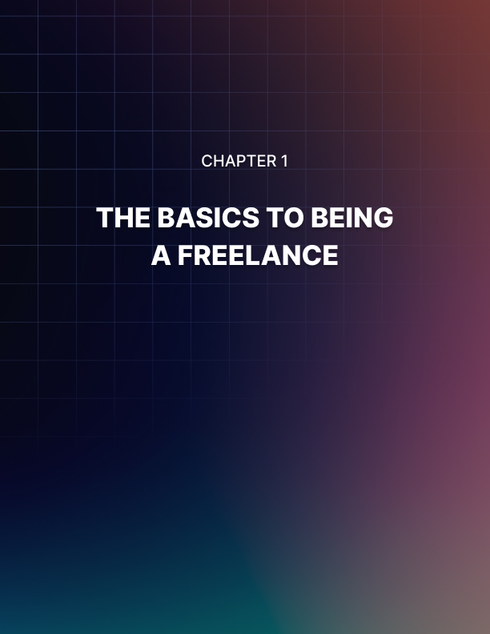

Chapter 1: The Basics To Being A Freelancer

This eBook will begin by outlining some of the basic features of freelance work.
The fundamentals details of a freelance business plan will be outlined in the next chapters, however, it would be remiss to discuss the basics of freelance work without stating unequivocally that, as a freelancer, you are also a business owner. You will be responsible for all elements of your business, which is why you need to have a solid understanding of what it means to be a freelancer.

Is a freelance career right for you?
Chances are, if you are reading this eBook, it is. Starting a freelance business requires courage and investment; two things you already have by choosing to read this content.

The remainder of this chapter will be discussing some of the most important things that you need to think about before starting your new business.

What skills do you have?
First of all, you need to start by thinking about what skills you have. These skills are likely things you have gained throughout your life and your career. Your freelance business will be most successful if you play to your strengths and your skills.

It can include, of course, any education and training you have received, as well as things that you excel in.

What interests you?
As well as your skills, you need to recognize what interests you. What are your passions and your interests? What kind of work do you enjoy?

What about your free time and hobbies? What do you do then, and what is it about them that you enjoy?

Your business will be most successful if you are doing work that you are genuinely passionate about.

Most importantly, what kind of work makes you happy?
You should think about, and reflect upon, the past projects that you have most enjoyed. What elements of your past work have you enjoyed? Is it in the customer service element, or the collaborative effort of a team?

Or, if you have been stuck doing work that you hate, reflect on why, and determine what you can do to make sure it does not happen again.

Concentrating on doing work that makes you happy will improve your quality of life and give you a spark that other freelancers do not have.

What will your service be?
As well as determining what you do, you also need to determine what you do not. This will ensure that you are only doing quality work in areas of your expertise that you want to do.

When you begin freelancing, you should really think about what you actually want to do. You may have an idea of the vague industry or area, but you should think about what specifically the kind of work that you want to do. It should lie at the intersection of your skills and passions—this will be the key to the success of your business.

Freelance work ideas
There are a plethora of freelance business ideas that can be tailored to your skills and interests. Chances are you already have an idea of what you would like to do, however, below, in no particular order is a list of potential freelance business ideas.

- Writing
- Copywriting
- Editing
- Proofreading
- Blogs
- Journalism
- Ghost-writing
- Content writing
- Web development
- Web design
- Website creation
- Software programming
- Graphic design
- Photography
- Transcribing
- Translating
- Teaching
- Online English teaching
- Tutoring
- Social media marketing
- Content creation
- Brand management
- Search Engine Optimization
- Data entry
- Admin
- Bookkeeping
- Virtual assistant
- Marketing

Once you have an overall idea of what you would like to do, you can narrow it down to a specific niche. This is not something that you need to do immediately, but it is something that you should keep in mind as you grow your business. Specialization is essential to business growth—but your niche can evolve as your direction changes.

Who are your clients?
Once you know what your business will be, you will need to consider who your target market will be. Clients will be discussed in more detail later in this eBook, nevertheless, you should be considering who your target audience will be as you plan your business.

It is important to remember that, in terms of clients, you should be aiming for quality over quantity. While (and this occurs especially when you are starting out) it can be tempting to take any and all clients you encounter, you should know that you are allowed to say no. If someone is rude or trying to rip you off, move on. There are plenty more out there. Allocate your time to clients and projects that you enjoy and believe in. In particular, it is recommended that you try to gain long-term clients.

One of your primary business goals should be to retain quality clients and build good relationships with them—regular work is fantastic.

Hidden costs
There may be hidden upfront business costs that you will need to invest in. Obviously, this is dependent on your industry and the things that you already own, but nevertheless, there are things that you need to consider. Will you need new software or technology? How about office equipment?

Can you work from home or do you need to rent somewhere? If you are thinking about using a coffee shop as an office—remember to budget in the coffees (and snacks!).

Working these out in advance is the best way to not get caught out with unexpected expenses.

Motivation
Having a freelance business requires motivation and discipline. You will no longer have a boss hovering around demanding that you work harder; you are now that boss. Being self-motivated and having good time management skills are quintessential traits of successful freelancers.

It also cannot be stated enough that you need to know your worth. If you feel undervalued or underappreciated, you will also likely feel unmotivated.

Figure out what motivational strategies work for you and utilize them to smash your goals.


Chapter 2: Creating A Business Plan And Choosing Your Goals

A business plan is essential for any business, freelance ventures included. You do not have to have a complex fifty-page document, full of tables, charts, and calculations (unless you want one and will find that helpful for yourself). Instead, you can come up with a short collection of goals that you can refer back to.

When you search for a “business plan,” templates appear that are full of sections with complicated things that need to be determined—not all of these are applicable to freelancers. Instead, think about the main goals that you have for your business, and your life; and center your plan around these.

Your business plan and goals should be adjusted as your business changes and grows. Set aside time periodically to review and update your goals.

Things to consider before starting
Before creating a business plan, you need to think about what your goals are for your business. Take the time to be introspective and really consider why you want to start a freelance business. Doing so will help you maximize your abilities and prospects.

Do you just want to freelance on the side? Or will you aim to expand it into a full-time career?

Why do you want to be freelance? Is it to get rid of the commute? Is it to be your own boss? To supplement your other income? For a better work/life balance?
You need to get to the bottom of what your motivation is for going freelance, and transform it into goals.

Basically, what do you want to get out of being a freelancer? Write down anything and everything that comes to mind and find ways to integrate it into your planning.

Cost of living
First, you need to figure out how much money you will need to make to survive. This is, naturally, often based on your income from any other work you have done.

Some people find themselves taking a pay cut when transitioning into becoming a freelancer, you need to make sure that you can withstand this and plan for it in advance.

Once you have figured out what your ideal level of income is, you can start to determine prices for your products and services. Your cost of living, and desired income level will impact the hours you will be working and how many projects you will be taking on.

It is also important to remember that adapting from receiving a regular paycheck to being a freelancer and getting paid intermittently (and, worst of all, having to regularly chase up clients who refuse to pay) can be difficult.

Outlining what your desired wage will be in your business plan is something that you can return to every so often to check that you are on progress. Or, if you are not meeting it, you can try to understand why and readjust your goals.

Research
You need to research your industry and your competition. You cannot just start up and expect success—there are a lot of other freelancers out there, and you need to set yourself apart from them. The best way to do this is to understand them.

You should research your competition; see to see what they are doing, where they exist online and what mistakes they are making. You can emulate the positive aspects of their marketing and branding for your own freelance business and improve upon any mistakes you see them making.

Additionally, you need to do this research on a periodic basis. You do not want your services to become out of date or redundant. Every so often, set aside some time to check in on your competition and see how their business is progressing—make sure that yours is, too.

Creating your brand
At some point in the development of your freelance business, you will need to determine a personal brand. Your brand is how your target clientele will view your business; it makes you seem professional and authoritative. A good brand is an indication of business success.

An element of your brand is how it appears visually. This will include things like your business name (it can just be your name), your logo, aesthetic design elements and how your website or portfolio is stylized.

The overall goals and missions of your business can be defined and outlined in your branding.

Where to find clients
You need to learn about and understand your target market. Once you have determined what you want your business to be, you need to determine whether there are enough clients out there to sustain it. While there usually is a market for pretty much everything, it is still a good idea to make sure that there are enough clients who will be interested in your services.

You should work out demographically who your target market is, and then try to understand their behavior. At the very least, you need to figure out where they would look for you. What is their internet use like? Where would they look for a freelancer? This is key. Without customers, your business will not succeed. You should endeavor to understand your audience precisely— this way you can target your services to them in a way that they will specifically enjoy and utilize.

Once you have a business plan, what should you do with it?
Your business plan should be something that you can return to when you find yourself stuck. Help your future self out and save them some trouble by giving them some inspiration.

You can include a list of potential client ideas and places to find clients. If you are in a dry spell of work, refer back to these and reach out to pitch them.

Make a list of your dream projects. If you have some spare time you could work on them to reinspire yourself and build your portfolio. Alternatively, reach out to some potential clients and pitch your ideas.

You can also come up with a list of marketing strategies to implement when work is slow. Finding new places or methods to target your clients is a fantastic thing to do—it will expand your business and increase your client pool.

Including an assortment of “things to do when you do not know what to do” is a must-have in any business plan. It can be easy to come up with a list of things that you need to do when your motivation level is high before you begin. Then, once you have started work and you may be feeling a little lost, you can refer back to this list and reignite the spark that you have for your freelance business.

You should further define your business plan to simple mission statements or goals. Some people find it beneficial to keep these at hand, somewhere you can easily refer to them. They could be aspirations or statements for how you want to conduct yourself. Remind yourself of these regularly to ensure that your business is heading in the way that you dreamt of.

It is also essential that you remember that your plan can be updated whenever you like. Businesses are not stagnant objects; they should progress and grow—you can update your plan whenever you feel the need to. A sign of failure for a freelance business is that it does not grow or change with the times.



Chapter 3: The Legal Stuff; Taxes, Ethics, And Contracts

The legal stuff is boring. There, we said it, so you do not have to! It can be confusing and tedious and, truthfully, reading legal advice can be a great precursor to a nap. Nevertheless, it is so incredibly important to make sure that your business is acting legally. While understanding the legal elements of freelance work can be a headache now, it is nothing compared to how you would be feeling if you found yourself in trouble.

When starting a freelance business, one of the things that you will need to become familiar with is the legal requirements for your industry; but also, for the region that you live in.

Although, here is a disclaimer: this eBook is not providing legal advice.

It will give some guidelines of things to think about, but it is not an exhaustive list. The laws and regulations differ from place to place, so you must do your research properly.

Legalities
The legal components that are applicable to freelance businesses differ from state to state so you must do your research thoroughly. But, in general, you will need to consider registering for taxes and business registration— including company structure and ownership.

You may also need to take out additional insurance. If you plan on working from home, some home insurance does not cover businesses, so you may have to take out additional business insurance. Check with your provider and see what is possible for you—just in case.

Some other things that you may need to investigate include intellectual property law, exclusivity clauses, and how credit will be awarded. You should also investigate data protection concepts, as well as how to cope with conflicts of interest.
It is better to be safe than sorry. It will be well worth your time to do extensive research into the legal requirements of freelance enterprises in your location and industry. When it comes to the law; being proactive is better than being reactive.

Business ethics
There is, of course, a difference between things that are legal and things that are ethical—just because something may be legally permissible, it does not mean that it is ethical or morally acceptable. While it may seem tempting to cut corners or ignore certain things, when you are the owner of a freelance business; it all will come down on you.

You are the only person on the line; your behavior and your reputation will make or break you, and, subsequently, your business could be at risk.

While it goes without saying regular business ethics and expectations still apply to freelancers. This, of course, means that you should pride yourself on being dependable, productive, open-minded, and compliant, as well as exhibiting integrity and loyalty.

You will need to keep communication open and honest. You should always keep your client up to date with your progress and keep them in the loop— you should think of yourself working with clients, not for. Do not give unrealistic expectations about project due dates (it is far better to give yourself a longer deadline and finish early than not complete on time). If something is unclear or you are unsure about something, do not be afraid, and do not just struggle through; ask questions.

Additionally, do not steal or plagiarize, and make sure that you are honest at all times. Remember, you are still a professional; you do not have to act casually like you are in your pajamas (even if you are)

Contracts
Contracts make clear exactly what you and your clients expect from one another. They can outline the terms of your work, for example, the number of revisions or edits you will apply, or payment expectations.

Contracts can also outline the details of the work that you will be completing—this is essential so that your client cannot demand additional work. Outlining clearly what work precisely you will be completing, in what capacity, and by when is essential to ensuring that you and your client are on the same page. You should also outline the timeframe of the project, as well as any deadlines.

And of course, the contract should include the terms of payment. Will you be paid hourly, or a lump sum? Will it be paid in parts, or once the project is completed? If nothing else, it is essential to outline payment terms.

You could just write up a list of your terms and conditions to send to your clients or link them to a webpage outlining your terms of service. You do not necessarily need to create a unique one for each client (though, depending on the service you should), but you can use a template.

Contracts can be used to protect you from clients that are trying to take advantage of you and trying to get more work for no additional money. Trust your gut, but make sure you are legally protected, too.

If you use contracts properly, they can save you from some trouble with any legalities. Ensuring that your terms of service, requirements, and expectations are clearly outlined is pivotal.

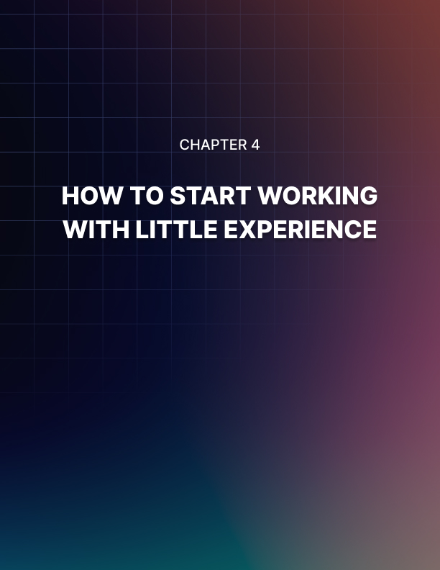

Chapter 4: How To Start Working With Little Experience

One of the biggest challenges that some freelancers face is finding work. It can seem daunting to transition into a form of work that is uneven and, sometimes, inconsistent. You probably have existing skills from your work that can be applied to your new freelance venture, but you may not have much experience.

This chapter will discuss some of the best methods for starting freelance work when you do not have much experience.

Gaining experience first
Many freelancers would not recommend shifting from full-time “regular” work to becoming a full-time freelancer. Ideally, you should not quit your freelance job for freelance work straight away.

Gaining experience will probably be your first goal as a freelancer, and it can be something that is done on the side to other work. You can build experience in your spare time, and then, once you feel secure in your work, as well as the number of your clients, you can become a full-time freelancer.

There is no shame in starting out part time; for some people, it is preferred. It allows you an insight into the lifestyle and responsibility, while still having the security of another source of income.

Working for free
It can seem very tempting to work for free to build experience. It can be an incredibly beneficial way to gain experience to fill your portfolio and maybe it is something that will work for you—but it is not an effective method for everyone.

However, it is important to be careful about working for free. Some clients will gain a “well, you worked for them for free, what about me?” attitude, which can be hard to escape. There is a fine line between working for free to gain experience and devaluing your skills.

Remember, at the end of the day, exposure does not pay the bills. If it is financially viable for you to work for free to build your portfolio, then, by all means, do so. But be careful of working for free for the benefit of exposure— after all, you cannot dine on exposure alone.

Work for less
While working for free may not be suitable, you will probably end up working for a lower wage. This is something that you should do, it will help you to gain reviews and clients, as well as experience and additions to your portfolio.

When you do something for less than its value, it will also help you to appreciate the value more. You may decide that, after working for a lower wage than you would like, that the overall value of your work is higher, and you end up readjusting your final prices.

Working for a lower price will help you to adjust to the lifestyle, and determine how long it actually takes you to complete a project. It is a good introduction to freelance life.

Gaining clients
One of the primary goals of business should be in client retention. When you are starting your business, there is a chance that you do not know any clients—change that!

Any interaction or work that you have should have the goal of building a long- lasting client relationship. Additionally, you can ask them to recommend your services to other people.

By knowing and understanding your target audience you can find clients. You should try to build up a database of clients that you can target and retain.

Cold contacting and pitching
While frowned upon in sales, for freelancers this can be a savior. Sometimes contacting clients shows initiative and puts your brand out in a positive way— especially if you show them.

Learn how to pitch your services. Find possible clients, research them, and then send them an irresistible pitch.

Putting yourself out there (especially if you are offering a lower price) is a great way to gain experience. It can also help you build long-lasting client relationships.

Be confident
At the end of the day, confidence is key.

If you seem unsure or unconvinced of your business, then your audience will be, too.

If you require more confidence in your service, consider taking a course in your area. This will bolster your professionalism, as well as making you seem more skilled and qualified in your area. However, if it is the “business” side of freelancing that you are unsure of (well, first of all, you are in the right place)! But finding a mentor could be a fantastic option for you. In particular, if you find a mentor, or build a network of freelancers that are similar to you (both in industry or geographically) they could help you to navigate the legal side of your business, and provide you with relevant, specific advice.

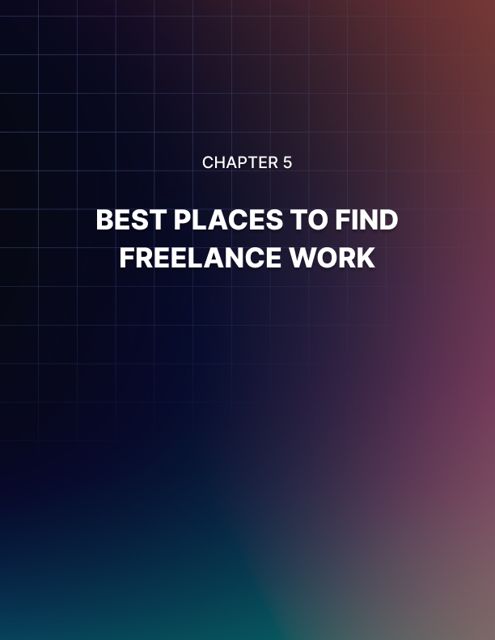

Chapter 5: Best Places To Find Freelance Work

There are many places where freelancers can find work. There are many websites dedicated to this very action. There are some (as discussed below) that cater to freelance work as a whole, and there are other, more niche websites that are specific to different industries. Do some research and determine what kind of platform will best for your service but is also somewhere where you will be able to find clients.

A good rule of thumb can be to find work in the places where your target clientele hangs out.

You need to remember that time spent finding work is time that could better be spent working. Once you have a good strategy for finding work; you should continue with it. But, if it is too time consuming and does not produce optimal results, try another method.

Profiles
Before outlining some locations for finding freelance work, it is important to consider your profile. All these platforms will require that you create a profile—it will have your name, skills, qualifications, etc., as well as a portfolio. It is essential that you fill out these profiles to the best of your abilities. Incomplete profiles look unprofessional and will likely lose you jobs.

Upwork
On the platform Upwork, clients post job listings, which usually includes the details of the project and often what they would like their freelancer to be like. Freelancers then bid and submit proposals, detailing why they would be the best person for the job. The client then chooses the best freelancer for the job.

Platforms like this are some of the most cited, and most common methods for finding freelance work, for good reason. They are an easy and accessible way to find work. These centralized platforms are well-respected and used frequently by many kinds of people.

Benefits of platforms such as these include the ease of use and the fact that both clients and freelancers are bound by the terms of use. Platforms take payment from clients and release it to the freelancer once both users have verified that the work is complete. The platform ensures that the content is delivered, and payment is received.

However, there are also some downsides to these platforms. The first is that the platform often takes a percentage of the payment to cover website fees and for facilitating the match. These can add up over time and mean that you are getting paid less than you deserve. Another issue is that such sites encourage a “race to the bottom” mentality. This means that freelancers often lower their prices for the service for a competitive advantage, which in turn forces others to lower their prices as well. On platforms like Upwork, some clients are not entirely clear on the value of a freelancer (or cannot afford one) so they sometimes opt for a cheaper option.

There are downsides and upsides to such websites, and ultimately it will come down to personal preference and abilities. They may work for your business, and they may not, but they are an incredibly accessible way for freelancers to find clients—even if you do not use them forever.

Freelancer
Freelancer is a website like Upwork. This platform is also available to freelancers and clients of all kinds, with job listings in many different areas.

Freelancer highlights the benefits of clients being able to view freelancer portfolios before accepting to work on a job together.

This kind of platform also features an in-built chat feature. This is an easy way to be able to interact with the other party on the platform. This keeps the jobs and the conversation, as well as project updates, on the platform and does not cross over to other platforms.

Again, however, such sites are known for sometimes being low paying, with freelancers fighting to undercut each other’s prices in order to gain work.

Fiverr
Fiverr is another option for freelance platforms. It is, however, sometimes geared towards smaller jobs. But it has a different job posting method. As well as the traditional method of clients posting jobs for freelancers to submit proposals, the reverse also happens.

Rather than a client posting, “I would like someone to design me a logo,” freelancers are able to post, “I design logos.” Clients then look through freelancers’ offerings to find people to work with, rather than the other way around. This is a unique and useful thing, especially if your service is unique.

Fiverr has a different attitude towards pricing, for this reason. Clients can see upfront what their budget will get them when they browse project offerings. There is, of course, still competition, but you are more in control of what you will charge for your services.

Guru
Guru is a “higher end” freelance work site, targeting expert freelancers and clients—that is designed for higher quality. It is advertising itself as a more “legitimate” website and prides itself on the quality of the freelancers it features.
It also has a different payment system. Most freelance sites take payment from the client and hold it until the project is verified complete and then release the funds to the freelancer. Guru is different, as well as this traditional, fixed price, payment system it has a variety of other options. Guru also offers hourly rates (using their time tracking software) as well as recurring payments for long-term projects.

Toptal
Toptal, named for the phrase “top talent” aims to provide just that. Before being able to use the website, there is a vetting process that includes experience verification, as well as an interview.

Being on such a reputable platform is a great way to attract legitimate, high paying clients. It will cement you as an authority and a high quality freelance business owner.

iFreelance
Alternatively, iFreelance is a membership driven site. Rather than freelancers forgoing a portion of each project they complete as host fees to the website, there is a monthly fee. However, the platform does not take a cut of your earnings. This could be useful if you are able to get a high number of listings (on this less popular site), otherwise it could be a wasted subscription.

LinkedIn
LinkedIn is a professional networking website that people mostly only update when they get a new job. However, LinkedIn is full of opportunities. Some recruiters trawl this platform to find people that are open to opportunities to try and connect with people in their area.

LinkedIn, if for nothing else, is a good way to build a network of other freelancers or potential clients in your industry. By filling out your profile, showcasing your work, and providing updates to your projects and business, you are opening your business to the eyes of others: people who may be looking for exactly what you are promoting.

In essence, do not overlook LinkedIn (or even other social media platforms). They take time to set up (though, the content is mostly the same across them all so it is not too laborious), but you never know what could come of it. It is a small upfront time investment that could attract numerous clients and add immense value to your freelance business.

Pitching
Another method of finding freelance work is to find a person or organization and pitch your services to them.

When pitching, firstly, you should be personalizing your emails, and, even more importantly, make sure that you are contacting the correct person. You should make sure that you do your research into the company and ensure that you are offering them something irresistible.

The most important part of pitching is to make sure that your pitch is good. Often, companies receive an abundance of promotional emails, offers, and pitches; you need to stand out from the rest and showcase what you have to offer them.


Chapter 6: How To Advertise Yourself: Creating A Portfolio

Having a high-quality portfolio is essential to being a successful freelancer. As well as showing your clients what you can do, your portfolio is a great way to add value to your business. It is the best, and strongest, advertisement for your services.

In the modern age of technology, a portfolio can simply be a website that shows elements of your work. It is a freelancer’s version of a resume (and, it can include elements of one). It should show your skills and education, as well as your experience. You can use things that you have done in the past here, too.

Building a portfolio
Clients will not want to work with someone who cannot verify the quality of their work. It will need to include examples of your work.

Having examples of your work is a fantastic way to offset any lacking experience. While you may have less experience than other freelancers if the quality of your work is better then it will be incredibly advantageous to your business.

But how do you fill a portfolio with little experience? The simple answer is to get some.

Working for free is one, often suggested, method of doing this. But, it is not for everyone. If you can financially withstand the free labor, then do so. However, in the future, remember that exposure does not pay the bills. Others believe that working for free can devalue the perception of your work—but it is undeniably a good way to get your name out there.

Working for a lower fee is something that you will probably have to do. You could pick up smaller projects on freelance gig sites, to gain some experience.
Also, just do some passion projects. Do some projects that you are excited about so that your passion can show through in your portfolio.

What should you put in a portfolio?
Your portfolio should show examples of your work, as well as your skills, education, and experience, and what your business actually is.
Your freelance portfolio does not have to have a billion completed projects. This could be overwhelming to clients, and chances are, they will not look at them all.
It should focus on select, high quality completed projects that show the depth and scale of your services. Additionally, you can include excerpts of projects. This will, again, show your skills, yet not take too long to do.

Profiles on websites
When signing up for profiles, particularly freelance work platforms, it is essential that you fill out all of the information. Any boxes or forms that the website has that you can utilize to showcase your skills, experiences or examples should be comprehensively filled out. Clients will be checking these extensively, and likely comparing you to your competition.

Website
As well as examples of your work, your website should also have your contact information.

It is also worth noting that you should not neglect your prior experience. While some new freelancers feel the need to prove themselves in the freelance sphere, including relevant past job experience will always highlight you in a positive light.

Some freelancers elect to have their rates and packages available on their website. This will make it clear to future clients what they can expect from your work.

Important sections to have on your website include: about, services, portfolio, testimonials, and contact.

Social media
You should also have a social media presence. As, obviously, almost everyone is on social media; having your own accounts and using them to interact with your industry is a good method of getting your brand out there.

If your service is something that you can share, for example, something graphic or visual, you can showcase on Instagram, do that. Starting a blog to share your content is also an effective portfolio building (as well as marketing) method. You should cross-share your content, including Tweeting links or sharing on Facebook. It does, of course, depend on what your business is and how “online” your audience is.

In essence, find the platforms that your clients use and create a presence on those sites. Making yourself easily found online and having an accessible portfolio is key.

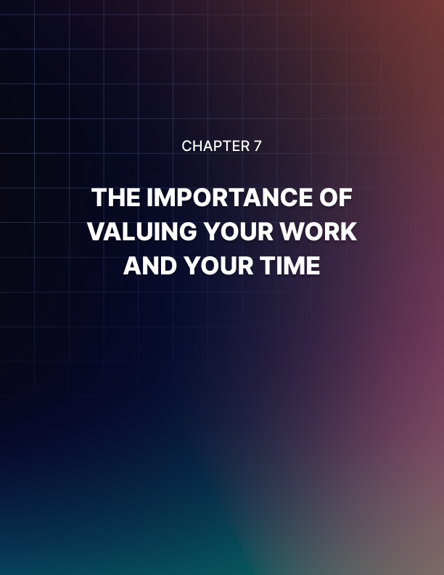

Chapter 7: The Importance of Valuing Your Work And Your Time

Pricing can be something that is difficult for freelancers to determine. You will want to value your time appropriately, yet, still be affordable for your client targets.

Clients often expect you to deliver the moon yet are only willing to pay for a garden rock. This is a bad analogy, but some clients will demand that you go to the moon and back for them yet will not pay you enough to fuel the rocket. Is that any better?

The essence of the analogy is that some people will try to take advantage of you.
There are a lot of freelancers out there, and clients often want to pay the least amount possible for work. Unfortunately, chances are, someone will always be willing to do something for less than you.

Nevertheless, it is important to choose a price that you feel is fair, and comfortable. At the end of the day, you have living expenses and you deserve to be compensated for your labor.

Choosing a niche
Sometimes, budding freelancers seem to think that by being less specific about their work, it will get them more work. This is not always the case.

For example, saying general content writer vs saying finance content writer. It makes you sound more professional and will instill more confidence.

Having a niche means that you can charge a premium price for a specified service. You do not have to define your niche right away, but it is something to do when your business grows.

Time management
While this can seem like a no-brainer, time management is essential to successful freelance work. Naturally, time management will play a part in your pricing. It is, of course, vaguely unreasonable to charge your clients for the cost of your procrastinating! Charge your clients in such a way that it makes sense for you, yet still aim to be as productive as possible.

There is a risk of taking too much advantage of the flexibility and using it as an excuse to relax and procrastinate. Having dedicated days off and setting clear times to relax or have leisure time is the best way to increase your productivity.

Some freelancers choose to do an hourly rate, whereas others do a project fee; it is completely up to you (just like everything else!). Think about the hours of the day that you would ideally be working, and stricture your income and working hours to suit this.

You also need to be motivated and disciplined. There are many different time management and organizational techniques that can be implemented. Lists and calendars are no-brainers. Setting deadlines for yourself, as well as giving project updates to your clients is a good way to stay on task.

Having a clear structure for your day, dividing your tasks into subtasks, and setting timers are all small ways to manage your time better. Figure out which times of day you are most productive. Is it right after your morning coffee? If so, do your high energy tasks that require the most effort then, and then do less intense tasks in the mid-afternoon lull.

In essence, however, find what works for you. There is no one size fits all approach to freelance work; you get back what you put in.

Value your time
As the expression goes; time is money. You deserve to be paid well for your work. Do not undervalue your services.

Make sure you have done some research into what your similar competitors are charging, and even look into what “regular” workers would charge for the same product. If you are spending extra time on your projects, and doing things outside the scope of your work, then you should negotiate payment increases.

If clients approach you asking you to work for less (or for free), use your best judgment. You do not have to, you have no obligation to work for any less than you feel that you are worth.

At the end of the day, you are an expert in your field, and you have valuable skills and experience, and you deserve to be paid for these things. Don’t forget to think about your long-term financial goals, too.



Chapter 8: The Next Adventure: Scaling Your Business

A misconception about freelance work is the idea that it is somehow not a “real” business. While, to begin with, it can seem like you and your laptop against the world, your business can grow.

It is important not to jump into too much too quickly. If you attempt to take on too much, you may end up failing. To begin with, focus on consistency and finding your feet.

But, once you are comfortable and confident, you will be able to grow your business. It will take time to plan; do not just jump into something. This chapter will outline some ideas for scaling your freelance business.

Full-time freelance
If you are starting off part-time, and have already made the switch to full- time freelancing, it is worth waiting until you are secure in your clients, work, and income level before you leave your old job.

So, perhaps your first adventure will be committing to a full-time freelance lifestyle.

Hiring a team
You can hire others and build a team. Being freelance does not mean you have to be alone. You can hire others to work with you and for your clients. Perhaps you could expand your business offerings, or simply have more people doing the same kind of work as you.

Subcontract
If you do not want to hire others to work for your business in the content creation or service providing, you could instead outsource other elements of your business.

Perhaps you need help with your business admin or organization. You could hire a virtual assistant to deal with marketing, emails, or contacting your clients. Alternatively, you could hire an accountant or someone else to help with your taxes.

You are able to subcontract numerous services, and this could free up time for you. Time you could use to spend working, or relaxing—the choice is yours.

Niche
By narrowing your freelance service down to a niche, you will be better suited for your clients. For example, a client who is looking for a finance writer, would rather hire someone who is a defined finance writer, rather than just a writer.

Additionally, you are able to charge more for a specialized service.

Building a brand
Once you are more established, you should make an effort to create a cohesive brand. This is a huge value-add to any business; it makes you reputable and authoritative.

It is not essential for all freelancers, but it is something that a potential client would find themselves attracted to. Often, when clients hire a freelancer, they want to work with a person, not a random business—so make sure they see that.

New services
Another form of business expansion could be adding new services to your business. Perhaps you could add new elements to your package deals or focus on different elements of your industry.

Your business should never be static. Make sure that you are keeping up with the kind of services that your clients are demanding.

Increase prices
At the very least, once you have more experience, and more skills, you should increase your price. You have worked hard, you deserve it!


Conclusion

In conclusion, there are several important things to consider when you are starting a freelance business.

Of these, creating an outstanding portfolio should be at the top of your list. Ultimately, your portfolio will be the strongest form of advertising.

Effectively, to begin a successful freelance business, you first need to figure out your service, and your audience. You need to make sure that your audience can find your business and that your services are relevant and attractive to them. Take on projects (even if they are not ideal, or as well paid as you would like) in order to build your skills, experience, and credibility.

Do not forget to focus on the business side of your business, and make sure that you are operating as a legal machine. And, once you are ready to start working full-time, work out where the best places to find your clients are. Frequent them and advertise properly. Learn how to manage your time and maximize your productivity. You have the flexibility to work however you choose and you should take advantage of that.

Once you have a strong foundation for your business, scale it up! You are the boss, and you get to decide how and when it operates.

Most of all, enjoy your business. Freelance work is tough, but the benefits are truly unparalleled. There is no other kind of work where you will get to live the life that you choose.

In all honesty, as long as you pay attention to your industry, keep up to date with trends and monitor your progress, your freelance business will have longevity. If you plan your freelance business and update your plan as your business evolves, then you will probably be successful in living your dream life. Freelance work is some of the most liberating and rewarding work out there; but it is not easy, put in the effort to ensure your success.

