Disclaimer

This ebook has been written for information purposes only. Every effort has been made to make this e-book as complete and accurate as possible.

However, there may be mistakes in typography or content. Also, this e-book provides information only up to the publishing date. Therefore, this e-book should be used as a guide - not as the ultimate source.

The purpose of this ebook is to educate. The author and the publisher do not warrant that the information contained in this ebook is fully complete and shall not be responsible for any errors or omissions.

The author and publisher shall have neither liability nor responsibility to any person or entity with respect to any loss or damage caused or alleged to be caused directly or indirectly by this e-book.
Table of Contents

Introduction 6
Why Freelance? 7
Chapter 1: Starting a Digital Freelancing Business 10
Goal Setting For Your Freelance Business 11
Chapter 2: Learning To Become a Freelancer 14
Choosing The Right Freelance Business 14
How To Market Yourself As a Freelancer 16
Meeting Your Freelancing Deadlines 17
Chapter 3: Finding Work As a Freelancer 21
Services To Offer As a Freelancer 22
Chapter 4: Potential Drawbacks As a Freelancer 28
Freelance Business Concerns 30
Drawbacks To Working At Home 31
Chapter 5: Becoming a Standout Freelancer 35
Networking For Digital Freelancers 36
Chapter 6: Types Of Digital Freelance Work 39
Online Tools For Digital Freelancers 40
Chapter 7: Finding Clients for Your Freelance Business 43
Building a List Of Prospective Clients 44
Advertising Your Digital Freelance Business 45
Conclusion 48

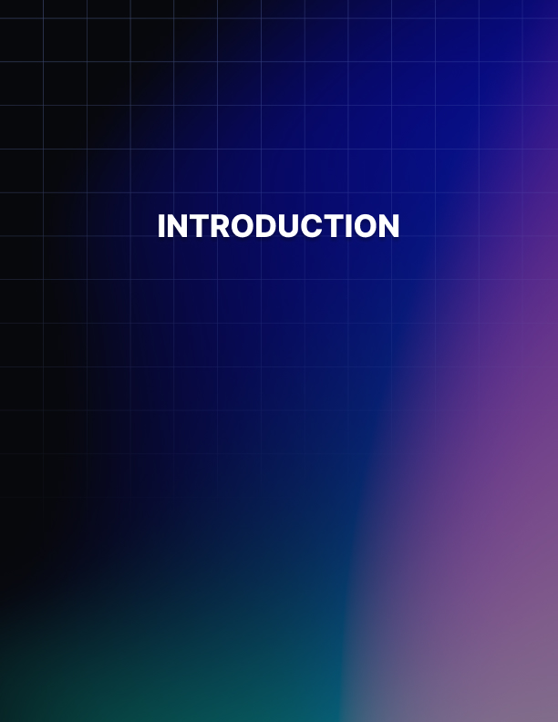

Introduction

Do you like working for other people? Do you like dealing with rush hour traffic morning and night; how about those late nights at the office that are never appreciated; and what about missing your kid's games and events?

If this sounds like you and you would like to change your life forever, this powerful new job will change your life.

Did you know that if you decide to freelance you can make thousands of dollars monthly and enjoy the feeling of working for yourself?

However, if you don't set up your payment system to allow for the fastest possible transfer of funds to your business's bank account you will be causing yourself untold headaches by having to wait days or even weeks to get paid for work you've already completed.

The purpose of the book is to let you in on a little secret.

That secret is about learning how to become a successful freelancer by knowing how to market your skills online and do it by having a critical edge on your competition.

Most people who think about starting a freelance career just do not know where to begin. They don’t know anything about how to generate a real-world, bankable income every month with their skills.

They know even less about how to get cash flow into their business quickly. There is good news though…

You are going to learn how you can start using your skills to create financial security through freelancing in a revealing new manual that I have put together for you that guides you through how to get jobs and beat out your competition because you have your payment processing set up to total customer convenience.

Getting started is easy and super-fast.

Don’t waste another minute of your life working for someone else if that isn’t making you happy! Take action and start your profitable freelancing career now!

Why Freelance?
Freelancing allows you to be your own boss. This means you make your own hours.

Wear what you want. Does your current job have a dress code? How does sitting in your pajamas all day sound; what about just spending the day wearing your favorite pair of worn-out jeans and that T-shirt from that unforgettable 1980’s rock concert. If you are an independent agent, like a freelancer, then you decide the dress code.

Making your own hours does not mean loafing around all day. It means having the self-discipline to set aside a certain amount of hours that you work each day.

But, as the boss, you get to decide what those hours are. That way you can pick up the kids from school, have lunch with the spouse, go to the gym during the day when it’s not so crowded, and never have to make that horrible rush-hour commute.

Being a freelancer means that you get to set your own prices for what your time is worth. No more waiting years for a raise that may never come. As you become more proficient and widen your client base you can double and triple your earnings as you see fit.

Have you ever considered living somewhere else but your job and family obligations keep you stuck in the same place? Freelancing gives you the freedom to take your family, if that applies to you, or just yourself and live wherever you want.

As long as you have a phone, a computer, and a way to receive mail, you can live at the South Pole or Hawaii and still have a lucrative freelancing career. Your home is your office. You can be sitting in a coffee shop and enjoying a scone with a mocha latte at the same time you are making millions of dollars.

When I was a child my father always told me that “nothing in life is free,” and “if it sounds too good to be true then it probably is.” In the case of freelancing the price is minimal. As you will see in future chapters you will need some general items such as a computer, a printer and maybe a fax and scanner.

After you have the materials needed to be a freelancer your greatest cost will be your time and effort. How much are you worth? The best part is that you get to decide what your time and effort are worth.

As far as the rule “if it sounds too good to be true it probably is,” here is something to consider. You should not quit your day job immediately and hope to make $10,000 next month. Instead, start slow and work your way to making the money you want.

If you are making the equivalent of your full-time job and you have too much freelance work to do, then decide to freelance full time and quit your day job.

If you work hard this process can happen rather quickly, so don’t be discouraged. The jobs are real. The money is real. The only investment is the amount of time you are willing to invest.

The market for freelancers is growing in leaps and bounds. The futures markets are projected to continue to grow at the same rapid rate. This means more fantastic freelance opportunities and greater potential income.

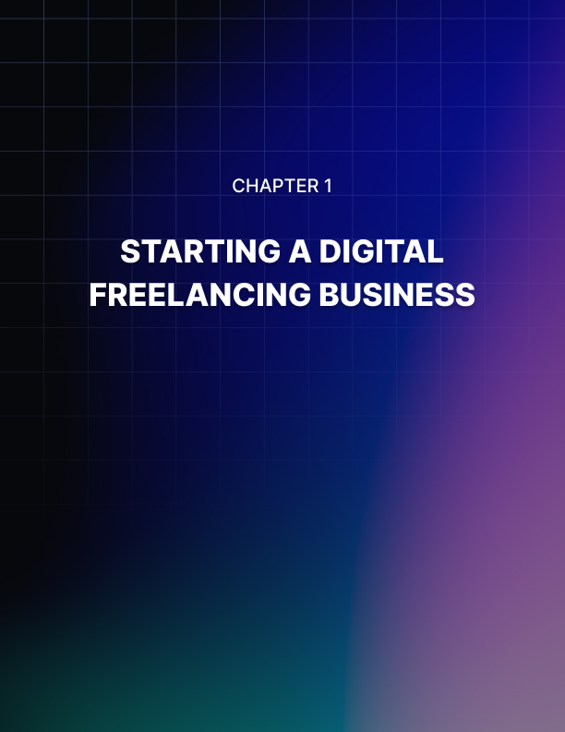

Chapter 1: Starting a Digital Freelancing Business

It is almost impossible these days to get very far without hearing the word “digital.”

You have most likely downloaded some form of the digital product yourself. Either an ebook, report, or some form of newsletter or magazine. It is no surprise then that the freelancing world has now gone digital.

Digital freelancing refers to any type of freelancer that works online. This may be a writer, graphic designer, coach, or any other type of service provider.

Working as a digital freelancer means that you can now find clients from around the world. Before the internet, a freelancer would basically have to go knocking on doors to find work. Now, this has all changed, and working digitally is becoming more popular than ever before.

During any type of slow-down period or recession, a person could start looking for work online.

While this sounds easy enough there are still basic items that you need to have in place to become successful. It is not just a matter of putting up a website, and being inundated with clients!

To become a successful digital freelancer you still need to present a professional image. This includes setting up a website, getting testimonials and reviews, and building a solid portfolio.

Other items you will need to consider include:

- Selecting a business name.
- Setting your rates.
- Offering reduced rates in exchange for testimonials.
- Payment system.
- Client ordering system.
- How much work you can actually take on.
- Finding clients.

As you can see, setting your new business up is more involved than you thought. It can be helpful to create a business plan which outlines all the steps involved. This will help you stay on track to actually get your business launched.

One of your first steps should be to outline the type of work you want to offer. This might be writing, editing, and proofreading, graphic design work, book-keeping, social media manager, and more.

Of course, it will be helpful to use a skill that you already have and build upon that. If you enjoy writing or graphics then pursue this area.

If you have to learn a new skill it will delay you launching your business. Start off by using skills that you have and you can always add to your repertoire over time.

Starting a solid digital freelancing business requires thought, planning, and effort. An online business is not a quick solution or way to fill your pockets with cash. Instead view it as a new career and treat it as such.

Goal Setting For Your Freelance Business
As with any type of business you need to set goals and expectations. If not, you may end up sitting around waiting for clients to contact you.
Then wondering why your bank account is not filling up with money!

Types Of Goals
Your first step is to create a list of goals for your new digital freelance business.

These can include items such as:

- Create an avatar of your ideal client.
- How many new clients do you need each month?
- Marketing your website.
- Creating and setting a business budget.
- Setting up an introductory special offer.
- Securing a set number of testimonials for your portfolio.
- Creating a social media presence.

Once you have this in place you want to expand on each point. Let’s take a look at marketing your website as an example.

You are responsible for driving traﬃc to your site and this means learning some basic search engine optimization tactics along with marketing ones. If this sounds foreign to you, then set aside some 6me each day to learn the basics and start applying what you learn.

Expanding on this goal you could create a sub-list as follows:

- Learn basic SEO tactics.

- Write a blog post 2-3 times a week and cover topics such as why hiring you is a good move, what you offer, why your business is different etc.

- Spend 60 minutes each day marketing your site by; creating videos, sharing tips and information across your social platform, blog commenting, and listing your site in related professional directories.

If you do this for each main goal you will end up with a large list of mini-goals that you can work on daily. This means that every day you will be performing some type of related task that is going to help you grow your freelance business. With the ultimate goal of gaining new clients on a regular basis.

One important aspect of marketing is understanding who your ideal client is. This is why we listed it in the goal section above. Take 6me to write out a detailed overview of who your ideal client is. This may include the type of business they run, a specific location where they live, their budget, and more.

Once you know this you can then slant your marketing to attract your ideal client. You may not find the perfect fit at first, but you will be narrowing down your selection and could eventually find the client that does match.

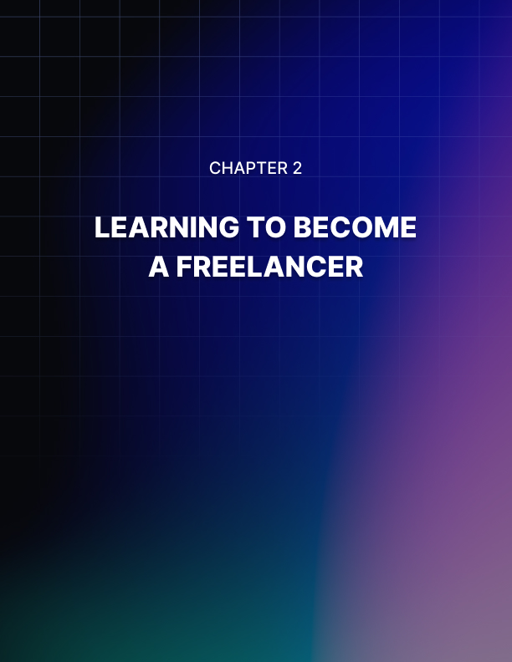

Chapter 2: Learning To Become a Freelancer

What kind of freelance jobs are available for working at home?

Do you know what types of jobs are available in the freelance marketplace?

I have researched and tested this market and I'm here to tell you the jobs available in this area are extremely plentiful.

Just a few of the things that you can leverage your skills into cash doing are; voiceover for TV, radio, eBooks, or even the movies; you can also do freelance writing or web design.

In no time, with the help of a simple google search on freelancing, you could be on your way to making thousands, even tens of thousands of dollars a month, no matter what your forte may be.

You can start freelancing from home and learn how to discover your talents and how to get started using them to make money immediately and not have to wait extended periods to get your money like most of your competition does.

It is not rocket science. It is easy if you just have simple steps to follow.

With a few simple steps, you will be on your way to the freedom and independence of a freelancing career.

Choosing The Right Freelance Business
When you are considering working from home, there is a set of decisions that must be made. First, you must decide whether or not working at home is right for you.

Next, you need to consider what type of work-at-home job you will be doing. There are many opportunities for freelancers out there, both offline and off. Having a successful freelance career starts with evaluating your own skills and requirements in a job and then finding the right match.

Sometimes the best place to start with your freelance career is where your out-of-the-home career ended. Many women find that they can become independent contractors in the field that they previously worked in. You can use your previous work experience as a launching pad for your freelance career.

Some of the ways to use your experience to your advantage are: finding a company that hires people in your field to work from home, using your previous experience to become an “expert” writer in your field, or starting a business related to your previous field.

However, some people look at their freelance careers as a way to break out of their old job. If you’d like to try something completely different, there are plenty of opportunities for entry-level work as an independent contractor.

Many of these jobs deal with telephone or online customer service. When you work as a customer service agent from your home, you just need a reliable Internet connection and a working phone. Companies also hire medical transcriptionists, data entry professionals, and virtual personal assistants to telecommute.

If you want to start your own business, the opportunities are very vast. You can start with a direct sales company and sell products from an established brand to friends and neighbors.

You’ll make commissions through your sales and also off of recruiting other people to sell the products. There are hundreds of direct sales companies that offer everything from aromatherapy products to candles to cooking supplies.

Another option for starting your own business is offering a service in your community. Daycare center operators, florists, professional organizers, and hairdressers all have the option of working at home, among many other professions.

Of course, starting a business in your community normally means that you’ve had some experience in that field. However, some small business ideas can be started without much experience at all.

Many women turn to the Internet as a source of at-home income. The World Wide Web offers a plethora of job opportunities. You can offer your services online as a freelance web designer, writer, or virtual assistant. You can also start an online store that sells products that you make yourself or have the rights to resell.

Many freelancers establish their businesses online by using one of the popular auction sites, like eBay. Still, others find a home in internet marketing, by directing web traffic to a website and then recommending certain products and services.

Decide first what type of job you’d like to do and then work from there. If you are truly a people person and need to get out each day, direct sales or a local service business might be right for you.

If you are the type of mom who lives online and is comfortable with the Internet, try finding a job or starting your own business on the web. If you like the comfort of having a weekly paycheck, look into telecommuting positions.

Once you’ve decided what category of job you’d like, do some research on what it takes to be successful at that type of business. If you feel like you are drawn to one particular business or company, then sit on your decision for a week and see how it feels.

Imagine what your life will be like as you take on the duties of that job. Most importantly, be realistic with yourself about how much time you can devote to your business. Finding the right match isn’t hard when you thoroughly consider your options.

How To Market Yourself As a Freelancer
Do you know what to do to successfully market yourself as a freelancer?

Do you know how to find your niche that you can enter to create long- lasting and highly profitable business partnerships?

In order for you to succeed, there must be a market for what you have to offer. And you must be prepared to answer to that market in as professional a manner as possible posturing you and your business as totally professional.

You will need to learn the secrets of the best freelancers to gain the experience and the specialization you need in order to fit into a niche that has extremely high-profit potential.

You already know that having skills and identifying them is essential. Do you also understand that none of your skills will matter if there is no drive or passion to go along with them?

This is the fuel that will keep you moving toward your goal of making thousands of dollars a month freelancing from the comfort of your own home.

But do you also know that how you present yourself and your business online can make the difference in getting good contracts and GREAT contracts? Professionals expect to deal with real pros. You need to have everything in place that will allow you to conduct your business like a true professional.

That means being able to conduct business in a way that is user-friendly for your customers, including the exchange of money for services.

What is the number one secret to getting new clients and creating a consistent monthly income as a successful freelancer?

Have a powerful marketing strategy. Without a strong marketing strategy you will have months you do well and months you make virtually nothing.

You will need to learn all of the secrets of how to stay on top and busy all the time. Wishing you had work will be a thing of the past because you’ll be overloaded with projects you can choose from.

You need to learn how to get new clients and how to keep them coming back over and over again with new jobs for you.

Isn’t it time that you take control of your financial future and create a huge income for yourself and your family? The keys that unlock the door to this are just a click away.

Meeting Your Freelancing Deadlines
When it comes to meeting deadlines, one way to manage your timetable effectively is to divide the large jobs and farm them out to several coders.

Let’s say you’ve been awarded a writing job to write an ebook on childcare with 10 chapters for $2,000 over 45 days. Bid out each chapter separately among 10 coders and allocate, say, $100 for each chapter over 25 days. This way you don’t have to worry about the deadline because you’ve given yourself a 20-day buffer and you stand to earn $1,000 for your efforts.

If you are going to handle a project in this manner you must be able to rewrite the articles you receive in order to make sure the entire book “flows” seamlessly and that the same style and tone of voice is consistent throughout.

Cultivate a Strong Talent Pool
In many cases, this is the most important asset needed when subcontracting work to others.

Here are a few additional tips to help you out in this regard:

Know How To Hire a Good Coder
There are four things you should look at when hiring a coder – their resume, their samples, their rating, and their client testimonials.

The last two are critical because it is easy to prepare a bogus resume and samples, especially on the internet.

If you look at those four things and feel you have found the person you are looking for, hire them.

Know How To Keep Them Happy
A happy coder always delivers better work than an unhappy one, given the same skill level. You keep your coders happy by dealing politely and professionally, paying them on time, and understanding them when they fall or falter (and believe me, they will miss a deadline now and then). Give them respect and they will give you their best.

Nurture Your Current Roster Of Clients
Here is the main reason why quality counts – it is quality, more than anything else, that will make your customers come running back to you again and again. Always put a premium on quality. First-class work is sometimes hard to find, especially given a limited budget. If you consistently deliver first-class work, you assure yourself and your coders of a prosperous business well into the future.

There is a popular saying in sales which says that “It is eight times easier to get new business from your current clients than it is from cold calls.” In other words, make sure you ask your clients for referrals from people they know or work with who may need the service you provide.

Some coders hesitate when it comes to asking for referrals because they feel it is unprofessional. They feel asking for referrals is like asking for a favor.

That is not really the case. If you have faith in your ability to deliver good work you are actually helping your client because of your willingness to provide quality work to their friends or business associates. That will reflect well on them too. It is a two-way street.

Now that we have looked at three online venues we are ready to look at developing eye-catching resumes that will help you land some of those great paying opportunities.

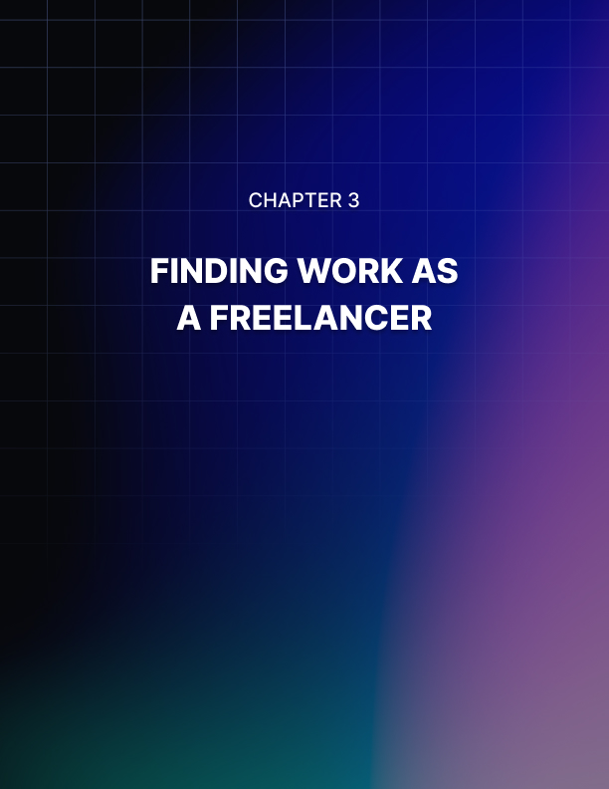

Chapter 3: Finding Work As a Freelancer

Finding work is generally the most difficult part of freelancing. In almost every area (writing, design, etc.) there is a ton of competition. And by “a ton,” I mean thousands upon thousands of people competing for the same jobs.

But don’t feel hopeless! The fact is, most of the competition is severely unprepared for the available jobs and many people just don’t know how to get them.

In this section, you’re going to learn about some of the various ways to find work as a freelancer, and how you can stand out from the competition in order to get more jobs and command a higher rate for your work.

Your Portfolio
One of the most important elements of being a successful freelancer is having a stellar portfolio available that shows your best work. (Be sure to ask every client before you use their project in your portfolio.

There are many reasons a client might not want their project to appear, and you don’t want to have a client upset because you used their project without permission.)

A good way to create a portfolio is by setting up a website with WordPress. WordPress is much easier for the average user to use than standard HTML and CSS.

Of course, if you’re more comfortable with HTML and CSS, you can use that instead. WordPress just makes websites set up a lot quicker and easier for those who aren’t well-versed in HTML and CSS.

Your portfolio should feature some of your best work, as well as contact information and testimonials. Testimonials should ideally include a photo of the person giving it, as well as a link to their website or contact information in case potential clients would like to verify the testimonial.

So what if you don’t have any work to show?

The best thing you can do is either make some samples that are meant simply to show your talent, or just take a few simple projects for free or at a heavy discount in order to build your portfolio.

Don’t use a free hosting service for your portfolio unless you are able to have your own domain name for it. It’s just not professional to host your site on a free server, and you may run into downtime issues that could cost your business. Hosting is only about $10 per month.

Freelance Websites
The most obvious place to find work is through various freelance websites. Many of these are very well known and get a tremendous amount of traffic. Yes, there is a lot of competition, but you can stand out from the competition in a number of ways.

First, you can make sure your profile and portfolio are the best they can be. Make sure you have plenty of quality examples of your work so people feel more assured that you can deliver what you say you will.

Next, you can work hard to complete jobs quickly to build feedback so people will trust you more than others. This is key, because people are rarely patient when it comes to getting work done.

Finally, you can compete on price by trying to be the lowest bidder, at least in the beginning. As you’re building feedback and a portfolio, you shouldn’t worry too much about money.

Just take the jobs that fit your skillset at the best price you can get. You can charge more later, once you have built your business.

Services To Offer As a Freelancer
First, we’re going to talk about some of the different services you might be interested in offering as a freelancer. Some of these will probably be obvious, but since you might not immediately think of all of them.

There are so many different services you could potentially offer to clients, and you can make money with whatever you find most interesting and have the most talent and ability to do.

Writing
Writing is the first thing most people think of when it comes to freelancing because it’s the one thing that doesn’t take a lot of natural talent or technical training to do. Most people have enough of a grasp of basic English spelling, grammar, and punctuation to take at least basic writing jobs.

In fact, some freelance designers or programmers do writing work on the side to supplement their income in between design jobs.

Because writing has a fairly low barrier to entry, it’s also highly competitive and doesn’t pay as much as some other types of freelancing. A simple article can pay as low as $1.50, but more complex jobs, especially if they need to be very high in quality, can pay significantly more.

There are many different types of writing you can do as a freelancer, for example:

- Blog posts and articles Short reports.
- Non-fiction ebooks.
- Fiction (books, stories, poetry, etc.)

Different types of work pay different amounts, but technical writing and fiction writing (such as ghostwriting romance books for authors) can pay quite a lot.

Design
Design requires a little bit more technical ability than writing, but if you have the aptitude for it and the experience, you can make good money doing all types of freelance graphic work.

At the basic end of the design spectrum are things like advertising banners and book covers. These require only a graphics program like Photoshop or GIMP, some stock photos, and a decent level of talent.

At the higher end are projects like posters, as well as projects that require some more technical ability like designing websites and user interfaces for apps and programs.
Here are some ideas for the types of graphics you can create:

- Book covers for authors Advertising banners.
- Posters and flyers Websites and blogs Logos.

If you want to get work as a designer, it’s extremely important to create a good portfolio with examples of what you can do. If you have never done a particular type of work before, create a few examples for your portfolio, even if they are fictional.

For example, create a cover for a book that doesn’t exist, or create
your own version of the cover of a popular book.

You could also offer to do work for people for free in the beginning to build your portfolio, but keep in mind that even if you’re offering free work, some people will want to see what you can do before they commit to working with you so they don’t waste your time and theirs if they end up not liking what you produce.

Artwork
If you’re a talented artist in any medium, there’s a great opportunity for you to earn money with that talent. Gone are the days when the only way an artist could make money was by selling original paintings.

These days, artists have a lot of possibilities for earning, such as some of the following:

- Portraits and caricatures Other commissions.
- Book cover art.
- Children’s book illustration Art for apps and video games.
- T-shirts, posters, and other items to sell.
- Prints of artwork (possibly framed for hanging on the wall).

These are just a few ideas of ways you can make money as a freelance artist. There are a nearly endless number of other ways!

Voiceovers
If you have a good voice and don’t have a very thick accent of any
kind, you might want to consider doing voiceover work.

Voiceover work is simple and requires very little technical knowledge. As long as you can read well, speak clearly, and perform basic computer functions, you can offer your voice for videos, audiobooks, and other projects.

The only things you’ll really need for voiceover work are:

- A decent computer.
- Audio processing software A good microphone (a must).
- A location good for recording (such as a closet).

Video Editing and Creation
Video editing is a more advanced skill that requires a little more technical knowledge and ability, but if you have the talent for it, you can make very good money creating videos and editing those that other people have created.

Video is quickly taking over text and photos as the media of choice online, and many individuals and companies are using them for a variety of promotional purposes.

Videos can be used for publicity, such as when celebrities post them on Facebook or Instagram. They can be used to promote something specific, such as when a restaurant posts a video of their newest dish and limited-time price promotion. Or they could be used in many other ways to publicize, promote, and sell.

Videos don’t have to be extremely complex. In fact, they don’t necessarily even have to contain any video. They could be just slideshows of photos or graphics with text, music, or voiceovers. Sometimes that format is even more effective than traditional videos.

Other Ideas
There are many other ways you can make money from home or on a freelance basis.

Some of them include:

- Keyword research Photo editing.
- Translation Photography.
- Programming and app creation Selling crafts online.
- Selling used items online.

These are just a few ideas. What’s your greatest talent? What’s the thing you enjoy doing most? Chances are, you can find a way to make money with it!

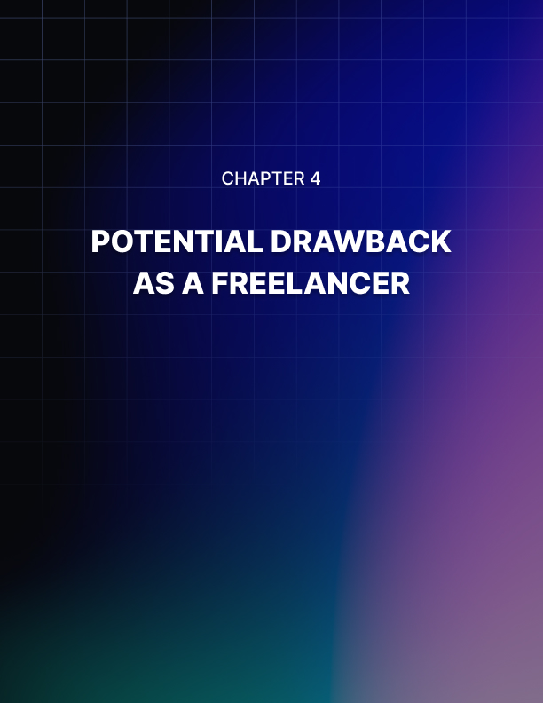

Chapter 4: Potential Drawbacks As a Freelancer

You probably already know most of the positive aspects of freelancing, such as the potential to make more money and the ability to work in your underwear at home or even on the beach in Tahiti.

Pretty cool, right? But there are a few drawbacks to consider, as well.

Let’s take a look at a few of the drawbacks that might make you reconsider freelancing. (Remember, you can always do freelance work while employed traditionally if you’re not ready to leap right into full- time freelancing. In fact, that’s usually the best idea!)

Taxes
Ugh, taxes. It’s something you don’t think much about when you work a normal job, because your taxes get taken out of your check and the only time you really have to worry about it is tax season when you have to file your taxes.

But when you’re a freelancer, you have to worry about taxes all the time. You have to save money from every payment to cover taxes, and it really hurts when you have to write out that check to Uncle Sam, because it all comes in one lump sum—unless you pay your taxes quarterly.

Taxes for a freelancer can be pretty complicated, so if you aren’t a tax professional, you’ll probably want to hire one to help you—at least in the beginning.

A good accountant will be able to teach you the basics of recordkeeping for tax purposes, and they’ll also help you when it comes to filing your taxes, so it’s a great idea to get a consultation with one as soon as possible.

Interruptions
Interruptions are huge productivity killers in any workplace, but if you work from home you’ll soon discover it’s much worse. People think that because you work at home, you’ll be free to talk to them, hang out with them, do them favors, etc. as if you didn’t work at all. And if you protest, they get offended as if you don’t want to talk to them at all.

People who have never worked from home will never truly grasp what it’s like, so there’s really no easy way to help them understand that they can’t just expect you to have the ability to drop whatever you’re doing at any moment for them.

For this reason, it’s a very good idea to turn off your cell phone and go into a room with a closed-door while you work. Ideally, you might even want to rent office space so you can have more privacy while you work. This may not always be possible, but if you can, office space in many areas is remarkably affordable.

Instability
Finding work as a freelancer isn’t guaranteed, and you may find the lack of a guaranteed paycheck is too much to deal with. Because work is so unstable, especially in the beginning, many freelancers work a full-time or part-time job to supplement their income.

You can increase your chances of finding work consistently by putting yourself in as many freelance marketplaces as possible, presenting a professional portfolio of work, and seeking references and testimonials that may help others choose you over their competition.

Lack Of Benefits
One huge thing that is a deal-breaker for a lot of potential freelancers is the lack of any benefits such as retirement and health insurance. While a lot of jobs don’t offer such benefits, most people don’t end up staying at those jobs for very long.

Health insurance for the self-employed is outrageously expensive, but if your income is relatively low you can qualify for Medicaid, or at least a reduced price on your health insurance.

Retirement is a huge issue, and it’s important to start saving early. Self-employed individuals should start an IRA (Individual Retirement Account) as early as possible and contribute the maximum amount possible to be sure they have money available for retirement, because they won’t be paying money into Social Security and thus cannot collect any when they retire.

Remember, there are drawbacks to everything—even traditional jobs. Freelancing may not be for everyone, but for others, it’s the only thing that makes them happy.

Freelance Business Concerns
Running an online business comes with plenty of items that you need to consider. Just because you don’t have a physical storefront you still need to set up your business correctly. This way you can be protected if and when any issues crop up.

While running a business on trust may sound like a good idea, it is not always a solid business method to choose. What happens if you finish work for a client and they never pay you? Do you have any safeguards in place in your business for this?

This is exactly why you want to set your digital freelance business up correctly. You can do this by having contracts and processes in place. This will actually help safeguard not just yourself, but your clients as well.

One of the worst things for anyone hiring a new business or service is knowing the quality of the work, if the job will be done on time and if it will be completed. Believe me, there are lots of people who pay for work that never gets delivered.

You want to set up your digital freelance business so it sets you apart from others. Your goal should be to offer a high-quality service, with prompt delivery at an affordable price.

Here’s a quick checklist of processes you may want to set up:

- Client questionnaire or intake form.
- Payment contract, 50% upfront, and final 50% before work is delivered.
- Outline the entire payment process, methods, currency, etc.
- Draw or outline of proposed work.
- Contact info so you can ask questions.
- Delivery date and what happens if work is late or the client would like to change due dates.

Remember that you may be working with clients from around the world, some of whom may not have English as their first language. This can often make communication a little harder.

This is why it is good that you have an outline of the proposed work in place. If things go wrong or the client isn’t happy you can refer back to the outline to see if something wasn’t explained properly.

Payment is another huge issue for some freelancers. While you may want to be paid in advance, the client doesn’t know you yet and will be hesitant to pay upfront. Agreeing on a fifty-fifty payment method is usually a good solution.

As a freelancer, you are getting paid to start the project. You then deliver the draw to the client, once approved they send the final payment, and you deliver the content in full.

If you don’t have any of these processes in place, you should seriously consider setting them up.

Drawbacks To Working At Home
Working at home is one of the fastest-growing trends in careers today. However, many people jump on the freelancer bandwagon without considering all of the drawbacks to working at home.

While some people are naturally inclined to work at home, others find the transition more difficult to make. There are many benefits to working at home, but the drawbacks need to be considered before you make the choice.

The first drawback to looking for a work-at-home career is that your current career may not easily transfer to a work-at-home situation. If you work in the medical field or are a police officer, being a freelancer might not be an easy transition unless you are willing to change careers entirely.

Sales and administrative positions transfer well, as do creative jobs like design and writing. For those in jobs that can’t make the work-at-home switch, you’ll have to think carefully about what you want to do when you start working at home and start investigating that field.

Cost is another important factor in deciding if working at home is right for you. Although many mothers start working at home to save on childcare, there are added costs to being a freelancer.

If you need health insurance, it will have to come out of your pocket instead of being paid by your employers. There are also many taxes that you will have to pay. Your record-keeping must be excellent in order to keep track of your income and expenses and to fill out your income tax return at the end of the year.

Working at home with children is not always as easy as it seems. If you have young children that aren’t in school yet, it may be difficult to work when they are awake. This can mean lots of busy nap times and late nights to get your projects done when they are sleeping.

Family members can help take care of your children from time to time, but the responsibility of both your children and your job will be firmly in your hands. With older children, it is sometimes easier to work from home. But you will still have to start and maintain a fairly balanced schedule in order to get everything done.

Freelancers have to be very self-motivated and disciplined in order to get their work done on time and correctly.

If you are the type of person that is motivated by outside factors (such as a supervisor), then working at home may not be your cup of tea.

When you work at home, there is no one there to look over your shoulder and make sure that you are still working.

Distractions like the television, Internet, and housework can be hindrances to your work-at-home success.

Isolation is another problem for freelancers. Working at home alone can get frustrating and lonely. Make sure you are comfortable with spending time alone, and that you take steps to combat isolation.

If you are especially prone to being depressed, then the isolation that comes with working at home may make you feel withdrawn and sad.

Taking steps to combat loneliness is an important part of any freelancer’s success.

After considering these factors, you may decide that working at home is not right for you. However, thousands of people deal with these drawbacks and still have successful work-at-home careers.

These reasons should not stop you from becoming a freelancer if that is really what you want to do. Just make sure you understand the realities of the work-at-home lifestyle before you commit to it.

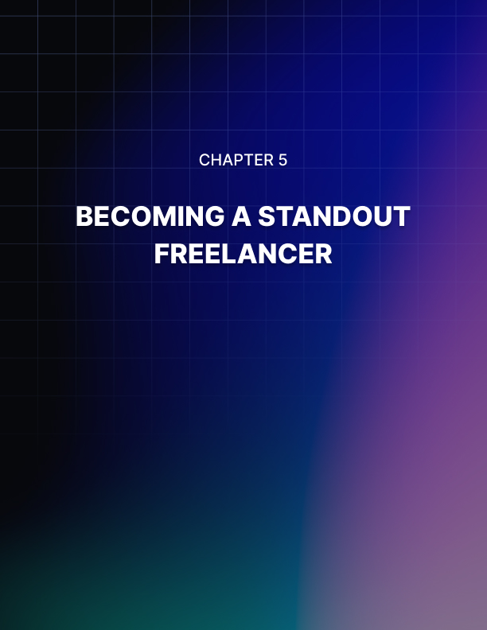

Chapter 5: Becoming a Standout Freelancer

Being a digital freelancer means that you are always looking for new clients and contacts.

This means spending time actively marketing your business, but did you know that you have a free source of marketing sitting right under your nose? Your own clients. Here’s how you can get your current clients to help you find new ones.

It is part of human nature to either recommend or dislike something. How many times have you eaten at a great restaurant or seen a good movie and instantly recommended it to your family and friends?

So it only makes sense that, as a freelancer, if you offer great work, your clients will happily recommend you.

What this means is that you have to work on becoming a standout freelancer.

Here’s how you can do this:

- Always be personable and friendly to your clients.
- Ensure that you understand the project completely and if not ask questions.
- Provide regular updates on long projects. This way your client knows how far along you are.
- Always deliver on time, if not early.
- Don’t settle for just okay, put your best efforts forth on every project.
- Don’t overlook customer service, make yours stellar.
- Use updated tools so you can offer the latest and greatest.
- Deal with every client in a professional manner.
- Send out invoices on time.
- Keep your website updated and looking modern.
- Maintain a current portfolio.
- Have an easy way for clients to contact you.
- Set competitive prices.
- Offer introductory specials for new clients.

Always remember that you may be dealing with clients who live in a different time zone. This may mean that direct communication is a little diﬃcult.

Have some form of communication set up so that clients can ask questions easily. You could use a help desk software for this or have a dedicated email address just for client use only.

Staying up to date with tools is important, you want to be able to offer your clients the latest designs for mobile sites for example. Or you want to take advantage of all the new templates in Microsoft Word and create stunning reports and documents.

By offering a great service your current clients are more likely to become repeat ones. Plus they will think of you first when they are asked which freelancer they use.

It isn’t that hard to become a standout freelancer, just think of how you would like to be treated if you were the client.

Networking For Digital Freelancers
As a digital freelancer, you will be spending the majority of your time online. This includes finding clients, marketing your business, and then performing your actual work. This is why you do not want to overlook the aspect of networking with other freelancers online as well.

Where To Network
When it comes to networking online you have several choices. First, you should search out online freelance forums, just do a quick search to find a ton of results. Then don’t forget about social media.

Do a search inside Facebook for freelance groups and pages and then join them and become active in the group. On Twitter search for people that you can follow and start retweeting their content for them.

One thing to remember about networking is that it is all about building relationships with people. Promoting your own services should not be your main objective here. Instead, see what you can learn from other freelancers and then give advice.

Why Network?
There are several reasons why you should start networking. One is that it will help your name to become recognized amongst other freelancers. Another good reason is that it could become a viable source of gaining new clients.

An established freelancer may have too much work and is happy to pass some contacts along to someone else. Especially if they know, like, and trust this person.

Then there is the aspect of word of mouth. You definitely want to get into the habit of recommending other freelancers. Some of your clients may have other needs that you do not cover.

For example, if you are writing them a report, they may need an e-cover and this is something that you don’t offer. You could then refer them to a good graphic designer. You will find that if you do this the other freelancer will appreciate it and often refer clients back to you.

Another aspect of working as a digital freelancer is that you may start to feel isolated. While the thought of working from a home oﬃce sounds wonderful, it can become lonely over time. So having a place to hangout for a few minutes each day with other freelancers can help you overcome this problem.

Networking with like-minded business owners can also help you stay motivated and on track with your business goals. You may find that you want to set up an accountability partnership with someone.

You would meet once or twice a week and set goals and objectives for the week. Hopefully, you can see the value of how networking can help you in all areas of your freelance business.
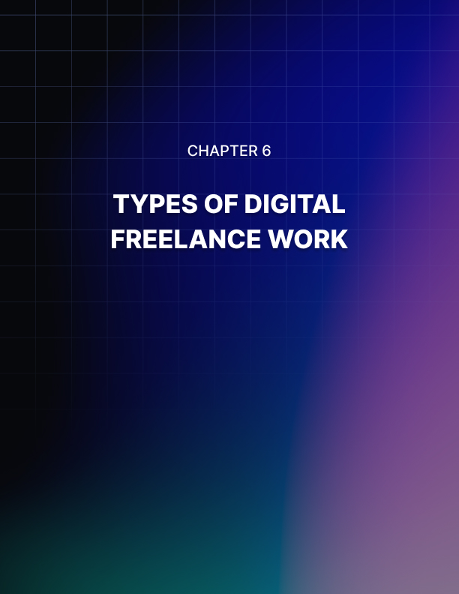

Chapter 6: Types Of Digital Freelance Work

If you are interested in setting up your own business you may want to consider performing some type of digital freelance work.

The term “digital freelance” simply refers to work that can be done online for your clients. While you may possess a certain talent that you can easily pursue, you may want to start something brand new.

In this chapter, we will take a look at various types of digital freelance work that you could perform, even though we discussed this in a previous chapter.

Freelance Writing
This is probably one of the most common types of freelance work that is performed online. Even so, you can specialize in different areas. For example, you may enjoy writing articles and blog posts. Or you may prefer longer documents such as reports, ebooks, and even white papers.

If you have specialized knowledge in a certain area such as nutrition or personal development you may want to concentrate on this. The upside to this is that you can often demand higher prices because of your expertise.

Graphics and Design Work
This is another popular field that includes all types of graphics work. While you may want to focus on website design and customization, there are other options as well.

These include designing book covers, headers, and banners. Social images and posters are also very popular. These are the images that people like to post on sites such as Facebook, Instagram, and Pinterest.

Photography
With the popularity of the internet, everyone loves to use photographs on their websites, in their products, and on their social sites. Using photos can lead to all kinds of copyright infringements. So setting up a photography freelance business could be your ticket to an extremely profitable business.

You could take photos specifically for clients and then sell them copyrights to your images. Your prices would be higher to reflect this of course. Or you may want to sell packages of photos to your customers.

With this method, you would take a certain theme such as dogs, cooking, lighthouses, etc., and then package them up. You could offer different prices depending upon the usage rights you attach to each one.

Video Producer
Online marketers love using video in their content and products. If you enjoy creating videos this could become a viable freelance business for you. As well as creating videos you could offer editing and even adding voice overs for clients.

As you can see you do have lots of options when it comes to deciding on what type of digital freelance work to offer.

Online Tools For Digital Freelancers
As an online business owner, you will want to invest in certain tools that help you in your business. While there are certainly a ton of business-related tools, you should invest in those that will be the most beneficial to you. Then as your business grows you can add more tools as necessary.

The following list highlights several tools that are essential for your business:

Website
You will need a domain name and hosting company for this. Namecheap and GoDaddy are two of the most popular companies. You can register your domain name and host it with them if you wish. Other hosting companies include Liquid Web, Hostgator, and Bluehost, just to name a few.

Autoresponder Service
You have both free and paid options in this regard. GetResponse and Aweber have been around for years and offer a low-cost trial. MailChimp is free and might be a good option for you when starting out.

Oﬃce Software
The two main ones are Microsoft Oﬃce or the free equivalent of OpenOﬃce. Microsoft Oﬃce now comes with OneDrive which offers free storage.

Invoice System
You can use Invoices inside PayPal or you might want to use an online version such as Freshbooks or Paymo. Or you may just want to use your own spreadsheets to track payments and expenses.

Payment Systems
The most common ones are PayPal, Stripe, and Authorize Net.

Storage System
Dropbox and Box both offer online storage which can also be used to share folders and documents with your clients.

Back-Up System
Always useful to have in case your hard drive crashes or your website gets hacked.

Long Distance Plan
Skype is a great way to communicate with your clients regardless of their location. Plans are relatively low cost for calling landlines and Skype to Skype calls are free.

Depending upon what type of services you are offering you may require additional tools. If you are offering graphic design then it is important to have an up-to-date version of a tool such as Photoshop.

If you are offering bookkeeping services then a good accounting software will be crucial.

Try not to go get tempted with fancy tools and devices. Start off with just the basics and work up as needed. You may find that the free version of Dropbox is good to start with, but over time as you need more space it only makes sense to upgrade to the paid version.

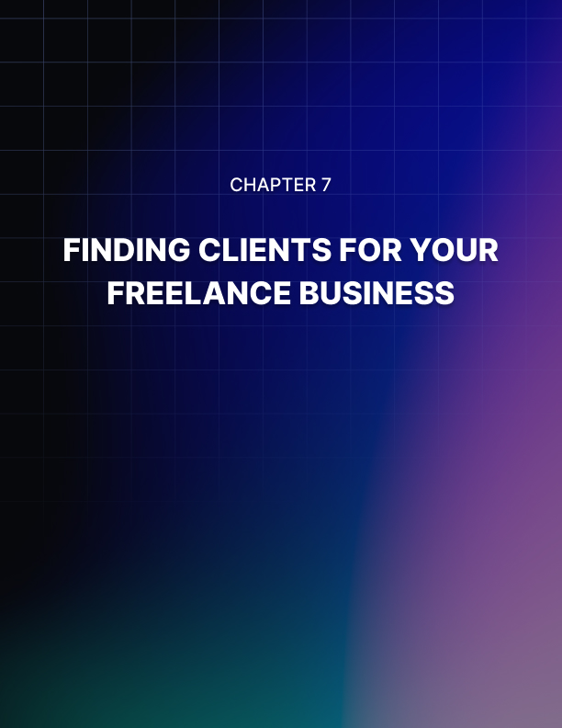

Chapter 7: Finding Clients for Your Freelance Business

As with any type of business you need clients and/or customers for it to flourish and grow.

If you are just starting up a digital freelance business you are going to require clients quickly. While the internet allows you to have a worldwide reach, just how do you go about finding clients? Let’s take a look.

If you already have some type of experience in your freelance field then you want to use this to your advantage. For example, if you enjoy writing and have self-published a book, then highlight this on your website. Being published can help attract new clients to you and provide you with credibility.

There are different ways to find new clients for your business. You can basically place advertisements online and look for clients. Or you may want to consider using one of the many freelance sites that are available. A popular one that you may have heard of is fiverr.com.

If you choose to use an online site you will be required to register and create an account. Some sites may charge for this, so look into this to see if it is something that would be viable or not for you.

Once registered you can then apply for jobs as they are posted. Each job will have a detailed description of what is required, along with an appropriate pay range.

When you find a job that appeals to you, you have to submit a bid. This then gets sent to the person who is hiring and they go through each bid, in turn, selecting the person they think is suitable.

This process can often take several days to complete and you may be waiting to see if your bid was accepted. If you go this route then you should get into the habit of bidding for jobs regularly. Once your bids start to be accepted your work schedule will begin to fill up.

Many of these jobs will be one-time-only assignments, so you will need to keep looking for new clients. You may find that you do get hired for longer periods

sometimes. This is great when this happens as it means you now have a regular income for several months to come.

As your calendar fills with assignments you may get to a point where you no longer need to bid on new jobs. Or you may have to hire additional help yourself.

Building a List Of Prospective Clients
When running a digital freelance business your main focus is to get new clients. One way to attract new clients is to build a list of potential clients. These may be people who are not quite ready to hire you but could be in the future.

One of the hardest things for a new freelancer is gaining experience and building that portfolio. To get around this problem you may want to consider giving away a sample of your work for free, or giving away a report related to your services.

An easy example of this would be if you are a writer or graphic designer. You could put together a free ebook cover that you give away, or write a selection of Tweets for various businesses.

To get your free gift the person would have to subscribe to your list by giving you their email address. This is the beginning of creating your own mailing list.

As you build your list you can then write up blog posts from both your perspective and from that of a client. These posts could be based around titles such as “10 Factors to Consider When Hiring a Freelancer” or “What Makes My Business Stand Out.” Then you simply email your list telling them about your new blog post.

As your readers start to build a relationship with you they will be more likely to ask you questions about your business. This can eventually lead to more clients. Another aspect of this is that you could run a special offer just for your list members. This would allow them to try out your services at a reduced price.

It is important to stay in touch regularly with your list. This can be done by sending out emails 2 or 3 times a week, or you may like to produce a bi-weekly or monthly newsletter.

Newsletters are a great way of staying connected with your readers. Plus you can offer tips and advice, ask for feedback, talk about your latest project, and more.

People may also find receiving a professional-looking newsletter less intrusive than several emails each week. Don’t forget to include your photo, a link to your website, and your social media information. Make it easy for prospective clients to find you online.

While building a list of clients does take time, it can become a valuable tool. Instead of advertising when you have space available you simply email your list instead.

Advertising Your Digital Freelance Business
In one of the above chapters, we focused on using online freelance sites to secure clients for your new business. In this section, we will discuss how to advertise your business to find your own clients.

The main advantage of doing this is that you can reduce any fees that you may have to pay for using online sites. Plus it is often a great way to find long-term clients. What freelancer is going to turn down having a regular client that orders month after month?

Social Media is a great place to advertise your new freelance business. You will want to create a business page for this and get all your friends and family to share your new page for you.

At the same time, you want to fill your new business page with tips relating to your freelance business. For example, if you offer graphics, include samples and offer tips for how to find images to use, copyright issues, and more.

Another great way to find clients is by having a blog on your main website. Here you would create blog posts about what your service includes, why people should hire you, and so on. Every time you write a new post, share it across all of your social sites. Don’t forget about “pinning” images to Pinterest, that’s a great place to get your graphics noticed.
Offering an introductory special price is a great way to attract new clients. You may even want to think about giving away a few hours of your time in exchange for a review. This helps you to build up your online portfolio, which in turn, can be used to attract further clients.

Forums are a great place to start your freelance career. Many forums have a Work Offered section where you can advertise your business. This may or may not be free, but even paying a small fee is worth it to get your business off the ground.

Online directories can be another way to find clients for your freelance business. There are many types of trade directories that offer free or paid listings. Just do an online search for directories that suit your services.

Word of mouth is another great tool when it comes to advertising your digital freelance business. In fact, many freelancers get to a point where they solely work on referrals from previous clients. They never have to worry about advertising again.

If you use all of the above methods you should have no trouble in attracting new clients to your freelance business.



Conclusion

Freelancing is one of the best ways to earn money because there’s such a high demand for services such as graphics design, website design, and writing.

Sure, there is also a lot of competition to deliver these services, but it’s a lot easier than you probably think to set yourself apart from the competition.

A lot of people prefer freelancing, because you don’t have to be tied down to a certain location at a certain time, and you have the potential to earn a lot more money for the time you spend working than you would if you were working for someone else.

There are a lot of benefits to working on a freelance basis, but there are also some drawbacks, and we’ll discuss a few of those so you can make a more informed decision as to whether or not you’d like to give it a try.

Freelancing is not for everyone. You have to deal with taxes, the potential instability of income, constant interruptions, having to motivate yourself, and more.

Not everyone can deal with these things. But if you can, you can make more money and have more freedom than almost any job could provide.

Best of all, you don’t need some ridiculously expensive college degree. Employers often expect you to have a degree, even if you’re far more talented and experienced than other candidates.

Why would you go into debt with student loans only to end up making less work for someone else than you could be working as a freelancer?

You must treat it like a regular job if you want to be successful. Create a regular work schedule and stick to it as much as you can. Try to minimize distractions. And be sure to let your friends and family know that when you’re working, you can’t be interrupted.

Don’t expect to make a fortune right away. Like any type of business, it takes a while before you start seeing good results, because you need time to build a reputation and get into the swing of things fully. But once you do, the sky’s the limit!

Best of luck with your new freelance business!

