Table of Contents

Introduction 3
Chapter 1: Why Instagram Ads? 5
Chapter 2: What Are Instagram Ads? 10
Stories Ads 10
Photos Ads (also known as Image Ads) 11
Video Ads 11
Carousel Ads 12
Collection Ads 12
Chapter 3: Setting Goals and the Best Instagram Ad Format for Your Business 14
Chapter 4: Identifying Your Target Audience 17
Your Core Marketing Persona 18
Setup your Target Audience 18
Your Audience Guide 20
Chapter 5: Content and Budget 22
Instagram Hashtags 22
Decide on a Budget for your Instagram Ads 23
Using Facebook Ads Manager 24
Create a Campaign 25
Ad Placements 26
Using Instagram 27
Tips for creating Successful Instagram Ads 27
Chapter 6: Measuring the Performance of your Instagram Account 31
The Growth of your Following 31
Number of Engagements per Follower 32
Chapter 7: Great Tools for Your Instagram Ads 37
Tools for Images 37
Tools for Videos 38
Tools for Scheduling 39
Chapter 8: Best Practices For Successful Instagram Ads 42
Conclusion 46



Introduction

There are so many reasons to get excited about the Instagram platform. It now has a billion active users and businesses of all kinds are seeing excellent results from setting up a profile and advertising with Instagram.

Instagram Ads are not the most expensive way to promote your business and brand but it is not a cheap option either, so you really need to get it right to see the highest returns. And this is what this guide is all about.

Many online marketers know about the power of Instagram and that it can be used to reach their target audience. But they don’t go about this in the right way and then end up claiming that advertising on Instagram doesn’t work. It does work - you just need to know what you are doing.

In this guide we will take you by the hand and guide you step by step through the process of creating successful Instagram Ads. We will show you how to identify your target audience correctly and explain how you can choose the right type of Instagram Ad to connect with them in the best way.

Engagement is the most important thing with social media and we will share with you how you can boost your engagement levels with all of your Instagram Ads. The harsh reality is that a lot of Instagram Ads get very few or no views and this is a situation that can be avoided with the right planning.

Use the techniques in this guide to create really successful Instagram Ads. Once you have achieved your first successful ad campaign you can go on to create many more and get a great return on your investment.

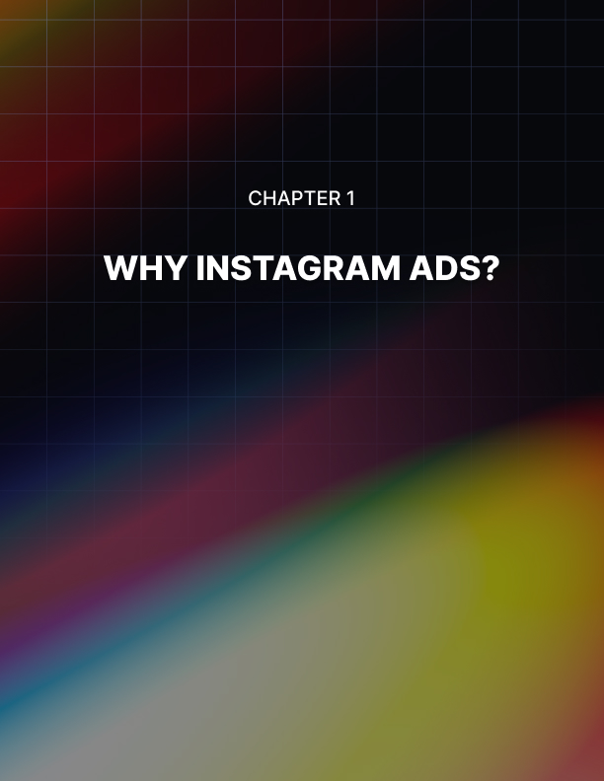

Chapter 1: Why Instagram Ads?

Why should you consider using Instagram to market your brand and your business when there are other social media platforms available?

Well one of the main reasons is that there are more than one billion active users each month on Instagram. Every day there are more than 500 million users on Instagram. The platform has seen explosive growth since its launch in 2010.

Did you know that Facebook now owns Instagram? The CEO of Facebook, Mark Zuckerberg, was quick to see the potential offered by Instagram and decided to buy it for $1 billion just 18 months after it launched.

More and more businesses have realized the power of Instagram. Most of the world’s top brands now have an Instagram account and it will not be too long until they all do. So surely it makes sense for you to use Instagram for your marketing?

Here are the major benefits of using Instagram for marketing a business:

More than a Third of Instagram Users have purchased through the Platform
The end game with any advertising is increased sales. Whether this is done by generating leads first doesn’t matter. You are looking for more sales in exchange for your advertising bucks. So will Instagram advertising help to increase your sales? Well here are a few facts about Instagram:

More than 33% of Instagram users have used it to make a purchase of a product online. This means that an Instagram user is 70% more likely to make a purchase than a non Instagram user.

Think about the numbers here. With a billion active users this means that 33% is over 333,000,000 people that have made a purchase online through the platform. That’s a staggering amount of potential customers that could be interested in what you have to offer. A lot of these users have a history of buying from Instagram.

Another interesting fact is that around 75% of Instagram users will take action after viewing an Instagram advertising post. They will visit your website if that is what you want them to do. If you want them to click a “contact us” or “shop now” button they will do this too.

If an Instagram user does not take the action that you want them to then you have the capability to retarget them over and over again until they do take the required action. This is a powerful feature of the Instagram advertising service.

Very Advanced Social Media Targeting
Instagram being owned by Facebook is a very good thing. It is well known that Facebook has very advanced targeting functionality and they have brought this to Instagram too. You can display your ads to a targeted audience such as:

- A specific age group
- People with specific interests
- People from specific locations
- People that exhibit specific behavior

Once you have specified your target audience in Instagram you have the ability to retarget them as we mentioned earlier. You can customize your retargeting to take into account engagement with Instagram posts, video views on Instagram, customer email lists and more.

With this kind of targeting functionality you can take your marketing to the next level with Instagram. You can set up specific sales funnels for your Instagram ads that will achieve the results that you are looking for.

You can Track Sales and Leads
There is no point spending money on any form of advertising if you can’t measure the effectiveness of it. The good news is that Instagram has the same comprehensive tracking features that the Facebook platform has.

You can track everything including clicks on links, leads generated and conversions. If you want to see the cost per result then this is also possible. It’s possible for you to measure just about everything. If you want to break down results further you can see where leads came from, what device they were using etc.

We would always recommend that you split test your ads and this is easy to track with Instagram Analytics. The metrics available with Instagram Ads are very comprehensive and provide advertisers with the feedback that they need.

Tap into an Unreached Customer Base
Statistics show that 50% of people on Instagram will view the profile of businesses that they like on a daily basis. If you don’t have an Instagram account then you will miss out on this kind of action.

It is unlikely that you will be able to find the same level of customers using other advertising channels outside of Instagram. When you establish your Instagram presence you really will be able to tap into a market of potential customers that would be very difficult, if not impossible, to replicate elsewhere.

Build your Audience Organically
One advantage that Instagram has over Facebook is that you can build an audience organically that will stay in touch with your brand. You can create a natural relationship without using ads rather than have to force it with ads as you do on Facebook.

Once you start to get followers this will grow organically through word of mouth. When an Instagram user follows your business they decide that they want to see your posts on their timeline. This is great for developing initial interest which you can then build on.

You can make Relationships Stronger
Brand engagement on Instagram is 10 times higher than it is on Facebook, 54 times higher than on Pinterest and 84 times higher than on Twitter. With engagement rates on this scale you can expect more interaction with your posts organically.

If a user “likes” a post on Instagram this is archived in their personal “Posts You’ve Liked” section. This is a bank of images that they “liked” on the platform that they can access at any time. You can use this to stimulate conversations and comments with your followers.

Learn what your Audience Likes and Dislikes
You can learn a great deal about your audience with Instagram. How good would it be to know what they like and dislike? When you know this you can create specific ad campaigns around this information.

It is easy for you to see what kind of content your audience likes and the content that they don’t like. You can also see the kinds of Instagram accounts that they like to follow. All of this will help you to provide your audience with the content that they are really looking for.

The Visual Advantage
If you didn’t already know, Instagram is a visual platform for images and videos. Text can be added but it is not mandatory. This is great because people are far more likely to remember what they see rather than what they hear or read.

Videos are the best media for engagement on social media. Images will also outperform text only posts significantly. You can create videos and images that really make your business stand out for higher engagement and increase your chances of converting followers into customers.

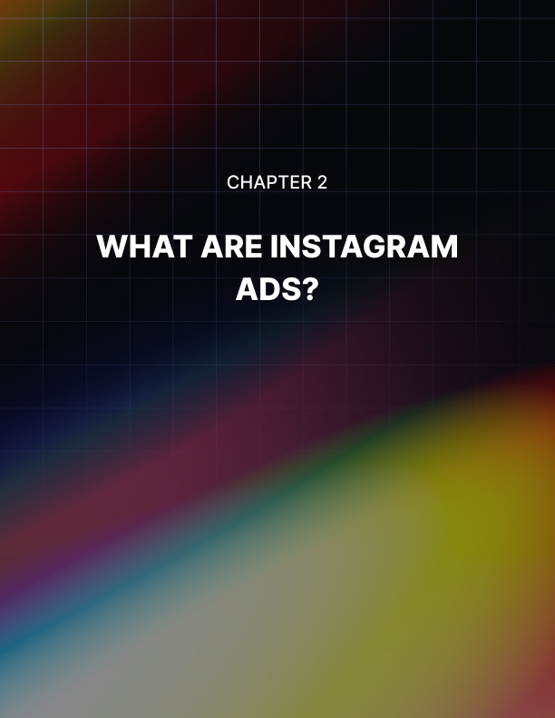

Chapter 2: What Are Instagram Ads?

Instagram first offered ads back in 2013 but it wasn’t until 2015 that this was opened up to everyone. Once businesses started to use Instagram Ads they found them to be very effective. At the time of writing this guide the average cost per click of Instagram ads is about $0.70 to $0.80. This comes from an analysis of over $300 million in ad spend on the platform.

This is an average cost and it is possible that your Instagram Ads could cost considerably less depending on a number of different factors. The time of year the ads are placed affects the cost with the last quarter of the year having the highest average costs.

There are five different Instagram Ad formats which are:

- Stories
- Photos
- Videos
- Carousel
- Collection

Each one of these formats are interlaced with Instagram user feeds and stories ensuring that the Instagram user has a non-disruptive experience on the platform. There are also a number of different calls to action that you can use to generate more leads. You can see these as we explain each of the five formats.

Stories Ads
With Instagram Stories Ads you can use the following call to action buttons:

- Apply now
- Book now
- Contact us
- Call now (only using video)
- Download

An Instagram Stories Ad is full screen and will appear between user’s stories. There are around 500 million users viewing stories each day so there is massive potential with this type of ad. When you go for a Stories Ad you can specifically target your audience and decide on how often they will see the ad. All stories expire after 24 hours on Instagram so Stories Ads are best for limited time offers.

You can use a number of filters with your Stories Ads such as adding video effects, face filters and text. The idea here is to create a really fun ad. It is really important that your Stories Ad looks like a normal post for a consistent experience. Users will “swipe up” calls to action and then automatically visit your website.

Photos Ads (also known as Image Ads)
You can use the following call to action buttons with Photos Ads:

- Apply now
- Book now
- Call now
- Contact us
- Get directions
- Learn more
- Get showtimes
- Download

With Photo Ads you will be showcasing your products and services through engaging images. If you already use these kinds of images in your marketing then you can leverage the power of Instagram to share these with a larger audience. There have been a number of success stories using Photos Ads.

Video Ads
Here are the call to action buttons you can use with Video Ads:

- Apply now
- Book now
- Call now
- Contact us
- Download

Video is the favorite media choice of Instagram users. Time spent watching videos on Instagram has increased significantly (around 80% year on year). So Instagram has made it very easy for advertisers to run video ad campaigns. There have been some incredible success stories with Instagram Video Ads.

Carousel Ads
With Carousel Ads you can use the following call to action buttons:

- Apply now
- Book now
- Contact us
- Call now
- Download

The idea with Carousel Ads is that users can swipe through a series of videos or images that all have a call to action button that will send them to your website. With a Carousel Ad you can:

- Showcase multiple products
- Share a story with multiple parts
- Perform a deep dive into a single product with up to 10 videos or images

If you want to show versatility then Carousel Ads are a good choice.

Collection Ads
You can only use two call to action buttons with Collection Ads which are:

- Learn more
- Purchase

Collection Ads have only been available since 2018 and the idea is pretty simple. When a user sees an ad from you they will be able to make a purchase directly from the ad. You can use the power of video and images in your Collection Ads. They can be a very cost effective way of increasing product sales.

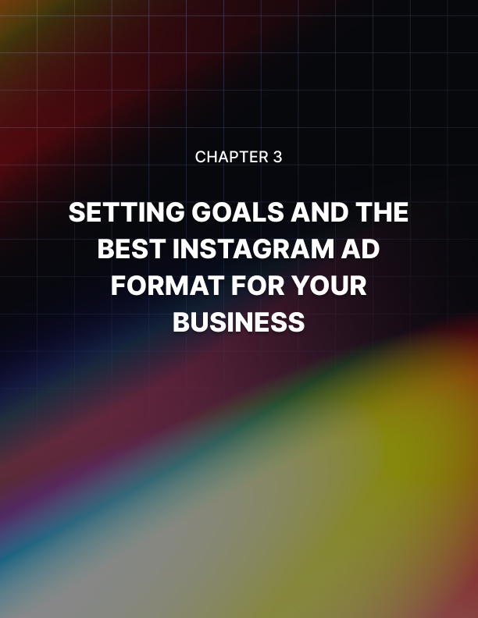

Chapter 3: Setting Goals and the Best Instagram Ad Format for Your Business

Before we get into choosing the best format of Instagram Ad for your business it is important that you understand the objectives that Instagram publishes about their advertising solutions. At the time of writing this guide they could be summarized as follows:

- To increase the number of clicks to the customer’s website – you can decide what section of your website you want the Instagram user to be directed to
- Instagram Ads should lead to a higher number of conversions
- The Ads can persuade people to take specific actions on your website
- If you have a mobile app then you can use Instagram Ads to drive up the number of installs
- You can use Instagram Ads to increase activity with your mobile phone app
- You can use Instagram Ads to drive up video views
- With Instagram Ads you can achieve predictable reach and have a greater level of control over message frequency
- You can use Instagram Ads to drive page post engagement
- You can use Instagram Ads to create mass awareness to a broad audience with guaranteed impressions

It is very important that you decide on the best Instagram Ad format for your marketing campaigns. In order to make this decision the starting point is always the goal that you have in mind.

You need a social media goal. This will act as your guiding light when it comes to Instagram Ads. Your goal will help you to decide what you should pursue, and almost as importantly, what you shouldn’t pursue.

We highly recommend that every Instagram ad campaign that you run has its own goal. There are 3 main goal options when using Instagram Ads which are:

- Raising the awareness of your brand
- Finding potential customers
- Increasing sales or conversions

When you are looking to increase your brand awareness ask yourself this question “what is your brand all about and why should anybody care?” You need to create Instagram Ads that will grab the attention of users.

Increasing brand awareness is the most popular ad campaign goal on Instagram so you need to be prepared for a fair amount of competition. It is really important that you focus on creating a memorable ad which stands out
.
If your goal is to find more potential customers through lead generation to get them on your email marketing list for example you can do this by creating a lead centric ad. The aim here is to drive Instagram users to your website. You can also use this kind of ad to collect more potential customer details and to increase engagement through the use of messages.

What about if you want to increase sales or conversions with your Instagram Ads? An example of a conversion could be the downloading of your mobile app. You could also offer an incentive with your ad such as a discount coupon.

So as an example if increasing the awareness of your brand was one of your social goals then it would be better for you to choose a Photo Ad or a Video Ad rather than a Collections Ad. A Photo Ad or Video Ad allows you to drive traffic to your website whereas a Collections Ad is all about selling directly from the ad. With a brand awareness campaign your aim is to provide the most captivating content to your audience as you can. If you have already established your brand and you just want to sell more products then a Collections Ad would be a good choice as Instagram users can make a purchase directly.

Maybe you want to showcase a number of new products that you are launching. In this case it is best to go for a Carousel Ad so that you can present your products with different images and videos to your audience.

So the advice with choosing the right Instagram Ad format is simple – which ad formats align closely to your goals?
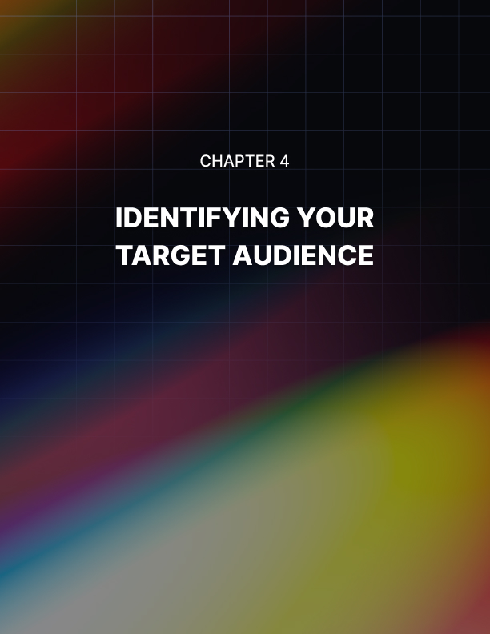

Chapter 4: Identifying Your Target Audience

Identifying your target audience is critical to your success with Instagram Ads. If you get this wrong then your whole ad campaign can end up being a waste of money and time. Fortunately Instagram has a lot of good tools to help you to identify your target audience.

A lot of people think that Instagram is just for teenagers who like to take selfies. There is certainly an element of that going on but there is a lot more besides. While it is true that Instagram appeals to a younger demographic, older people do use it as well. Here is the demographic breakdown:

- 18 to 29 year olds make up around 55% of the user base
- 30 to 49 year olds make up around 28% of the user base
- 50 to 64 year olds make up around 11% of the user base
- Adults over 65 make up around 4% of the user base

Another interesting thing is where Instagram users live. These are the latest location demographics:

- 32% of Instagram users live in urban areas
- 28% of Instagram users live in the suburbs
- 18% of Instagram users live in the country

There are more female Instagram users than male users but this gap is a lot less now than it used to be. It is predicted that a lot more adults in their 30’s will be using Instagram in the near future just as this happened with Facebook.

You should at least have some idea about who your target market is. If you are not 100% sure then this is OK as you can learn more about your audience as you progress with Instagram Ads. But you don’t want to be wildly wrong about your target audience otherwise you can end up spending a fortune on ads and not achieve anything.

Your Core Marketing Persona
The best way to start to identify your target audience is with your core marketing persona. Other nuances can come later once you start to dig around into Instagram Insights and your Instagram Analytics after running some ads.

So we recommend that you start with a simple persona for example – female, age 18 to 30, lives in the USA.

Once you have established this base persona you can use the tools available with Instagram, and third party tools as well, to go deeper. There have been a number of significant improvements to the options available for ad targeting with Instagram. There are also some external tools such as Falcon that will help you to learn more about your audience.

One of the best ways to find out more about your audience is to look at the engagement on your old posts to see which content they responded the best to. This will really help you to avoid creating Instagram Ads that will not provide your audience with what they are looking for.

With Instagram it is possible to create a custom audience based on the people that have interacted with your posted content on the platform already. If you have a list of business contacts you can also upload this to help create your custom audience.

Setup your Target Audience
One of the great things about using Instagram Ads is that you will use Facebook’s existing and comprehensive knowledge of demographics to present your ads to the right people. So for example using your base persona if you want to target females between 18 and 30 that live in New York and are interested in healthy eating then you can easily do that.

Here are the most important audience targeting options that you have with Instagram Ads:

Location Targeting
You can choose to target a specific country, region, state, city and even zip code. You can include or exclude specific places as well if you want to do that.

Age Targeting
You can choose age ranges from 13 years old to over 65 years old.

Gender Targeting
You can choose to target males, females or both.

Language Targeting
It is recommended that you leave this blank unless the language you are targeting is not common to your targeted location.

Demographic Targeting
You can get into a lot of detail here. There are a lot of sub categories to choose from and some of these have sub-sub categories. As an example you can select the “Home” category then the “Home Ownership” sub category and then choose “Renters”.

There are demographic choices around education, finances, life events, parents, politics, relationships and more.

Interests Targeting
Again you will find a number of categories and subcategories here. As an example you can find people that have an interest in aviation or fine wines or science fiction movies here. There are so many possibilities.

Behavior Targeting
This is another targeting area with a lot of choices. For example you may be interested in a specific job role, purchasing behavior, anniversaries and a ton more.

Connections Targeting
You can use this to target people that have connected with your app, event or page.

Lookalike Audience
You also have the option to create a “Lookalike Audience”. Let’s say for example that you created a Custom Audience but you have tapped them all out. Well you can ask Instagram to find a lookalike audience composed of people that have similar traits to your custom audience.

Your Audience Guide
After you have made your choices to configure your target audience you will be shown a guide that explains how specific or broad your audience is. You will be told how broad your audience is, the potential reach in numbers and your estimated daily results based on factors such as your budget, previous campaign data and market data.

You really need to pay close attention to the information you see here. It is important that the size of your audience is not too large (which usually means that you haven’t targeted it enough) but also not too specific since the audience numbers may be so small that it would not be worth running an ad campaign.

When you are satisfied with your targeted audience be sure to save it so that you can refer to it again and maybe use it for future Instagram Ad campaigns. We recommend that you create a few different audiences so that you can test which works the best. This is possible by creating multiple ad sets which you will see at the top of the Instagram Ads Manager.
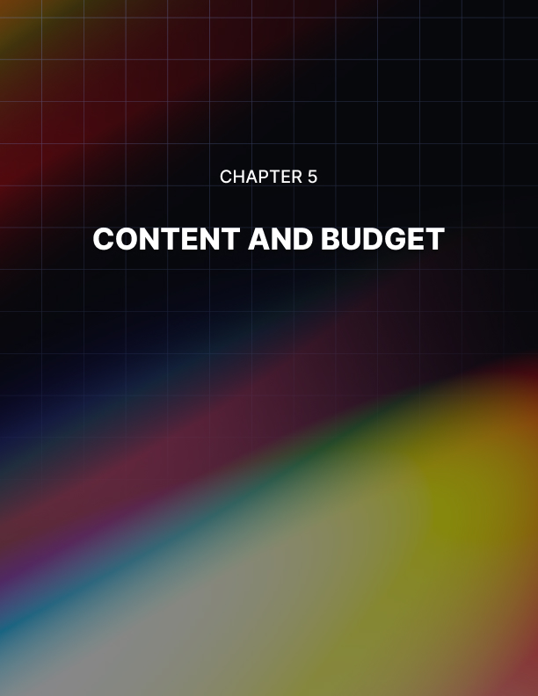

Chapter 5: Content and Budget

If you get your message right in the content that you use for your Instagram Ads then you will experience a lot more success. You need to ensure that your message is “on point” and really resonates with your target audience.

What kind of voice will you use in your content? Do you want a formal voice or a casual one? Think about the tone you are going to use as well. Here you have the option of being “in your face” and provocative or friendly and warm.

You will get the best results from your Instagram Ads if you are consistent. Around 60% of the top brands that use Instagram Ads use the same filter for their content. They consistently put out the same message which helps to reinforce their brand in the minds of their target audience.

Your message will really resonate if you know what your target audience really wants. This will help you to decide what kind of angle you should go for with your Instagram Ads. Do you want to inspire your audience? If you are targeting Millennials then you could promote a cause that you support as this is popular with them.

The best content creates a connection with people. You can use Instagram Analytics to tell you which content your target audience has responded the best to in the past. Once you know this you can make sure that you use this in your ads.

You need to accept that you will probably not get it right the first time with the content that you use for your Instagram Ads. Be prepared to analyze previous campaigns and what your competitors are doing to optimize your content.

Instagram Hashtags
You can create a special hashtag for your Instagram Ads campaign. The reason for coming up with your own unique hashtag is because it will make the discovery of your content easier for your target audience. You can build communities around hashtags and also with a hashtag you can set trends and generate a real buzz. It really isn’t difficult to create your own hashtags but the real trick is to create one that will drive engagement with your target audience.

Short hashtags are the best because they are easier to remember as well as it being easier to type in. You also need to make it as clear as possible what your hashtag means. Always test your hashtag ideas for uniqueness as you don’t want to use one that someone else has used. When people interact with your hashtags, respond swiftly to build on the awareness and buzz.

Decide on a Budget for your Instagram Ads
You have two options when it comes to setting a budget for your Instagram Ads:

- A daily budget
- A lifetime budget

When you set a daily budget you will be able to set a cap on the amount that you spend on your Instagram Ads every day. With a lifetime budget you can set the maximum spend amount for the lifetime of your ad campaign.

It is essential that you set a budget to control your expenditure. When you are making a budget decision, consider the schedule for your ad campaign. What time of day do you want to run your ads and what day do you want to launch your campaign?

Optimizing your ad delivery will have an impact on your budget. For example you can choose link clicks in your ads which will force the Instagram algorithm to calculate how to get you the most clicks for the lowest possible price.

As an alternative you can go for a number of impressions. This means that Instagram will show your ad as many times as your budget will allow. Also you could choose to go for a daily unique reach where your ads are displayed to as many unique Instagram users for the money you are prepared to spend.

When you are starting out with Instagram Ads we recommend that you manually set your bids rather than choosing the automatic option. By choosing the manual option you are able to decide on the maximum price that you are prepared to pay for link clicks.

With the automatic option the Instagram algorithm will make this decision for you. But one of the advantages of setting this manually you will have the option to make higher bids than your competitors to try and outdo them.

Automatic bidding is a good option if you have a large target audience and you do not have a lot of competitors. For smaller audiences and high competition then we recommend the manual option for bids. This will stop you bidding too high as well.

When you are considering bids, think about the conversion value for your business. Only you know this and you cannot rely on Instagram for this because they don’t know. Be aware that not all audiences offer the same value. If this is the case then you need to adjust your bids based on the audience you are targeting. The final decision to make that will affect your budget is when you want your ads to be displayed throughout the day. There is a standard option here or you can choose the more expensive “accelerated” option which will make the pace of delivery faster.

You have a number of different options when it comes to advertising on Instagram. Depending on the route that you choose there will be specific tools and options available to you.

There are two different ways that you can create an ad on Instagram:

- Instagram
- Facebook Ads Manager

Using Facebook Ads Manager
So why should you use the Facebook Ads Manager?

Well you can use it to create ads that will appear on both Facebook and Instagram. You can also create customized audiences and use other features as well as monitor how well your ads are performing.

If you don’t have a Facebook account then go and create one and also create a Facebook page. If you already have a Facebook account and page then ignore this. You will need to add some details about your business and ensure that you complete all of the required fields.

If you haven’t done this already then you should link your Instagram account to your Facebook account. Just go to the Business Manager in Facebook, select “Business Settings” and you will see a menu on the left hand side where you can select “Instagram Accounts”. A new page will appear where you can add your Instagram account.

Create a Campaign
Now you can go to the “Ads Manager” and then start a new campaign by clicking the +Create button. A new page appears and you can choose from either “Guided Creation” or “Quick Creation”.

If you are new to setting up ad campaigns on Facebook then we recommend that you choose “Guided Creation”. With this you will be guided through all of the steps that you need to perform to set up a campaign.

If you are experienced with setting up Facebook Ads then it will be better if you use the “Quick Creation” option. You will have more control over your ad campaign by choosing this option.

For this guide we will use “Guided Creation”.

The first thing you need to do is to choose your ad campaign objective. For your Instagram Ads you can choose from the following:

- Brand Awareness
- Reach
- Traffic
- App Installs
- Engagement
- Video Views
- Lead Generation
- Messages
- Conversions
- Catalog Sales
- Store Visits

Choose the objective that fits with your ad campaign goal. After selecting your objective you will be asked to give your ad campaign a name. Create a name that makes sense so that you will easily remember it because you will probably set up many campaigns.

Now it is time to identify your audience. We discussed this in detail in a previous chapter. Choose the right options for your target audience and then check how broad or specific your audience is. Once you are happy with your target audience you can move on to the next step.

Ad Placements
Now it is time to select your ad placements. You have the choice here of where you want your ad to appear on Facebook and Instagram. Here you have the choice of “Automatic Placements” or “Edit Placements”.

With Automatic Placements your ads are displayed wherever they are likely to perform in the best way. We recommend that you run your ads on both Facebook and Instagram. The Edit Placements option enables you to make the choice of where your ad appears.

For example if you only wanted your ads to appear in Instagram Stories or just in Instagram feeds then you can make decisions like this using Edit Placements. When you are creating Instagram Ads you can only select “Mobile Devices”.

Your next step is to set your budget and your ad schedule. We discussed budget considerations in the last chapter so you should have a firm idea of how much you want to spend and how long you want your campaign to run. Please be aware that ads shown on Sundays are more expensive than other days of the week.

After you have set your budget options you will now be setting up your ad. The first step is to select the Facebook page to link your ad to. Then you have to decide which of the 5 formats for your ads.

Next you need to select the videos or images you want to use in your ad. Then you need to create some copy for your ad. When you do this you want to grab the attention of users and persuade them to check out your ad. Take your time with this as it is very important.

The next steps are to choose a payment option, review your ad and then confirm it when you are happy with everything. Facebook has a guide to the ad formats available on Instagram where you will find the specifications and the elements of design you need to take into consideration. You can find the page here. Finally choose the most appropriate call to action button for your ad and your desired website link where users will be diverted to when they click on the button. There are advanced options here where you can set up a Facebook pixel for tracking or an app event. These are very important as they will show you how users interact after clicking your ad.

Using Instagram
To use the Instagram app to create an ad campaign you need to have already promoted a post that you have made on the platform. Just find a post that has performed well and receive a good level of engagement and then promote it to reach more Instagram users.

If your Instagram account is not set up for business then you will need to change this first. To promote your post just follow these steps:

- Go to the post that you want to promote
- Select a goal for your promotion – do you want to drive traffic to your website or increase the number of Instagram users that see the post?
- Choose an appropriate call to action button for your post
- Setup your audience to receive the post by selecting the right demographics. Alternatively you can ask Instagram to choose a default audience for you.
- Enter your budget and the duration of the ad
- Create Promotion

Using the Facebook Ads Manager you can track the results of your promotion and all other Instagram Ads.

Tips for creating Successful Instagram Ads
Now that you know how to set up ads on Instagram we want to share some tips with you so that your ads have the maximum chance of success. There are a number of things that you need to take into consideration when creating Instagram Ads:

You need to know your Audience
The more that you know your audience the more likely it is that your ads will be successful. You should plan your ad even before you decide on the content and the copy that you will write. Make it your business to find out everything that you can about your audience so that you can create a message that really resonates well with them.

Your aim is to create an ad that grabs their attention and creates engagement.

So you need to ask yourself:

- What do my audience need?
- What do my audience want?
- What problems do my audience have?
- What are the goals and desires of my audience?

When you can answer these questions you can create ads that answer them. This will be really appreciated and you will get a lot of ad views and a high level of engagement. So do your homework here.

What Text should you use?
You already know that Instagram is a visual medium and that you can only use a small amount of text in your Instagram Ads. With the caption there is a character limit of 2,200 and we do not recommend that you use all of this limit.

Tell users what you want them to do by including a persuasive call to action. Remember that it is all about “what’s in it for them”. If they see a real benefit in taking the action then they will click on your ad.

Hashtags
We have already discussed the benefits of using hashtags in a previous chapter. A lot of Instagram advertisers treat hashtags as an afterthought and we recommend that you think carefully about them because they can be very powerful.

Statistics show that adding a hashtag to an ad provides an engagement boost of over 12% on average. For each post that you make you can add up to 30 hashtags. It is all about quality and not quantity here so only choose hashtags that are relevant to your niche.

Drive Engagement
There are two types of engagement with social media platforms:

- Reactive engagement – this is where you respond to direct messages, mentions and comments
- Proactive engagement – you make the first move here to engage with others. This is the best way to create a buzz about your ad and your business

You need to do both of these things. When users respond to your add with comments for example then you need to respond quickly. Users will be keen to see that there is a real human being behind the business.

Consistency
Keep all of your advertising messages consistent. Make sure that the tone of the message is consistent as well as the visuals that you use. If your ads are all very different then you will not build the same level of trust.

Keeping it Fresh
If one of your Instagram Ads is particularly successful then it is tempting to stick with this but we recommend that you mix it up a bit because ads lose their flavor after a while. Every week or fortnight switch the ads that you are displaying. This will help to prevent your audience from tuning out.

When you use different ads you can test which are the best performers. You can easily change an ad by using a different caption for example. In fact we strongly encourage you to use different ad copy and visuals with a campaign.

Take a look at the call to action buttons and see which ones perform the best. For example, does “Shop Now” perform better than “Learn More”? How do different captions perform? What about different hashtags? Be prepared to test everything and tweak as necessary.
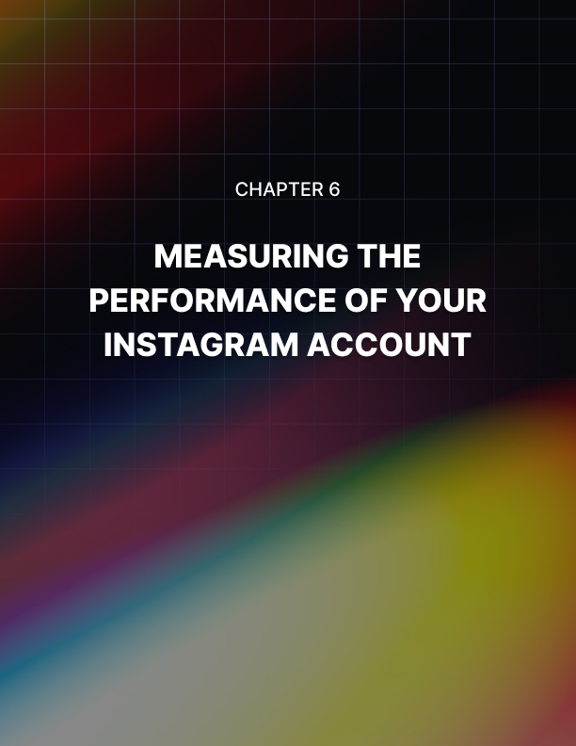

Chapter 6: Measuring the Performance of your Instagram Account

It sounds simple doesn’t it? Just measure how well you are doing on Instagram and then do more of what is working and identify the problems and fix what is not working. When you use Instagram for your marketing you will be spending time and money so you will want to ensure that you are getting the best results for your efforts.

But what Instagram metrics should you be paying attention to? If you are new to Instagram it is not always totally clear on what you should be looking at and what it means. There are a lot of metrics you can look at so we want to give you the most important ones in this chapter.

It may seem unbelievable but a lot of Instagram marketers do not pay much attention to the analytics that they have available to them. This doesn’t make any sense as you will just be stabbing in the dark if you don’t do this.

We talked earlier about having goals for social media and for your ad campaigns. You need to put a lot of thought into these goals to ensure that they match the overall goals of your business. So let’s take a look now at the most important Instagram metrics and what they mean.

The Growth of your Following
It is one thing to have a large number of followers on Instagram but this doesn’t always mean that your marketing efforts are working. There are a number of techniques that you can use to increase follower numbers but this will not add anything to your bottom line.

It is more important to look at the growth of your follower count. If there is steady growth then this is a good indication that you are moving in the right direction. You are capturing the attention of new Instagram users and expanding your reach.

So what you need to do here is to pay careful attention to the way that your follower count is increasing. This is far more important than just numbers. Let’s say that on average you are receiving 50 new followers every month.

If you started with just 500 followers before your marketing campaigns then this is a very good 10% growth rate. But if you had 5000 followers to start with then this is a much less impressive growth rate of just 1%.

Use these two steps to determine how well you are doing with follower growth:

- Identify the number of new followers you gained over the last month.
- Divide this number by the number of followers that you started the month with.

You can look at this over a few months to determine your average follower growth rate. Set a target for a higher growth rate if the results are not as you want them to be. It is much more important to have a smaller number of active followers than a huge number of followers that do not really do anything when you post content.

Number of Engagements per Follower
This follows on from the follower growth. You want to know how many of your followers engage with your content whether these are ads or regular posts. In order to calculate your engagement per follower you will need to know the total amount of engagement for a time period. An external tool like Sprout Social or Agency Analytics can provide this.

Once you know the total engagements number you can perform a simple calculation to calculate the engagement rate:

Total Engagements / Follower Count X 100

This is the total engagements divided by the follower count times by 100 to give you a percentage figure. You will need to perform this calculation over a period of time to see whether your engagement per follower is improving or not. You can measure this for a specific post or ad as well.

Why is this important? Because 70% of posts made on Instagram are never seen by users. Having millions of followers will be irrelevant if none of them are seeing and interacting with your posts.

Let’s say that one of your posts has 20 likes. If you have 20,000 followers then this is not very impressive as it only gives an engagement rate of 1%. We recommend that you calculate your follower engagement rate on a weekly or monthly basis. Don’t try to do this every day as you will not get accurate data over the long term.

Traffic to your Website
A lot of marketers use Instagram Ads to drive traffic to their website which makes perfect sense. In order to measure the amount of traffic that your website is receiving from Instagram we recommend that you install Google Analytics on your website.

With Google Analytics installed you can go to the “Acquisition” section and then select “Channels”. Select the “social” option and here you will see the social platforms that sent the traffic. For Instagram it will show you the general traffic and traffic from Stories.

Comments for Posts
It is nice to see a number of “Likes” for an ad or post you have made but the number of comments your content receives is far more valuable. There is a lot more effort involved in leaving a comment rather than just hitting the “Like” button.

When users leave comments it shows that your post really caught their interest and created a connection with them. Therefore it is important to know the number of comments that you receive and monitor your averages to see if they are increasing or decreasing.

As an example you may have received an average of 5 comments per post six months ago but now you are averaging 8 comments per post. This tells you that your marketing efforts are working well and you are improving your connection with your audience. When you are running Instagram Ads take a look at the comments on these and any variations that you display. Is the comment count higher for some ads rather than others? If so, why is this?

Engagement with Instagram Stories
If you use Instagram Stories for your marketing (which you should) then it is important to know how well these are doing. Stories take more effort to put together and they only stay on Instagram for 24 hours.

It is best to use Instagram Insights for this. Look for “reach” and “exits” within Insights. The reach figure tells you how many users saw your Instagram Story. As you build your follower base this number should increase.

The “exit” metric tells you which slide users were viewing when they exited the story. This is a good way to spot any elements of your stories that users didn’t like, if a lot of users exited on the same slide then you can take a look at that slide and make improvements in the future.

Your Reach
You can use Instagram Insights to view your reach figures. This number basically tells you how many users have seen your post. This is not the same as post impressions. If a user sees your post 3 times for example this will register as 3 impressions. For the reach figure this will only count as 1.

Reach is far more important than impressions. You will see a “Total Reach” figure in Instagram Insights but you also want to pay attention to your “Reach Rate” as well. Your reach rate is the percentage of your followers that see your posts.

You need to make a simple calculation here. Just divide the reach of a specific post by the total number of followers you have. So as an example if you have a reach of 200 and you have 1000 followers then your reach rate is 20%.

Your Top Posts
Use your Instagram analytics to identify your top posts. You can see the top posts by the number of likes, top posts by the number of shares, top posts by the number of impressions and more.

This is probably obvious to you but identifying your top posts will tell you which content your audience really likes the best and connects with. You can determine whether videos or images work the best, the best days and times to make posts and the type of content that created the most engagement.

Instagram Ad Clickthroughs
When you are spending money on Instagram Ads you must measure the number of click throughs that you get from users clicking on the call to action buttons you have placed in your ads.

If you are running different ads for split testing then you can identify which ones have the highest clickthrough rate. Also you need to keep a close eye on your ad cost per click numbers and the number of ad impressions you are getting.

Hashtag Engagement
This is a measure of the hashtags that were used the most in your posts. It will help you determine how well you are growing your following and your levels of engagement. For your following growth you can use this measure to indicate which hashtags you should be using in your content.

It will also tell you about trending hashtags so that you can create new ads and posts around these emerging trends. When you create your own unique hashtags you will want to see how much engagement you are getting from your audience with these.
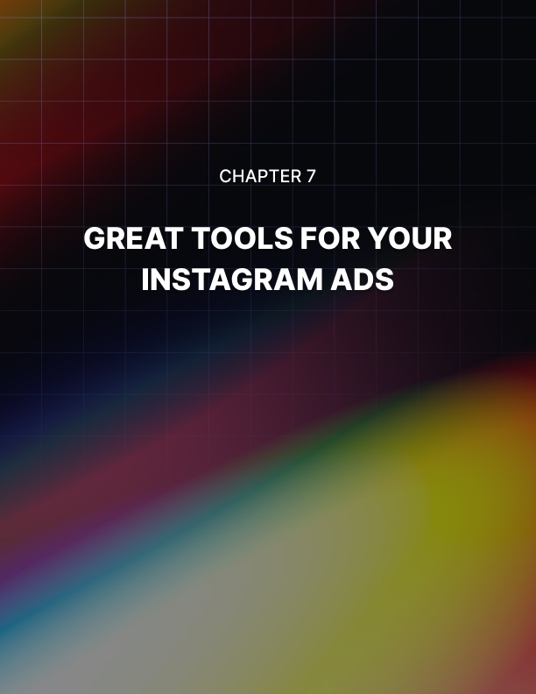

Chapter 7: Great Tools for Your Instagram Ads

There are a lot of great tools that you can use to create really good Instagram Ads that will help you to generate more leads and sales. They will also save you a lot of time and money as you will be able to create effective ads without the need to pay someone to do this for you.

Tools for Images
You are going to be using images in a number of your Instagram Ads so why not make them the best that they can be? Great images always get a lot of attention but creating them can be difficult if you are not a graphic designer. Don’t worry because there are some great tools out there to help you.

Instagram Layout
This is a free tool from Instagram that makes it very easy for you to create a multi image collage. You can get the app for free for both iOS and Android devices. If you want to include images of multiple products (or views of a single product) in one post then Layout for Instagram is a great tool.

There are a number of formats that you can choose from within the Layout tool. You can easily select all of the images that you want to include as well. As this tool is an Instagram creation there are no integration problems with the platform.

Quick
In your image ads it is very likely that you will want to include some text. This text will be used to persuade the Instagram user to click through your ad. If you are not adept at image editing then you can do this quickly and easily by using a great little app called “Quick”.

When you use Quick it is very easy to not only add text to your images but also to make adjustments to the placement of the text, the color, the size and the font. There is a free version of the Quick app that will provide you with the capability to do most image edits and if you want more features you can purchase these within the app.

Afterlight
If you really want to make your images stand out with great filters and editing options that go beyond the tools provided by Instagram then you need Afterlight. There are many unique filters and lighting effects in this app which will really make your images stand out.

At the time of writing this guide the app is available for both Android and iOS devices at a small cost of $0.99. You will have access to 15 tools for adjustment, 15 preset cropping tools, 74 filters, 78 textures and 128 frames.

Superimpose
You can do some great image editing with the Superimpose app. For example you can take a foreground image and remove it from the background and then place this foreground image in another image entirely.

You can do other great things with Superimpose too such as rotate foreground images and blend images together or their textures. There are a lot of really good masking features with this app. Superimpose is available for both iOS and Android devices for just $0.99.

Tools for Videos
You need to create some of your Instagram Ads using videos. People really like to watch videos on Instagram and you can make them really special by using some of the tools featured below.

PicPlayPost
You can make really engaging video collages containing video clips, images, animated GIFs and sounds using PicPlayPost. If you want to place a number of images (or a single image) next to a video then this is easy with this app. You can also add some background music.

PicPlayPost is a free app that you can use on your Android or iOS device. The app is frequently updated and new features appear from time to time. If you have an iPhone then there is support for Live Photos.

Lapse It
Time lapse videos are very popular on Instagram and now you can create your own using a great app called Lapse It. With Lapse It you can create accelerated versions of events that slowly change such as seeing a flower bloom from a bud in a few seconds.

It is easy to import existing videos into Lapse It and then add the time lapse effect to them. You can speed things up or slow them down using the app and also add music in the background. There are so many features in the free version for iOS and Android and if you need more than you can upgrade to the pro version for only $1.99.

Boomerang
You can use the free Boomerang app from Instagram to really grab attention from Instagram users. Shoot brief videos with this app and then you can play the video backwards and forwards in an endless loop. Get Boomerang for your Android or iOS device.

Tools for Scheduling
To increase the likelihood of success for your Instagram Ads and normal posts you need to publish your content at the right times. There are a number of scheduling apps that make this very easy for you to do so that you increase your chances of higher engagement levels.

Later
If you want to improve your Instagram marketing then you need the Later app. The interface with Later is very easy to use and navigate and you can use it for free with one Instagram account to schedule 30 posts per month. The free version only allows you to schedule images for posting.

If you want to schedule videos and stories then you will need to upgrade to the “Plus” version which will cost you around $9 a month. Using Later is a very effective way to schedule your Instagram posts at the right time.

Sked Social
An alternative scheduling app to Later is Sked Social. You can schedule all types of posts and stories with Sked Social. There is a version of the app for Android and iOS devices and there is a 7 day free trial where you can use it for a week to see if you like it. You can set up Sked Social to send you notifications via email when posts are made.

Hootsuite
Hootsuite is one of the most used social media schedulers available. It works great with Instagram and other platforms such as Facebook and Twitter. With Hootsuite you can respond to any comments on your Instagram posts, make reposts and view likes etc. Plans start from $19 a month.

Hopper
If you want to source content for your Instagram account as well as schedule it for posting then Hopper is really worth considering. Their slogan is that Hopper is the number one scheduling tool for Instagram. It is certainly a very popular application among Instagram marketers.

You can do so much with Hopper such as manage postings to multiple accounts, photo editing, commenting, reposting and a lot more. One of the best things about Hopper is that you can use it on your laptop or desktop computer rather than try to manage everything from a small mobile device. Plans start from $19 a month.
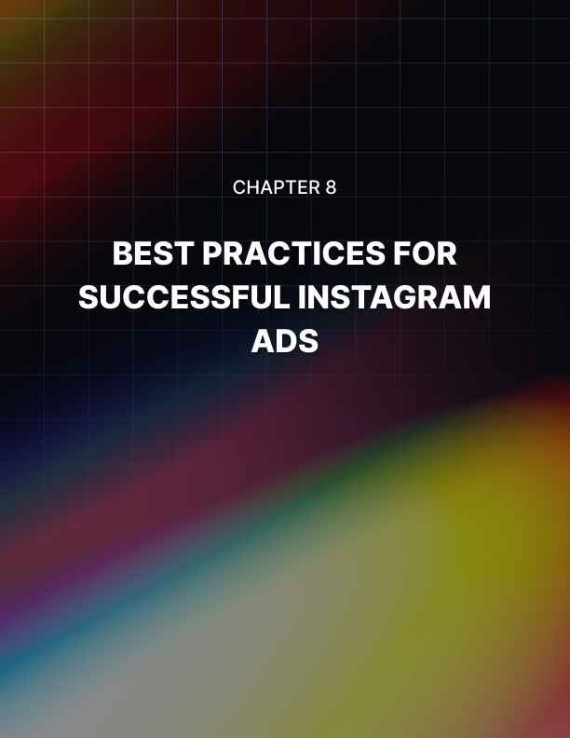

Chapter 8: Best Practices For Successful Instagram Ads

Now that you know about the different types of Instagram Ads and how to set them up we want to provide you with these 7 best practices that will help you to obtain the highest possible return on investment (ROI).

Add Personality into your Ads
What are you planning for your next ad? A video that appeals to people’s emotions? An intriguing image that builds curiosity? It is very important that all of your ads have the “human touch”. If this is lacking in your ad then you will not get the engagement that you are looking for.

Instagram users always want to be entertained. They like humor and posts that have an amazing factor. What they don’t want to see is some boring ad that just talks about a product. You always need to appeal to the user's emotions in your ads. Don’t just publish bland and boring stuff or you will be wasting your money.

Keep your Ads Relevant
Always keep in mind that all of the social media platforms are different. As an example you would not post the same ad on Twitter as you would on LinkedIn because the audience will have a very different state of mind.

This is true for Instagram as well. You need to put yourself in the shoes of your potential customer and think about where they are. For example a 40 page eBook download may work on LinkedIn but it is very unlikely to appeal to an Instagram user. Don’t make your ads too sales orientated on Instagram either.
Users of the platform are not looking for that.

Hashtags
We have talked about hashtags a lot in this guide because they are very important. A lot of advertisers on Instagram will just go for very common hashtags such as #love or #food. You need to be more creative than this. Do some research to identify the hashtags that users are the most likely to search for when trying to find the content you are providing.

Some people really overdo it with hashtags. They see that they can add 30 so they have to add 30! If you do this then users will probably think that your ad looks really desperate which is not a good thing.

So what is the ideal number of hashtags for an ad or a post? Well a study of 65,000 posts found that 9 hashtags was the ideal number to generate the highest level of engagement. Also revealed in this study was that longer hashtags are often better performers than shorter ones.

Contests
If you really want to achieve your goals for your Instagram Ads campaigns as quickly as possible then running a contest or a giveaway is really one of the best ways to achieve this. People just love free stuff and competitions.

When you run a contest associated with your brand you will excite your audience. A successful contest or giveaway will help you to grow your follower base and you can really generate a buzz on the platform if you do this right.

Be prepared to give away prizes of value. You can use your own products (which is the best way to go) or something else that you can use to brand your business. There are companies that sell branded giveaways such as USB sticks and you can get a good deal on these if you buy in bulk.

Post at the right times
You want to give your ads every chance of being seen by the most people in your target audience and making your posts at the right time is the best way to achieve this. If you sign up to lifetime budgeting you can use Instagram’s “ad-schedule” feature where you can specify on which days and at what times you want your ads to run.

Do you know when your audience is around on Instagram? If you don’t then you need to find this out. You can experiment with different days and time and work out optimum times with trial and error.

Think about your niche here. If you run an online store what days and times do shoppers typically browse and make purchases? Look at your own website stats to see when you have traffic spikes and use these as the basis for your posting schedule.

Test with a Couple of Campaigns
Unless you are a seasoned Instagram advertiser and know your audience on the platform inside out it is best to set up a couple of ad campaigns so that you can learn more about your audience. You want to find out the following:

- What kind of images will they respond to?
- What call to action buttons get the best response?
- What kind of messages are most likely to be shared, liked or commented on?

You can run campaigns on a small scale to find the answers to these questions. Don’t measure these campaigns in terms of sales. This is a test of your audience so that you can plan a full scale campaign that you are confident will deliver great results.

Split Testing
One of the great things about Instagram is that you have the opportunity to test a number of different visuals to see how well they connect with your audience. The best way to determine which works the best is to set up some split testing.

For example you could create a Photo Ad, create a Video Ad or include around 4 images in a Carousel Ad. You could also incorporate user generated content and see which variant provides the best results.

You don’t have to stop with split testing your visuals. Try split testing different calls to action and different posting schedules as well. The more that you test your Instagram Ads the more success you will have overall.
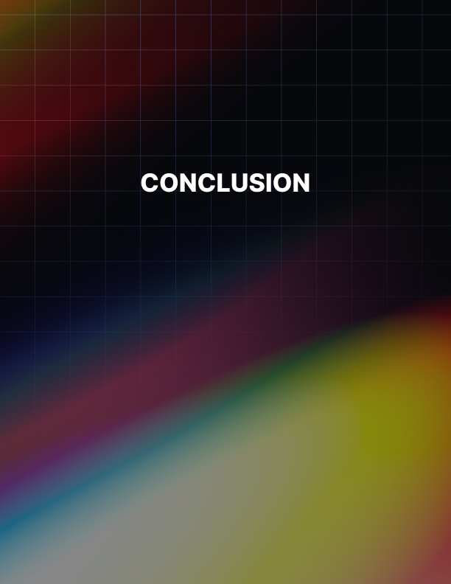

Conclusion

You now have everything that you need to plan for and implement successful Instagram Ads. We recommend that you plan each ad campaign properly and set goals for each one. The more effort that you put in at the setup stage the more likely you are to experience success.

There are very few businesses which cannot benefit from the power of Instagram Ads. Don’t believe others who tell you that they don’t work – they were probably approaching Instagram Ads wrong.

You can use Instagram Ads to generate leads and sales. You can also use them to increase your following on Instagram and improve your engagement levels. Think long term when you are planning to use Instagram Ads.

Always be consistent with your content posting whether they are ads or standard posts. You should use the same voice and tone for your business every time. It is vital that you build trust with your audience on Instagram.

So now it is over to you. You need to take action and follow the advice in this guide. Don’t skip any steps in the process.. Plan all of your ads and make sure that you split test everything. You can then build on the best performing ads.

We hope that you found Instagram Ads Success informative and helpful. Get started today with your Instagram Ads. We wish you every success with your advertising on the Instagram platform!

