Disclaimer
This work may not be copied, sold, used as content in any manner or your name put on it until you buy sufficient rights to sell it or distribute it as your own from us and the authorized reseller/distributor.
Every effort has been made to be accurate in this publication. The publisher does not assume any responsibility for errors, omissions or contrary interpretation. We do our best to provide the best information on the subject, but just reading it does not guarantee success. You will need to apply every step of the process in order to get the results you are looking for.
This publication is not intended for use as a source of any legal, medical or accounting advice. The information contained in this guide may be subject to laws in the United States and other jurisdictions. We suggest carefully reading the necessary terms of the services/products used before applying it to any activity which is, or may be, regulated. We do not assume any responsibility for what you choose to do with this information. Use your own judgment.
Any perceived slight of specific people or organizations, and any resemblance to characters living, dead or otherwise, real or fictitious, is purely unintentional.
Some examples of past results are used in this publication; they are intended to be for example purposes only and do not guarantee you will get the same results. Your results may differ from ours. Your results from the use of this information will depend on you, your skills and effort, and other different unpredictable factors.
It is important for you to clearly understand that all marketing activities carry the possibility of loss of investment for testing purposes. Use this information wisely and at your own risk.

Table of Contents
Introduction 6
Chapter 1: What Is Instagram Marketing All About? 8
What is Instagram Marketing? 8
Chapter 2: Optimizing Your Instagram Profile For Doing Business 12
Switching To A Professional Account 12
Customizing Your Profile 13
Chapter 3: Researching The Best Hashtags And Topics For Your Instagram Campaigns 16
Finding Top Hashtags and Topics 16
Finding Related Hashtags 17
Chapter 4: Creating A Basic Instagram Marketing Post Or Product Teaser 20
Creating Your Post 20
Creating Your Marketing Post 21
Chapter 5: Promoting An Instagram Post From The App 24
Promoting A Post 24
Selecting An Objective 24
Customizing The Campaign 25
Launching Your Promoted Post 26
Chapter 6: Using Instagram Stories To Raise Product Awareness 28
Creating Your Story 28
Posting Your Story 30
Chapter 7: Repurposing Your Instagram Content For Other Platforms 32
On Facebook 32
On Twitter 33
Chapter 8: Using Instagram Live For A Product Reveal 36
Going Live 36
During Live 37
Chapter 9: Promoting A Facebook Post On Your Instagram Account 40
Creating The Campaign 40
Setting Up Your Campaign 41
Setting Up The Ad And Launching The Campaign 42
Chapter 10: Running A Facebook Video Ad On Your Instagram Profile 44
Creating The Video Ad Campaign 44
Setting Up Your Campaign 44
Setting Up The Video Ad 45
Chapter 11: Running A Product Catalog Ad On Instagram 47
Creating A Catalog 47
Setting Up The Product Catalog Ad Campaign 48
Setting Up The Ad 49
Chapter 12: Instagram Marketing Tips For Brands And Businesses 51
Set Your Marketing Goals Straight 51
Chapter 13: Creating The Type Of Instagram Content That Customers Love 55
Chapter 14: Tips For Capturing And Editing The Perfect Instagram Photo 59
Equipment And Specs 59
Taking The Perfect Instagram Photos 59
Chapter 15: Using And Understanding Instagram Insights To Track Your Performance 63
Accessing Instagram Insights 63
Activity Metrics 63
Chapter 16: Proven Instagram Marketing Strategies To Try 67
Chapter 17: Instagram Marketing Do’s And Don’ts 71
Do’s 71
Don’ts 72
Chapter 18: Instagram Marketing Premium Tools And Services To Consider 75
Chapter 19: Instagram Marketing FAQs 79



Introduction
Welcome to our Latest Instagram Marketing Training, designed to take you by the hand and walk you through the process of getting the most out of Instagram on behalf of your business.
I’m very excited to have you here, and I know that this will be very helpful for you.
This exclusive training will show you step-by-step, topic by topic, and tool by tool, what you need to know to dominate Instagram Marketing, in the easiest way possible, using the most effective tools and in the shortest time ever.
This training consists of 20 training chapters, ready to show you the latest Instagram Marketing strategies.

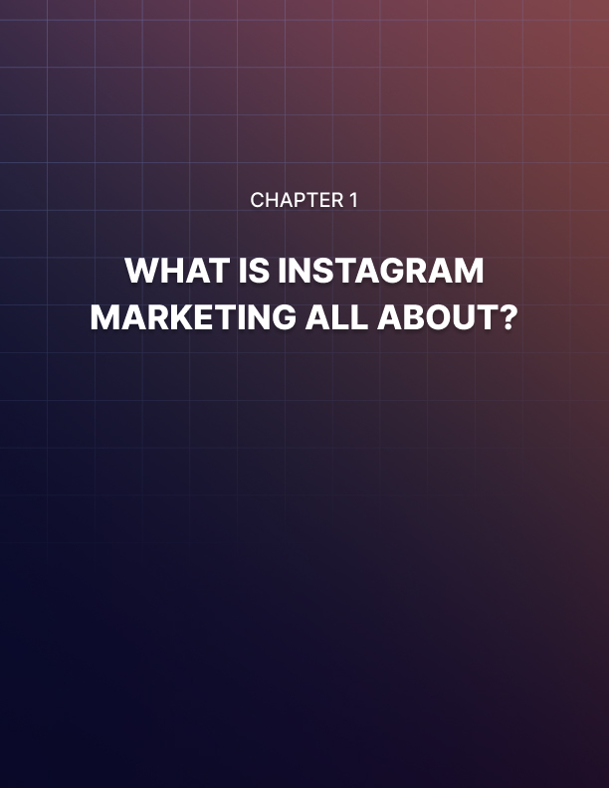

Chapter 1: What Is Instagram Marketing All About?
Welcome to “Instagram Marketing”, the ultimate Instagram Marketing crash course for anyone who wants to learn how to use Instagram to build their online presence and grow their business.
We want to thank you for picking us as your guide in this exciting journey, as well as congratulate you for your decision to improve your online marketing game.
Here you’re going to learn all you need to launch and grow your brand or business on Instagram, how to reach the perfect type of customer, and how to generate more profits with advanced-level strategies. But first, let’s start with the basics.

What is Instagram Marketing?
Instagram marketing is quite simply the use of the Instagram platform and its features to market your content, your brand, your products, your services, and your business.
Content creators, brands, marketers, and businesses have learned how to use it to share stuff like pictures and videos in a way that is so casual that immediately engages, which makes it the perfect platform to promote and sell through visual discovery.
Instagram marketing is a combination of organic social media marketing strategies, visual discovery, and built-in advertising features that are unique to the Instagram ecosystem.
How Does It Work?
Instagram marketing works great because it lets you showcase your products with images, and because it helps you create brand awareness through photos and videos that you can use to tell stories, or to highlight the coolest parts of the lifestyle that you want customers to associate with your brand.
You can leverage Instagram’s scrollable gallery format to grab the attention of users with a powerful image or video that makes them stop to check your post. Once you’ve captured the attention of a user with a visual element in your post, the next step is to make them take action.
Instagram helps you in this step by letting you add copy, captions, calls to action, and hashtags into your post. This is how you can drive people to a landing page, or to comment, or to click on a hashtag to discover related content.
This simple method is very effective to drive awareness, engagement, and action in basically any business-to-consumer niche, and it works because it helps the user make an instant visual and emotional connection with what you’re trying to sell.
For example, if you’re running a baking shop, you can post photos of yoursweets to Instagram two or more times a day, and you can optimize your image posts with hashtags related to that business as well as with geo keywords that’ll help potential customers in your area to discover your shop.
Couple that with behind-the-scenes videos to give your shop an air of coolness, and soon you’ll be attracting new customers to your shop.
Other powerful features such as integration with Facebook Ads can help you take your business to the next level because they let you run paid ads and promotions across Instagram, Facebook, and many other places around the web.
Why Should You Consider Instagram Marketing For Your Business?
Instagram is BIG and active.
There you’ll find over a billion active accounts, worldwide, every single month.
This gives you a great opportunity to expand your business to a larger and possibly global audience.
- 90% of Instagram users follow and interact with business accounts.
- Of those, at least 30% have purchased products that they have seen on Instagram!
- Instagram helps you to showcase your products or services in a very casual way thanks to its unique creative tools and immersive formats.
- Instagram enhances the way you reach people with your message along the customer journey.
- Instagram allows you to create a profile that is visually appealing and where you can add a backlink to your business website, or any other landing page.
- It integrates with Facebook Advertising, which will help you to explode your reach and sales with ads that are cheap and high converting.
What’s The Future For Instagram Marketing?
Instagram is working on amazing features for businesses as we speak. One that is worth looking forward to is integration with Facebook’s “Brand Collabs”, a platform where content creators can find brands that they can partner with.
Another cool feature Instagram is working on is running Instagram Shopping posts as ads, which are posts that feature products that people can purchase with a single click. This can be a tremendous opportunity for independent product creators and small retail brands on Instagram to increase their sales.
The future looks bright and profitable for Instagram marketers, so, are you ready to learn all about Instagram Marketing and get ready to make it big?
Yes?
Then awesome, see you in lesson one next!

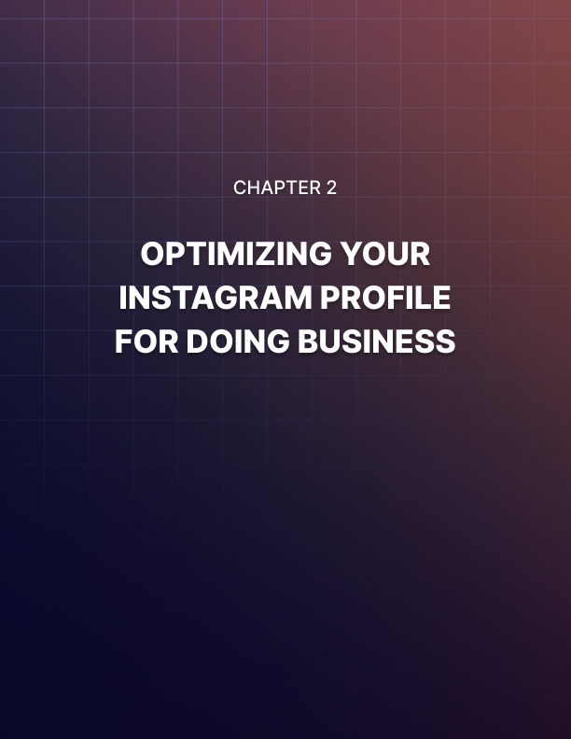

Chapter 2: Optimizing Your Instagram Profile For Doing Business
Here you’ll learn how to get your Instagram account ready to promote your stuff and do business.
When you create an Instagram account, you only get access to basic features for common users. But if you want to be able to use business-friendly features such as your business profile, promoted posts and insights, you have to switch to a professional account, and in this lesson we are going to show you how to do it easily, the right way.

Switching To A Professional Account
Start by opening the Instagram app and login in to your account. Now tap on the profile icon in the lower-right corner. Once in the profile section, tap on the menu icon on the upper-right corner, then tap on “settings”. Now you are going to tap on “account”. Next, click on the “linked accounts” option. What you’ll do now is to connect your Facebook account to your Instagram account. This will make switching easier.
For this, tap on the Facebook tab. Make sure you are already logged in to Facebook on your device when you do this. Tap on “connect”. You can then select whether to enable “Facebook sharing” to share your Instagram connect to Facebook automatically. For this example, we are going to tap on “not now”.
Switching to a professional account is the best way to grow your brand and business on Instagram because that’s how you can access professional tools that are not available to basic accounts, such as advertising and analytics.
Doing the switch is very easy, and you can do it in just a few taps, without leaving your device. Start by tapping on the profile icon to go back to the profile section. There, tap on the “edit profile” button. Once in the “edit profile” section, tap on the “switch to professional account” link.
The first step is to select “which best describes you”. You can select “creator” if you run an account for a public figure, a content producer, an artist, or an influencer.
Or you can select “business” if you’ll run an account for a retailer, a local business, a brand, an organization, or a service provider.
For this example, we are going to select “business” so we can switch the account that we manage for our online business. As you can see here, switching to a professional account will allow you to learn more about your followers through insights, to reach more customers with paid promotions, and to add a “contact” button to your profile that will make it easier for people to get in touch with your business.
Let’s tap on the “continue” button to move on. The next step is to select a category. You can either select a category from the list of suggested categories, or you can enter a keyword into the “search categories” field to find the perfect category. Once you select a category, tap on “next”.
Now it is time to add your “public business information”. There are three types of contact info you can add here: your business email address, your business phone number, and your business address.
This information will be displayed on your profile so people can contact you easily, without having to visit your website first.
Here you simply have to add your contact info, and then to click on “next”. In case you don’t want to add this information to your profile, tap on “don’t use my contact info”.
In this example, we are going to add only our business email address, which is filled by default, so we’ll tap on “next” to continue.
Now it is time to connect your Instagram account to your Facebook page. Start by selecting the Facebook Page of your business from this list, then tap on “next”.

Customizing Your Profile
Now that you’ve successfully switched to a professional account, tap on “go to profile”, then tap on “edit profile” to go to your Instagram business profile to apply some optimizations.
Start by tapping on “website”. Here you are going to add the URL of your business website. Now tap on “bio” to add a brief description of your brand or business, and to add keywords as hashtags related to your business and niche.
Later on you can use this field as part of a funnel, where you can send people from a post to an actionable link that you’ll add to your bio. To finish, tap on “done”. And that’ll be it friends! This is how you can get your Instagram account ready for business!

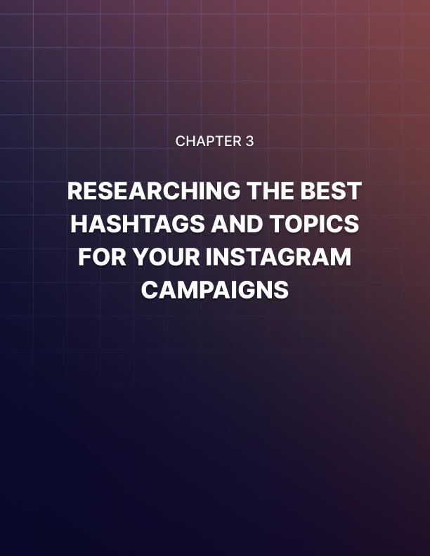

Chapter 3: Researching The Best Hashtags And Topics For Your Instagram Campaigns
You’ve just turned your personal Instagram account into an optimized professional account to do business, and now you’re ready for work. The first thing you’ll do before creating content for the platform is to find the best hashtags to use with your account.
Finding targeted keywords in your niche is important because you can add those as hashtags to your posts to make your content more discoverable, and in this lesson we are going to share with you the easiest way to find the best hashtags and topics to use for your business.

Finding Top Hashtags and Topics
You can easily find the best hashtags and topics for your business using Instagram’s search function. For this, simply open the app while logged in to your account and tap on the “search” icon.
This will take you to the search page. Most people use this section to find trending content published by the accounts that they follow, related accounts, and to find content and accounts using keywords, just like they would do on Google. Likewise, you can use this feature the same way to find your hashtags and topics.
You can start by checking what’s on top of search results when you use one of your base niche keywords. A base niche keyword is simply a keyword that is common, high traffic, and openly used in your industry.
For example, if you run an account for a beauty blog, you can use “makeup” as your base keyword. In our case, because we run an account for a wellness and health business, we are going to type “healthy” into the search bar.
This will show you top results related to your keyword. As you can see, this includes personal accounts, business accounts, hashtags, and even locations related to that keyword.
There are two things that you can do with these results. One is to take note of featured hashtags. As you can see, these hashtags are featured in millions of posts across Instagram, and they’re targeted at users looking for specific topics related to your keyword.
In our case, you can see that top topics related to our keywords include “lifestyle” and “food”. This means that we can add these long-tail keywords to related posts so we can reach people looking for that kind of content.
The other way you can use these results is to explore featured accounts to reverse-engineer the content that they create and to collect the hashtags that they use.
For example, you can tap on this featured account to check their profile. Here you can see the keywords that they use, and how they customized their profile. Let’s tap on one of their posts, then let’s scroll to the bottom of the caption, where we’ll find the hashtags.
As you can see, there are some hashtags on this post that you may not be familiar with, but that are related to the niche that we are researching. What this means is that there is an audience made of people that are using these hashtags to find this type of content, so it is a good idea to save these hashtags to a file so we can use them on a similar post to attract this audience to our account!

Finding Related Hashtags
There is also a dedicated section where you will only find hashtags that are related to your keyword.
Let’s go back to the search section so we can show you. There, tap on the “tags” tab. Here you will find all those other hashtags that you can use to reach your perfect audience.
One thing you’ll notice is that some of the hashtags on top were already featured in the “top” section, so the correct strategy here is to find lower-traffic hashtags at the bottom of this section.
Hashtags with 1 million posts or more are great because they are used by a lot of focused members of your target audience, who are much more engaged with the content that they’re looking for.
This means that these hashtags, while they don’t generate as much traffic as hashtags with over 20 million posts, generate more relevant engagement, and they’re less likely to attract engagement from bots, which can lower the score of your account. So what you’ll do now is to tap on one of those keywords to see what type of posts are using it. This will help you to find ideas to create content of your own. Something cool you can do is tap on “follow” to follow content posted using this hashtag, and to see even more related hashtags to examine and follow.
And that’s it my friends! Now take your time to check the rest of the hashtags featured in the “tags” section, so we can move to the next step!
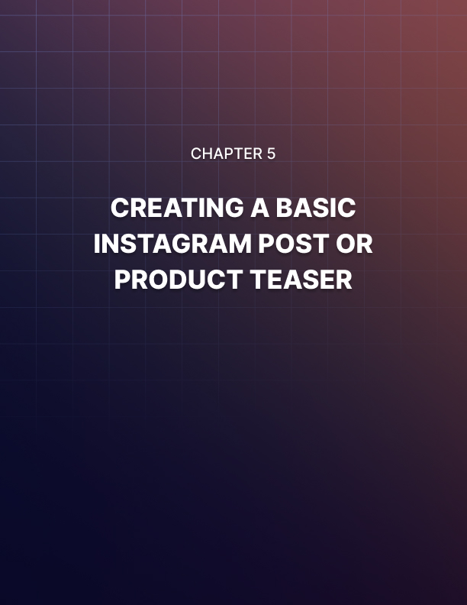

Chapter 4: Creating A Basic Instagram Marketing Post Or Product Teaser
Now that you’ve found the best hashtags for your business and topics for your content, it is time to create your first marketing post.
When creating an Instagram marketing post, the idea is to share content that is casual enough to generate engagement, but that also creates awareness about your brand, or about one of your products or services.
In this lesson we are going to walk you through an example where we create a marketing post designed to promote a product we sell by asking our audience a casual question to encourage engagement.

Creating Your Post
To create a post, open the Instagram app and tap on the “plus” icon in the actions menu. Next, you have to select what type of media you’ll use in your post: “photo” or “ video”.
We highly recommend you to take your product pictures or videos before you create your posts, and then to tap on “library” to add your media. This will give you time to produce better visuals for your posts.
In this case, we are going to select the picture of a cool upcoming product that we’ll sell as merchandising. Once you select your media, tap on “next” to continue.
After selecting your media, you will be prompted to edit it. Instagram offers you a nice variety of editing tools to enhance the visual impact of your images and videos.
Here you can start by selecting from different color filters to give your media a different look and feel. Then, you can tap on “edit” to further adjust some values such as brightness, contrast, structure, warmth, saturation, color, shadows, and much more! Once you are done editing your media, tap on “next” to continue.

Creating Your Marketing Post
Now it is time to create your marketing post. Let’s start by composing the caption that will appear on the post.
The secret behind composing an engaging caption that encourages people to interact with your account is either to write about a topic that your audience is sensitive to, such as a pain point or a hot take, or to include an actionable element, such as a question.
Questions are great because they’re the easiest way to trigger interactions. By asking a simple question related to the product or topic in your post, you’ll be encouraging people to comment and share your content. This is important, because generating engagement organically is the best way to grow your account and increase its relevance.
So, let’s open up this caption with a question asking users how they would use the product that we are promoting in the post. This is an indirect way to advertise the product and its benefits, by directly asking potential customers about uses for it.
Once you compose this caption, you have to add your hashtags. Now, when it comes to adding hashtags to a post, you will not need to add every hashtag in your niche, but only hashtags that are directly related to your post.
While Instagram lets you add up to 30 hashtags in a single post, we’ve found the optimal number to be five hashtags or less, though it is a good idea to try for yourself and add up to 15 hashtags across different posts. Then you can check which posts got the highest engagement to determine your optimal number of hashtags per post.
We’re now done creating this post, and there are a number of settings we can adjust before publishing it.
You can tap on “tag people” to tag other accounts on your post. You can tap on “add location” in case you want to tag a business location on your post.
And lastly, you can post to other accounts, including other Instagram accounts on your device as well as accounts on other social platforms.
Once you are ready to publish your post, read your caption to proofread for spelling errors or missing content, then tap on “share”.

Your post will be posted right away to your account, and now your followers will be able to see it and interact with it, as well as people using the hashtags in your post to find content that is relevant to them.
And that’s it my friends! Try creating up to 10 new posts to fill your profile with content. Next up we will be showing you how to advertise your new post so you can reach even more people, fast!
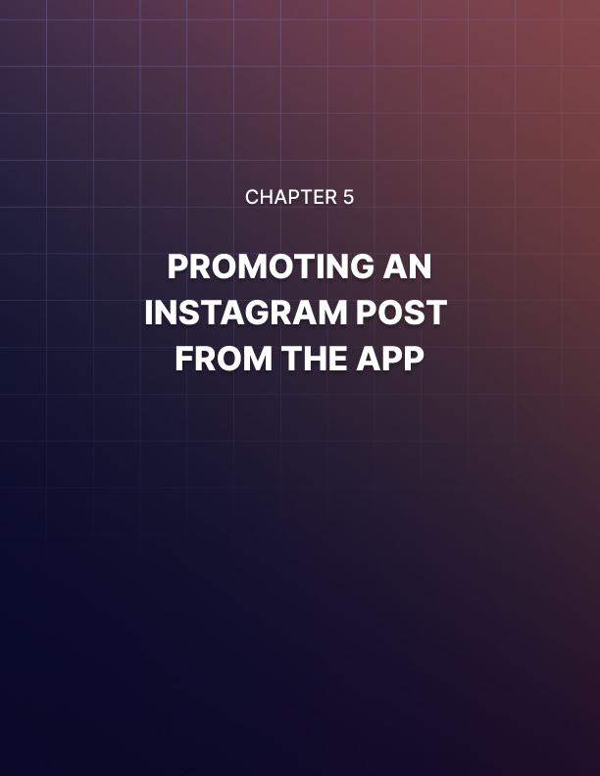

Chapter 5: Promoting An Instagram Post From The App
Hey there friends! Creating and sharing posts on Instagram is an easy way to grow your brand account while having fun on the platform. And although you can reach an amazing number of people organically when you share engaging and relevant stuff, you will get to a point where you’ll hit a growth wall.
It could also happen that you’d want to generate more engagement and drive more results faster. In this lesson we are going to show you how to promote one of your Instagram posts right from the app, the easy way.

Promoting A Post
You have to start by picking a post that you’d like to promote. For this, open the Instagram app and tap on the profile icon to go to your profile section.
There you will find your published posts by scrolling to the content column below your bio. What you’ll do now is to pick a post to promote. Once you decide, tap on the post thumbnail to open the post. Once you’re on the post, tap on the “promote” button.

Selecting An Objective
Now you will be prompted to select an objective. This is what you want to achieve by promoting your Instagram post. You can select “your profile” if your objective is to get more users to view your profile. This will add a “visit profile” call-to-action (CTA) to your post to prompt people that you reach with your promoted post to visit your profile and view more of your content.
You can select “your website” if your objective is to send people from Instagram to your website. By selecting this objective you will be able to add a CTA button that will encourage users to take action.
And you can select “your direct messages” if your objective is to encourage people to send you direct messages. This objective will add a “send message” CTA to your post that invites people to send you direct messages.
For this example, we are going to select “your website” so we can send people to our business website. Because we selected this objective, we will be prompted to confirm “website” as the “destination”. It is already selected, so we’ll simply have to tap on “next” to continue.

Customizing The Campaign
Now it is time to customize your campaign settings. This includes defining your target audience, your budget, and duration.
Let’s start by defining your audience. First, define whether you want to target special requirements in certain members of your audience. Special requirements include attributes such as credit, employment, and housing.
You can target special requirements if you’re running campaigns where you promote credit, housing, and employment opportunities.
To enable special requirements, simply enable the “special requirements” option, then select the special category that you want to target. We won’t target special requirements with our post, so we’ll simply continue without selecting a category to keep the special requirements disabled.
When defining your audience, there are two ways to match your targets. If you select “automatic”, Instagram will target users that are similar to your followers. And if you select “create your own”, you will be able to create your audience by yourself. If you select this method, you will be able to select your target locations, your audience interests, age, and gender.
For this example we are going to select “automatic” so Instagram helps us reach users that match the interests, locations, and demographics of our existing followers. After defining your audience, tap on “next” to continue.
Now you have to define your budget and duration. Start by selecting how much you’ll spend daily using the “budget” lever button. Now select the number of days you’ll promote your post using the “duration” lever button. You will see your total ad spend across the duration of your campaign, as well as your estimated reach above. Once you are done selecting your budget and duration, tap on “next” to continue.

Launching Your Promoted Post
You’ve just set your promoted post campaign, and all you have to do now is to review your promoted post settings.
Once you are ready to start advertising your post, simply tap on the “create promotion” button. And that’s it! This is the easiest way to reach even more people with the same content fast and at a very affordable cost!
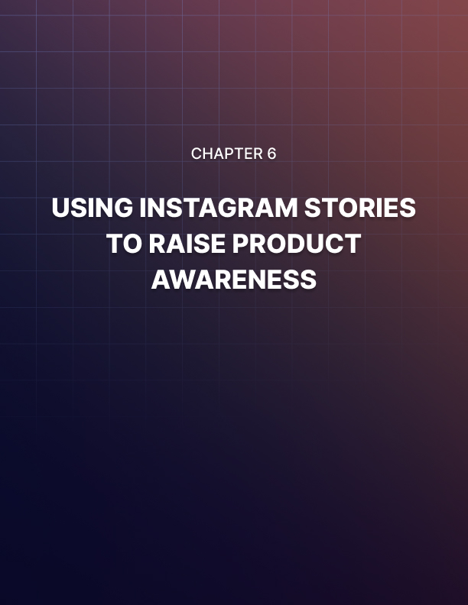

Chapter 6: Using Instagram Stories To Raise Product Awareness
Hey there everybody! Instagram posts are one of the best methods to deliver your branded content, but they’re only half of what Instagram lets you do, because you can also create Instagram stories.
If you’re familiar with Instagram stories, they are slideshow-type posts that let you share content that looks and feels more interactive.
Because Instagram Stories are so engaging, you can use them to raise awareness about a product or topic easily, and in this chapter we are going to show you how to create a branded story quickly.
One advantage of Instagram Stories over regular posts is that they appear right on top of the timeline. This is an area that is readily accessible to users, it is horizontally scrollable, and saves stories for 24 hours.
This means that users are unlikely to miss your Stories.
To create an Instagram Story, simply tap on the “Your Story” icon on the Stories bar on top of your Instagram timeline.

Creating Your Story
Unlike a regular post, an Instagram story is simply media with no captions or optimizations, such as an image, video, or recording, to which you add cool looking and interactive elements.
The first thing you have to do is to pick your story format. The “normal” format allows you to take a picture, to record a video, or to select media from your gallery for your story, in normal mode.
The “boomerang” format allows you to record a video that loops. A “ boomerang” story looks similar to a GIF, and it works great for product teasers or behind the scenes stuff.
The “layout” format will let you add multiple images to a single story layout. You can select from different grids that include from two to six placements to create a collage.
The “superzoom” format lets you record a segment that highlights a portion of your screen with a superzoom effect. The “hands-free” format allows you to record story videos without having to press the “record” button.
And lastly, the “create” format will let you to freely add interactive elements to an image or video from your gallery, or to use other types of elements such as shoutouts, GIFS, story templates, polls, questions, donation boxes for nonprofits, countdowns, and quizzes. This is the format that we’ll use for this example, so let’s stay on this screen.
You can use these elements to create crazy combinations that will keep your followers entertained and engaged.
For this example we are going to use a picture of a merchandising product we’ll sell through our online store, and we are going to add some attention grabbing elements such as a call to action using highlight text, and an emoji.
So we’ll start by tapping on the “gallery” icon to locate and add the product image first. Once you add your image you will be able to use the story editing tools, which includes stickers, emojis, text, and more.
Let’s start by tapping on the “text” icon to add a caption as the call to action. Type your caption, select a color, then select a size, and a font style. Then tap on “done”. Now arrange the text on the screen. Let’s now tap on the “stickers” icon to add a cool sticker. For this example, we are going to select a countdown sticker to show a countdown of the date when the product goes live in the store.
Tap on “done” when you’re done customizing your sticker, then resize it and fix its position on the screen. Bear in mind that stories can be messy, that they don’t have to be consistent with your brand’s aesthetics, that they only last for 24 hours, and that they’re objective is to create entertaining impact, so don’t worry if they don’t look exactly perfect!
Let’s now tap on the “stickers” icon again to add a couple more stickers to increase the visual impact of the story.

Posting Your Story
We are done customizing this story, so let’s take a final look so we’re sure it looks fine and dandy. We like it a lot, and we’re sure our followers will love it, so now we simply have to tap on “send to”.
On the following screen you can select whom you are going to send it to. Here you simply have to tap on “share” to “your story”. Then, tap on “done”. And that’s it! We encourage you to create one or more stories a day to keep your followers engaged!
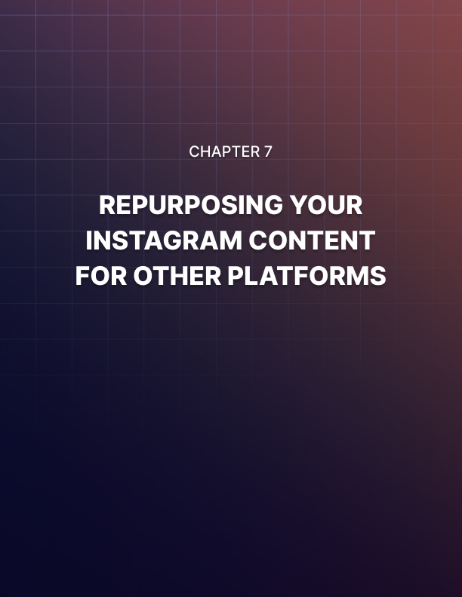

Chapter 7: Repurposing Your Instagram Content For Other Platforms
Using Instagram as a platform to publish your content and grow your online presence will help you reach and engage an audience that you’ll hardly find somewhere else, but you can take your reach further by repurposing your Instagram content on other channels.
This strategy is called cross-promoting, and it allows you to leverage your existing Instagram content to engage users on other social media platforms and to create backlinks to your Instagram account on those platforms.
In this lesson we are going to show you the right way to repurpose Instagram content on top social media channels.

On Facebook
Alright folks, let’s start on Facebook. What we’ll do on Facebook, and on the rest of platforms we’ll show, is simply to take content from one of our Instagram posts, which includes the image, copy, and hashtags, so we can use it on a post that we’ll create there.
With that in mind, go to your Facebook account, and enter the business page where you’ll publish your post. Next, click on the “write a post” field.
What you’ll do here is to simply enter the text from your caption on the Instagram post. Now, one thing worth noting is that character limits don’t work the same on other platforms as they do on Instagram.
And while you can compose long-form captions for Facebook posts, the idea is to create teaser-type posts to encourage people to click on your Instagram link to check the original post there.
One trick that works great is to open this post with headline text. This is simply a title that you’ll use to catch the attention of the user. In this example, we are going to open with a question related to the product that we are promoting on the Instagram post.
Next you are going to add your post caption. This can be a segment of your Instagram caption, a description of your Instagram post, or a shorter variation of the same caption. In this example, we are going to describe the content of the original Instagram post.
After you enter your headline and text, add a call to action and a shortened link to the original Instagram post.
As you can see here, Facebook will generate a cool-looking preview of your post by pulling your featured image or video into the post, as well as the name of your account and publication date.
Lastly, add your hashtags at the end of the post, right below the call to action and URL. Then, click on “post” to finish.

On Twitter
Twitter is a crazy-engaging platform that can funnel lots of visits to your Instagram posts and profile.
The structure of a Twitter post is going to be similar to what we created on Facebook. Start by going to your Twitter account. Then click on the “tweet” button.
Here you are going to apply the same strategy we applied on Facebook. You just have to be careful not to go over the character limit, which is 280 characters. This means that you have to compose a shorter caption this time, so you can leave space for your URL and hashtags.
Ok, so let’s start by composing the headline. Here you can use the exact same headline that you used on Facebook, as it is going to have the same effect.
Now you are going to add the post text. You can use the same text that you used on Facebook as long as it is short-form. Otherwise you can simply add a call to action to encourage users to check the original post on Instagram.
We’ll do that in this example, so you can see how easy it is. Here we’ll simply compose a call to action to invite users to find lots of answers to the question in our headline over at Instagram. Then we are going to add the shortened post URL.
Now you have to add your hashtags. There are two smart ways to use hashtags on Twitter. First, you can use keywords in your copy as hashtags. Simply find a keyword that is relevant to the post, then add a hash symbol right before it, like this. The second way is to add the hashtags at the end of your text, like this.
Lastly, click on the “gallery” icon to upload the image or video that you used in your original Instagram post. Now that you’ve fully created your repurposed post, click on “tweet” to publish it!
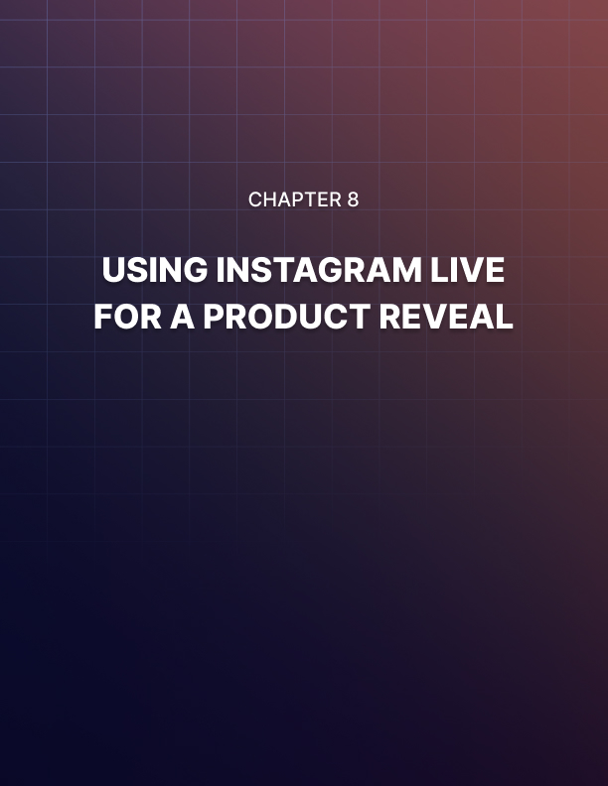

Chapter 8: Using Instagram Live For A Product Reveal
Promoting your products and other branded stuff on Instagram is great for business, and there is a very entertaining, very engaging way to do it that your audience will love.
We’re talking about doing product reveals on Instagram Live, Instagram’s builtin live streaming feature that will allow you to showcase your products and interact with potential customers in real time!
In this lesson we are going to show you how to easily go live on Instagram, and how to set up a product reveal broadcast!

Going Live
Going live on Instagram is a very straightforward process that won’t require you to set up complicated live streaming software or super sophisticated streaming equipment. In fact, all you’ll need is a good cell phone with a good camera, and a good internet connection.
To go live on Instagram start by opening the app on your device. Then, tap on the camera icon in the upper-left corner. Next, select “live”.
To go live you will simply have to tap on the “live” button. Now, there are some settings that you can adjust before going live.
First, tap on the “settings” icon in the upper-left corner. Here you can select to hide your live session. We don’t recommend you to use this feature for marketing purposes, so let’s move to the following settings.
In “allow message replies” you can select who can message you and reply during your live session. Here we recommend that you use the default “everyone” setting. Now you can select how to save your live session. Enable “save to camera roll” if you want to save your live session to your phone. This is a useful feature that you can enable in case you want to share your video on other platforms, such as Twitter or YouTube.
You can also enable “save to archive” to save your live session to your Instagram archive instead of your phone.
Next you can adjust “sharing”. Here we recommend you to enable all default sharing settings. This way you can reshare your live session in the “stories” section, allowing users to share your live session as a message, and share your Live session as a story on your connected Facebook page!
Once you have configured your live settings, tap on “done”. Before going live you can also select whether to go live in normal mode, or you can select to go Live using a filter. For this example, we are going to go live in normal mode. Now that we’re ready to go live, we simply have to tap on the “live” button.

During Live
Once you tap “live” you’ll get a message to let you know that your connection was successful and that you are alive now.
A cool thing that Instagram does when you go live is to show all your followers a notification on the upper side of the screen telling them that you're going live.
We recommend you to schedule your live sessions in advance so you can announce your live reveal events across all your social channels.
When you do a product reveal, you have to prepare your presentation, and to have a sample or demo ready to tease the product on screen when possible.
Let’s assume you prepared your presentation the right way, so let’s take a quick look at what you can do while you’re live.

First, you can tap on the “gallery” icon to share an image or video during your reveal.
When you select an image or video, it will fill your background. This will allow you to show images or videos about the product that you are revealing, and to use them for our presentation, like we’re doing here. This is because you can select one image first, then another, in a way that is similar to a webinar.
You can also share comments with your attendees by sweeping up. In the case of a product reveal, you can use this function to share your product launch page or product sales page URL.
Your attendees will start asking questions at some point, and you can tap on the “questions” icon to see their questions regarding your product.
A couple more functions worth checking are the direct messaging and “go live with” icons. The “direct message” function allows you to send a direct message or invitation to other accounts while you’re live. And the “go live with” feature allows you to go live with any of your viewers.
Once you are ready to finish your live reveal, simply tap on “end”, then confirm. You can then tap on “share to story” so your live session is added to your stories for 24 hours.
And that’s it my friends! A great way to drive interest in your products while you interact with your followers in real time!
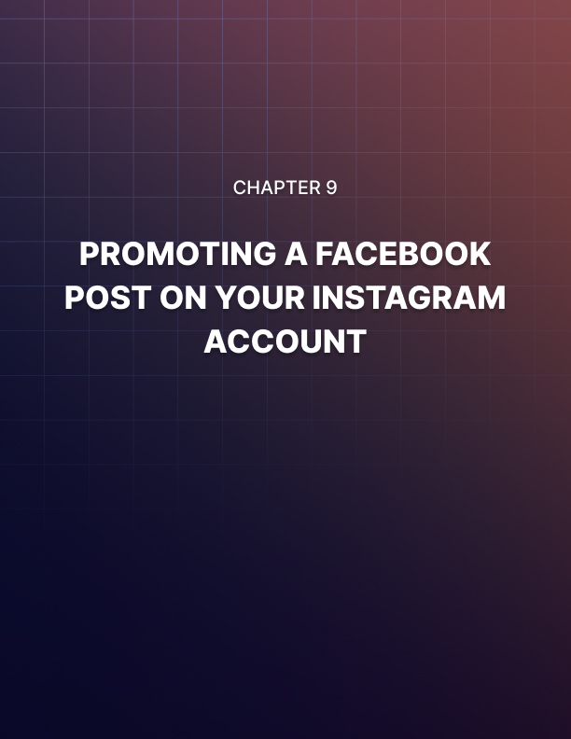

Chapter 9: Promoting A Facebook Post On Your Instagram Account
So far we’ve been walking you through the right ways to use Instagram for marketing, step by step.
Most of these strategies will help you to grow steadily and to stay relevant, but there’s going to be a point where you’ll need to scale. The best, fastest way to scale is to run paid campaigns to promote your content.
Luckily, Instagram integrates with the Facebook Ads platform, one of the most widely used advertising platforms on the planet. In this lesson we are going to show you how to get started using this platform by promoting a Facebook post from your business page on your Instagram account!

Creating The Campaign
The first step is to access the Facebook Ads platform. You can do this by visiting the “facebook.com/adsmanager” URL while logged in to your Facebook account.
This will take you to the ads manager page, where you can create and manage Facebook ad campaigns that have outreach on the Instagram network.
To create a Facebook ads campaign, start by clicking on the “create ad” button. You will be prompted to select a marketing objective on the following page. Because you are going to create a campaign to promote a page post from your Facebook page on Instagram, select “engagement” as the marketing objective for this campaign.
Now select “post engagement” as your objective. Then, enter the name to save this campaign into the “campaign name” field. Now click on the “set up ad account” button.
What you’ll do now is to select your “account country”, your “currency”, and your “time zone”. Make your selections, and click on “continue”.

Setting Up Your Campaign
Now it is time to set up your ad campaign settings. This includes setting up your ad set, audience, placements, budget, and schedule.
Let’s start by entering the name of this campaign’s ad set into the “ad set name” field.
Let’s now move to the “audience” section. Here you are going to select your target audience, demographics, and attributes.
Start by clicking on the “edit” icon in the “locations” section to select the locations where you want to show your ads. Here you simply have to enter the name of a location that you want to target into the “add more locations” field, then select the location from the results. You can add as many locations as you want!
Now click on the “edit” button corresponding to “age” to select the minimum age and the maximum age of people that you want to see your ads.
You can also click on the “edit” button corresponding to “gender” to select a specific gender. This is useful when you want to advertise something to a specific gender. For example, if you are going to advertise custom automotive parts, it is better to select “male” as your target gender. Or if you are going to advertise makeup products, it is better to select “female” as your target gender.
In this case, we are going to leave the default “all” genders setting as our target.
Now click on the “edit” button corresponding to “detailed targeting”. Here you can select more detailed criteria that will help you target the perfect prospect. This includes demographic attributes, interests, and behaviors. All you have to do is to enter a keyword into the “detailed targeting” field, and then to select an item from the results. You can add as many attributes as you want to target!
Lastly, click on “show more options”, then click on the “edit” button corresponding to “languages”. Now enter the language or languages that you want to target. Make sure to always target the same languages you use to create content.
Once you are done defining your audience, move to the “placements” section. The “automatic” setting allows you to promote your post across multiple placements that includes Facebook, Instagram, and other networks.
But because the goal is to focus the budget for this campaign to promote a post on Instagram, you have to select “manual placements”. Next, deselect all placements except “Instagram”.
Let’s now move to the “budget and schedule” section. Here you are going to set your budget and your ad schedule.
Start by selecting “daily budget” as your budget type. Next, enter your daily budget amount into the budget field. Here you can start with a daily budget as low as $5 and scale as you see fit!
When it comes to the start and duration of your campaigns, you can select to “run my ad set continuously starting today” to promote your post right away and to stop the campaign manually later on, or you can select “set a start and end date” to schedule when to start and when to stop promoting your post.
In this example, we are going to select “run my ad set continuously starting today”. Once you are done setting this up, click on “continue”.

Setting Up The Ad And Launching The Campaign
Now it is time to set up your ad. Start by entering the name to save this ad into the “ad name” field.

Now move to the “identity” section. Click on the “Facebook page” menu button, and select the Facebook page that is connected to your Instagram account. You’ll see your Instagram username below, in the “Instagram Account” section.
Now you are going to click on the “use existing post” tab below. Move to the “creative” section, and click on “select post”. You will see a list of all Facebook posts on your page. All you have to do now is to click on the post that you want to promote, and then to click on “continue”.
Your selected post will load as the ad creative, and you will see a preview on the right column of this section.
And now that your ad is ready, you will simply have to click on the “confirm” button to submit your campaign. It will start running from 5 to 15 minutes after you submit it!
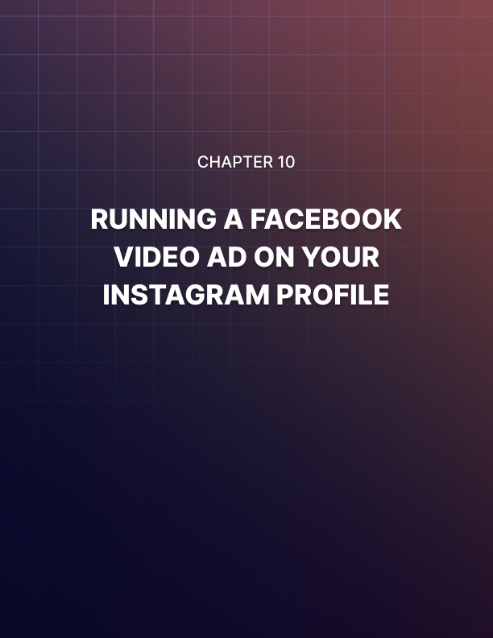

Chapter 10: Running A Facebook Video Ad On Your Instagram Profile
We’ve just set up an advertising campaign to promote a Facebook post from your business page on your Instagram account, and as you could see, it is an easy method to generate more engagement from existing content.
This time around we are going to show you how to set up a video ad campaign to promote a Facebook video through your Instagram profile!

Creating The Video Ad Campaign
Let’s start right on the ads manager page. Just like in the previous lesson, you can directly access this page by visiting the “facebook.com/adsmanager/” URL while logged in to your Facebook account. On this page, click on the create ad” button to go to the campaign creation page.“
To create a video ad campaign, you have to select “video views” as your marketing objective. Now enter the name to save your new campaign into the “campaign name” field. Then, click on the “set up add account” button to quickly select your ad account settings. Lastly, click on “continue” to start configuring the campaign.

Setting Up Your Campaign
Now it is time to set up the ad campaign. Start by entering the name to save this ad set into the “ad set name” field.
Next, move to the “audience” section to define your target audience. First, select your target “locations”.
Next, select your target “age”. Then your target “gender” if it applies.
Now click on the “edit” icon corresponding to “detailed targeting” to select your detailed targeting criteria by entering your keywords into the detailed targeting field and selecting items from the results.
Now click on “show more options”, then click on the “edit” icon corresponding to “languages” to select your target languages. Now move to the “placements” section. Select “manual placements”, then deselect all platforms except Instagram.
Now move to the “budget and schedule” section. Select “daily budget” as your budget type, then enter your daily budget amount into the amount field.
Now select your schedule. For this example, we will select to “run my ad set continuously starting today”. Once you are done configuring your campaign at this point, click on “continue”.

Setting Up The Video Ad
Now it is time to create your video ad. Start by entering the name of this new ad into the “ad name” field. Now move to the “identity” section, click on the “Facebook page” menu button, and select the Facebook page that is connected to your Instagram account.
Now scroll down to the “media” section and click on the “add video” button to upload the video that you are going to promote on Instagram.
Next, click on the “upload” button to locate your video. Double-click on it, and wait for it to upload. The recommended length for videos that you want to promote on Instagram is 15 seconds or less. Longer videos can’t be promoted on the Instagram timeline.
You can move to the “text” section after uploading your video. Here you are going to add a copy to your video ad. First, enter your copy into the “text” field. Next, check the “add a website URL” option and enter your landing page URL into the “website URL” field.
You can click on the “call to action” menu button to select a different call to action button. In this case, we’ll use the default “learn more” CTA button.
Now that your video ad for Instagram is ready, go to the preview section on the right to see how it is going to look on different Instagram placements.
Finally, after setting up and previewing your ad, click on the “confirm” button to submit and launch your Facebook video ad campaign on Instagram!
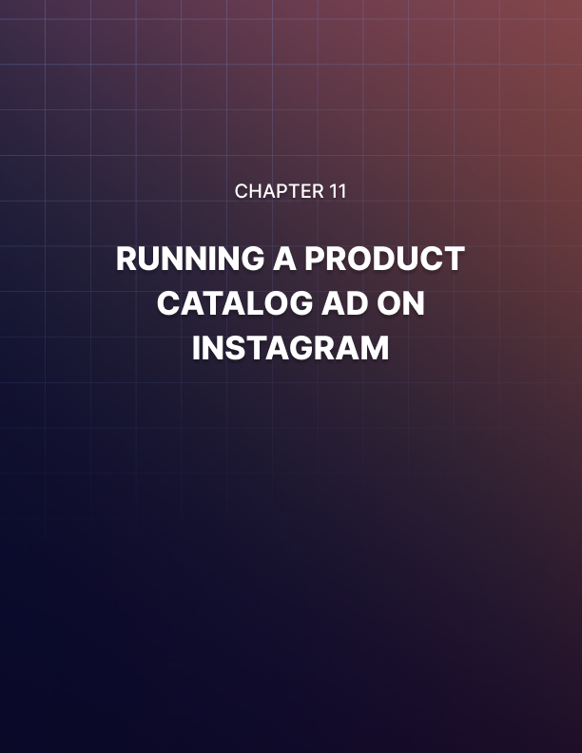

Chapter 11: Running A Product Catalog Ad On Instagram
Instagram has become a favorite platform among retailers because it enhances the visual experience of potential customers checking a product line.
If you want to increase your sales the way top retailers do, there’s no better way than to run a product catalog ad on Instagram, and in this lesson we are going to show you how to do it easily, step by step.

Creating A Catalog
Before you are able to run a catalog ad on Instagram, you will need to create a catalog to promote. You can do this through the ads manager by clicking on the tools menu button, then on the “catalogs” option.
Once on the catalog manager page, click on “create catalog”. Now select the category that best describes your business. Click on “next”, and select the method that you are going to use to upload your catalog. For this example, we’ll select “upload product info”.
Now select the business that owns the catalog. You can select “personal” if you haven’t added any business information to your ad’s manager. Now enter the name of your new catalog into the “name your catalog” field. Then, click on “ create”.
You can add products to your catalog by going back to the catalog manager.
For this, click on the “catalogs” option in the tools menu.
Once on the catalog manager page, enter your catalog. On the catalog page, click on the “products” tab. Next, click on “add products”. On the following page, select “add manually”. Then you can start filling your product info, which includes product image, name, description, website link, and price.
Once you have added all this info, click on “add product”. Repeat these steps to add the rest of your products to the catalog!

Setting Up The Product Catalog Ad Campaign
Now that you have a catalog to promote, go to the ads manager page and click on “create ad”.
Once on the campaign creation page, select “catalog sales” as your marketing objective. Now enter a name for your new campaign into the “campaign name” field. Then, click on the “catalog” menu button, and select your catalog from the menu. Now click on “set up ad account” to quickly select your ad account settings for this campaign.
Now you can start configuring the campaign. First, enter the name of this new ad set into the “ad set name” field. Now click on the “product set” menu button to select the products that you want to promote in the ad.
Now move to the audience section to define your target audience. There are two targeting methods that you can use when configuring a catalog sales campaign. You can select “retarget ads to people who have interacted with your products on and off Facebook” to show your catalog ads to people who have seen your products on your website, on your app, or on Facebook. To use this method you will need to create and set up a retargeting pixel first so you can track when users interact with your products.
Or you can select to “find prospective customers even if they haven’t interacted with your business” to show your catalog ads to all users even if they haven’t visited your site or app. For this example, we are going to select this method.
Let’s now define the audience. Here we’ll do like we’ve done in the previous campaign: first, we’ll define “locations”. Next, we’ll define “ages”. We’ll skip “ gender”, and we will select detailed targeting criteria. Next, we are going to click on “show more options” to select our target language.
Let’s now move to the “placements” section. Here we are going to select “ manual placements”, and then we will deselect all platforms except Instagram.
This is how you can optimize your budget to increase catalog sales on Instagram!
Now move to the “budget and schedule” section. Select “daily budget” as your budget type, and then enter your daily budget amount. Now select when to start running your ads, and then click on “continue” to start creating the ad.

Setting Up The Ad
Alright folks, now it is time to create the ad. Start by entering the name of this ad into the “ad name” field.
Now move to the “identity” section, click on the “Facebook page” menu button, and select the Facebook page that is connected to your Instagram account.
There are three types of ad formats available: carousel, single image, and slideshow. For this example, we are going to select “carousel” as the ad format.
Let’s now move to the “ad creative” section to customize the ad. First, let’s select “multiple products” as the catalog format.
Next, let’s select “slideshow” in the “catalog cards” section. This option will show multiple product images from your catalog in your ad.
The “headline” and “new feed link description” fields are filled with variables that pull information about each product from your catalog into the ad by default, so you can skip this setting.
Now enter your ad copy into the “primary text” field. Next, enter your lading page URL into the “see more URL” field. Lastly, click on the “deep link destination” menu button and select “open deep link in a mobile web browser”.
You can see a preview of how your catalog sales ad will look on the Instagram feed and other placements on the preview window to the right.
Once you are done configuring your campaign, customizing your ad, and reviewing your campaign settings, click on the “confirm” button to submit and launch your product catalog sales campaign!
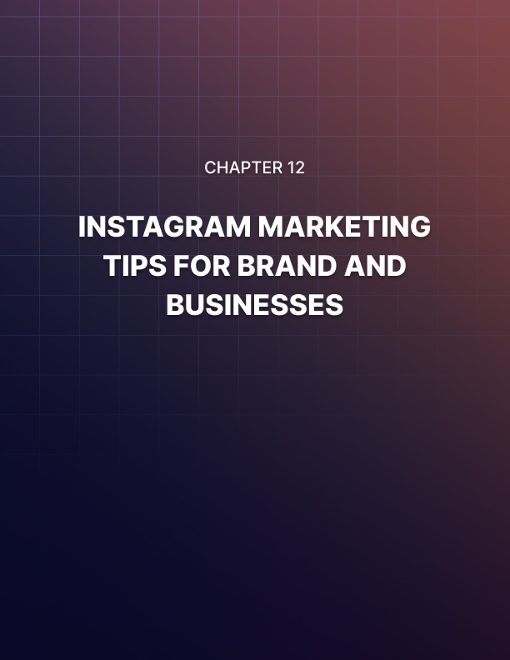

Chapter 12: Instagram Marketing Tips For Brands And Businesses
Instagram is just about the perfect platform for brands and retailers to grow because it allows them to showcase their products and branded content in an entertaining, visually striking way.
Whether you’re running an Instagram account for a business, or you’re a brand trying your luck on the platform, there are a series of things you can do to get more results out of your Instagram marketing game. Here are some useful Instagram Marketing tips to help you make the most out of the platform!

Set Your Marketing Goals Straight
Before you go building your Instagram presence full force, it is important that you define your marketing objectives.
A marketing objective is what you want to achieve by promoting your business on Instagram. Your marketing objectives can vary according to the stage you are in your business lifecycle, but it is key that you start with the basics. This includes creating brand awareness among Instagram users first, generating engagement to build a targeted audience second, and then promoting your products and services to start moving potential customers down your sales funnel.
Now, in case you have already built a presence and audience elsewhere, and you’d like to use Instagram to achieve a very specific objective, you have to start by answering the following questions:
- Are you going to use Instagram to build brand awareness specifically among Instagram users that you can’t reach on other platforms?

- Are you going to use Instagram because it offers you a better way to showcase your products?

- Are you going to use Instagram as a customer service channel?

- Do you plan to use Instagram as a sales channel?
Answering those questions will give you a clearer idea of your Instagram marketing objectives. For example, you might want to use Instagram exclusively to run catalog ads to drive sales. Or you might want to use Instagram only to post product pictures with a call to action to encourage users to click on the link in your bio to go to your store.
Reverse-Engineer Your Competitors
One shortcut that you can take to become more successful on any platform is to reverse engineer what successful competitors in your niche are doing.
The people behind successful Instagram accounts know what type of posts generate engagement, what kind of posts stir emotions, and what type of posts drive sales, and they’re constantly using those types of posts to get results.
So instead of trying your luck with original content or improvisation, we recommend you to emulate the type of content that your top competitors share, you just have to give it your own spin, use your brand voice, and your brand aesthetics.
You will see that by reverse-engineering content from successful accounts you will be able to generate results faster, and your account will grow in no time!
Audit Your Instagram Account
A best practice among successful Instagram marketers is to audit their Instagram accounts regularly.
Auditing your Instagram account means to take a good look at everything in your Instagram account and examine what’s helping you to build the type of account that you want your audience to follow, so you can keep and optimize those elements, and eliminate the ones that don’t help. Things that you have to audit include:
- Your profile picture.
- The copy in your bio.
- Your URLs.
- Your Hashtags.
- Your Posts.
- The accounts that you follow.
Take a critical look at these elements and decide what you’ll eliminate and what you’ll edit. Do this while picturing how a potential customer will think of your account.
Create A Consistent Brand Identity
We’ve mentioned that it is important to keep a consistent brand aesthetic, and this is what that means.
A consistent brand aesthetic is the consistency of colors, shapes, fonts, filters, and other elements across your account and content. This will help you build a consistent brand identity that helps people recognize stuff posted by your brand on first glance.
And this is it my friends! These tips will give you an advantage that you wouldn’t have otherwise, and we encourage you to start applying them today!
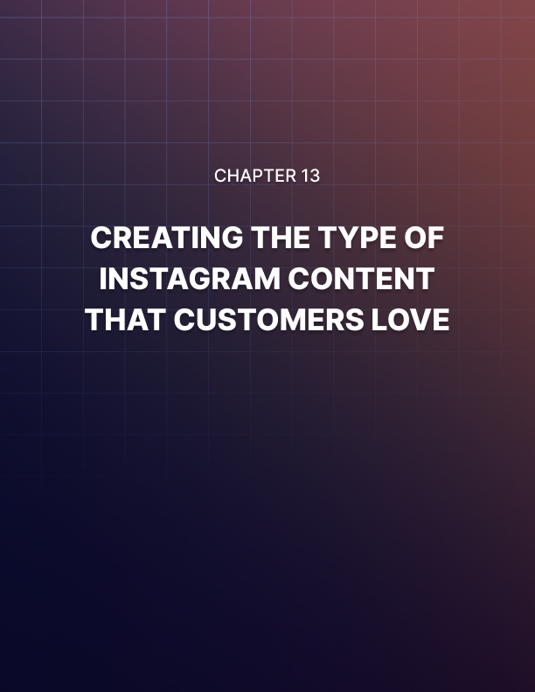

Chapter 13: Creating The Type Of Instagram Content That Customers Love
If there’s one thing that you are more than aware of at this point is that content is at the heart of any Instagram Marketing strategy.
With so many possibilities and a large variety of powerful editing tools to pimp up your images and videos, it can be difficult to determine what’s the type of content that customers like.
That’s why in this lesson we are going to discuss the elements that make the type of Instagram content that customers love!
Stylish, Striking Pictures
Instagram became wildly popular thanks to people using it to share striking, eye-popping images and pictures. And that is exactly the type of image that will help you to differentiate your content from the rest: images that include some kind of highlight element or distinctive feature. This can be anything that catches the eye, such as a beautiful natural occurrence like sunsets, dawn, snow, bright lights, and water effects, beautiful architectural compositions, and special effects such as unique color schemes and combinations.
Those elements, when combined with your products and great angles, will help you give your content that unique and polished look that customers love.
The good news is that you won’t need expensive equipment or a big travel budget to produce striking pictures. You will just need a good smartphone with a quality camera, a tripod, and basic lightning equipment.
You can use Instagram’s built-in editing tools and filters to enhance your pictures, and you can use royalty free resources to find exotic backgrounds for your feature product images!
Media Featuring People
A lot of people see Instagram as a reflection of the lifestyles and things that they’d like to have.
They use Instagram to see pictures and videos of people using the products that they’d like to own, of people wearing clothes that they’d like to wear, and of people visiting places that they’d like to visit someday.
This means that, by producing images or videos of people using your products or services, or of people visiting your business, you can increase purchasing intent and drive more sales.
This strategy not only helps you to put your products and services in a real world context, it also helps you to humanize your brand and makes it more relatable!
Bit-Sized Videos
Video is increasingly becoming the most popular media format among social media users, especially on Instagram.
That’s no secret, but what’s really surprising is the type of video that can help you sell the most on the platform.
On Instagram, the best type of videos to drive sales are bite size, very short videos featuring your product front and center. Videos captured with a smartphone camera are especially effective because they give your content a casual vibe that customers love, and that encourages them to buy on a whim!
Loops and Timelapse Videos
Video loops and timelapses are insanely popular on Instagram, and lots of brands use those formats to give a different spin to their marketing campaigns. For instance, you can create video loops where you perform an action with your products, or a timelapse video where you show your service in action until you show the results that you promise.
Because these types of videos are so cool and entertaining, people share them like crazy, which can help you to reach many more customers!
Image Macros
Image macros are those super popular images with witty captions that people share like crazy everywhere.
And while they won’t necessarily help you to move sales, they can help you to capture the attention of customers in your niche. The trick is to combine image macros with your brand, or with the stuff that you sell.
You simply have to come up with smart comments about your products, and to share them as image macros on Instagram. Potential customers will stumble upon them, they will share them, and they will follow your account to see more of your branded macros in your timeline.
You can also create more elaborate image macros if you can come up with tips, jokes, or inspirational quotes.
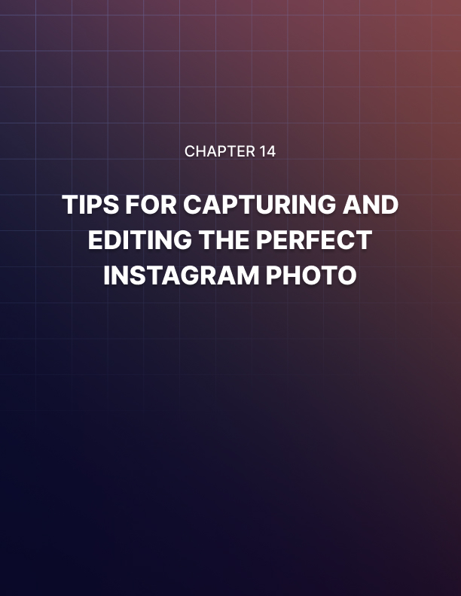

Chapter 14: Tips For Capturing And Editing The Perfect Instagram Photo
One thing we have pointed out before is that Instagram exploded in popularity thanks to image posts, which are the most common type of Instagram posts.
And there's a good reason for that. Image posts allow brands and content creators to share their best photos to create awareness and engagement. This is because great photos can help you to really show the quality and lifestyle that you want to reflect.
To help you achieve that, we’re going to share with you some tips that’ll teach you how to capture and edit the perfect Instagram photos!

Equipment And Specs
You can use your own smartphone camera to take your Instagram photos as long as your camera is between 18 and 25 megapixels. Other equipment you can buy to take amazing Instagram pictures include:
- A soft box for lightning.
- An adjustable tripod to hold your phone.
- A selfie stick.
Although all pictures you upload to Instagram will be shown as square on the feed, it helps to know the dimensions of your pictures according to format:
- Square photos should be 1080 by 1080 pixels.
- Landscape photos should be 1080 by 566 pixels.
- Profile photos should be 1350 by 1080 pixels.

Taking The Perfect Instagram Photos
Having great equipment and knowing the right specs for your photos will allow you to take amazing pictures only when you combine it with the right techniques. Let’s take a look at the best techniques to take great photos with your phone.
Apply The Rule Of Thirds
The “Rule of Thirds” is a technique where you place the subject of your picture a bit off center to create a light imbalance that forces the viewer to pay more attention to the subject. This means that by creating this imbalance you’ll focus the attention on your product.
You can apply the rule of thirds by turning on your camera grid lines. Then, aim your subject in the intersection between a set of vertical and horizontal lines in the grid.
You can enable your camera grid lines by going to your camera settings while you are in camera mode.

Use Symmetry
People are naturally attracted to symmetry and cool patterns. You can achieve symmetry simply by placing your subject right at the center of your pictures. Another good technique is to use leading lines to draw attention to your subject.
This is the opposite of the Rule of Thirds, and it can also help you to achieve very interesting results!
Focus On A Single Subject
If your objective is to highlight a product or feature in your pictures, the best method is to focus your photos on a single subject.
This means that you have to take your pictures with your subject, whether it is a product, object, or person, against a clear or minimal background, free of other objects and distractions.
A good way to focus your photos on a single subject when you can’t use a clear background, or when you prefer to use a natural background for your pictures, is to shoot your pictures against negative space.
Negative space is simply empty space around the subject of your picture. You can achieve this by placing your product, object, or person against an empty wall, or inside an empty room.

Try Different Angles And Perspectives
When taking pictures, it is a good idea to test more than one angle and perspective. Because people are used to seeing stuff at eye level all the time, giving your photos an interesting perspective can rapidly increase engagement.
You can do this simply by changing your shooting position. Experiment by twisting, turning, and doing inverse angles.
Use Natural Light When Possible
Soft boxes are very practical, but they can cause unwanted shadows and ugly light areas that can damage an otherwise nice photo.
That’s why we recommend you to use natural light when possible. Taking pictures of the outdoors, right before sunset or at sunrise, can help you to create warm, striking, natural-looking images.
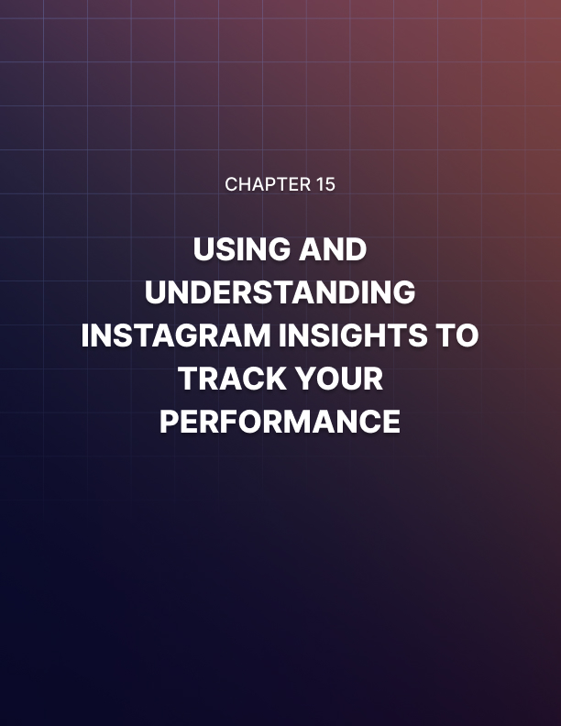

Chapter 15: Using And Understanding Instagram Insights To Track Your Performance
Tracking and analyzing your performance is a commonplace activity among marketers across all platforms.
Tracking and analyzing is important because it helps you see what content is driving the most engagement, to discover what’s working, to find out what’s not, and to determine what needs to be tested and optimized. In this lesson we are going to show you how to use and understand Instagram
Insights, the platform’s built-in analytics tool, to track your performance.

Accessing Instagram Insights
You will be able to access Instagram Insights from the Instagram app once you switch to a professional account. To access Insights, you simply have to open the Instagram app while logged in to your account. Tap on the profile icon, then tap on the menu icon. Lastly, tap on the “insights” tab on the menu.

This will take you to the insights section, where you’ll find detailed analytics and metrics about your content, your activity, and your audience, and we will explain what the information and metrics on this section mean.

Activity Metrics
“Activity Metrics” are details about the performance of your content, such as the number of people you reach and how much engagement they generated. The following are the activity metrics you’ll find in this section.
Impressions
Impressions represent the number of times your content has been seen by users. This is a relevant metric because it includes all kinds of views.
That means that your total number of impressions includes the number of times users saw your content, read your content, and actually paid attention to your content, but it also includes the number of times that users scrolled past your content without paying attention to it. It also includes the number of times that people visited your profile, or that saw your content through a direct message.
In other words, you can use this metric to determine how many times people have seen your profile and your content across all possible placements.
Reach
Reach is also related to the number of views you get on your content, but this time it relates to unique views.
A unique view represents unique views from an individual user. So if one user visited your profile and then searched your content, it counts as a unique view.
This is a much more relevant metric because it lets you know the number of users that actually viewed your profile and content. This is a strong signal of intent.
Interactions
Interactions represent engagement. That is, likes, comments, shares, and saves. This is a much more accurate metric when it comes to determining performance because it lets you know if you’re getting a healthy amount of interactions when compared to your impressions and reach. To give you an example, let’s imagine that you’re getting thousands and thousands of impressions and reach, but only a handful of likes and comments, and no one is saving your posts. This is a signal that you are reaching a good number of people, but that your content isn’t engaging enough.
On the other hand, if you’re generating a thousand impressions a day and a similar amount of interactions, then it means you're on the right track!
Audience Metrics
Audiencemetrics are details about your audience.More specifically, they’re pieces of demographic information that will allow you to learn more about the type of people that you attract with your content. Audience metrics you’ll find through insights are as follows.

Gender
Audiencemetrics includes the gender range of your audience.It will be represented as a percentage, and it will help you to know which gender finds your content relevant.

Age
Audience metrics also include the age range of your audience. It is represented as a percentage as well, and it helps you to know what’s the average age of people that find your content enjoyable, or useful.
Top Locations
Insights will also provide you with a breakdown of the locations where your audience lives. It includes cities and countries, from top to bottom.
By knowing your top locations, you can also uncover other details about your audience, such as dominant language, time zone, and purchasing power.
Active Hours
Another useful metric is “hours” and “days” when your followers are the most active. This information will help you to better plan and schedule when to publish your content for maximum reach and engagement!
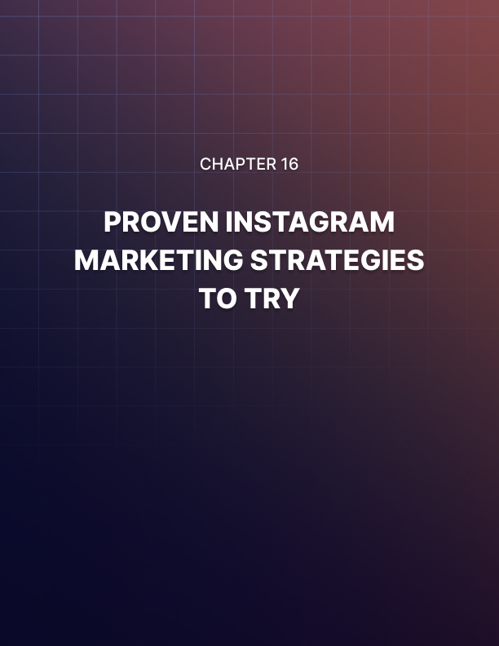

Chapter 16: Proven Instagram Marketing Strategies To Try
Marketing your business online successfully can take a couple years of trial and error while you develop a series of strategies that work for you.
This can be a big turn off for anyone, so we’ve decided to give you a collection of proven Instagram marketing strategies so you do it right from the very start!
Use Hashtags To “ Categorize” Your Posts
You can use hashtags to make it easier for people to find your content under certain categories beyond your base niche keywords. This strategy goes beyond using keywords that are related to your niche and product as hashtags, like we explained during the very first lessons.
What you’ll do is to include a combination of general hashtags, branded hashtags that you can borrow from competitor accounts in your niche with larger followings, alongside your base and related hashtags.
This will help you to basically place your content under a content category when people use those hashtags to search content!
Run Contests And Giveaways
Running giveaways on your account might be the easiest and quickest way to get a lot of new followers and engagement.
All you have to do is to announce a prize that you’ll reward to a random user. For a chance to win, people have to follow your account, like the post where you announce the giveaway, and share it.
You can run this campaign for several days, and in the meanwhile you’ll get tons of participants following your account, commenting on your posts, and sharing your content. This will in turn increase the relevance of your account.
Post At The Right Times
Believe it or not, there are specific times when Instagram users are the most active. In general, this can be in between off-work hours during weekdays, but it’s been determined that peak activity on Instagram happens from Mondays through Thursdays at any time, except the hours between 3 PM and 4 PM.
To determine the right time to post, take a look at your audience insights and see where the majority of your followers are from. You can use their time zone to determine the best times to schedule and post your content!
Interact With Followers
People will become emotionally connected to your brand or business if you start interacting with them. All you have to do is to reply to their comments, or to like nice comments.
This will help you to build a stronger, more reciprocal customer relationship, and that will cause customers to become repeat clients, or even brand ambassadors down the line!
Share User-Generated Content (UGC)
Another way to make your followers go crazy about your brand is to share their own content. Not pictures from their accounts and such, but content that they create for your brand.
That’s called user-generated content, and all you have to do is to encourage followers to create content that is focused on your brand, products, or businesses.
This is quite easy, because you can simply ask people to take a picture showcasing one or some of your products, and to tag your account in the post.
For example, if you sell clothes, you can ask users to take a picture where they’re wearing one of your clothes.
You can also leverage certain hashtags by instructing people to use a hashtag in their caption. In fact, user-generated content is a great way to create a branded hashtag of your own, as well as to raise awareness about the hashtag.
Instagram users love when brands ask them to generate content for them because that’s a great way to generate more views and followers for their own accounts.
Hijack Trending Topics
You can leverage the popularity of trending topics and viral content when it’s fresh. For example, you can hijack a holiday like the “national ice cream day” by creating a branded post about the holiday where you include the “#nationalicecreamday” hashtag in the caption. This strategy works with viral news, local events, and national trends.

Partner With Influencers
A great way to grow your Instagram presence and drive more results is by partnering with influencers.
Because Instagram influencers have access to large, engaged audiences, you can leverage their popularity to promote your stuff.
To give you an example, a single shoutout by an influencer with thousands of followers can help you generate hundreds if not thousands of unique sales.
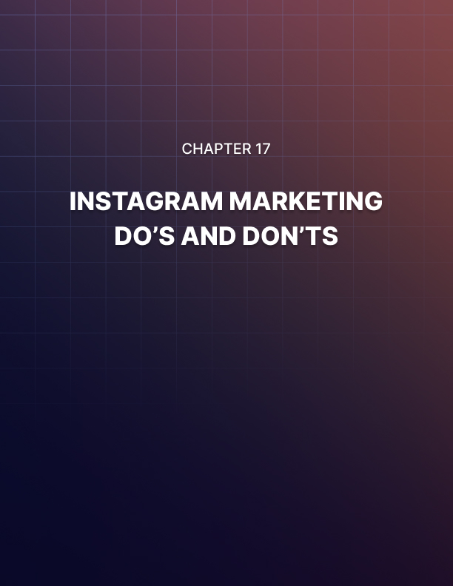

Chapter 17: Instagram Marketing Do’s And Don’ts

Do’s
Be Consistent
Post consistently and on a predictable basis to keep your followers engaged and glued to your account. Try sticking to a content schedule if possible.
Always Use The Link In Your Bio
You can’t add links to your Instagram posts, so it is a good idea to always use your bio to share your landing page URLs and to remind people to click by adding a call to action in your posts.
Ask Questions
Asking questions of your followers is a great form of engagement. Doing so strengthens your customer relationships, and makes your brand more likable.
Engage With Other Brands
People enjoy watching competing brands engaging on Instagram. Simply comment, like, and share stuff from your competitors to create more branded conversations.
Create A Unique “Brand Voice”
It is important that you develop a unique “voice” for your account. This is the way your brand “speaks” on Instagram, and it will help you to differentiate your account from the rest.
Share Motivational Stuff
Instagram users love motivational content. A motivational quote, image, or video about your brand will be enough to encourage users to share with their friends and followers.

Use All Available Tools
Instagram has a lot of amazing tools that will help you take your brand to the next level. From its powerful image editing tools to its engaging video formats, you’ll have a lot of fun trying every feature.
Promote Your Instagram Account
You can add shortcuts to your Instagram profile as well as a feed of your Instagram content on your website to promote your Instagram account there as well as on other channels.
Share Relatable Content
You can show a more casual side of your company by sharing content that is relatable, such as pictures of pets, your staff’s favorite dishes, music, and humor.
Try Alternative Engagement Techniques
You can create stories using elements such as polls, quizzes, and questions to engage users in a different, fun, and relevant way that will keep them coming back for more.

Don’ts
Don’t Over Post
Avoid posting too many times a day. It sounds like a good idea, but it can bore your audience, get you unfollowed, and create a reputation as spammer.
Don’t Ghost Your Audience
On the other hand, it isn’t a good idea to ghost your audience by not posting either. In fact, missing your regular posting frequency for a day or two can lower your relevance by a lot!
Don’t Be Salesy
Avoid using salesy language on Instagram. Don’t use calls-to-action urging people to buy. Instead, encourage people to visit your product pages by offering an incentive.

Don’t Share Stock Media
Never post stock images or videos on Instagram. Instagram users are put off by stock content because they’re there to see content that shows your brand’s authentic side.
Don’t Share Irrelevant Content
Don’t post content that isn’t relevant to your audience. While you can share offtopic content that your followers will enjoy, you have to avoid sharing stuff that’s too irrelevant.
Don’t Overuse Hashtags
You don’t have to use all 30 allowed hashtags just because. Using too many hashtags will just make your captions look crowded and disorganized.
Don’t Use Auto-Commenters
Instagram users can identify automated responses from a mile away. In fact, automated responses can cause people to dismiss your account as a spam account not worth their time.
Don’t Buy Followers And Engagement
This is a strategy that fails every time because the Instagram algorithm is really good at identifying artificial engagement bought to inflate metrics, and it can only help you to make your account irrelevant.
Don’t Argue With Users
Social media users can be really mean and rude at times, but that doesn’t mean that you have to reciprocate. Always reply professionally to rude comments no matter what!
Don’t Steal Content
If you’d like to share an image, video, caption, or quote that you think is cool, make sure to always ask for permission and to credit the original creator to keep your account in good standing!
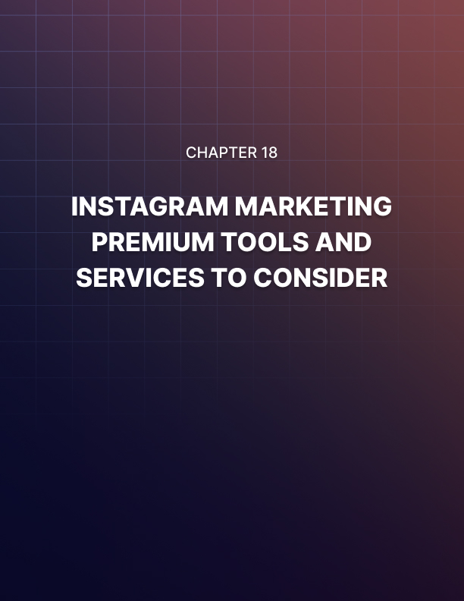

Chapter 18: Instagram Marketing Premium Tools And Services To Consider
Buffer
Buffer is a social media management tool that is perfect for Instagram Marketers. Buffer can help you to simplify your workflow because it provides you with tools to coordinate and schedule your Instagram posts. It also provides you with an accessible dashboard where you can reply to comments and other interactions directly from your desktop computer. Other Buffer features include the Stories planner, a programmable first comment for scheduled posts, a hashtag planner, and custom reports.
Foursixty
Foursixty is an amazingly different Instagram marketing tool that will allow you to turn content from your Instagram feed into cool shoppable experiences.
It works by integrating with your Instagram account to pull content such as product pictures and repurpose it as eCommerce galleries that look very similar to an Instagram feed.
Shoppers simply have to tap or click on one of the images and Foursixty will redirect them to a product page.
GRUM
GRUM is a dead simple Instagram scheduling tool that will help you to schedule your Instagram content right from the web.
With GRUM you will be able to schedule and publish photos and videos to multiple profiles at the same time, and also to manage an unlimited number of accounts at the same time. Other worthy GRUM features include tagging, desktop publishing, and a very intuitive interface.

Crowdfire
Crowdfire is a useful social media management and scheduling tool that can help you streamline your Instagram marketing activities.
It provides you with straightforward publishing and scheduling features, automated post formatting, custom scheduling according to time zone, and a special “scheduled content meter” that’ll help you know whether you have enough content scheduled each week! It also provides you with powerful analytics and mention tracking features!
Hootsuite
Hootsuite is a versatile social media management tool that is wildly popular among Instagram marketers thanks to its powerful host of features.
Hootsuite can help you to plan all your Instagram marketing content under a single collaborative calendar, to create unique and beautiful Instagram posts, to keep your content calendar active with automated posts that fill content gaps in your schedule, and much more!
Hopper
Hopper is a social media management tool that is made for businesses looking for a solution to simplify their Instagram marketing tasks.
With Hopper you can create up to 50 Instagram posts at once using bulk uploading, to set individual time zones for different accounts, and to integrate Instagram analytics and grid planning. It also provides you with features such as full image editing, reposting, and rescheduling!
Iconosquare
Iconosquare is a powerful analytics, social media management, and social media scheduling tool for brands, marketers, and agencies on Instagram.
You can use Iconosquare to predict the performance of your content through its insightful industry benchmarks, which automatically compares your content against content published by top-performing competitors, and it gives you detailed optimization suggestions to help you improve your content like a pro!

Combin
Combin is a dedicated Instagram marketing tool that provides you with great marketing and content planning solutions, which includes
Instagram audience growth, management, and attraction, post and story planning, multiple account management, engagement automation, outcoming and incoming activity monitoring, and more!
Later
Later is an amazing marketing platform for Instagram that will allow you to visually plan, schedule, and analyze posts for Instagram, and other platforms too!
With “Later” you’ll be able to plan up to a week of Instagram posts in 20 minutes or less using its powerful visual content calendar.
It will also let you preview your feed before you post, it will let you auto-publish without notifications required, it can help you to import media from anywhere, to find and repost user-generated content, and much, much more!
Linktree
Linktree is a useful tool that will allow you to create a custom link for your Instagram bio. What it does is to redirect users to a page where you can add links to all your other channels, or to more product pages, or to more landing pages. This is the perfect solution to bypass the one-link limitation!
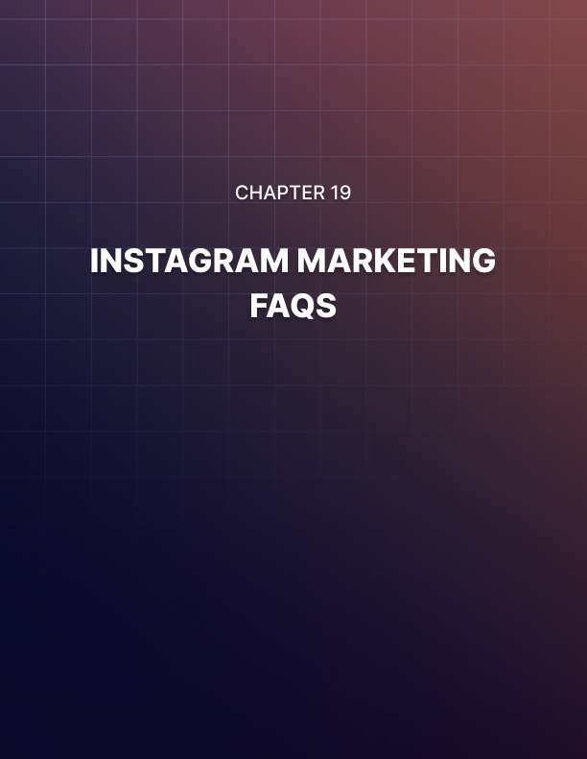

Chapter 19: Instagram Marketing FAQs
What’s The Advantage Of Instagram Marketing Over Other Platforms?
Instagram has been marketed since the very beginning as a platform where people go to see cool pictures and videos about stuff they like, and that’s the reason why it is such a good place to promote your products.
Instagram users are also more engaged than users on other social media platforms, and they check Instagram often.
Do You Need A Social Media Manager To Help You Out?
All the stuff you’ll learn in this training will help you to become your own social media manager, although you might want some help with Instagram marketing once your business scales.
A better solution would be to subscribe to a social media management platform. They’re easy to use, are much less expensive, and can align well to your marketing objectives on autopilot!
How Much Money Do You Have To Invest On Instagram Marketing?
You won’t need to invest much when you’re getting started beyond paying a good graphic designer to create a kick-ass logo and images for your profile as long as you apply all the strategies in this training.
You will need to invest some money down the line once you’re ready to scale, such as investing money on ads, or on influencers, but this isn’t as much money as you would spend on a dedicated social media manager.
Is Advertising A Good Alternative To Instagram Marketing?
Advertising your Instagram content is a complimentary activity to your overall Instagram marketing strategy. In other words, you can’t replace Instagram marketing with advertising, and you can’t stop marketing your brand on Instagram once you start running ads.
Remember, you are going to use advertising to increase your reach, drive more sales, and scale, and that’s just part of Instagram marketing.
What’s Another Great Complimentary Marketing Strategy For Instagram?
Blogging is a great complementary strategy because you can use it to create a loop that goes from your blog to your Instagram content and from your Instagram content back to your blog.
For example, you can produce images to share on Instagram, and create blog posts about those pictures as well. You can then upload one of those pictures to Instagram with a call to action inviting users to visit your blog through the link in your bio, and you can also embed the post with the picture into a blog post. That way you can generate traffic between both marketing channels.
What’s A Common Instagram Marketing Mistake?
Inconsistency is a very common mistake that can cost you the relevance of your account. To avoid this mistake, simply stick to a regular posting frequency, interact with followers when appropriate, and participate in trends when they’re hot. That’s how you let your followers know that your brand is active.
What Type Of Businesses Thrive On Instagram?
Any business with a visual appeal can thrive on Instagram easily. For example, eCommerce brands can thrive because Instagram is the perfect place to post nice product pics. Fitness brands can post videos and images that showcase their products being used during workouts or outdoors.
Businesses in the food industry, such as restaurants, breweries, or bakeries can also use Instagram to entice Instagram users with mouth-watering images and videos showing their products. Electronics stores can also leverage Instagram to upload sleek pictures of their products. In short, you can thrive as long as you have a cool product or service to show on camera.
What Type Of Businesses Would Have A Hard Time On Instagram?
Businesses that sell more abstract solutions, such as software or consulting companies, are going to find it difficult to promote their products or services on Instagram, and should in fact use other platforms instead.
Also business-to-business companies, which thrive in more professional and sales-oriented environments.
What Are Some Key Metrics To Pay Attention To?
Key metrics that are important to track on Instagram include “engagement per follower”, which tells you how much each individual follower interacts with your account, “follower growth”, which tells you the consistency at which your number of followers is growing, the number of comments received compared against your total number of followers, and “reach”.
Is SEO Essential On Instagram?
SEO isn’t as essential as is using hashtags correctly. This is because content on Instagram is indexed through hashtags. In other words, people will find your Instagram content when they use keywords that are included in your hashtags.

