TABLE OF CONTENTS
____
INTRODUCTION 4
THE INTERVIEW SUCCESS MINDSET 7
Understanding Interview Psychology 7
Building Unshakeable Confidence 9
Transforming Interview Anxiety 11
CRAFTING WINNING RESPONSES 15
Mastering Response Frameworks 15
Building Your Response Library 18
Advanced Response Optimization 20
THE POWER OF PERSONAL BRANDING 24
Building Your Professional Identity Foundation 24
Differentiating Your Brand in the Market 27
Creating Brand Consistency and Credibility 28
Activating Your Brand in Interviews 30
MASTERING NON-VERBAL COMMUNICATION 35
The Psychology of Non-Verbal Communication 36
Strategic Body Language for Interview Success 38
Vocal Presence and Paraverbal Communication 40
HANDLING TOUGH INTERVIEW SITUATIONS 45
Mastering the Art of Strategic Response 45
Navigating Complex Interview Formats 48
Strategic Salary Negotiations 50
YOUR PATH TO INTERVIEW MASTERY 54
Building Your Interview Excellence Framework 54
Creating Your Systematic Development Plan 56
Implementing Effective Feedback Systems 58

DISCLAIMER
____
The information provided in this ebook is intended solely for educational and informational purposes. The author does not accept any responsibility for the outcomes that may arise from the application of the material within. While efforts have been made to ensure the accuracy and relevance of the content, the author cannot be held accountable for any errors or omissions, or for any consequences resulting from the use or misuse of the information provided. The responsibility for any actions taken based on the information in this ebook lies solely with the reader.
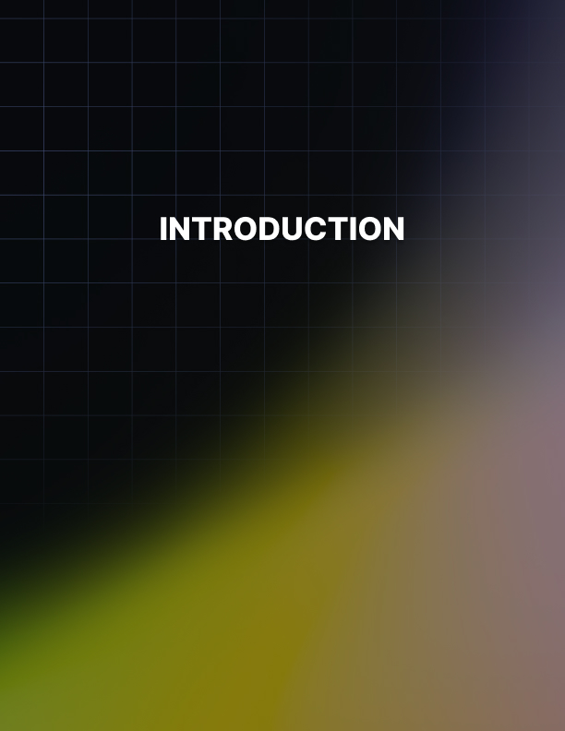

INTRODUCTION
____
The job interview stands as a critical turning point in your career journey, a moment where preparation meets opportunity and your future hangs in the balance. Whether you're a recent graduate stepping into your first professional role or an experienced professional seeking new challenges, mastering the art of interviewing can make the difference between landing your dream job and watching it slip away.
You might wonder why some candidates seem to breeze through interviews while others struggle, despite having similar qualifications. The truth is that successful interviewing isn't just about having the right skills or experience, but about knowing how to present yourself effectively, connect with interviewers, and showcase your unique value proposition. This book will help you transform from a nervous candidate into a confident professional who knows exactly how to navigate any interview situation.
Think of job interviews as performances where authenticity meets strategic communication. Every gesture, word, and response matters. You'll learn not just what to say, but how to say it in a way that resonates with hiring managers and makes them remember you long after the interview ends. The strategies and techniques shared in these pages have been refined through years of research and real-world application, helping countless professionals secure positions at their target companies.
One of the most powerful aspects of interview mastery is understanding that it's not about memorizing perfect answers or trying to be someone you're not. Instead, it's about developing a toolkit of proven techniques you can adapt to any situation while staying true to yourself. Through this book, you'll discover how to leverage your experiences, handle challenging questions with ease, and project the kind of confidence that makes hiring managers take notice.
Success in job interviews isn't left to chance. By approaching your interview preparation systematically and mastering the key elements that influence hiring decisions, you can significantly increase your chances of receiving that coveted job offer. Whether you're struggling with interview anxiety, unsure how to articulate your value, or simply looking to sharpen your interview skills, this book provides the guidance you need to excel in any interview setting.
Every successful professional was once in your position, facing the same challenges and uncertainties. What sets them apart is their commitment to mastering the interview process. Let this book be your guide to developing the skills, confidence, and presence needed to ace your next interview and secure the career opportunities you deserve.
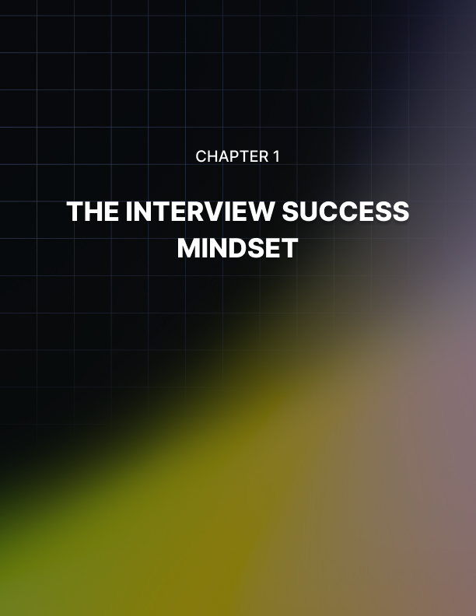

THE INTERVIEW SUCCESS MINDSET
____
Two candidates walk into separate interview rooms. Both of them possess identical qualifications and experience. But within an hour, their paths diverge dramatically. The first applicant exudes quiet confidence, engages naturally with her interviewer, and receives an offer. The second one, despite his credentials, appears tense and withdrawn, leading to a polite rejection.
The difference? Their mindset.
Research from Harvard Business School reveals that candidates who demonstrate genuine confidence and positive mindset are 42% more likely to receive job offers than equally qualified candidates who display anxiety or self-doubt. Your mental approach determines whether you'll forge meaningful connections with interviewers and showcase your authentic self.

Understanding Interview Psychology
Gone are the days when interviews resembled interrogations. Modern hiring practices focus on mutual exploration and cultural alignment. When you view an interview as a balanced conversation between professionals, you transform from a passive participant into an active contributor. This fundamental shift empowers you to engage more naturally, ask insightful questions, and evaluate whether the role truly matches your career aspirations.
Your perception profoundly influences how interviewers evaluate you. When you genuinely believe in your capabilities and value, this confidence radiates through your communication, body language, and overall presence.
James is a talented software developer who consistently underperformed in interviews despite his technical expertise. His breakthrough came when he identified his limiting belief that "interviewers are trying to trap me" was causing defensive behavior. When he reframed interviews as collaborative discussions about problem-solving, his demeanor transformed entirely. In his next interview, the same technical knowledge, presented with an open and engaged mindset, secured him the position.
Many candidates unknowingly sabotage their chances through deeply ingrained mental barriers. These psychological obstacles manifest in subtle ways:
- Fear of Rejection
This primal fear can cause you to play it safe, holding back valuable insights and unique perspectives that could set you apart.

- Imposter Syndrome
The nagging feeling that you're not qualified enough, despite evidence to the contrary, often leads to undervaluing your achievements.
- Perfectionism
The pursuit of flawless responses can paradoxically create stiff, rehearsed interactions that lack authenticity.
- Comparison Anxiety
Imagining how other candidates might perform can distract you from showcasing your unique value proposition.
- Past Interview Trauma
Previous negative experiences can create limiting beliefs that affect future performance unless consciously addressed.

Building Unshakeable Confidence
Authentic confidence differs markedly from arrogance. It stems from a deep understanding of your value proposition and a realistic assessment of your capabilities. This type of confidence acknowledges both strengths and areas for growth, making you more relatable and trustworthy to interviewers.
To build genuine interview confidence, start by conducting a thorough inventory of your professional journey. Document specific instances where you've overcome challenges, delivered results, or acquired unique insights. This evidence-based approach provides concrete material to support your confidence and combat self-doubt.

Pre-Interview Confidence Boosters
Transform interview anxiety into productive energy through systematic preparation:
- Physical Preparation
- Practice power posing in private spaces.
- Maintain good posture during preparation.
- Use controlled breathing exercises.
- Dress professionally but comfortably.
- Get adequate rest and nutrition.
- Mental Rehearsal
- Visualize successful interview scenarios.
- Practice responses while monitoring body language.
- Record and review mock interviews.
- Study company information thoroughly.
- Prepare relevant questions.
- Positive Affirmation
- Review past achievements.
- Focus on value contribution.
- Acknowledge preparation efforts.
- Maintain perspective about the opportunity.
- Remember past successes.
Timing | Activity | Purpose
Daily practice | Achievement review | Build confidence foundation
Week before | Company research | Develop knowledge confidence
Day before | Outfit preparation | Reduce morning stress
Morning of | Visualization exercise | Mental preparation
2 hours before | Power posing | Boost confidence hormones
1 hour before | Response practice | Polish presentation
30 minutes before | Breathing exercises | Calm nerves
10 minutes before | Success affirmations | Final mental boost

Transforming Interview Anxiety
Understanding the biology of interview stress helps you manage it effectively. When you feel nervous before an interview, your body activates its fight-or-flight response, releasing adrenaline and cortisol. This natural reaction can either enhance or impair your performance, depending on how you interpret and channel it.
A Harvard Business School study published in the Journal of Experimental Psychology shows that simply reframing anxiety as excitement can improve performance. Instead of trying to calm down, acknowledge the elevated energy and direct it toward engaging more dynamically with your interviewers. This mental shift transforms nervous energy from a liability into an asset.
Here are some quick anxiety management techniques for interview day:
- Box Breathing - Inhale for four counts, hold for four, exhale for four, and hold for four. Repeat.
- Grounding Exercise - Focus on five things you can see, four you can touch, three you can hear, two you can smell, and one you can taste.
- Progressive Muscle Relaxation - Systematically tense and relax muscle groups from toes to head.
- Positive Memory Anchor - Recall a specific moment of professional success.
- Reality Check - Remind yourself that this is one conversation in a long career.
- Power Walk - Take a brief, confident walk before entering the building.
- Mindful Observation - Focus on detailed observation of your surroundings to stay present.
Your mindset shapes every aspect of your interview performance, from how you prepare to how you respond in the moment. By developing a success-oriented mindset and implementing practical confidence-building techniques, you create a foundation for authentic, engaging interviews that showcase your true potential.
The goal isn't to eliminate nervousness but to channel it productively while remaining genuine and professional. As you move forward with your interview preparation, focus first on strengthening your mental approach.
The power to transform your interview experience lies within your mindset. Start small, practice consistently, and watch as your confidence grows with each interaction. Your next interview isn't just a test of your qualifications—it's an opportunity to demonstrate the unique value you bring to potential employers.
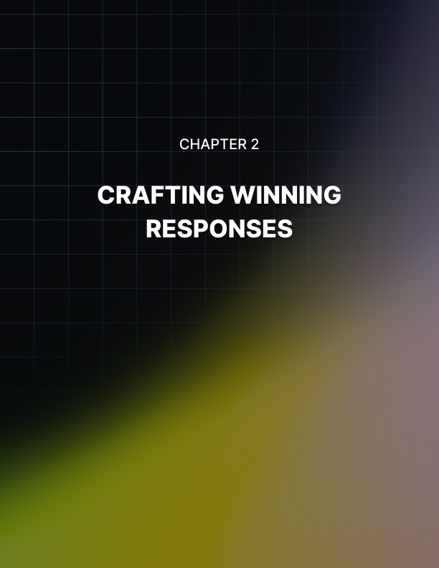

CRAFTING WINNING RESPONSES
____
Two senior marketing candidates face the same interview question: "Tell me about a campaign you led that delivered exceptional results." The first candidate stumbles through a scattered narrative about various projects, losing the interviewer's attention within seconds. The second candidate tells a compelling story about a specific digital campaign, methodically outlining the challenge, their strategic approach, and the measurable impact: increasing quarterly revenue by 47%. Despite similar experience levels, only one candidate successfully showcases their expertise.
Candidates who deliver structured, evidence-based responses are more likely to advance in the interview process. Your ability to articulate your experience through clear, compelling narratives directly impacts your success rate. Yet many candidates overlook this crucial skill, focusing solely on their qualifications while neglecting the art of presentation.

Mastering Response Frameworks
The foundation of effective interview communication lies in understanding and applying proven response frameworks. These structures help you organize your thoughts, maintain focus, and ensure you're hitting all crucial points while keeping the interviewer engaged. The most versatile and powerful of these frameworks is the STAR method.
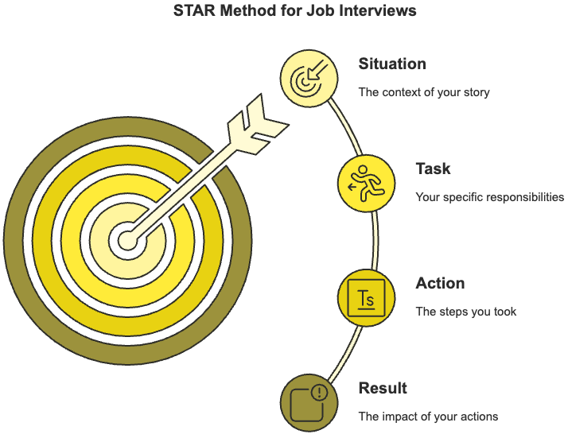
When applying the STAR method, see it as telling a professional story with four distinct chapters:
Your Situation sets the scene, providing essential context without unnecessary details. For example: "While managing the marketing team at TechCorp during our expansion into Asian markets..."
The Task clarifies your specific responsibility or challenge. Rather than saying, "I had to improve sales," be precise: "I was tasked with increasing our product adoption rate in the Singapore market by 25% within six months."
Your Action demonstrates your professional capabilities and decision-making process. Instead of generic statements like "I worked hard," detail your strategic approach: "I conducted in-depth market research, developed culturally-tailored messaging, and built partnerships with local influencers. I then implemented an integrated digital campaign across three platforms, continuously optimizing based on performance metrics."
The Result validates your impact through concrete outcomes. Replace vague claims like "it went well" with specific achievements: "The campaign exceeded targets by 40%, generating $2.3M in new revenue and establishing our brand as a category leader in the Singapore market."
Here’s a detailed comparison of unstructured versus STAR-formatted responses:
- Poor Response
"I've done lots of team leadership stuff. Like, we had this big project that was behind schedule, and I helped get everyone organized. We worked really hard and managed to finish it on time. The client was happy."
- STAR-Structured Response
"When I joined Project Atlas at Innovative Solutions , I inherited a 12-person development team that was six weeks behind schedule on a mission-critical client deliverable. I immediately conducted a team capabilities assessment, restructured our workflow using agile methodologies, and implemented daily progress tracking with clear accountability measures.
I also negotiated with stakeholders to reprioritize features, allowing us to focus on core functionality first. Through these changes, we delivered the essential features two weeks ahead of the revised deadline, achieved a 96% client satisfaction score, and improved team velocity by 40% compared to the previous quarter."

Building Your Response Library
Success in interviews requires more than understanding frameworks. You need a well-prepared collection of experiences that demonstrate your capabilities across various scenarios. Think of this as building a professional story portfolio that you can adapt and deploy based on different interview questions.
Start by analyzing common interview questions in your industry and identifying experiences that showcase relevant skills. For each experience, develop multiple versions that emphasize different aspects:
Leadership Example
- Version 1 - Focus on strategic decision-making.
- Version 2 - Emphasize team development.
- Version 3 - Highlight crisis management.
- Version 4 - Demonstrate change leadership.
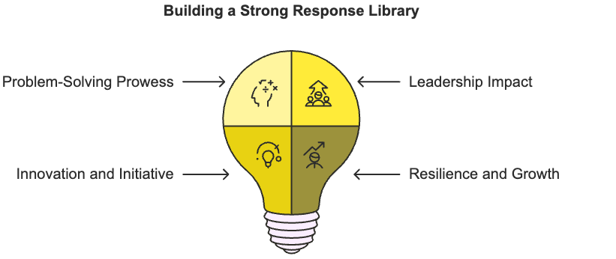
When building your response library, focus on experiences that demonstrate:
Problem-Solving Prowess - Document situations where you identified complex challenges and implemented effective solutions. Include details about your analytical process, resource management, and creative thinking.
Leadership Impact - Prepare stories that show different facets of your leadership style, from direct team management to influence without authority. Focus on how you motivated others, handled conflicts, and achieved results through collaboration.
Innovation and Initiative - Highlight instances where you introduced new ideas, processes, or technologies. Explain how you identified opportunities for improvement and successfully implemented changes.
Resilience and Growth - Share experiences where you faced setbacks, learned from failures, or adapted to unexpected challenges. These stories demonstrate emotional intelligence and professional maturity.
For each experience in your library, maintain detailed notes about:
- Quantifiable results and metrics
- Key decisions and their rationale
- Stakeholder management strategies
- Resources utilized and constraints
- Lessons learned and applications
- Potential follow-up question responses

Advanced Response Optimization
Mastering advanced response techniques elevates your interview performance from competent to compelling. These strategies help you connect with interviewers on a deeper level while showcasing your expertise.

Strategic Emphasis
Place your strongest points at the beginning and end of your responses, leveraging the psychological principles of primacy and recency. When discussing a successful project, open with its most impressive impact and close with the long-term benefits or lessons learned.

Contextual Adaptation
Customize your responses based on the interviewer's background and role. When speaking with:
- Technical leaders - Emphasize specific methodologies and tools
- C-level executives - Focus on business impact and strategic alignment
- HR professionals - Highlight people management and cultural fit
- Direct managers - Detail operational expertise and team dynamics

Language Precision
Replace weak or passive language with strong, active verbs that convey confidence and capability:
Instead of "I helped improve team performance"
Use "I transformed team performance by..."
Instead of "We made some changes to the process"
Use "I spearheaded process improvements that..."

Narrative Arc
Structure your responses to create engagement and maintain interest.
- Hook - Start with an attention-grabbing statement.
- Context - Provide necessary background quickly.
- Conflict - Present the challenge or opportunity.
- Resolution - Detail your actions and approach.
- Impact - Share concrete results and implications.
Remember to weave company research into your responses naturally. If you know the organization values innovation, emphasize how your experiences align with this priority. When describing results, frame them in terms relevant to the company's current challenges or goals.
Your ability to craft compelling interview responses directly impacts your career trajectory. By mastering response frameworks, building a robust experience library, and implementing advanced optimization techniques, you transform your interview performance from adequate to exceptional. Focus on developing responses that not only answer questions but also showcase your unique value proposition and potential contribution to the organization.
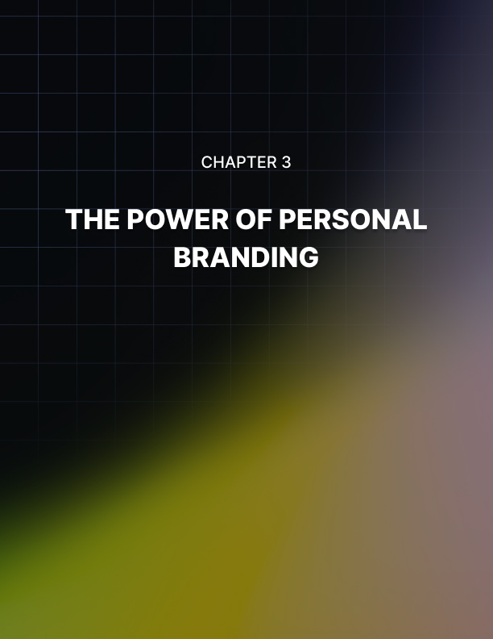

THE POWER OF PERSONAL BRANDING
____
Your personal brand isn't just about self-promotion. It's about authentically communicating your unique value proposition in a way that resonates with potential employers.
Research from LinkedIn's Talent Solutions reveals that candidates with a strong, consistent personal brand are 58% more likely to secure job offers than equally qualified competitors. Additionally, hiring managers spend 31% more time reviewing LinkedIn profiles of candidates who have developed a clear professional narrative.

Building Your Professional Identity Foundation
Creating a compelling professional identity requires deep self-reflection and strategic positioning. Many candidates make the critical mistake of projecting what they believe employers want to hear rather than developing an authentic brand that showcases their genuine strengths and perspectives. This approach invariably falls flat during interviews, as hiring managers are skilled at detecting misalignment between claimed and actual professional identities.
Take Sarah's transformation as an example. As a marketing professional, she initially presented herself as a generalist, believing versatility would appeal to employers. Her interviews felt scattered and unconvincing because she couldn't speak with genuine passion about any particular aspect of her work.
Through careful introspection and market analysis, she identified her true strength: leveraging data analytics to craft emotionally resonant campaigns. This authentic core became the foundation of her professional identity, allowing her to speak with natural enthusiasm and back her claims with specific examples that demonstrated both technical expertise and creative insight.
The foundation of your professional identity emerges from four key elements that must align cohesively.
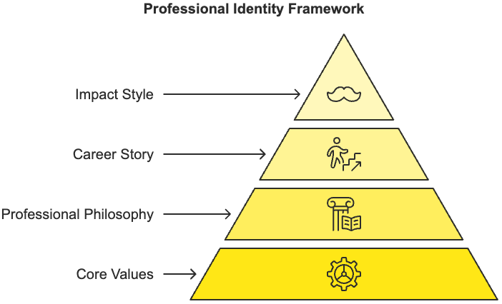
Your core values represent the fundamental principles guiding your professional decisions and actions. These might include innovation, integrity, collaboration, or continuous learning. More importantly, you must be able to demonstrate how these values have influenced your career choices and professional achievements.
Your professional philosophy encompasses your unique perspective on your field and approach to challenges. This could be your commitment to agile methodologies, user-centered design, or data-driven decision-making. The key is articulating not just what you believe but why you believe it and how it has proven effective in your work.
Your career story connects your experiences into a meaningful progression that showcases your growth and direction. Rather than presenting a chronological list of roles, focus on the pivotal moments and decisions that shaped your professional journey. Include challenges overcome, lessons learned, and how each experience built upon previous ones to create your current expertise.
Your impact style describes your distinctive way of creating value and driving results. Some professionals excel at building and motivating teams, while others might shine at solving complex technical challenges or fostering innovation. Understanding and articulating your impact style helps potential employers envision how you would contribute to their organization.

Differentiating Your Brand in the Market
Standing out in today's competitive job market requires more than just solid qualifications. Your personal brand must create meaningful differentiation that makes you memorable and valuable to potential employers. This differentiation should stem from authentic aspects of your professional identity rather than manufactured uniqueness.
Marcus, a senior software engineer, exemplifies effective brand differentiation. Instead of focusing solely on his technical expertise, he positioned himself as a "developer-educator" who elevated entire engineering teams through knowledge sharing and mentorship. This authentic differentiator, supported by specific examples of team members he had mentored and documentation systems he had created, set him apart from equally qualified candidates who emphasized only their coding abilities.
Your professional narrative should weave together your experiences into a compelling story that demonstrates your unique value. This narrative must highlight pivotal moments that shaped your professional perspective, demonstrate consistent growth and learning, illustrate your problem-solving approach through specific examples, connect past experiences to future aspirations, and reflect your authentic professional values.
Jennifer's story illustrates the power of transforming potential negatives into brand strengths. Rather than downplaying her experiences with startup failures, she incorporated them into a powerful narrative about resilience and innovation: "Each setback taught me invaluable lessons about product-market fit and team dynamics. These insights now inform my approach to product development, helping me identify potential pitfalls early and build more sustainable solutions."

Creating Brand Consistency and Credibility
Your personal brand must maintain consistency across all professional interactions while adapting to different contexts and audiences. This consistency builds trust and reinforces your message throughout the interview process, from initial application to final negotiations.
Start by ensuring your digital presence aligns with and reinforces your brand message. Your LinkedIn profile should serve as a cornerstone of your online brand, with a compelling headline, summary, and experience descriptions that reflect your core message and professional narrative.
Your professional portfolio, if applicable, should showcase work samples that demonstrate your unique approach and expertise. Published content, whether blog posts, articles, or professional social media engagement, should consistently support your brand positioning and thought leadership.
Your brand communication strategy should extend beyond digital presence to encompass all interview-related interactions. Use your cover letter and initial communications to introduce key elements of your brand story.
During interviews, ensure your responses consistently reflect your core value proposition while adapting to specific question contexts. Follow-up communications should reinforce your brand message by referencing specific discussions that align with your professional identity.
Building brand credibility requires more than consistency; it demands authentic demonstration of your claimed expertise and values. Develop a comprehensive evidence bank that supports your brand claims:
- Professional achievements that demonstrate your impact and approach.
- Client or colleague testimonials that validate your working style.
- Industry recognition or certifications that support your expertise claims.
- Thought leadership content that showcases your insights and perspectives.
- Quantifiable results that prove your effectiveness.
Your personal brand must evolve with your career while maintaining core authenticity. Regularly assess and refine your brand strategy by tracking interview feedback patterns, monitoring responses to different brand elements, gathering input from your professional network, analyzing which stories and examples resonate most, and assessing alignment between your intended and perceived brand.
Remember to prepare audience-specific variations of your brand message that maintain consistency while addressing the particular concerns and interests of different stakeholders. Technical leaders may want to dive deep into methodologies and tools, while C-level executives might focus more on strategic impact and business alignment.
As you move forward in your interview preparation, focus on authentically communicating your unique value proposition while maintaining consistency across all touch points. Your personal brand should serve as a framework that makes your professional story memorable and compelling to potential employers.

Activating Your Brand in Interviews
The true test of your personal brand comes during face-to-face interactions where every response and gesture either reinforces or undermines your professional identity. Successful brand activation requires careful preparation and strategic implementation across different interview scenarios.
Rachel, a product marketing manager, activated her brand during a series of interviews. She positioned herself as a "consumer insight specialist who transforms customer feedback into product innovations." Throughout her interviews, she consistently demonstrated this expertise by:
- Referencing specific instances where customer insights led to successful product improvements.
- Sharing her unique methodology for gathering and analyzing customer feedback.
- Discussing how she built cross-functional relationships to implement customer-driven changes.
- Showing examples of how she communicated complex customer data to different stakeholders.
Her brand activation was so effective that the hiring manager specifically mentioned her clear value proposition when extending the offer.
To successfully activate your brand during interviews, develop a strategic framework that includes:
- Situation-Specific Examples
Create a library of professional stories that demonstrate different aspects of your brand. Each story should be adaptable for various interview questions while consistently reinforcing your core value proposition.
- Brand Language
Develop a set of powerful phrases and terms that effectively communicate your professional identity. These should feel natural and authentic rather than rehearsed or promotional.
- Value Demonstrations
Prepare concrete ways to demonstrate your expertise during interviews, such as sharing relevant industry insights or offering thoughtful solutions to current challenges.
- Cultural Alignment
Research the organization's values and culture thoroughly, then prepare specific examples showing how your brand aligns with and could enhance their environment.
Brand activation becomes particularly powerful when you can adapt your message for different interview stages and stakeholders while maintaining consistency. Your personal brand truly crystallizes when you can seamlessly shift emphasis between your technical prowess for technical interviewers and your business impact for executives, all while staying rooted in your authentic professional identity.
With HR Representatives:
- Focus on cultural fit aspects of your brand.
- Highlight interpersonal skills and team contributions.
- Demonstrate alignment with company values.
With Technical Managers:
- Emphasize specific methodologies and tools within your expertise.
- Share detailed examples of problem-solving approaches.
- Discuss technical leadership experiences.
With Executive Leadership:
- Connect your brand to strategic business objectives.
- Focus on measurable impact and results.
- Demonstrate big-picture thinking and vision.
Your brand activation should create memorable moments that stick with interviewers long after the conversation ends. These moments often come from:
- Unexpected insights that showcase your unique perspective
- Compelling stories that perfectly illustrate your value
- Thoughtful questions that demonstrate strategic thinking
- Creative solutions to current challenges
- Authentic passion for your area of expertise
Effective personal branding in interviews isn't about perfect polish—it's about authentic alignment between who you are, what you offer, and what the organization needs. As you prepare for your next interview, focus on developing a brand that genuinely reflects your professional identity while creating meaningful differentiation in the market. Your success depends not just on what you know, but on how effectively you communicate your unique value to potential employers.
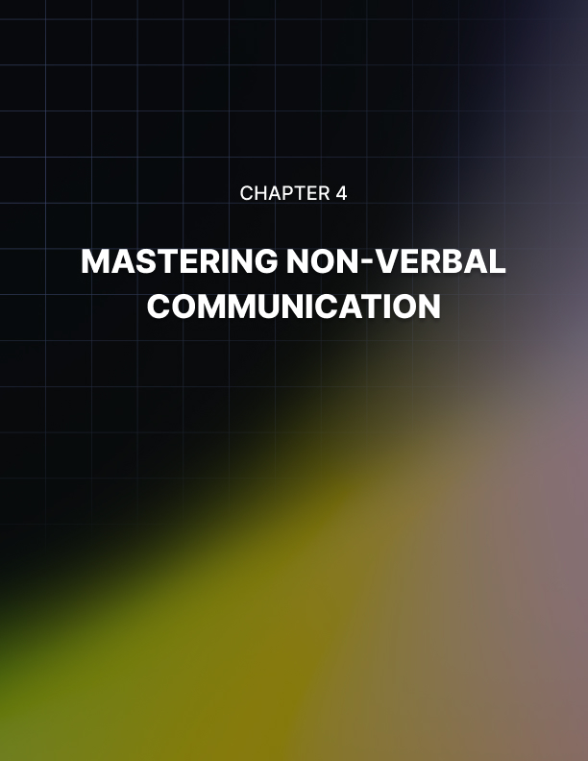

MASTERING NON-VERBAL COMMUNICATION
____
A single glance. A subtle shift in posture. The slightest change in vocal tone. Within seconds of entering an interview room, these non-verbal signals create powerful first impressions that can overshadow even the most carefully prepared responses.
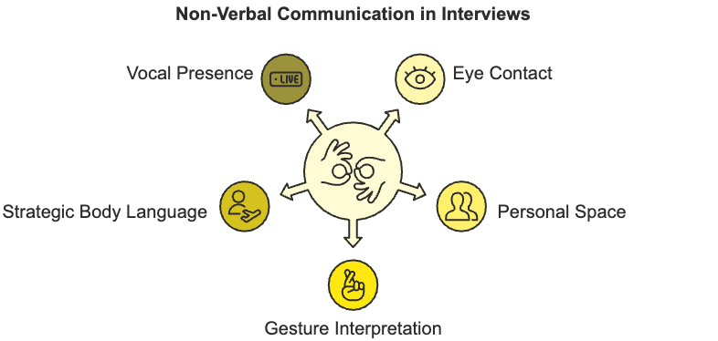
Research from UCLA reveals that 93% of communication effectiveness stems from non-verbal cues, while a mere 7% comes from the actual words spoken. For job seekers, mastering this silent language of success often determines whether their qualifications translate into job offers.

The Psychology of Non-Verbal Communication
Your brain processes non-verbal signals faster than conscious thought, forming instant judgments about credibility, confidence, and competence. This evolutionary trait, developed over millions of years before spoken language, continues to drive our social interactions and decision-making. In the high-stakes environment of a job interview, these split-second assessments can determine your fate before you've completed your first response.
Understanding the science behind non-verbal communication reveals why it carries such weight in professional interactions. Your brain contains specialized neurons called mirror neurons that automatically simulate the emotional states we observe in others. When you display confident body language, these neurons trigger similar confidence-related responses in your interviewer's brain. Conversely, nervous gestures or uncertain expressions can activate doubt or discomfort in observers.
This neurological mirroring explains why authentic confidence proves more powerful than rehearsed behaviors. Your genuine emotional state creates a cascade of subtle, unconscious signals that either align with or contradict your intended message.
Imagine how a candidate claiming leadership experience while displaying submissive body language sends conflicting signals that trigger doubt in observers. How do you think their interviewer will perceive them?
The impact of non-verbal communication varies across cultures, adding another layer of complexity to interview interactions. Significant differences in how non-verbal cues are interpreted exist across various cultures and communication contexts.

Eye Contact Norms
While sustained eye contact suggests confidence and honesty in Western cultures, it may be considered aggressive or disrespectful in parts of Asia and Africa. Understanding appropriate gaze patterns for your interview context prevents unintended negative signals.

Personal Space
The comfortable distance for professional interaction varies dramatically between cultures. North Americans typically maintain about 4 feet of personal space in business settings, while Middle Eastern cultures often prefer closer proximity. Mismatched distance expectations can create unconscious tension.

Gesture Interpretation
Common gestures carry different meanings across cultures. The "thumbs up" sign, viewed positively in America, is considered offensive in parts of the Middle East. Similarly, head nodding indicates agreement in most Western cultures but can signal disagreement in Bulgaria.
Professional presence emerges from the alignment of multiple non-verbal channels. When verbal content matches non-verbal signals, message impact tends to increase significantly. This alignment encompasses:
- Physical Presence - How you occupy space and move through it
- Facial Communication - Your expression patterns and emotional signals
- Gestural Language - How you use your hands and body to emphasize points
- Vocal Qualities - The paraverbal aspects of speech like tone, pace, and volume
- Proxemic Behavior - How you manage personal space and positioning
- Appearance Signals - Your grooming, attire, and overall professional presentation

Strategic Body Language for Interview Success
Your body language creates an immediate visual story about your confidence, competence, and character. Research from Harvard Business School demonstrates that candidates who display confident, open body language are 61% more likely to receive positive interviewer ratings than those showing closed or uncertain postures.
Developing powerful body language requires understanding the key components of non-verbal presence.

Posture Architecture
Your physical bearing serves as the foundation of non-verbal communication. Proper posture involves more than simply sitting up straight—it requires conscious alignment of your entire physical structure.
Keep your feet firmly planted on the floor, spine elongated, shoulders relaxed and back, and chin level. This position optimizes breathing, projects confidence, and creates an impression of engaged presence.

Gesture Eloquence
Your hand movements either enhance or detract from your message. Effective gestures remain within the "gesture box," the area from your shoulders to your waist, extending slightly beyond your torso width.
Keep movements deliberate and purposeful, using open palm gestures to convey honesty and upward movements to emphasize positive points. Avoid self-touching behaviors like fixing clothes or touching your face, as these signal nervousness.

Facial Animation
Your face communicates emotional intelligence and interpersonal awareness. Practice maintaining appropriate facial responsiveness: showing genuine interest through subtle eyebrow movements, balanced smiling, and engaged expressions. Avoid extreme expressions or frozen features, as these create impressions of either emotional volatility or disconnection.
Understanding the power dynamics of body language allows you to project authority while maintaining approachability. Several key non-verbal dominance behaviors have been identified that effectively convey professional confidence in workplace settings, such as:
- Claiming appropriate physical space through relaxed, open posture
- Using measured movements that suggest unhurried confidence
- Maintaining level eye contact without staring or avoiding
- Speaking with well-modulated vocal tone and strategic pausing
- Demonstrating emotional control through balanced expressions
- Mirroring interviewer's positive non-verbal signals

Vocal Presence and Paraverbal Communication
Your voice serves as a powerful tool for conveying confidence, expertise, and emotional intelligence. Vocal qualities like pitch, pace, and volume have been seen to significantly impact how others perceive your competence and credibility. Many candidates focus exclusively on their words while neglecting these crucial paraverbal elements.

Vocal Presence
Developing strong vocal presence requires mastering several key components:
- Voice Production
Proper breathing forms the foundation of powerful speech. Practice diaphragmatic breathing to support your voice, allowing you to project clearly without strain. This involves breathing deeply into your abdomen rather than shallow chest breathing. Regular practice helps this breathing pattern become automatic, supporting consistent vocal performance under pressure.
- Pitch Modulation
Your vocal pitch affects how authoritative and confident you sound. While slightly lower pitch generally conveys more authority, extreme lowering sounds unnatural. Find your optimal pitch range through practice, and learn to vary pitch naturally for emphasis without falling into monotone delivery or upspeak patterns.
- Pace Control
Speaking rate directly impacts how others process your message. However, strategic variation in pace creates engagement and emphasis. Practice speeding up slightly for less important details and slowing down for key points.
- Resonance Development
A well-resonated voice carries better and sounds more professional. Focus on speaking with chest resonance rather than nasal or throat tension. Regular exercises like humming scales and sustained vowels help develop fuller resonance.

Vocal Patterns
Common vocal patterns that undermine interview performance include:
- Upspeak
Ending statements with rising intonation makes declarations sound like questions and suggests uncertainty. Practice maintaining downward inflection at sentence endings to convey confidence.
- Vocal Fry
This creaky voice quality often occurs when speaking without proper breath support. It can signal disengagement or lack of energy. Maintain consistent breath support and adequate volume to avoid this pattern.
- Speed Racing
Speaking too quickly suggests nervousness and makes it difficult for interviewers to process responses. Use strategic pausing and measured pace to demonstrate thoughtful communication.
Your mastery of non-verbal communication directly impacts interview success. Focus on developing natural alignment between your physical presence, facial expressions, gestures, and vocal qualities.
Authentic confidence flows from thorough preparation and genuine professional capability. Practice these elements regularly, but avoid becoming so focused on technique that you lose natural engagement. Your next interview provides an opportunity to demonstrate not just what you know, but how effectively you can connect and communicate with others.
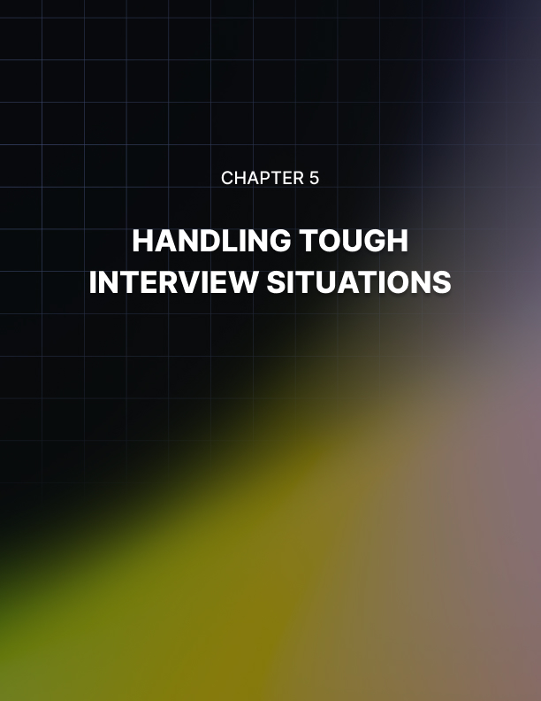

HANDLING TOUGH INTERVIEW SITUATIONS
____
You sit across from five stern-faced executives, your heart racing as they fire an unexpected question about a major professional failure. Instead of letting anxiety take control, you take a deliberate breath and share an authentic story about growth through adversity. This moment—your response to intense pressure—will determine your success more than any qualification on your resume.
Research from the Journal of Applied Psychology reveals that candidates who demonstrate composure and strategic thinking during challenging interview situations are 72% more likely to receive job offers than those who become flustered or defensive. As workplace dynamics grow increasingly nuanced, employers specifically design interview processes to test your ability to handle pressure, uncertainty, and complex conversations. Your success hinges not just on what you know, but on how effectively you navigate these pivotal moments.

Mastering the Art of Strategic Response
When faced with unexpected questions, remember that interviewers often care more about your thought process and composure than the specific answer. They're evaluating your ability to think critically under pressure, structure complex thoughts in real-time, and demonstrate emotional intelligence while maintaining professionalism.
Matthew is a software engineering leader interviewing for a CTO position. When asked to explain blockchain technology to a five-year-old, he initially felt thrown off balance. Instead of panicking, he employed the PAUSE method:
- Pause to breathe and collect thoughts.
- Acknowledge the creative nature of the question.
- Understand the core concept needed.
- Structure a simple, relatable analogy.
- Engage the interviewer with interactive explanations.
He transformed a potentially stressful moment into a compelling demonstration of his ability to communicate complex ideas clearly: "Imagine you and your friends have a special notebook where you write down all your toy trades. Everyone has their own copy of this notebook, and whenever someone makes a trade, everyone writes it down. This way, nobody can cheat or forget what trades happened."
Matthew’s ability to break down complex technology into accessible concepts while maintaining professional poise impressed the panel more than any technical jargon could have.
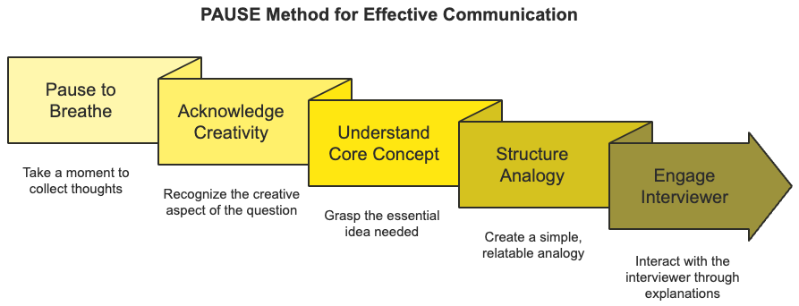
The key to handling unexpected questions lies in developing a robust framework for managing surprises effectively. Your response should demonstrate:
- Critical Thinking Under Pressure
Show your ability to analyze complex situations quickly and develop structured responses. Rather than rushing to answer, take a moment to organize your thoughts and approach the question systematically.
- Emotional Intelligence
Maintain awareness of both your emotional state and the interviewer's perspective. If a question touches on sensitive topics, acknowledge any discomfort while maintaining professional composure.
- Adaptability
Demonstrate your ability to pivot and reframe challenges into opportunities. When faced with questions that could highlight potential weaknesses, show how you've grown from past experiences.
- Professional Integrity
Never sacrifice honesty for expedience. If you don't know something, acknowledge it while explaining how you would find the answer or develop the needed expertise.

Navigating Complex Interview Formats
Modern hiring processes often involve multiple interview formats, each requiring specific preparation and strategies. Understanding how to navigate these various scenarios significantly improves your chances of success.

Panel Interviews: Managing Multiple Stakeholders
Panel interviews test your ability to engage multiple decision-makers while maintaining consistent professional presence. Success requires mastering several key elements:
- Engagement Distribution
Make initial eye contact with the questioner, then systematically engage other panel members while responding. This demonstrates inclusive communication skills and confidence. Move your gaze naturally between panel members, spending slightly more time with the primary questioner but ensuring everyone feels included.
- Energy Management
Maintain consistent energy levels throughout the session, using brief pauses between questions to reset and refocus. This demonstrates professional stamina and emotional regulation. Pay attention to your posture and voice projection, ensuring you remain engaging even after multiple rounds of questioning.
- Question Management
Address multi-part questions systematically, ensuring comprehensive responses while maintaining clarity. Take brief notes if necessary to track complex queries, and don't hesitate to ask for clarification when needed. This shows both attention to detail and confidence in managing complex communication.
- Conflict Navigation
When panel members express different viewpoints, acknowledge various perspectives while maintaining your professional stance. This demonstrates diplomatic skills and strategic thinking. Use phrases like "That's an interesting perspective. In my experience..." to show respect for differing views while standing firm on your expertise.

Virtual Interview Excellence
Remote interviews have become permanent fixtures in hiring processes, requiring specific preparation and execution strategies. Beyond basic technical setup, consider:
- Environmental Control
Create a professional background that reflects your personal brand while minimizing distractions. Test lighting and audio quality thoroughly. Your background should be clean and professional without being sterile. Natural light positioned correctly can significantly improve how you appear on camera.
- Digital Presence
Practice "camera presence" by recording yourself and analyzing your virtual impact. Pay attention to facial expressions, gestures, and energy projection through the screen. Camera angles can affect how you're perceived, so position your camera at eye level and maintain appropriate distance.
- Technical Backup
Prepare contingency plans for technical issues, including backup internet connections and alternative contact methods. Have a phone ready with hotspot capability, and ensure you have the interviewer's contact information readily available.

Strategic Salary Negotiations
Compensation discussions require balancing assertiveness with diplomacy. Candidates who prepare thoroughly for salary negotiations are more likely to secure higher compensation packages than those who approach these conversations casually. Your approach to compensation discussions should evolve throughout the interview process.

Early Stages
Focus on understanding the role and responsibilities completely before engaging in salary discussions. When asked about compensation expectations early in the process, redirect the conversation to ensure mutual fit first: "I'm excited to learn more about the role and how I can contribute to your team's success. Once we establish mutual fit, I'm confident we can find compensation that works for both parties."

Mid-Process
Begin gathering specific information about the role's scope and expectations. Research industry standards and prepare target ranges based on:
- Market data for similar positions
- Your experience level and unique expertise
- The company's size and industry
- Geographic location and cost of living
- Total compensation package elements

Final Stages
Present research-backed salary expectations confidently. Frame the discussion around value creation rather than just compensation.
Use specific examples of past achievements to support your desired range: "In my current role, I implemented process improvements that reduced costs by 23% annually. I'm excited to bring similar innovations to your team."
Salary negotiation extends beyond base pay. Consider the entire compensation package, including:
- Equity or stock options
- Performance bonuses
- Professional development budgets
- Flexible work arrangements
- Healthcare and retirement benefits
- Paid time off and work-life balance policies
As you progress through increasingly challenging interview situations, remember that each difficult moment presents an opportunity to demonstrate your value and professional capability. Focus on maintaining authenticity while showcasing your ability to handle complex situations with grace and strategic thinking. Your success in navigating these challenges will set you apart in today's competitive job market.
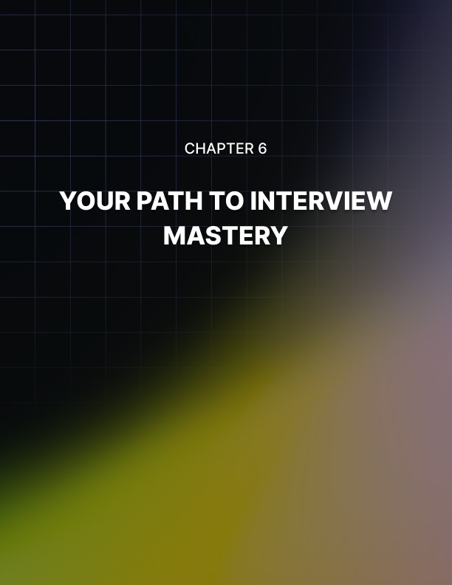

YOUR PATH TO INTERVIEW MASTERY
____
You walk out of another successful interview, feeling energized rather than drained. Six months ago, this scenario seemed impossible. Back then, each interview felt like crossing a minefield. One wrong step could trigger disaster.
Today, you navigate these conversations with natural confidence, turning challenging questions into opportunities to showcase your expertise. This transformation didn't appear magically. It emerged through deliberate practice and systematic skill development.

Building Your Interview Excellence Framework
Mastering interviews requires more than memorizing standard responses or practicing power poses. You need a holistic approach that integrates mindset management, structured responses, personal branding, non-verbal communication, and challenge handling into a cohesive system for continuous improvement.
Your interview skills are like an intricate ecosystem where each element supports and enhances the others. When you strengthen your confidence through deliberate practice, your non-verbal communication naturally becomes more assured. This improved presence helps you handle challenging questions more effectively, creating a positive feedback loop that elevates your overall performance.
Your journey toward interview excellence progresses through distinct stages. Each transition between these stages represents a significant shift in both your interview capabilities and your professional self-concept, marked by increasingly sophisticated integration of skills and strategic awareness.
At the foundation level, you focus on basic competencies:
- Managing interview anxiety
- Providing clear, structured responses
- Maintaining professional presence
- Understanding common question types
- Developing initial confidence
The intermediate stage brings more sophisticated capabilities:
- Crafting compelling professional narratives
- Projecting authentic confidence
- Handling unexpected challenges
- Building rapport with interviewers
- Demonstrating strategic thinking
At the advanced level, you develop mastery in:
- Creating genuine connections
- Adapting fluidly to different contexts
- Transforming challenges into opportunities
- Leading conversations strategically
- Showcasing thought leadership
Consider Elena's transformation from intermediate to advanced interviewee. As she developed deeper confidence in her professional narrative, her body language naturally became more assured. This increased presence helped her handle challenging questions more effectively, creating a virtuous cycle of improvement. She discovered that enhancing one aspect of her interview performance naturally elevated others, accelerating her overall progress.

Creating Your Systematic Development Plan
Effective interview mastery requires treating each interview as a learning opportunity, not just a test of your current abilities. See yourself as an athlete preparing for competition, where each practice session and performance provides valuable data for improvement.
Start by conducting a thorough self-assessment across key competency areas:
- Response Quality
How effectively do you structure and deliver your professional stories? Record yourself answering common interview questions and analyze your responses for clarity, impact, and engagement. Look for opportunities to strengthen your examples with specific metrics and memorable details.
- Personal Presence
How confidently do you carry yourself in professional situations? Practice your interviews on video to evaluate your body language, vocal tone, and overall energy. Pay attention to subtle signals that might undermine your authority or credibility.
- Strategic Thinking
How well do you understand and address the underlying concerns behind interview questions? Review your past interviews to identify moments where you could have demonstrated deeper insight into business challenges or organizational needs.
- Adaptability
How effectively do you adjust your approach for different interview formats and audiences? Practice modifying your communication style for technical interviews, behavioral assessments, and executive conversations.
Robert's journey illustrates this systematic approach. As a project manager transitioning to product leadership, he recognized that while his technical expertise was solid, his strategic vision needed strengthening. He focused on developing stories that demonstrated business impact while maintaining his existing strengths in operational details. This targeted approach helped him secure a senior product role that previously seemed out of reach.
Your development plan should balance immediate interview preparation with long-term professional growth. Consider both tactical skills for upcoming interviews and strategic capabilities that will serve you throughout your career.
Near-term tactical focus areas:
- Refining your response frameworks
- Building industry-specific examples
- Enhancing virtual interview presence
- Strengthening salary negotiation tactics
Long-term strategic development:
- Building thought leadership
- Developing executive presence
- Expanding professional networks
- Deepening industry expertise

Implementing Effective Feedback Systems
Interview mastery demands reliable mechanisms for gathering and applying feedback about your performance. While direct feedback from interviewers often remains limited, you can create multiple channels for gaining valuable insights.

Self-Assessment Protocol
Immediately after each interview, conduct a thorough review of your performance. Document specific aspects:
- Questions that triggered uncertainty
- Moments where your energy fluctuated
- Stories that resonated strongly
- Interviewer reactions to specific examples
- Technical topics requiring deeper preparation

Professional Network Feedback
Build relationships with mentors and peers who can provide honest feedback about your interview approach. Consider organizing a practice group where members can:
- Conduct mock interviews under realistic conditions
- Share industry insights and trends
- Review and refine response strategies
- Provide constructive criticism
- Discuss emerging interview requirements

Market Intelligence
Develop relationships with trusted recruiters and industry professionals who can provide broader context about evolving interview expectations, such as:
- Current market demands
- Industry-specific requirements
- Emerging skill requirements
- Salary trends
- Hiring process evolution
David's experience demonstrates how systematic feedback collection transforms performance. After implementing a structured review process, he identified patterns in his responses that needed refinement. Within three months, he noticed significant improvements, particularly in maintaining energy throughout extended interview sessions and handling technical discussions with greater confidence.
The path to interview mastery requires dedication to continuous improvement and willingness to learn from every experience. Your journey will evolve as you grow professionally and adapt to changing market demands. Focus on systematic skill development, gather reliable feedback, and maintain your commitment to growth. With each interview, you build not just interview capability but broader professional competence that serves you throughout your career.
Remember, true interview mastery isn't about achieving perfection—it's about developing the capability to consistently present your authentic professional self while continuing to learn and adapt. Stay committed to your development journey, remain open to feedback, and keep pushing the boundaries of your capabilities.

