TABLE OF CONTENTS
____
INTRODUCTION 5
YOUR FIRST IMPRESSION MATTERS 8
The Anatomy of an Attention-Grabbing Headline 8
The Psychology Behind Compelling Headlines 9
Crafting Your Headline 10
Common Pitfalls and Proven Formulas 11
CRAFTING IRRESISTIBLE INVITATIONS 14
The Power of Persuasive CTAs 14
The Anatomy of an Effective CTA 15
The Psychology Behind Effective CTAs 16
CTA Techniques and Common Mistakes 17
Testing, Optimizing, and Measuring CTA Success 18
BUILDING TRUST AND CONNECTION 23
The Power of Narrative Consistency 24
Addressing Concerns and Objections Proactively 24
Leveraging Social Proof and Testimonials 25
Creating Emotional Connections Through Storytelling 25
The Art of Persuasive Language 26
PSYCHOLOGY OF PERSUASION 32
The Foundation of Persuasion 32
Advanced Psychological Triggers 34
Crafting Psychologically Persuasive Copy 35
The Future of Persuasive Psychology in Digital Marketing 36
RECAP AND ROADMAP TO COPYWRITING MASTERY 40
The Power of Integration 40
Putting Theory into Practice 41
Developing Your Unique Voice 42
Expanding Your Toolkit 43
The Power of Simplicity 44

DISCLAIMER
____
The information provided in this ebook is intended solely for educational and informational purposes. The author does not accept any responsibility for the outcomes that may arise from the application of the material within. While efforts have been made to ensure the accuracy and relevance of the content, the author cannot be held accountable for any errors or omissions, or for any consequences resulting from the use or misuse of the information provided. The responsibility for any actions taken based on the information in this ebook lies solely with the reader.

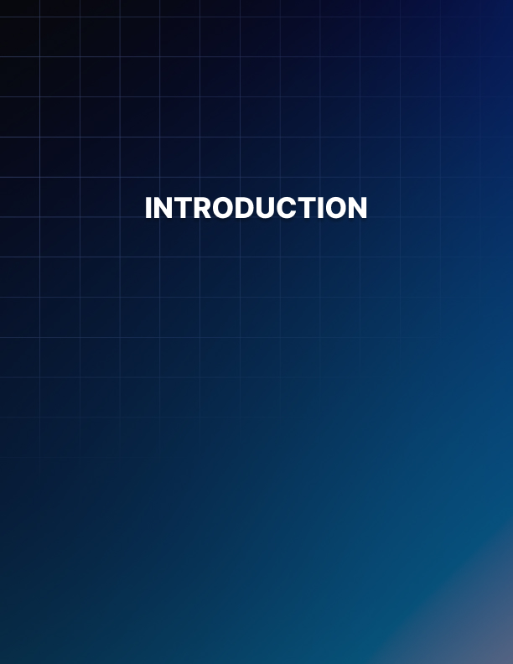

INTRODUCTION
____
Welcome to the gateway of digital persuasion. You're about to discover how to turn casual browsers into eager customers. This ebook is your toolkit for crafting landing pages that do more than catch attention—they engage and convert effectively.

This isn’t about tricks—it’s about understanding what drives people online.

Picture your landing pages grabbing attention, compelling visitors to read every word, and driving them to click your call-to-action buttons. This isn’t a pipe dream—it’s the reality that awaits as you apply the strategies in these pages.
Whether you're an entrepreneur, marketer, or content creator, this ebook is your guide to mastering online persuasion. You’ll learn to write headlines that grab attention, craft calls-to-action people can’t ignore, and use storytelling to turn skeptics into loyal customers.
This isn’t about tricks—it’s about understanding what drives people online. You’ll learn to shape your copy around your audience’s needs, creating content that doesn’t just sell but also solves problems and encourages action.
As you go through the chapters, you’ll build up your copywriting skills with insights on word choice, layout, and the psychology of color. Soon, you'll see landing pages as more than just web content—they’re tools for building connections and influencing decisions.
Prepare for transformation. This book is for those ready to roll up their sleeves and dive into the details. If you’re ready to turn your landing pages into conversion machines, it’s time to start.
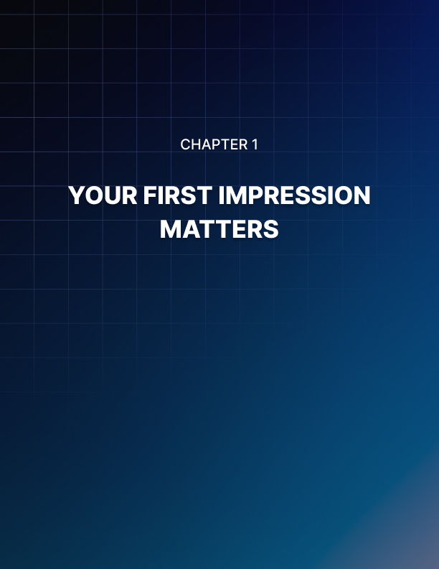

YOUR FIRST IMPRESSION MATTERS
____
The moment a visitor lands on your page, your headline takes center stage. It's your opening act, your handshake, your first impression. In the blink of an eye, it must grab attention, spark curiosity, and compel the reader to stay. Crafting magnetic headlines is both an art and a science, blending creativity with psychology to create an irresistible hook.

The Anatomy of an Attention-Grabbing Headline
Picture your headline as a beacon in a sea of digital noise. It needs to shine bright enough to guide your ideal customers safely to shore. A truly effective headline combines clarity, relevance, urgency, uniqueness, and promise.
- Clarity ensures your message is instantly understood, while relevance speaks directly to your target audience's needs.
- Urgency creates a sense of immediacy, uniqueness helps you stand out, and a strong promise offers clear value to the reader.
For instance, instead of a vague "Revolutionize Your Digital Marketing Paradigm with Our Cutting-Edge Solutions," try a clear and benefit-driven headline like "Boost Your Online Sales with Proven Marketing Strategies."
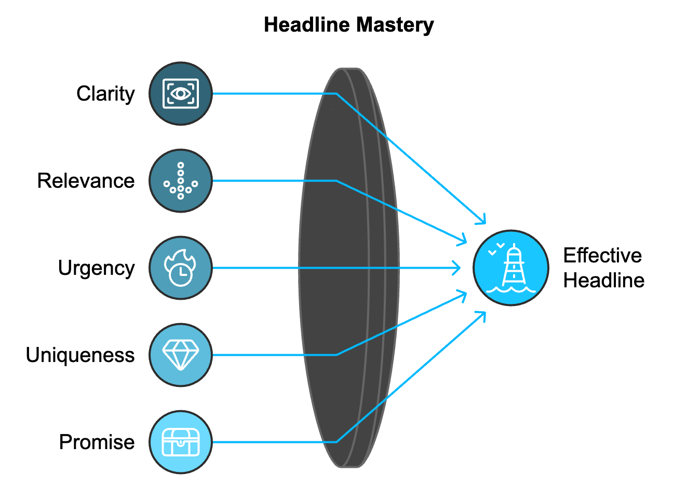

The Psychology Behind Compelling Headlines
Understanding the psychological triggers that make headlines effective can elevate your copywriting from good to great. Key principles include the curiosity gap, loss aversion, social proof, reciprocity, and authority.
- The curiosity gap works by hinting at valuable information without revealing everything, motivating readers to seek more.
- Loss aversion plays on our tendency to avoid losses more than seek gains, making headlines that highlight potential pitfalls highly effectively.
- Social proof leverages our inclination to follow others' actions, while reciprocity taps into our desire to give back when we receive something of value.
- Authority builds trust by associating your message with experts or respected institutions.
Consider this headline that combines several of these principles:
"Harvard Study Reveals: This 5-Minute Daily Habit Boosts Productivity by 37%".
It leverages authority (Harvard), creates curiosity (what's the habit?), and promises a specific, desirable outcome (37% productivity boost).

Crafting Your Headline
Creating compelling headlines is a process that combines creativity with strategic thinking. Start by identifying your core message and understanding your audience deeply. Brainstorm multiple ideas without judgment, then refine them by incorporating power words, adding urgency or scarcity, and ensuring clarity and specificity. Test your headlines for uniqueness and polish them until every word earns its place. Finally, if possible, A/B test different versions to see which resonates most with your actual audience.
Here's a table summarizing the key steps:
Step | Action
1 | Identify Core Message
2 | Know Your Audience
3 | Brainstorm Ideas
4 | Inject Power Words
5 | Add Urgency/Scarcity
6 | Ensure Clarity & Specificity
7 | Test for Uniqueness
8 | Refine and Polish
9 | A/B Test

Common Pitfalls and Proven Formulas
Even experienced copywriters can fall into common headline traps. Avoid being too clever at the expense of clarity, using clickbait tactics that erode trust, or crafting overly generic headlines that fail to engage. Be cautious with superlatives, and don't ignore SEO considerations. Keep your headlines concise, aiming for under 70 characters to optimize display in search results.
While creativity is crucial, you don't always need to reinvent the wheel. Several headline formulas have proven effective across various industries and audiences. These include:
- "How to [Achieve Desired Outcome] in [Timeframe]"
- "[Number] Ways to [Solve a Problem]"
- "The Secret of [Desired Outcome]"
These templates provide a solid starting point, but remember to customize them to fit your unique voice and offering.
Mastering the art of headline writing is a game-changer for your landing pages. Understanding the psychology behind effective headlines and applying these principles will help you create headlines that capture attention and compel action. Your headline is your first and sometimes only chance to make an impression, so make it count. Experiment with different approaches, always keeping your audience's needs and desires at the forefront. With practice and persistence, you'll develop the skill to craft headlines that consistently engage, intrigue, and convert.
The most effective headlines are those that speak directly to your audience's deepest desires or most pressing problems. They offer a glimpse of a solution or a better future, creating an irresistible pull that draws readers in. Refining your headline crafting skills reveals how the right combination of words can open doors, spark conversations, and drive the success of your entire marketing campaign. So take the time to hone this critical skill – your future conversions depend on it.
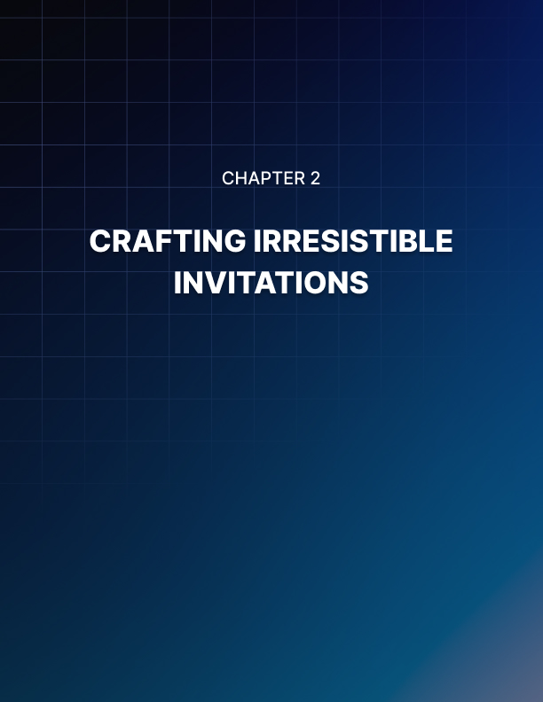

CRAFTING IRRESISTIBLE INVITATIONS
____
Your landing page's call-to-action (CTA) is where the rubber meets the road. It's the tipping point between a visitor's passive browsing and active engagement. A well-crafted CTA can transform curiosity into commitment, transforming casual visitors into valuable leads or customers.

The Power of Persuasive CTAs
Think of your CTA as the climax of your landing page's story. It's the moment where you invite your reader to take the next step in their journey with you. A powerful CTA doesn't just ask for action; it compels it. It creates a sense of urgency, taps into emotions, and clearly communicates the value of taking that next step. According to a 2023 study by ConversionXL, personalized CTAs perform 202% better than basic, generic calls-to-action. HubSpot reports that emails with a single CTA increased clicks by 371% and sales by 1617%. A recent analysis by Unbounce shows that using first-person phrasing (e.g., "Start my free trial" instead of "Start your free trial") can increase click-through rates by up to 90%. These numbers underscore the immense impact that a well-crafted CTA can have on your conversion rates.

The Anatomy of an Effective CTA
An effective CTA is composed of several key elements that work together to create a compelling invitation to action.
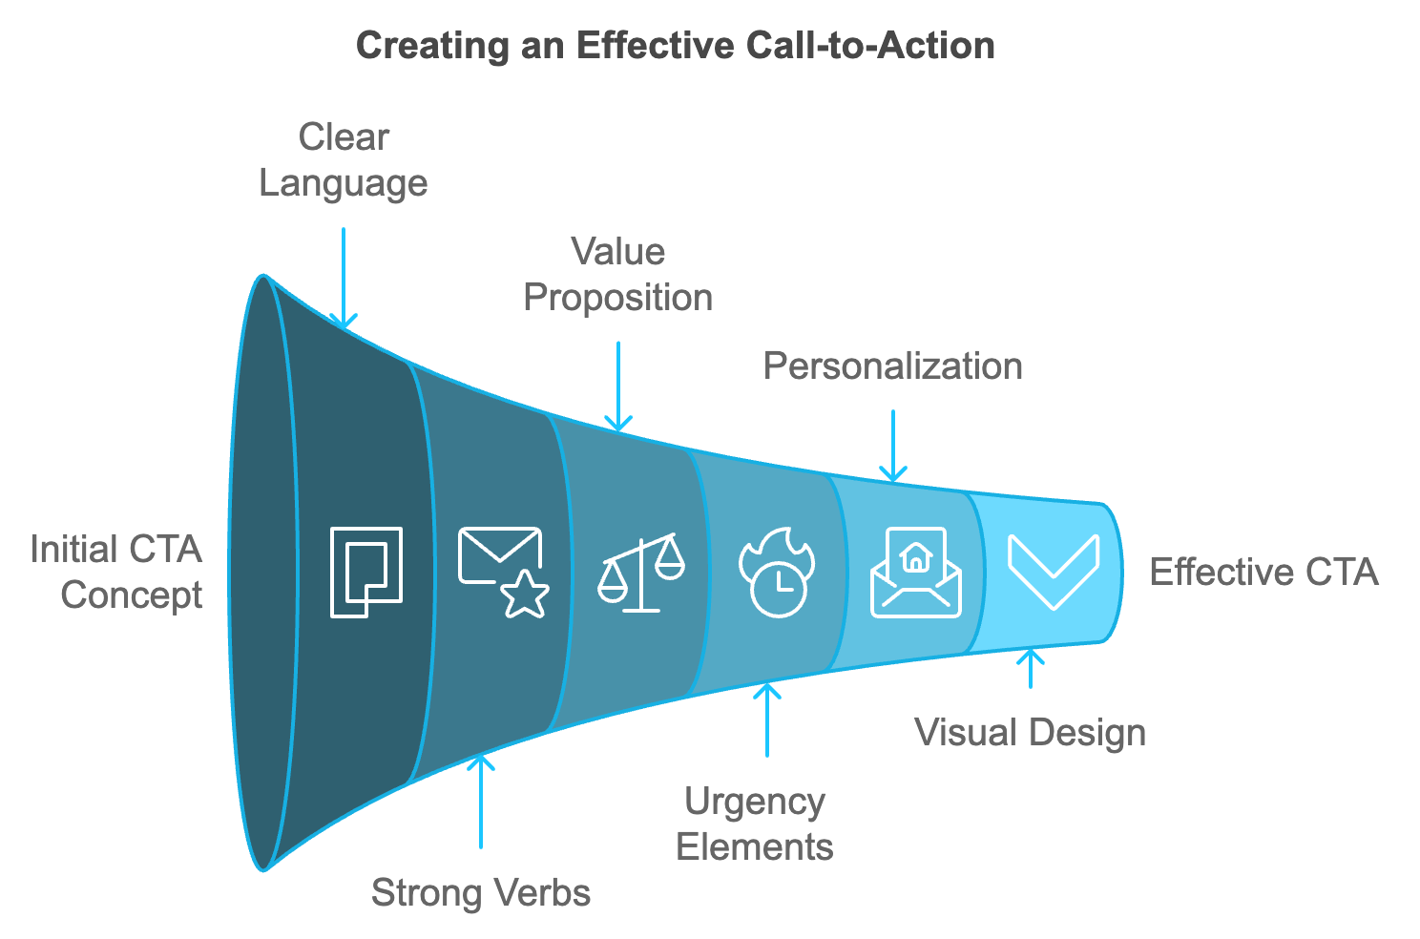
Clear and concise language is essential, as your CTA should be straightforward and easy to understand at a glance. Avoid jargon or complex phrases, and instead use simple, action-oriented language that leaves no room for confusion.
Strong command verbs are crucial, as starting your CTA with a powerful verb can inspire action. Words like "Get," "Start," "Join," "Discover," or "Transform" can create a sense of momentum and excitement.
The value proposition should be clearly communicated, showing what the user will gain by taking action. This could be a solution to a problem, access to exclusive content, or a desirable outcome.
When appropriate, incorporate elements that create a sense of urgency or scarcity. Phrases like "Limited time offer" or "Only 5 spots left" can motivate immediate action.
Personalization is key, as tailoring your CTA to your specific audience using language and offers that resonate with their needs, desires, and pain points can significantly increase its effectiveness.
The visual design of your CTA should make it stand out on the page, using contrasting colors, white space, and strategic placement to draw attention.
Finally, the size and placement of your CTA button should be large enough to be easily clickable, especially on mobile devices, and placed in a prominent location, often above the fold for immediate visibility.

The Psychology Behind Effective CTAs
Understanding the psychological triggers that influence decision-making can help you craft more compelling CTAs. Loss aversion is a powerful motivator, as people are more motivated to avoid losses than to acquire gains. Frame your CTA to highlight what the user might miss out on by not taking action. Social proof can be incredibly persuasive, as we tend to follow the actions of others. Incorporate elements of social proof in or around your CTA, such as user numbers or testimonials. The principle of reciprocity suggests that when people receive something, they feel compelled to give back. Offer something of value before asking for action. Commitment and consistency play a role, as once people commit to something, they're more likely to follow through. Start with small commitments and build up. Scarcity increases perceived value, so use it tactically to create urgency. Authority is another important factor, as people trust experts and authorities. Leverage credibility markers to support your CTA. Finally, the principle of liking suggests that we're more likely to say yes to people or brands we like, so build rapport and connection throughout your landing page.

CTA Techniques and Common Mistakes
Once you've mastered the basics, consider advanced techniques to take your CTAs to the next level.
- Two-step CTAs can be effective, starting with a low-commitment action that leads to a more significant CTA.
- Dynamic CTAs use visitor data to display different CTAs based on factors like location, device, or previous interactions with your site.
- Negative CTAs present the alternative to taking action, which can make the positive choice more appealing.
- CTA pairing uses multiple CTAs that work together, such as a primary CTA for your main offer and a secondary CTA for those not quite ready to commit.
- Micro-commitments break down your desired action into smaller, less intimidating steps, building momentum towards the ultimate goal.
- Exit-intent CTAs use pop-ups or overlays triggered when a user is about to leave your site, offering a last-chance opportunity to engage.
- Video CTAs incorporate clickable calls-to-action within video content for an interactive experience.
However, it's important to avoid common CTA pitfalls. Vague or weak language, offering too many options, misalignment with page content, ignoring mobile users, overlooking the post-click experience, neglecting to test, and using manipulative tactics can all undermine the effectiveness of your CTAs. Focusing on clear, value-driven language, maintaining consistency with your page content, optimizing for all devices, and continuously testing and refining your approach helps create CTAs that not only capture attention but drive meaningful action.

Testing, Optimizing, and Measuring CTA Success
The work doesn't stop once you've crafted your CTA. Continuous testing and optimization are crucial for maximizing performance. A systematic approach includes A/B testing, where you create two versions of your CTA, changing one element at a time and measuring which performs better. Multivariate testing allows you to test multiple elements at once to find the best combination. Heat mapping tools can visualize where visitors are clicking on your page, informing optimal CTA placement. User testing gathers qualitative feedback by having real users interact with your page and share their thoughts on the CTA. Conversion path analysis looks at the entire user journey to understand how your CTA fits into the broader conversion process. Segmentation analyzes how different user segments respond to your CTAs, as you might find that what works for one group doesn't work for another. CTA optimization is an ongoing process, so regularly review performance and make incremental improvements.
To truly understand the effectiveness of your CTAs, you need to track the right metrics. Key performance indicators (KPIs) to monitor include:
- Click-Through Rate (CTR)
Measures the percentage of visitors who click on your CTA.
- Conversion Rate
Tracks the percentage of visitors who complete the desired action after clicking the CTA.
- Bounce Rate
A high rate can indicate a misalignment between your CTA and the landing page.
- Time on Page
Reflects the level of visitor engagement with your content.
- Form Completion Rate
Tracks completion if your CTA leads to a form, indicating the form's effectiveness.
- Revenue per Click
Important for e-commerce sites to measure earnings from each click.
- Cost Per Acquisition (CPA)
Measures the cost to acquire a customer, especially useful in paid campaigns.
Focusing on these metrics allows you to gain a complete understanding of your CTA's performance and pinpoint areas for improvement.
CTA Element | Description | Impact on Performance
Language | Clear, concise, action-oriented | +202% (personalized vs. generic)
Verb Choice | Strong command verbs (e.g., "Get," "Start") | Increases momentum and excitement
Value Prop | Clear communication of benefits | Drives motivation to act
Urgency | Limited time offers, scarcity | Motivates immediate action
Design | Contrasting colors, strategic placement | Improves visibility and click-through rates
Mobile Optimization | Easy to tap on smaller screens | Crucial for mobile conversions
Personalization | Tailored to audience needs | Up to 90% increase in CTR

Crafting compelling calls-to-action is both an art and a science. It requires a deep understanding of your audience, clear communication of value, and strategic use of psychological triggers. Applying the principles and techniques discussed, rigorously testing, and continually optimizing based on data will help you create CTAs that not only capture attention but drive meaningful action. Your CTA is more than just a button or a line of text – it's an invitation to your audience to take the next step in their journey with your brand. Make it count.
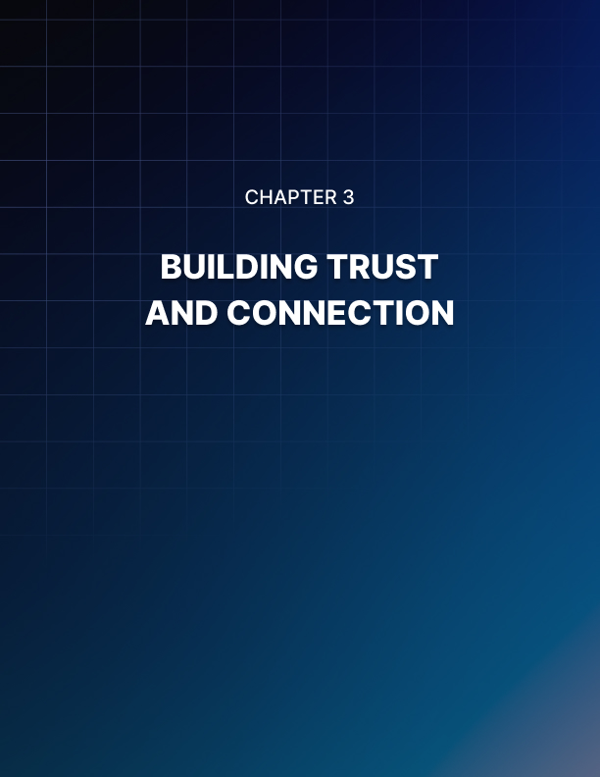

BUILDING TRUST AND CONNECTION
____
The foundation of your landing page is set with a captivating headline and a compelling call-to-action. Now, it's time to focus on the heart of your message: the body content. This is where you build trust, establish connections, and persuade your visitors to take action. Crafting persuasive body content is an art that combines storytelling, psychology, and strategic communication.
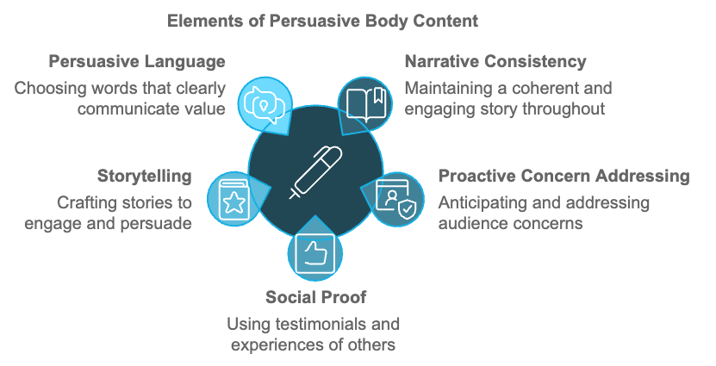

The Power of Narrative Consistency
Narrative consistency is key to maintaining engagement and building trust. When your body content aligns seamlessly with your headline and CTA, you create a cohesive story that guides your reader toward conversion. To achieve narrative consistency, reflect your headline's promise in your opening paragraph, maintain a consistent tone and voice throughout your content, use a logical flow of ideas that leads naturally to your CTA, and reinforce your main message at key points in your content. For example, if your headline promises "5 Proven Strategies to Double Your Productivity," your body content should clearly outline these five strategies, providing evidence and examples for each. This consistency reassures your reader that you're delivering on your promises, building trust and credibility.

Addressing Concerns and Objections Proactively
Addressing concerns proactively in your body content demonstrates understanding and helps build trust. This approach also helps to overcome potential objections before they become roadblocks to conversion. To effectively address concerns, identify common objections through market research and customer feedback, address each objection clearly and concisely, provide evidence or guarantees to alleviate concerns, and use FAQ sections to tackle specific questions. For instance, if you're selling a high-ticket item, price might be a common objection. You could address this by highlighting the long-term value, offering a payment plan, or providing a money-back guarantee. By tackling objections head-on, you show confidence in your offering and respect for your customer's decision-making process.

Leveraging Social Proof and Testimonials
People trust the experiences of others. Incorporating social proof and testimonials into your body content can significantly boost your persuasive power. According to a 2023 study by BrightLocal, 91% of consumers say positive reviews make them more likely to use a business. Effective ways to use social proof include customer testimonials with specific results or benefits, case studies showcasing successful outcomes, trust badges or certifications, usage statistics or customer numbers, and awards or recognition from industry bodies. When using testimonials, be specific and authentic. A quote like "This product changed my life!" is less impactful than "After using this productivity app for 30 days, I increased my daily output by 40% and secured a promotion at work." The more relatable and detailed the social proof, the more powerful its effect.

Creating Emotional Connections Through Storytelling
Stories have a unique power to engage, persuade, and create lasting memories. Weaving storytelling into your body content helps create emotional connections that resonate with your audience on a deeper level. Effective storytelling in landing page copy identifies a relatable protagonist (often your target customer), presents a challenge or problem, introduces your product or service as the solution, and shows the positive transformation or outcome. Consider this example for a fitness app:
"Meet Sarah, a busy mom who struggled to find time for exercise. Like many of us, she felt guilty about neglecting her health but couldn't seem to fit workouts into her packed schedule. Then she discovered FitMinute. With just 10 minutes a day, Sarah started seeing results. Not only did she lose 15 pounds in three months, but she also found herself more energetic and present for her family. Sarah's story isn't unique - it's the story of thousands of FitMinute users who've reclaimed their health, one minute at a time."
This narrative approach helps potential customers see themselves in Sarah's story, creating an emotional connection and illustrating the real-world benefits of the product.

The Art of Persuasive Language
The words you choose can significantly impact the persuasiveness of your content. Persuasive language isn't about manipulation; it's about clearly communicating value and motivating action. Key elements of persuasive language include active voice, power words, sensory language, benefit-focused language, and inclusive language. The goal is to be clear, concise, and compelling. Avoid jargon or overly complex language that might alienate your reader. Instead, aim for a conversational tone that builds rapport and trust.
Element | Example
Active Voice | "Our app will boost your productivity"
Power Words | "Exclusive," "Guaranteed," "Revolutionary"
Sensory Language | "Feel the smooth texture," "Taste the rich flavor"
Benefit-Focused | "Save time and reduce stress"
Inclusive Language | "Together, we can achieve your goals"

How you structure your body content can significantly affect its readability and persuasive power. A well-structured landing page guides the reader's eye and maintains their interest from start to finish. Consider this structure for effective body content:
- Opening Hook
- Problem Statement
- Solution Introduction
- Benefits Breakdown
- Features Explanation
- Social Proof
- Objection Handling
- Reinforcement
- Transition To CTA
Using this structure ensures that your content flows logically, building your case step by step and leading naturally to your CTA.
While we're focusing on copy, it's important to remember that visuals play a crucial role in supporting and enhancing your written content. Strategic use of images, videos, infographics, and other visual elements can make your landing page more engaging and persuasive. Effective use of visuals includes high-quality product images or screenshots, videos demonstrating your product in action, infographics summarizing key benefits or data, icons to break up text and highlight key points, and before and after images to showcase results. When incorporating visuals, ensure they align with your narrative and reinforce your key messages. A 2023 study by MIT found that the human brain can process images in as little as 13 milliseconds, highlighting the power of visual content in quickly conveying information and emotions.
These days, many visitors tend to scan your content rather than read every word. Optimizing for both readability and scannability ensures that your key messages come across, even to those who are quickly skimming your page. Techniques for improving readability and scannability include using short paragraphs (3-4 lines max), incorporating bulleted or numbered lists, utilizing subheadings to break up content and highlight key points, employing white space to prevent visual clutter, using bold or italics to emphasize important points (but don't overdo it), ensuring sufficient contrast between text and background, and choosing a readable font and appropriate font size. A study by the Nielsen Norman Group found that users typically read only 20-28% of words on a web page. By optimizing for scannability, you ensure that even those who don't read every word still grasp your main points and value proposition.
With consumers growing more skeptical of marketing messages, authenticity and transparency in your body content are crucial. Being genuine in your communication builds trust and credibility, which are essential for persuasion. Ways to incorporate authenticity and transparency include being honest about what your product can and can't do, sharing real customer stories, including challenges they've faced, providing sources for data or statistics, being upfront about pricing, including any recurring costs, clearly explaining your terms, conditions, and policies, and highlighting improvements based on customer feedback. Authenticity isn't just ethical; it's effective. A 2023 survey by Stackla found that 88% of consumers say authenticity is important when deciding which brands they like and support.
Nearing the end of your body content, it’s crucial to craft a compelling close that smoothly transitions to your CTA. This is your final opportunity to reinforce your key messages and motivate action. Elements of an effective close include recapping the main benefits, reiterating the problem your product solves, providing a final piece of compelling evidence or social proof, creating a sense of urgency or scarcity if appropriate, and smoothly leading into your CTA. For example:
"Thousands of professionals like you have already discovered how FocusMax can transform their productivity. With our 30-day money-back guarantee, you have nothing to lose and hours of focused work to gain. But remember, our special launch pricing ends in just 48 hours. Ready to supercharge your productivity?"
This close reinforces the benefits, provides social proof, addresses potential objections with a guarantee, creates urgency, and smoothly transitions to the CTA.

These days, many visitors tend to scan your content rather than read every word.

Crafting persuasive body content is a nuanced skill that combines psychology, storytelling, and strategic communication. Maintaining narrative consistency, addressing concerns proactively, leveraging social proof, creating emotional connections through storytelling, using persuasive language, structuring content effectively, supporting your message with visuals, optimizing for readability, staying authentic, and crafting a compelling close all help create body content that not only informs but persuades. Your goal is not just to convey information, but to build trust, create connections, and motivate action. With practice and continuous refinement, you can master the art of persuasive body content, transforming your landing pages into powerful conversion tools.
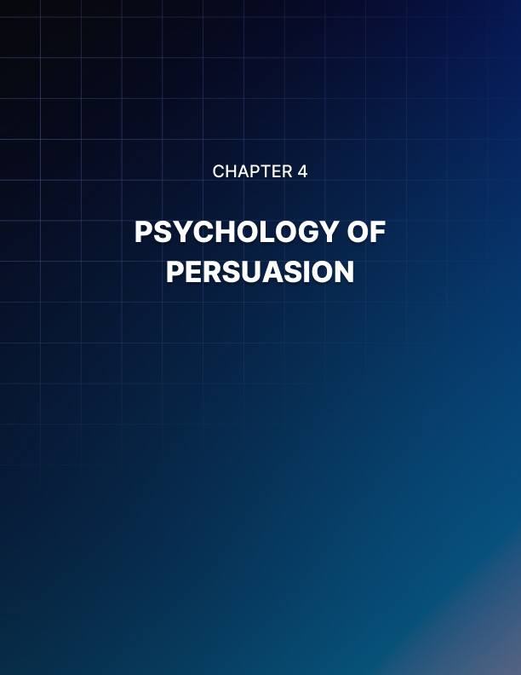

PSYCHOLOGY OF PERSUASION
____
The art of persuasion isn't just about clever wordplay or catchy slogans. It's about understanding the intricate workings of the human mind and leveraging psychological principles to guide decision-making. In this chapter, we'll explore the psychological triggers that can enhance the persuasiveness of your landing page copy, helping you create content that resonates deeply with your audience and drives conversions.

The Foundation of Persuasion
At its core, persuasion is about influencing thoughts, feelings, and behaviors. It's a complex interplay of cognitive processes, emotional responses, and social dynamics. Understanding these elements allows you to craft messages that speak directly to your audience's needs, desires, and motivations.
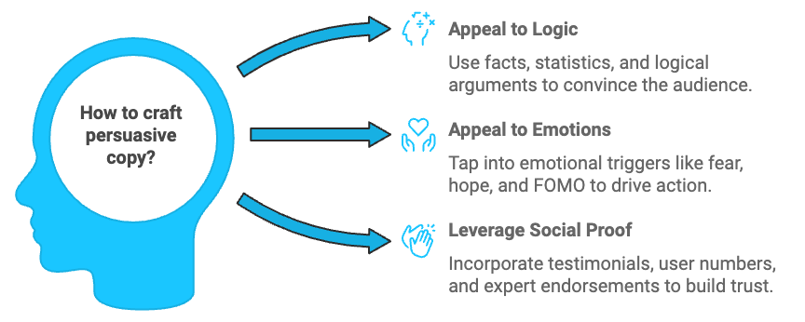
Human decision-making is far from rational. We're influenced by a myriad of cognitive biases - mental shortcuts that help us process information quickly but can lead to flawed reasoning. Understanding these biases allows you to tailor your copy to align with these natural tendencies rather than work against them. One powerful bias is the anchoring effect. This is our tendency to rely heavily on the first piece of information we encounter when making decisions. You can use this in your copy by presenting your most compelling benefit or offer first, setting a positive anchor for the rest of your message. The availability heuristic is another bias worth noting. It refers to our tendency to overestimate the likelihood of events with greater "availability" in memory. You can leverage this by using vivid, memorable examples and stories in your copy, making the benefits of your product or service more readily available in your audience's mind.
While logic plays a role in decision-making, emotions often drive our choices. Understanding and appealing to emotional triggers can significantly boost the persuasiveness of your copy. Fear of missing out (FOMO) is a powerful emotional driver. Highlighting limited-time offers or exclusive benefits can tap into this fear, motivating action. Hope is another potent emotion. People are drawn to products or services that promise a better future. Frame your offering as a solution that can help your audience achieve their aspirations.
Humans are inherently social creatures, and we often look to others to guide our behavior. This principle of social proof can be a powerful tool in your persuasive arsenal. Incorporate testimonials, user numbers, or client logos to show that others have trusted and benefited from your offering. Expert endorsements can also leverage the principle of authority, another key aspect of social influence.

Advanced Psychological Triggers
Beyond these foundational elements, several advanced psychological triggers can elevate your persuasive copy to new heights. The principle of reciprocity states that we feel obligated to return favors or gestures. In your copy, you can trigger this by offering something of value upfront. This could be free information, a trial period, or a bonus gift. Once people commit to something, they're more likely to follow through with related actions. This principle can be used to guide users through a series of small commitments leading to your main conversion goal. Start with low-stakes requests, like subscribing to a newsletter or downloading a free guide. Then, use your copy to remind users of these commitments as you guide them towards bigger actions.
The scarcity principle suggests that people value things more when they're rare or dwindling in availability. Use this principle carefully in your copy to create a sense of urgency without being manipulative. Highlight limited-time offers, exclusive features, or dwindling stock. While it might seem counterintuitive, offering too many choices can actually hinder decision-making. This phenomenon, known as the paradox of choice, can lead to decision paralysis. In your landing page copy, focus on a limited number of key benefits or options. If you have multiple products or services, consider guiding users to the best option based on their needs.

Crafting Psychologically Persuasive Copy
Now that we've explored these psychological principles, let's look at how to apply them effectively in your landing page copy. Stories are one of the most effective ways to engage emotions and make information memorable. Use narrative structures in your copy to illustrate the benefits of your product or service. Instead of simply listing features, tell the story of a customer's journey. How you frame information can significantly impact its persuasive power. Consider the difference between these two statements:
- "Our time management course will help you save 10 hours a week."
- "Imagine what you could do with an extra 520 hours a year - that's what our time management course offers."
Both convey the same information, but the second frames it in a way that makes the benefit feel more substantial and exciting.
Specific claims are often more believable and persuasive than general ones. Instead of saying "Our software will boost your productivity," try "On average, our users report a 37% increase in task completion within the first month." Identifying and addressing your audience's pain points can be a powerful persuasive technique. Show that you understand their challenges and position your offering as the solution. Engage your readers' senses with vivid, descriptive language. This can help create a more immersive and persuasive experience. Instead of "Our app is easy to use," try "Our intuitive interface guides you smoothly through each task, making productivity feel effortless and enjoyable."
People are more likely to be persuaded by those they perceive as similar to themselves. Use language and examples that resonate with your target audience, creating a sense of shared identity or experience. Persuasion isn't one-size-fits-all. What works for one audience might not work for another. That's why testing and optimization are crucial. Use A/B testing to compare different persuasive techniques and see which resonates most with your audience. Look at metrics like conversion rates, time on page, and bounce rates to gauge the effectiveness of your copy. Don't be afraid to experiment with different psychological triggers or combinations of techniques. The key is to continually refine your approach based on data and feedback.

The Future of Persuasive Psychology in Digital Marketing
As technology evolves, so too does our understanding of persuasive psychology. Emerging trends like personalization and AI-driven content optimization are opening new avenues for persuasive copy. Personalization allows you to tailor your persuasive techniques to individual users based on their behavior, preferences, and demographics. This targeted approach can significantly enhance the effectiveness of your psychological triggers. AI and machine learning are also revolutionizing how we understand and apply persuasive psychology. These technologies can analyze vast amounts of data to identify patterns and predict which persuasive techniques will be most effective for different audience segments.
Psychological Principle | Description | Application in Copy
Anchoring Effect | Reliance on first piece of information | Present most compelling benefit first
Availability Heuristic | Overestimating likelihood of memorable events | Use vivid examples and stories
FOMO | Fear of missing out on opportunities | Highlight limited-time offers
Social Proof | Looking to others for guidance | Include testimonials and user numbers
Reciprocity | Feeling obligated to return favors | Offer free value upfront
Scarcity | Valuing rare or limited items more | Emphasize limited availability
Paradox of Choice | Decision paralysis from too many options | Focus on key benefits or options

Mastering the psychology of persuasion is an ongoing process. It requires a deep understanding of human behavior, ethical considerations, and a commitment to continuous learning and optimization. Applying these psychological principles thoughtfully and ethically allows you to create landing page copy that not only persuades but also builds lasting relationships with your audience. The most effective persuasion isn't about tricks or manipulation - it's about understanding your audience's needs and genuinely offering solutions that improve their lives or businesses.
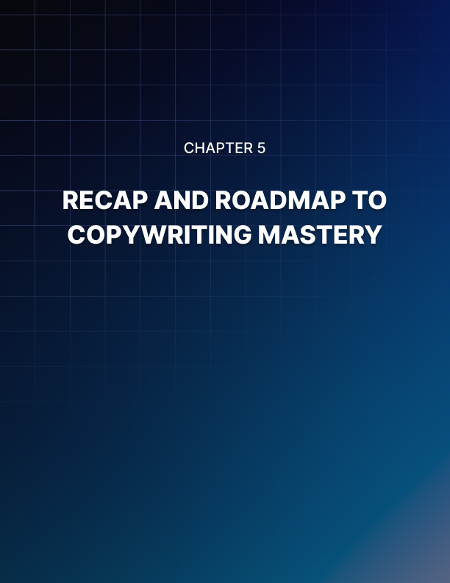

RECAP AND ROADMAP TO COPYWRITING MASTERY
____
You've explored the core elements of crafting compelling landing page copy. From magnetic headlines to persuasive calls-to-action, engaging body content, and the psychology of persuasion, you've gained a wealth of knowledge and practical strategies. Now, it's time to bring it all together and chart your path forward to copywriting mastery.

The Power of Integration
The true strength of effective landing page copy lies not in any single element, but in how these components work together to create a cohesive, persuasive whole. Your headline grabs attention and sets expectations. Your body content builds trust and connection while addressing concerns. Your call-to-action motivates action. And throughout, you're leveraging psychological principles to enhance your message's impact. Consider how each element supports and reinforces the others. Your headline should seamlessly lead into your opening paragraph, which in turn should flow naturally through your body content towards your call-to-action. The psychological triggers you employ should be consistent throughout, creating a unified persuasive argument that guides your reader towards conversion.

Putting Theory into Practice
Knowledge is power, but application is key. Moving forward, focus on implementing these strategies in your own copywriting projects. Start with your existing landing pages. Analyze them through the lens of what you've learned. Are your headlines truly captivating? Does your body content build trust and address objections effectively? Are your CTAs compelling and strategically placed? Don't be afraid to make bold changes. Sometimes, a complete rewrite is necessary to fully implement these principles. Other times, small tweaks can make a significant difference. The key is to approach your copy with a critical eye, always looking for opportunities to enhance its persuasive power. Copywriting is not a one-and-done process. It's an ongoing cycle of creation, testing, and refinement. Embrace A/B testing as a fundamental part of your copywriting process. Test different headlines, vary your body content structure, experiment with CTA placements and wording. Use analytics to track key metrics like bounce rate, time on page, and conversion rate. But don't just look at the numbers. Qualitative feedback can be equally valuable. Consider implementing user testing or surveys to gather insights directly from your target audience. Their feedback can provide invaluable insights into how your copy is perceived and where it might be falling short.

Developing Your Unique Voice
While the principles we've discussed are universally applicable, the most effective copywriters develop their own unique voice. This voice should align with your brand identity and resonate with your target audience. It's the special sauce that sets your copy apart from the competition. Developing this voice takes time and practice. Experiment with different tones and styles. Are you casual and conversational, or more formal and authoritative? Do you use humor, or keep things strictly professional? There's no one-right answer – the key is finding what works for your brand and audience.
The world of digital marketing is constantly evolving, and effective copywriters must evolve with it. Stay informed about emerging trends, new platforms, and shifting consumer behaviors. Subscribe to industry publications, attend webinars and conferences, and engage with other professionals in the field. For example, the rise of voice search is changing how people interact with online content. This might influence how you craft headlines and structure your content for featured snippets. Similarly, the growing emphasis on personalization might lead you to create multiple versions of your copy tailored to different audience segments.
Honing your persuasive copywriting skills requires maintaining a strong ethical foundation. The goal should always be to persuade, not manipulate. Be honest in your claims, transparent about your offerings, and respectful of your audience's intelligence. Avoid using high-pressure tactics or creating false scarcity. Instead, focus on clearly communicating the genuine value of your product or service. The most effective copy builds long-term relationships with customers, not just short-term conversions.

Expanding Your Toolkit
While this book has focused on landing page copy, the principles you've learned can be applied across various forms of marketing communication. Consider how you might adapt these strategies for email marketing, social media posts, product descriptions, or even video scripts. Each medium has its own nuances, but the core principles of effective communication remain the same. Expanding your toolkit makes you a more versatile and valuable copywriter.
At its heart, great copywriting is about connection. It's about understanding your audience's needs, desires, fears, and aspirations, and speaking to them in a way that resonates. Cultivate empathy as a cornerstone of your copywriting practice. Spend time really getting to know your target audience. Create detailed buyer personas. Read the same blogs and forums they do. If possible, talk to them directly. The more deeply you understand your audience, the more effectively you'll be able to craft a copy that speaks directly to their needs and motivations.
We touched on storytelling earlier, but it's worth emphasizing its importance. Humans are hardwired to respond to stories. They engage our emotions, make information more memorable, and help us make sense of the world. Practice weaving storytelling elements into your copy. This doesn't mean every piece needs to be a full narrative. Even a short landing page can tell a story – the story of a problem solved, a transformation achieved, or a future realized. Look for opportunities to use narrative structures, vivid details, and emotional arcs in your copy.

The Power of Simplicity
In your pursuit of persuasive copy, don't underestimate the power of simplicity. It's often tempting to pack your landing page with every possible benefit and feature, but this can overwhelm your reader and dilute your main message. Practice the art of distillation. Can you communicate your core value proposition in a single sentence? Can you explain your product's key benefit in terms a fifth-grader would understand? This exercise in simplicity can help you cut through the noise and deliver a message that truly resonates.
The best copywriters are inherently curious. They're always asking questions, seeking to understand not just the what, but the why and the how. Cultivate this sense of curiosity in your own practice. Ask questions about your product or service. Why was it created? What problem does it solve? How exactly does it work? Ask questions about your audience. What keeps them up at night? What are their secret desires? What objections might they have? This curiosity will not only make you a better copywriter but also a more valuable asset to your team or clients. It will help you uncover unique angles and insights that can set your copy apart.
The journey to copywriting mastery is ongoing. There's always more to learn, new techniques to master, and skills to refine. Commit to continuous learning and improvement. Read widely, not just about copywriting and marketing, but across various fields. Often, the most innovative ideas come from cross-pollination between different disciplines. Practice regularly, even when you're not working on a specific project. Consider starting a blog or newsletter to keep your skills sharp.
As you continue to develop your copywriting skills, it's important to have a clear way to measure your progress and set goals for improvement. Establish key performance indicators (KPIs) for your copy. These might include conversion rates, click-through rates, time on page, or other metrics relevant to your specific goals. Set both short-term and long-term goals for your copywriting. Maybe you want to improve your headline writing skills in the next month, or perhaps you aim to increase the overall conversion rate of your landing pages by a certain percentage over the next quarter. Having clear, measurable goals will help you stay focused and motivated in your journey to mastery.
KPI | Short-term Goal | Long-term Goal
Conversion Rate | Increase by 5% in 1 month | Increase by 20% in 6 months
Click-through Rate | Improve by 10% in 2 weeks | Improve by 30% in 3 months
Time on Page | Increase by 15 seconds in 1 month | Increase by 1 minute in 6 months

As we look to the future, it's clear that the field of copywriting will continue to evolve. Emerging technologies like AI and machine learning are already changing how we approach content creation and optimization. Voice search and smart speakers are altering how people interact with digital content. Social media platforms are constantly introducing new formats and features. Stay ahead of the curve by keeping an eye on these trends and considering how they might impact your copywriting approach. At the same time, remember that the fundamental principles of effective communication will always remain relevant. No matter how technology evolves, there will always be a need for compelling, persuasive copy that connects with human readers on an emotional level.
Continuing to master landing page copy means recognizing that every word you write is an opportunity to connect, persuade, and inspire action. With dedication, practice, and a commitment to continuous improvement, you have the power to create copy that not only converts but truly resonates with your audience. The strategies and insights you've gained are your toolkit – now it's time to put them into action and make your mark in the world of persuasive copywriting.

