Disclaimer

This ebook has been written for information purposes only. Every effort has been made to make this e-book as complete and accurate as possible.

However, there may be mistakes in typography or content. Also, this e-book provides information only up to the publishing date. Therefore, this e-book should be used as a guide - not as the ultimate source.

The purpose of this e-book is to educate. The author and the publisher do not warrant that the information contained in this ebook is fully complete and shall not be responsible for any errors or omissions.

The author and publisher shall have neither liability nor responsibility to any person or entity with respect to any loss or damage caused or alleged to be caused directly or indirectly by this e-book.
Table of Contents

Introduction 6
Leadership: Is It For You? 7
Chapter 1: Leadership Is Action... Not Position 9
Are You a Leader or a Slacker? 9
Chapter 2: Simple Leadership Basics 12
Blueprint for Leadership - How to Be a Better Leader 13
Chapter 3: Leadership: Is Mentoring For You? 16
Realize Your Full Potential 17
Chapter 4: Effective Public Speaking 20
Chapter 5: The Real Costs Of Not Doing Leadership Training 24
How One-on-One Executive Coaching Can Work For You 25
Chapter 6: How To Unleash All Your Leadership Potential 28
Effective Listening 29
Chapter 7: The Difference Between Boss and Leader 32
Developing Leadership Personalities 33
Leadership Development On Your Own 35
Chapter 8: What Is Leadership Development? 38
Types Of Leadership Development 38
The Essentials Of Leadership Development 40
The Keys To Effective Leadership Development 41
Getting Personal 42
How to See the Future as a Leader 43
Chapter 9: Myths About Leadership That Need to Stop! 46
How to Give Correct Instructions 47
How to Motivate and Inspire Your Team 48
Conclusion 51



Introduction

Although some people treat the terms management and leadership as synonyms, the two should be distinguished.

As a matter of fact, there can be leaders of completely unorganized groups. On the other hand, there can be managers, as conceived here, only where organized structures create roles.
Separating leadership from management has important analytical advantages. It permits leadership to be singled out for study without the encumbrance of qualifications relating to the more general issues of management.

To clarify, leadership is certainly an important aspect of managing. The ability to lead effectively is one of the keys to being an effective manager; also, undertaking the other essentials of managing -- doing the entire managerial job -- has an important bearing on ensuring that a manager will be an effective leader.

Managers must exercise all the functions of their role in order to combine human and material resources to achieve objectives. The key to doing this is the existence of a clear role and a degree of discretion or authority to support the manager’s actions.

The essence of leadership is followership. In other words, it is the willingness of other people to follow that makes a person a leader. Moreover, people tend to follow those whom they see as providing a means of achieving their own desires, wants and needs.
Leadership and motivation are closely interconnected. By understanding motivation, one can better appreciate what people want and why they act as they do.

Also, leaders may not only respond to subordinates' motivations but also arouse or dampen them by means of the organizational climate they develop. Both these factors are as important to leadership as they are to management.
Leadership can be defined as influence, that is, the art of influencing people so that they will strive willingly and enthusiastically toward the achievement of group goals.

Ideally, people should be encouraged to develop not only a willingness to work but also a willingness to work with zeal and confidence.

Leadership: Is It For You?
Leadership is something that is fundamentally part of a society. It is necessary in any good society that someone stands up and takes charge.

Leadership is essential, we know that, but does that mean everyone out there is a leader? The fact of the matter is that some individuals are not made to be leaders.

They are followers. And just as important in society as leaders are followers. So, where do you lie? Are you going to play leadership roles within your life?

For many people, the instinct to take those leadership roles just comes to them. It is just something that happens. They step up to the plate when needed. They respond first in class. They take charge of the baseball game on the playground.
They step up to the plate on the job. While you cannot be first in every case, individuals that have leadership skills will often be seen and heard throughout their lives.

But not all leaders are born with this talent. Many of them must learn it. People with an ambition to be a leader can do so by taking classes and studying the necessary skills that it takes to be a leader.

While all of this may sound simple, it can be quite a task to learn. It is hard to teach a person to react in a situation that is not planned well.

Because leaders are determined by their actions, we often see that leadership roles are filled with individuals who put themselves out there to be chosen, so to speak. But this is not always the case.

In many cases of emergency, leaders are those that take charge long before anyone else reacts. In that, these individuals will have a cool head about themselves and be able to see the necessary work ahead while others are worrying, panicking or simply in shock.

These are probably the true leaders in our society.
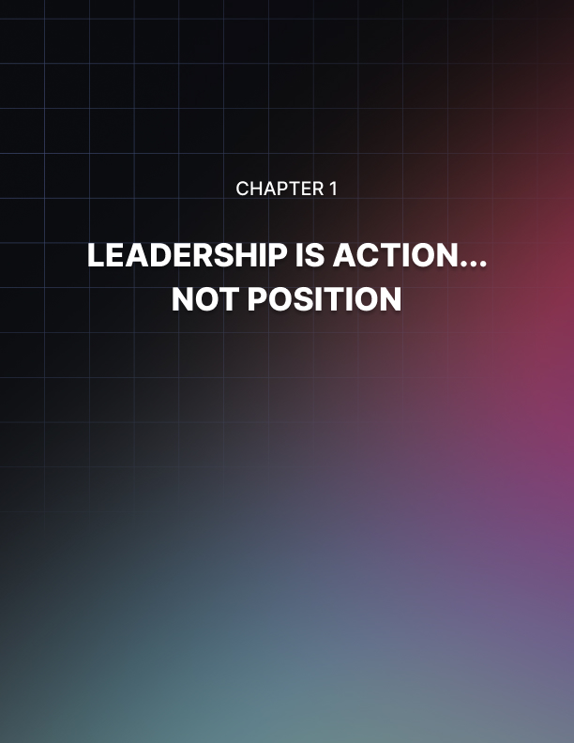

Chapter 1: Leadership Is Action... Not Position

People respond to good leadership! Period! It is in all aspects of our lives, not just business.

A mother is a leader in her home; a son may be leader of a team sport or a daughter the leader of the debate team. A group relies on the person in charge to actually lead them to success. A true leader is highly ethical, honest and respected.

In our society we have leaders and followers. Are we born to one or the other? No! Can you hone your leadership skills? Absolutely!

The leaders that I admire seem to have all of these in place:

- They think BIG! They don’t put a ceiling in place. Instead, no limit is set as to how big or how much better something can be.
- The goals are firmly set in place and the eye does not come off of it.
- They make known to all involved the final product that they are all going for, for example, if you sell widgets, it takes x number of widgets to be affluent, or you want to win that football game and ultimately the title. Know what you’re going for.
- They can get compliance to orders.
- When goals are met, they set new goals or raise the bar.

People will follow your lead willingly if you are honest, ethical, if you are consistent and treat them with respect. Rewarding someone when a job is well done is always appreciated.
A good leader will also off load someone who consistently hinders the group who is just not a team player.

You can improve your own self- respect and become an inspiration to others. How great is that!

Are You a Leader or a Slacker?
Do you claim to be a Leader in your business or your field of expertise?

I have noticed that many people claim to be Leaders, but I consider them Slackers instead. A Slacker is someone that basically likes to give instruction or direction, but takes no action on advancing themselves or their business.

Does this describe you, your up-line or someone else? Mastermind Team?

Here are some clues that might help you out:

Leader: Praises his/her team and offers encouragement.
Slacker: Quick to find fault and slow to give praise.

Leader: Holds himself/herself to a higher standard than his/her team.
Slacker: Has a high level of expectation for his/her team but doesn’t hold
himself/herself to that same standard.

Leader: Leads by example and is a role model for his/her team.
Slacker: Blends in with the crowd and never steps up to take a leadership role.

Leader: Has deep rooted belief in his/her business and leads new teammates
through the growth process.
(Learning the business and facing obstacles.)
Slacker: Convinces a person to join his/her team then pawns them off on
someone else or simply pushes them to the side.
(Referred to as “sign and drop”.)

Which of these characteristics best describes you and your teammates? Be honest with yourself.

Just remember, that a leader must lead and nourish others through the growth process.

If he/she loses integrity and fails to take action, then this same failure mindset will ripple down to his/her teammates. A team will duplicate their leader and their leader’s actions.

Let me ask you one last time… Are you a Leader or a Slacker?
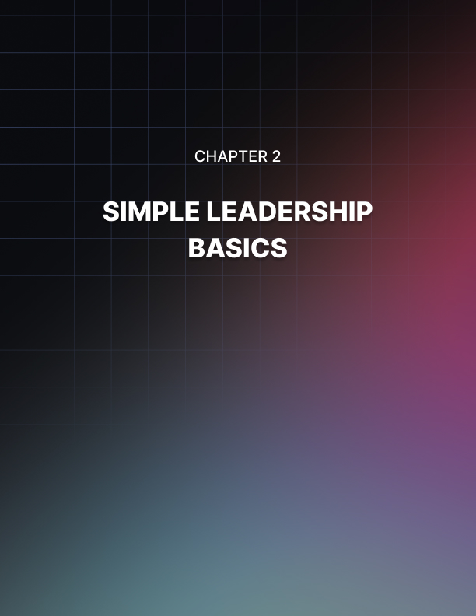

Chapter 2: Simple Leadership Basics

A great cloud of jargon, debate, and junk theory surrounds the idea of leadership, what it is, who does it, and how to do it well.

But if you have just been promoted, and you're responsible for a group for the first time, there are only a few things you really need to know about leadership.
When you get promoted and become responsible for the performance of a group you become a leader. But you don't undergo some magical change. In fact, it will probably take you over a year to completely adjust to your new role.

You're a leader because the people in your group treat you like one. The only choice you have is what kind of job you'll do.

When you become a leader your power actually goes down. As an individual contributor, you just have to decide to work harder, longer or smarter to improve performance. When you're responsible for the performance of a group, the group is your destiny. They choose whether to act or not.

When you become a leader, your influence goes up. The people who work for you pay attention to what you say and do. They adjust their behavior accordingly.
The result is that you use your behavior (what you say and do) to influence the behavior of the people who work for you to achieve a defined objective.

Achieving the objective is part of your job as a leader. The other part is caring for your people.

It may be possible to achieve good short-term results without caring for your people. But you can't achieve long term success for you or your company without the willing cooperation of the best folks you can find.

At the end of the day, you can measure your leadership based on those two standards. Did we accomplish the mission? Are the members of my group better off today than yesterday?

You can find out more about all of this and learn it almost effortlessly from my book, Performance Talk: The One-on-One Part of Leadership.

Blueprint for Leadership - How to Be a Better Leader
If you were to build a house, you would begin with a blueprint. This blueprint proves useful because it contains more than directions on how to build a house. It also describes the finished house.

So, what does this have to do with leadership?

Last month I asked an audience of leaders to tell me the characteristics of an ideal leader.

Their answers were (in the order collected):

A good listener, enthusiasm, passion, shows appreciation, a visionary, role model, trusting, integrity, organized, knowledgeable, credibility, persuasive, charisma, team building, clarity of purpose, problem solver, attitude of service, leads by example, patience, willing to act without complete knowledge, understands followers, consistent, empowers other people, and adapts to change.

I'll add that this is essentially the same list that I receive from other audiences when I ask this question. From this comes some useful insights.

- Notice what the list contains: All of these characteristics relate to the human side of leadership. That's interesting because I often hear people minimize this side of leadership with terms like "soft" or "touchy feely."

Actually, applying these characteristics requires more strength than not.

- Notice what the list excludes: Absent from this list (and all lists from other programs) are characteristics such as stern, mean, serious, short tempered, vindictive, tough, angry, harsh, punitive, controlling, violent, or ruthless.

And that's interesting because many popular representations of leadership emphasize at least one of these "hard" characteristics. In fact, these characteristics are the refuge of those who lack the strength (or the skills) to apply the human side of leadership.

- How about you? How would you rate yourself as a leader compared to the list of positive characteristics? If you were to survey the people who report to you, how would they describe your leadership?

Would they list characteristics from the "soft" list or from the "hard" list? Could you become more effective by improving upon any of the "soft" characteristics? And how about the other leaders in your organization? Do they truly maximize human potential?

People want leaders who treat them with genuine compassion, courtesy, and respect. They want leaders who help them become more successful. They want leaders who inspire them with a vision for a better world and show them how to go there.
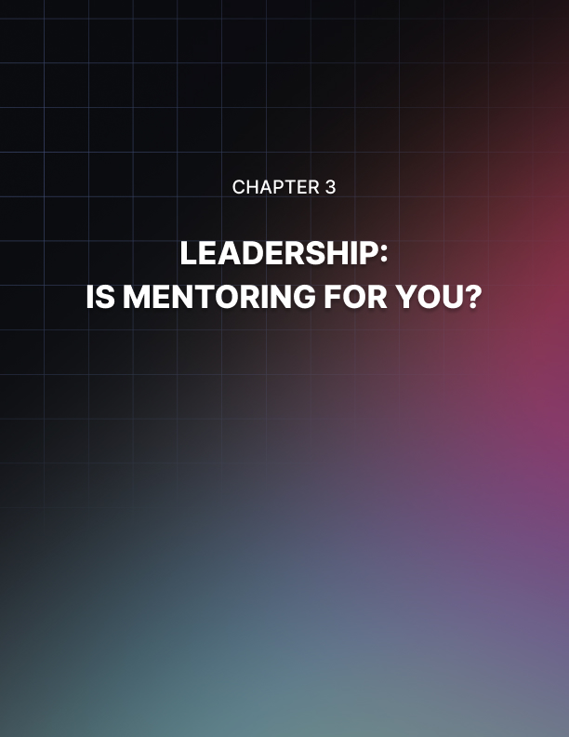

Chapter 3: Leadership: Is Mentoring For You?

If you are considering mentoring a younger person, here are some things to think about.

Make sure that mentoring is for you. Most effective mentors truly, deeply enjoy helping younger people grow and develop. Make sure you're likely to enjoy the process before you take it on.

Make sure you have the time and flexibility. If your schedule is already overloaded or you're under stress at home, you might want to consider holding off on a mentoring commitment until things are a little less hectic.

Make sure you know what you bring to the table. None of us is good at everything, but every one of us is really good at something. If you know what you're good at and what other things you may bring to the table, you're more likely to be successful.

In his excellent book, Winning, Jack Welch says that "There is no one right mentor. There are many right mentors." From your perspective, that means you don't have to do everything. You aren't the only place that your protégé should get help.

Make sure you know what kind of people you like to work with and which ones are hard for you. Mentoring should be a pleasant relationship for both of you.

Make sure you know what you expect from your protégé. It's a good idea to tell him or her what you expect them to do. Clear expectations are vital to a mentoring relationship.

Make sure you know that a good mentoring relationship should be a good experience for both of you. You should both enjoy it. You should both grow and develop. And you should both make a friend for life.

Mentoring can be one of the most rewarding experiences of your career or it can be a frustrating and time-consuming trial. Make sure you know what you're getting into.

Realize Your Full Potential
I have been fascinated over the years by the debate, research and discussion about leadership and management.

Increasingly there seems to be a focus on the differences between leadership and management and it seems to me that this has developed in part because of deficits in one or the other.

Most of us would like to become, or to think of ourselves as, strong leaders. There is something appealing about the idea of creating and pursuing a vision and influencing others to support the necessary transitions. True enough, if it wasn't for good leadership, nothing would change or improve.

Leadership training helps you unlock your full potential and realize your ambitions in the business world. Leadership is firmly at the core of every successful organization, and the effective management of people is a hugely valuable skill that's always in demand.

Open learning allows you to gain leadership training without the disruption of traditional study.

With open learning you can study in your own time and at your own pace, moving through the training course at whatever rate suits you best. This means that you can easily fit your course around your current life commitments, whether you have family responsibilities, a full-time job or any other constraints on your time.

You could even earn a prestigious business degree through open learning, and open up a whole new range of career opportunities for yourself!
However, not as many people seem to be as drawn toward being a good manager. Maybe I am misreading the "climate", but management is often associated with the mundane, the routine and a whole range of "left-brain" activity for which the kudos are few.

There appears to be a perception that one can be a leader or a manager, but not much acknowledgement that those skill sets can reside in the same individual. I believe this is an erroneous view.
My view of leadership and management is that they do require different skill sets, but must coexist in order for any change to occur effectively. It is like a hand and a glove. Put together they make a great partnership.



Chapter 4: Effective Public Speaking

Although speaking in public is really a monologue of sorts, this monologue is addressed to a ready, able and receptive audience who wants to learn from you as much as you want to learn from them.

Speaking in public would be more effective if it is listened to. The following are effective tips to maintain that necessary contact with the audience.

Greet Them
Minutes before your actual speaking engagement, you could walk around the venue and familiarize yourself with the people who will be listening to you.

As the people and the attendees arrive, give them a warm greeting. It is so much easier to deliver a speech to a group of people whom you consider as friends than to a bunch of anonymous faces.

Be Positive
Honestly, people expect and want you to succeed. Audiences want to be as informed, stimulated and entertained as they could be. If you fail, they cringe with you. Succeed and your audience benefits just as well from your great speaking performance.

There Is Nothing To Be Sorry About
If you mention to the audience that you are nervous or if you express your apologies to any problems you think may exist about your speech or your speech delivery, you may be setting them up to focus on that thing you are apologizing for.

You do not have to mention this to them, chances are they haven’t noticed this until you brought it up. Relax and be silent. Your audience will relax with you.

Establish Eye Contact
Connect with your audience, appear natural. Or better yet, be as natural as you can be, without overdoing it of course. You should be able to get the audience to nod their heads as an acknowledgement of what you are trying to convey.
Do not breeze through your speech. Pause for a while or for a brief moment, especially at those points you want to emphasize. This is also a good time to establish eye contact with your attendees as well as to catch that much needed breath.

Do Not Debate
If during the question and answer part of your speaking engagement an audience expresses disagreement with any part of your message, you need not aggressively prove your point to him or her.
A debate is not just a futile means to get your point across but it could just as well never be resolved. Get that attendee to talk with you after your speaking engagement, never during.

Relax Your Way to Public Speaking
Believe it or not, fear of death is actually second to the one greatest fear that the majority of humanity seems tensely afraid of: fear of speaking in public.

If fear is all that you are thinking, then forget about that presentation that could earn your company and you the necessary sales.

Presentation and public speaking are one of the most efficient as well as effective manners in making your products and services known. Why deny your product or service the chance to be heard?

If you are still afraid, try your very best to focus on the various positive after effects of making that presentation. Create in your mind the numerous clients, customers and contact persons you might not get to see or be involved with if you let that unnecessary and irrelevant anxiety take hold of you.

Your presentation may only take thirty minutes but the long-term effects of your pitch or presentation might go a long way.

If the fear is still gripping you, try to do the following exercises to help your body relax and warm up to whatever it is you plan to do in your presentation. Turn that negative energy into a positive one and see who benefits best from it.

Warm Up Your Body
Are you wearing high heeled shoes now? If you are, please take them off now. Then go and stand up. Try to stand on only one leg. Then shake the leg that is off the floor. Switch legs and do the same thing again. What you are doing is taking the negative energy of anxiety towards the floor and out of your body.

Though this may appear and sound so out of this world, it actually works. For your information, actors use this as a warm-up exercise prior to attacking any scene.

Hold out your hands, shake them, fast. Put your hands over your head and bring them to your sides. Repeat the same process. Doing this continually will take the tension off your hands and arms so any movements you make with them during your presentation gets to appear natural.

Ease the tension present in the muscles of your face. In order to do this what you could do is chew in a manner that is exaggerated.

These exercises are done for the purpose of warming any part of your body that is edgy, uptight or taut from being too nervous thinking about how you will do in your presentation.

Do not think too much though as it only adds unnecessary stress. Relax and your audience will relax along with you.
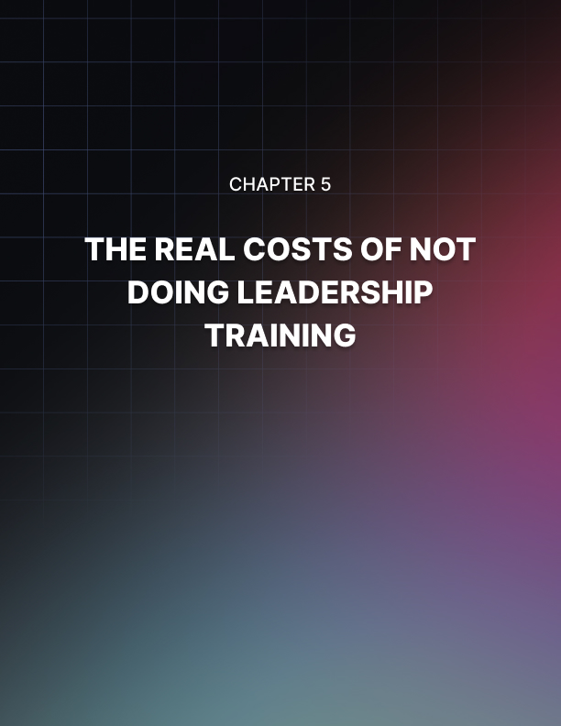

Chapter 5: The Real Costs Of Not Doing Leadership Training

A report from the Said Business School at Oxford University in the UK found that British businesses and public sector organizations are wasting almost $140 million on executive education programs that are poorly conceived and delivered.

The study went on to say that 35 percent of HR directors and 21 percent of other executives believed that their current training and development programs were meeting corporate strategic objectives.

The bulk of the money was being spent on individually developed courses for senior executives.

If those businesses want to quit wasting all that money on bad management training, I know where they can get their money’s worth. And it doesn't have anything to do with having more academics design special courses, events, and outings for senior staff.

Here's a novel idea folks. Why not spend your money on leadership training and development down in the trenches, where it will really do some good?

Most companies don't do nearly enough of that. In 2003, just 7 percent of training budgets in the US were spent on first line leaders and most of that was for learning administrivia and for prophylactic HR.

The fact is that front line leaders don't get much training at all and precious little of it is actually about leadership skills. Maybe that's because companies think they're saving money by not investing in front line leader training.

True, there's no budget line item absorbing funds that might be spent on the executive dining room, or art for the CEO's office. But there are what economists call "opportunity costs," the costs of not training front line leaders.

There's the opportunity cost of lost productivity. Good frontline leadership builds both morale and profitability.

There's the opportunity cost of lost leadership. Great companies develop most of their own leaders. If you have to go outside for leadership you incur recruitment costs and transition costs.

Finally, there's the cost of lawsuits. Good frontline leadership creates organizations where lawsuits are less likely. And, if the company is sued over a supervision issue, defense will be easier if the leaders have been doing their jobs.

How about your company? Do you develop your own leaders? Do you help them develop the skills they need to improve morale and productivity and avoid lawsuits? Think about that the next time you consider the training budget.

How One-on-One Executive Coaching Can Work For You
Does your company need a jumpstart? Is revenue low, morale declining, and your leadership tactics no longer making an impact? This may be the perfect time to look into leadership coaching.

A good executive coaching program should do more than just set you up with a speaker reading over a PowerPoint presentation.

Team up your senior leaders with a good corporate coaching program, and you could be discussing fostering relationships, building strategy, and improving revenue and communications all while hitting the slopes, climbing a mountain or rafting some white water.

It’s easy to connect in an environment where you can be creative, and think outside the box.

A good leadership system can make all the difference in your organization. Its effects; communication, human performance, accountability, delivery and measurement.

A one-on-one approach, and a program that is tailored to suit your organization’s specific needs, is the best choice in executive coaching.

There are a few important things to consider if you want to engage in an executive coaching program. Look for a company that will provide you with someone who is more than just a speaker.

You want to be paired up with someone who will be a trusted advisor to you as your organization grows and changes. Also, a good coaching program will include industry consultants to provide expert advice in some technical areas.

Talk to your consultant about the specific goals you want your leadership program to meet. Every business or organization needs direction in a different area or department. This is what makes a one-on-one coaching program so unique; you work on meeting goals where your company needs it the most.
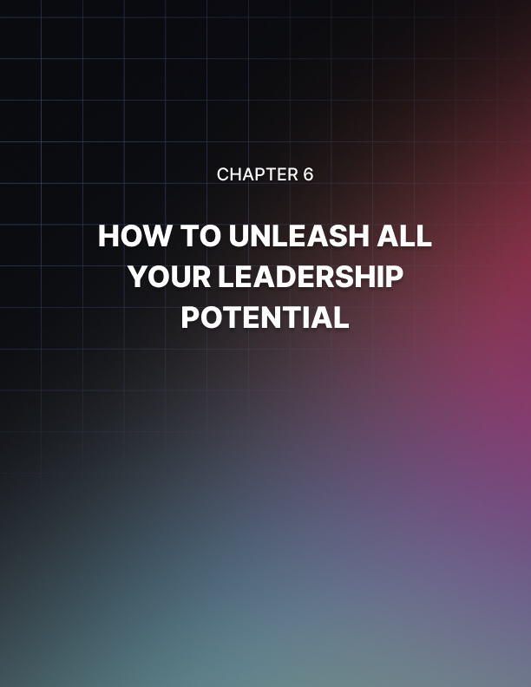

Chapter 6: How To Unleash All Your Leadership Potential

There is a steady flow of information in the form of books, articles, white papers and training all in the context of "what is leadership" or "how to develop a leader"?

In this issue, I will avoid those two questions and write about two others that I believe might be on the minds of a lot of you readers and they are:

- Why does better leadership make a difference?
- How does better leadership achieve those differences?

Leadership is a highly unique form of human behavior that requires the integration of character, knowledge and experience. So, what can you do if you step up and unleash your leadership potential? Change the world.

Your journey to unleashing your leadership potential begins with a great understanding of self. Discover your personality traits and how they relate to leadership. When we know ourselves, we can maximize our positive traits, and become aware of our weaker areas, which help us to achieve our leadership potential.

Once you understand and know yourself, next you must hone your communication skills. These are not limited to your public speaking skills either. This includes your writing style and your body language. Your ability to communicate effectively enhances your ability to improve interpersonal relationships. Another important skill is to learn how to learn.

Examine different teaching methods and learning styles to identify how you and those you may lead learn best. This skill will greatly enhance your ability to make decisions and give clear instructions.

An Exceptional Leader is one that recognizes the value of harnessing the skills and abilities of team members and leads them toward greater efficiency and effectiveness.

And so, leader is not a title and leadership is not something you are born into. Leadership is something you develop.

This is what Dr. Ken Blanchard, in his book "The Heart of A Leader" had to say about good leaders; "If you want to know why your people are not performing well, step up to the mirror and take a peek."

Effective Listening
All too often we are far more enthusiastic about talking than we are listening. Yet it is so vital if we are to communicate effectively.

Most breakdowns in relationships are caused because people talk at each other without really making contact. Unless someone hears what has been said including the subtext the words have little value.

When we are actively listened to, we feel valued and are far more likely to engage in negotiation and compromise.

Listening is about far more than words. Watching facial expression and body language is often a far more accurate barometer than the words that are being used.

Nice things being said where the smile doesn’t reach the eyes is an obvious example.

To be an effective listener it is vital that you listen actively.

Some tips to becoming a more effective listener:

- Make eye contact.
- Read the body language of the talker.
- Are they relaxed, anxious, angry?
- Extremes are easy to recognize but often the message is much subtler.
- Mirror the talker’s body language - subtly, a gentle dance rather than a caricature.
- Show that you are listening, nod, make appropriate responses.
- Ask relevant questions, ask them to clarify if you are not clear about their meaning.
- Summarize so what you are saying is……….
- Use open ended questions, the who, what, where, when.
- Be careful of the tone of your voice when you respond or ask questions. It is all too easy to come across as judgmental or as an interrogator from the Spanish Inquisition.
- Use empathy. Acknowledge difficulties, but be careful not to fall into the trap of going into anecdotes from your experience. “I sense that you are finding this rather difficult” rather than “Oh I know, it happened to me but mine was bigger, more difficult etc.”

Take a real interest, if you are simply going through the motions the lack of sincerity will be obvious to others. Leave your ego behind, concentrate on the other person.
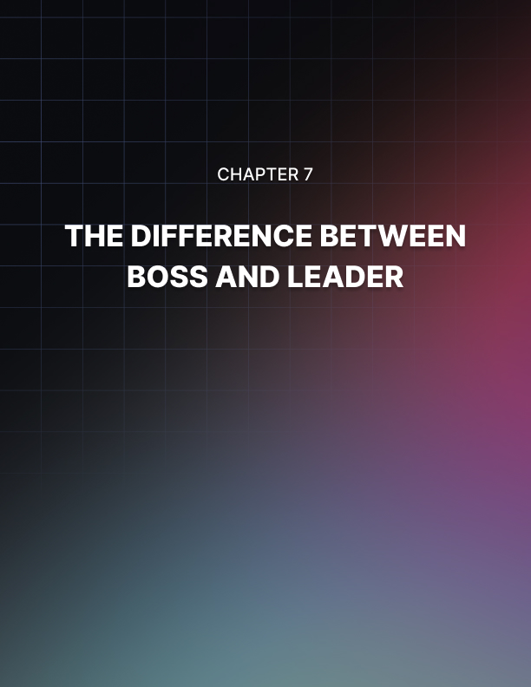

Chapter 7: The Difference Between Boss and Leader

Every leader is a boss. But every boss is not the leader. This defines the difference between a boss and a leader.

The biggest difference between a boss and a leader is one. The boss is respected and obeyed because of his/her seniority.

A leader is respected and looked up to as an example not only because of seniority but mainly because of the qualities of character and ability. Please view these wallpapers in this reference.

Those who aspire to become leaders must lead by example. The team must always have a firm belief that the leader will be there during every crisis.

Not to fix the blame, but fix the problem. If the team members find that the leader does not follow what he/she preaches, they will have no respect for him/her. They may obey him/her, but the respect will be missing. Leaders gain this respect by their actions. They look and act sincerely. There is no mismatch between their words and actions. They look integral in approach and character.

To be a leader, every boss must display characteristics such as knowledge, planning, anticipation, foresight, action, result oriented approach, perspective, respect every team member, earn their respect, act as a friend and act as a mentor.

This is quite a list, but if you want to become a good leader you need these qualities. This is true not only for national leaders but for persons in every leadership position in any organization.

Once a person earns the respect of his /her team members he/she ceases to be only a boss and transforms into a leader.

Developing Leadership Personalities
A self-help guru once defined leadership as simply the ability to make
things happen using the help of other people’s skills and abilities.
Some leaders are quite gifted from birth, but many leaders go through leadership development after being spotted to possess the leadership potentials.

One question: What type of person or personality makes the best leader?

Leadership Personality
One can imagine that the person who has the greatest success, heading the largest organization or corporation is the one that makes the best leader. It is possible.

On the other end of the pole, could a person with a little drive or entrepreneurial skills end up being a leader? It is also possible.

Developing Leadership Skills
Some people are very lucky because they have an easier time developing their leadership skills than the others. There is no question that certain personality types make better leaders than the rest of us.
The next question is this: What personality types would make better leaders? Each of us fit into some personality types, whether ordinary or on the eccentric side.

Whichever it is, there might be some parts of it that would make an excellent type of leader. On the other hand, your personality type could undergo leadership development training and become a very effective leader.

The following are some of the more recognizable leadership personalities, different though they are in more ways than one.

Powerful Leader
He is the king, the lion in an organization. He is the type of person
who wants to be in the driver’s seat.

His personality notwithstanding, the strength of his leadership comes from good decision-making skills which come naturally. His negative aspect is his tendency to be a morale-booster.

However, people will eventually discover his caring heart and they will learn to love and respect him. They might even grow and develop themselves from his challenges.

Perfectionist Leader
As an animal, he could be compared to a beaver in the organization.
He will be the one who will never forget to cross all the “T's and dot all the “I”s.

This personality type can handle all the details of the group’s daily operations, but can nevertheless let go of the small stuff. Another good news: everyone he meets will soon learn and share his wisdom.

Peaceful Leader
He is the golden retriever, and he can be the hardest to motivate. He can definitely frustrate most of the personality types listed in any group.

However, he has the most compassion among everybody. It is very easy for the rest to share their most personal feelings with him.

Popular Leader
This guy is the most fun of all the other leader types. If there is no fun, he will create a fun situation for him and everyone.

His greatest strength is his uncanny ability to rally everyone to meet the organization’s goals. Almost everyone wants to be with him, except of course, the perfectionist.

In his quest to make things fun, he usually overlooks some details that can be important. Or so, the perfectionist would like to think.

You As The Leader
What leadership personality would you be? What are your strengths and your weaknesses? If you are to be developed and groomed as a leader, what would you want for yourself?

Leadership Development On Your Own
Being a leader can be innate to some people. But, without leadership development these skills may not be enhanced, thus, the true potentials of the leader may not come out.

These days, leadership development is usually categorized into two including individual leadership development and group leadership development.

The first one usually focuses on the specific leadership traits of an individual while the second one is more on seeing leadership development as a process wherein the surrounding people and the working environment are involved.

Developing Your Own Leadership Skills
If you feel that you have great chances of becoming an effective leader, then now is the time to consider enhancing your leadership skills on your own. For you to do that, you must first assess what hinders you to being an effective leader.
For some, it's their personal issues and problems while others are because of their inability to understand and accept certain situations.

To be able to overcome these issues and emerge as a better leader, you must:

- Forgive yourself and let the past go: Experts say that many people have the great potential to become effective leaders only that they cling on so much to the past and couldn’t forgive themselves for the mistakes that they have committed.

If you want to become an effective leader, try to accept that there are things that are beyond your control. Then, you will be able to forgive yourself and start anew. If you just keep thinking of the past, this will serve as a reminder of your failure.
And if you keep thinking about your defeat, you will undergo a never-ending cycle of blaming yourself for the things that you did not really opt to do.

- Have a dream and hold on to it: To lead is not an easy task to start with. It would require lots of effort and self-assessment to be able to maximize your full potential as a leader.

For people who would want to reap the benefits of good leadership in the future, they should start now by having a dream that they could hold on to.

The scale or the size of that dream doesn’t matter, it can be a big thing or a small thing, what's important is the person is willing to do everything to achieve that dream.

For some people, having big dreams works on them because they are looking forward to big rewards in the future. That is why they are giving their best this early.

While some people opt to have small dreams because they want to make sure that they will be able to accomplish that dream and won't have to deal with defeat or failure in the future.

- Always take one step ahead: Leadership development on your own means you have to be able to continuously motivate yourself despite so many problems.

You can do this by taking one step ahead of things, meaning, you need to plan ahead and do things ahead of time so you will be given more opportunity or chance in case the first plan did not work.

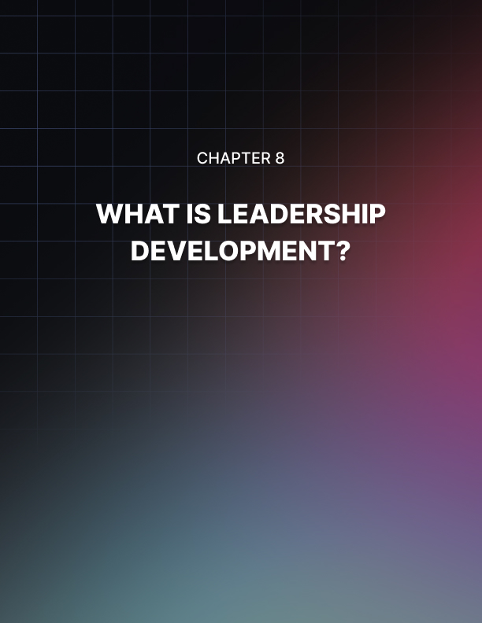

Chapter 8: What Is Leadership Development?

As defined, leadership development refers to any method or activity that aims to enhance the quality of leadership within an individual or a person heading an organization.

Before, leadership development activities were very rigid, formal and strict because the people who are conducting them want to ensure that everything should be in a formal setting.

The leadership development activities before were only confined to Masters in Business Administration (MBA) style programs that are usually offered in prestigious universities and business schools.

But now, the trends in leadership development have shifted into a more laid back and personal setting. Although there is still the serious and formal aspect of it, many people who conduct it are incorporating other means to motivate the participants to actively join the sessions.

Some of the trends in leadership development these days include action learning which uses movements in teaching leadership values.

Others make use of trails, adventure courses as well as high-ropes to help participants discover their inner leadership potentials.

There are also those who indulge in executive retreats believing that these busy people need a quiet and peaceful environment to reflect on their issues and hopefully, come out as better individuals and better leaders.

Types Of Leadership Development
Leadership development can be applied into two settings—an individual setting or a group setting. In developing individual leaders, traditional approaches are usually used.

These usually focus on targeting the individual’s leadership abilities as well as assessing the attitudes of individuals when it comes to leading other people or an organization.

Experts say that leadership may be innate to some people but if not recognized early and not nurtured properly, the effectiveness of his or her ability to lead may decrease over a period of time.

To help people with innate leadership skills achieve their fullest potentials, it is a must for them to undergo leadership development as soon as possible.

However, individual leadership development may be hard at first since it is not easy to deal with different personal characteristics that usually hinder the effectiveness of a person's leadership.

Experts say that for an individual to enhance his or her leadership, he or she must undergo formalized programs to address issues and improve leadership competencies.

But individuals can enhance their leadership skills on their own by developing their focus and their persistence in learning new things.

Aside from developing individual leadership, there is another method of getting the best out of a leader and that is through the help of other people.

Unlike in individual leadership development that focuses on specific attributes of a leader such as behavior, ways of thinking, or feeling, the collective leadership development focuses on the development of leadership as a process.

Meaning, this type of leadership development will target interpersonal relationships, the social influence process, and the team dynamics between the leader and his/her team.

It will also focus on factors that surround the team such as the organizational climate as well as the social network linkages among the organization and between its members.

The Essentials Of Leadership Development
Not all people who conduct leadership development are sensitive to the needs of different kinds of leaders.

They don’t realize that there are those leaders who rely or depend on other people or experiences just to keep them going while there are those who rely on themselves in bringing out their leadership skills.

If you are part of a group that conducts leadership development, then you must know that using the traditional and formal approach no longer works. Now, even leaders want activities that are not purely based on books and theories but they want real life learning.
Since many clients prefer non-traditional leadership development, you must know how to develop strategies to ensure that they will be satisfied with the outcome.

Today, one of the most common and effective approaches that are being used in leadership development is incorporating the concept of self-motivation.

This is because many experts believe that leaders these days need lots of reflection and self-assessment. Self-motivation is very important for leaders because it will help them know what are their strengths as well as their weaknesses.

If a leader knows what his or her strengths are, that person will be able to continue what he or she is doing and even enhance it. On the other hand, knowing one's weaknesses is as equally as important because through this, the person will know what the areas he or she should improve on are.

If one knows his or her weaknesses, he or she might be able to turn these into opportunities that will make him or her successful in the future.

To ensure that the participants will be receptive to the idea of using self-motivation to develop good leadership skills, then you must carefully explain to them how it works.

Make them understand that it is through being motivated that an effective leader can set his or her mind into something. Setting one’s mind into something will help him or her look forward to the results of what they are aiming for.

The next best thing that you can tell participants during leadership development is to start with small and simple tasks. Being a leader might be easy for some but for others, it is very difficult to be effective in it.

Make your participants understand that if they start small and simple, he or she will be able to accomplish these goals the easier and faster way.
If simple goals are set and achieved this early, they will be able to earn self-confidence that they will need in facing greater and bigger challenges ahead.

Experts agree leadership development is a very important factor for people who are aiming for success in their lives. This is also important because it gives the person a sense of freedom in choosing paths that he or she has to take.

Through the values that are taught during the activities, leaders are given the chance to maneuver or control their own lives which in the future, will help them be the best persons that they want to be.

The Keys To Effective Leadership Development
Leadership development can be categorized into two including individual training and group training.

These days, more and more companies seek the help of firms that offer this kind of training because many studies prove the effectiveness of leadership development training in the overall success of the company.
People who are conducting leadership development training would agree that traditional means of enhancing the skills of leaders may not ensure 100 percent success rate. This is because learning patterns have changed drastically over the previous years.

In fact, statistics show that many companies seeking leadership development training opt for the non-conventional ways of developing leadership skills among its employees.

This is because they also believe that people now learn by relating things to their personal experiences.

Getting Personal
The key to effective leadership development training these days is the human aspect. Before, training was usually based on theories and taught by rigid people in formal seminars. But now, many leadership development training focuses on a more laid-back approach which is both personal and less formal.
The most usual setting of leadership development training nowadays is through physical activities such as team building sports. Others resort to more quiet options like executive retreats to allow the leaders to get fresh air and clear their minds off stress.

In seminars that go along with leadership development training, one concept is always included before experts believe that this single trait is the foundation to becoming an effective leader—being motivated, that is.

Experts say that through motivation, leaders would be able to make decisions that would affect his or her life and career in the future.

In most leadership development training, motivating the participants is usually one of the major highlights because this is the key to the success of the activity.

The Trainor’s focus on motivating leaders because they believe that this is the first step for them to develop a positive outlook in life. This is very important because if one keeps an open and positive outlook towards life in general, he or she will be able to overcome the everyday struggle that would come along the way.

Also, if the leader has a positive outlook in life, he or she will be able to turn failures into successes by seizing each opportunity that knocks on the door.
Experts say that for one to develop a positive outlook in life, he or she must be able to keep a positive attitude first. Once a positive attitude is set, it is easier to look at things in an orderly way.

For one to develop a positive attitude, he or she must undergo self- reassessment to find out what are his or her strengths as well as the weaknesses.

Once all of these have been identified, it will be easier to turn the bad ones into good ones and there would also be greater chances of making the positive ones better.

Although this might look simple during leadership development training, many participants are still having difficulties in achieving this because of so many factors such as personality, upbringing, and ways of managing stress as well as failure.

How to See the Future as a Leader
A leader must wear many hats. Sometimes a leader must be a ruler who makes the final judgment. Sometimes a leader needs to keep the team calm. And sometimes, a leader must be the one to solve arguments and disputes.

One of the most important jobs of an effective leader of all though, is to effectively see the future. In other words, a leader must be able to anticipate what is just around the corner and predict what challenges and changes will face their organization.

This is absolutely crucial, because it is what will allow them to create a more resilient business and to weather any storm. Moreover, it is what will allow them to take advantage of changes in the market and truly flourish rather than just survive.
So how do you do it?

Financial Modeling
One answer is to use financial modeling. This is an accounting strategy that can be useful in all manner of leadership roles – even including leading the household!

The idea is essentially that you’re going to look at the situation your business is in financially and then try to predict how that might change.

To do this, you will look at your overheads and your income. How many customers do you have? How much of your sales is profit? What else are you spending money on? How long until you pay off your loans?

This then allows you to make a graph – your financial model – and you can use that in order to plot the future predictions for your earnings.

This might be a sharp incline, or it might be a steady plateau. It may be that it takes a while for you to break even.

Either way though, this information now allows you to budget for the future, knowing how much spare cash you’ll have at any given time.

Moreover, it lets you create imaginary scenarios – seeing how your business would survive an increase in rent for example. If the answer is ‘it wouldn’t’, then you need to change your numbers or set out contingency plans!
Resilience

Resilience means that a business is able to stand up to all kinds of changes.

There are many ways you can make your business more resilient but the best includes increasing the number of products or revenue streams you have, having money saved in the bank and paying off all outstanding loans and debts.
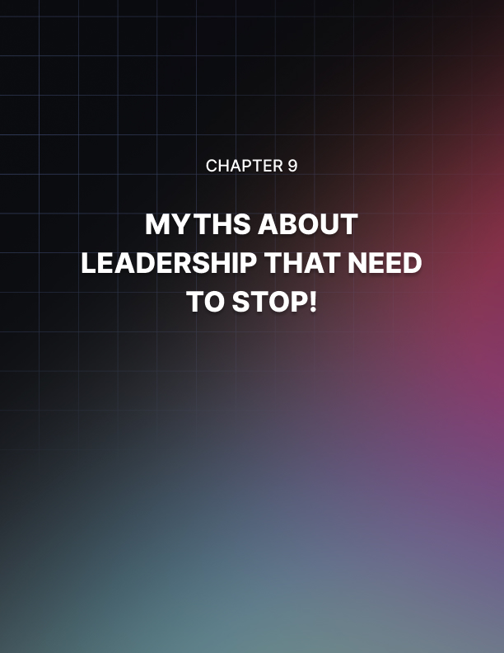

Chapter 9: Myths About Leadership That Need to Stop!

Don’t worry if you don’t think you are a ‘great leader’ naturally.

It’s perfectly fine to feel that there are others out there better suited to leadership roles and in fact few of us see ourselves as being natural born leaders until we are thrust into the role.

The good news is that most leaders are made rather than born and that means you can develop the necessary skills ‘on the job’ as it were. Part of this will mean doing your research, which you’re doing right now… well done!

Unfortunately, though, what doesn’t help matters is that there is a lot of misinformation out there making things harder for us. There are a lot of prevailing myths about leadership that do nothing other than steer us onto the wrong course.

Here are a few of the worst…

Being a Leader Involves Shouting
One thing that people think is that being a leader means ‘being in charge’ and that this in turn means stamping down their authority and shouting at people to reprimand them when necessary.

But while this might have been true in the 50s, it’s a wildly outdated approach today. For starters, shouting simply makes you appear out of control and emotional – rather than calm and collected.

Moreover, shouting suggests that you are in charge of someone else; you aren’t. All you are is in a position where you get to choose the next course of action.

This is due to an agreement between you and the person you are instructing and they can choose to terminate that agreement at any time, as can you. Treat people with respect, even when they’re not listening to reason.

Leaders Should be ‘One of the Guys’
Conversely though, it is not pertinent to try and be ‘mates’ with your team. While that might sound appealing, the reality is that it will lead to more problems.

It makes it harder when you have to make tough decisions, it can lead to accusations that your personal feelings are getting in the way and it can sometimes cross a line into disrespect. Be friendly but try to separate business and pleasure at least in the office.

Being a Leader Means Being Bold and Brave
Being a leader does not mean you have to be bold and brave. It
doesn’t mean you need to have wide shoulders and a massive chest,
or infinite confidence.

All leaders are human (except Optimus Prime) and that means they have weaknesses, character flaws and self-doubt just like everyone else. Being a leader is not about who you are but is about what you do!

How to Give Correct Instructions
The way you give instructions is going to be one of the most important defining features of you as a leader. Because ultimately, this is what will make up the majority of your job!

As a leader, you are going to be spending most of your day-to-day life asking people to do things and then checking they are done correctly. But in order to do this well, you need to know how to give instructions and how to ensure the best outcome.

Here’s what you need to do…

Be Clear and Precise
The first and most important thing you need to do is to be clear and precise. The reason for this is that you need to be able to prevent mistakes and misunderstandings.

If you give unclear instructions, then that will lead to your team either needing to ask for more information and clarification from you or to them making mistakes that lead to big problems and possibly lose you money.

This means that the good leader is also a good communicator by
default. If you’re not a good communicator… train yourself to be!

Explain the Why
What’s even more important though, is that you explain the why in what you are asking people to do. In fact, better yet is to ask people to achieve a certain result, tell them why and give no instruction on how.

This first of all makes you a more hands-off leader and less of a micromanager. People like this because it gives more work satisfaction and makes them feel trusted.

Moreover though, explaining the what and why more than the how is going to allow your team to be flexible where necessary.

Let’s say for example that you tell your staff they need to print 500 fliers and deliver them around the neighborhood. What happens if the printers break? Or if the roads are snowed off? Now your team will either be stuck, or they’ll come to you to ask for directions.

Instead, tell your team they need to get 500 adverts out in the local area. This now opens up many contingency plans and other options. They could maybe outsource the flier creation to a printing company for instance, or they might use email instead or advertise in the town hall.

Either way, they have now achieved the same thing quicker and with more satisfaction because they haven’t had to ask your permission for every slight deviation in the plan!

How to Motivate and Inspire Your Team
Want to motivate your team and get them to work better and faster? Then you should just offer them bonuses for working harder and faster right? Or introduce the threat of punishment for those who take too long? Wrong!

When you introduce penalties and rewards, you encourage faster, sloppier work that is more likely to lead to mistakes. What’s more, is that you encourage people to step on each other to get to the top. And you stifle creativity!

So, what do you do instead?

Intrinsic vs Extrinsic Motivation
The problem is that both of these solutions involve extrinsic motivation. That means that the motivation is coming from elsewhere; that the activity is not rewarding in itself. This means that the team will simply want to finish fast and go home!

Conversely though, if you can make it so that the activity itself is rewarding, then you’ll find they naturally work harder of their own volition.
So how do you create this change?

Ownership
One solution is to give your team some degree of ownership over what they are doing and to give them credit for their rewards. A good way to do that? To put their name on what they create!

There is a big reason behind why this works and that is that it gives them a sense of pride in their work. That in turn makes the work rewarding – this is their project.
If it goes well, then they can brag about it. And if they can brag about it, then it will benefit them.

At the same time, it’s also important to give your team some degree of control over what they are doing. That means making sure that they can make decisions if they need to and take the necessary responsibility that comes with that.

Once again, this makes the project feel more like it is really ‘theirs’ and it makes them much happier to work longer hours as a result. Of course, there are other ways you can make work fun too! Introducing lots of breaks, changing the working environment and even gamifying certain aspects can all make a big difference to the way that your team works and behaves – so give it a go!

The Biggest Tip
But the biggest tip of all? Make sure you have the right people on your team in the first place. Some people just won’t find what you’re doing exciting. And they’re the wrong people for your organization!


Conclusion

What makes a great leader? Of course, every leader is different.

While some leaders will be very charismatic, loud and proud, others will be understated and calm.

While some will be ‘by the book’, others will be creative and flexible in
the way they work.

But while leaders all vary and come in many shapes and sizes, there are certainly some prevailing features and traits that seem to unite them.

Let’s take a look then at some of the things that make a great leader and some of the traits you should adopt if you want to be greater at leading!

Responsible
A good leader should be responsible. That means they need to be able to take the flack when things go wrong and they need to be courageous enough to take risks and then take the flak when those risks go wrong.

This is important because it ensures that the team feels safe and liberated to work their best, knowing that they answer only to one person who will protect their best interests.

Knowledgeable
A good leader should be knowledgeable. No one knows everything (and a good leader will be the first to admit this!) but you should certainly know the ins and outs of your industry and your work.

The reason this is so important is that it will mean that people can turn to you when they don’t know what to do. It also means you’ll be able to understand the basics of every part of your business, so that
you can keep an eye on the bigger picture and help every facet of your team to work together seamlessly.

Calm
It is highly important that a good leader be calm. This means that you shouldn’t shout at insubordinate staff and it means that you should never come across as stressed, scared or worried.

A leader will always be a barometer for the mood for their team. As
as soon as you lose it, the team will start to panic. Even if you’re worried, make sure that you don’t project this outwardly.

Passionate
Most of all, a good leader should be highly passionate. That means that they should believe strongly in what they’re doing and it means that they should understand the ‘why’ behind their business.

This is important because when you are passionate and you believe in your business, that means you can inspire others. Without this, you’ll be going through the motions and the entire team will be affected negatively.

