Table Of Contents
Introduction 5
Organic Traffic for Sustainable Growth 8
The Importance of Organic Traffic 8
Organic vs. Paid Traffic 9
Case Study: Buffer's Success with Organic Traffic 10
Challenges and Strategies for Building Organic Traffic 10
Mastering Organic Traffic 15
Optimizing Content for SEO 18
On-Page SEO: The Core of Your Strategy 18
Off-Page SEO: Building Your Site’s Authority 20
Advanced SEO Techniques 22
Overcoming Common SEO Challenges 24
Measuring SEO Success 25
The SEO Journey Never Ends 26
Leveraging Social Media for Reach 29
Understanding Social Media Algorithms 29
Content Strategies for Maximum Engagement 30
Engagement Strategies to Boost Organic Reach 32
Platform-Specific Strategies for Organic Reach 34
Measuring and Analyzing Organic Reach 35
Overcoming Common Challenges in Organic Reach 36
Case Study: Organic Reach Success Story 37
Implementing Strategies 38
Building a Loyal Audience 41
Understanding the Audience Journey 41
Creating a Seamless User Experience 42
Building Trust and Credibility 43
Fostering Engagement and Community 44
Personalizing the Customer Experience 44
Nurturing Through Email Marketing 45
Leveraging Content Marketing for Loyalty 46
Overcoming Common Challenges 47
Measuring Success and Iterating 48
Case Study: Building a Loyal Audience in Action 48
Leveraging User-Generated Content (UGC) 49
Implementing a Referral Program 50
Harnessing the Power of Social Proof 51
Creating Exclusive Experiences 52
Leveraging Artificial Intelligence for Personalization 53
The Ongoing Journey of Audience Loyalty 54
Recap and Encouragement to Innovate 57

Disclaimer
The information provided in this ebook is intended solely for educational and informational purposes. The author does not accept any responsibility for the outcomes that may arise from the application of the material within. While efforts have been made to ensure the accuracy and relevance of the content, the author cannot be held accountable for any errors or omissions, or for any consequences resulting from the use or misuse of the information provided. The responsibility for any actions taken based on the information in this ebook lies solely with the reader.



Introduction
Some websites effortlessly attract a steady stream of visitors, while others struggle to gain traction. You’ve likely experienced clicking on a captivating post in your social media feed that leads you to a website aligned with your interests. That’s the power of organic traffic.
In a world where attention is one of the most valuable assets, mastering the art of generating organic traffic isn’t just a skill—it’s a vital asset. This book will guide you in transforming your online presence from obscurity to a thriving hub of engaged visitors.
While paid advertising may seem like a quick fix, it offers only short-term results. Organic traffic, on the other hand, provides sustainable, long-term growth. In fact, according to a BrightEdge study, organic search drives 53% of all website traffic—outperforming every other channel.
However, the online world is evolving rapidly, and staying ahead requires up-to-date strategies. This book will introduce you to cutting-edge techniques that are shaping the future of marketing, offering more than just the usual tactics.
By mastering organic traffic generation, your content can rise to the top of search results, your social media posts can achieve viral reach, and your website can become a trusted resource in your niche. These outcomes are within reach with the right approach.
Throughout this book, you’ll learn:
- The latest SEO trends to boost your search rankings
- Social media strategies that transform casual visitors into loyal followers
- Content optimization techniques that search engines will favor
- Audience retention tactics to keep visitors coming back for more
This isn’t just theory—we’ll explore real-world examples, case studies, and practical advice you can apply immediately. Industry experts will share the strategies they’ve used to achieve significant growth, helping you overcome common challenges like algorithm changes and content invisibility.
By the end of this journey, you’ll have the tools and knowledge to take control of your online presence. You won’t be dependent on paid advertising or affected by algorithm shifts. Instead, you’ll build a strong, sustainable online presence that grows over time.
Whether you’re a seasoned marketer, an entrepreneur building a brand, or a content creator looking to expand your reach, this book will provide invaluable insights and strategies to help you succeed online.

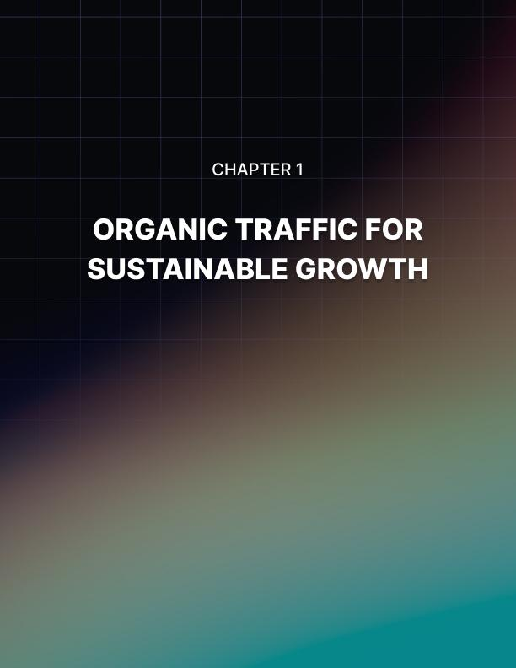

Organic Traffic for Sustainable Growth
In the bustling digital marketplace, organic traffic stands as a beacon of sustainable growth. You, as a savvy social media marketer, are about to embark on a journey that will transform your approach to building an online presence. Gone are the days when paid advertisements were the only path to visibility. Today, organic traffic is the key to unlocking long-term success and establishing a robust digital footprint.
Imagine a world where your content naturally attracts and engages your target audience, where your brand’s message resonates so powerfully that it spreads like wildfire across the internet. This isn’t a distant dream—it’s the reality that organic traffic can create for you. As you delve into this chapter, you’ll uncover the secrets to harnessing this powerful force, learning not just what organic traffic is, but why it’s absolutely critical for your marketing strategy.

The Importance of Organic Traffic
At its core, organic traffic refers to visitors who land on your website as a result of unpaid search results. When you create content that aligns with what people are searching for, and when search engines deem that content valuable and relevant, you earn organic traffic. It’s the digital equivalent of word-of-mouth marketing, where your content’s merit speaks for itself. But why should you care about organic traffic? The answer lies in its sustainability and cost-effectiveness. Unlike paid traffic, which stops the moment you turn off the tap of ad spend, organic traffic continues to flow long after you’ve published your content. It’s an investment that pays dividends over time, growing in value as your online presence strengthens.
Consider this: according to a 2023 study by Ahrefs, over 90% of pages get no organic search traffic from Google. This statistic might seem daunting, but for you, it represents an enormous opportunity. By mastering the art of attracting organic traffic, you’ll position yourself in the elite 10% that captures the lion’s share of online attention.

Organic vs. Paid Traffic
To truly appreciate the value of organic traffic, it’s essential to understand how it differs from its paid counterpart. Paid traffic, while immediate and controllable, comes with a hefty price tag and diminishing returns. Every click costs you money, and the moment you stop paying, your visibility plummets. Organic traffic, on the other hand, is like planting a tree. It takes time and nurturing to grow, but once established, it provides shade, fruit, and beauty for years to come. The cost of organic traffic is essentially free, aside from the time and resources invested in creating quality content, while paid traffic requires a continuous financial investment. The benefits of organic traffic can last for months or even years after content publication, whereas paid traffic stops as soon as you stop paying. Users often trust organic results more than paid ads.
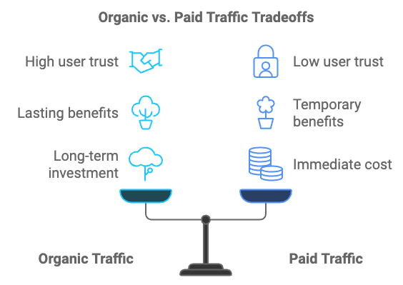
A 2023 survey by BrightLocal found that 76% of consumers trust organic search results more than paid ads. As your organic presence grows, you can attract more traffic without necessarily increasing your costs proportionally, while scaling paid traffic always means spending more. Organic traffic comes from users actively seeking out information, leading to higher engagement and conversion rates, while paid traffic can sometimes be perceived as intrusive.

Case Study: Buffer's Success with Organic Traffic
To illustrate the power of organic traffic, let’s look at the success story of Buffer, a social media management platform. In its early days, Buffer focused heavily on content marketing and SEO to drive organic traffic. By consistently producing high-quality, informative blog posts and optimizing them for search engines, Buffer saw its organic traffic grow from zero to over 1 million monthly visitors in just three years. Key takeaways from Buffer’s strategy include consistency in publishing content regularly, maintaining a steady flow of valuable information for their audience; quality in each piece of content being well-researched and providing actionable insights; SEO focus by optimizing their content for relevant keywords, making it easier for their target audience to find them; and a value-first approach, instead of hard-selling their product, they focused on providing value, which naturally led to increased brand awareness and trust. By prioritizing organic traffic, Buffer not only saved on advertising costs but also built a loyal audience that continues to drive their growth today.

Challenges and Strategies for Building Organic Traffic
While the benefits of organic traffic are clear, the path to achieving it is not without obstacles. As you embark on your organic traffic journey, you’re likely to encounter several common challenges. One of the most frustrating aspects of building organic traffic is the slow initial growth. Unlike paid ads, which can drive traffic immediately, organic growth takes time. It’s not uncommon to spend months creating content before seeing significant results. The solution lies in patience and persistence. Focus on consistently producing high-quality content and optimizing it for search engines. Use tools like Google Search Console to track your progress and identify areas for improvement. Remember, every piece of content you create is an asset that can continue to drive traffic for years to come.
In many niches, you’ll find yourself competing against established players with larger budgets and more resources. This intense competition can make it challenging to rank for your target keywords and gain visibility. Instead of trying to compete head-on for highly competitive keywords, focus on long-tail keywords and niche topics where you can establish authority. Use tools like Ahrefs or SEMrush to identify less competitive keywords with good search volume. As you build your authority, you can gradually target more competitive terms.
Search engines frequently update their algorithms, which can impact your organic traffic. A change in Google’s algorithm could potentially cause a drop in rankings and traffic overnight. To overcome this challenge, stay informed about algorithm updates by following reputable SEO news sources. Focus on creating high-quality, user-focused content rather than trying to game the system. Diversify your traffic sources so you’re not entirely dependent on search engines.
Even if you manage to drive traffic to your site, you might find that visitors aren’t engaging with your content or taking desired actions, resulting in low engagement rates. Analyze your user behavior with tools like Google Analytics. Look at metrics like bounce rate, time on page, and exit pages to identify where users are losing interest. Use this information to improve your content and user experience. Consider implementing interactive elements, such as quizzes or calculators, to boost engagement.
In many niches, there’s an overwhelming amount of content being produced daily. Standing out in this sea of information can be challenging due to content saturation. Focus on creating unique, in-depth content that provides more value than what’s already out there. Use data, original research, or personal experiences to offer fresh perspectives. Consider creating content in different formats, such as videos, infographics, or podcasts, to cater to different audience preferences.
Now that you understand the challenges, let’s explore strategies to overcome them and build sustainable organic growth. Your content is the foundation of your organic traffic efforts. A well-planned content strategy ensures that you’re creating the right content for your audience and business goals. Key elements of an effective content strategy include audience research to understand your target audience’s needs, preferences, and pain points; keyword research to identify relevant keywords and topics that your audience is searching for; a content calendar to plan your content creation and publication schedule; content formats to determine which types of content (blog posts, videos, infographics, etc.) resonate best with your audience; and distribution channels to identify where and how you’ll share your content to maximize reach.
Understanding and aligning with search intent is crucial for organic traffic success. Search intent refers to the purpose behind a user’s search query. There are four main types of search intent: informational, where users are seeking information or answers to questions; navigational, where users are looking for a specific website or page; commercial, where users are researching products or services before making a purchase; and transactional, where users are ready to make a purchase or take a specific action. By creating content that matches the search intent of your target keywords, you increase your chances of ranking well and attracting qualified traffic.
While quality content is crucial, technical SEO ensures that search engines can easily crawl, index, and understand your site. Key technical SEO elements to focus on include site speed by optimizing images, leveraging browser caching, and minimizing code to improve load times; mobile-friendliness to ensure your site is responsive and provides a good user experience on all devices; URL structure by using clean, descriptive URLs that include relevant keywords; XML sitemap to create and submit a sitemap to help search engines discover and index your content; and internal linking to use a logical internal linking structure to help both users and search engines navigate your site.
Backlinks from reputable sites signal to search engines that your content is valuable and trustworthy. While you can’t control who links to you, you can increase your chances of earning quality backlinks. Strategies for earning backlinks include creating link-worthy content by producing unique, valuable content that others naturally want to reference; guest posting by contributing high-quality articles to reputable sites in your niche; digital PR to get featured in industry publications or news outlets; broken link building by finding broken links on other sites and offering your content as a replacement; and resource page link building by finding relevant resource pages and suggesting your content for inclusion.
While social media typically doesn’t directly impact search rankings, it can significantly boost your content’s visibility and drive referral traffic. Effective social media strategies for organic growth include platform selection to focus on platforms where your target audience is most active; consistent posting to maintain a regular posting schedule to keep your audience engaged; engagement by actively participating in conversations and responding to comments; content repurposing to adapt your content for different social media platforms; and hashtag strategy to use relevant hashtags to increase discoverability.
Email marketing remains one of the most effective ways to nurture relationships with your audience and drive repeat traffic to your site. Key email marketing strategies include lead magnets to create valuable resources (e.g., ebooks, templates) to encourage email sign-ups; segmentation to divide your email list based on subscriber interests or behaviors; personalization to use subscriber data to tailor email content and recommendations; automation to set up email sequences to nurture leads and re-engage inactive subscribers; and A/B testing to continuously test different elements of your emails to improve performance.
A positive user experience not only helps with SEO but also increases the likelihood of visitors engaging with your content and returning to your site. Key UX elements to consider include navigation to make it easy for users to find what they’re looking for; page layout to use a clean, logical layout that guides users through your content; content readability to use short paragraphs, subheadings, and bullet points to make your content easy to scan; call-to-action (CTA) placement to strategically place CTAs to guide users towards desired actions; and site search to implement a robust search function to help users find relevant content quickly.
Video content can significantly boost engagement and time on site, both of which are positive signals for search engines. Strategies for incorporating video include YouTube SEO to optimize your videos for YouTube search to tap into the world’s second-largest search engine; video embeds to include relevant videos in your blog posts to increase engagement; live streaming to use platforms like Facebook Live or Instagram Live to connect with your audience in real-time; video transcripts to provide transcripts for your videos to make them accessible and searchable; and video snippets to create short, shareable video clips for social media to drive traffic back to your full content.
If your business has a local component, local SEO can be a powerful driver of organic traffic. Key local SEO strategies include Google My Business to claim and optimize your Google My Business listing; local keywords to incorporate location-based keywords into your content and meta tags; NAP consistency to ensure your Name, Address, and Phone number are consistent across the web; local link building to earn backlinks from local directories, chambers of commerce, and other local organizations; and customer reviews to encourage satisfied customers to leave reviews on Google and other platforms.
The digital landscape is constantly evolving. To maintain and grow your organic traffic, you need to stay informed and be ready to adapt your strategies. Key monitoring and adaptation strategies include analytics review to regularly review your website analytics to identify trends and opportunities; competitor analysis to keep an eye on your competitors’ strategies and look for ways to differentiate yourself; industry trends to stay informed about changes in your industry that might impact content needs or search behavior; content updates to regularly update your existing content to ensure it remains relevant and accurate; and experimentation to try new content formats or distribution channels.
To ensure your organic traffic strategies are effective, you need to track the right metrics. Key performance indicators (KPIs) to monitor include organic traffic volume, organic conversion rate, organic bounce rate, average time on page, pages per session, keyword rankings, organic click-through rate (CTR), new vs. returning visitors, page load time, and domain authority. To effectively measure these KPIs, you’ll need the right tools such as Google Analytics, Google Search Console, SEMrush or Ahrefs, Moz Pro, Hotjar, PageSpeed Insights, and Yoast SEO (for WordPress).
Even with a solid strategy in place, you may encounter periods where your organic traffic growth stagnates. Common plateaus and how to overcome them include content fatigue, keyword cannibalization, technical SEO issues, algorithm updates, competitive pressure, and seasonal fluctuations. By addressing these challenges proactively, you can maintain and accelerate your organic traffic growth.
Once you’ve mastered the basics and overcome common plateaus, consider advanced strategies to take your organic traffic to the next level. These include topic clusters and pillar pages, schema markup, voice search optimization, content partnerships, user-generated content, interactive content, predictive SEO, international SEO, AI-powered content optimization, and progressive web apps (PWAs).
As you continue to refine your organic traffic strategies, it’s crucial to keep an eye on emerging trends that could shape the future of SEO and content marketing. Areas to watch include artificial intelligence and machine learning, visual search, augmented and virtual reality, zero-click searches, E-A-T (Expertise, Authoritativeness, Trustworthiness), Core Web Vitals, video content optimization, entity-based SEO, passage ranking, and mobile-first indexing.

Mastering Organic Traffic
Mastering organic traffic is an ongoing journey that requires patience, persistence, and adaptability. By implementing the strategies outlined in this chapter and staying attuned to emerging trends, you’ll be well-positioned to build a sustainable, traffic-generating machine that doesn’t rely on paid advertising. Remember, the key to success lies in providing genuine value to your audience. Every piece of content you create, every optimization you make, should be driven by the goal of solving problems and answering questions for your target users. As you continue to refine your approach, always keep the user at the center of your strategy.
Organic traffic isn’t just about attracting visitors; it’s about building a loyal audience that trusts your brand and returns to your site time and time again. By focusing on creating high-quality, user-centric content and optimizing it for search engines, you’re not just driving traffic – you’re building a foundation for long-term business success. As you move forward, stay curious and never stop learning. The world of SEO and content marketing is constantly evolving, and those who succeed are those who remain flexible and eager to adapt to new challenges and opportunities. With the knowledge and strategies you’ve gained from this chapter, you’re well-equipped to navigate the exciting world of organic traffic and achieve sustainable growth for your online presence.

Metric | Description | Importance
Organic Traffic Volume | Total number of visitors from organic search | High
Organic Conversion Rate | Percentage of organic visitors completing desired actions | High
Organic Bounce Rate | Percentage of single-page sessions | Medium
Average Time on Page | Average duration visitors spend on a page | Medium
Pages per Session | Average number of pages viewed in a session | Medium
Keyword Rankings | Position in search results for target keywords | High
Organic Click-Through Rate (CTR) | Percentage of users clicking on your search result | High
New vs. Returning Visitors | Ratio of new to returning organic visitors | Medium
Page Load Time | Speed at which your pages load | High
Domain Authority | Prediction of a website’s ranking ability | Medium

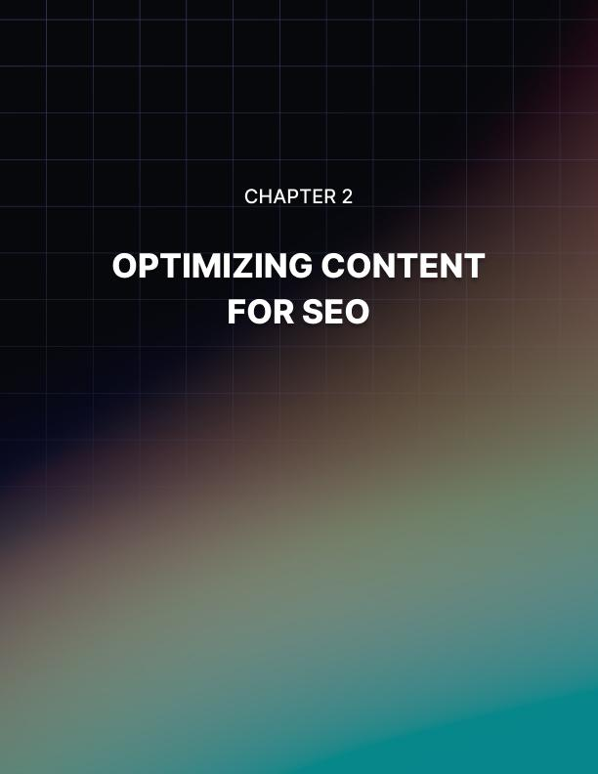

Optimizing Content for SEO
In the digital age, content is king, but even the most brilliantly crafted content can languish in obscurity if it’s not optimized for search engines. As a social media marketer, you’re about to embark on a journey that will transform your content from hidden gems to shining beacons in the vast sea of online information. Search Engine Optimization (SEO) is the compass that will guide your content to the top of search engine results pages (SERPs), making it discoverable to your target audience.
The landscape of SEO is constantly evolving, with search engines like Google continuously refining their algorithms to provide users with the most relevant and high-quality results. Your mission, should you choose to accept it, is to stay ahead of these changes and leverage them to your advantage. This chapter will equip you with the latest SEO trends, tools, and techniques to ensure your content not only ranks well but also resonates with your audience.

On-Page SEO: The Core of Your Strategy
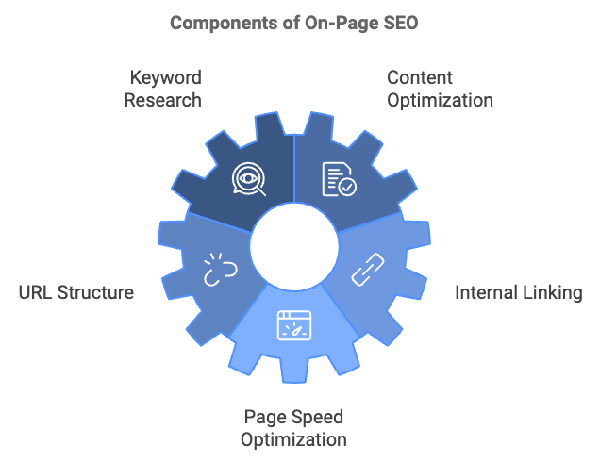
On-page SEO refers to the practice of optimizing individual web pages to rank higher and earn more relevant traffic in search engines. It involves both the content and HTML source code of a page that can be optimized, as opposed to off-page SEO which refers to links and other external signals.
Keyword Research
Before you even begin crafting your content, you need to know what your audience is searching for. Keyword research is the process of identifying the terms and phrases your potential visitors are using to find information related to your business or industry. To conduct effective keyword research, start with seed keywords, which are broad terms related to your business or content topic. Use keyword research tools like SEMrush, Ahrefs, or Google’s Keyword Planner to expand your list and provide valuable data on search volume and competition. Analyze search intent to understand why users are searching for these terms. Look for long-tail keywords, which are longer, more specific phrases that often have less competition and higher conversion rates. Finally, check for trending topics using tools like Google Trends to identify rising search interests in your niche.
For example, if you’re writing content about social media marketing, your seed keyword might be “social media marketing.” Using a tool like SEMrush, you might discover long-tail keywords like “social media marketing strategies for small businesses” or “how to measure social media marketing ROI.”

Content Optimization
Once you’ve identified your target keywords, it’s time to incorporate them into your content. However, it’s crucial to remember that while keywords are important, they should never compromise the quality or readability of your content. Use your primary keyword in the title, placing it close to the beginning of your title tag for maximum impact. Include keywords in headings using H1, H2, and H3 tags to structure your content and incorporate relevant keywords. Optimize your meta description, which, while not a direct ranking factor, can improve click-through rates. Use keywords naturally throughout the content, aiming for a keyword density of 1-2%, but prioritize natural language over keyword stuffing. Include related terms and synonyms to help search engines understand the context of your content. Finally, optimize images by using descriptive file names and alt text, incorporating keywords where relevant.

URL Structure
Your URL structure plays a role in both user experience and SEO. Keep URLs short and descriptive, use hyphens to separate words, include your target keyword, and avoid unnecessary parameters or session IDs. For example, a good URL structure for an article about social media marketing tips might look like this: www.yourdomain.com/social-media-marketing-tips

Internal Linking
Internal linking is the practice of linking to other pages on your own website. It helps search engines understand the structure of your site and can distribute link equity (ranking power) throughout your pages. Use descriptive anchor text, link to relevant, high-quality content, create a logical site structure, and use a reasonable number of links (don’t overdo it).

Page Speed Optimization
Page speed is a crucial factor for both user experience and SEO. Google has explicitly stated that page speed is a ranking factor, especially for mobile searches. To improve your page speed, optimize images by compressing them and using the right format, minify CSS, JavaScript, and HTML, leverage browser caching, reduce server response time, and use a content delivery network (CDN). Tools like Google’s PageSpeed Insights can help you identify areas for improvement.

Off-Page SEO: Building Your Site’s Authority
While on-page SEO focuses on optimizing elements within your website, off-page SEO refers to actions taken outside of your own website to impact your rankings within search engine results pages (SERPs).
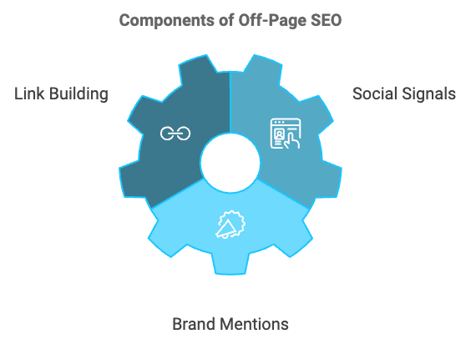
Link Building
Link building is the process of acquiring hyperlinks from other websites to your own. Search engines use these links to crawl the web, and they also view these links as votes of confidence. The more high-quality, relevant sites that link to you, the more likely you are to rank well in search results. Effective link building strategies include creating linkable assets, guest blogging, broken link building, digital PR, and influencer outreach. Remember, quality trumps quantity when it comes to backlinks. A few links from highly authoritative, relevant sites are worth more than many links from low-quality or irrelevant sites.

Social Signals
While Google has stated that social signals are not a direct ranking factor, there’s evidence to suggest they can indirectly impact your SEO. When your content is shared widely on social media, it increases visibility, which can lead to more backlinks and traffic – both of which are ranking factors. To leverage social media for SEO, create shareable content, optimize your social media profiles, engage with your audience regularly, use hashtags strategically, and encourage social sharing of your content.

Brand Mentions
Even unlinked mentions of your brand can contribute to your SEO efforts. Google’s algorithm is sophisticated enough to recognize brand mentions and associate them with your website. To increase brand mentions, create newsworthy content, participate in industry events and conferences, engage in community discussions, offer expert quotes or interviews, and develop a strong PR strategy.

Advanced SEO Techniques
As search engines become more sophisticated, SEO strategies must evolve. Here are some advanced techniques to keep you ahead of the competition:
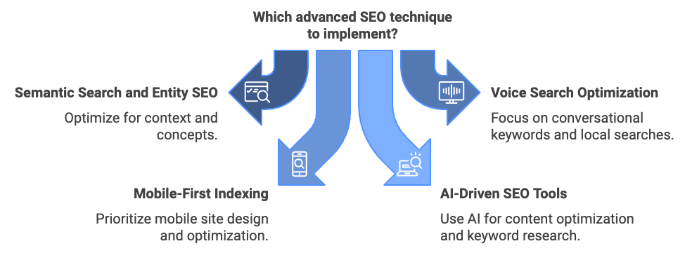

Semantic Search and Entity SEO
Semantic search refers to search engines’ ability to understand the context and intent behind a search query, rather than just matching keywords. Entity SEO focuses on optimizing for concepts or “things” rather than just keywords. To optimize for semantic search, use structured data markup (schema.org), create comprehensive, in-depth content that covers all aspects of a topic, use natural language and synonyms in your content, focus on topics rather than just keywords, and build topical authority by creating clusters of related content.

Voice Search Optimization
With the rise of digital assistants like Siri, Alexa, and Google Assistant, optimizing for voice search is becoming increasingly important. Focus on conversational, long-tail keywords, create content that answers specific questions, optimize for local searches (many voice searches are location-based), improve your site’s loading speed, and aim for featured snippets, which are often used for voice search results.

Mobile-First Indexing
Google now uses the mobile version of your site for indexing and ranking. This means that your mobile site should be your primary focus when it comes to SEO. To ensure your site is mobile-friendly, use responsive design, optimize page speed for mobile devices, use larger font sizes and button sizes for easy tapping, avoid using Flash or other technologies not supported on mobile devices, and implement Accelerated Mobile Pages (AMP) where appropriate.

AI-Driven SEO Tools
Artificial Intelligence is revolutionizing SEO, offering powerful tools for content optimization, keyword research, and more. Some AI-powered SEO tools to consider include MarketMuse for content optimization and topic modeling, Clearscope for AI-powered content optimization, Frase for AI-assisted content creation and optimization, and WordLift for entity-based SEO and structured data automation.

User Experience (UX) Signals
Google is increasingly using user experience signals as ranking factors. This includes metrics like bounce rate, time on site, and click-through rate. To improve your UX signals, create engaging, high-quality content, improve site navigation and internal linking, optimize page load times, ensure your site is mobile-friendly, and use clear calls-to-action.

Overcoming Common SEO Challenges
Even with a solid SEO strategy in place, you may encounter several challenges. Here’s how to address some of the most common issues:

Content Invisibility
If your content isn’t showing up in search results, it could be due to several factors: your site is new and hasn’t been fully indexed yet, your content is thin or low-quality, your site has technical issues preventing proper indexing, or you’re targeting highly competitive keywords. To address this, submit your sitemap to Google Search Console, improve your content quality and depth, conduct a technical SEO audit to identify and fix any issues, and target less competitive, long-tail keywords to start building authority.

Slow Indexing
If Google is taking a long time to index your new content, use Google Search Console’s URL Inspection tool to manually request indexing, improve your site’s crawl budget by removing low-quality pages, use internal linking to help search engines discover new content faster, and share new content on social media to increase its visibility.

Google Algorithm Updates
Google regularly updates its algorithm, which can sometimes cause fluctuations in rankings. To mitigate the impact of algorithm updates, stay informed about upcoming updates, focus on creating high-quality, user-focused content, diversify your traffic sources, regularly audit your site for potential issues, and be patient – sometimes rankings recover on their own after an update.

Keyword Cannibalization
This occurs when multiple pages on your site target the same keyword, causing them to compete with each other in search results. To address keyword cannibalization, conduct a content audit to identify competing pages, consolidate similar content into a single, comprehensive page, use canonical tags to indicate the preferred version of a page, and implement a clear content hierarchy and internal linking structure.

Dealing with Negative SEO
Negative SEO refers to actions taken by competitors to harm your site’s rankings, such as building spammy backlinks to your site. To protect against negative SEO, regularly monitor your backlink profile, use Google’s Disavow Tool to reject harmful backlinks, keep an eye on your site’s performance in Search Console, and maintain a diverse and natural backlink profile.

Local SEO Challenges
For businesses with a physical presence, local SEO is crucial. Common challenges include inconsistent NAP (Name, Address, Phone) information across the web, lack of local citations, poor Google My Business optimization, and negative reviews. To address these issues, use a tool like Moz Local to ensure NAP consistency, build local citations on relevant directories, fully optimize your Google My Business listing, and encourage satisfied customers to leave positive reviews while responding professionally to negative ones.

Measuring SEO Success
To ensure your SEO efforts are paying off, it’s crucial to track the right metrics. Some key performance indicators (KPIs) to monitor include organic traffic, keyword rankings, organic click-through rate (CTR), bounce rate, average time on page, pages per session, conversion rate, backlink profile, page load speed, and domain authority.

Tools for SEO Success
To effectively implement and measure your SEO strategies, you’ll need the right tools. Some essential SEO tools to consider include Google Search Console, Google Analytics, SEMrush or Ahrefs, Screaming Frog, Moz Pro, Yoast SEO (for WordPress), PageSpeed Insights, Schema Markup Generator, Answer the Public, and BuzzSumo.

The SEO Journey Never Ends
As you’ve discovered throughout this chapter, SEO is a complex and ever-evolving field. It requires a combination of technical knowledge, creativity, and strategic thinking. But don’t let the complexity discourage you. Every step you take to optimize your content for search engines is a step towards greater visibility and success for your brand.
Remember, SEO is not about tricking search engines or manipulating rankings. It’s about creating the best possible experience for your users and helping search engines understand the value of your content. By focusing on providing genuine value, staying informed about the latest trends and best practices, and consistently applying the strategies we’ve discussed, you’ll be well on your way to SEO success.
As you move forward, keep in mind that SEO is a long-term game. Results won’t come overnight, but with patience and persistence, you’ll see your efforts pay off in increased traffic, engagement, and authority in your niche.

SEO Aspect | Key Points
On-Page SEO | Keyword research, content optimization, URL structure, internal linking, page speed
Off-Page SEO | Link building, social signals, brand mentions
Advanced Techniques | Semantic search, voice search optimization, mobile-first indexing, AI-driven tools
Challenges | Content invisibility, slow indexing, algorithm updates, keyword cannibalization, negative SEO
Metrics to Track | Organic traffic, keyword rankings, CTR, bounce rate, conversion rate
Future Trends | AI and machine learning, voice search, visual search, Core Web Vitals

As you implement these SEO strategies, remember to stay user-focused, be consistent, experiment and adapt, keep learning, and monitor and adjust your approach based on performance data. By mastering the art and science of SEO, you’re not just improving your search rankings – you’re building a stronger, more visible online presence that will serve as the foundation for all your digital marketing efforts.

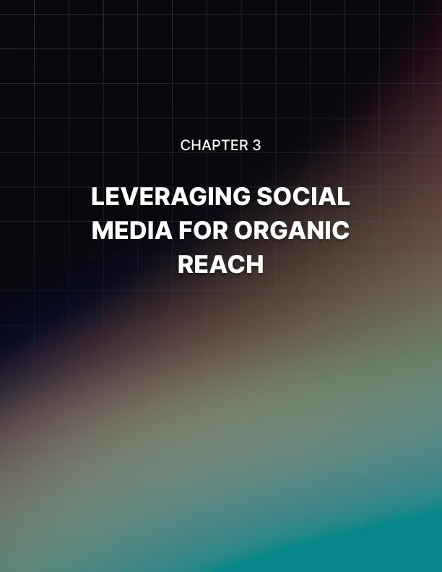

Leveraging Social Media for Reach
In today’s digital landscape, social media has become an indispensable tool for businesses and marketers seeking to expand their reach and connect with their target audience. As a savvy social media marketer, you’re about to embark on a journey that will transform your approach to organic reach, allowing you to harness the full potential of social platforms without relying on paid advertising.
The allure of social media lies in its ability to foster genuine connections, spark conversations, and create communities around brands and ideas. However, with algorithm changes and increasing competition for user attention, achieving organic reach on social media has become more challenging than ever. But fear not – armed with the right strategies and a deep understanding of how social platforms work, you can cut through the noise and make your content shine.
In this chapter, we’ll explore effective strategies for leveraging various social media platforms to attract and engage your target audience organically. From understanding algorithm changes to mastering content creation that resonates, we’ll cover everything you need to know to build a thriving social media presence without spending a dime on ads.

Understanding Social Media Algorithms
Before diving into specific strategies, it’s crucial to understand how social media algorithms work. These complex systems determine what content users see in their feeds, and mastering them is key to improving your organic reach. Facebook’s algorithm prioritizes content that sparks meaningful interactions between people. It considers factors such as relationship, interest, engagement, and recency. To work with Facebook’s algorithm, focus on creating content that encourages genuine conversations, use Facebook Groups to build community and increase engagement, leverage Facebook Live to boost real-time interactions, and encourage your followers to select “See First” in their news feed preferences for your page.
Instagram’s algorithm is similar to Facebook’s but with some unique factors, including interest, recency, relationship, frequency, following, and usage. To optimize for Instagram’s algorithm, post consistently to maintain engagement, use Instagram Stories and Reels to increase visibility, encourage followers to turn on post notifications for your account, and engage with your followers’ content to strengthen relationships.
Twitter’s algorithm is designed to show users the most relevant tweets first, considering factors such as relevance, engagement, recency, and rich media. To work with Twitter’s algorithm, tweet frequently to increase your chances of visibility, use relevant hashtags to improve discoverability, engage in conversations and respond to mentions, and share a mix of original content and curated retweets.
LinkedIn’s algorithm focuses on promoting high-quality, professional content, prioritizing personal connections, interest relevance, engagement, and dwell time. To optimize for LinkedIn’s algorithm, share industry insights and professional experiences, engage with your network’s posts, use relevant hashtags to increase discoverability, and encourage employees to share company content.
Understanding these algorithms is just the first step. Now, let’s dive into specific strategies to boost your organic reach across social media platforms.

Content Strategies for Maximum Engagement
Creating content that resonates with your audience is crucial for organic reach. One of the most important strategies is to know your audience. Before creating content, it’s essential to understand who you’re creating it for. Develop detailed buyer personas that include demographics, interests and hobbies, pain points and challenges, preferred social media platforms, and content consumption habits. Use tools like Facebook Audience Insights, Twitter Analytics, and LinkedIn Analytics to gather data about your followers. Conduct surveys or interviews with your customers to gain deeper insights.
Another powerful strategy is to embrace storytelling. Humans are hardwired to respond to stories. Use storytelling techniques in your social media content to create emotional connections with your audience. Share customer success stories, highlight employee experiences, narrate your brand’s journey and milestones, and use metaphors and analogies to explain complex concepts. For example, if you’re a fitness brand, instead of just posting workout tips, share the transformation story of a client who overcame personal challenges through fitness.
Visual content typically performs better on social media. According to a study by BuzzSumo, Facebook posts with images receive 2.3 times more engagement than those without. Incorporate various types of visual content, such as high-quality photos, infographics, GIFs, short videos (e.g., Instagram Reels, TikTok videos), and live streams. Use tools like Canva or Adobe Spark to create professional-looking visuals even if you’re not a designer.
Leveraging user-generated content (UGC) is another powerful way to boost engagement and build trust. Encourage your followers to create and share content related to your brand by running photo contests, featuring customer testimonials, sharing user reviews, and creating a branded hashtag for customers to use. For instance, Airbnb’s #WeAccept campaign encouraged users to share stories of acceptance and belonging, generating thousands of posts and strengthening the brand’s community.
It’s also crucial to optimize content for each platform. Each social media platform has its own content formats and best practices. Tailor your content accordingly. For Facebook, use a mix of text, images, and videos, and longer posts can work well. On Instagram, focus on high-quality visuals, Stories, and Reels, and use multiple hashtags. For Twitter, use short, concise messages with relevant hashtags and mentions. On LinkedIn, share professional content, industry insights, and longer-form articles. For TikTok, create short, entertaining videos using trending sounds and hashtags.
Creating timely and trending content is another effective strategy. Stay on top of current events and trends relevant to your industry. Create content that taps into these topics by using tools like Google Trends or BuzzSumo to identify trending topics, participating in relevant hashtag holidays, commenting on industry news or developments, and creating content around major events. However, be careful not to force relevance – only comment on trends that genuinely align with your brand.
Don’t be afraid to experiment with different content formats. Diversifying your content can help you reach different segments of your audience. Try live videos, polls and quizzes, 360-degree photos or videos, augmented reality filters, and interactive content like “Choose Your Own Adventure” Stories.
Finally, focus on value-driven content. Create content that provides real value to your audience, such as educational posts (how-to guides, tips, and tricks), industry insights and analysis, behind-the-scenes glimpses of your business, Q&A sessions or AMAs (Ask Me Anything), and exclusive offers or early access for followers. By consistently providing value, you’ll build trust and loyalty, encouraging followers to engage with and share your content.

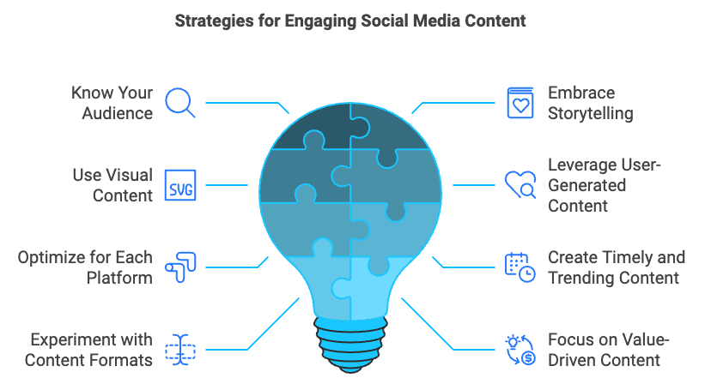

Engagement Strategies to Boost Organic Reach
Creating great content is only half the battle. To truly boost your organic reach, you need to actively engage with your audience and encourage interactions. One of the most crucial strategies is to respond promptly to comments and messages. Engaging with your audience in real-time can significantly boost your visibility. Set up notifications for comments and messages, aim to respond within a few hours, if not sooner, use a conversational tone in your responses, and address concerns or complaints professionally and publicly when appropriate. Tools like Hootsuite or Sprout Social can help you manage responses across multiple platforms.
Asking questions and encouraging discussions is another effective way to increase engagement. Prompt your audience to share their thoughts by ending posts with open-ended questions, creating polls or surveys, asking for opinions on industry trends or news, and encouraging followers to share their experiences. For example, a travel brand might ask, “What’s your dream vacation destination and why?”
Using hashtags strategically can increase the discoverability of your content. Research popular and relevant hashtags in your industry, create branded hashtags for campaigns or events, use a mix of broad and niche hashtags, and avoid overusing hashtags (especially on platforms like Facebook). Tools like Hashtagify or RiteTag can help you find effective hashtags for your content.
Collaborating with influencers and partners can help you reach new audiences organically. Identify influencers or brands with similar target audiences, co-create content or run joint campaigns, participate in or host Twitter chats, and guest post on each other’s blogs and share on social media. Remember to choose partners whose values align with your brand.
Don’t just wait for engagement – actively seek it out by engaging with other accounts. Follow and engage with industry leaders and influencers, join relevant groups or communities, comment on and share content from other accounts, and participate in industry discussions and Twitter chats. This strategy helps build relationships and increases your visibility in your niche.
Optimizing posting times can significantly impact engagement levels. Use platform analytics to identify when your followers are most active, experiment with posting at different times and track results, consider time zones if you have a global audience, and use scheduling tools to maintain consistency. Remember that optimal posting times can vary by platform and audience.
Encouraging employee advocacy can be a powerful way to amplify your social media content. Create guidelines for employees sharing company content, provide easy-to-share content for employees, recognize and reward employees who actively engage, and use tools like LinkedIn Elevate or Hootsuite Amplify to manage employee advocacy programs.
Leveraging user tagging and mentions can also boost your organic reach. Encourage users to tag your brand in their posts by running contests that require tagging, sharing user-generated content and tagging the creator, and asking questions that prompt users to tag friends (e.g., “Tag someone who needs a vacation!”). When users tag your brand, it exposes your content to their network, potentially increasing your reach.

Platform-Specific Strategies for Organic Reach
While many strategies work across platforms, each social network has unique features that can be leveraged for organic reach. For Facebook, utilize Facebook Groups to create and manage a group related to your industry or brand, as groups often have higher engagement rates than pages. Go Live, as Facebook Live videos are prioritized in the News Feed and can generate up to 6 times more engagement than regular videos. Use Facebook Stories, which appear at the top of the News Feed, increasing visibility. Optimize for Facebook Search by using relevant keywords in your page name, about section, and posts to improve discoverability. If you have a physical location, incentivize customers to check in when they visit.
On Instagram, leverage Instagram Stories and use interactive features like polls, questions, and quizzes to boost engagement. Create Reels, as Instagram is heavily promoting this content, giving it prime placement in the app. If you sell products, set up Instagram Shopping to make your posts shoppable. Utilize IGTV for longer-form video content to complement your regular posts. Geotag your posts to help you reach local audiences.
For Twitter, participate in Twitter Chats by joining or hosting regular chats related to your industry to build community and increase visibility. Use Twitter Lists to create and share lists of industry influencers or valuable resources. Leverage Twitter Moments to curate and tell stories using tweets. Optimize your profile for search by using relevant keywords in your bio and pinned tweet. Engage with trending topics by joining conversations around trending hashtags when relevant to your brand.
On LinkedIn, publish long-form content using LinkedIn’s publishing platform to share in-depth industry insights. Leverage LinkedIn Live to host live events or Q&A sessions to engage your professional network. Use Showcase Pages to create dedicated pages for specific products or initiatives. Engage in LinkedIn Groups to participate in relevant industry groups to build authority and connections. Optimize your company page by using keywords in your company description and regularly updating your page with fresh content.
For TikTok, participate in challenges by creating content around popular TikTok challenges or starting your own. Use trending sounds by incorporating popular songs or sound bites into your videos. Collaborate with TikTok creators by partnering with influencers for duets or other collaborative content. Leverage TikTok’s unique features like green screen effects, transitions, and filters creatively. Cross-promote on other platforms by sharing your TikTok content on other social networks to drive traffic to your TikTok account.

Measuring and Analyzing Organic Reach
To continually improve your organic reach, it’s crucial to measure and analyze your performance regularly. Key metrics to track include reach (the number of unique users who saw your content), impressions (the total number of times your content was displayed), engagement rate (the percentage of people who engaged with your post out of those who saw it), click-through rate (the percentage of people who clicked on a link in your post), follower growth rate (the rate at which you’re gaining new followers), and share of voice (how much of the conversation in your industry your brand owns compared to competitors).
There are various tools available for analysis. Each social media platform offers its own analytics tools (e.g., Facebook Insights, Twitter Analytics). Google Analytics can be used with UTM parameters to track traffic from social media to your website. Third-party tools like Hootsuite, Sprout Social, or Socialbakers offer more advanced analytics and reporting features.
Regularly conducting a social media audit is essential to identify areas for improvement. Review your performance across all platforms, analyze your top-performing content, assess your audience demographics and behavior, compare your performance to competitors, evaluate the effectiveness of your posting schedule, and identify underperforming areas and brainstorm improvements.
Continuously test different elements of your social media strategy through A/B testing. Test post types (e.g., images vs. videos), posting times, caption lengths, call-to-action phrases, and hashtag strategies. Use the results to refine your approach and improve organic reach.

Metric | Description | Calculation
Engagement Rate | Measures how actively involved your audience is with your content | (Total Engagements / Total Reach) x 100
Click-Through Rate (CTR) | Measures how often people click on a link in your post | (Total Clicks / Total Impressions) x 100
Follower Growth Rate | Measures the rate at which you’re gaining new followers | ((New Followers - Lost Followers) / Total Followers) x 100
Share of Voice | Measures how much of the conversation in your industry your brand owns | (Your Brand Mentions / Total Industry Mentions) x 100

Overcoming Common Challenges in Organic Reach
Even with a solid strategy in place, you may encounter several challenges when trying to boost your organic reach. One common issue is declining organic reach, as social media platforms prioritize paid content. To combat this, focus on creating highly engaging, share-worthy content, encourage employees and brand advocates to share your content, diversify your content across multiple platforms, and consider using paid promotion strategically to boost your best organic content.
Algorithm changes can also pose a challenge. Stay adaptable by regularly reviewing platform announcements and updates, diversifying your content strategy, focusing on engagement and community-building rather than gaming the system, and continuously testing and refining your approach.
Content saturation is another hurdle, with millions of posts published every day. To cut through the noise, focus on creating unique, high-quality content, find your brand’s unique voice and perspective, use storytelling to create emotional connections, and leverage user-generated content to add authenticity.
Maintaining consistency in creating high-quality content can be time-consuming. To manage this, develop a content calendar to plan ahead, use scheduling tools to maintain a consistent posting schedule, repurpose content across different formats and platforms, curate and share relevant third-party content to supplement your original posts, and consider outsourcing or delegating some content creation tasks.
Measuring ROI for organic social media efforts can be challenging. To address this, set clear, measurable goals aligned with business objectives, use UTM parameters to track traffic from social media to your website, implement conversion tracking to measure lead generation and sales, track brand awareness metrics like share of voice and sentiment, and use social listening tools to measure the impact of your efforts on brand perception.

Case Study: Organic Reach Success Story
Let’s examine how a small e-commerce business, “GreenLeaf Essentials,” successfully leveraged organic social media strategies to grow their brand and increase sales without relying on paid advertising. GreenLeaf Essentials is an eco-friendly home goods company that sells sustainable kitchen and bathroom products. With a limited marketing budget, they needed to rely heavily on organic social media to build brand awareness and drive sales.
Their strategy focused on content creation, emphasizing educational content about sustainability and eco-friendly living to position themselves as thought leaders in the space. They encouraged user-generated content by asking customers to share photos of their products in use with the hashtag #GreenLeafLiving, reposting the best submissions. GreenLeaf collaborated with micro-influencers in the sustainability niche, offering product exchanges for honest reviews and content creation. They built a community by creating a Facebook Group called “Sustainable Home Heroes” where members could share tips and discuss eco-friendly living. Finally, they optimized their content for each platform, using Instagram for visually appealing product shots, Pinterest for DIY eco-friendly home projects, and YouTube for in-depth product demos and sustainability tips.
Over 12 months, GreenLeaf Essentials achieved impressive results: a 500% increase in Instagram followers, a 300% increase in engagement rate across all platforms, a 200% increase in website traffic from social media, and a 150% increase in online sales attributed to organic social media efforts.
Key takeaways from this case study include the importance of consistent, value-driven content in building trust and authority, the power of encouraging user-generated content to create social proof and expand reach, the benefits of building a community around your brand to foster loyalty and repeat customers, the effectiveness of platform-specific strategies, and the crucial role of patience and persistence in organic growth.

Implementing Strategies
Mastering organic reach on social media requires a multi-faceted approach that combines understanding platform algorithms, creating engaging content, fostering community, and staying adaptable to changes in the social media landscape. By implementing the strategies outlined in this chapter and continually refining your approach based on performance data, you can build a strong organic presence that drives meaningful results for your brand.
Remember, success in organic social media marketing doesn’t happen overnight. It requires consistency, patience, and a willingness to experiment and adapt. Stay true to your brand voice, focus on providing value to your audience, and always be open to learning and evolving your strategy.
As you move forward, keep these key points in mind:
- Understand and work with platform algorithms
- Create diverse, high-quality content tailored to each platform
- Engage actively with your audience and foster community
- Leverage user-generated content and influencer partnerships
- Regularly analyze your performance and adjust your strategy
- Stay ahead of trends and be willing to experiment with new features and platforms

By following these principles and implementing the strategies discussed in this chapter, you’ll be well-equipped to navigate the ever-changing world of social media marketing and achieve sustainable organic growth for your brand.



Building a Loyal Audience
In the ever-evolving digital landscape, attracting visitors to your content is only the first step in a much larger journey. The true measure of success lies in your ability to transform these casual browsers into loyal followers and, ultimately, passionate brand advocates. This chapter will guide you through the intricate process of nurturing and maintaining strong relationships with your audience, providing you with the tools and strategies necessary to create a thriving community around your brand.
As a social media marketer, you’re well aware that the digital realm is a bustling marketplace of ideas, products, and services. In this crowded space, building a loyal audience is not just beneficial – it’s essential for sustainable growth. A loyal audience doesn’t just consume your content; they engage with it, share it, and become an extension of your marketing team. They are the ones who will stick with you through algorithm changes, market fluctuations, and fierce competition.
But how do you transform a first-time visitor into a loyal follower, and then into a brand advocate? The journey is complex and multifaceted, requiring a deep understanding of human psychology, consumer behavior, and the nuances of digital engagement. In this chapter, we’ll explore proven strategies to create a seamless user experience, foster a sense of community, and build lasting relationships with your audience.

Understanding the Audience Journey
Before diving into specific strategies, it’s crucial to understand the typical journey a user takes from first encounter to brand advocacy. This journey can be broken down into several stages: awareness, interest, consideration, conversion, loyalty, and advocacy. Each stage requires different approaches and strategies. Let’s explore how to effectively guide users through each stage, turning casual visitors into passionate brand advocates.

Creating a Seamless User Experience
The foundation of building a loyal audience lies in providing an exceptional user experience from the very first interaction. A seamless user experience reduces friction, encourages engagement, and makes users more likely to return. Key strategies to enhance your user experience include optimizing your website for speed and navigation, ensuring mobile responsiveness, personalizing the user experience, implementing clear and compelling calls-to-action (CTAs), and providing excellent customer support.
Website speed is crucial for retaining visitors. According to a study by Google, 53% of mobile site visitors leave a page that takes longer than three seconds to load. To improve your site speed, consider compressing images, minimizing HTTP requests, using a content delivery network (CDN), enabling browser caching, and optimizing your code by minifying CSS, JavaScript, and HTML.
Navigation is equally important. Users should be able to find what they’re looking for quickly and easily. Implement a clear, logical site structure with intuitive menus and search functionality. Use breadcrumbs to help users understand their location within your site hierarchy.
With mobile devices accounting for over half of global web traffic, mobile responsiveness is non-negotiable. Implement a responsive design that adapts to different screen sizes and orientations. Test your site on various devices to ensure a consistent experience across platforms.
Personalization can significantly enhance user engagement and loyalty. According to a study by Epsilon, 80% of consumers are more likely to make a purchase when brands offer personalized experiences. Implement personalization strategies such as recommending content based on browsing history, displaying personalized product recommendations, using geolocation to show relevant local information, and addressing users by name in emails and on-site messaging.
Guide users towards desired actions with clear, compelling CTAs. Use action-oriented language, create a sense of urgency, and ensure your CTAs stand out visually. A/B test different CTA designs, placements, and copy to optimize performance.
Responsive, helpful customer support can turn a potentially negative experience into a positive one. Implement multiple support channels such as live chat, email, and social media. Consider using AI-powered chatbots to provide 24/7 support for common queries.

Building Trust and Credibility
Trust is the cornerstone of any loyal relationship, including the one between a brand and its audience. Strategies to build and maintain trust include consistently delivering high-quality content, being transparent and authentic, showcasing social proof, and prioritizing data privacy and security.
Quality content is the foundation of trust in the digital world. Ensure your content is accurate and well-researched, valuable and relevant to your audience, well-written and free of errors, and regularly updated to remain current.
Transparency builds trust. Be open about your business practices, admit mistakes when they happen, and provide behind-the-scenes glimpses into your operations. Share your brand’s story and values to create an emotional connection with your audience.
Social proof is a powerful trust signal. Incorporate elements such as customer testimonials and reviews, case studies and success stories, trust badges and certifications, and social media follower counts and engagement metrics.
With increasing concerns about data privacy, demonstrating your commitment to protecting user information is crucial. Clearly communicate your data practices, obtain explicit consent for data collection, and implement robust security measures.

Fostering Engagement and Community
Engagement is the lifeblood of a loyal audience. Strategies to foster meaningful engagement and build a sense of community include encouraging user-generated content (UGC), creating interactive content, hosting virtual and in-person events, leveraging social media for community building, and implementing a loyalty program.
UGC is a powerful way to increase engagement and create a sense of community. Encourage users to share their experiences with your brand through photo or video contests, hashtag campaigns, customer spotlights, and product reviews and ratings.
Interactive content encourages active participation and can significantly boost engagement. Consider incorporating polls and surveys, quizzes and assessments, interactive infographics, and 360-degree videos or virtual tours.
Events provide opportunities for direct interaction with your audience. Consider hosting webinars or live Q&A sessions, virtual conferences or summits, local meetups or workshops, and annual user conferences.
Social media platforms are ideal for fostering community. Strategies include creating and moderating Facebook Groups, hosting Twitter chats or Instagram Live sessions, encouraging user-to-user interactions in comments, and sharing and celebrating community members’ successes.
Loyalty programs can incentivize repeat engagement and purchases. Design a program that offers meaningful rewards, is easy to understand and participate in, provides exclusive benefits to loyal members, and encourages social sharing and referrals.

Personalizing the Customer Experience
Personalization is key to making your audience feel valued and understood. Strategies to create personalized experiences include segmenting your audience, implementing dynamic content, using behavioral triggers, and leveraging AI and machine learning.
Divide your audience into segments based on factors such as demographics (age, location, gender), behavior (purchase history, content preferences), psychographics (interests, values, lifestyle), and stage in the customer journey. Use these segments to tailor your content, offers, and communication strategies.
Use dynamic content to personalize your website and email communications. This could include personalized product recommendations, content recommendations based on browsing history, location-specific offers or information, and personalized email subject lines and content.
Set up automated responses based on user behavior. For example, send a welcome series to new subscribers, trigger a re-engagement campaign for inactive users, offer a discount to users who abandon their shopping cart, and congratulate users on achieving milestones (e.g., one year as a customer).
AI and machine learning can take personalization to the next level. Consider implementing AI-powered chatbots for personalized customer service, predictive analytics to anticipate user needs, and machine learning algorithms for content and product recommendations.

Nurturing Through Email Marketing
Email remains one of the most effective channels for nurturing relationships with your audience. To maximize its impact, segment your email list, create targeted email campaigns, personalize email content, optimize email frequency and timing, and implement automated email flows.
As with your overall audience, segment your email list to deliver more relevant content. Use factors such as past purchase behavior, email engagement levels, content preferences, and demographics.
Develop email campaigns tailored to different segments and stages of the customer journey. This could include welcome series for new subscribers, educational content for leads in the consideration stage, cross-sell or upsell campaigns for existing customers, and re-engagement campaigns for inactive subscribers.
Go beyond using the recipient’s name. Personalize email content based on past purchases or browsing history, abandoned cart items, location-specific offers or events, and personal milestones (e.g., birthdays, anniversaries).
Finding the right balance in email frequency is crucial. Too many emails can lead to fatigue, while too few can result in disengagement. Use A/B testing to determine optimal send times and frequencies for different segments.
Set up automated email flows to nurture leads and customers throughout their journey. Examples include onboarding series for new customers, post-purchase follow-ups, renewal reminders for subscription-based services, and milestone celebration emails (e.g., customer anniversaries).
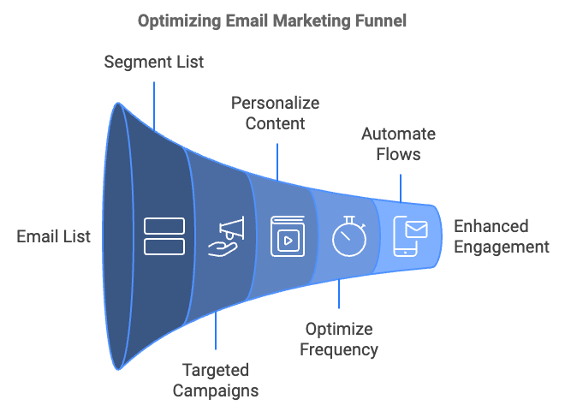

Leveraging Content Marketing for Loyalty
Content marketing plays a crucial role in building and maintaining audience loyalty. To use content effectively, create a content strategy aligned with the customer journey, develop a variety of content formats, implement a content hub, use storytelling to create emotional connections, and encourage content sharing.
Develop content that addresses the needs and questions of users at each stage of their journey. This could include blog posts, infographics, and social media content for the awareness stage; whitepapers, case studies, and comparison guides for the consideration stage; product demos, free trials, and customer testimonials for the decision stage; and how-to guides, troubleshooting content, and advanced tips for the post-purchase stage.
Different audience members prefer different types of content. Diversify your content mix with blog posts and long-form articles, videos (tutorials, product demos, behind-the-scenes), podcasts, infographics and data visualizations, ebooks and whitepapers, and webinars and live streams.
Create a centralized location where your audience can easily access all your content. This could be a resource center on your website, organized by topic or content type.
Storytelling can create powerful emotional connections with your audience. Share stories about your brand’s history and values, customer success stories, employee experiences, and behind-the-scenes glimpses of your operations.
Make it easy for your audience to share your content. Implement social sharing buttons, create shareable infographics or quote images, and consider offering incentives for content sharing.

Overcoming Common Challenges
Building a loyal audience is not without its challenges. Common obstacles include high bounce rates, low retention rates, declining engagement, negative feedback or reviews, and algorithm changes. To overcome these challenges, consider improving page load times, ensuring your content matches user intent, optimizing your site’s design and navigation, implementing a strong onboarding process for new users, regularly seeking and acting on user feedback, providing ongoing value through content and features, experimenting with new content formats or topics, responding promptly and professionally to negative feedback, and diversifying your traffic sources.

Measuring Success and Iterating
To ensure your efforts are effective, it’s crucial to measure success and continuously iterate. Key performance indicators (KPIs) to track include retention rate, churn rate, Customer Lifetime Value (CLV), Net Promoter Score (NPS), engagement rate, and repeat purchase rate.
Utilize tools such as Google Analytics for website traffic and behavior analysis, social media analytics tools for platform-specific insights, email marketing platforms for email performance metrics, customer feedback tools for gathering user insights, and CRM systems for tracking customer interactions and purchases.
To continuously improve your audience loyalty, regularly conduct user surveys and interviews to gather feedback, use A/B testing to optimize your website, emails, and content, analyze user behavior data to identify areas for improvement, stay informed about industry trends and best practices, and encourage and act on employee feedback, as they often have valuable insights.

Case Study: Building a Loyal Audience in Action
Let’s examine how a hypothetical company, “GreenGrow Gardening,” successfully built a loyal audience using the strategies discussed in this chapter. GreenGrow Gardening is an online retailer of organic gardening supplies and plants. When they started, they faced stiff competition from established gardening brands and struggled to retain customers beyond their initial purchase.
GreenGrow implemented a comprehensive strategy to build audience loyalty, including content marketing, email marketing, community building, a loyalty program, personalization, and enhanced customer support. After implementing these strategies over the course of a year, GreenGrow saw significant improvements in customer retention rate, engagement rate, Facebook Group growth, repeat purchase rate, Customer Lifetime Value, and Net Promoter Score.
GreenGrow’s success in building a loyal audience stemmed from providing consistent value through high-quality, relevant content, personalizing the customer experience across all touchpoints, fostering a sense of community among their customers, rewarding loyalty with tangible benefits, and offering exceptional, proactive customer support. By focusing on these elements, GreenGrow transformed their one-time customers into passionate brand advocates who not only continued to purchase but also actively promoted the brand to others.

Leveraging User-Generated Content (UGC)
One of the most powerful tools in building a loyal audience is user-generated content. UGC not only provides social proof but also fosters a sense of community and ownership among your audience. To effectively leverage UGC, encourage customer reviews and testimonials, create UGC campaigns, showcase UGC on your platforms, and engage with UGC creators.
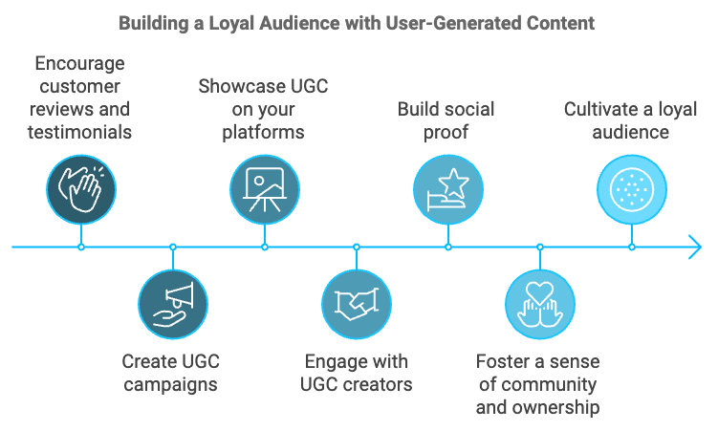
Customer reviews and testimonials are invaluable forms of UGC. They provide authentic feedback that can influence potential customers and help build trust. To encourage reviews, send follow-up emails after purchases asking for feedback, offer incentives for leaving reviews, make the review process as simple and straightforward as possible, and respond to all reviews to show that you value customer feedback.
Launch campaigns that actively encourage your audience to create and share content related to your brand. Some ideas include photo contests where users share images of themselves using your product, hashtag campaigns that encourage users to share their experiences, “Customer of the Month” features that spotlight loyal customers, and “How I Use It” campaigns where customers share unique ways they use your products.
Once you have UGC, make sure to showcase it prominently. This not only provides social proof but also makes the content creators feel valued. Consider creating a dedicated section on your website for customer stories or photos, featuring UGC in your social media posts, including customer testimonials in your email marketing campaigns, and using UGC in your advertising materials (with permission, of course).
When customers take the time to create content about your brand, make sure to acknowledge and engage with them. This could involve commenting on and sharing their posts, sending personal thank-you messages, offering exclusive perks or experiences to top content creators, and inviting prolific UGC creators to participate in product development or testing.

Implementing a Referral Program
A well-designed referral program can turn your loyal customers into brand ambassadors, helping you acquire new customers while strengthening existing relationships. To create an effective referral program, define clear incentives, make it easy to participate, promote your referral program, and track and optimize its performance.
Offer incentives that are valuable enough to motivate referrals but still profitable for your business. This could include discount codes for both the referrer and the new customer, store credit or loyalty points, free products or services, or exclusive access to new products or features.
The easier it is for customers to refer others, the more likely they are to do so. Consider creating a dedicated landing page for your referral program, providing pre-written messages that customers can easily share, offering multiple sharing options (email, social media, direct link), and implementing a user-friendly tracking system so customers can see their referral status.
Make sure your customers know about your referral program. Include information about the program in your email signatures, create social media posts highlighting the benefits of referring, add a referral program section to your customer account dashboard, and mention the program in your post-purchase communications.
Regularly analyze the performance of your referral program and make adjustments as needed. Track metrics like referral rate, conversion rate, and customer acquisition cost. Survey participants to gather feedback on the program, A/B test different incentives and messaging to optimize performance, and consider implementing a tiered system that rewards top referrers.

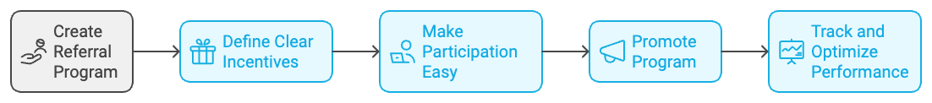

Harnessing the Power of Social Proof
Social proof is a psychological phenomenon where people conform to the actions of others under the assumption that those actions are reflective of correct behavior. In the context of building a loyal audience, social proof can be a powerful tool. To effectively use social proof, display customer testimonials, highlight usage statistics, showcase endorsements and partnerships, and leverage social media proof.
Showcase positive feedback from satisfied customers. Feature testimonials prominently on your website, especially on key landing pages, include customer quotes in your marketing materials, create video testimonials for a more personal touch, and use industry-specific review platforms to build credibility.
Numbers can be powerful persuaders. Share statistics that demonstrate your product or service’s popularity, such as the number of customers served, amount of product sold, time saved or money earned by customers, or growth metrics (e.g., “Join our community of over 100,000 happy customers”).
If you have endorsements from industry experts or partnerships with well-known brands, make sure to highlight these. Display logos of partner companies on your website, share quotes from industry experts about your product or service, and highlight any awards or certifications you’ve received.
Use social media to showcase your popularity and engage your audience. Display your social media follower counts, embed social media feeds on your website to show real-time engagement, share user-generated content from social media on your other marketing channels, and use social media advertising features that show when a user’s friends have interacted with your brand.

Creating Exclusive Experiences
Exclusivity can be a powerful motivator for loyalty. By offering exclusive experiences or content to your most engaged audience members, you can strengthen their connection to your brand and incentivize others to increase their engagement. Strategies for creating exclusive experiences include developing a VIP program, offering behind-the-scenes access, creating members-only content, and hosting exclusive events.
Create a tiered system that rewards your most loyal customers with exclusive perks. This could include early access to new products, special discounts, priority customer service, or personalized products. Clearly communicate the benefits of each tier and how customers can achieve them.
Offer your loyal audience a glimpse into your company’s inner workings. This could involve sharing behind-the-scenes videos of product development, giving virtual tours of your facilities, or providing insights into your decision-making processes. This transparency can foster a deeper connection with your brand.
Create content that’s only accessible to certain members of your audience. This could be a members-only blog, exclusive video content, in-depth guides or reports, or a private podcast. Ensure this content provides significant value to justify its exclusivity.
Host events that are only open to your most loyal customers. These could be virtual events like webinars or Q&A sessions with company leaders, or physical events like product launch parties or workshops. The exclusivity of these events can make attendees feel valued and strengthen their connection to your brand.

Leveraging Artificial Intelligence for Personalization
As AI technology continues to advance, it offers exciting possibilities for personalizing the customer experience and building loyalty. AI can help you analyze vast amounts of data to gain insights into customer behavior, automate personalized interactions, and predict future customer needs. Here are some ways to leverage AI for personalization:
Implement AI-powered recommendation engines that analyze customer behavior and preferences to suggest relevant products or content. This can significantly enhance the user experience and increase engagement and conversions. For example, Amazon’s recommendation engine is responsible for 35% of its revenue.
Use AI chatbots to provide instant, personalized customer service 24/7. These chatbots can handle common queries, guide users through your website, and even make product recommendations based on the conversation. As the technology improves, AI chatbots are becoming increasingly sophisticated and capable of handling complex interactions.
Employ AI to analyze customer data and predict future behavior. This can help you anticipate customer needs and proactively offer solutions. For instance, AI could predict when a customer is likely to churn, allowing you to take preventive action.
Use AI to personalize email marketing campaigns. AI can determine the best time to send emails to individual customers, personalize subject lines and content based on past behavior, and even generate personalized product recommendations to include in emails.
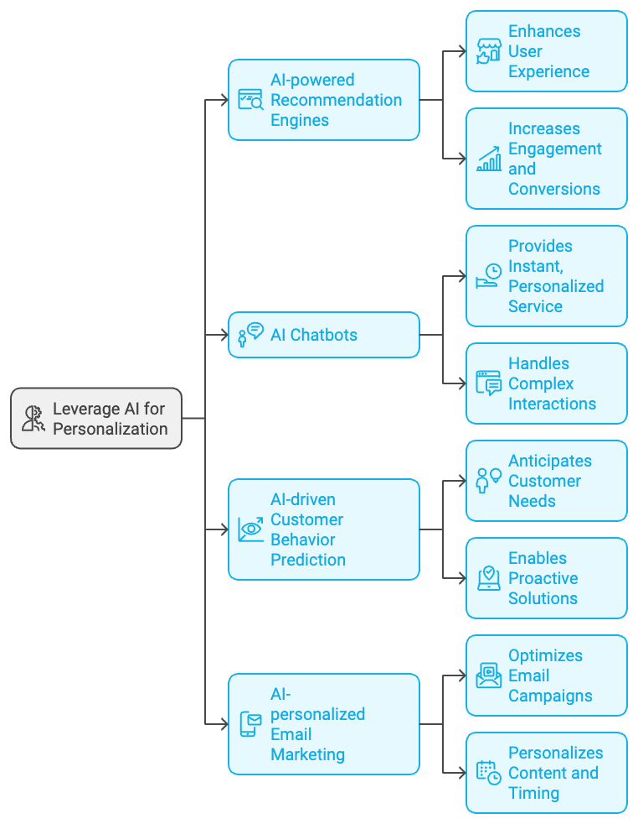

The Ongoing Journey of Audience Loyalty
Building a loyal audience is not a destination, but an ongoing journey. It requires consistent effort, continuous learning, and a willingness to adapt to changing customer needs and market conditions. The strategies outlined in this chapter provide a comprehensive framework for transforming casual visitors into brand advocates, but success ultimately depends on your ability to understand and meet the unique needs of your audience.
Remember that loyalty is earned through consistent positive experiences. Every interaction a customer has with your brand – from browsing your website to receiving a package to contacting customer service – is an opportunity to strengthen their loyalty or risk losing it. Prioritize delivering value at every touchpoint, and always keep the customer at the center of your decision-making process.
As you implement these strategies, keep in mind that building a loyal audience takes time. Be patient, and focus on making steady progress rather than expecting overnight success. Regularly analyze your efforts, celebrate small wins, and be willing to pivot when something isn’t working.
Finally, never underestimate the power of genuine human connection. While technology and data-driven strategies are crucial, at its core, loyalty is about relationships. Show your audience that you genuinely care about their needs and experiences, and they’ll be more likely to stick with you for the long haul.
By following the strategies outlined in this chapter and maintaining a customer-centric approach, you’ll be well on your way to building a loyal audience that not only supports your brand but actively advocates for it. This loyal audience will become your most valuable asset, driving sustainable growth and success for your business in the competitive digital landscape.



Recap and Encouragement to Innovate
As we reach the culmination of our journey through the intricacies of building a sustainable online presence without relying on paid ads, it’s time to pause, reflect, and look ahead. This final chapter serves as both a comprehensive recap of the key strategies we’ve explored and a rallying cry for continued innovation in your digital marketing efforts. The digital landscape is ever-evolving, and your approach to it should be equally dynamic. Let’s revisit the core principles we’ve discussed, reinforce their importance, and explore how you can continue to push the boundaries of organic growth in an increasingly competitive online world.
We began our journey by unveiling the true potential of organic traffic. In a digital ecosystem often dominated by paid advertising, organic traffic stands out as a beacon of sustainable growth. Unlike paid traffic, which stops the moment you turn off the ad spend, organic traffic continues to flow long after you’ve published your content, growing in value as your online presence strengthens. Remember the key advantages of focusing on organic traffic: cost-effectiveness, long-term value, higher trust and credibility, scalability, and a targeted audience. As you move forward, continue to prioritize organic traffic as the bedrock of your digital marketing strategy. However, remember that the landscape is constantly changing. Stay informed about updates to search engine algorithms, evolving user behavior, and emerging platforms. Regularly audit your organic traffic sources and be prepared to adapt your strategies as needed.
Search Engine Optimization (SEO) remains the heart of organic traffic generation. We delved deep into both on-page and off-page SEO strategies, exploring everything from keyword research to link building. As you continue to refine your SEO approach, keep these key principles in mind: user intent is paramount, content quality trumps quantity, technical SEO is crucial, link building is relationship building, and local SEO matters. As SEO continues to evolve, stay alert to emerging trends. Voice search optimization, for instance, is becoming increasingly important as more users rely on voice assistants. Similarly, the rise of zero-click searches (where users get their answer directly in the search results) means you need to optimize for featured snippets and other SERP features. Consider investing in advanced SEO tools and training to stay ahead of the curve. Tools like SEMrush, Ahrefs, or Moz can provide valuable insights into your SEO performance and help you identify opportunities for improvement. Additionally, consider attending SEO conferences or webinars to stay updated on the latest trends and best practices.
Social media remains a powerful tool for extending your organic reach, but it requires a strategic approach. As platforms continue to refine their algorithms to prioritize meaningful engagement, your focus should be on building genuine connections with your audience. Here are some key principles to guide your ongoing social media efforts: platform-specific strategies, consistency is key, engagement over broadcast, leverage user-generated content, and stay agile. As you move forward, keep an eye on emerging social media platforms and features. While it’s not necessary (or usually advisable) to be on every platform, be open to exploring new channels that align with your target audience and brand identity. For instance, if your audience skews younger, you might consider establishing a presence on platforms like TikTok or exploring features like Instagram Reels. Also, don’t underestimate the power of niche social platforms or online communities. Depending on your industry, platforms like LinkedIn groups, Reddit communities, or industry-specific forums could be valuable channels for extending your organic reach and establishing thought leadership.
Building a loyal audience is perhaps the most crucial aspect of sustainable online growth. As we discussed, the journey from first-time visitor to brand advocate is a complex one, requiring careful nurturing at each stage. As you continue to refine your audience retention strategies, keep these principles at the forefront: personalization is non-negotiable, community building is powerful, exceptional customer experience is crucial, content remains king, and loyalty should be rewarded. As you look to the future, consider how emerging technologies could enhance your audience retention efforts. For instance, artificial intelligence and machine learning could enable even more sophisticated personalization. Virtual or augmented reality could offer new ways to engage with your products or services. Blockchain technology could provide innovative ways to reward loyalty or ensure transparency in your operations.
Throughout our journey, we’ve emphasized the importance of measuring and analyzing your performance. As you continue to refine your organic growth strategies, lean even more heavily into data-driven decision making. Here are some ways to enhance your analytical approach: implement robust tracking, invest in analytics tools, foster a culture of testing, explore predictive analytics, and leverage data visualization. Remember, the goal of data analysis isn’t just to collect numbers, but to derive actionable insights that can inform your strategy. Regularly set aside time to dive deep into your data, identify trends or anomalies, and brainstorm ways to act on these insights.
The digital marketing landscape is constantly evolving, with new technologies, platforms, and user behaviors emerging all the time. To maintain and grow your organic reach, it’s crucial to stay ahead of these trends. Here are some areas to watch and consider incorporating into your strategy: voice search optimization, visual search, augmented and virtual reality, artificial intelligence and machine learning, privacy and data protection, sustainability and social responsibility, micro and nano influencers, interactive content, video content, and programmatic advertising.
As we conclude our journey through the world of organic digital marketing, I want to emphasize one final, crucial point: the importance of continuous innovation. The strategies and tactics we’ve discussed throughout this book are not set in stone. They are a foundation upon which you must build, experiment, and innovate. The digital landscape is not just changing – it’s evolving at an unprecedented rate. What works today may not work tomorrow, and what seems impossible today may become standard practice in the near future. Your ability to adapt, experiment, and innovate will be your greatest asset in this dynamic environment.
Here are some ways to foster a spirit of innovation in your organic marketing efforts: cultivate curiosity, embrace failure, allocate resources for experimentation, cross-pollinate ideas, listen to your audience, collaborate, and stay agile. Remember, innovation doesn’t always mean inventing something entirely new. Often, it’s about finding creative ways to apply existing concepts or technologies to your specific situation. It’s about looking at challenges from new angles and being willing to question established practices.
As you move forward, I encourage you to approach your organic marketing efforts with a mindset of continuous improvement and innovation. Don’t be content with merely implementing the strategies we’ve discussed – look for ways to enhance them, combine them in unique ways, or even challenge them when necessary. Your journey in organic marketing is unique to you and your brand. Embrace that uniqueness. Don’t be afraid to forge your own path, to try new things, and to let your authentic voice shine through in all your marketing efforts. The digital world is vast and full of opportunities – it’s up to you to seize them.
As you continue on your organic marketing journey, know that you’re part of a larger community of marketers all striving to create meaningful connections in the digital space. Embrace this community, learn from others, share your own insights, and together we can continue to evolve and improve the practice of organic marketing. Your journey in organic marketing is just beginning. There will be challenges ahead, but also incredible opportunities for growth, learning, and impact. Embrace the journey with enthusiasm and determination. Stay true to your values, keep your audience at the center of everything you do, and never stop learning and evolving.
The future of organic marketing is bright, and you have the power to shape it. So go forth with confidence, armed with the strategies and insights we’ve discussed, and start building your organic presence. Remember, every piece of content you create, every interaction you have with your audience, is a step towards building a stronger, more resilient online presence. As you implement these strategies and continue to learn and grow, you’ll likely encounter new challenges and opportunities that we haven’t covered here. That’s the nature of the ever-evolving digital landscape. But by applying the principles we’ve discussed – focusing on value creation, building genuine relationships, staying adaptable, and always keeping your audience at the center of your efforts – you’ll be well-equipped to navigate whatever comes your way.

