Table of Contents

Introduction 3
Chapter 1: Be In-charge of the Buying Process 5
Chapter 2: It All Starts At The Squeeze Page 8
Chapter 3: Present a Directly-Related PAID Product Deal 11
Chapter 4: This is the Time to Slip in an Upsell or Downsell Offer 14
Chapter 5: Set Up Your Autoresponder Follow-Up Sequence 17
Chapter 6: Performing Through Testing to Ensure that Your Funnel Works Perfectly 20
Chapter 7: Launch Your New Product 23
Conclusion 26

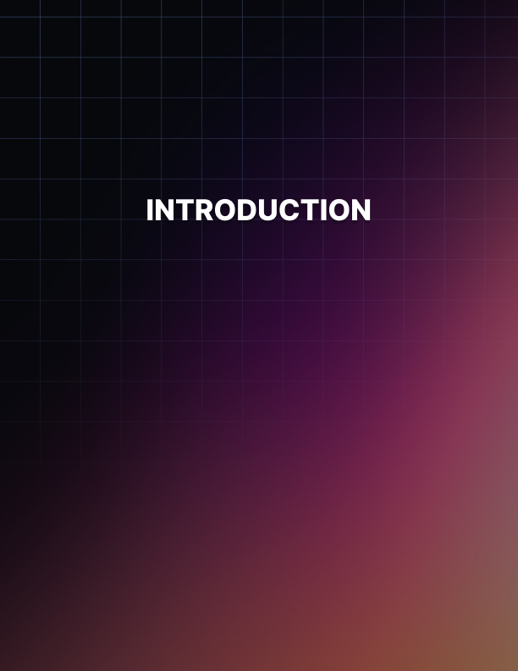

Introduction

You have likely heard the expression that owning your own product is the key to making real money online. That is true for a number of reasons. One of the key reasons why that is true is because, if you own the product, you can create a sales funnel that you control and you profit from at 100% (or whatever amount you choose in regards to your affiliates, etc.). If you don’t own the product, then you can’t control the sales funnel, and you don’t profit from any additional sales made through that funnel.

It is a known fact that virtually every Internet marketer makes most of his/her profits via the back- end of the sales funnel, NOT the front-end.

In fact, some marketers are willing to take a loss on the front-end of the funnel, just to get new customers onto his/her buying list and to help make profits for his/her affiliates so that they are willing to promote his/her future product offers.

The real money is made on the back-end of the sales funnel because that is where the higher- priced offers are normally made.

Add in that the creator of the funnel usually makes 50-100% of the sales of these upsell offers, and it’s no wonder why most Internet marketers make most of their revenues from one-time offers or OTOs.

Therefore, if you want to make considerable money as an Internet marketer, you have to have your own product and you have to control the sales funnel.

If you don’t do that, you will likely never make considerable profits online, as affiliate marketing limits you to whatever the product owner and sales funnel creator decides.

You may be wondering how to go about creating your own sales funnel. Fortunately, this book will help you to know exactly what a sales funnel is, how to create one, and how to maximize its potential so you get the most profit possible from it.
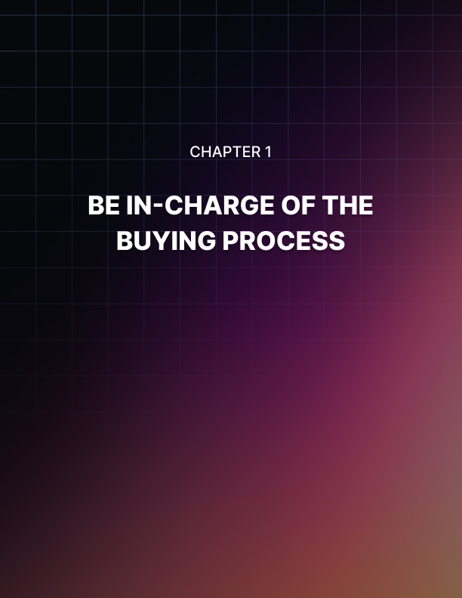

Chapter 1: Be In-charge of the Buying Process

As mentioned in the Introduction, if you don’t control the sales funnel, you are at the mercy of the one who is making profits online. This is why most Internet marketers say that you must sell your own digital products (and, essentially, control the sales funnel) to really profit online.

Thus, you need to control the sales funnel by creating your own digital product and setting up the funnel.

When creating a sales funnel, you really are creating two or more offers, since you need to be able to offer your prospect or customer another offer on top of the original or main offer.

This is usually considered an upsell or one-time offer (commonly referred to as an OTO).

However, it is now quite common to have a sales funnel where you have far more than just two offers.

You can have anywhere from three to ten or more offers in one funnel, composed of upsells (advanced or more enhanced versions of the main product) and downsells (advanced or more enhanced versions of the main product, but not as advanced or enhanced as the corresponding upsell).

There are really only two rules regarding sales funnels and corresponding upsells and downsells: The one-time offers (i.e. upsells and downsells) relate to the main product offer in some way so that you add more value to the main product offer, and the one-time offers are optional purchases and NOT necessary to enable the main product offer to fulfill the value it is supposed to as described in the product’s sales letter.

Thus, you can create a sales funnel composed of several different offers that will enable you to earn profits with each purchase.

Not every customer who buys the main offer will buy any of the upsells, but it’s likely some will, as it has been shown through research that people are more willing to buy cross-sells and upsells right after they have purchased a main offer.

This is the same buying principle that leads a person to buy fries and a soft drink along with a hamburger (i.e. cross-sell) or to buy a more advanced version of a gardening tool to get more value from it (i.e. upsell).

The more people you can get to buy your main offer, the greater the chance that they will buy one or more of your one-time offers, since they have already purchased your main offer.

This is especially true if you provide a “downsell” to the corresponding “upsell,” as it’s also been proven through research that if you present a similar offer to a previous offer for a lower price, many consumers will purchase it, thinking they are getting a great deal.

This is all the more reason why you need to take control of your sales funnel and start getting qualified traffic to it today.

The sooner you start doing this, the sooner you will start building up your online income, not only via more sales from your sales funnel, but also via the increased number of customers to your buyers’ list.



Chapter 2: It All Starts At The Squeeze Page

The very start of your sales funnel needs to begin with the squeeze page. A squeeze page is just a Web page that offers the visitor something of value, such as a report on a specific topic of interest, in return for the person’s contact information (usually the person’s name and email address).

The idea behind the squeeze page is to entice the visitor to willingly give up his/her name and email address so that you can follow up with him/her later with other relevant and useful information so that you can build a relationship with him/her and show that you are an expert in this industry or niche.

Once the person feels comfortable with you and feels you know this industry or niche well, he/ she will be more likely to purchase the offers you recommend to him/her. These offers should consist of your own products, as well as affiliate offers that you endorse.

Of course, as mentioned before, the greatest online profits come from products you own, so you really want your subscribers to become comfortable with you so that they will purchase the offers in your sales funnel.

This is where the bulk of your profits will come from and, if you build the relationship properly and don’t abuse their trust or time, it’s certainly possible that they will purchase from you repeatedly whenever you offer a product offer of relevance to them. This is how you can build your online income over time.

Therefore, you need a product that you can offer to your squeeze page visitor for free in order for him/her to be willing to give up his/her contact information. You can either create this product on your own, use outsourcers to create it, and/or use private label rights (PLR) products to create it. The main point is that the information must be valuable to the subscriber and the squeeze page must indicate exactly what the prospect will be getting when he/she submits his/her contact information.

Therefore, if you plan to provide a mini-report or mini-ebook on how to get more qualified traffic to your website, your squeeze page must indicate this, and your autoresponder needs to send the link to download that report or send an email with the attached file as soon as the subscriber has sent his/her contact information (known as single opt-in) or after he/she has confirmed that he/she wants the report (known as double opt-in).

If the information sounds valuable to the subscriber, he/she will be willing to give up his/her contact information.

If it doesn’t, he/she likely won’t, so the free gift must be something that the subscriber wants to find out about so that he/she will give up his/her contact information.

Note that the information you provide in this free report should be useful to the person, but it should NOT include everything about the topic in question.

If you include all of the information in that free report, they’ll have no reason to buy any of your related offers, which is exactly the ultimate goal you have in mind for them.

Thus, the free report needs to be useful and valuable to where it gives them some insight into the problem or issue they are having, but also indicate or imply that you have more valuable information for them to consider acquiring by visiting your main product’s sales page, the link of which should be at the end of your free report so that they can find out more about it and purchase it.
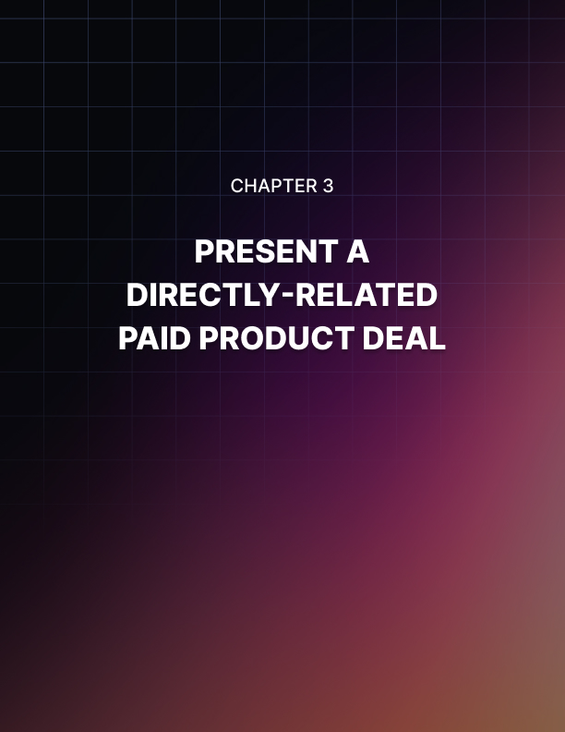

Chapter 3: Present a Directly-Related PAID Product Deal

After the subscriber has input his/her contact information into your squeeze page, he/she should be taken to a Web page that states that the free report he/she signed up for is on its way to his/ her inbox.

This is the beginning of your relationship with this subscriber; you need to use good email marketing practices in order to build the relationship further and convince the prospect that you are a respected and knowledgeable person in your industry and that the prospect can trust you, the information you provide, and the offers you present.

Research has shown that it takes at least seven contacts with a prospect before he/she is willing to buy a paid offer. This means that you need to make contact with that person at least seven times before you can reasonably expect the person to push the “buy” button on your offer.

Now, some prospects will be willing to purchase before seven contacts are made, some will only be willing to do it after more than seven contacts are made, and some will not be willing to buy period. It varies depending upon the person, his/her way of thinking, and his/her situation.

Still, with virtually all sales that you make, good email marketing practices and building the relationship are key to making those sales.

Expecting a prospect to just become a lifelong customer overnight or after one to two emails is very unlikely.

Therefore, you need to provide more valuable information in your follow-up emails after he/she has downloaded your free report.

You need to follow up with him/her to ensure he/she has gotten the report, provide additional information on the problem or issue, and gently hint that the main product offer in your sales funnel is the key to solving the problem or issue in question.

You also should let your email subscriber know that you are available to answer any questions he/she might have about the issue or problem, as this will encourage him/her to reach out to you for advice and help. By offering advice and help for free, this will further strengthen the idea that you are an expert in your field and that your paid main product offer will be even more helpful and useful to the prospect than the free report he/she downloaded was.

Over time through good email marketing follow-up, some of your prospects will be ready to purchase your main product offer. This is why it is vital that you put a link to your main product offer in each email you send.

Note, though, that you should not “hard-sell” or aggressively promote your product in each follow-up email you send; rather, you should only “hard-sell” in one to two emails at most in a 7- part email follow-up sequence.

The other emails should just provide information on the problem or issue and some steps to help remedy the situation, along with a link to your main product offer at or near the end of the email. Most people are not fond of “hard selling” or aggressively marketing products; this is why you cannot afford to do this too often in your emails or you risk losing the subscriber entirely, as it’s likely he/she will unsubscribe using the link in the email.

If this happens, you will likely lose the opportunity to connect with that subscriber and make him/ her a lifelong customer forever. Thus, you cannot hard-sell your main product offer; providing important information and helping to educate the prospect is key to convincing the prospect that your main product offer is worth purchasing.

Once the prospect has come to the realization that your main product offer is worth purchasing, he/she will click onto the link in one of your emails and purchase your offer.

The prospect has turned into a customer and entered your sales funnel; now is the time when your sales funnel begins to work its magic.
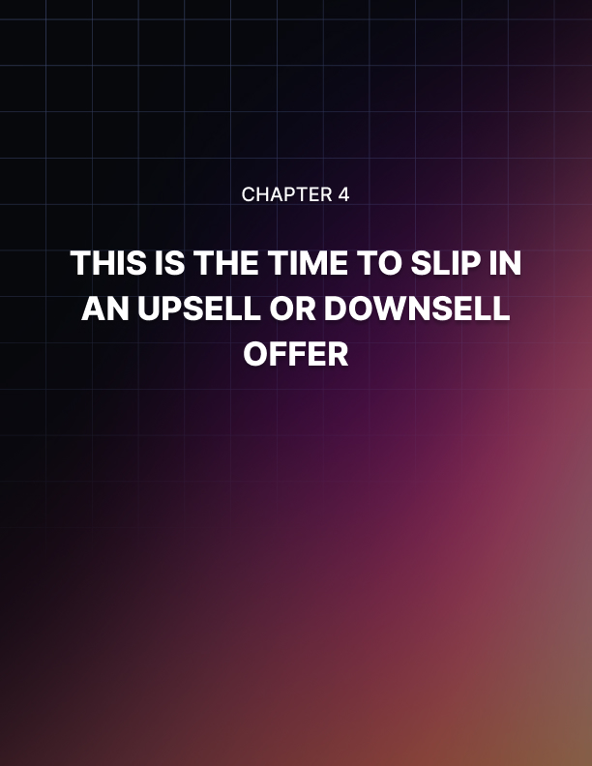

Chapter 4: This is the Time to Slip in an Upsell or Downsell Offer

Once the prospect has turned into a customer and purchased your main product offer, he/she has entered your sales funnel.

This means that you should be offering the customer an opportunity to “upgrade” his/her order. This is done through a value-enhancing upsell that is related to the main product offer he/she just ordered.

The upsell can be an enhanced version that offers more information if the main product offer was an ebook/audio course/video course or more features if the main product offer was a software program, etc.

The upsell can also be a related offer that provides additional value to the main product offer. For instance, perhaps your main product offer was a traffic generation course; your upsell could be an email marketing course designed to improve the conversion rates of the traffic you get to your site via the main product offer.

The key with any upsell is to provide additional value to the main product offer the customer just purchased.

The upsell should NOT be a mandatory purchase in order for the main product offer to provide the value it was promised to deliver; that would not only be unethical, but it will damage your reputation because many consumers will look upon that as a dirty marketing tactic because you weren’t forthcoming in what your main product offer needed in order to provide what you said it would.

Thus, never make the OTOs or upsells mandatory to purchase; the main product offer must provide the value it was intended to provide by itself.

All upsells and downsells must be optional, never mandatory.

If the relevant upsell is valuable and enticing enough to the customer (taking into account value and price), he/she will likely purchase it, thus increasing the amount of profit you gain from this customer.

Once he/she has purchased the upsell, he/she can be taken to the download page to access both the main product offer and the upsell or he/she can be taken to another valuable upsell offer related to the main product offer.

If the customer decides to decline the upsell offer, you can have the funnel take him/her to the download page for the main product offer, you can have the customer go to another upsell offer for him/her to consider, or you can have the customer go to a modified version of the upsell he/she just rejected, usually for a lower price.

This modified version of the upsell is normally referred to as a “downsell,” partly because the price is lower, and oftentimes, the downsell has one or more elements missing from it that were in the corresponding upsell.

Note that a downsell can be the exact same upsell for a lower price, although this is rarely the case.

The reason why the downsell is presented immediately after the upsell that was rejected is because, research shows that many consumers don’t want to miss out on an offer entirely, so if they get a second chance to pick up the same or similar offer for a lower price, they will often jump at the chance to do so.

This is why Internet marketers will often include corresponding downsells with their upsells, so they have a greater chance of earning conversions and more money from their sales funnels.

Most Internet marketers will present a series of upsells and downsells throughout their sales funnels, all related to the main product offer and enhancing its value in some way. Some buyers of the main product offer will not purchase any upsells or downsells, others will purchase one or more upsells, and others will purchase one or more downsells.

Having a combination of upsells and downsells in your sales funnels will increase the chances for conversions and additional profits, and as it has been said before, most Internet marketers make the bulk of their profits on the back-end of the funnel (i.e. upsells and downsells), not from the front-end of the funnel (i.e. main product offer).
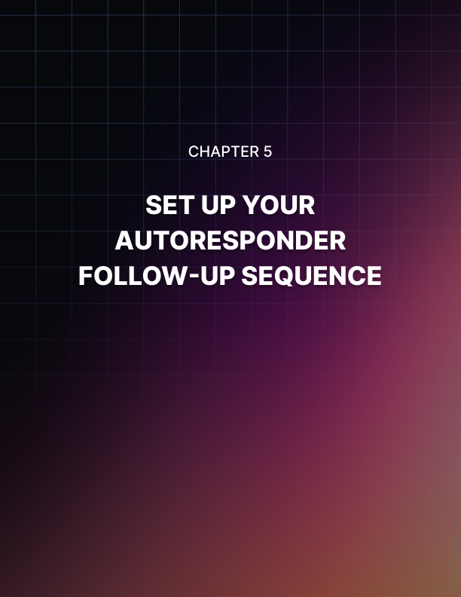

Chapter 5: Set Up Your Autoresponder Follow-Up Sequence

As mentioned earlier in this ebook, once the prospect has downloaded your free report on the problem or issue from your squeeze page, you need to follow up with him/her and build the relationship. There should be a series of about seven follow-up email messages, with the first one going out right after he/she has sent his contact information (or after he/she has confirmed that contact information by clicking on the confirmation link if you use double opt- in).

The most convenient and easiest way to do this is to set up the email messages in your autoresponder; that way, when the prospect completes the form or clicks on the confirmation link in the email that is sent to him/her, the email messages will automatically be sent to him/her over a period of days depending on when you scheduled them to be sent.

In that first email message, you should thank him/her for requesting the free report, include a link to download that free report, mention that you will follow up with more relevant information and offers related to the problem/topic/industry, and provide your contact information so that he/she can get in touch with you if he/she has any questions related to the free report, the problem it touches upon, or anything else.

In subsequent follow-up emails, you should look to build up the relationship by providing more valuable information regarding the problem/issue brought up in the free email report, along with information regarding remedies or solutions to that issue.

You should also include a link to your main product offer’s sales page as a reference for them to consider checking out and purchasing to help them solve the problem or issue in a more comprehensive manner.

As was mentioned earlier in this ebook, you should not hard-sell your main product offer in every follow-up email you send. On average, two out of the seven emails you send should be hard-sell, often the fourth email and seventh email you send. In these emails, you should discuss how your main product rectifies the problem or issue in a more comprehensive manner so that the problem or issue is resolved and the person doesn’t have to deal with it any more.

For instance, if the issue is getting enough quality traffic to one’s website, you can mention that your main product has many powerful, tested ways to get quality traffic to one’s site, so much so that the person will never wonder how to get qualified traffic to his/her website again.

As mentioned, only two of the seven emails at most should really hard-sell or aggressively promote your offer, as most people are not fond of aggressive selling tactics.

Aggressively selling too often can turn the prospect away from becoming a paid customer and can even lead to him/her unsubscribing from your list altogether, essentially ending the relationship and any chance of them becoming a paid customer in the future.

Always focus on providing value in your follow-up emails, as this is the key to convincing your subscribers that your products are worth purchasing.

They will think, “if the information he/she is providing in these free emails and in the free report is that good, then the information he/she is providing in a paid product must be even better; thus, I will purchase it.”

The goal of follow-up emails is to make the subscriber more comfortable with you and your expertise to the point where he/she will trust you and your recommendations, leading to the eventual purchase of your product.

This, of course, will lead to him/her entering your sales funnel, consisting of several upsells and downsells, which can lead to multiple sales and much profit. This is how the best Internet marketers make the vast majority of their income and how they can live the “Internet lifestyle” without having a traditional “9-5” job.
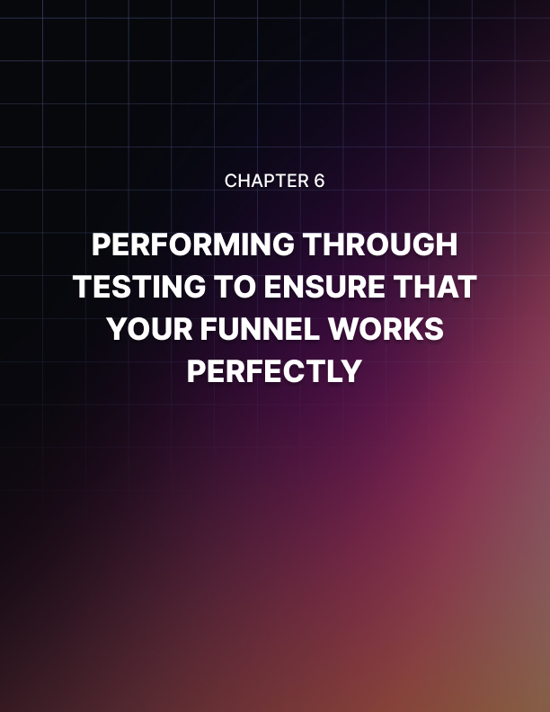

Chapter 6: Performing Through Testing to Ensure that Your Funnel Works Perfectly

A key mistake many new Internet marketers make is not testing their sales funnel to ensure that it works. Many of these marketers will only find out that their sales funnels are not working as they should from customers or subscribers who are willing to pass along the word that the sales funnel is broken.

While they may eventually find out that the sales funnel is broken and not working properly at some point, those Internet marketers who fail to test it ahead of time lose out on all of those potential profits they could have had if they had just tested the funnel themselves ahead of time. After all, they have virtually no chance of getting those customers back into the funnel, especially if those offers are one-time offers, as those offers (both upsells and downsells) are only supposed to be shown after the main product offer is purchased. After the customer exits the funnel, they essentially lose the chance to gain more profits from that customer.

In addition, those marketers may get a reputation for not being the most proficient or reliable in creating sales funnels and offers, which could damage their chances of working in profitable joint ventures, getting more customers and subscribers, etc.

In essence, it’s not worth overlooking whether your sales funnel is properly working or not; you need to test it ahead of time before launching your product offer.

Thus, you should go through the ordering process to ensure that all parts of the sales funnel work as they should.

This means that you should request the free report you offer on your squeeze page and ensure that you receive the report (or link to download the report) and the follow-up email sequence you created.

This also means that you should purchase the main offer, ensure you get the follow-up email to download the main product, and also ensure that you get sent to the first upsell offer in your sales funnel.

Note that most of the major sales platforms (ClickBank, JVZoo, WarriorPlus, etc.) provide an option to pay $0 or $0.01 to test the product to ensure it’s working.

Thus, you can and should test all aspects of your sales funnel first before you “publish” it and promote it to the public for purchase.

You should go through each upsell and downsell, purchasing them and ensuring they take you to the next offer in the sales funnel. You should also go through each offer of the sales funnel and decline the offer to ensure the funnel takes you to the next appropriate offer in the funnel to ensure that every customer is presented the offers that you expect him/her to be offered to maximize the profit potential of each customer who goes through your sales funnel.

It would also not hurt to ask other experienced Internet marketers to test your sales funnel as well, just to ensure that it works for them as it should.

Remember, if your sales funnel falters at all while a customer is going through it, you lost any chance of adding onto your profits from that customer, with virtually no way of making up for that lost profit, so it never hurts to double-check and even triple-check your sales funnel to ensure it’s working properly.

This includes the emails that should be sent after a purchase is made from each upsell and downsell within the funnel; ensure that they are sent so that customers will not be upset over failing to get an email with their product download information in it.
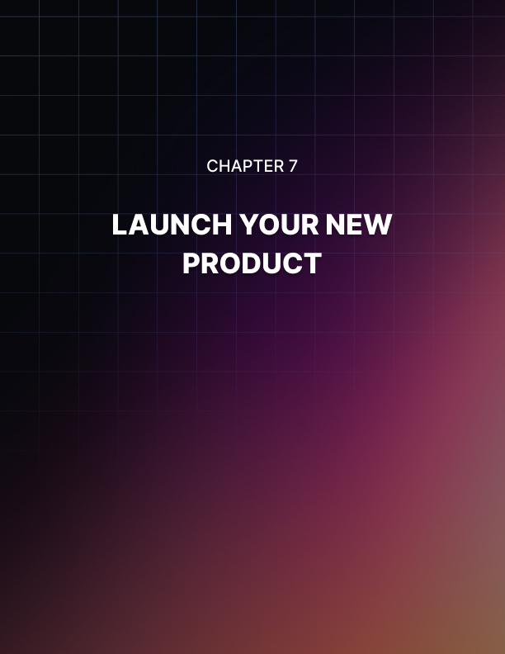

Chapter 7: Launch Your New Product

Once you have confirmed that your sales funnel is working properly as it should and all relevant emails are sent at the appropriate times for each purchase that is made, it’s time to launch your new product!

This means that you should set all prices to the price points you have set for each offer throughout your sales funnel (from the $0 or $0.01 you used to test the funnel).

Once you have done that, you need to start promoting your product via email marketing, forum marketing, social media, your blog/newsletter, paid advertising, joint ventures, and more.

The key is to get the word out about your new product and let the world know that the problem or issue they are dealing with can be effectively remedied or solved by your product.

Your product is the key to making their lives less stressful and that it is ready to be purchased.

If you’ve had any beta-testers of your product (which is often a good idea to ensure that only the highest value is provided in solving the problem and to ensure all mistakes or errors are eliminated) and have received testimonials from them, you can include them in your sales and promotional material to help convince people that your product is the “real deal” in solving the issue they are facing.

Testimonials are often instrumental in getting people to order your product, as they can alleviate people’s doubts about whether the product will really do what it is expected to do and about whether you are really a legitimate business person and one who can be trusted to provide what you state you will provide.

Thus, any testimonials, from beta-testers or owners of previous versions of the product, should be used to help alleviate people’s fears and make them more likely to purchase your product offer.

As time goes on, you should be using software tools to monitor how well your offers are converting throughout your sales funnel.

There are many software platforms that can provide this; Google Analytics provides a free way for you to accomplish this as well.

You need to know what parts of your funnel are converting well and which aren’t doing as well in order to determine what offers are really doing well with your target market and which aren’t so that you can learn from those mistakes and ensure that future offers better meet the needs of your target market.

You can really analyze the various aspects of your funnel to see whether it’s the offer itself (whether it’s the main product offer or any of the upsells or downsells) that is underperforming or if the sales copy is not resonating with your target audience and convincing them of the value of your offer, etc.

Thus, once you have launched your product, you still have much work to do in order to learn what parts of the sales funnel are working as well as expected, what parts are overperforming expectations, and what parts are underperforming expectations.

This is how you can improve your current sales funnel and make it more profitable, as well as create more profitable sales funnels for future product launches from the very beginning, leading to greater profitability sooner in the future.
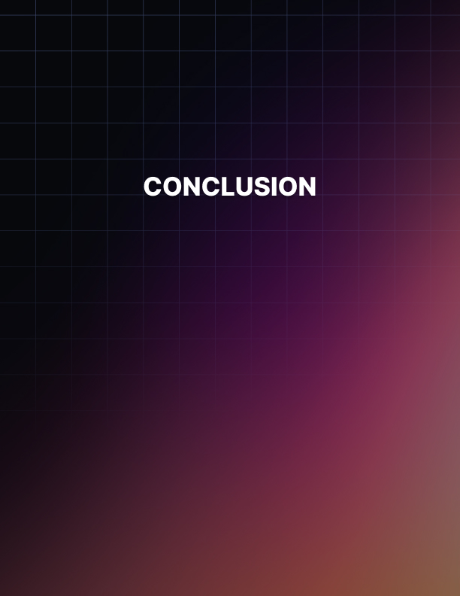

Conclusion

In this ebook, you have learned the importance of controlling your sales funnel (and, thus, having your own product) and how it can lead to greater profits online. You learned how the squeeze page starts the sales funnel process, as this leads to a prospect getting the free report on an industry issue or problem of interest.

You learned how you follow up with email marketing via your autoresponder in order to convince the prospect that you are an expert in this field and can be trusted to provide quality information on this issue or problem.

You learned that it takes on average seven contacts in order for a prospect to become a paying customer. You also learned that you should not hard-sell in every email you send out, as most consumers don’t like marketers who aggressively sell time and again.

You should send no more than two out of seven hard-sell emails; the key to getting them to become a paying customer is to provide quality, valuable information in your emails and only include a link to your main product’s sales page at the end of each email, along with a line or two about the product’s benefits.

Over time and with good email marketing practices, some of those prospects will become paying customers because they will think, “if the information you’re providing in the free report and emails is this good, the information you provide in your paid product must be even better.”

Once they have purchased the main offer, they will be presented with one or more upsells that can enhance the value of the main offer.

If they choose to purchase an upsell, they may be presented with another upsell to add more value to the main offer. This can continue until they reach the end of the sales funnel; they’ll receive corresponding emails with links to download each product they purchased.

If they choose not to purchase an upsell, they may be presented with the same offer at a lower price or a similar offer at a lower price, known as a downsell.

This is done because many consumers will leap at the chance to purchase an offer that they consider to be a better deal. The customer may see and even purchase many downsells instead of the upsells throughout a sales funnel. Conversely, a customer may not purchase any of the upsells or downsells in a sales funnel.

It is important to ensure that your sales funnel works correctly before you launch your product, as there is no way to get back a customer or prospect who wanted to buy the main offer or an upsell or downsell, but can’t do so because the sales funnel doesn’t work correctly.

Test it beforehand, and have other respectable Internet marketers test it as well before you launch your product to ensure that your customers see all of the upsells and downsells they are expected to see through your sales funnel to maximize the profit potential from each customer.

When you have confirmed your sales funnel is working, launch your product to the world. Promote it through such means as email marketing, social media marketing, paid advertising, forum marketing, joint ventures, and more.

Analyze what parts of the sales funnel are performing as expected, underperforming expectations, and over-performing expectations so you know what offers are resonating with your target market and what ones aren’t so you can make adjustments to the current sales funnel and improve its profitability, as well as improve future product sales funnels so that they are more profitable from the very beginning.

By following the information in this book, you will know how to create and control a product sales funnel so you can maximize the profit potential of each customer who enters your funnel and gain the maximum amount of profit from each product offer you create.

Good luck!

