Table of Contents

Chapter 1: The Ecommerce Growth 3
Chapter 2: Store Set Up for Sales 6
Chapter 3: Branding For Sales 11
Chapter 4: Content Assets for Driving Sales 13
Best Practices 13
Chapter 5: Optimizing Your Conversions 20
Chapter 6: Email Automations for Sales 30
Pre Purchase Email Sequences 30
Chapter 7: Customer Service 37
Chapter 8: Content Amplification for Sales 40
Content Strategy Process 41
Conclusion 45

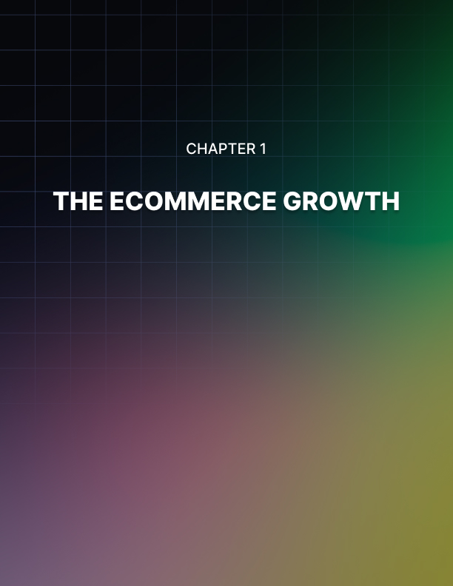

Chapter 1: The Ecommerce Growth
Why is Ecommerce Growing?
- Social Media: Connected world. Sharing products. Promoting products!
- Mobile: More consumption. More shopping!
- On-demand generation: We want it now! Convenience! Same day delivery!
- Niche products: The products that aren’t in your local stores can still be accessed!
- Big Spenders Type 1: Baby boomers, Gen X & Y:Now tech-savvy and trust online transactions
- Big Spenders Type 2: Millennials Tech-savvy and now have money to spend
- Worldwide lockdowns: Because shit‘s going down so we can online shop inside

The Effect of Mobile
Mobile use by far outweighs desktop use. We are constantly connected to our mobile devices (in case you didn’t notice).

How this affects online shopping…
- 2/3 of customers in the U.S. use two devices during shopping process
- 1/3 of people who see a mobile ad on Facebook actually make a purchase on desktop
- 60% of people in the USA have more than one device
- 50% of people are on their second device while they are watching
- The TV Mobile ecosystem is segmented. On average we each consume 200 media channels
- Facebook and Instagram have the most mobile users on their platforms … 10x more than other channels combined.

What does this all mean?
These trends shape the Mobile EcoSystem as we see it today. How people are behaving and consuming. How tech is developing etc… Online stores are built and grown in line with those trends in order to be successful.

Ecommerce Growth Engine Core Elements
These are the key growth levers for a successful store:
- Traffic
- Ads
- Content Social Media Email SEO Retargeting
- Site Pages
- Checkout pages Product pages Home pages
- Landing pages/sales pages Collection pages Opt-in pages
- Pre Purchase Campaigns
- Lead generation & Opt-ins Promotions Offers
- Presell pages
- Activation email campaigns
- Traffic
- Cart abandonment campaigns
- Upsells & Cross sells
- Site Pages Upsells Cross sells Promotions
- Reviews/Testimonials Referrals
- Support Offers Content
- Win back campaigns
- Pre Purchase Campaigns Videos
- Images Podcasts

Each of these campaigns are happening simultaneously. Dynamically connected and linked together to create an automated growth engine.

Traffic goes to various offers and site pages... promotions are amplified through content creation which then generates traffic... which in turn triggers an email sequence etc. Each campaign is designed to make money! If set up well, it’s hugely profitable.
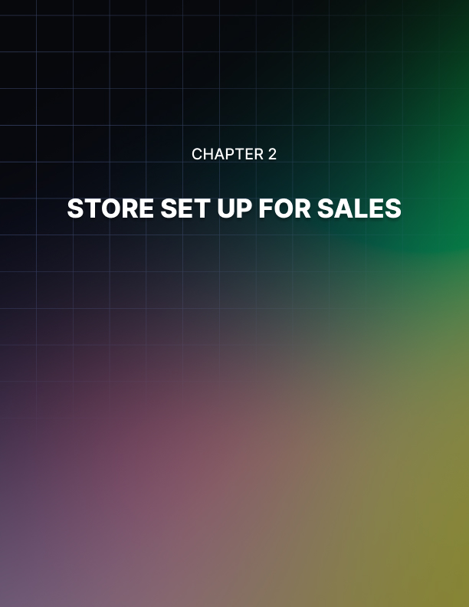

Chapter 2: Store Set Up for Sales
Let’s talk about the tech stack you need to put in place to position you for growth.

Your Site & Platform
Choosing the right platform is a huge factor in positioning you for success and efficiency. So choose the right one!

Your platform will include:
- Content Management
- Search
- Shopping Cart
- Product Management
- Pricing
- Order Management
- Payment Systems
- Inventory Management - connect to your fulfillment
- Business Logic - notifications, shipping notifications etc
- Integrations - 3rd party apps etc

Lots of choices, including:
- Shopify
- Woocommerce
- Magento
- Ecwid
- BigCommerce

Email Service Provider (ESP) options:
- Klaviyo
- Active Campaign
- Constant Contact
- Get Response
- Mailchimp
- Infusion soft
- Aweber

The features you should have:
Contact Tagging
A/B testing
Smart automations
Template editors
Phone support
Store integrations
Help desk and live chat integrations
Smart sending options

Helpdesk
You’re in retail! You need a help desk to speak to all your happy customers.

Your main options:
- Zen Desk
- Help Scout

Live Chat options:
- Intercom.io
- Facebook
- Olark
- LiveChat
- Bold Chat
- Live Person
- Website Alive

Video Hosting
You’ll need to create videos for your website and for your marketing at multiple stages within your funnel and customer buying journey, so you’ll need to add video hosting to your tech stack.

Your options:
- Youtube
- Wistia
- Vimeo

Analytics & Reporting
It’s essential you can see how users are behaving in your store. You need to know:

- How long people stay on your site Which pages they visit
- Which pages they exit
- What are your conversion rates Etc. etc.

Google Analytics
Main and best solution is Google Analytics. Free and advanced. Here’s what you must do with your Google Analytics…

Set up enhanced ecommerce tracking:
This will allow you to see how much revenue you are making. Your average order value. Your conversion rates. Products purchased etc This can be done with a one-click set up to connect with Shopify.

Set up goals and funnels:
Find out how people progress through your store. See the flow from homepage, to product pages, checkout pages, and highlight where you are losing people in that process before optimizing the pages for increased conversions.

This is essential to set up as the key to ecommerce success is to ensure you can take the customer all the way through the store flow to the end purchase!

Track website searches
Find out what people are searching for on your site. If they are searching for a particular product, this can shape which new products you can sell to meet search demand etc.

It will also show you how valuable the customers are who search, by giving you the revenue details and order value for each search.

The data will highlight the most valuable search terms that you should be optimizing for by building content and products around them.

Use UTM codes for all links
You need to know where your customers are coming from. For all of your links that point to your website, you should use the links so that you can learn the value of each link and campaign.

The UTM data will tell you where a customer came from, how much they spent, what they purchased etc. i.e. Facebook traffic converts more than instagram and email etc etc. Use for all external links and campaigns.

Setting up your analytics effectively is an essential component to your store as it enables you to make data driven decisions to position you to optimize for sales and growth.
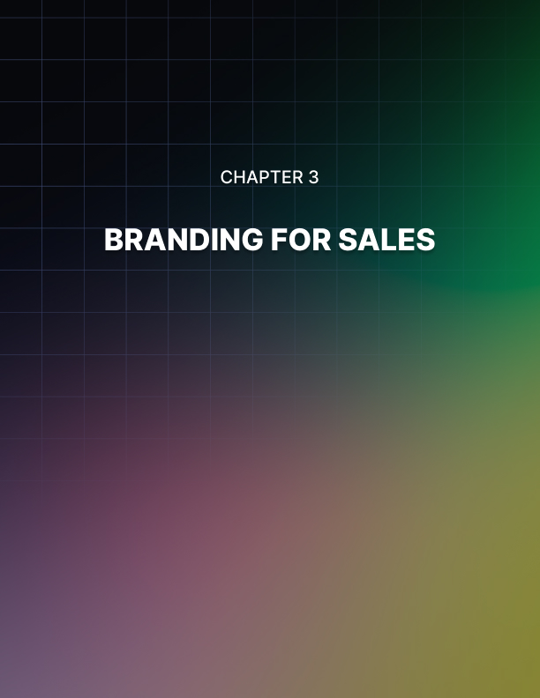

Chapter 3: Branding For Sales
This aspect of the business is what makes your store work or not.

You have to have these 3 things to form your mission, story and purpose, if you are going to succeed.

- Your USP (unique selling point)
- Who are you?
- What‘s your brand's story?

People buy from people. They want to engage, relate, and connect with a person and their story! Remember, we live in a social economy!

If you aren‘t the face of the brand, try to find an influencer or personality. You will still make sales without, but the impact of having a face can result in real scale. You‘ll use your mission story and purpose across your content and marketing assets that we‘ll cover below.

Show it to them
It’s all about how you come across to your customers. Things that help include:

- Knowing what aesthetic your target market likes.
- Having a tagline that tells your story in one sentence.
- Creating an emotional response when customers see your brand.

This helps create the messaging and marketing around your brand. So... Create your brand, the mission, the story, and purpose, and get clear about it... even before you start any marketing activities.

This will help you shape how you communicate with your customers. The better you communicate with your market, the better your sales conversions and growth will be.
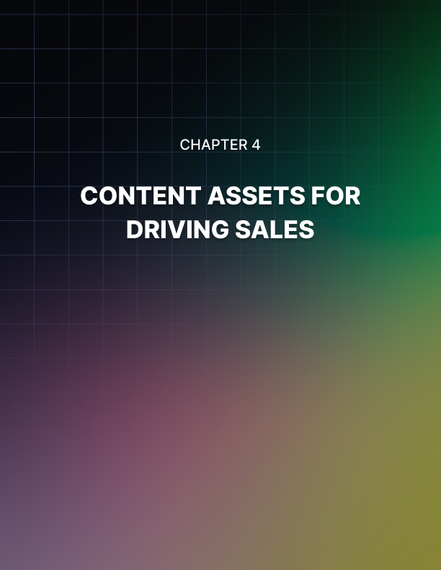

Chapter 4: Content ASsets for Driving Sales
The heart of your store includes the following main pages:

- Homepage Store/Catalog Page
- Product Page
- Cart / Checkout
- Thank You Page
- Blog
- More Info

With the above in mind, you need to think of what content assets you need for each page in your store in order to communicate with customers and make as many sales as possible at each stage.

This is what you need:
- Product descriptions, images, videos More information pages Why buy from us video
- Hello from the owner video Post opt-in thank you video
- Post purchase thank you video
- Home page intro content / sales content Tag line FAQ content

Having this content in place and at the right place will maximize your conversions. And... not only do you have each asset on the relevant page, but you should also use the same asset in multiple places within your marketing campaigns such as your email marketing, social media, ads etc.

Best Practices
Product Descriptions
Let‘s look at the best practices when generating the content, beginning with the product descriptions.

Arguably the most important content you’ll create. This is where people are on the cusp of buying. You need to give them a final boost by including:

- Features AND benefits – How is the customer going to benefit from owning the product?
- Use mini stories – Share stories of how they’ll feel and what they’ll experience when they have the product
- Create scannable descriptions – People don’t always read, so use headlines, bullets, etc to make the info easy to digest
- Talk to your target audience – Use words and terms they understand. Speak their language. Relate.
- Social proof – Testimonials, reviews, case studies etc.
- Overcome objections – People don’t buy because of fear of loss. Overcome these fears. Give guarantees.
- Include USP’s – What is your unique offer? Why are you different?

Product Images
Hugely important! This is what people consume before they buy!

Things to note:
- Use as many as possible. The more the better
- Show the product in use
- Show ownership benefit and experience
- Ensure you have high quality images for best conversions

Product Sales Videos
Best way to communicate the value of your products. You MUST have sales videos for your main products and best selling products.

Things to note:
- Videos can be a slide presentation or just face to camera, or mix of both. Don't need to spend money on high quality production.
- You can use an iPhone or a simple powerpoint.
- Keynote Screenflow, Camtasia etc.
- Hiring a professional might be better if you can make it work.
- But always test variations... Quick and easy can be beat over produced!
- Ensure you have high quality images for best conversions.

Why to use video on your core content pages:
- 64% of all internet traffic globally is video consumption
- On average products with video enjoy 88% more time spent on page
- 1/3 millennials purchase a product as a result of a product video
- 50% of users who watch videos on mobile use it to decide on purchases

The Best Product Videos Should:
- Show The Product In Use
- Displays Ownership Benefits
- Tell A Good Story
- Includes Social Proof
- Overcomes Objections
- Has Strong Call To Action

If you can meet these elements you’ll create high quality videos for your brand that will have significant results in sales for your online store.

Information Pages
15%-25% of buyers will visit the more information pages before they purchase. Those people that go to these pages are considered warmer leads and more likely to complete the checkout.

These pages don’t sell hard. But they support the selling process and are very important. These are the pages where customers can get more information, and where you should produce content for:

Where to use video on your core content pages:
- About Us
- Contact Us
- Why Buy From Us
- Shipping Information
- Return Policy
- Privacy Policy
- Faq
- Terms And Conditions

Product Images
Hugely important! This is what people consume before they buy!

Things to note:
- Use as many as possible. The more the better
- Show the product in use
- Show ownership benefit and experience
- Ensure you have high quality images for best conversions

Product Sales Videos
Best way to communicate the value of your products. You MUST have sales videos for your main products and best selling products.

Things to note:
- Videos can be a slide presentation or just face to camera, or mix of both Don’t need to spend money on high quality production
- You can use an iPhone or a simple powerpoint
- Keynote Screenflow, Camtasia etc
- Hiring a professional might be better if you can make it work
- But always test variations... Quick and easy can be beat over produced!
- Ensure you have high quality images for best conversions

Why to use video on your core content pages:
- 64% of all internet traffic globally is video consumption
- On average products with video enjoy 88% more time spent on page
- 1/3 millennials purchase a product as a result of a product video
- 50% of users who watch videos on mobile use it to decide on purchases

Why Buy From Us – Video
Short explainer video to include:
- Why customers should buy from you What makes you different
- What is your USP
- Why you care about customers
- How you will go the extra mile Your bigger purpose

Our Story - Video
Best way to communicate the value of your products. You MUST have sales videos for your main products and best selling products.

Key content asset to build a relationship with the customer:
- Introduce people to your brand
- Tell your story
- Why you created the brand
- Create intimacy & raport
- Share guarantees and promises
- Thank them for visiting

Post Opt-in Thank You - Video
You’ll be collecting email addresses in a number of places as you attract people into your store. As soon as they opt-in you nurture the relationship so you can convert them into paying customers. So, the thank you page is important to get the relationship off to a good start and get them to continue into the next action you want them to take.

Here‘s an example script:
“Hey, thanks so much for signing up and joining our community. You’re going to get some resources, promotions and discounts in your email over the coming weeks. Like our facebook page to join our group and join in the conversation. Thanks again, and speak soon!”

Post Purchase Thank You - Video
Customers have given you money! They’ve committed to you. Build the relationship more so you can send them into higher levels of the customer journey so you can create loyalty and additional revenue.

What to include:
- Thanks for your purchase
- Here’s what to expect
- We’ll send shipping notifications
- We’ll send email newsletters and promos
- Follow us on social media
- Thank you!

Intro Content
Not a video of this one. But this is where you‘ll allow people to learn who you are within a few short seconds of visiting the home page.

What to include:
- Explain your brand
- What you do
- Who you are based
- Your USP
- Images

Frequently Asked Questions
What to include:
- Dynamic drop downs work well and reduce page load speed
- Videos can be more engaging and powerful if possible
- At worst, you can simply display the FAQ’s as text

About Us
What to include:
- Use the ‘Why Buy From Us’ video asset
- Also repurpose into text and images
- Include bullets and headlines down the page to make it easy to read

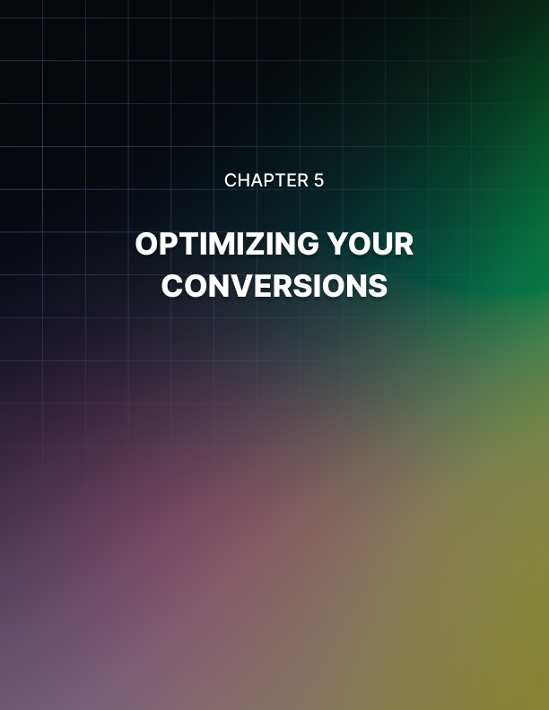

Chapter 5: Optimizing Your Conversions
This is where the money is made in increasing conversions. These optimization tactics are how you go from 1%, 2%, 3%, 4%, 5% conversion rates which have a significant impact on your revenues.

Millions of dollars are spent each month by leading ecommerce stores in order to test various stages of the funnel in which customers flow through. From the homepage, to product page, to the cart and checkout pages, you should be obsessed with measuring how you are taking a customer from one stage to the next.

Your website plays a huge factor in how strong your flow is, and how profitable your website funnel is.

These are the key takeaways and best practices you should be optimizing...

Optimizing Your Header
The header is the first thing that is seen by a customer. It should be the first place they get hooked to take additional action on. Two key must haves for your head.

Add a big, prominent search bar to your header!
- 30% of visitors use a search bar
- If you can get somebody to search they are more likely to convert
- You’ll also get search data to drive product and marketing strategy Use multiple headers for more content and messaging
- Navigation bar
- Search bar and shipping
- Announcement and shipping bar
- Here’s where you should further optimize your header...
- Logo with link back to home page in top left hand corner
- Guarantee
- Unique selling point
- Special offer
- Tag line
- Phone number
- More information page links in first header
- Store navigation in second header
- Link to shopping cart in top right hand corner
- Link to live chat
- Opt-in opportunity

Don’t make the header too busy. Prioritize user experience. Always test!

Optimizing Your Footer
Similarly, the footer will also be the same across your site and it’s another opportunity to soft sell the visitor with messaging and content that will support them in their buying process.

The best practices in a footer include:
- Opt-In Call To Action
- Security Shipping & Credit Card Symbols
- 3 Part Footer Block (Social Profiles, Navigation, Contact Info)
- Floating Live Chat / Contact Widget
- Floating Shopping Cart Site Search

Some stores also include the following elements on all pages of their site to ensure the branding and messaging is always prominent:

- ‘Hello from us’ & ‘why buy from us’ Videos
- Testimonials / Social Proof Images / Community Images
- Ownership Benefit / Sales Headline

Other stores might only show these on the homepage. You can test which works best for you.

Optimizing Your Homepage
Ideally, you’ll have most visitors going directly to product pages from your ads and content but 30-40% of your visitors will end up on your homepage. Why?
It’s the way consumers are used to shopping. Think of Amazon and Apple etc... The homepage becomes the hub of the store. It has the offers, the recommendations, the product promotions, the search opportunities etc. It’s the front window.

For smaller retailers, this means you need to make your homepage rich and engaging.

What to include:
- Main Banner
- Headline and Intro Content
- Category Image Navigation (show your categories with images)
- Featured Product Sliders (3 is the magic number)
- Product Image Navigation (show your products with images)
- Additional Content Block (blogs/brand story/about/ etc)
- 3rd Party Press (or Brand Sales Video)

There is no right or wrong way to create your homepage. You can have multiple sections. It can be as long as you want it to be. As long as you include the above factors to make it a rich and engaging page, the more conversions you’ll generate.

Category / Collection Pages
The main goal of these pages is to get people to engage with the products and click through to the product pages.

Layout will differ slightly depending on whether you have a multiple or few products in a category.

‘Multiple products’ are considered to be 15+. Few products are 10 or less.

Layout for Few Products:
Social media has conditioned us to scroll now. It’s how we consume and engage. This means we can stack products on top of each other rather than squeezing everything above the fold.

If you only have a handful of products, you can try to give people enough information to buy from the category page along with a way to get more details if they want. It’s a preview of the product before they click through the product page

Elements to do this:
- Regular price and sale price
- Hero shot of the product
- Product sales video if possible (key differentiator)
- Product info snippet
- CTA for more information (product detail)
- CTA for add to bag

Layout for Multiple Products:
This will look different to a store page with less products. If you have 15- 20-30+ products you need to adapt the elements so a customer can engage with them all. That‘s why this layout is the most common.

Elements to do this:
- Dynamic filtering is essential so you can sort your results
- Show price, sale price and star rating
- Add a featured item, bundle or deal at the top of the page.

Optimize Single Product Page
The most important pages in a store. People are interested. Now they need to be pushed over the line to become customers.

This is where you should invest most of your time in making these pages the best they can possibly be. This is where people purchase and where the success of your eshop happens.

There are traditional product pages and more recent longer form product pages that people use. There is no real difference in performance between the two as the elements are ultimately the same, just designed differently. You can test both versions or go with what you like and work for your product and brand.

If you only have a handful of products, you can try to give people enough information to buy from the category page along with a way to get more details if they want. It’s a preview of the product before they click through the product page

These are the elements to make a winning product page:
- Multiple high quality product images.
- Well done product description (headlines, bullets, etc.)
- Product sales video
- 3rd party pitch videos or press videos.
- Add to cart above the fold.
- USP’s in image format under the add to cart button.
- Image zoom.
- Reviews, user submitted content and Q&A Customer video reviews.
- Social proof images.
- You might also like cross sells.
- Lose the left navigation, make it a full page to keep people on the page Try Keep the following above the fold on your product page
- Product Sales Video Product Image
- CTA (add to cart)
- Short Description

By adding each one of these elements into your product pages, you’ll see a jump in conversions for each one you include. When you use them all together, you will see significant improvements in performance and conversions.

Optimizing Shopping Cart
Get people comfortable in accessing their cart before giving you their card details. Fortunately Shopify provides optimised shopping cart templates, but here are some more essential elements for best conversions:
- Multiple continue to checkout buttons
- Using the isolation effect (use one color for call to action buttons)
- Progress bar. Let them know where they are in the process
- Security and guarantee symbol
- Links to all relevant info (shipping etc) to reduce bounce rates
- Product image & contents of the cart
- Shipping calculator if you charge for it
- Customer accounts

Optimizing Checkout Page
The final stage of getting the money! Again, Shopify has pre-built checkout pages that are optimised for conversions. Remember, Shopify makes money when you make money so trust that they know how to convert at checkouts.

- Congruence - keep the same branding and colors etc.
- Multiple payment options - paypal
- Single page - generally performs better!
- Coupon field

Additional Applications
You have your tech stack setup, but with focus now on optimizing your site for conversions, here are some tools and applications that you should add to your marketing stack.

Apps to use:
- Reviews Widget
- Exit-Intent
- Social Selling
- Referrals
- Coupon Pop-Up
- Landing Page Builder
- Shipping Integrator
- Cart Abandonment

Reviews Widget
It‘s all about social proof! Arguably the biggest selling tactic. You should be showing views prominently on your store in multiple places. There are widgets to do this for you.

- Simple Integration
- Mobile Responsive
- Customizable Styling
- Email Settings
- Rich Snippets
- Multiple Widgets
- User Generated Content
- Help Desk Integration
- Q&A Feature

Exit Intent
Email accounts for 1/3 of online sales for most online stores... So, capture users' email before they leave your site with an Exit Intent.

- An effective way to get email leads into your pre-purchase campaign
- This can generate thousands of dollars in revenue each month
- This is NOT an 'exit pop-up‘. That‘s spammy.
- Inceltivize visitors with discounts
- This generates 1/6 of monthly customers for many stores

Recommended Apps: Optimonk

Social Selling
This is referral marketing. Incentivising your customers to refer friends by giving both of them a special deal.

Recommended Apps: FriendBuy or Referral Candy

Coupon Pop Up
This is like an exit intent pop up but happens when somebody lands on your site well before they try to leave. Again, this captures email addresses where you can then sell to them. An effective way to get email leads into your pre-purchase campaign.

Recommended Apps: Better coupon box

Cart Abandonment
70% of people that make it to the checkout page will abandon it without completing their purchase. These customers need to enter an email automation that reminds them to complete their purchase.

This is a huge revenue generator, and there are many applications on the market that you can use for this including your email service provider (Klayvio, Active Campaign etc)

- For specialist cart abandonment software we can use something like rejoiner.com
- An effective way to get email leads into your pre-purchase campaign
- This can generate thousands of dollars in revenue each month
- This is NOT an 'exit pop-up‘. That‘s spammy.
- Inceltivize visitors with discounts
- This generates 1/6 of monthly customers for many stores

Recommended Apps: Your ESP or Rejoiner

Landing Pages
Use landing page builders to quickly create opt-in pages, sales pages, presell pages, social pages, special offer and promotional pages.

These pages are additions to your core site pages and usually built for a specific purpose. And they don’t require a designer or developer to build the pages for you. It’s as easy as drag and drop.

Recommended Apps: ClickFunnels / Zippify / WooFunnels

Coupon Pop Up
This is like an exit intent pop up but happens when somebody lands on your site well before they One Click Upsells.

Increase your average order value (AOV) by 15-25% by adding one or more additional items to the order in just one click, AFTER a customer purchases the initial product.

This is where you can cover your acquisition costs and massively increase revenues which means you can spend more money on advertising.

You can have multiple upsells and downsells in your checkout funnel.

Recommended Apps: ClickFunnels / Zippify / WooFunnels

Other Apps
The above tools are the essential apps that you need to have in your marketing stack.

Here are some others that you can potentially use:
- Bundles
- Discounting
- Shipping & Inventory
- Customizing
- Niche Specific

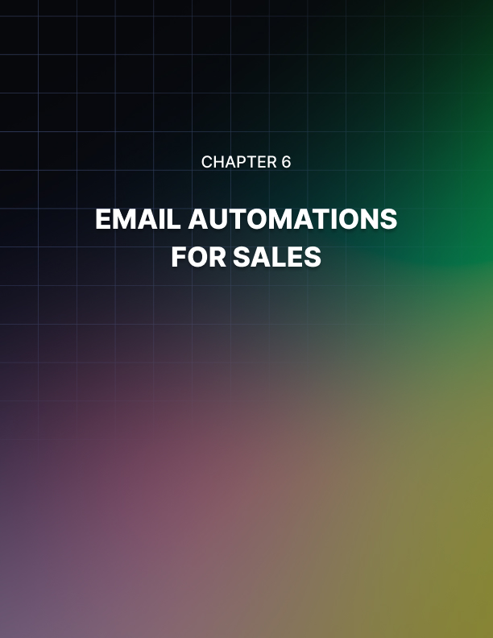

Chapter 6: Email Automations for Sales
Email is not dead. It’s alive and well. Around 1/3 of your sales will come from your emails. So... it’s essential you build out your email campaigns and automations that convert.

The four main types of emails that are sent:
- Trust / Relationship Builders - engage and build relationship
- Social Proof - prove why you are of value
- Content - soft sell
- Offers - promote your products

Key requirement for success: Always use smart automation!

Based on the behavior and actions of a customer with your store, you need to automatically move them from one list to another, or one email automation into another.

Some best practices for email sending to consider...
- Always Use Deadlines
- Good Looking Design (text emails work well too, but this e-commerce)
- Images Sell The Click
- Ask For The Sale
- Use UTM Codes

Now, here are the different email campaigns and sequences that should be set up for your store...

Pre Purchase Email Sequences
The aim of the pre-purchase email sequences are to build the relationship and trust with the potential customer to eventually convert them into customers. You want to give them more time to purchase and persuade them to do so.

There are multiple pre purchase sequences that you should have set up. Let‘s cover the main types for your store:

Pre Purchase Email Sequence#1
This is a soft selling sequence with and should be triggered when a contact visits your site and gives you their email address via:

- Header / Footer Opt-In
- Coupon Box Pop-Up
- Exit-Intent Pop Up
- Lead Generation Campaigns

Here are the best practices for structuring the sequence:
- At Least 7 Days Of Emails
- End With Strongest Offer
- Leverage Discount Ladder
- Unsubscribe from list If They Buy
- Add to the broadcast list if they don’t purchase

Pre Purchase Email Sequence #1: Example
Send this only to customers who have never been through an email automation of yours before. This is the first contact with you.

- Email 1: Day 0: Welcome to the Community
- Email 2: Day 1: Social Proof
- Email 3: Day 3: Product Benefit (ownership benefit)
- Email 4: Day 5: Long Form Video (online pres, webinar, video sales)
- Email 5: Day 6: PDF of video content (people like to read)
- Email 6: Day 8: Emotional triggers (build intimacy, build the relationship)
- Email 7: Day 9: Scarcity (last chance to consume long form video or PDF)
- Email 8: Day 10: Discount Increase

Always use text, images, video thumbnails, and CTA buttons in your emails to be consistent and to encourage clicks. And always try to include each of the email types above.

Hundreds of thousands of dollars can be generated from each of these emails. And, the first and last emails can generate the same amount of revenue due to the engagement and offers.

Pre-Purchase Email Sequence #2
A second pre-purchase email sequence. This is slightly different to the previous sequence as it only sends to those email contacts that are captured through:

- Incentivized Discount Exit
- Intent Pop Up

Again, through smart automation, you should remove contacts from other pre- purchase lists if they have entered this sequence and only send if they have not previously entered the automation.

Pre Purchase Email Sequence #2: Example:
Main difference is the additional emails sharing the promised discount.

- Email 1: Day 0: Here’s your discount code/coupon
- Email 2: Day 1: Social Proof
- Email 3: Day 2: Last chance for your discount code
- Email 4: Day 3: Product Benefit (ownership benefit)
- Email 5: Day 5: Long Form Video (online pres, webinar, video sales)
- Email 6: Day 6: PDF of video content (people like to read)
- Email 7: Day 8: Emotional triggers (build intimacy, build the relationship)
- Email 8: Day 9: Scarcity (last chance to consume long form video or PDF)
- Email 9: Day 11: Discount Increase
- Email 10: Day 12: Last Chance on Discount Increase
- Email 11: Day 14: Content

You can also use some of your content assets within these sequences to build the relationship with new leads. This sequence will get you additional revenue on top of all the other sequences and emails you send.

Note: Open rates will decrease as contacts go further into the automation. It’s normal. The initial email and the later offers are the emails that will generate the most revenue. The rest shouldn’t be disregarded. They will still make revenue and they’ll still build the engagement with your contacts.

And... you don’t have to stop at 7-10 emails. You can continue the sequence for another week or two, as long as you are building the relationship by providing value.

Post Purchase Email Sequences
This post purchase sequence is triggered as soon as their purchase is complete. You should remove contacts from all other automations and lists.

Here is what you will send them emails about:
- Welcome & Shipping details
- Pre arrival
- Additional offers, upsells, cross-sells
- Content

Ultimately this is where you turn them into repeat customers and generate more revenue from them.

Post Purchase Content assets:
You should create new content assets (in addition to the content assets previously covered) to build an even stronger, more intimate connection with your new customers. Create welcome videos. Sales videos and presentations for additional products. Product/box openings etc etc. Make it personable and intimate.

Post Purchase Email Sequence: Example
- Email 1: Day 0: Thank you and welcome!
- Email 2: Day 1: Pre Arrival 1: A look inside our business/office/house/team
- Email 3: Day 3: Pre Arrival 2: Press release or more reviews
- Email 4: Day 5: Pre Arrival 3: Product benefit and excitement
- Email 5: Day 7: Upsell/Cross Sell: New product reveal teaser
- Email 6: Day 9: Upsell/Cross Sell: Long Form Video Product Presentation
- Email 7: Day 11: Upsell/Cross Sell: PDF of video content
- Email 8: Day 13: Content asset generator: Selfie Request with product
- Email 9: Day 15: Upsell/Cross Sell: Scarcity to watch product presentation
- Email 10: Day 17: Content asset generator: Video Testimonial Request
- Email 11: Day 19: Upsell/Cross Sell: Additional Product 1 - pre sell and offer
- Email 12: Day 21: Upsell/Cross Sell: Additional Product 2 - pre sell and offer
- Email 13: Day 23: Upsell/Cross Sell: Additional Product 3 - pre sell and offer
- Email 14: Day 25: Content asset generator: Customer Survey

Note: Only send upsells and cross sells content to people who have not previously been sent the same content in a different automation. Smart automations!

See more about welcome and pre-arrival emails below...

Initial Welcome Email
Things to include:
- Thank you and welcome
- Shipping information and delivery
- What to expect from us
- Follow us on social media (choose one)

Show (or remind) people:
- Who you are and why you created the brand
- Why you created the brand
- Your story

Pre-Arrival Emails Goals should be to:
- Build Excitement before they receive delivery of their purchase
- Reduce Buyers Remorse
- Reduce Refund Rates
- Increase Review Ratio
- FaceTime! Show people a face to the brand.
- Ideas Open The Box Video
- Press or 3rd Party Pitch
- Video Social Proof, Science, Case Study
- Content Related To Ownership Benefit

Again there is no limit or set rule to how much you can send in your post purchase sequence.

The result in a solid campaign will significantly increase sales and revenue.

Post Purchase Win Back Email Sequence
This is used to dynamically send emails to previous customers based on their behavior. A customer should receive the automation if they have placed an order, and then not placed an additional order within 60 days.

If a customer hasn’t repurchased your product in 60 days, then it’s likely they are lost customers.

This sequence is therefore important as a last ditch attempt to save them.

You can again generate significant amounts of profit with this dynamic automation using discount ladders to offer more incentive than previous engagement and upsell/cross sell sequences.

Post Purchase Win Back Sequence: Example
- Email 1: After 60 days: 10% Discount Offer
- Email 2: After 62 days: 10% Discount Offer Last Chance
- Email 3: After 70 days: Free + Shipping Offer
- Email 4: After 72 days: Free + Shipping Offer Last Chance
- Email 5: After 90 days: 15% Discount Offer

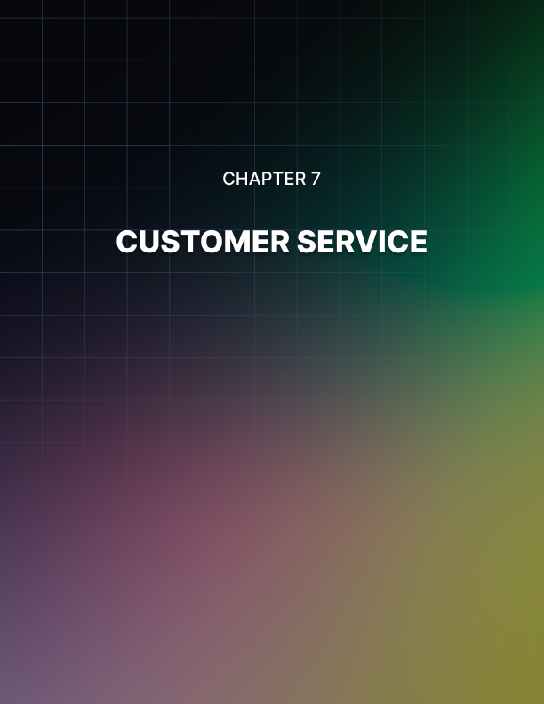

Chapter 7: Customer Service
You’ve put in the work to get all the customers. Now you need to make sure you keep them happy! In addition to your emails, you‘ll also be communicating on your customer service channels to drive sales.

Remember that we also live in a social media driven world where it’s very easy for people to leave negative footprints for your business. Social word of mouth is powerful. So... customer service is extremely important.

Goals:
Respond Within 12 Hours - Don’t keep people waiting.
Aim for high satisfaction rates
Respond to all negative ratings

Tips To Help:
All communication channels should open tickets.
Facebook Messages
Voicemails
Chat Messages
Review & Q/A Widgets
Include referral widget link in all emails
Tag tickets & chats for future marketing copy (Copywriting, FAQ’s etc)

Live Chat Tips:
Use triggered events based on behavior to offer people help
Give coupons and discounts to incentivise them to buy

Package Inserts:
This is additional content that is delivered with your product in order to give added experience. It is an opportunity to put your brand, your story, your philosophies, your product ethos, how to’s etc... into the hands of your customer to create further connection. This can come in the form of mailers, invoices, brochures etc.

Tips to create a good package insert:
- Use high quality design
- Show and tell
- Give coupon for next order or Incentivize referral
- Cross sell other products
- Indoctrinate into the tribe

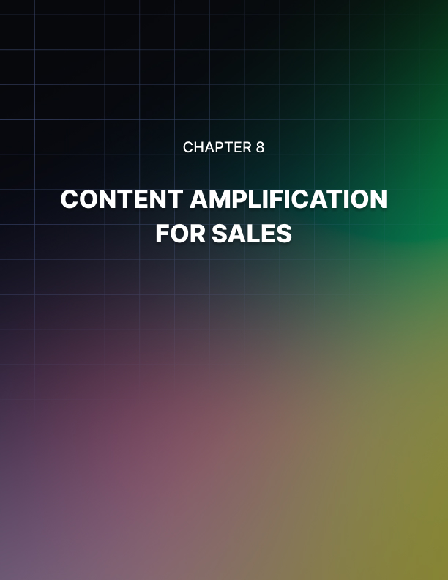

Chapter 8: Content Amplification for Sales
This is where you’ll re-engage with the people who have previously engaged with your brand, while using your content to capture new customers into your store too.

Successful ecommerce stores generate almost half of their revenue from ‘returning visitors’. So reengaging contacts with content opens up the doors for them to come back! The goal therefore is to convert those prospects by soft selling with content! All successful ecommerce stores should be doing this because it works!

You’ll create content assets to engage with your audience on your own channels. Content with value that’s interesting and relatable to your audience. You’ll amplify that content across your multiple marketing channels (email, social, blog, etc) to send people back to your site... And then you’ll send offers to people based on their interaction.

A note on your email lists
As you now know, your email list will generate 1/3 of sales. So outside of the automations previously covered, you‘ll use it here to...

- Send broadcast emails to your list
- Engage with high quality, relevant content
- New products
- Holiday Sales & Promotional Offers.
- Social engagement campaigns.
- Any value you can think of.
- How often should you email your lists
- 1-3x Per Week good
- 3x is idea
- At Least One Offer Per Month

Content Strategy Process
This is now a common process for content marketing. Here, it‘s broken up into 4 phases…

- Creation - create the content, videos, images, blogs
- Optimization - links, tracking codes
- Syndication - publish to your various channels (socials, email list etc)
- Amplification - put money behind it to boost it’s reach

Note: Be consistent. The more touch points, the bigger the connection and relationship... and the more conversions you’ll generate. It’s the key to success.
Let’s walk through that process step by step...

- Creation
Video is the most effective form of content! Here‘s why:

- Face to face with your audience
- The consistency of face to face builds intimacy and trust
- You can syndicate video content into other formats (articles, posts etc)
- Video sells!
- Optimizes for social media optimisation
- Generates continuous content assets that lead to sales conversions!

Notes: If you don’t have a personality or face of your brand, use somebody else as the face.

Or use multiple people and rotate them.

And... if video doesn’t work for you and you’d rather write... then write! It will still generate sales if you follow the same process. Should you email your lists.

Types of Content you should create:
- Opinions - polarizing is popular
- Educational content
- Behind the scenes
- Industry specific
- Timely / relevant to current events
- Tips lists
- Community feedback
- Interviews & guests (other brands)
- Curated content (commenting)
- Anything to the problems/conversations your community has

- Optimization
This ensures that your content is easy for your customers to consume on multiple channels and in multiple formats.

It needs to be optimized for Facebook, Instagram, Stories, Blogs, Email etc.

Here is a summarized method for optimizing: (You can see more on content syndication and amplification in our strategy here)

Best practices to optimize your content:
- Create a title
- Create a highlight - sections covered (timestamps etc)
- Create a transcription - for blog posts and emails
- Create a custom thumbnail - capture those clicks
- Create tweets and image quotes from the video - use for social posts
- Create a watermark for the intro and outros of your content
- Create captions for your video for added engagement

- Syndication
You’ve created and optimized the content for different platforms. Now syndicate to the channels below:

- Store blog
- Facebook
- Twitter
- Instagram
- Pinterest
- YouTube
- Email

Use UTM links on all content that you are posting outside of your store so you can track the impact and performance on sales and revenue.

Create content excerpts/intros above each post to let people know what the content is about. If you are only one of these channels, just post there. But you should be on at least one social channel.

- Amplification
Boosting your content with paid promotion and ads increases the engagement on the content, allowing you to get in front of more potential customers.
This also fills the top of your funnel and makes it more profitable to retarget customers who have previously engaged with your brand, and thus optimising ad campaigns and conversions.

These are the best practices to amplify your content:
- Use Facebook‘s boost post option!
- Set the campaign objective: video views
- Put 10-20% of total ad budget on boosting posts for engagement
- Only promote the post for a week
- Follow up engaged viewers with direct response sale ads
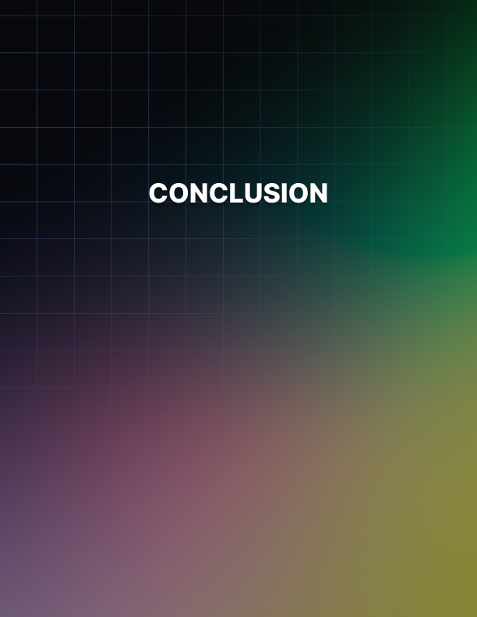

Conclusion
Lot’s of information. Lots of steps. Lot’s of campaigns. Our best advice is to go through this strategy in order. Start with the tech stack, then optimize your site for conversions, creating content, creating your email sequences, adding your marketing stack apps, before building out your brand with content!

If you put all the steps together in this strategy you’ll be joining the best e- commerce stores in the world and you’ll put yourself in a position to take your store to the next level.

