TABLE OF CONTENTS
____
INTRODUCTION 5
THE ENTREPRENEUR'S RESILIENCE BLUEPRINT 8
The Entrepreneurial Roller Coaster 8
Resilience and Its Connection to Success 9
Building Your Resilience Blueprint 10
Resilience in Action 12
STRESS MANAGEMENT STRATEGIES 15
The High Cost of Entrepreneurial Stress 15
High-Impact Stress Reduction Techniques 16
Time Management 18
Entrepreneurs Who Mastered Stress Management 19
Your Stress Management Action Plan 20
CULTIVATING A POSITIVE ENTREPRENEURIAL MINDSET 24
The Science of Positivity in Entrepreneurship 25
Harnessing the Power of Gratitude 25
Seeing is Believing 26
Affirmations and Building a Positive Support Network 27
The Power of Positive Psychology in Entrepreneurship 29
Changing Negative Thoughts and Tracking Progress 30
DEVELOPING UNSHAKEABLE MENTAL TOUGHNESS 34
The Essence of Mental Toughness in Entrepreneurship 34
The Engines of Mental Toughness 36
Building Mental Toughness Through Adversity 37
Practical Exercises and Measurement 38
KEY TAKEAWAYS AND NEXT STEPS 43
The Resilience Blueprint 43
Stress Management Mastery 44
The Power of Positivity 45
Unshakeable Mental Toughness 46
Measuring Your Progress and Next Steps 46

DISCLAIMER
____
The information provided in this ebook is intended solely for educational and informational purposes. The author does not accept any responsibility for the outcomes that may arise from the application of the material within. While efforts have been made to ensure the accuracy and relevance of the content, the author cannot be held accountable for any errors or omissions, or for any consequences resulting from the use or misuse of the information provided. The responsibility for any actions taken based on the information in this ebook lies solely with the reader.


INTRODUCTION
____
In the demanding world of entrepreneurship, your mindset is your most valuable asset.

Have you ever wondered why some business leaders thrive under pressure while others falter?

What makes certain individuals bounce back from setbacks stronger than ever? The answer is mental resilience—a skill that can be developed, not just inherited. And this ebook is here to show you how to build it, step by step.
Welcome to your personal guide to entrepreneurial mental toughness. This isn't just another self-help book; it's a carefully designed roadmap to help you become a resilient force in the business world. Inside, you'll discover how to turn stress into an ally, maintain a positive outlook even when facing challenges, and build a mindset that transforms failure into opportunity.
Imagine navigating the ups and downs of entrepreneurship with confidence. Picture facing obstacles with strategies that turn them into stepping stones toward success. That's what this book offers—a practical toolkit for developing the mental toughness needed to succeed in business.
You'll find battle-tested techniques and real-world advice, drawn from entrepreneurs who’ve faced the same challenges. Through their stories and actionable exercises, you'll learn how to rewire your brain for resilience and implement stress-management strategies that work.
What makes this book different? It's not about avoiding challenges, but about embracing them. You'll learn to see obstacles as opportunities and setbacks as setups for comebacks. This isn’t about just staying positive; it's about building true, unshakeable confidence from within.
Are you ready to thrive under pressure and cultivate a mindset that will become your secret weapon in business? If so, you're in the right place. This book will guide you on a transformative journey, helping you develop the mental resilience to overcome any challenge and lead with strength. Your journey to mental toughness starts now. Let’s build your resilience, one strategy at a time.
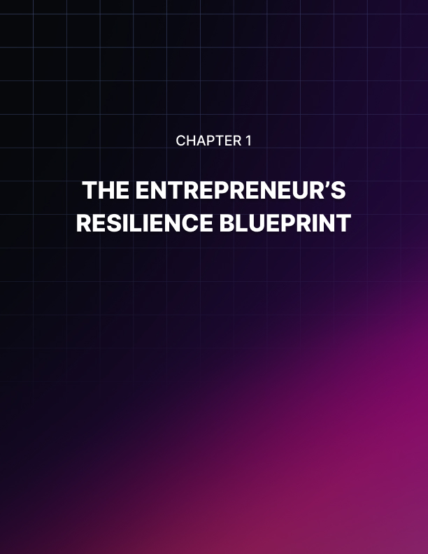

THE ENTREPRENEUR'S RESILIENCE BLUEPRINT
____

The Entrepreneurial Roller Coaster
Entrepreneurship is an exciting but challenging ride that takes more than just business skills. It requires unwavering mental fortitude to weather the storms of setbacks, failures, and relentless stress. Imagine you're on a rollercoaster, slowly climbing to the top with anticipation and a touch of fear, then suddenly plummeting down at breakneck speed, twisting and turning through loops and corkscrews. That's entrepreneurship in a nutshell. The highs are exhilarating, but the lows can be gut-wrenching.
You'll face uncertainty at every turn, questioning whether your product will resonate with the market, if you can secure crucial funding, or if a competitor will launch a similar offering. These questions and countless others will bombard you daily, testing your resolve and challenging your confidence. Failure, too, is an ever-present specter. Statistics show that:
- about 20% of new businesses fail during the first two years of operation,
- 45% fail during the first five years,
- and 65% fail during the first 10 years.
These numbers aren't meant to discourage you, but to prepare you for the reality that setbacks are part of the entrepreneurial journey. Then there's the constant stress.
A 2023 survey by the National Federation of Independent Business found that 72% of small business owners reported feeling overwhelmed by their responsibilities. The pressure to succeed, make payroll, satisfy customers, and stay ahead of the competition can be relentless. But here's the good news: you can learn to thrive amidst these challenges. That's where resilience comes in.

Resilience and Its Connection to Success
Resilience isn't about avoiding difficulties or powering through them unscathed. It's the ability to adapt and bounce back from adversity. For entrepreneurs, it's the mental and emotional capacity to face challenges head-on, learn from failures, and emerge stronger.
Dr. Angela Duckworth, a psychologist renowned for her work on grit and perseverance, defines resilience as "the ability to persist in the face of challenges and to bounce back from adversity."
This definition encapsulates what you, as an entrepreneur, need to cultivate. Resilience isn't a fixed trait; it's a skill you can develop and strengthen over time. Just as you would exercise to build physical strength, you can train your mind to become more resilient.
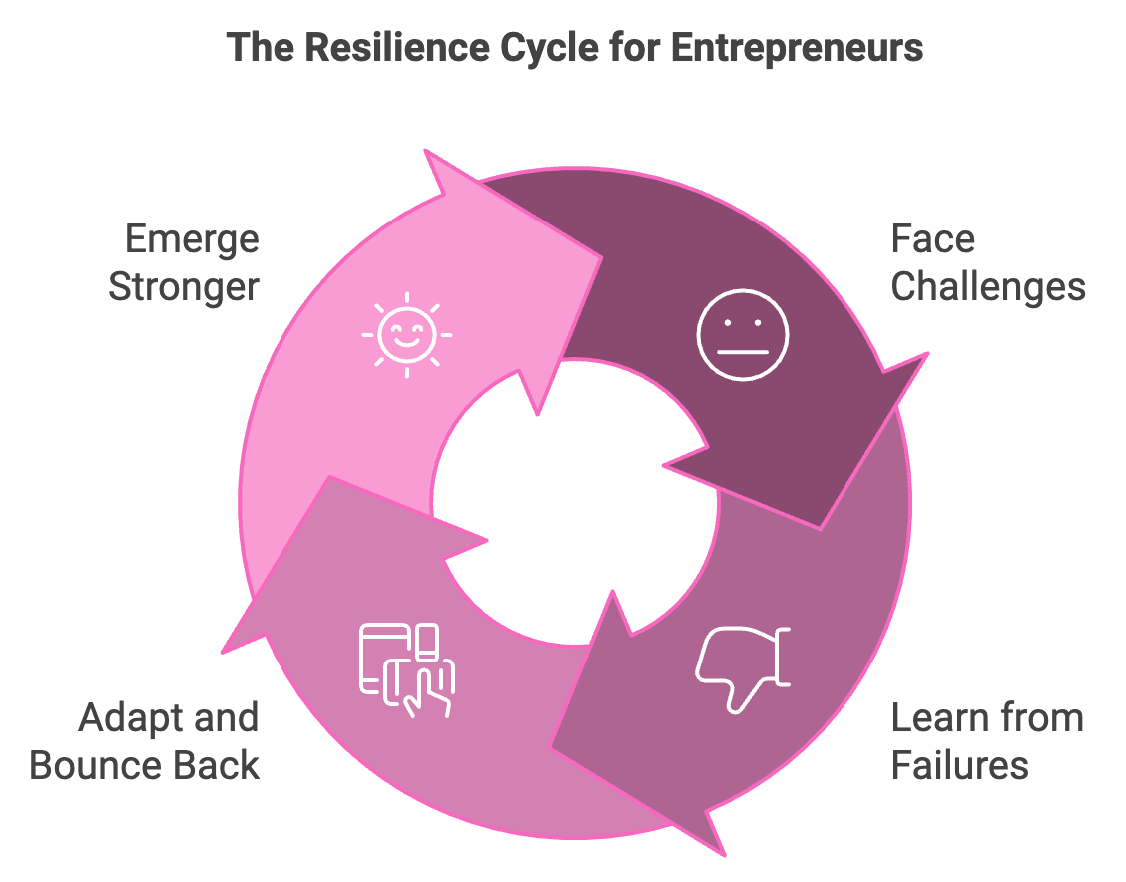
The connection between resilience and success in entrepreneurship is undeniable. Resilient entrepreneurs are better equipped to navigate uncertainty, learn from failures, manage stress effectively, adapt to change, and inspire and lead others. A 2023 study published in the Journal of Business Venturing found that entrepreneurs with higher levels of psychological resilience were 31% more likely to achieve sustained business growth over a five-year period. This underscores the direct link between your mental fortitude and your venture's success.

Building Your Resilience Blueprint
Now that you understand the importance of resilience, let's explore how you can start building it. Your resilience blueprint consists of several key components:
- Mindset Shifts
The first step in building resilience is shifting your mindset. This involves changing how you perceive challenges and setbacks. Adopt a growth mindset, believing that your abilities and intelligence can be developed through effort and learning. Let go of the need for perfection and focus on making continuous progress. Reframe failure as a necessary part of the learning process.
- Cognitive Reframing
This powerful technique involves changing how you think about a situation. It's about finding alternative ways to look at events, especially those that initially seem negative. Practice identifying the situation, noticing your thoughts, challenging these thoughts, and reframing them in a more balanced way.
- Goal Realignment
In the face of setbacks, it's crucial to be able to reassess and realign your goals. Use the SMART framework (Specific, Measurable, Achievable, Relevant, Time-bound) to set and realign goals. When faced with a setback, revisit your goals using this framework. You might need to adjust timelines, redefine success metrics, or even pivot to a new approach.
- Building a Support Network
Resilience isn't built in isolation. Surrounding yourself with a strong support network can significantly boost your ability to bounce back from challenges. Seek mentors, join peer groups, cultivate personal relationships, and consider professional help like a business coach or therapist.
- Developing Healthy Habits
Your physical well-being directly impacts your mental resilience. Incorporate regular exercise, adequate sleep, balanced nutrition, and mindfulness practices into your routine.

Resilience in Action
To illustrate the power of resilience, let's look at two entrepreneurs who bounced back from significant setbacks:
Entrepreneur | Setback | Resilient Response | Outcome
Arianna Huffington | First book rejected by 36 publishers | Persevered in writing | Became bestselling author and created The Huffington Post
Steve Jobs | Ousted from Apple in 1985 | Founded NeXT Computer and Pixar | Returned to lead Apple to unprecedented success

These stories demonstrate that setbacks, even major ones, don't have to spell the end of your entrepreneurial journey. With resilience, you can turn challenges into stepping stones for future success.
As you move forward in your entrepreneurial journey, remember that building resilience is an ongoing process. It requires consistent effort and practice. But with each challenge you face and overcome, you're strengthening your resilience muscle, setting yourself up for long-term success. Your resilience blueprint is now in place. It's time to start building.


STRESS MANAGEMENT STRATEGIES
____
The entrepreneurial path is paved with high-stakes decisions, relentless deadlines, and constant pressure to innovate and succeed. As you navigate this challenging terrain, effective stress management becomes not just a luxury, but a necessity for your long-term success and well-being.

The High Cost of Entrepreneurial Stress
Stress is an inevitable part of the entrepreneurial journey, but when left unchecked, it can exact a heavy toll on your health, relationships, and business performance. A 2023 survey by the Global Entrepreneurship Monitor found that 62% of entrepreneurs reported experiencing high levels of stress, with 41% saying it negatively impacted their business decisions.
The effects of chronic stress can be far-reaching, including increased risk of cardiovascular disease, weakened immune system, disrupted sleep patterns, higher rates of anxiety, depression, and burnout, impaired decision-making, reduced creativity, decreased focus, poor leadership, strained team relationships, and missed opportunities.
Recognizing these potential consequences, it's clear that mastering stress management is not just about feeling better—it's about safeguarding your entrepreneurial vision and ensuring your venture's longevity.
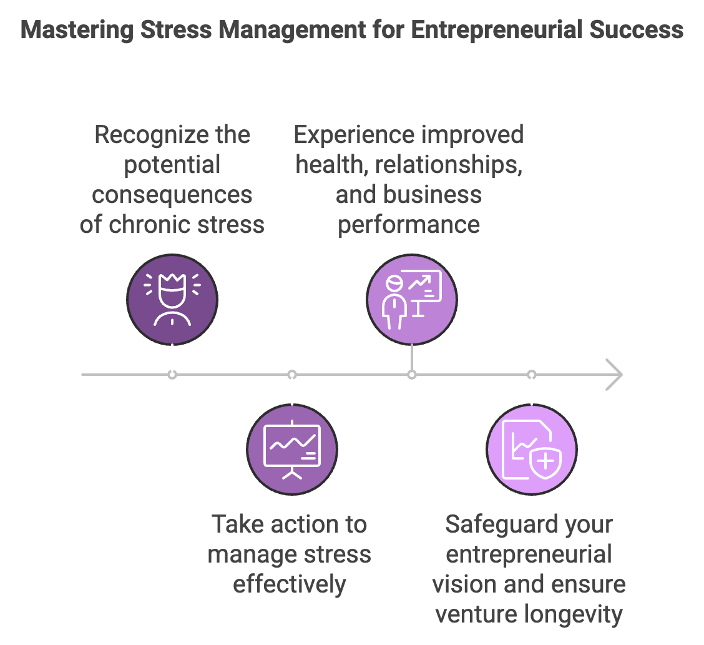

High-Impact Stress Reduction Techniques
Let's explore some research-backed strategies that can help you effectively manage stress and maintain peak performance:
Progressive Muscle Relaxation (PMR)
Progressive Muscle Relaxation is a powerful technique that involves systematically tensing and then relaxing different muscle groups in your body. This practice not only helps reduce physical tension but also interrupts the stress response cycle in your brain. To practice PMR, find a quiet, comfortable place to sit or lie down. Starting with your toes, tense the muscles as tightly as you can for 5 seconds, then release the tension suddenly and completely. Notice the feeling of relaxation in the muscles. Move up to your feet, then calves, thighs, and so on, all the way to your face and head. Repeat the process if needed, focusing on the contrast between tension and relaxation. A 2023 study published in the Journal of Occupational Health Psychology found that entrepreneurs who practiced PMR for 15 minutes daily reported a 28% reduction in perceived stress levels after four weeks.
Mindfulness-Based Stress Reduction (MBSR)
Mindfulness-Based Stress Reduction, developed by Jon Kabat-Zinn, is a structured program that combines mindfulness meditation, body awareness, and yoga to help people manage stress and improve overall well-being. Key components of MBSR include body scan meditation, sitting meditation, Hatha yoga, and informal mindfulness practices. To incorporate MBSR into your routine, start with short, daily mindfulness sessions (5-10 minutes), gradually increase the duration as you become more comfortable, and consider taking an 8-week MBSR course for a comprehensive introduction. Research published in the Journal of Business Venturing in 2023 showed that entrepreneurs who completed an MBSR program experienced a 35% reduction in stress-related symptoms and reported improved decision-making capabilities.
Physical Activity Integration
Regular physical activity is a potent stress-buster. Exercise releases endorphins, improves mood, and enhances cognitive function. As a busy entrepreneur, the key is to integrate physical activity into your daily routine seamlessly. Try strategies such as walking meetings, desk exercises, active commuting, and micro-workouts. A 2023 study in the International Journal of Workplace Health Management found that entrepreneurs who engaged in at least 150 minutes of moderate-intensity exercise per week reported 40% lower stress levels and 25% higher productivity compared to their sedentary counterparts.

Time Management
Effective time management is crucial for reducing stress and increasing productivity. Common time management pitfalls include multitasking, perfectionism, poor prioritization, and overcommitment. To address these issues, consider implementing the power of time-blocking, a scheduling method where you divide your day into blocks of time, each dedicated to accomplishing a specific task or group of tasks. This technique can significantly reduce stress by providing structure and focus to your day.
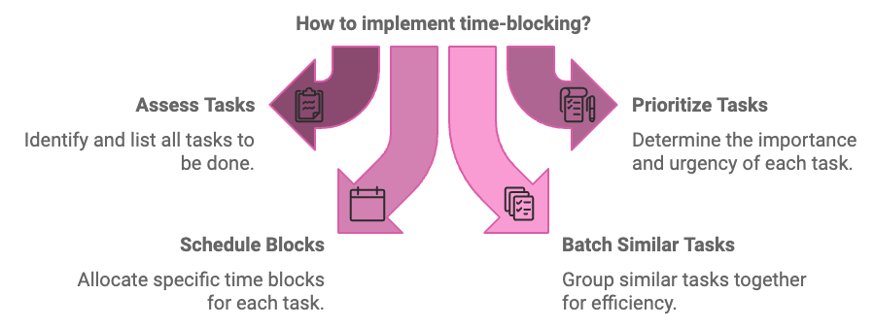
To implement time-blocking, assess your tasks, prioritize them, schedule blocks, batch similar tasks, include breaks, be flexible, and regularly review and adjust your system. A 2023 survey by Atlassian found that entrepreneurs who consistently used time-blocking reported a 37% increase in productivity and a 29% decrease in work-related stress.

Entrepreneurs Who Mastered Stress Management
Let's look at two entrepreneurs who successfully reduced stress while scaling their businesses:
Sarah Chen, Founder of TechInnovate
Sarah Chen, founder of the AI startup TechInnovate, faced overwhelming stress as her company rapidly grew from 5 to 50 employees in just 18 months. She implemented daily mindfulness practice, time-blocking, and regular physical activity. As a result, she experienced a 45% reduction in self-reported stress levels, a 30% increase in employee satisfaction scores, and a 22% improvement in quarterly revenue growth.
Marcus Lim, CEO of EcoSolutions
Marcus Lim, CEO of the sustainable packaging company EcoSolutions, struggled with chronic stress as he navigated complex regulatory challenges and rapid market expansion. He adopted Progressive Muscle Relaxation, active commuting, and strict email management and delegation strategies. Consequently, he saw a 38% decrease in cortisol levels, a 25% improvement in sleep quality, and an 18% increase in team productivity.

Your Stress Management Action Plan
Now that you're equipped with these powerful stress management strategies, it's time to put them into action. Here's a step-by-step plan to help you integrate these techniques into your daily routine:
- Assess your current stress levels using a stress inventory or journal to identify your main sources of stress and how they affect you.
- Choose 2-3 stress reduction techniques that resonate with you, starting small to ensure consistency.
- Use time-blocking to allocate specific times for your chosen stress reduction activities.
- Inform your team and family about your stress management goals and consider finding an accountability partner.
- Keep a log of your stress levels and the effectiveness of your chosen techniques, using apps like Headspace or Calm to support your practice.
- After two weeks, review your progress and make necessary adjustments to your stress management plan.
- Gradually incorporate additional stress management techniques as you become more comfortable with your initial choices.
Stress management is not a one-size-fits-all solution. It's about finding the right combination of techniques that work for you and your unique situation. Be patient with yourself as you develop these new habits, and celebrate small wins along the way. As you implement these strategies, you'll likely notice improvements not just in your stress levels, but in your overall quality of life and business performance. You'll find yourself better equipped to handle the challenges of entrepreneurship, make clearer decisions, and lead your team more effectively.
Stress management is not about eliminating stress entirely—some level of stress can be motivating and productive. Instead, it's about developing the skills to manage stress effectively, preventing it from overwhelming you or hindering your success. By prioritizing stress management, you're making a strategic investment in yourself and your business. You're building the resilience and mental clarity needed to navigate the complex world of entrepreneurship successfully. As you move forward, remember that managing stress is an ongoing process. Continue to refine your techniques, stay attuned to your needs, and make stress management an integral part of your entrepreneurial journey.
Stress Management Technique | Time Commitment | Potential Benefits
Progressive Muscle Relaxation | 15 minutes daily | 28% reduction in perceived stress levels
Mindfulness-Based Stress Reduction | 20-45 minutes daily | 35% reduction in stress-related symptoms
Physical Activity Integration | 150 minutes per week | 40% lower stress levels, 25% higher productivity
Time-Blocking | Varies | 37% increase in productivity, 29% decrease in work-related stress
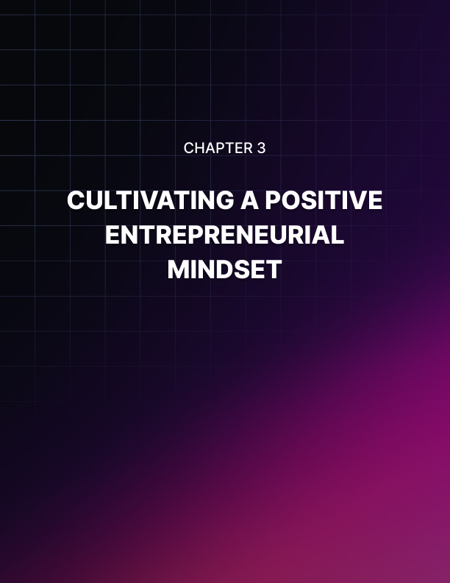

CULTIVATING A POSITIVE ENTREPRENEURIAL MINDSET
____
Positivity isn't just a feel-good concept—it's a powerful tool that can transform your entrepreneurial journey. As you navigate the ups and downs of building and growing your business, your mindset becomes your most valuable asset. This chapter will equip you with robust strategies to cultivate and maintain a positive outlook, even in the face of daunting challenges.
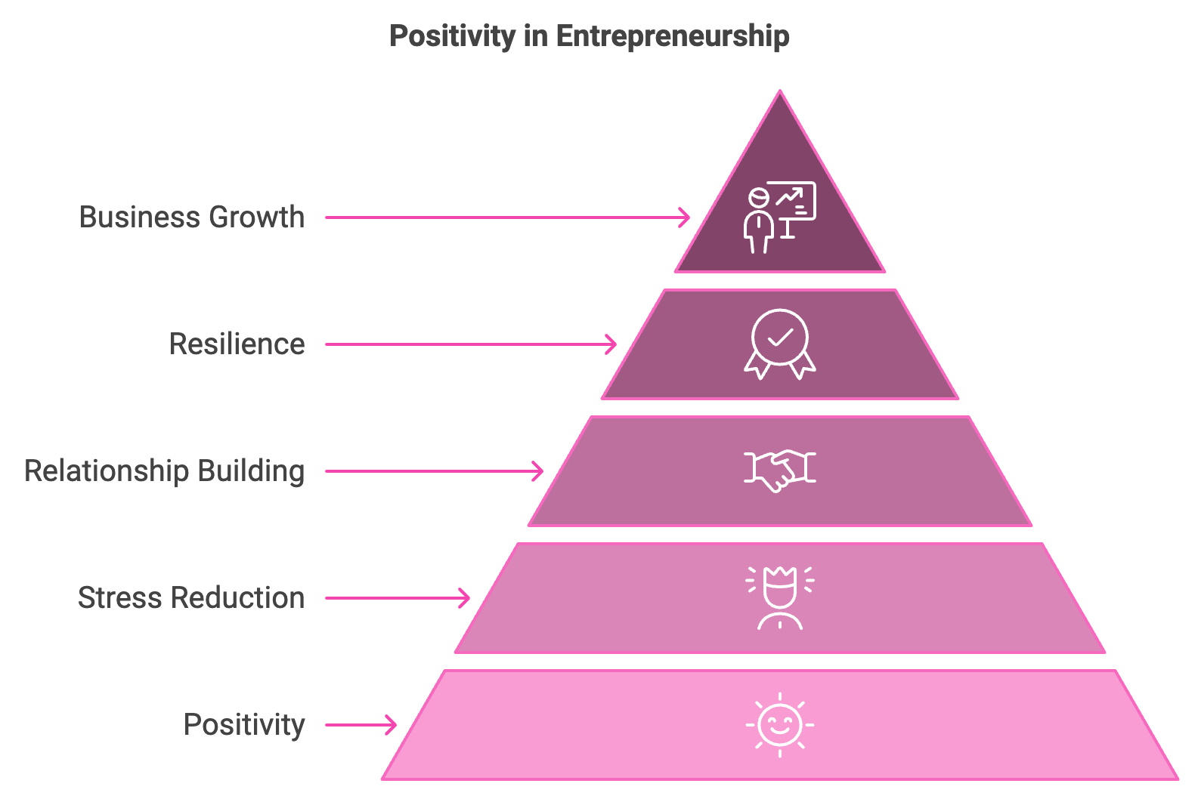

The Science of Positivity in Entrepreneurship
Before diving into practical strategies, it's crucial to understand the scientific basis for cultivating a positive mindset. Positive psychology, a field pioneered by Dr. Martin Seligman, focuses on the study of human flourishing and optimal functioning. This science has profound implications for entrepreneurs. A 2023 study published in the Journal of Business Venturing found that entrepreneurs with a positive mindset were 42% more likely to overcome business challenges and 37% more likely to report higher levels of job satisfaction compared to those with a negative outlook. Moreover, positivity has been linked to enhanced creativity, better problem-solving skills, and improved resilience—all critical traits for entrepreneurial success.
Positive emotions broaden your thought-action repertoire, allowing you to see more possibilities and solutions. This "broaden-and-build" theory, proposed by psychologist Barbara Fredrickson, suggests that positive emotions help you build lasting personal resources, from physical and intellectual resources to social and psychological ones. The implications of this theory for entrepreneurs are significant, as it suggests that cultivating positive emotions can lead to a virtuous cycle of personal and professional growth.

Harnessing the Power of Gratitude
Gratitude is a powerful tool in your positivity arsenal. It shifts your focus from what's lacking to what's abundant in your life and business. Gratitude journaling is an effective way to harness this power. Start each day by writing down three things you're grateful for in your business. These can be small wins, supportive team members, or even challenges that have helped you grow. A 2023 study in the International Journal of Wellbeing found that entrepreneurs who practiced gratitude journaling for eight weeks reported a 31% increase in life satisfaction and a 28% decrease in perceived stress levels.
To make the most of your gratitude practice, be specific in your entries, focus on people to strengthen business relationships, look for unexpected sources of gratitude, and write regularly, aiming for at least three times a week to see significant benefits. Another effective gratitude practice is the gratitude walk. Take a 10-minute walk around your office or neighborhood, mentally listing everything you're grateful for in your business. This combines the benefits of gratitude with physical activity, boosting both your mood and energy levels.

Seeing is Believing
Visualization is a technique used by top athletes, successful entrepreneurs, and high achievers across various fields. It involves creating a vivid mental image of your desired outcome. For entrepreneurs, this can be particularly powerful in goal-setting and problem-solving. The goal visualization exercise is an effective way to implement this technique:
- Find a quiet space where you won't be disturbed.
- Close your eyes and take a few deep breaths to center yourself.
- Imagine your business one year from now, having achieved a significant goal.
- Engage all your senses:
  - What do you see? (Your team celebrating, new office space, product launch)
  - What do you hear? (Congratulations, customer feedback, team discussions)
  - What do you feel? (Pride, excitement, satisfaction)
  - What do you smell? (New office smell, celebratory champagne)
  - What do you taste? (Success, victory)
- Hold this image for 5-10 minutes, really immersing yourself in the experience.
- Slowly open your eyes and jot down any insights or action steps that come to mind.
Practice this visualization exercise daily, preferably in the morning to set a positive tone for your day. A 2023 study in the Journal of Applied Psychology found that entrepreneurs who regularly practiced visualization reported 27% higher goal achievement rates compared to those who didn't.

Affirmations and Building a Positive Support Network
Affirmations are positive statements that can help you overcome self-sabotaging thoughts. They work by rewiring your brain's neural pathways, making positive thinking more automatic over time. To create powerful entrepreneurial affirmations, make them personal and specific to your business goals, use present tense, keep them positive and action-oriented, and ensure they're realistic and believable.
Examples include: "I am a resilient and innovative entrepreneur, finding opportunities in every challenge" and "My business is growing and thriving, attracting the right customers and team members."
Repeat your chosen affirmations daily, preferably looking at yourself in a mirror to add a visual component to the practice.
Your environment significantly influences your mindset. Surrounding yourself with positive, supportive people can dramatically impact your entrepreneurial outlook. Mentorship is a key component of building a positive support network. Seek out mentors who have achieved what you aspire to in your business. Their guidance and positive outlook can be invaluable. A 2023 survey by the Global Entrepreneurship Monitor found that entrepreneurs with mentors were 43% more likely to maintain a positive outlook during business challenges compared to those without mentors.
To find the right mentor, identify your specific needs and goals, research potential mentors in your industry or network, reach out with a clear, concise request explaining why you'd value their mentorship, and be prepared to offer value in return.
Peer groups are another crucial element of a positive support network. Join or create a peer group of fellow entrepreneurs. Regular meetups or mastermind sessions can provide support, accountability, and fresh perspectives. A 2023 study in the Journal of Business Venturing found that entrepreneurs who participated in regular peer group meetings reported 35% higher levels of optimism and 29% lower levels of burnout compared to those who didn't. To maximize the benefits of peer groups, set clear goals and expectations, meet regularly, be open and honest about your challenges and successes, offer support and constructive feedback to others, and celebrate each other's wins, no matter how small.

The Power of Positive Psychology in Entrepreneurship
Positive psychology offers several evidence-based interventions that can significantly boost your entrepreneurial mindset.
The Three Good Things Exercise is a powerful tool. At the end of each day, write down three good things that happened in your business. For each good thing, answer these questions:
- Why did this good thing happen?
- What does it mean to you?
- How can you have more of this good thing in the future?
This exercise trains your brain to focus on positive events and their causes, countering the natural negativity bias we all have.
A 2023 study in the Journal of Positive Psychology found that entrepreneurs who practiced this exercise for two weeks reported a 25% increase in overall life satisfaction and a 30% decrease in symptoms of depression.
The Best Possible Self Exercise is another effective intervention. Spend 15 minutes writing about your best possible future self as an entrepreneur. Imagine that everything has gone as well as it possibly could. You have worked hard and succeeded at accomplishing all your business goals. Be as specific and vivid as possible. This exercise increases optimism and helps clarify your goals.
A 2023 study in the Journal of Happiness Studies found that entrepreneurs who regularly engaged in this exercise reported 33% higher levels of optimism and 28% clearer goal clarity compared to those who didn't.
Positive Psychology Exercise | Benefits
Three Good Things | 25% increase in life satisfaction, 30% decrease in depression symptoms
Best Possible Self | 33% increase in optimism, 28% improvement in goal clarity

Changing Negative Thoughts and Tracking Progress
Even with all these positive practices, negative thoughts will inevitably arise. The key is learning to recognize and transform these thoughts. Follow this step-by-step process:
- Identify the negative thoughts.
- Challenge the thought.
- Reframe the thought.
- Take action.
Practice this process whenever you catch yourself in a negative thought spiral. Over time, you'll find it becomes more automatic, leading to a more consistently positive mindset.
To ensure you're making progress in cultivating a positive mindset, it's important to track your journey. Use mood tracking apps or journals to record your daily mood and look for patterns and improvements over time. Calculate your positivity ratio by counting your positive and negative interactions or thoughts at the end of each day, aiming for a 3:1 ratio of positive to negative. Take a resilience assessment every month to track your progress in bouncing back from challenges. Finally, track how many of your weekly or monthly goals you're achieving, as a positive mindset should correlate with improved goal attainment.

Your mindset is your most powerful tool as an entrepreneur.

Cultivating a positive entrepreneurial mindset is an ongoing process. It requires consistent effort and practice, but the rewards are immeasurable. As you implement these strategies, you'll likely notice improvements not just in your outlook, but in your business performance, relationships, and overall quality of life. By consciously cultivating positivity, you're not just making your journey more enjoyable—you're setting yourself up for long-term success and fulfillment. Embrace these practices, be patient with yourself as you develop new habits, and watch as your positive mindset transforms your entrepreneurial journey.

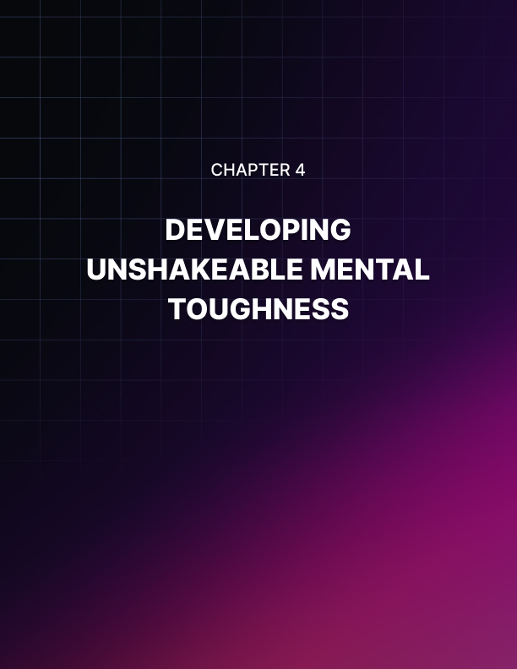

DEVELOPING UNSHAKEABLE MENTAL TOUGHNESS
____
Mental toughness stands as the cornerstone of entrepreneurial success. It's the intangible quality that propels you forward when obstacles seem insurmountable, when doubts creep in, and when the path ahead appears shrouded in uncertainty. This chapter will guide you through the process of cultivating a level of mental fortitude that goes beyond ordinary resilience, equipping you with the tools to thrive in the high-pressure world of business.

The Essence of Mental Toughness in Entrepreneurship
Mental toughness is more than just perseverance or grit. It's a complex psychological construct that encompasses your ability to perform consistently under pressure, maintain focus in the face of distractions, and bounce back stronger from setbacks. For entrepreneurs, mental toughness is the difference between those who fold under pressure and those who rise to the challenge. A 2023 study published in the Journal of Business Venturing found that entrepreneurs with high levels of mental toughness were 47% more likely to successfully navigate business crises and 39% more likely to report consistent year-over-year growth compared to their less mentally tough counterparts. These statistics underscore the critical role mental toughness plays in your entrepreneurial journey.
Mental toughness can be broken down into four key components, often referred to as the 4Cs:
- Control
Control in entrepreneurship means maintaining composure in high-stress situations and believing in your ability to shape outcomes. To enhance your sense of control, practice mindfulness meditation to improve emotional regulation, implement the "5-second rule" developed by Mel Robbins, and develop contingency plans for various business scenarios.
- Commitment
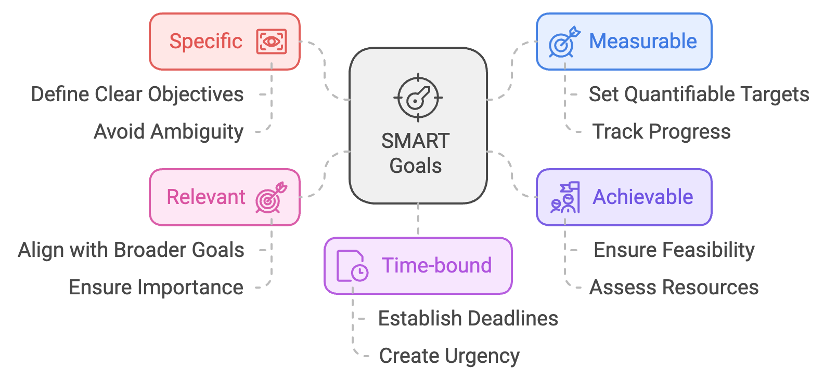
Commitment for entrepreneurs means setting clear goals and persevering through obstacles. To bolster your commitment, use the SMART goal-setting framework, implement the "implementation intention" technique, and practice visualization daily.

- Challenge
Seeing challenges as opportunities is crucial for entrepreneurial success. To cultivate this mindset, reframe setbacks using the "growth mindset" approach, implement the "challenge-skill balance" concept from flow psychology, and practice intentional discomfort.
- Confidence
Confidence is the bedrock of mental toughness. To boost your entrepreneurial confidence, use positive self-talk, implement the "confidence log" technique, and seek and provide mentorship.

The Engines of Mental Toughness
Grit, defined by psychologist Angela Duckworth as "passion and perseverance for long-term goals," is a crucial component of mental toughness. To cultivate grit, identify your "why," practice deliberate, focused effort, embrace the "marginal gains" philosophy, and develop a growth mindset. A 2023 study in the Journal of Applied Psychology found that entrepreneurs who scored high on measures of grit were 35% more likely to sustain their businesses through economic downturns compared to those with lower grit scores.
While positivity is crucial, blind optimism can be detrimental. The mental contrast method, developed by psychologist Gabriele Oettingen, offers a balanced approach to goal pursuit. This technique involves visualizing your desired outcome in detail, identifying potential obstacles that could prevent you from achieving this outcome, and developing strategies to overcome these obstacles. To implement the mental contrast method, set aside 15 minutes each week for a mental contrasting session, start by vividly imagining a key business goal achieved, then list potential obstacles that could hinder this achievement, for each obstacle, brainstorm at least two strategies to overcome it, and create action plans based on these strategies. A 2023 study in the European Journal of Social Psychology found that entrepreneurs who regularly practiced mental contrasting were 29% more likely to achieve their short-term business goals compared to those who only engaged in positive visualization.

Building Mental Toughness Through Adversity
Just as physical strength is built through resistance training, mental toughness is forged through adversity. Incorporate these "mental workouts" into your routine:
- cold exposure,
- fasting,
- public speaking,
- physical challenges,
- rejection therapy.
A 2023 survey by Entrepreneur Magazine found that business leaders who regularly engaged in at least three forms of "adversity training" reported 38% higher levels of mental toughness and 42% better stress management compared to those who didn't.
Let's examine two entrepreneurs who demonstrated remarkable mental toughness:
- Elon Musk's journey with SpaceX exemplifies mental toughness in action.
Despite facing numerous setbacks, including three failed rocket launches that nearly bankrupted the company, Musk persevered. He maintained control by staying deeply involved in the technical details, demonstrated commitment by investing his own money when funds were low, embraced the challenge of revolutionizing space travel, and maintained confidence in his vision. His grit paid off when SpaceX successfully launched its fourth rocket, securing a $1.6 billion contract with NASA.
- Sara Blakely, founder of Spanx, showcased mental toughness throughout her entrepreneurial journey.
She maintained control by bootstrapping her company and keeping ownership, stayed committed to her vision despite numerous rejections from manufacturers, saw the challenge in disrupting the undergarment industry as an opportunity, and built confidence through persistent cold-calling and self-promotion. Her mental toughness led Spanx to become a billion-dollar company, making Blakely the youngest self-made female billionaire at the time.

Practical Exercises and Measurement
Incorporate these exercises into your routine to systematically build mental toughness:
- the 5-Minute Journal
- the 100-Day Challenge
- the Stoic Evening Review
- the Comfort Zone Challenge
- the Resilience Scenario Planning
To ensure you're making progress, it's crucial to measure and track your mental toughness. Use the Mental Toughness Questionnaire 48 (MTQ48), keep a "resilience journal," set specific, measurable goals related to mental toughness, and seek regular feedback from mentors, team members, or a business coach on your ability to handle pressure and setbacks.
Developing unshakeable mental toughness is a journey, not a destination. It requires consistent effort, self-reflection, and a willingness to push beyond your comfort zone. As you implement these strategies and exercises, you'll find yourself better equipped to handle the pressures and challenges of entrepreneurship. Remember, mental toughness isn't about being invulnerable or never experiencing doubt or fear. It's about developing the capacity to perform at your best despite these challenges, to bounce back stronger from setbacks, and to maintain unwavering commitment to your entrepreneurial vision. With practice and persistence, you can cultivate the mental fortitude needed to navigate the complex, often turbulent waters of entrepreneurship and emerge as a resilient, successful business leader.
Mental Toughness Component | Key Strategies | Benefits
Control | Mindfulness meditation, 5-second rule, Contingency planning | Improved emotional regulation, Better decision-making under pressure
Commitment | SMART goals, Implementation intentions, Visualization | Increased goal achievement, Enhanced perseverance
Challenge | Growth mindset, Challenge-skill balance, Intentional discomfort | Greater resilience, Improved problem-solving skills
Confidence | Positive self-talk, Confidence log, Mentorship | Higher self-efficacy, Improved leadership skills

The Mental Toughness Equation:
MT = (C₁ + C₂ + C₃ + C₄) × (G + P)
Where:
MT = Mental Toughness
C₁ = Control
C₂ = Commitment
C₃ = Challenge
C₄ = Confidence
G = Grit
P = Perseverance
This equation illustrates that mental toughness is a product of the four components (4Cs) multiplied by the combination of grit and perseverance, emphasizing the synergistic effect of these elements.

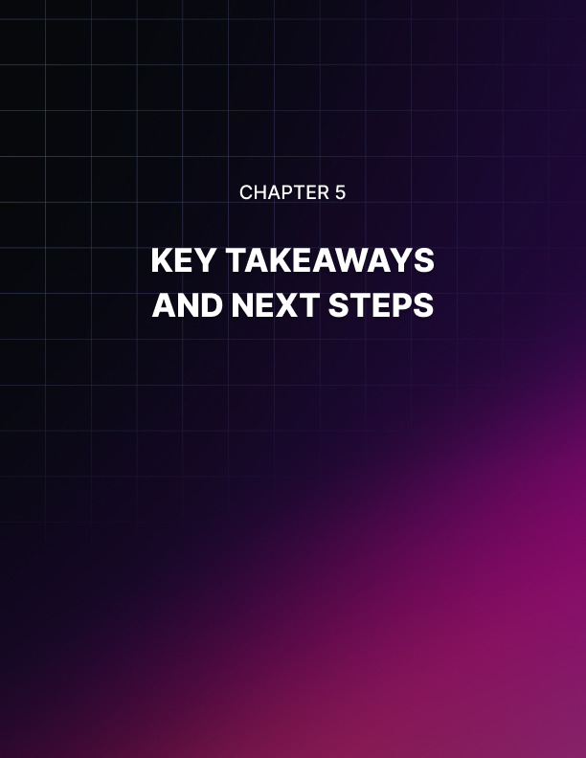

KEY TAKEAWAYS AND NEXT STEPS
____

The Resilience Blueprint
Your journey began with understanding the fundamental aspects of resilience specifically tailored for entrepreneurs. Let's revisit the key components of your resilience blueprint:
You've learned to adopt a growth mindset, embracing challenges as opportunities for learning and growth. This shift in perspective allows you to view setbacks not as failures, but as valuable lessons on your entrepreneurial journey. You've practiced the art of cognitive reframing, transforming negative situations into more balanced or positive perspectives. This skill enables you to maintain optimism and find constructive solutions even in the face of adversity. The ability to reassess and realign your goals in response to changing circumstances is crucial for long-term success. You've recognized the value of building a strong support network, including mentors, peers, and personal relationships. This network serves as your safety net and source of inspiration during challenging times. You've acknowledged the intrinsic link between physical well-being and mental resilience. Regular exercise, adequate sleep, balanced nutrition, and mindfulness practices form the foundation of your resilience-building routine. Remember, resilience is not a destination but a continuous journey. As you face new challenges in your entrepreneurial path, consistently revisit and refine these components of your resilience blueprint.

Stress Management Mastery
Effective stress management is a cornerstone of entrepreneurial resilience. Let's recap the high-impact techniques you've learned:
Progressive Muscle Relaxation (PMR) helps you release physical tension and interrupt the stress response cycle. Regular practice can lead to significant reductions in perceived stress levels. By incorporating Mindfulness-Based Stress Reduction (MBSR), including mindfulness meditation, body awareness, and yoga into your routine, you can dramatically reduce stress-related symptoms and improve decision-making capabilities. Regular exercise not only boosts your physical health but also serves as a powerful stress-buster. Whether it's walking meetings, desk exercises, or dedicated workout sessions, consistent physical activity is crucial for managing stress. Time-Blocking helps you structure your day, reduce multitasking, and increase productivity. By allocating specific time blocks for different tasks, you can significantly decrease work-related stress. As you continue your entrepreneurial journey, make these stress management techniques an integral part of your daily routine. Managing stress effectively is not just about feeling better—it's about maintaining peak performance and safeguarding your long-term success.

The Power of Positivity
Cultivating a positive entrepreneurial mindset is more than just feeling good—it's a strategic advantage. Let's revisit the key strategies for maintaining a positive outlook:
Gratitude Journaling helps shift your focus from what's lacking to what's abundant in your life and business. This simple yet powerful technique can significantly increase life satisfaction and decrease perceived stress levels. By vividly imagining your desired outcomes through visualization, you're priming your brain for success. Regular visualization practice can lead to higher goal achievement rates and improved problem-solving skills. Positive self-talk and affirmations help rewire your brain's neural pathways, making positive thinking more automatic over time. Craft personalized, action-oriented affirmations that resonate with your entrepreneurial goals. Surrounding yourself with mentors, peers, and supportive relationships creates an environment conducive to maintaining a positive outlook. Regular interaction with your support network can provide fresh perspectives, accountability, and motivation. Positive Psychology Exercises like the Three Good Things Exercise and the Best Possible Self Exercise are evidence-based interventions that can boost optimism, increase life satisfaction, and clarify your goals. As you move forward, consistently incorporate these positivity-boosting practices into your routine. A positive mindset is not just about feeling optimistic—it's about expanding your capacity for creativity, problem-solving, and resilience.

Unshakeable Mental Toughness
Mental toughness is the secret weapon of successful entrepreneurs. Let's recap the key components and strategies for developing this crucial trait:
The 4Cs of Mental Toughness - Control, Commitment, Challenge, and Confidence - form the foundation of mental toughness. Continuously work on enhancing each of these components through targeted exercises and mindset shifts. Cultivate grit by identifying your core motivations, practicing deliberate effort, and embracing the philosophy of marginal gains. Remember, grit is a key predictor of long-term entrepreneurial success. Use mental contrasting to balance optimism with realistic planning. Regularly engage in mental contrasting sessions to identify potential obstacles and develop strategies to overcome them. Incorporate "mental workouts" like cold exposure, fasting, public speaking challenges, and rejection therapy into your routine. These practices help build resilience and prepare you for real-world business challenges. As you continue to develop your mental toughness, remember that it's an ongoing process. Regularly challenge yourself, seek feedback, and refine your mental toughness strategies.

Measuring Your Progress and Next Steps
To ensure continuous growth in your resilience journey, it's crucial to track your progress. Here are some key metrics and methods to consider:
Regularly take standardized resilience assessments like the Connor-Davidson Resilience Scale or the Brief Resilience Scale. These tools can provide quantitative measures of your resilience over time. Use stress inventories or apps to track your perceived stress levels. Look for trends and correlations with your stress management practices. Monitor how many of your set goals you're achieving. Improved resilience should correlate with a higher goal achievement rate. Track the ratio of positive to negative thoughts or interactions in your day. Aim for a 3:1 ratio of positive to negative. Use tools like the MTQ48 to measure your mental toughness periodically. Keep a resilience journal to track your challenges, responses, and learnings. This qualitative data can provide valuable insights into your growth. Regularly seek feedback from mentors, team members, and peers about your ability to handle stress and bounce back from setbacks. Remember, progress isn't always linear. There will be ups and downs, but the overall trend should show improvement over time.
As you conclude this book, it's crucial to create a plan for your ongoing resilience development. Here's a step-by-step guide to help you move forward:
- Take stock of where you are now using the measurement tools mentioned above to establish your baseline.
- Set specific, measurable goals for each area of resilience based on your self-assessment.
- Create a daily and weekly schedule that incorporates the key practices you've learned.
- Identify the resilience skills that need the most work and prioritize their development.
- Commit to ongoing learning about resilience and related topics.
- Set up an accountability system to keep you on track.
- Schedule monthly and quarterly reviews of your resilience development plan.
- Regularly step out of your comfort zone and set increasingly challenging goals.
- Look for opportunities to share your knowledge with your team or other entrepreneurs.
- Acknowledge and celebrate your growth, no matter how small.
Resilience Component | Key Practices | Measurement Tools
Mindset | Growth mindset, Cognitive reframing | Mindset assessment questionnaires
Stress Management | PMR, MBSR, Physical activity, Time-blocking | Perceived Stress Scale (PSS)
Positivity | Gratitude journaling, Visualization, Affirmations | Positive and Negative Affect Schedule (PANAS)
Mental Toughness | 4Cs practice, Grit cultivation, Mental contrasting | Mental Toughness Questionnaire 48 (MTQ48)

Building resilience is a lifelong journey. As an entrepreneur, your ability to bounce back from setbacks, manage stress effectively, maintain a positive outlook, and demonstrate mental toughness will be continually tested. But with consistent practice and a commitment to growth, you can develop the unshakeable resilience needed to thrive in the challenging world of entrepreneurship. Embrace the ups and downs of entrepreneurship with confidence, knowing that you have the tools and strategies to navigate any storm. Your resilience is your greatest asset—nurture it, strengthen it, and let it propel you towards unprecedented success in your entrepreneurial endeavors.

